Original Research Article

Microscopic Structure and Micrometric Properties of Wool in Two Southern Indigenous Sheep Breeds: Trichy Black and Nellore

ABSTRACT

Aims: This study investigates the micrometrical and morphological characteristics of wool from two indigenous Indian sheep breeds: Trichy Black and Nellore.
Methodology:Wool from shorn wool bales were collected as samples from six adult Trichy Black and Nellore Sheep. Using light microscopy, the medullation, pigmentation, and fibre parameters were calculated. The cuticular pattern of the various types of wool were studied using the gelatin cast technique.A novel, rapid, and cost-effective cross-sectioning technique using cellophane tape is reported for the first time, providing a practical and efficient tool (taking less than 10 minutes) for forensic and textile analysis.
Results:Results indicate that Trichy Black wool comprises two fiber types (thin and thick), whereas Nellore wool exhibits four distinct types, ranging from thin non-medullated to thick highly medullated fibers. Microscopic analysis revealed that both breeds possess highly medullated fibers; the Medullary Index (MI) for Trichy Black thick fibers was 0.8, while Nellore medullated fibers reached an MI of 0.95. Cuticular patterns varied from imbricate in coarser fibers to coronal in finer wool. Nellore wool proved to have the highest diameter of as high as
Conclusion:The study highlights the coarse, medullated nature of these wools, typical of carpet-grade fibers, and provides essential baseline data for breed identification. This research facilitates forensic trichology and informs breeding strategies aimed at enhancing wool quality while preserving the natural hardiness of native Southern Indian sheep

Keywords: Forensic Trichology, hair, sheep wool, Trichy Black, Nellore

1. INTRODUCTION

For millennia, Sheep wool, a natural and renewable fiber, has been essential part of human civilization (The History of Wool Fact Sheet, n.d.),(Ryder, 1964). The land mammals are covered with two distinct types of hairs: Coarse hairs covering shorter finer hairs (Ammayappan, 2012), (Jackson et al., 2020). The hair in the body of sheep are called as wool fibres, and mainly the fine curly hairs that make up the fleece is termed as “wool” (Rogers, 2006). Generally, the term wool is also used for the fleeces obtained from other species like yak, elk, cashmere, alpaca, camels or rabbits (Doyle et al., 2021).

Sheep plays a vital role in the livelihood of a large population of marginal and small farmers. There are various sheep breeds which are selected and bred such that it has genetic improvement, and improvement in economic traits like increased meat, milk and fibre production. India’s sheep population has reached 74.26 million in 2019, and the Annual report states that the Telangana ranks first, followed by Andra Pradesh and Tamil Nadu ranks fifth in the sheep population. It accounts for about 13.8% of the India’s total livestock population (DAHD, 2024). From the wild sheep which was present around 10,000 BCE, which had long medullated overhairs and fine underwool to the current breed of sheep like Australian Merino, which has fine medium diameter wool, wool has displayed different morphological characteristics with respect to their primary fibre diameters, secondary fibre diameter, fibre medullation, and secondary follicle ratio (Jackson et al., 2020). The hair is composed of the root and the shaft, where the root is the region of the hair which is embedded in the dermis of the skin and the outermost visible part is the shaft.

A wool fiber comprises of three primary layers:

Cuticle: The outermost layer consisting of overlapping flat scales like cells that protect the fiber and contribute to its felting properties (Fratini et al., 1994). The cuticle has epicuticle, exocuticle and the endocuticle (Marshall et al., 1991).

Cortex: Making up about most of the fiber, the cortex contains thin elongated cells (FG Orwin et al., 1984).This determine the fiber's strength, elasticity, and dye affinity.

Medulla: Present in coarser fibers, the medulla is a central hollow region that can influence the fiber's insulation properties, is a network of air-filled cell walls present in the middle of the medium to coarser wool fibres. Not all wool fibres are medullated, coarser wool and usually fine wools do not contain a medulla (Ammayappan, 2012). The fibres can be classified based on the type and arrangement of the medulla (De Marinis & Asprea, 2006a).

Hair microscopy is an important tool to identify and differentiate various species of animals, but there exist a few literatures on the various trichology of different breeds of sheep of India. Recent scientific investigations into the microanatomy of the sheep wool have revealed its intricate structure and it has a wide utility beyond its traditional use in textiles. The study of wool fibres has been a carried out since a long time before the advent of the synthetic fibres. Yet, there are no atlases published on the hair of the domesticated and wild sheep of India. In addition, the hair of many species of sheep and goat have not yet been described.

Due to a dearth of information on the micro-anatomy of the wool from Indian breeds of sheep, we have chosen to work on two coarse wool breeds of domestic sheep namely: Trichy Black and Nellore. Trichy Black is also called as Trichy Karungurumbai. It is one of the recognized breeds of sheep of Tamilnadu(Kavitha et al., 2015). It is distributed in Ariyalur, Permabalur, Trichy, Kallakuruchy, Virudunagar, Tirupathur, and Tiruvannamalai districts of Tamil Nadu. The fleece is extremely coarse, hairy and open (CSWRI, n.d.). It is a wool purpose breed and usually has black colored hairs all over the body (TNAU AGRITECH, n.d.), (Kavitha et al., 2015). Trichy Black has been used as a meat and coarse wool purpose sheep and is quite adaptable to our South Indian climatic conditions (Kavitha et al., 2015). Nellore is distributed in Nellore district and neighboring areas of Prakasham and Ongole districts of Andhra Pradesh (CSWRI, n.d.). These are tall animals with little hair except at the brisket, withers and breech (TNAU AGRITECH, n.d.). According to Bhateshwar, Trichy Black and Nellore breeds belong to the Southern Peninsular region and is mostly bred for mutton purpose (CSWRI, n.d.), (Bhateshwar et al., 2022).
Wool fiber histomorphology encompasses the microscopic structure and morphological characteristics that determine fiber quality, processing potential, and commercial value. While many research papers offer extensive information about general wool fiber structure and Indian sheep breeds, specific histo-morphological data for Trichy Black and Nellore breeds are limited in the available literature. Detailed knowledge of fiber characteristics would inform breeding programs aimed at improving wool quality while maintaining the natural hardiness and adaptation of indigenous breeds (Ammayappan et al., 2012). In this article, the microanatomical structure of the wool of Trichy Black and Nellore is elaborated and compared. A simple and quick method to prepare cross section of wool fibres has been reported for the first time. By delving into the intricacies of wool fibers, researchers and industries can harness its full potential, driving innovations that align with sustainability and performance goals.

2. material and methods

2.1 Sample collection and preparation

The shorn wool bales were collected from six adult Trichy Black and Nellore Sheep from a farm in Theni, Tamil Nadu. To carry out the study, the fibres were first washed in 70% alcohol (Madkour & Abdelsabour‐Khalaf, 2022), dried and then processed accordingly.
2.2Medulla, pigmentation, and fibre parameters

The wool fibres from Trichy Black and Nellore were mounted onto glass slide with DPX. Mean fibre diameter (MFD) and diameter of medulla (n=10) were measured using the light microscope (Magnus MX21iLED). The medullary index (MI) is the diameter of the medulla relative to the diameter of the wool and the medulla to cortex ratio (M/C) were also calculated (Lungu et al., 2007), (Mihaylov & Kirilov, 2022). The pigmentation of the wool was also studied. Ten measurements were taken for each wool samples, the mean and standard deviation were calculated. The photomicrographs were acquired under 40x using the light microscope.
2.3Cuticular pattern examination

To study the cuticular pattern, 20% gelatin coated slides were used where the fibres were kept in contact with the gelatin and then after the gelatin had set, the fibres were removed to expose the cuticular patterns (Van den Broeck et al., 2001). Photomicrographs were taken under 40x magnification using a light microscope (Magnus MX21iLED). The cuticle and medulla were classified (De Marinis & Asprea, 2006b), (Deedrick & Koch, 2004).
2.4Cross-section

The cellophane tape was fixed onto the countertop and the wool fibres were placed onto the tape in the required orientation, then another piece of tape was applied over the tape such that the wool fibres are sandwiched between the tapes. With the use of new stainless-steel razor blade a straight cut was applied onto the tape. Then with the other end of the new stainless steel razor blade, another straight cut was applied parallel to the cut made before, this will result in a thin strip of tape with the cross section of wool in between. This thin strip was picked with forceps and kept on a slide such that the cross section of the wool fibre faced the object piece and the photomicrographs were acquired under 40x using the light microscope (Magnus MX21iLED).

3. results and discussion

The study of the microanatomical structure of the hair/ wool is very important in forensic investigations. In this study, the hair from the shorn bales were used, and this could be comparable to the type of sample obtained during a forensic investigation. The pelage of animals demonstrates: overhairs, guard hairs and underhairs. Tridico explains that the overhairs are distinctly longer and the guard hairs are larger or coarser hairs which forms the bulk of the hair and these guard hairs are in variable sized which cannot be differentiated form the underhairs. Whereas, the underhairs are shorter and finer hairs in comparison to the other two types of hair, and underhairs tend to be wavy and have uniform diameter all along the hair with a tapering tip (Tridico, 2009). In this study specifically this classification has not been followed since the samples were from the shorn wool from the sheep. Indian wool is typically categorized as being used to make blankets and carpets (Bhateshwar et al., 2022). When it comes to defining end use and value addition, quality parameters such as physio-chemical, mechanical, and morphological features are crucial. Moreover, Indian wools were generally medullated, hence the end products are not comparable with the fine or superfine wools produced elsewhere in the world (Ammayappan et al., 2012).
The shorn wool of Trichy Black sheep was highly pigmented and black in appearance (Figure 1.a), whereas, the wool of Nellore sheep was relatively coarser and straighter (Figure 3.a).

3.1 Fibre diameters

Under microscopic observation,the wool of Trichy Black showed two types of wool fibres: thin (Figure 1.b) and thick fibres (Figure 1.c). The mean fibre diameters (MFD) of the wool fibres of Trichy black and Nellore were calculated (Figure 2). The mean fibre diameters (MFD) are shown in the column bar graphs (Figure 2). The medullary Index (MI) and Medulla/ Cortex ratio (M/C) were not calculated for the thin wool fibres of Trichy Black, whereas, the MI was 0.8 and M/C was 5.08 for the thick fibres.
The wool of Nellore showed four types of wool fibres: thick brown fibres (Figure 3.b), thick highly medullated fibres (Figure 3.d& f), thin transparent non medullated fibres (Figure 3.g), and thin brown non-medullated fibres (Figure 3.i). For the Nellore sheep,the MI of thick brown wool fibres was 0.21 and for thick medullated wool fibres was 0.95. Furthermore, M/C of thick brown wool fibres were 1.56 and for thick medullated wool fibres was 24.60. The diameter of the fibre represents the thickness or fineness of the fibre. The coarseness or fineness of the animal fibres dictates the end usage such as textile industry, apparel production, beddings, and carpets, wool fibres greater than 31µ can be used for Bedding upholster and carpets (Tridico, 2009). Trichy Black produces coarse wool and traditionally have been used by Kurumbas to make blankets and this sheep has been vital for their sustenance and livelihood (Gopu et al., 2021). The breed Trichy Black is classified as a wool-purpose breed, though specific fiber diameter, crimp characteristics, and microscopic properties are not detailed in the available literature. In this study, two types of wool fibres were identified, thin and thick, where the thin fibres were less than 20µm, which indicates they are the true wool type underfur and the thick hair of about 87.88 µm, indicating the higher percentage of the medullated hairy type fibres, based on the classification by Ammayappanet al (2012).The diameters of the fibres of Nellore breed varied with the fibres types. The MFD of the thin non medullated wool fibres were under 20 µm, whereas the thick fibres were above 80 µm indicating that they are kempy medullated outer hairs of the sheep. The thickest of the fibres were of Nellore and it was about 143.52µm in diameter (Figure 2 and 3d).

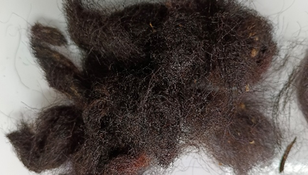 | 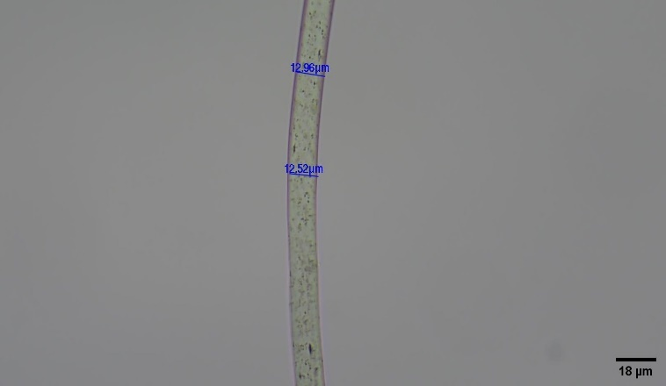
- Photograph of the Trichy Black wool | - Photomicrograph of thin wool
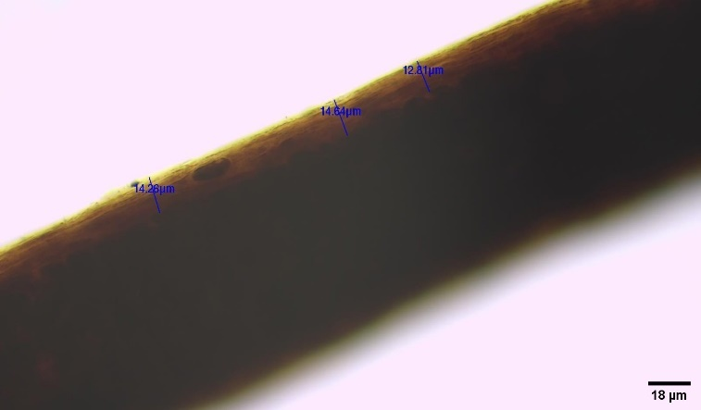 | 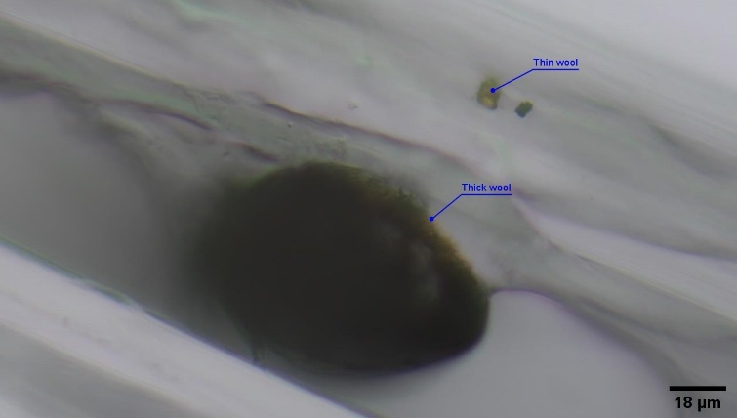
- Photomicrograph of Thick wool | - Cross section- thin and thick wool
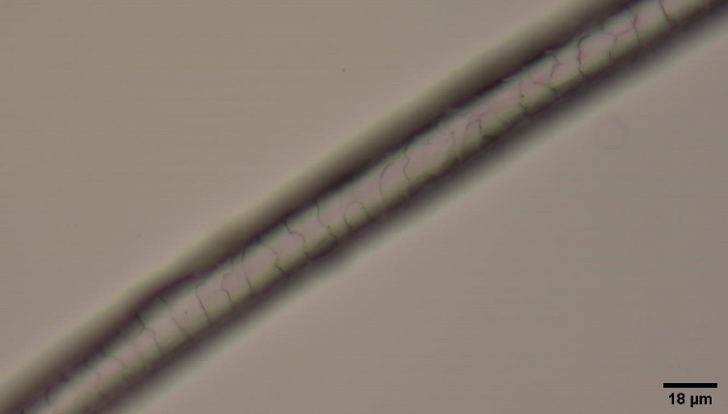 | 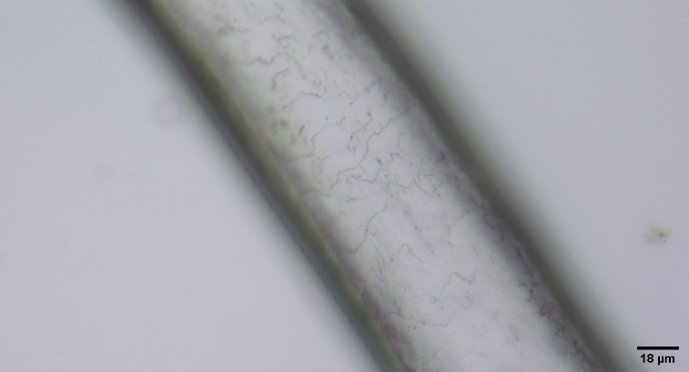
- Cuticular pattern- thin wool | - Cuticular pattern - thick wool
Figure 1: Gross appearance, medulla and cuticular patterns of Trichy Black wool.

Table 1: Cuticular scale patterns and medullary pattern in Trichy Black wool
Type of wool | Cuticle scales |  |  |  | Medulla |  |  | Cortex | Cross section
Type of wool | Pattern | Margin Type | Margin shape | Margin distance | Structure | Pattern | Margin | Cortex | Cross section
Thin | Coronal | Smooth | Smooth | Distant |  |  |  | Brown pigmented granules | Oval - oblong
Thick | Imbricate | Streaked | Crenate | Near | Amorphous | Continuous | Scalloped | Heavily pigmented | Oval - oblong

3.2Cross section of wool fibre

While much attention has been given to hair morphology and shaft analysis through surface imaging, cross-sectional analysis offers an internal view of the hair shaft, which can reveal subtle structural differences. Cross-sectioning is a valuable technique in trichological study to study differences of a family in a genera (Cooper & Kirk, 1953). Various techniques have been described such as embedding in paraffin, embedding in colloidion, and embedding the hair in celluloid acetone medium on a strip of balsa wood (Mathiak, 1938). Later, hair or fibres were embedded in araldite (Rogers, 1959), (Pepper & Lantis, 1977), resin (Grieve & Kotowski, 1986), and acetate (Dagnall et al., 1995) for examination. While all these methods take time and requires certain level of experience. Much difficulty has been faced while embedding the hair so that true cross section is the result (Cooper & Kirk, 1953). Whereas, in this paper, we have described a relatively simple method to obtain cross sections of the hair fibres.
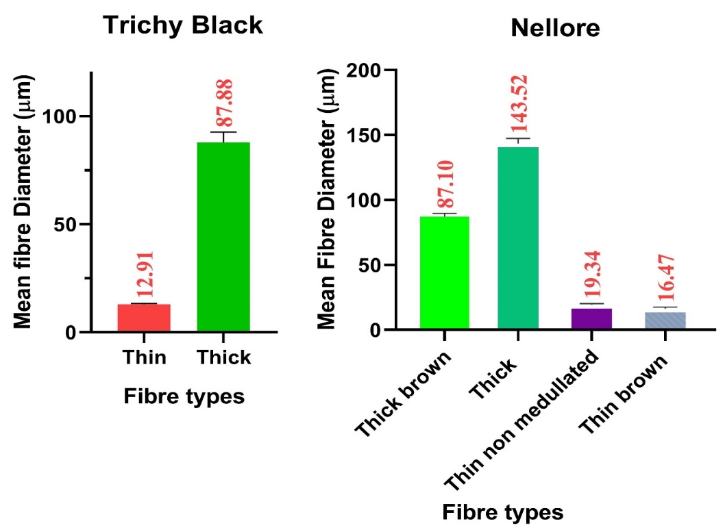
Figure 2: Mean Fibre diameters of Trichy Black and Nellore wool. Column bar graphs showing the mean fibre diameters (MFD) with Standard Deviation (SD) (n=10).

We have obtained satisfactory results with the cellophane tape method, which has proved to be quick and easy, which is a requirement while testing forensic samples. This method can be applied to human hair and for taking cross sections of forensic samples and it takes less than 10 minutes from the moment hair is received to cross sectional viewing. The one major requirement for this cellophane technique is steady hands and this is the least expensive, least dangerous involving no harmful chemicals described for cross-sectioning of hair fibres currently. After the cross section is viewed, the section can be mounted with DPX for eternity.
The shape, size and the morphology of cross section of the hair varied with the hair fibre type. The cross section of the fibres of Trichy Black reveals that the thin hair is oval shaped with medulla absent. Further, the cross section of the thick hairrevealed oval large medulla and the thin hair was of same shape (Figure 1.d) and (Table 1). The simple cellophane tape method revealed the cross section of Nellore wool: the thick brown fibres (Figure 3.c), thick highly medullated fibres (Figure 3.e), thin transparent non medullated fibres (Figure 3.h), and thin brown non-medullated fibres (Figure 3.j). The cross section of the fibres of Nellore reveals that the thick brown hair is circular in shape with a large medulla (Table 2). Further, the cross section of the thick hair shows oblong shape with a large medulla, which could be compared to the cross section of sheep guard hair (Anwar et al., 2012) and the thin non medullated hair and thin brown hair were oval in shape.

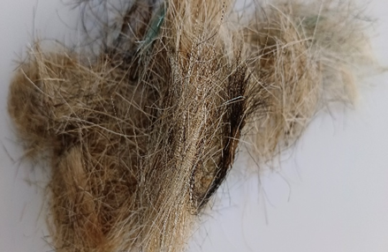 | 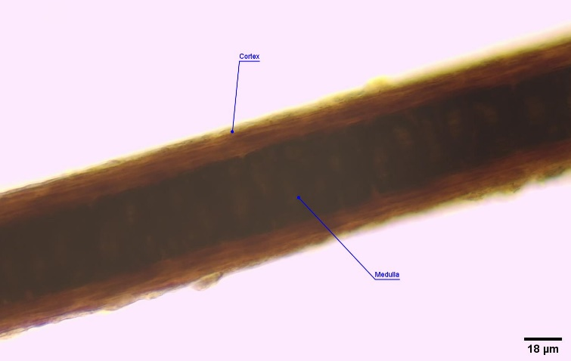
- Photograph of the Nellore wool | - Photomicrograph of Thick Brown wool
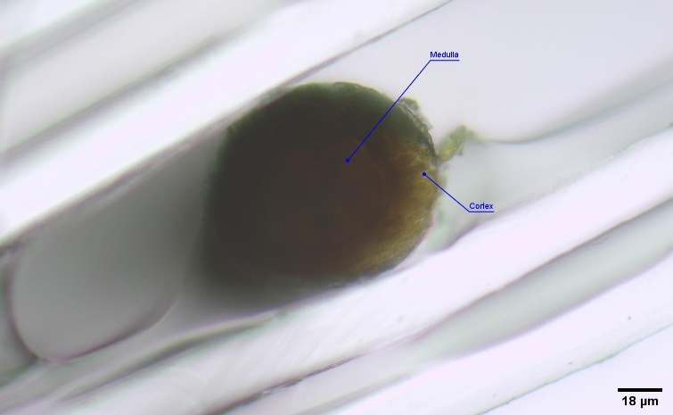 | 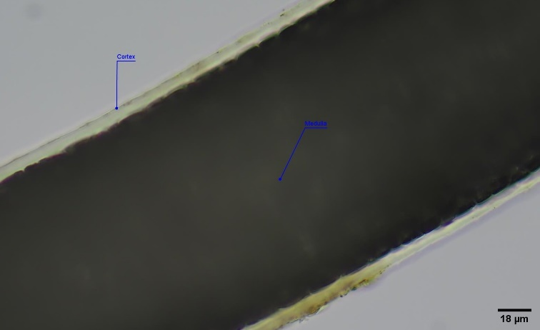
- Cross section- Thick Brown wool | - Photomicrograph of Thick wool
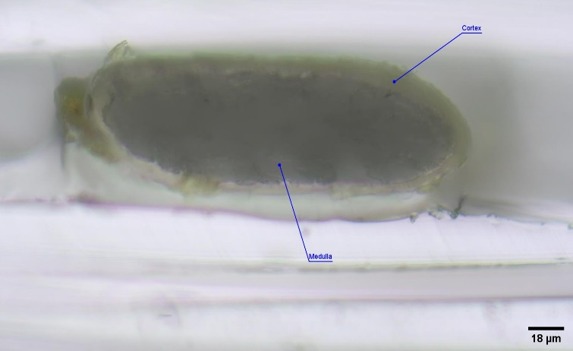 | 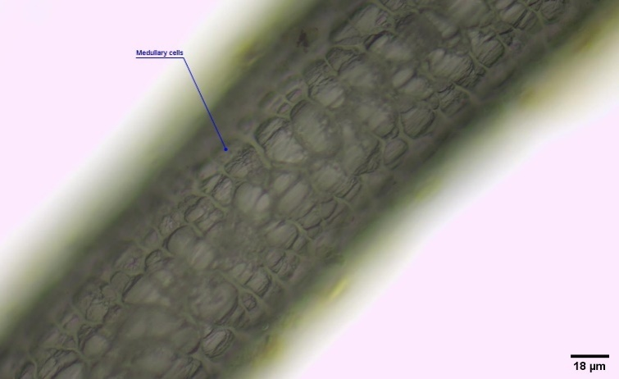
- Cross section-Thick wool | - Photomicrograph of Thick wool- multiseriate medulla
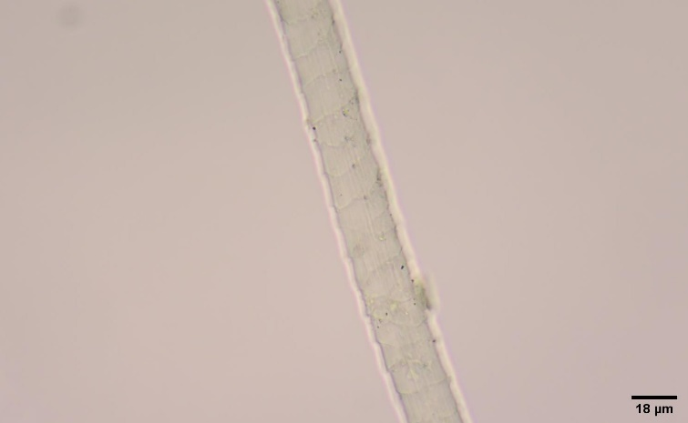 | 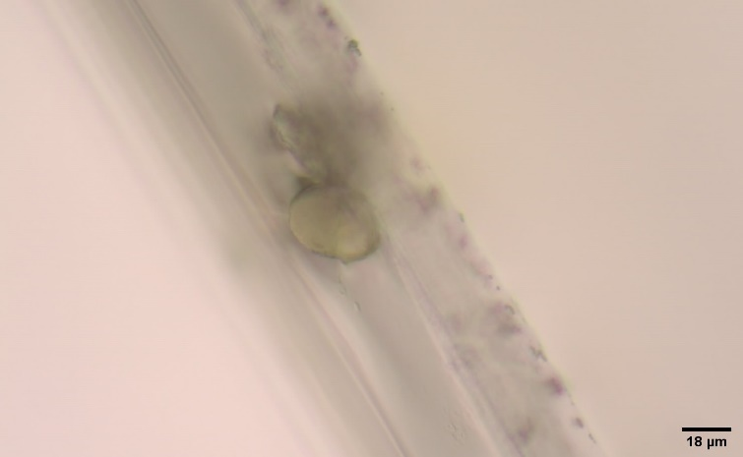
- Photomicrograph of thin non medullated wool | - Cross section-Thin non medullated wool
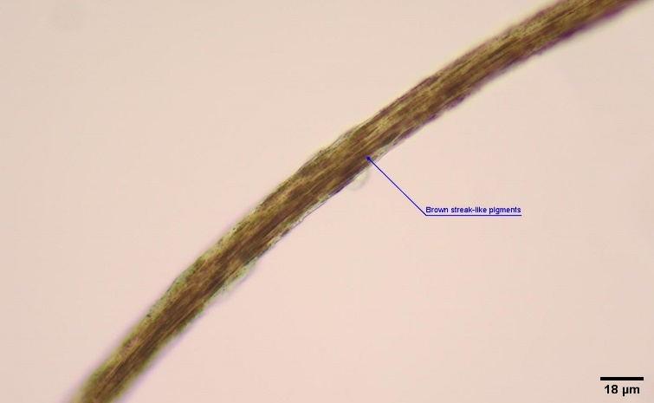 | 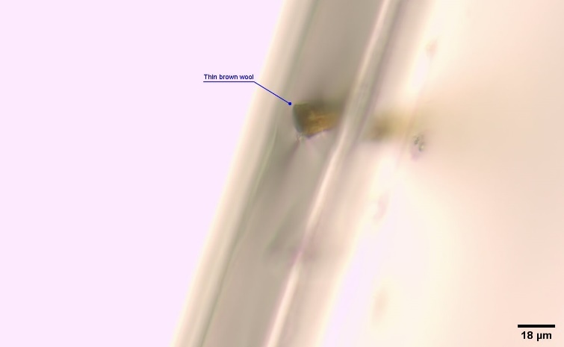
- Photomicrograph of thin brown wool | - Cross section- Thin Brown wool
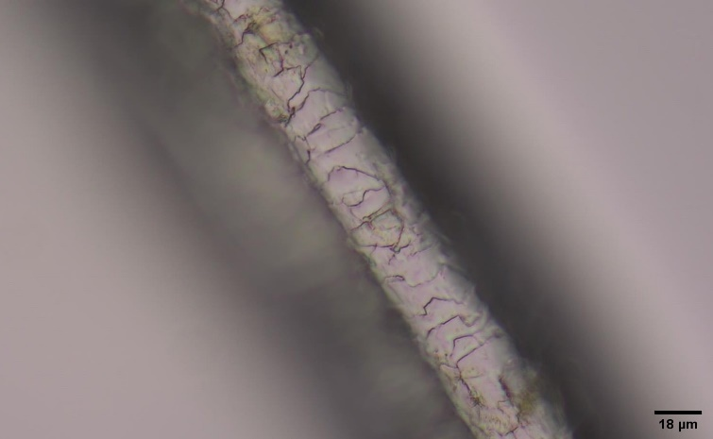 | 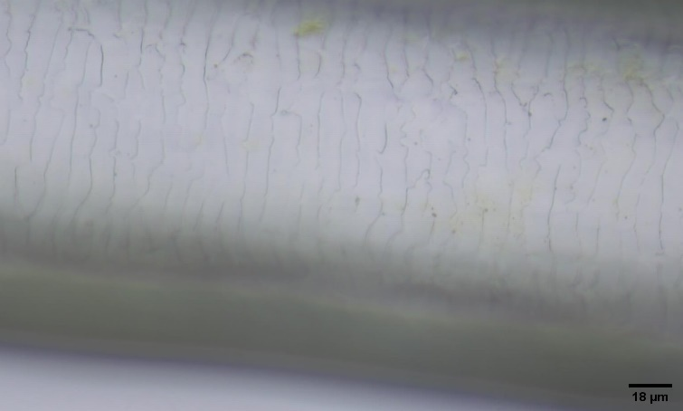
- Cuticular pattern - Thick brown wool | - Cuticular pattern - Thick wool
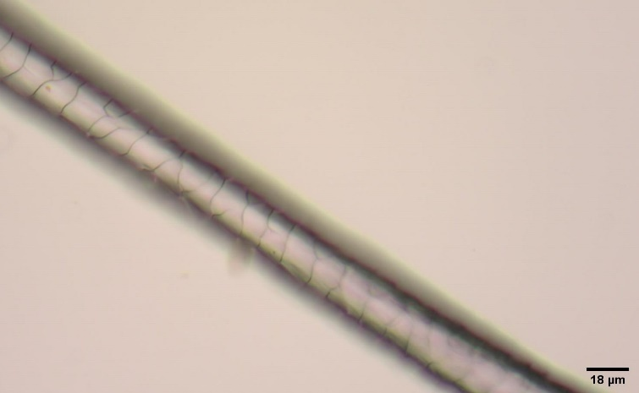 | 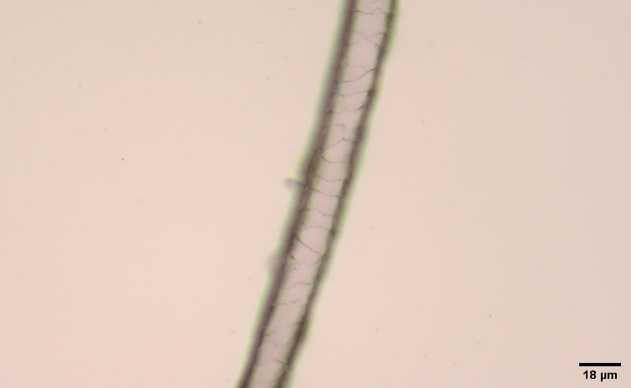
- Cuticular pattern- Thin non medullated wool | - Cuticular pattern - Thin brown wool
Figure 3: Gross appearance, medulla and cuticular patterns of Nellore wool.

Table 2: Cuticular scale patterns and medullary pattern in Nellore wool
Type of wool | Cuticle scales |  |  |  | Medulla |  |  | Cortex | Cross section
Type of wool | Pattern | Margin Type | Margin shape | Margin distance | Structure | Pattern | Margin | Cortex | Cross section
Thick brown | Imbricate | Streaked | Crenate | Distant | Uniseriate | Continuous/ discontinuous | Scalloped | Heavily pigmented | Round
Thick | Imbricate | Streaked | Crenate | Near | Multiseriate | Continuous | Scalloped | Thin, pigmented sparsely | Oblong large medulla
Thin non medullated | Coronal | Smooth | Smooth | Distant |  |  |  | No pigmentation | Oval
Thin brown | Coronal | Smooth | Smooth | Distant |  |  |  | Brown streak like pigment granules | Oval

3.3Cuticular pattern

The cuticle, which is composed of a series of flattened cells containing lipids, are responsible for the hydrophobicity of the cuticle (Plowman & Harland, 2018). The cuticular pattern of the thin (Figure 1.e) and thick fibres (Figure 1.f) fibres of Trichy Black showed that the margins and the pattern differed (Table 1). The cuticular pattern of the thick wool fibres of Trichy Black reveals that they have an Imbricate pattern of scales. The margins of the scales were streaked and the shape was crenate. The edges of the scales were closer to one another. The cuticular pattern of the thin wool fibres of Trichy Black reveals that they have coronal pattern of scales. The margins of the scales were smooth and the edges of the scales were far away from each other. Ahmed et al showed that the sheep’s dorsal guard hairs’ cuticular scales had smooth margins, and had an irregular mosaic shape and wide distance between them (Ahmed et al., 2018).

The cuticular pattern of Nellore wool revealed: thick brown fibres (Figure 3.k), thick highly medullated fibres (Figure 3.l), thin transparent non medullated fibres (Figure 3.m), and thin brown non-medullated fibres (Figure 3.n) are reported in Table 2. Thin non medullated wool showed regions of discontinuous medulla. The cuticular pattern of the thick brown fibres of Nellore revealed that the cuticular scales had an imbricate pattern, similar to findings Ahmed et al., in sheep and the cuticles were crenate in shape , similar to camel’s hair (Alsafy et al., 2024), and their margins streaked with cuticular margins were quite far from one another. The cuticular pattern of the thick fibres of Nellore reveals that the cuticular scales had an Imbricate pattern and the cuticles were Crenate in shape, which is comparable to the Goat (Ahmed et al., 2018). The margins were streaked and the cuticular margins were closer to one another. The cuticular pattern of the thin non medullated fibres and the thin brown fibres of Nellore reveals that the cuticular scale had a coronal pattern, with the scales being smooth in shape and margins, further, the margins were distant from one another (Figure 3m and Table 2).

3.4Cortex

The cortex has influence on the wool’s physical and chemical characteristics. The cortex of the thin wool fibres of Trichy Black reveals that had small oval brown granules throughout the fibre, similar to camel’s hair (Alsafy et al., 2024) and the thick wool fibres were heavily pigmented.The cortex of the thick brown fibres of Nellore were heavily pigmented, but the medulla was visible through the pigmented cortical region, similar to camel’s hump hair (Alsafy et al., 2024). The cortex of the thick fibres of Nellore was very thin compared to the medulla and it was pigmented sparsely, and overall, it was transparent, similar to the hair of spotted deer (Abinaya et al., 2025) and mouse deer (Joshi et al., 2012). The cortex of the thin non medullated fibres showed no pigmentation and the thin brown fibres of Nellore had brown streak like pigment granules as observed in the camel’s hump hair (Alsafy et al., 2024), buffalo (Ahmed et al., 2018), and distal part of the hair of barking deer (Joshi et al., 2012).and In contrast, Ahmed et al, showed absence of pigmentation in the cortex of sheep’s wool, but there was no mention of breed in their work(Ahmed et al., 2018).

3.5Medullary pattern

The medulla is actually a specialized region in the hair and it is found in rodent hairs, human hairs and wool when the fibre diameter increases. Plowman and Harland state that not all fibres have medulla. Medulla is absent in fine fibres of 20μm typically (Plowman & Harland, 2018). Ahmed et al., showed that the medullary pattern observed in the sheep’s dorsal guard hair was fragmented medulla, which was in contrast with the buffalo and donkey which had a wide medulla. In the review, byBhateswaret al., it is explained that the Indian wool is coarse and hence methods to improve the indigenous sheep by crossbreeding programme are in place, and various factors affect the wool quality like: feeding, housing, climatic conditions, genetics and health care.

The medullary pattern of the thick hair fibres of Trichy Black reveals that they are amorphous in structure with a continuous pattern and a scalloped margin. The scalloped margins were characteristically seen in Spotted deer (Abinaya et al., 2025), Sambar deer and Nilgai (Charjan et al., 2019). The thin wool fibres lack medulla which corresponds to the fact that this thin wool fibre was less than 20μm in diameter. The medullary pattern of the fibres of Nellore reveals that the thick brown wool had a uniseriate structure of the medullary cells, with a continuous/ discontinuous pattern and the margins were scalloped. The medullary pattern of the thick wool fibres of Nellore revealed multiseriate structure of the medullary cells, with a continuous pattern and a scalloped margin. The thin wool fibres of Nellore lack medulla.

The medullar index (MI) has been used for distinguishing the human hair from animal hair. The MI of animal hairs have been larger than the human hair which is more than 1/3 or 0.33 (Vaishnav et al., 2021). The MI of domestic animals hair ranges from 0.3 to 0.75 (Senthilkumar et al., 2018).The MI of thick fibres of Trichy Black was 0.8, which can be compared to the MI of camel’s hair (Alsafy et al., 2024) and that of the sambar deer with a larger medulla (Shajan et al., 2024). M/C was 5.08 for the thick fibres, this value can be comparable with the data obtained for goat which was 4.8 (Lungu et al., 2007), indicating the higher space occupied by the medulla in the medullated wool fibres. The medullary Index (MI) of thick brown wool fibres of Nellore was 0.21 and for thick medullated wool fibres was 0.95, which is even greater than the MI obtained for sambar deer (Shajan et al., 2024). Furthermore,Medulla/ Cortex ratio (M/C) of thick brown wool fibres were 1.56 and for thick medullated wool fibres was 24.60, which is proved by the largest medullary region of the hairs studied.
Advancements in microscopy and analytical techniques continue to deepen our understanding of wool's microanatomy. Future research may focus on genetic modifications to enhance desirable fiber traits, development of novel wool-based composites, and exploration of wool's potential in emerging fields like biomedicine and nanotechnology. Finally, due to the limitations, in future we would widen the research and create valuable data on the various inter-breed differences in the micro-anatomical structure of sheep’s wool. Both the sheep breeds had large medullated fibres along with the fine hairs. Since these breeds are bred for meat and for carpet wool, this study will further incite interest in the study of various other wool and meat breeds of India.
4. Conclusion

Thence, the absence of breed-specific histo-morphological studies represents a significant gap in understanding the commercial potential and optimal processing methods for wool from these Indian breeds. Also, this type of research will open new avenues for researchers interested in sheep wool production and also dealing with forensic identification of sheep breeds. The study concludes that the wool of Trichy Black and Nellore are coarse medullated along with their fine undercoat. Similar studies will facilitate knowledge of the wool fibre characteristics so that breeding and genetic improvement programs from native breeds can to be tried in order to maintain the endurance of the animals and get maximum gain in terms of better wool production.

References

- Abinaya, S., Jayachitra, S., Sivagnanam, S., Veeraselvam, M., Kannan, T. ., Hemavathi, N., & Kavena, C. (2025). Forensic Characterization of Hair in Spotted Deer (Axis axis). The Indian Veterinary Journal, 102(4), 5–7.
- Ahmed, Y. A., Ali, S., & Ghallab, A. (2018). Hair histology as a tool for forensic identification of some domestic animal species. EXCLI Journal, 17(July), 663–670. https://doi.org/10.17179/excli2018-1478
- Alsafy, M. A. M., El-Gendy, S. A. A., Derbalah, A., Rashwan, A. M., & Haddad, S. S. (2024). Scanning electron microscopy and morphometric analysis of the hair in dromedaries with SEM-EDX in relation to age. BMC Zoology, 9(1), 17. https://doi.org/10.1186/s40850-024-00204-0
- Ammayappan, L. (2012). Eco-friendly Surface Modifications of Wool Fiber for its Improved Functionality: An Overview. Asian Journal of Textile, 3(1), 15–28. https://doi.org/10.3923/ajt.2013.15.28
- Ammayappan, L., Nayak, L. K., Ray, D. P., & Basu, G. (2012). Role of quality attributes of Indian wool in performance of woolen product: Present status and future perspectives - A review. Agricultural Reviews, 33(1), 37–45.
- Anwar, M. B., Nadeem, M. S., Beg, M. A., Kayani, A. R., & Muhammad, G. (2012). A photographic key for the identification of mammalian hairs of prey species in snow leopard (Panthera uncia) Habitats of Gilgit-Baltistan province of Pakistan. Pakistan Journal of Zoology, 44(3), 737–743.
- Bhateshwar, V., Rai, D. C., Datt, M., & Aparnna, V. P. (2022). Current status of sheep farming in India. Journal of Livestock Science, 13(2), 135. https://doi.org/10.33259/JLivestSci.2022.135-151
- Charjan, R., Nandeshwar, N. C., Banubakode, S. B., Kurkure, N. V, & Bonde, S. W. (2019). Cuticular and Medullary Structure of Some Wild Herbivoresof India. THE INDIAN JOURNAL OF VETERINARY SCIENCES AND BIOTECHNOLOGY, 15(01), 14–16. https://doi.org/10.21887/ijvsbt.15.1.3
- Cooper, R. M., & Kirk, P. L. (1953). An Improved Technique for Sectioning Hairs. The Journal of Criminal Law, Criminology, and Police Science, 44(1), 124–127. https://doi.org/10.2307/1139480
- CSWRI. (n.d.). ICAR Central Sheep and Wool Research Instiute. Retrieved November 27, 2024, from http://www.cswri.res.in/breed_profiles.asp
- Dagnall, J. L., Duckett, J. G., & Gurnell, J. (1995). A simple negative staining technique for the identification of mammal hairs. Journal of Zoology, 237(4), 670–675. https://doi.org/10.1111/j.1469-7998.1995.tb05025.x
- DAHD. (2024). Department of Animal Husbandry and Dairying Ministry Of Fisheries, Annual Report 2024-25. http://dahd.nic.in/about-us/divisions/statistics
- De Marinis, A. M., & Asprea, A. (2006a). Hair identification key of wild and domestic ungulates from southern Europe. Wildlife Biology, 12(3), 305–320. https://doi.org/10.2981/0909-6396(2006)12[305:HIKOWA]2.0.CO;2
- De Marinis, A. M., & Asprea, A. (2006b). How Did Domestication Change the Hair Morphology in Sheep and Goats? Human Evolution, 21, 139–149. https://doi.org/10.1007/s11598-006-9010-0
- Deedrick, D., & Koch, S. (2004). Microscopy of hair part II: a practical guide and manual for animal hairs. Forensic Science Communications, 6(3). http://www.ncjrs.gov/App/abstractdb/AbstractDBDetails.aspx?id=240430
- Doyle, E. K., Preston, J. W. V, McGregor, B. A., & Hynd, P. I. (2021). The science behind the wool industry. The importance and value of wool production from sheep. Animal Frontiers, 11(2), 15–23. https://doi.org/10.1093/af/vfab005
- FG Orwin, D., L Woods, J., & L Ranford, S. (1984). Cortical Cell Types and their Distribution in Wool Fibres. Australian Journal of Biological Sciences, 37(4), 237. https://doi.org/10.1071/BI9840237
- Fratini, A., Powell, B. C., Hynd, P. I., Keough, R. A., & Rogers, G. E. (1994). Dietary Cysteine Regulates the Levels of mRNAs Encoding a Family of Cysteine-Rich Proteins of Wool. Journal of Investigative Dermatology, 102(2), 178–185. https://doi.org/10.1111/1523-1747.ep12371759
- Gopu, P., Murali, N., Saravanan, R., Balasundaram, B., & Malarmathi, M. (2021). Study on wool quality and traditional pattern of wool weaving from tiruchy black sheep in Tamil Nadu. Indian Journal of Small Ruminants (The), 27(2), 271–274. https://doi.org/10.5958/0973-9718.2021.00051.9
- Grieve, M. C., & Kotowski, T. M. (1986). An Improved Method of Preparing Fiber Cross Sections. Journal of the Forensic Science Society, 26(1), 29–34. https://doi.org/10.1016/S0015-7368(86)72443-2
- Jackson, N., Maddocks, I. G., Watts, J. E., Scobie, D., Mason, R. S., Gordon-Thomson, C., Stockwell, S., & Moore, G. P. M. (2020). Evolution of the sheep coat: the impact of domestication on its structure and development. Genetics Research, 102(e4), 1–8. https://doi.org/10.1017/S0016672320000063
- Joshi, H. R., Gaikwad, S. A., Tomar, M. P. S., & Shrivastava, K. (2012). Comparative Trichology of Common Wild Herbivores of India Department of Veterinary Anatomy & Histology , College of Veterinary Science & Animal Department of Animal Genetics & Breeding , College of Veterinary Science & Animal. 3(6), 3455–3458.
- Kavitha, S. T., Subramanian, A., Sivaselvam, S. N., Thiagarajan, R., & Balasubramanian, S. (2015). Genetic characterisation of Tiruchy Black sheep of Tamil Nadu using microsatellite markers. Indian Journal of Animal Research, 49(3), 320. https://doi.org/10.5958/0976-0555.2015.00061.8
- Lungu, A., Recordati, C., Ferrazzi, V., & Gallazzi, D. (2007). Image analysis of animal hair: morphological features useful in forensic veterinary medicine. Lucrari Stiintifice Medicina Veterinara, XL(July), 439–446.
- Madkour, F. A., & Abdelsabour‐Khalaf, M. (2022). Performance scanning electron microscopic investigations and elemental analysis of hair of the different animal species for forensic identification. Microscopy Research and Technique, 85(6), 2152–2161. https://doi.org/10.1002/jemt.24073
- Marshall, R. C., Orwin, D. F. G., & Gillespie, J. M. (1991). Structure and biochemistry of mammalian hard keratin. Electron Microscopy Reviews, 4(1), 47–83. https://doi.org/10.1016/0892-0354(91)90016-6
- Mathiak, H. A. (1938). A Rapid Method of Cross-Sectioning Mammalian Hairs. The Journal of Wildlife Management, 2(3), 162. https://doi.org/10.2307/3796437
- Mihaylov, R., & Kirilov, K. (2022). Morphological study on hairs from mammalian predators in Bulgaria. Agricultural Science and Technology, 14(2), 102–107. https://doi.org/10.15547/ast.2022.02.025
- Pepper, M. C., & Lantis, S. D. H. (1977). A new technique for cross sectioning free hairs. Journal of Investigative Dermatology, 68(2), 111–112. https://doi.org/10.1111/1523-1747.ep12491672
- Plowman, J. E., & Harland, D. P. (2018). Fibre Ultrastructure. In Advances in Experimental Medicine and Biology(Vol. 1054, pp. 3–13). https://doi.org/10.1007/978-981-10-8195-8_1
- Rogers, G. E. (1959). Electron microscopy of wool. Journal of Ultrastructure Research, 2(3), 309–330. https://doi.org/10.1016/S0022-5320(59)80004-6
- Rogers, G. E. (2006). Biology of the wool follicle: an excursion into a unique tissue interaction system waiting to be re‐discovered. Experimental Dermatology, 15(12), 931–949. https://doi.org/10.1111/j.1600-0625.2006.00512.x
- Ryder, M. L. (1964). Fleece evolution in domestic sheep. Naure, 204, 555–559.
- Senthilkumar, S., Gnanadevi, R., Kannan, T. A., Arunaman, C. S., & Ramesh, G. (2018). Microanatomical Observations of Hair in Domestic Animals: A comparative Study. Journal of Entomology and Zoology Studies, 6(5), 1925–1929.
- Shajan, C., Yadav, A., Dheer, T., & Verma, H. (2024). Morphological Examination of the Hair of Different Wild Animals: A Prospective Study. International Journal of Forensic Science, 7(1), 11–15.
- The history of wool Fact Sheet. (n.d.). American wool, Division American Sheep Industry Association, Inc. www.sheepusa.org
- TNAU AGRITECH. (n.d.). Retrieved May 22, 2025, from http://www.agritech.tnau.ac.in/expert_system/sheepgoat/breeds.html
- Tridico, S. R. (2009). Natural animal textile fibres: structure, characteristics and identification. In Identification of Textile Fibers (pp. 27–67). Elsevier. https://doi.org/10.1533/9781845695651.1.27
- Vaishnav, L., Parashar, S., Kumar, A., & Sachdeva, M. P. (2021). A study on hair analysis of different Canidae breeds. Forensic Science International: Reports, 3(October 2020), 100169. https://doi.org/10.1016/j.fsir.2020.100169
- Van den Broeck, W., Mortier, P., & Simoens, P. (2001). Scanning electron microscopic study of different hair types in various breeds of rabbits. Folia Morphologica, 60(1), 33–40. http://www.ncbi.nlm.nih.gov/pubmed/11234696

