Original Research Article

Pathogenicity and Integrated Management of Colletotrichum capsici [Syd. (Butler and Bisby)] Causing Anthracnose of Betelvine (Piper betle L.)

.
ABSTRACT

An in vitro study was conducted to evaluate the efficacy of botanicals and fungicides against Colletotrichum capsici, the causal agent of anthracnose of betelvine, using the poisoned food technique. Seven botanicals were tested at 2.5, 5 and 10 per cent concentrations. All botanicals significantly inhibited mycelial growth over the control, with datura showing maximum inhibition of 15.70, 30.09 and 37.17 per cent at 2.5, 5 and 10 per cent concentrations, respectively. At 10 per cent, bryophyllum, neem, tulsi, and garlic recorded 30.75, 22.57, 20.79 and 16.59 per cent inhibition respectively. Seven fungicides were evaluated at 100–1000 ppm. Propiconazole 25% EC caused 100 per cent inhibition at all concentrations. At 100 ppm, copper oxychloride, tebuconazole + trifloxystrobin, and carbendazim + mancozeb showed 87.17, 73.89, and 72.34 per cent inhibition, respectively, while Mancozeb 75% WP recorded 85.61 per cent inhibition at 1000 ppm.

Keywords: Betelvine, Anthracnose, Colletotrichum capsici, Botanicals, Fungicides

1. INTRODUCTION

Betelvine (Piper betle L.) is an important perennial cash crop cultivated widely in India under artificially created microclimatic structures known as bareja. These systems provide shade, high humidity, and moderate temperature essential for quality leaf production (Guha and Jain, 1997). However, the same conditions favor the development of fungal diseases.
Anthracnose caused by Colletotrichum capsici is one of the most destructive diseases of betelvine, affecting leaves and stems and causing necrotic lesions, cracking, defoliation, and sometimes complete plant mortality (Chattopadhyay and Maity, 1990). Yield losses ranging from 25 to 90 per cent have been reported depending on environmental conditions and disease severity (Maity and Sen, 1982; Singh and Joshi, 1971).
Disease development is largely governed by physiological and nutritional factors that influence fungal growth, sporulation, and pathogenicity (Khandebharad, 1974; Naik et al., 1988). Excessive dependence on fungicides has raised concerns regarding environmental safety and resistance. Therefore, understanding pathogen biology along with evaluation of botanicals and fungicides is essential for developing sustainable disease management strategies. The present investigation was undertaken with these objectives.

2. MATERIAL AND METHODS
PATHOGENICITY
a) Attached leaves
To prove the pathogenicity of the test fungus on standing betelvine crop, a potted plant was inoculated using a pure fungal culture. Two leaves were injured with a sterilized needle; one was inoculated with a 5 mm mycelial disc, while the other was sprayed with spore suspension. Similarly, two uninjured healthy leaves were also inoculated in the same manner. Control plants were sprayed with sterile water. After inoculation, all vines were covered with polythene bags to maintain high humidity for infection. Proper watering was ensured.
b) Detached leaves
Fresh, healthy betelvine leaves were disinfected with sodium hypochlorite and washed with sterile water. Two leaves were injured and inoculated with mycelial disc and spore suspension, while two uninjured leaves were similarly inoculated. Control leaves received only sterile water. All samples were kept in humid conditions. After incubation, disease symptoms developed mainly on injured, inoculated leaves, similar to natural infection, confirming pathogen involvement

2.1 Evaluation of botanicals
Seven botanical leaf extracts (AAK, neem, tulsi, datura, onion, garlic, and bryophyllum) were evaluated against the test fungus using the poisoned food technique. The extracts were prepared, filtered, and tested at 2.5%, 5%, and 10% concentrations by amending potato dextrose agar (PDA). A 5 mm mycelial disc from a 7-day-old culture of the fungus was placed at the centre of each plate and incubated at 25 ± 2°C for six days.

2.2 Evaluation of fungicides
Seven fungicides were evaluated at 100, 200, 500, and 1000 ppm concentrations using the same technique. The quantity of fungicide required was calculated based on active ingredient using the formula:

Amount required=Concentration (ppm) × Volume of PDA106×CF
After incubation, mycelial growth was measured and percent inhibition was calculated following Vincent (1947):
Percent inhibition=C−T/C×100
Where, C is mycelial growth in the control and T is mycelial growth in the treatment.

2.3 Statistical Analysis
All experiments were conducted in a completely randomized design with three replications. The data were subjected to statistical analysis, and critical differences were calculated at the 5% level of significance.

3. results and discussion
Pathogenicity
Spore suspension method
In the spore suspension method, minute spots appeared within three days after inoculation when the pin-prick technique was used, and the lesions were fully developed after six days. In contrast, in the un-prickled (undamaged) method, initial spots appeared after four days, and lesions were observed on the eighth day after inoculation.
Mycelial disc method
In the damaged (pin-pricked) leaves, minute spots developed within four days after inoculation, and the lesions were fully developed by the seventh day. In contrast, in the unprickled (undamaged) leaves, initial spots appeared within five days, and lesions were observed on the eighth day after inoculation. No signs of disease development were observed in the control plants
Detached leaf technique:
Spore Suspension method
In the pin-pricked method, spots appeared within 2 days and lesions fully developed by 6 days. In the unprickled method, spots appeared after 3 days and lesions by 7 days.
Mycelial disc method
Pin-prickled leaves showed symptoms faster, with spots in 2 days and full lesions by 8 days, while unprickled leaves developed spots in 6 days and lesions by 9 days; no disease appeared in the control.
In the present investigation pin-prickled inoculation method found superior overunpin-prickledspore inoculation method to prove pathogenicity as reported by Roy et al., (1997), Ravanappa (2003) and Gawande et al., (2006).
Table1. Efficacy of different methods of testing the pathogenicity of C. capsici on betelvine
S.No. | Method of inoculation |  | Symptoms expressed on leaves (after no. of days)
S.No. |  |  | Attached leaves |  | Detached leaves
S.No. |  |  | Initiation of spot | Full  Development of spot | Initiation of spot | Full  Development of spot
S.No. |  |  | 3 | 6 | 2 | 6
S.No. | Spore suspension | Pin-prickled leaves
1.
1. | Spore suspension | Unpin-prickled leaves | 4 | 8 | 3 | 7
2. | Mycelial disc | Pin-prickled leaves | 4 | 7 | 2 | 8
2. | Mycelial disc | Unpin-pricked leaves | 5 | 8 | 6 | 9
3. | Control | Pin-prickled leaves | - | - | - | -
3. | Control | Unpin-pricked leaves | - | - | - | -

3.1 Effect of botanicals against C. capsici
The effect of seven botanicals, namely aak, neem, tulsi, datura, onion, garlic, and bryophyllum, was evaluated at 2.5, 5 and 10 per cent concentrations for inhibition of mycelial growth of C. capsici using the poisoned food technique (Nene and Thapliyal, 1982). Results were presented in Table 1 and Fig 1.
All the botanicals significantly inhibited mycelial growth as compared to the control. Among the botanicals tested, datura was found to be significantly superior at all concentrations, showing maximum inhibition of mycelial growth. At 2.5 per cent concentration, datura, garlic, bryophyllum and tulsi recorded 15.70, 7.07, 6.63, and 6.19 per cent inhibition of mycelial growth, respectively.
At 5 per cent concentration, datura again exhibited the highest inhibition (30.09%), followed by bryophyllum (15.04%), tulsi (13.94%), garlic (13.71%), and neem (13.27%). Similarly, at 10 per cent concentration, datura showed maximum inhibition (37.17%), followed by bryophyllum (30.75%), neem (22.57%), tulsi (20.79%), and garlic (16.59%). The results clearly indicated that inhibition of mycelial growth increased with increasing concentration of botanicals, with maximum inhibition observed at 10 per cent concentration.
Botanicals are the most economical, environmentally friendly approach to manage C.capsici on betelvine. Among the botanicals tested, datura was found best against C.capsici under in vitro conditions. In the current investigation, best result for percent inhibition of mycelial growth was exhibited 15.70, 30.09, and 37.17% by datura at all three-concentration tested followed by 6.63, 15.04, and 30.75 % for bryophyllum and 7.07, 13.71, and 22.57% for garlic. These outcomes were supported the result reported by Bagri et al., (2004).

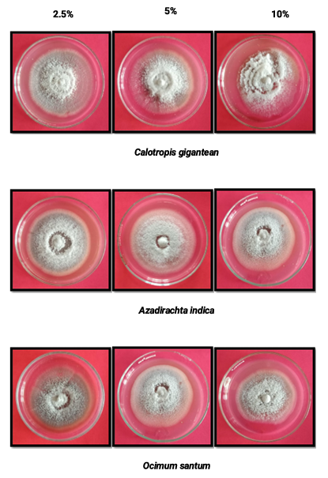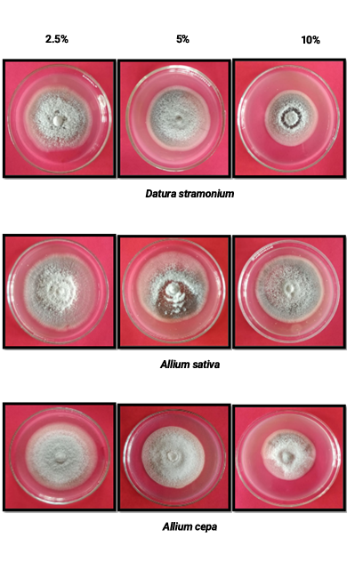

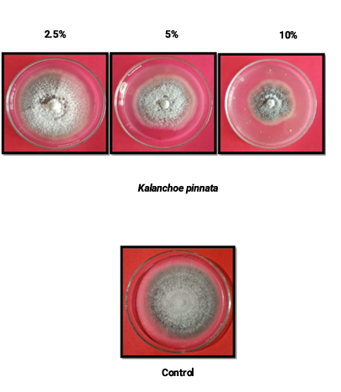
Plate.1 Mycelial growth of C. capsici due to different botanicals

Table 2. In – vitro evaluation of botanicals against C. capsici
S. No. | Botanicals |  | Concentration |  |  |  |  |  |  | Mean A
S. No. |  |  | 2.5% |  | 5% |  |  | 10% |  | Mean A
S. No. |  |  | Mycelial growth (mm) | % Inhibition | Mycelial growth (mm) | % Inhibition |  | Mycelial growth (mm) | % Inhibition | Mean A
T1 | AAK |  | 74.00 | 1.77 | 70.67 | 6.20 |  | 67.67 | 10.18 | 6.05
T2 | NEEM |  | 71.33 | 5.30 | 65.33 | 13.27 |  | 59.67 | 20.79 | 13.12
T3 | TULSI |  | 70.67 | 6.19 | 64.83 | 13.94 |  | 62.83 | 16.59 | 12.24
T4 | DATURA |  | 63.50 | 15.70 | 52.67 | 30.09 |  | 47.33 | 37.17 | 27.65
T5 | ONION |  | 74.67 | 0.89 | 71.00 | 5.75 |  | 67.33 | 10.62 | 5.75
T6 | GARLIC |  | 70.00 | 7.07 | 65.00 | 13.71 |  | 58.33 | 22.57 | 14.45
T7 | BRYOPHYLLUM |  | 70.33 | 6.63 | 64.00 | 15.04 |  | 52.17 | 30.75 | 17.47
T8 | Control |  | 76.00 | 0.00 | 75.00 | 0.00 |  | 75.00 | 0.00 | 75.33
Mean B |  |  |  | 14.86 |  | 21.67 |  |  | 28.00
Factors |  | C.D at 5% |  |  |  |  | SE(m)±
Factor (A) Fungicide |  | 1.23 |  |  |  |  | 0.43
Factor (B) Concentration |  | 0.75 |  |  |  |  | 0.26
Factors (AXB) |  | 2.14 |  |  |  |  | 0.75
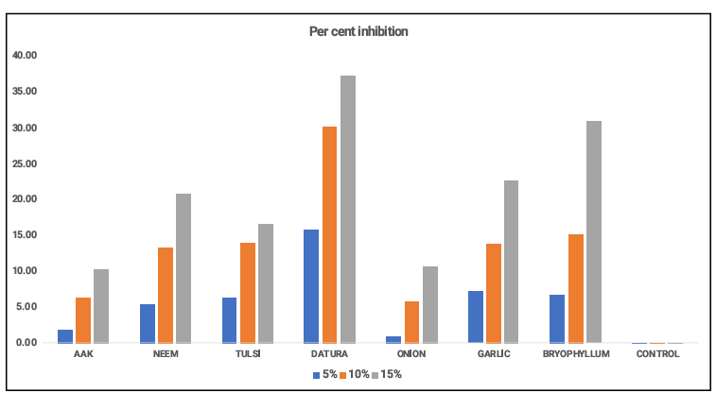
Fig. 1. In- vitro evaluation of botanicals against C. capsici

3.2. Effect of fungicides against C. capsici

Seven fungicides (single and combination) viz., Mancozeb 75% WP, Copper oxychloride 75% WP, Propiconazole 25% EC, Hexaconazole 5% SC, Carbendazim 50% WP, Tebuconazole 50% + Trifloxystrobin 25% WG and Carbendazim 12% + Mancozeb 63% WP, were evaluated at 100, 200, 500 and 1000 ppm concentrations for inhibition of mycelial growth of C. capsici using the poisoned food technique (Nene and Thapliyal, 1982). The results are depicted in Table 2 and Fig. 2.
All the fungicides significantly inhibited mycelial growth compared to the control. Among the fungicides tested, Propiconazole 25% EC was found to be significantly superior at all concentrations, exhibiting complete (100%) inhibition of mycelial growth. At 100 ppm concentration, copper oxychloride, tebuconazole 50% + trifloxystrobin 25% WG, and carbendazim 12% + mancozeb 63% WP recorded 87.17, 73.89, and 72.34 per cent inhibition of mycelial growth, respectively.
At 200 ppm concentration, copper oxychloride (88.72%), carbendazim 12% + mancozeb 63% WP (78.98%), and tebuconazole 50% + trifloxystrobin 25% WG (75.89%) showed higher inhibition. At 500 ppm concentration, copper oxychloride, carbendazim 12% + mancozeb 63% WP, and tebuconazole 50% + trifloxystrobin 25% WG exhibited complete (100%) inhibition of mycelial growth. At 1000 ppm concentration, all fungicides showed 100 per cent inhibition except Mancozeb 75% WP, which recorded 85.61 per cent inhibition.
Fungicides are crucial for reduction of growth of fungi; it is one of the quick alternates for disease management. In this study fungicides, single and combo products were evaluated under in-vitro conditions using the poisoned food technique against C. capsica at 100, 200, 500, and 1000 ppm concentrations. Propiconazole25%EC at all four concentrations was found to be performed superior than rest other fungicides with a maximum inhibition (100%) of mycelial growth. Copper oxychloride 50%WP, Tebuconazole50%+ Trifloxystrobin 25%WG and Carbendazim 12%+Mancozeb 63%WP exhibited 100% inhibition at 500 ppm concentrationwhileMancozeb75% WP exhibited the poorest result on 1000 ppm with 85.61% inhibition. In a similar manner, Propiconazole 25%ECwas revealed to be the most effective fungicide against C.capsici under in vitro condition (Gawande et al. 2006; Gopinath et al., 2006; Ahmed et al., 2014 and Hembram and Baskey (2015)).

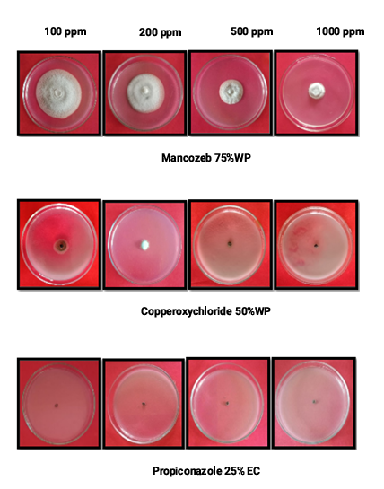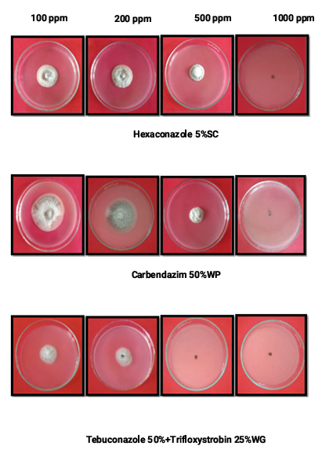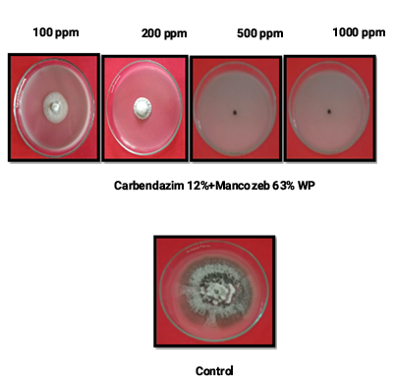
Plate.2 Mycelial growth of C. capsici due to different fungicides

Table 2. In – vitro evaluation of fungicides against C. capsici
S. No. | Fungicides | Concentration |  |  |  |  |  |  |  |  |  |  | Mean A
S. No. | Fungicides | 100 ppm |  |  | 200 ppm |  | 500 ppm |  |  | 1000 ppm |  |  | Mean A
S. No. | Fungicides | Mycelial growth (mm) |  | % Inhibition | Mycelial growth (mm) | % Inhibition | Mycelial growth (mm) |  | % Inhibition | Mycelial growth (mm) |  | % Inhibition | Mean A
T1 | Mancozeb 75% WP | 59.00 |  | 14.57 | 45.67 | 39.37 | 25.83 |  | 65.70 | 10.83 |  | 85.61 | 51.31
T2 | Copperoxychloride 75% WP | 9.67 |  | 87.17 | 8.50 | 88.72 | 0.00 |  | 100.00 | 0.00 |  | 100.00 | 93.97
T3 | Propiconazole 25% EC | 0.00 |  | 100.00 | 0.00 | 100.00 | 0.00 |  | 100.00 | 0.00 |  | 100.00 | 100
T4 | Hexaconazole 5% SC | 31.17 |  | 58.63 | 27.17 | 63.94 | 24.17 |  | 67.91 | 0.00 |  | 100.00 | 72.62
T5 | Carbendazim 50% WP | 51.00 |  | 10.44 | 33.66 | 18.44 | 22.67 |  | 69.90 | 0.00 |  | 100.00 | 49.69
T6 | Tebuconazole 50% + Trifloxystrobin 25% WG | 19.67 |  | 73.89 | 18.17 | 75.89 | 0.00 |  | 100.00 | 0.00 |  | 100.00 | 87.47
T7 | Carbendazim 12% + Mancozeb 63% WP | 20.83 |  | 72.34 | 15.83 | 78.98 | 0.00 |  | 100.00 | 0.00 |  | 100.00 | 87.82
T8 | Control | 75.33 |  | 0.00 | 75.33 | 0.00 | 75.33 |  | 0.00 | 75.33 |  | 0.00 | 0.00
Mean B |  |  |  | 52.13 |  | 58.17 |  |  | 75.44
Factors |  |  | C.D at 5% |  |  |  |  | SE(m)±
Factor (A) Fungicide |  |  | 5.63 |  |  |  |  | 1.98
Factor (B) Concentration |  |  | 3.98 |  |  |  |  | 1.40
Factors (AXB) |  |  | 11.26 |  |  |  |  | 3.97

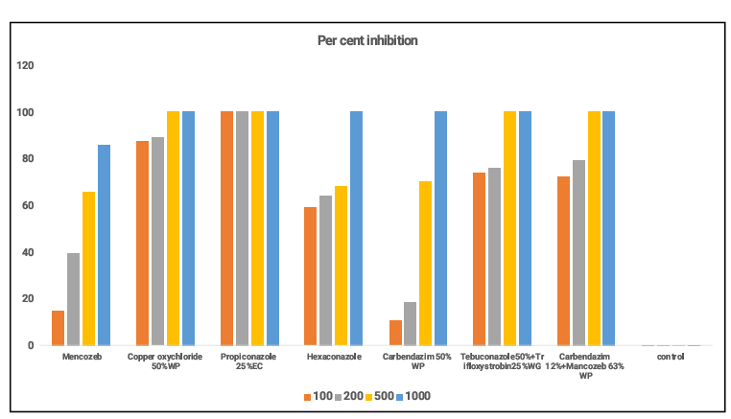
Fig. 2. In- vitro evaluation of fungicides against C. capsici

4. Conclusion
The study demonstrated that both botanicals and fungicides were effective in suppressing the mycelial growth of C. capsici under in vitro conditions. Datura leaf extract exhibited the highest antifungal activity among botanicals, showing increased inhibition with rising concentrations, while other botanicals showed moderate effects. Among fungicides, propiconazole 25% EC caused complete inhibition at all concentrations, whereas copper oxychloride and combination fungicides were also highly effective at higher doses. The results support the integration of eco-friendly botanicals with effective fungicides for sustainable management of anthracnose of betelvine.

References
Bagri, R. K., Jain, K. L., & Sharma, S. K. (2004). Evaluation of plant extracts against Colletotrichum species under in vitro conditions. Indian Phytopathology, 57, 176–179.

Chattopadhyay, C., & Maity, S. (1990). Incidence of anthracnose disease of betelvine. Plant DiseaseResearch,5,87–91.

Gawande, V. L., Giri, G. K., & Dey, U. (2006). Evaluation of fungicides against anthracnose pathogen. Indian Journal of Plant Protection, 34, 123–126.

Gopinath, K., Ramasamy, S., & Balasubramanian, P. (2006). Fungicidal management of anthracnose disease caused by Colletotrichum spp. Plant Disease Research, 21, 98–101.

Guha, P., & Jain, R. (1997). Status and prospects of betelvine cultivation in India. Agricultural Review, 18,211–219.
Gawande AD, Asalmol MN and Raut SP. 2006. Management of Colletotrichum spp. on Piper longum (L.). Annals of Plant Protection Sciences 14(2): 411-414.

Hembram, S., & Baskey, S. (2015). Evaluation of fungicides against Colletotrichum spp. causing anthracnose. Journal of Mycology and Plant Pathology, 45, 312–316.

Khandebharad, R. (1974). Physiological studies on Colletotrichum spp. Indian Phytopathology,27,142–146.

Maity, S., & Sen, B. (1982). Loss assessment due to anthracnose of betelvine. Indian JournalofPlantPathology,15,45–49.

Naik, M. K., Hiremath, R. V., & Hegde, R. K. (1988). Influence of nutritional factors on growth of Colletotrichum spp. Indian Journal of Mycology and Plant Pathology, 18, 42–46.

Singh, R., & Joshi, L. (1971). Losses due to anthracnose in betelvine. Indian Journal of Agricultural Sciences, 41, 879–883.

Vincent JM. 1947. Distortion of fungal sac hypae in the presence of certain inhibitors. Nature pp,159-850.

