Constraints Faced by Farmers Adopting Integrated Farming System under the Farmer FIRST Programme: Insights from Morena District, Madhya Pradesh, India
________________________________________________________________________

Abstract
The study was conducted in the Morena district of Madhya Pradesh to identify the major constraints faced by farmers practicing Integrated Farming System (IFS) under the Farmer FIRST Programme (FFP). A total of 60 beneficiary farmers were selected, and data were collected using a structured interview schedule. Constraints were categorized into production, marketing, financial, and management constraints, and ranked using Garrett’s Ranking Method. Results revealed that shortage of labour (mean score = 56.33) and uncertain weather conditions (mean score = 50.00) were the most critical production constraints. Among marketing constraints, high transportation costs (mean score = 59.50) and price fluctuations (mean score = 54.75) ranked highest. Increasing rate of labour wages (mean score = 64.25) and inadequate subsidies (mean score = 45.25) were the top financial constraints. In terms of management, difficulty in labour management (mean score = 59.50) and pest and disease management (mean score = 54.75) were the key barriers. The findings indicate that financial and management constraints dominate the challenges faced by IFS farmers. Policy and extension interventions, including farm mechanization, affordable credit, improved storage facilities, strengthened market linkages, and capacity building, are essential to mitigate these constraints effectively.
Keywords: Integrated Farming System, Farmer FIRST Programme, Constraints, Garrett’s Ranking Method, Morena district

Introduction
Integrated Farming System (IFS) has emerged as a holistic and resource-efficient approach to address the challenges of declining farm profitability, land fragmentation, and livelihood vulnerability among small and marginal farmers. By integrating complementary enterprises such as crops, livestock, fisheries, poultry, and horticulture, IFS aims to optimize resource use, enhance income stability, generate year-round employment, and improve food and nutritional security. Several empirical studies have demonstrated that diversified farming systems not only reduce production risks but also enhance resilience against climatic and market uncertainties.
In the Indian context, the relevance of IFS has increased significantly due to rising input costs, labour scarcity, and increasing climatic variability. Smallholders often face constraints related to labour availability, credit access, market integration, and enterprise management, which limit the effective adoption and sustainability of integrated farming practices. These constraints are not merely technological in nature but are deeply embedded within socio-economic, institutional, and policy environments. Therefore, understanding farmers’ perceived constraints is essential for designing location-specific and farmer-centric interventions.
The Farmer FIRST Programme (FFP), launched by the Indian Council of Agricultural Research (ICAR), represents a paradigm shift from conventional top-down extension approaches towards participatory, farmer-led research and extension. The programme emphasizes farmer–scientist interaction, need-based technology refinement, and capacity building through on-farm trials and demonstrations. Under FFP, IFS has been promoted as a key strategy to enhance livelihood security by strengthening farmers’ adaptive capacity and enterprise diversification. However, despite institutional support and technical interventions, the success of IFS under FFP largely depends on farmers’ ability to manage multiple enterprises efficiently and overcome operational constraints.
Evidence from earlier studies suggests that constraints related to labour management, financial resources, marketing infrastructure, and technical knowledge often act as major bottlenecks in the adoption of integrated farming systems. Labour scarcity and rising wage rates increase production costs, while inadequate access to affordable credit and subsidies restrict investment in enterprise diversification. Similarly, poor market linkages, high transportation costs, and price fluctuations adversely affect the profitability of diversified farm outputs. Management-related challenges, such as coordinating labour across enterprises and managing pests and diseases in integrated systems, further complicate farm operations.
Although several studies have examined the benefits and adoption of IFS, systematic analyses focusing on the prioritization of constraints faced by IFS farmers under the Farmer FIRST Programme at the micro-level remain limited. Morena district of Madhya Pradesh, characterized by a predominance of smallholders and active implementation of FFP-based IFS modules, provides an appropriate setting to investigate these issues. Identifying and ranking the constraints perceived by farmers using a systematic tool such as Garrett’s Ranking Method can generate actionable insights for policymakers, extension agencies, and programme implementers.
In this context, the present study was undertaken to identify and prioritize the major production, marketing, financial, and management constraints faced by farmers practicing Integrated Farming Systems under the Farmer FIRST Programme in Morena district of Madhya Pradesh.

Methodology
The present study was conducted in Morena district of Madhya Pradesh, where the Farmer FIRST Programme (FFP) has been actively implemented through the Rajmata Vijayaraje Scindia Krishi Vishwavidyalaya (RVSKVV), Zonal Agricultural Research Station (ZARS), Morena. The district was purposively selected due to the predominance of small and marginal farmers and the widespread adoption of Integrated Farming System (IFS) modules under the programme.
A total of 60 beneficiary farmers practicing Integrated Farming Systems under FFP were selected for the study using purposive sampling. These farmers had been associated with the programme for a sufficient duration to enable meaningful assessment of constraints encountered during the adoption and operation of integrated farming practices. Primary data were collected during the agricultural year through personal interviews, using a structured and pre-tested interview schedule designed specifically for the study.
Based on an extensive review of literature and preliminary discussions with extension experts and programme officials, the constraints perceived by the respondents were categorized into four major dimensions, namely: production, marketing, financial, and management constraints. Each category consisted of a set of commonly reported constraints relevant to integrated farming systems. Respondents were asked to rank the identified constraints within each category according to the severity perceived by them in their farming operations.
To prioritize the constraints, Garrett’s Ranking Method was employed, as it allows conversion of ordinal ranks into quantitative scores, facilitating meaningful comparison among constraints. The ranks assigned by individual respondents were converted into percent positions using the following formula:
Percent Position = [(Rij − 0.5) / Nj] × 100
Where,
Rij = the rank given for the i-th constraint by the j-th respondent.
Nj = the total number of constraints ranked.
The percent positions were then transformed into Garrett scores using the standard Garrett conversion table. For each constraint, the scores obtained from all respondents were summed and averaged to derive the mean Garrett score, which served as the basis for ranking the constraints in descending order of severity. Higher mean scores indicated more severe constraints as perceived by the farmers.
The analyzed data were presented using tables and graphical illustrations to facilitate clarity and interpretation. Descriptive statistical tools such as mean scores and ranks were employed to explain the relative importance of different constraints across categories.
The study followed standard ethical procedures, and informed consent was obtained from all respondents prior to data collection.

Results and Discussion
The data presented in Table 1 show the distribution of respondents according to the various constraints faced by them in the adoption and practice of Integrated Farming Systems.
Table 1. Constraints faced by farmers in practicing Integrated Farming Systems
S. No. | Constraints | Mean Score | Rank
1 | PRODUCTION CONSTRAINTS
a. | Shortage of labour | 56.33 | 1
b. | Uncertain weather conditions | 50.00 | 2
c. | Decreased yields due to incidence of pests and diseases | 43.66 | 3
2 | MARKETING CONSTRAINTS
a. | High transportation costs | 59.50 | 1
b. | Price fluctuations | 54.75 | 2
c. | Low remunerative price for the produce | 35.75 | 3
3 | FINANCIAL CONSTRAINTS
a. | Increasing rate of labour wages | 64.25 | 1
b. | Inadequate subsidies | 45.25 | 2
c. | High interest rates | 40.50 | 3
4 | MANAGEMENT CONSTRAINTS
a. | Difficulty in labour management | 59.50 | 1
b. | Difficulty in pest and disease management | 54.75 | 2
c. | Lack of knowledge on balanced use of fertilizer | 45.25 | 3
By using Garrett’s ranking method
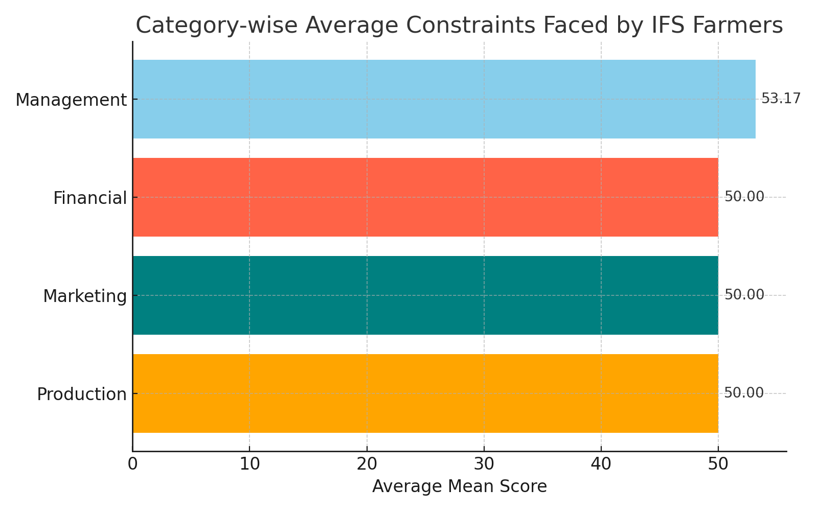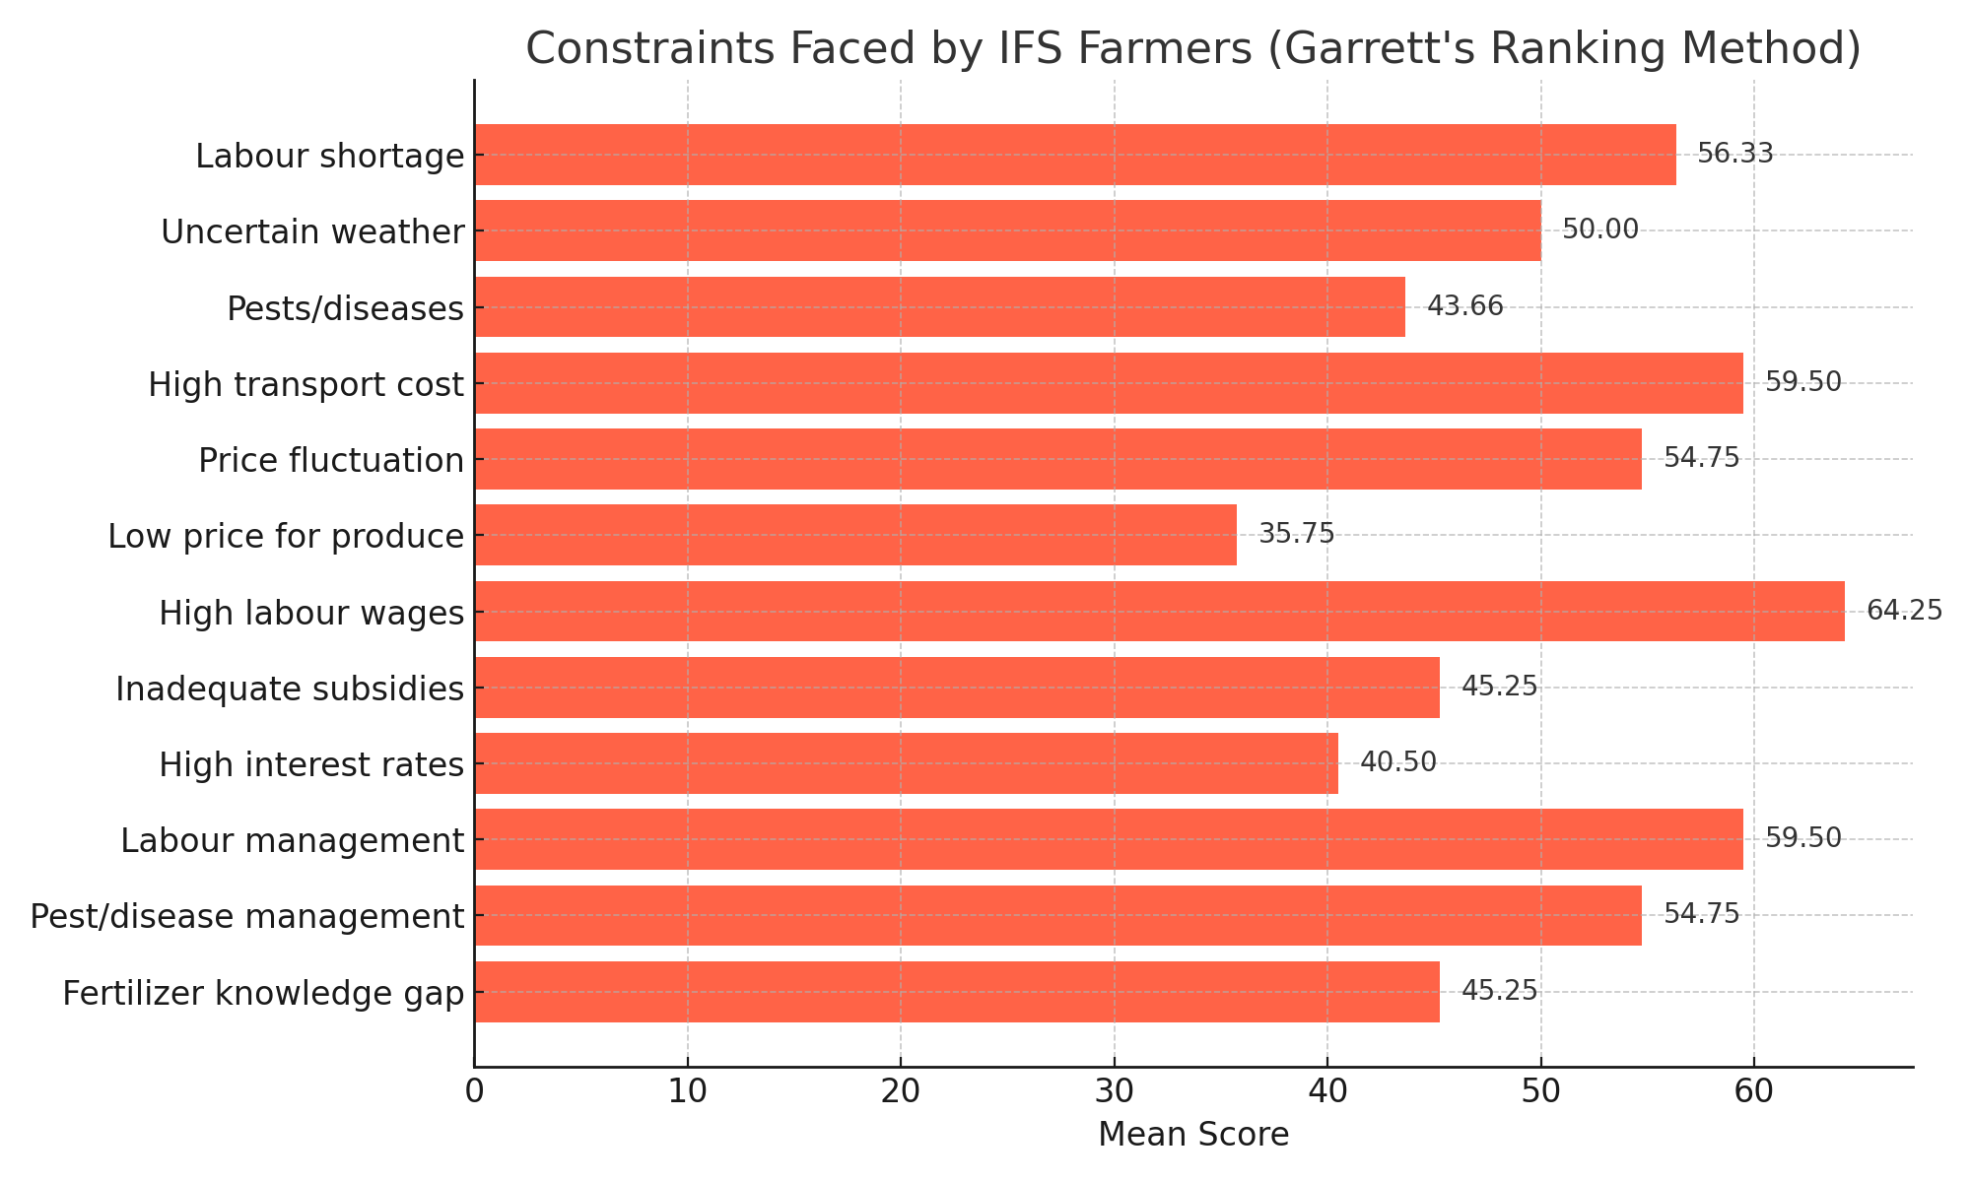
Figure 1: Top-ranked constraints by category (Production, Marketing, Financial, Management). | Figure 2: Average scores of all constraints faced by IFS farmers under FFP.
The constraints faced by Integrated Farming System (IFS) farmers under the Farmer FIRST Programme (FFP) were analyzed using Garrett’s Ranking Method, which enabled prioritization of problems based on their perceived severity. The results reflect farmers’ real-world operational difficulties across production, marketing, financial, and management dimensions.
Production constraints emerged as a major concern, with shortage of labour ranked as the most severe constraint (mean score = 56.33). This finding highlights the growing rural labour scarcity and seasonal migration in the study area. Uncertain weather conditions (mean score = 50.00) ranked second, indicating increased vulnerability of diversified farming systems to climatic variability. Incidence of pests and diseases leading to reduced yields (mean score = 43.66) further constrained effective enterprise integration. Similar labour and climate-related constraints have also been reported in integrated farming studies conducted in semi-arid regions of India.
Among marketing constraints, high transportation costs ranked first (mean score = 59.50). The dispersed nature of enterprises under IFS increases dependence on transport for marketing multiple outputs, thereby raising production costs. Price fluctuations (mean score = 54.75) ranked second, reflecting unstable market conditions and limited price assurance mechanisms. Low remunerative prices for farm produce (mean score = 35.75) were ranked third, indicating weak bargaining power of smallholders.
Financial constraints were perceived as the most severe overall. Increasing labour wages emerged as the top-ranked constraint (mean score = 64.25), reinforcing the dual challenge of labour scarcity and rising costs. Inadequate subsidies (mean score = 45.25) and high interest rates (mean score = 40.50) further limited farmers’ capacity to invest in enterprise diversification and farm inputs. These findings suggest that financial stress significantly affects the sustainability of IFS adoption.
Under management constraints, difficulty in labour management ranked first (mean score = 59.50), indicating challenges in coordinating labour across multiple enterprises. Pest and disease management (mean score = 54.75) was another critical issue, especially in integrated crop–livestock systems. Lack of knowledge on balanced fertilizer use (mean score = 45.25) ranked third, pointing to the need for continued capacity building and technical guidance.

Production Constraints
Among production-related constraints, shortage of labour emerged as the most severe constraint, followed by uncertain weather conditions. Labour scarcity reflects seasonal migration and declining availability of agricultural labour in the study area, while climatic variability increases the vulnerability of diversified farming systems. Incidence of pests and diseases leading to yield reduction further constrained effective integration of enterprises.

Marketing Constraints
In the marketing category, high transportation costs ranked first, indicating that the dispersed nature of multiple enterprises under IFS increases marketing expenses. Price fluctuations were ranked second, reflecting unstable market conditions and limited price assurance mechanisms for diversified farm outputs. Low remunerative prices ranked third, suggesting weak bargaining power of smallholders.

Financial Constraints
Financial constraints were perceived as the most severe among all categories. Increasing labour wages ranked first, reinforcing the combined impact of labour scarcity and rising production costs. Inadequate subsidies and high interest rates further restricted farmers’ capacity to invest in enterprise diversification, farm inputs, and improved technologies, thereby affecting the sustainability of IFS adoption.

Management Constraints
Under management constraints, difficulty in labour management emerged as the top-ranked issue, highlighting the complexity of coordinating labour across multiple farm enterprises. Pest and disease management was another major concern, particularly in integrated crop–livestock systems. Lack of knowledge on balanced fertilizer use ranked third, indicating the need for continued technical guidance and capacity building.
Overall, the results indicate that financial and management-related constraints were more dominant than production and marketing constraints, emphasizing that institutional, economic, and managerial support is as critical as technological interventions for the successful implementation of IFS under FFP.

Conclusion
The findings clearly indicate that farmers practicing Integrated Farming Systems under the Farmer FIRST Programme face multiple, interrelated constraints. Labour shortage, high transportation costs, rising labour wages, and labour management difficulties emerged as the most critical barriers affecting effective adoption and sustainability of IFS. Notably, financial and management-related constraints were found to be more severe than production-related issues.
To enhance the impact of IFS interventions, policy measures should prioritize farm mechanization, affordable and timely credit, adequate subsidies, and strengthening market infrastructure at the local level. Extension agencies should focus on capacity building in labour management, pest and disease control, and balanced input use, supported by regular field-level training and demonstrations. Addressing these constraints holistically will improve the livelihood security of small and marginal farmers and strengthen the long-term effectiveness of the Farmer FIRST Programme.

Policy and Extension Implications
The study highlights the need for policy support to address labour scarcity, rising production costs, and marketing inefficiencies faced by IFS farmers. Policies promoting farm mechanization, custom hiring centres, timely credit, and adequate subsidies tailored to Integrated Farming Systems can enhance adoption and sustainability. Strengthening local market infrastructure, aggregation facilities, and price information services will help reduce transportation costs and price risks.
From an extension perspective, greater emphasis should be placed on capacity building in labour management, integrated pest and disease management, and balanced input use. Regular training programmes, on-farm demonstrations, and participatory farmer–scientist interactions under the Farmer FIRST Programme can improve managerial efficiency and technical competence, thereby strengthening the overall effectiveness of IFS interventions.

Way Forward
For the long-term sustainability of IFS under the Farmer FIRST Programme, a holistic and systems-based approach is essential. Future interventions should integrate technological innovations with institutional support, market linkages, and skill development. Greater convergence among research institutions, extension agencies, financial organizations, and local governance bodies will enhance the effectiveness of IFS interventions.
Future research may focus on quantifying the economic and livelihood impacts of addressing key constraints and evaluating the effectiveness of policy and extension interventions over time. Scaling up successful IFS models through participatory approaches and continuous capacity building will strengthen farmers’ resilience and contribute to sustainable livelihood security.

Limitations of the Study
The study was limited to 60 beneficiary farmers practicing Integrated Farming Systems under the Farmer FIRST Programme in Morena district of Madhya Pradesh; hence, the findings may not be directly generalizable to other regions or non-beneficiary farmers. The analysis was based on farmers’ perceived constraints, which may be influenced by individual experiences and seasonal conditions. Moreover, the use of Garrett’s Ranking Method allows prioritization of constraints but does not measure their economic magnitude or long-term impacts.

Scope for Future Research
Future research may focus on larger and more diverse samples across different agro-climatic regions to improve the generalizability of findings. Comparative studies between beneficiary and non-beneficiary farmers can provide deeper insights into the effectiveness of the Farmer FIRST Programme. Longitudinal studies may be undertaken to examine changes in constraints over time and their impact on farm income, productivity, and livelihood security. Further research could also evaluate the economic viability of interventions aimed at mitigating key constraints in Integrated Farming Systems.

References
Behera, U.K., France, J. (2016). Integrated farming systems and the livelihood security of small and marginal farmers in India and other developing countries. Advance in Agronomy, 138: 235–282. https://doi.org/10.1016/bs.agron.2016.04.001.
Birthal, P.S., Hazrana, J. (2019). Crop diversification and resilience of agriculture to climatic shocks: Evidence from India. Agricultural Systems, 173: 345-354. https://doi.org/10.1016/j.agsy.2019.03.005
Chambers, R., & Conway, G. R. (1992). Sustainable rural livelihoods: Practical concepts for the 21st century. IDS Discussion Paper No. 296. Institute of Development Studies, Brighton.
Chand, R., Raju, S. S., & Pandey, L. M. (2011). Growth crisis in agriculture: Severity and options at national and state levels. Economic and Political Weekly, 46(26–27), 37–42.
Dixit, S., Singh, S. P., & Singh, R. (2021). Livelihood security of farmers under diversified farming systems. Indian Journal of Extension Education, 57(4), 30–36.
Dessart, F. J. (2019). Farmers’ views on EU agri-environmental policies. Contributing to the Common Agricultural Policy Impact Assessment with evidence from focus groups. Publications Office of the European Union, Luxembourg, ISBN 978-92-76-01439-3, doi:10.2760/049327
Ezeh CL, Anyiro CO, Ogbonnaya LK, Osondu CK, Obioma NQ. Impact of agricultural development programme (ADP) on rural women contact farmers' poverty levels in Aguata agricultural zone of Anambra State, Nigeria. Res Rev J Agric Allied Sci.2012;1(1):19-29.
Food and Agriculture Organization of the United Nations. (2021).The State of Food and Agriculture 2021: Making agrifood systems more resilient to shocks and stresses. Rome: FAO.
Garrett, H. E. (1981). Statistics in psychology and education. Vakils, Feffer and Simons.
Government of India. (2021). Agricultural Census 2015–16 (Phase II). Ministry of Agriculture & Farmers Welfare, New Delhi.
Hasanain, M., Fatima, A., Maurya, D. K., Verma, S. K., Singh, P. K., Singh, S., & Mishra, R. (2020). Integrated farming system for livelihood security to small and marginal farmers. Food and Scientific Reports, 36–38. ISSN 2582-5437.
ICAR (2016). Agricultural Technology Application Research Institute, ATARI, ZONE-X, HYDERABAD.
Khobragade, S., Mohapatra, S., Mahananda, M., Singh, A., Singh, A. (2021). Integrated farming system (IFS): a review. Int. J. Econ. Plants 8(3): 181–187. http://ojs.pphouse.org/index.php/IJEP/article/view/4689.
Kumar, R., Singh, V., & Meena, M. S. (2021). Constraints in adoption of integrated farming systems among small farmers: A field-based analysis. Indian Journal of Agricultural Sciences, 91(7), 1023–1028.
Meena, M. S., Mishra, J. R., & Singh, K. M. (2019). Constraints perceived by farmers in adoption of integrated farming systems. Indian Journal of Extension Education, 55(3), 15–20.
Rao, I. S., Reddy, B. S., & Reddy, A. R. (2018). Management constraints in crop–livestock based farming systems. Journal of Extension Systems, 34(2), 1–9.
Reddy, B. S., & Rao, D. (2023). Production and management constraints in integrated crop–livestock systems of semi-arid India. Journal of Extension Systems, 39(1), 15–22.
Sarkar, S., & Chatterjee, A. (2021). Challenges in integrated farming practices under changing climatic conditions. Environment and Ecology, 39(4), 1753–1759.
Sharma, D., & Chaudhary, L. (2020). Financial constraints influencing the adoption of improved agricultural technologies among smallholders. Indian Research Journal of Extension Education, 20(2), 45–50.
Singh, J., Meena, M. S., & Sharma, A. (2021). Farmer FIRST Programme: Issues, challenges and opportunities in technology dissemination. Extension Education Review, 33(1), 22–30.
Singh, R. P., Kumar, P., & Sharma, A. (2020). Adoption of integrated farming system and its impact on farm income and employment in India. Indian Journal of Agricultural Sciences, 90(10), 1895–1900.
Yadav, B., Sahu, R.K., Kumar, B., Kumar, K. and Singh, P. (2022). Assessment of IFS model in context of doubling farmers income in district Banda; A Micro Study. Econ. Aff., 67(4). https://doi.org/10.46852/0424-2513.4.2022.9.

