Original Research Article

Assessment of Spatial variation of Age wise
Body Mass Index (BMI) of Tea Plantation workers in Nilgiris, Tamilnadu, India

Abstract
Body mass index plays a crucial role in preventing diseases and promoting health. The study shows that the nutritional status among tea plantation workers significantly changes socio-economic and health promotion, based on creating the modelling of occupational health and nutritional status of tea plantation workers. This study examines the nutritional status of tea plantation workers, focusing on its significant relationship with age wise variation. The Nilgiris district, located in the northwestern corner of Tamil Nadu, Southern India, served as the study area. Data were collected from through stratified random sampling, resulting in a sample size of 300 tea plantation workers acrossallsix taluks. Z-scores, a statistical measure indicating a score's relation to the mean across variables, were utilised to analyze the data.The Z score is a statistical measurement of a score’s relationship to the mean in a group of variables. Given that body mass index (BMI) significantly affects the occupational health and socio-economic status of tea plantation workers, addressing morbidity levels prevalent in this population is imperative. The results reveal significant spatial and age-wise disparities in nutritional status. Taluks such as Gudalur and Pandalur exhibit a higher prevalence of underweight conditions, while Coonoor and Udhagamandalam show relatively optimal BMI levels. The findings indicate that socio-economic conditions, inadequate dietary intake, and occupational factors strongly influence the nutritional health of workers. This study provides valuable insights for policymakers to design targeted health and nutrition interventions for tea plantation communities.This research, employing statistical modelling, offers valuable insights for health policy decision-making regarding future tea plantation workers.
Keywords: Tea Plantation Workers, Z-score, BMI, Age wise variation

1.Introduction
Access to workplace health and safety has faced significant challenges on a global scale (Galgamuwa, 2017). Poor diet and ill health adversely impact working conditions (Shawe et al., 2023), leading to increased sickness and decreased productivity. Maintaining a healthy body and proper diet is essential to preventing common occupational health problems (Dwivedi et al., 2023;Mate 2025). Good nutrition and a healthy weight are vital for both mental and physical health (Balaji & Saravanabavan, 2020, 2021; Sudharsan et al 2019).
Alarmingly, statistics indicate over 2 million work-related deaths and approximately 300 million non-fatal occupational accidents occur each year (Joghataei et al., 2023; Rahamath Nisha & Saravanabavan, 2020). Workplace interventions that enhance nutritional education or incorporate environmental changes can positively influence employees' dietary behaviours (Dutta et al., 2023). Evidence suggests that moderate workplace physical activity and risk behaviour interventions can significantly reduce body weight (Bezzina et al., 2024). Nutritional issues among tea garden adolescents may arise from various growth-limiting factors (Kalita & Choudhury, 2024). The socio-economic and health conditions of workers are heavily influenced by their environment and morbidity rates (Saravanabavan et al., 2023, 2021, 2019; Vinothini et al.,2025,2024,2024a,2022; Mallick & Roy, 2022). Many tea garden workers face challenges such as hunger, poverty, unemployment, illiteracy, malnutrition, and serious occupational health issues (Baiano, 2020; Saravanabavan et al., 2021a).This study utilizes BMI-for-age as an essential indicator for assessing thinness or overweight among tea plantation workers (Messner et al., 2024; Ganesan and Saravanabavan, 2018;2025). The WHO recommends BMI-for-age as the optimal indicator for assessing under-nutrition (thinness) or overweight among adolescents (Byker Shanks et al.,2025;Shatsang et al 2025). However, few studies in India have focused on assessing thinness using BMI-for-age.Tea plantation workers face nutritional challenges and diseases that can impair their health (Engjaipi et al 2025). Age-related reductions in appetite, physical activity, and lean body mass can occur even without overt occupational health (Bai et al., 2023; Saravanabavan et al 2025;2025a;2025b). Nutrition is defined as the science of food and its relationship to health (Vlaicu et al., 2023; Malik et al., 2023; Radhakrishnan, & Vaithialingam,2023). Nutritional needs are heightened during various life stages, yet inadequate diets and unfavourable environments in developing countries can adversely affect growth and nutrition, particularly among adolescents(Umasankar and Saravanabavan,2024). Poor nutrition often leads to short stature and low lean body mass, resulting in numerous current and future health issues.
Despite increased food production, studies indicate that poorer sections of the population in India continue to suffer from malnutrition (Saravanabavan,1996;2011;2013). Body Mass Index (BMI) categorizes individuals as underweight, normal weight, overweight, or obese (Byker Shanks et al., 2025). It is a reliable indicator of body fatness and is commonly used to screen for weight categories that could lead to health problems. Consequently, various measurements, including sitting height, weight, and indices based on these metrics, have been extensively used to define malnutrition (Li et al., 2024). Nutritional inadequacies can lead to significant adverse effects on growth and health (Zittermann et al., 2023; Vinothini and Saravanabavan, 2022;2023). These researchers compared tea factory laborers with control subjects, finding that workers had significantly lower BMI, body fat percentage, and energy expenditure, despite exhibiting good physical fitness (Mandal et al.,2023; Vinothini et al 2025a; Eswari et al 2025;2021). The study highlighted poor socioeconomic and health status among the laborers.Understanding the nutritional status of a community is critical to comprehending its overall development process, as under-nutrition remains a significant health challenge in developing countries. This study employs statistical modelling to analyze health and nutritional determinants among tea plantation workers in the Nilgiris, offering essential insights for future policy recommendations. The primary objective is to examine the occupational health characteristics of tea plantation workers and assess their nutritional status across spatial (taluk-wise) contexts in the Nilgiris district.
2.Study Area
The Nilgiris district is located in the northwestern part of Tamil Nadu, India, covering an area of 2,549.38 sq. km. It lies between latitudes 11°8′–11°37′ N and longitudes 76°27′–77°4′ E, with an average elevation of about 6,500 feet above sea level. Tea plantations dominate land use, accounting for approximately 68.56% of cultivated land.
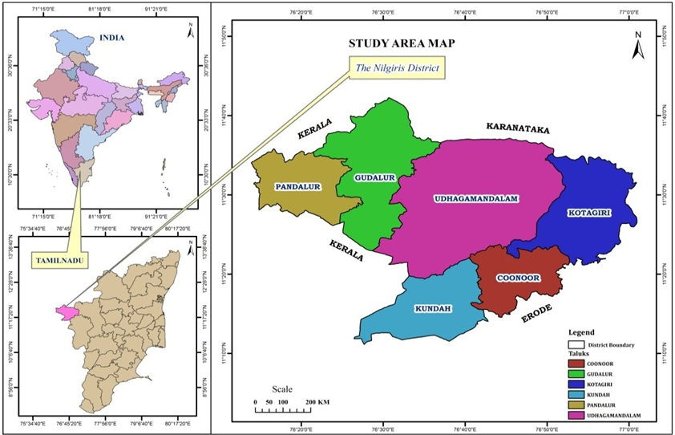
Fig 1: Location of the study Area
3.Methodology
3.1 Sources of Data
Data was obtained from both primary and secondary sources. Secondary data on health indicators was collected from inpatient and outpatient records of tea plantation hospitals in Coonoor,along with workers details from TANTEA (Tamil Nadu Tea Plantation Corporation). Primary data were gathered through a structured questionnaire survey using stratified random sampling, covering 300 workers. The field survey was conducted in 2025 to assess the health and socio–economicconditions of the respondents
3.2 Methods and Techniques
The standard score (Z-score) technique was applied to synthesize variable sets, illustrating the relationship between selected Socio-Economic and occupational health variables to tea plantation workers.A Z-score is a statistical measurement of a score's relationship to the mean in a group (Chinawa et al., 2024). It can be positive or negative, indicating whether the score is above or below the mean and by how many standard deviations.

Z= x-µ
σ
x- Row Score,
µ-Mean of the given population sample,
σ-standard deviation of the given population sample.

A cross-sectional study was conducted among tea garden workers to measure height and weight using standard procedures. BMI was computed from these measurements. To achieve the study's objectives, primary data were collected from tea plantation workers in the Nilgiris district and analysed using Z-score statistical techniques, with Excel tools applied for calculating mean and standard deviation.
BMI is calculated using the following formula:
BMI = W / $H^{2}$
Where BMI is body mass index, W is weight, and H is height.
The median serves as a crucial measure of location, indicating data distribution. Notably, extreme values do not influence the median.
Standard deviation summarizes the differences of each observation from the mean. Positive and negative differences balance to yield a sum of zero; the squares of the differences are then totaled. This sum is divided by the number of observations minus one, providing the mean of the squares, followed by taking the square root to return to the original units.

4.Results and Discussion
The results analyze the nutritional status of tea plantation workers across different age groups. The data indicate that nutritional problems, including underweight conditions, prevail in specific taluks, notably Gudalur and Pandalur. In contrast, Coonoor and Udhagamandalam show more optimal weights.
4.1 Body Mass Index Classification
BMI categorises tea plantation workers into various classifications based on age groups, specifically less than 25, 25-50, and over 50 years old. BMI is a function of weight and height, serving to determine if an individual has a healthy weight for their height.
Table 1: Body Mass Index Classification and Nutritional Status

S.No | BMI Classification | Nutritional Status
1 | Very severely underweight | < 16.0
2 | Severely underweight | 16.0 – 16.9
3 | Underweight | 17.0 – 18.4
4 | Optimal weight | 18.5 – 24.9
5 | Overweight | 25.0 – 29.9
6 | Obese class I | 30.0 – 34.4
7 | Obese class II | 35.0 – 39.9
8 | Obese class III | > 40.0
Source: WHO
The above (Table:1) explains the Body Mass Index and nutritional level recommended by the WHO.(Fig 2) The nutritional status range following is, very severely underweight < 16.0, severely underweight 16.0-16.9, underweight 25.0-29.9, optimal weight 18.24.9, overweight 25.0-29.9, obese class I 30.0-34.4, obese class II 35.0-39.9 and obese class III > 40.0.
BODY MASS INDEX CHART
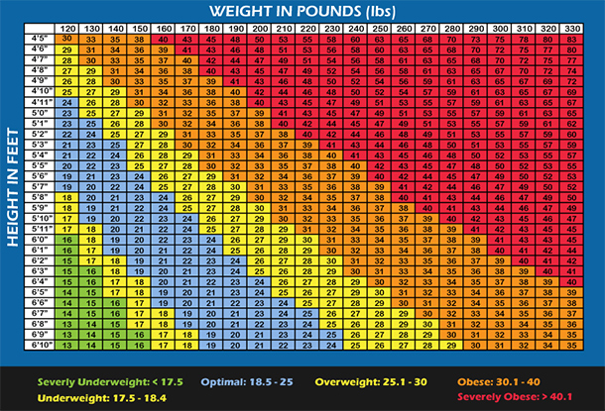

Note: The Conversion factor to keep in1 Kg= 2.20461 Ibs
Fig: 2 High and Weight BMI Chart

Table 2: Body Mass Index < 25 Age group
S. No | Name of the Taluk | Workerse | < 25 Age group | Height in  (Cm) | Weight in (Kg) | BMI
1 | Gudalur | 9 | 22 ± 1.7 | 153.8 ± 6.7 | 51.3 ± 5.9 | 18.1 ± 2.5
2 | Pandalur | 8 | 23 ±1.5 | 153.1 ± 5.4 | 50.5 ± 4.7 | 16.2 ± 2.2
3 | Coonoor | 11 | 21 ± 2.3 | 148.4 ± 5.7 | 48.9 ± 3.1 | 22.4 ± 1.8
4 | Udhagamandalam | 9 | 21 ± 2.4 | 152.2 ±7.6 | 47.4 ± 3.8 | 20.5 ± 2.0
5 | Kotagiri | 11 | 22 ±1.4 | 152.4 ± 5.6 | 44.8 ± 3.9 | 27.1 ± 2.7
6 | Kundah | 2 | 23 ± 0.7 | 153 ± 8.5 | 50 ± 2.8 | 21.6 ± 3.6
 | Total | 50 | 22 ± 1.66 | 152.15 ± 6.58 | 48.81 ± 4.03 | 21.2 ± 2.5
Methods: M=Mean and SD= standard deviation
4.2 Nutritional Status of the BMI < 25 Age Group
Nutritional status of body mass index of tea plantation workers in the Nilgiris district.(Table 2). The table represents the tea workers< 25 age group from Gudalur and UdhagamandalamThe age group of the tea plantation workers (Table2) explains the BMI body mass index level of the tea plantation workers in the Nilgiri district. Among the district of the tea plantation workers mean and standard deviation of < 25 age group of value (22 ± 1.66). The tea plantation workers low age group in the Taluk of Coonoor (21 ± 2.3) and Udhagamandalam (21 ± 2.4) mean and SD value. Moderate of in the age group tea plantation workers, twoGudalur taluk (22 ± 1.7) and Kotagiri (22 ±1.4) mean and SD value of age group and high in the age group of workers Kundah Taluk (23 ± 0.7).( Fig 4)The hight in centimetres of the workers mean and standard deviation low in the Taluk of Coonoor (148.4 ± 5.7) and moderate of height of the Taluk of Udhagamandalam (152.2 ±7.6) and KotagirTaluk (152.4 ± 5.6) mean and standard deviation value. The height high among Gudalur taluk (153.8 ± 6.7), Pandalur (153.1 ± 5.4) and Kundah Taluk (153 ± 8.5). Among the height of the tea plantation workers in the Nilgiri district of mean and standard deviation of value (152.15 ± 6.58).
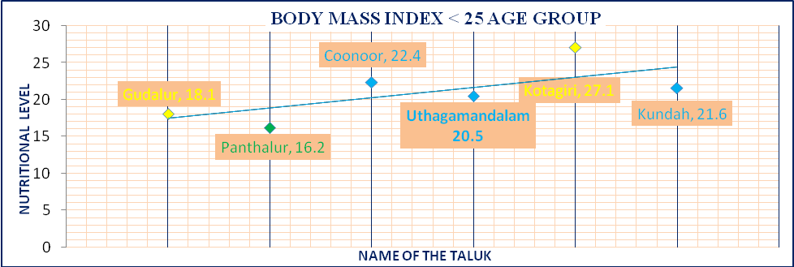
The weight in kilograms of tea plantation workers in six taluk wise is analyzed, the low level-weight of workers are in the Taluk of Kotagiri (44.8 ± 3.9) mean and standard deviation value and moderately indicate the Taluk of Udhagamandalam (47.4 ± 3.8) and Coonoortaluk value of (48.9 ± 3.1). In the age group of < 25, there is a high weight of workers among Gudalur taluk (51.3 ± 5.9), Pandalur (50.5 ± 4.7) and Kundah Taluk (50 ± 2.8). The average weight of the tea plantation workers among the Nilgiri

Fig 3 Body Mass Index (25-50) Age group

district the mean and standard deviation of value (48.81 ± 4.03)(Fig 3)

Poor nutrition among tea garden adolescents may be attributed to the availability of various growth-limiting factors. Tea garden adolescents have to take on various household responsibilities since both parents are generally engaged as manual workers in the industry, which probably adversely influences their health and nutrition. Increased requirements of diet due to rapid growth during adolescence, and tribal adolescents in India consume a diet much below the recommended level.
The Fig: 2 represents the nutritional status of tea plantation workers. Show that the < 25 age group of Gudalurtaluk’s (18.1 ± 2.5) tea plantation workers are underweight. In Pandalurtaluk (16.2 ± 2.2), workers are severely underweight. Coonoor (22.4 ± 1.8), Udhagamandalam (20.5 ± 2.0) and Kundah (21.6 ± 3.6) tea workers are found in the optimal weight category. The only taluk which comes under the overweight category in Kotagiri taluk (27.1 ± 2.7). The main reasons behind the variation in nutritional status of tea workers are due to lack of nutritional intakes, food not taken in proper time, below poverty level, poor intake of nutritious food and the socio-economic status of the workers also plays an important role for the above.
In the present study, BMI has been used for age as an indicator to describe thin or overweight. Instead, BMI-for-age was recommended by WHO (1995) as the best indicator for use in adolescence to describe under-nutrition (thinness) or overweight. But, there are a few studies in India which have attempted to describe thinness using BMI-for-age as the indicator. (Sung et al, 2024)
4.3 Nutritional Status of BMI between 25-50 Age Groups
The nutritional status of tea plantation workers ranges between the 25 – 50 age group.(Table 3) The average age of workers among the district mean and standard deviation value of (38.83±7.17). The mean standard deviation of age group ranges between Gudalur (38 ± 7.2), Pandalur (39 ± 6.8), Udhagamandalam (39 ± 6.0), Coonoor (42 ± 7.0), Kotagiri (36 ± 8.0) and Kundah Taluk (39 ± 8.0).
Table 3: Body Mass Index 25 - 50 Age group
S. No | Name of the Taluk | Workers | 25-50 Age group | Height in  (Cm) | Weight in (Kg) | BMI
1 | Gudalur | 26 | 38 ± 7.2 | 159.5 ± 5.3 | 51.3 ± 4.8 | 21.5 ± 2.5
2 | Pandalur | 29 | 39 ± 6.8 | 159.6 ± 5.3 | 51.3 ± 4.8 | 17.5 ± 2.1
3 | Coonoor | 33 | 42 ± 7.0 | 158.2 ± 6.7 | 54.8 ± 4.6 | 21.9 ± 3.1
4 | Udhagamandalam | 30 | 39 ± 6.0 | 154.5 ± 5.8 | 52.3 ± 4.9 | 22.1 ± 3.1
5 | Kotagiri | 32 | 36 ± 8.0 | 157.9 ± 5.0 | 53.8 ± 5.4 | 16.5± 2.6
6 | Kundah | 30 | 39 ± 8.0 | 156.7 ± 5.9 | 53.0 ± 4.6 | 25.8 ± 2.8
 | Total | 180 | 38.83±7.17 | 157.73 ± 5.66 | 52.75 ± 4.85 | 21.5 ± 2.7
Methods: M=Mean and SD= standard deviation
The significance of age group indicates the height of the tea workers in six Taluk wise in the Nilgiris district. The average and standard deviation of value (157.73 ± 5.66). In the district, taluk level differs from the height, Gudalur (159.5 ± 5.3) and PandalurTaluk (159.6 ±5.3). The Udhagamandalam Taluk (154.5 ± 5.8), Coonoor (158.2 ± 6.7), Kotagiri (157.9 ± 5.0) and Kundah Taluk (156.7 ± 5.9)(Table 3).
The weight in Kg of tea plantation workers differs from taluk to taluk in the Nilgiris district. The mean and SD value in the district were 52.75 ± 4.85. The significant of weight among the six taluk of the Nilgiris district > 50 kg, average and standard deviation value of Gudalur (51.3 ± 4.8), Pandalur (51.3 ± 4.8), Udhagamandalam (52.3 ± 4.9), Coonoor (54.8 ± 4.6), Kotagiri (53.8 ± 5.4) and Kundah Taluk (53.0 ± 4.6). The poor nutritional status of adolescents, especially girls, has important implications in terms of physical work capacity and adverse reproductive outcomes (WHO,1995). The high rate of adverse reproductive outcomes is already an important concern in the tea garden population (Subbaet al., 2024).
Body mass index (BMI), expressed as the ratio of weight to height squared, can be a good parameter to grade chronic energy deficiency (CED) in adults (Titaley et al., 2024). Inadequacies in nutritional intake or under-nutrition can be considered a major sourceof many adverse effects on the growth and health of individuals (Dwivedi et al., 2024).

Fig 4: Body Mass Index (25-50) Age group
The above (Fig:4) shows the nutritional status of the tea plantation workers in the age group between 25-50. Gudalur (21.5 ± 2.5), Coonoor (21.9 ± 3.1) and Udhagamandalam (22.1 ± 3.1) taluks come under the optimal weight category. The only taluk recorded under the underweight category among the tea workers was Pandalur (17.5 ± 2.1). The severely underweight category is from Kotagiri (16.5± 2.6). In the overweight category comes Kundah taluk (25.8 ± 2.8). The nutritional level variation is due to poverty, unsafe behaviour andlack of nutritional food intake.
4.4 NUTRITIONAL STATUS OF BMI > 50 AGE GROUP
Table 4 explains the body mass index of the tea plantation workers in the Nilgiris district. Among the districts of the tea plantation, the workers mean and standard deviation of the > 50 age group of value was (54.66 ± 2.66). The tea plantation workers age group in the Taluk of Coonoor (52 ± 2.0) and Udhagamandalam (54 ± 3.0) mean and SD value.

Table 4: Body Mass Index > 50 Age group
S. No | Name of the Taluk | Workers | > 50  Age  group | Height in  (Cm) | Weight in  (Kg) | BMI
1 | Gudalur | 15 | 56 ± 3.0 | 153.5 ± 7.8 | 51.1 ± 3.7 | 16.9 ± 4.3
2 | Pandalur | 13 | 55 ± 3.0 | 156.5 ± 6.5 | 53.0 ± 7.2 | 17.6 ± 3.7
3 | Coonoor | 6 | 52 ± 2.0 | 156.0 ± 6.0 | 54.0 ± 3.9 | 22.3 ± 1.6
4 | Udhagamandalam | 11 | 54 ± 3.0 | 154.2 ± 5.7 | 51.2 ± 4.4 | 25.1 ± 3.0
5 | Kotagiri | 7 | 56 ± 2.0 | 154.9 ± 6.0 | 52.0 ± 3.1 | 21.9 ± 2.8
6 | Kundah | 18 | 55± 3.0 | 151.1 ± 7.3 | 52.5 ± 3.17 | 22.3 ± 3.6
 | Total | 70 | 54.66 ± 2.66 | 154.36 ± 6.55 | 52.3 ± 4.25 | 22 ± 3.2
Methods: M=Mean and SD= standard deviation
In this > 50 age group of tea plantation workers, the Talk of Gudalur(56 ± 3.0) and Kotagiri (56 ± 2.0) mean and SD value of age group and high in the age group of workers Kundah Taluk (55± 3.0). The height in centimetres of the workers mean and standard deviation in the taluk of Coonoor (156.0 ± 6.0) and moderate height of the taluk of Udhagamandalam (154.2 ± 5.7) and Kotagiri Taluk (154.9 ± 6.0) is mean and standard deviation value (Table 4). The height in cm among Gudalur taluk (153.5 ± 7.8), Pandalur (156.5 ± 6.5) and Kundah taluk (151.1 ± 7.3). Among the height of the tea plantation worker in the Nilgiris district, the mean and standard deviation of value (52.3 ± 4.25).
The weight in kilograms of tea plantation workers in six Taluk wise analyses, the low-level weight of workers in Gudalur taluk (51.1 ± 3.7) mean and standard deviation value and moderately indicate in the taluk of Udhagamandalam (51.2 ± 4.4) and Coonoortaluk value of (54.0 ± 3.9). In the age group of < 25, the high weight of the workerswas observed among the taluk of Kotagiri (52.0 ± 3.1), Pandalur (53.0 ± 7.2) and Kundah Taluk (52.5 ± 3.17). The average weight of tea plantation workersin the Nilgiri district of mean and standard deviation of value 48.81 ± 4.03.
In the result of the > 50 age group, Coonoor (17.6 ± 3.7), Kotagiri (21.9 ± 2.8), and Kundah taluk (22.3 ± 3.6) come under the optimal weight category. The tea workers at Gudalur (16.9 ± 4.3) come under the severely underweight section. Pandalurtaluk (17.6 ± 3.7) is in the underweight category. Udhagamandalam (25.1 ± 3.0) is the only taluk that comes under the overweight category. This age group is most affected in the case of nutritional level because of their age and minimal intake of nutritional food (Fig.5)

Fig 5: Body Mass Index>50 Age group
The present study analyses the nutritional status of BMI body mass index. The Nilgiri district tea plantation workers are affected by nutritional disorders in the different age groups, is shown in the taluk wise.(table 4) The three-taluk affected by nutritional defects are Pandalur, Gudalur and Kotagiri taluk. These taluk tea workers are affected by underweight. The poor nutritional status of workers, especially male and female workers, has important implications in terms of physical work capacity and adverse reproductive outcomes. The high rate of adverse reproductive outcomes has already been an important concern in the tea garden population. Interpreting indicators during the 25 - 50 age groups are a complicated issue due to nutritional changes. Despite that, the present findings of BMI generated through tea plantation workers based on the survey will be useful health and nutritional needs of tea plantation workers.
Figure 6 displays the BMI in all age groups of BMI in spatial form. The severely underweight categories in the taluk like Pandalur, Gudalur and Udhagamandala, while in the age group of 25- 50, Kotagirei are more underweight. Similarly, the>50 age group in Gudalur is reported as underweight. In the overall age group, Gudalur and Pandalur are reported as the most underweight against the taluk of Coonoor, Udhagamandalm.At the same time,
Kotagirei also reported being severely underweight following Gudalur and Pandalur. Because the socioeconomic and health variables are strongly determinedat the taluks. In this fact are identified for non-spatial information.

Fig 6 Z score variation of (+) and (-) BMI score
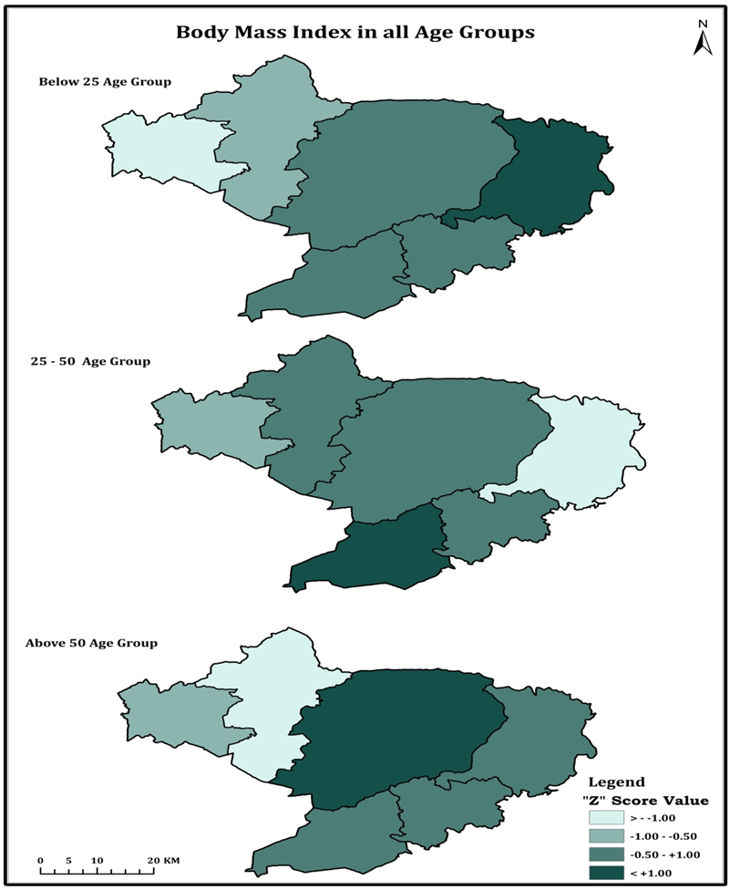
Fig. 7: Body mass Index in different age groups of Plantation workers
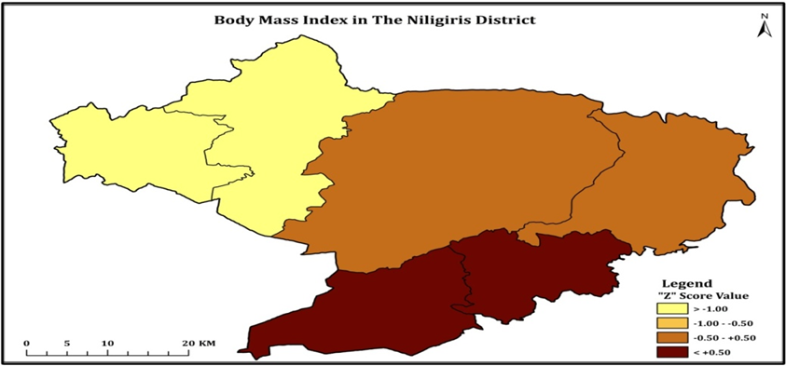
Fig. 8I BMI in all age groups in the Nilgiris district of Tea plantation workers
Similarly, the different age groups of BMI in the Nillgirs district can be standardised into Z-score values. Because of easy identification based on the classification. In this method, we can adopt different age projected in the map. The age group of less than 25 category Pandalurhas are lowest BMI Status against High in Kotagiri taluk. In the age group of 25-50, Taluk Kundah has reported a high value of BMI of more than 50. Udhagamandalam is the maximum. (Fig.7)The overall age group of the district Pandalur and Gudalurhas the lowest BMI value, against Kudha, Coonoor has the maximum in the Z value, and the remaining two taluk, like Udhagamandalm and Kotagirei are a medium BMI in the Z score value. The above information indicates that the socio-economic condition of the population and health care availability are reasonable variations of BMI in the district (Fig. 8)
5.Conclusion
The variation in the nutritional status of tea plantation workers is primarily influenced by inadequate dietary intake, poor meal timing, poverty, and limited access to nutritious food. Spatial analysis reveals that Gudalur and Pandalur taluks have a high prevalence of underweight individuals, while Coonoor maintains optimal BMI levels across all age groups. The spatial BMI indicators are proof that taluks like Gudalur Pandalur, Udhagamandalam, and Kotagiri have a low level of BMI status in the majority of the age group of workers. These factors significantly impact BMI and highlight the urgent need for targeted nutritional and healthcare interventions to improve the well-being of tea plantation workers.
Declarations

Availability of Data and Materials:
The datasets generated during and/or analyzed during the current study are available from the corresponding author on reasonable request.

Ethics
Human Ethics and Consent to Participate: “Human Ethics and Consent to Participate declarations: not applicable” to clarify that no human or animal studies were conducted in this research.

Ethics Approval

This study involved human participants and was conducted using a structured questionnaire survey only. No physical or clinical procedures were involved. Informed consent was obtained from all respondents prior to data collection, and participation was entirely voluntary. The privacy and confidentiality of the participants were strictly maintained throughout the study.

Human or Animal rights. This article does not contain any studies with human participants or animals performed by any of the authors, since only the secondary data collected at various centres are used in the study.

Clinical Trial Number “Clinical trial number: not applicable.”

Consent to Publish Declaration: “Consent to Publish declaration: not applicable.”

COMPETING INTERESTS DISCLAIMER:
Authors have declared that they have no known competing financial interests OR non-financial interests OR personal relationships that could have appeared to influence the work reported in this paper.

6. Reference

Bai, L., Huang, J., Wang, D., Zhu, D., Zhao, Q., Li, T., ... & Xu, Y. (2023). Association of body mass index with mortality of sepsis or septic shock: an updated meta-analysis. Journal of Intensive Care, 11(1), 27.
https://doi.org/10.1186/s40560-023-00677-0

Baiano, A. (2020). Edible insects: An overview on nutritional characteristics, safety, farming, production technologies, regulatory framework, and socio-economic and ethical implications. Trends in Food Science & Technology, 100, 35-50.https://doi.org/10.1016/j.tifs.2020.03.040
Balaji, D., & Saravanabavan, V. (2020). A geo medical analysis of dengue cases in Madurai city-Tamilnadu India. GeoJournal, 85(4), 979-994.
https://doi.org/10.1007/s10708-019-10006-4

Balaji, D., & Saravanabavan, V. (2021). Geo spatial variation of dengue risk zone in Madurai city using autocorrelation techniques. GeoJournal, 86(3), 1481-1501.
https://doi.org/10.1007/s10708-020-10143-1

Bezzina, A., Clarke, E. D., Ashton, L., Watson, T., & James, C. L. (2024). Workplace Health Promotion Programs Targeting Smoking, Nutrition, Physical Activity, and Obesity in Men: A Systematic Review and Meta-Analysis of Randomized Controlled Trials. Health Education & Behavior, 51(1), 113-127.DOI: 10.1177/10901981231208396

Byker Shanks, C., Bruening, M., & Yaroch, A. L. (2025). BMI or not to BMI? debating the value of body mass index as a measure of health in adults. International Journal of Behavioral Nutrition and Physical Activity, 22(1), 23.
https://doi.org/10.1186/s12966-025-01719-6

Dutta, P., Goswami, G., & Barman, H. (2023, April). Financial inclusion among backward communities: A study of the tea garden workers in Assam, India. In Forum for Social Economics (Vol. 52, No. 2, pp. 203-218). Routledge.https://doi.org/10.1080/07360932.2021.1999297

Dwivedi, S. K., Issar, K., & Tiwari, V. (2023). Nutrient Requirements in Health and Disease. In Handbook of Nutraceuticals: Science, Technology and Engineering (pp. 1-26). Cham: Springer International Publishing.https://doi.org/10.1007/978-3-030-69677-1_3-1

Dwivedi, S., Singh, V., Mahra, K., Sharma, K., Baunthiyal, M., & Shin, J. H. (2024). Functional foods in the northwestern Himalayan Region of India and their significance: a healthy dietary tradition of Uttarakhand and Himachal Pradesh. Journal of Ethnic Foods, 11(1), 20. https://doi.org/10.1186/s42779-024-00236-4

Eswari, S., Saravanabavan, V., & Balaji, D. (2021). Structural equation modelling approach to determine the mother and child health care in Madurai district, Tamil Nadu. International Journal of Scientific Research in Science and Technology, 8(2), 335-344.
Eswari, S., Saravanabavan, V., Vinothini, C., & Balaji, D. (2025). Mother And Child Health Care In Madurai District: A Structural Equation Modelling Approach. Mother And Child, 100(1), 39-54.

Engjaipi, L., Saravanabavan, V., & Vinothini, C. (2025). Gender-wise travel pattern and utilization of primary health centers of Karbi Anglong district, Assam. International Journal of Science and Research Archive, 14(03), 1320-1330.
Galgamuwa, L. S., Iddawela, D., Dharmaratne, S. D., &Galgamuwa, G. L. S. (2017). Nutritional status and correlated socio-economic factors among preschool and school children in plantation communities, Sri Lanka. BMC Public Health, 17, 1-11. DOI: 10.1186/s12889-017-4311-y
Ganesan, J., & Saravanabavan, V. (2018). Nutritional problems of anaemia disorders among the tea plantation labourers in nilgiris district–a geo medical study. International Journal of Scientific Research in Science, Engineering and Technology, 4, 1360-1366.

Hanafi, M. H., Anuar, N. S., Arayama, M., Aduayom-Ahego, A., Misnon, M. I., & Ismail, S. I. (2024). The Relationship Between Body Mass Index and Various Foot Measurements. In International Conference on Movement, Health and Exercise (pp. 99-108). Springer, Singapore. https://doi.org/10.1007/978-981-97-4186-1_9

Joghataei, A., Gholamnia, R., Khaloo, S. S., Khodakarim, S., & Saeedi, R. (2023). Burden of injury due to occupational accidents and its spatiotemporal trend at the national and subnational levels in Iran, 2011–2018. International archives of occupational and environmental health, 96(7), 1061-1076.https://doi.org/10.1007/s00420-023-01990-9

Kalita, L., & Choudhury, H. K. (2024). Exploring the impact of occupational mobility on socioeconomic status of tea garden labor community of Assam. SN Business & Economics, 4(7), 71.https://doi.org/10.1007/s43546-024-00669-8

Li, S., Fu, Z., & Zhang, W. (2024). Association of anthropometric measures with all-cause and cause-specific mortality in US adults: revisiting the obesity paradox. BMC public health, 24(1), 929. https://doi.org/10.1186/s12889-024-18418-9

Mate, T. N., Saravanabavan, V., & Vinothini, C. (2025). Consumption of Areca Nut and its Socioeconomic and Health Impacts in Shillong, Meghalaya-A Geo Annexical Analysis. International Journal of Research Publication and Reviews, 6(11), 899-909.
Majumder, R., Kurpad, A. V., Sachdev, H. S., Thomas, T., & Ghosh, S. (2024). Anthropometric growth reference for Indian children and adolescents. Indian Pediatrics, 61(5), 425-434.
https://doi.org/10.1007/s13312-024-3128-x

Mallick, A., & Roy, S. K. (2022). Living in sick tea plantations: socioeconomic and health conditions of indigenous tea garden workers and their survival strategies. In Indigenous People and Nature (pp. 217-239). Elsevier.https://doi.org/10.1016/B978-0-323-91603-5.00004-X

Malik, D., Narayanasamy, N., Pratyusha, V. A., Thakur, J., & Sinha, N. (2023). Understanding Nutrition. In Textbook of Nutritional Biochemistry (pp. 43-64). Singapore: Springer Nature Singapore.
https://doi.org/10.1007/978-981-19-4150-4_2

Mandal, D., Bhattacherjee, S., Biswas, A. K., & Samanta, S. (2023). Determinants of malnutrition among the tea garden workers of Darjeeling district in 2021: an ordinal regression analysis. International Journal Of Community Medicine And Public Health, 10(6), 2132–2137.

Messner, A., Nairz, J., Kiechl, S., Winder, B., Pechlaner, R., Geiger, R., ... &Kiechl-Kohlendorfer, U. (2024). Comparison of body mass index and fat mass index to classify body composition in adolescents—The EVA4YOU study. European Journal of Pediatrics, 183(5), 2203-2214. https://doi.org/10.1007/s00431-024-05474-x

Mondkar, S. A., Khadilkar, V., Jahagirdar, R., Kore, V., Yewale, S., Dange, N., ... & Khadilkar, A. (2024). Comparison of nutritional status of healthy under-five Indian children using composite index of anthropometric failure on WHO 2006 versus 2019 Indian synthetic growth charts. Indian Journal of Pediatrics, 91(7), 659-666.
https://doi.org/10.1007/s12098-023-04865-6

Radhakrishnan, R., & Vaithialingam, S. (2023). Exploring the suitability of groundwater for domestic water quality and irrigation purpose in Dindigul district, Tamil Nadu. In Surface and groundwater resources development and management in semi-arid region: strategies and solutions for sustainable water management (pp. 253-277). Cham: Springer International Publishing.
https://doi.org/10.1007/978-3-031-29394-8_14

RahamathNisha, R., & Saravanabavan, V. (2020). Occupational health: a special reference to lung disease in petrochemical, metal and building material industrial workers in Melur taluk Madurai district. International journal of Contemporary medical Research, 7(7), G1-G6.
doi: 10.21276/ijcmr.2020.7.7.12

Saravanabavan, V. (1996). Bicycles and health-a geo medical study of Madurai city. In Velo Australis and Velo-City'96, International Bicycle Conference, 1996, Fremantle, Western Australia.
Saravanabavan, V. (2011). GIS analysis of pedestrian problem and spatial risk areas for each buffer zone in uraban cities a case study of Madurai city in Tamlnadu, India.
Saravanabavan, V. (2013). Patients perception and travel behavior pattern in primary health care center in Haripad block-A micro Geo-medical study. Journal of Language in India, 13(4), 194-207.
Saravanabavan, V., Balaji, D., & Preethi, S. (2019). Identification of dengue risk zone: A geo-medical study on Madurai city. GeoJournal, 84, 1073-1087. https://doi.org/10.1007/s10708-018-9909-9

Saravanabavan, V., Reshma, C. U., & Preethi, S. (2021). Determinants of reproductive health in working women in Thrissur district, Kerala. GeoJournal, 86, 239-253. https://doi.org/10.1007/s10708-019-10051-z

Saravanabavan, V., Balaji, D., Reshma, C. U., Sheheersha, S. K., Sudharsan, R., Vimala Vinnarasi, J., ... & Balasubramani, K. (2021a). Urban disease ecology and its spatial variation of Chikungunya in Madurai City, Tamilnadu, India: a geo-medical study. GeoJournal, 86, 2335-2350. https://doi.org/10.1007/s10708-020-10192-6

Saravanabavan, V., Emayavaramban, V., Thangamani, V., Manonmani, I. K., Rose, R. S., Balaji, D., ... & Vinothini, C. (2023). Spatial variation of covid-19 morbidity status and identification of risk zone in Tamil Nadu (India) during first wave. GeoJournal, 88(2), 1341-1354. https://doi.org/10.1007/s10708-022-10680-x

Saravanabavan, V., Vinothini, C., Vadivel, S., Sanjeevi Prasad, S., Katturajan, K., & Balaji, D. (2025). Assessing the performance of primary health centres in Meghalaya: An automatic linear modelling. International Journal of Science and Research Archive, 16(01), 454-465.

Saravanabavan, V., Vinothini, C., Suja Rose, R. S., & Balaji, D. (2025a). A Geo-Chemical Study of Water Pollution Due to the Tanning Industry: A Case Study of Dindigul District, Tamilnadu, India. In Groundwater Resource Management Planning Strategies: A Geospatial Approach: Volume 1 (pp. 651-683). Cham: Springer Nature Switzerland.
https://doi.org/10.1007/978-3-031-88870-0_25

Saravanabavan, V., Nongspung, C., Vinothini, C., & Vadivel, S. (2025b). Healthcare Accessibility in East Khasi Hills, Meghalaya, India: Age, Gender, and Socioeconomic Barriers to Primary Health Centre Access. Asian Journal of Geographical Research, 8(3), 488-505.
https://doi.org/10.9734/ajgr/2025/v8i3313

Shatsang, R. A., Saravanabavan, V., & Vinothini, C. (2025). Health and Socio-Economic Analysis of Adolescent Drug Abuse in Ukhrul District, Manipur. International Journal of Research Publication and Reviews, 6(10), 2479-2488.

Shawel, S., Baraki, N., Alemeshet, Y., Abebe, D. S., &Egata, G. (2023). Undernutrition and associated factors among adult https://doi.org/10.1186/s12888-023-05117-9 s with mental and neurological disorders in public health hospitals, Eastern Ethiopia, 2019: a cross-sectional study. BMC psychiatry, 23(1), 617. https://doi.org/10.1186/s12888-023-05117-9

Subba, P., & Bhattacharya, M. (2024). Hyposidratalaca (Geometridae: Lepidoptera) outbreak in tea gardens: management strategies and future prospects. Journal of Plant Diseases and Protection, 131(3), 681-694. https://doi.org/10.1007/s41348-024-00898-x

Sudharsan, R., Saravanabavan, V., Devanathan, D., & Tech, M. (2019). Patient Satisfaction and Perceptions about Quality of Healthcare at a Primary Healthcare Centre of Thanjavur District, Tamil Nadu. International Journal of Research in Science and Technology, 9, 2249-0604.
Sung, M., Kumar, A., Mishra, R., Kulkarni, B., Kim, R., & Subramanian, S. V. (2024). Temporal change in prevalence of BMI categories in India: patterns across States and Union territories of India, 1999–2021. BMC Public Health, 24(1), 1322.
https://doi.org/10.1186/s12889-024-18784-4

Titaley, C., Ardianto, A. C., Zawawi, W. O. M., Asmin, E., Tahitu, R., Sara, L. S., ... & Ratu, R. N. R. (2024). Chronic Energy Deficiency Associated with Body Mass Index of Adolescent Girls. Window of Health: Jurnal Kesehatan, 31-43.https://doi.org/10.33096/woh.vi.707

Vinothini, C., & Saravanabavan, V. (2022). Spatial Distribution of Emerging Diseases in Madurai District: A Geo Medical Study. International Journal of Innovative Science and Research Technology, 7(6), 2456-2165.
Vinothini, C., & Saravanabavan, V. (2023). Determinants of health care facilities and patients’ accessibility to PHC in Madurai district. International Journal of Geography, Geology, and Environment, 5(2), 17-22.
Vinothini, C., Saravanabavan, V., &Emayavaramban, V. (2022). Location Accessibility of PHC and Health care travel performance in Madurai District. International Journal of Innovative Science and Research Technology. Volume 7, Issue 12, December – 2022 ISSN, (2456-2165)

Vinothini, C., Suja Rose, R. S., & Saravanabavan, V. (2024). Assessment of primary health care accessibility and patients’ perception in Madurai district: a geo-medical study. GeoJournal, 89(5), 211.
https://doi.org/10.1007/s10708-024-11208-1

Vinothini, C., Saravanabavan, V., & Rose, R. S. (2024a). Travel patterns of adult patients to primary health centers in Madurai district: A public health perspective. International Journal of Science and Research Archive, 13(1), 141-149.
DOI url: https://doi.org/10.30574/ijsra.2024.13.1.1605

Vinothini, C., Saravanabavan, V., & Suja Rose, R. S. (2025). Travel Behaviour Of Child Patients And Health Care Accessibility Of PHC In Madurai District, Tamilnadu. International Research Journal of Educatioin and Technology, 7(02).

Vinothini, C., Suja Rose, R.S & Saravanabavan, V. Patients’ Perception and Health care Accessibility of Primary Health care centre in Madurai District-A Geo-Medical Study. December 2025a
Annals 0f the National Association Of Geographers India 45(2):233-249
DOI:10.32381/ATNAGI.2025.45.02.8

Vlaicu, P. A., Untea, A. E., Varzaru, I., Saracila, M., & Oancea, A. G. (2023). Designing nutrition for health—Incorporating dietary by-products into poultry feeds to create functional foods with insights into health benefits, risks, bioactive compounds, food component functionality and safety regulations. Foods, 12(21), 4001.
https://doi.org/10.3390/foods12214001

Umasankar, R. V., & Saravanabavan, V. (2024). Geospatial analysis of health care resource allocation in Karur District: Insights from GIS. Shodhkosh: Journal of Visual and Performing Arts, 5(1).January 646–655.

Zittermann, A., Schmidt, A., Haardt, J., Kalotai, N., Lehmann, A., Egert, S., ... & German Nutrition Society. (2023). Protein intake and bone health: an umbrella review of systematic reviews for the evidence-based guideline of the German Nutrition Society. Osteoporosis International, 34(8), 1335-1353. https://doi.org/10.1007/s00198-023-06709-7

