Original Research Article
Free and Nanoparticle-Based Vitamin C and Curcumin Improve Renal Functions, Lipid Profile, and Kidney Histology in Adenine-Induced Chronic Kidney Disease in Male Wistar Rats
Abstract
Chronic kidney disease (CKD) is a major public health problem characterized by progressive loss of renal function, dyslipidemia, and structural damage to kidney tissue, increasing morbidity and mortality. Although vitamin C and curcumin possess established antioxidant and renoprotective properties, their clinical effectiveness is limited by poor bioavailability and stability. This study investigated effects of free and chitosan nanoparticle–based vitamin C and curcumin on renal function, lipid profile, and kidney histology in adenine-induced chronic kidney disease male Wistar rats. Chitosan nanoparticles were prepared using the ionic gelation method. Forty rats were randomly assigned into eight groups (n = 5): control, CKD, chitosan nanoparticle control, vitamin C, curcumin, vitamin C nanoparticle, curcumin nanoparticle, and vitamin C–curcumin nanoparticle. Chronic kidney disease was induced by oral administration of adenine (400 mg/kg/day) for 21 days, followed by 21 days of treatment. Renal function parameters, lipid profile indices, and renal histological features were evaluated. Adenine-induced CKD resulted in marked renal dysfunction, lipid abnormalities, and histological alterations. Treatment with nanoparticle-based antioxidants, particularly the vitamin C–curcumin nanoparticle, showed greater improvement compared to free antioxidants. These findings indicate that chitosan-based nanoparticle delivery enhances the therapeutic efficacy of vitamin C and curcumin in adenine-induced chronic kidney disease.
Key words: Chronic kidney disease; Adenine-induced nephropathy; Chitosan nanoparticles; Antioxidant therapy; Renal function; Kidney histology.
Keywords: Adenine; Chronic kidney disease; Nanoparticle; Chitosan

Introduction
Chronic kidney disease (CKD) is a major global health problem associated with increasing morbidity, mortality, and economic burden [1]. It is defined by persistent reduction in kidney structure and function lasting at least three months, leading to impaired excretory capacity, metabolic imbalance, and progressive organ damage [2]. As the disease advances, patients commonly present with albuminuria, elevated renal biomarkers, chronic inflammation, and structural alterations of kidney tissue, all of which contribute to poor clinical outcomes and reduced quality of life damage [3].
The etiology of CKD is multifactorial and includes hypertension, metabolic disorders, exposure to nephrotoxic substances, and prolonged use of certain medications or herbal preparations [4]. Sustained hypertension causes damage to renal microvasculature, resulting in arteriolar thickening, glomerular injury, and impaired glomerular filtration [5]. Beyond hemodynamic factors, oxidative stress and inflammation are central mechanisms in the initiation and progression of CKD [6]. Excessive generation of reactive oxygen species overwhelms endogenous antioxidant defenses, while persistent inflammatory responses promote renal fibrosis, tubular damage, and functional decline [7,8].
Oxidative stress and inflammation are also closely linked to dyslipidemia and cardiovascular complications, which significantly increase mortality risk in CKD patients [9]. Altered lipid metabolism accelerates vascular injury and further exacerbates renal dysfunction, creating a vicious cycle that promotes disease progression [10]. In advanced stages, CKD often necessitates long-term dialysis or kidney transplantation, interventions that are costly, complex, and frequently inaccessible in resource-limited settings, including many low- and middle-income countries.
Despite improved understanding of CKD pathophysiology, effective therapeutic strategies targeting its underlying mechanisms remain limited. Antioxidant compounds such as vitamin C and curcumin have demonstrated renoprotective, anti-inflammatory, and lipid-modulating effects in experimental studies [11]. However, their therapeutic potential is constrained by poor bioavailability, low stability, and limited tissue penetration, which reduce their overall efficacy [12].
Nanoparticle-based drug delivery systems offer a promising approach to overcoming these limitations. Chitosan nanoparticles are particularly attractive due to their biocompatibility, biodegradability, and ability to enhance drug stability and absorption [13]. By improving antioxidant delivery and retention, nanoparticle formulations may enhance therapeutic outcomes in chronic kidney disease. However, evidence regarding the comparative effects of free versus nanoparticle-based vitamin C and curcumin on renal function, lipid metabolism, and kidney histology remains limited. Therefore, this study evaluated the effects of free and chitosan nanoparticle–based vitamin C and curcumin on renal function, lipid profile, and kidney histology in adenine-induced chronic kidney disease male Wistar rats.
2.0 Materials and Methods
2.1 Study Location
The study was conducted at the Chemical Pathology Laboratory, School of Medical Laboratory Science, Centre for Advanced Medical Research and Training (CAMRET) Usmanu Danfodiyo University, Sokoto State, Nigeria, Chemical Pathology Laboratory and Histopathology Laboratory Usmanu Danfodiyo University Teaching Hospital (UDUTH) Sokoto State, Nigeria.
2.2 Chemicals and Reagents
All chemicals and reagents used were of analytical grade. Adenine (≥98% purity), chitosan (100–200 kDa), sodium tripolyphosphate (TPP), vitamin C (ascorbic acid), curcumin, and phosphate-buffered saline were purchased from Macklin Biochemical Co., Ltd., No. 550 Yindu Road, Minhang District, Shanghai 201108, China. Lipid profile reagents were obtained from Randox Laboratories Ltd., 55 Diamond Road, Crumlin, County Antrim, BT29 4QY, United Kingdom. Reagents for renal function were prepared according to standard protocols at the Chemical Pathology Laboratory, UDUTH. Absolute acetic acid was diluted to working concentration at Usmanu Danfodiyo University, Sokoto.
Ethical Approval
Ethical clearance involving experimental animal was obtained from Usmanu Danfodiyo University Health Research and Ethical Committee (UHREC), Sokoto with ethical number NHREC/UDU-HREC/25/06/2023-PGM24. All study protocol was in compliance with international practice for the care and use of Laboratory Animals.
2.2 Preparation and Characterization of Nanoparticles
Chitosan nanoparticles, vitamin C, curcumin, and their nanoparticle-based formulations were prepared using the ionic gelation method based on established protocols from previous studies [13,14,15,16]. Nanoparticles were preliminarily characterized for particle size, polydispersity index, and functional group interactions using Dynamic Light Scattering (DLS) and Fourier Transform Infrared (FTIR) spectroscopy. Detailed formulation procedures and physicochemical characterization are reported separately, as the present manuscript focuses on biological outcomes.
2.3 Research Design
This was an experimental study conducted to evaluate the effect of nanoparticle-based antioxidant supplementation on renal function, lipid profile and kidney histology in adenine-induced chronic kidney disease in male Wistar rats.

2.4 Experimental Animals
Forty (40) male Wistar rats (2–3 months old; 180-200 g) were obtained from the Animal House, University of Ibadan, Oyo State, Nigeria. Animals were acclimatized for two weeks under standard laboratory conditions (22–25 °C, 12 h light/dark cycle) and provided standard pellet feed and water ad libitum.
2.5 Sample Size Calculation
The sample size for this study was determined using the resource equation method, a standard approach in experimental animal research (NC3Rs, 2020). The total number of animals (𝑁=40) and the number of experimental groups (𝐺=8) were used to calculate the error degrees of freedom (E).
E=N – G =40 – 8 = 32
Since:
E falls within an acceptable range, the sample size is considered adequate to detect statistically significant differences among groups. The animals were randomly allocated into eight experimental groups, with five rats per group, ensuring sufficient power for biochemical and histological analyses while adhering to ethical standards for animal use.
2.6 Induction of Chronic Kidney Disease and Treatment
Chronic kidney disease was induced by oral administration of adenine at 400 mg/kg body weight daily for 21 days. Animals were subsequently treated for another 21 days according to group allocation, including vitamin C, curcumin, chitosan nanoparticles, and their nanoparticle-based formulations, either singly or in combination. The total study duration was 42 days.
2.7 Sample Collection and Analysis
Blood samples were collected by cardiac puncture, and serum was separated for renal function and lipid profile analyses. Kidneys were excised, rinsed in normal saline, and fixed in 10% neutral buffered formalin for histological examination using hematoxylin and eosin staining.
2.8 Statistical Analysis
Results were expressed as mean ± standard deviation (SD). Data were analyzed using one-way analysis of variance (ANOVA) followed by Tukey’s post-hoc test. Statistical significance was set at p ≤ 0.05.

3.0 Result
Table 1 presents renal function indices in control and adenine-induced CKD male Wistar rats. Adenine administration significantly increased serum urea (14.06 ± 0.61 mmol/L), creatinine (4.62 ± 0.14 mg/dL), and urine albumin (2.60 ± 0.24 mg/dL) compared with control values (2.53 ± 0.31 mmol/L, 0.56 ± 0.03 mg/dL; p ≤ 0.05). CKD rats also exhibited electrolyte imbalance, with elevated sodium (188.75 ± 2.49 mmol/L) and potassium (7.55 ± 0.22 mmol/L). Treatment significantly improved renal biomarkers across all groups (p ≤ 0.05). Notably, the vitamin C–curcumin nanoparticle group significantly lower urea (2.70 ± 0.31 mmol/L) and creatinine (0.62 ± 0.02 mg/dL) to levels comparable with the control.
Table 2 shows the serum lipid profile of control and adenine-induced CKD rats. CKD induction significantly increased total cholesterol (192.75 ± 2.25 mg/dL), triglycerides (219.00 ± 1.47 mg/dL), VLDL, and LDL (149.02 ± 2.08 mg/dL), while HDL was significantly reduced (0.18 ± 0.01 mg/dL) compared with control values (68.00 ± 0.57 mg/dL, 49.75 ± 3.88 mg/dL, and 1.59 ± 0.21 mg/dL, respectively; p ≤ 0.05). Treatment with free and nanoparticle-based antioxidants significantly improved lipid parameters (p ≤ 0.05). The vitamin C–curcumin nanoparticle group showed marked improvement, with triglycerides (48.25 ± 1.49 mg/dL) and HDL (1.12 ± 0.01 mg/dL) approaching control levels.

Table 1 Renal function Profile of Control and Adenine- induced Chronic Kidney Disease Male Wistar Rat
Group | Urea (mmol/L) | Creatinine (mg/dL) | Serum Albumin (mg/dL) | Urine Albumin (mg/dL) | Na⁺ (mmol/L) | K⁺ (mmol/L) | Cl⁻ (mmol/L)
Control(A) | 2.53±0.31ª | 0.56±0.03 ª | 3.30±0.10^{ab} | 0.32±0.02ª | 139.00±1.22ª | 3.27±0.09ª | 96.00±3.03ª
CKD (B) | 14.06±0.6e | 4.62±0.14^{d} | 5.21±0.12e | 2.60±0.24^{b} | 188.75±2.49^{b} | 7.55±0.22^{d} | 119.75±0.48 ^{d}
CSNP (C) | 7.50±0.14 ^{cd} | 2.06±0.04 ^{c} | 4.20±0.27 ^{d} | 0.42±0.03ª | 136.25±0.85ª | 5.15±0.09 ^{bc} | 100.25±1.44 ^{ab}
Vit C (D) | 8.83±0.12^{d} | 1.90±0.12 ^{c} | 3.77±0.09 ^{bcd} | 0.42±0.03ª | 134.00±2.44ª | 5.42±0.09^{c} | 103.50±0.29 ^{bc}
Curcumin (E) | 6.86±0.63 ^{bc} | 1.91±0.09 ^{c} | 3.55±0.05 ^{bc} | 0.35±0.03ª | 139.25±0.47ª | 5.35±0.06^{c} | 108.00±0.4^{c}
Vit C NP (F) | 5.90±0.37^{b} | 1.06±0.01^{b} | 3.92±0.13 ^{cd} | 0.37±0.03ª | 134.75±0.75ª | 4.73±0.37 ^{bc} | 107.75±1.9^{c}
CNP (G) | 4.06±0.24ª | 1.04±0.05^{b} | 3.25±0.06 ^{ab} | 0.35±0.03ª | 140.00±0.91ª | 4.35±0.06^{b} | 103.50±0.64 ^{bc}
Vit C CNP (H) | 2.70±0.31ª | 0.62±0.02 ª | 2.85±0.64 ª | 0.25±0.03ª | 140.00±2.70ª | 3.42±0.20ª | 98.00±0.41 ^{ab}
Values are expressed as mean ± SEM. Different superscripts in the same column differ significantly (p ≤ 0.05). CSNP = Chitosan nanoparticle, Vit C = Vitamin C, CNP = Curcumin nanoparticle, Vit C NP = Vitamin C nanoparticle, Vit C CNP = Vitamin C–Curcumin nanoparticle, Na⁺ = Sodium; K⁺ = Potassium, Cl⁻ = Chloride.

Table 2: Serum Lipid Profile of Control and Adenine-Induced Chronic Kidney Disease Male Wistar Rat
Group | TC (mg/dL) | TG (mg/dL) | HDL (mg/dL) | VLDL (mg/dL) | LDL (mg/dL)
Control(A) | 68.00±0.57 ^{f} | 49.75±3.88 ª | 1.59±0.21 ^{c} | 61.75±5.43 ^{ab} | 57.75±0.60 ª
CKD (B) | 192.75±2.25 e | 219.00±1.47 ^{d} | 0.18±0.01 ª | 96.75±7.61 ^{d} | 149.02±2.08 ^{f}
CSNP (C) | 108.50±0.65 ^{c} | 80.00±4.08 ^{bc} | 0.18±0.01 ª | 74.75±3.77 ^{bc} | 92.47±0.65 ^{c}
Vit C (D) | 138.50±5.62 de | 100.00±0.00 ^{c} | 0.15±0.03 ª | 47.50±2.10 ª | 118.47±5.62 e
Curcumin (E) | 128.25±2.84 ^{d} | 87.50±4.79 ^{bc} | 0.18±0.00 ª | 93.00±3.19 ^{cd} | 110.72±3.59 de
Vit C NP (F) | 86.50±2.25 ^{b} | 66.75±2.35 ^{ab} | 0.17±0.03 ª | 65.00±01.47 ^{ab} | 73.23±2.63 ^{b}
CNP (G) | 145.50 ± 1.85 e | 264.25 ± 10.55 e | 0.94 ± 0.02 ^{b} | 51.75 ± 2.95 ª | 92.35±3.04 ^{c}
Vit C CNP (H) | 110.00±3.34 ª | 48.25±1.49 ª | 1.12±0.01 ^{b} | 53.75±1.31 ª | 100.03±3.56 ^{cd}
Values are expressed as mean ± SEM. Different superscripts in the same column differ significantly (p ≤ 0.05). CKD = Chronic kidney disease, CSNP = Chitosan nanoparticle, Vit C = Vitamin C, CNP = Curcumin nanoparticle, Vit C NP = Vitamin C nanoparticle, Vit C CNP = Vitamin C–Curcumin nanoparticle, TC = Total cholesterol, TG = Triglycerides; HDL = High-density lipoprotein, LDL = Low-density lipoprotein, VLDL = Very-low-density lipoprotein.

Histological analysis of H&E-stained kidney sections revealed marked differences across groups (Figure 1). The control group showed normal renal architecture with intact glomeruli and preserved tubules. Adenine-induced CKD caused severe changes, including glomerular sclerosis, widened Bowman’s spaces, tubular atrophy, and inflammatory infiltration. Treatment with chitosan nanoparticles and single antioxidant formulations produced mild to moderate improvement. Nanoparticle-based treatments showed greater restoration of renal structure, with the combined vitamin C–curcumin nanoparticle group exhibiting near-normal histology.

*
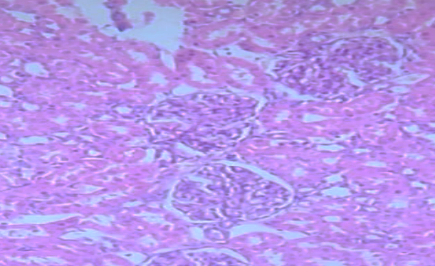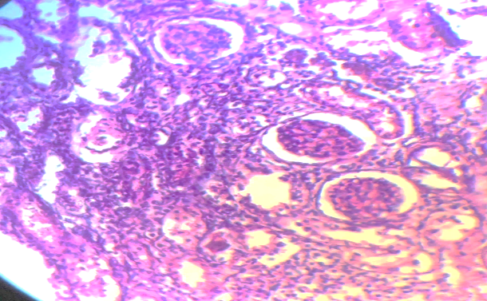
DC
SC
RCC
C
PC
SC
RC
*
C
*
B
A
DC
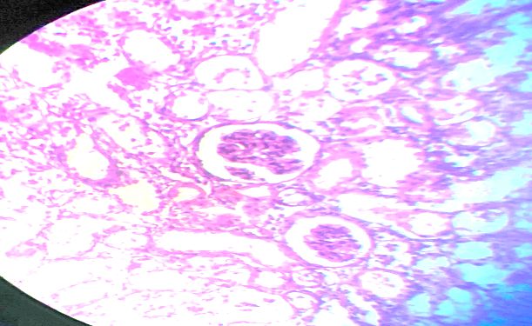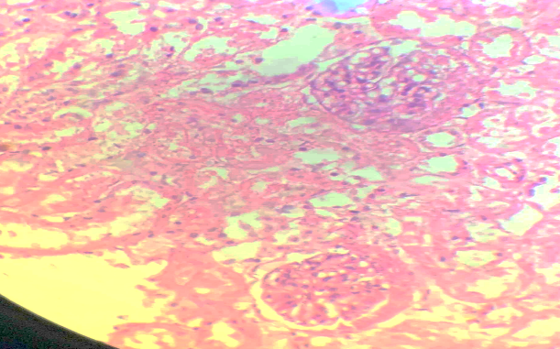
SC
RC
DC
PC
C
*
*
RC
SC
PC
DC
C
D
C
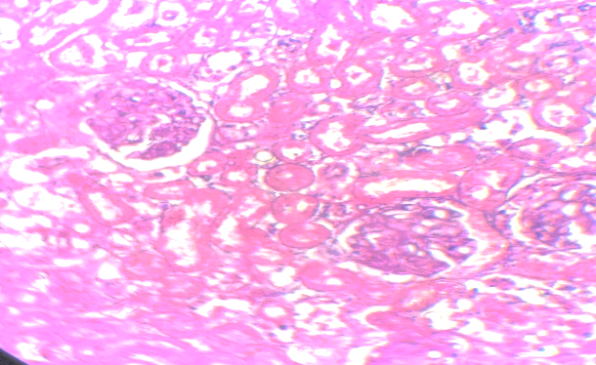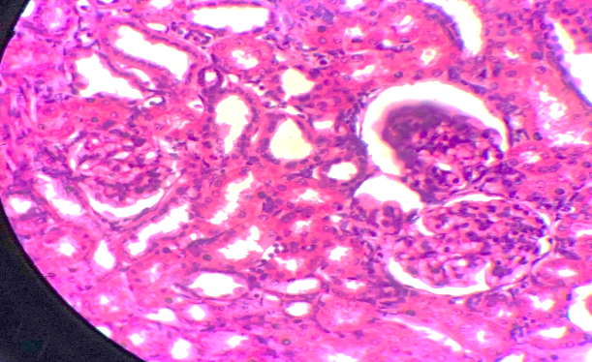
RC
SC
RC
*
C
DC
PC
*
C
SC
RC
DC
PC
F
E
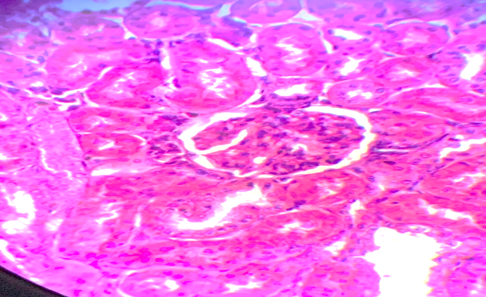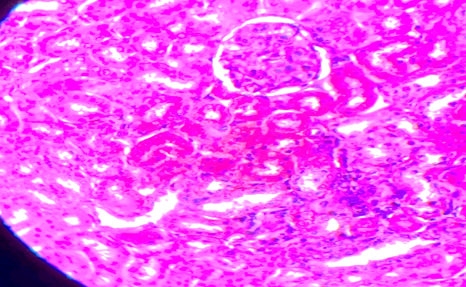
SC
*
C
PC
DC
RC
PC
*
DC
C
SC
H
G
Fig. 1: Hematoxylin and Eosin–stained kidney sections of Wistar rats.
Control (A) shows normal renal architecture with distinct renal corpuscles (RC), intact glomerular tuft capillaries (C), and a parietal layer of Bowman’s capsule lined by single squamous cells (SC) enclosing a narrow Bowman’s space (*). The proximal convoluted tubules (PCT) exhibit star-shaped lumina (PC) lined with cuboidal, deeply acidophilic cells possessing basal rounded nuclei and apical brush borders. The distal convoluted tubules (DCT) display wider lumina (DC) lined by less acidophilic cells with centrally placed nuclei and a less prominent brush border. Section (B) shows marked pathological alterations including widened Bowman’s spaces (*), glomerular sclerosis (G), tubular atrophy (arrowhead), and dense inflammatory infiltration (−−). Sections (C), (D), and (E) reveal mild to moderate histopathological changes, whereas sections (F) and (G) demonstrate improved renal architecture, with section (H) exhibiting the most pronounced restoration toward normal histological structure
4.0 Discussion
In this study, adenine administration successfully induced CKD in the male Wistar rats, as evidenced by significant alterations in renal function parameters compared with the control group. The CKD group showed significantly elevated serum urea (14.06 ± 0.61 mmol/L), creatinine (4.62 ± 0.14 mg/dL), sodium (188.75 ± 2.49 mmol/L), potassium (7.55 ± 0.22 mmol/L), chloride (119.75 ± 0.48 mmol/L), and urine albumin (2.60 ± 0.24 mg/dL) compared with the control group, which presented lower values for urea (2.53 ± 0.31 mmol/L), creatinine (0.56 ± 0.03 mg/dL), sodium (139.00 ± 1.22 mmol/L), potassium (3.27 ± 0.09 mmol/L), and urine albumin (0.32 ± 0.02 mg/dL). Serum albumin concentration was significantly higher in the CKD group (5.21 ± 0.12 g/dL) compared to the control (3.30 ± 0.10 g/dL) and treatment groups. This increase may reflect a physiological response to renal injury, possibly due to altered protein metabolism and compensatory mechanisms during early-stage CKD. These results are consistent with previous studies [17,18], which also reported elevated urea, creatinine, and urinary albumin in adenine-induced CKD compared with control and treated groups. In this study, significant electrolyte disturbances were observed, which may be attributed to differences in adenine administration methods. Adenine was administered via oral gavage rather than being incorporated into the diet (0.2% w/w, 0.7% w/w), as commonly used in previous experiments, likely resulting in a higher effective dose and more severe renal impairment. Treatment with antioxidants, particularly nanoparticle-based formulations, improved renal function parameters. The vitamin C–curcumin nanoparticle complex showed the greatest effect in restoring renal function markers, highlighting its enhanced bioavailability and synergistic therapeutic effect.
The lipid profile results showed significant elevation in total cholesterol (192.75 ± 2.25 mg/dL), triglycerides (219.00 ± 1.47 mg/dL), very low-density lipoprotein (96.75 ± 7.61 mg/dL), and low-density lipoprotein (LDL: 149.02 ± 2.08 mg/dL), accompanied by a marked reduction in high-density lipoprotein (HDL: 0.18 ± 0.01 mg/dL) in the CKD group compared to the control and treatment groups. This pattern is consistent with previous studies by Ghelani et al., 2019 and Ceja-Galicia et al., 2023, [20,21] which reported elevated lipid parameters in adenine-induced CKD models. The observed dyslipidemia suggests the impact of inflammation and oxidative stress triggered by adenine administration, which increases the risk of cardiovascular complications. Inflammatory cytokines released during CKD activate macrophages that engulf oxidized lipoproteins, perpetuating cytokine release and forming a vicious cycle that contributes to atheroma formation. Furthermore, hemodynamic alterations and renal hypertrophy stimulate hypoxia-inducible factor (HIF)-1α activation, which disrupts mitochondrial fatty acid oxidation and enhances lipid accumulation. Reactive oxygen species (ROS) generated during this process oxidize lipoproteins, impair lipoprotein lipase activity, and reduce HDL functionality, thereby aggravating lipid imbalance. The marked reduction in dyslipidemia observed in the treatment groups, particularly the vitamin C nanoparticle and vitamin C–curcumin nanoparticle formulations, suggests restored antioxidant activity. These findings indicate their enhanced capacity to mitigate oxidative stress and inflammation, thereby restoring lipid homeostasis in adenine-induced CKD.
Representative H&E-stained kidney sections are shown in Figure 1. The control group exhibited normal renal architecture with intact glomeruli and well-preserved tubular structures. In contrast, adenine-treated rats showed severe histopathological alterations, including glomerular sclerosis, widened Bowman’s space, tubular atrophy, interstitial fibrosis, and inflammatory cell infiltration, indicating advanced renal damage. Treatment with chitosan nanoparticles, vitamin C, and curcumin produced mild to moderate histological improvement. More pronounced restoration of renal architecture observed in nanoparticle-treated groups. The combined vitamin C–curcumin nanoparticle group demonstrated near-normal renal histology with minimal degenerative changes, indicating better nephroprotective effects. These findings are consistent with previous report by Diwan et al., 2013 and Elakabawy et al., 2024 [22,23] on adenine-induced renal injury and the enhanced protective efficacy of nanoparticle-based antioxidant formulations.
4.1 Conclusion
The vitamin C–curcumin chitosan nanoparticle demonstrated better physicochemical properties and more pronounced biological benefits, via decreasing urea and creatinine levels, alongside correction of dyslipidemia and improvement in histological architecture. These results indicate that nanoparticle delivery substantially enhances antioxidant bioavailability and efficacy, producing synergistic renoprotective, antioxidant, and anti-inflammatory effects in adenine-induced chronic kidney disease.
References
- Cockwell, P. and Fisher, L.A. (2020). The global burden of chronic kidney disease. The Lancet, 395, pp.662–664. https://doi.org/10.1016/S0140-6736(19)32977-0
- Mallamaci F. and Tripepi G. (2024) Risk Factors of Chronic Kidney Disease Progression: Between Old and New Concepts. Journal of Clinical Medicine, 24;13(3):678. doi: 10.3390/jcm13030678. PMID: 38337372; PMCID: PMC10856768.
- Fa, A., Ck, I. and Jo, A. (2011). Guidelines for the Detection and Management of Chronic Kidney Disease (CKD).
- Sabra, M.S., Allam, E.A.H., El-Aal, M.A., Hassan, N.H., Mostafa, A.-H.M. and Ahmed, A.A.N. (2024). A novel pharmacological strategy using nanoparticles with glutathione and virgin coconut oil to treat gentamicin-induced acute renal failure in rats. Naunyn. Schmiedebergs Arch. Pharmacology, https://doi.org/10.1007/s00210-024-03303-4
- Evans, P.D. and Taal, M.W. (2011). Epidemiology and causes of chronic kidney disease. Medicine. Baltimore, 39, 402–406.
- Ku, E., Lee, B.J., Wei, J. and Weir, M.R. (2019). Hypertension in CKD: Core Curriculum 2019. American Journal of Kidney Disease, 74, 120–131. https://doi.org/10.1053/j.ajkd.2018.12.044
- Libetta, C., Sepe, V., Esposito, P., Galli, F. and Dal Canton, A. (2011). Oxidative stress and inflammation: Implications in uremia and hemodialysis. Clinical Biochemistry, 44, 1189–1198. https://doi.org/10.1016/j.clinbiochem.2011.06.988
- Mandal, A.K. (2015). Pathogenesis and Prevention of Progression of Chronic Kidney Disease. Open Journal International Medicine 5, 58–73. https://doi.org/10.4236/ojim.2015.53010
- Ling, X.C. and Kuo, K.L., 2018. Oxidative stress in chronic kidney disease. Renal Replacement Therapy, 4(1), pp.1-9.
- Rysz, J., Gluba-Brzózka, A., Rysz-Górzyńska, M. and Franczyk, B. (2020). The Role and Function of HDL in Patients with Chronic Kidney Disease and the Risk of Cardiovascular Disease. International Journal of Molecular Science, 21, 601. https://doi.org/10.3390/ijms21020601
- Rapa, S.F., Di Iorio, B.R., Campiglia, P., Heidland, A. and Marzocco, S. (2019). Inflammation and Oxidative Stress in Chronic Kidney Disease—Potential Therapeutic Role of Minerals, Vitamins and Plant-Derived Metabolites. Internation Journal of Molecular Science, 21, 263. https://doi.org/10.3390/ijms21010263
- Mohany, M., Ahmed, M.M. and Al-Rejaie, S.S. (2022). Molecular Mechanistic Pathways Targeted by Natural Antioxidants in the Prevention and Treatment of Chronic Kidney Disease. Antioxidants, 11, 15. https://doi.org/10.3390/antiox11010015
- Alishahi, A., Mirvaghefi, A., Tehrani, M.R., Farahmand, H., Koshio, S., Dorkoosh, F.A. and Elsabee, M.Z. (2011). Chitosan nanoparticle to carry vitamin C through the gastrointestinal tract and induce the non-specific immunity system of rainbow trout (Oncorhynchus mykiss). Carbohydrate Polymorphism, 86, 142–146. https://doi.org/10.1016/j.carbpol.2011.04.028
- Padayatty, S.J., Katz, A., Wang, Y., Eck, P., Kwon, O., Lee, J.-H., Chen, S., Corpe, C., Dutta, A., Dutta, S.K. and Levine, M., (2003). Vitamin C as an Antioxidant: Evaluation of Its Role in Disease Prevention. Journal of American College of Nutrition. 22, 18–35. https://doi.org/10.1080/07315724.2003.10719272
- Duse, L., Baghdan, E., Pinnapireddy, S.R., Engelhardt, K.H., Jedelská, J., Schaefer, J., Quendt, P. and Bakowsky, U. (2018). Preparation and characterization of curcumin-loaded chitosan nanoparticles for photodynamic therapy. Physica Status Solidi A, 215, p.1700709. https://doi.org/10.1002/pssa.201700709
- Lagumdžija, D., Mehmedbašić, A.H., Jesenković, D.A., Kudić, B., Kapić, D., Ćosović, E., Lepara, O., Kelle, B.P., Prguda-Mujić, J., Kusturica, J., Pušina, N.H., Bečić, F. and Ćesić, A.K. (2024). Curcumin and its combination with a reduced dose of rosuvastatin: A promising therapy for chronic kidney disease and associated dyslipidemia in rat models. Biomolecules and Biomedicine. https://doi.org/10.17305/bb.2024.11091
- Bartani, Z., Nemati, H., Heshmati, S., Tarlan, M. and Sadeghi, M. (2025). The protective effect of curcumin nanoparticles on renal damage caused by a combination of bleomycin, etoposide, and cisplatin. BMC Nephrology. 26, 354. https://doi.org/10.1186/s12882-025-04286-x
- Zaaba, N.E., Al-Salam, S., Beegam, S., Elzaki, O., Yasin, J. and Nemmar, A. (2023). Catalpol Attenuates Oxidative Stress and Inflammation via Mechanisms Involving Sirtuin-1 Activation and NF-κB Inhibition in Experimentally-Induced Chronic Kidney Disease. Nutrients, 15, 237. https://doi.org/10.3390/nu15010237
- Aljebory, A.M. and Alsalman, T.M. (2017). Chitosan Nanoparticles: Review Article, 3.
- Ghelani, H., Razmovski-Naumovski, V., Chang, D. and Nammi, S. (2019a). Chronic treatment of curcumin improves hepatic lipid metabolism and alleviates the renal damage in adenine-induced chronic kidney disease in Sprague-Dawley rats. BMC Nephrology, 20, 431. https://doi.org/10.1186/s12882-019-1621-6
- Ceja-Galicia, Z.A., Aranda-Rivera, A.K., Amador-Martínez, I., Aparicio-Trejo, O.E., Tapia, E., Trujillo, J., Ramírez, V. and Pedraza-Chaverri, J. (2023). The Development of Dyslipidemia in Chronic Kidney Disease and Associated Cardiovascular Damage, and the Protective Effects of Curcuminoids. Foods 12, 921. https://doi.org/10.3390/foods12050921
- Diwan, V., Mistry, A., Gobe, G. and Brown, L. (2013). Adenine-induced chronic kidney and cardiovascular damage in rats. Journal of Pharmacolical. Toxicology Methods, 68, 197–207. https://doi.org/10.1016/j.vascn.2013.05.006
- Elakabawy, N., Elnegris, H., Abdelrahman, A. and Hassan, E. (2024). Histological and Immunohistochemical study on the possible ameliorative effect of propolis in experimental adenine -induced chronic kidney disease of adult male albino rats. Egypt. Journal of Histology, 0, 0–0. https://doi.org/10.21608/ejh.2024.254345.1983

