Review Article
The Digital Reset: Cultivating Digital Discipline and Inner Balance

Abstract:
The world is becoming increasingly interconnected by technology, leading to digital addiction with adverse effects (cognitive impairment, sleep disruptions, and workplace productivity) that have been amplified. Therefore, digital well-being is being emphasized, which describes a mindful, measured, and deliberate attitude toward our relationship with digital technologies. Digital well-being is not intended to pull us away from disconnections; it aims for healthy interactions that build psychological resilience, emotional regulation, and physical health. The fundamental backing of digital well-being is self-regulation. Users take preventative measures like screen-time or app-based restrictions, tech-free zones and digital detoxes. While many users want to reduce their smartphone or other digital device usage, changing behaviour is often a challenging task to achieve. While the landscape of popular digital wellness tools and apps in this space has exploded to aid in this, evidence-based research exploring their efficacy is very limited, and the onus for implementation most often falls on an individual’s ability to push through and avoid temptation from the reclamation of one’s attention that awaits us digitally. This paper provides that definition, and through it, awareness is raised of the significance of digital hygiene as a means for both personal well-being and environmental conservation.
Keywords: Digital hygiene, digital addiction, digital detox, mental health, environmental sustainability, screen time management.

1. Introduction
Technology has been influencing all aspects of life. The pervasive media is providing many benefits and challenges, which means that connectivity comes with a lot of information alongside opportunities against fears of digital addiction and its widespread impact (Twenge and Campbell, 2018; Przybylski and Weinstein, 2017). Digital devices are deeply integrated into our life influencing every aspect of life; therefore, practising digital hygiene through mindfulness practices can be really helpful to communicate better, learn, and relax. We now have technology cynicism: smartphones, computers and gadgets of all kinds hold us hostage to prolonged screen time, which is closely associated with decreased productivity, sleep issues and worse cognitive function, three major impediments to reaching our highest self. However, excessive usage can be detrimental due to negative outcomes like digital fatigue, reduced attention, disturbed sleep and social isolation. Digital wellness is a unique tool that is the intentional and conscious use of digital technology to improve the physical, emotional and psychological well-being (Beetham, 2016). Given these hurdles, the needs and practices of Digital Wellness (DW) are becoming clearer and gaining traction. More importantly, digital health is not only personal but also a global dimension. And how we make, use and discard digital technology from the growing piles of e-waste to energy-guzzling data centres, affects our environment for the worse (Belkhir and Elmeligi, 2018; Hertlein et al., 2021).
Digital Wellness connects health to the larger issue of environmental sustainability through the implementation of applications, tracking devices, and behavioural interventions that build on technology in itself, thereby enabling a balanced use of technology, paving the way towards stress reduction, an essential element for achieving a smooth work-life balance. This review examines the paradoxical terrain that digital wellness occupies, situated between promoting better habits, increasing productivity, and fostering more sustainable engagement with technology itself. The role of Digital Wellness (DW) has developed as a crucial counterpoint to various challenges posed by excessive technology use. Digital wellness describes the practice of taking advantage of the benefits that digital tools can offer while limiting the downsides they can create, like burnout, anxiety and social disconnection (Figure 1) (Kushlev and Leitao, 2020).

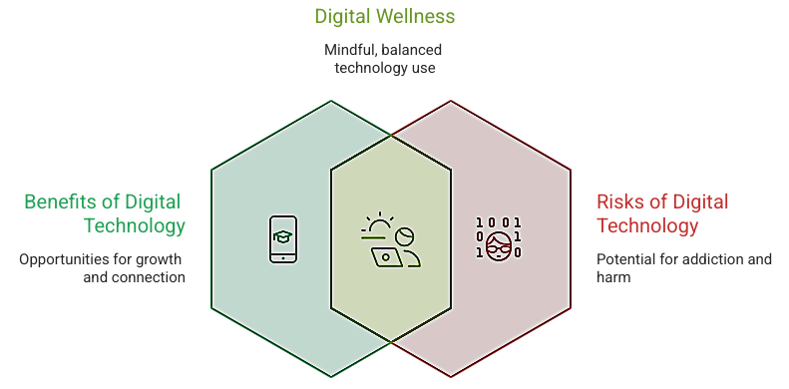

Figure 1. Balancing Digital Benefits and Risk (Kushley and Leitao, 2020)
What is Digital Wellness?
Digital wellness refers to the intentional and conscious development of self-consciousness in addition to creating appropriate uses for technology, such as limiting activities and reducing the bad side effects. With the unquenchable thirst for technology pervading almost every aspect of life, the deliberate development of self-awareness along with engaging in healthy technology practices will be core to reducing the adverse effects caused by excess digital engagement and thus embodying what it means to live well in a world filled with devices (Chaudhary & Sharma, 2022). This idea has the potential to ensure that how you use technology aligns with what you value most in your life, personally, professionally, and societally, a process that can effectively turn technology from a source of distraction into a tool for self-improvement. Digital wellness is to focus in the presence of distractions and to have control (Mark et al., 2017), facilitating deeper connections with meaningful offline events (Uhls et al., 2014), engaging in weekly physical activity, and often possessing outdoor experiences, which rejuvenate body and mind (Rosen et al., 2016), while balancing technology use with other keeping psychological chronic fatigue at bay or sustaining digital citizenship within parts of life which ends up being an ethical issue in responsibility. Regular commitment to the domain of digital well-being can lead to better mental health, higher productivity, and stronger relationships while allowing for a life that is more balanced and satisfying. Building mindful tech habits into our daily lives will better arm us against the onslaught of cognitive overload, emotional exhaustion and sedentary behaviours whilst enabling us to carve opportunities for reflection, creativity and intentional engagement in the personal and professional sphere. Accordingly, digital well-being stands as an empowering and preventative way to manoeuvre an ever-more technology-driven environment (Figure 2) (Kushlev et al., 2016a).
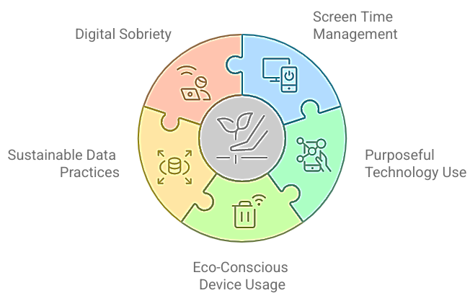

Figure 2. Key strategies for achieving digital wellness with sustainability
(Kushlev et al., 2016)

2. Methods for deliberate engagement and sustainable health
Mindful and sustainable tech practices are critical for individual health as well as planetary health. In this age of digital interaction, implementing some structured strategies can help to minimize the downsides of too much screen time while improving productivity and quality of life.
a. Managing Screen Time
Daily limitations on the use of entertainment and social media applications have been repeatedly proven to reduce digital distractions and mental fatigue and mitigate information overload (Panova & Carbonell, 2018). Digital wellbeing dashboards or screen time trackers are invaluable feedback mechanisms that help users achieve a greater degree of self-regulation when it comes to their screen usage habits. The 20-20-20 rule is an ergonomic technique to relieve digital eye strain in which a person observes something about 20 feet from the device used every 20 minutes for at least 20 seconds (Sheppard and Wolffsohn, 2018). These scientifically driven interventions are crucial in trying to balance the scales of better online and life offline, all the while promoting productivity and wellbeing.

Equally if not more important are the environmental and behavioural changes, such as creating tech-free areas inside the home and imposing digital curfews (especially in the hours before bedtime) to foster restorative sleep and encourage mental clarity (Christensen et al., 2016).
Such practices are the most impactful for kids who have shown a gradual shift from playing outside and moving their bodies to leading more sedentary lifestyles that centre around screen consumption and entertainment. This significant change has been linked to a decrease in physical activity, an increase in stress levels as well as weakening of familial bonds. This negative turn, along with the persistence of social distancing precautions, can be countered by encouraging outdoor sports, unstructured play and hobbies that require a mind-based approach to tasks; strengthening social ties in this manner will yield holistic developmental benefits across all ages (Figure 3) (Tremblay et al., 2011).

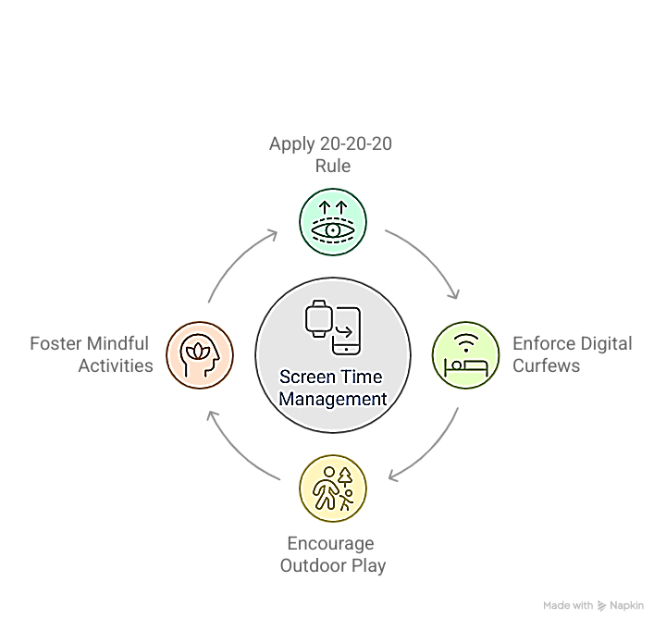

Figure 3. Cycle of Healthy Screen Time Management (Tremblay et al., 2011)
b. Purposeful Technology Use
Intentional engagement with technology emphasizes digital tools as resources for creativity, learning and relationships with a person performs; people should be interested in developing passive (2020) consumption patterns. For younger age children, various ways of introducing engaging sessions can be introduced through diversion apps for educational structures and ability builders, like MyHome-work for keeping academics organized, Seesaw for interactive learning, or nature- and tech-exploration apps that merge the two worlds of nerdy curiosity. These habits foster that calling, leadership and cognitive risk-taking while reducing the dangers of the death of genuine interaction through mindless scrolling and constant exposure to non-value-added material. Guiding users in setting concrete aims before engaging with devices, digital mindfulness is supposed to soothe context to ensure that online activity is consistent with your values, priorities, and goals for well-being (Throuvala et al., 2019). This allows individuals to audit their goals, communication vectors, and work-life dichotomies within the context of their digital behaviours (Gergen, 2009) as they purposely choose technologies that support introspection, productivity and reflection. Combined, these approaches transform technology from a distracting force into an intentional ally for personal growth and overall well-being.
c. Intentionally Using Devices in a Green Environment
Technology has a massive environmental footprint, and several ways of using it sustainably are essential (Balde et al., 2017). Using energy-efficient devices/tools and turning off unused electronic devices can help reduce energy use in this system (Belkhir & Elmeligi, 2018). In addition, the responsible recycling of end-of-life devices protects harmful substances from leaking into the environment and supports material recovery (Forti et al., 2020). More generally, industry-level initiatives such as Green IT and green nanotechnology reduce the carbon footprint of the digital age. Such techniques involve innovations such as energy-efficient servers, green materials and the design of software to reduce power consumption by data centres (Zhou et al., 2021). By integrating individual behavioural changes and system-level technological developments, we could massively reduce the environmental costs of the digital age.
d. Sustainable Data Practices
Data centres, powering the infrastructure of our digital universe and often requiring immense electricity at a high baseline level, culminating in power levels comparable to small cities (Jones 2018), have large constant data transfer rates feeding powerful cooling systems and active server life that together result in an outsized portion of this energy expenditure. People can help reduce this footprint by measures such as deleting unused files, apps and backups (Corcoran 2019). Moreover, choosing cloud service providers based on their use of renewable energy sources makes it possible to reduce carbon emissions associated with data hosting (Cook et al., 2017). This balance between individual-level digital hygiene and systemic green data practices allows society to attack one of the most energy-demanding aspects of our digital infrastructure, whilst continuing to reap the benefits well connected technology has brought. Therefore, by avoiding large file transfers and unnecessary streaming, better usage practices can be planned effectively (Aslan et al., 2018).
e. Digital Cleanness
Intentional practice of maintaining an organised and mindful digital environment can help reduce excessive screen usage, bring down digital clutter, and enable purposeful technology usage. Unregulated digital usage, long screen time, and excessive notifications can lead to reduced attention, stress and cognitive overload (Mark et al., 2018; Montag & Walla, 2016). Therefore, adopting a digital routine that regulates actions by decluttering notes, files, and limiting essential device use contributes to improvement in emotional well-being through healthier behavioural patterns (Kushlev et al., 2016a; Duke & Montag, 2017). Mindful digital practices can reduce energy demands, thereby minimising unnecessary data usage and contributing to personal well-being (Jones, 2018).
Research says that digital cleanness can be beneficial by enhancing emotional regulation and cognitive efficiency through intentional engagement with digital environments. Therefore, it is very important to reduce constant digital multitasking, which would cause mental fatigue, impair memory, and bring down productivity (Ophir et al., 2009; Rosen et al., 2013). Practices such as screen time management, disengagement and mindful content consumption from digital platforms can restore and improve cognitive function. Moreover, excessive digital usage has been linked with poor sleep quality and anxiety and depression; therefore, reducing digital engagement can help adolescents and adults with good sleep and better performance (Twenge et al., 2018; Exelmans & Van den Bulck, 2016). Therefore, digital cleanness can support mental clarity, further contributing significantly to psychological flexibility and holistic/overall well-being.

3. Public Health and Education Digital Wellness
Digital wellness has been advanced largely by the public health and education sectors by equipping young leaders with skills to harness digital environments responsibly. Therefore, integrating digital wellness programs into various educational frameworks helps students to learn self-regulation, protect mental well-being, and adopt respectful online communities (Livingstone et al., 2017; OECD, 2021). At a broader level, digital health innovations such as telemonitoring and e-health platforms have demonstrated significant potential to improve patient outcomes, accessibility, and healthcare efficiency (WHO, 2019). These also bring some concerns related to waste generation, energy consumption, and environmental footprint. There is a need to implement a “green by design” method in digital health, warranting that technological progress aligns with sustainability ideologies while preserving clinical efficacy and economic viability (Bree et al., 2000).

4. Challenges and Future Directions
Digital wellness poses several challenges that extend beyond public health, influencing education, technology, individual behaviour, and environmental sustainability. The overuse of digital gadgets arises from addictive behaviours, perpetual connectivity, shortened attention, and impaired emotional and mental well-being (Montag and Walla 2016; Rosen et al. 2013). The rapid growth of digital infrastructure leads to environmental problems (Jones, 2018), resulting in interrelated electronic waste issues that underscore the importance of an integrated strategy with behavioural alteration (Floridi et al., 2018). The overgrowth of digital infrastructure is causing many environmental problems, such as carbon emissions and high energy consumption, that produce excess electronic waste. There are no studies on the long-term effectiveness of digital wellness (Chaudhary & Sharma, 2022).

5. Conclusion
Excessive digital engagement has been associated with several detrimental effects viz., poor work performance, disturbed sleep patterns and low cognitive function, preventing people from performing at their best. Digital wellness has become an essential guideline that promotes a healthy interaction through digital gadgets without interrupting mental and physical well-being and environmental sustainability. The interconnected association between human well-being and environmental sustainability is more relevant in our present times. Whether innovations are done with the ethics of sustainability (in itself based on foundation principles) will be an important factor that will ensure the extraordinary progress in digital technology doesn't come at the cost of our planet's health and vitality. These innumerable examples, alongside an infinite number of other representations of simple yet purposeful actions, provide people with the opportunity to live healthier lives that help them find personal growth and lead to a drastically lower digital carbon footprint. The more we explore this hypothesis, the more obvious it becomes that digital wellness is a crucial step towards our personal well-being and ultimately a more eco-friendly post-carbon society. By intentionally making our online decisions in accordance with our fundamental beliefs and ethics, we become architects of a future where tech enables us to live fuller lives without sacrificing the quality of human connection while also preserving a more sustainable planet for those who come after.

References
Alter, A. (2017). Irresistible: The rise of addictive technology and the business of keeping us hooked. Penguin Press.
Aslan, J., Mayers, K., Koomey, J. G., & France, C. (2018). Electricity intensity of internet data transmission: Untangling the estimates. Journal of Industrial Ecology, 22(4), 785–798. https://doi.org/10.1111/jiec.12630
Babu, A., & Joseph, A. P. (2025). Digital wellness or digital dependency? a critical examination of mental health apps and their implications. Frontiers in Psychiatry, 16, 1581779.
Balde, C. P., Forti, V., Gray, V., Kuehr, R., & Stegmann, P. (2017). The global e-waste monitor 2017: Quantities, flows, and resources. United Nations University.
Beetham, H. (2016). Digital capability framework. Jisc. https://www.jisc.ac.uk
Belkhir, L., & Elmeligi, A. (2018). Assessing ICT global emissions footprint: Trends to 2040 & recommendations. Journal of Cleaner Production, 177, 448–463. https://doi.org/10.1016/j.jclepro.2017.12.239
Chaudhary, R., & Sharma, M. (2022). Digital wellness: Concept, components, and practices. Journal of Technology and Society, 14(2), 45–53.
Chisholm, A., & Hartman-Caverly, S. (2022). Privacy literacy: From doomscrolling to digital wellness. portal: Libraries and the Academy, 22(1), 53-79.
Christensen, M. A., Bettencourt, L., Kaye, L., Moturu, S. T., Nguyen, K. T., Olgin, J. E., ... & Marcus, G. M. (2016). Direct measurements of smartphone screen-time: Relationships with demographics and sleep. PloS One, 11(11), e0165331. https://doi.org/10.1371/journal.pone.0165331
Cook, G., Van Horn, J., & Matthews, H. S. (2017). Clicking clean: Who is winning the race to build a green internet? Greenpeace International.
Corcoran, P. (2019). Energy efficiency of cloud computing: Technologies and trends. Computer, 52(8), 28–36. https://doi.org/10.1109/MC.2019.2921234
Duke, É., & Montag, C. (2017). Smartphone addiction, daily interruptions and self-reported productivity. Addictive Behaviors Reports, 6, 90–95.

Exelmans, L., & Van den Bulck, J. (2016). Bedtime mobile phone use and sleep in adults. Social Science & Medicine, 148, 93–101.
Floridi, L. (2014). The ethics of information. Oxford University Press.
Floridi, L., Cowls, J., Beltrametti, M., Chatila, R., Chazerand, P., Dignum, V., … & Vayena, E. (2018). AI4People—An ethical framework for a good AI society: Opportunities, risks, principles, and recommendations. Minds and Machines, 28(4), 689–707.
Forti, V., Baldé, C. P., Kuehr, R., & Bel, G. (2020). The global e-waste monitor 2020: Quantities, flows and the circular economy potential. United Nations University.
Frick, N. R., Matthes, J., & Birkner, T. (2021). Digital detox: An analysis of digital abstinence in the context of environmental sustainability. Sustainability, 13(5), 2780. https://doi.org/10.3390/su13052780
Gergen, K. J. (2009). Relational being: Beyond self and community. Oxford University Press.
González, R., León, A., & Ordóñez, C. (2020). Digital mindfulness: Reducing stress and improving well-being through intentional technology use. Computers in Human Behavior Reports, 2, 100024. https://doi.org/10.1016/j.chbr.2020.100024
Greenhalgh, T., Wherton, J., Papoutsi, C., Lynch, J., & Hughes, G. (2017). Beyond adoption: A new framework for theorizing and evaluating nonadoption, abandonment, and challenges to the scale-up, spread, and sustainability of health and care technologies. Journal of Medical Internet Research, 19(11), e367. https://doi.org/10.2196/jmir.8775
Harwood, J., Dooley, J. J., Scott, A. J., & Joiner, R. (2014). Constantly connected – The effects of smart-devices on mental health. Computers in Human Behavior, 34, 267–272. https://doi.org/10.1016/j.chb.2014.02.006
Hayama, Y., & Desai, H. (2025). Digital Wellbeing. In Digital Futures in Human-Computer Interaction (pp. 224-242). CRC Press.
Hertlein, K. M., Blumer, M. L., & Smith, J. M. (2021). Digital wellness: A framework for digital media use in couples and families. Journal of Family Theory & Review, 13(4), 442–457. https://doi.org/10.1111/jftr.12427
Jones, N. (2018). How to stop data centres from gobbling up the world’s electricity. Nature, 561(7722), 163–166. https://doi.org/10.1038/d41586-018-06610-y

Jr Rogayan, D. V., & Dollete, L. F. (2025). Gearing up for the era of digital wellness: challenges and opportunities. Journal of Public Health, 47(1), e140-e141.

Kickbusch, I., Piselli, D., Agrawal, A., Balicer, R., Banner, O., Adelhardt, M., & Capobianco, E. (2021). The Lancet and Financial Times Commission on governing health futures 2030: Growing up in a digital world. The Lancet, 398(10312), 1727–1776.
Kushlev, K., & Leitao, M. R. (2020). The effects of smartphones on well-being: Theoretical integration and research agenda. Current Opinion in Psychology, 36, 72–77. https://doi.org/10.1016/j.copsyc.2020.04.001
Kushlev, K., Dwyer, R., & Dunn, E. W. (2016). The social price of constant connectivity: Smartphones impose subtle costs on well-being. Current Directions in Psychological Science, 25(6), 515–521. https://doi.org/10.1177/0963721416663193
Kushlev, K., Proulx, J., & Dunn, E. W. (2016a). Silence your phones: Smartphone notifications increase inattention and hyperactivity symptoms. Proceedings of the 2016 CHI Conference on Human Factors in Computing Systems, 1011–1020.

Livingstone, S., Mascheroni, G., & Staksrud, E. (2017). European research on children’s internet use: Assessing the past and anticipating the future. New Media & Society, 20(3), 1103–1122.
Mark, G., Gudith, D., & Klocke, U. (2017). The cost of interrupted work: More speed and stress. Proceedings of the SIGCHI Conference on Human Factors in Computing Systems, 107–110. https://doi.org/10.1145/3025453.3026021
Montag, C., & Walla, P. (2016). Carpe diem instead of losing your social mind: Beyond digital addiction and why we all suffer from digital overuse. Cogent Psychology, 3(1), 1157281.

OECD. (2021). 21st-century readers: Developing literacy skills in a digital world. Organisation for Economic Co-operation and Development.

Ophir, E., Nass, C., & Wagner, A. D. (2009). Cognitive control in media multitaskers. Proceedings of the National Academy of Sciences, 106(37), 15583–15587.
Palalas, A., & Doran, M. (2023). Digital wellness framework for online learning. Canadian Journal of Learning and Technology, 49(3), 1-25.
Panova, T., & Carbonell, X. (2018). Is smartphone addiction really an addiction? Journal of Behavioral Addictions, 7(2), 252–259. https://doi.org/10.1556/2006.7.2018.49
Péréa, C., Gérard, J., & de Benedittis, J. (2023). Digital sobriety: From awareness of the negative impacts of IT usages to degrowth technology at work. Technological Forecasting and Social Change, 194, 122670.
Przybylski, A. K., & Weinstein, N. (2017). Digital screen time limits and young children's psychological well-being: Evidence from a population-based study. Child Development, 90(1), e56–e65. https://doi.org/10.1111/cdev.13007
Ribble, M. (2015). Digital citizenship in schools: Nine elements all students should know (3rd ed.). International Society for Technology in Education.
Rosen, L. D., Carrier, L. M., & Cheever, N. A. (2016). The association of technology-related anxiety and stress with sleep, academic performance, and self-regulation. Stress and Health, 32(5), 533–541. https://doi.org/10.1002/smi.2631
Rosen, L. D., Lim, A. F., Felt, J., Carrier, L. M., Cheever, N. A., Lara-Ruiz, J. M., Mendoza, J. S., & Rokkum, J. (2013). Media and technology use predicts ill-being among children, preteens and teenagers independent of the negative health impacts of exercise and eating habits. Computers in Human Behavior, 29(3), 1243–1250.
Sheppard, A. L., & Wolffsohn, J. S. (2018). Digital eye strain: Prevalence, measurement and amelioration. BMJ Open Ophthalmology, 3(1), e000146. https://doi.org/10.1136/bmjophth-2018-000146
Specker Sullivan, L., & Reiner, P. (2021). Digital wellness and persuasive technologies. Philosophy & Technology, 34(3), 413-424.
Throuvala, M. A., Griffiths, M. D., Rennoldson, M., & Kuss, D. J. (2019). Motivational processes and dysfunctional mechanisms of social media use among adolescents: A qualitative focus group study. Computers in Human Behavior, 93, 164–175. https://doi.org/10.1016/j.chb.2018.12.012.
Tremblay, M. S., et al. (2011). Systematic review of sedentary behaviour and health indicators in school-aged children and youth. International Journal of Behavioral Nutrition and Physical Activity, 8, 98. https://doi.org/10.1186/1479-5868-8-98
Twenge, J. M., Joiner, T. E., Rogers, M. L., & Martin, G. N. (2018). Increases in depressive symptoms, suicide-related outcomes, and suicide rates among U.S. adolescents after 2010 and links to increased new media screen time. Clinical Psychological Science, 6(1), 3–17.
Uhls, Y. T., et al. (2014). Five days at outdoor education camp without screens improves preteen skills with nonverbal emotion cues. Computers in Human Behavior, 39, 387–392. https://doi.org/10.1016/j.chb.2014.05.036
van Bree, R., et al. (2020). Environmental impact of telemonitoring in chronic disease care: A comparative life-cycle assessment. Journal of Medical Internet Research, 22(11), e18575. https://doi.org/10.2196/18575
van Dijk, J. (2020). The digital divide. Polity Press.

World Health Organization (WHO). (2019). WHO guideline: Recommendations on digital interventions for health system strengthening. World Health Organization.
Zhou, Y., Chen, M., & Li, Q. (2021). Green nanotechnology: Concepts, benefits, and challenges. Journal of Cleaner Production, 278, 123805. https://doi.org/10.1016/j.jclepro.2020.123805.

