Original Research Article

Climate variability and Kharif rice yield in Namsai, Arunachal Pradesh (2018–2023): a rainfall-dominated response

.
ABSTRACT

Aims: This study quantifies climatic drivers of Kharif-season rice yield variability in Namsai district, Arunachal Pradesh.
Study design: The present study conducted using seasonally aggregated rainfall and temperature indicators with regression-based attribution and scenario modelling. .
Place and Duration of Study: This study focused on the Namsai district of Arunachal Pradesh in Northeast India, where rice constitutes the dominant staple crop and agricultural production is largely dependent on monsoon rainfall. The present study was conducted during 2018–2023 using seasonal climate data obtained from the Indian Meteorological Department (IMD) Data Service Portal.
Methodology: The climate data were aggregated across the Kharif growing season (June–October) to capture hydroclimatic conditions relevant to key rice growth stages. In the present study, we conducted bivariate association of rice yield with rainfall and with temperature, while also estimating conditional (partial) associations that net out the covariance between rainfall and temperature. Further, structural multivariate specification used to generate mean yield projections under counterfactual climate perturbations relative to a recent baseline period.
Results: Seasonal rainfall varied markedly (2455.6–4545.8 mm), while mean temperature remained relatively stable (26.8–27.8 °C). Rice yield exhibited substantial fluctuations (3.19–3.44 t ha⁻¹) that closely aligned with rainfall anomalies. Rainfall showed a moderate positive correlation with yield (r = 0.68), while temperature displayed a moderate negative association (r = −0.38). Regression results consistently identified rainfall as the dominant climate driver, with higher seasonal rainfall significantly reducing yield across bivariate, conditional, and multivariate models, whereas temperature effects were not statistically robust after controlling for rainfall. The joint climate model explained 51% of inter-annual yield variation (R² = 0.518). Scenario projections anchored to recent climate conditions indicated a baseline yield of about 3.36 t ha⁻¹, with lower expected yields under drier and warmer conditions
Conclusion: Non-invasive independent predictors for screening esophageal varices may decrease medical as well as financial burden, hence improving the management of cirrhotic patients. These predictors, however, need further work to validate reliability.

Keywords: Rainfed, climatic variability, climate risk, crop yield modelling, temperature, rainfall, yield, regression
1. INTRODUCTION

Rice (Oryza sativa L.) is one of the world’s most important staple crops, providing essential calories, protein, and nutrients to more than half of the global population. Beyond its nutritional value, rice plays a vital role in supporting rural livelihoods, generating employment, and contributing to national and global economies (Yaghoubian et al., 2012). In many developing countries, it supplies about 21% of total caloric intake and 15% of dietary protein (Zibaee, 2013). Its socio-economic significance is further reflected in its contributions to trade, cultural traditions, and household food security, leading the United Nations to designate 2004 as the “International Year of Rice.”Globally, rice is cultivated on approximately 165 million hectares, with Asia accounting for nearly 90% of total production. China and India are the leading producers, together contributing around 400 million tonnes annually, while countries such as Bangladesh, Indonesia, and the Philippines remain major importers (USDA, 2021). Between 1961 and 2022, global rice production increased by about 260%, driven largely by the Green Revolution, genetic improvements, and enhanced agricultural inputs. In India, rice is grown across multiple cropping seasons, with the rainfed kharif season (May–July) contributing nearly 65% of total production, while rabi and zaid seasons account for the remainder (Singh et al., 2017).

Global food insecurity has intensified in recent years, with the number of undernourished people increasing by nearly 150 million worldwide, including an additional 103 million between 2019 and 2020 and a further 46 million in 2021 (FAO, 2022). Correspondingly, the global prevalence of undernourishment rose from 8.0% in 2019 to 9.3% in 2020 and reached 9.8% in 2021, following a relatively stable period since 2015 (Tang et al., 2023). These trends highlight growing pressure on food systems at a time when climate-related risks to agriculture are intensifying. Climate variability is already affecting agricultural productivity, and the probability of severe yield losses is expected to increase under future climate scenarios (Pachauri & Meyer, 2014). Climate change is characterized by long-term shifts in temperature and rainfall patterns, increased inter-annual variability, and more frequent extreme weather events, all of which pose serious threats to crop production and rural livelihoods (Wassmann et al., 2010; IPCC, 2007). Since the late nineteenth century, global mean surface temperature has risen by approximately 0.85 °C, with accelerated warming observed in recent decades (IPCC AR5). Under high-emission scenarios, nearly 10% of land currently suitable for major crops may become climatically unsuitable by mid-century, creating substantial challenges for agri-food systems (IPCC AR6, 2021).

Rice, a staple food for more than half of the world’s population, is particularly sensitive to temperature increases. Empirical studies indicate that rice yields may decline by about 1–7% for every 1 °C rise in mean temperature, while projections from the International Food Policy Research Institute suggest that global rice production could decrease by 12–14% by 2050 due to climate change (Sarwar et al., 2022). At the same time, demand for rice continues to grow due to population expansion and rising incomes. United Nations projections indicate that the global population increased from approximately six to eight billion between 2000 and 2025 (United States Bureau of the Census, 1998), and global rice production was estimated to need an increase of nearly 40% by 2025 to meet food requirements following productivity slowdowns during the 1990s (Fahad et al., 2018).

Based on population and income projections, global demand for milled rice was expected to rise from about 439 Mt in 2010 to 496 Mt in 2020 and further to approximately 555 Mt by 2035, representing an overall increase of around 26% over 25 years, although the growth rate was projected to decline slightly over time (Fahad et al., 2019). Asia is expected to account for nearly two-thirds of this increase, with rice consumption projected to rise from about 388 Mt in 2010 to nearly 465 Mt by 2035, despite declining per capita consumption in countries such as China and India (IRRI, Africa Rice and CIAT, 2010). In addition, rice demand in the Americas is projected to increase by about 33%, while total consumption in Africa is expected to rise by approximately 30 Mt over the same period (IRRI, Africa Rice and CIAT, 2010).

India is a major contributor to global rice cultivation, leading the world in rice-growing area with about 42.9–43.7 million hectares, which represents nearly 27% of the global total (Singh et al., 2022; FAO India, 2024). In terms of production, India ranks second after China, producing approximately 103 million tonnes in 2011–12 and about 118.4 million tonnes during 2019–2020 (Singh et al., 2024). Rice contributes more than 40% of the country’s total food grain output, emphasizing its critical role in national food security (FAO India, 2024). However, despite the extensive cultivated area and high overall output, average productivity remains relatively modest, ranging from about 2,177 to 2,705 kg ha⁻¹ (Singh et al., 2022; Singh et al., 2024). A substantial share of production comes from the Kharif season, which depends on the summer monsoon; in 2019–2020 alone, Kharif rice accounted for nearly 102.4 million tonnes (Guha et al., 2021).

Over the past two decades, rice production in India has increased steadily from 88.5 million tonnes in 2003 to a record 135.8 million tonnes in 2022, corresponding to an average annual growth rate of about 2.16%, almost double the global average of 1.35% (Durand-Morat and Mulimbi, 2024). This growth has largely been driven by yield improvements rather than expansion of harvested area, which increased by only about 0.58% annually. Average yields improved from approximately 2.08 to 2.84 t ha⁻¹, reflecting an annual growth rate of around 1.57% (Durand-Morat and Mulimbi, 2024). Rice cultivation in India is strongly influenced by the monsoon season (June–October; Kharif), which contributes nearly 86% of total annual production, while the remaining share comes from the Rabi and Zaid seasons (Soora et al., 2013). Consequently, variability in monsoon onset, distribution, and intensity plays a decisive role in determining rice productivity. Delayed monsoon onset and pronounced intra-seasonal rainfall variability during 2009–10 resulted in an estimated reduction of about 10 million tonnes in rice production (Soora et al., 2013).

Climate change is expected to intensify these stresses, with projections indicating that rising temperatures could reduce crop productivity in India by 10–40% by the end of the century under a business-as-usual scenario (IPCC, 2007). Future projections further suggest that by 2050, nearly 15–40% of India’s rainfed rice-growing regions may experience declining climatic suitability (Singh et al., 2017). Long-term analyses indicate that since 1974, about 88% of rice-harvested areas have exhibited statistically significant yield responses to climatic variability, contributing to an estimated 0.4% decline in consumable rice-derived calories relative to historical climate conditions (Ray et al., 2019).

The North-Eastern Region (NER) of India, comprising eight states and covering approximately 26.2 lakh km² with a population of about 40 million, relies heavily on rice as its primary staple food, supporting the livelihoods of over 60% of the population (Sangeetha et al., 2020). The region is rich in traditional rice diversity and serves as an important genetic reservoir. Agriculture in the NER is predominantly rainfed, characterized by monocropping and traditional practices such as shifting cultivation. Factors including strong socio-cultural preferences, dependence on local varieties, limited use of agrochemicals, poor moisture retention in upland soils, inadequate irrigation infrastructure, and hilly, erosion-prone terrain contribute to low productivity and cropping intensity (Choudhury et al., 2022). Climatic variability in the NER has intensified in recent decades, with mean annual temperatures increasing by approximately 1°C per decade (Dash et al., 2012). In 2013, the region experienced severe rainfall deficits, with states such as Arunachal Pradesh, Assam, Nagaland Mizoram, Tripura, and Meghalaya recording 36–61% below-normal precipitation, while Sohra reported a 33% deficit. These climatic stresses, combined with limited adaptive capacity and constrained management practices, heighten vulnerability and pose significant risks to regional food security (Arshad et al., 2016).

Although climate change is a natural phenomenon, its pace has intensified markedly due to human activities (Bharali and Khan, 2011). In India, the north-eastern region is particularly vulnerable because of its fragile geo-ecological setting, transboundary river systems, and socio-economic constraints (Maiti et al., 2017). The Eastern Himalayas are especially sensitive to climatic variations, with high-altitude ecosystems recognized as among the most climate-vulnerable regions globally, outside the polar areas (ICIMOD, 2010; Xu et al., 2009). Ecosystems across the Himalayan region have become increasingly fragile (NITI Aayog, 2018). Prolonged droughts, intensive groundwater extraction, and localized water diversions have significantly affected the quality and availability of spring water across the North-Eastern states.

Arunachal Pradesh has fragile ecosystems shaped by complex terrain, making them highly sensitive to climate change. These changes threaten biodiversity and local livelihoods, as communities rely heavily on natural resources and have increasingly observed climatic shifts in recent decades (Maiti et al., 2014). The state has also faced extreme events, including severe cloudbursts in 2008 and 2010 that caused widespread flooding and damage to forests and agricultural land (Maiti et al., 2017). Rice (Oryza sativa L.) plays a central role in the agricultural economy of Arunachal Pradesh, a state characterized by diverse agro-ecological conditions and climatic variability (Barua et al., 2025). Located within the Eastern Himalayan region, the state is an important reservoir of rice genetic resources, containing traits that support adaptation to a wide range of environmental stresses (Roy Choudhury et al., 2014). However, increasing occurrences of climate extremes such as floods and droughts pose growing challenges to rice cultivation, threatening both food security and rural livelihoods (Sandhu et al., 2019).

In Arunachal Pradesh, particularly in the Namsai region, farmers predominantly grow traditional and indigenous rice varieties, which generally exhibit lower productivity compared to the improved and high-yielding varieties cultivated in other parts of the country. Rice is the most important crop in Namsai district, occupying nearly 8,669 ha out of the total 35,972 ha of cultivated land (CRIDA, 2018). The crop forms the backbone of the local agricultural economy and is deeply integrated into household food security, rural livelihoods, and cultural traditions. The predominance of rice cultivation is strongly linked to the region’s favorable agro-climatic conditions, abundant monsoonal rainfall, and the suitability of lowland ecosystems for paddy farming.

Rice production in Namsai is primarily concentrated during the kharif season, with only limited cultivation occurring in the pre-kharif period due to constraints in water availability and land preparation. Sowing generally takes place from June to August, synchronizing with the onset of the southwest monsoon, while harvesting is completed between November and December. Farmers cultivate a diverse array of local landraces and improved varieties, selected for their adaptability to specific micro-environments, tolerance to biotic and abiotic stresses, and compatibility with traditional management systems. In addition to varietal diversity, rice farmers in the district commonly practise manual weeding, green manuring, livestock-based nutrient recycling, and minimal mechanization due to small and fragmented landholdings.

Water management largely depends on rainfall and traditional irrigation channels, making rice production highly sensitive to climatic variability. Despite these challenges, the strong reliance on organic practices has contributed to maintaining soil fertility, reducing input costs, and supporting sustainable production systems across the district. This paper aims to evaluate the effect of climatic variability on rice production in Namsai district, Arunachal Pradesh.

2. material and methods

2.1 Study area and agriculture context
The study focuses on Namsai district, Arunachal Pradesh, in Northeast India (Fig. 1). The district is characterized by a humid subtropical climate with high rainfall and humidity. It is geographically located between 95.45° and 96.20° E longitude and 27.30° and 27.55° N latitude. The average maximum and minimum temperatures are 34.93°C in June and 15.43°C in January, respectively (GOAP, 2023). Relative humidity ranges from 62% to 90%. The average monthly rainfall is about 204.12 mm, while annual rainfall ranges from 2449.42 mm to 2523.5 mm (NEDFi, 2023), placing the district within a heavy rainfall belt. The kharif season (June–October) coincides with the primary rice-growing period and accounts for the majority of annual precipitation, making crop performance highly sensitive to inter-annual monsoon variability.
Rice (Oryza sativa) is the dominant crop in the district, occupying nearly 8,669 hectares out of the total cultivated area of 35,972 hectares. It forms the backbone of the local agricultural economy and plays a central role in household food security, rural livelihoods, and cultural traditions. The predominance of rice cultivation is strongly associated with favorable agro-climatic conditions, abundant monsoonal rainfall, and the suitability of lowland ecosystems for paddy cultivation.
Rice production in Namsai is primarily concentrated during the kharif season, with limited cultivation during the pre-kharif period due to constraints related to water availability and land preparation. Sowing generally occurs from June to August, synchronized with the onset of the southwest monsoon, while harvesting is completed between November and December. Farmers cultivate a diverse range of local landraces and improved varieties, selected for their adaptability to specific micro-environments, tolerance to biotic and abiotic stresses, and compatibility with traditional farming systems. Common agronomic practices include manual weeding, green manuring, livestock-based nutrient recycling, and minimal mechanization due to small and fragmented landholdings. Water management largely depends on rainfall and traditional irrigation channels, making rice cultivation highly vulnerable to climatic variability.
Despite these challenges, the continued reliance on organic practices has helped maintain soil fertility, reduce input costs, and promote sustainable agricultural systems. A study was conducted in Namsai district to analyze climatic variability during the period 2018–2023 and evaluate its impact on rice production and productivity. The district was purposively selected as it represents one of the major rice-growing regions of Arunachal Pradesh and is highly susceptible to climatic disturbances such as irregular rainfall, temperature fluctuations, and extreme weather events that directly influence rice growth and yield.
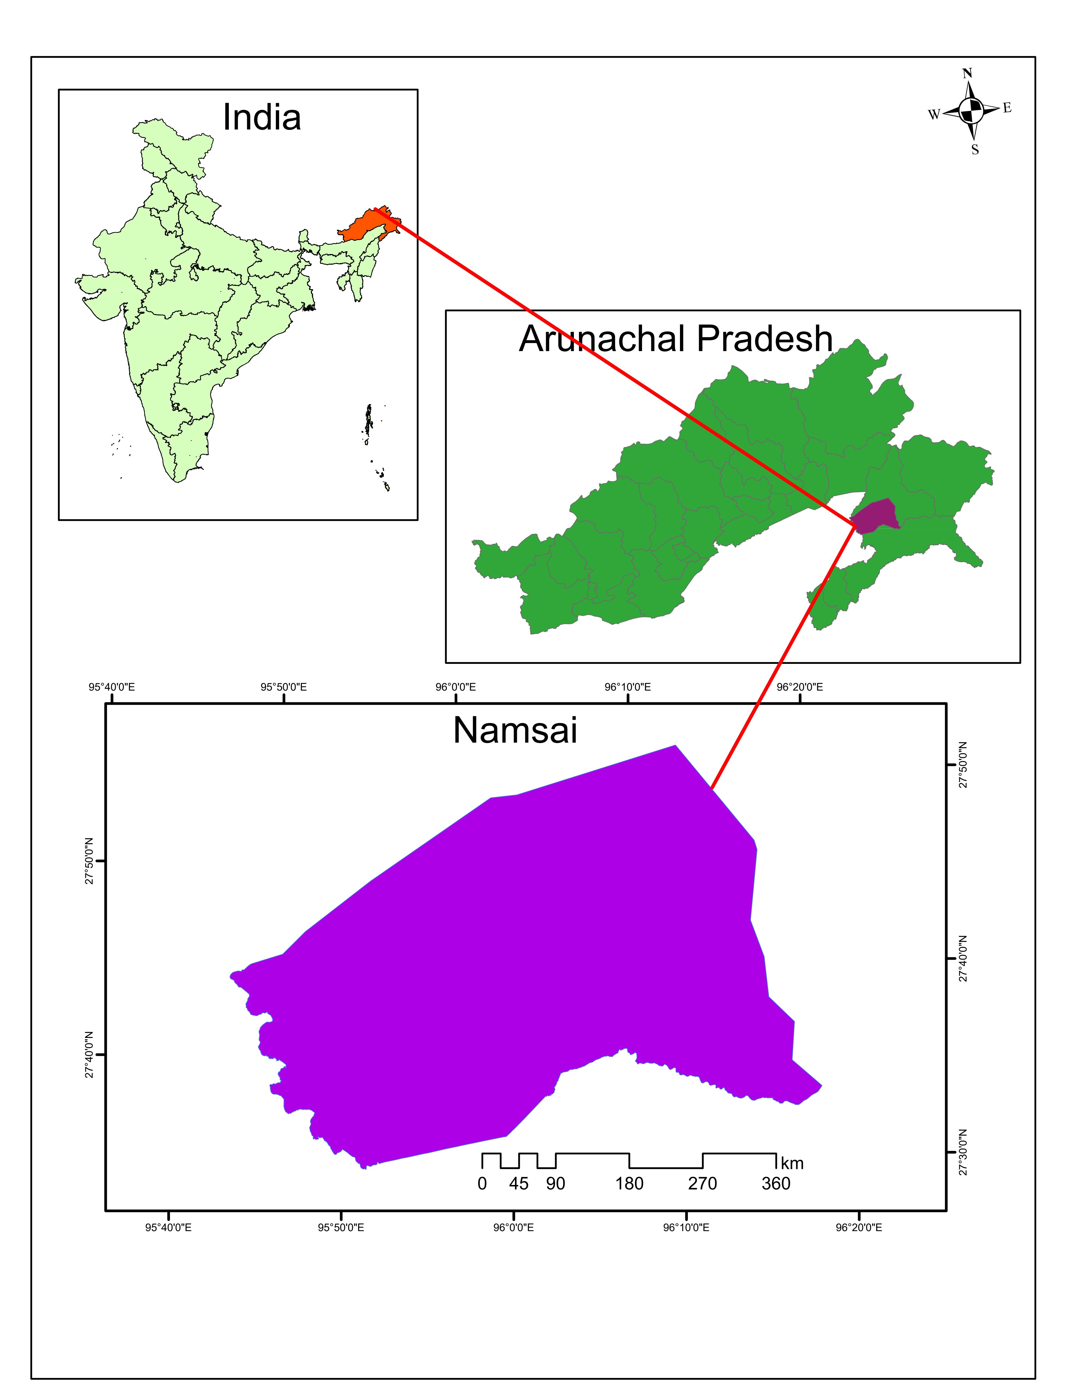
Figure 1. Geographic location of the study area in Namsai district, Arunachal Pradesh, Northeast India. The inset map highlights Arunachal Pradesh within Northeast India, with Namsai marked in purple, while the enlarged map shows the boundary of Namsai district.
2.2 Data sources, climate variable construction, and modelling approach
Seasonal climate data were obtained from the Indian Meteorological Department (IMD) Data Service Portal for the period 2018–2023 and aggregated across the kharif growing season (June–October) to capture hydroclimatic conditions relevant to key rice growth stages. Mean seasonal temperature (°C) and cumulative seasonal rainfall (mm) were constructed to represent thermal and moisture regimes influencing crop development, while rice yield data (t ha⁻¹) were compiled from official statistics of the Department of Agriculture, Government of Arunachal Pradesh. Accordingly, Kharif rice yield in year t was denoted as$Y_{t}$, seasonal rainfall as $R_{t}$, and seasonal mean temperature as $T_{t}$. Temporal climate variability was examined using observed time-series plots combined with locally estimated scatterplot smoothing (LOESS) to capture inter-annual dynamics without imposing parametric structure (Cleveland and Devlin, 1988)). Directional changes were quantified using linear trend models expressed as $C_{t}=α+βt+ε_{t}$(Eq. 1), where $C_{t}$represents seasonal rainfall or temperature, $β$denotes the annual rate of change, and $ε_{t}$is a stochastic disturbance term (Kalita et al., 2024). Anomaly years were identified through visible departures from smoothed climatic trajectories (Hsiang, 2016). Pairwise Pearson correlation coefficients were further computed to assess contemporaneous associations among rainfall, temperature, and rice yield using $r_{XY}=Cov(X,Y)/(σ_{X}σ_{Y})$(Eq. 2), providing preliminary insight into climate–yield co-variation (Gogoi et al., 2025; Lobell & Burke, 2010).
To quantify climate sensitivities, a sequence of econometric models was implemented, integrating bivariate ordinary least squares (OLS), Frisch–Waugh–Lovell (FWL) residual regressions, and a multivariate structural specification (Lovell, 2008; Roberts and Schlenker, 2013;Miao et al. 2016). Unconditional marginal relationships were first estimated as $Y_{t}=α_{1}+β_{1}R_{t}+ε_{t}$(Eq. 3; Model 1) and $Y_{t}=α_{2}+β_{2}T_{t}+ε_{t}$(Eq. 4; Model 3) (Zhao et al., 2016). Conditional marginal effects were then isolated using FWL residualisation by regressing rainfall on temperature ($R_{t}=γ_{0}+γ_{1}T_{t}+u_{t}$) and incorporating rainfall residuals into $Y_{t}=α_{3}+δ_{1}{\hat{u}}_{t}+ε_{t}$(Eq. 5; Model 2), while temperature residuals were derived from $T_{t}=ϕ_{0}+ϕ_{1}R_{t}+v_{t}$and included as $Y_{t}=α_{4}+δ_{2}{\hat{v}}_{t}+ε_{t}$(Eq. 6; Model 4)(Greene, 2003). These formulations isolate conditional climate effects while preserving coefficient interpretability. Joint hydrothermal influences were subsequently estimated through a structural multivariate model, $Y_{t}=α_{5}+β_{3}R_{t}+β_{4}T_{t}+ε_{t}$(Eq. 7; Model 5), which served as the primary framework for scenario-based projections (Roberts and Schlenker, 2013; Lobell et al., 2011; Kalita et al., 2024).
Using Model 5, expected mean yields were simulated under stylized climate perturbations relative to a recent baseline climate defined by the 2018–2023 averages. Scenarios combined rainfall deviations of −15%, +20%, and +40% with warming increments of +0.5 °C and +1.0 °C to reflect plausible inter-annual variability. Predicted yields were obtained as in ${\hat{Y}}_{s}={\hat{α}}_{5}+{\hat{β}}_{3}R_{s}+{\hat{β}}_{4}T_{s}$(Eq. 8), where $R_{s}$and $T_{s}$denote scenario-specific climate conditions. Yield deviations from baseline were computed as $ΔY_{s}=(X_{s}-X_{b})\hat{β}$(Eq. 9), with uncertainty quantified using covariance-corrected standard errors, $SE(ΔY_{s})=\sqrt{(X_{s}-X_{b})Var(\hat{β})(X_{s}-X_{b})^{'}}$(Eq. 10). Finally, a continuous climate response surface was generated as $\hat{Y}(R,T)={\hat{α}}_{5}+{\hat{β}}_{3}R+{\hat{β}}_{4}T$(Eq. 11) and visualized using iso-yield contours to illustrate trade-offs between rainfall and temperature across perturbation space. All statistical analyses were conducted using R software version 4.5.1.
3. results and discussion

3.1 Rainfall distribution during the Kharif rice-growing season (2018–2023)
Rainfall during the kharif season in Namsai over 2018–2023 is concentrated in the early monsoon months and declines progressively toward the post-monsoon period (Table 1). Mean monthly rainfall was highest in June (859.20 mm) and July (899.78 mm), indicating that these months receive the bulk of seasonal precipitation critical for rice transplanting and early crop establishment. Adequate rainfall during this period supports puddling, transplanting operations, and early vegetative growth, which are important for subsequent crop performance. Rainfall levels moderated during August (587.1 mm) and September (572.7 mm), suggesting relatively stable moisture availability during the active vegetative and reproductive growth stages of rice. However, substantial interannual variability persisted during these months, with September rainfall ranging from 76.2 mm to 1037.6 mm, indicating the potential for both moisture stress and excess water conditions during sensitive phenological stages. Such variability can disrupt nutrient uptake, increase lodging risk, and complicate pest and disease management.
By October, average rainfall declined sharply to 277.7 mm, reflecting monsoon withdrawal and reduced water availability during the late reproductive to maturity stages of rice. The lower minimum rainfall observed in September (76.2 mm) and October (89.0 mm) suggests a heightened risk of terminal moisture stress, particularly for late-planted or longer-duration varieties. Overall, the pronounced intra-seasonal and interannual variability in rainfall—especially during July and September—highlights the sensitivity of Kharif rice cultivation in Namsai to fluctuations in monsoon rainfall distribution, with direct implications for field operations, crop growth, and yield stability.
Table 1. Monthly rainfall distribution during the Kharif season in Namsai, Arunachal Pradesh (2018–2023)
Month | Mean rainfall (mm) | Minimum (mm) | Maximum (mm)
June | 859.2 | 478.6 | 1419.7
July | 899.8 | 250.9 | 1502.6
August | 587.1 | 152.0 | 1336.7
September | 572.7 | 76.2 | 1037.6
October | 277.7 | 89.0 | 823.1
Notes: Monthly rainfall statistics are based on Kharif season months (June–October) for the period 2018–2023. Mean values represent interannual monthly averages, while minimum and maximum values capture observed interannual variability within each month. Rainfall is expressed in millimetres (mm).
3.2 Temperature regime during the Kharif rice-growing season (2018–2023)
Mean monthly temperatures during the kharif season in Namsai over 2018–2023 remained relatively stable from June to October, ranging narrowly between 26.2°C and 28.3°C, indicating uniform thermal conditions during most of the rice-growing period (Table 2). Such temperature stability coincides with critical rice growth stages, including transplanting, tillering, and panicle initiation, during which sustained warm conditions support vegetative growth and biomass accumulation. August recorded the highest mean temperature (28.3°C), while June, July, and September showed slightly lower means of 27.0°C, 27.7°C, and 27.8°C, respectively, reflecting mild seasonal cooling without abrupt thermal stress during reproductive development.
By October, mean temperature declined more noticeably to 26.8°C, corresponding with the transition to post-monsoon conditions and the late reproductive to grain-filling stages of rice. While mean temperatures decreased, maximum monthly temperatures remained consistently high throughout the Kharif season, ranging from 31.5°C to 33.7°C, indicating continued exposure of rice crops to warm daytime conditions across growth stages. Such conditions can enhance photosynthetic activity but may also increase evaporative demand particularly under declining rainfall later in the season.
In contrast, minimum temperatures exhibited greater seasonal variation, decreasing from approximately 23.2–24.0°C during June–August to 23.8°C in September and further to 20.9°C in October. This widening diurnal temperature range toward the end of the season suggests cooler night-time conditions during crop maturity. Cooler nights during the grain-filling stage can influence assimilate partitioning and grain development, potentially affecting final yield and harvest timing. Overall, the Kharif temperature regime in Namsai is characterized by thermally stable early- and mid-season conditions followed by increased diurnal variability during crop maturation, with direct relevance for rice physiological processes and yield formation.
Table 2. Monthly temperature distribution during the Kharif rice season in Namsai, Arunachal Pradesh (2018–2023)
Month | Mean temperature (°C) | Minimum (°C) | Maximum (°C)
June | 27.0 | 23.2 | 31.5
July | 27.7 | 23.7 | 33.0
August | 28.3 | 24.0 | 33.6
September | 27.8 | 23.8 | 33.7
October | 26.2 | 20.9 | 32.0
Notes: Monthly temperature statistics are based on Kharif season months (June–October) for the period 2018–2023. Mean values represent interannual monthly averages, while minimum and maximum values capture observed interannual variability. Temperature is expressed in degrees Celsius (°C).

3.3 Climatic variability, anomaly years, and rice yield outcomes during the Kharif season in Namsai (2018–2023)
Table 3 and Figure 2 summarize inter-annual variability in kharif-season mean temperature, seasonal total rainfall, and rice yield in Namsai over 2018–2023. Seasonal mean temperature exhibited limited variability, remaining within a narrow range of 26.8–27.8 °C. The highest mean temperature was recorded in 2021 and 2023 (27.8 °C), while the lowest occurred in 2020 (26.8 °C), identifying these years as relative thermal anomalies within the study period (Figure 2B). Visual inspection of the temperature time series (Figure 2B) indicates only a weak directional change, with year-to-year variability dominating over any systematic trend. In contrast, kharif-season total rainfall displayed pronounced inter-annual variability, ranging from 2455.6 mm in 2018 to 4545.8 mm in 2020. Rainfall increased sharply from 2018 to 2020, with 2018 representing a dry anomaly year and 2020 a wet anomaly year, followed by a moderate decline in 2021. Subsequently, rainfall increased again in 2022, the second-highest rainfall year, before declining in 2023. Despite these fluctuations, the dominant feature of the rainfall series is strong interannual variability rather than a consistent directional trend.
Trend analysis of kharif-season climate variables (2018–2023) indicates no statistically significant temporal change in either rainfall or temperature. Seasonal rainfall exhibits high interannual variability, with a non-significant trend (R² = 0.011, p = 0.845) and a pronounced anomaly in 2020. Similarly, mean temperature shows a weak increasing tendency (+0.094 °C yr⁻¹), but this trend is not statistically distinguishable from zero (R² = 0.214, p = 0.356). These results suggest that short-term variability, rather than long-term climatic trends, dominates the hydrothermal regime in Namsai during the study period, consistent with the observed yield responses being driven primarily by rainfall fluctuations.

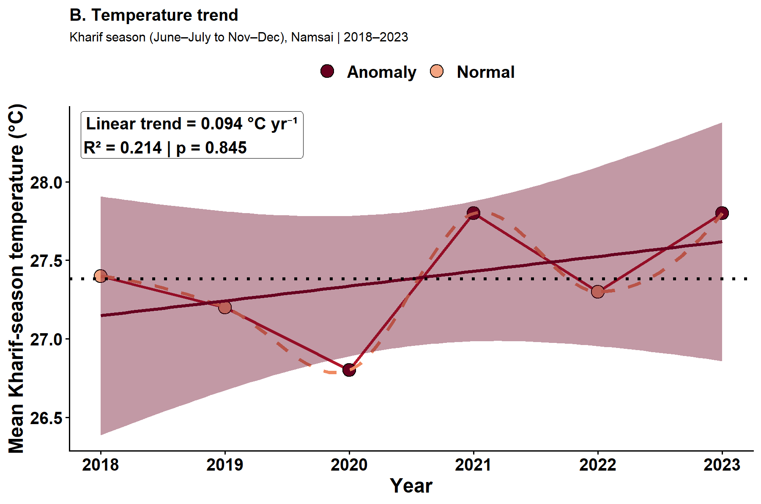
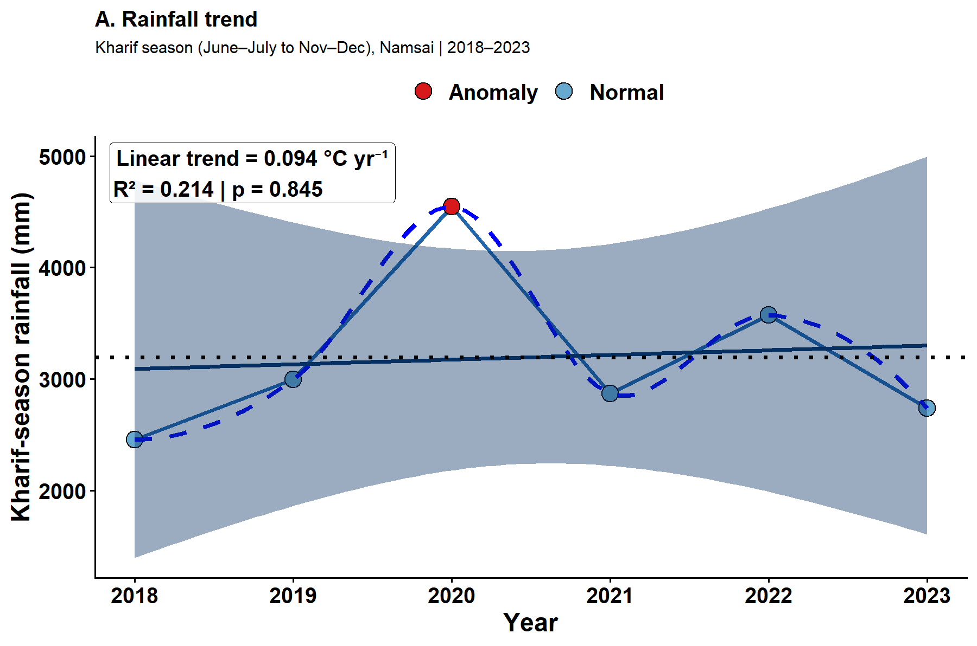

Figure 2. Climate trends during the Kharif rice season in Namsai (2018–2023). Observed annual trends in (A) Kharif-season rainfall and (B) mean Kharif-season temperature in Namsai. Solid lines represent observed values, dashed lines indicate LOESS-smoothed trends, and dotted horizontal lines show long-run means. Highlighted points denote anomaly years exceeding ±1 standard deviation from the mean. Linear trend statistics are reported within each panel.
Rice yield exhibited considerable year-to-year variability during the study period, ranging from 3.19 t ha⁻¹ in 2018 to 3.44 t ha⁻¹ in 2020 (Table 3). Yield increased between 2018 and 2020, reaching a maximum in 2020 and a minimum in 2018, followed by a partial decline in 2021, a small rebound in 2022, and a slight decline in 2023. The temporal pattern indicates substantial short-term variability rather than a consistent long-term trajectory.
Table 3. Inter-annual variability in Kharif-season climate conditions and rice yield in Namsai, Arunachal Pradesh (2018–2023)
Year | Kharif-season mean temperature (°C) | Kharif-season total rainfall (mm) | Rice yield (t ha⁻¹)
2018 | 27.4 | 2455.6 | 3.19
2019 | 27.2 | 2996.9 | 3.43
2020 | 26.8 | 4545.8 | 3.44
2021 | 27.8 | 2868.1 | 3.40
2022 | 27.3 | 3574.0 | 3.42
2023 | 27.8 | 2738.5 | 3.31
Notes: Kharif-season mean temperature represents the seasonal average across June–October. Kharif-season total rainfall denotes cumulative rainfall over the same period. Rice yield is reported as average yield per hectare. The table highlights pronounced inter-annual variability in seasonal rainfall and yield relative to comparatively limited variability in seasonal mean temperature over 2018–2023.

Years characterized by lower seasonal rainfall, including 2018 (2455.6 mm) and 2023 (2738.5 mm), coincided with relatively lower rice yields (3.19 and 3.31 t ha⁻¹, respectively). Conversely, years with comparatively higher seasonal rainfall, such as 2019 (2996.9 mm), 2020 (4545.8 mm), and 2022 (3574.0 mm), were associated with higher yields (3.43, 3.44, and 3.42 t ha⁻¹). This pattern suggests sensitivity of rice production outcomes to rainfall magnitude and inter-annual variability during the kharif season. Variations in seasonal mean temperature over the same period were comparatively small and did not exhibit an obvious correspondence with year-to-year yield fluctuations. The results indicate that climatic variability during the kharif season in Namsai over 2018–2023 was characterized by relatively stable thermal conditions and highly variable seasonal rainfall, with identifiable wet and dry anomaly years. Rice yield outcomes co-varied more closely with rainfall variability and anomalies than with seasonal mean temperature. These observed patterns provide the empirical basis for subsequent correlation and regression analyses examining the marginal and conditional relationships between climate variables and rice yield.
3.4 Climate–yield relationships during the Kharif season (2018–2023)
Rice yield exhibits a moderate positive correlation with rainfall (r = 0.68), indicating that higher seasonal precipitation is generally associated with increased yield. However, given the six-year sample, this association should be interpreted as descriptive rather than statistically conclusive. In contrast, rice yield shows a weak to moderate negative correlation with temperature (r = −0.38), suggesting that higher temperatures tend to be associated with lower yields, although the strength of this relationship is comparatively weaker. A strong negative correlation between temperature and rainfall (r = −0.78) is also observed, indicating that warmer years tend to coincide with lower rainfall. This inverse relationship suggests potential collinearity or confounding effects, which justifies the use of multivariate and Frisch–Waugh–Lovell (FWL) approaches to isolate independent effects. Overall, the correlation structure points to a rainfall-dominated yield response, with temperature playing a secondary and potentially indirect role through its association with rainfall variability (Figure 3).
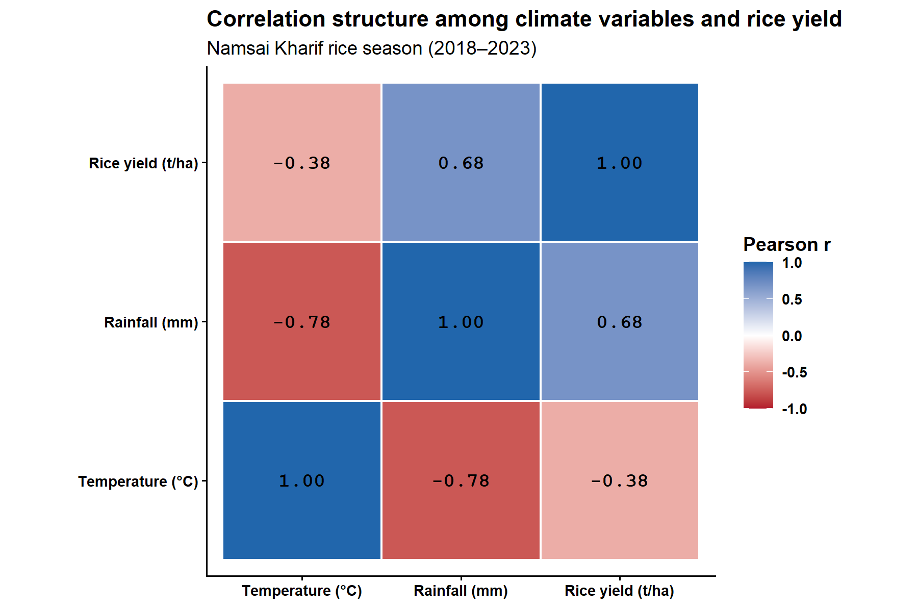
Figure 3. Correlation structure among climate variables and rice yield. Pearson correlation matrix for Kharif-season rainfall, temperature, and rice yield in Namsai (2018–2023). Cell colours indicate the direction and magnitude of correlations, with numerical values reporting correlation coefficients.
Figure 4 and Table 4 summarize the relationships between kharif-season climate variability and rice yield in Namsai during 2018–2023 using bivariate models, conditional (FWL) residual regressions, and a multivariate structural OLS specification. Consistent with the correlation structure, Model 1 (Yield ~ Rainfall) indicates a positive association between rainfall and yield (R² = 0.465), but the rainfall coefficient is not statistically significant at conventional levels in this short sample. The rainfall effect remains positive in the conditional marginal specification using the Frisch–Waugh–Lovell residual regression in Model 2, although it is likewise not statistically significant. In the scatterplots (Figure 4, Panels A–B), years with above-average rainfall deviations are generally associated with higher yield deviations, indicating a consistent positive rainfall–yield pattern across both total and partial effect specifications. For temperature, Model 3 (Yield ~ Temp) estimates a negative association between temperature and yield (R² = 0.147), but this effect is also not statistically distinguishable from zero. The conditional marginal temperature effect in Model 4 remains weak and statistically insignificant. In Figure 4 (Panels C–D), temperature anomaly years correspond to observable yield deviations; however, the dispersion around the fitted relationships is wider than in the rainfall models, indicating lower explanatory power and greater uncertainty.
Model 5 (Yield ~ Temp + Rainfall) provides the structural multivariate OLS specification used for scenario-based projections. In this model, rainfall retains a positive association with yield after accounting for temperature, while the temperature coefficient becomes positive but remains statistically indistinguishable from zero. Model 5 achieves the highest explanatory power among the estimated models (R² = 0.518; adjusted R² = 0.197) and a lower RMSE (0.088), indicating improved predictive performance relative to the bivariate specifications. Accordingly, Model 5 is used as the basis for the scenario-based yield projections reported in Section 3.5.
Figure 4. Regression relationships between climate variables and rice yield (Models 1–4). Standardized regression relationships between Kharif rice yield and (A) rainfall, (B) rainfall conditional on temperature (FWL), (C) temperature, and (D) temperature conditional on rainfall (FWL) for Namsai (2018–2023). Points represent annual observations, and fitted lines denote estimated marginal effects from Ordinary Least Squares and Frisch–Waugh–Lovell residual regressions.
Table 4. Regression analysis: Namsai Kharif rice (2018–2023)
Variables | Model 1:  Yield ~ Rainfall | Model 2:  Rainfall | Temp (FWL) | Model 3:  Yield ~ Temp | Model 4:  Temp | Rainfall (FWL) | Model 5:  Yield ~ Temp + Rainfall (OLS)
Model intercept | 3.08 (0.15) | 3.37 (0.04) | 6.05 (3.24) | 3.37 (0.04) | 0.40 (4.66)
Rainfall | 0.00009 (0.00005) | 0.00012 (0.00008) | - | - | 0.00012 (0.00008)
Temperature | - | - | -0.10 (0.12) | - | 0.09 (0.16)
R² | 0.465 | 0.371 | 0.147 | 0.053 | 0.518
Adjusted R² | 0.331 | 0.214 | -0.066 | -0.183 | 0.197
RMSE | 0.080 | 0.087 | 0.101 | 0.106 | 0.088
Log-likelihood | 7.862 | 7.378 | 6.464 | 6.151 | 8.177
AIC | -11.724 | -8.756 | -8.928 | -6.303 | -10.354
BIC | -12.140 | -9.381 | -9.344 | -6.928 | -10.978
Notes: Regression coefficient estimates are reported with standard errors in parentheses. Models (1) and (3) are bivariate ordinary least squares (OLS) regressions, while Models (2) and (4) report conditional marginal effects using Frisch–Waugh–Lovell (FWL) residual regressions. In this six-year sample, rainfall and temperature coefficients are directionally informative but are not statistically significant at conventional levels. Model (5) is the structural multivariate OLS model used for scenario-based yield projections in Section 3.5.

3.5 Climate sensitivity and scenario-based yield responses of kharif rice in Namsai (2018–2023)
The mean-only scenario analysis based on the multivariate OLS specification (Model 5) characterizes the conditional response of kharif rice yield in Namsai to joint perturbations in seasonal rainfall and temperature relative to a recent-climate baseline (2018–2023 mean) (Fig. 5). The imposed scenarios span a range of deviations in monsoon-season rainfall (−15%, +20%, and +40%) combined with modest increases in seasonal mean temperature (+0.5 °C and +1.0 °C), providing a structured representation of hydroclimatic variability around the baseline (Fig. 5A). The joint response surface derived from Model 5 indicates that expected yield varies systematically across the combined temperature–rainfall space, with iso-yield contours revealing trade-offs between thermal and moisture conditions (Fig. 5B). Scenario locations embedded within this surface show that lower rainfall perturbations combined with moderate warming are associated with lower expected yields relative to the baseline, whereas moderate warming under higher rainfall produces comparatively smaller deviations (Fig. 5B). The configuration of the response surface is consistent with stronger sensitivity to rainfall variability, with temperature acting as a secondary modifier within the narrow range of seasonal means observed during 2018–2023 (Fig. 5B).
Projected mean yields under the defined scenarios show clear differentiation relative to the baseline climate, with uncertainty expressed as confidence intervals for the conditional mean (Fig. 5C). The baseline scenario, anchored at the recent-climate mean, yields an expected value of approximately 3.36 t ha⁻¹, while the drier scenario combined with moderate warming shows a comparatively small negative deviation from this reference (Fig. 5C). In contrast, wetter and very wet scenarios are associated with progressively higher expected yields (Fig. 5C). Expressed relative to the baseline, the estimated effect sizes indicate reductions in mean yield under drier conditions, with the largest positive deviation occurring under the very wet, warmer scenario (Fig. 5D). The covariance-corrected confidence intervals highlight uncertainty linked to the joint estimation of rainfall and temperature effects while retaining the baseline as the zero-reference condition (Fig. 5D). Collectively, these results indicate that within the observed climatic range of the study period; mean kharif rice yield in Namsai is more responsive to variations in seasonal rainfall than to small shifts in mean temperature, and that the combined influence of decreased rainfall and warming is associated with lower expected yields relative to recent conditions (Fig. 5).
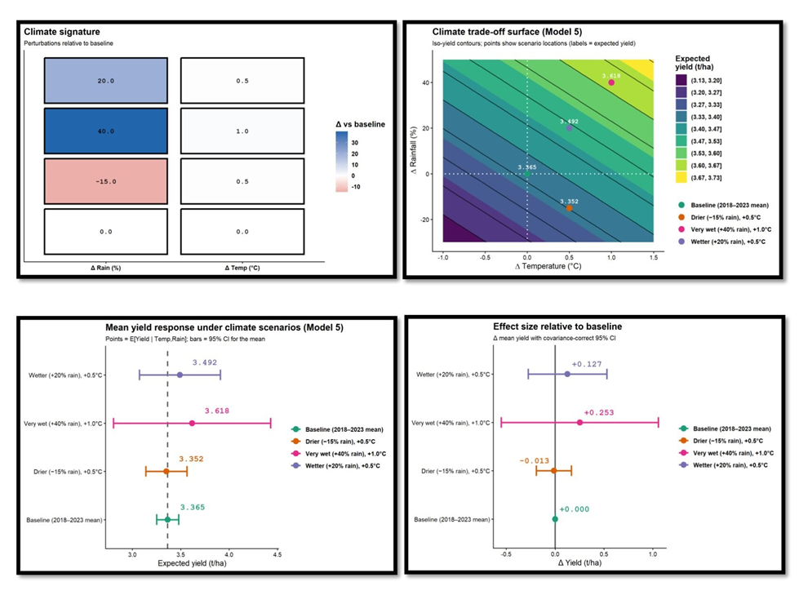 Figure 5. Mean yield response of Namsai kharif rice to alternative climate scenarios (2018–2023). Expected yield responses are derived from a structural multivariate OLS model (Yield ~ Temperature + Rainfall; Model 5), with baseline climate defined as the 2018–2023 mean. Panel A shows rainfall and temperature perturbations relative to baseline. Panel B depicts the temperature–rainfall trade-off surface with iso-yield contours and scenario locations. Panel C reports scenario-specific expected mean yields with 95% confidence intervals for the mean. Panel D presents yield changes relative to baseline with covariance-corrected 95% confidence intervals. Confidence intervals reflect uncertainty in the estimated mean response, not prediction uncertainty.
(A)
(B)
(C)
(D)

Discussion
Rice productivity in smallholder systems is shaped by interacting climatic, ecological, and management drivers, with longitudinal evidence showing that environmental variability and production constraints jointly influence agrarian outcomes in rice-based farming systems (Aravindakshan et al., 2020). Inter-annual hydroclimatic variability during the kharif season emerged as a central driver of rainfed rice yield outcomes in Namsai over 2018–2023, with rainfall fluctuations exerting a stronger statistical influence than seasonal mean temperature. The study period was characterized by pronounced year-to-year rainfall departures, including anomaly years associated with excess precipitation, while temperature remained confined to a relatively narrow range. Across marginal, conditional, and multivariate specifications, rainfall consistently showed a positive association with yield, indicating that lower seasonal totals were generally linked to lower yields after accounting for temperature co-movement. Gogoi et al. (2025) reported that dry conditions reduced rice yield, whereas wetter conditions enhanced yield; temperature also influenced rice productivity. Tangjang (2024) similarly reported that, in Arunachal Pradesh, rice productivity exhibited temporal fluctuations and that annual rainfall significantly influenced productivity, while temperature showed no significant relationship. The present results therefore indicate that, within the observed interannual range (2018–2023), rainfall remains the primary climate correlate of yield in Namsai. This broadly aligns with findings from parts of Northeast India where rainfall variability, rather than gradual thermal change, dominates short-run yield volatility in rainfed rice systems (Kalita et al., 2024), although contrasting evidence from Manipur suggests that the sign and magnitude of rainfall effects can vary across local agro-ecological contexts (Singh et al., 2026).
In contrast, temperature effects over the 2018–2023 period were weaker and less robust once rainfall variability was controlled. Although seasonal mean temperature displayed a modest negative bivariate relationship with yield, its explanatory contribution remained secondary to rainfall in all modelling frameworks. This does not imply that thermal stress is agronomically unimportant; rather, it reflects the limited inter-annual variation in seasonal averages captured in the dataset and the likelihood that yield sensitivity may operate through intra-seasonal heat exposure and minimum-temperature dynamics not resolved by seasonal aggregation. Physiological studies from Manipur and neighbouring regions highlight that elevated night temperatures and heat stress during reproductive stages can impair grain formation and yield stability (Laishram et al., 2023), while longer time-series analyses confirm temperature as a meaningful yield determinant once broader climatic variability is incorporated (Singh, 2025).
The observed correlation structure reinforces the need for joint hydrothermal modelling, with rainfall and temperature negatively correlated, rainfall positively associated with yield, and temperature negatively associated with yield in simple bivariate comparisons. The FWL decomposition indicates that the positive rainfall effect is not solely an artefact of covariance with temperature, reinforcing the structural interpretation of the multivariate model that underpins the scenario analysis. Scenario-based projections demonstrate a pronounced asymmetry in yield response, with limited declines under drier conditions but larger gains under enhanced rainfall, indicating a moisture-limited production regime despite moderate warming. Although excessive rainfall has been associated with production risks elsewhere in Northeast India (Kalita et al., 2024), the present results suggest that, within the observed interannual range in Namsai, the system operated more under moisture limitation than under excess-water stress.
Overall, the findings indicate that short-term climate risk in Namsai rainfed Kharif rice systems is currently dominated by rainfall variability—particularly episodes of less precipitation—while temperature effects are likely to become more evident over longer horizons or under more extreme warming regimes. This rainfall-centric vulnerability aligns with regional assessments emphasizing hydroclimatic hazards as the primary constraint to rice-based livelihoods and the focal point of farmer adaptation strategies (Lotha et al., 2024). Although constrained by the short time series and seasonal aggregation, the convergence of trend diagnostics, correlation structure, regression estimates, and scenario responses provides coherent evidence that managing rainfall-induced production risk will remain central to climate resilience in Namsai rice systems.
4. Conclusion
This study provides an integrated empirical assessment of how inter-annual hydroclimatic variability shapes kharif rice productivity in Namsai, a predominantly rainfed rice system embedded within the monsoon-dependent landscapes of Northeast India. By combining seasonal climate diagnostics, correlation analysis, marginal and conditional regression models, and scenario-based yield projections, the analysis delivers a transparent and policy-relevant characterization of climate sensitivity over the 2018–2023 period. Across all modelling frameworks, seasonal rainfall variability emerged as the dominant climatic correlate of yield fluctuations, with lower monsoon rainfall generally associated with lower rice productivity after controlling for temperature co-movement. In contrast, seasonal mean temperature exhibited weaker and less robust effects within the relatively narrow thermal range observed. Scenario simulations reinforced this asymmetry, showing lower expected yields under drier and warmer conditions relative to the recent climate baseline, while higher rainfall combined with modest warming produced comparatively higher expected yields. Together, these results suggest that reduced rainfall constitutes a central source of short-run climate risk for rainfed rice in this region.
Methodologically, the study demonstrates the value of parsimonious and interpretable regression-model designs for examining climate–yield relationships in data-constrained subnational settings. The convergence of trend analysis, conditional marginal effects, and structural scenario projections provides a coherent analytical framework that can be extended to other monsoon-dominated agro-ecological zones. From a policy and adaptation perspective, the findings suggest that climate-resilience strategies for Namsai rice systems should prioritize rainfall-related production risks, including improved irrigation infrastructure, drought-tolerant varietal deployment, flexible crop calendars, and strengthened early-warning systems. While long-term warming may intensify thermal stress in the future, current vulnerability in this short sample appears to be shaped more immediately by rainfall variability.
Several limitations warrant acknowledgment. The relatively short time series and seasonal aggregation constrain inference regarding nonlinear thresholds, intra-seasonal heat exposure, and long-term climate trends. Future research should integrate longer historical datasets, higher-frequency climate indicators, and management variables to disentangle compounding climatic and agronomic drivers of yield risk. Linking climate variability to household-level adaptation behaviour and welfare outcomes would further strengthen the policy relevance of climatic modelling evidence in the region.
In conclusion, this study suggests that inter-annual rainfall variability currently governs climate sensitivity in Namsai rainfed kharif rice systems more strongly than modest thermal fluctuations within the observed 2018–2023 range. By offering a transparent empirical framework and practical insights for climate-risk management, the analysis contributes to the growing body of subnational climate–agriculture research needed to design targeted, context-specific adaptation strategies in monsoon-dependent food systems.

Consent (where ever applicable)

Not applicable

Ethical approval (where ever applicable)

Not applicable

References

NITI Aayog. (2018). Inventory and revival of springs in the Himalayas for water security. Report of Working Group I, contributing to sustainable development in the Indian Himalayan Region.
Aravindakshan, S., Krupnik, T. J., Groot, J. C., Speelman, E. N., Amjath-Babu, T. S., & Tittonell, P. (2020). Multi-level socioecological drivers of agrarian change: Longitudinal evidence from mixed rice-livestock-aquaculture farming systems of Bangladesh. Agricultural Systems, 177, 102695.
Arshad, M., Kumar, A., & Singh, R. (2016). Climate variability, rainfall deficits, and implications for rice production in Northeast India. Journal of Agrometeorology, 18(2), 123–130.
Barua, U., Bora, M. S., Nithinkumar, K., Munglang, N., Borah, B. K. D., Sahani, S., & Wangchu, L.(2025). Evaluating climate-resilient rice varieties in eastern Arunachal Pradesh. Annals of Agriculture Research, 46 (3), 240-245.
Bharali, S., & Khan, M. L. (2011). Climate change and its impact on biodiversity: Some management options for mitigation in Arunachal Pradesh. Current Science, 101(7), 855–860.
Childs, N. W., & LeBeau, B. (2021). Rice Outlook: U.S. Department of Agriculture, Economic Research Service. Economic Research Service (ERS) website.
Choudhury, B. U., Nengzouzam, G., Ansari, M. A., & Islam, A. (2022). Causes and consequences of soil erosion in northeastern Himalaya, India. Current Science, 122(7), 772-789.
ICIMOD. (2010). Climate change impact and vulnerability in the Eastern Himalayas: Synthesis report. International Centre for Integrated Mountain Development (ICIMOD). https://lib.icimod.org/records/pge7j-50m76
CRIDA. (2018). Agriculture Contingency Plan for Namsai District, Arunachal Pradesh. KVK Momong, Namsai-District under ICAR RC NEH Region AP Centre, Basar, Arunachal Pradesh: ICAR-Central Research Institute for Dryland Agriculture.
Dash, S. K., Sharma, N., Pattnayak, K. C., Gao, X. J., & Shi, Y. (2012). Temperature and precipitation changes in north-east India and their future projections. Global and Planetary Change, 98-99, 31-44. https://doi.org/10.1016/j.gloplacha.2012.07.006
Durand-Morat, A., & Mulimbi, W. (2024). International Rice Outlook: International Rice Baseline Projections 2023-2033. AAES Research Reports and Research Bulletins. https://scholarworks.uark.edu/aaesrb/58
Fahad, S., Adnan, M., Noor, M., Arif, M., Alam, M., Khan, I. A., & Wang, D. (2019). Major constraints for global rice production. In Advances in rice research for abiotic stress tolerance 1-22. https://doi.org/10.1016/B978-0-12-814332-2.00001-0
Fahad, S., Ihsan, M. Z., Khaliq, A., Daur, I., Saud, S., Alzamanan, S., & Huang, J. (2018). Consequences of high temperature under changing climate optima for rice pollen characteristics-concepts and perspectives. Archives of Agronomy and Soil Science, 64(11), 1473-1488.
FAO, IFAD, UNICEF, WFP, & WHO. (2022). The state of food security and nutrition in the world 2022: Repurposing food and agricultural policies to make healthy diets more affordable. Rome, FAO. https://doi.org/10.4060/cc0639en
Gogoi, N., Pathak, B., Rehman, R., Upadhyaya, S., Mahanta, P., Borah, A., Baishya, K. J., & Bhuyan, K. (2025). Rice yield responses to climate variability in Northeast India using a machine learning approach. Theoretical and Applied Climatology, 156(4), 233.
Government of Arunachal Pradesh. (2023). District Irrigation Plan under Pradhan Mantri Krishi Sinchayee Yojana (PMKSY), Namsai District.
Greene, W. H. (2003). Econometric analysis (5th ed.). Prentice Hall.
Guha, S., Sharma, A. K., Yadav, R. K., Sharma, A., Yadav, M., & Arora, N. (2021). Agricultural Statistics at a Glance 2020. Directorate of Economics and Statistics, Department of Agriculture, Cooperation and Farmers Welfare, Government of India.
Hsiang, S. (2016). Climate econometrics. Annual Review of Resource Economics, 8(1), 43–75.
Kalita, B., Kumar, C. J., Hazarika, N., Baruah, K. K., & Borah, L. (2024). Exploring climate change adaptation practices and agricultural livelihoods among rice farmers of the Brahmaputra Valley in Northeast India. Environmental Management, 73(6), 1180-1200.
Laishram, O., Meetei, S., Khan, M. H., Singh, A. R., Shah, M. Z., & Yuingamla, S. W. (2023). Climatic factors influencing local rice varieties in Thoubal (Valley) and Ukhrul (Hill) districts of Manipur: A case study. Journal of Diversity Studies, 1(2), 11–15.
Lobell, D. B., & Burke, M. B. (2010). On the use of statistical models to predict crop yield responses to climate change. Agricultural and Forest Meteorology, 150(11), 1443–1452.
Lobell, D. B., Schlenker, W., & Costa-Roberts, J. (2011). Climate trends and global crop production since 1980. Science, 333(6042), 616–620.
Lotha, T. N., Ritse, V., Nakro, V., Rudithongru, L., Hazarika, N., & Jamir, L. (2024). Climate change impact and traditional adaptation practices in Northeast India: A review. Current World Environment, 19(2), 558.
Maiti, S., Jha, S. K., Garai, S., Nag, A., Bera, A. K., Paul, V., & Deb, S. M. (2017). An assessment of social vulnerability to climate change among the districts of Arunachal Pradesh, India. Ecological Indicators, 77, 105–113. http://dx.doi.org/10.1016/j.ecolind.2017.02.006
Mastrandrea, M. D., Mach, K. J., Plattner, G. K., Edenhofer, O., Stocker, T. F., Field, C. B., & Matschoss, P. R. (2011). The IPCC AR5 guidance note on consistent treatment of uncertainties: a common approach across the working groups. Climatic Change, 108(4), 675.
Murasingh, S., Kuttippurath, J., Dash, S. S., Raj, S., Remesan, R., Jha, M. K., & Kumar, P. (2022). Long-term trends and projections of hydrological fluxes under RCP climate change scenarios for a mountainous river catchment of northeast India. Journal of Water and Climate Change, 13(4), 1776–1789.
North Eastern Development Finance Corporation Limited (NEDFi). (2023). Statistical Abstract of Arunachal Pradesh 2023. https://databank.nedfi.com
Pachauri, R. K., & Meyer, L. A. (2014). “Climate Change 2014: Synthesis Report,” in Contribution of working groups I, II and III to the Fifth Assessment Report of the Intergovernmental Panel on Climate Change, (Geneva, Switzerland: IPCC), 1–151.
Ray, D. K., West, P. C., Clark, M., Gerber, J. S., Prishchepov, A. V., & Chatterjee, S. (2019). Climate change has likely already affected global food production. PLoS One, 14(5), 1–18.
Roberts, M. J., Schlenker, W., & Eyer, J. (2013). Agronomic weather measures in econometric models of crop yield with implications for climate change. American Journal of Agricultural Economics, 95(2), 236–243.
Roy Choudhury, D., Singh, N., Singh, A. K., Kumar, S., Srinivasan, K., Tyagi, R. K., & Singh, R. (2014). Analysis of genetic diversity and population structure of rice germplasm from north-eastern region of India and development of a core germplasm set. PLOS one, 9(11), e113094.
Sandhu, N., Dixit, S., Swamy, B. P. M., Raman, A., Kumar, S., Singh, S. P., & Kumar, A. (2019). Marker assisted breeding to develop multiple stress tolerant varieties for flood and drought prone areas. Rice, 12(1), 8.
Sangeetha, K., Kumar, R., & Singh, A. (2020). Rice production and food security in the North-Eastern Region of India. Journal of Agrometeorology, 22(3), 145–152.
Sarwar, N., Ahmad, S., Khan, M. A., & Hasanuzzaman, M. (2022). World rice production: An overview. Modern techniques of rice crop production, 3-12. https://doi.org/10.1007/978-981-16-4955-4_1
Singh, A. M., Elangbam, G., Sharma, G. N., Singh, T. C. & Teresa, K. (2025). Long-term rainfall seasonality trends and abrupt shifts in the Northeast Indian Province of Manipur. Discover Sustainability, 6(1), 881.
Singh, A., Singh, R.,& Sarkar, S. (2024). Climate change impact on rice productivity and quality. Indian Farmer, 11(10), 437–441.
Singh, M. S., Aravindakshan, S., Kumar, K. A., Khamhoo, S., & Balasubramanian, D. (2026). Climate Sensitivity of Kharif Rice Yield in Manipur, Northeast India. International Journal of Environment and Climate Change, 16(2), 552-569.
Singh, R., Srivastava, P., Singh, P., Upadhyay, S., & Raghubanshi, A. S. (2017). Human overpopulation and food security: challenges for the agriculture sustainability. Environmental issues surrounding human overpopulation (12-39). https://doi.org/10.4018/978-1-5225-1683-5.ch002.
Soora, N. K., Aggarwal, P. K., Saxena, R., Rani, S., Jain, S., & Chauhan, N. (2013). An assessment of regional vulnerability of rice to climate change in India. Climatic Change, 118(3), 683–699.
Tang, L., Wu, A., Li, S., Tuerdimaimaiti, M., & Zhang, G. (2023). Impacts of climate change on rice grain: a literature review on what is happening, and how should we proceed?. Foods, 12(3), 536.
Tangjang, M. A. (2024). Effect of climate change on the production and productivity of rice (Oryza sativa L.) and maize (Zea mays L.) in Arunachal Pradesh. African Journal of Biological Sciences, 6(Si3), 414–435.
United States Bureau of the Census. (1998). International Database. Electronic database, Suitland MD. Updated June 15, 1998.
Wassmann, R., Nelson, G. C., Peng, S. B., Sumfleth, K., Jagadish, S. V. K., Hosen, Y., & Rosegrant, M. W. (2010). Rice and global climate change. Rice in the global economy: strategic research and policy issues for food security, 411-432.
Xu, J., Grumbine, R. E., Shrestha, A., Eriksson, M., Yang, X., Wang, Y. U. N.,& Wilkes, A. (2009). The melting Himalayas: cascading effects of climate change on water, biodiversity, and livelihoods. Conservation Biology, 23(3), 520-530.
Yaghoubian, Y., Pirdashti, H., Mottaghian, A., & Hosseini, S. J. (2012). Effect of fluctuating salinity at different growth stages on physiological and yield-related parameters of rice (Oryza sativa L.). International Journal of Agriculture, 2(3), 266.
Zhao, C., Piao, S., Wang, X., Huang, Y., Ciais, P., Elliott, J., Huang, M., Janssens, I. A., Li, T., Lian, X., & Liu, Y. (2016). Plausible rice yield losses under future climate warming. Nature Plants, 3(1), 1–5.
Zibaee, A. (2013). Rice: importance and future. Journal of Rice Research, 1(2), 1000e102.

