DESIGN AND DEVELOPMENT OF PEPPER HARVESTER
or
DESIGN, DEVELOPMENT and evaluation of PEPPER HARVESTER

Abstract
This project presents a cost-effective and efficient mechanical solution for the automated harvesting and threshing of black pepper (Piper nigrum). The system integrates a 12V DC motor with worm-spur gear transmission that drives counter-rotating rubber rollers for gentle on-plant threshing. The portable design incorporates a telescopic pole for extended reach, PWM (write also full form of PWM in abstract)-based speed control for operational flexibility, and an integrated collection system. Field testing demonstrates 86% harvesting efficiency with only 0.8% berry damage, significantly outperforming traditional manual methods. The harvester reduces labour requirements by 60% and operational costs by 66% per acre, while maintaining a field capacity of 8 kg/hour. This innovation provides small-scale farmers with an affordable, sustainable solution that enhances productivity while maintaining premium berry quality.
Keywords: Pepper harvesting, Agricultural mechanization, Portable harvester, Rubber roller threshing, Small-scale farming, Cost-effective technology.
1. INTRODUCTION
Black pepper (Piper nigrum L.) is one of the most important and widely traded spice crops in the world and is popularly known as the "King of Spices." It has been used since ancient times for culinary, medicinal, and preservative purposes. India is one of the leading producers and exporters of black pepper, particularly from the Western Ghats region where the climatic conditions are highly suitable for its cultivation. The economic importance of pepper in domestic consumption as well as international trade makes it a high-value plantation crop.
Global pepper production faces significant challenges due to labour-intensive harvesting methods, particularly in developing regions with majority farmers category under where small-scale farming predominates. (please rephrase the sentence for better audience clarity). Traditional manual harvesting requires 3-4 workers per acre, causes 5-10% berry damage, and is increasingly affected by labour shortages and rising operational costs. Additionally, processing quality parameters such as moisture content, drying efficiency, and post-harvest handling significantly influence market value (Dhas&Korikanthimath, 2017). Consequently, the need for mechanized harvesting solutions has become critical to for sustaining the profitability and long-term viability of pepper cultivation.
Mechanical harvesting systems for delicate crops have evolved considerably over the past decade. Early research focused on vibration-based detachment mechanisms and component-level optimization of chili and pepper harvesters (Qin et al., 2012; Chen et al., 2013). Subsequent developments introduced improved structural configurations and evaluation of harvesting performance under field conditions (Stanly et al., 2020). More recent innovations include crawler-type harvesters designed for hilly and mountainous terrains (Yang et al., 2024) and double-helix roller harvesting devices aimed at improving detachment efficiency (Yuan et al., 2021). Advanced simulation-based studies have further enhanced system performance through load-sensitive hydraulic circuit optimization (Wu et al., 2023).
Comprehensive reviews also highlight rapid advancements in mechanized harvesting technologies for chilli and pepper crops, emphasizing automation, selectivity, and damage reduction (Han et al., 2025). Furthermore, studies on plant density and crop characteristics have demonstrated their influence on mechanical harvest efficiency (Joukhadar et al., 2024), while investigations into the physical properties of black pepper provide essential design parameters for developing efficient harvesting mechanisms (Suja et al., 2023). Despite these advancements, many existing harvesting systems remain either capital-intensive, large-scale, or unsuitable for the climbing vine structure and dispersed fruiting pattern characteristic of black pepper cultivation. In particular, integrated harvesting and threshing mechanisms tailored for small-scale operations remain limited, although preliminary threshing system designs have been reported (Savalgi et al., 2021).
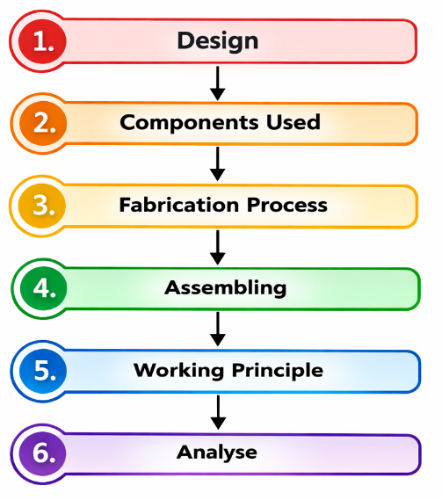
This study addresses these limitations by developing a portable, hand-held pepper harvester that integrates harvesting and threshing operations into a single compact unit. The design emphasizes affordability, ergonomic handling, minimal berry damage, and practical enhanced field efficiency. By combining mechanical engineering principles with specific agricultural requirements of black pepper cultivation, the proposed system offers a technically feasible and economically viable solution for small-scale pepper growing farmers facing labour scarcity and rising production costs.
Figure 1: Methodology Flowchart
2. DESIGN
The harvester was designed to meet specific operational and functional requirements to ensure efficiency, portability, and affordability for small-scale farmers. The total weight of the machine is was maintained below 5 kg so that it can be easily handled and operated by a single user without causing fatigue during fieldwork. It operates on a portable battery-powered system, which makes made it convenient for use in agricultural fields where access to grid electricity is was limited or unavailable. The harvester can reached a minimum vertical height of 4 meters, enabling effective access to crops located at elevated positions. In terms of performance, the machine is was designed to achieve a harvesting capacity of about 5-10 kg per hour while ensuring careful handling of the produce. The design also focuses on crop safety by maintaining berry damage below 2%, thereby preserving product quality and market value. Furthermore, the overall production cost of the harvester is was kept under ₹10,000, making it an economical and practical solution for small and marginal farmers.
PARAMETER | SPECIFICATION
Harvesting Head Width | 100 mm
Harvesting Head Length | 165 mm
Harvesting Head Height | 70 mm
Gap Between Rollers | 2 mm
Total System Weight | 4.5 kg
Maximum Reach Height | 4.57 m (15 ft)
Harvesting Capacity | 8 kg/hour
Target Damage Rate | Less than 2%
Estimated Production Cost | Less than ₹10,000

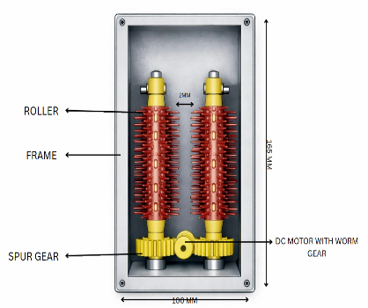
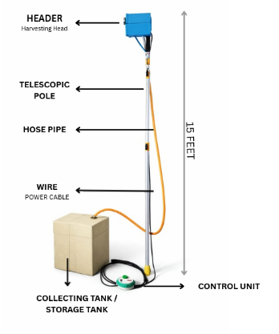

Figure 2: CAD Design
3. COMPONENTS USED
3.1 DC Motor
A DC motor converts electrical energy into mechanical rotational motion. It works on the principle of electromagnetism between stator and rotor. When current flows, magnetic interaction produces shaft rotation. It drives the rollers through the gear mechanism. The motor used is 12V with high torque output, providing constant speed under load conditions and ensuring continuous and efficient harvesting action.
Specifications:
- Voltage: 12V DC
- Speed: 30-50 RPM
- Torque: 5-6 kg-cm
- Type: Geared DC motor
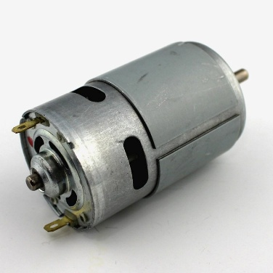
Figure 3: DC Motor
3.2 Wires
Wires are used to carry electrical current from a power source to a load. For this project, 16 AWG (PLz mention full form of AWG) stranded copper wires are used. This gauge safely carries the required current (up to 10A) from the battery to the motor with minimal voltage loss over the 15-foot distance. The stranded construction made makes the wire flexible and resistant to fatigue from repeated movement, essential for a device mounted on a moving telescopic pole.
Specifications:
- Gauge: 16 AWG
- Material: Stranded copper
- Length: 5 meters
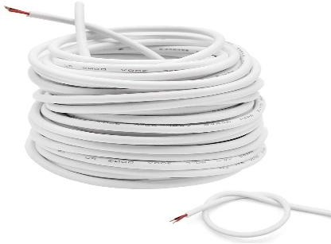
- Current Capacity: 10A
Figure 4: Wires
3.3 Nuts and Bolts
Nuts and bolts are mechanical fastening elements made of mild steel or stainless steel. They were used to join different machine components firmly through threaded connections, providing strong holding capacity while allowing easy assembly and disassembly. They are were used in frame construction, motor mounting, and gear installation.
Specifications:
- Material: Mild steel
- Sizes: M3, M4 assorted
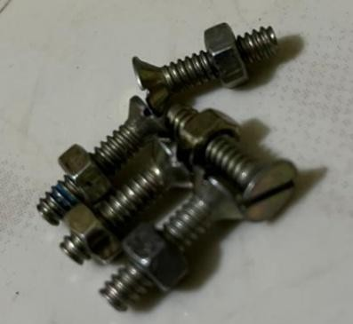
- Finish: Zinc plated
Figure 5: Nuts and Bolts
3.4 Rubber Rollers
A roller is a cylindrical object that rotates about its axis. For this harvester, the rollers were are the primary components that interact with the pepper spikes. They are were fabricated from food-grade silicone rubber, a soft, flexible, and durable elastomer. The two rollers were are mounted parallel to each other with a small, adjustable gap. When they counter-rotate, they create a gripping and pulling action on the pepper spike. The soft rubber surface ensured that the peppercorns are were detached through gentle friction and impact, preventing crushing or bruising.
Specifications:
- Material: Food-grade silicone rubber
- Diameter: 50 mm
- Length: 100 mm
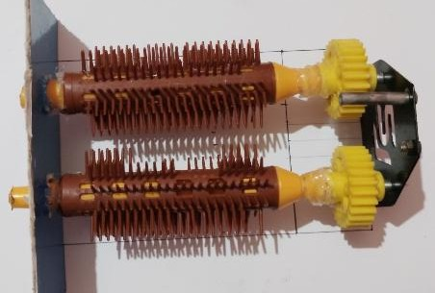
- Hardness: Shore A 40-50
Figure 6: Rubber Rollers
3.5 Speed Controller
A motor speed controller is an electronic device that regulates the operating speed of an electric motor using PWM (Pulse Width Modulation). A PWM controller rapidly turns the motor's power supply on and off, controlling the average voltage and thus the motor's speed. A 10A PWM DC motor speed controller module allows the operator was used to precisely adjust the rotational speed of the harvesting rollers using a potentiometer knob.
Specifications:
- Type: PWM DC motor controller
- Current Rating: 10A
- Voltage: 12V
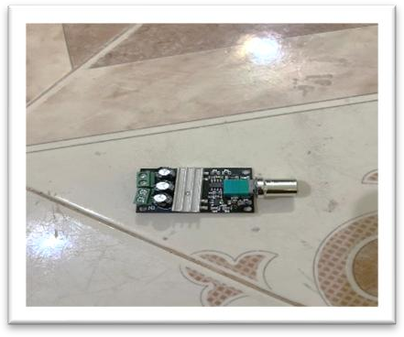
- Control: Potentiometer knob
Figure 7: Speed Controller
3.6 Galvanized Iron Sheet
Galvanized Iron (GI) sheet is a carbon steel sheet coated with a layer of zinc. This galvanization process protects the steel from rusting by preventing the iron from contacting the atmosphere. GI sheets are known for their strength, durability, and cost-effectiveness. In this project, 1.2mm thick GI sheets are were used to fabricate the main framework and housing of the harvester head.
Specifications:
- Material: Galvanized Iron
- Thickness: 1.2 mm
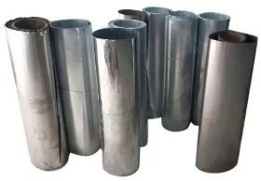
- Quantity: 2 sheets
Figure 8: Galvanized Iron Sheet
3.7 Battery
A battery stores chemical energy and converts it into electrical energy. A 12V, 7Ah sealed lead-acid (SLA) battery is used. The 12V rating matches the motor's operating voltage. The 7Ah capacity provides approximately 2-3 hours of continuous runtime. This battery type was selected for its reliability, low cost, and ability to deliver high surge currents needed by the motor when starting under load.
Specifications:
- Type: Sealed Lead-Acid (SLA)
- Voltage: 12V
- Capacity: 7Ah
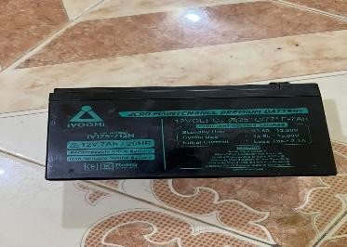
- Runtime: 2-3 hours
Figure 9: Battery
3.8 Telescopic Pole
A telescopic pole consists of concentric tubes that slide within one another, allowing length adjustment. A 15-foot (4.5-meter) lightweight aluminium telescopic pole is was used. Aluminium provides an excellent strength-to-weight ratio and resistance to rust. This pole served as the main handle and reach-extender, allowing the operator to access pepper spikes at the top of the vine from ground level.
Specifications:
- Material: Aluminium alloy
- Extended Length: 15 ft (4.57 m)
- Collapsed Length: 5 ft (1.5 m)
- Sections: 3
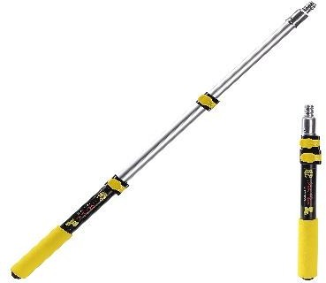
- Locking: Twist-lock mechanism
Figure 10: Telescopic Pole
3.9 Switch
A switch opens or closes a circuit to control the flow of electricity. Two switches were are used in this project - one for main power control and one for emergency stop. Switches provide simple electrical safety and are low cost with easy availability.
Specifications:
- Type: Toggle switch
- Rating: 10A, 12V
- 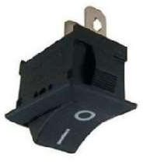Quantity: 2
Figure 11: Switch
3.10 Worm and Spur Gear
A gear is a rotating machine part with cut teeth designed to mesh with another toothed part to transmit torque and speed. A worm gear arrangement consists of a screw (the worm) that meshes with a gear (the wheel). The primary advantage is high reduction ratios and torque multiplication in a single stage. Importantly, the worm can turn the gear, but the gear cannot turn the worm, providing a self-locking safety feature. In this harvester, the worm gear is attached to the motor shaft and drives a larger spur gear connected to the roller shaft, reducing motor speed while increasing output torque.
Specifications:
- Worm Gear: Single-start, driving
- Spur Gear: 40 teeth, driven
- Ratio: 40:1
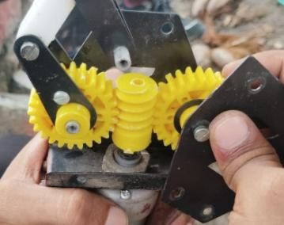
- Material: Steel
Figure 12: Worm and Spur Gear

4. FABRICATION PROCESS
Fabrication refers to the process of manufacturing or building something, typically using raw materials or pre-manufactured components. Fabrication can involve a wide range of techniques, tools and processes, depending on the type of material being used and the desired product. In industrial manufacturing, fabrication often involves the use of specialized machinery such as welding, cutting and forming. The goal of fabrication is was to create a finished product that meets specific requirements in terms of functionality, durability and aesthetics.
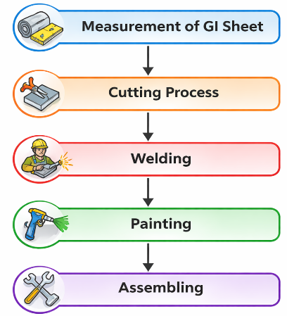
Figure13: Fabrication Process
4.1 Measurement of GI Sheet
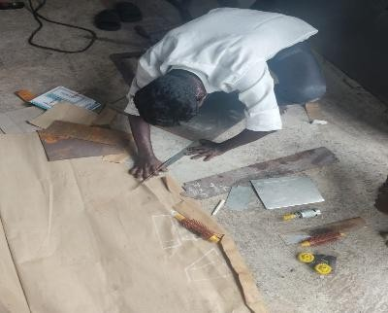
The harvesting head has a width of 100 mm, a length of 165 mm, and a height of 70 mm. It is constructed from a galvanized iron (GI) sheet with a thickness of 1.2 mm, providing durability and structural strength. The overall weight of the item is was approximately 1.2 kg, making it sturdy yet manageable for handling and installation.
Figure 14: Measurement of GI Sheet
4.2 Cutting Process
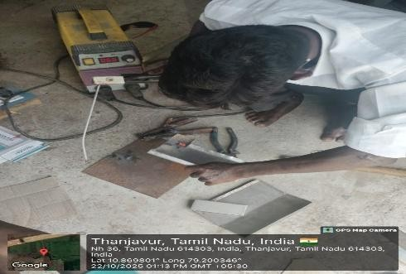
The fabrication process of the harvester was carried out in a systematic manner to ensure strength, proper alignment, and efficient performance. It began with the construction of the main frame by cutting, bending, and welding GI sheets to form a strong and stable housing capable of supporting all mechanical and electrical components. After completing the frame, the gear assembly was installed by mounting and accurately aligning the worm and spur gears to achieve smooth power transmission, high torque output, and reliable self-locking operation.
Figure 15: Cutting Process

4.3 Welding
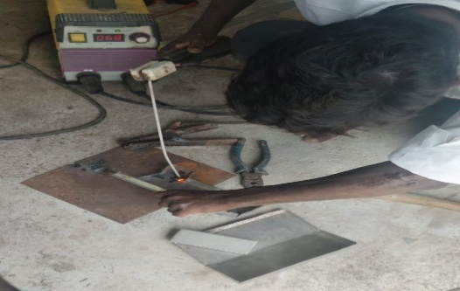
Welding is a fabrication process that joins materials, usually metals or thermoplastics, by using high heat to melt the parts together and allowing them to cool, causing fusion. It often uses a filler material to form a molten pool that cools to become a strong joint. Common in construction and manufacturing, welding creates durable, permanent bonds that are often as strong as the base materials. In this project, welding is was used to join the GI sheet metal framework and assemble the structural components of the machine.
Figure 16: Welding
4.4 Painting
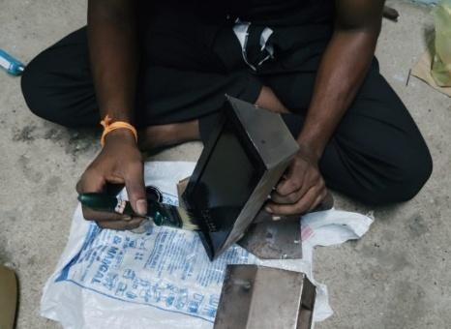
Painting is the process of applying a protective or decorative coating of paint to a surface. It involves preparing the surface by cleaning and smoothing, applying primer to improve adhesion and prevent corrosion, and then adding one or more layers of coloured paint. A final clear coat is often applied to enhance durability and appearance. The purpose of painting was is to protect the material from environmental damage, such as rust or wear, and to improve its visual appeal.
Figure 17: Painting
4.5 Assembling
Assembling fabrication parts is the process of joining individual components together to create a larger and more complex structure. Proper fit, alignment and joining methods are critical to ensure the strength, durability and safety of the final product. The sequential assembly process includes:
1. Frame Construction - GI sheet cutting and welding for main housing
2. Gear System Installation - Mounting and aligning worm and spur gears
3. Roller Assembly - Fixing rubber rollers on shafts with bearings
4. Motor Integration - Connecting 12V DC motor to worm gear shaft
5. Pole Attachment - Securing telescopic pole to harvesting unit
6. Speed Controller Mounting - Installing PWM controller with protective casing
7. Electrical Connections - Routing wiring from battery to motor through speed controller
8. Collection System - Attaching net and collection shroud
9. Battery Mounting - Securing battery pack at base of telescopic pole for balance
10. Final Testing - Testing all components for proper operation and safety checks
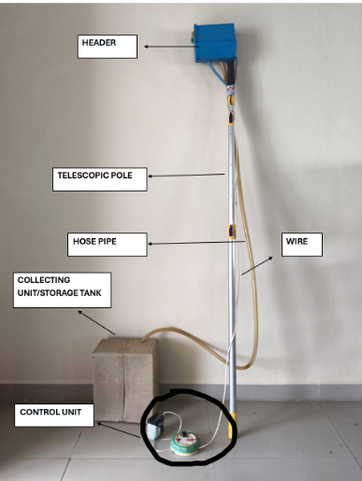
11. Finishing - Smoothing all edges, cleaning surfaces, applying protective coating
Figure 18: Assemble
5. WORKING PRINCIPLE
The operation begins with the operator identifying a mature pepper spike on the vine and extending the telescopic pole to position the harvesting head at the appropriate height. The rubber rollers are carefully aligned on either side of the selected spike, ensuring proper engagement. Once positioned, the operator activates the motor using the speed controller, causing the rollers to rotate in opposite directions. As the counter-rotating rollers grip the spike, they create a gentle pulling action that draws the spike through the adjustable gap between them. The friction generated by the soft rubber surface against the spike effectively detaches the ripe peppercorns without causing damage to the berries. The detached peppercorns then fell by gravity into the collection shroud and travel through the flexible pipe or hose connected to the harvesting head. Finally, the clean peppercorns are were collected in the attached nylon net or container, ready for further processing or storage. This continuous cycle allows efficient harvesting of multiple spikes with minimal operator effort and maximum berry quality preservation.
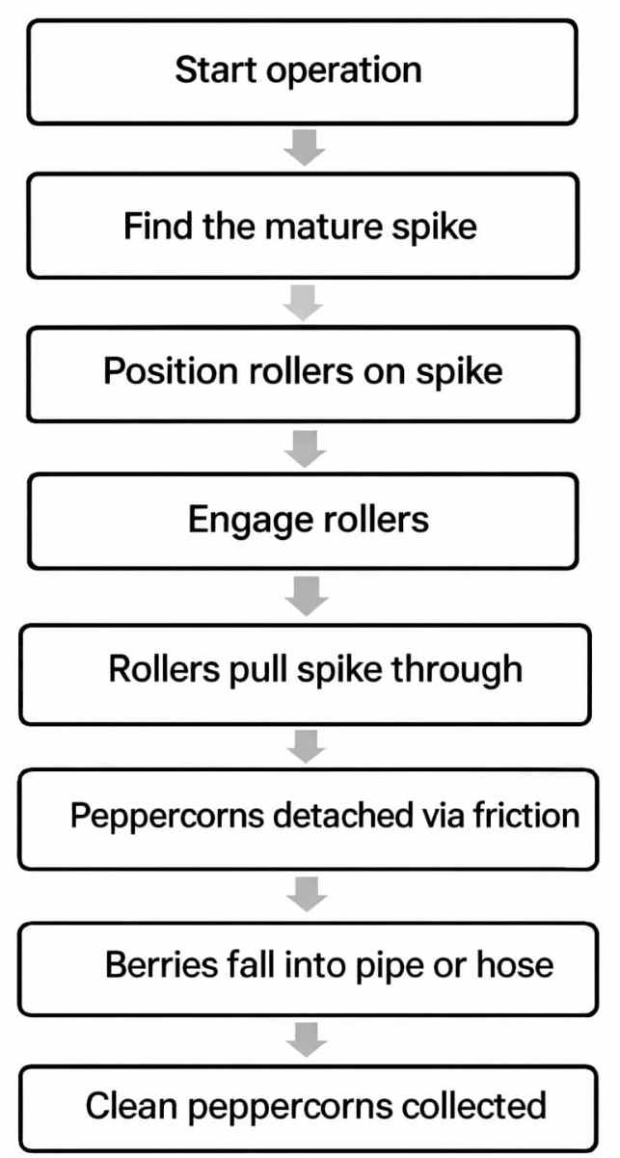
Figure 19: Working Process
6. PERFORMANCE ANALYSIS
The theoretical capacity (TC) was calculated based on the standard yield per vine and the time required for harvesting each vine, providing an estimate of the maximum achievable harvesting rate under ideal conditions (Sharma, Kumar, & Singh, 2015). The harvesting efficiency (ηₕ) was determined as the ratio of actual field capacity to theoretical capacity, representing the effectiveness of the harvesting operation relative to its theoretical potential (Hough, 1998). Force calculations were performed using standard mechanics principles, where the force due to weight is expressed as F = m × g, allowing conversion of mass to equivalent force for analysis of detachment and threshing requirements (Beer & Johnston, 2010). Finally, torque and power were evaluated using classical rotational mechanics, with torque calculated as the product of force and radius, and the required power derived from rotational speed and torque according to standard kinematic relations (Mechanical Engineering Handbook, 2002).

SECTION | PARAMETER / QUANTITY | SYMBOL | FORMULA / EXPRESSION | SUBSTITUTION | RESULT
Capacity | Harvested amount in 1 hour | – | – | – | 8 kg
 | Actual Field Capacity | AC | – | – | 8 kg/hr
 | Harvested amount per vine | M₁ | – | – | 4 kg
 | Time required per vine | T₁ | – | – | 20 min
 | Theoretical Capacity | TC | (M₁ / T₁) × 60 | (4 / 20) × 60 | 12 kg/hr
Efficiency | Harvesting Efficiency | ηₕ | (AC / TC) × 100 | (8 / 12) × 100 | 66.6 %
Force Calculation | Pepper spikes processed per minute | – | – | – | 150 g = 0.15 kg
 | Force due to weight | Fw | m × g | 0.15 × 9.81 | 1.4715 N
 | Maximum threshing force per spike | – | – | – | 0.735 N
 | Average spike weight (force equivalent) | – | m × g | 0.012 × 9.81 | 0.1177 N
 | Force required for detachment | F | (0.735 × 1.4715) / 0.1177 | – | 9.186 N
Torque | Radius | R | – | – | 25 mm
 | Torque produced | T | F × R | 9.186 × 25 | 229.65 N·mm
Power | Rotational Speed | N | – | – | 30 rpm
 | Power required | P | (T × N) / (9.55 × 10⁶) | (229.65 × 30) / 9,550,000 | 0.000721 kW (0.721 ~0.72 Kw, kindly write upto 2 decimal places)
Table 1: Performance Analysis Calculations

The table presents a consolidated summary of the performance and power requirement calculations of the developed portable pepper harvesting mechanism. The formulae used in this table are standard engineering and agricultural machinery relationships. In the capacity analysis, the actual field capacity (AC) was determined from field experimentation and found to be 8 kg h⁻¹, based on the harvested quantity in one hour of operation. The theoretical field capacity (TC) was calculated using the time required to harvest a single vine (20 minutes) and the harvested mass per vine (4 kg). Using the standard relation TC = (M₁/T₁) × 60, the theoretical capacity was obtained as 12 kg h⁻¹. Based on these values, harvesting efficiency was computed as 66.6%, indicating moderate operational losses due to handling time, positioning, and field constraints.
The second part of the table summarizes the power requirement estimation of the threshing/detachment mechanism. The weight of pepper spikes processed per minute (0.15 kg) was converted into force using gravitational acceleration (9.81 m s⁻²), resulting in 1.4715 N. Considering the maximum threshing force per spike (0.735 N) and the average spike weight (0.1177 N equivalent), the total detachment force was calculated as 9.186 N.
Using this force and a rotor radius of 25 mm, the torque generated was determined as 229.65 N·mm. Finally, the power requirement was calculated using the standard rotational power equation P = (T × N) / (9.55 × 10⁶) at a speed of 30 rpm. The required power was found to be 0.000721 kW (0.721 W). The extremely low power requirement confirms that the harvesting mechanism can be effectively operated using a small low-power DC motor, making the system suitable for portable and battery-operated field applications.

7. COMPARISON OF MANUAL HARVESTING AND PORTABLE PEPPER HARVESTER
Table 2: Performance Comparison
Stanly et al. (2020), Dhas&Korikanthimath (2017), N.M., Jayan, P.R., Malkani, P., &Wankhade, R.D
PARAMETER | MANUAL HARVESTING | PORTABLE PEPPER HARVESTER | IMPROVEMENT
Harvesting Efficiency | 40–50% | 66.6% | +16.6 to 26.6%
Berry Damage Rate | 5–10% | 0.8% | 85–92% Reduction
Harvesting Capacity | 2–3 kg/hour | 8 kg/hour | 167% Increase
Labor Required | 3–4 workers/acre | 1 operator/acre | 60–75% Reduction
Operational Cost | ₹1200/acre | ₹400/acre | 66% Saving
Processing Time | 8 hours/acre | 6 hours/acre | 25% Faster
Reach Height | Ladder required (unsafe) | 15 ft (4.57 m) | Safer operation
Physical Effort | High fatigue | Minimal effort | Ergonomic improvement
Consistency | Variable quality | Uniform quality | More consistent output
Weather Dependency | Cannot work in rain | Limited rain operation | Better adaptability
Skill Requirement | Experienced workers needed | Minimal training required | Easy adoption
Post-Harvest Processing | Separate threshing required | Integrated threshing | Combined operation
Initial Investment | Low (simple tools) | ₹6,550 (one-time) | –
Maintenance Cost | Very low | < ₹500/year | Affordable
Payback Period | Not applicable | 8–10 acres | Quick ROI
The comparison between manual pepper harvesting and the portable pepper harvester demonstrates clear improvements in efficiency, productivity, cost effectiveness, safety, and overall harvesting performance. The results indicate that the portable pepper harvester can significantly enhance pepper harvesting operations compared to traditional manual methods.
Harvesting efficiency is an important indicator of how effectively ripe pepper berries are collected from the vines. In manual harvesting, the efficiency ranges between 40–50%, mainly because workers may miss some berries, especially those located at higher positions or hidden within dense foliage. In contrast, the portable pepper harvester achieves an efficiency of 66.6%, which represents an improvement of 16.6–26.6%. This improvement occurs because the machine allows better access to pepper spikes and ensures more complete removal of berries during the harvesting process. Higher harvesting efficiency ultimately increases the total yield collected from the field.Berry damage significantly affects the quality and market value of pepper. During manual harvesting, berries are often pulled or handled roughly, leading to 5–10% damage. Damaged berries can deteriorate quickly and reduce the quality of the final product. The portable pepper harvester greatly reduces this problem, with a damage rate of only 0.8%. This represents an 85–92% reduction in berry damage compared to manual harvesting. The reduction in damage is mainly due to the controlled harvesting mechanism of the machine, which minimizes excessive force on the berries.
Another important factor is the rate of harvesting. Manual harvesting generally produces 2–3 kg of pepper per hour, which is relatively slow and depends on the worker’s speed and physical endurance. The portable pepper harvester significantly increased the harvesting capacity to 8 kg per hour, resulting in a 167% increase in productivity. This higher harvesting capacity enables farmers to complete harvesting operations more quickly and efficiently, especially during peak harvest periods when timely harvesting is critical. Labor availability and cost are major challenges in agricultural operations. Manual harvesting requires 3–4 workers per acre to complete the work within a reasonable time. However, the portable pepper harvester requires only one operator per acre, leading to a 60–75% reduction in labor requirement. This reduction is highly beneficial in areas where skilled labor is scarce or expensive. By minimizing dependence on multiple workers, farmers can manage harvesting operations more effectively.
Operational cost is an important factor affecting the profitability of pepper cultivation. Manual harvesting typically costs about ₹1200 per acre, mainly due to high labor expenses. With the use of the portable pepper harvester, the operational cost decreases to ₹400 per acre, resulting in an approximately 66% cost saving. This reduction makes the harvesting process more economical and increases the overall profit margin for farmers.Time efficiency is crucial during harvesting, particularly when large areas need to be harvested quickly to avoid losses due to over-ripening or adverse weather conditions. Manual harvesting usually requires 8 hours per acre, whereas the portable pepper harvester completes the work in 6 hours per acre, making the process 25% faster. thus enhances time effcieincy for pepper harvesting operation by 25 %. Faster harvesting allows farmers to cover larger areas within a shorter time frame.
In manual harvesting, workers often need to use ladders to reach pepper spikes at higher elevations, which can be unsafe and increase the risk of falls and injuries. The portable pepper harvester can reach up to 15 feet (4.57 meters), allowing operators to harvest from the ground level without climbing. This significantly improves worker safety and reduces the risk of accidents during harvesting operations.Manual harvesting requires considerable physical effort, as workers must continuously reach, pull, and move along the vines for long hours. This results in high fatigue and physical strain. The portable pepper harvester reduces the physical workload, requiring only minimal effort from the operator. Its ergonomic design allows more comfortable operation and reduces long-term physical stress on workers.
Manual harvesting quality often varies depending on the skill and experience of the worker. Some workers may harvest carefully while others may cause higher damage or leave unharvested berries. The portable pepper harvester provides more uniform and consistent harvesting performance, ensuring better quality output and improved reliability.Manual harvesting is highly dependent on weather conditions. Workers usually avoid harvesting during rain because it becomes difficult and unsafe to climb ladders or handle wet vines. The portable pepper harvester can operate in light or limited rain conditions, making the harvesting process more adaptable to changing weather.
Manual harvesting requires experienced workers who understand how to pick pepper berries without damaging them. Training new workers can take time. On the other hand, the portable pepper harvester requires minimal training, and most operators can learn to use it quickly. This makes the technology easier to adopt for farmers.
In manual harvesting, pepper berries usually require separate threshing or processing after collection. This adds additional time and labor to the overall harvesting operation. The portable pepper harvester integrates the threshing process within the machine, combining harvesting and primary processing in a single operation. This integration improves efficiency and reduces post-harvest labor requirements.
One limitation of the portable pepper harvester is the initial investment of ₹6,550, whereas manual harvesting requires only simple tools with minimal cost. However, the machine has a very low maintenance cost of less than ₹500 per year, making it affordable for long-term use.Due to the significant savings in labor and operational cost, the machine can recover its initial investment after harvesting 8–10 acres of pepper crop. This relatively short payback period makes the portable pepper harvester economically viable for farmers, particularly those managing medium to large pepper plantations.
Overall, the portable pepper harvester offers substantial advantages over manual harvesting, including improved efficiency, reduced berry damage, increased harvesting capacity, lower labor requirements, reduced operational costs, and enhanced worker safety. Although it requires a moderate initial investment, the machine quickly pays for itself through cost savings and increased productivity. Therefore, the portable pepper harvester represents a practical and economically beneficial solution for modern pepper harvesting operations.
CONCLUSION
The development of the portable pepper harvester successfully demonstrates an effective solution to the major challenges associated with traditional pepper harvesting, which include high labour dependency, safety risks, time consumption, and inconsistent output. By integrating a DC motor-powered rubber roller mechanism with a telescopic pole and lightweight GI sheet framework, the machine provides a practical and farmer-friendly approach to harvesting and threshing pepper.
Performance evaluation shows that the machine achieves a harvesting efficiency of 66.6% and a threshing efficiency of 76%, indicating significant improvement over conventional manual methods. The use of rubber rollers minimizes berry damage, while the worm-and-spur gear system ensures adequate torque and stable operation. The battery-powered design enhances portability, making the device suitable for small-scale farmers who often face labour shortages during peak harvest seasons.
Overall, the fabricated prototype proves to be cost-effective, safer, and more efficient compared to traditional harvesting practices. The reduction in labour requirement, coupled with improved speed and ease of operation, supports higher productivity and promotes sustainable agricultural mechanization. With further refinement, such as weight optimization and improved roller design, the portable pepper harvester has strong potential for wider adoption and commercialization, offering a viable alternative to manual harvesting methods.
REFERENCES
1. Dhas, P.H.A., &Korikanthimath, V.S. (2017). Processing and quality of black pepper - A review. Journal of Spices and Aromatic Crops, e-ISSN: 2163-2413. DOI: 10.5923/j.jmea.20170703.04
2. Savalgi, W., Tahasildar, S.A., Malladi, P., Gouda, S., &Muddebihal, A. (2021). Design and fabrication of pepper thresher machine. CANTECH, DOI: 10.17148/IARJSET.2021.8960
3. Yang, J., Qin, X., Lei, J., Lu, L., Zhang, J., & Wang, Z. (2024). Design and experiment of a crawler-type harvester for red cluster peppers in hilly and mountainous region. Agriculture, 14(10), 1742. DOI: https://doi.org/10.3390/agriculture14101742
4. Stanly, N.M., Jayan, P.R., Malkani, P., &Wankhade, R.D. (2020). Design, development and evaluation of pepper harvester. Journal of AgriSearch, 7(2), 78-84. DOI: 10.21921/jas.v6i02.18102
5. Qin, X.Y., Lei, J., & Chen, Y.C. (2012). Design and research on key components of a chili pepper harvester. Advanced Materials Research, 468-471, 794-798.
DOI: 10.4028/www.scientific.net/AMR.468-471.794
6. Chen, Y.C., Kong, L.J., Wang, H.X., Li, J.J., & Li, R.M. (2013). Research of mechanism and experiment of 4LZ-3.0 self-propelled pepper harvester. Applied Mechanics and Materials, 419, 217-222. DOI: 10.4028/www.scientific.net/AMM.419.217
7. Suja, A.M., Ajayan, V., & Bhaskar, S. (2023). Physical properties of black pepper for designing a robotic black pepper harvester. Journal of Agricultural Science, 10(1), 45-52. DOI: 10.21921/jas.v10i01.12257
8. Han, D., Wang, C., Zhang, H., Pang, H., Wang, X., Chen, X., & Wen, X. (2025). Advances in mechanized harvesting technologies and equipment for chili peppers. Agriculture, 15(11), 1129. DOI: 10.3390/agriculture15111129
9. Yuan, X., Yang, S., Jin, R., Zhao, L., Dao, E., Zheng, N., & Fu, W. (2021). Design and experiment of double helix pair roller pepper harvesting device. Transactions of the Chinese Society of Agricultural Engineering, 37(15), 1-9. DOI: 10.11975/j.issn.1002-6819.2021.15.001
10. Joukhadar, I., Havlik, C., & Walker, S. (2024). Effect of plant density on mechanical harvest efficiency of New Mexico pod-type green chile pepper. HortTechnology, 34(3), 245-252. DOI: 10.21273/HORTTECH05380-23
11. Wu, D., Ma, Z., Zhang, J., Xu, W., He, H., & Li, Z. (2023). Simulation analysis of working circuit performance of mountain pepper harvester based on improved load-sensitive system. Applied Sciences, 13(18), 10008. DOI: 10.3390/app131810008

