Artificial Intelligence in Dental Health Informatics: Advancing Early Diagnosis, Clinical Decision-Making, and Economic Efficiency

Abstract
Artificial intelligence (AI) is increasingly transforming dental health informatics by integrating advanced computational techniques into clinical decision-making and healthcare management. In dentistry, where diagnosis and treatment planning rely heavily on visual interpretation of radiographic and clinical data, AI technologies—particularly machine learning and deep learning algorithms—have demonstrated significant potential in improving diagnostic accuracy and efficiency. Recent developments in AI-driven image analysis have enabled the early detection of common oral diseases such as dental caries, periodontal disease, periapical lesions, and oral malignancies, often achieving performance levels comparable to experienced clinicians.
This review provides a comprehensive overview of the current applications of artificial intelligence in dental health informatics, with particular emphasis on diagnostic imaging, clinical decision support systems, and predictive analytics for treatment planning. It examines the role of contemporary AI models in enhancing early disease detection, compares AI-assisted diagnostic performance with clinician judgment, and evaluates their potential to improve workflow efficiency within dental practices. In addition, the review explores key barriers to the clinical implementation of AI technologies, including challenges related to data quality, algorithm transparency, ethical considerations, patient privacy, and infrastructural limitations in dental healthcare systems.
Furthermore, the economic implications of AI integration in dentistry are discussed, with attention to cost–benefit analyses and long-term value in preventive and screening-based dental care. Emerging evidence suggests that AI-supported diagnostic systems may reduce diagnostic variability, optimize resource utilization, and improve patient outcomes when integrated appropriately into clinical workflows. However, rather than replacing clinicians, AI technologies are most effective when used as supportive tools that augment clinical expertise and enhance evidence-based decision-making.
Overall, while artificial intelligence holds considerable promise for advancing dental health informatics and improving the quality of oral healthcare delivery, careful consideration of regulatory, ethical, and implementation challenges is essential for its safe and effective integration into routine dental practice.
Objectives of the Review
The objective of this review is to examine the evolving role of artificial intelligence (AI) in dental health informatics and its implications for modern dental practice. Specifically, this review aims to:
- Summarize current applications of AI in dental diagnostics, including the detection of dental caries, periodontal disease, and oral malignancies.
- Evaluate the performance of AI-assisted diagnostic systems in comparison with clinician judgment in dental imaging and clinical decision-making.
- Discuss the integration of machine learning and deep learning models into dental workflows, including radiographic interpretation and treatment planning.
- Identify key barriers to the clinical adoption of AI in dentistry, such as data quality issues, ethical concerns, algorithm transparency, and infrastructure limitations.
- Assess the economic implications of AI implementation in dental care, with emphasis on cost-effectiveness, workflow efficiency, and long-term benefits for preventive dentistry.
Through this review, we aim to provide a comprehensive understanding of how AI technologies can support clinicians, enhance diagnostic accuracy, and contribute to the advancement of dental health informatics.
Keywords: Artificial intelligence; Dental informatics; Oral diagnosis; Machine learning; Clinical decision support; Cost-effectiveness.
Introduction
Artificial intelligence (AI) is rapidly transforming healthcare by enabling the analysis of large and complex datasets that are beyond the capacity of traditional clinical methods. Advances in machine learning and deep learning algorithms have made it possible for computer systems to identify patterns within medical data and assist clinicians in making more accurate and timely decisions. Over the past decade, AI has been increasingly integrated into multiple medical disciplines, including radiology, oncology, cardiology, and pathology, where diagnostic processes depend heavily on image interpretation and pattern recognition [1–3]. Dentistry represents a particularly suitable field for the application of AI technologies because clinical decision-making frequently relies on radiographic interpretation, visual examination, and structured clinical datasets. The digital transformation of dental practice through electronic records and digital imaging systems has further created an environment in which AI-driven analytics can be effectively implemented.
From a clinician’s perspective, the integration of AI into dental health informatics offers an opportunity to enhance diagnostic accuracy while improving efficiency in routine practice. Modern dental care increasingly relies on digital radiographs, panoramic imaging, and cone-beam computed tomography (CBCT), all of which generate large volumes of imaging data. Interpreting these datasets requires significant clinical experience and concentration, particularly when subtle pathological changes are present. Artificial intelligence systems, particularly those based on deep learning models, have demonstrated the ability to detect radiographic patterns associated with dental diseases with accuracy comparable to trained clinicians [4,5]. By assisting in image analysis, AI systems may help clinicians identify early disease manifestations that could otherwise be overlooked during routine examinations.
One of the most promising applications of AI in dentistry lies in the early detection of common oral diseases such as dental caries, periodontal disease, and periapical pathology. Early diagnosis plays a critical role in preventing disease progression and reducing the need for complex restorative or surgical interventions. Several studies have shown that deep learning algorithms trained on dental radiographs are capable of identifying carious lesions and periodontal bone loss with high sensitivity [6,7]. These findings suggest that AI-based diagnostic tools may support clinicians in detecting early pathological changes that might not yet be clinically evident.
Beyond caries detection, artificial intelligence has also shown significant potential in the early identification of oral malignancies. Oral squamous cell carcinoma remains one of the most prevalent oral cancers worldwide, and its prognosis is strongly influenced by the stage at which it is diagnosed. Early lesions may present with subtle clinical features that are easily overlooked during routine examinations. AI-driven diagnostic models trained on photographic and histopathological datasets have demonstrated encouraging accuracy in identifying suspicious lesions and distinguishing malignant changes from benign conditions [8]. From a clinical standpoint, such technologies may enhance screening programs and assist clinicians in recognizing lesions that warrant further investigation or biopsy.
Another area where AI is gaining importance is clinical decision support. Machine learning algorithms can analyze multiple clinical variables simultaneously, including patient history, radiographic findings, and risk factors, to assist clinicians in treatment planning. For example, predictive models may estimate the likelihood of disease progression or treatment outcomes, enabling clinicians to tailor treatment strategies to individual patient needs. Studies comparing AI-based diagnostic systems with clinician performance have reported that, in certain diagnostic tasks, AI models perform at levels comparable to experienced practitioners [9]. However, it is important to recognize that AI systems function best as adjunctive tools rather than independent decision-makers.
From the perspective of clinical practice, AI technologies have the potential to reduce diagnostic variability between clinicians. Radiographic interpretation can be influenced by factors such as practitioner experience, fatigue, and subjective judgment. AI systems provide standardized analytical outputs that may help minimize such variability. Moreover, AI algorithms can rapidly analyze large datasets, making them particularly useful in high-volume clinical environments or community screening programs where time and specialist availability may be limited.
Despite these promising developments, the integration of AI into routine dental practice remains at an early stage. Several challenges must be addressed before widespread adoption becomes feasible. One of the most significant challenges relates to the quality and availability of training datasets used to develop AI algorithms. Machine learning models require large volumes of accurately labeled data in order to achieve reliable performance. In dentistry, the availability of standardized and well-annotated datasets remains limited, which may restrict the generalizability of AI systems across different clinical settings [11]. Variability in imaging protocols and equipment further complicates the development of universally applicable AI models.
Ethical and regulatory considerations also represent important factors in the adoption of AI technologies. Concerns regarding patient data privacy, algorithm transparency, and potential bias in training datasets have been widely discussed in the medical literature. Studies have emphasized the importance of developing transparent and explainable AI systems that allow clinicians to understand how diagnostic conclusions are generated [12]. Without such transparency, clinicians may hesitate to rely on algorithm-based recommendations, particularly when patient outcomes are involved.
Economic considerations are another important aspect influencing the implementation of AI in dentistry. The integration of AI systems requires investment in software platforms, compatible digital infrastructure, and clinician training. Although these costs may initially appear substantial, several economic analyses suggest that AI-assisted diagnostic systems may ultimately prove cost-effective by improving early disease detection and reducing the need for complex treatment procedures [13]. In preventive dentistry, early diagnosis facilitated by AI could significantly reduce long-term treatment costs by enabling timely intervention before disease progression occurs. Similarly, early identification of oral cancer may reduce the need for extensive surgical and oncologic treatment, ultimately improving patient survival and reducing healthcare expenditure.
For clinicians, the most realistic vision of AI integration is not one in which machines replace human expertise but rather one in which AI serves as a supportive clinical tool. The concept of a human–AI partnership has been increasingly emphasized in the healthcare literature, highlighting the complementary strengths of computational systems and clinical judgment [10]. While AI algorithms excel at identifying patterns within large datasets, clinicians remain essential for interpreting findings within the broader context of patient history, symptoms, and treatment goals.
The future of dental health informatics will likely involve increasing collaboration between clinicians, researchers, and technology developers. As AI technologies continue to evolve, they may become integrated into routine dental workflows through automated radiographic analysis, digital charting systems, and predictive decision support platforms. Such developments could contribute to more precise and personalized dental care while improving overall efficiency in clinical practice.

Figure 1. AI Workflow in Dental Health Informatics
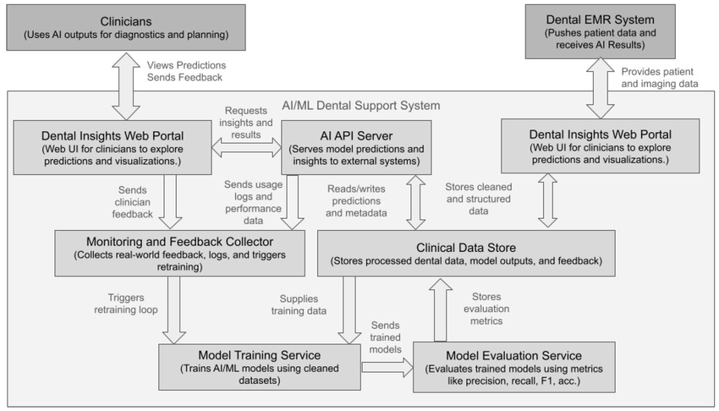
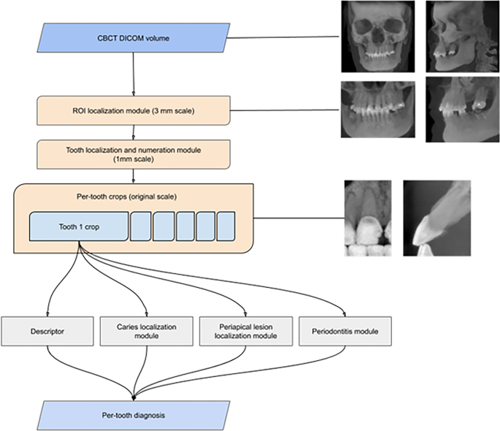
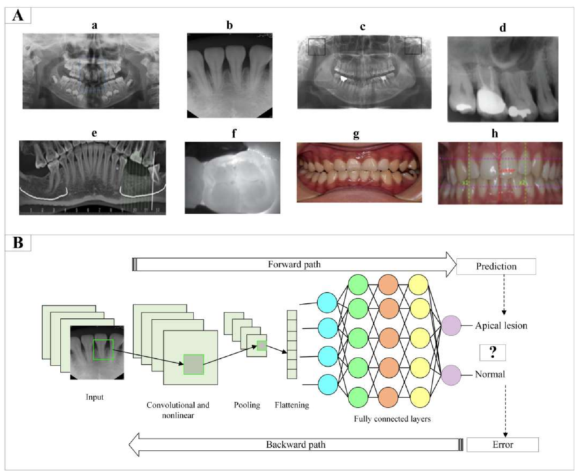
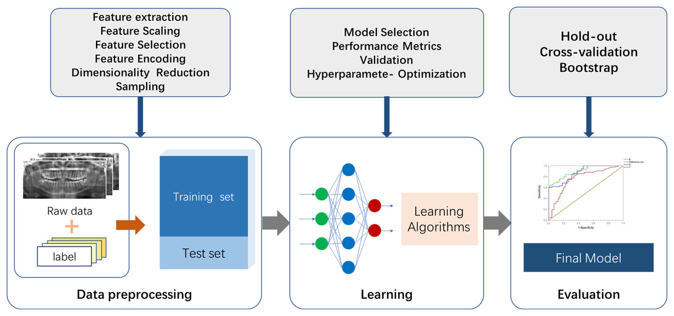
Legend:
This figure illustrates a typical AI workflow in dentistry:
Data acquisition → preprocessing → model training → validation → clinical deployment → decision support.

Given the rapid advancements in artificial intelligence and its growing relevance to dental practice, a comprehensive understanding of its applications and limitations is essential for clinicians and researchers alike. This review, therefore, aims to explore the current role of AI in dental health informatics from a clinical perspective. Particular emphasis is placed on diagnostic imaging, clinical decision support systems, barriers to implementation, and the economic implications of AI integration in dentistry.
Artificial Intelligence Models Used in Dentistry
Artificial intelligence encompasses a broad spectrum of computational approaches designed to simulate aspects of human cognitive processes, including learning, reasoning, and pattern recognition. Within dentistry, these technologies are primarily implemented through machine learning and deep learning models capable of processing large datasets derived from radiographic images, clinical records, and patient information. The application of these computational tools has expanded significantly over the past decade as dental practice has increasingly transitioned toward digital imaging systems and electronic health records. Such digitalization has created large repositories of clinical data that can be analyzed using advanced algorithms, thereby enabling the development of intelligent systems capable of assisting clinicians in diagnosis and treatment planning [2,3].
Machine learning refers to computational techniques that allow algorithms to learn patterns from data without being explicitly programmed for each specific task. In the context of dental informatics, machine learning models can analyze imaging datasets, identify diagnostic patterns, and generate predictions regarding disease presence or progression. Traditional machine learning approaches often rely on structured datasets in which relevant features are manually extracted and provided to the algorithm. These features may include radiographic measurements, anatomical landmarks, or clinical variables such as patient age, oral hygiene status, and medical history. By analyzing these variables, machine learning models can classify images or predict disease outcomes with increasing accuracy as more data becomes available [26].
Among the most widely used machine learning algorithms in dentistry are support vector machines (SVMs), decision tree models, and random forest algorithms. Support vector machines are supervised learning methods that classify data by identifying the optimal boundary separating different categories within a dataset. In dental research, SVM models have been applied to differentiate between normal and pathological structures on radiographic images and to classify various types of dental lesions. These algorithms are particularly useful when working with smaller datasets because they can achieve reliable classification performance even when the number of available training samples is limited.
Random forest algorithms represent another important machine learning technique used in dental informatics. These models operate by constructing multiple decision trees and combining their predictions to generate a final outcome. Random forest models are particularly effective when analyzing complex clinical datasets containing numerous variables. In dentistry, they have been used to predict periodontal disease risk, estimate treatment outcomes, and analyze patient behavioral factors associated with oral health. By integrating multiple clinical parameters, these algorithms can assist clinicians in identifying patients who may benefit from preventive interventions or more intensive monitoring.
While traditional machine learning models rely heavily on manual feature extraction, deep learning represents a more advanced approach capable of automatically learning relevant features directly from raw data. Deep learning algorithms are typically based on artificial neural networks, which are computational structures inspired by the architecture of the human brain. These networks consist of multiple interconnected layers that process data sequentially, allowing the system to identify increasingly complex patterns within the dataset. The ability of deep learning algorithms to automatically extract features makes them particularly suitable for analyzing medical images, where subtle patterns may be difficult to define manually.
Among deep learning architectures, convolutional neural networks (CNNs) have emerged as the most widely used model for dental imaging analysis. CNNs are specifically designed to process visual data by applying convolutional filters that detect patterns such as edges, textures, and shapes within an image. As the network processes the image through successive layers, it learns to recognize increasingly complex features that correspond to specific anatomical structures or pathological findings. This hierarchical feature extraction allows CNN models to identify dental diseases with a high degree of accuracy.
In dental radiology, CNN-based systems have been successfully applied to the detection of dental caries, periapical lesions, periodontal bone loss, and impacted teeth. Studies evaluating the performance of deep learning algorithms in caries detection have demonstrated promising results, with some models achieving diagnostic sensitivity comparable to experienced clinicians [6,7]. These findings highlight the potential of CNN-based systems to function as supportive diagnostic tools in routine dental practice.
Another area in which CNN models have shown significant promise is the analysis of panoramic radiographs and cone-beam computed tomography (CBCT) images. These imaging modalities generate large volumes of anatomical information that can be challenging to interpret, particularly when evaluating subtle pathological changes. Deep learning algorithms trained on large imaging datasets can analyze these images efficiently, identifying anatomical landmarks, detecting lesions, and assisting clinicians in treatment planning. For example, CNN models have been developed to automatically detect tooth structures and assign tooth numbering in panoramic radiographs, which can streamline digital charting processes in clinical settings [21].
In addition to imaging analysis, artificial intelligence is increasingly being applied to the interpretation of clinical records through natural language processing (NLP). NLP is a branch of AI that enables computers to understand and analyze human language. In dental informatics, NLP techniques can extract relevant clinical information from electronic dental records, including patient symptoms, diagnoses, and treatment outcomes. By converting unstructured text data into structured datasets, NLP algorithms facilitate large-scale clinical research and improve the organization of patient records.
The integration of NLP with other AI technologies may also support the development of advanced clinical decision support systems. Such systems can combine imaging findings with patient history, risk factors, and treatment records to generate diagnostic suggestions or treatment recommendations. Although these technologies are still evolving, they represent an important step toward more comprehensive digital healthcare systems capable of assisting clinicians in complex decision-making processes.
From a clinician’s perspective, the adoption of AI technologies must ultimately translate into practical benefits within daily practice. One of the most significant advantages of AI models is their ability to process large datasets rapidly and consistently. In busy clinical environments, clinicians may be required to interpret dozens of radiographs within a limited time frame. AI systems can assist by pre-screening images and highlighting areas of potential concern, thereby allowing clinicians to focus their attention on cases requiring detailed evaluation.
However, it is important to recognize that AI models are highly dependent on the quality and diversity of the data used during training. Algorithms trained on limited or biased datasets may perform poorly when applied to different patient populations or imaging conditions. For example, variations in radiographic equipment, exposure settings, and image quality can significantly influence algorithm performance. Consequently, the development of robust AI systems requires large and diverse datasets that accurately represent real-world clinical scenarios.
Another important consideration involves the interpretability of AI algorithms. Deep learning models are often described as “black box” systems because their internal decision-making processes may be difficult to interpret. For clinicians, understanding the rationale behind a diagnostic suggestion is critical for maintaining trust in AI-assisted systems. Recent research has therefore focused on developing explainable AI models that provide visual or statistical explanations for their predictions. Such developments may enhance clinician confidence and facilitate the integration of AI tools into routine clinical workflows.
The implementation of AI technologies also requires collaboration between dental professionals, computer scientists, and healthcare policymakers. Developing clinically useful algorithms involves not only technical expertise but also a deep understanding of dental pathology and clinical workflow. Interdisciplinary collaboration is therefore essential to ensure that AI systems address real clinical needs rather than purely theoretical problems.
As digital dentistry continues to evolve, AI models are expected to become increasingly integrated into diagnostic and treatment planning systems. Automated radiographic interpretation, digital treatment simulations, and predictive analytics may eventually become routine components of dental practice. Such technologies have the potential to enhance diagnostic precision, improve treatment outcomes, and support evidence-based decision-making.
Nevertheless, the successful integration of AI into dentistry will depend on maintaining a balance between technological innovation and clinical judgment. While AI systems can provide valuable analytical support, the ultimate responsibility for patient care remains with the clinician. Human expertise, ethical reasoning, and patient-centered decision-making cannot be replaced by algorithms. Instead, the future of dental health informatics will likely be defined by a collaborative relationship in which artificial intelligence complements the diagnostic and therapeutic skills of dental professionals.
Table 1. Applications of AI in Dental Health Informatics
Domain | AI Application | Clinical Benefit
Conservative Dentistry | Caries detection (bitewing radiographs) | Early diagnosis, minimally invasive treatment
Periodontology | Bone loss quantification | Improved staging and grading
Oral Medicine | Oral cancer detection | Early intervention, improved survival
Oral Radiology | Automated lesion detection | Reduced diagnostic variability
Orthodontics | Cephalometric analysis | Faster treatment planning
Implantology | Implant planning (CBCT-based AI) | Increased precision, reduced surgical errors
OMFS | Pathology detection, surgical simulation | Better decision-making and outcomes

Applications of Artificial Intelligence in Dental Diagnostics and Early Disease Detection
The application of artificial intelligence in dental diagnostics has expanded rapidly in recent years, largely driven by advancements in digital imaging technologies and the availability of large clinical datasets. Diagnostic procedures in dentistry rely heavily on the interpretation of radiographic images, intraoral photographs, and clinical findings, making the field particularly well suited for AI-driven analysis. Machine learning and deep learning models have demonstrated significant potential in assisting clinicians with the early detection of common oral diseases, thereby improving treatment outcomes and supporting preventive approaches to patient care. From a clinician’s perspective, the integration of AI into diagnostic workflows has the potential to reduce diagnostic variability, enhance efficiency, and support evidence-based clinical decision-making.
One of the most extensively studied applications of artificial intelligence in dentistry is the detection of dental caries. Dental caries remains one of the most prevalent oral diseases worldwide and is a major cause of tooth structure loss and restorative treatment. Early detection of carious lesions is critical for implementing minimally invasive treatment strategies and preventing disease progression. However, identifying early enamel lesions on radiographs can be challenging, particularly when lesions are subtle or masked by overlapping anatomical structures. Deep learning algorithms, particularly convolutional neural networks (CNNs), have demonstrated promising results in identifying carious lesions on bitewing radiographs with high sensitivity and accuracy [6,7]. These algorithms are capable of analyzing radiographic images pixel by pixel, identifying patterns associated with demineralization and early enamel breakdown that may be difficult for clinicians to detect during routine examination.
From a clinical standpoint, AI-assisted caries detection may serve as a valuable adjunct to traditional diagnostic methods. While experienced clinicians often rely on a combination of visual inspection, tactile examination, and radiographic interpretation, AI systems can provide an additional layer of analysis that may improve diagnostic confidence. Studies comparing the diagnostic performance of AI models and clinicians have shown that AI systems often demonstrate higher sensitivity in detecting early lesions, whereas clinicians tend to exhibit greater specificity by avoiding false-positive diagnoses [9]. When used together, these complementary strengths can enhance overall diagnostic accuracy and support more reliable treatment planning.
Artificial intelligence has also shown considerable promise in the diagnosis of periodontal disease. Periodontal diseases are characterized by inflammation and progressive destruction of the supporting structures of the teeth, including the periodontal ligament and alveolar bone. Radiographic evaluation of alveolar bone levels plays a critical role in assessing disease severity and determining appropriate treatment strategies. However, measurement of bone loss on radiographs can vary between clinicians due to differences in interpretation and measurement techniques. AI-based systems have been developed to automatically assess periodontal bone loss on panoramic and periapical radiographs, providing standardized measurements that can assist clinicians in evaluating disease progression [17].
These automated assessment systems analyze radiographic landmarks and calculate the distance between the cemento-enamel junction and the alveolar crest, which serves as a key indicator of periodontal bone loss. By providing consistent and objective measurements, AI systems may reduce interobserver variability and improve the monitoring of periodontal disease over time. In addition, such technologies may support large-scale epidemiological studies by enabling rapid analysis of radiographic datasets from population-based screenings.
Another important application of artificial intelligence in dental diagnostics involves the identification of periapical pathology. Periapical lesions often arise as a result of pulpal infection and may present as radiolucent areas around the root apex on radiographic images. Detecting these lesions can sometimes be challenging, particularly when lesions are small or located in anatomically complex regions. Deep learning algorithms trained on radiographic datasets have demonstrated the ability to identify periapical lesions with high accuracy, often matching the diagnostic performance of experienced clinicians [20]. These systems can assist clinicians in identifying areas that require further evaluation, thereby improving diagnostic efficiency in busy clinical environments.
Artificial intelligence has also been applied in orthodontic diagnostics, where accurate identification of anatomical landmarks is essential for treatment planning. Orthodontic analysis often involves the evaluation of cephalometric radiographs, which require the precise identification of skeletal and dental landmarks. Manual landmark identification can be time-consuming and may vary between clinicians depending on their level of experience. AI-driven systems have been developed to automatically identify cephalometric landmarks on radiographs, enabling rapid and standardized orthodontic analysis [23]. Such technologies may significantly reduce the time required for orthodontic treatment planning while improving consistency in measurements.
Beyond radiographic analysis, artificial intelligence is increasingly being used in the detection of potentially malignant oral disorders and oral cancers. Oral squamous cell carcinoma remains a major global health concern, particularly in regions with high prevalence of tobacco and alcohol use. Early detection of oral cancer significantly improves prognosis and survival rates; however, early-stage lesions may be difficult to identify during routine clinical examinations. AI-based diagnostic models trained on clinical photographs and histopathological images have shown encouraging results in identifying suspicious lesions and distinguishing malignant changes from benign oral conditions [8]. These systems analyze subtle variations in tissue color, texture, and morphology that may not be readily apparent to the human eye.
From a clinical perspective, AI-assisted screening tools may be particularly valuable in community health programs and primary care settings where access to specialist expertise is limited. Automated screening systems could assist general practitioners in identifying lesions that require referral to oral medicine or oral surgery specialists. In this way, AI technologies may contribute to earlier diagnosis and improved patient outcomes.
Another area in which artificial intelligence is demonstrating growing relevance is implant dentistry. Successful implant placement requires careful evaluation of bone quality, anatomical structures, and prosthetic considerations. Cone-beam computed tomography (CBCT) has become an essential imaging modality for implant planning, providing three-dimensional visualization of the maxillofacial region. However, interpreting CBCT datasets requires significant expertise and time. AI-based systems have been developed to assist clinicians in analyzing CBCT images, identifying anatomical landmarks, and evaluating bone volume and density for implant placement [22]. These systems can also help detect critical structures such as the inferior alveolar nerve and maxillary sinus, thereby reducing the risk of surgical complications.
In addition to improving diagnostic accuracy, artificial intelligence may enhance workflow efficiency in dental practice. Automated detection systems can rapidly analyze radiographic images and highlight areas of potential concern, allowing clinicians to focus their attention on cases requiring detailed evaluation. In high-volume clinical environments, such as hospital dental departments or community clinics, AI-assisted screening tools may significantly reduce the time required for radiographic interpretation.
Despite these promising applications, clinicians need to recognize that AI technologies are not intended to replace professional judgment. The interpretation of diagnostic findings must always be considered within the broader context of the patient’s clinical presentation, medical history, and treatment goals. AI systems function most effectively as supportive tools that augment clinician expertise rather than as independent decision-making systems.
Furthermore, the reliability of AI algorithms depends heavily on the quality of the data used during training. Algorithms trained on limited or biased datasets may produce inaccurate results when applied to different patient populations or imaging conditions. Therefore, ongoing research and validation studies are essential to ensure that AI systems perform consistently across diverse clinical environments.
Artificial Intelligence vs Clinician Decision-Making in Dentistry
The increasing integration of artificial intelligence (AI) into dental diagnostics has generated significant interest regarding how AI-based systems compare with clinician decision-making. Early studies evaluating AI in healthcare primarily focused on determining whether algorithms could match or surpass human diagnostic accuracy. However, more recent perspectives emphasize the complementary relationship between AI systems and clinician expertise. Dentistry involves complex clinical reasoning that extends beyond radiographic interpretation to include patient history, clinical examination findings, behavioral risk factors, and treatment preferences. Consequently, evaluating the role of AI in dental decision-making requires consideration of both technological performance and the contextual judgment provided by clinicians.
Artificial intelligence systems, particularly those based on deep learning architectures such as convolutional neural networks (CNNs), have demonstrated remarkable ability in identifying patterns within large imaging datasets. In dental radiology, CNN models trained on annotated radiographs can rapidly analyze images and detect pathological changes associated with dental caries, periodontal bone loss, and periapical lesions. Several studies have reported that AI systems can achieve diagnostic sensitivity comparable to experienced clinicians when detecting proximal caries or identifying radiolucent lesions on bitewing radiographs [5,6]. Such findings highlight the potential of AI technologies to function as valuable diagnostic adjuncts in routine dental practice.
Despite these encouraging results, diagnostic accuracy in dentistry involves more than simply identifying radiographic abnormalities. Clinicians interpret radiographic findings within the broader clinical context of each patient. Factors such as symptoms, caries risk assessment, dietary habits, oral hygiene practices, and medical history often influence diagnostic interpretation and treatment planning. Artificial intelligence algorithms may successfully detect radiographic patterns suggestive of disease but often lack the contextual awareness required to incorporate these additional variables unless specifically trained using comprehensive clinical datasets.Human–AI Collaboration Model in Dentistry

Fig 2. AI-Human Collaboration Task
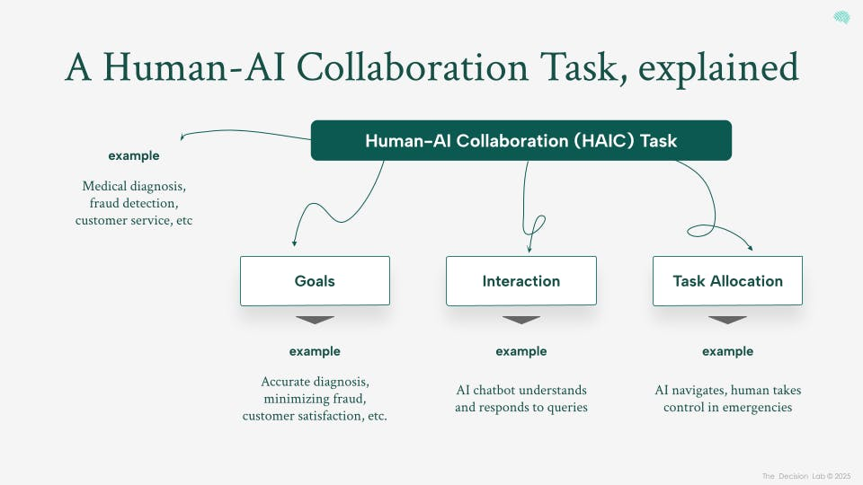
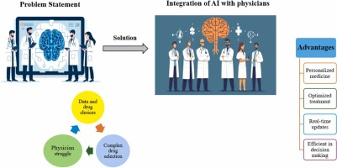
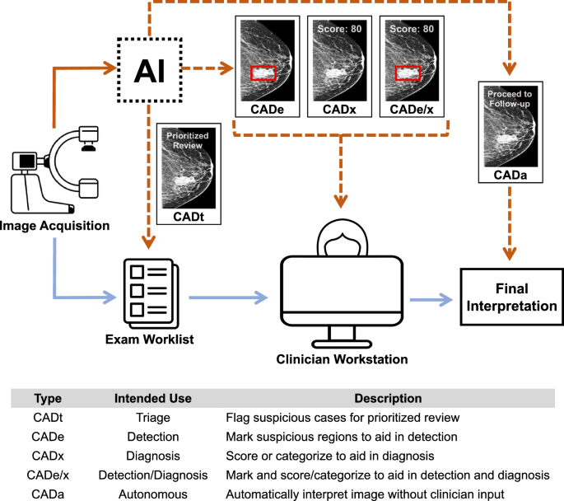

Legend:
AI provides diagnostic suggestions → clinician integrates clinical context → final decision-making → improved patient outcomes.

For example, a radiographic radiolucency suggestive of early proximal caries may not necessarily require operative intervention. An experienced clinician may evaluate lesion activity, fluoride exposure, and the patient’s oral hygiene status before deciding on a preventive or restorative treatment approach. In contrast, an AI algorithm trained solely on radiographic images may identify the lesion but cannot independently determine the most appropriate management strategy. Therefore, AI-generated outputs must be interpreted by clinicians who possess the necessary clinical knowledge to guide patient-centered treatment decisions.
Another important consideration when comparing AI systems with clinicians involves the balance between sensitivity and specificity. Artificial intelligence models often demonstrate high sensitivity, meaning they are capable of detecting a large proportion of potential pathological findings. However, increased sensitivity may be associated with higher false-positive rates, as algorithms may identify radiographic patterns that resemble disease but do not correspond to clinically significant pathology. Clinicians, relying on experience and contextual interpretation, may demonstrate greater specificity by avoiding unnecessary diagnoses or interventions.
These differences highlight the potential advantages of combining AI analysis with clinician expertise. In clinical practice, AI systems may function as preliminary screening tools that identify areas of potential concern on radiographs. The clinician can then evaluate these highlighted regions and determine whether the findings are clinically relevant. Such collaborative workflows may ultimately improve diagnostic accuracy while reducing the likelihood of missed lesions.
Artificial intelligence may also assist in reducing interobserver variability in radiographic interpretation. Differences in clinician training, experience, and fatigue can influence diagnostic outcomes. AI algorithms provide consistent analytical outputs and may serve as a standardized “second reader” during image interpretation. By highlighting suspicious regions on radiographs, AI systems may help clinicians identify subtle findings that might otherwise be overlooked during routine examinations.
Table 2. Comparison of AI vs Clinician Decision-Making in Dentistry
Parameter | Artificial Intelligence | Clinician
Diagnostic Accuracy | High (especially imaging-based) | High (experience-dependent)
Consistency | Excellent | Variable
Speed | Rapid | Moderate
Contextual Judgment | Limited | Strong
Fatigue Influence | None | Present
Ethical Reasoning | Absent | Present
Adaptability | Limited in rare cases | High

However, several limitations remain. Artificial intelligence systems depend heavily on the datasets used during training. Algorithms trained on limited or biased datasets may demonstrate reduced accuracy when applied to new patient populations or imaging environments. Variations in radiographic equipment, exposure parameters, and image quality can also influence algorithm performance. Consequently, clinicians must continue to exercise professional judgment when interpreting AI-generated outputs.
Another important issue concerns the interpretability of AI algorithms. Many deep learning systems operate as complex computational models whose internal processes are difficult to interpret. This “black box” nature has raised concerns within the medical community regarding transparency and accountability in AI-assisted decision-making [36]. Clinicians may be reluctant to rely on algorithm-based recommendations if the reasoning behind those conclusions cannot be clearly explained.
To address this challenge, researchers have developed explainable artificial intelligence (XAI) methods that provide visual representations of algorithm reasoning. For instance, heatmaps or saliency maps can highlight the specific regions of a radiographic image that contributed to a diagnostic prediction. Such techniques allow clinicians to verify whether the AI system’s interpretation aligns with their own assessment.
Importantly, clinical decision-making in dentistry involves ethical considerations, patient communication, and individualized treatment planning. Discussions regarding treatment options, financial considerations, long-term prognosis, and patient preferences are integral aspects of dental care that cannot be replicated by computational systems. These human-centered elements remain essential components of clinical practice.
For these reasons, the most realistic model for AI integration in dentistry is one in which artificial intelligence functions as a supportive tool that augments clinician expertise. This concept of “augmented intelligence” emphasizes the collaborative relationship between computational systems and healthcare professionals [42]. AI algorithms provide analytical support by processing large datasets and identifying patterns, while clinicians interpret these findings within the broader context of patient care.
Evidence from other medical disciplines suggests that diagnostic accuracy often improves when AI systems and clinicians work together compared with either approach alone [10]. Similar collaborative models are likely to become increasingly important in dentistry as AI technologies continue to evolve. Ultimately, the goal of integrating artificial intelligence into dental practice should be to enhance clinical decision-making while preserving the essential role of professional judgment.
Barriers to AI Adoption in Dental Practice
Despite the considerable potential of artificial intelligence in dental health informatics, the integration of AI technologies into routine dental practice remains limited. Several technical, ethical, regulatory, and practical challenges must be addressed before AI systems can be widely adopted in clinical environments. Understanding these barriers is essential for clinicians, researchers, and policymakers seeking to implement AI-based technologies responsibly within dental healthcare systems.
One of the most significant challenges involves the availability and quality of training datasets used for developing AI algorithms. Machine learning models require large volumes of accurately labeled clinical data to achieve reliable performance. In dentistry, however, standardized datasets containing well-annotated radiographic images and comprehensive clinical information remain relatively scarce. Many existing datasets originate from single institutions or limited patient populations, which may reduce the generalizability of AI models across different clinical settings [11].
Variability in radiographic acquisition protocols further complicates algorithm development. Differences in imaging equipment, exposure parameters, image resolution, and patient positioning can significantly influence radiographic appearance. Algorithms trained on images obtained from one imaging system may perform poorly when applied to images acquired using different technologies. Developing robust AI models therefore requires multicenter datasets that reflect the diversity of real-world clinical environments.
Another important barrier relates to the interpretability of AI algorithms. Deep learning models often function as complex computational systems whose internal processes are difficult to interpret. This lack of transparency may create uncertainty among clinicians who are ultimately responsible for patient care decisions. Without clear explanations of how AI systems arrive at diagnostic conclusions, clinicians may hesitate to rely on algorithm-generated recommendations [36].
Ethical considerations also represent a significant challenge. Algorithmic bias may occur when training datasets do not adequately represent diverse patient populations. If AI systems are developed using data derived from limited demographic groups, diagnostic performance may vary across different populations. Such disparities could potentially contribute to unequal healthcare outcomes if not carefully addressed [12].
Patient privacy and data security represent additional concerns. AI development often requires access to large datasets containing radiographic images, clinical records, and demographic information. Protecting patient confidentiality is essential when collecting and utilizing these datasets. Secure data storage systems, anonymization protocols, and strict adherence to healthcare data protection regulations are therefore necessary when implementing AI technologies.
Regulatory frameworks for AI-based medical technologies are still evolving. Traditional regulatory processes were designed primarily for static medical devices rather than adaptive algorithms that may change over time through continuous learning. Developing regulatory pathways that ensure both patient safety and technological innovation remains an ongoing challenge for healthcare authorities [38].
Economic considerations also influence the adoption of AI in dental practice. Implementing AI systems requires investment in compatible digital infrastructure, software platforms, and clinician training. For smaller dental practices with limited financial resources, these costs may represent a significant barrier. Demonstrating clear improvements in diagnostic accuracy, efficiency, and patient outcomes will therefore be essential for encouraging broader adoption.
Clinician acceptance is another important factor influencing AI integration. Many dental professionals have limited exposure to machine learning technologies during their formal education. As a result, some practitioners may feel uncertain about how AI systems function or how they should be incorporated into clinical workflows. Educational initiatives that introduce dental professionals to AI principles and applications may help address these concerns.
Table 3. Barriers to AI Adoption in Dentistry
Category | Barrier | Impact
Human | Lack of trust, limited training | Resistance to adoption
Technical | Poor data quality, lack of standardization | Reduced accuracy
Organizational | High cost, infrastructure gaps | Limited implementation
Ethical | Privacy concerns, bias | Legal and moral challenges

Finally, the successful implementation of AI technologies requires interdisciplinary collaboration between dental professionals, computer scientists, and healthcare policymakers. Developing clinically relevant AI systems requires not only technical expertise but also a deep understanding of dental pathology and clinical workflows.
Addressing these challenges will be essential for enabling the responsible and effective integration of artificial intelligence into modern dental practice.
Cost–Benefit Analysis and Economic Impact of AI in Dentistry
The integration of artificial intelligence into dental healthcare systems has important economic implications for clinicians, healthcare institutions, and policymakers. While AI technologies offer significant potential for improving diagnostic accuracy and clinical efficiency, their implementation requires financial investment in digital infrastructure, software systems, and professional training. Evaluating the economic impact of AI adoption in dentistry therefore involves assessing both the costs associated with implementation and the long-term benefits that may arise from improved diagnostic capabilities and preventive care.
One of the most significant economic advantages of artificial intelligence in dentistry relates to improved early disease detection. Many common oral diseases, including dental caries and periodontal disease, progress gradually and may remain asymptomatic during their early stages. When diagnosis is delayed, treatment often becomes more complex and costly, requiring procedures such as root canal therapy, periodontal surgery, or prosthetic rehabilitation. AI-assisted diagnostic systems capable of identifying early pathological changes on radiographic images may allow clinicians to intervene earlier in the disease process. Early intervention through preventive or minimally invasive treatments is generally less expensive than managing advanced disease stages, thereby reducing the overall economic burden of oral healthcare [14].
From a preventive dentistry perspective, the economic benefits of early disease detection can be substantial. Preventive interventions such as fluoride therapy, dietary counseling, and minimally invasive restorative procedures require fewer resources compared with extensive restorative or surgical treatments. AI technologies that assist clinicians in identifying early carious lesions or periodontal bone loss may therefore support a preventive approach to oral healthcare, which has long been recognized as a cost-effective strategy for improving population oral health outcomes.
Artificial intelligence may also improve efficiency in dental practice workflows. Radiographic interpretation represents a routine yet time-consuming aspect of clinical practice, particularly in high-volume dental clinics or hospital settings. AI algorithms capable of automatically analyzing radiographs and identifying potential abnormalities can streamline the diagnostic process. By highlighting areas of concern, AI systems allow clinicians to focus their attention on cases requiring detailed evaluation. This increased efficiency may reduce the time required for radiographic interpretation and potentially improve patient throughput within dental practices.
Another area in which AI may generate economic benefits involves predictive analytics for treatment planning. Machine learning models can analyze patient data, including radiographic findings, clinical parameters, and behavioral risk factors, to estimate the likelihood of disease progression or treatment outcomes. For example, predictive algorithms may identify patients at high risk for periodontal disease progression or implant failure. Early identification of high-risk patients allows clinicians to implement preventive measures or alternative treatment strategies, potentially reducing the likelihood of costly complications or treatment failures.
Despite these potential advantages, the initial costs associated with implementing AI technologies should not be underestimated. Dental practices may need to invest in compatible digital imaging systems, specialized software platforms, and secure data storage infrastructure capable of supporting AI applications. In addition, clinicians and staff may require training to effectively utilize AI-assisted diagnostic tools. For smaller dental practices with limited financial resources, these initial investments may represent a barrier to adoption.
Another economic consideration involves the ongoing maintenance and updating of AI systems. Machine learning algorithms require periodic updates and retraining to maintain optimal performance as new clinical data become available. Software licensing fees, technical support, and system upgrades may contribute to recurring operational expenses. Consequently, evaluating the long-term cost-effectiveness of AI technologies requires consideration of both initial implementation costs and ongoing maintenance expenditures.

Figure 3. Cost–Benefit Curve of AI Implementation
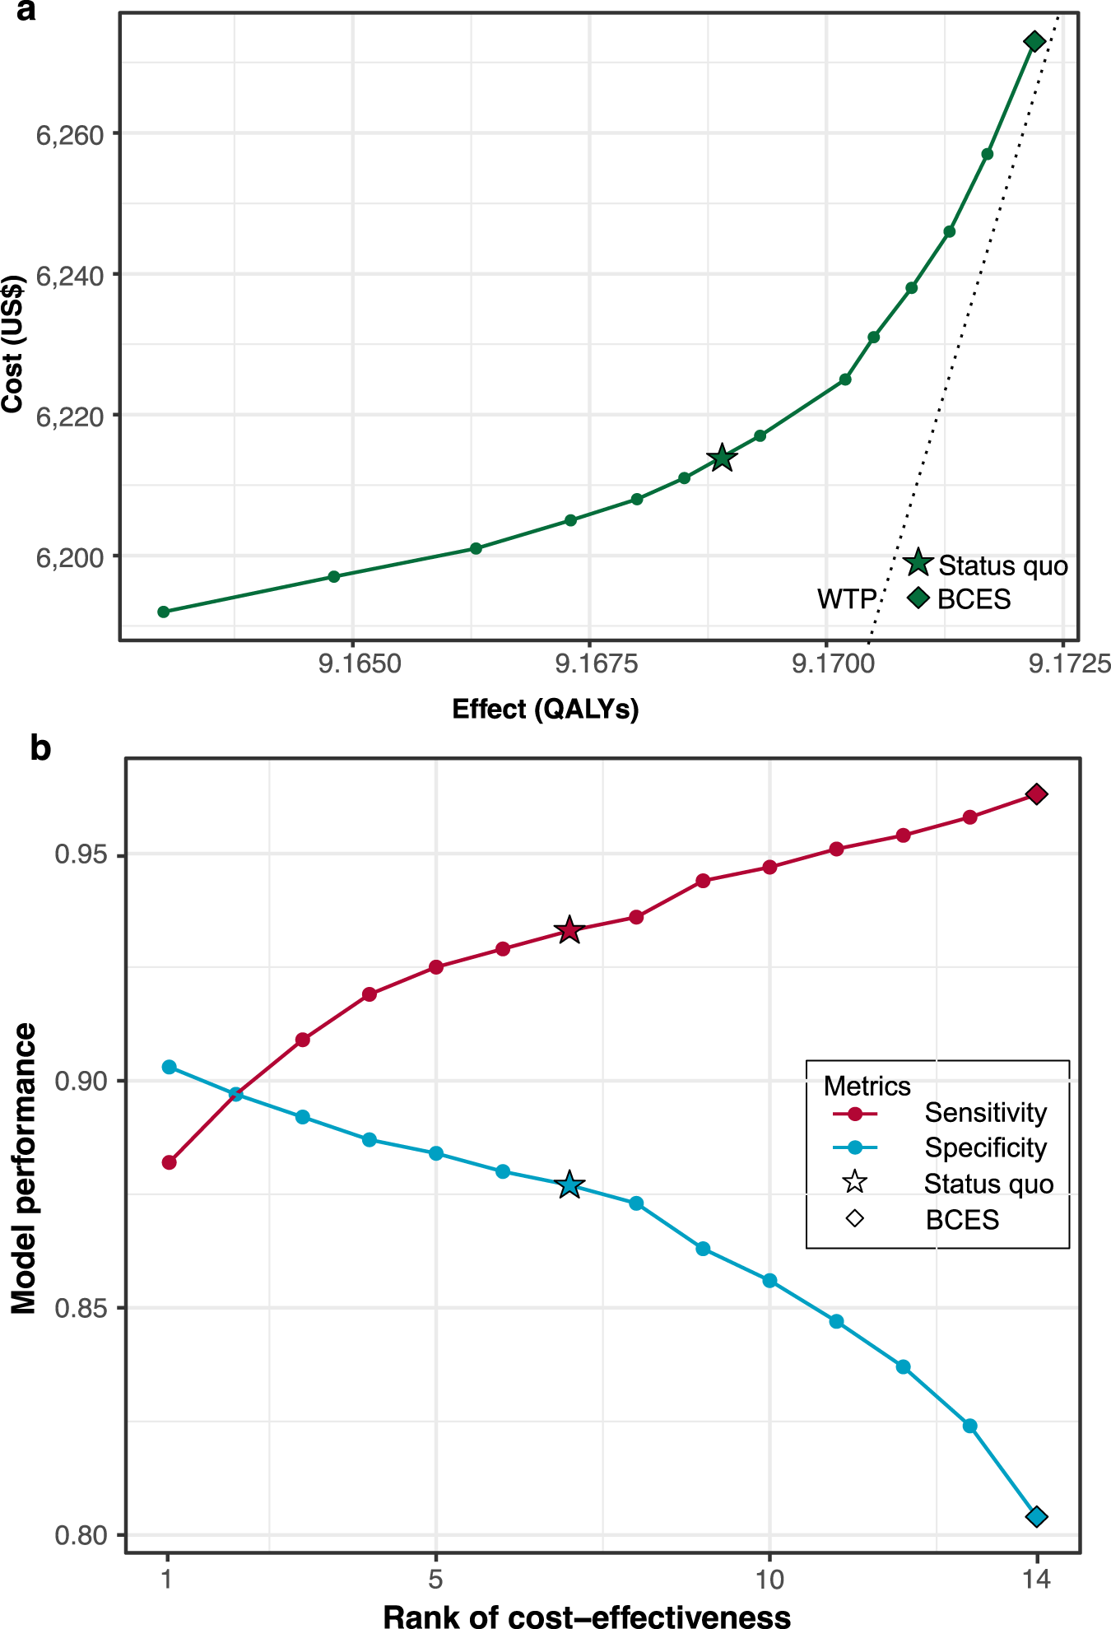
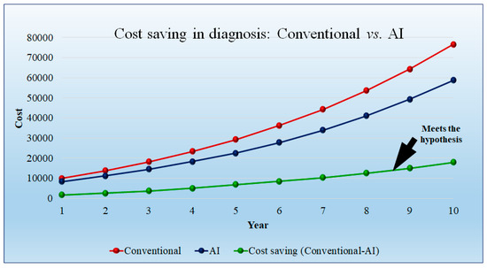
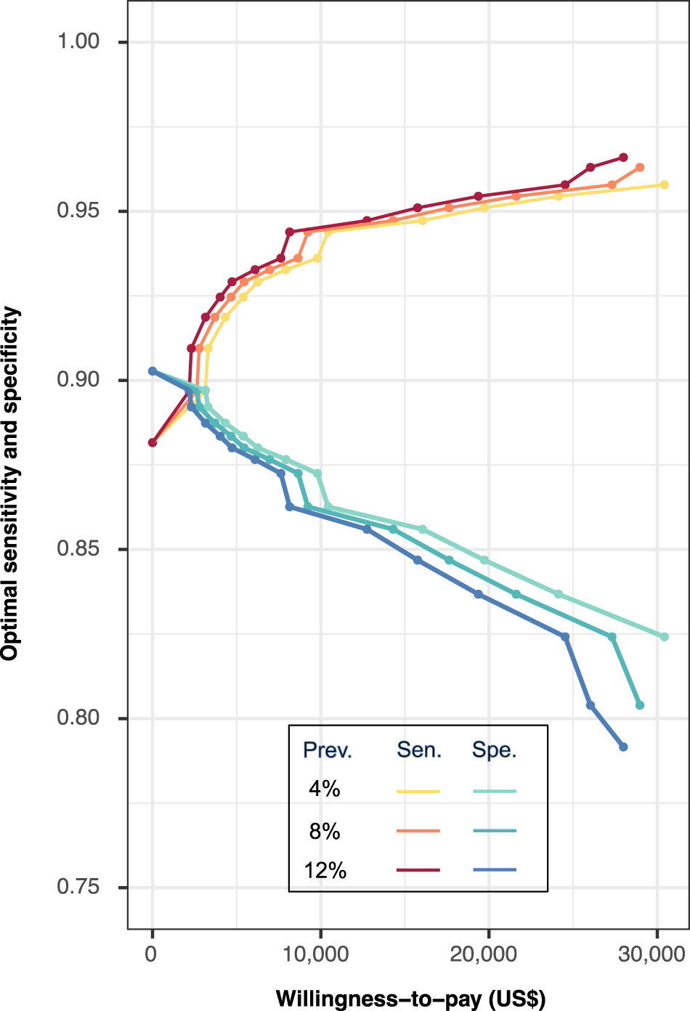
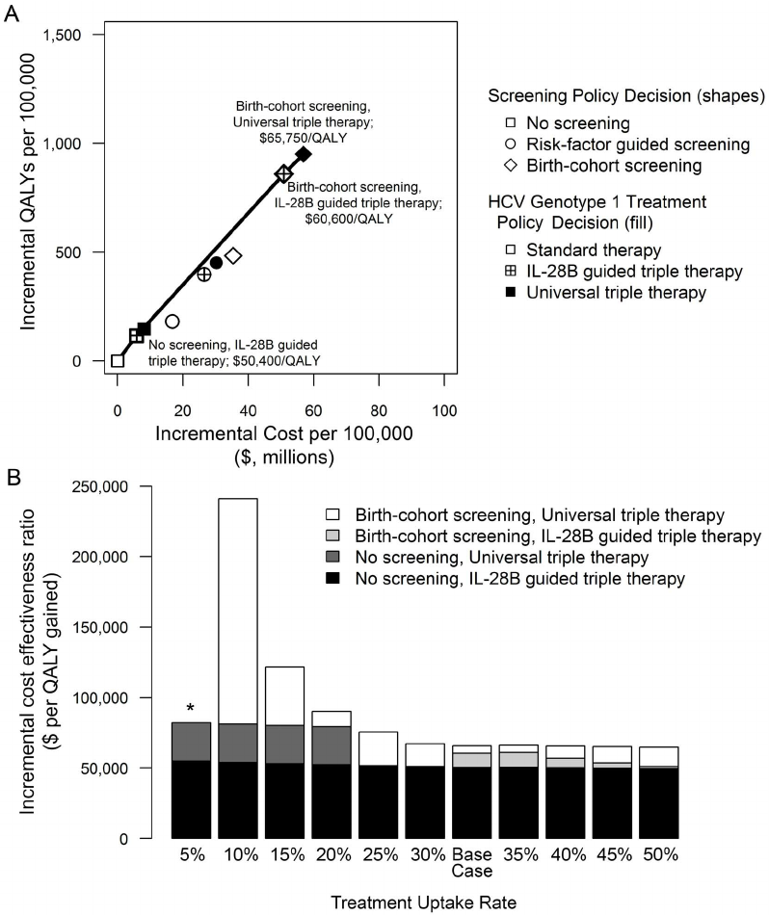
Legend:
Initial costs are high during implementation, but long-term benefits outweigh costs due to improved efficiency and early diagnosis.

Health economic studies evaluating AI applications in healthcare have suggested that AI-assisted diagnostic systems may ultimately prove cost-effective, particularly in screening and preventive care programs [13]. For example, early detection of oral cancer through AI-supported screening tools may significantly reduce the costs associated with advanced oncologic treatment while improving patient survival outcomes. Similar benefits may be observed in large-scale population screening programs for dental diseases.
In addition to direct financial benefits, AI integration may also generate indirect economic advantages. Improved diagnostic accuracy and streamlined clinical workflows may enhance patient satisfaction and treatment outcomes. Patients who receive timely and accurate diagnoses are more likely to maintain trust in their healthcare providers and adhere to recommended treatment plans. From a practice management perspective, increased efficiency and improved clinical outcomes may contribute to stronger patient retention and practice reputation.
Table 4. Cost vs Benefit Analysis of AI in Dentistry
Aspect | Costs | Benefits
Financial | Software, hardware, maintenance | Reduced long-term treatment costs
Clinical | Training time | Improved diagnostic accuracy
Workflow | Integration challenges | Faster decision-making
Patient Outcomes | Initial adjustment | Early diagnosis, better prognosis

From a broader healthcare perspective, artificial intelligence may facilitate more efficient allocation of healthcare resources. Automated screening systems could enable large-scale community dental screening programs capable of identifying individuals at high risk for oral diseases. By prioritizing patients who require specialized care, such systems may improve access to dental services and reduce the burden on specialist clinics.
Ultimately, while artificial intelligence has the potential to generate substantial economic benefits in dentistry, its successful implementation requires careful planning and evaluation. Cost-effectiveness analyses must consider not only the financial costs of AI systems but also their impact on clinical outcomes, workflow efficiency, and preventive care. As research in dental health informatics continues to evolve, further economic studies will be necessary to determine the most effective strategies for integrating AI technologies into dental healthcare systems.
7. Discussion and Future Directions
Artificial intelligence is rapidly transforming many aspects of healthcare, and dentistry is increasingly benefiting from these technological advancements. As digital imaging technologies, electronic dental records, and advanced diagnostic tools become more widely adopted, the volume of clinical data generated in dental practice continues to expand. Artificial intelligence systems provide powerful analytical tools capable of processing these large datasets and identifying diagnostic patterns that may support clinical decision-making.
The findings discussed in this review demonstrate that AI technologies have considerable potential to enhance multiple aspects of dental healthcare. AI-assisted diagnostic systems have shown promising results in detecting dental caries, periodontal bone loss, periapical pathology, and oral malignancies. In addition, AI applications are being developed to assist with orthodontic analysis, implant planning, and automated dental charting. These technologies may significantly improve diagnostic efficiency and reduce variability in radiographic interpretation.
Future research in dental artificial intelligence will likely focus on developing more integrated diagnostic systems capable of analyzing multiple types of clinical data simultaneously. Current AI models often analyze individual data sources, such as radiographic images or intraoral photographs. However, combining imaging data with patient medical history, behavioral risk factors, and genetic information may allow AI systems to generate more comprehensive diagnostic predictions. Such developments may contribute to the emergence of precision dentistry, in which treatment strategies are tailored to the unique characteristics of each patient.
Another promising direction for future development involves integrating AI technologies with emerging digital dentistry systems. Advances in intraoral scanning, computer-aided design and manufacturing (CAD/CAM), and digital orthodontic planning have already transformed many aspects of dental practice. Artificial intelligence may further enhance these technologies by automating diagnostic processes, optimizing treatment planning, and predicting treatment outcomes.
Tele-dentistry represents another important area where AI technologies may play an increasingly significant role. Remote screening systems powered by artificial intelligence could allow clinicians to evaluate oral conditions using digital images transmitted through telehealth platforms. Such technologies may expand access to dental care in underserved regions where specialist services are limited. AI-assisted screening tools may help primary care providers identify patients who require referral to dental specialists, thereby improving early detection of oral diseases.
However, the future development of AI in dentistry must address several ongoing challenges. Ensuring transparency, reliability, and fairness in AI algorithms remains essential for maintaining clinician confidence and patient safety. Regulatory frameworks must continue to evolve to accommodate the unique characteristics of AI-based medical technologies while maintaining rigorous standards for safety and effectiveness.
Education will also play a critical role in facilitating the successful adoption of artificial intelligence in dental practice. Dental professionals must develop a basic understanding of AI technologies in order to effectively interpret algorithm outputs and integrate them into clinical workflows. Incorporating digital health and artificial intelligence education into dental curricula may help prepare future clinicians for the evolving landscape of technology-assisted dentistry.
Ultimately, the future of artificial intelligence in dentistry will likely be defined by collaboration between clinicians, researchers, and technology developers. Interdisciplinary research efforts will be essential for developing AI systems that address real clinical challenges and improve patient care.
Rather than replacing clinicians, artificial intelligence should be viewed as a supportive tool that enhances the diagnostic and analytical capabilities of dental professionals. By combining the computational power of AI with the clinical expertise of dental practitioners, dentistry may move toward a more precise, efficient, and patient-centered model of oral healthcare.
Conclusion
Artificial intelligence is rapidly emerging as a transformative technology in dental health informatics. Advances in machine learning and deep learning algorithms have enabled the development of AI systems capable of analyzing complex clinical datasets, particularly radiographic images, with levels of diagnostic accuracy that increasingly approach those of experienced clinicians.
Applications of artificial intelligence in dentistry now extend across multiple areas of clinical practice. AI-assisted diagnostic systems have demonstrated promising results in detecting dental caries, periodontal disease, periapical lesions, and oral malignancies. In addition, AI technologies are being integrated into orthodontic analysis, implant planning, and clinical decision-support systems. These developments highlight the potential of AI technologies to support preventive dentistry and improve treatment outcomes through earlier and more accurate disease detection.
Despite these promising advancements, several challenges must be addressed before artificial intelligence can be fully integrated into routine dental practice. Issues related to data quality, algorithm transparency, ethical considerations, regulatory oversight, and economic feasibility remain important areas of concern. Addressing these challenges will require collaboration among clinicians, researchers, technology developers, and healthcare policymakers.
From a clinical perspective, artificial intelligence should not be viewed as a replacement for professional expertise. Instead, AI technologies are most effective when used as supportive tools that augment clinical judgment and enhance evidence-based decision-making. The combination of human expertise and computational intelligence offers the greatest potential for improving diagnostic accuracy and patient care.
As research in dental artificial intelligence continues to evolve, these technologies are likely to become increasingly integrated into digital dental workflows. With careful implementation and ongoing evaluation, artificial intelligence has the potential to significantly enhance the quality, efficiency, and accessibility of oral healthcare delivery.
References
- Topol EJ. High-performance medicine: the convergence of human and artificial intelligence. Nat Med. 2019;25(1):44-56. https://doi.org/10.1038/s41591-018-0300-7
- Litjens G, Kooi T, Bejnordi BE, Setio AAA, Ciompi F, Ghafoorian M, et al. A survey on deep learning in medical image analysis. Med Image Anal. 2017;42:60-88. https://doi.org/10.1016/j.media.2017.07.005
- Jiang F, Jiang Y, Zhi H, Dong Y, Li H, Ma S, Wang Y, et al. Artificial intelligence in healthcare: past, present and future. Stroke Vasc Neurol. 2017;2(4):230-243. https://doi.org/10.1136/svn-2017-000101
- Schwendicke F, Samek W, Krois J. Artificial intelligence in dentistry: chances and challenges. J Dent Res. 2020;99(7):769-774. https://doi.org/10.1177/0022034520915714
- Lee JH, Kim DH, Jeong SN, Choi SH. Detection and diagnosis of dental caries using a deep learning-based convolutional neural network algorithm. Sci Rep. 2018;8:1-7. https://doi.org/10.1038/s41598-018-26007-9
- Cantu AG, Gehrung S, Krois J, Chaurasia A, Rossi JG, Gaudin R, et al. Detecting caries lesions using deep learning on dental radiographs. J Dent. 2020;103:103425. https://doi.org/10.1016/j.jdent.2020.103425
- Krois J, Ekert T, Meinhold L, Golla T, Kharbot B, Wittemeier A, et al. Deep learning for the radiographic detection of proximal caries. J Dent Res. 2019;98(12):1360-1367. https://doi.org/10.1177/0022034519878104
- Fu Q, Chen Y, Li Z, Wang Y. Artificial intelligence for oral cancer detection. Oral Oncol. 2020;104:104741. https://doi.org/10.1016/j.oraloncology.2020.104741
- Liu X, Faes L, Kale AU, Wagner SK, Fu DJ, Bruynseels A, et al. A comparison of deep learning performance against healthcare professionals in disease detection. Lancet Digit Health. 2019;1(6):e271-e297. https://doi.org/10.1016/S2589-7500(19)30123-2
- Esteva A, Kuprel B, Novoa RA, Ko J, Swetter SM, Blau HM, et al. Dermatologist-level classification of skin cancer with deep neural networks. Nature. 2017;542(7639):115-118. https://doi.org/10.1038/nature21056
- Kelly CJ, Karthikesalingam A, Suleyman M, Corrado G, King D. Key challenges for delivering clinical impact with artificial intelligence. BMC Med. 2019;17:195. https://doi.org/10.1186/s12916-019-1426-2
- Obermeyer Z, Powers B, Vogeli C, Mullainathan S. Dissecting racial bias in an algorithm used to manage the health of populations. Science. 2019;366(6464):447-453. https://doi.org/10.1126/science.aax2342
- Wang Y, Kung L, Byrd TA. Economic evaluation of artificial intelligence in healthcare. npj Digit Med. 2024;7:1-10. https://doi.org/10.1038/s41746-024-01032-9
- Schwendicke F, Samek W, Krois J. Cost-effectiveness of artificial intelligence in dentistry. J Dent. 2022;119:104093. https://doi.org/10.1016/j.jdent.2022.104093
- Hung M, Voss MW, Rosales MN, Li W, Su W, Xu J, et al. Artificial intelligence and dental informatics: a systematic review. Int J Med Inform. 2020;137:104222. https://doi.org/10.1016/j.ijmedinf.2020.104222
- Patel J, et al. Artificial intelligence in oral and maxillofacial radiology: current applications and future directions. Oral Surg Oral Med Oral Pathol Oral Radiol. 2021. https://doi.org/10.1016/j.oooo.2021.03.012
- Park WJ, Park JB. History and application of artificial intelligence in dentistry. J Clin Periodontol. 2021. https://doi.org/10.1111/jcpe.13461
- Kim J, Lee HS, Song IS, Jung KH. DeNTNet: deep neural transfer network for detection of periodontal bone loss using panoramic radiographs. Sci Rep. 2020;10:17615. https://doi.org/10.1038/s41598-020-70942-3
- Lee KS, et al. Artificial intelligence-based detection and analysis in CBCT imaging. Dentomaxillofac Radiol. 2022;51. https://doi.org/10.1259/dmfr.20210145
- Ariji Y, Yanashita Y, Kutsuna S, Muramatsu C, Fukuda M, Kise Y, et al. Automatic detection and classification of dental lesions using deep learning. Oral Radiol. 2019;35:361-368. https://doi.org/10.1007/s11282-019-00385-9
- Tuzoff DV, Tuzova LN, Bornstein MM, Krasnov AS, Kharchenko MA, Nikolenko SI, et al. Tooth detection and numbering in panoramic radiographs using convolutional neural networks. Comput Methods Programs Biomed. 2019;174:17-23. https://doi.org/10.1016/j.cmpb.2018.12.009
- Chen H, et al. Artificial intelligence-assisted implant planning. Clin Oral Implants Res. 2022. https://doi.org/10.1111/clr.13850
- Miki Y, Muramatsu C, Hayashi T, Zhou X, Hara T, Katsumata A, et al. Classification of teeth in cone-beam CT using deep learning. Angle Orthod. 2020;90(3):371-377. https://doi.org/10.2319/022020-144.1
- Heo MS, Kim JE, Hwang JJ, Han SS. Artificial intelligence in dental diagnosis. Imaging Sci Dent. 2019;49(1):1-7. https://doi.org/10.5624/isd.2019.49.1.1
- Zhang X, et al. Deep learning-based pathology detection for oral cancer. J Pathol Inform. 2021;12:9. https://doi.org/10.4103/jpi.jpi_92_20
- Rajkomar A, Dean J, Kohane I. Machine learning in medicine. npj Digit Med. 2018;1:18. https://doi.org/10.1038/s41746-018-0029-1
- Beam AL, Kohane IS. Big data and machine learning in health care. JAMA. 2018;319(13):1317-1318. https://doi.org/10.1001/jama.2017.18391
- Deo RC. Machine learning in medicine. Circulation. 2015;132(20):1920-1930. https://doi.org/10.1161/CIRCULATIONAHA.115.001593
- Wiens J, Saria S, Sendak M, Ghassemi M, Liu VX, Doshi-Velez F, et al. Do no harm: a roadmap for responsible machine learning for health care. Nat Biomed Eng. 2019;3:173-182. https://doi.org/10.1038/s41551-018-0304-3
- Chartrand G, Cheng PM, Vorontsov E, Drozdzal M, Turcotte S, Pal CJ, et al. Deep learning: a primer for radiologists. Radiology. 2017;284(3):627-641. https://doi.org/10.1148/radiol.2017162559
- Hosny A, Parmar C, Quackenbush J, Schwartz LH, Aerts HJWL. Artificial intelligence in radiology. Nat Rev Cancer. 2018;18:500-510. https://doi.org/10.1038/nrc.2018.77
- Razzak MI, Naz S, Zaib A. Deep learning for medical image processing: overview and future trends. Comput Biol Med. 2018;92:60-70. https://doi.org/10.1016/j.compbiomed.2018.01.003
- Park SH, Han K. Methodologic guide for evaluating clinical performance and effect of artificial intelligence technology for medical diagnosis. Korean J Radiol. 2018;19(1):1-9. https://doi.org/10.3348/kjr.2018.19.1.1
- Bates DW, Saria S, Ohno-Machado L, Shah A, Escobar G. Big data in health care. Health Aff. 2014;33(7):1123-1131. https://doi.org/10.1377/hlthaff.2014.0041
- Shortliffe EH, Sepúlveda MJ. Clinical decision support in the era of artificial intelligence. JAMA. 2018;320(21):2199-2200. https://doi.org/10.1001/jama.2018.17163
- London AJ. Artificial intelligence and black-box medical decisions. Science. 2019;364(6442):797-799. https://doi.org/10.1126/science.aay5992
- Challen R, Denny J, Pitt M, Gompels L, Edwards T, Tsaneva-Atanasova K. Artificial intelligence, bias and clinical safety. BMJ Qual Saf. 2019;28:231-237. https://doi.org/10.1136/bmjqs-2018-008370
- Parikh RB, Obermeyer Z, Navathe AS. Regulation of predictive analytics in medicine. J Clin Oncol. 2019;37(10):891-894. https://doi.org/10.1200/JCO.18.01562
- Briganti G, Le Moine O. Artificial intelligence in medicine: today and tomorrow. Front Med. 2020;7:27. https://doi.org/10.3389/fmed.2020.00027
- Naylor CD. On the prospects for a learning health care system. N Engl J Med. 2018;378:203-205. https://doi.org/10.1056/NEJMp1711353
- Senders JT, Arnaout O, Karhade AV, Dasenbrock HH, Gormley WB, Broekman MLD, et al. Machine learning in neurosurgery. Neurosurgery. 2018;83(2):181-192. https://doi.org/10.1093/neuros/nyx518
- Yu KH, Beam AL, Kohane IS. Artificial intelligence in healthcare. Nat Biomed Eng. 2018;2:719-731. https://doi.org/10.1038/s41551-018-0307-0
- Miotto R, Li L, Kidd BA, Dudley JT. Deep patient: an unsupervised representation to predict patient outcomes. Sci Rep. 2016;6:26094. https://doi.org/10.1038/srep26094
- Hannun AY, Rajpurkar P, Haghpanahi M, Tison GH, Bourn C, Turakhia MP, et al. Cardiologist-level arrhythmia detection with deep neural networks. Nat Med. 2019;25:65-69. https://doi.org/10.1038/s41591-018-0268-3
- Komorowski M, Celi LA, Badawi O, Gordon AC, Faisal AA. The artificial intelligence clinician learns optimal treatment strategies for sepsis. Nat Med. 2018;24:1716-1720. https://doi.org/10.1038/s41591-018-0213-5

