Cluster Analysis-Based Evaluation of Genetic Diversity in Mungbean (Vigna radiata (L.) Wilczek) for Efficient Parent Selection

Aims: To assess genetic diversity among mungbean (Vigna radiata (L.) Wilczek) genotypes using multivariate cluster analysis and to identify promising parents for yield improvement and breeding programmes.
Study design: Field experiment laid out in a randomized block design with three replications.
Place and Duration of Study: Conducted at CCS Haryana Agricultural University, Hisar during Kharif 2024.
Methodology: A total of 21 mungbean genotypes were evaluated for yield and yield-attributing traits. Genetic divergence was analyzed using Ward’s minimum variance method. Clustering pattern, intra- and inter-cluster distances and cluster mean values were computed to assess variability and identify superior genotypes.
Results: The genotypes were grouped into six distinct clusters, indicating substantial genetic variability. Cluster II and Cluster III contained the highest number of genotypes, while Cluster VI was monogenetic, reflecting unique genetic constitution. The highest intra-cluster distance was recorded in Cluster II (280.21), indicating greater variability within the cluster. The maximum inter-cluster distance was observed between Cluster IV and Cluster VI (545.00), suggesting wide genetic divergence. Cluster mean analysis revealed that Cluster IV recorded the highest mean yield per plot, followed by Cluster V and Cluster III. Cluster V exhibited superior performance for key yield-contributing traits such as number of branches and pods per plant, whereas Cluster II showed relatively lower mean values for most traits.
Conclusion: The study demonstrates the presence of significant genetic diversity among mungbean genotypes. Genotypes from clusters showing high inter-cluster distance and superior mean performance, particularly Clusters IV, V, and VI, can be effectively utilized in hybridization programmes to exploit heterosis and develop high-yielding varieties. Integrating genetic divergence with cluster mean analysis provides a reliable approach for efficient parent selection in mungbean breeding.
Keywords: Mungbean; Genetic diversity; Cluster analysis; Yield traits; Genetic divergence

INTRODUCTION
Mungbean (Vigna radiata (L.) Wilczek) is an important shortduration pulse crop widely cultivated in tropical and subtropical regions, particularly in South and Southeast Asia. It constitutes a significant source of high-quality plant protein (20-25%), essential amino acids (notably lysine), dietary fiber, micronutrients such as iron and zinc and diverse bioactive compounds including phenolics and flavonoids, thereby contributing to food and nutritional security in developing regions (Sarkar and Kundagrami, 2016; Nair et al., 2024). Its low flatulence-causing factors and high digestibility further enhance its dietary suitability compared to other pulses (Dahiya et al., 2015).In addition to its nutritional value, mungbean contributes significantly to sustainable agriculture by improving soil fertility through biological nitrogen fixation in association with Bradyrhizobium species (Joshi et al., 2003, Sharma et al., 2023).Through symbiotic association with Bradyrhizobium spp., it can fix approximately 30–70 kg N ha⁻¹, thereby reducing reliance on synthetic nitrogen fertilizers and lowering greenhouse gas emissions(Graham and Vance, 2003). The incorporation of mungbean in crop rotations and intercropping systems has been shown to improve soil organic carbon, enhance nutrient cycling and increase the productivity of subsequent cereal crops (Peoples et al., 2009, Sharma et al., 2025).
Despite its importance, the productivity of mungbean remains relatively low due to limited genetic variability and susceptibility to various biotic and abiotic stresses (Deplazes, 2019). The restricted genetic variability within cultivated gene pools significantly constrains the efficiency of conventional breeding approaches and limits the scope for achieving substantial genetic gains in yield and stress resilience.The exploitation of genetic diversity present in germplasm is therefore essential for crop improvement programs aimed at developing highyielding and stress-tolerant varieties (Zubair et al., 2007). Therefore, systematic exploitation of genetic diversity conserved in indigenous and exotic germplasm collections is crucial for broadening the genetic base and enhancing breeding efficiency. Germplasm characterization using morphological, physiological and molecular markers provides valuable insights into the extent and structure of genetic variation, enabling precise selection of divergent and complementary parental lines (Malli et al., 2018). Genetic diversity analysis helps in understanding the extent of variation among genotypes and facilitates the identification of suitable parents for hybridization.
Multivariate statistical techniques such as cluster analysis have proven to be effective tools for assessing genetic divergence among genotypes based on multiple traits simultaneously. It enables the classification of germplasm into distinct groups and help in identifying traits contributing most to variability (Anderson, 1972). Cluster analysis groups genotypes based on similarity or dissimilarity. Previous studies have demonstrated considerable genetic variability among mungbean genotypes using multivariate approaches, indicating the potential for selection and breeding (Sarkar and Kundagrami, 2016; Zubair et al., 2007). Therefore, evaluating genetic diversity using quantitative traits is crucial for effective germplasm utilization and the development of improved cultivars.The present study was undertaken to assess the genetic diversity among mungbean genotypes using cluster analysisanalysis and to identify promising genotypes and traits for future breeding programs.

2. MATERIALS AND METHODS
The field experiment was conducted at Pulses Research Area, CCS HAU, Hisar during Kharif 2024. In terms of geography, Hisar location is positioned at a latitude of 29.10° N and a longitude of 75.46° E, with an elevation of 215.2 m above mean sea level and is situated within the semi-tropical region of the North West Plain Zone of India. The area is marked by a semi-arid climate featuring hot and dry winds in the summer and severe cold conditions during the winter season with an average rainfall of 452 mm. The soil displays a combination of alluvial and aeolian with a texture of sandy loam. The experimental material consisting of 21 field pea genotypes comprised newly bred genotypes that are deemed to be of significant importance for current field pea production. All these were sown in randomized block design (RBD) design, in three replications with row-to-row and plant-to-plant spacing 45 cm and 10 cm, respectively.
Observations were recorded on randomly selected plants from each plot for various quantitative traits, including days to flowering, days to maturity, plant height, number of branches per plant, number of pods per plant, seed yield per plot, test weight and disease incidence of mungbean yellow mosaic viruse. The recorded data were subjected to statistical analysis to assess genetic variability and diversity among the genotypes. Cluster analysis was performed using Ward’s minimum variance method to group the genotypes into different clusters based on the observed traits. The intra- and inter-cluster distances were calculated to estimate the degree of genetic divergence among the clusters.

3. RESULTS AND DISCUSSION

3.1 Cluster Analysis
Cluster analysis is a widely used multivariate technique for assessing genetic diversity among genotypes based on multiple traits simultaneously. In the present investigation, the studied cotton genotypes were grouped into six distinct clusters based on Ward’s minimum variance method (Table 1). The dendrogram (Fig. 1) illustrated the distribution of genotypes into different clusters, indicating the presence of substantial genetic variability among the evaluated lines.Among the six clusters, Cluster II and Cluster III contained the maximum number of genotypes (six each), followed by Cluster I and Cluster V (three genotypes each), whereas Cluster IV contained two genotypes and Cluster VI consisted of a single genotype. The presence of a solitary genotype in Cluster VI indicates its distinct genetic constitution from the other genotypes.The clustering pattern revealed that genotypes belonging to the same cluster exhibited relatively smaller genetic divergence among themselves, while genotypes belonging to different clusters were genetically more diverse.This wide inter-cluster divergence is particularly important for breeding programmes, as crosses between genetically distant genotypes are more likely to generate higher heterosis and broader variability in segregating populations. The distinct nature of Cluster VI further highlights its potential as a valuable genetic resource, as such unique genotypes may carry rare or desirable alleles that can be exploited in crop improvement. Such genetically diverse genotypes may serve as potential parents in hybridization programmes aimed at developing superior recombinants.Similar clustering of genotypes into distinct groups with considerable inter-cluster divergence has been reported by Patil et al. (2018) and Singh et al. (2020), who also observed that genotypes grouped in distant clusters exhibited greater genetic diversity and were more suitable for hybridization programmes. Furthermore, the occurrence of solitary clusters indicating unique genotypes has also been documented in studies by Kumar et al. (2019), supporting the present observation of Cluster VI.
Table 1. Clustering of genotypes into different clusters based on genetic divergence
Cluster | Number of genotypes | Genotypes
Cluster I | 3 | MH2301, MH2315, MH421
Cluster II | 6 | MH2302, MH2306, MH2310, MH2332, MH2334, MH2344
Cluster III | 6 | MH2308, MH2314, MH2343, MH2346, MH2348, MH1762
Cluster IV | 2 | MH2319, MH2330
Cluster V | 3 | MH2320, MH2335, MH1142
Cluster VI | 1 | MH318
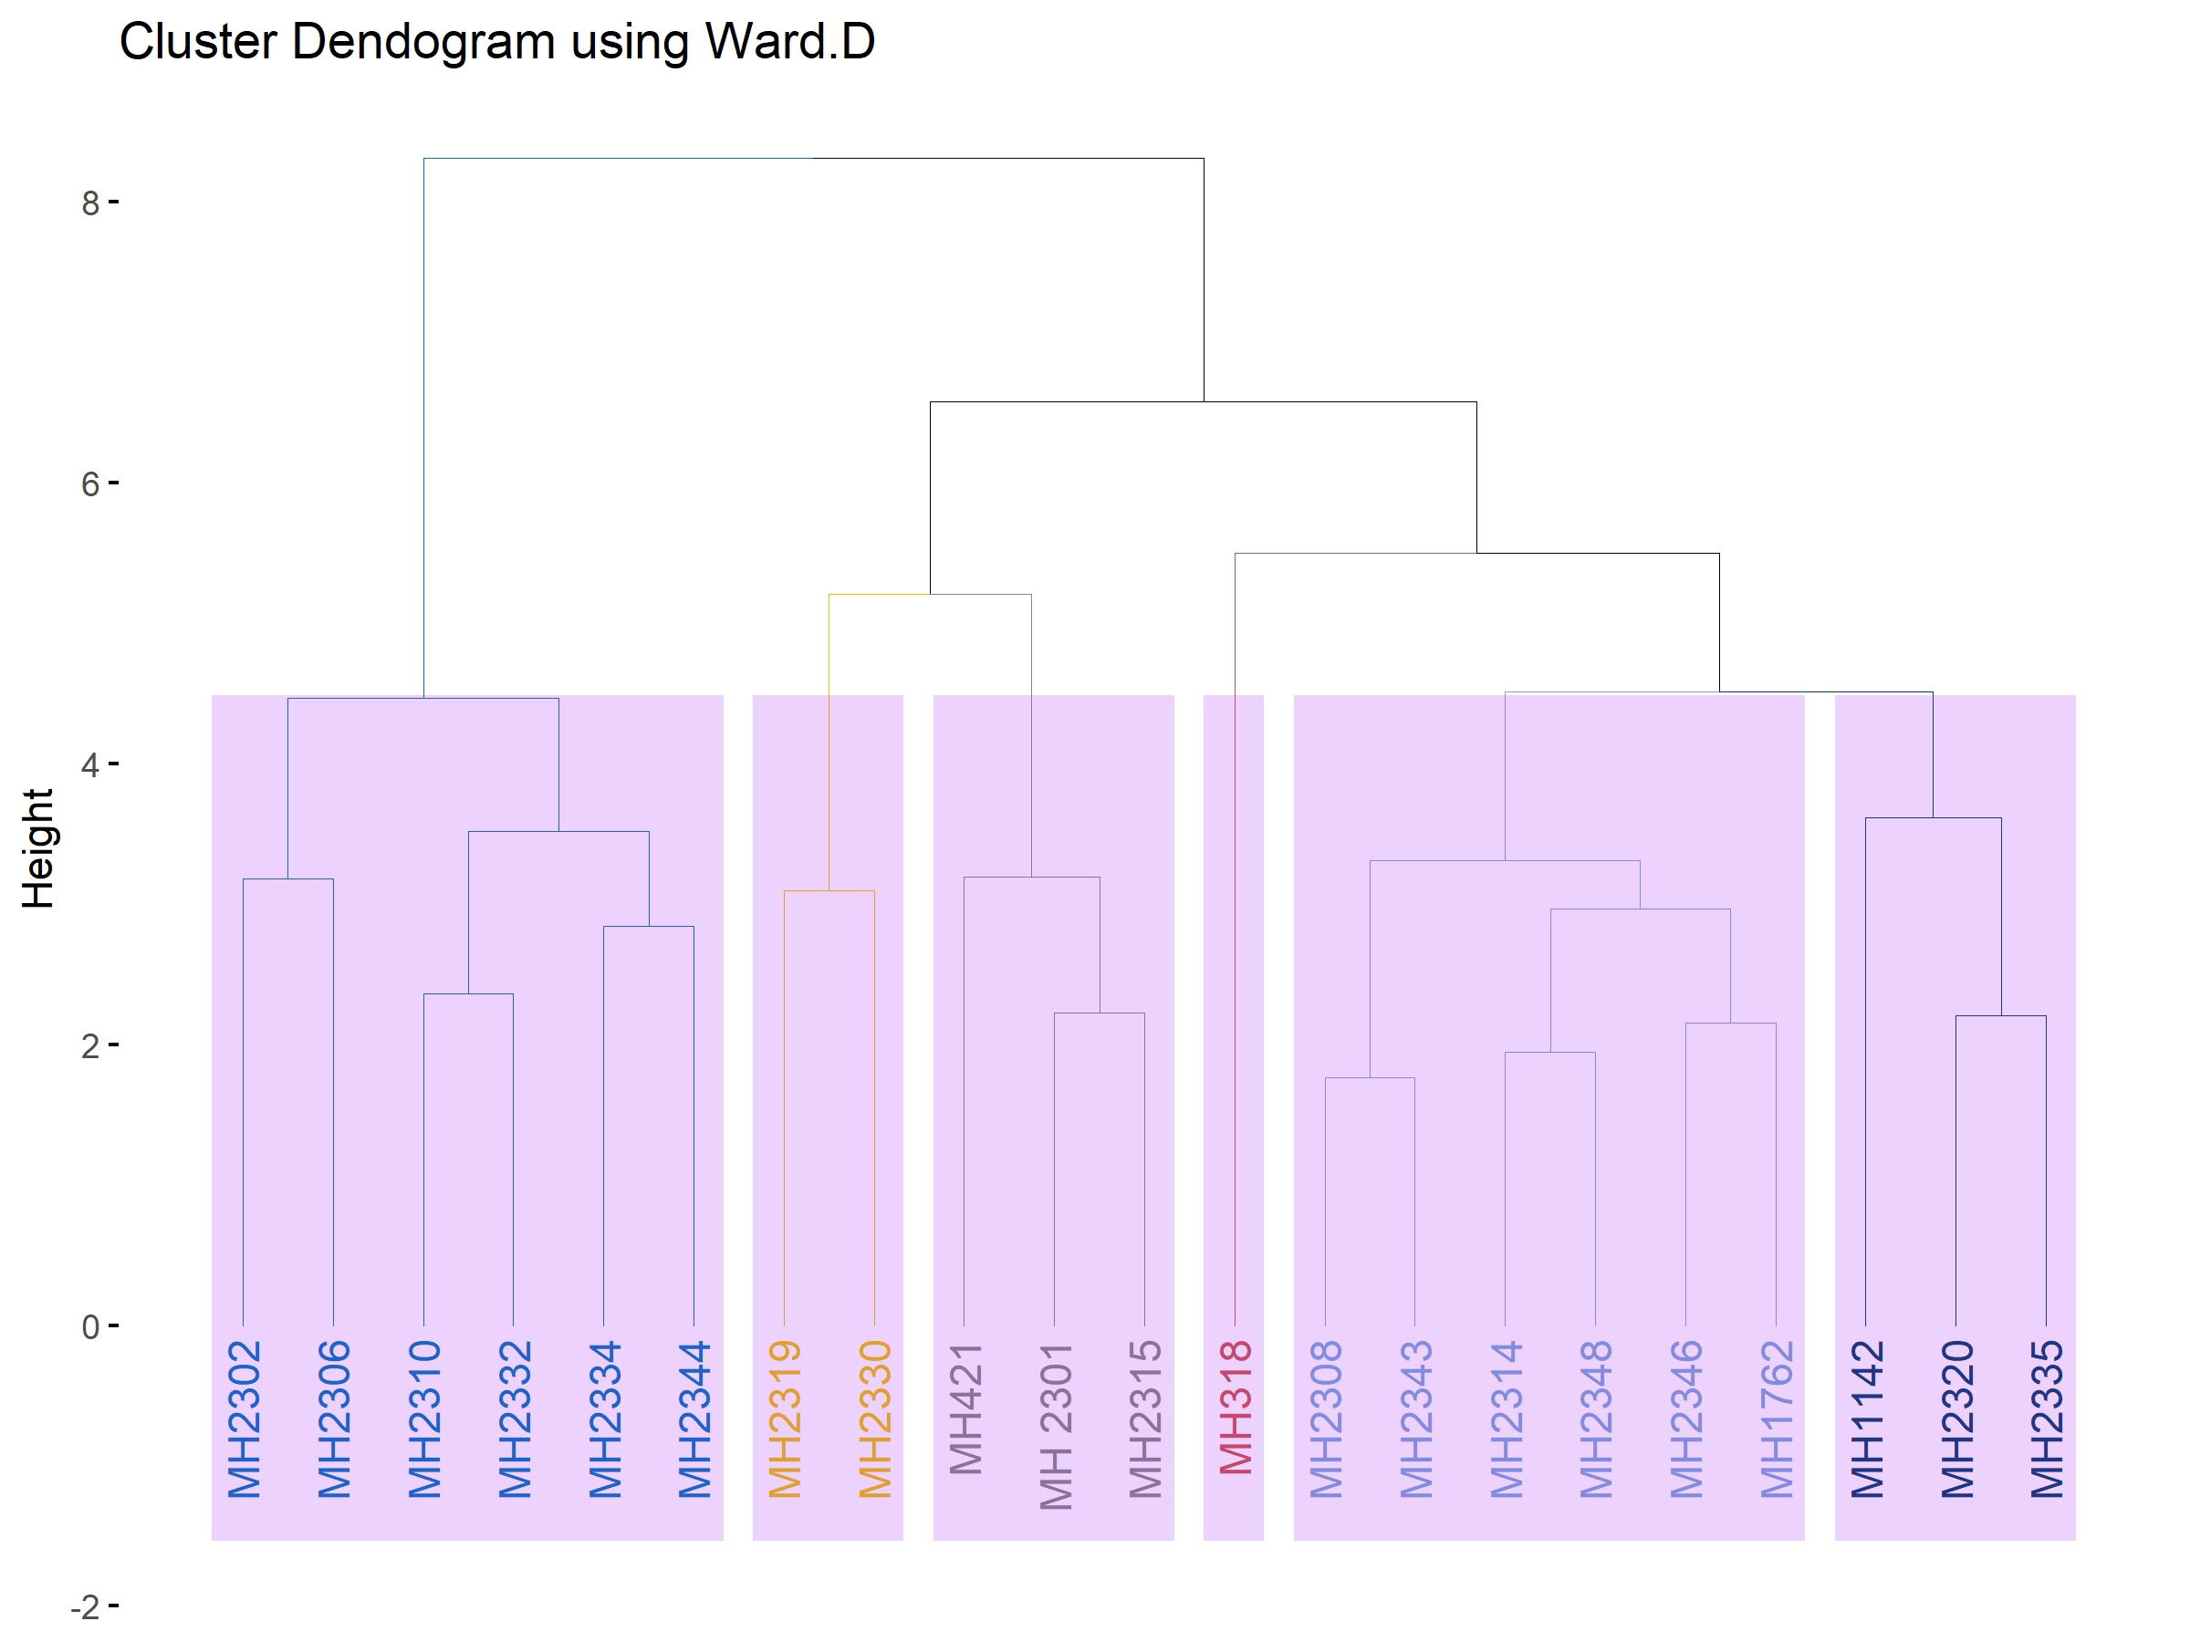
Fig 1: The distribution of genotypes into different clusters
The intra-cluster distance represents the genetic variability present within a cluster, whereas the inter-cluster distance reflects the degree of genetic divergence between different clusters. Generally, higher inter-cluster distances indicate greater genetic diversity among clusters and provide better opportunities for selecting genetically divergent parents for hybridization programmes.The magnitude of intra- and inter-cluster distances among the six clusters is presented in Table 2. The highest intra-cluster distance was observed in Cluster II (280.21) followed by Cluster I (238.18), indicating comparatively greater genetic variability among the genotypes within these clusters. In contrast, Cluster V and Cluster VI showed relatively lower intra-cluster distances, suggesting lesser variability among the genotypes grouped in these clusters.Among the inter-cluster distances, the maximum genetic divergence was observed between Cluster IV and Cluster VI (545.04), followed by the distance between Cluster II and Cluster IV (484.41). The minimum inter-cluster distance was recorded between Cluster III and Cluster V (143.49), indicating closer genetic relationship between the genotypes belonging to these clusters.Genotypes belonging to clusters separated by large inter-cluster distances are expected to produce greater heterosis and wider variability in segregating generations. Therefore, hybridization between genotypes from Cluster IV and Cluster VI may be particularly useful for developing superior recombinants and improving economically important traits in cotton breeding programmes.Likewise, Kumar et al. (2019), Srivastava et al. (2018), Pratap et al. (2024) and Azam et al. (2024)studied intra and inter cluster among different genotypes of fieldpea.
Table 2. Inter and intra (diagonal) cluster distance among different clusters
Cluster | C1 | C2 | C3 | C4 | C5 | C6
C1 | 238.18 | 261.53 | 245.19 | 465.64 | 209.06 | 317.56
C2 | 261.53 | 280.21 | 264.10 | 484.41 | 227.40 | 340.96
C3 | 245.19 | 264.10 | 245.19 | 400.38 | 143.49 | 324.36
C4 | 465.64 | 484.41 | 400.38 | 268.05 | 321.97 | 545.04
C5 | 209.06 | 227.40 | 143.49 | 321.97 | 66.46 | 288.39
C6 | 317.56 | 340.96 | 324.36 | 545.04 | 288.39 | 56.87
Cluster mean analysis helps in identifying clusters possessing desirable combinations of traits and provides useful information for selecting potential parents in breeding programmes. The mean performance of different clusters for the studied traits is presented in Table 3. Considerable variation was observed among the clusters for the traits under study, indicating the presence of substantial genetic variability among the evaluated genotypes. Among the clusters, Cluster IV exhibited the highest mean value for trait yield per plot (643.00), followed by Cluster V (490.33) and Cluster III (437.67), suggesting that genotypes belonging to these clusters possess superior performance for this trait. Cluster V recorded comparatively higher mean values for traits such as number of branches and number of pods, indicating better overall performance for yield contributing characters. In contrast, Cluster II showed comparatively lower mean values for most of the traits, indicating relatively inferior performance. Clusters exhibiting superior mean values for important yield contributing traits may be considered promising sources for selection and hybridization. Furthermore, crossing genotypes belonging to clusters separated by large inter-cluster distances along with superior cluster mean performance may result in the development of desirable recombinants and transgressive segregants in subsequent generations.Similar findings have been reported in recent studies, where significant differences in cluster means for yield and associated traits were observed in field pea genotypes (Sharma et al., 2023; Srivastava et al., 2024). Furthermore, Cluster V in the present study showed higher mean values for important yield-contributing traits such as number of branches and number of pods, which are known to have a positive association with yield. This observation is in agreement with findings of Achenef et al. (2025) and Khan et al. (2021), who reported that clusters with superior performance for yield components contribute significantly to overall productivity and can be utilized effectively in breeding programmes.
Table 3. Mean performance of clusters for different traits
Cluster | DF | DM | MYMV | PH | NBP | NPP | YPP | TSW
Cluster I | 39.67 | 61.33 | 1.00 | 75.67 | 1.27 | 22.33 | 393.33 | 2.95
Cluster II | 41.83 | 67.33 | 1.67 | 81.83 | 1.15 | 20.00 | 393.00 | 3.30
Cluster III | 39.33 | 62.50 | 2.33 | 75.00 | 1.83 | 23.83 | 437.67 | 3.05
Cluster IV | 40.00 | 64.00 | 2.00 | 92.00 | 2.45 | 24.00 | 643.00 | 3.07
Cluster V | 39.67 | 64.67 | 1.00 | 81.33 | 2.53 | 28.67 | 490.33 | 2.83
Cluster VI | 38.00 | 60.00 | 5.00 | 61.00 | 2.80 | 25.00 | 233.00 | 2.90
Conclusion:The present study revealed substantial genetic variability among mungbean genotypes, as evidenced by cluster analysis and divergence estimates. The grouping of genotypes into six distinct clusters indicated significant genetic diversity, with certain clusters exhibiting superior performance for yield and related traits. High inter-cluster distances, particularly between Cluster IV and Cluster VI, suggest the presence of wide genetic divergence, offering potential for heterosis breeding. Cluster mean analysis identified Cluster IV and Cluster V as promising sources for yield and yield-contributing traits. Therefore, hybridization among genetically diverse and high-performing clusters can be effectively utilized for developing superior recombinants. Overall, the integration of cluster analysis and genetic divergence provides a reliable approach for selecting potential parents in mungbean improvement programmes.
References:
Achenef, G., Abo, T., Yilma, G., Tesfaye, D., Tilahun, N., Yimam, K., & Workie, A. (2025). Assessment of Genetic Variability and Performance of Field Pea (Pisum sativum) Advanced Genotypes Across Environments. Asian Journal of Agriculture and Allied Sciences, 8(1), 45-56.
Anderson, P. W. (1972). More is different: broken symmetry and the nature of the hierarchical structure of science. Science, 177(4047), 393-396.
Dahiya, P. K., Linnemann, A. R., Van Boekel, M. A. J. S., Khetarpaul, N., Grewal, R. B., & Nout, M. J. R. (2015). Mung bean: Technological and nutritional potential. Critical reviews in food science and nutrition, 55(5), 670-688.
Deplazes-Zemp, A. (2019). Challenges of justice in the context of plant genetic resources. Frontiers in plant science, 10, 1266.
Graham, P. H., & Vance, C. P. (2003). Legumes: importance and constraints to greater use. Plant physiology, 131(3), 872-877.
Joshi, V., Kumar, S., & Rawat, S. (2020). Study on infection and development of root-knot nematode, Meloidogyne javanica on mungbean. J Entomol, 8, 1621.
Khan, M. M. H., Rafii, M. Y., Ramlee, S. I., Jusoh, M., & Al Mamun, M. (2021). AMMI and GGE biplot analysis for yield performance and stability assessment of selected Bambara groundnut (Vigna subterranea L. Verdc.) genotypes under the multi-environmental trials (METs). Scientific reports, 11(1), 22791.
Kumar, P., Singh, D., and Kumar, V. (2019). Genetic divergence analysis in cotton genotypes based on morphological traits. International Journal of Current Microbiology and Applied Sciences, 8(4): 1234–1242.
Malli, S. K., Lavanya, G. R., & Nikhil, B. S. K. (2018). Genetic variability, heritability and genetic advance in mungbean (Vigna radiata L. Wilczek) genotypes.
Nair, R. M., Smith, M., Somta, P., Noble, T., &Schafleitner, R. (2024). International Mungbean Congress. Book of Abstracts. Publication No. 24-1075.
Patil, S.S., Naik, M.R., and Patil, B.R. (2018). Genetic divergence studies in cotton (Gossypium hirsutum L.). Journal of Cotton Research and Development, 32(1): 45–50.
Peoples, M. Á., Brockwell, J., Herridge, D. F., Rochester, I. J., Alves, B. J. R., Urquiaga, S., ... & Jensen, E. S. (2009). The contributions of nitrogen-fixing crop legumes to the productivity of agricultural systems. Symbiosis, 48(1), 1-17.
Pratap, V., Sharma, V., Kumar, H., Shukla, G., & Kumar, M. (2024). Multivariate Analysis of Quantitative Traits in Field Pea (Pisum sativum var. arvense). Legume Research: An International Journal, 47(6).
Sarkar, M., &Kundagrami, S. (2016). Multivariate analysis in some genotypes of mungbean [Vigna radiata (L.) Wilczek] on the basis of agronomic traits of two consecutive growing cycles. Legume Research, 39(4), 523-527.
Sharma, A., Yadav, R., Sheoran, R., Kaushik, D., Mohanta, T. K., Sharma, K., ... & Kaushik, P. (2023). Estimation of heterosis and the combining ability effect for yield and its attributes in field pea (Pisum sativum L.) using PCA and GGE biplots. Horticulturae, 9(2), 256.
Sharma, A., Yadav, R., Sheoran, R., Kumar, P., Kaushik, D., Dhaka, K., ... & Sharma, A. (2025). Evaluation of genotype× environment interactions for seed yield in field pea (Pisum sativum L.) genotypes using multivariate analysis model. Euphytica, 221(5), 58.
Singh, R., Verma, S.K., and Kumar, A. (2020). Assessment of genetic diversity in upland cotton using multivariate analysis. Electronic Journal of Plant Breeding, 11(2): 456–462.
Srivastava, A., Sharma, A., & Kumar, R. (2018). Cluster analysis in field pea (Pisum sativum L.). Journal of Pharmacognosy and Phytochemistry, 7(5), 655-657.
Zubair, M., Ajmal, S. U., Anwar, M., & Haqqani, A. M. (2007). Multivariate analysis for quantitative traits in mungbean [Vigna radiata (L.) Wilczek]. Pakistan Journal of Botany, 39(1), 103.

