Case report
Cytology of canine cutaneous round cell tumours: Histiocytoma and Mast cell tumour
– A case report

Abstract
An 11 year old male Labrador and 8 year old female Pug breed of dogs was were presented to the Department of Veterinary Surgery and Radiology, Institute of Veterinary Sciences and Animal Husbandry, SOA (Deemed to be University) Bhubaneswar with a history of nodular growth on the hind limb and on the skin. Fine needle aspiration biopsy was performed from the mass the tissue taken from affected part of the said dogs. A Giemsa-stained smear was prepared from the collected mass tissue, air dried and fixed with methanol. Cytological examination of histiocytoma revealed neoplastic cells appeared round to spherical or oval in shape arranged in a discrete pattern and contained round, oval, indented nucleus with large pale blue cytoplasm. Mast cell tumours showed discrete round neoplastic cells containing metachromatic intracytoplasmic granules.
Keywords. Canine, mast cell, histiocytoma, cytology
1. Introduction
Skin and subcutis are the most common sites for neoplasms in dogs accounting for 67.5% of tumours (Dorn et al., 1968). Common round cell tumours in dogs are mast cell tumours, histiocytoma, plasmacytoma, transmissible venereal tumour and lymphoma (Fernandez et al., 2005). Cutaneous histiocytoma (CH) is a common benign skin tumour that usually appears as a solitary mass in young dogs under 4 year of age (Goldschmidt and Hendrick, 2002). The most common sites of involvement of histiocytoma include head, neck and appendages. Mast cell tumour alone accounts for approximately one fourth of skin tumors in dogs (Welle et al., 2008). The most common sites for mast cell tumours include ventral aspect of neck, lateral aspect of thigh, thoracic and abdominal regions. Mast cell tumours represent approximately 7-21% of all cutaneous malignancies in canine (Gomez et al., 2020). It is frequently diagnosed in middle to older aged dogs of to breeds of dogs such as Boxers, Labrador Retrievers, Boston Terriers and Pugs, showing a significantly higher genetic predisposition (Warland and Dobson, 2013). The present study case report is based on the occurrence of histiocytoma and mast cell tumour in of Labrador and Pug breed of dogs.
2. Case presentation
2.1. Case History and Clinical Observation
An A 11 year old male Labrador and 8 year old female Pug breed of dogs was were presented to the Department of Veterinary Surgery and Radiology, Institute of Veterinary Sciences and Animal Husbandry, SOA (Deemed to be University) Bhubaneswar with a history of nodular growth on the hind limb and on the skin. Fine needle aspiration biopsy was performed from the mass and subjected for cytological examination. A Giemsa stained smear was prepared and air dried and fixed with methanol and put for staining with a working solution of Giemsa stain A Giemsa-stained smear was prepared from the collected mass tissue, air dried and fixed with methanol (2 part Giemsa : 8 part distilled water). Cytological examination of histiocytoma revealed neoplastic cells appeared round to spherical or oval in shape arranged in a discrete pattern and contained round, oval, indented nucleus with large pale blue cytoplasm (Figure 1). Mast cell tumour showed discrete round neoplastic cells containing metachromatic intracytoplasmic granules (Figure 2).
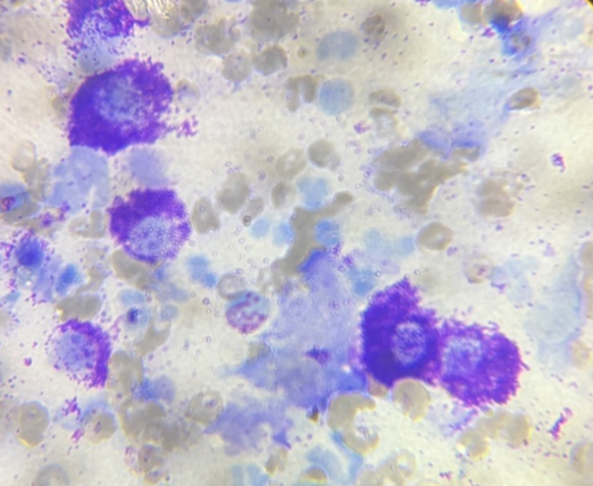
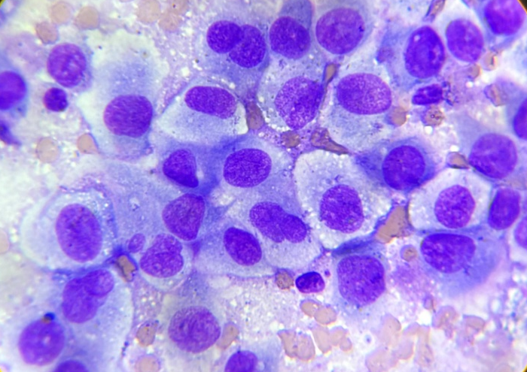

Figure 1: Histiocytoma: Round to spherical Figure 2: Mast cell tumour: Round
shape with indented nuclei, pale blue cytoplasm. cells containing round nucleus with
Giemsa, 100x metachromatic cytoplasmic granules.
Giemsa, 100x

3. Discussion
Cutaneous histiocytoma is the most common skin tumour of dogs (Goldschmidt and Hendrick, 2002) constituting around 18% of all canine skin tumours (Reddy et al., 2009). Histiocytoma can affect different age groups but they are most commonly seen in young dogs. Morris and Dobson (2001) reported that nearly 50% of histiocytoma cases are diagnosed in dogs less than two years of age. Meanwhile, the result of our case was in accordance with the findings of the previous worker On the other hand, our findings are in agreement with the earlier worker (Subapriya et al., 2025) who reported histiocytoma in 12 year old male non-descript dog. Krithiga et al. (2005) and Subapriya et al. (2025) reported that male dog dogs are more susceptible to histiocytoma which support our findings. Previous study findings exhibited that

Data exists for incidence of certain breeds of dogs includes Scottish terriers, Bull terriers, Boxers, English cocker spaniels, Doberman pinschers and Shetland sheep breeds of dogs are more prominent (Taylor et al., 1969). However, in the present study the case was reported in Labrador breed of dog. Cytological examination of histiocytoma revealed neoplastic cells appeared round to spherical or oval in shape arranged in a discrete pattern and contained round, oval, indented nucleus with large pale blue cytoplasm. These findings are in support with earlier work of Subapriya et al. (2025).
Mast cell tumours are the third most common canine malignant cutaneous tumours which accounts for 5.55 to 22.4% of cutaneous tumours of dogs (Oliveira et al., 2020; Dadhich et al., 2022). Mathur et al. (2018) reported that prevalence was more common among different age group between of 6 to 10 years and this result findings also was supported in this case which was in support our findings. Certain breed of dogs with higher incidence of mast cell tumour includes Boxers, Golden Retrievers and other larger breed types (White et al., 2011). However, only few cases have reported in Pug breed of dog (White et al., 2011; McNiel et al., 2006). Some studies reported that female particularly neutered females have been associated with increased risk of mast cell tumour (O’ Connell and Thomson, 2013 and White et al., 2011). Cytological examination of mast cell tumour revealed discrete round neoplastic cells containing metachromatic intracytoplasmic granules. These findings are in support with earlier work of Ramesh et al. (2025).
4. Conclusion
Cytology is reliable, easy and non-invasive tool in for diagnosis of tumours in dogs. It helps us to identify disease process, neoplasia, inflammation or non-specific inflammation. The present study case reports the occurrence of histiocytoma and mast cell tumour in Labrador and Pug breed of dogs. Early diagnosis of tumours help us to prevent delayed treatment as the mass grow, they can become fixed to deeper tissues making them complete removal much harder.
Ethical approval
Not applicable
References
- Dadhich, R., Dadhich, H., & Sharma, G.D. (2022). Pathological and haemato-biochemical studies of mastocytoma in dogs. Indian Journal of Canine Practice, 14(2), 146-148.
- Dorn, C.R., Taylor, D.O.N., Schneider, R., Hibbard, H.H., & Klauber, M.R. (1968). Survey of animal neoplasms in Alameda and Contra Costa Counties, California. II. Cancer morbidity in dogs and cats from Alameda County. Journal of National Cancer Institute, 40(2), 307-318.
- Fernandez, N.J., West, K.H., Jackson, M.L., & Kidney, B.A. (2005). Immunohistochemical and histochemical stains for differentiating canine cutaneous round cell tumors. Veterinary Pathology, 42,437-445.
- Goldschmidt, M.H., & Hendrick, M.J. (2002). Tumors of the skin and soft tissues. In: Meuten DJ, editor. Tumors in Domestic Animals. Ames, Iowa, Iowa State University Press, 109- 111.
- Gómez, S., Ortega, J., Martín, E., Pérez, M., & Rodríguez, A. (2020). A retrospective study on the outcomes of canine mast cell tumors treated with surgery and adjuvant chemotherapy. Veterinary Comparative Oncology, 18(4), 554-562.
- Krithiga, K., Manohar, B. M., & Balachandran, C. (2005). Cytological and histopathological study on cutaneous round cell tumours in canines. Indian Journal of Veterinary Pathology, 29(1), 38-41.
- Mathur, K.Y., Rao, S., Chandrashekaraiah, G.B., & Munivenkatappa, B.S. (2018). Cytological and histopathological studies of canine round cell tumors. International Journal of Livestock Research, 8(6), 88-95.
- McNiel, E.A., Prink A.L., & O’Brien, T.D. (2006). Evaluation of risk and clinical outcome of mast cell tumours in pug dogs. Veterinary Comparative Oncology, 4(1), 2–8.
- Morris, J., & Dobson, J. (2001). “Small Animal Oncology”, Blackwell Science Ltd, London.
- O’Connell, K., & Thomson, M. (2013). Evaluation of prognostic indicators in dogs with multiple, simultaneously occurring cutaneous mast cell tumours: 63 cases. Veterinary Comparative Oncology, 11(1), 51–62.
- Oliveira, M. T., Campos, M., Lamego, L., Magalhães, D., Menezes, R., Oliveira, R., & Ferreira, D. A. (2020). Canine and feline cutaneous mast cell tumor: a comprehensive review of treatments and outcomes. Topics in Companion Animal Medicine, 41, 100472.
- Ramesh, S., Kumar, S. D., Harish, L. J., Balakumar, A., Preetha, S., & Kumar, V. (2025). Cytological Diagnosis of Canine Cutaneous Mast Cell Tumour with Nodal Metastasis. Indian Journal of Veterinary Pathology, 49(3), 258-261.
- Reddy, G. M., Kumar, R., Kumar, P., Sharma, A. K., & Singh, N. D. (2009). Canine skin tumours: occurrence and histopathology. Indian Journal of Veterinary Pathology, 33(2), 200-203.
- Subapriya, S., Vairamuthu, S., Sivasankar, R., Bharathidasan, M., Vijay, A. & Shafiuzama, M. (2025). Histiocytoma in Dogs: Cytomorphological and Incidence based study of 162 cases. AMA, 56, 21323-21332.
- Taylor, D.O., Dorn, C.R., & Luis, O.H. (1969). Morphologic and biologic characteristics of the canine cutaneous histiocytoma. Cancer Research, 29, 83–92.
- Warland, J., & Dobson, J. (2013). Breed predispositions in canine mast cell tumor: A single-centre experience in the United Kingdom. Veterinary Journal, 197(2), 496-498.
- Welle, M. M., Bley, C. R., Howard, J., & Rüfenacht, S. (2008). Canine mast cell tumours: a review of the pathogenesis, clinical features, pathology and treatment. Veterinary Dermatology, 19(6), 321-339.
- White, C.R., Hohenhaus, A.E., Kelsey, J., & Procter-Gray, E. (2011). Cutaneous MCTs: associations with spay/neuter status, breed, body size, and phylogenetic cluster. Journal of American Animal Hospital Association, 47(3), 210–6.

