Original Research Article
Evaluation of Rice (Oryza sativa L.) Genotypes for Iron Toxicity Tolerance under Hydroponic Conditions

.
ABSTRACT

Aim: To evaluate rice genotypes for iron toxicity tolerance under controlled conditions to identify potential donor lines useful in breeding programmes aimed at developing iron toxicity tolerant rice varieties.
Study design: Completely randomized design (CRD) with three replications under hydroponic conditions.
Place and Duration of Study: Farming Systems Research Station, Sadanandapuram, Kollam, on March 2022
Methodology: A total of 106 rice genotypes, including traditional cultivars and released varieties, were evaluated for iron toxicity tolerance using hydroponic culture with graded iron concentrations of 0 (control), 500, 750, and 1000 mg L⁻¹. The genotypes were arranged in a completely randomized design with three replications. Observations on shoot length, root length, total number of roots, number of fresh roots, number of leaves and visual bronzing score as an indicator of iron toxicity symptoms were recorded to assess the effect of increasing iron concentrations on plant growth and tolerance levels.
Results: Analysis of variance revealed highly significant differences among genotypes for all traits except number of leaves at 750 and 1000 mg L⁻¹ and visual score under control conditions. Increasing iron concentration resulted in a progressive decline in growth parameters. Mean shoot length decreased from 17.7 cm (control) to 16.0 cm at 1000 mg L⁻¹, while root length declined from 8.2 cm to 7.0 cm. Total number of roots decreased from 10.4 to 7.5 and number of fresh roots showed a drastic reduction under Fe stress. Visual bronzing score increased from 0 in control to 6.1 at 1000 mg L⁻¹ Fe. Considerable genotypic variation was observed among the 106 rice varieties, with certain genotypes maintaining higher growth and lower bronzing scores even at high iron concentrations. Based on the visual scoring and tolerance classification, twelve tolerant and eighteen moderately tolerant genotypes were identified. Thirteen landraces and seventeen released varieties with high growth maintenance and low visual scores at highest iron concentration were identified as potential donors for developing iron toxicity tolerant rice varieties.
Conclusion: Hydroponic screening proved to be an efficient and reliable method for early stage evaluation of iron toxicity tolerance in rice. The identified tolerant and moderately tolerant genotypes can serve as valuable donor parents in breeding programmes focused on developing high yielding, iron toxicity tolerant rice varieties.

Keywords: Rice, iron toxicity tolerance, hydroponics, leaf bronzing score, screening.

1. INTRODUCTION

Rice (Oryza sativa L.) is one of the most important staple food crops cultivated extensively in tropical and subtropical regions. Productivity of the crop is often constrained by various abiotic stresses, among which iron toxicity is a major limitation in lowland rice ecosystems. Iron toxicity primarily occurs in waterlogged acidic soils where ferric iron (Fe3⁺) is reduced to soluble ferrous iron (Fe²⁺), resulting in excessive uptake by plants. This leads to physiological disorders such as leaf bronzing, impaired root development and reduced yield.
The severity of iron toxicity depends on several factors including genotype, soil conditions and crop management practices. Yield reduction due to iron toxicity is associated with disruptions in nutrient balance, oxidative stress and metabolic impairment. Therefore, development of toxicity tolerant varieties is a sustainable approach to mitigate yield losses.
Screening of genotypes for iron toxicity tolerance has been carried out using field trials, pot culture and hydroponic techniques. Field screening reflects natural conditions but is influenced by environmental variability, whereas hydroponic screening provides controlled conditions with uniform stress imposition. Hence, hydroponic methods are widely used for early stage screening of large germplasm collections.
In this context, the present study was undertaken to evaluate a diverse set of rice genotypes for iron toxicity tolerance using hydroponic screening and to identify promising lines for further breeding programmes.

2. material and methods

The laboratory screening experiment was conducted at the Farming Systems Research Station (FSRS), Sadanandapuram, Kollam, Kerala during march 2022. The experimental material consisted of 106 rice (Oryza sativa L.) genotypes (Appendix 1), including 60 traditional cultivars and 46 released varieties collected from different research stations under Kerala Agricultural University. The experiment was laid out in a completely randomized design with three replications and the genotypes were subjected to four iron concentrations, namely 0 mg L⁻¹ (control), 500 mg L⁻¹, 750 mg L⁻¹ and 1000 mg L⁻¹ Fe. Hydroponic screening was carried out using Yoshida nutrient solution, following standard procedures with slight modifications. Four day old seedlings were initially preconditioned in deionized water and subsequently transferred to nutrient solutions containing the respective iron concentrations. Iron was supplied in the form of Fe-EDTA (ferric ethylenediaminetetraacetic acid). The pH of the nutrient solution was maintained at 5.0 throughout the experimental period by adjusting with 1N HCl and 1N NaOH. The nutrient solution was renewed at weekly intervals to ensure uniform nutrient availability. The experimental plants were maintained under controlled conditions for a period of 28 days.
Observations were recorded on shoot length (cm), root length (cm), total number of roots, number of fresh roots and number of leaves. Iron toxicity symptoms were assessed through visual scoring based on the Standard Evaluation System (SES) developed by the International Rice Research Institute (IRRI, 1996), using a scale of 0 to 9, where lower scores indicated tolerance and higher scores indicated indicate susceptibility. The experimental data were subjected to analysis of variance (ANOVA) to determine the significance of differences among genotypes under different iron concentrations. Mean values were computed, and genotypes were classified into different tolerance categories based on their response to iron toxicity.

3. results and discussion

3.1 Analysis of variance
The analysis of variance revealed highly significant differences among the 106 rice genotypes for all the characters studied under different iron concentrations, except for number of leaves at 750 and 1000 mg L⁻¹ and visual scoring under control conditions, indicating the presence of substantial genetic variability for iron toxicity tolerance among the genotypes (Table 1). The significant variation observed confirms the effectiveness of the hydroponic screening method in for differentiating genotypes under controlled iron stress conditions. Similar observations of significant genotypic variation under iron toxicity have been reported by Rout et al. (2014) and Sitaresmi et al. (2021), emphasizing the existence of exploitable genetic diversity for tolerance breeding.

Table 1. Analysis of variance for completely randomized design at four different concentrations of iron in 106 rice genotypes

Characters | Concentration of iron (mg L⁻¹) | Mean Sum of Squares
Characters | Concentration of iron (mg L⁻¹) | Treatment | Error
Shoot length (cm) | 0 | 37.885** | 3.279
Shoot length (cm) | 500 | 66.288** | 2.130
Shoot length (cm) | 750 | 52.954** | 1.112
Shoot length (cm) | 1000 | 63.760** | 5.482
Root length (cm) | 0 | 5.631** | 0.898
Root length (cm) | 500 | 22.333** | 0.748
Root length (cm) | 750 | 20.027** | 3.659
Root length (cm) | 1000 | 18.560** | 3.865
Total number of roots | 0 | 10.905** | 2.211
Total number of roots | 500 | 14.589** | 1.748
Total number of roots | 750 | 17.751** | 2.858
Total number of roots | 1000 | 34.442** | 3.362
Number of fresh roots | 0 | 10.767** | 2.352
Number of fresh roots | 500 | 25.492** | 1.154
Number of fresh roots | 750 | 21.927** | 1.179
Number of fresh roots | 1000 | 33.772** | 1.780
Number of leaves | 0 | 0.241** | 0.082
Number of leaves | 500 | 0.059** | 0.031
Number of leaves | 750 | 0.035 | 0.044
Number of leaves | 1000 | 0.082 | 0.063
Visual scoring (0–9) | 0 | 0 | 0
Visual scoring (0–9) | 500 | 24.369** | 0.673
Visual scoring (0–9) | 750 | 21.588** | 26.303
Visual scoring (0–9) | 1000 | 18.526** | 0.730
** Significant at 1 percent level

3.2 Effect of iron toxicity on growth parameters
Iron toxicity had a pronounced effect on the growth parameters of rice seedlings. A progressive decline in growth parameters was observed with increasing iron concentration from control to 1000 mg L⁻¹ Fe (Table 2 and Plate 1), indicating the detrimental effect of excess excessive iron on plant development. Shoot length showed a marked reduction under elevated iron levels, which may be attributed to impaired physiological processes and nutrient imbalance caused by excessive Fe²⁺ accumulation in plant tissues. Similar reductions in shoot growth under iron toxicity have been reported by Fageria and Rabelo (1987), Onaga et al. (2013b), Aung et al. (2018) and Elango et al. (2022), confirming that shoot growth is highly sensitive to iron stress. Root traits were even more severely affected, as evidenced by significant reductions in root length, total number of roots and fresh root production with increasing iron concentration. Excess iron in the root zone induces oxidative stress, cellular damage and inhibition of root elongation, as earlier reported by Ponnamperuma et al. (1955), Crestani et al. (2009) and Suma et al. (2022). The reduction in root number further indicates inhibition of root initiation and branching under toxic conditions, which is consistent with findings of Onaga et al. (2013a) and Onyango et al. (2018).
The number of leaves also declined under increasing iron levels, reflecting suppression of vegetative growth due to interference with photosynthesis and metabolic activities. Similar observations were reported by Baruah et al. (2007) and Oktatora et al. (2021). Overall, the mean performance of genotypes indicated a consistent decline in all growth parameters with increasing iron concentration; however, considerable variation existed among genotypes in their response to iron stress. Certain genotypes maintained relatively higher shoot and root growth along with lower bronzing symptoms even at 1000 mg L⁻¹ Fe, indicating strong tolerance. Such differential responses among genotypes have also been reported by Wu et al. (2014) and Ahmed et al. (2023), highlighting the presence of genetic variability for iron toxicity tolerance.
The ability of tolerant genotypes to sustain growth under iron stress may be attributed to mechanisms such as restricted iron uptake, retention of excess iron in roots and enhanced tissue tolerance. Engel et al. (2012) reported that tolerant genotypes exhibit iron exclusion and compartmentalization mechanisms, while Onaga et al. (2013) demonstrated that limited translocation of iron to shoots reduces toxicity symptoms. The present findings support these observations, as tolerant genotypes maintained better root growth and lower bronzing, indicating effective regulation of iron uptake and internal distribution.

Table 2. Mean performance for different characters at four different concentrations of iron in 106 rice genotypes

Characters | Concentration of iron (mg L⁻¹) | Mean | Minimum | Maximum | CD (5%) | SE(m)
Shoot length (cm) | 0 | 17.7 | 11.2 | 28.3 | 2.917 | 1.045
Shoot length (cm) | 500 | 17.8 | 10.6 | 32.6 | 2.351 | 0.843
Shoot length (cm) | 750 | 17.5 | 10.5 | 31.7 | 3.266 | 1.171
Shoot length (cm) | 1000 | 16 | 8.9 | 29.9 | 3.771 | 1.352
Root length (cm) | 0 | 8.2 | 4.5 | 11.5 | 1.526 | 0.547
Root length (cm) | 500 | 8.2 | 3.4 | 18.8 | 1.393 | 0.499
Root length (cm) | 750 | 8.1 | 3.6 | 17.1 | 3.081 | 1.104
Root length (cm) | 1000 | 7 | 2.6 | 14.4 | 3.166 | 1.135
Total number of roots | 0 | 10.4 | 6 | 14.3 | 2.395 | 0.858
Total number of roots | 500 | 10.3 | 4 | 16.3 | 2.13 | 0.763
Total number of roots | 750 | 8.4 | 1.7 | 14.3 | 2.723 | 0.976
Total number of roots | 1000 | 7.5 | 1.7 | 19.3 | 2.953 | 1.059
Number of fresh roots | 0 | 10.4 | 6 | 14.3 | 2.47 | 0.885
Number of fresh roots | 500 | 3.5 | 0 | 13.3 | 1.73 | 0.62
Number of fresh roots | 750 | 2.8 | 0.3 | 12.3 | 1.749 | 0.627
Number of fresh roots | 1000 | 3 | 0.3 | 13.7 | 2.149 | 0.77
Number of leaves | 0 | 3 | 2 | 4 | 0.461 | 0.165
Number of leaves | 500 | 3 | 2.3 | 3.7 | 0.286 | 0.102
Number of leaves | 750 | 3 | 2.7 | 3.3 | N/A | 0.121
Number of leaves | 1000 | 3 | 2.7 | 3.7 | N/A | 0.145
Visual scoring (0–9) | 0 | 0 | 0 | 0 | 0 | 0
Visual scoring (0–9) | 500 | 3.7 | 0.3 | 9 | 1.321 | 0.474
Visual scoring (0–9) | 750 | 4.9 | 0.3 | 9 | 1.459 | 0.523
Visual scoring (0–9) | 1000 | 6.1 | 1 | 9 | 1.376 | 0.493
C.D. (5%) - Critical difference at 5%, SE (m) - Standard error of mean

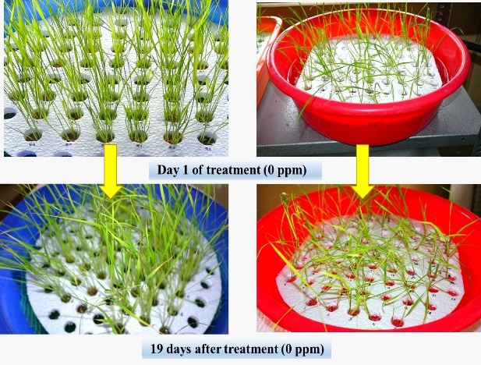
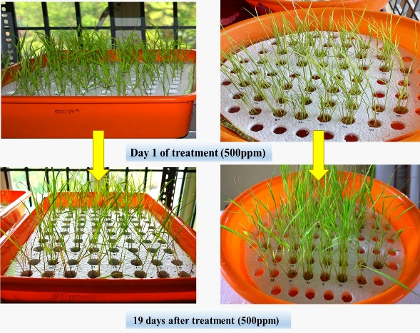
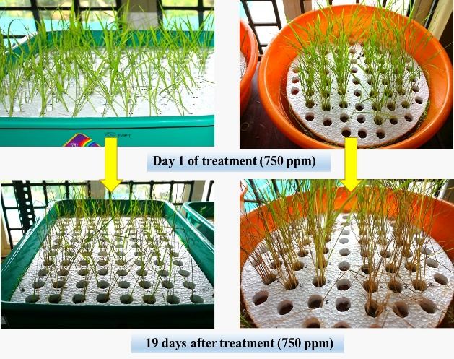
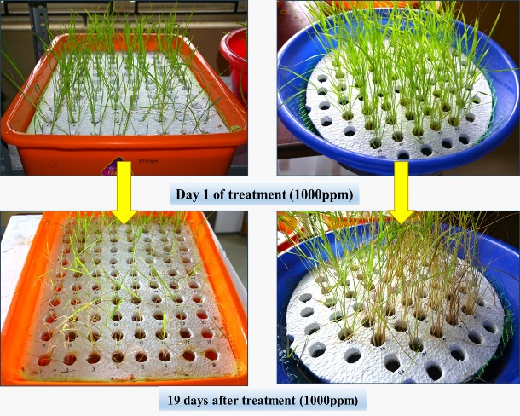

Plate 1. Reaction of 106 rice genotypes to different concentrations of iron

3.3. Visual scoring for iron toxicity symptoms
Visual scoring for iron toxicity symptoms revealed a clear increase in leaf bronzing with increasing iron concentration. The symptoms appeared initially on older leaves and intensified over time, leading to severe discoloration and necrosis in susceptible genotypes. Based on the visual scoring (0-9) recorded by all the genotypes at highest iron concentration (1000 mg L⁻¹), they were classified as highly tolerant, tolerant, moderately tolerant, moderately susceptible, susceptible and highly susceptible. Tolerant genotypes exhibited lower bronzing scores and maintained better growth. The use of leaf bronzing score (LBS) as a reliable indicator of iron toxicity has been well documented by Yoshida (1981) and Mandal et al. (2004).
The rapid onset of bronzing symptoms under hydroponic conditions observed in the present study is consistent with the findings of Bresolin et al. (2019) and Diop et al. (2020), who reported that LBS is an effective and rapid phenotypic marker for screening tolerance. The high scores in susceptible lines reflect the extensive oxidative damage to chlorophyll systems described by Pereira et al. (2013). After excluding the moderately susceptible, susceptible and highly susceptible genotypes, the highly tolerant, tolerant and moderately tolerant genotypes were selected (Table 3) for further studies.

Table 3. Selected genotypes based on visual scoring (0-9) in hydroponics experiment

Sl. No. | Genotype | Score | Reaction
Landraces
1 | Chenthadi | 2.3 | Tolerant
2 | Chenkayama | 3 | Moderately tolerant
3 | Chettivirippu | 3 | Moderately tolerant
4 | Nayarambalam Pokkali | 3 | Moderately tolerant
5 | Pokkali | 3 | Moderately tolerant
6 | Chellanum Chettivirippu | 3.7 | Moderately tolerant
7 | Karutha Kuruka | 3.7 | Moderately tolerant
8 | Kunjikayama | 3.7 | Moderately tolerant
9 | Kuthiru | 3.7 | Moderately tolerant
10 | Onamuttan | 3.7 | Moderately tolerant
11 | Punchaparuthi | 3.7 | Moderately tolerant
12 | Cheruvirippu | 4.3 | Moderately tolerant
13 | Traditional Virippu | 4.3 | Moderately tolerant
Released Varieties
14 | Pournami | 1 | Tolerant
15 | Karuna | 1.7 | Tolerant
16 | Makom | 1.7 | Tolerant
17 | Vytilla 9 | 1.7 | Tolerant
18 | Bhadra | 2.3 | Tolerant
19 | Panchami | 2.3 | Tolerant
20 | Prathyasha | 2.3 | Tolerant
21 | Vytilla 2 | 2.3 | Tolerant
22 | Vytilla 3 | 2.3 | Tolerant
23 | Vytilla 8 | 2.3 | Tolerant
24 | Vytilla 10 | 2.3 | Tolerant
25 | Ezhome 3 | 3 | Moderately tolerant
26 | Karthika | 3 | Moderately tolerant
27 | Vytilla 4 | 3 | Moderately tolerant
28 | Vytilla 7 | 3 | Moderately tolerant
29 | Vytilla 6 | 3.7 | Moderately tolerant
30 | Vytilla 1 | 4.3 | Moderately tolerant

4. Conclusion

The present investigation revealed significant genetic variability among rice genotypes for iron toxicity tolerance. Hydroponic screening was found to be an efficient and reliable method for early-stage evaluation. The study also emphasized the importance of growth parameters and visual scoring as key indicators for screening and selection. Tolerant genotypes identified in the study can be utilized as donor parents in breeding programmes for developing high yielding rice varieties adapted to iron toxic environments.

References
Ahmed, I. M., Dai, H., Zheng, W., Cao, F., Zhang, G., & Sun, D. (2023). Genotypic variation in rice for iron toxicity tolerance and associated physiological mechanisms. Plant Physiology and Biochemistry, 194, 123–134.
Aung, M. S., Masuda, H., Kobayashi, T., Nakanishi, H., & Nishizawa, N. K. (2018). Iron toxicity in rice and tolerance mechanisms. Rice, 11(1), 1–15.
Baruah, K. K., Das, B., & Das, K. (2007). Effect of iron toxicity on growth and yield of rice. Oryza, 44(2), 123–126.
Bresolin, A. P. S., de Andrade, L. R., & Pereira, M. P. (2019). Leaf bronzing as an indicator of iron toxicity in rice. Acta Physiologiae Plantarum, 41(5), 78.
Crestani, M., Pereira, M. P., & Castro, E. M. (2009). Physiological responses of rice plants subjected to iron toxicity. Acta Physiologiae Plantarum, 31(6), 1235–1242.
Diop, N. N., Brouwer, J., & Senthilkumar, K. (2020). Screening for iron toxicity tolerance in rice under controlled conditions. Plant Stress, 1, 100010.
Elango, D., Rajendran, K., Vanitha, K., & Mahendran, P. P. (2022). Evaluation of rice genotypes for iron toxicity tolerance under hydroponic conditions. Electronic Journal of Plant Breeding, 13(2), 456–463.
Engel, K., Asch, F., & Becker, M. (2012). Classification of rice genotypes based on their tolerance to iron toxicity. Journal of Plant Nutrition and Soil Science, 175(6), 871–881. https://doi.org/10.1002/jpln.201100421
Fageria, N. K., & Rabelo, N. A. (1987). Response of rice cultivars to iron toxicity. Journal of Plant Nutrition, 10(7), 1123–1130.
International Rice Research Institute (IRRI). (1996). Standard evaluation system for rice (4th ed.). Los Baños: IRRI.
Mandal, B., Hazra, G. C., & Mandal, L. N. (2004). Use of leaf bronzing score for screening rice genotypes for iron toxicity tolerance. Journal of Plant Nutrition, 27(6), 1025–1034.
Oktatora, M., Sembiring, H., & Suwarno, W. B. (2021). Evaluation of rice genotypes under iron toxicity stress. IOP Conference Series: Earth and Environmental Science, 648, 012089. https://doi.org/10.1088/1755-1315/648/1/012089
Onaga, G., Edema, R., & Asea, G. (2013a). Physiological responses of rice to iron toxicity stress. Journal of Plant Interactions, 8(4), 289–297. https://doi.org/10.1080/17429145.2012.725247
Onaga, G., Edema, R., & Asea, G. (2013b). Tolerance of rice germplasm to iron toxicity stress and the relationship between tolerance, Fe uptake and root morphology. African Crop Science Journal, 21(3), 163–174.
Onyango, D. A., Entila, F., Dida, M. M., Ismail, A. M., & Drame, K. N. (2018). Mechanisms of iron toxicity tolerance in rice. Journal of Plant Physiology, 223, 1–11. https://doi.org/10.1016/j.jplph.2018.01.004
Pereira, M. P., Crestani, M., & Castro, E. M. (2013). Oxidative stress and chlorophyll degradation in rice under iron toxicity. Plant Physiology and Biochemistry, 70, 1–7.
Ponnamperuma, F. N., Bradfield, R., & Peech, M. (1955). Physiological disease of rice attributable to iron toxicity. Nature, 175, 265–266. https://doi.org/10.1038/175265a0
Rout, G. R., Sahoo, S., & Das, A. B. (2014). Screening of rice genotypes for iron toxicity tolerance using hydroponic system. Rice Science, 21(2), 103–110. https://doi.org/10.1016/S1672-6308(13)60173-9
Sitaresmi, T., Wening, R. H., Rakhmi, A. T., Yunani, N., & Susanto, U. (2021). Evaluation of rice genotypes for tolerance to iron toxicity stress. Biodiversitas, 22(1), 45–52. https://doi.org/10.13057/biodiv/d220107
Suma, A., Radhakrishnan, V. V., & Mohanan, K. V. (2022). Screening of rice genotypes for iron toxicity tolerance. Journal of Crop Improvement, 36(5), 678–692.
Wu, L. B., Shhadi, M. Y., Gregorio, G., Matthus, E., Becker, M., & Frei, M. (2014). Genetic and physiological analysis of tolerance to iron toxicity in rice. Rice, 7(1), 1–12. https://doi.org/10.1186/s12284-014-0023-0
Yoshida, S. (1981). Fundamentals of rice crop science. Los Baños: International Rice Research Institute.

APPENDIX

Appendix 1. List of rice genotypes used for screening of iron toxicity tolerance.
Sl. No. | Treatment | Name of genotype | Source
I. Traditional cultivars used
1 | T1 | Kokkan | RARS, Pattambi
2 | T2 | Palthondi | RARS, Pattambi
3 | T3 | Valichoori | RARS, Pattambi
4 | T4 | Karutha chitteni | RARS, Pattambi
5 | T5 | White mahsuri | RARS, Pattambi
6 | T6 | Chenkayama | RARS, Pattambi
7 | T7 | Thekkan cheera | RARS, Pattambi
8 | T8 | Thekkan chitteni | RARS, Pattambi
9 | T9 | Orkayama | RARS, Pattambi
10 | T10 | Mundakankutty | RARS, Pattambi
11 | T11 | Thavalakannan | RARS, Pattambi
12 | T12 | Kanali | RARS, Pattambi
13 | T13 | Ittikandan | RARS, Pattambi
14 | T14 | Kuttadan | RARS, Pattambi
15 | T15 | Kunnamkulamban | RARS, Pattambi
16 | T16 | Eravapandy | RARS, Pattambi
17 | T17 | Oorpandy | RARS, Pattambi
18 | T18 | Marathondi | RARS, Pattambi
19 | T19 | Chuvanna chitteni | RARS, Pattambi
20 | T20 | Chenthadi | RARS, Pattambi
21 | T21 | Thekkan | RARS, Pattambi
22 | T22 | Kochuvithu | RARS, Pattambi
23 | T23 | Vadakan vellarikayama | RARS, Pattambi
24 | T24 | Kunju kunju | RARS, Pattambi
25 | T25 | Cheruvellari | RARS, Pattambi
26 | T26 | Chenthady | RARS, Pattambi
27 | T27 | Kodukanni | RARS, Pattambi
28 | T28 | Chettivirippu | RARS, Pattambi
29 | T29 | Vellari | RARS, Pattambi
30 | T30 | Mullankayama | RARS, Pattambi
31 | T31 | Onamuttan | RRS, Moncompu
32 | T32 | Punchakayama | RRS, Moncompu
33 | T33 | Ambalavayal | RRS, Moncompu
34 | T34 | Aryan | RRS, Moncompu
35 | T35 | Kunjooty | RRS, Moncompu
36 | T36 | Kuravetty | RRS, Moncompu
37 | T37 | Ambalayavayal-1 | RRS, Moncompu
38 | T38 | Meter | RRS, Moncompu
39 | T39 | Kunjikayma | RRS, Moncompu
40 | T40 | Cherya aryan | RRS, Moncompu
41 | T41 | Syamala | RRS, Moncompu
42 | T42 | Chembavu | RRS, Moncompu
43 | T43 | Swarnamalli | RRS, Moncompu
44 | T44 | Jaduhallika | RRS, Moncompu
45 | T45 | Kuthiru | RRS, Moncompu
46 | T46 | Kalyanikutty | RRS, Moncompu
47 | T47 | Ambasamudram | RRS, Moncompu
48 | T48 | Punchaparuthy | RRS, Moncompu
49 | T49 | Edavaka | RRS, Moncompu
50 | T50 | Ponkuruka | RRS, Moncompu
51 | T51 | Chokiriyan | RRS, Moncompu
52 | T52 | Vyttila kuruka | RRS, Vytilla
53 | T53 | Pokkali | RRS, Vytilla
54 | T54 | Traditional virippu | RRS, Vytilla
55 | T55 | Rakthasali | RRS, Vytilla
56 | T56 | Chellanum chettivirippu | RRS, Vytilla
57 | T57 | Nayarambalam pokkali | RRS, Vytilla
58 | T58 | Cheruvirippu | RRS, Vytilla
59 | T59 | Kuthiru | RRS, Vytilla
60 | T60 | Karutha kuruka | RRS, Vytilla
II. Released varieties used
1 | T61 | Neeraja | RARS, Pattambi
2 | T62 | Akshaya | RARS, Pattambi
3 | T63 | Supriya | RARS, Pattambi
4 | T64 | Mangala mahsuri | RARS, Pattambi
5 | T65 | Karuna | RARS, Pattambi
6 | T66 | Nila | RARS, Pattambi
7 | T67 | Jyothi | RARS, Pattambi
8 | T68 | Matta triveni | RARS, Pattambi
9 | T69 | Harsha | RARS, Pattambi
10 | T70 | Bhadra | RRS, Moncompu
11 | T71 | Asha | RRS, Moncompu
12 | T72 | Pavizham | RRS, Moncompu
13 | T73 | Karthika | RRS, Moncompu
14 | T74 | Aruna | RRS, Moncompu
15 | T75 | Makom | RRS, Moncompu
16 | T76 | Remya | RRS, Moncompu
18 | T78 | Renjine | RRS, Moncompu
19 | T79 | Pavithra | RRS, Moncompu
20 | T80 | Panchami | RRS, Moncompu
21 | T81 | Remanika | RRS, Moncompu
22 | T82 | Uma | RRS, Moncompu
23 | T83 | Revathy | RRS, Moncompu
24 | T84 | Karishma | RRS, Moncompu
25 | T85 | Krishnanjana | RRS, Moncompu
26 | T86 | Gouri | RRS, Moncompu
27 | T87 | Prathyasha | RRS, Moncompu
28 | T88 | Sreyas | RRS, Moncompu
29 | T89 | Pournami | RRS, Moncompu
30 | T90 | Manuratna | ARS, Mannuthy
31 | T91 | Ezhome-1 | RARS, Pilicode
32 | T92 | Ezhome-2 | RARS, Pilicode
33 | T93 | Ezhome-3 | RARS, Pilicode
34 | T94 | Ezhome-4 | RARS, Pilicode
35 | T95 | Mithila | RARS, Pilicode
36 | T96 | Jaiva | RARS, Pilicode
37 | T97 | Vyttila-1 | RRS, Vytilla
38 | T98 | Vyttila-2 | RRS, Vytilla
39 | T99 | Vyttila-3 | RRS, Vytilla
40 | T100 | Vyttila-4 | RRS, Vytilla
41 | T101 | Vyttila-6 | RRS, Vytilla
42 | T102 | Vyttila-7 | RRS, Vytilla
43 | T103 | Vyttila-8 | RRS, Vytilla
44 | T104 | Vyttila-9 | RRS, Vytilla
45 | T105 | Vyttila-10 | RRS, Vytilla
46 | T106 | Vyttila-11 | RRS, Vytilla

