Original Research Article
Genetic Variability and Trait Analysis in Brinjal (Solanum melongena L.) for Efficient Selection Strategies

.
ABSTRACT

The present study aimed to assess the extent of genetic variability, heritability and genetic advance among different brinjal (Solanum melongena L.) genotypes for various quantitative traits to identify suitable characters for effective selection and crop improvement. The experiment was conducted using a randomized block design with three replications. The study was carried out at the Horticulture Farm, Department of Horticulture, SKN College of Agriculture, SKNAU, Jobner, during the Kharif season of 2022. A total of 36 brinjal genotypes were evaluated at a spacing of 60 x 60 cm. Statistical analysis included analysis of variance to assess variability, estimation of phenotypic coefficient of variation (PCV) and genotypic coefficient of variation (GCV) using standard procedures and heritability (broad sense) and genetic advance as per cent of mean. Analysis of variance revealed that highly significant differences was observed among the genotypes for all characters, indicating considerable variability. PCV was consistently higher than GCV, suggesting environmental influence on character expression. High PCV and GCV were observed for traits such as root-knot index (42.49% and 42.11%), fruit volume (42.12% and 41.82%) and fruit yield per plant (39.06% and 35.30%). Heritability estimates were high for all characters, ranging from 63.12% (moisture content) to 99.47% (number of flowers per cluster). High heritability coupled with high genetic advance was recorded for key traits, including root-knot index (85.96%), fruit volume (85.54%) and fruit yield per plant (65.73%). The study confirms the presence of considerable genetic variability among brinjal genotypes. Traits exhibiting high heritability along with high genetic advance are primarily governed by additive gene action and can be effectively improved through direct selection, thereby aiding in the development of superior genotypes.

Keywords: genotypes, genetic variability, heritability, genetic advance, phenotypic coefficient of variation, genotypic coefficient of variation,

1. INTRODUCTION

Brinjal, also known as eggplant or aubergine (Solanum melongena L.), is the most important warm-season vegetable crop grown in the Indo-Burma region of Asia, as well as in some African countries. Brinjal is an annual herbaceous plant that is sometimes perennial in nature and is primarily self-pollinating. The Solanum genus comprises 2,000 species belonging to 75 genera. The important species in the Solanum genus include Solanum melongena, Solanum torvum, Solanum nigrum, Solanum macrocarpon, Solanum ferox, and Solanum aethiopicum. South asian people have been growing brinjal for the past 4,000 years in the subcontinent; it is believed to have its origins in India (Dunlop 2006). The species S. melongena was well-known in India since ancient times (De Candolle 1886) and is believed to be a native of the Indo-Burma region is the center of origin according to Vavilov 1928. In the genus "Solanum," mainly three species are cultivated i.e., depressum (dwarf brinjal), escullantum (large round) and serpentium (long slender), (Choudhary 1976).
Brinjal is typically grown for culinary use and serves as an excellent source of several nutrients, vitamins, minerals and phenols with cardio-protective benefits (Bushra et al., 2022). India’s diverse climate, geography and brinjal have given rise to a wide variety of brinjal genotypes, with different colours, fruit morphology, fruit quality and culinary properties (Teja et al., 2025). The fruits are abundant in calcium, magnesium, phosphorus and fatty acids (Tripathi et al., 2025). India is the world's major producer of brinjal, with an area of 684.70 thousand hectares, 12886 thousand metric tonnes of production and 18.83 metric tonnes per hectare productivity (Anonymous, 2025). It is cultivated across both summer and winter seasons and is predominantly adapted to tropical climates. It is extensively grown in several Asian countries, including India, Bangladesh, China, Pakistan, Philippines and Japan. Major brinjal producing states are Odisha, Karnataka, West Bengal, Bihar, Andhra Pradesh, Telangana, Uttar Pradesh and Maharashtra.
The crop improvement program's success depends largely on the availability, nature and effective utilization of genetic variability in plant species (Paramanik et al., 2023). Variability is a fundamental need for almost every crop improvement program. The total variability observed in the germplasm can be classified into heritable and non-heritable components based on genetic parameters such as phenotypic coefficient of variation (PCV), genotypic coefficient of variation (GCV), heritability and genetic advance. Heritability and genetic advance expressed as a percentage of the mean are related to the efficiency of selection value for the particular trait (Thomas et al., 2022). Understanding genetic information, derived from analysis of genetic diversity and interrelationship within species, is essential for the efficient utilization of plant genetic resources. In this regard, this study was designed to evaluate genetic variation, heritability and genetic advance as a percent of the mean value for various quantitative traits of brinjal.

2. material and methods

The present study was conducted at the Horticulture farm, Department of Horticulture, SKN College of Agriculture, SKNAU, Jobner, during Kharif 2022. The location altitude is 427 meters above MSL and situated at 26°58´N of latitude and 75°23´E of longitude. A total of 36 brinjal genotypes were evaluated with a spacing of 60 x 60cm in a randomized block design (RBD) with three replications per genotype. All the recommended cultural practices were followed during the crop growing period. Randomly selected five plants were taken from each plot for recording the observations on various sixteen quantitative characters, viz., plant height at 30 and 45 DAT, fruit diameter, days to 50% flowering, no. of fruits per cluster, root-knot index, no. of cluster per plant, days to first harvest, no. of flower per cluster, SPAD reading, average fruit weight, fruit volume, moisture content, no. of fruits per plant, total phenol content and fruit yield per plant. The average values across replications for each trait were subjected to statistical analysis. Subsequently, the genotypic and phenotypic coefficients of variation (PCV and GCV) were evaluated by using the method proposed by Burton (1952). Heritability in the broad sense and expected genetic advance were calculated by using the method suggested by Johnson et al. (1955). For later data refinement and further statistical calculations, RStudio was used.

3. results and discussion

3.1 Analysis of Variance
The analysis of variance revealed statistically highly significant variation among the genotypes across all the evaluated traits viz; plant height at 30 and 45 DAT, fruit diameter, days to 50% flowering, no. of fruits per cluster, root-knot index, no. of cluster per plant, days to first harvest, no. of flower per cluster, SPAD reading, average fruit weight, fruit volume, moisture content, no. of fruits per plant, total phenol content and fruit yield per plant. These results aligned with the findings of Kumar et al. (2025), Tabasum et al. (2024), Thomas et al. (2022), Praveen et al. (2020) and Gazala et al. (2019). Analysis of variance for the above characteristics indicates sufficient variability, which can be exploited for the selection of desirable genotypes for further breeding programs, as mentioned in Table 1. However, analysis of variance alone is insufficient and can’t be fully account for all the underlying genotypic variation within genotypes.

3.2 Genetic parameters of variability

In any breeding programme, one of the most crucial selection criteria is the degree of variability existing in the crop species, which highly influences the success of crop improvement programs. Several metrics, including GCV, PCV, h² and Genetic Advance (GA%) are used to evaluate variance. Environmental factors played a crucial role in determining how the trait was expressed phenotypically. Both environmental (non-heritable) and genotypic (Heritable) components together contribute to phenotypic variability. In the present investigation, various genetic parameters like GCV, PCV, heritability in the broad sense and GA% have been explained and are shown in Table 3. The findings of the results have been discussed as follows.
For both qualitative and quantitative traits, the genotypic coefficient of variation (GCV) was lower than the phenotypic coefficient of variation (PCV), indicating the influence of environmental factors. Ukkund et al. 2007, suggested that the magnitude of variability coefficients differs from trait to trait, being i.e., low, moderate, or high. In the present study, the levels of variability for all characteristics were classified as low (≤15%), moderate (15-30%) and high (>30%), indicating greater diversity in the studied population. A high phenotypic coefficient of variation (PCV) suggests the selection potential for the given trait, which depends on the amount of variability present in the crop population. A high genetic coefficient of variation (GCV) indicates the genetic variability present in a considerable amount for the given characteristic, which may be facilitate further selection in a crop species. As shown in Table 2, the PCV in our present study was high for the characteristics, i.e. Root-knot index (42.49%), Fruit volume (42.12%), Fruit yield per plant (39.06%), number of flowers per cluster (38.90%), average fruit weight (36.40%), number of fruits per plant (36.11%) and number of fruits per cluster (34.16%). Moderate PCV was recorded for SPAD reading (28.32%), fruit diameter (24.31%), number of clusters per plant (23.67%), total phenol content (22.47%), plant height at 30 DAT (19.42%) and plant height at 45 DAT (17.66) Whereas, it was low for days to 50% flowering (10.26%), days to first harvest (8.31%) and moisture content (1.38%).
Likewise, a high GCV was found for Root-knot index (42.11%), Fruit volume (41.82%), Fruit yield per plant (35.30%), number of flowers per cluster (38.80%), average fruit weight (35.32%), number of fruits per plant (34.24%) and number of fruits per cluster (33.88%). Moderate GCV was recorded for SPAD reading (27.22%), fruit diameter (26.76%), number of clusters per plant (21.56%), total phenol content (22.34%), plant height at 30 DAT (18.74%) and plant height at 45 DAT (16.99) Whereas, it was low for days to 50% flowering (10.05%), days to first harvest (8.10%) and moisture content (0.68%). The high genotypic coefficient of variation (GCV) for the mentioned characters signifies substantial genetic variation, facilitating the selection of superior brinjal genotypes. Previous studies have also revealed high, moderate and low estimates of genotypic (GCV) and phenotypic (PCV) coefficient of variation for different traits by Teja et al. (2025), Tabasum et al. (2024), Soumya et al. (2023), Sharma et al. (2022), Barik et al. (2021) and Praveen et al. (2020).
Table 1: List of genotypes and source

_{Genotypes} | _{Source}
Pusa Kranti, Pusa Purple Cluster, Hara Bangan-1, Safed Bangan-1, Pusa Uttam | _{ICAR-IARI, New Delhi}
IC112848, IC354511, IC354539, IC112993, IC112909, IC354546, IC249315, IC169782, IC347750, IC218975 | _{ICAR-NBPGR, New Delhi}
KS-445, KS-421, KS-534, KS-448, KS-449, KS-556, Azad B-1, Azad B-2, Azad B-3, Azad B-4, RS-530, Kalyanpur Type-3 | _{CSAUAT, Kanpur (U.P.)}
Narender Brinjal-1, Narender Brinjal-2, Narender Brinjal-3, Narendra Suyog | _{ANDUAT, Ayodhya (U.P.)}
_{Kashi Taru, Kashi Uttam} | _{ICAR-IIVR, Varanasi (U.P.)}
_{Thar Rachit} | _{ICAR-CIAH, Bikaner (Raj.)}
_{GNRB-1} | _{ASPEE-COH, NAU, Gujarat}
_{Pant Raj} | GBPUAT, Pantnagar (Uttarakhand)

Table 2: Analysis of variance for yield and yield contributing traits in brinjal

_{S. No.} | _{Plant Character} | _{Replication [2 df]} | _{Treatment [35 df]} | _{Error [70 df]}
₁ | _{Plant height at 30 DAT (cm)} | _{0.262} | _{43.898**} | _{1.070}
₂ | _{Plant height at 45 DAT (cm)} | _{0.218} | _{58.660**} | _{1.539}
₃ | _{Days to 50 per cent flowering} | _{4.361} | _{109.210**} | _{1.523}
₄ | _{Number of clusters per plant} | _{1.648} | _{82.798**} | _{5.303}
₅ | _{Number of flowers per cluster} | _{0.029} | _{6.860**} | _{0.012}
₆ | _{SPAD reading} | _{67.890} | _{1103.860**} | _{29.320}
₇ | _{Number of fruits per cluster} | _{0.043} | _{3.018**} | _{0.016}
₈ | _{Number of fruits per plant} | _{27.530} | _{1754.750**} | _{63.260}
₉ | _{Days to first harvest} | _{4.694} | _{111.779**} | _{1.923}
₁₀ | _{Fruit volume (cc)} | _{62.600} | _{6247.500**} | _{29.500}
₁₁ | _{Fruit diameter (cm)} | _{0.058} | _{4.505**} | _{0.061}
₁₂ | _{Average fruit weight (g)} | _{28.030} | _{1620.880**} | _{32.920}
₁₃ | _{Root-knot index} | _{6.600} | _{6291.700**} | _{38.200}
₁₄ | _{Moisture content (%)} | _{0.871} | _{2.322**} | _{1.175}
₁₅ | _{Total Phenol content (mg/100g)} | _{15.500} | _{20484.800**} | _{78.400}
₁₆ | _{Fruit yield per plant (kg)} | _{0.311} | _{7.256**} | _{0.504}
** Denotes significant at 1% level of significance
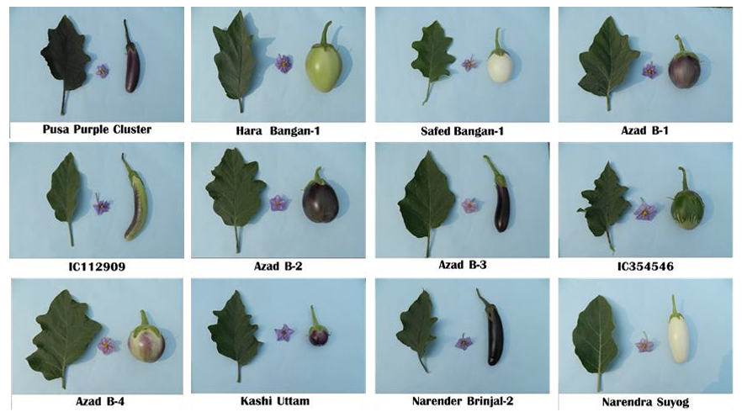
Fig. 1: Variability of different brinjal genotypes
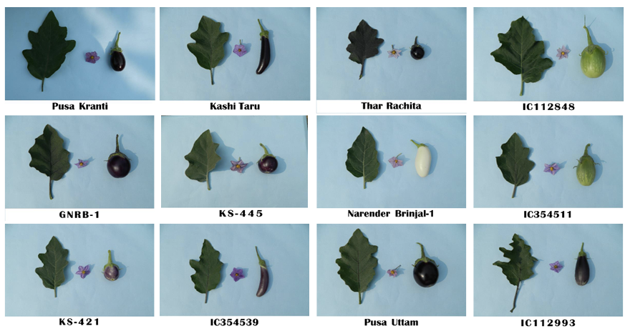
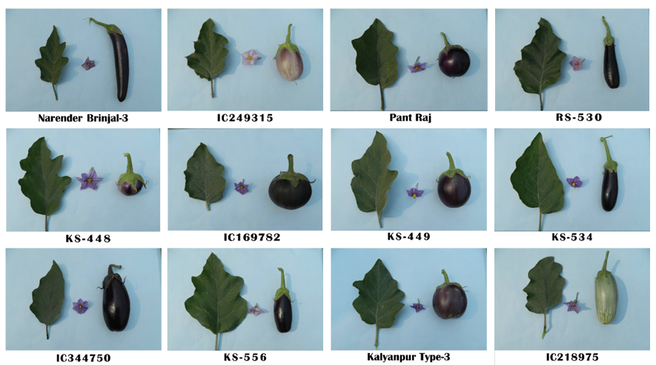
Fig. 2: Variability of different brinjal genotypes
Fig. 3: Variability of different brinjal genotypes

3.3 Heritability

The efficiency of breeding techniques for different qualities is significantly influenced by heritability, which is essential for identifying the degree to which genetic factors influence phenotypic expression. According to Johansan et al. (1955), estimating heritability along with genetic advance is useful for predicting the expected advancement through selection. In the present investigation, broad-sense heritability was found to be high (>60%) for all the traits, viz. number of flowers per cluster (99.47%), total phenol content (98.86%), fruit volume (98.6%), number of fruits per cluster (98.36%), root-knot index (98.20%), fruit diameter (96.01%), days to 50 per cent flowering (95.93%), days to first harvest (95.01%), average fruit weight (94.14%), plant height at 30 DAT (93.03%), plant height at 45 DAT (92.52%), SPAD reading (92.43%), number of fruits per plant (89.91%), number of clusters per plant(82.97%), fruit yield per plant (81.70%) and moisture content (63.12%). High heritability estimates for various characters suggest that most of the observed phenotypic variation is due to genetic factors, enabling effective selection based on phenotype. Earlier, similar findings were also reported by Teja et al. (2025), Thomas et al. (2022), Sharma et al. (2022) and Prajapati et al. (2021).

3.4 Genetic advance as per cent of mean

The expression of the traits with high heritability and genetic advance is predominantly governed by additive gene effects and therefore, selection based on phenotypic performance will be useful to improve these characters in the future, as suggested by Prasad et al. (2004).
As shown in Table 3, results revealed that genetic gain (expressed as per cent of population mean) was low to high for different characters. High heritability (>60%) coupled with high genetic gain over mean (>20%) it was found high for the traits viz., root-knot index (85.96%), fruit volume (85.54%), number of flowers per cluster (79.71%), average fruit weight (70.60%), number of fruits per cluster (69.22%), number of fruits per plant (66.88%), fruit yield per plant (65.73%), fruit diameter (54.01%), SPAD reading (53.92%), total phenol content (45.76%). Moderate genetic gain was observed for number of clusters per plant (40.45%), plant height at 30 DAT (37.23%), plant height at 45 DAT (33.66%), days to 50 per cent flowering (20.28%), days to first harvest (16.26%) whereas, lowest genetic gain was observed for moisture content (0.70%). The results were consistent with those of Tabasum et al. (2024), Soumya et al. (2023), Barik et al. (2021), Prajapati et al. (2021), and Praveen et al. (2020).

Table 3: Estimates of genetic parameters of variation for the different characters of brinjal genotype
_{S. No.} | _{Character} | _{Mean} | _{Range} | _{GCV} | _{PCV} | _{Heritability (%)} | _{GA} | _{GA as % of Mean}
₁ | _{Plant height at 30 DAT (cm)} | _{20.17} | _{13.66-32.36} | _{18.74} | _{19.42} | _{93.03} | _{7.51} | _{37.23}
₂ | _{Plant height at 45 DAT (cm)} | _{25.69} | _{19.07-40.42} | _{16.99} | _{17.66} | _{92.52} | _{8.65} | _{33.66}
₃ | _{Days to 50 per cent flowering} | _{59.61} | _{51.00-71.00} | _{10.05} | _{10.26} | _{95.93} | _{12.09} | _{20.28}
₄ | _{Number of clusters per plant} | _{23.58} | _{14.00-35.53} | _{21.56} | _{23.67} | _{82.97} | _{9.54} | _{40.45}
₅ | _{Number of flowers per cluster} | _{3.89} | _{1.49-10.65} | _{38.80} | _{38.90} | _{99.47} | _{3.10} | _{79.71}
₆ | _{SPAD reading} | _{69.52} | _{43.01-106.51} | _{27.22} | _{28.32} | _{92.43} | _{37.48} | _{53.92}
₇ | _{Number of fruits per cluster} | _{2.95} | _{1.00-6.80} | _{33.88} | _{34.16} | _{98.36} | _{2.04} | _{69.22}
₈ | _{Number of fruits per plant} | _{69.35} | _{18.13-120.53} | _{34.24} | _{36.11} | _{89.91} | _{46.38} | _{66.88}
₉ | _{Days to first harvest} | _{74.75} | _{65.00-83.67} | _{8.10} | _{8.31} | _{95.01} | _{12.15} | _{16.26}
₁₀ | _{Fruit volume (cc)} | _{108.86} | _{34.33-213.00} | _{41.82} | _{42.12} | _{98.6} | _{93.12} | _{85.54}
₁₁ | _{Fruit diameter (cm)} | _{4.55} | _{2.66-7.72} | _{26.76} | _{27.31} | _{96.01} | _{2.45} | _{54.01}
₁₂ | _{Average fruit weight (g)} | _{65.13} | _{30.13-118.07} | _{35.32} | _{36.40} | _{94.14} | _{45.99} | _{70.60}
₁₃ | _{Root-knot index} | _{108.42} | _{23.00-186.33} | _{42.11} | _{42.49} | _{98.20} | _{93.20} | _{85.96}
₁₄ | _{Moisture content (%)} | _{90.49} | _{89.26-92.65} | _{0.68} | _{1.38} | _{63.12} | _{0.63} | _{0.70}
₁₅ | _{Total phenol content (mg/100g)} | _{369.16} | _{216.70-542.92} | _{22.34} | _{22.47} | _{98.86} | _{168.93} | _{45.76}
₁₆ | _{Fruit yield per plant (kg)} | _{4.25} | _{1.18-7.38} | _{35.30} | _{39.06} | _{81.70} | _{2.79} | _{65.73}

4. Conclusion

The findings of the present investigation indicate that there is a good amount of genetic variation present in among the genotypes studied, which is useful for future crop improvement programs in a crop species. Analysis of variance showed a significant difference among the brinjal genotypes for all the characteristics, corroborating that sufficient variability is present in the material. Generally, the phenotypic coefficient of variation (PCV) was higher than the genotypic coefficient of variation (GCV), signifying that these traits are influenced by environmental factors in addition to genetic factors. However, almost all the traits showed high heritability along with high genetic gain, indicating that the additive gene action mainly controlled these traits. Direct selection of these traits would be effective and could help in selecting superior brinjal genotypes for further crop improvement.

Competing interests

Authors have declared that no competing interests exist.

References

Anonymous (2025). Database, Department of Agriculture and Farmers Welfare. Government of India.
Barik, S., Ponnam, N., Acharya, G. C., Singh, T. H., Dash, M., Sahu, G. S., & Mahapatra, S. K. (2021). Genetic variability, character association and diversity studies in brinjal (Solanum melongena L.). Electronic Journal of Plant Breeding, 12(4): 1102-1110.
Burton, G. W. (1952). Quantitative inheritance in grasses. Proc. Int. Grassesland cong., 1:277- 283.
Bushra, A., Zakir, H. M., Sharmin, S., Quadir, Q. F., Rashid, M. H., Rahman, M. S., & Mallick, S. (2022). Human health implications of trace metal contamination in top soils and brinjal fruits harvested from a famous brinjal-producing area in Bangladesh. Scientific Reports, 12;14278.
Choudhary B. (1976). Vegetables, National Book Trust, New Delhi. 58.
De Candolle A. (1886). Origin of cultivated plants. Reprinted 1959 by Hafner Publ. Co, NewYork, 29-33.3.
Dunlop, F. (2006). Revolutionary Chinese Cookbook. Recipes from Hunan Province, Ebury Pess. 202.2.
Johnson, H. W., Robinson, H. F., & Comstock, R. F. (1955). Estimates of genetic and environmental variability in soybean. Agron. J., 47(10);314-318.
Johnson, H. W., Robinson, H. F., & Comstock, R. E. (1955). Estimates of genetic and environmental variability in soya bean. Agronomy Journal, 47:314-318.
Kumar, R., Katiyar, R., Muttepawar, M., Kumar, S., Kumar, R., Vikrant, A., Nayak, A. K., & Pathak, V. N. (2025). Genetic Variability, Heritability and Genetic Advance Studies in Chickpea (Cicer arientinum L.) Journal of Advances in Biology & Biotechnology, 28(1); 944-948.
Paramanik, S., Rao, M. S., Rashmi, K., Panda, K. K., & Chakraborty, A. (2023). Studies on genetic variability, heritability and genetic advance for quantitative traits and nutritional traits in rice (Oryza sativa L.). Electronic Journal of Plant Breeding 14(4);1527-1537.
Prajapati, D. R., Patel, D. A., & Patel, D. K. (2021). Study of genetic variability in brinjal (Solanum melongena L.). International Journal of Chemical Studies, 9(2): 945-947.
Prasad, M., Mehta, N., Dikshit, S. N., & Nichal, S. S. (2004). Genetic variability, genetic advance and heritability in brinjal (Solanum melongena L.). Orissa Journal of Horticulture, 32: 26-29.
Sharma, P., Nair, R., Bhan, K. S., & Tiwari, S. (2022). Genetic Variability for Quantitative in Brinjal (Solanum melongena L.). Biological Forum – An International Journal, 14(1); 00-00.
Soumya, B. K., Deo, C., Singh, S., Bhutia, N. D., Tayeng, T., Hazarika, B. N., Debbarma, A., Sakhamo, K., & Dutta, R. (2023). Genetic Variability Studies in Brinjal (Solanum melongena L.) for Quantitative and Qualitative Characters. International Journal of Environment and Climate Change, 13(10);4463-4473.
Tabasum, S., Nazir, G., Hussain, K., Ali, G., Nazir, N., Mushtaq, F., Hussain, Z., & Arizoo (2024). Analysis of Genetic Variability and Heritability in Brinjal (Solanum melongena L.) Genotypes, Journal of Advances in Biology & Biotechnology, 27(4);198-205.
Teja B. L., Sadhu, S., Hijam, L., Roy, S. K., Chatterjee, R., & Chakraborty, M. (2025). Exploring Genetic Variability and Cause-effect Relationship for Yield and its Contributing Traits in Brinjal (Solanum melongena L.). International Journal of Bio-resource and Stress Management, 16(4); 01-10.
Thomas, A., Namboodiri, R. V., Sujatha, R., Sreekumar, K. M., Binitha, N. K., & Varghese, S. (2022). Genetic variability and correlation analysis for yield and yield contributing characters in brinjal (Solanum melongena L.), Electronic Journal of Plant Breeding,13(3);895 –900.
Tripathi, A., Kumar, J., Silas, V. J., Yadav, A., Quatadah, S. M., & Sharma, S. (2025). Analysis the Genetic Variability and Character Association in Brinjal (Solanum melongena L.). Journal of Experimental Agriculture International, 47(7);203-213.
Ukkund, K. C., Madalageri, M. B., Patil, M. P., Mulage, R., & Kotikal, Y. K. (2007). Variability studies in green chilli (Capsicum annum L.). Karnataka Journal of Agricultural Science, 20;102-104.
Vavilov, N. I. (1928). Geographical centers of our cultivated plants. In: Proceedings of the 5th International Congress of Genetics, New York. 342-369.4.

