Original Research Article

Clinical Utility of Serum Free Light Chain Assays in Multiple Myeloma Diagnosis: A 10-Year Multicenter Analysis from South-South Nigeria

.
ABSTRACT

Background:
In resource-limited settings, the diagnosis of multiple myeloma (MM) often relies on serum protein electrophoresis (SPE), which lacks sensitivity for light chain-only and oligo-secretory disease. This study evaluates the diagnostic utility of serum free light chain (sFLC) assays in a Nigerian cohort.
Methods:
This was a 10-year retrospective multicenter study of 67 patients diagnosed with MM in Port Harcourt, Nigeria. Clinical and laboratory parameters at diagnosis were analyzed. Renal function was assessed using estimated glomerular filtration rate (eGFR, CKD-EPI). Correlation between involved free light chains (iFLC) and renal function was evaluated.
Results:
The mean age was 55.9 ± 11.7 years, with a male-to-female ratio of 1.2:1. Bone pain (44.8%) and anemia (34.3%) were the most common presentations. SPE detected an M-protein in 68.7% of cases, while 31.3% were SPE-negative but sFLC-positive, representing a significant diagnostic gap. Over 50% of patients had renal impairment (eGFR <90 mL/min/1.73m²), with 17.9% having severe impairment (eGFR <40). Lambda-predominant disease was associated with significantly worse renal outcomes compared to kappa (p=0.019). A strong inverse correlation was observed between iFLC levels and eGFR (r = −0.68, p < 0.001).
Conclusion:
sFLC assays are indispensable for accurate diagnosis of MM in resource-limited settings, closing a critical diagnostic gap. Lambda light chain predominance was associated with more severe renal impairment and may serve as a prognostic marker.

Keywords: [Multiple myeloma, serum free light chains, serum protein electrophoresis, resource-limited}

1. INTRODUCTION

Multiple myeloma (MM) is a plasma cell malignancy. It is characterized by the clonal proliferation of plasma cells that produce monoclonal immunoglobulins or free light chains.¹ Plasma cells usually home to the bone marrow and as such diagnosing plasma cell disease usually requires the morphologic, immunophenotypic, and molecular assessment of the bone marrow. However, where there is the localized collection of these clonal plasma cells in the extramedullary parts of bones or of soft tissues, diagnosing MM in these situations require a biopsy and immunohistochemical examination of these swellings. Additionally, because these cells secrete their proteins into the circulation, it is also possible to investigate the disease by measuring these peripheral blood parameters; this is especially correct in those few MM which are oligosecretory in nature. Quantitative and/or qualitative assessment of these plasma cells-produced proteins form the basis for the diagnosis, monitoring of response to therapy, and also assessment of relapse in the management of multiple myeloma specifically, and plasma cell dyscrasia by extension. In developed climes where there their populations have good health-seeking behaviour, where access to regular medical care is made easy by good health insurance, and where there is ready availability of laboratory capacity for immunophenotyping, molecular and genetic investigations, it is easy to diagnose MM in the early stages. This is not the situation in Sub-Saharan Africa, including Nigeria, where due to economic difficulties and paucity of relevant equipment, many patients frequently present late and at different stages of advanced disease and also with significant end-organ damage, including renal impairment, anemia, and skeletal complications.^{2,3}
Serum protein electrophoresis (SPE) is one of the most widely available diagnostic tools in many low-resource settings.^{4,5} it works via the separation of proteins based off of their electrical charge and their sizes when an electrical current is passed through a medium containing these proteins. However, SPE lacks sensitivity in detecting light chain multiple myeloma (LCMM) and oligo-secretory disease, which may only be diagnosed by assessment of bone marrow aspirate or trephine biopsy sample of the marrow or of a biopsied extramedullary plasmacytoma or of other soft tissues.^{6,7} In appreciation of the limitations of this ancillary diagnostic modality, the serum free light chain (sFLC) assay was introduced. sFLC offers superior sensitivity and allows earlier detection of clonal plasma cell disorders,¹ and it has been incorporated into International Myeloma Working Group (IMWG) diagnostic criteria for multiple myeloma. The test measures the quantity of unbound monoclonal light chains which are found in the serum of patients by using antibodies specific to these light chains. The degree of light chain-antibody complex is determined by nephelometric assessment or by the turbidity of the sample. The aim of this study was to highlight the diagnostic gaps that exist between SPE and sFLC assays as it applies to patients diagnosed with and managed for MM at tertiary healthcare facilities in Port Harcourt.

2. methods

This was a retrospective multicenter study conducted across tertiary healthcare institutions in Port Harcourt, Nigeria, over a 10-year period (from June 2013 to July 2023). The study population was patients with a confirmed diagnosis of MM based on IMWG criteria. Clinical and laboratory data at diagnosis were extracted from patient records, including; demographics (age, sex), clinical features (bone pain, anemia, fractures), hemoglobin concentration, bone marrow plasmacytosis, biochemical parameters (urea, creatinine, uric acid, SPE and sFLC). Renal function was assessed using eGFR calculated with the CKD-EPI equation and categorized according to CKD staging. Data was analyzed using SPSS version 24. Descriptive statistics (Mean, Median, SD) were used for demographic data. Correlation between involved light chains (iFLC) and eGFR was assessed using Spearman’s rank correlation. P-values <0.05 were considered statistically significant.

3. results and discussion

A total of 67 patients were included. The mean age was 55.9 ± 11.7 years (range 28–83), with 32.8% aged ≤50 years. The Male:Female ratio: was 1.2:1. The clinical burden at presentation was severe; bone pain was the primary complaint in 44.8% of patients, with 23.9% presenting with pathological fractures. The median duration of back pain prior to diagnosis was 5 months. The mean haemoglobin concentration was 8.8 ± 2.1 g/dL; with 23 patients (34.3%) having severe anemia (Hb <8 g/dL). Average bone marrow plasmacytosis was 48.7% ± 28.9%. However, about 7 (10.4%) patients presented with <10% plasma cells in the marrow despite diagnostic sFLC ratios. Table 1 shows the presenting features of the cohort.
Table 1: Clinical Parameters of MM patients
Clinical Feature | Frequency (n) | Percentage (%)
Bone pain | 30 | 44.8
Severe Anemia <8g/dL | 23 | 34.3
Pathological fractures | 16 | 23.9
Renal impairment (eGFR <90 mL/min/1.73m²) | 34 | 50.7
Severe renal impairment (eGFR <40 mL/min/1.73m²) | 12 | 17.9
eGFR- estimated glomerular filtration rate
Serum protein electrophoresis (SPE) was performed in 46 patients (68.7%), of whom 37 (80.4%) demonstrated a detectable monoclonal protein (M-protein), while 9 (19.6%) had no identifiable M-protein. The median M-protein concentration was 28 g/L. Patients with higher M-protein levels (>30 g/L) had significantly elevated total protein levels (123.8 g/L vs 75.2 g/L vs 68.6 g/L; p < 0.001) and significantly lower serum albumin levels (26.1 g/L vs 33.5 g/L vs 38.9 g/L; p < 0.001). Although haemoglobin levels were lower in patients with higher M-protein burden (7.9 g/dL vs 8.9 g/dL vs 10.8 g/dL), this difference did not reach statistical significance (p = 0.07).
Serum free light chain (sFLC) assays were performed in 45 patients (67.2%), of whom 43 (95.6%) demonstrated abnormal light chain levels. Kappa light chain involvement was more common (68.9%), while lambda involvement was observed in 40% of cases. The median kappa and lambda concentrations were 944 mg/L and 514.8 mg/L respectively, with a median kappa-lambda ratio of 14.1, reflecting marked monoclonality. Of the 9 patients without detectable M-protein on SPE, 8 (88.9%) had abnormal sFLC assays.

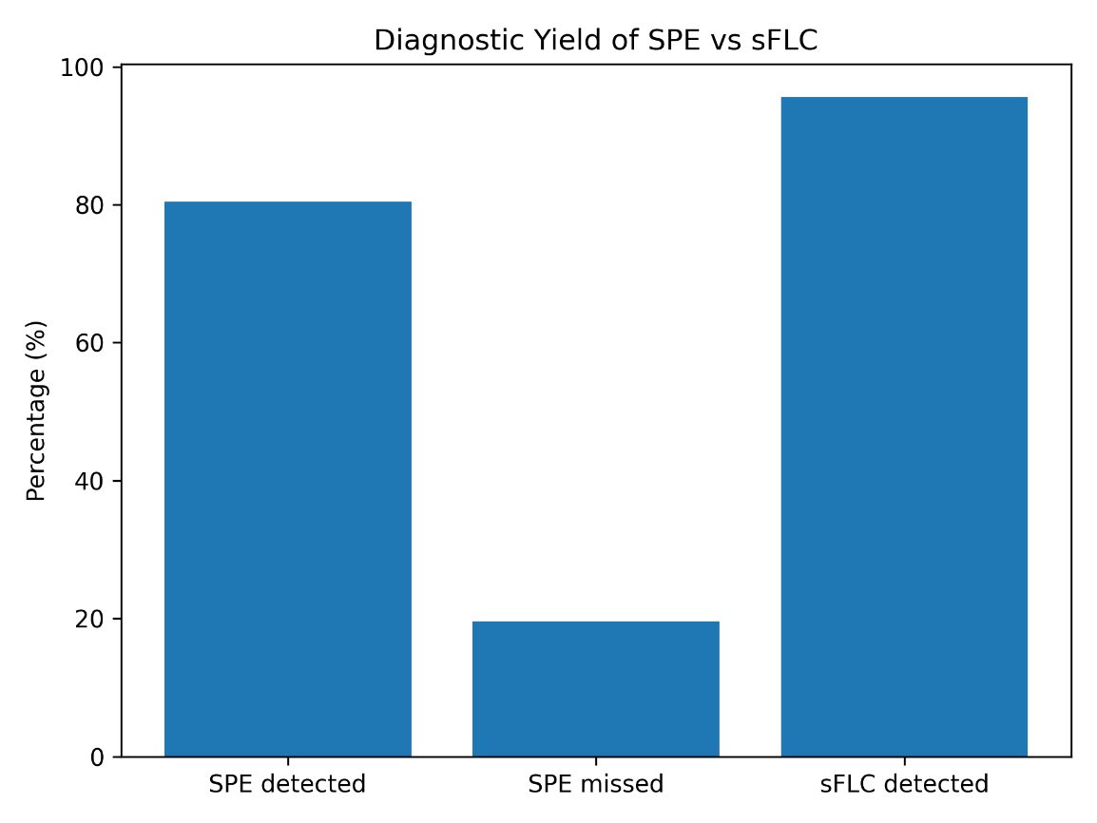
Figure 1: Diagnostic yield of serum protein electrophoresis vs serum free light chains
Patients with lambda chain involvement had significantly lower haemoglobin levels compared to those with kappa involvement (7.4 g/dL vs 8.7 g/dL; p = 0.05). Although not statistically significant, lambda-chain myeloma also demonstrated higher mean serum creatinine (181.9 µmol/L vs 123.5 µmol/L; p = 0.13) and lower eGFR (63.8 vs 71.9 mL/min/1.73 m²; p = 0.49).
Renal impairment (RI) was also observed even in patients without detectable M-protein, which occurred as eGFR <90 in n=34 (50.7%) and eGFR <40 in n=12 (17.9%) cases. There was a strong negative correlation existing between iFLC levels and renal function (r = −0.68, p < 0.001). Table 2 shows the comparison of involved light chains with regards to creatinine, eGFR and renal impairment.
Table 2: Renal Function and Light Chain Isotype
Parameter | Kappa (n=42) | Lambda (n=25) | p-value
Median iFLC (mg/L) | 218 | 288 | 0.041
Median Creatinine (µmol/L) | 81 | 102.5 | 0.038
Mean eGFR (mL/min) | 88.4 | 63.2 | 0.027
Severe RI (<40) | 11.9% | 28.0% | 0.019
iFLC- involved free light chain, eGFR- estimated glomerular filtration rate, RI- renal impairment

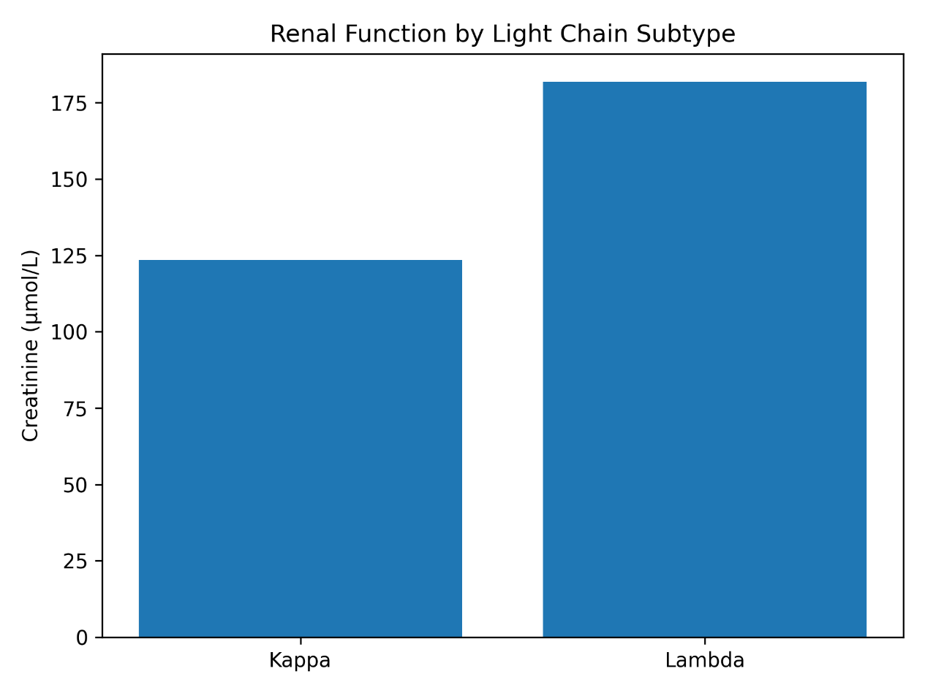
Figure 2: Renal function by light chain subtype

The median age at diagnosis of 56 years observed in this cohort is notably lower than the 65–70 years typically reported in literature from high-income settings. This lower mean age at diagnosis of MM has been well described in several sub-Saharan Africa publications and also by experiential and anecdotal evidence, and may reflect a combination of demographic factors, financial difficulties, delayed healthcare access, and potential biological differences in disease behaviour.^{8,9} The predominance of anaemia, bone pain, and renal impairment in our patients suggests a high tumour burden at presentation.^{10,11}
Serum protein electrophoresis demonstrated good diagnostic utility (despite not being performed for all patients due to financial constraints), it detected the presence of M-protein in up to 80.4% of the MM patients; however, it failed to identify disease in approximately one-fifth of cases. This finding is clinically significant and is in keeping with global data which shows that about 15–20% of MM cases are light-chain-only or oligosecretory variants.^{6,12,13} The inability of SPE to detect monoclonal protein in these patients highlights its intrinsic limitations, particularly in low tumour burden states, when only free light chains are produced, or where the clone of malignant plasma cells is small and the M-protein produced overlaps with polyclonal proteins.⁷
On the other hand, sFLC assays demonstrated markedly superior diagnostic sensitivity, identifying abnormal monoclonal light chains in 95.6% of tested patients. In addition, sFLC detected disease in 88.9% of patients who were M-protein-negative on SPE. This finding underscores the indispensable role of sFLC testing in preventing underdiagnosis of MM especially in patients who may have low concentration of plasma cells in the bone marrow and/ or are SPE negative;^{14,15} it also demonstrates the superiority of sFLC to SPE in the management of MM. The sFLC assay also serves as a functional biomarker of tumor burden, supporting diagnosis even when bone marrow aspiration or trephine biopsy findings are inconclusive.^{16,17}
Higher M-protein concentrations were associated with hypoalbuminaemia in our patients, which was expected since increased tumour burden drives both elevated immunoglobulin production and systemic inflammatory responses, leading to reduced albumin synthesis. The strong statistical association between serum M-protein and hypoalbuminaemia (p < 0.001) reinforces the prognostic relevance of these markers in MM patients and so suggests parameters to consider in their management.
An important clinical observation was the association of lambda light chain disease with lower haemoglobin levels and worse renal function. Although only haemoglobin reached statistical significance, the trend of renal parameters supports existing evidence that lambda chains are more nephrotoxic and causes worse renal impairment compared to MM in which the kappa chains are the involved chains. This may be because their physical property allows them have a higher propensity for dimerization and deposition within renal tubules, thereby contributing to cast nephropathy and progressive renal dysfunction.^{18,19} Lambda chains form dimers and polymers, with increased affinity for Tamm–Horsfall protein and greater propensity for cast nephropathy.^{3,20} Lambda chains are also resistant to proteolysis and their continued accumulation in the tissues of the kidneys predisposes toxicity. In our resource-constrained environment, this has profound clinical implications, since there is limited access to dialysis because of financial limitations of the patients, and also due to the presence of only a few dialysis facilities. Over half of our patients had renal impairment, and this was present even in patients without detectable M-protein on SPE, thereby highlighting the role of free light chains in the pathogenesis of renal damage in MM, and also other plasma cell dyscrasias.
In many resource-limited settings, diagnostic pathways rely heavily on SPE due to cost and availability constraints. However, this study demonstrates that such reliance may result in substantial underdiagnosis and by extension, delays in treatment initiation, and this would mean a worse prognosis of the disease for the patient. The integration of sFLC testing into routine diagnostic workflows represents a high-impact intervention that would definitely and significantly improve diagnostic accuracy, enable earlier therapeutic intervention, and reduce organ damage, thereby improving the overall quality of life of those who are living with the disease. Therefore, sFLC assays are not merely complementary but they are most essential for the accurate diagnosis of multiple myeloma, and also in the follow-up assessment of these patients, particularly in resource-constrained environments where diagnostic limitations are most pronounced.

4. Conclusion

This study provides real-world evidence highlighting a critical diagnostic gap associated with reliance on SPE alone in MM diagnosis, and establishes sFLC testing as a high-yield, clinically impactful diagnostic modality. The study emphasizes the significance of sFLC and points to the importance of its inclusion in the current diagnostic criteria for the disease. The study also shows that Lambda chain involvement is associated with worse renal function.

5. LIMITATIONS

This was a retrospective study with a small sample size of the cohort. Other specialized tests such as cytogenetics and fluorescent in-situ hybridization were not done for our patients due to unavailability in our region.

9. Consent

Not applicable.

10. References

- Rajkumar SV. Multiple myeloma: 2024 update on diagnosis, risk-stratification, and management. Am J Hematol. 2024 Sep;99(9):1802-1824. doi: 10.1002/ajh.27422. Epub 2024 Jun 28
- Madu, AJ; Ocheni, S; Nwagha, TA; Ibegbulam, OG; Anike, US¹. Multiple myeloma in Nigeria: An insight to the clinical, laboratory features, and outcomes. Nigerian Journal of Clinical Practice 17(2):p 212-217, Mar–Apr 2014.
- Nwabuko OC, Igbigbi EE, Chukwuonye II, Nnoli MA. Multiple myeloma in Niger Delta, Nigeria: complications and the outcome of palliative interventions. Cancer Manag Res. 2017 May 22;9:189-196.
- Pires AM, Barreto JP, Caetano J, Soares MJ, Geraldes C, Fernandes B, Coucelo M, et al On Behalf Of The Portuguese Multiple Myeloma Group. Multiple Myeloma Laboratory Diagnostics Made Simple: Practical Insights and Key Recommendations. J Clin Med. 2025 Oct 9;14(19):
- Thokerunga, E., Ntege, C. & Ahmed, A.O. Are African primary physicians suspicious enough? Challenges of multiple myeloma diagnosis in Africa. Egypt J Intern Med 33, 54 (2021).
- Silva C, Costa A, Paiva D, Freitas S, Alves G, Cotter J. Light-Chain Multiple Myeloma: A Diagnostic Challenge. Cureus. 2021 Oct 29;13(10)
- Lalani A, Aziz K, Khan M, Zubair T, Ahmed SI. A Patient of Multiple Myeloma with Absent M-spike on Serum Protein Electrophoresis and Elevated Serum-Free Light Chains: A Case Report and Literature Review. Cureus. 2019 Aug 16;11(8)
- Dash S, Mohanty PK, Sahu KK, et al. Delayed diagnosis of multiple myeloma in developing countries. J Glob Oncol. 2019;5:1–7
- Urban VS, Cegledi A, Mikala G. Multiple myeloma, a quintessential malignant disease of aging: a geroscience perspective on pathogenesis and treatment. Geroscience. 2023 Apr;45(2):727-746
- Liu L, Yu Z, Cheng H, Mao X, Sui W, Deng S, Wei X, Lv J, Du C, Xu J, Huang W, Xia S, An G, Zhou W, Ma X, Cheng T, Qiu L, Hao M. Multiple myeloma hinders erythropoiesis and causes anaemia owing to high levels of CCL3 in the bone marrow microenvironment. Sci Rep. 2020 Nov 25;10(1):20508.
- Sloan, M.J., Raje, N. (2008). Anemia and Erythropoeitic Growth Factors in Multiple Myeloma. In: Lonial, S. (eds) Myeloma Therapy. Contemporary Hematology. Humana Press. https://doi.org/10.1007/978-1-59745-564-0_28
- Rafae A, Malik MN, Abu Zar M, Durer S, Durer C. An Overview of Light Chain Multiple Myeloma: Clinical Characteristics and Rarities, Management Strategies, and Disease Monitoring. Cureus. 2018 Aug 15;10(8):e3148
- Trisal, Monal; Rawat, Anamika¹; Mishra, Jyoti¹; Sengar, Kangana²; Mishra, Sanjay Kumar³. Non-secretory myeloma: clinical profile and diagnostic utility of immunohistochemistry and free light chain assay in a rare variant of plasma cell myeloma. MGM Journal of Medical Sciences 12(2):p 306-312, April-June 2025.
- Banderker RB, Fazel FB, Zemlin AE, Khine A-A, Jalavu TP. Serum-free light chain test utilisation at a South African academic laboratory and comparison with serum protein electrophoresis results. Afr J Lab Med. 2023;12(1), a2201
- De Novellis D, Fontana R, Carobene A, Serio B, Ferrara I, Martorelli MC, Mettivier L et al. Serum Free Light-Chain Ratio at Diagnosis Is Associated with Early Renal Damage in Multiple Myeloma: A Case Series Real-World Study. Biomedicines. 2022 Jul 10;10(7)
- Ellen Jenner,Serum free light chains in clinical laboratory diagnostics,Clinica Chimica Acta,Volume 427,2014, Pages 15-20
- Markovic U, Leotta V, Tibullo D, et al. Serum free light chains and multiple myeloma: Is it time to extend their application?. Clin Case Rep. 2020;8:617–624.
- Gallan AJ, Khalighi MA. Lambda Light Chain Crystalline Cast Nephropathy and Proximal Tubulopathy. Kidney Int Rep. 2016 Aug 12;1(4):316-320
- Gutiérrez-Peredo GB, Filho JCBO, Montaño-Castellón I, Gutiérrez-Peredo AJ, Crusoé EQ, Gusmao-Flores D. Lambda light chain-induced monoclonal gammopathy of renal significance, manifesting with Fanconi Syndrome and osteomalacia. BMC Nephrol. 2022 Aug 9;23(1):278.
- Wang MY, Yong ZH, Wang S, Wang SX, Zhou XJ, Dong YJet al. Light chain Cast Nephropathy: The Relationship between Tamm-Horsfall Protein Immunoreactivity and Clinical Pathological Features and Prognosis. Kidney Dis (Basel). 2026 Jan 22;12(1):237-247

