Original Research Article

Knowledge, Awareness and Practice about Chronic Oro-facial Pain among Interns Postgraduates and Dentists of Gujarat, India: A Cross-sectional Questionnaire Study

ABSTRACT

Background: Orofacial pain (OFP) is a challenging condition in dentistry involving chronic pain in the mouth, jaws, and face. Understanding OFP is essential for accurate diagnosis and treatment. This study aimed to assess the knowledge of general dentists and specialists about OFP.

Methods: A cross-sectional questionnaire-based study was carried out among general dentists and specialists. The validated questionnaire covered etiology, clinical signs, examination, and treatment of OFP. Data were analyzed using SPSS software, and correlations were tested using Spearman’s coefficient.

Results: The overall findings indicate that awareness regarding the definition and causation of orofacial pain among dental professionals is notably high, reflecting a sound understanding of its fundamental aspects. However, there remain certain misconceptions concerning the non-dental origins of orofacial pain, suggesting the need for more comprehensive theoretical and clinical exposure. While most respondents recognize that psychological and stress- related factors play a significant role in the onset and persistence of orofacial pain, their understanding appears to be moderate rather than complete, indicating an area for further emphasis in dental education.

Additionally, the responses reveal diagnostic and training gaps, as many participants reported limited familiarity with standard management guidelines and insufficient participation in structured training programs. Despite these shortcomings, there is strong overall support for a multidisciplinary approach to orofacial pain management and for its formal recognition as a distinct specialty by the National Dental Commission (NDC), underscoring the profession’s readiness to enhance expertise and collaboration in this critical area of dental practice.

Conclusion: Most dentists lacked adequate knowledge about chronic orofacial pain, especially in treatment aspects. Continuous education and inclusion of OFP courses in dental training programs are recommended to improve clinical competence and patient care.

Keywords: Orofacial pain, Chronic pain, Knowledge, Dentists, Temporomandibular disorders.

INTRODUCTION
Orofacial pain encompasses a wide range of painful conditions affecting the head, face, oral cavity, and associated structures. It includes temporomandibular disorders, neuropathic pain, and musculoskeletal disorders, which often require interdisciplinary management. Despite its clinical importance, the understanding of chronic orofacial pain among dental professionals remains inconsistent, potentially affecting patient outcomes. The ability of dental practitioners to identify and manage chronic orofacial pain depends heavily on their theoretical knowledge and clinical experience. This study was undertaken to evaluate the knowledge, awareness and clinical practices regarding chronic orofacial pain among dental interns, postgraduate students, and practicing dentists across Gujarat.
Chronic orofacial pain (COFP) represents a significant clinical challenge because of its multifactorial etiology involving biological, psychological, and social dimensions. Accurate diagnosis often requires differentiation between odontogenic and non-odontogenic sources of pain, which can be complex and time-consuming. Misdiagnosis may lead to unnecessary dental procedures, delayed treatment, and prolonged patient suffering.
Globally, several studies have highlighted gaps in dental professionals’ understanding of COFP, emphasizing the need for enhanced undergraduate and postgraduate training in India, where the burden of dental and maxillofacial disorders is substantial, such knowledge gaps may have an even greater impact on clinical practice and patient care. Understanding the current level of awareness and practice patterns among dental professionals in Gujarat can provide valuable insights for curriculum development, continuing dental education, and evidence-based pain management protocols.
Therefore, the present study aims to assess the knowledge, awareness, and clinical practices related to chronic orofacial pain among dental interns, postgraduate students, and practitioners across various institutions in Gujarat. The findings are expected to help identify educational deficiencies and support strategies for improving pain management competencies in dental practice.

MATERIALS AND METHODS

Study Design
A cross-sectional, questionnaire-based study was conducted among dental interns, post graduate students and practicing dentists across various institutions and private clinics in Gujarat. The study aimed to assess the knowledge, awareness, and clinical practices regarding chronic orofacial pain (COFP) within this professional group. Ethical clearance was obtained prior to data collection, and participation was voluntary.
Data Collection
Data were collected through an online survey designed using Google Forms, and the survey link was distributed via email to eligible participants. The questionnaire consisted of 15 structured questions divided into three key domains:
- Knowledge–assessing theoretical understanding of chronic orofacial pain,
- Awareness– evaluating perception, recognition, and relevance in clinical practice, and
- Practice–exploring diagnostic and management approaches adopted by practitioners.
A pilot study was initially conducted on a small sample to ensure clarity, relevance, and reliability of the questionnaire. Participant confidentiality and anonymity were strictly maintained to promote honest and unbiased responses.

STATISTICAL ANALYSIS
The collected data were compiled in Microsoft Excel (2007/2013) and analyzed using IBM SPSS Statistics version 21.0. Descriptive and frequency analyses were used to summarize participant responses. The Shapiro–Wilk test assessed the normality of data distribution. Comparative analyses among groups (interns, postgraduate students, and practicing dentists) were carried out using the Chi-square test, independent t-test, and One-way ANOVA, with non-para metric tests applied where appropriate. A confidence interval of 95%, alpha error of 5%, and study power of 80% were maintained. Ap-value<0.05 was considered statistically significant.

RESULT

Fig 1. Distribution of Respondents’ occupation
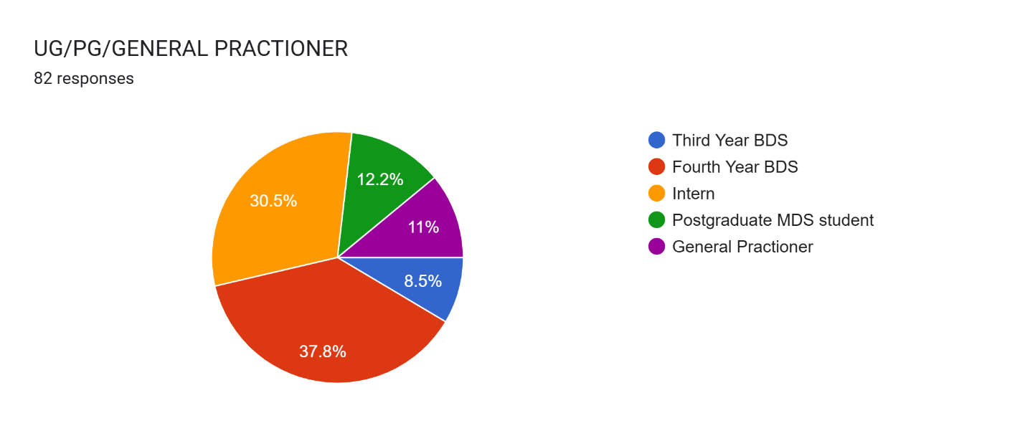
- The respondent distribution in this study showed that the majority of participants were Fourth Year BDS students, followed by Interns, while the fewest respondents were Third Year BDS students

Fig 2. Distribution of awareness level of Respondents regarding orofacial pain

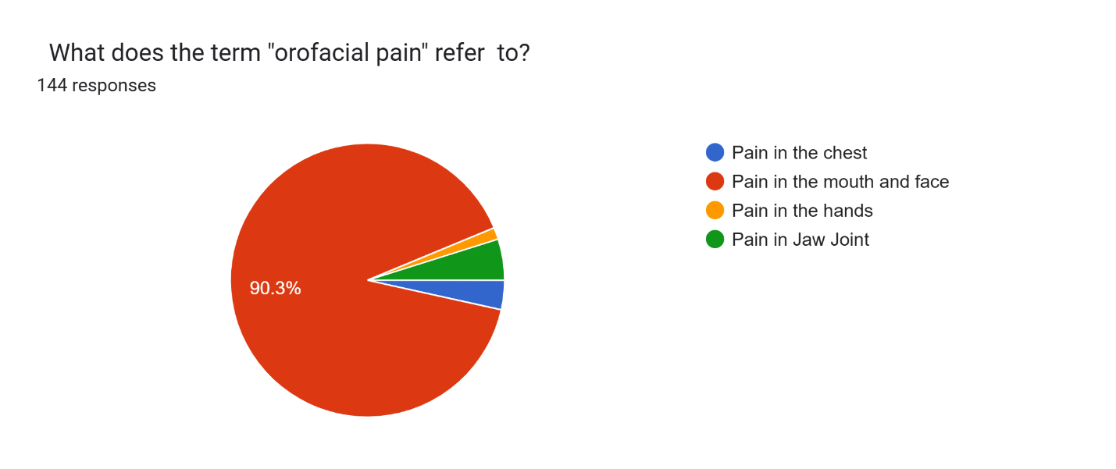
- Regarding definition awareness, 90.3% of respondents correctly identified orofacial pain as pain occurring in the mouth and face.
Fig 3. Preference of Respondents for the treatment of orofacial pain
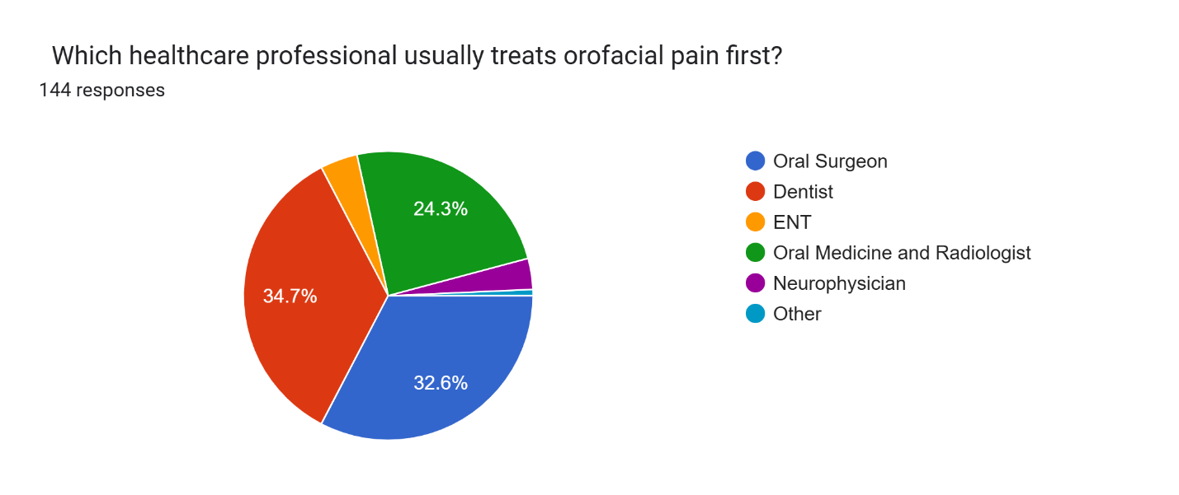
- When asked about the first-line professional to approach for treatment of orofacial pain, most participants chose Dentists (34.7%), followed by Oral Surgeons (32.6%) and specialists in Oral Medicine and Radiology (24.3%), while only a few selected ENT specialists or Neuro physicians.
Fig 4. Awareness of Respondents about the cause of orofacial pain
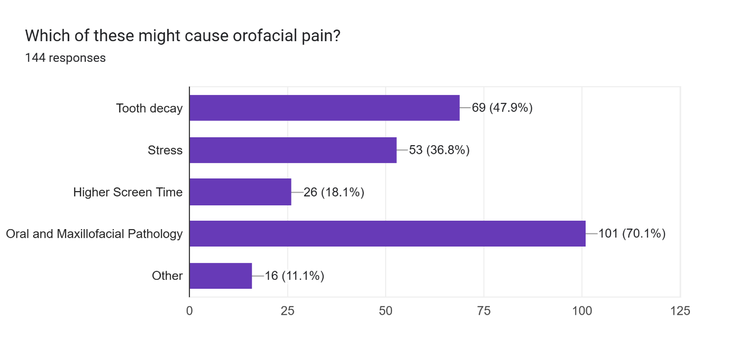
- In terms of perceived major causes of orofacial pain, Oral and Maxillofacial Pathology was identified by 70.1% of respondents, followed by Tooth Decay at 47.9%, with only a few citing Stressor Screen Time as contributing factors...
fig 5. Awareness of Respondents regarding the orofacial pain 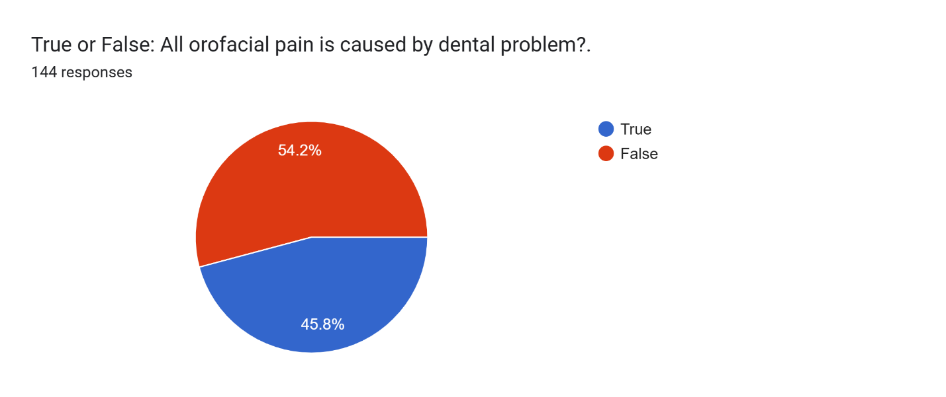
- When questioned whether all orofacial pain is dental in origin, 54.2% correctly responded “No,” while 45.8% still believed all such pain is dental in nature
Fig 6. Awareness of Respondents regarding the effect of stress on orofacial pain
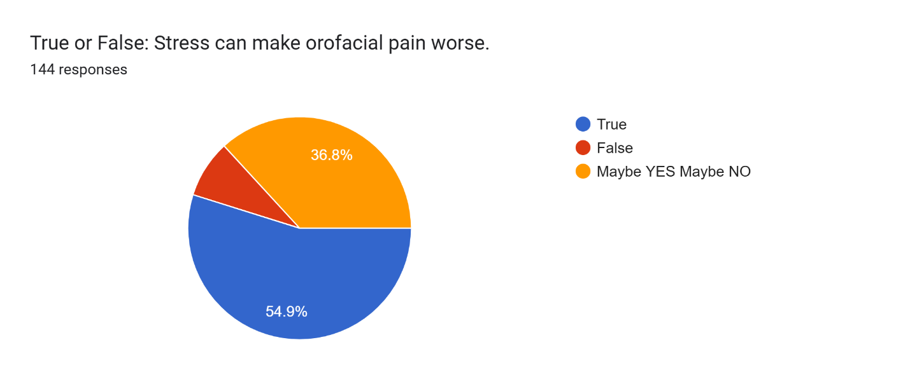
- Regarding the effect of stress,54.9%of participants agreed that stress worsens orofacial pain, 36.8% were uncertain, and only a few disagreed.

Fig 7. Responses about whether diagnostic challenges affect the treatment of orofacial pain

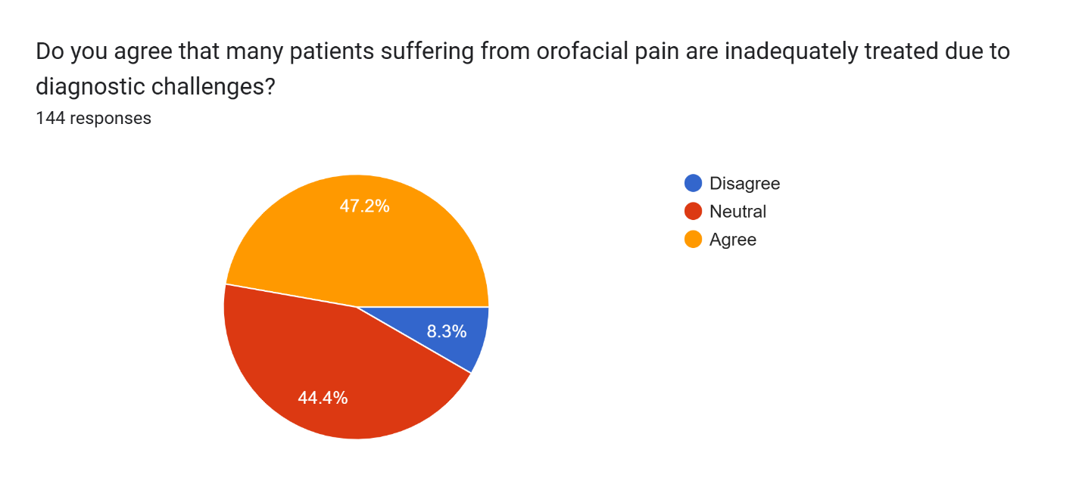
- Similarly, 47.2% agreed that diagnostic challenges affect treatment outcomes,44.4%remained neutral, and 8.3% disagreed.
Fig 8. Responses regarding the effect of psychological factors on orofacial pain
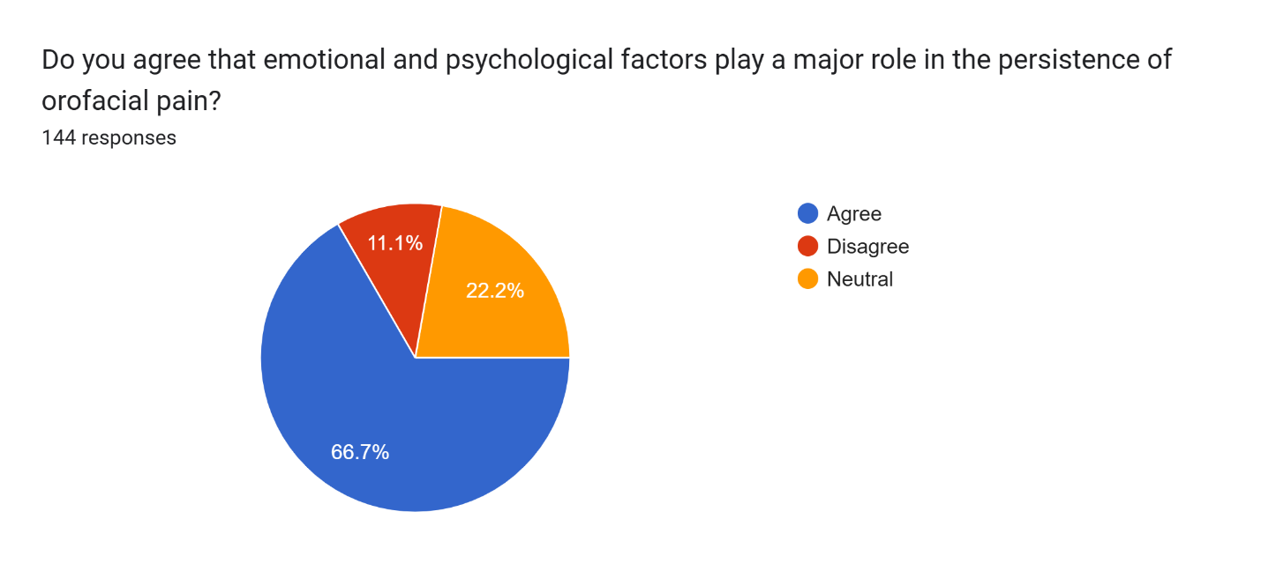

- Concerning psychological factors, 66.7% agreed that these factors affect the persistence of pain, while 22.2% were neutral and 11.1% disagreed.

Fig 9. Responses regarding the core dental competency of orofacial pain

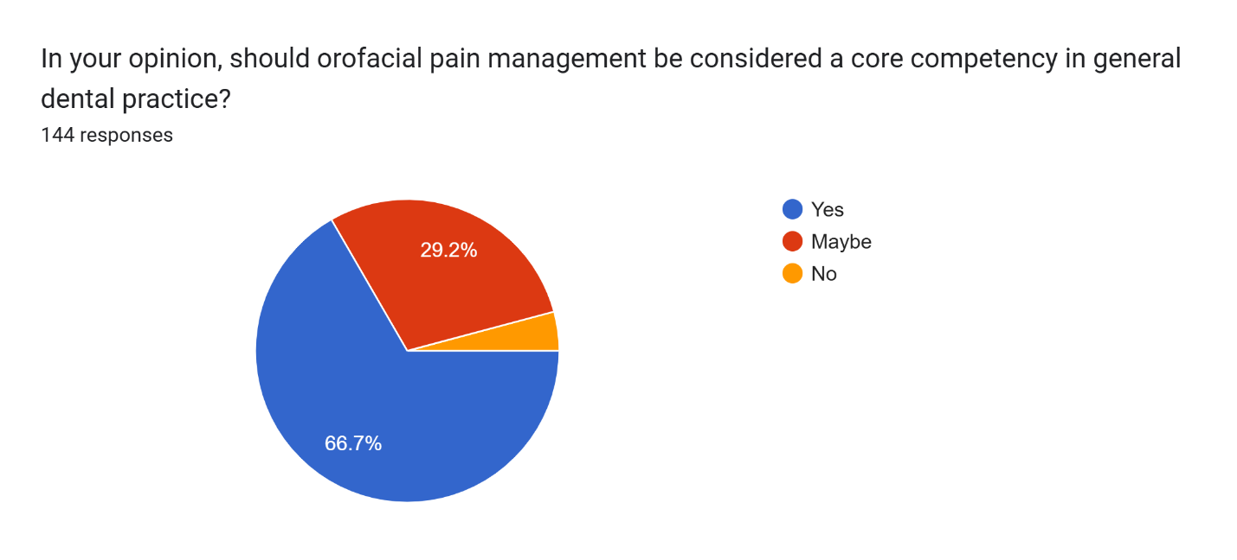9) When asked whether orofacial pain managements should be a core dental competency,66.7% agreed, 29.2% were unsure, and 4.2% disagreed.

Fig 10: Frequency of orofacial pain

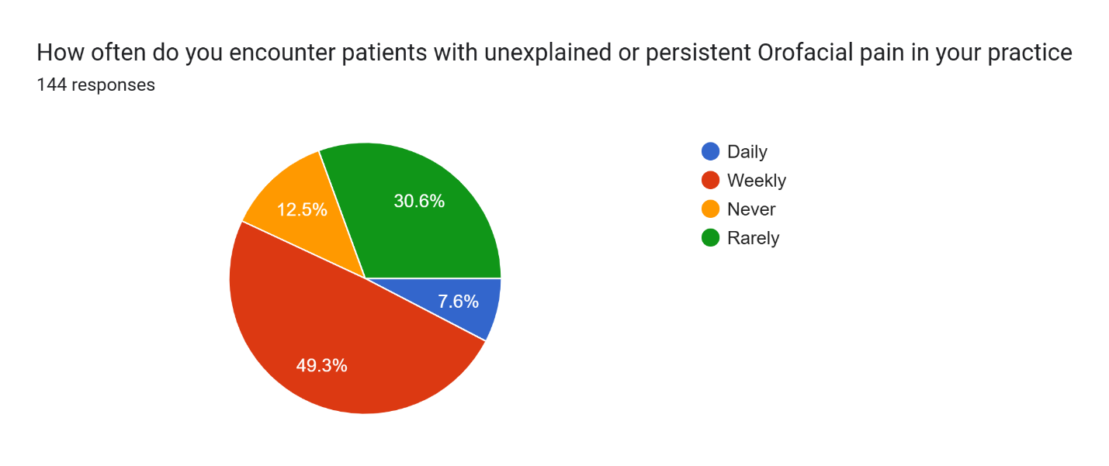10) In terms of the frequency of encountering orofacial pain patients, 49.3% reported weekly encounters, 30.6% rarely encountered such patients, 12.5% never did, and 7.6% reported daily encounters.]

Fig 11. Responses regarding a multidisciplinary approach to managing orofacial pain
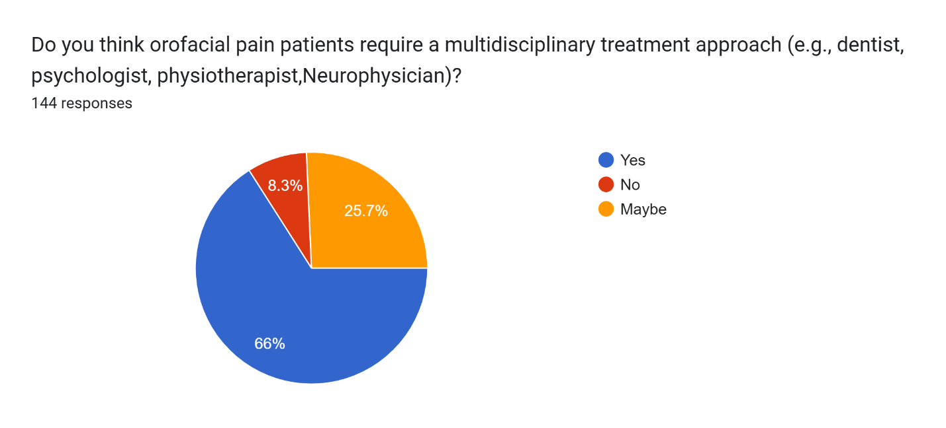

11) Support for a multidisciplinary approach to managing orofacial pain was expressed by 66% of respondents, while 25.7% were uncertain and 8.3% disagreed.

Fig 12. Frequency of the type of orofacial pain

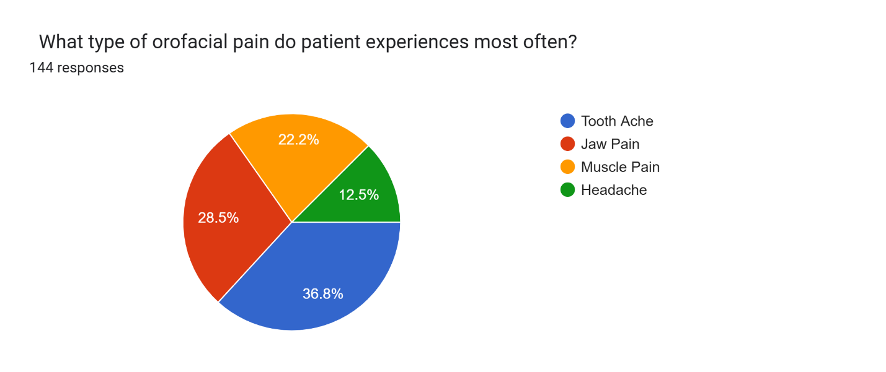

12) The most common types of orofacial pain experienced or observed were Toothache (36.8%), followed by Jaw Pain (28.5%), Muscle Pain (22.2%), and Headache (12.5%).

Fig 13. Commonly used diagnostic approach to assess orofacial pain
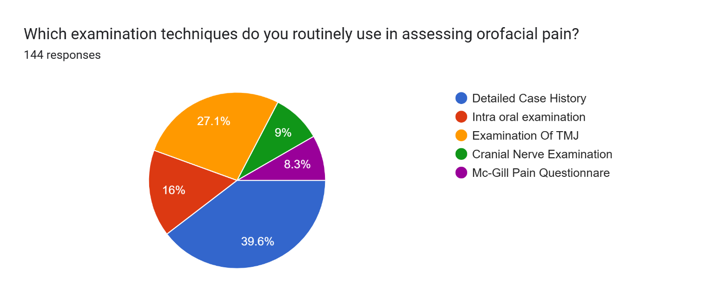13) In terms of common examination methods,39.6%reported taking a detailed case history as their primary diagnostic approach, and 27.1% performed temporomandibular joint (TMJ) examination, whereas fewer respondents reported using intraoral or cranial nerve examinations or patient questionnaires.

Fig 14. Responses regarding the standard orofacial pain management guidelines
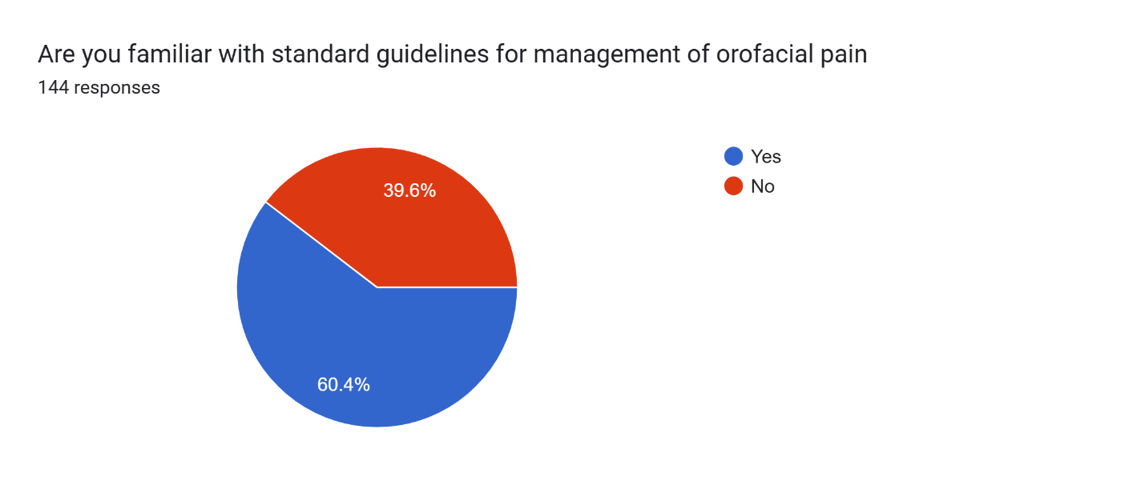
14) With respect to familiarity with standard orofacial pain management guidelines, 60.4% of participants were familiar with them, while 39.6% were not —indicating a notable training gap.

Fig 15. Responses regarding attending orofacial pain–related training programs
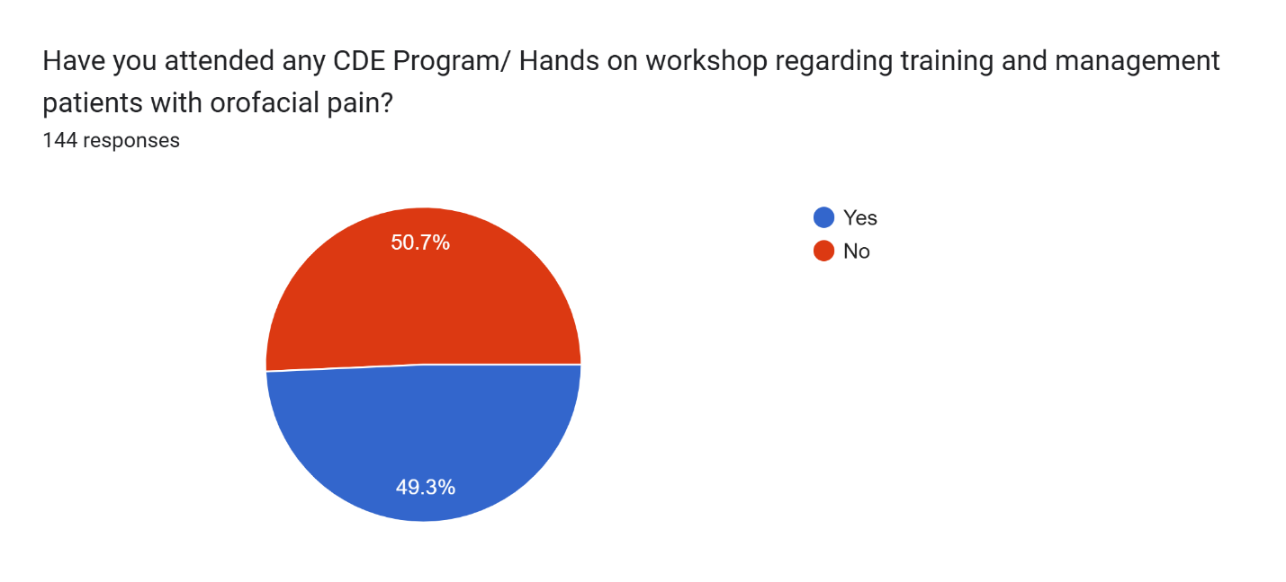
15) In terms of prior attendance in orofacial pain–related training programs, 49.3% had attended at least one, while 50.7% had not, reflecting the need for more structured and accessible educational initiatives.

Fig 16. Responses regarding whether orofacial pain should be recognised as a distinct speciality
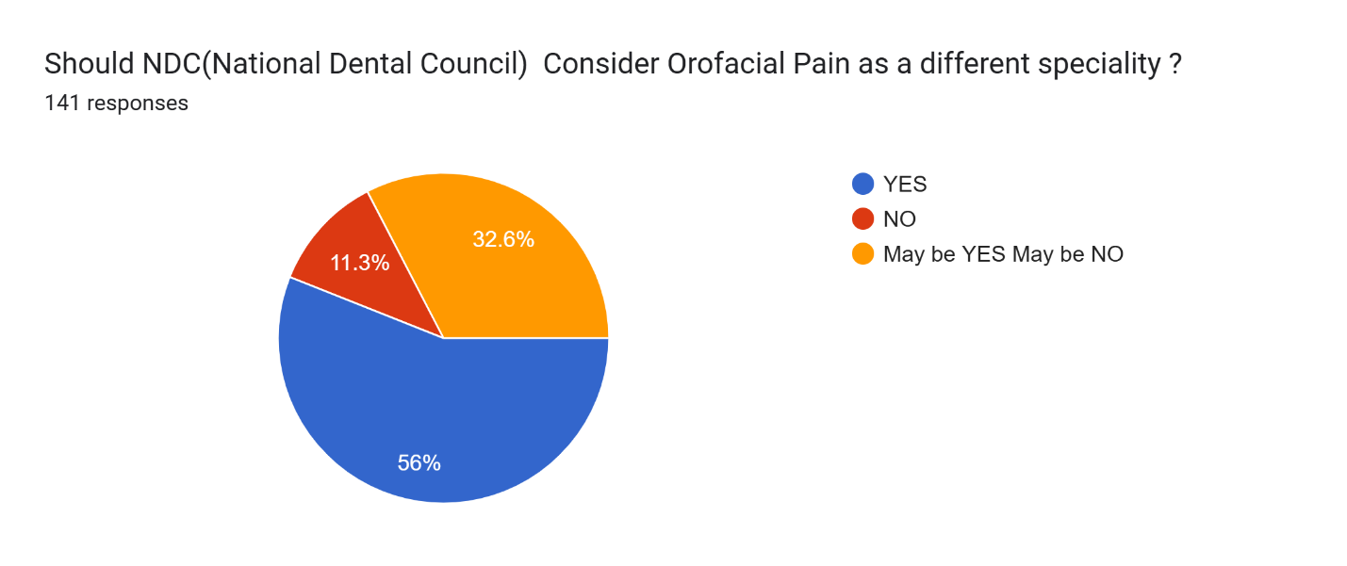16) Finally, when asked whether orofacial pain should be recognized as a distinct specialty under the National Dental Commission (NDC),56%agreed, 32.6% were uncertain, and 11.3% disagreed.

DISCUSSION

Chronic orofacial pain (COFP) represents a complex group of conditions involving the oral cavity, face, and associated structures, including temporomandibular disorders, neuropathic pain, and musculoskeletal conditions. The diagnosis and management of these conditions are challenging due to their multifactorial etiology involving biological, psychological, and social factors. Dental practitioners are often the first healthcare professionals consulted by patients experiencing orofacial pain; therefore, their knowledge and clinical competence play a crucial role in early diagnosis and management. Previous studies have reported that limited training and exposure to chronic pain conditions among dental professionals may contribute to diagnostic difficulties and inappropriate treatment¹
The present study evaluated the knowledge, awareness, and clinical practices related to chronic orofacial pain among dental interns, postgraduate students, and practicing dentists in Gujarat. The findings demonstrated that the majority of respondents possessed basic theoretical knowledge regarding orofacial pain, as most participants correctly identified its definition. However, misconceptions regarding the etiology and diagnosis of orofacial pain were observed. Although more than half of the participants recognized that not all orofacial pain originates from dental causes, a considerable proportion still believed it to be primarily odontogenic.
The study also showed moderate awareness regarding the role of psychological factors in chronic pain, and a majority of participants supported a multidisciplinary approach to its management. Despite encountering patients with orofacial pain in clinical practice, many respondents reported limited familiarity with standard management guidelines and insufficient participation in formal training programs.

Significance of the Study: The findings of the present study highlight an important gap between theoretical knowledge and clinical competency in the management of chronic orofacial pain among dental professionals. Identifying these deficiencies is essential for improving dental education and training programs. Incorporating structured teaching modules, clinical case discussions, and continuing dental education programs can significantly enhance dentists’ ability to diagnose and manage orofacial pain conditions effectively.

The results of this study are consistent with findings reported in previous investigations. Aggarwal et al. reported that many dental practitioners demonstrated inadequate knowledge regarding the diagnosis and management of chronic orofacial pain and emphasized the importance of continuing professional development programs²².
Similarly, Borromeo and Trinca found that dental students and general dentists often have limited understanding of the fundamental concepts of orofacial pain, particularly with respect to non-odontogenic causes²³.
Furthermore, studies by Vallon and Nilneret al reported that many dental graduates felt inadequately prepared to diagnose and manage temporomandibular disorders and orofacial pain due to insufficient clinical training²¹.
Tegelberg et al. also observed limited knowledge among general dentists regarding temporomandibular disorders, indicating the need for improved educational exposure during dental training³¹.
These findings are in agreement with the present study, which also identified gaps in knowledge and training related to chronic orofacial pain.

Strengths and Limitations: One of the strengths of this study is the inclusion of participants from different stages of dental training, including interns, postgraduate students, and practicing dentists, providing a broader understanding of knowledge and practice patterns. However, certain limitations should be considered. The cross-sectional design and reliance on self-reported responses may introduce response bias. Additionally, the study population was limited to dental professionals in Gujarat, which may limit the generalizability of the findings.

Clinical Implications: The findings of this study emphasize the need to strengthen education and training related to chronic orofacial pain in dental curricula. Introducing dedicated modules on orofacial pain, organizing workshops and continuing dental education programs, and encouraging interdisciplinary collaboration can improve dentists’ diagnostic competence and management skills. Such initiatives may ultimately lead to improved patient outcomes and more effective management of chronic orofacial pain conditions.
CONCLUSION
The study underscores the importance of strengthening knowledge, awareness, and clinical practices related to chronic orofacial pain among dental professionals in Gujarat. Despite varying levels of understanding across interns, postgraduate students, and practicing dentists, significant knowledge gaps persist in advanced diagnosis, multidisciplinary management, and referral protocols. Addressing these deficiencies requires an integrated approach that combines theoretical instruction with clinical exposure and hands-on experience.
Regular workshops, case-based discussions, and continuing dental education (CDE) programs focusing on pain assessment and management can help bridge this gap. Encouraging interdepartmental collaboration—particularly between oral medicine, prosthodontics, and neurology—can further enhance diagnostic accuracy and patient outcomes. By reinforcing these educational and practical aspects, dental professionals can be better equipped to manage complex orofacial pain cases effectively, leading to improved patient satisfaction, reduced treatment delays, and an overall enhancement in the quality of oral healthcare delivery.

REFERENCE

- Oberoi S. S., Hiremath S. S. Yashoda, R., Marya, C., Rekhi A. Prevalence of various oro facial pain symptoms and their overall impact on quality of life in a Tertiary Care Hospital in India. J. Maxillofac.OralSurg.2014;13(4):533–538.doi:10.1007/s12663-013-0576-6.[DOI][PMCfreearticle][PubMed][GoogleScholar]

- Shamim T. A simple working classification proposed for Orofacial Pain (OFP) commonly encountered in dental practice. Korean J. Pain. 2013;26(4):407–408. doi: 10.3344/kjp.2013.26.4.407. [DOI] [PMC free article] [PubMed] [Google Scholar]

- Macfarlane T.V., Glenny A.M., Worthington H.V. Systematic review of population-based epidemiological studies of orofacial pain. J. Dent. 2001;29(7):451–467. doi: 10.1016/S0300- 5712(01)00041-0. [DOI] [PubMed] [Google Scholar]

- Aggarwal V.R., McBeth J., Zakrzewska J.M., Lunt M., Macfarlane G.J. The epidemiology of chronic syndrome s that are frequently unexplained :Do they have common associated factors? Int. J. Epidemiol. 2006;35(2):468–476. doi: 10.1093 / /dyi265. [DOI] [PubMed] [GoogleScholar]

- Tomoyasu Y. Mori M Takaya K., Honda Y, Yamane A., Yabuki T., Ishii- Maruyama M., JinzenjiA., MaedaS. ,Shimada M., MiyawakiT.Chronicorofacialpain in dental patients: Retrospective investigation over 12 years. Acta Med. Okayama. 2014;68(5):269–275. doi: 10.18926/AMO/52895. [DOI] [PubMed] [Google Scholar]

- De Queiroz JR, Mollica FB. Benetti P.de Araujo M.A., Valera M. C. Degree of chronic oro facial pain associated to the practice of musical instruments in orchestras participants. Indian Jene. Res. 2014;25(1):28–31. doi: 10.4103/0970-9290.131050. [DOI] [PubMed] [Google Scholar]

- Shueb S.S., Nixdorf D.R., John M.T., Alonso B.F., Durham J. What is the impact of acute and chronic orofacial pain on quality of life? J. Dent. 2015;43(10):1203–1210. doi: 10.1016/j.jdent.2015.06.001. [DOI] [PubMed] [Google Scholar]

- Blanco-Aguileri A -Hungría A., Biedma -VelázquezL., Serrano-Del-Rosal R., González- López L., Blanco-Aguilera E., Segura-Saint-Gerons R. Application of an oral health-related quality of life questionnaire in primary care patients with orofacial pain and temporomandibular disorders. Med. Oral Patol. Oral Cir. Bucal. 2014;19(2) 127–e135. doi: 10.4317/medoral.19061. [DOI] [PMC free article] [PubMed] [Google Scholar]

- Luo Y., McMillan A.S., Wong M.C., Zheng J., Lam C.L. Orofacial pain conditions and impact on quality of life in community-dwelling elderly people in Hong Kong. J. Orofac. Pain. 2007;21(1):63–71. [PubMed] [Google Scholar]

- von Eckardstein K.L., Keil M, Rohde V. Unnecessary dental procedures as a consequence of trigeminal neuralgia. Neurosurgeons. Rev. 2015;38(2):355–360. doi: 10.1007/s10143-014-0591-.[DOI][PubMed]

- Matchup M.J. Diagnostic challenges of neuropathic toothpain.J.Can.Dent.Assoc. 2004;70(8):542–546. [PubMed] [Google Scholar]

- Israel H .A., Ward J.D., Horrell B., Scrivani S.J. Oral and maxilla facial surgery in patients with chronic orofacial pain. J. Oral Maxillofac. Surg. 2003;61(6):662–667. doi: 10.1053/joms.2003.50133. [DOI] [PubMed] [Google Scholar]

- Law A.S., Lilly J.P. Trigeminal neuralgia mimicking odontogenic pain: A report of two cases. OralSurg.OralMed. OralPathol.OralRadiol. Endod.1995;80(1):96–100.doi:10.1016/S1079- 2104(95)80024-7. [DOI] [PubMed] [Google Scholar]

- Heir G.M., Haddox J.D., Crandall J., Eliav E., Radford S., Schwartz A., Jaeger B., Ganzberg S., Aquino C., Benoliel R., American Academy of Orofacial Pain Position paper: Appropriate use of pharmaco therapeutic agents by the orofacial pain dentist.J.Orofac.Pain.2011;25(4):381–390.[PubMed][Google Scholar]

- Lavigne G.J., Sissel B.J. Canadian orofacial pain team workshop report on the global year against orofacial pain. Pain Res. Manag. 2015;20(1):7–14. doi: 10.1155/2015/785692. [DOI] [PMC free article] [PubMed] [Google Scholar]

- Klasser G.D., Gremillion H.A. Past, present, and future of predoctoral dental education in orofacial pain and TMDs: A call for interprofessional education.J.Dent.Educ.2013;77(4):395–400.[PubMed][Google Scholar]

- Simm W., Guimarães A.S. The teaching of temporomandibular disorders and orofacial pain at undergraduate level in Brazilian dental schools. J. Appl. Oral Sci. 2013;21(6):518–524. doi: 10.1590/1679-775720130235. [DOI] [PMC free article] [PubMed] [Google Scholar]

- Greenwood L.F., Lewis D.W., Burgess R.C. How competent do our graduates feel? J. Dent. Düc. 1998;62(4):307–313. [PubMed] [Google Scholar]

- Holmes D.C., Diaz-Arnold A.M., Williams V.D. Alumni self-perception of competence at time of dental school graduation. J. Dent. Educ. 1997;61(6):465–472. [PubMed] [Google Scholar]

- Wirz S., Ellerkmann R.K., Buecheler M., Putensen C., Nadstawek J., Wartenberg H.C. Management of chronic orofacial pain: A survey of general dentists in german university hospitals.PainMed.2010;11(3):416–424.doi:10.1111/j.1526-4637.2010.00805.x.[DOI][PubMed]

- Vallon D., Nilner M. Undergraduates and graduate’s perception of achieved competencies in temporomandibular disorders and orofacial pain in a problem-based dental curriculum in Sweden.Eur.J.Dent.Educ.2009;13(4):240–247.doi:10.1111/j.1600-0579.2009.00583.x.[DOI][PubMed][Google Scholar]

- Aggarwal V.R., Joughin A., Zakrzewska J.M., Crawford F.J., Tickle M. Dentists and specialists knowledge of chronic orofacial pain: Results from a continuing professional development survey.Prim.Dent.Care.2011;18(1):41–44.doi:10.1308/135576111794065838.[DOI][PubMed][Google Scholar]

- Borromeo G.L., Trinca J. Understanding of basic concepts of orofacial pain among dental students and a cohort of general dentists. PainMed.2012;13(5):631–639.doi:10.1111/j.1526- 4637.2012.01360.x. [DOI] [PubMed] [Google Scholar]

- Al-Khotani A., Naimi-Akbar A., Björnsson O., Christidis N., Alstergren P. Professional knowledge among Swedish and Saudi healthcare practitioners regarding orofacial pain in children and adolescents. J. Oral Rehabil. 2016;43(1):1–9. doi: 10.1111/joor.12330.[DOI] [PubMed] [Google Scholar]

- GreenburgM., Glick M. Burket's Oral Medicine. 12 The’d. Hamilton: BCDeckerInc;2015. pp. 309–334. [Google Scholar]

- Schiffman E.L., Truelove E.L., Ohrbach R., et al. The research diagnostic criteria for temporomandibular of validity. J. Orofac. Pain. 2010; 24:7–24. [PMC free article] [PubMed] [Google Scholar]

- Alonso A.A., Heima M., Lang L.A., Teich S.T. Dental students perceived level of competence in orofacial pain. J. Dent. Educ. 2014;78(10):1379–1387. [PubMed] [Google Scholar]

- Lindfors E., Tegelberg Å., Magnusson T., Ernberg M. Treatment of temporomandibular disorders - knowledge, attitudes and clinical experience among general practising dentists in Sweden. Acta Odontol. Scand. 2016;74(6):460–465. doi: 10.1080/00016357.2016.1196295. [DOI] [PubMed] [Google Scholar]

- Schönwetter D.J., Law D., Mazurat R., Sileikyte R., Nazarko O. Assessing graduating dental students’ competencies: The impact of classroom, clinic and externships learning experiences. Eur.J.Dent.Educ.2011;15(3):142–152.doi:10.1111/j.1600-0579.2010.00648. x.[DOI][PubMed] [GoogleScholar]

- Au T.S., Wong M.C., McMillan A.S., Bridges S., McGrath C. Treatment seeking behaviour in southern Chinese elders with chronic orofacial pain: A qualitative study. BMC Oral Health. 2014;14:8.doi:10.1186/1472-6831-14-8.[DOI][PMC free article][PubMed][Google Scholar]

- Tegelberg A., Wenneberg B.,List T.General practice dentists knowledge of temporomandibular disorders in children and adolescents.Eur.J.Dent.Educ.2007;11(4):216–221.doi:10.1111/j.1600-0579.2007.00458.x.[DOI][PubMed][GoogleScholar]

- Peters S., Goldthorpe J., McElroy C., King E., Javidi H., Tickle M., Aggarwal V.R. Managing chronic orofacial pain: A qualitative study of patients, doctors, and dentist’s experiences. Br. J. Health Psychol. 2015;20(4):777–791. doi: 10.1111/bjhp.12141. [DOI] [PubMed] [GoogleScholar]

- Coulter I., Garrioch S., Toft A. An atypical cause of trigeminal neuralgia and panhypopituitarism. Br. J. Radiol. 2010;83(996):1087–1089. doi: 10.1259/bjr/33431002. [DOI] [PMC free article] [PubMed] [Google Scholar]

- Ishi Y., Asaoka K., Sugiyama T., Yokoyama Y., Yamazaki K., Echizenya S., Itamoto K., Echizenya K. Case report: Trigeminal neuralgia caused by a minute meningioma with hyperostosed suprameatal tubercle. Case Rep. Neurol. 2015;7(2):167–172. doi: 10.1159/000438856. [DOI] [PMC free article] [PubMed] [Google Scholar]

- Xia L., Zhong J., Zhu J., Wang Y.N., Dou N.N., Liu M.X., Visocchi M., Li S.T. Cholesteatoma of cerebello pontine angle presented as trigeminal neuralgia.J.Craniofac.Surg.2014;25(4):1540– 1542. doi: 10.1097/SCS.0000000000000778. [DOI] [PubMed] [Google Scholar]

- Klieb H.B., Freeman B.V. Trigeminal neuralgia caused by intracranial epidermoid tumour: Report of a case. J. Can. Dent. Assoc. 2008;74(1):63–65. [PubMed] [Google Scholar]

- Dahiya P., Kamal R., Kumar M., Niti, Gupta R., Chaudhary K. Burning mouth syndrome and menopause. Int. J. Prev. Med. 2013;4(1):15–20. [PMC free article] [PubMed] [Google Scholar]

- ZakrzewskaJ.M. Multi-dimensionalityofchronicpainoftheoralcavityandface.J.Headache Pain. 2013;14:37. doi: 10.1186/1129-2377-14-37.[DOI] [PMC free article] [PubMed] [GoogleScholar]

- Zakrzewska J.M. Trigeminal neuralgia: Unilateral episodic facial pain. J. Pain Palliat. Care Pharmacother.2015;29(2):182–184.doi: 10.3109/15360288.2015.1037523.[DOI][PubMed][Google Scholar]

- Chisnoiu A.M., Picos A.M., Popa S., Chisnoiu P.D., Lascu L., Picos A., Chisnoiu R. Factors involved in the etiology of temporomandibular disorders: A literature review. Clujul Med. 2015;88(4):473–478. doi: 10.15386/cjmed-485.[DOI] [PubMed]

