Screening of Indian Mustard (Brassica juncea L.) Genotypes under NaCl-Induced Salinity Stress at the Germination Stage

ABSTRACT
Salinity stress greatly limits germination and crop establishment in Indian mustard (Brassica juncea L.). This study tested 80 genotypes at five NaCl levels (0, 50, 100, 150, and 200 ppm) under controlled lab conditions. Germination dropped steadily from 70.5% without salt to 44.5% at 200 ppm, showing salt’s strong negative effect. We found significant genetic differences in tolerance. Genotypes such as EC-520747, EC-491779, CS-60, DRMR-IJ-31, and Pusa Agarni showed better germination under stress, while RH-119 and Jawahar Mustard-3 were more sensitive. The salinity tolerance index also fell as salt levels rose. These results show that screening at germination is a useful approach for identifying salt-tolerant genotypes for breeding programs aimed at improving mustard yields in saline soils.
Keywords: Salinity stress, Indian mustard, germination, Genetic variability
1.0 INTRODUCTION
Indian mustard (Brassica juncea L.) is one of the most important oilseed crops in India, contributing considerably to edible oil production and the agricultural economy. Its wide adaptability in diverse agro-climatic conditions makes it a major rabi crop; however, its productivity is highly influenced by abiotic stresses, including temperature fluctuations, drought, and salinity. Among these, salinity stress has emerged as a serious challenge, particularly in arid and semi-arid regions where soil salinization is increasing due to irrigation practices and climate change.
Salinity stress mainly damages plants by creating an imbalance in water movement and causing harm from too much sodium (Na⁺) and chloride (Cl This disrupts key physiological and metabolic processes, reducing water uptake and enzyme activity and causing oxidative stress, leading to poor growth and yield (Majid et al., 2021). The germination and early seedling stages are particularly sensitive to salt, as they are critical for crop establishment and future productivity. Many studies report lower germination rates, delayed emergence, and weaker seedlings in Brassica crops under saline conditions.
Genetic variability plays a major role in increasing salinity stress tolerance in crops. Earlier, several studies reported considerable variability among Indian mustard genotypes for growth- and development-related traits, suggesting the potential to select superior genotypes through systematic screening (Tiwari et al., 2025; Choudhary et al., 2025; Gupta et al., 2023). In addition to morphological traits, physiological and biochemical responses, such as osmolyte accumulation, antioxidant activity, and hormonal regulation, are key mechanisms that govern stress tolerance. Among these, proline accumulation helps maintain osmotic balance and protects cellular structures, while abscisic acid (ABA) regulates stress signals and adaptive responses under adverse conditions (Meena et al., 2019; Rehman et al., 2022).
Despite considerable research on genetic variability and stress tolerance in Indian mustard under field conditions, most studies have focused on temperature stress or yield-related traits under different sowing environments (Pandey et al., 2024). Limited attention has been paid to controlled, laboratory-based screening of genotypes under salinity stress during germination, particularly at varying concentrations of sodium chloride (NaCl). Early-stage screening under controlled conditions provides a rapid, reliable, and cost-effective approach to identify salt-tolerant genotypes before field evaluation.

In view of the above gaps, the present study was undertaken with the following objectives:
- To evaluate the germination response of Indian mustard (Brassica juncea L.) genotypes under different NaCl concentrations.
- To compare the performance of genotypes under salinity stress at the germination stage in laboratory conditions.
- To identify salt-tolerant and salt-sensitive genotypes based on germination parameters.
- To generate baseline information for selecting suitable genotypes for breeding programs targeting salinity tolerance.

2.0 ENVIRONMENTAL CONDITION

The germination experiment was conducted under controlled indoor conditions during a period of stable, cool winter temperatures, spanning from 13th to 23rd December 2023. According to daily temperature records from AccuWeather for Sherpur, India, the mean maximum temperature over the observation period was 22.36°C, and the mean minimum temperature was 6.36°C, as indicated in Table 1 & Fig. 1.
Throughout the 11-day monitoring period, maximum temperatures remained relatively stable, fluctuating narrowly between 20°C and 25°C, with the highest recorded on 17th December at 25°C and the lowest on 20th December at 20°C. Minimum temperatures reflected typical seasonal variation for northern Indian winter, ranging between 5°C and 8°C, with the coldest days being 20th to 23rd December, when minimum temperatures dipped to 5°C and 6°C. These consistent environmental conditions ensured a relatively uniform thermal environment for seed germination. The relatively moderate daytime temperatures coupled with cooler nights simulate field-like winter conditions common during the rabi cropping season, thereby offering realistic insight into genotype performance under typical agricultural conditions. If Graph 02 (the temperature graph) visually represents these temperature trends—such as through a dual-line chart for daily max and min values—it likely illustrates a gentle downward trend in both max and min temperatures after the mid-point of the experiment. This decline may also have subtly influenced moisture retention and germination rates in more sensitive genotypes, especially under high NaCl concentrations.

Table 01: Record of temperature from 13th to 23rd December 2023

Date | 13th-23rd December 2023 |  |  |  |  |  |  |  |  |  |  | Mean
Date | 13 | 14 | 15 | 16 | 17 | 18 | 19 | 20 | 21 | 22 | 23 | Mean
Tmax (°C) | 23 | 23 | 22 | 22 | 25 | 22 | 22 | 20 | 22 | 22 | 23 | 22.36
Tmin (°C) | 6 | 8 | 7 | 6 | 7 | 8 | 6 | 5 | 5 | 6 | 6 | 6.36
Source: https://www.accuweather.com/en/in/sherpur/3008767/weather-forecast/3008767

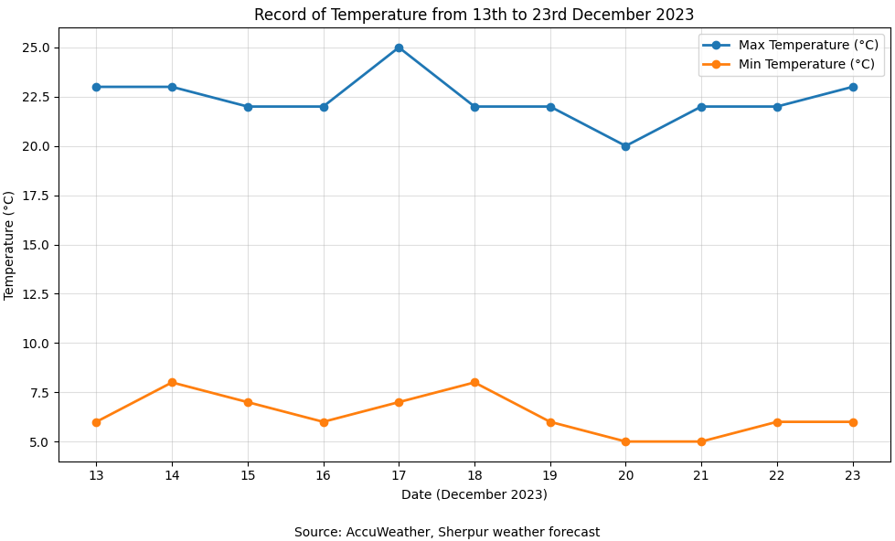
Fig. 1: Temperature variation from 13th to 23rd December 2023

3.0 METHODOLOGY
The experiment was conducted in the School of Agriculture laboratory at Jigyasa University (formerly Himgiri Zee University) in Sherpur, Dehradun, Uttarakhand, India. The study was conducted over 10 days, from December 13 to December 23, 2023, using the seedling pot method. A total of 80 genotypes of Brassica juncea (Indian mustard) were selected for evaluation. These genotypes were obtained from various agricultural research institutes across India, ensuring a broad and diverse genetic representation. To examine the impact of salinity stress on seed germination, five concentrations of sodium chloride (NaCl) solutions were prepared:
- Control (0 ppm)
- 50 ppm
- 100 ppm
- 150 ppm
- 200 ppm
Eight plastic seedling trays were used for sowing. Each tray contained 50 individual pots, which were uniformly filled with a sand-soil mixture. The rows in each tray were clearly labelled with the corresponding genotype numbers and NaCl concentrations to ensure accurate identification and data collection. For each genotype, 25 seeds were sown—five seeds per pot—across various pots treated with the five NaCl concentrations. Each pot was treated with 20 ml of its respective NaCl solution, applied based on the labelled concentration. Germination data were recorded on the eighth day after sowing (December 21, 2023) to assess the early-stage salt tolerance of the genotypes under controlled laboratory conditions.

4.0 RESULT AND DISCUSSION

4.1 Effect of Salinity on Germination of Indian Mustard Genotypes

The germination behaviour of 80 Indian mustard (Brassica juncea L.) genotypes under varying levels of NaCl clearly indicated a progressive decline in germination with increasing salinity stress (Table 02 & Fig. 2). Under control conditions, the mean germination percentage was 70.5%, which gradually declined to 67.5%, 55.5%, 47.75%, and 44.5% at NaCl concentrations of 50, 100, 150, and 200 ppm, respectively. This trend highlights the inhibitory effect of salinity on seed germination.
The reduction in germination under saline conditions may be attributed to osmotic stress and ionic toxicity, which restrict water uptake and disrupt metabolic activities essential for germination. Similar findings were reported by Chawhan et al. (2025), who observed that increasing salinity reduces germination percentage and seedling vigour due to decreased osmotic potential and ion toxicity. Likewise, Sharma et al. (2013) reported a significant reduction in germination as salt concentration increased, which they attributed to impaired enzyme activity and delayed embryo development.
A clear increase in variability was also observed with increasing salinity, as indicated by a rise in the coefficient of variation from 35.02% (control) to 54.10% (200 ppm). This suggests differential genotypic responses to stress and highlights substantial genetic variability in salinity tolerance, which is essential for breeding programs. Similar observations were reported by Dhillon et al. (2025), who emphasized the importance of genotype × salinity interaction and variability for selection in stressful environments.

Table 02: Rate of germination of Brassica juncea L. genotypes under different concentrations of sodium chloride (NaCl)

Sl. N. | Genotypes | Rate of germination (%) of Indian mustard seeds with different levels of Sodium Chloride (NaCl) treatment
Sl. N. | Genotypes | Control | 50 ppm | 100 ppm | 150 ppm | 200 ppm
1 | Ashirwad | 100 | 80 | 80 | 60 | 20
2 | Arawali | 80 | 80 | 60 | 20 | 20
3 | Brijraj | 60 | 60 | 40 | 40 | 40
4 | Bhagirathi | 80 | 80 | 60 | 20 | 20
5 | BR-40 | 40 | 40 | 60 | 20 | 20
6 | CS-52 | 80 | 100 | 80 | 60 | 20
7 | CS-54 | 60 | 60 | 40 | 40 | 40
8 | CS-56 | 100 | 60 | 60 | 40 | 40
9 | CS-60 | 60 | 40 | 40 | 20 | 100
10 | DRMR-1165.40 | 100 | 80 | 80 | 60 | 60
11 | DRMR-IJ-31 | 100 | 100 | 100 | 80 | 80
12 | DRMR-150-35 | 60 | 40 | 40 | 40 | 20
13 | DRMR-59 | 100 | 80 | 100 | 60 | 60
14 | DRMR-2136 | 100 | 100 | 80 | 60 | 40
15 | DRMR-2017-15 | 60 | 40 | 40 | 40 | 20
16 | EC-165232 | 20 | 80 | 40 | 20 | 20
17 | EC-765954 | 20 | 60 | 100 | 100 | 80
18 | EC-765563 | 40 | 40 | 80 | 80 | 40
19 | EC-206754 | 40 | 80 | 40 | 60 | 60
20 | EC-520747 | 60 | 80 | 40 | 100 | 100
21 | EC-491596 | 20 | 40 | 20 | 20 | 40
22 | EC-764646 | 40 | 20 | 20 | 80 | 60
23 | EC-491779 | 80 | 80 | 60 | 60 | 100
24 | EC-765856 | 80 | 60 | 80 | 40 | 40
25 | EC-33571 | 80 | 60 | 40 | 60 | 80
26 | EC-765451 | 60 | 80 | 20 | 40 | 80
27 | EC-399318 | 20 | 60 | 40 | 60 | 60
28 | EC-206723 | 80 | 80 | 80 | 60 | 60
29 | EC-766061 | 40 | 40 | 60 | 40 | 80
30 | EC-765865 | 40 | 40 | 20 | 80 | 60
31 | EC-491579 | 60 | 60 | 40 | 40 | 20
32 | EC-481011 | 80 | 80 | 60 | 40 | 40
33 | EC-482983 | 100 | 60 | 40 | 20 | 40
34 | EC-765800 | 40 | 40 | 20 | 20 | 20
35 | EC-765459 | 20 | 60 | 60 | 80 | 80
36 | Gujrat Mustard-1 | 80 | 40 | 60 | 60 | 20
37 | Gujrat Mustard-2 | 100 | 60 | 60 | 40 | 40
38 | Gujrat Mustard-3 | 80 | 80 | 40 | 20 | 20
39 | Geeta | 100 | 100 | 80 | 80 | 60
40 | JD-6 | 80 | 60 | 40 | 40 | 20
41 | Jawahar Mustard-3 | 40 | 40 | 20 | 20 | 20
42 | Jawahar Mustard-2 | 60 | 40 | 40 | 20 | 20
43 | Jawahar Mustard-1 | 80 | 60 | 40 | 40 | 20
44 | Jagannath | 60 | 80 | 60 | 40 | 20
45 | Kanti | 100 | 80 | 80 | 60 | 20
46 | Krishna | 80 | 60 | 60 | 20 | 20
47 | Kranti | 100 | 100 | 80 | 60 | 40
48 | Laxmi | 80 | 60 | 40 | 40 | 40
49 | Maya | 100 | 60 | 40 | 20 | 40
50 | NRCDR-601 | 80 | 60 | 40 | 40 | 40
51 | NDRE-4 | 80 | 60 | 80 | 60 | 40
52 | NRCHB-101 | 60 | 100 | 60 | 40 | 40
53 | NRCDR-2 | 100 | 100 | 80 | 40 | 20
54 | Pusa Tarak | 20 | 60 | 60 | 20 | 80
55 | Pusa Jaykishan | 60 | 100 | 40 | 80 | 80
56 | PR-20 | 80 | 100 | 80 | 80 | 40
57 | Pusa Agarni | 100 | 80 | 80 | 80 | 80
58 | PM-32 | 60 | 80 | 60 | 80 | 80
59 | PM-21 | 40 | 80 | 40 | 20 | 20
60 | PM-725 | 80 | 100 | 40 | 80 | 80
61 | PR-21 | 60 | 60 | 60 | 40 | 40
62 | PR-19 | 100 | 80 | 60 | 80 | 40
63 | PBR-210 | 40 | 40 | 80 | 60 | 80
64 | PM-28 | 100 | 80 | 60 | 40 | 40
65 | Pusabold | 80 | 80 | 60 | 40 | 20
66 | Pusa Mahak | 60 | 60 | 40 | 20 | 20
67 | Patan Mustard | 80 | 80 | 60 | 40 | 20
68 | PM-25 | 100 | 60 | 80 | 20 | 20
69 | PM-26 | 80 | 40 | 40 | 40 | 60
70 | PM-29 | 100 | 60 | 40 | 40 | 40
71 | PM-27 | 80 | 80 | 60 | 60 | 40
72 | PM-22 | 100 | 60 | 60 | 40 | 40
73 | PM-24 | 80 | 60 | 40 | 20 | 20
74 | PM-30 | 60 | 80 | 80 | 60 | 80
75 | Pusa Bahar | 100 | 80 | 40 | 40 | 40
76 | Pusa Vijay | 60 | 60 | 60 | 40 | 20
77 | Pusa 6012 | 80 | 80 | 60 | 60 | 40
78 | RH-119 | 40 | 40 | 20 | 20 | 20
79 | RH-749 | 40 | 60 | 60 | 80 | 80
80 | RCC-4 | 100 | 80 | 60 | 40 | 40
NaCl Treatment Level |  | Control | 50 ppm | 100 ppm | 150 ppm | 200 ppm
Mean |  | 70.5 | 67.5 | 55.5 | 47.75 | 44.5
Standard Deviation (SD) |  | 24.69 | 19.33 | 19.99 | 21.79 | 24.07
Coefficient of Variation (CV%) |  | 35.02 | 28.64 | 36.02 | 45.63 | 54.10

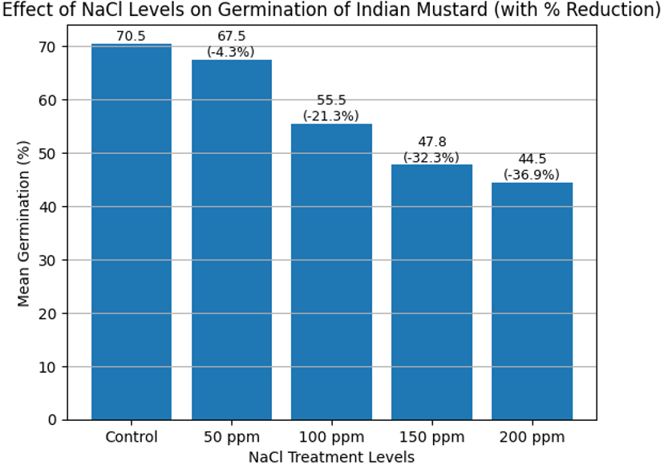
Fig. 2: Effect of NaCl levels on germination of Indian mustard

4.2 Genotypic Variation in Response to Salinity Stress

Considerable variation among genotypes was evident across all salinity levels. Some genotypes maintained relatively high germination even at elevated NaCl concentrations, indicating greater tolerance, while others showed sharp reductions.
Genotypes such as DRMR-IJ-31, Pusa Agarni, PM-32, PM-30, RH-749, and EC-520747 exhibited comparatively higher germination even under elevated salinity levels, suggesting their potential tolerance. In contrast, genotypes such as RH-119, Jawahar Mustard-3, and EC-765800 showed consistently poor germination under stress, indicating sensitivity.
As Fig. 3 highlights, there is substantial variation in salinity tolerance among genotypes at 200 ppm NaCl. Genotypes such as EC-520747, EC-491779, and CS-60 exhibited the highest germination (100%), indicating strong tolerance, while several others maintained around 80% germination, reflecting moderate tolerance. These results confirm the presence of significant genetic variability for salinity tolerance at the germination stage.

Certain genotypes may maintain higher germination under saline conditions due to better osmotic adjustment, ion homeostasis, and efficient metabolic functioning. Pandey et al. (2017) reported that tolerant genotypes maintain osmotic balance through the accumulation of compatible solutes and better ionic regulation. Similarly, Singh et al. (2019) highlighted that salt-tolerant genotypes exhibit better physiological stability and maintain a favourable Na⁺/K⁺ balance under stress conditions.
The wide genotypic variability observed in this study supports earlier findings by Aggarwal et al. (2024) and Sharma et al. (2019), who reported significant diversity among mustard genotypes for germination and seedling traits under salinity stress.
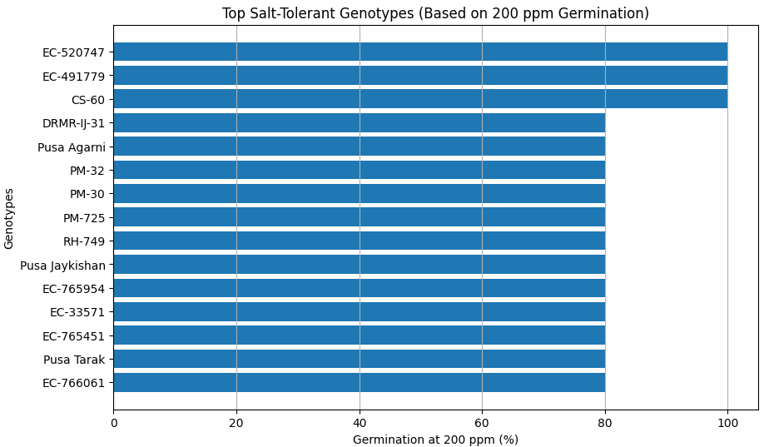
Fig. 3: Top salt-tolerant (at 200 ppm) genotypes of Indian mustard

4.3 Dose-Dependent Response of Salinity Stress

The data clearly indicate a dose-dependent reduction in germination with increasing NaCl concentration. While a slight reduction was observed at the lower concentration (50 ppm), a sharp decline was evident at the higher concentrations (150 and 200 ppm). The salinity tolerance index, as shown in Fig. 4, exhibited a steady decline with increasing NaCl concentration, dropping from 100% under control conditions to 63.1% at 200 ppm. A sharp reduction was observed beyond 50 ppm, indicating increased sensitivity of genotypes at higher salinity levels. This trend confirms the strong inhibitory effect of salinity stress on germination performance. This suggests that mild salinity may be tolerated to some extent, but higher salt concentrations severely inhibit germination. This trend is consistent with the findings of Prasad et al. (2021), who reported that germination and seedling growth decrease progressively as stress intensity increases, with more severe effects at higher salinity levels.
A few genotypes showed irregular responses (e.g., improved germination at certain higher concentrations), which may be due to experimental variation or genotype-specific adaptive mechanisms. Such responses have also been reported in earlier studies, in which certain genotypes exhibited stress acclimation or tolerance thresholds.

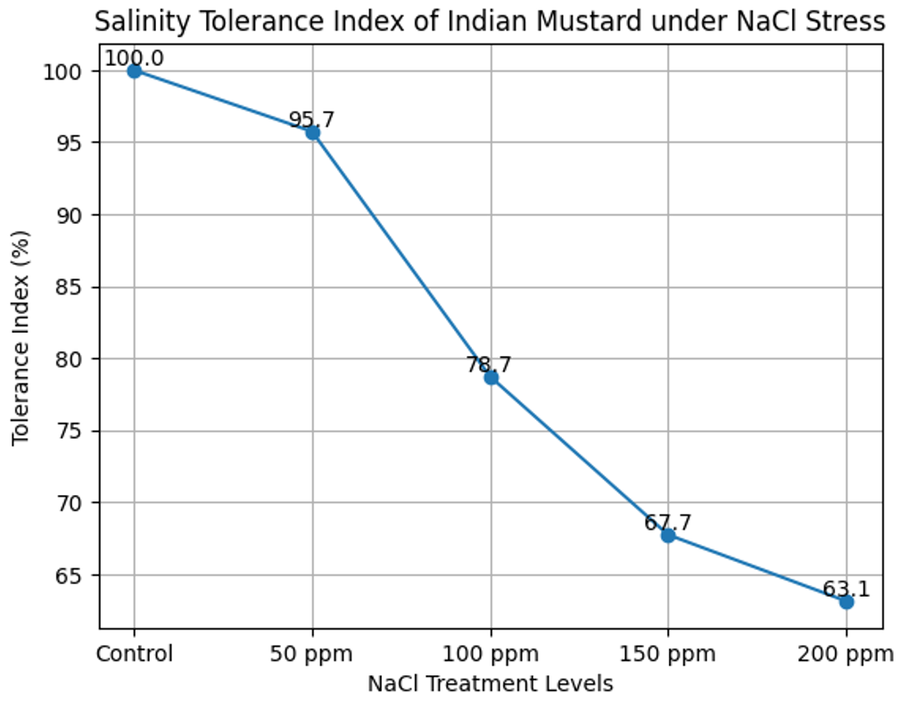
Fig. 4: Salinity tolerance index of Indian mustard under different NaCl concentrations

4.4 Implications for Screening and Breeding

The present study clearly demonstrates that germination stage screening is an effective and reliable approach for identifying salinity tolerance in Indian mustard. The observed variation among genotypes provides an opportunity to select tolerant lines for further breeding programs.
Germination percentage under different salinity levels can serve as a simple yet powerful selection criterion. This is consistent with Aggarwal et al. (2024) and Dhillon et al. (2025), who emphasized that early-stage screening using germination and seedling traits is useful for identifying salt-tolerant genotypes.

4.5 ANOVA Interpretation
The key interpretation from the ANOVA (Table 3) is that the mean germination rate decreases with increasing salt concentration. The pattern suggests that salinity negatively impacts seed germination, and variance remains relatively high across treatments, indicating some genotypic variability in response.

F-value = 21.73: This value is much higher than the F critical value (2.39), suggesting a significant difference among group means. P-value = 3.20 × 10⁻¹⁶: This is far below the common alpha level (0.05), indicating highly significant results. Based on these findings, the null hypothesis—stating that all group means are equal—is rejected. This establishes that varying concentrations of sodium chloride (NaCl) have a statistically significant effect on the germination rate of Brassica juncea, thereby confirming that salinity stress notably influences seed germination performance.

Table 03: ANOVA Summary Showing the Effect of Different Sodium Chloride (NaCl) Concentrations on Mean Germination Percentage and Variance in Brassica juncea L.

Source of Variation | SS | df | MS | F | P-value | F crit
Between Groups | 42916 | 4 | 10729 | 21.73 | 3.20 × 10⁻¹⁶ | 2.3945
Within Groups | 195035 | 395 | 493.76
Total | 237951 | 399
Treatment |  | Mean Germination (%) |  | Variance
Control |  | 70.5 |  | 617.47
50 ppm |  | 67.5 |  | 378.48
100 ppm |  | 55.5 |  | 404.81
150 ppm |  | 47.75 |  | 480.95
200 ppm |  | 44.5 |  | 587.09

4.6 Overall Interpretation

Overall, the study confirms that salinity stress significantly affects germination in Indian mustard and that the degree of reduction varies widely among genotypes. The progressive decline in germination with increasing NaCl concentration, coupled with high variability among genotypes, indicates strong genetic control of salinity tolerance traits.
These findings reinforce the importance of early-stage screening and support the use of germination parameters as reliable indicators of salt-tolerant genotypes, which can be utilized in breeding programs to improve mustard productivity under saline conditions.

5.0 CONCLUSION

The present study clearly demonstrated that salinity stress significantly affects seed germination in Indian mustard, with a progressive decline in germination percentage observed as NaCl concentration increased from control to 200 ppm. The reduction in germination under saline conditions confirms the inhibitory effects of osmotic stress and ionic toxicity on early plant establishment.

A wide range of variability was observed among the 80 genotypes, indicating strong genetic diversity for salinity tolerance at the germination stage. Genotypes such as EC-520747, EC-491779, CS-60, DRMR-IJ-31, Pusa Agarni, and PM-30 exhibited comparatively higher germination under higher salinity levels, suggesting their potential as salt-tolerant lines. In contrast, genotypes like RH-119 and Jawahar Mustard-3 were identified as highly sensitive.

The steady decline in the salinity tolerance index with increasing NaCl concentration further confirmed the dose-dependent effect of salinity stress. The increasing coefficient of variation at higher salinity levels highlights the differential genotypic response and the scope for effective selection under stress conditions.

Overall, the study establishes that germination-based screening under controlled conditions is a reliable, rapid, and efficient approach for identifying salt-tolerant genotypes in Indian mustard. The identified tolerant genotypes can be used in future breeding programs to develop salinity-resilient cultivars, thereby contributing to sustainable mustard production in salt-affected areas.

REFERENCE

Majid, A. et al. 2021. Abscisic acid in coordination with nitrogen alleviates salinity-inhibited photosynthetic potential in mustard by improving proline accumulation and antioxidant activity. Stresses, 1(3):162–180.

Chawhan, A.P. et al. 2025. Comparative analysis of germination indices of specific plant species with horticultural importance under varying levels of salinity concentration. Discover Plants, 2(1).
Dhillon, A. et al. 2025. Genetic variability in Indian mustard for salt stress tolerance at seedling stage. Journal of Oilseed Brassica, 16(1):81–87.

Aggarwal, G. et al. 2024. A method for screening salt stress tolerance in Indian mustard (Brassica juncea) at seedling stage. Scientific Reports, 14(1).

Pandey, M. et al. 2017. Time course of physiological, biochemical and gene expression changes under short-term salt stress in Brassica juncea. Crop Journal, 5(3):219–230.

Sharma, V. et al. 2019. Comparative studies among Brassica species to identify salinity tolerant genotypes of rapeseed-mustard. International Journal of Current Microbiology and Applied Sciences, 8(06):2073–2083.

Sharma, P. et al. 2013. Salt tolerance of Indian mustard (Brassica juncea) at germination and early seedling growth. Environmental and Experimental Biology, 11.

Prasad, S.N. et al. 2021. Screening of Indian mustard (Brassica juncea L. Czern and Coss) genotypes with respect to seedling growth physiology under salinity and high-temperature stress. International Journal of Environment and Climate Change, 11:97–108.

Singh, J. et al. 2019. Differential response of Indian mustard (Brassica juncea) under salinity: photosynthetic traits and gene expression. Physiology and Molecular Biology of Plants, 25(1):71–83.

Gupta, A. et al. 2023. Genetic variability, heritability, genetic advance and cluster analysis in Indian mustard (Brassica juncea L.) under timely and late sown conditions. International Journal of Plant & Soil Science, 35(19):292–301.

Pandey, B. et al. 2024. Optimization of sowing dates in Indian mustard (Brassica juncea L.) to combat yield losses caused by high temperature at reproductive stage. Plant Science Today, 11(1):81–92.
Tiwari, A. et al. 2025. Genetic variability and improvement in Indian mustard (Brassica juncea L.). Journal of Advances in Biology & Biotechnology, 28(10):591–606.

Choudhary, R. et al. 2025. Assessment of genetic variability and heritability in Indian mustard genotypes. Journal of Advances in Biology & Biotechnology.

Meena, M. et al. 2019. Regulation of L-proline biosynthesis, signal transduction, transport, accumulation and its vital role in plants during variable environmental conditions. Heliyon, 5(12):e02952.

Rehman, R.S. et al. 2022. Abscisic acid mediated abiotic stress tolerance in plants. Asian Journal of Research in Crop Science:1–17.

