Effect of Natural Input and AMF on Establishment and Growth of Papaya (Carica papaya L.)

Abstract
A field investigation entitled “Effect of Natural Input and AMF on Establishment and Growth of Papaya (Carica papaya L.)” was conducted in 2025-26 at the Crop Research Center- III, Department of Horticulture, School of Agriculture, ITM University, Gwalior (M.P.), India. The experiment was laid out in a factorial randomized block design with three replications, comprising four levels of jeevamrit application treatments in main plots (control, 30%, 40% and 50%) and three levels of AM fungi in subplots (0control, 25 g/plant, 50 g/plant). The results revealed that the application of 50% Jeevamrit (J₄) significantly enhanced growth parameters including plant height (cm), stem girth (cm), petiole length (cm) and number of full grown leaves during its growth period over control (J₁). Similarly, application of 50 g/plant AM fungi (A₃) showed observed significant increase in growth attributes of papaya over control (A₁).
Keywords: Arbuscular Mycorrhizal Fungi, Growth, Jeevamrit and Papaya, Carica papaya L.

Introduction
Carica papaya L. (Family: Caricaceae) is the primary edible species among the 48 recognized members of its genus (Koul et al.,2022). It is characterized as an evergreen, softwooded herb with a hollow, unbranched trunk. Its phyllotaxy features include large, palmate leaves with elongated petiole (Jiménez et al., 2014). The species is functionally polygamous, exhibiting three primary sexual phenotypes: pistillate, hermaphrodite, and staminate. Fruits develop axially, ranging in morphology from spherical to oblong, and contain numerous seeds attached to a central placenta (Xiang et al., 2025).
Indigenous to Mesoamerica, Carica papaya is hypothesized to be a hybrid of two Carica species. It was introduced to India in the 16th century via Malacca (Kumar and Abraham, 1943). Currently, it is a major tropical and subtropical crop cultivated extensively in Brazil, India, Australia, and South Africa (Sanikommu et al., 2021). In the Indian context, papaya maintains year-round availability, with a reported cultivation area of 146,000 hectares and a total output of 5,449,000 MT while within Madhya Pradesh, production reaches 585.72 thousand MT across 14.40 thousand hectares in according to 3rd advance estimate 2024-25 (Anon, 2024-25).
Papaya is highly valued for its therapeutic and nutritional profile, specifically its high moisture content (91.47%), vitamin A (2472 IU/100g), considerable amount of protein (0.4%), biotin (3.05 µg/100g), vitamin C (43.1 µg/100g), iron (0.23 mg/100g) and calcium (15.02 mg/100g) (Longvah et al., 2017). The immature fruits are a vital source of papain, a proteolytic enzyme used in the pharmaceutical and food industries. Mature fruits are utilized in various value-added products, including jams, RTS beverages and confectionery items like tutti-frutti (Ram and Sharma, 1996).
Madhya Pradesh offers a conducive environment for papaya cultivation due to its diverse agro-climatic conditions, characterized by well-drained fertile soils and a favorable thermoperiod that supports rapid biomass accumulation and high fruit sugar concentration (TSS). However, while as the demand for papaya is increasing, its their supply and output are declining in Madhya Pradesh. The decline in papaya production is primarily due to the excessive and continuous application of chemical fertilizers, coupled with inadequate use of organic sources (Reference???). The implementation of these practices affects the physical, chemical, and biological properties of the soil, leading to a degradation in the quality of agricultural yields (Reference???). As the costs associated with chemical fertilizers continue to rise, leading to diminished returns on investment, it is essential to focus on the cultivation of high-quality papaya with low residue levels. This focus should align with initiatives aimed at improving crop yield and overall profitability.
Given the increasing demand for high-quality food, environmentally sustainable crop cultivation presents a practical solution. Organic farming serves as a method to achieve this goal by utilizing natural inputs for crop cultivation and avoiding chemical fertilisers and pesticides, which are recognized for their potential environmental risks. Liquid organic manures have the ability to promote plant growth and support the health of microorganisms and other biological entities present in the soil (Reference???). Jeevamrit is a biologically active solution generated via fermentation processes (Taku and Doruk, 2025). Jeevamrit is defined by a substantial population of microbial organisms that multiply, enhancing nitrogen fixation and facilitating the mobilization and utilization of nutrients. This procedure results in an increase in soil fertility (Palekar, 2006).
To maintain sustainable soil productivity, it is crucial to achieve a balance in soil biological activity, as any disturbance can impact nutrient transformation within the soil (Reference???). The hypothesis suggests that the integration of Arbuscular Mycorrhizal (AM) fungi with a growth enhancer, specifically organic liquid manure like jeevamrit, may lead to varied impacts on both crop performance and soil health. The existing data regarding the integration of organic nutrient substances in Madhya Pradesh, particularly within the realm of organic farming, is notably scarce. Therefore, the current investigation entitled “Integrated effect of Jeevamrit and Arbuscular Mycorrhizal Fungi on establishment and growth of Papaya (Carica papaya L.)” was conducted.
Materials and Methods
Experimental site and location
The experiment entitled “Effect of Natural Input and AMF on Establishment and Growth of Papaya (Carica papaya L.)” was undertaken during 2025-26 at the Crop Research Center- III, Department of Horticulture, School of Agriculture,ITM University, Gwalior (M.P.), India. The experimental site is situated within the semi-arid zone of Northern Madhya Pradesh at ITM University, Gwalior, located at a latitude of 26.17° N, a longitude of 78.20° E, and an elevation of 197 meters above mean sea level. The experimental field exhibited a clay loam texture in its soil composition, with a measured pH level of 7.57, indicating a neutral level. The sample exhibited low organic carbon levels of 0.42 per cent and available nitrogen measured at 215.07 kg N/ha. The analysis indicated low levels of available phosphorus, measured at 20.95 kg P/ha, and high levels of available potassium, recorded at 350.08 kg K/ha. The experiment was laid out in a factorial randomized block design with three replications, comprising four levels of jeevamrit application treatments in main plots (control, 30%, 40% and 50%) and three levels of AM fungi in subplots (control, 25 g/plant, 50 g/plant).
Papaya seedlings (cv. Red Lady) were propagated in 300-gauge polyethylene bags (22 × 15 cm) filled with a 1:1:1 ratio of well-rotted farmyard manure (FYM), soil and sand. Prior to sowing, seeds were treated with Beejamrit for 1–2 minutes, followed by single-seed placement per bag and subsequent light irrigation to facilitate germination. The experimental site was prepared in June through deep primary tillage using a tractor-drawn mouldboard plough to eliminate weed seed banks and crop residues, followed by secondary tillage and rotavation for soil pulverization. Basal enrichment was conducted with FYM at @ 250 kg/ha before demarcating a layout with a 1.8 m × 1.8 m spacing. Pits of 60 cm × 60 cm × 60 cm were excavated and solarized for 15 days, then backfilled with a mixture of topsoil, 10 kg FYM and AM fungal inoculum according to each treatment combination. On July 1st, 2025, fifty-day-old uniform saplings were transplanted individually per pit during the evening hours to minimize seedling mortality. After transplantation, soil application of Jeevamrit recommended @ 500 L/ha was done according to each treatment combination at monthly intervals during the growth period of the crop. Routine agronomic practices were applied across all experimental plots. Key variables were measured including growth attributes like plant height (cm), stem girth (cm), petiole length (cm) and number of full-grown leaves at 30, 60, 90, 120, 150 and 180 DAT (days after transplanting). The recorded data were analyzed using the analysis of variance (ANOVA) technique as outlined by Panse and Sukhatme (1985) for a factorial randomized block design. The least significance test was employed to analyze the impact of treatments at a 5% significance level.
Jeevamrit Preparation:
200 liters of water were filled in a barrel; 10 kilograms of fresh desi cow dung and 10 kg of old cow urine were added; 2 kg of jaggery, 2 kg of pulse flour (gram), and a little amount of living soil (about 100 g) from under the banyan tree's canopy were added. After giving the mixture a thorough stir, let it ferment in the shade for 48 hours. Jeevamrut was now prepared for use. For an acre of land, two hundred liters of jeevamrut were plenty. It provides nutrients, but more significantly, it functions as a catalytic agent to increase earthworm and soil microbial activity. Primarily utilized as a foliar spray, it is also administered as a seed treatment (Palekar, 2006).
Results and Discussion
Effect of soil application of Jeevamrit on growth attributes of papaya (Carica papaya L.)
Soil application of Jeevamrit significantly enhanced the growth attributes (Table 1-4) of papaya (Carica papaya L.) under agro-climatic conditions in Gwalior. Notably, the plant height of papaya increased significantly with increase in days to transplanting except at 30 DAT where soil application of Jeevamrit on plant height was found non-significant. The plant height increased gradually upto 180 DAT. Application of 50% Jeevamrit (J₄) recorded significantly highest plant height [93.85 (60 DAT), 145.85 (90 DAT), 186.90 (120 DAT), 222.39 (150 DAT) and 244.45 (180 DAT)] cm over control (J₁) which recorded significantly minimum plant height of papaya. Plant height under 40% Jeevamrit (J₃) and 50% Jeevamrit (J₄) were found to be on par with each other across all the growth period. Same trend was also observed for stem girth (cm) of papaya where, maximum stem girth was observed under the effect of 50% Jeevamrit (J₄)[16.08 (60 DAT), 21.92 (90 DAT), 29.15 (120 DAT), 38.09 (150 DAT) and 47.35 (180 DAT)] cm, with on par value recorded with treatment contain 40% Jeevamrit (J₃) during its growth period.
Significant effects were also observed for petiole length (cm) of papaya starting at 60 DAT upto 180 DAT, however non-significant effects were observed during 30 DAT. Petiole length were maximized under 50% Jeevamrit (J₄) [50.40 (60 DAT), 67.92 (90 DAT), 79.31 (120 DAT), 85.32 (150 DAT) and 87.88 (180 DAT)] cm, reflecting robust canopy growth with enlarged petiole. Least petoile length was recorded in control (J₁). The number of full grown leaves also increased with increase in growth period of papaya however, significant growth was observed during all the growth periods except for 30 and 60 DAT. Maximum number of full grown leaves were observed under the effect of 50% Jeevamrit (J₄) [27.59 (90 DAT), 37.18 (120 DAT), 44.97 (150 DAT) and 50.818 (180 DAT)] which was also found on par with 40% Jeevamrit (J₃). Eventually least number of full grown leaves were recorded under the effect of control (J₁). This increase in growth attributes in papaya with increase in dosage of Jeevamrit in soil can be attributed to microbial load and plant growth promoting substances in addition to nutrients in Jeevamrit that help in improving plant growth, metabolic activities and resistance to pest and diseases which might have helped in increasing plant growth attributes (Gore and Sreenivasa, 2011). Chaturvedi et al. (2025) on ber, Devi et al. (2025) on kiwifruit and Jhadeet al. (2021) on papaya found similar results while working on Jeevamrit.
Effect of soil application of AM fungi on growth attributes of papaya (Carica papaya L.)
Plant height (cm) of papaya were significantly affected by soil application of AM fungi upto 180 DAT except at initial days (30 DAT) where non-significant effects were recorded. Highest plant height) [91.64 (60 DAT), 141.42 (90 DAT), 183.25 (120 DAT), 218.88 (150 DAT) and 239.80 (180 DAT)] cm was observed under the effect of 50 g/plant AM fungi (A₃) which was also found at par with 25 g/plant AM fungi (A₂) whereas significantly lowest plant height was observed in control (A₁). Likewise, highest stem girth [15.99 (60 DAT), 21.66 (90 DAT), 28.60 (120 DAT), 37.39 (150 DAT) and 46.45 (180 DAT)] cm was observed in treatment containing 50 g/plant AM fungi (A₃). It was also found that 50 g/plant AM fungi (A₃) and 25 g/plant AM fungi (A₂) had on par effects on stem girth of papaya while control (A₁) recorded significantly least stem girth of papaya. Following the same trend. Significant effects were also observed for petiole length (cm) of papaya except for 30 days after transplanting. Highest petiole length [50.00 (60 DAT), 66.66 (90 DAT), 77.72 (120 DAT), 83.66 (150 DAT) and 86.18 (180 DAT)] cm was observed under the effect of 50 g/plant AM fungi (A₃) while significantly least petiole length of papaya was recorded under control (A₁).
Number of full grown leaves increased significantly with increase in growth period of papaya except at 30 and 60 days after transplanting where non-significant effects were observed. 50 g/plant AM fungi (A₃) observed maximum number of full grown leaves [27.25 (90 DAT), 36.78 (120 DAT), 44.12 (150 DAT) and 49.95 (180 DAT)] while significantly minimum number of full grown leaves were observed under control (A₁).
The enhancement in growth attributes is primarily attributed to the extra-radical hyphal network of AM fungi, which extends beyond the root depletion zone to significantly increase the effective surface area for nutrient acquisition, particularly of immobile ions like phosphorus and zinc. This symbiotic association triggers an up-regulation of growth-promoting hormones such as auxins and gibberellins and improves host water-use efficiency through better osmotic adjustment and stomatal regulation (Wahab et al., 2023). Consequently, the increased nutrient flux and metabolic activity accelerate cellular elongation and photosynthetic capacity, manifesting as superior plant height, stem thickness and number of full grown leaves. Similar findings were also recorded by Chebet et al. (2020) and Sankaralingam et al. (2016) while working on papaya.
Conclusion
The study demonstrates that the integrated soil application of Jeevamrit and Arbuscular Mycorrhizal (AM) fungi significantly augments the vegetative growth dynamics of papaya (cv. Red Lady) under the agro-climatic conditions of Gwalior. The experimental results reveal that 50% Jeevamrit (J₄) and 50 g/plant AM fungi (A₃) are the most effective treatments, yielding maximum values for plant height, stem girth, petiole length and number of full grown leaves. The synergistic success of these organic and biological interventions is attributed to the enhanced microbial load and phytohormonal stimulation provided by Jeevamrit, coupled with the expanded nutrient-scavenging capacity of the AM fungal hyphal network. Consequently, adopting these natural farming protocols can be recommended as a sustainable alternative to synthetic fertilizers for enhancing the productivity and morphological health of papaya in Madhya Pradesh.

Table 1. Effect of Jeevamrit and Arbuscular Mycorrhizal Fungi on plant height (cm) of papaya
Plant height (cm)
Treatments | 30 DAT | 60 DAT | 90 DAT | 120 DAT | 150 DAT | 180 DAT
Jeevamrit : Soil application (J)
J₁: Control | 64.18 | 81.52 | 123.37 | 161.68 | 192.96 | 213.05
J₂: 30% | 65.41 | 87.08 | 133.27 | 174.59 | 207.67 | 227.33
J₃: 40% | 65.60 | 91.24 | 141.34 | 179.96 | 215.50 | 236.99
J₄: 50% | 68.87 | 93.85 | 145.85 | 186.90 | 222.39 | 244.45
F-Test | NS | ** | ** | ** | ** | **
S.E. (m) (±) | 1.32 | 1.85 | 3.12 | 4.08 | 4.90 | 4.79
CD at 0.05 % | NS | 5.43 | 9.16 | 11.97 | 14.36 | 14.04
AM Fungi : Soil application (A)
A₁: Control | 63.61 | 83.19 | 127.13 | 165.73 | 196.93 | 217.45
A₂: 25g/plant | 66.90 | 90.42 | 139.31 | 178.37 | 213.08 | 234.10
A₃: 50g/plant | 67.55 | 91.64 | 141.42 | 183.25 | 218.88 | 239.80
F-Test | NS | ** | ** | ** | ** | **
S.E. (m) (±) | 1.14 | 1.60 | 2.70 | 3.54 | 4.24 | 4.14
CD at 0.05 % | NS | 4.71 | 7.93 | 10.37 | 12.44 | 12.16
Interaction effect (J × A) | NS | NS | NS | NS | NS | NS

Table 2. Effect of Jeevamrit and Arbuscular Mycorrhizal Fungi on stem girth (cm) of papaya
Stem girth (cm)
Treatments | 30 DAT | 60 DAT | 90 DAT | 120 DAT | 150 DAT | 180 DAT
Jeevamrit : Soil application (J)
J₁: Control | 10.49 | 12.77 | 17.95 | 24.81 | 32.94 | 40.65
J₂: 30% | 10.87 | 14.15 | 19.63 | 26.72 | 35.26 | 43.63
J₃: 40% | 11.07 | 15.52 | 21.19 | 28.23 | 36.92 | 45.89
J₄: 50% | 11.37 | 16.08 | 21.92 | 29.15 | 38.09 | 47.35
F-Test | NS | ** | ** | ** | ** | **
S.E. (m) (±) | 0.24 | 0.29 | 0.41 | 0.57 | 0.77 | 0.91
CD at 0.05 % | NS | 0.86 | 1.21 | 1.68 | 2.27 | 2.68
AM Fungi : Soil application (A)
A₁: Control | 10.55 | 12.58 | 17.90 | 25.10 | 33.52 | 41.26
A₂: 25g/plant | 11.06 | 15.33 | 20.96 | 27.98 | 36.49 | 45.43
A₃: 50g/plant | 11.25 | 15.99 | 21.66 | 28.60 | 37.39 | 46.45
F-Test | NS | ** | ** | ** | ** | **
S.E. (m) (±) | 0.21 | 0.25 | 0.36 | 0.50 | 0.67 | 0.79
CD at 0.05 % | NS | 0.74 | 1.05 | 1.46 | 1.97 | 2.32
Interaction effect (J × A) | NS | NS | NS | NS | NS | NS

Table 3. Effect of Jeevamrit and Arbuscular Mycorrhizal Fungi on petiole length (cm) of papaya
Petiole length (cm)
Treatments | 30 DAT | 60 DAT | 90 DAT | 120 DAT | 150 DAT | 180 DAT
Jeevamrit : Soil application (J)
J₁: Control | 37.92 | 42.49 | 58.04 | 68.56 | 74.34 | 76.24
J₂: 30% | 38.80 | 47.94 | 62.42 | 73.84 | 79.33 | 81.50
J₃: 40% | 39.08 | 48.80 | 65.80 | 76.90 | 82.72 | 85.19
J₄: 50% | 40.12 | 50.40 | 67.92 | 79.31 | 85.32 | 87.88
F-Test | NS | ** | ** | ** | ** | **
S.E. (m) (±) | 0.78 | 0.98 | 1.35 | 1.65 | 1.61 | 1.67
CD at 0.05 % | NS | 2.87 | 3.96 | 4.84 | 4.72 | 4.90
AM Fungi : Soil application (A)
A₁: Control | 37.83 | 43.33 | 58.81 | 70.51 | 75.88 | 77.69
A₂: 25g/plant | 39.32 | 48.89 | 65.17 | 75.73 | 81.75 | 84.23
A₃: 50g/plant | 39.78 | 50.00 | 66.66 | 77.72 | 83.66 | 86.18
F-Test | NS | ** | ** | ** | ** | **
S.E. (m) (±) | 0.68 | 0.85 | 1.17 | 1.43 | 1.39 | 1.45
CD at 0.05 % | NS | 2.49 | 3.43 | 4.19 | 4.09 | 4.24
Interaction effect (J × A) | NS | NS | NS | NS | NS | NS

Table 4. Effect of Jeevamrit and Arbuscular Mycorrhizal Fungi on number of full grown leaves of papaya
Number of full grown leaves
Treatments | 30 DAT | 60 DAT | 90 DAT | 120 DAT | 150 DAT | 180 DAT
Jeevamrit : Soil application (J)
J₁: Control | 13.86 | 15.88 | 23.53 | 32.16 | 39.10 | 44.30
J₂: 30% | 14.35 | 16.36 | 25.32 | 34.60 | 41.76 | 47.51
J₃: 40% | 14.58 | 16.54 | 26.11 | 35.20 | 43.59 | 49.25
J₄: 50% | 14.99 | 16.99 | 27.59 | 37.18 | 44.97 | 50.81
F-Test | NS | NS | ** | ** | ** | **
S.E. (m) (±) | 0.30 | 0.34 | 0.55 | 0.74 | 0.87 | 1.01
CD at 0.05 % | NS | NS | 1.60 | 2.18 | 2.55 | 2.96
AM Fungi : Soil application (A)
A₁: Control | 13.99 | 16.15 | 23.24 | 31.82 | 39.88 | 45.28
A₂: 25g/plant | 14.56 | 16.47 | 26.42 | 35.76 | 43.08 | 48.67
A₃: 50g/plant | 14.79 | 16.72 | 27.25 | 36.78 | 44.12 | 49.95
F-Test | NS | NS | ** | ** | ** | **
S.E. (m) (±) | 0.26 | 0.30 | 0.47 | 0.64 | 0.75 | 0.87
CD at 0.05 % | NS | NS | 1.39 | 1.88 | 2.21 | 2.56
Interaction effect (J × A) | NS | NS | NS | NS | NS | NS

Figure 1. Effect of Jeevamrit and Arbuscular Mycorrhizal Fungi on plant height (cm) of papaya
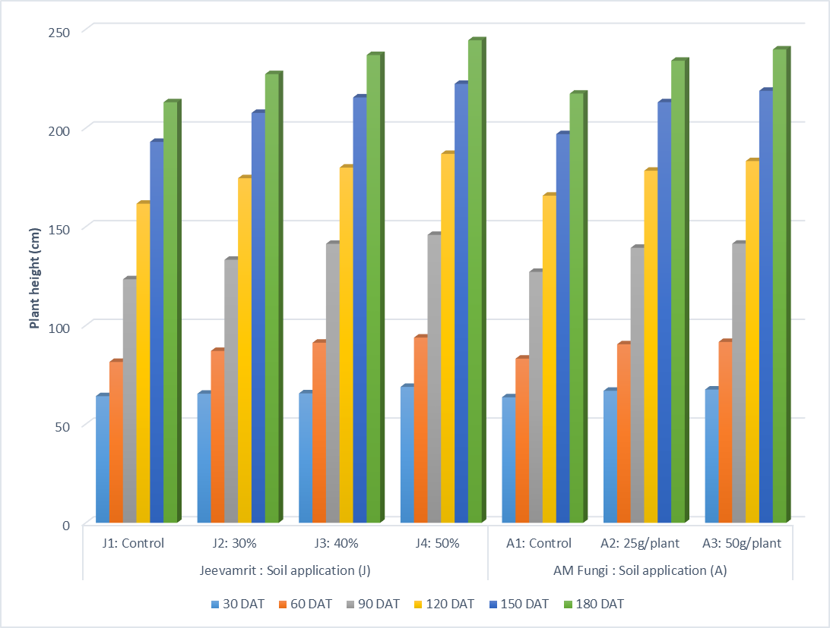

Figure 2. Effect of Jeevamrit and Arbuscular Mycorrhizal Fungi on stem girth (cm) of papaya
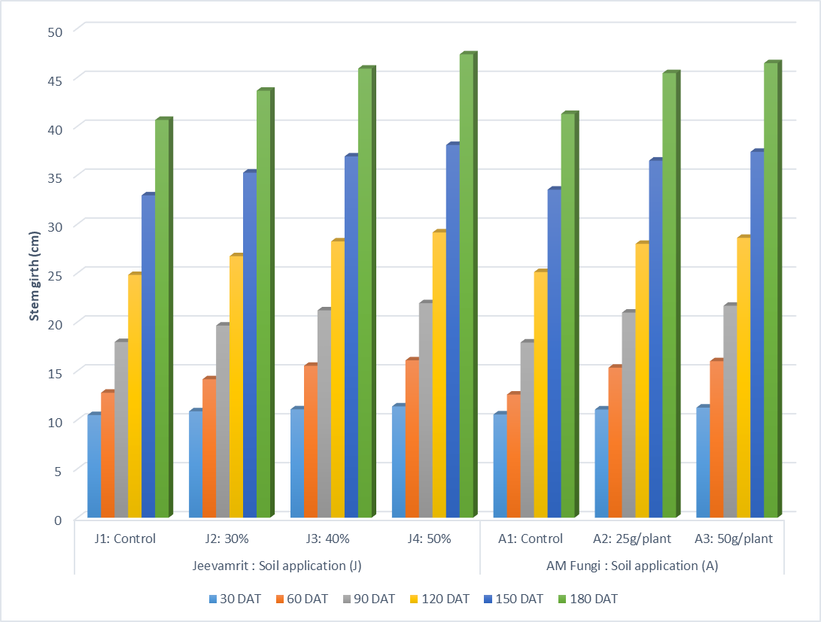

Figure 3. Effect of Jeevamrit and Arbuscular Mycorrhizal Fungi on petiole length (cm) of papaya
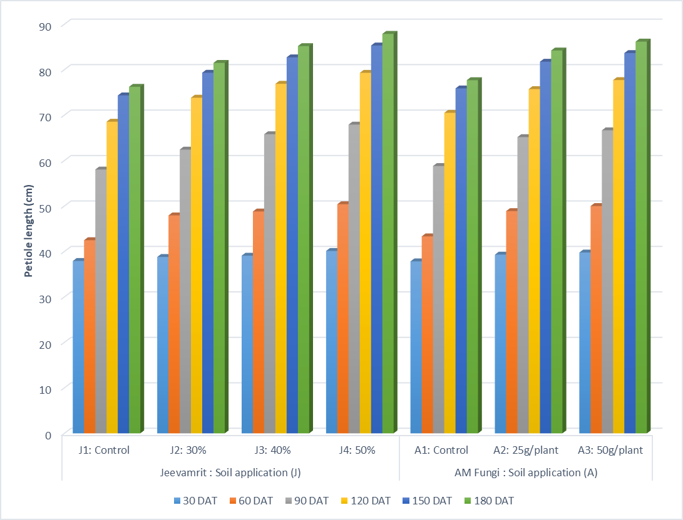

Figure 4. Effect of Jeevamrit and Arbuscular Mycorrhizal Fungi on number of full grown leaves of papaya
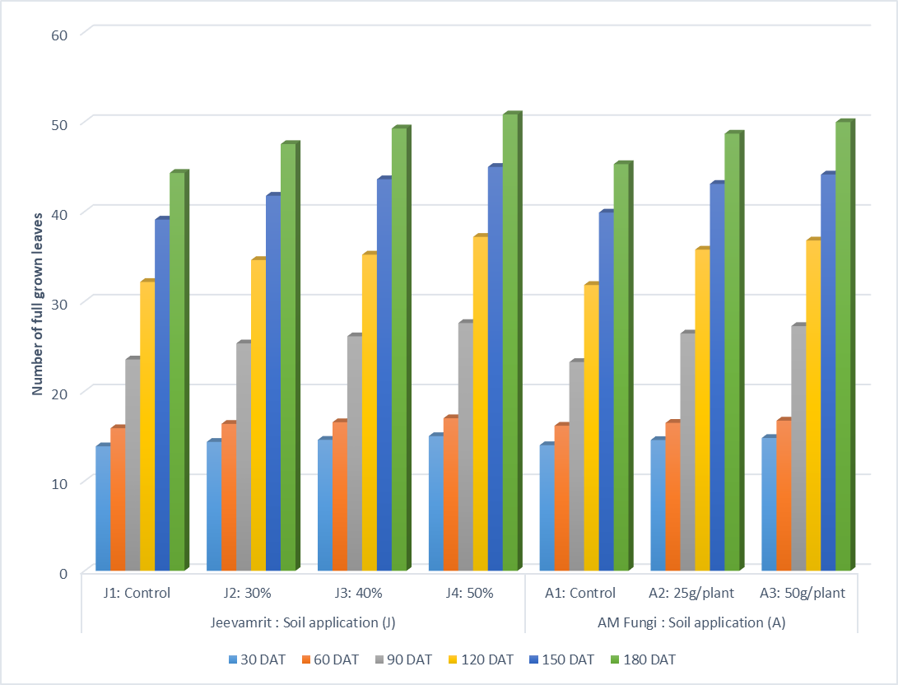

COMPETING INTERESTS DISCLAIMER:
Authors have declared that they have no known competing financial interests OR non-financial interests OR personal relationships that could have appeared to influence the work reported in this paper.

References
- Anonymous (2024-25). Area and Production of Horticulture crops for 2024-25 (3rd Advance Estimates), Department of Agriculture & Farmers Welfare.
- Chaturvedi, S., Ram, D. and Pandey, A. K. (2025). Synergistic effects of different organic manures sources on quality attributes of ber (Zizyphusmauritiana Lam.) cv. Apple under sodic soil conditions. Journal of Scientific Research and Reports, 31(4): 81–89.
- Chebet, D. K., Wanzala, F. K. and Wamocho, L. S. (2020). Effect of Arbuscular Mycorrhizal inoculation on Biomass, Nutrient Uptake, Root Infectivity and Soil Colonization of Papaya (Carica papaya L.) Seedlings. International Journal of Environment, Agriculture and Biotechnology, 5(5): 1383-1388.
- Devi, M., Sharma, A., Shukla, A., Vikram, A., Dev, I., Chandel, R. S., Chauhan, J., Verma, S., Kapoor, R., Rana, R. and Sheoran, P. (2025). Impact of Jeevamrit and Ghanjeevamrit on soil properties and productivity of kiwi fruit. Plant Science Today, 12(2): 1-7.
- Gore, N. and Sreenivasa, M. N. (2011). Influence of liquid organic manures on growth, nutrient content and yield of tomato (Lycopersicon esculentum Mill.) in the sterilized soil. Karnataka Journal of Agricultural Sciences, 24(2): 153-157.
- Jhade, R. K., Ambulkar, P. L., Shrivastava, D. and Alawa, S. L. (2021). Efficacy of INM with Jeevamrutha on Growth, Yield and Quality of Papaya (Carica papaya L.) cv. Taiwan Red Lady under Satpura Plateau Region of Madhya Pradesh District Chhindwara. International Journal of Current Microbiology and Applied Sciences,10(Special Issue): 3050-3056.
- Jiménez, V. M., Mora-Newcomer, E. and Gutierrez-soto, M. (2014). Biology of the Papaya Plant. In book: Genetics and Genomics of Papaya. Ed. by R Ming and PH Moore. New York, Springer, pp. 17-33.
- Koul, B., Baveesh, P., Sharma, C. and Kumar, A. (2022). Carica papaya L.: A Tropical Fruit with Benefits beyond the Tropics. 14(8): 2-33.
- Kumar, L. S. S. and Abraham, A. (1943). The papaya its botany, culture and uses. J. Bombay Nat. His. Soc., pp. 5.
- Longvah, T., Anantan, I., Bhaskarachary, K., Venkaiah, K. and Longvah, T. (2017). Indian food composition tables. Hyderabad: National Institute of Nutrition. Indian Council of Medical Research, 578.
- Palekar, S. (2006). Text book on ShoonyaBandovaladaNaisargikaKrushi, Published by SwamyAnand, Agri Prakashana, Bangalore, pp. 210-214.
- Panse, V. G. and Sukhatme, P. V. (1985). Statistical Methods for Agricultural Workers. Indian Council of Agricultural Research Publication, 87-89.
- Sanikommu, V. R. R., Aj, S., Chinnasamy, K. and Kalal, P. (2021). Papaya (Carica papaya L.). In book: Tropical Fruit Crops: Theory to Practical, pp. 426-468.
- Sankaralingam, S., Kathiresan, D., Harinathan. B. and Selvam, P. (2016). Effect of arbuscular mycorrhizae fungi on growth and development of Carica papaya. Scientific Journal of Seoul Sciences, 4(1): 1-7.
- Taku, D. and Doruk, K. (2025). Jeevamrut: A Natural Growth Booster for Sustainable Agriculture. Agritech Today, 3(8): 10-11.
- Wahab, A., Muhammad, M., Munir, A. and Abdi, G. (2023). Role of Arbuscular Mycorrhizal Fungi in Regulating Growth, Enhancing Productivity, and Potentially Influencing Ecosystems under Abiotic and Biotic Stresses. Plants, 12(17): 3102.
- Xiang, T., Zhu, Y., Wang, Y., Chen, X., Zhang, Z., Lai, J., Zhou, P., Ming, R. and Yue, J. (2025). The dynamic regulatory network of stamens and pistils in papaya. BMC Plant Biol., 25: 254.

