Original Research Article

Experimental Evaluation of Thermal Performance of a Propane Flame Weeding System Under Varying Operating Conditions for Sustainable Agriculture

Abstract
Flame weeding is a promising non-chemical technique for weed control, wherein thermal energy is applied to plant tissues for a short duration to induce cellular damage. The present study evaluated the thermal performance of a propane-based flame weeding system under varying operating conditions. Experiments were conducted using Response Surface Methodology (RSM) with a Central Composite Design (CCD), considering operating pressure, burner distance and exposure duration as independent variables. Burner temperature, target surface temperature and soil temperature were measured as response parameters. The results indicated that operating pressure was the most influential factor governing flame intensity and temperature generation. Target surface temperature increased significantly with operating pressure and decreased with increasing burner distance, while exposure duration primarily influenced cumulative heating and soil temperature. Burner temperature was mainly dependent on fuel flow rate. The developed regression models adequately predicted temperature responses and highlighted the importance of proper parameter optimization for efficient and safe flame weeding operations.
The study also underscores the environmental significance of flame weeding as a sustainable alternative to chemical herbicides. By reducing reliance on synthetic inputs, the technique minimizes soil and water contamination. Furthermore, optimization of operating parameters enhances energy-use efficiency, thereby reducing fuel consumption and associated carbon emissions. Overall, the findings support the potential of flame weeding as an eco-friendly and climate-resilient weed management strategy for sustainable agricultural systems.
Keywords: Flame weeding; Thermal weed control; Operating pressure; Response Surface Methodology (RSM); Soil temperature; Sustainable Agriculture

- INTRODUCTION
Weed management is a critical component of crop production, as weeds compete with crops for essential resources such as nutrients, water, light and space, thereby reducing yield and crop quality. Conventional weed control practices rely heavily on chemical herbicides; however, increasing concerns regarding herbicide resistance, environmental contamination, and food safety have encouraged the adoption of non-chemical alternatives. Among these, thermal weed control-particularly flame weeding as gained considerable attention in both organic and conventional production systems due to its residue-free nature and operational simplicity (Datta and Knezevic, 2013).
Flame weeding operates by exposing plant tissues to high temperatures for a short duration, resulting in rapid heating that causes protein denaturation, disruption of cell membranes, and eventual desiccation of plant tissues (Peerzada and Chauhan, 2018). Unlike direct burning, the technique delivers a controlled heat dose sufficient to induce irreversible cellular damage. Therefore, its effectiveness depends primarily on the amount and rate of heat energy transferred to the plant surface rather than combustion itself (Knezevic et al., 2009).
The performance of flame weeding is strongly influenced by operating parameters such as gas pressure, burner distance from the target surface, and exposure duration. These parameters govern fuel flow rate, combustion intensity, and heat transfer efficiency (Knezevic et al., 2014; Merfield, 2017). Operating pressure directly controls propane flow and flame intensity, while burner distance affects heat transfer due to convection and air entrainment losses. Exposure duration determines the cumulative heat load delivered to the surface. Hence, flame weeding can be considered a controlled heat transfer process involving combustion, convection, and radiation mechanisms.
In practical applications, flame weeders are often operated without proper calibration of these parameters, leading to inefficient fuel use, non-uniform heating, and excessive soil thermal loading. Excessive soil heating can adversely affect soil biological activity and moisture conditions, whereas insufficient heating may fail to deliver the required lethal thermal dose for effective weed control. Despite growing interest in flame weeding, limited studies have systematically quantified the combined effects of operating parameters on the thermal behaviour of propane burners under field conditions.
A clear understanding of the relationship between operating parameters and temperature distribution is therefore essential for proper calibration and safe operation of flame weeding systems. Response Surface Methodology (RSM) provides a systematic and reliable approach to evaluate the interactions among multiple variables and to develop predictive models under varying conditions. Accordingly, the present study was undertaken to evaluate the thermal performance of a propane flame weeding system under different operating conditions and to develop predictive models for temperature behaviour, with the objective of improving operational efficiency while minimizing unnecessary soil heating.
Reducing dependence on chemical herbicides has become increasingly important due to their contribution to environmental pollution, greenhouse gas emissions associated with their production and use, and degradation of soil and water resources. In this regard, thermal weed control techniques such as flame weeding offer a viable alternative by eliminating chemical inputs and lowering ecological risks. However, since flame weeding relies on fuel-based energy, proper optimization of operating parameters is necessary to ensure efficient energy utilization and to minimize associated carbon emissions. Therefore, improving the thermal efficiency of flame weeding systems is essential not only for effective weed control but also for promoting sustainable and climate-resilient agricultural practices.
MATERIALS AND METHODS
2.1 Experimental Site
The experiment was conducted under open field conditions at the college experimental farm to evaluate the thermal performance of a propane flame weeding system. The field was prepared to obtain a relatively uniform ground surface so that the burner height and thermal exposure could be maintained consistently during testing. The study focused on temperature behaviour of the burner and target surface rather than biological weed response.
2.2 Propane Flame Weeding System
A commercially available hand-held propane torch flame kit (AUSAIL make, heavy-duty type) was used as the thermal energy source (Fig. 1). The unit operated on liquefied petroleum gas supplied from a cylinder through a flexible hose of approximately 3 m length. The system consisted of a stainless-steel burner head, ergonomic handle, flow-control valve, turbo trigger and piezoelectric ignition mechanism. The burner produced a high-temperature flame in the range of approximately 2000–2800 °C and a heat output of about 0.5–1.2 MBTU h⁻¹. Flame intensity was regulated by adjusting the gas flow control valve, which allowed variation in thermal output during experiments. The stainless-steel burner head ensured uniform flame distribution and stable combustion.
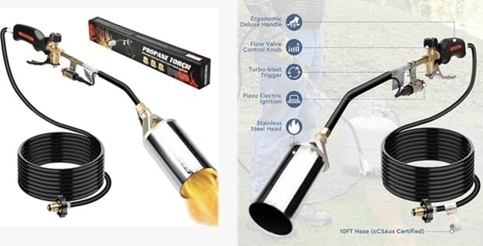
Fig. 1. Propane torch flame kit used for thermal performance evaluation
2.3 Measurement of Gas Operating Pressure
A glycerin-filled Bourdon-type pressure gauge (HiAir Model HI2653; 63 mm dial; range 0–4 kg cm⁻²) was installed in the gas delivery line to measure operating pressure. The gauge had an accuracy of ±2% full-scale deflection. Continuous monitoring of pressure enabled stable control of flame intensity and ensured repeatable experimental conditions during testing.
2.4 Instrumentation for Temperature Measurement
Target surface temperature and soil temperature were measured using a digital infrared thermometer (INKBIRDPLUS Model INK-IFT03) having a measuring range of −50 °C to 750 °C and an accuracy of ±1.5 °C (or ±1.5 % of reading). The instrument allowed non-contact measurement of temperature with a 16:1 distance-to-spot ratio and a response time of approximately 0.5 s. Immediately after flame exposure, the thermometer was directed toward the heated surface to record the peak temperature. This method enabled rapid measurement without disturbing the heated surface and allowed evaluation of thermal energy transfer.
2.5 Modification of Burner Assembly
To monitor pressure variations more accurately, the propane torch assembly was modified by installing two pressure gauges at different positions in the gas delivery system (Fig. 2). The first gauge was placed near the cylinder outlet to monitor the supply pressure and ensure uniform gas delivery from the cylinder. The second gauge was installed near the burner inlet to measure the actual operating pressure reaching the nozzle during flame application.
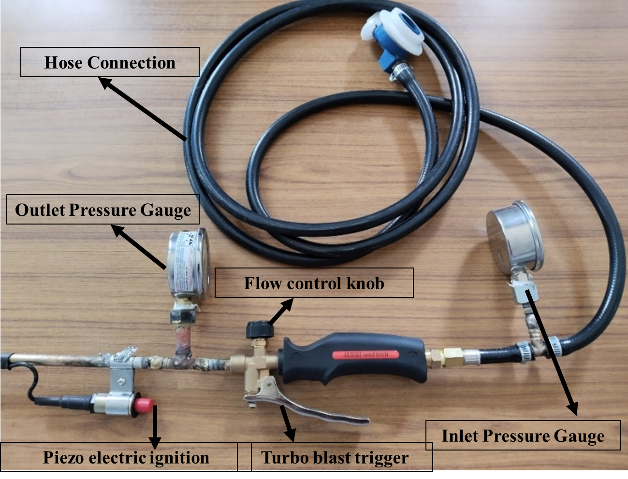
Fig. 2. Modified propane torch assembly with pressure gauges
The dual-gauge arrangement enabled continuous monitoring of both upstream and downstream pressure conditions and helped in identifying pressure drop along the hose and control valve. Since flame intensity is directly governed by gas pressure, accurate measurement of burner inlet pressure was necessary for maintaining consistent combustion conditions. During operation, the gas flow control valve was adjusted while observing the burner-side gauge to obtain the desired operating pressure level for each experimental run.
This arrangement allowed real-time observation of pressure changes corresponding to valve adjustments and enabled precise regulation of thermal output. The modification improved repeatability of the experiments by ensuring that each treatment was applied under predefined pressure conditions and minimized variation in flame intensity during testing.
2.6 Experimental Design
The experiments were planned using Response Surface Methodology (RSM) with a Central Composite Design (CCD) generated in Design-Expert®13 software. Three independent operating parameters mentioned in table 1 were selected. The selected range of each parameter was based on practical operating limits of the burner and preliminary trials to ensure stable combustion and safe field operation.
Operating pressure was chosen because it directly controls the propane flow rate through the nozzle and therefore determines flame intensity and heat generation. Variation in pressure allows evaluation of the amount of thermal energy produced by the burner. Flame exposure duration was included to study the effect of heating time on thermal energy delivered to the surface. While pressure governs instantaneous heating, exposure duration determines the cumulative heat input received by the surface. Burner distance from the surface was selected because it influences heat transfer efficiency. Increasing the distance causes dispersion of the flame and heat loss to the surrounding air, whereas shorter distance increases heat flux reaching the surface.
Table 1. Experimental operating parameter levels.
Parameter | Levels
Operating pressure (kg cm⁻²) | 0.5, 1.0, 1.5, 2.0, 2.5
Flame exposure duration (s) | 0.5, 1.0, 2.0, 3.0, 4.0
Burner distance from surface (cm) | 5, 10, 15, 20, 25
A total of 80 experimental runs consisting of factorial points, axial points and replicated centre points were conducted to evaluate linear, quadratic and interaction effects of operating parameters on temperature responses. The CCD design allowed development of predictive regression models and identification of suitable operating ranges for thermal application.
2.7 Experimental Procedure
A square test plot of 50 × 50 cm was demarcated to maintain a uniform test area for each experimental run (Fig. 3). Prior to flame application, the initial soil surface temperature was recorded to establish baseline thermal conditions. The burner distance from the target surface was adjusted using a measuring scale according to the predetermined levels of the experimental design.
Operating pressure was regulated using the gas flow control valve and continuously monitored with the installed pressure gauges to maintain the required pressure for each treatment. Flame exposure duration was controlled using a stopwatch. During each test run, the burner was moved uniformly across the test area while maintaining a constant height and approximately uniform travel speed to ensure consistent thermal exposure over the entire surface. Immediately after flame application, the target surface temperature was measured using a non-contact infrared thermometer to capture the peak thermal response. Burner outlet temperature was recorded near the nozzle region to evaluate combustion intensity, and soil surface temperature was measured at the ground level to assess heat transfer into the soil layer. The sequence of the surface condition before, during and after flame application is illustrated in Fig. 3, which represents the thermal exposure process used for evaluating the temperature response of the system.
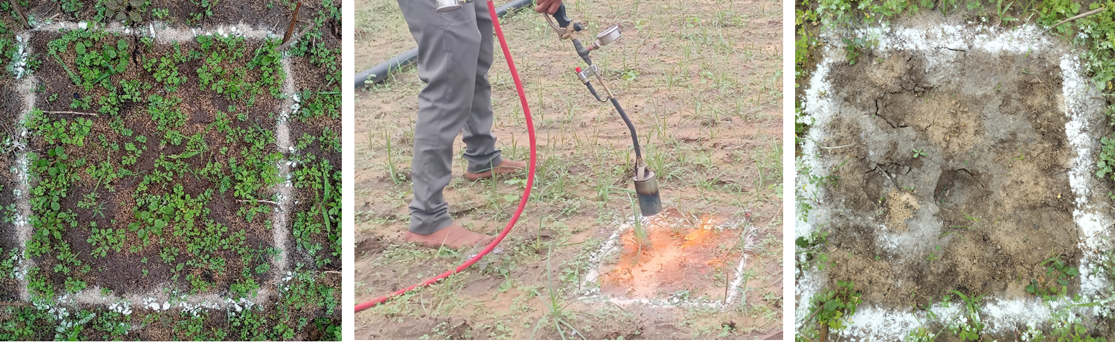
Fig. 3. Sequence of surface condition before, during and after flame application showing thermal exposure of the target area.
2.8 Response Parameters
The following thermal response parameters were recorded:
- Burner temperature (°C)
- Target surface temperature (°C)
- Soil surface temperature (°C)
Burner temperature (°C) was measured to represent the combustion intensity and thermal energy generated at the nozzle. Flame temperature is primarily governed by fuel flow rate and therefore indicates the strength of the burner system (Datta and Knezevic, 2013; Knezevic et al., 2014). Target surface temperature (°C) was recorded immediately after flame exposure to determine the heat transferred from the flame to the exposed surface. Thermal weed control operates through rapid heating rather than direct burning, and surface temperature is widely used as an indicator of effective heat delivery (Ascard, 1995; Knezevic et al., 2009; Peerzada and Chauhan, 2018). Soil surface temperature (°C) was measured to assess thermal penetration into the ground and to avoid excessive soil heating. Monitoring soil temperature is necessary for safe operation because part of the heat energy reaches the soil through convection and radiation (Bond and Grundy, 2001; Merfield, 2017). Together, these parameters describe heat generation at the burner, heat transfer to the surface and heat penetration into the soil.
2.9 Statistical Analysis
Experimental data were analysed using Design-Expert®13 software. Second-order polynomial regression models were developed to describe the relationship between operating parameters and temperature responses. Analysis of variance (ANOVA) was performed to determine the significance of linear, quadratic and interaction effects. Model adequacy was evaluated using coefficient of determination (R²), adjusted R² and lack-of-fit tests. Response surface plots were generated to visualize the influence of operating parameters on thermal behaviour.
3. RESULTS AND DISCUSSION
3.1 Thermal performance of the flame weeding system
The thermal behaviour of the propane flame weeding system was evaluated by analysing the influence of operating pressure, burner distance and exposure duration on burner temperature, target surface temperature and soil temperature. The response surface plots illustrated the combined effects of the operating parameters on heat generation and heat transfer characteristics of the system.
3.1.1 Target surface temperature
The response surface plot in Fig. 4(a) showed the combined effect of operating pressure and exposure duration on target surface temperature. The figure indicated that target surface temperature increased predominantly with increasing operating pressure, whereas exposure duration produced only a moderate effect. The increase in temperature with pressure occurred because operating pressure directly regulated the propane mass flow rate to the burner. Higher gas flow intensified combustion and produced a hotter and longer flame, thereby increasing radiative heat transfer to the surface. Similar observations were reported by Knezevic et al. (2009) and further supported by Datta and Knezevic (2021), who stated that plant injury during flaming depends primarily on flame intensity rather than heating duration.
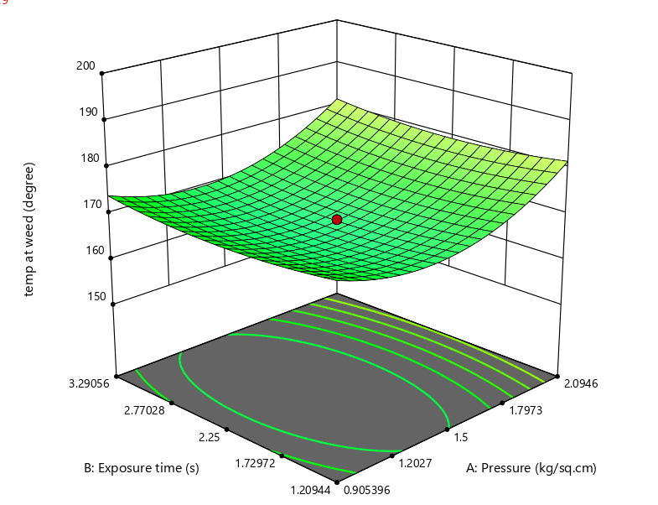
Fig. 4(a). Response surface illustrating the interaction of operating pressure and exposure time on target surface heating.
The curvature of the response surface in Fig. 4(a) further revealed a non-linear relationship between pressure and temperature. At lower pressure levels, temperature increased rapidly due to improved fuel–air mixing, whereas at higher pressure levels the temperature rise became less proportional because part of the heat dissipated into the surrounding air through convection and radiation losses. Comparable behaviour was observed by Knezevic et al. (2009) in thermal weed control experiments.
The interaction between operating pressure and burner distance was illustrated in Fig. 4(b). The figure clearly shows that burner distance strongly influenced heat transfer to the surface. Maximum temperature was recorded when high operating pressure was combined with a shorter burner distance. When the burner was positioned closer to the surface, the flame envelope directly contacted the target and provided maximum heat flux. Increasing the burner distance substantially reduced temperature because the flame entrained surrounding air before reaching the surface. Rask and Kristoffersen (2007) similarly reported that thermal efficiency decreases rapidly as the distance between burner and target increases. More recent studies by Peerzada and Chauhan (2018) and Melander et al. (2019) also confirmed that burner proximity significantly affects heat transfer efficiency in thermal weed control systems.
The results confirm that operating pressure controls flame energy generation, while burner distance controls heat transfer efficiency. Peerzada and Chauhan (2018) and Datta and Knezevic (2021) also reported that thermal damage during flaming occurs mainly due to rapid heating rather than prolonged heating, which explains the comparatively smaller effect of exposure duration on peak temperature.
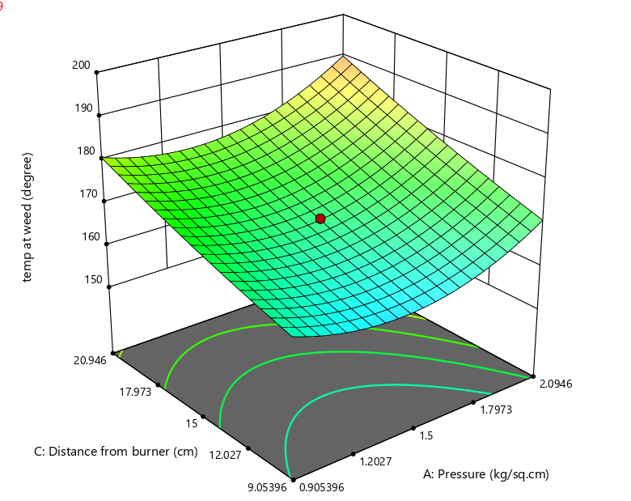
Fig. 4(b) Response surface depicting the combined influence of operating pressure and burner proximity on surface temperature distribution.
The experimental data were analysed using Response Surface Methodology (RSM), and the developed quadratic model for target surface temperature was found to be highly significant (F = 9.40, p < 0.0001). The coefficient of determination (R² = 0.8766) indicated that 87.66% of the variability was explained by the selected operating parameters, while the low coefficient of variation (C.V. = 2.86%) reflected good experimental precision. The Adequate Precision value of 11.80 (>4) confirmed a strong signal-to-noise ratio, and the non-significant lack-of-fit demonstrated good agreement between predicted and observed values, indicating that the model is reliable for prediction within the experimental range.
3.1.2 Burner temperature
The influence of operating parameters on burner outlet temperature was presented in Fig. 5(a). The figure showed that burner temperature increased markedly with increasing operating pressure, while exposure duration had negligible influence. The increase in burner temperature occurred because higher pressure increased the discharge rate of propane through the nozzle, which intensified combustion and increased flame energy release. Similar findings were reported by Datta and Knezevic (2013) and were further supported by Knezevic et al. (2014), who explained that flame temperature was primarily governed by fuel flow rate. A slight curvature in Fig5(a) indicated a non-linear response in which temperature increased rapidly at low pressure but tended to approach a plateau at higher pressure due to radiative heat losses and air entrainment. Comparable behaviour was also observed by Melander et al. (2019) in thermal weed control studies.
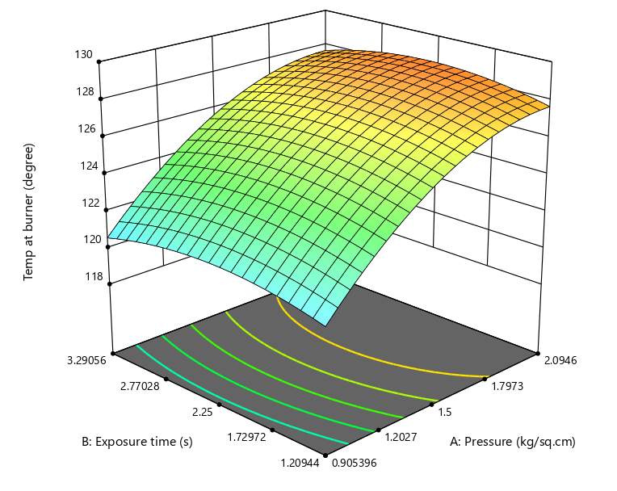
Fig. 5(a). Effect of operating pressure and exposure duration on burner temperature showing non-linear combustion response.
The interaction between operating pressure and burner distance was shown in Fig. 5(b). The figure indicated that burner temperature increased significantly with pressure but remained almost unchanged with variation in burner distance. This occurred because combustion temperature was established at the nozzle before the flame reached the target surface. Changing the burner height affected heat transfer but did not influence combustion temperature. Similar observations were reported by Rask and Kristoffersen (2007) and Peerzada and Chauhan (2018), who found that burner temperature remained relatively independent of burner height while surface heating varied significantly. These results indicated that burner temperature represented the combustion characteristic of the system, whereas surface temperature represented heat transfer performance.
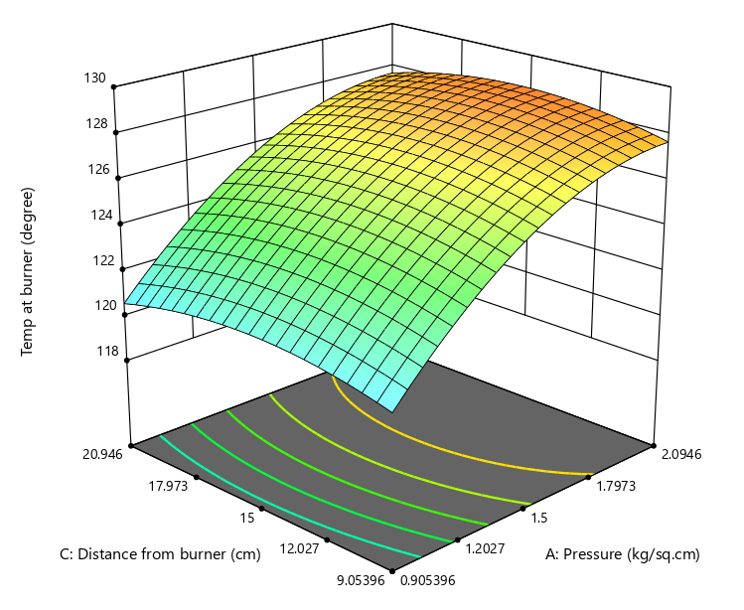
Fig. 5(b). Influence of operating pressure and burner distance on burner temperature characteristics
The experimental data were analysed using Response Surface Methodology (RSM), and the developed quadratic model for burner temperature was found to be significant (F = 5.68, p < 0.0001). The coefficient of determination (R² = 0.8110) indicated that 81.10% of the variability was explained by the selected operating parameters, while the low coefficient of variation (C.V. = 1.75%) demonstrated high experimental precision. The Adequate Precision value of 8.30 (>4) confirmed a strong signal-to-noise ratio, and the non-significant lack-of-fit indicated good agreement between predicted and observed values, confirming that the model was reliable for prediction within the experimental range.
3.1.3 Soil surface temperature
The response surface plot in Fig. 6(a) showed the combined effect of operating pressure and exposure duration on soil surface temperature. The figure indicated that soil temperature increased with both operating pressure and exposure duration. Higher pressure produced a hotter flame, while longer exposure duration allowed heat to accumulate at the soil surface. Similar behaviour was reported by Bond and Grundy (2001) and further supported by Melander et al. (2019), who explained that soil heating during flame weeding depends on the total heat energy applied rather than direct combustion of soil.
The interaction between operating pressure and burner distance was presented in Fig. 6(b). The figure showed that soil temperature increased mainly with operating pressure, whereas burner distance had comparatively smaller influence. Even at greater distances, part of the thermal energy reached the soil through radiation and convection. Similar observations were reported by Rask and Kristoffersen (2007) and Peerzada and Chauhan (2018), who noted that radiant heat from the flame can reach the soil surface even when direct flame contact is limited.
Merfield (2017) reported that excessive pressure and prolonged heating could increase soil thermal loading and should be avoided to protect soil biological activity. Therefore, proper adjustment of operating parameters was necessary to maintain adequate surface heating while preventing excessive soil temperature rise.
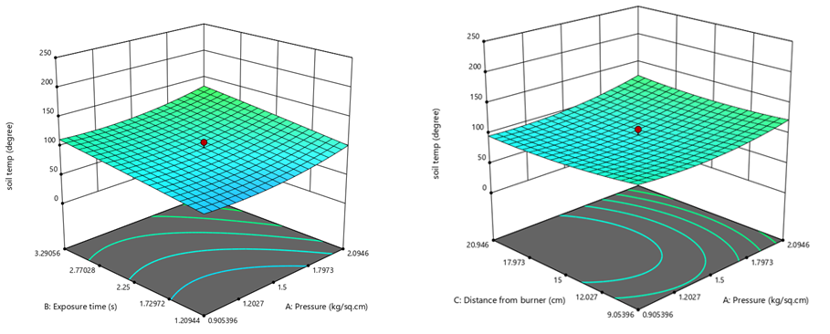
Fig. 6(a-b). The response surface plots of combined influence of operating pressure with exposure duration and burner distance on soil surface temperature.
The experimental data were analysed using Response Surface Methodology (RSM), and the developed quadratic model for soil surface temperature was found to be significant (p < 0.01). The coefficient of determination (R² = 0.8009) indicated that 80.09% of the variability was explained by the selected operating parameters. The analysis showed that operating pressure and exposure duration were significant contributors to soil heating, while burner distance had comparatively smaller influence. The non-significant lack-of-fit confirmed good agreement between predicted and observed values, indicating that the model was reliable for prediction within the experimental range.
3.1.4 Heat transfer mechanism
The overall thermal behaviour of the system can be explained based on the heat transfer mechanisms illustrated in Fig. 7 (schematic diagram). Heat energy released during combustion reached the surface through convection and radiation, while a portion of the energy was conducted into the soil. Operating pressure governed the amount of heat generated; burner distance controlled the efficiency of heat transfer and exposure duration determined the cumulative heat absorbed.
Ascard et al. (2007) described flame weeding as a controlled thermal treatment in which plant tissue is damaged by rapid heating rather than burning. The present results support this explanation and demonstrate that proper calibration of operating parameters is essential for efficient thermal application.
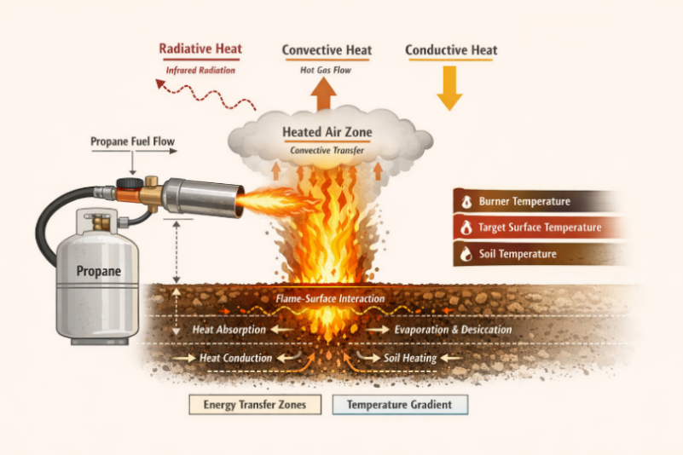
Fig. 7- Schematic diagram showing heat transfer mechanisms from the propane flame to the target surface and soil during flame weeding
4. ENVIRONMENTAL AND CLIMATE CHANGE IMPLICATIONS
The results of the present study have significant implications for environmental sustainability and climate change mitigation in agricultural systems. Conventional weed management practices rely heavily on chemical herbicides, which can lead to soil degradation, water contamination and adverse effects on non-target organisms. Additionally, the manufacturing and application of herbicides contribute to indirect greenhouse gas emissions, thereby increasing the environmental footprint of crop production systems.
Flame weeding, as a non-chemical technique, eliminates the use of synthetic herbicides and thereby reduces the risk of chemical residues in soil and water. This makes it particularly suitable for sustainable and organic farming systems. The findings of this study demonstrate that proper optimization of operating parameters such as operating pressure, burner distance and exposure duration can significantly improve thermal efficiency while avoiding excessive energy use. Efficient parameter selection ensures that adequate thermal energy is delivered to the target weeds while minimizing unnecessary fuel consumption and heat loss. This not only enhances weed control efficiency but also reduces carbon emissions associated with propane combustion. Furthermore, the concept of variable-rate flame weeding, where energy input is adjusted according to weed growth stage and field conditions, aligns with precision agriculture and climate-smart farming approaches.
Although flame weeding involves the use of fossil fuel, its environmental impact can be minimized through optimized operation and potential integration with alternative renewable energy sources in the future. Therefore, the present study contributes to the development of eco-friendly, sustainable and climate-resilient weed management strategies that support environmental conservation and sustainable agricultural production.
5. CONCLUSION
The present study evaluated the thermal performance of a propane-based flame weeding system under varying operating pressures, burner distances, and exposure durations. The results clearly demonstrated that operating pressure was the dominant factor influencing both burner temperature and target surface temperature, as it directly governed propane flow rate and combustion intensity. Burner distance played a crucial role in determining heat transfer efficiency, with shorter distances resulting in higher surface temperatures due to direct flame contact and reduced convective heat losses.
Exposure duration had a comparatively smaller effect on peak temperature but significantly influenced cumulative heat transfer and soil temperature. An increase in operating pressure and exposure duration led to higher soil temperatures, emphasizing the need for careful parameter selection to avoid excessive soil heating and potential adverse effects on soil properties.
The developed response surface models effectively predicted temperature behaviour and confirmed that flame weeding operates as a controlled heat transfer process involving combustion, convection, and radiation mechanisms. Appropriate adjustment of operating parameters can ensure adequate thermal exposure for effective application while minimizing unnecessary energy use and soil heating. These findings provide a scientific basis for proper calibration and safe operation of flame weeding equipment, contributing to improved energy efficiency and consistent field performance.
Furthermore, optimized flame weeding offers notable environmental advantages as a sustainable alternative to chemical herbicides. By reducing dependence on synthetic inputs, it minimizes the risks of soil and water contamination. Improved energy-use efficiency through parameter optimization also helps reduce fuel consumption and associated carbon emissions. Overall, flame weeding demonstrates strong potential as an eco-friendly and climate-resilient weed management approach, supporting sustainable agricultural systems under changing environmental conditions.
References
Ascard, J. (1995). Effects of flame weeding on weed species at different developmental stages. Weed Research, 35(5), 397–411.
Ascard, J., Hatcher, P. E., Melander, B., Upadhyaya, M. K., & Blackshaw, R. (2007). Thermal weed control. In Non-chemical weed management: principles, concepts and technology (pp. 155–175). CAB International, Wallingford, UK.
Bernik, R., Vučajnk, F., & Zver, A. (2009). Weed control with flaming.
Bond, W., & Grundy, A. C. (2001). Non-chemical weed management in organic farming systems. Weed Research, 41(5), 383–405.
Datta, A., & Knezevic, S. Z. (2013). Effect of weed growth stage on the efficacy of flaming. Weed Research, 53, 1–12.
Datta, A., & Knezevic, S. Z. (2013). Flaming as an alternative weed control method for conventional and organic agronomic crop production systems: A review. Advances in Agronomy, 118, 399–428.
Knezevic, S. Z., Datta, A., Scott, J., & Charvat, L. D. (2009). Weed control with flaming and cultivation. Biomass and Bioenergy, 33, 684–688.
Knezevic, S. Z., Stepanovic, S., & Datta, A. (2014). Growth stage influences response of weeds to flaming. Weed Technology, 28, 454–463.
Kumawat, A., Singh, S., Yadav, R. S., & Meena, R. K. (2019). Weed management: A key factor for sustainable crop production. International Journal of Current Microbiology and Applied Sciences, 8(3), 2246–2256.
Lague, C., Gill, J., & Péloquin, G. (2001). Thermal control in plant protection. Proceedings of the International Conference on Sustainable Agriculture, 115–121.
Merfield, C. N. (2017). Thermal weed control for organic and conventional production systems. Crop Protection, 96, 95–105.
Mutch, D. R. (2008). Flaming as a method of weed control in organic farming systems. Extension Bulletin, Michigan State University Extension.
Parish, S. (1990). A review of non-chemical weed control techniques. Biological Agriculture & Horticulture, 7(2), 117–137.
Peerzada, A. M., & Chauhan, B. S. (2018). Thermal weed control: History, mechanisms and impacts. Crop Protection, 114, 9–19.
Peerzada, A. M., & Chauhan, B. S. (2018). Thermal weed control: History, mechanisms, and impacts. In Non-chemical weed control (pp. 9–31). Academic Press.
Pelletier, F. (1995). Flame weeding: Effects on weed control and crop safety. Applied Engineering in Agriculture, 11(6), 789–794.
Peteinatos, G. G., et al. (2014). Automated/precision weed detection and site-specific weed management. Weed Research, 54, 321–341.
Rask, A. M., & Kristoffersen, P. (2007). A review of non-chemical weed control on hard surfaces. Weed Research, 47, 370–380.
Rifai, M. N., Dubois, J., & Savoie, P. (1996). Effect of flame weeding on weed control and crop response. Canadian Agricultural Engineering, 38(3), 215–222.
Slaughter, D. C., Giles, D. K., & Downey, D. (2008). Autonomous robotic weed control systems: A review. Computers and Electronics in Agriculture, 61, 63–78.
Stepanovic, S., Datta, A., Neilson, B., Bruening, C., Shapiro, C. A., Gogos, G., & Knezevic, S. Z. (2016). Effectiveness of flame weeding and cultivation for weed control in organic maize. Biological Agriculture & Horticulture, 32(1), 47–62.
Wijayasinghe, K., et al. (2025). Flame weeding as an eco-friendly weed management technique. Indian Journal of Weed Science, 57(1), 108–114.

