Highlighting climate spatial evolution in Kolda region's agricultural watershed

.
ABSTRACT

In several developing countries, the quest for food sovereignty has generated considerable interest at the local and regional levels. Food production is heavily dependent on traditional rain-fed agriculture, which is highly sensitive to climatic fluctuations. Understanding climatic cycles in relation to production systems and water resource availability is now the subject of a well-established consensus. This step is essential for any sustainable development project. In this study, we examined the variability and trends of various climatic variables, including precipitation, temperature, and relative humidity at the Kolda station over the period 1960–2014. Our approach is based on a monthly and annual graphical representation of these variables. These variables were chosen because they represent valuable indicators of climate change for both populations and ecosystems. Thus, at the end of the study, the results obtained are consistent and revealing. The results showed that the diverse ecosystems of the Kolda region are highly sensitive to variations in precipitation, temperature, and relative humidity. The region faces climate challenges, including irregularity, rising and falling temperatures depending on the parameters studied. These situations have contributed to water scarcity and increased ecological and social vulnerability.

Keywords: climate events, water resources, water scarcity, agricultural systems, subsistence farming, human well-being, sustainable development

1. INTRODUCTION

Over the past few decades, climate change has consistently been recognized as a major issue at local, regional, and even international levels (Lakehal & Hamdi, 2021). Climate is defined as the synthesis of meteorological conditions in a given region, characterized by long-term variables in the state of the atmosphere (Sabeur, 2022; Sekela et al., 2019). For climatologists, climate is the set of meteorological phenomena that occur in a given location in their usual sequence (Lakehal & Hamdi, 2021). According to Daif (2017), climate is influenced by a series of parameters, including atmospheric circulation, ocean circulation, topography, and the amount of solar energy received by the Earth's surface. Sintayehu (2025) argues that climate disruption mechanisms manifest as variability and change. Climate variability is a natural modification of the climate and therefore independent of human activities. Climate change, on the other hand, is any evolution of the climate over time, whether due to natural variability or human activities (Dimon, 2008). Climate variability and change, which disrupt socio-ecological systems globally, are caused by natural or anthropogenic (human) factors (Yao et al., 2024; Sintayehu, 2025). According to Tilahun et al. (2025), human activity influences regional, sub-regional, and global climate regimes. Climate constitutes a complex set of interdependent elements, where a slight modification of one variable can easily lead to significant changes in most of the other elements (Girma et al., 2019). These changes affect agricultural activities, which are the source of all the food consumed by humans and domestic animals. Like any productive activity, agricultural production has an environmental impact (Alemu, 2018; Kouassi et al., 2022). According to Tilahun et al. (2025), climate is a major factor in sustainable development: it is a natural resource that affects human activities such as agricultural production, energy consumption, and the use and management of certain resources, such as water. Abera et al. (2023); Mozimwè et al. (2022) go further, stating that climate hazards disrupt the hydrological processes of a watershed, the functioning of ecosystems, social, economic, and ecological systems, as well as human well-being. This is why climate disruptions and their relationship with water resource variability are now a sustainable development issue (Kouassi, 2007; Sadio et al., 2023). To address the changes brought about by climate hazards, each nation must prioritize this issue and develop its own strategies, leading to the creation of scenarios that enable the forecasting and sustainable management of water resources (Dimon, 2008). According to Tode et al. (2022), issues related to climate impacts constitute a major challenge of the century, requiring a global response to improve the well-being of local populations. Climate studies rely on an analysis of daily weather patterns over a long period, generally thirty consecutive years, to characterize atmospheric conditions. This analysis is based on variables such as rainfall, temperature, relative humidity, river flow, sunshine duration, and wind direction (Faty and Ndiaye, 2017). According to Lotfie et al. (2018), several studies conducted worldwide have demonstrated that the productivity of rainfed agriculture depends on climate and farming practices, with a particular emphasis on climatic variables. Among these meteorological parameters, Ndlela et al. (2020) argue that rainfall and temperature are fundamental variables that serve as key indicators of climate variability and long-term changes, as the other variables are dependent on them. Although climate change is a global issue, its negative impacts can vary in intensity across countries, nations, and socioeconomic levels (Sintayehu, 2025). In developing countries, numerous studies have highlighted the perception of climate phenomena by local populations (Teshome, 2023). In West Africa, farmers perceive climate change through rising temperatures, reduced rainfall, a late start to the rainy season, periods of drought, floods, and cyclones (Bachir et al., 2009; Lanzeny et al., 2022). In this part of the world, the influence of climate on humans is felt in several areas: water resources, agriculture, food security, health, hygiene, stability, etc. (Tanina et al., 2026). Our objective in this work is to:
- Study the spatio-temporal variability of key climatic parameters at the Kolda station over the period 1960-2014;
- Highlight its potential impact on water resources.
This involves developing endogenous strategies (at the local and national levels) to adapt to the changes induced by climate change.

2. material and methods

2.1 Study Area

Kolda region is one of the 14 administrative regions of Senegal. It is located in Upper Casamance in the south of the country, between latitudes 12°20' and 13°40' North, and longitudes 13° and 16° West (Mballo et al., 2022). The Kolda region covers an area of 13,718 km², representing 7% of the national territory. Geographically, it is bordered to the north by The Gambia, to the east by the Tambacounda and Kédougou regions, to the west by the Sédhiou region, and to the south by Guinea-Bissau and Guinea-Conakry (ANSD, 2023) (Figure 1). The climate is Sudano-Guinean, with rainfall occurring from June to October, peaking in August and September, and a dry season from November to May. Average rainfall varies from 700 to 1300 mm (Bourama, 2018). However, rainfall is highly variable from year to year, but crop water needs are generally met despite some pockets of drought observed in certain areas due to climatic hazards and environmental degradation (acute deforestation, recurring bushfires, overgrazing, etc.) (Moussa et al., 2020). The lowest average monthly temperatures are recorded between December and January, ranging from 25 to 30°C, while the highest are recorded between March and September, with variations of 30 to 40°C (Marta and Ariadna, 2017). The terrain consists of sandy-clayey sandstone forming plateaus with abundant natural vegetation (savanna or open woodland), interspersed with valleys containing rice paddies and lowland pastures. It is comprised of three units: plateaus, slopes, and lowlands (PRDI, 2014). The region boasts abundant and diverse natural vegetation, ranging from forest to shrub savanna, and including unique ecosystems such as palm groves, mangroves, and other artificial plantations. The population is characterized by its ethnic diversity, with the Fulani constituting the vast majority and maintaining a well-established agropastoral tradition, followed by the Mandinka, Wolof, Diola, Balanta, Serer, Manjack, Mancagne, and others (Fanchette, 2010). The population is very young (60%), with a population growth rate of around 2.4%. Seasonal migration to urban centers is significant. Agriculture is the primary economic activity, employing over 90% of the population. The region boasts a diverse range of agricultural production, characterized by crops that include cereals (maize, millet, rice, sorghum, fonio), cash crops such as peanuts, which account for approximately three-quarters of production (along with peanuts, cotton, and sesame), tubers (cassava, sweet potato), market gardening, and fruit crops (Bourama, 2018). Its location as a border region to three countries gives it enormous geographical potential in the economic, social, and cultural dynamics of the sub-region (ANSD, 2017).

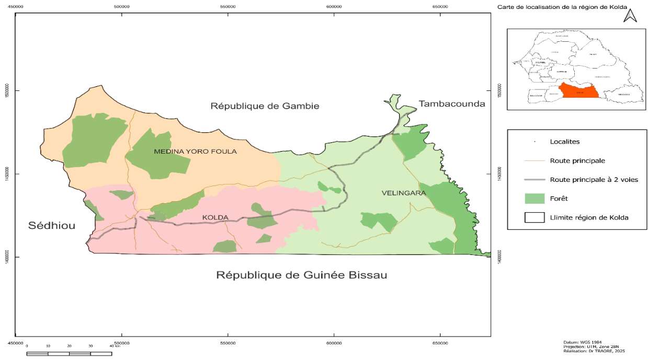

Fig. 1. Location of study area

2.2 Visual examination

Visual or exploratory analysis is a procedure used to highlight factors explaining the correlation and dependence between selected variables. It starts with the data and relies on an observational approach to gain an overview and uncover irregularities (Tossou et al., 2017). The analyst examines the data from all angles, seeks to identify patterns, and, where appropriate, formulates plausible hypotheses. The focus is on the tool's effectiveness in most situations rather than its optimality (Doumouya et al., 2016). Climatic parameters such as precipitation, temperature, relative humidity, evapotranspiration, etc., are frequently analyzed at all scales (Isabelle et al., 2019). This approach involves representing histograms (or graphs) of all observations, as well as trend lines, to visualize their evolution over the study period. A judicious and rigorous interpretation of the results makes it possible to obtain a global vision and to detect possible irregularities in the climate (Diouf et al., 2016).

3. Data and application

This study focuses on the Kolda region in southern Senegal, in the Upper Casamance. It relies on factors that define climate, including precipitation, temperature, and relative humidity. A series of data spanning five decades (1960-2014), at monthly and annual time steps, made available to us by ANACIM (the National Agency for Civil Aviation and Meteorology), was used. This national agency is reliable and specializes in collecting high-quality climate data. It is worth reiterating that climate is a primary factor that directly influences crop distribution and management. The Kolda station was chosen for this purpose due to the need for high-quality data over a long and uninterrupted period. The selection of climate parameters was based on a practical criterion: data accessibility and the fact that these parameters directly affect water resources and agricultural production. Agriculture plays a vital role in the survival of populations. Clearly, agricultural production depends on the availability of water and inputs. Successful agricultural production has significant consequences, ranging from the survival of subsistence farming to the region's economic situation. In recent years, production across all crops in the region has declined significantly. This situation has a considerable impact on the stability of the food and economic systems in this part of the country. In this context, the analysis of meteorological time series is more necessary than ever and requires increased vigilance. Our approach is based on visual examination. We created a graphical representation of monthly and annual rainfall, as well as monthly and annual average minimum, maximum, and mean relative temperatures and humidity, incorporating the trend line and the interannual average for rainfall. We also examined the ombrothermic diagram to highlight the correlation between rainfall and temperature. This framework allowed us to visualize the distribution of the studied parameters, identify trends, and assess their significance. Our goal is to extract all information that can inform relevant stakeholders about the climate risks of this period and to raise their awareness of the need for a reassessment of water resources and appropriate agricultural planning.

4. results and discussion

4.1 Rainfall

4.1.1 At monthly scale

Figure 2 presents the distribution of average monthly rainfall at the Kolda station. The analysis reveals a dry period (November to April), characterized by a lack of rain, and a wet period (May to October), characterized by heavy rainfall, with a peak of 308.2 mm recorded in August. The rainy period shows an increase from May to August and a decrease until October. The trend line for this series reveals an increase in average monthly rainfall.

Fig. 2. Inter-monthly variation in rainfall from 1960-2014

4.1.2 At annual scale

Figure 3 illustrates the evolution of annual rainfall at the Kolda station. At first glance, an alternation of years with and without rainfall is noticeable during the study period. Over the period considered, 28 years had rainfall values above the interannual average (1061.8 mm) and 27 years below. The lowest rainfall was observed in 1980 (565.9 mm) and the highest in 2005 (1644.3 mm). Overall, rainfall in Kolda is characterized by a general trend towards consistency.

Fig. 3. Interannual evolution of rainfall from 1960-2014

4.2 Temperature

4.2.1 At monthly scale

Figures 4a, 4b, and 4c respectively represent the evolution of maximum, minimum, and average monthly temperatures at the Kolda station. Figure 4d presents a comparative analysis of the three variables. Regarding the maximum temperature (Figure 4a), the peak is reached in April (40.5°C) and the lowest value in August (31.9°C); the trend line shows a downward trend. For Figure 4b (minimum temperature), the threshold is reached in June (24.5°C) and the lowest value in January (13.8°C); the trend line shows an upward trend. For the average monthly temperature (Figure 4c), the highest value is reached in May (31.95°C) and the lowest in December (24.09°C); the overall trend is downward. With figure 4d, we can see that the hot season extends from March to July, where monthly temperatures exceed the annual average, while the period from August to February represents the cold season with a monthly average below the annual average.

Fig.4a. Evolution of the monthly maximum temperature

Fig.4b. Evolution of the monthly minimum temperature

Fig. 4c. Monthly evolution of average temperature

Fig. 4d. Monthly evolution of maximum, minimum and average temperatures

4.2.2 At annual scale

The temperature evolution for the Kolda station between 1960 and 2014 is illustrated in Figures 5a, 5b, and 5c, corresponding to the maximum, minimum, and average temperatures, respectively. A comparative analysis of the three variables is shown in Figure 5d. The graph (Fig. 5a) reveals a more or less pronounced variation in temperatures from one year to the next. The peak was reached in 2007 (37.3°C) and the lowest value in 1979 (33.7°C). The trend line shows an upward trend. Regarding Fig. 5b, the highest value was reached in 2012 (21.6°C) and the lowest in 1975 (19.08°C). The trend line indicates a general upward trend. Regarding the annual temperature (Fig. 5c), with an interannual average of 28.08°C, the highest value was recorded in 2010 (29.24°C) and the lowest in 1979 (26.73°C). The trend line shows a general warming trend. Analysis of Fig. 5d shows that the three curves share the same shape. The overall trend is one of increase. This increase is more significant for the maximum temperature than for the average and minimum temperatures. In short, the warm period is more extensive in space and more persistent in time than the cold period. This is due to global warming.

Fig. 5a. Evolution of the annual maximum temperature

Fig.5b.Evolution of the annual minimum temperature

Fig. 5c. Evolution of the average annual temperature

Fig. 5d. Annual evolution of maximum, minimum and average temperatures

4.3 Relative Humidity

4.3.1 At monthly scale
Figures 6a, 6b, and 6c show the evolution of maximum, minimum, and average relative humidity, respectively. Figure 6d combines all three variables. In Figure 6a, the maximum value (approximately 97.5%) was recorded in September, and the minimum value (approximately 91.6%) in December. The trend line shows a marked increase in humidity. Analysis of the minimum relative humidity (Figure 6b) reveals an increase from February to August, followed by a decrease until January. The peak corresponds to 67.31%, and the lowest value to 17.5%. The trend line shows a marked increase. Regarding the average relative humidity (Figure 6c), there is an increase from February to August, followed by a decrease until January. The maximum value was recorded in August (82.3%), and the minimum value in February (47.1%). The trend line reveals a slight increase. As shown in Fig. 6d, and logically, unlike the "temperature" variable, the highest relative humidity values are obtained in the middle of the wet season (May to October) due to high evaporation and warm winds; the lowest values are obtained in the middle of the dry season (November to January). The trend lines for all three series show an increase. This increase is more significant for minimum relative humidity than for average and maximum relative humidity.

Fig. 6a. Evolution of maximum monthly relative humidity

Fig. 6b. Evolution of minimum monthly relative humidity

Fig. 6c. Evolution of average monthly relative humidity

Fig. 6d. Monthly evolution of maximum, minimum and average relative humidity
4.3.2 At annual scale

Figures 7a, 7b, and 7c illustrate the annual evolution of maximum, minimum, and average relative humidity over the period 1960–2014, respectively. Figure 7d summarizes the three curves. For maximum relative humidity (Fig. 7a), the highest value was recorded in 1975 and the lowest in 2012. The trend line reveals a very marked decrease. For minimum relative humidity (Fig. 7b), the peak was reached in 1961 and the lowest value in 1977. The trend line shows a slight decrease. Regarding average relative humidity (Fig. 7c), the highest value was recorded in 1966 and the lowest in 1985. The trend line reveals a very marked decrease. Analysis of Fig. 7d shows that the three curves have the same shape. The overall trend is downward. This decrease is more significant for maximum relative humidity than for average and minimum relative humidity.

Fig. 7a. Evolution of maximum annual relative humidity

Fig. 7b. Evolution of the annual minimum relative humidity

Fig. 7c. Evolution of average annual relative humidity

Fig. 7d. Annual evolution of maximum, minimum and average relative humidity
4.4 Pluviothermic diagram
This method involves plotting rainfall and twice the average monthly temperature on the y-axis, and the months on the x-axis. This diagram distinguishes dry months when rainfall (P) < 2T, and wet months when P > 2T. Thus, the analysis of Figure 8 reveals two distinct periods : (i) a wet period from July to September, characterized by high rainfall and low temperatures, and (ii) a dry period from October to June, characterized by low rainfall and rising temperatures. This confirms the Sudanian-Guinean nature of the region.
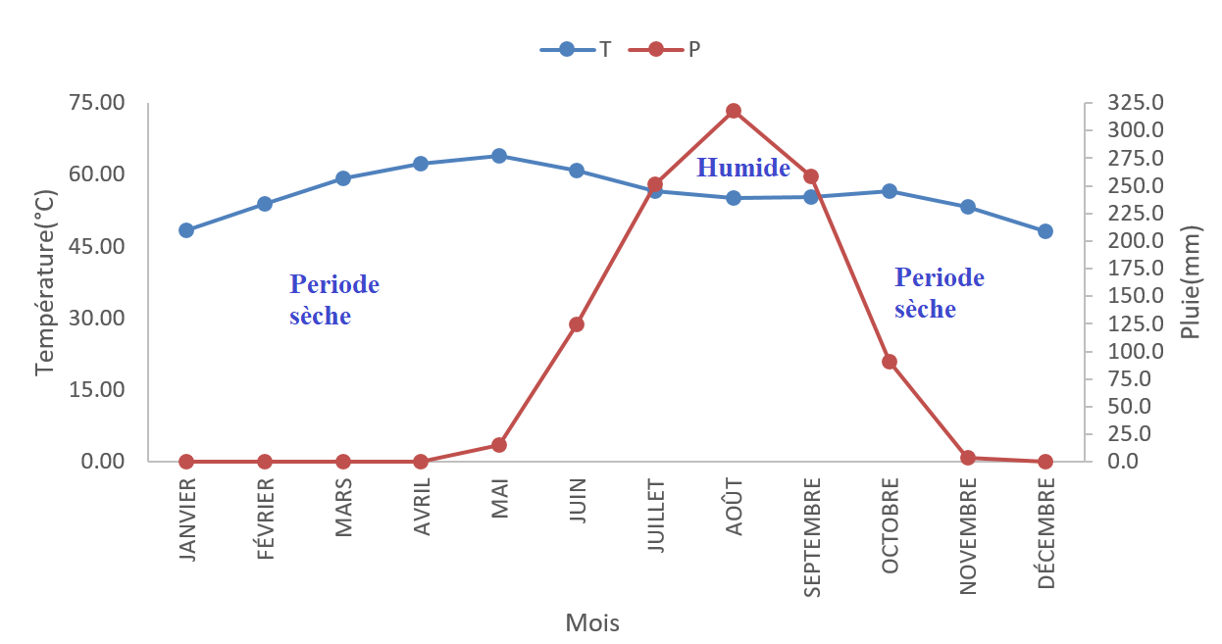
Fig. 8. Variation of the ombrothermic curve
4. Conclusion and Recommendation
Over the past few decades, the West African continent has suffered the adverse effects of climate change. This disruption has resulted in water supply difficulties, altered agricultural systems, a trade deficit, and a destabilization of the economic system and the entire social fabric. These factors significantly impact the living conditions and well-being of local populations. To address this threat, it is crucial to understand the phenomenon in order to better grasp climate cycles by studying the variability and trends of various climatic variables, including rainfall, temperature, and relative humidity. It is within this framework that this study, focusing on the Kolda region, was conducted. The meticulous analysis of a series of data spanning five decades (1960-2014), at monthly and annual time steps, has yielded highly revealing and promising results. Regarding monthly rainfall, the analysis reveals a dry period (November to April), characterized by a lack of rain, and a wet period (May to October), characterized by heavy rainfall, with a peak of 308.2 mm recorded in August. The rainy period shows an increase from May to August and a decrease until October. The trend curve for this series reveals an increase in average monthly rainfall. On an annual scale, there is an alternation of years with and without rainfall during the study period. Over the period considered, 28 years have rainfall values above the interannual average (1061.8 mm) and 27 years below. The lowest rainfall was observed in 1980 (565.9 mm) and the highest in 2005 (1644.3 mm). In summary, rainfall in Kolda is marked by a general trend towards consistency. Regarding temperatures, the hot season extends from March to July, during which monthly temperatures exceed the annual average, while the period from August to February represents the cool season, with monthly averages below the annual average. On an annual scale, the analysis shows that the three curves share the same shape. The overall trend is upward. This upward trend is more significant for the maximum temperature than for the average and minimum temperatures. In short, the hot period is more extensive in space and more persistent in time than the cool period. This is due to climate change. As for relative humidity, the highest values are obtained in the middle of the wet season (May to October) due to high evaporation and warm winds; the lowest values are obtained in the middle of the dry season (November to January). The trend curves for all three series reveal an increase. This increase is more significant for the minimum relative humidity than for the average and maximum relative humidity. On an annual scale, the analysis shows that the three curves have the same shape. The general trend is downward. This decrease is more significant for maximum relative humidity than for average and minimum relative humidity. Regarding the ombrothermic diagram, the analysis distinguishes two periods : (i) a wet period from July to September, characterized by high rainfall and low temperatures, and (ii) a dry period from October to June, characterized by low rainfall and rising temperatures. This confirms the Sudanian-Guinean nature of the region. Based on the available information, this study reveals that the diverse ecosystems of the Kolda region are highly sensitive to variations in rainfall, temperature, and relative humidity. The region faces climatic challenges, including irregular rainfall, rising temperatures, and falling relative humidity. These situations have contributed to water scarcity and increased ecological and social vulnerability. Given that the livelihoods of the populations in this region rely on small-scale subsistence agriculture, which is susceptible to various stressors, the vulnerability of this sector to the impacts of climate change and its variability constitutes one of the main challenges for developing countries, particularly in Africa. Therefore, these findings should serve as a warning to authorities and policymakers regarding the urgent need to develop adaptation strategies aimed at making rainfed agriculture more profitable and reducing reliance on this type of agriculture. To this end, the following solutions can be implemented :
- Mobilization and storage of runoff and groundwater from aquifers for water management ;
- Quantity and quality of inputs, adoption of modern technologies, and efficient infrastructure and supply chains to improve productivity ;
- Choice of low-water-requirement crops, modification of planting calendars and techniques, and selection of earlier-maturing varieties ;
- Irrigation alternatives to further reduce dependence on rain-fed agriculture ; and
- Regulated and well-structured irrigation techniques.
Once these recommendations are implemented, agriculture would constitute the main source of employment and income for the majority of the population. Otherwise, the local food sovereignty long proclaimed by the authorities will remain nothing more than a pipe dream.

References

Abera, H., Walelign, W., Girma, M., Dereje ,A. and Sebastian, G. (2023). Rainfall variability and its seasonal events with associated risks for rainfed crop production in Southwest Ethiopia. Cogent Food & Agriculture, 9(1), 1-20.

Alemu, D.,and Berhanu, K. (2018).The political economy of agricultural commercialization in Ethiopia: Discourses, actors and structural impediments. Agricultural policy research in Africa Working Paper 14. 40p

Ani, M. Jaunat, J. Marin, B.. Barel, Marie. ,Gnandi, K. (2022). Long-Term Evolution of Rainfall and Its Consequences on Water Resources: Application to the Watershed of the Kara River (Northern Togo). Water, 14(12), 1-22

ANSD, (2017). Regional economic and social situation 2014. Final regional report. 98p.

ANSD, (2023). Economic and Social Situation (SES) of Kolda 2020-2021. Final regional report. 170p.

Ardoin, B. S. (2004). Hydroclimatic variability and impacts on water resources of large river basins in the Sudano-Sahelian zone. Thesis from the University of Montpellier II, France, 330 p.

Ardoin, S., Lubès, N.H., Servat, E., Dezetter, A., Boyer, J.F. (2003). Analysis of persistent drought in West Africa: characterization of the situation in the 1990s. IAHS Publication, No. 278, 223-228.
Atidegla, S.C., Koumassi, H.D., Houssou,E.S.(2017).Climate variability and vegetable production in the Ahomey-Gblon floodplain in Benin, Int.J. Biol. Chem.Sci ,11(5),2254-2269

Bigot, S., Brou, Y. T., Oszwaid, J., Diedhiou, A. (2005). Factors of rainfall variability in Côte d’Ivoire and relationships with certain environmental changes. Drought, 16, no. 1, pp. 5-13.

Bourama, S. (2018). Revaluation of Historical and Cultural Heritage for Sustainable Tourism Development: The Case of the Kolda Region. Master's Thesis. Assane Seck University of Ziguinchor. 78p
Brou, Y.T. (2005). Climate, socio-economic changes and landscapes in Ivory Coast. Summary report of scientific activities presented in view of obtaining the Habilitation to Supervise Research, University of Science and Technology of Lille, France, 212p.

Daif, M. (2017). Study of some climatic variables of the Sebaou sub-basin (W.Tizi-Ouzou. National Higher School of Hydraulics. Arbaoui Abdellah, Master's thesis, ENSH], 130p
Diouf, R., Sambou, H., Traore, V. B., Ndiaye, M. L., Chaibo, A., Sambou, B., Diaw, A. T.and Beye ,A. C. (2016). Frequency Analysis and Exploratory of Rainfall Variability in Bounkiling River Basin in a Context of Climate Changeand Variability. American Journal of Engineering Research. 5: 82-93
Djaman, K., Balde, A.B., Rudnick, D.R., Ndiaye, O. and Irmak S., (2016). Long-Term Trend Analysis in Climate Variables and Agricultural Adaptation Strategies to Climate Change in the Senegal River Basin. International Journal of Climatology, 37, 2873-2888
Doumouya, F. R., Traore, V. B., Sadio, M., Sambou, H., Issaka, A. A. H., Diaw, A. T., Sambou, B. and Beye, A. C. (2016). Rainfall Variability in Sine Saloum River Basin in a Context of Climate Change and Variability. Advances in Research, 6, 1-12.
Fanchette, S. (2010), A peripheral region facing the challenge of decentralization: Fuladu, the land of the Fulani of Upper Casamance (Senegal).

Faty, A., Kane, A. and Ndiaye, A. L. (2017). Influence of climatic events on seasonal rainfall patterns in the upper Senegal River basin. Journal of Water Science, 30(2), 79–87

Girma, M., Kindie ,T., Mezegebu ,G., Tamado, T., Moti, J., and Berhane ,L. (2019). Rainfall Variability and its Implications for Wheat and Barley Production in Central Ethiopia. Ethiop. J. Crop Sci. 7(2), 99-111

Issa, M. and Oumar, S. (2019). Climate variability and food production in Upper Casamance (Southern Senegal). Review of geographical space and Moroccan society, 28 (29), 161-178

Issa ,M., Oumar, S., Demba ,G. and Bouly ,S. (2022). Rainfall variability and development of agricultural activity in the Kolda region (Senegal)”, Environmental Dynamics, 48,101-126

Issa, M. and Oumar, S. (2019). Rainfall Variability and Food Insecurity in Senegal: The Case of Upper Casamance . Conference on Climate Change and Food Security in West Africa co-organized by Université Cheikh Anta Diop de Dakar (UCAD) and Center for Development Research (ZEF), University of Bonn, on 17-18 November 2019 in Dakar, Senegal,10p.

PRDI, (2014). Emerging Senegal Plan, February 2014

Kouassi, A. M. (2007). Characterization of a potential change in the rainfall-runoff relationship and its impacts on water resources in West Africa: the case of the N'zi (Bandama) watershed in Côte d'Ivoire. Doctoral thesis. University of Cocody. 210p

Kouassi, A. M.. Kouao, J. M. and Kouakou, K. E. (2022). Intra-annual characterization of climate variability in Côte d'Ivoire. Bulletin of the Association of French Geographers, 99(2), 289-306

Lakehal ,S. and Hamdi ,A. (2021). Study of climate variability through rainfall series: the example of the Tafna watershed (NW Algeria). Master's thesis. University Center – Maghnia. 257p.

Lotfie, A. Y., Abdelrahman, A. K., Faisal, M. E., Ahmed,M. A., Hussain, S. A., Abdelhadi, A. W., Yasunori ,K. and Imad-eldin, A. and Ali, B.(2018). Rainfall variability and its implications for agricultural production in Gedarif State, Eastern Sudan. African Journal of Agricultural Research,13(31), pp. 1577-1590

Todé, M.K., Hounsou, M.B., Kawoun, A. G.M., Tassigui, S.S. and Ahamidé, B. (2022). Indicators of climate variability on cotton in the commune of Banikoara in northeastern Benin. Int. J. Adv. Res. 10(09), 656-664

Mahaman, B. S. , Raoul ,T. , Koffi ,F. K. , Marie ,S. O.G.A , Boyossoro, H. K. , Eric, V. D., Sékouba, O., Ta Marc, Y. , Kouadio, A. , Jean, P. J. , Issiaka ,S. and Jean ,B. (2009). Spatio-temporal variability of rainfall and its impact on groundwater resources: the case of the Abidjan district (southern Côte d'Ivoire), In : 14th International Symposium on Environmental Assessment, Niamey. 18p

Marta, A. C. and Ariadna, S. A. (2017). The isolation of Kolda (Senegal). The mobility of the living and the deceased. Quaderns, 33, 31-45.

Moussa, S., Mohamed., Alain, B. (2010). Production systems in the Kolda region: dynamics of innovation through village poultry farming. ISDA 2010, Montpellier, 28-30

Ndlela T, Sifundza LS, Beckedahl H, Kapwata T, Laban TL, Mahlangeni N, et al. Analysis of rainfall and tem-perature trends in Eswatini from 1981 to 2020: A perspective of climate change and variability. S Afr J Sci. 2026;122 (1/2), 1-8

Ouedraogo, M. (2001). Contribution to the study of the impact of climate variability on water resources in West Africa. Analysis of the consequences of a persistent drought: hydrological standards and regional modelling. PhD thesis, University of Montpellier II, France, 257p.

Paturel, J. E., Servat, E., DELATTRE, M. O. (1998). Analysis of long-term rainfall series in non-Sahelian West and Central Africa in a context of climate variability. Journal of Hydrological Sciences, 43(3), 937-945

Rodrigue, D. (2008). Adaptation to climate change: perceptions, local knowledge and adaptation strategies developed by producers in the communes of Kandi and Banikoara, northern Benin. THESIS. UNIVERSITY OF ABOMEY-CALAVI (BENIN). 130p

Sabeur, K. (2022). Statistical study of rainfall and climate characterization: Application to a watershed of the Sebdou wadi (Northwest Algeria). Master's thesis, Aboubakr Belkaïd University-Tlemcen, 130p

Sadio, C. A. A. S, Faye, C. Pande, C. B.. Tolche, A. D. , Ali, M. S., Cabral-Pinto, M. M. S. and Elsahabi, M. (2023) .Hydrological response of tropical rivers basins to climate change using the GR2M model : the case of the Casamance and Kayanga-Géva rivers basins. Environmental Sciences Europe, 35 (113), 1-22

Sangboliéwa, L. O., Aichatou, K. (2022). Climate Change and Adaptation of Farmers in Napié (Northern Ivory Coast) 35th Annual Colloquium of the International Association of Climatology – AIC ,6P

Sekela, T. and Manfred, B. F. (2019). Seasonal and Annual Rainfall Variability and Their Impact on Rural Water Supply Services in theWami River Basin, Tanzania. Water, 11 (2055), 1-18

Sene I., Diene, A.N., Traore, V.B. and Niane, D.T. (2019). Rainfall Analysis for Agricultural Purposes in Thies Region, Senegal Journal of Environmental Science, Toxicology and Food Technology.13 (2019) 30-39.

Servat, E., Paturel, J. E., Kouame, B., Travaglio, M., Ouedraogo, M., Boyer, J. F., Lubes-Niel, H., Fritsch J. M., Masson, J.M., Marieu, B. (1998). Identification, characterization and consequences of hydrological variability in West and Central Africa. IAHS, 252, 323-337

Sintayehu, A.W. (2025). Seasonal and Annual Rainfall Variability and Trends in the Dawuro Zone, Ethiopia. Innovation, 6(3),112-125

Tanina, D. S., Nagnin, S., Yéi, M.S. O., Théophile, L., Gbombélé, S., Kouassi, E. A. and Jean ,B. (2026). Climate variability and its impact on water resources in the Grand-Lahou square degree (South-West of Côte d'Ivoire)”, Physio-Géo, 5(2011), 55-73

Teshome, L. (2023). Seasonal and Annual Rainfall Variability and Trends in Metekele Zone North Western Ethiopia. Journal of Climatology and Weather Forecasting,11(3), 1-8

Tilahun, S. A., Zerihun, Y. A., Belayneh, B. G. and Mekonen, G. A. (2025). Rainfall variability and trends in western Amhara: implication for sustainable water management and agricultural productivity. Water Practice & Technology ,20(2), 450 -467

Tossou, E. M.., Ndiaye, M. L., Traore, V. B., Sambou, H., Nelly ,C. K., Sy, B. A. and Diaw ,A.T. (2017). Characterization and Analysis of Rainfall Variability in the MonoCouffo River Watershed Complex, Benin (West Africa). Resources and Environment, 7,13-29

Yao, F.Z., Dembélé, M., N'go, Y. A. and Kouakou, Y. E. (2024). Water resources management under climate change and anthropogenic pressure in the upper Bandama catchment in Northern Côte d'Ivoire. J. of Water and Climate Change, 15(9), 4500-4514

