Short Communication

Review on traditional use of medicinal plants species in oral and dental health care practices among tribal communities

Abstract
Traditional knowledge of medicinal plants plays a vital role in primary oral healthcare among tribal communities, particularly in regions with limited access to modern dental services. The present review synthesizes ethnomedicinal information on twenty plant species belonging to diverse botanical families traditionally used to manage oral and dental ailments such as toothache, gum inflammation, pyorrhea, dental caries, mouth ulcers, and oral malodor. Various plant parts including bark, leaves, rhizomes, roots, fruits, latex, and chewing sticks are employed in the form of pastes, decoctions, infusions, oils, and direct mastication. The documented species exhibit potential antimicrobial, anti-inflammatory, analgesic, and wound-healing properties, which support their traditional applications in oral health management. This review highlights the pharmacological relevance of these ethnomedicinal practices, emphasizes the need for scientific validation through phytochemical and clinical investigations, and underscores the importance of conserving indigenous knowledge systems for the development of affordable and sustainable herbal dental care strategies.
Keywords: Ethnomedicine; Medicinal plants; Oral health; Tribal communities
Introduction
Oral and dental diseases such as dental caries, gingivitis, periodontitis, toothache, and oral ulcers are among the most common health problems affecting populations worldwide (Nazir, 2017). These conditions significantly impair quality of life by causing pain, discomfort, difficulty in eating, and secondary infections. In many developing regions and remote tribal areas, access to professional dental care remains limited due to socioeconomic constraints, geographical isolation, and inadequate healthcare infrastructure (Muralidharan and Bhate, 2025). As a result, traditional plant-based remedies continue to serve as the primary source of oral healthcare among indigenous communities (Wang et al., 2025). Ethnomedicinal knowledge related to oral and dental health is deeply embedded in tribal culture and has been transmitted orally across generations (Ahmad et al., 2021). Communities rely on locally available plant resources to manage dental pain, gum inflammation, mouth ulcers, pyorrhea, and oral malodor. Despite the widespread traditional use of medicinal plants in dental care, systematic documentation and scientific evaluation of these practices remain insufficient. Furthermore, many ethnomedicinal claims lack comprehensive phytochemical characterization and clinical validation, limiting their integration into mainstream dental practice. Therefore, consolidating ethnobotanical data is essential for preserving valuable traditional information and identifying promising candidates for further pharmacological investigation (Mekonnen et al., 2022). The present review aims to compile and critically analyze documented ethnomedicinal plants used in oral and dental healthcare practices among tribal communities. The need for this study arises from the growing demand for affordable, accessible, and plant-based alternatives in dental care, as well as the urgent requirement to conserve indigenous knowledge for future generations and sustainable healthcare development.
Methodology
The present review is based on a comprehensive analysis of documented ethnomedicinal information provided in the compiled table on medicinal plants traditionally used for oral and dental healthcare among tribal communities. Data regarding plant names, families, plant parts used, modes of preparation and application, and reported therapeutic uses were systematically examined and organized (Kumar, 2025). The cited literature sources associated with each species were considered to ensure authenticity and reliability of ethnobotanical records. The collected information was further categorized based on types of oral ailments treated, such as toothache, gum disorders, dental decay, mouth ulcers, and oral malodor. Emphasis was placed on identifying commonly used plant parts, patterns of preparation (paste, decoction, infusion, chewing sticks, latex, or oil application), and potential pharmacological relevance (Sahu et al., 2026). The methodology primarily involved qualitative synthesis and comparative analysis to highlight trends, therapeutic significance, and research gaps in traditional oral healthcare practices (Jena et al., 2025).
Results
The review documented twenty ethnomedicinal plant species belonging to diverse botanical families including Fabaceae, Myrtaceae, Amaranthaceae, Asteraceae, and others, indicating broad taxonomic representation in traditional oral healthcare practices. The most frequently utilized plant parts were leaves, bark, sticks, and roots, followed by rhizomes, fruits, latex, and flower buds (Figure 1). Toothache emerged as the most commonly treated condition, with several species such as Syzygium aromaticum, Acorus calamus, and Stereospermum kunthianum being applied directly in the form of chewing or paste. Gum disorders and pyorrhea were managed using chewing sticks and bark preparations from plants like Azadirachta indica and Salvadora persica, which serve both mechanical and therapeutic functions (Table 1). Modes of preparation were simple and locally adaptable, primarily involving paste preparation, decoctions for gargling, infusion, oil application, and direct chewing (Figure 2). The widespread use of chewing sticks reflects an integrated approach combining physical plaque removal with the antimicrobial action of phytochemicals.
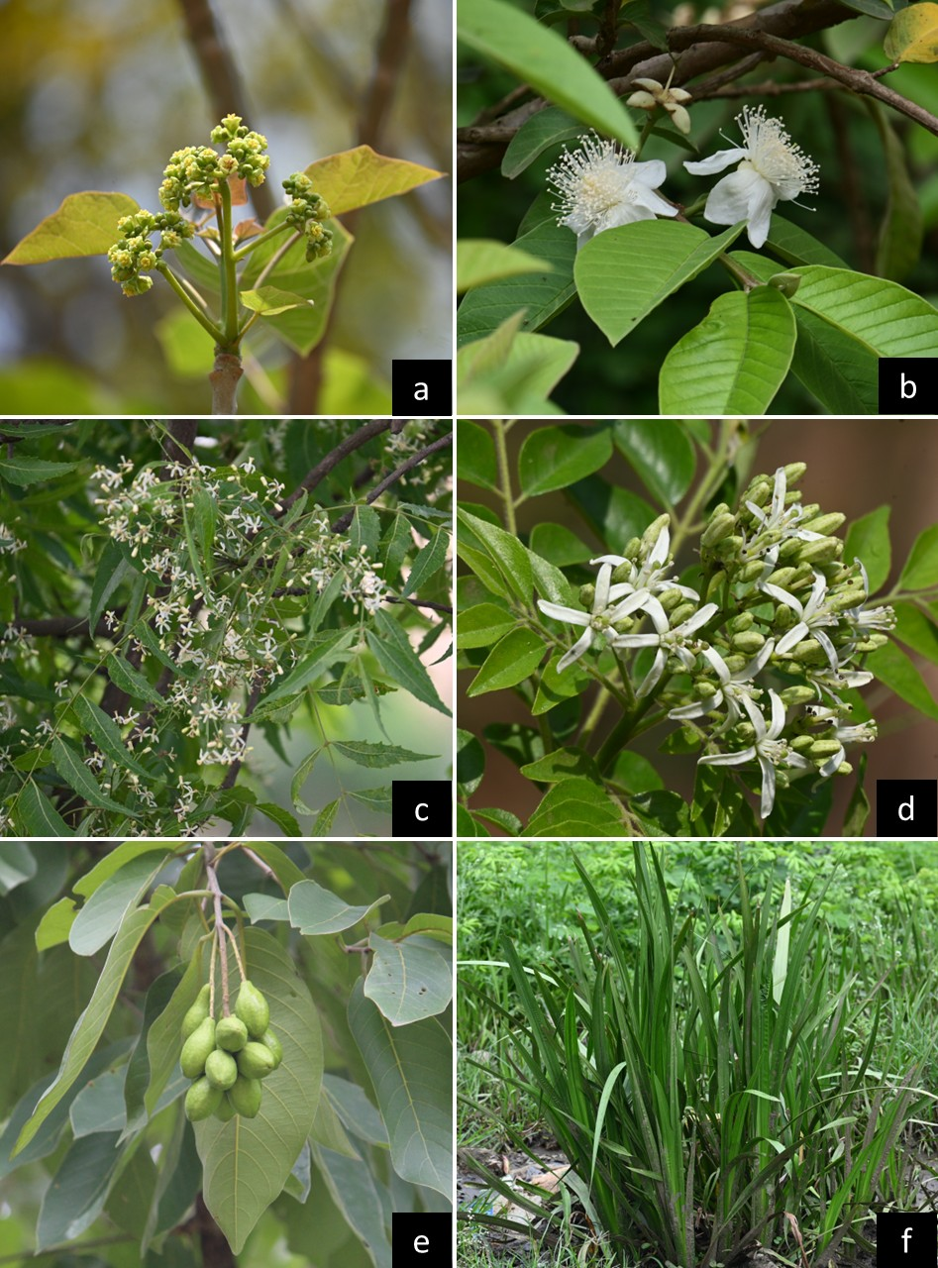
Plate 1: Common plants used in teeth problems; a) Jatropha curcas, b) Psidium guajava, c) Azadirachta indica, d) Bergera koenigii, e) Terminalia chebula and f) Acorus calamus

For example, the analgesic effect of clove is attributed to eugenol, while neem contains azadirachtin and other bioactive compounds with proven antibacterial and anti-inflammatory properties. Similarly, leaf decoctions of Psidium guajava and flower extracts of Calendula officinalis are traditionally used for mouth ulcers and oral inflammation due to their wound-healing and antiseptic properties. These findings demonstrate a strong correlation between traditional practices and known pharmacological activities. The results also reveal that tribal oral healthcare practices are cost-effective, sustainable, and reliant on locally available flora. However, variations in dosage, preparation methods, and application techniques may influence therapeutic outcomes. While several plants have been scientifically investigated and incorporated into modern herbal dental formulations, many species remain underexplored. Therefore, further phytochemical screening, antimicrobial assays against oral pathogens, toxicity studies, and controlled clinical trials are necessary to validate traditional claims and facilitate their integration into evidence-based dental medicine. Overall, the documented ethnomedicinal practices highlight a valuable reservoir of knowledge with significant potential for future drug discovery and sustainable oral healthcare development (Table 1).

Figure 1: Frequency use of different plant parts
Table 1: Ethnomedicinal plants used to treat oral and dental health problems
Plant Name | Plant parts Used | Mode of Uses | Source(s)
Acacia arabica (Lam.) Willd.  (Fabaceae) | Bark | Bark paste is used to cure toothache. | Refaey et al., (2024)
Achyranthes aspera L.  (Amaranthaceae) | Stem bark | Bark paste is applied on gum to reduce pain. | Pasupuleti et al., (2023)
Acorus calamus L.  (Acoraceae) Plate 1f | Rhizome | Rhizome paste is used to cure teeth pain. | Pasupuleti et al., (2023)
Amaranthus caudatus L.  (Amaranthaceae) | Roots | Chewing roots is effective to treat teeth problems. | Amanpour et al., (2023)
Asarum sieboldii Miq.  (Aristolochiaceae) | Whole plant | Whole plant paste is used to cure teeth problems. | Happy et al., (2025)
Azadirachta indica A.Juss.  (Meliaceae) Plate 1c | Stick | Stick is used to brush the teeth to treat pyorrhea. | Pasupuleti et al., (2023)
Bergera koenigii L.  (Rutaceae) Plate 1d | Leaves | Leaves decoction is used to cure teeth problems. | Chandra et al., (2015)
Calendula officinalis L.  (Asteraceae) | Flowers | Decoction is used as mouth wash liquid. | Refaey et al., (2024)
Carica papaya L. (Caricaceae) | Leaves | Leaf paste is useful to treat canker sores. | Cruz et al., (2017)
Dysphania ambrosioides (L.) Mosyakin & Clemants  (Amaranthaceae) | Whole plant | Paste of plant is used to cure teeth pain. | Ashu and Naidoo, (2015).
Eucalyptus globulus Labill.  (Myrtaceae) | Leaves | Leaf oil is applied to reduce the pain. | Refaey et al., (2024)
Gymnanthemum amygdalinum (Delile) Sch.Bip.  (Asteraceae) | Leaves | Decoction is used for gargling to reduce toothache. | Ashu and Naidoo, (2015).
Jatropha curcas L.  (Euphorbiaceae) Plate 1a | Latex | Latex is applied to cure teeth decay. | Gloria-Garza et al., (2025)
Millettia ferruginea (Hochst.) Hochst. ex Baker  (Fabaceae) | Bark | Bark paste is used to treat teeth decay. | Suleman et al., (2012)
Psidium guajava L.  (Myrtaceae) Plate 1b | Leaf bud | Leaf bud is chewing to treat mouth ulcer. | Ramírez-Torres et al., (2025)
Salvadora persica L.  (Salvadoraceae) | Stick | Chewing sticks is used to cure toothache. | Amanpour et al., (2023)
Searsia natalensis (Bernh. ex C.Krauss) F.A.Barkley  (Anacardiaceae) | Leaves | Chewing leaves are effective act to reduce pain. | Kidane et al., (2014)
Sida rhombifolia L.  (Malvaceae) | Stick | Chewing stick and mouth rinse to cure toothache. | Ashu and Naidoo, (2015).
Stereospermum kunthianum Cham.  (Bignoniaceae) | Stem | Stem is chewed to cure toothache. | Ragunathan et al., (2009)
Syzygium aromaticum (L.) Merr. & L.M.Perry  (Myrtaceae) | Dried flower buds | Chewing dried flower buds is used to cure toothache. | Amanpour et al., (2023)
Terminalia chebula Retz.  (Combretaceae) Plate 1e | Fruit powder | Fruit powder is used to make infusion. Infusion is used to treat mouth odour. | Gloria-Garza et al., (2025)

Figure 2: Frequency of different modes of use
Discussion
The ethnomedicinal use of plants for oral and dental care reflects a long chronological progression of traditional knowledge, gradually supported and validated by modern scientific studies. Across different regions and time periods, communities have relied on locally available plant resources to manage toothache, gum disorders, mouth ulcers, and oral hygiene. When examined chronologically through documented studies, a clear evolution emerges from simple chewing practices and crude pastes to more refined preparations such as decoctions, oils, and infusions.
In the earlier phase of documentation, traditional practices largely revolved around direct application or chewing of plant parts. For instance, studies such as Ragunathan et al. (2009) reported the use of Stereospermum kunthianum, where the stem is chewed directly to alleviate toothache. This simple mechanical and phytochemical approach highlights one of the earliest forms of dental care, where chewing not only releases bioactive compounds but also aids in cleaning teeth. Similarly, Kidane et al. (2014) documented the chewing of leaves of Searsia natalensis to reduce dental pain, emphasizing the reliance on easily accessible plant parts without complex preparation.
By the mid-2010s, research began to show a transition toward slightly processed remedies, particularly the use of pastes and decoctions. Ashu and Naidoo (2015) provided multiple examples of this shift. The whole plant paste of Dysphania ambrosioides was used to treat tooth pain, while decoctions of Gymnanthemum amygdalinum leaves were employed for gargling to relieve discomfort. Additionally, Sida rhombifolia sticks were used both as chewing tools and as a source for mouth rinses, illustrating a combination of mechanical and medicinal benefits. These practices represent an intermediate stage where preparation methods became more deliberate, enhancing the efficacy of plant-based remedies.
Around the same period, Chandra et al. (2015) highlighted the use of Bergera koenigii (curry leaves), where leaf decoctions were used to manage dental problems. This indicates a growing understanding of extraction techniques, as boiling helps concentrate active compounds. Similarly, Cruz et al. (2017) documented the use of Carica papaya leaf paste for treating canker sores, showing an expansion of plant use beyond toothache to broader oral health conditions.
Moving into the early 2020, there is a noticeable diversification in both plant species and modes of application. Amanpour et al. (2023) reported several traditional remedies, including chewing the roots of Amaranthus caudatus for dental problems, using chewing sticks of Salvadora persica for toothache, and chewing dried flower buds of Syzygium aromaticum to relieve pain. These practices highlight the continued importance of chewing-based treatments while also reflecting an increased awareness of specific plant parts with potent bioactive compounds.
In parallel, Pasupuleti et al. (2023) documented several plant-based treatments that demonstrate both traditional continuity and innovation. For example, bark paste of Achyranthes aspera is applied to gums to reduce pain, while rhizome paste of Acorus calamus is used for toothache. Notably, Azadirachta indica (neem) sticks continue to be widely used as natural toothbrushes for treating pyorrhea, reflecting a practice that has persisted across centuries due to its proven antimicrobial properties.
Recent studies also emphasize refined and targeted applications, including oils, latex, and specialized extracts. Refaey et al. (2024) reported the use of bark paste of Acacia arabica for toothache, flower decoctions of Calendula officinalis as mouthwash, and leaf oil of Eucalyptus globulus for pain relief. These methods demonstrate a more advanced understanding of phytochemistry, where specific plant derivatives are used for targeted therapeutic effects.
The most recent contributions, such as Gloria-Garza et al. (2025) and Happy et al. (2025), further illustrate the increasing sophistication and diversity of plant-based dental treatments. For instance, latex from Jatropha curcas is applied to treat tooth decay, indicating the use of concentrated plant exudates. Similarly, fruit powder of Terminalia chebula is prepared as an infusion to treat mouth odor, reflecting an integration of traditional knowledge with more standardized preparation techniques. The use of the whole plant paste of Asarum sieboldii also highlights a holistic approach, where multiple plant components contribute to therapeutic efficacy.
Another notable development in recent years is the use of specific plant parts with precise therapeutic roles. For example, Psidium guajava leaf buds are chewed to treat mouth ulcers (Ramírez-Torres et al., 2025), while bark paste of Millettia ferruginea is used for tooth decay (Suleman et al., 2012), showing both continuity and refinement in ethnomedicinal practices.
Overall, the chronological progression of these studies reveals three major trends. First, there is a shift from simple, direct use of plant parts (chewing and raw application) to more processed forms such as pastes and decoctions. Second, there is an expansion in the diversity of plant species and parts used, reflecting broader ethnobotanical exploration. Third, there is an increasing emphasis on targeted and efficient delivery methods, such as oils, latex, and infusions, which enhance therapeutic outcomes.
In conclusion, the use of medicinal plants for oral health has evolved significantly over time while maintaining its traditional roots. Early practices focused on accessibility and simplicity, whereas modern approaches incorporate scientific validation and improved preparation techniques. This chronological development not only underscores the richness of traditional knowledge but also highlights its relevance in contemporary healthcare, particularly in the search for natural and sustainable alternatives to synthetic dental treatments.
Conclusion
The present review highlights the significant role of ethnomedicinal plants in managing oral and dental health problems among tribal communities. The documented species demonstrate diverse therapeutic applications for toothache, gum disorders, dental decay, mouth ulcers, and oral malodor, utilizing various plant parts through simple and locally accessible preparation methods. The findings underscore the strong empirical foundation of traditional knowledge, supported by the presence of bioactive compounds with antimicrobial, anti-inflammatory, and analgesic properties. However, scientific validation through phytochemical, pharmacological, and clinical studies remains essential to ensure safety, efficacy, and standardization. Preservation of indigenous knowledge and sustainable utilization of medicinal plant resources are crucial for promoting affordable, culturally acceptable, and plant-based alternatives in modern oral healthcare systems.

References
Ahmad K, Ahmad M, Huber FK, Weckerle CS. Traditional medicinal knowledge and practices among the tribal communities of Thakht-e-Sulaiman Hills, Pakistan. BMC Complement Med Ther. 2021 Sep 13;21(1):230. doi: 10.1186/s12906-021-03403-1.
Amanpour S, Akbari Javar M, Sarhadinejad Z, Doustmohammadi M, Moghadari M, Sarhadynejad Z. A systematic review of medicinal plants and herbal products' effectiveness in oral health and dental cure with health promotion approach. J Educ Health Promot. 2023 Sep 29;12:306. doi: 10.4103/jehp.jehp_1297_22.
Ashu AM and Naidoo S. (2015). Ethnomedicinal Plants Used by Traditional Healers to Treat Oral Health Problems in Cameroon. Evid Based Complement Alternat Med. 2015;2015:649832. doi: 10.1155/2015/649832.
Chandra SBR, Nagarajappa R, Suma S, Thakur R. Herbal extracts in oral health care - A review of the current scenario and its future needs. Pharmacogn Rev. 2015 Jul-Dec;9(18):87-92.
Cruz MC, Diaz Gómez M, Oh MS. Use of traditional herbal medicine as an alternative in dental treatment in Mexican dentistry: a review. Pharm Biol. 2017 Dec;55(1):1992-1998.
Gloria-Garza MA, Reyna-Martínez GR, Jiménez-Salas Z, Campos-Góngora E, Kačániová M, Aguirre-Cavazos DE, Bautista-Villarreal M, Leos-Rivas C, Elizondo-Luevano JH. Medicinal Plants Against Dental Caries: Research and Application of Their Antibacterial Properties. Plants. 2025 May 5;14(9):1390. doi: 10.3390/plants14091390.
Happy K, Mudondo J, Yim NH, Kang Y. Asarum sieboldii, a Potential Ethnomedicinal Herb in Dentistry and Oral Health. Int Dent J. 2025 Aug;75(4):100816. doi: 10.1016/j.identj.2025.03.025.
Jena N, Vimala, Singh B, Patra A, Sharma BP, Hossain E and Kumar S. (2025). Methods for ethnobotanical data collection, phytochemistry, antioxidant, anthelmintic, and antimicrobial activities for pharmacological evaluation of medicinal plants. Journal of Biodiversity and Conservation. 9(2): 87-107.
Kidane B., van Andel T., van der Maesen L. J. G., Asfaw Z. Use and management of traditional medicinal plants by Maale and Ari ethnic communities in southern Ethiopia. Journal of Ethnobiology and Ethnomedicine. 2014;10(1):p. 46. doi: 10.1186/1746-4269-10-46
Kumar S. (2025). Data collection from literature for biological sciences, medicinal plants research, ethnobotany, and pharmacology: a methodological overview. Journal of Biodiversity and Conservation. 9(2): 167-169.
Mekonnen AB, Mohammed AS, Tefera AK. Ethnobotanical Study of Traditional Medicinal Plants Used to Treat Human and Animal Diseases in Sedie Muja District, South Gondar, Ethiopia. Evid Based Complement Alternat Med. 2022 Sep 19;2022:7328613. doi: 10.1155/2022/7328613.
Muralidharan AP and Bhate K. (2025). Overcoming barriers to oral healthcare in India's tribal regions: Insights and strategies. J Family Med Prim Care. 2025 Jun;14(6):2579-2580.
Nazir MA. (2017). Prevalence of periodontal disease, its association with systemic diseases and prevention. Int J Health Sci (Qassim). 11(2):72-80.
Pasupuleti MK, Nagate RR, Alqahtani SM, Penmetsa GS, Gottumukkala SNVS, Ramesh KSV. Role of Medicinal Herbs in Periodontal Therapy: A Systematic Review. J Int Soc Prev Community Dent. 2023 Feb 27;13(1):9-16.
Ragunathan M., Abay S. M. Ethnomedicinal survey of folk drugs used in Bahir Dar Zuria district, northwestern Ethiopia. Indian Journal of Traditional Knowledge. 2009;8(2):281–284.
Ramírez-Torres V, Torres-León C, Londoño-Hernandez L, Gómez-García R, Ramírez-Guzmán N. Therapeutic Potential of Latin American Medicinal Plants in Oral Diseases: From Dental Pain to Periodontal Inflammation-A Systematic Review. Int J Mol Sci. 2025 Nov 27;26(23):11502. doi: 10.3390/ijms262311502.
Refaey MS, Abosalem FE, El-Basyouni RY, Elsheriri SE, Elbehary SH and Fayed MAA. (2024). Exploring the therapeutic potential of medicinal plants and their active principles in dental care: A comprehensive review. Heliyon. 10(18): e37641. DOI: 10.1016/j.heliyon.2024.e37641
Sahu JK, Sureshrao GA, Majhi S, Dimri R, Sharma BP, Tailor V, Kumar Sand Patra A. (2026). Methodology for writing review articles in biological sciences: a systematic and scholarly guide. Archives of Current Research International. 26(2): 170-182.
Suleman S., Alemu T. A survey on utilization of ethnomedicinal plants in Nekemte town, east Wellega (Oromia), Ethiopia. Journal of Herbs, Spices & Medicinal Plants. 2012;18(1):34–57.
Wang X, Anwar T, Qureshi H, El-Beltagi HS, Sehar Z, Solieva D, Azizov B, Rebouh NY, Abbasov MA, Yakubov F, Alomran MM. Plant-based traditional remedies and their role in public health: ethnomedicinal perspectives for a growing population. J Health Popul Nutr. 2025 Aug 20;44(1):300. doi: 10.1186/s41043-025-01036-5.

