Bioinformatics analysis and expression profiling of the jasmonic acid-responsive transcription factor SlMYB83
Short Research Article

ABSTRACT
Aims: In this study, the candidate gene SlMYB83 was identified through screening in wild-type tomato and the jasmonic acid (JA)-deficient spr2 mutant. Its protein structural characteristics, putative regulatory functions, and expression patterns in response to exogenous methyl jasmonate (MeJA) were systematically characterized through bioinformatics and expression analyses. These findings provide a theoretical basis for subsequent functional validation and molecular mechanism studies of SlMYB83.
Study Design: This study was conducted using a research design that integrated bioinformatics prediction with gene expression analysis. The SlMYB83 protein was first subjected to prediction and characterization, followed by an examination of its expression differences across various tissues. Additionally, changes in SlMYB83 expression were compared between the spr2 mutant and under conditions of exogenous methyl jasmonate (MeJA) application.
Methodology: In this study, bioinformatics approaches were employed to comprehensively analyze the physicochemical properties, signal peptide, transmembrane domains, conserved domains, secondary structure, tertiary structure, protein–protein interactions, subcellular localization, and promoter cis-regulatory

elements of tomato SlMYB83. These analyses were integrated with quantitative real-time PCR to determine the tissue-specific expression pattern of SlMYB83 and to assess its expression changes in the spr2 mutant and following exogenous MeJA application.
Results: SlMYB83 was characterized as a non-transmembrane, hydrophilic protein with a slightly acidic nature, localized to the nucleus. It contains a SANT domain (PLN03091), which is implicated in the regulation of diverse biological processes, including growth and development, light response, drought stress, abscisic acid signaling, and anaerobic induction, as well as various stress-responsive pathways. Among the tissues examined, SlMYB83 transcript levels were highest in leaves and lowest in fruits. These results suggest a negative regulatory relationship between SlMYB83 and JA in tomato.
Conclusions: In this study, the fundamental characteristics of tomato SlMYB83 were elucidated, thereby enriching the current knowledge of the MYB protein family. These findings provide a theoretical foundation for further investigation into the role and molecular mechanisms of SlMYB83 in JA-mediated regulation of plant growth and development.
Keywords: Tomato; SlMYB83; Jasmonic acid (JA); Bioinformatics; Signaling pathway

INTRODUCTION
Tomato (Solanum lycopersicum), a member of the Solanaceae family, is recognized as a major horticultural crop worldwide due to its considerable nutritional value and distinct flavor (Shang et al., 2025). Tomato is a key model plant in molecular research (Li et al., 2026); however, it is susceptible to both biotic and abiotic stresses during growth (Sánchez-Reyna et al., 2025), which severely impair its yield and quality. Therefore, elucidating the signal transduction and transcriptional regulatory networks of tomato under stress conditions is of great significance for understanding the crop’s “growth–defense” trade-off mechanism and for providing potential targets for stress-tolerant breeding.
Plant hormones are a class of low-molecular-weight compounds that play critical roles in plant growth, development, and stress responses (Vrobel et al., 2024; Chen et al., 2024), with jasmonic acid (JA) being one of them. Studies have shown that JA plays a critical role in activating the antioxidant system, thereby enabling plants to adapt to abiotic stress (Li et al., 2024). In the presence of JA, JA is converted into its bioactive form, (+)-7-iso-jasmonoyl-L-isoleucine (JA-Ile) (Dougherty et al., 2024). Upon binding of JA-Ile to the COI1-JAZ complex within the SCF^{[COI1]} E3 ubiquitin ligase

complex, JAZ proteins undergo ubiquitination followed by proteasomal degradation, thereby relieving the repression of the transcription factor MYC2 by JAZ. This subsequently activates the transcription of MYC2-downstream genes and triggers plant defense and repair responses (Wasternack & Hause, 2024; Luo et al., 2023).
Methyl jasmonate (MeJA), a methyl ester derivative of JA, enhances JA-mediated cold tolerance in tomato by upregulating the expression of SlMYB13 (Demiwal et al., 2024; Zhang et al., 2025). MeJA and JA are widely recognized as lipid-derived stress hormones that play critical roles in plant growth and development, as well as in defense against biotic and abiotic stresses (Wang & Zhang, 2021; Sonatan et al., 2026). They form intricate crosstalk networks with other hormones, including salicylic acid (SA), abscisic acid (ABA), and ethylene (Liu & Timko, 2021), to collectively orchestrate plant growth and defense responses. In the tomato spr2 (suppressor of prosystemin-mediated responses 2) mutant, JA biosynthesis is impaired due to a defect in the chloroplastic fatty acid desaturase involved in the octadecanoid pathway, resulting in significantly reduced JA content in leaves and suppressed JA synthesis upon wounding (Zhao et al., 2016). Therefore, the JA mutant spr2 represents an ideal material for dissecting the function of the JA signaling pathway and provides a valuable genetic platform for elucidating the JA signaling regulatory network.
Transcription factors enhance plant stress tolerance by regulating the expression of downstream genes (Zhang & Xia, 2023). The MYB transcription factor family is one of the largest transcription factor families in plants (Chen et al., 2025). MYB transcription factors are directly involved in the regulation of the JA signaling pathway: COI1 promotes the ubiquitin-dependent degradation of JAZ proteins, thereby releasing Arabidopsis AtMYB21 and AtMYB24, and subsequently activating the expression of JA-mediated genes involved in anther development and filament elongation (Lu et al., 2025). Overexpression of PnMYB2 in ginseng enhances the expression of JA biosynthesis-related genes and confers resistance to root rot (Wang et al., 2025). However, MYB transcription factors regulated by the JA signaling pathway in tomato remain to be systematically identified, and the response mechanism of SlMYB83 in the spr2 mutant background is still unclear.
Based on our previous transcriptome screening of wild-type tomato and the jasmonic acid-deficient spr2 mutant, we identified SlMYB83 as a candidate gene. It was speculated that JA and SlMYB83 may co-regulate stress tolerance and growth and development in tomato. Whether SlMYB83 is involved in the JA pathway, as well as its structural and functional characteristics, remain to be elucidated through systematic bioinformatics analysis and experimental validation. Here, we conducted a comprehensive bioinformatics analysis of SlMYB83, combined with tissue-specific

expression profiling and analysis of expression changes in mutants and in response to hormone treatment, to systematically characterize its structural features and expression patterns, thereby providing a foundation for subsequent functional studies.

MATERIALS AND METHODS

Plant Materials and Growth Conditions
The plant materials used in this experiment included the cultivated tomato variety ‘Jinguan No. 5’ (wild-type, WT) and the jasmonic acid-deficient mutant spr2. The tomato seeds were subjected to heat shock treatment for 5 minutes and subsequently incubated in darkness at 25 °C for 2 days to promote germination. The germinated seedlings were transplanted into nutrient soil and cultivated in a controlled environment growth chamber under the following conditions: light intensity of 20,000 lux, a photoperiod of 16 h light/8 h dark, and temperatures of 25 °C (day) and 18 °C (night). Plants were grown until the four-leaf stage with one unfolding leaf, at which point they were used for subsequent experiments.

Target Sequences
The gene and protein sequences of tomato SlMYB83 were downloaded from the Phytozome website (https://phytozome-next.jgi.doe.gov/).

Bioinformatics Analysis Tools
The SlMYB83 gene was analyzed using bioinformatics websites and analysis software (Table 1) for predictions and assessments of protein physicochemical properties, hydrophilicity/hydrophobicity, signal peptide, transmembrane domains, subcellular localization, and promoter cis-regulatory elements.
Table 1. Tools used for bioinformatics analysis

Tools Website Effect
Prediction of physicochemical

ProtParam http://web.expasy.org/protparam/

ExPASy ProIScale Expasy - ProtScale

SignalP-5.0 https://services.healthtech.dtu.dk/service.php?SignalP-5.0

TMHMM-2.0 https://services.healthtech.dtu.dk/service.php?TMHMM-2.0
properties of protein sequences Hydrophilic and hydrophobic analysis of proteins
Prediction and analysis of signal peptides
Transmembrane strueture analysis of proteins

NCBI https://www.ncbi.nlm.nih.gov/Structure/cdd/wrpsb.cg Conserved domain analysis

SOPMA
http://npsa-pbil.ibcp.fr/cgi-bin/npsa_automat.pl?page=/NPSA/npsa_sopma.html
Prorein secondary strucure predictiontion

SWISS-MODEL https://swissmodel.expasy.org/ Protein 3D structure prediction

Plant-mPLoc http://www.csbio.sjtu.edu.cn/bioinf/plant-multi/
Prediction of subcellular localization of proteins

PLANTCARE https://bioinformatics.psb.ugent.be/webtools/plantcare/html/ Promoter prediction
STRING STRING: functional protein association networks Protein-protein interaction prediction
Analysis of cis-regulatory elements in

Tbtools-Ⅱ
promoters

MeJA Treatment and Gene Expression Analysis
To investigate the response of SlMYB83 to jasmonic acid signaling, tomato seedlings were grown until the two-leaf stage. Seedlings with uniform growth were selected and subjected to exogenous application of 100 µM methyl jasmonate (MeJA) solution. Samples were collected at 5 days after treatment, immediately flash-frozen in liquid nitrogen, and subsequently stored at −80 °C until further use for RNA extraction.
To collect samples from spr2 mutant seedlings, plants were grown until the two-leaf stage. Seedlings were then harvested, wrapped in aluminum foil, labeled, immediately frozen in liquid nitrogen, and subsequently stored at −80 °C until further use for RNA extraction.
The successfully extracted RNA was reverse transcribed into cDNA, and the expression levels of SlMYB83 in MeJA-treated plants and spr2 mutants were examined by quantitative real-time PCR (qRT-PCR).

Statistical Analysis
Data were organized using Microsoft Excel 2021. Multiple comparisons were performed using Tukey’s honestly significant difference (HSD) test (P < 0.05) in GraphPad Prism 10 software to assess statistically significant differences. Graphs were generated using GraphPad Prism 10, and data are presented as the mean ± standard deviation (SD).

RESULTS AND ANALYSIS

Physicochemical Properties and Hydrophobicity of the SlMYB83 Protein
As shown in Table 2, the SlMYB83 protein sequence was analyzed using ProtParam. The results indicated that the SlMYB83 protein consists of 353 amino acids, with a predicted molecular weight of 39,459.76 Da and a theoretical isoelectric point (pI) of 6.06, indicating a slightly acidic nature. The instability index was 56.82, classifying it as an unstable protein. ProtScale analysis (Fig. 1) revealed a grand average of hydropathicity (GRAVY) of −0.725, suggesting a hydrophilic property.

Table 2. Analysis of physicochemical properties of SlMYB83

ORF
Deduced Protein

Gene name
Gene
Genome
length

ID position

Chr11:56833703-
(bp)
Length (aa)
MW (Da)
pI GRAVY
Intability index

SlMYB83 LOC101262590
56837291
1062bp 353 39459.76 6.06 -0.725 56.82

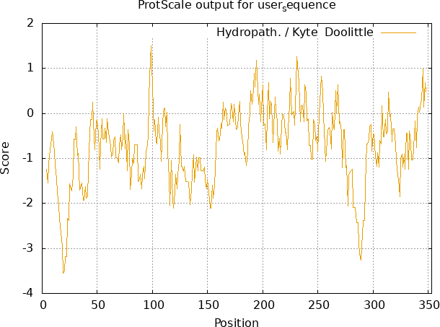

Fig. 1. Prediction of hydrophilicity and hydrophobicity of the SlMYB83 protein

Prediction of Signal Peptide and Transmembrane Domains in the SlMYB83 Protein
A signal peptide is a short peptide chain, typically 5 to 30 amino acids in length, that directs newly synthesized proteins to the secretory pathway and is usually located at the N-terminus of secreted proteins. Analysis of the SlMYB83 protein using SignalP-
5.0 revealed the absence of a signal peptide cleavage site, indicating that SlMYB83 does not contain a signal peptide (Fig. 2A).
The transmembrane domain structure of the SlMYB83 protein was further predicted using TMHMM-2.0 (Fig. 2B). The results showed that SlMYB83 contains no transmembrane domains, indicating that it is a non-secretory, non-transmembrane protein.

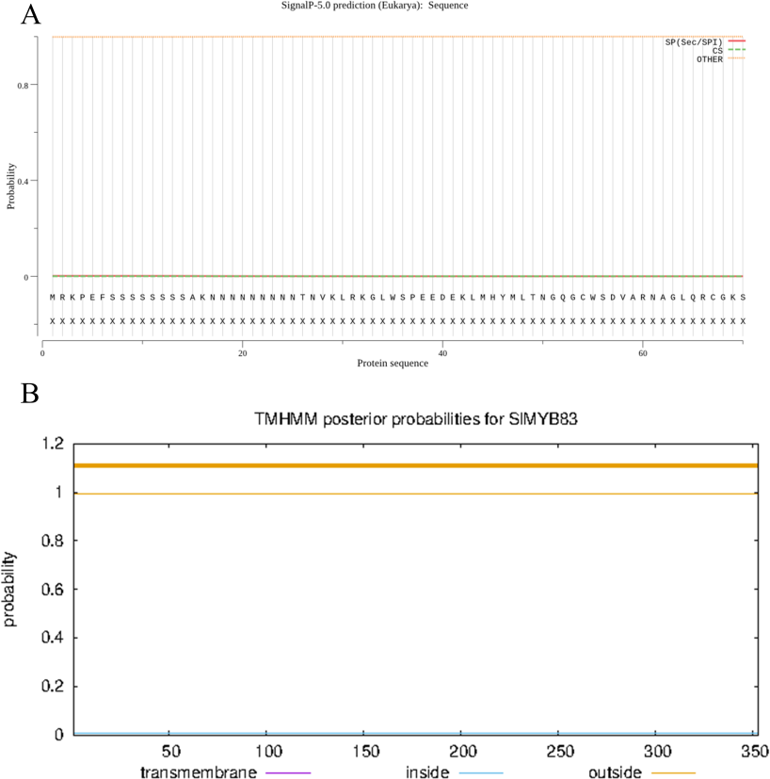

Fig. 2. Prediction of signal petides and transmembrane domains for SlMYB83 protein

Note: A, Prediction of the signal peptide of the SlMYB83 protein. B, Prediction of transmembrane domains in the SlMYB83 protein.

Prediction of Secondary and Tertiary Structures of the SlMYB83 Protein
The secondary structure of the SlMYB83 protein was predicted using SOPMA (Fig. 3A). The results showed that the secondary structure of this protein is primarily composed of α-helices, extended strands, β-turns, and random coils. Among these, random coils accounted for the highest proportion at 62.89%, corresponding to 222 amino acids, followed by α-helices at 24.65% (87 amino acids), extended strands at 7.37% (26 amino acids), and β-turns at 5.10% (18 amino acids). This suggests that SlMYB83 may exert its biological functions through random coil regions mediating interactions with target proteins.
The tertiary structure of the protein encoded by SlMYB83 was predicted using homology modeling via the SWISS-MODEL online server (Fig. 3B). The results showed that the protein typically exists as a monomer, with magnesium ions likely serving as its binding ligands. Tertiary structure modeling revealed that SlMYB83 shares 57.14% sequence identity with the Arabidopsis transcription factor WER, suggesting that it may function as an R2R3-MYB transcription factor involved in DNA recognition.

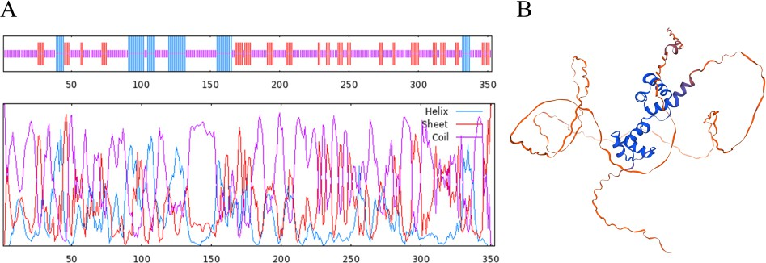

Fig. 3. Prediction of the secondary and tertiary structures of the SlMYB83 protein

Note: A, Prediction of the secondary structure of the SlMYB83 protein. B, Prediction of the tertiary structure of the SlMYB83 protein.

Prediction of Functional Domains and Subcellular Localization of the SlMYB83 Protein
Analysis of the SlMYB83 gene sequence was performed using the Phytozome online tool, revealing that the coding sequence (CDS) is 1,062 bp in length. The conserved domain of the gene was analyzed using the NCBI online tool, and the results showed that the SlMYB83 protein contains a SANT domain (PLN03091) and belongs to the cl33633 superfamily (Fig. 4A).
Subcellular localization was predicted using the Plant-mPLoc online tool. The results indicated that the SlMYB83 protein is localized to the nucleus (Fig. 4B), suggesting that this protein primarily functions in the nucleus, which is consistent with the previous finding that it lacks transmembrane domains.
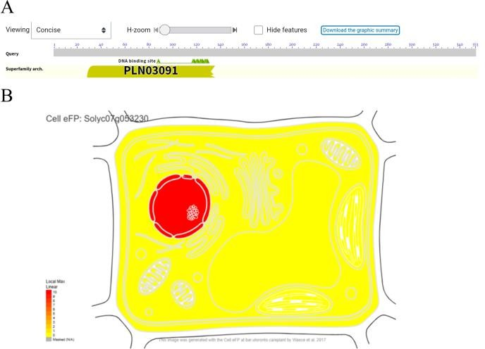
Fig. 4. Prediction of functional domains and subcellular localization of the SlMYB83 protein

Note: A, Prediction of functional domains in the SlMYB83 protein. B, Prediction of subcellular localization of the SlMYB83 protein.

Cis-Regulatory Element Analysis of the SlMYB83 Gene Promoter
The promoter sequence of the SlMYB83 gene was obtained by extracting the 2,000 bp region upstream of the transcription start site from the annotated tomato genome file. This sequence was then submitted to the PlantCARE database for analysis to identify cis-regulatory elements within the SlMYB83 promoter. The resulting data were subsequently imported into Tbtools II software for visualization and further analysis (Fig. 5). The results revealed the presence of multiple hormone-responsive and stress-responsive elements within the promoter sequence, including those involved in MeJA, abscisic acid (ABA), drought, promoter and enhancer regions, light response, anaerobic induction, and auxin-responsive element. These findings suggest that SlMYB83 may be involved in light regulation, stress responses, and crosstalk among multiple hormone signaling pathways.

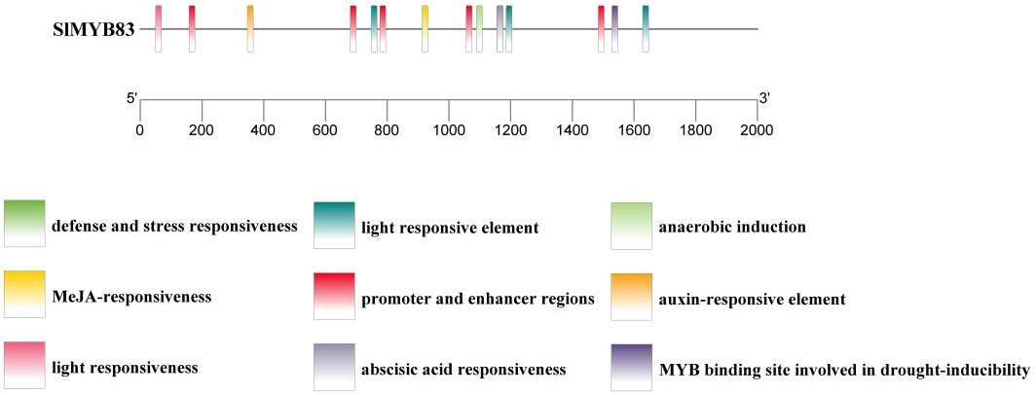
Fig. 5. Analysis of cis-acting elements in the SlMYB83 gene

Protein-Protein Interaction Network Analysis of SlMYB83
Protein-protein interaction network analysis was performed using STRING to identify proteins potentially interacting with SlMYB83 (Fig. 6). The results indicated that SlMYB83 may interact with proteins such as Phy7 and RPS25, suggesting a potential role in mediating temperature stress responses (Table 3).

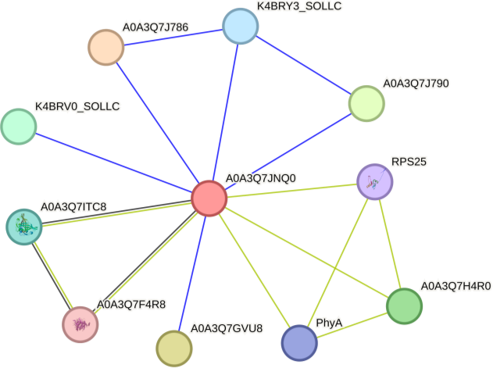
Fig. 6. Analysis of the protein-protein interaction network of the SlMYB83 protein Table 3. Predicted interacting proteins and their information

Name Interacting protein name Information on interacting proteins

SlMYB83 A0A3Q7J786 HTH myb-type domain-containing protein.
A0A3Q7GVU8 HTH myb-type domain-containing protein.
A0A3Q7J790 HTH myb-type domain-containing protein.
A0A3Q7H4R0 Uncharacterized protein.
K4BRV0_SOLLC HTH myb-type domain-containing protein.
A0A3Q7ITC8 NAC domain-containing protein.
K4BRY3_SOLLC HTH myb-type domain-containing protein.
Phytochrome; Regulatory photoreceptor which exists in two forms that are reversibly interconvertible by

PhyA

RPS25

A0A3Q7F4R8
light: the Pr form that absorbs maximally in the red region of the spectrum and the Pfr form that absorbs maximally in the far-red region.
40S ribosomal protein S25; Belongs to the eukaryotic ribosomal protein eS25 family.
Cellulose synthase; Belongs to the glycosyltransferase 2 family. Plant cellulose synthase subfamily.

Tissue-Specific Expression Analysis of SlMYB83
To determine the expression levels of SlMYB83 in different tomato tissues, RNA was extracted from root, stem, leaf, flower, and fruit tissues, followed by qRT-PCR analysis. The results showed that SlMYB83 transcript levels were highest in leaves, followed by flowers and roots, then stems, and lowest in fruits (Fig. 7).

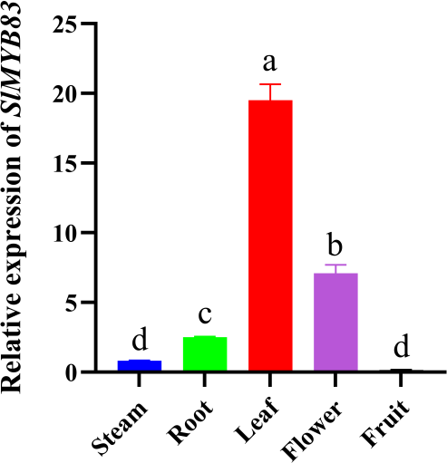

Fig. 7. Tissue specific expression analysis of SlMYB83

Note: Each bar represents the RNA content in different parts of the tomato, and the letters (a, b, c, d) indicate the statistical means of the groups based on Tukey's test (P < 0.05).

Regulatory Role of JA in SlMYB83 Expression
To investigate the regulatory relationship of JA on SlMYB83 expression, changes in SlMYB83 transcript levels were examined in the jasmonic acid-deficient mutant spr2 and in plants subjected to exogenous MeJA application. In the spr2 mutant, the expression level of SlMYB83 was significantly higher than that in the WT (Fig. 8A), suggesting that JA may negatively regulate SlMYB83 expression. To further validate this, we applied exogenous MeJA to WT plants. The results showed a highly significant decrease in SlMYB83 expression (Fig. 8B), further supporting the negative regulatory role of JA on SlMYB83.
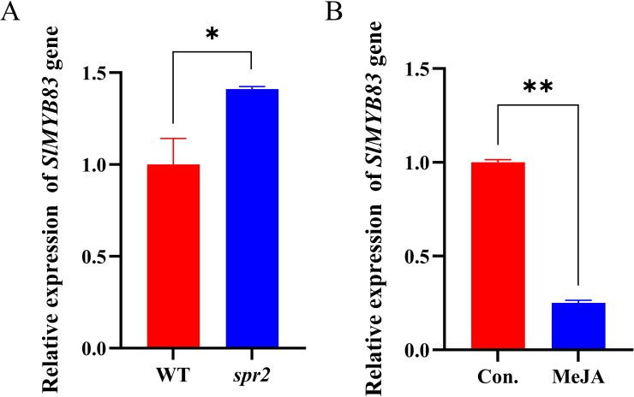

Fig. 8. Comparison of SlMYB83 expression in WT and spr2 and comparison of SlMYB83 expression levels in WT and exogenous sprayed MeJA plants

Note: A, Comparison of SlMYB83 expression in WT and spr2. B, Comparison of SlMYB83 expression levels in WT and exogenous sprayed MeJA plants. *indicate significant differences between WT and different plants. (*P＜ 0.05 and **P＜0.01).

DISCUSSION
The JA signaling pathway is closely associated with stress defense and resistance in plants (Xu et al., 2024), constituting a central pathway that integrates stress responses with the regulation of growth and development. MYB transcription factors enhance plant tolerance by regulating reactive oxygen species (ROS) metabolism and the JA signaling pathway (Wang et al., 2026). As pivotal downstream regulators of the JA signaling pathway, functional characterization of MYBs has become a major focus in plant molecular biology research. In this study, we performed systematic bioinformatics analysis and expression profiling of SlMYB83, which was identified through screening in wild-type tomato and the spr2 mutant, and characterized its jasmonic acid-responsive features, providing important theoretical value.
The structural features of transcription factors are often closely associated with their functions. SlMYB83 exhibits a typical MYB conserved domain, lacks signal peptide and transmembrane domains, and is a nuclear-localized hydrophilic protein, consistent with the typical characteristics of plant transcription factors (Cui & An, 2024). The secondary structure is primarily composed of random coils and α-helices, while the tertiary structure forms a conserved helix-turn-helix (HTH) motif, providing a structural basis for DNA binding and transcriptional regulatory function. Cis-regulatory element analysis of the promoter is a crucial approach for inferring gene regulatory mechanisms. The promoter region contains specific MeJA-responsive elements, indicating that SlMYB83 is regulated by JA signaling. Additionally, the presence of light-responsive, stress-responsive, and various hormone-related elements suggests that SlMYB83 may not only participate in JA-mediated defense responses but also play a role in orchestrating the balance between growth, development, and stress adaptation. Protein-protein interaction network analysis further indicated that SlMYB83 may interact with proteins such as Phy7 and RPS25 and participate in temperature stress responses, suggesting that it likely occupies a key node in the hormone regulation and defense response network of tomato. Tissue-specific expression analysis revealed that SlMYB83 is highly expressed in leaves, which are primary organs for stress perception and JA synthesis in plants. Consistent with this, it has been reported that MaMYBR30 in mulberry is also expressed in leaves and can be induced by drought stress and salt stress (Liu et al., 2024). It is therefore speculated that SlMYB83 primarily functions in leaves to participate in JA-mediated stress responses, such as disease resistance and drought tolerance. Its constitutive expression pattern

suggests that SlMYB83 is not only involved in stress responses but may also regulate the growth and development processes of tomato roots, stems, flowers, and fruits, indicating functional diversity.
Notably, SlMYB83 was significantly upregulated in the spr2 mutant but markedly downregulated following exogenous MeJA treatment, suggesting a potential negative correlation between its expression and jasmonic acid signaling. In the spr2 mutant, which exhibits reduced endogenous JA content, SlMYB83 expression is elevated, suggesting that JA may exert a repressive effect on SlMYB83 under normal conditions. Following exogenous application of MeJA, SlMYB83 expression was significantly downregulated, further validating this negative regulatory relationship. This observation suggests that SlMYB83 may act as a negative feedback-responsive gene in the JA signaling pathway, or alternatively, that it is derepressed under JA-deficient conditions to participate in compensatory transcriptional regulation.

CONCLUSIONS
Bioinformatics analysis of the SlMYB83 gene revealed that SlMYB83 lacks a signal peptide and transmembrane domains, with subcellular localization predicted to be in the nucleus. Its conserved domain is limited to the SANT domain PLN03091, and random coils constitute the largest proportion of its secondary structure. Three-dimensional structural modeling predicted 57.14% sequence similarity with the Arabidopsis transcription factor WER, confirming its role as an R2R3-MYB transcription factor involved in DNA recognition. Additionally, multiple stress-responsive elements, including MeJA, drought and ABA, were identified in its promoter sequence. qRT-PCR analysis revealed that SlMYB83 exhibited the highest expression level in leaves and the lowest in fruits. In the spr2 mutant, SlMYB83 expression was significantly higher than that in the WT, whereas upon exogenous application of MeJA to WT plants, SlMYB83 expression was markedly decreased, suggesting that JA plays a negative regulatory role in suppressing SlMYB83 expression.

DISCLAIMER (ARTIFICIAL INTELLIGENCE)
All authors have declared that no competing interests exist, and that no artificial intelligence (AI) technologies were used in the process of writing this paper.

COMPETING INTERESTS
Authors have declared that no competing interests exist.

REFERENCES
Chen, L., Zhang, Y., Bu, Y., et al. (2024). Imaging the spatial distribution of structurally diverse plant hormones. Journal of Experimental Botany, 75(22), 6980–6997.
Chen, S., Ma, F., Chen, J., et al. (2025). Function of R2R3-Type myeloblastosis transcription factors in plants. Rice Science, 32(3), 307–321.
Cui, R., An, X. (2024). Research progress of MYB transcription factor family in plant stress resistance. Notulae Botanicae Horti Agrobotanici Cluj-Napoca, 52(1), 13491.
Demiwal, P., Nabi, S. U., Mir, J. I., et al. (2024). Methyl jasmonate improves resistance in scab-susceptible Red Delicious apple by altering ROS homeostasis and enhancing phenylpropanoid biosynthesis. Plant Physiology and Biochemistry, 207, 108371.
Dougherty, K., Prashar, T., Hudak, K. A. (2024). Improved pokeweed genome assembly and early gene expression changes in response to jasmonic acid. BMC Plant Biology, 24(1), 801.
Li, X., Wang, Z., Sun, S., et al. (2024). IbNIEL-mediated degradation of IbNAC087 regulates jasmonic acid-dependent salt and drought tolerance in sweet potato. Journal of Integrative Plant Biology, 66(2), 176–195.
Li, Y., Zhu, J., Lv, R., et al. (2026). Functional analysis of SlCDPK12 and its interacting protein SlACS11 in the regulation of tomato resistance to Phytophthora infestans. Journal of Plant Physiology, 317, 154689.
Liu, H., Timko, M. P. (2021). Jasmonic acid signaling and molecular crosstalk with other phytohormones. International Journal of Molecular Sciences, 22(6), 2914.
Liu, L., Li, S., Tang, F., et al. (2024). MAMYBR30, a novel 1R-MYB, plays important roles in plant development and abiotic stress resistance. Plants, 13(13), 1794.
Lu, M., He, Q., Wang, G., et al. (2025). JA-responsive R2R3-type MYB transcription factor OsMYB4P confers broad-spectrum antiviral immunity in rice. Plant Biotechnology Journal, 23(10), 4602–4617.
Luo, L., Wang, Y., Qiu, L., et al. (2023). MYC2: a master switch for plant physiological processes and specialized metabolite synthesis. International Journal of Molecular Sciences, 24(4), 3511.
Sánchez-Reyna, A., González-García, Y., Alpuche-Solís, Á. G., et al. (2025). Synergistic effect of zinc oxide, magnesium oxide and graphene nanomaterials on Fusarium oxysporum-inoculated tomato plants. Phyton, 94(7), 2097–2116.
Shang, J., Li, F., Kong, X., et al. (2025). Bioinformatics analysis of the tomato (Solanum lycopersicum) methylesterase gene family. BMC Plant Biology, 25(1), 649.
Sonatan, S. D., Paul, J. K., Azmal, M., et al. (2026). The role of jasmonic acid and

methyl jasmonate in enhancing photosynthesis and stress response. Journal of Plant Physiology, 318, 154725.
Vrobel, O., Zeljković, S. Ć., Dehner, J., et al. (2024). Multi-class plant hormone HILIC-MS/MS analysis coupled with high-throughput phenotyping to investigate plant–environment interactions. The Plant Journal, 120(2), 818–832.
Wang, T., Zhang, X. (2021). Genome-wide dynamic network analysis reveals the potential genes for MeJA-induced growth-to-defense transition. BMC Plant Biology, 21(1), 450.
Wang, X., Jiang, H., Yang, X., et al. (2025). Dual MYB regulation of jasmonate and phenylpropanoid pathways enhances methyl jasmonate-induced defense in postharvest Agaricus bisporus. Postharvest Biology and Technology, 231, 113949. Wang, X., Liu, H., Wei, H., et al. (2026). Potato transcription factor StMYB19 enhances drought tolerance by regulating ROS homeostasis and JA signalling pathway.
Plant Science, 364, 113006.
Wasternack, C., Hause, B. (2024). BFP1: One of 700 Arabidopsis F-box proteins mediates degradation of JA oxidases to promote plant immunity. Molecular Plant, 17(3), 375–376.
Xu, X., Wen, T., Ren, A., et al. (2024). Gossypium arboretum PPD2 facilitates root architecture development to increase plant resilience to salt stress. Physiologia Plantarum, 176(4), e14473.
Zhang, N., Zhang, H., Bai, B., et al. (2025). Jasmonic acid activates transcription factor SLMYB13 to enhance cold resistance in tomato. Plant Cell & Environment, 48(10), 7332–7347.
Zhang, Y., Xia, P. (2023). The DREB transcription factor, a biomacromolecule, responds to abiotic stress by regulating the expression of stress-related genes. International Journal of Biological Macromolecules, 243, 125231.
Zhao, S., Ma, Q., Xu, X., et al. (2016). Tomato jasmonic acid-deficient mutant spr2 seedling response to cadmium stress. Journal of Plant Growth Regulation, 35(3), 603–610.

