Review article
Spirulina: The Future Superfood and Its Production

Abstract
Spirulina, a filamentous photosynthetic cyanobacterium belonging to the genus Arthrospira, gained global recognition as a sustainable and nutrient-dense food resource. In the context of escalating food insecurity, climate variability, and resource limitations, spirulina presents a viable alternative to conventional protein sources. This review critically examines the nutritional composition, therapeutic potential, cultivation technologies, industrial applications, environmental sustainability, and future prospects of spirulina. Rich in proteins (60–70%), essential amino acids, vitamins, minerals, and bioactive compounds such as phycocyanin, spirulina demonstrates antioxidant, anti-inflammatory, immunomodulatory, and hypolipidemic properties. Cultivation systems, including open raceway ponds and closed photobioreactors, are evaluated in terms of efficiency, scalability, and economic feasibility. Furthermore, the integration of spirulina into functional foods, pharmaceuticals, aquaculture, and cosmetic industries is discussed. Despite its advantages, challenges such as contamination risks, high production costs, and regulatory constraints persist. The paper concludes by emphasizing spirulina’s pivotal role in achieving sustainable development goals (SDGs), particularly in nutrition security and environmental conservation.
Keywords
Spirulina; Arthrospira; superfood; microalgae; sustainable nutrition; functional foods; food security
1. Introduction
The global demand for food is projected to rise significantly due to population growth, urbanization and changing dietary patterns. Traditional agriculture faces constraints such as land degradation, water scarcity, and greenhouse gas emissions, necessitating alternative food sources with high efficiency and low environmental impact. Microalgae have emerged as promising candidates in this regard due to their rapid growth rates, high photosynthetic efficiency and minimal resource requirements (Becker, 2007). Among these, spirulina (Arthrospira platensis and A. maxima) has received considerable attention owing to its exceptional nutritional profile and ease of cultivation (Saranraj and Sivasakthi, 2014).
Spirulina, scientifically known as Arthrospira platensis, is an edible blue green micro alga (Ciferri, 1983). It is a filamentous, photosynthetic, spiral-shaped, multicellular and cyanobacterium that has gained global attention as a sustainable and nutrient-dense food source (Ali and Saleh, 2012). It was first discovered by Hernando Cortez (Spanish Scientist) and Conquistadors in 1519. During visit by Cortez in Lake Texcoco in valley of Mexico, he observed spirulina was eaten at the tables of the Aztecs (Ugwu et al., 2008).
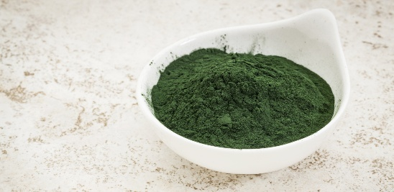
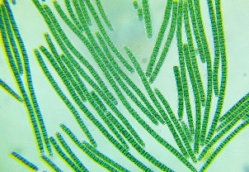
It is widely cultivated across the world and is considered one of the most promising alternative protein sources to address food security challenges. Recent estimates indicate that global spirulina production has reached tens of thousands of tonnes annually, with continuous growth driven by increasing demand for functional foods and nutraceuticals (Cai et al., 2021; Vieira et al., 2025). Moreover, the global spirulina market is projected to exceed USD 1 billion by 2030, reflecting its expanding commercial significance (Musa et al., 2025; Vala et al., 2025).
Plate 1. Spirulina microscopic view (a) and powder form (b).
Source: Science Learning Hub- The University of Waikato Te Whare Wānanga o Waikato, www.sciencelearn.org.nz
Biologically, spirulina belongs to cyanobacteria and performs oxygenic photosynthesis similar to higher plants. Its ability to grow rapidly, utilize carbon dioxide efficiently, and thrive in alkaline conditions makes it highly suitable for mass cultivation. Furthermore, spirulina cultivation has a low environmental footprint, requiring less land and water compared to conventional crops, while also contributing to carbon sequestration (Chang et al., 2023; Bhalamurugan et al., 2018). These attributes make spirulina an important component of sustainable agriculture and future food systems.
Historically, spirulina was consumed by ancient civilizations such as the Aztecs and indigenous communities around Lake Chad, where it was harvested and incorporated into traditional diets (Habib et al., 2008). In recent decades, it has been commercialized globally as a dietary supplement and functional food ingredient. The recognition of spirulina by international organizations such as the FAO and WHO underscores its potential in combating malnutrition and promoting health (FAO, 2020; WHO, 2021).
This review synthesizes current knowledge on spirulina, focusing on its biochemical composition, health benefits, cultivation methods, industrial applications and future potential. The objective is to provide a comprehensive scientific basis for its designation as a “super future food”.
2. Life cycle of Spirulina
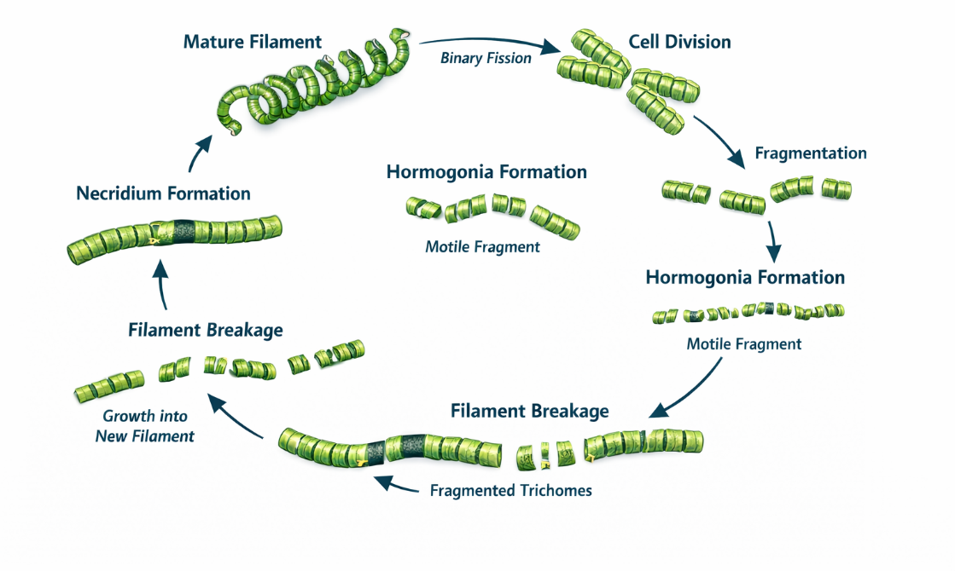
Spirulina is a photosynthetic cyanobacterium exhibiting a relatively simple yet highly efficient life cycle adapted to extreme alkaline environments (Ciferri, 1983; Vonshak, 1997). Morphologically, it consists of multicellular, helically coiled trichomes that proliferate through vegetative mechanisms, primarily binary fission of cells within filaments and fragmentation into motile hormogonia, which subsequently elongate into mature trichomes (Tomaselli, 1997; Richmond, 2004). The formation of necridia (specialized dead cells) facilitates filament breakage and dispersal, representing a key reproductive adaptation in the absence of sexual reproduction (Furmaniak et al., 2017; Lee et al., 2021). Physiologically, Arthrospira demonstrates remarkable metabolic flexibility, functioning predominantly as a photoautotroph while also capable of mixotrophic and heterotrophic growth under specific environmental conditions (Park et al., 2022). Optimal growth typically occurs in highly alkaline waters (pH 8.5–10.5) and elevated temperatures (30–35 °C), conditions that limit biological competition and favor large-scale biomass accumulation (Vonshak, 1997; Belay, 2002). At the cellular level, Spirulina is rich in photosynthetic pigments such as chlorophyll-a and phycobiliproteins (notably phycocyanin), supporting efficient light harvesting and high primary productivity (Richmond, 2004). Its ecological success in soda lakes and artificial cultivation systems is further linked to its tolerance of high carbonate concentrations and intense irradiance (Furmaniak et al., 2017). Collectively, the biology and life cycle of Spirulina reflect a streamlined, asexual propagation strategy coupled with physiological adaptations that underpin its ecological dominance and biotechnological significance (Ciferri, 1983; Park et al., 2022).
Figure 1. Life cycle of Spirulina.
Source: Author-generated using ChatGPT (OpenAI, 2026).
3. Growth factors affecting Spirulina
The growth of Spirulina (Arthrospira spp.) is regulated by a complex interplay of environmental and nutritional factors that collectively determine biomass productivity, physiological performance, and biochemical composition. Light intensity and photoperiod are key determinants of photosynthetic efficiency, with optimal growth typically observed under moderate to high irradiance, whereas excessive light exposure can result in photoinhibition and the generation of reactive oxygen species (Lafarga et al., 2020; Choi et al., 2023). Temperature exerts a strong influence on enzymatic activity and cellular metabolism, with the optimal range generally between 30–35 °C; deviations from this range can significantly reduce growth rates and alter pigment synthesis (Kumar et al., 2021; Singh and Singh, 2022). The alkaline pH conditions (8.5–10.5) characteristic of Spirulina habitats enhance bicarbonate availability for carbon fixation while limiting contamination by other microorganisms, thereby promoting stable cultivation (Markou et al., 2020; Choi et al., 2023).
Nutrient availability, particularly nitrogen, phosphorus, and inorganic carbon, plays a central role in regulating growth kinetics and metabolite accumulation; for example, nitrogen limitation can reduce protein content while enhancing the accumulation of certain secondary metabolites (Kumar et al., 2021; Aouir et al., 2022). Micronutrients such as iron, magnesium, and trace elements are essential for chlorophyll synthesis, electron transport, and enzymatic functions, directly affecting photosynthetic performance and biomass yield (Lafarga et al., 2020; El-Sheekh et al., 2021). Salinity and dissolved oxygen also influence growth dynamics, as Arthrospira exhibits moderate halotolerance but may experience osmotic and oxidative stress under extreme conditions (Choi et al., 2023; Aouir et al., 2022). Additionally, mixing and aeration are critical in large-scale cultivation systems, as they enhance light distribution, improve gas exchange, and prevent cell sedimentation (Markou et al., 2020; El-Sheekh et al., 2021). Recent studies further demonstrate that mixotrophic cultivation strategies, involving the supplementation of organic carbon sources, can significantly enhance biomass productivity compared to purely autotrophic conditions (Singh and Singh, 2022; Kumar et al., 2021). Overall, optimization of these interacting factors is essential for maximizing Spirulina growth and tailoring its biochemical composition for diverse industrial and biotechnological applications (Lafarga et al., 2020; Choi et al., 2023).
4. Nutritional Composition of Spirulina
Spirulina is widely regarded as one of the most nutrient-dense foods known, owing to its rich composition of macronutrients and micronutrients. The protein content of spirulina ranges between 60–70% of its dry weight, making it superior to conventional plant-based protein sources such as soybean and lentils (Soni et al., 2017). The protein is highly digestible due to the absence of cellulose in its cell wall, enhancing its bioavailability (Table 1).
In addition to proteins, spirulina contains essential amino acids, although sulfur-containing amino acids such as methionine and cysteine are present in lower quantities (Khan et al., 2005). It is also a rich source of vitamins, including B-complex vitamins (B1, B2, B3), vitamin E, and pro-vitamin A in the form of beta-carotene. The mineral content includes iron, calcium, magnesium, potassium and zinc, which are essential for various physiological functions.
A unique feature of spirulina is its abundance of bioactive compounds such as phycocyanin, chlorophyll, carotenoids, and phenolic compounds. These compounds contribute to its antioxidant and therapeutic properties (Wu et al., 2016). The presence of essential fatty acids, particularly gamma-linolenic acid (GLA), further enhances its nutritional value. Overall, spirulina’s comprehensive nutrient profile makes it an ideal candidate for addressing nutritional deficiencies and enhancing human health.
Table 1. Comparative Nutritional Composition of Spirulina and Common Food Sources (per 100 g dry weight basis).
Nutrient Component | Spirulina | Soybean | Milk Powder | Egg (Whole, dried) | Wheat Flour
Protein (%) | 60–70 | 36–40 | 26 | 48 | 10–13
Carbohydrates (%) | 15–20 | 30 | 38 | 3–5 | 70–75
Lipids (%) | 5–8 | 18–20 | 27 | 40 | 1–2
Energy (kcal) | ~290–320 | ~450 | ~496 | ~540 | ~340
Iron (mg) | 28–50 | 15 | 0.5 | 7 | 3–4
Calcium (mg) | 120–180 | 200 | 912 | 250 | 15–30
Beta-carotene (mg) | 150–300 | Negligible | Low | Low | Negligible
Vitamin B12 (µg) | 2–3* | Absent | Present (low) | Moderate | Absent
Essential Fatty Acids | Present (GLA) | Present | Limited | Present | Minimal
Digestibility (%) | 85–95 | ~85 | ~95 | ~97 | ~75
*Note: Bioavailability of vitamin B12 in spirulina is debated.
[Source: Becker. (2007); Soni et al. (2017); Habib et al. (2008)]
From a nutritional standpoint, spirulina is exceptionally rich in protein, contributing over 60% of its dry weight, along with a balanced profile of essential amino acids (Lestingi et al., 2024; Fattah et al., 2020). In addition to protein, it contains carbohydrates (15–20%), lipids (6–14%), vitamins (B-complex and K), and minerals such as iron, calcium, and magnesium (Spínola et al., 2024). Spirulina is also a rich source of bioactive compounds like phycocyanin, carotenoids, and polyunsaturated fatty acids, which contribute to its antioxidant, anti-inflammatory, and immunomodulatory properties (Chang et al., 2023; Lestingi et al., 2024). These nutrients make spirulina highly beneficial for improving overall health and immunity.
5. Health Benefits of Spirulina
Spirulina has been extensively studied for its wide range of health-promoting properties, attributed primarily to its bioactive compounds. One of the most significant benefits is its antioxidant activity, largely due to the presence of phycocyanin, which scavenges free radicals and reduces oxidative stress (Wu et al., 2016). This property plays a crucial role in preventing chronic diseases such as cancer, cardiovascular disorders and neurodegenerative conditions.
Spirulina also exhibits potent anti-inflammatory effects by inhibiting the production of pro-inflammatory cytokines. Its immunomodulatory properties enhance the activity of macrophages, natural killer cells and antibodies, thereby strengthening the immune system (Khan et al., 2005). Additionally, spirulina has been shown to improve lipid profiles by reducing total cholesterol, low-density lipoprotein (LDL), and triglycerides while increasing high-density lipoprotein (HDL), contributing to cardiovascular health.
In the context of metabolic disorders, spirulina demonstrates antidiabetic effects by improving insulin sensitivity and regulating blood glucose levels. It is also widely used in combating malnutrition, particularly in developing countries, due to its high nutrient density and ease of supplementation (Habib et al., 2008). Furthermore, studies indicate its potential in detoxification, antimicrobial activity and even anticancer properties. These multifaceted health benefits position spirulina as a functional food with therapeutic potential.
6. Cultivation and Production Techniques
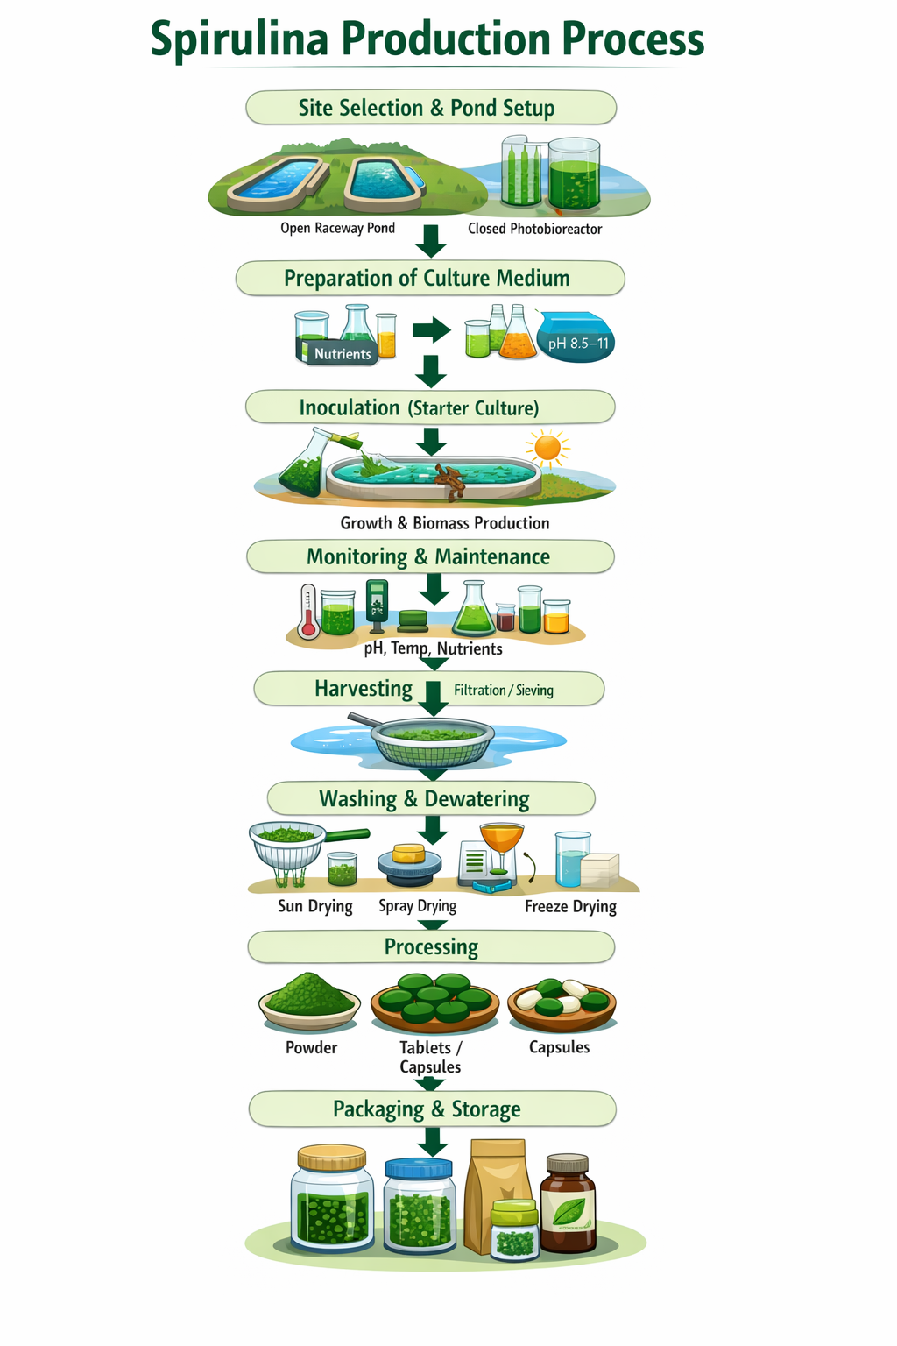
The production of spirulina is relatively simple and can be carried out in controlled conditions. The large-scale production of spirulina is primarily achieved through two cultivation systems: open raceway ponds and closed photobioreactors. Open pond systems are widely used due to their low capital and operational costs. These systems utilize natural sunlight and are suitable for regions with warm climates. However, they are susceptible to contamination, evaporation losses and environmental fluctuations, which can affect productivity and quality (Soni et al., 2017).
Closed photobioreactors, on the other hand, offer a controlled environment with optimized parameters such as light intensity, temperature, pH and nutrient supply. These systems reduce contamination risks and enhance biomass productivity, albeit at higher costs. Advances in photobioreactor design, including tubular and flat-panel systems, have improved efficiency and scalability (Guldhe et al., 2017).
6.1. Site Selection and Infrastructure: Spirulina production begins with selecting a location that provides abundant sunlight, warm temperature (30–35°C), and clean water supply. Open raceway ponds are commonly used due to their low cost and simplicity, while closed photobioreactors are preferred for controlled, contamination-free production. Proper pond design (shallow depth of 20-30 cm) ensures efficient light penetration and mixing.
Figure 2. Spirulina production process. Source: Author-generated using ChatGPT (OpenAI, 2026).
6.2️. Preparation of Culture Medium: A nutrient-rich alkaline medium is prepared to support spirulina growth. The medium typically contains sodium bicarbonate (carbon source), nitrogen (urea or nitrates), phosphates and trace elements such as iron and magnesium. The pH maintained between 8.5 and 11, favors spirulina growth and suppresses contaminating organisms. Balanced nutrient composition is essential for maximizing biomass yield and quality.
6.3️. Inoculation: A healthy starter culture of spirulina introduced into the prepared medium. The inoculum density (typically 10–20% of culture volume) must be sufficient to ensure rapid establishment. Under optimal conditions, spirulina begins multiplying through photosynthesis.
6.4️. Growth and Biomass Production: Continuous mixing using paddle wheels ensures uniform distribution of light and nutrients and prevents sedimentation. Biomass productivity depends on environmental conditions and process control.
6.5️. Monitoring and Maintenance: Regular monitoring of pH, temperature, nutrient levels and contamination is essential. Deviations from optimal conditions can reduce growth or lead to contamination by unwanted algae or microorganisms.
6.6️. Harvesting: Spirulina is harvested when the culture reaches high biomass density (dark green colour). Due to its filamentous nature, it can be easily separated using filtration or fine mesh screens.
6.7️. Washing and Dewatering: The harvested biomass is washed thoroughly with clean water to remove residual salts and impurities. Dewatering through filtration or pressing to obtain a thick paste.
6.8️. Drying: Drying is a crucial step to enhance shelf life. Methods include:
- Sun drying (lab trays, low cost, may reduce nutrient quality)
- Spray drying (industrial scale, better retention of quality)
- Freeze drying (highest quality, expensive)
- Hot air oven (low temperature ~40–50°C)
Drying reduces moisture content to safe levels, ensuring stability and preventing microbial growth.
6.9️. Processing: The dried biomass is processed into various commercial forms such as powder, tablets, capsules, and extracts (AlFadhly et al., 2022).
6.10. Packaging and Storage: The final product is packed in airtight, moisture-proof containers. Proper storage under cool and dry conditions helps maintain product quality.
7. Importance of Spirulina:
7.1. Nutritional Significance: Spirulina, recognized as one of the most nutrient-dense microbial biomasses, contains approximately 60-70 % protein (dry weight basis) with a well-balanced essential amino acid profile, making it comparable to conventional protein sources such as soybean and superior to many plant proteins (Becker, 2013; Soni et al., 2017). In addition to protein, spirulina contains 15-20 % carbohydrates and 6–14% lipids, along with essential micronutrients such as iron, calcium, magnesium, and potassium (Spínola et al., 2024). Its iron content is highly bioavailable, making it particularly effective in addressing iron-deficiency anemia (Habib et al., 2008).
7.2. Bioactive Compounds and Therapeutic Potential: Spirulina is a rich source of biologically active compounds, including phycocyanin, β-carotene, phenolic compounds, and γ-linolenic acid. Phycocyanin, which constitutes up to 20 % of total protein, has been reported to exhibit strong antioxidant and anti-inflammatory activities by scavenging reactive oxygen species (Chang et al., 2023). Clinical and experimental studies indicate that spirulina supplementation can significantly reduce serum cholesterol, triglycerides, and oxidative stress markers, thereby lowering the risk of cardiovascular diseases (Fattah et al., 2020). Furthermore, its immunomodulatory effects enhance macrophage activity and antibody production, contributing to improved immune response (Lestingi et al., 2024). Its consumption appears to promote the growth of intestinal micro flora as well (Kulshreshtha et al., 2008).
7.3. Functional Food and Nutraceutical Applications: Due to its high nutrient density and bioactive profile, spirulina is extensively used in the formulation of functional foods, dietary supplements and pharmaceutical products. Its incorporation into food systems enhances protein content and provides natural pigments, particularly phycocyanin, which is used as a natural blue colorant. Spirulina has also been shown to improve digestibility and nutrient bioavailability, as its cell wall lacks cellulose, unlike many plant-based sources (Soni et al., 2017). Studies have demonstrated its application in bakery, dairy, and beverage products, where it significantly enhances nutritional quality without compromising sensory attributes (AlFadhly et al., 2022).
7.4. Role in Animal and Aquaculture Nutrition: Spirulina is widely used as a feed supplement in poultry, livestock, and aquaculture systems. Inclusion of spirulina in feed has been reported to improve growth performance, feed conversion ratio and immune status in animals (Rana et al., 2024). In aquaculture, spirulina enhances pigmentation, survival rate and disease resistance in fish and shrimp. Studies indicate that supplementation levels of 5–10 % in feed can significantly improve productivity and product quality, making it a valuable component in sustainable animal production systems.
7.5. Environmental Sustainability and Carbon Sequestration: Spirulina cultivation is highly sustainable due to its efficient resource utilization. It requires significantly less land and water compared to conventional crops and can be cultivated in non-arable or saline environments (Bhalamurugan et al., 2018). Spirulina exhibits high photosynthetic efficiency and can fix substantial amounts of carbon dioxide, contributing to carbon sequestration and climate change mitigation. Additionally, it can be integrated with wastewater treatment systems to recover nutrients such as nitrogen and phosphorus, thereby supporting circular bio-economy models (Cai et al., 2021).
7.6. Economic and Industrial Importance: Spirulina represents a high-value product with expanding demand in global markets. The spirulina industry is projected to grow significantly, with market value expected to exceed USD 1 billion by 2030 (Musa et al., 2025; Vala et al., 2025). Its production offers viable opportunities for small-scale enterprises, rural entrepreneurship, and commercial ventures, owing to its short production cycle and high biomass productivity. Moreover, its diverse applications in food, feed, cosmetics, and pharmaceuticals enhance its industrial relevance.
8. Commercial Products of Spirulina
Spirulina (Arthrospira spp.) has emerged as a highly versatile commercial microalga, with applications spanning the food, nutraceutical, pharmaceutical, cosmetic, and feed industries. The most dominant products in the global market are dietary supplements in the form of powders, tablets, capsules, and flakes, owing to their high protein content (60–70%) and rich nutritional profile (Lafarga et al., 2020; Luo et al., 2024). In the food industry, Spirulina is increasingly incorporated as a functional ingredient in products such as pasta, bakery items, beverages, energy bars, and dairy alternatives, enhancing both nutritional value and natural coloration (Wu et al., 2023; Luo et al., 2024). One of the most commercially valuable derivatives is phycocyanin, a natural blue pigment widely used as a food colorant and antioxidant in beverages, confectionery, and cosmetics (Choi et al., 2023; Lafarga et al., 2020). Additionally, Spirulina is utilized in aquaculture and livestock feed as a protein supplement and growth enhancer, improving feed efficiency and immune responses in animals (Kavitha et al., 2021). The cosmetic industry also exploits Spirulina extracts for their antioxidant, anti-aging, and skin-rejuvenating properties, further expanding its commercial scope (Wu et al., 2023). Overall, the diversification of Spirulina-based products is driven by increasing consumer demand for natural, sustainable, and health-promoting ingredients (Lafarga et al., 2020; Luo et al., 2024).
9. Market Trends and Global Demand
The global market for Spirulina has witnessed substantial growth in recent years, driven by rising awareness of plant-based nutrition and sustainable food sources. The increasing demand for functional foods, dietary supplements, and natural pigments has positioned Spirulina as a key commodity in the microalgae industry (Lafarga et al., 2020; Wu et al., 2023). Market analyses indicate steady expansion, supported by trends such as veganism, clean-label products, and the replacement of synthetic additives with natural alternatives (DataM Intelligence, 2025). Furthermore, the growing application of Spirulina in pharmaceuticals and nutraceuticals, particularly for its antioxidant, anti-inflammatory, and immunomodulatory properties, is contributing to market growth (Choi et al., 2023; Luo et al., 2024). Emerging economies are also playing a significant role in market expansion due to increased production capacity and lower labor costs (Kavitha et al., 2021).
10. Economic Analysis of Spirulina Production
Despite its strong commercial potential, the economic feasibility of Spirulina production is influenced by several cost-intensive factors across the production chain. Cultivation systems, particularly open raceway ponds and closed photobioreactors, require substantial capital investment, with infrastructure and land costs forming a significant portion of initial expenditure (Costa et al., 2019). Operational costs, including nutrients, energy, labor, and water management, contribute heavily to overall production expenses, with nutrient inputs alone accounting for approximately 15–25% of total costs (Madkour et al., 2012; Kavitha et al., 2021). Harvesting and downstream processing, especially drying and extraction of high-value compounds like phycocyanin, are energy-intensive and further increase production costs (Lafarga et al., 2020; Choi et al., 2023). Additionally, factors such as contamination risks, climate dependency, and yield variability can affect economic stability and scalability (Costa et al., 2019).
11. Techno-Economic Feasibility
Recent techno-economic analyses suggest that optimizing cultivation systems and integrating advanced technologies can significantly improve the profitability of Spirulina production. The use of photobioreactors, improved strain selection, and process optimization strategies such as nutrient recycling and wastewater utilization can reduce operational costs and enhance productivity (Rahmann et al., 2021; Choi et al., 2023). Moreover, the adoption of mixotrophic cultivation and biorefinery approaches, where multiple high-value products are extracted from the same biomass, offers promising avenues for economic sustainability (Luo et al., 2024; Wu et al., 2023). Under optimized conditions, production systems can achieve favorable economic returns with moderate payback periods, making Spirulina a viable component of the circular bioeconomy (Rahmann et al., 2021). Overall, continued technological advancements, cost reduction strategies, and expanding market demand are expected to strengthen the commercial viability of Spirulina in the coming years (Lafarga et al., 2020; DataM Intelligence, 2025).
12. Challenges and Limitations
The large-scale adoption of spirulina as a mainstream food source is constrained by multiple technical, economic, and socio-regulatory challenges. One of the primary limitations is the relatively high production cost associated with controlled cultivation systems such as photobioreactors, which require significant capital investment, energy input, and skilled operation (Soni et al., 2017; Guldhe et al., 2017). Although open raceway ponds are more economical, they are highly vulnerable to contamination by unwanted microorganisms, including toxic cyanobacteria, which can compromise product safety and quality (Richmond, 2004; Borowitzka, 2005).
Another critical challenge is maintaining consistency in biomass composition. Variability in environmental conditions such as light intensity, temperature and nutrient availability can lead to fluctuations in protein, pigment, and micronutrient content, thereby affecting standardization (Becker, 2007). Maintaining optimal conditions is challenging in large-scale systems, particularly in outdoor cultivation, where fluctuations can lead to reduced productivity and metabolic instability (Jiménez et al., 2003; Chojnacka et al., 2004). Additionally, post-harvest processing methods, particularly drying techniques, may degrade heat-sensitive nutrients like vitamins and bioactive compounds.
Food safety concerns also persist due to the potential accumulation of heavy metals, microcystins, or other contaminants when cultivation conditions are not adequately controlled (Khan et al., 2005; Grosshagauer et al., 2020). From a nutritional perspective, spirulina lacks sufficient levels of sulfur-containing amino acids such as methionine and cysteine, limiting its use as a sole protein source.
Economic feasibility remains a major limitation in Spirulina production, primarily due to high operational costs associated with nutrients, energy, and infrastructure. Culture media, particularly those based on Zarrouk’s formulation, are expensive and contribute significantly to overall production costs (Raoof et al., 2006; Becker, 2007). Energy requirements for mixing, aeration, and drying further increase operational expenses, limiting large-scale profitability (Ugwu et al., 2008). Additionally, variability in biomass yield due to environmental factors can affect economic stability and scalability (Jiménez et al., 2003).
Furthermore, consumer acceptance remains a barrier due to its distinct color, taste, and perception as an algal product. Regulatory inconsistencies across countries also hinder commercialization and global trade (FAO, 2020). Collectively, these challenges highlight the need for technological innovation, strict quality control and policy harmonization.
13. Future Prospects
The future of spirulina as a sustainable and functional food is highly promising, driven by advancements in biotechnology, increasing consumer awareness, and the global shift toward alternative protein sources. Innovations in genetic engineering and metabolic pathway optimization are expected to enhance spirulina’s productivity, nutrient profile, and resilience to environmental stress conditions (Caporgno and Mathys, 2018). Such developments may enable the production of tailored spirulina strains enriched with specific bioactive compounds for targeted nutritional and therapeutic applications.
Emerging technologies such as photobioreactor optimization, automation and artificial intelligence-based monitoring systems are likely to improve cultivation efficiency and reduce production costs (Guldhe et al., 2017). Additionally, integration of spirulina production with circular bioeconomy models, including wastewater treatment and carbon capture systems, can further enhance its environmental sustainability.
Spirulina is also gaining attention in novel food applications, including plant-based meat alternatives, functional beverages and nutraceuticals, thereby expanding its market potential (Lafarga, 2019). Its role in personalized nutrition and biofortification strategies is particularly significant in addressing micronutrient deficiencies in vulnerable populations.
Moreover, spirulina has been identified as a potential food source for space missions due to its high nutrient density and oxygen-generating capability, making it relevant for long-duration extraterrestrial habitation. With continued research, policy support, and technological innovation, Spirulina is poised to become a cornerstone of future global food systems.
14. Conclusion
Spirulina represents a powerful combination of nutrition, sustainability, and economic potential. It has emerged as a highly promising candidate in the transition toward sustainable and nutritionally secure food systems. Its exceptional biochemical composition, characterized by high-quality protein, essential micronutrients, and bioactive compounds, positions it as a potent functional food capable of addressing global challenges such as malnutrition, food insecurity, and lifestyle-related diseases (Soni et al., 2017; Wu et al., 2016). In addition to its health-promoting properties, spirulina demonstrates significant environmental advantages, including low land and water requirements, high photosynthetic efficiency, and the ability to sequester carbon dioxide, making it an environmentally sustainable alternative to conventional agriculture (Becker, 2007).
Looking forward, advancements in cultivation technologies, bioprocess optimization, and product development are expected to enhance the scalability and accessibility of spirulina. With coordinated efforts from researchers, industry stakeholders and policymakers, Spirulina holds the potential to become a cornerstone of future food systems, contributing significantly to global health, nutrition and environmental sustainability.

References
- AlFadhly, N. K., Alhelfi, N. A., Altemimi, A. B. and Verma, D. K., 2022. Trends and technological advancements in spirulina (Arthrospira) production and application in food systems. Sustainable Food Technology, 2:1–15.
- Ali, S.K. and Saleh, A.M., 2012. Spirulina-an overview. Int J Pharm Pharm Sci, 4(3): 9-15.
- Aouir, A., Mahdid, A. and Amrane, A., 2022. Effect of environmental factors on the growth and biochemical composition of Spirulina platensis. Environmental Technology & Innovation, 25, p.102157.
- Becker, E. W., 2007. Microalgae as a source of protein, Biotechnology Advances, 25(2): 207–210.
- Becker, E. W., 2013. Microalgae for human and animal nutrition. In: Richmond, A. and Hu, Q. (eds.) Handbook of microalgal culture: applied phycology and biotechnology. 2nd ed. Oxford: Wiley-Blackwell, pp. 461–503.
- Belay, A., 2002. The potential application of Spirulina (Arthrospira) as a nutritional and therapeutic supplement in health management. Journal of the American Nutraceutical Association, 5(2): 27–48.
- Bhalamurugan, G. L., Valerie, O. and Mark, L., 2018. Valuable bioproducts obtained from microalgal biomass and their commercial applications: A review. Environmental Engineering Research, 23(3): 229–241.
- Borowitzka, M.A., 2005. Culturing microalgae in outdoor ponds. Journal of Applied Phycology, 17(3): 201–206.
- Choi, W.Y., Park, J.Y. and Lee, C.G., 2023. Environmental factors affecting growth and biochemical composition of Arthrospira platensis. Algal Research, 69, p.102930.
- Cai, T., Park, S. Y. and Li, Y., 2021. Nutrient recovery from wastewater streams by microalgae: Status and prospects. Renewable and Sustainable Energy Reviews, 19: 360–369.
- Caporgno, M.P. and Mathys, A. 2018. Trends in microalgae incorporation into innovative food products, Journal of Applied Phycology, 30(2): 733–746.
- Chang, Y. K., Lee, J. Y. and Kim, J. H., 2023. Functional properties and health benefits of spirulina (Arthrospira): A review. International Journal of Food Science & Technology, 59(3): 1197–1210.
- Chojnacka, K., Noworyta, A. and Witek-Krowiak, A., 2004. Evaluation of Spirulina growth in different culture conditions. Enzyme and Microbial Technology, 34(5): 461–465.
- Ciferri, O., 1983. Spirulina, the edible microorganism. Microbiological reviews, 47(4): 551-578.
- Costa, J.A.V., de Morais, M.G. and Bezerra, R.P., 2019. Spirulina production in large-scale systems. In: Microalgae Biotechnology. Springer.
- DataM Intelligence, 2025. Spirulina market size, trends and forecast. Industry report.
- El-Sheekh, M.M., Abomohra, A.E.F. and Hanelt, D., 2021. Optimization of environmental conditions for improved biomass and biochemical composition of Spirulina platensis. Annals of Microbiology, 71(1): 1–12.
- FAO., 2020. The State of Food Security and Nutrition in the World. Rome: Food and Agriculture Organization.
- Fattah, I. M. R., Mahmud, N., Shaari, K. and Rahman, N. A., 2020. Nutritional composition and health benefits of spirulina: A review. Journal of Applied Phycology, 32(6); 3489–3502.
- Furmaniak, M.A., Misztak, A.E., Franczuk, M.D., Wilmotte, A., Waleron, M. and Waleron, K.F., 2017. Arthrospira genomes reveal genetic diversity and evolutionary adaptation to extreme environments. Scientific Reports, 7, p.41160.
- Grosshagauer, S., Kraemer, K. and Somoza, V., 2020. The true value of Spirulina. Journal of agricultural and food chemistry, 68(14): 4109-4115.
- Guldhe, A., Singh, P., Ansari, F. A., Singh, B. and Bux, F., 2017. Advances in cultivation and processing of microalgae’, Renewable and Sustainable Energy Reviews, 71: 879–890.
- Jiménez, C., Cossío, B.R. and Niell, F.X., 2003. Relationship between physicochemical variables and productivity in Spirulina cultures. Aquaculture, 221(1–4): 331–345.
- Kavitha, M.D., Kathiresan, S. and Ramesh, M., 2021. Commercial cultivation techniques of Spirulina. Bioresource Technology Reports, 15, p.100741.
- Kulshreshtha, A., Jarouliya, U., Bhadauriya, P., Prasad, G.B.K.S. and Bisen, P.S., 2008. Spirulina in health care management. Current pharmaceutical biotechnology, 9(5), pp.400-405.
- Kumar, M., Kulshreshtha, J. and Singh, G.P., 2021. Growth and biochemical responses of Spirulina platensis under varying environmental conditions. Bioresource Technology Reports, 15, p.100741.
- Lafarga, T., 2019. Effect of microalgal biomass incorporation into foods’, Food Research International, 120: 505–512.
- Lafarga, T., Fernández-Sevilla, J.M., González-López, C. and Acién-Fernández, F.G., 2020. Spirulina for the food and functional food industries. Food Research International, 137, p.109356.
- Lee, Y.K., Ding, S.Y. and Low, C.S., 2021. Growth and physiological characteristics of Arthrospira platensis under different environmental conditions. Algal Research, 54, p.102189.
- Lestingi, A., Faccia, M., Trani, A. and Gambacorta, G., 2024. Nutritional and functional properties of spirulina and its application in food products. Foods, 13(2):1–18.
- Luo, X., Wu, Q. and Zhang, X., 2024. Applications of Spirulina in functional foods and nutraceuticals. Food Bioscience, 55, p.102345.
- Madkour, F.F., Kamil, A.E. and Nasr, H.S., 2012. Production and nutritive value of Spirulina platensis in reduced cost media. Egyptian Journal of Aquatic Research, 38(1), pp.51–57.
- Markou, G., Nerantzis, E. and Georgakakis, D., 2020. Effects of environmental conditions on the growth of Arthrospira (Spirulina) and its biochemical composition. Journal of Applied Phycology, 32(1): 1–12.
- Musa, M., Khan, M.S. and Patel, A., 2025. Global market trends and economic potential of spirulina production. Journal of Cleaner Production, 412, p.137456.
- Park, W.S., Kim, H.J. and Lee, C.G., 2022. Cultivation and biochemical composition of Arthrospira platensis under varying trophic modes. Bioresource Technology, 344, p.126211.
- Rahmann, G., Azim, K., Brányiková, I., Chander, M., David, W., Erisman, J.W., Grimm, D., Hammermeister, A., Ji, L., Kuenz, A., Løes, A.K., Wan-Mohtar, W.A.A.Q.I., Neuhoff, D., Niassy, S., Olowe, V., Schoeber, M., Shade, J., Ullmann, J. and van Huis, A., 2021. Innovative, sustainable, and circular agricultural systems for the future. Organic Agriculture, 11, pp.179–185.
- Rana, K. J., Das, P. and Meena, D. K., 2024. Role of spirulina in aquaculture nutrition and sustainability. Frontiers in Sustainable Food Systems, 9, p.1530889.
- Raoof, B., Kaushik, B.D. and Prasanna, R., 2006. Formulation of a low-cost medium for mass production of Spirulina. Biomass and Bioenergy, 30(6): 537–542.
- Richmond, A., 2004. Handbook of Microalgal Culture: Biotechnology and Applied Phycology. Oxford: Blackwell Science.
- Saranraj, P. and Sivasakthi, S., 2014. Spirulina platensis–food for future: a review. Asian J. Pharm. Sci. Technol, 4(1): 26-33.
- Singh, R. and Singh, P., 2022. Influence of nutrient and environmental factors on growth and pigment production in Spirulina. Journal of Applied Biology & Biotechnology, 10(2): 45–52.
- Soni, R. A., Sudhakar, K. and Rana, R. S., 2017. Spirulina – From growth to nutritional product: A review. Trends in Food Science & Technology, 69: 157–171.
- Spínola, V., Llorent-Martínez, E. J. and Castilho, P. C., 2024. Spirulina (Arthrospira): Nutritional composition, bioactive compounds and food applications. Journal of Applied Phycology, 36(1): 45–60.
- Tomaselli, L., 1997. Morphology, ultrastructure and taxonomy of Arthrospira (Spirulina). In: A. Vonshak (ed.) Spirulina platensis (Arthrospira): Physiology, Cell-biology and Biotechnology. London: Taylor & Francis, pp.1–15.
- Vala, A. K., Patel, M. and Singh, R., 2025. Spirulina industry growth and future perspectives. Algal Research, 78, p.103230.
- Vieira, J. H., Santos, M. A. and Costa, J. A. V., 2025. Advances in large-scale production of spirulina: Challenges and opportunities. Bioresource Technology, 402, p.130123.
- Vonshak, A., 1997. Spirulina platensis (Arthrospira): Physiology, Cell-biology and Biotechnology. London: Taylor & Francis.
- Ugwu, C.U., Aoyagi, H. and Uchiyama, H., 2008. Photobioreactors for mass cultivation of algae. Bioresource technology, 99(10): 4021-4028.
- Wu, Q., Liu, L. and Miron, A., 2023. Spirulina in human nutrition and health. Critical Reviews in Food Science and Nutrition, 63(10), pp.1500–1515.
- Wu, Q., Liu, L., Miron, A., Klímová, B., Wan, D. and Kuča, K., 2016. The antioxidant and anti-inflammatory activities of Spirulina’, Archives of Toxicology, 90(8): pp.1817–1840.

