Phytochemical evaluation and Herbicidal activity of Asparagus racemosus Willd. plant oleoresin

Abstract
Asparagus racemosus Willd. (Family Asparagaceae), commonly known as Shatavari, is an important medicinal plant with a long history of traditional use in Ayurvedic medicine. The present study aims to evaluate and compare the chemical composition and herbicidal activity of Asparagus racemosus root oleoresin (ARRO) and leaf oleoresin (ARLO). The oleoresins were obtained by cold percolation using methanol and analyzed by gas chromatography-mass spectrometry (GC-MS). A total of sixty-nine compounds were identified, contributing to 80.42% and 81.22% of the total peak area in ARRO and ARLO, respectively. Phytol (13.33%) and 5-hydroxymethylfurfural (13.16%) were the major constituents. Herbicidal activity was assessed against radish (Raphanus raphanistrum subsp. sativus) seeds at concentrations ranging from 250–1000 µL/mL. Both oleoresins exhibited significant inhibition of seed germination, root length, and shoot length in a dose-dependent manner, with IC₅₀ values determined for each parameter. The findings demonstrate that A. racemosus oleoresins possess promising allelopathic properties, indicating their potential as natural herbicide alternatives for plant protection applications.
Keywords: Asparagus racemosus Willd., Oleoresin, Cold percolation, Phytol, Herbicide activity.
- INTRODUCTION
Asparagus racemosus Wild. is a prominent plant species belonging to the Asparagaceae family. This herbaceous perennial plant indigenous to various regions of South Asia, including India, Nepal, Sri Lanka, and the Himalayan region. With a long history of traditional medicinal use, Shatavari has gained significant recognition for its diverse therapeutic properties and has been an integral part of Ayurvedic medicine for centuries [1,2]. The plant is believed to possess various beneficial properties, including antioxidant, immunostimulants, anti-inflammatory, and adaptogenic effects. It has been used traditionally to treat a range of health issues, particularly those related to the female reproductive system, as well as to boost the immune system and promote general well-being. [3,4]. Asparagus racemosus is characterized by its climbing or climbing-spreading habit, with long, slender, and succulent stems that can reach up to 1-2 meters in length. The plant bears tiny needle-like leaves, which are arranged in a feathery and cladophyllous manner. The delicate, white, and fragrant flowers emerge in small, drooping clusters or racemes, hence the species name "racemosus." These blooms eventually give rise to spherical, red berries when mature [5]. In Ayurvedic medicine, Asparagus racemosus is regarded as a potent Rasayana, a class of rejuvenating herbs known for promoting overall health and longevity [6]. Shatavari is particularly renowned for its positive effects on female reproductive health. It is often referred to as the ‘Queen of Herbs’ due to its beneficial impact on women's well-being, specifically for supporting fertility, regulating menstrual cycles, and easing menopausal symptoms. Additionally, Shatavari is also known for its adaptogenic qualities, which aid the body in coping with stress and preserving balance. It is also believed to promote digestive health, enhance immunity, and improve vitality [7,8]. The roots of Asparagus racemosus Willd. are cooling, bitter, sweet, oleaginous, and indigestible appetisers that can be used to treat night blindness, leprosy, epilepsy, tumours, inflammation, and diarrhoea. The roots are employed in the Unani system as laxatives, tonics, aphrodisiacs, galactogogues, and in the treatment of kidney and liver diseases [9]. A few flavouring compounds found in shoots include thiophene, thiazole, aldehyde, ketone vanillin, asparagusic acid, and its methyl and ethyl esters. Quercetin, rutin (2.5% dry basis), and hyperoside are all present in the mature fruits and flowers, as well as diosgenin and quercetin-3-glucuronide in the leaves. A. racemosus roots mainly contain 4 saponins, for example, Shatavari, the glycosides of Sars sapogenin. Roots of A. racemosus are also used against jaundice [10]. The immune system benefits from Shatavari dried root powder. As a result, the inflammatory response is reduced. It stimulates the immune system to combat infections, tumours, and immunological weaknesses (such as AIDS) [11]. Asparagus racemosus contains a variety of bioactive compounds, including saponins, flavonoids, alkaloids, and essential oils. Saponins, in particular, are considered to be the major active constituents responsible for its diverse medicinal properties [7,12]. In recent years, Asparagus racemosus has gained attention in modern scientific research due to its potential health benefits. Studies have investigated its antioxidant, anti-inflammatory, and immune-modulating properties, among other aspects [13]. As a result, Shatavari supplements and herbal products have become increasingly popular in the global market as natural remedies for various health concerns.
- MATERIALS AND METHODS
  - Collection of plant material
The plant material was collected from the Horawala, Dehradun (30º42’59.6709” N and 77º88’92.6239’’ E). The altitude is about 648m above sea level in the Garhwal region of Uttarakhand in the month of February 2023.
  - Oleoresin preparation
Fresh leaves and roots of the Asparagus racemosus Willd. plant were collected, dried, and pulverized into a coarse powder. The pulverized powder of leaves and roots was then extracted using the cold percolation method with methanol. The resulting oleoresins was filtered and condensed using a rotary evaporator. The oleoresin was stored at 4°C for further chemical analysis and determination of biological activities.
  - GC-MS analysis
Asparagus racemosus Willd. leaf and root oleoresin were subjected to a gas chromatography-mass spectrometry (GC-MS) examination utilizing GCMS-QP 2010 Plus technique. Oven temperature 50 ⁰C, Carrier gas Helium, Injection volume 1µl, Injection temp. 60 ⁰C, Injection mode Split, Flow control mode Linear velocity, Pressure 69.0 kPa, Total flow 30.8 mL/min, Column flow rate 1.21 mL/min, Linear velocity 39.9 cm/sec, Purge flow 3.0 mL/min, Split ratio 22:1. The injector and ion source temperature were set at 250⁰C and 200⁰C, respectively. The oven temperature program was as follows: initial temperature at 50 ⁰C (held for 2 min), increased to 210⁰C at a rate of 6 ⁰C/min, and held for 11 min. Mass spectra were recorded at 70 eV with a scan range of 40-600 m/z. The identification of the compounds of oleoresin was performed by comparing their mass spectra and kovats indices with those in the NIST and Wiley libraries [14].

  - Herbicidal bioassay
The herbicidal activity of methanol oleoresin from Asparagus racemosus Willd. at different concentrations (250-1000µL/mL) were assessed against radish (Raphanus raphanistrum sub sp. Sativus) seeds by using the method developed by Sahu and Devkota [15]. For evaluating the seed germination inhibition, different concentrations of methanol oleoresin (250-1000µL/mL) were prepared in 1% Tween-20 aqueous solution. The seeds were surface sterilized in a 5% sodium hypochlorite solution for 15 minutes. Three replicates of seven sterilized radish seeds were placed in each petri dish lined with filter paper to maintain adequate moisture for germination. Then 4 mL of various concentrations of the tested sample were added onto the plates and seeds were allowed to germinate at 25±1ºC for 24 hrs in an incubator. The experiment was concluded once all the seeds in the control group had germinated Herbicidal activity was evaluated by comparing the activity of the control and the standard herbicide pendimethalin. IC₅₀ values were calculated by non-linear regression analysis. The formulas used for determining the inhibition of seed germination, shoot length, and root length were as follows.
% Inhibition =100 × (1- St/Sc)
Where,
St – no. of seeds germinates in treatment
Sc – no. of seeds germinates in control
  - Statistical analysis
All experiments were performed in triplicates, and the results were expressed as mean ± standard deviation (SD). Data were analyzed using one way analysis of variance (ANOVA) followed by Duncan’s multiple range test (DMRT) at p< 0.05 significance level using SPSS software version 20.0 (IBM Corp., USA). IC₅₀ values were calculated using regression analysis in Microsoft Excel 2016.
- RESULTS AND DISCUSSION
  - Chemical composition of oleoresin
The phytoconstituents present in the ARRO and ARLO oleoresins were identified, and are shown in (Table 1) based on the sequence in which they eluted on the DB-5 column during GC-MS. Twenty-eight and Forty-five compounds were identified in ARRO and ARLO, contributing to 80.42% and 81.22% of the total peak area of the oleoresins, respectively. In ARLO, the major constituents were phytol (13.33%), n-hexadecanoic acid (12.04%), δ-6-octadecenoic acid (8.37%), 4H-1-benzopyran-4-one (3.00%), 17-acetoxy-3 -β-methoxy (2.74%), 4-ethenyl-2,6-dimethoxy (2.40%), ethanol (2.08%), 4,4,5,8-tetramethylchroman-2-ol (1.77%), 4,8,12,16-tetramethylheptadece-n-4-olide (1.72%), (Z,Z,Z)- methyl ester (1.69%), benzenepropanoic acid (1.63%), 2-phenyl-1,3-dioxan5-yl-ester (1.57), (E)-4-(3-hydroxyprop-1-en-1-yl)-2-methoxyphenol (1.45%), 1-methyl-5-fluorouracil (1.44%), 3,7,11,15-tetramethylhexadec-2-en-1-yl acetate (1.42%), 6,8-dimethoxy-3 (1.37%), phenylacetic acid (1.35%), campesterol (1.26%), pyrimidine (1.23%), dasycarpidan-1-methanol acetate (1.16%), trans-sinapyl alcohol (1.16%), 3,3-dimentho (1.13%), benzofuran (1.03%), ethyl ester (1%). In ARRO, the major constitutes were 5-hydroxymethylfurfural (13.16%), 3-furoic acid (11.59%), benzyl-dimethyl-silyl ester (9.77%), n-hexadecenoic acid (3.59%), cis-9-hexadecanoic acid (3.58%), elaidic acid (3.5%), palmitic acid (3.33%), δ-6-octadecenoic acid (2.68%), linoleic acid (2.67%), ropivacaine (2.47%), 1-methyl-5-fluorouracil (2.45%), phenol (2.23%), girinimbine (2.07%), murrayafolin (1.74%), glycerol-β-palmitate (1.73%), heptadecanoic acid (1.65%), benzoic acid (1.52%), ethyl ester (1.24%), benzene propanoic acid (1.19%), 2-(trimethylsilyl) ethyl (1.13%), 2-dimethyl-4-methoxy-7-[5-(tbutyldimethylsilyloxy)-4-methyl-2-hexenyl (1.17%) and demeton-S-methyl sulfone (1.2%). The ion-chromatogram of ARRO and ARLO oleoresins is shown in (Fig. 1).
Table 1. Comparative chemical composition of ARRO and ARLO
S.No | Compound name | ARRO | ARLO
 | (E)-4-(3-hydroxyprop-1-en-1-yl)-2-methoxyphenol | _ | 1.45
 | 1-(3'-isopropylphenylthio) prop-1-yne | _ | 0.56
 | 1,5-hexadien-3-ol | _ | 0.73
 | 1,7-acetoxy-3-beta methoxy-4,4- | _ | 2.74
 | 1-H-cyclopropa [3,4] Benz1 | _ | 0.95
 | 1-methyl-5-fluorouracil | 2.45 | 1.44
 | 2-(trimethylsilyl) ethyl | 1.13 | _
 | 2-cyclohexylpiperidine | 0.88 | _
 | 2-dimethyl-4-methoxy-7-  [5 (t-butyldimethylsilyloxy)-4-methyl-2-hexenyl- | 1.17 | _
 | 2-ethanediyl ester | _ | 0.79
 | 2-H-pyran | 0.66 | _
 | 2-phenyl-1,3-dioxan5-yl-ester | _ | 1.57
 | 2-thiophenecarboxamide | _ | 0.62
 | 3-(1,4-dioxa-8-azaspiro [4.5] dec-8-ylmethyl)-5 | _ | 0.49
 | 3,3'-dimentoxy | _ | 1.13
 | 3,6-nonadecadione | _ | 0.53
 | 3,7,11,15-tetramethylhexadec-2-en-1-yl acetate | _ | 1.42
 | 3-furoic acid | 11.59 | _
 | 4,4,5,8-tetramethylchroman-2-ol | _ | 1.77
 | 4,8,12,16-tetramethylheptadecan-4-olide | _ | 1.72
 | 4-ethenyl-2,6-dimethoxy | _ | 2.40
 | 4-fluoroamphetamine | _ | 0.55
 | 4-fluorobenzyl alcohol | _ | 0.51
 | 4H-1-benzopyran-4-one | _ | 3.00
 | 5-ethenyl-2-methoxy | 0.72 | _
 | 5-hydroxymethylfurfural | 13.16 | _
 | 6,8-dimethoxy-3 | _ | 1.37
 | 6-hydroxy-4,4,7-atrimethyl-5,6, | _ | 0.75
 | 8,14-seco-3,19-epoxyandrostane | _ | 0.88
 | Acetamide | _ | 0.53
 | α- Hydroxytestosterone | _ | 0.63
 | Benzenemethanol | _ | 0.54
 | Benzenepropanoic acid | 1.19 | _
 | Benzenepropanoic acid | _ | 1.63
 | Benzofuran | _ | 1.03
 | Benzoic acid | 1.52 | _
 | Benzyldimethylsilyl ester | 9.77 | _
 | Campesterol | _ | 1.26
 | cis-9- hexadecanoic acid | 3.58 | _
 | Dasycarpidan-1-methanol, acetate | _ | 1.16
 | Demeton-S-methyl sulfone | 1.20 | _
 | Disulfide | 0.99 | _
 | Dodecanoic acid | _ | 0.67
 | Elaidic acid | 3.5 | _
 | Ethanol | _ | 2.08
 | Ethyl ester | 1.24 | 1.00
 | Girinimbine | 2.07 | _
 | Glycerol -β-palmitate | 1.73 | _
 | Heptadecanoic acid | 1.65 | _
 | Linoleic acid | 2.67 | _
 | Methyl ester | _ | 1.69
 | Murrayafolin | 1.74 | _
 | n-Hexadecanoic acid | 3.59 | 12.04
 | Palmitic acid | 3.33 | _
 | Phen-1,4-diol | _ | 0.75
 | Phenol | 2.23 | _
 | Phenol | _ | 0.81
 | Phenylacetic acid | _ | 1.35
 | Phthalic acid | _ | 0.61
 | Phytol | _ | 13.33
 | p-xylene | _ | 0.77
 | Pyrimidine | _ | 1.23
 | Ropivacaine | 2.47 | _
 | Ropivacaine | _ | 0.63
 | Stearin | 0.75 | _
 | TMS derivative | _ | 0.58
 | trans-sinapyl alcohol | _ | 1.16
 | γ-pyrone | 0.76 | _
 | δ-6-octadecenoic acid | 2.68 | 8.37
 | Total % | 80.42 | 81.22
ARLO= Asparagus racemosus Willd. Leave oleoresin. ARRO= Asparagus racemosus Willd. Root oleoresin [14].
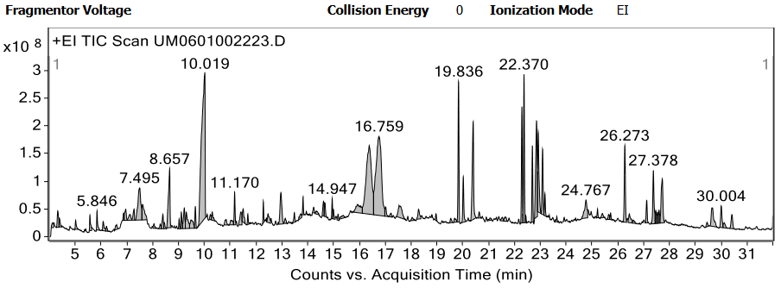
(a)
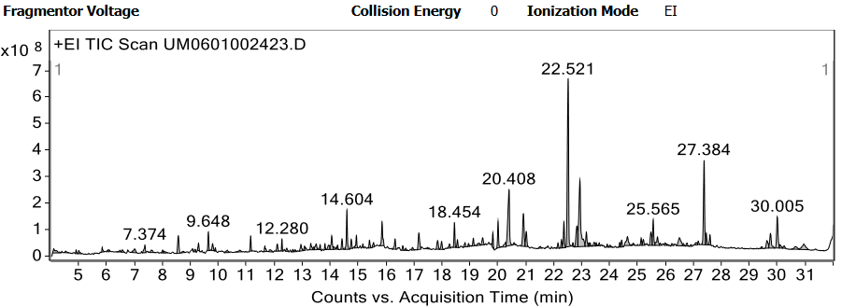
(b)
Fig. (1). (a) Ion-chromatogram of ARRO; (b) Ion-chromatogram of ARLO
  - Herbicidal activity
    - Inhibition of seed germination
The effect of various concentrations of oleoresins on seed germination is shown in Table 5. Seed germination rate decreased with increasing oleoresin concentrations (250–1000 L/mL). At one week, the control group seed germination rate peaked at 100%. At the highest concentration (1000 μL/mL), the herbicidal activity of the leaf part oleoresin (ARLO) was found to be 82.00%, followed by the root part oleoresin (ARRO) at 87.00%. As shown in Table 2 and Fig. 2, the observed order of activity, in terms of IC₅₀, was ARLO (145.31±40.89 μL/mL) followed by ARRO (109.98±22.49 μL/mL), indicating that ARRO was more potent inhibiting seed germination.
Table 2. IC₅₀ value of inhibition of seed germination of ARLO & ARRO
S. No. | Sample name | IC₅₀ values (µL/mL) |  |  | Mean IC₅₀ values (µL/mL) ±SD
S. No. | Sample name | I | II | III | Mean IC₅₀ values (µL/mL) ±SD
1 | ARLO | 185.95 | 145.83 | 104.16 | 145.31±40.89
2 | ARRO | 123.96 | 121.95 | 84.03 | 109.98±22.49
ARLO= Asparagus racemosus Willd. Leave oleoresin. ARRO= Asparagus racemosus Willd. Root oleoresin; IC₅₀-half maximal inhibitory concentration
    - Inhibition of root length
The percent root length inhibition for ARLO was recorded as 54.00%, 63.00%, 77.66%, and 93.33% from lowest to highest concentration (250–1000 L/mL), while for ARRO it was 52.00%, 66.33%, 81.33%, and 93.66%, respectively (Table 5). The IC₅₀ for root length inhibition was observed in the following order: ALRO (75.78±13.65 μL/mL) > ARRO (80.86±59.49 μL/mL), indication that ARLO exhibited greater potency for root growth inhibition (Table 3 and Fig.2).
Table 3. IC₅₀ value of inhibition of root length of ARLO & ARRO
S. No. | Sample name | IC₅₀ values (µL/mL) |  |  | Mean IC₅₀ values (µL/mL) ±SD
S. No. | Sample name | I | II | III | Mean IC₅₀ values (µL/mL) ±SD
1 | ARLO | 89.28 | 76.08 | 61.98 | 75.78±13.65
2 | ARRO | 147.63 | 61.47 | 33.48 | 80.86±59.49
ARLO= Asparagus racemosus Willd. Leave oleoresin; ARRO= Asparagus racemosus Willd. Root oleoresin; IC₅₀-half maximal inhibitory concentration
    - Inhibition of shoot length
The percent shoot length inhibition was calculated when 100% germination was achieved at level of concentrations 250, 500, 750, 1000 μL/mL. In the case of ARLO, the percent inhibition of root length was recorded as 59.00%, 68.00%, 78.66% and 92.00% from lowest to highest concentrations, while in the case of ARRO, the percent inhibition was calculated as 61.00%, 64.66%, 73.00%, and 92.66% respectively, and represented in Table 5. When 100% of the control seeds germinated, the IC₅₀ was computed to assess the relative herbicidal activities of each sample with regard to the inhibition of root growth. The following is the order in which the activity was noticed: ARLO (70.87±17.62 μL/mL) > ARRO (70.91±69.25 μL/mL) (Table 4; Fig.2).
Table 4. IC₅₀ value of inhibition of shoot length of ARLO and ARRO
S. No. | Sample name | IC₅₀ values (µL/mL) |  |  | Mean IC₅₀ values (µL/mL) ±SD
S. No. | Sample name | I | II | III | Mean IC₅₀ values (µL/mL) ±SD
1 | ARLO | 83.33 | 58.41 | 64.10 | 70.87±17.62
2 | ARRO | 150.46 | 38.26 | 24.03 | 70.91±69.25
ARLO= Asparagus racemosus Willd. Leave oleoresin; ARRO= Asparagus racemosus Willd. Root oleoresin; IC₅₀-half maximal inhibitory concentration.
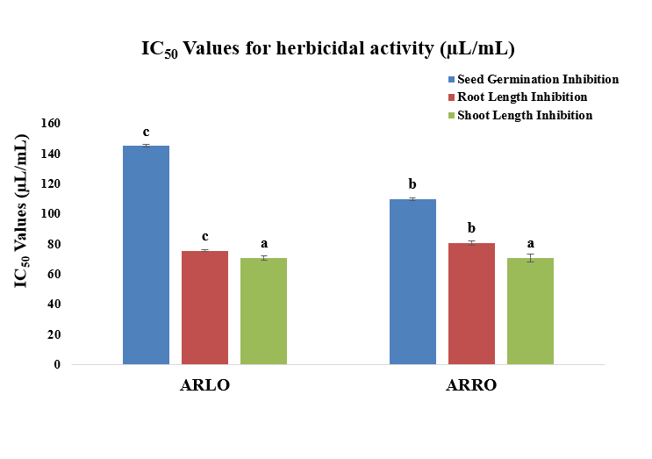
Fig. (2). IC₅₀ values of seed germination, root length and shoot length inhibition of Asparagus racemosus Willd. oleoresin
Table 5. Percent inhibition of seed germination, root length, shoot length of Asparagus racemosus Willd.
S. No. | Sample name | % Inhibition of seed germination |  |  |  | % Inhibition of root length |  |  |  | % Inhibition of shoot length
S. No. | Sample name | 250 µL/mL | 500 µL/mL | 750 µL/mL | 1000 µL/mL | 250 µL/mL | 500 µL/mL | 750 µL/mL | 1000 µL/mL | 250 µL/mL | 500 µL/mL | 750 µL/mL | 1000 µL/mL
1 | ARLO | 58.00±2.00ª | 61.00±1.00^{b} | 65.00±1.00^{c} | 82.00±2.64^{d} | 54.00±2.00 ª | 63.33±1.52^{b} | 77.66±2.51^{c} | 93.33±1.52^{d} | 59.00±1.00 ª | 68.00±1.00^{b} | 78.66±2.51^{c} | 92.00±2.54^{d}
2 | ARRO | 58.33±1.52 ª | 58.66±2.30^{b} | 66.66±2.51^{c} | 87.00±2.64^{d} | 52.00±1.00 ª | 66.33±0.57 ^{b} | 81.33±0.57 ^{c} | 93.66±1.52^{d} | 61.00±2.64 ª | 64.66±2.51^{b} | 73.00±2.00^{c} | 92.66±2.08 ^{d}
3 | Pendamethalin* | 100 ± 0.0 | 100 ± 0.0 | 100 ± 0.0 | 100 ± 0.0 | 100 ± 0.0 | 100 ± 0.0 | 100 ± 0.0 ^{c} | 100 ± 0.0 | 100 ± 0.0 | 100 ± 0.0 | 100 ± 0.0 | 100 ± 0.0
*Standard herbicide; ARLO= Asparagus racemosus Willd. Leave oleoresin ARRO= Asparagus racemosus Willd. Root oleoresin. Values in the same row followed by different superscript letters are significantly different at p<0.05 according of Duncan’s multiple range test.
Greater herbicidal activity for root and shoot growth inhibition was observed in ARLO compared to ARRO, whereas ARRO showed greater seed germination inhibition. It was inferred that the herbicidal activity could be attributed to the presence of several bioactive components, including phytol, n-hexadecenoic acid, and 5-hydroxymethylfurfural in the oleoresins. Another possibility is that the synergistic effect of both minor and major compounds presents in the oleoresins of Asparagus racemosus Willd. leaves and root parts contribute to the enhanced herbicidal activity.
CONCLUSION
A. racemosus is an important medicinal plant having traditional importance as it is used in the indigenous system of medicines like Ayurveda, Sidha, and Unani. Traditional practices are proven by various experimental and scientific studies. This demonstrates the plant with tremendous potential in both healthcare and trade. Considerable work has been done to explore the comparative phytochemical analysis of leaf and root part oleoresin from Asparagus racemosus Willd. revealed variations in their chemical composition. Both oleoresins exhibited significant herbicidal activities, indicating their potential plant protection applications. Despite the biological activity and medicinal applications of the plant, countless possibilities for pharmacological applications remain to be explored. Further studies are needed to understand the detailed mode of action of A. racemosus against R. raphanistrum before we can conclude that A. racemosus oleoresins can be developed as a biological herbicide.
LIST OF ABBREVATIONS
ARLO | : Asparagus racemosus leaf oleoresin
ARRO | : Asparagus racemosus root oleoresin
GC-MS | : Gas chromatography-mass spectrometry
IC₅₀ | : Half maximal inhibitory concentration
NIST | : National Institute of Standards and Technology
SD | : Standard deviation
CONFLICT OF INTEREST
The authors declare that they have no conflict of interest
REFERENCES
- Angiosperm Phylogeny Group III. An update of the Angiosperm Phylogeny Group classification for the orders and families of flowering plants: APG III”. Bot. J. Linn. Soc., 2009, 161 (2), 105–121. https://doi.org/10.1111/j.1095-8339.2009.00999.x
- Arya S; Kumar R; Prakash O; Kumar S; Mahawer SK; Chamoli S; de Oliveira MS. Chemical composition and biological activities of Hedychium coccineum Buch.-Ham. ex Sm. essential oils from Kumaun hills of Uttarakhand. Molecules, 2022, 27(15), 4833. https://doi.org/10.3390/molecules27154833
- Negi JS; Singh P; Joshi G.P; Rawat M.S; Bisht V.K. Chemical constituents of Asparagus. Pharmacog., 2004, Vol 4, Issue 8. https://doi.org/10.4103%2F0973-7847.70921
- Arya S; Mahawer S.K; Karakoti H; Kumar R; Prakash O; Kumar S; Rawat D.S. Study of the Variability of the Chemical Profile, and Biological Activity Approaches of Hedychium coronarium J. Koenig Essential Oil from Different Habitats of Uttarakhand, India. J. Food Qual., 2023. https://doi.org/10.1155/2023/7335134
- Gogte V.M. Ayurvedic pharmacology and therapeutic uses of medicinal plants. Mumbai: SPARC, 2000.
- Singh J; Tiwari H. Chemical examination of roots of Asparagus racemosus. J Indian Chem Soc. 1991, 68, 427428.
- Clifford H.G. "Asparagus racemosus". Flora of Australia. Canberra: Australian Biological Resources Study, Department of Agriculture. Water and the Environment. 2020. https://doi.org/10.3390/horticulturae8050439
- Hayes PY. Structural clarification with the isolation of Shatavarin V. A new steroidal saponin from the root of A. racemosus. Tetrahedron Lett. 2006; 47(49):8683-8687. https://doi.org/10.1016/j.tetlet.2006.10.030
- Michael F; Fay Mark W; Chase Nina Rønsted; Dion S; Devey Yohan Pillon J; Chris Pires; Gitte Peterson; Ole Seber; Jerrold I. Davis. Phylogenetic of liliales: summarized evidence from combined analysis of five plastid and one mitochondrial loci Alis. 2006, 22, 559-565.
- Kirtikar K.R; Basu B.D. Indian Medicinal Plants. In: Singh B, Singh MP, editors. Dehradun, India: New Connaught Place. 1984, 2499.
- Shashi Alok; Sanjay Kumar Jain; Amita Verma; Mayank Kumar; Alok Mahor; Monika Sabharwal. Plant profile, phytochemistry and pharmacology of Asparagus racemosus (Shatavari) Asian Pacific J. Trop. Dis. 2013, 242-251. https://doi.org/10.1016/S2222-1808(13)60049-3
- Goyal R.K; Singh J; Lal H. Asparagus racemosus- An update. Ind. J. Med. Sci. 2003. 57, 408- 414.
- Hussain A; Ahmad M.P; Wahab S; Sarfaraj Hussain M; Ali M. A Review on Pharmacological and Phytochemical Profile of Asparagus racemosus Wild. 2002.
- Adams R.P. Identification of essential oil components by gas chromatography/mass spectrometry (Vol.456). Carol stream, IL: Allured Publishing Corporation. 2007.
- Sahu and Devkota. Allelopathic effects of Aqueous extract of leaves of mikania micrantha h.b.k on seed germination and seedling growth of Oryza sativa L. and Raphanus sativus L. scientific world, 2013, Vol. 11, No. 11.

