Short communication

CASE STUDIES ON LOW-COST STRUCTURED VERTICAL PLANTATION OF STRAWBERRY SUITABLE FOR URBAN HORTICULTURE

.
ABSTRACT

Strawberry (Fragaria × ananassa) is a high-value fruit rich in vitamin C with notable anti-inflammatory, anticancer, and antimicrobial properties. Although strawberries are predominantly cultivated under open-field conditions, soil-based production is declining due to the increasing prevalence of soil-borne pests and diseases, which are difficult to manage in the absence of regulated soil sterilization methods. In the present study, a low-cost vertical farming system was developed using 90 mm PVC pipes arranged in a three-tier frame structure and maintained under partial shading (50% shade-net) to create a semi-controlled microclimate, with soil used as the primary growing medium. Results indicate that strawberry plants require partial shading during the vegetative stage, which promotes leaf development by reducing transpiration stress and improving moisture retention. Subsequent removal of the shed at the onset of flowering was found to enhance floral initiation and increase the number of flowers per plant, likely due to improved light availability. This stage-specific light management combined the advantages of open-field and protected cultivation, resulting in improved vegetative and reproductive performance. Overall, plants exhibited higher numbers of leaves, flowers, and fruits, leading to appreciable yield under the system indicating its suitability for adoption in urban horticultural production.

Keywords: Shade-net, Strawberry, Urban-Horticulture, Vertical-Farming

1. INTRODUCTION

Strawberry (Fragaria x ananassa) is a popular fruit crop, having gained significant interest in the past several decades, thus increasing demand for specialty crops. Strawberries are a healthy addition to the diet, providing essential nutrients as well as high levels of vitamin C and folate. Strawberries are also rich in bioactive compounds such as phenolic compounds which along with Vitamin C, act as antioxidants that provide a wide array of benefits including anti-inflammation, anti-cancer, and anti-microbial properties [5,8]. Most strawberries are grown in open-field conditions however its cultivation in soil is rapidly declining due to soilborne pests and diseases that are difficult to manage without regulatory restricted soil sterilisation products [10]. Temporary structures are used in field production to protect the crop against adverse weather, but there is an increased interest in greenhouse and controlled environment production, which affords a greater amount of control in managing production and can lead to increased yields and production efficiency [17]. Urban Horticulture is the production of food in urban and peri-urban areas with many types of equipment and layouts are used, from simple soil cultivation to vertically orientated systems [1] which is grown within or on top of buildings such as rooftops, warehouses or offices [2, 16]. Globally, urban horticulture has an important role to play in the food security and resilience of urban and semi-urban cities. Strawberries are considered a suitable candidate for UH due to the plant's architecture (low height profile), which allows plants to be grown in levels or walls, its high market value, and its wide demand and high nutritional value [5,7]. However, in UH farming, cross-disciplinary knowledge, skills, and practical experience remain limited. This study highlights the potential benefits of integrating strawberry cultivation into urban horticulture (UH) food systems using low-cost, locally available structural systems.

2. methodology

2.1 Vertical Growing System
A vertical cultivation system was developed using 90 mm diameter round PVC plumbing pipes arranged in a three-tier, multi-storey frame structure (30x30 ft) fabricated from iron bars and Square Hollow Sections (SHS) and placed in a home balcony covered just an of 2.5 sqft (Fig,1,2). The pipes were vertically mounted and securely fixed to ensure structural stability. Each PVC pipe was modified by carving multiple uniformly spaced square planting openings at 10 cm vertical intervals. These openings served as planting pockets for strawberry seedlings, ensuring adequate spacing for canopy development and light interception. Both ends of the pipes were partially sealed using stones and inert pellets to provide drainage while maintaining aeration within the column. Small perforations were also incorporated at the lower end to prevent water stagnation and promote proper drainage.

2.2 Growing Media
Topsoil was collected from an open field and subjected to solarization for pathogen reduction. The soil was spread in a thin layer under transparent polyethylene sheets and exposed to direct sunlight for an appropriate duration to eliminate soil-borne pathogens, weed seeds, and harmful microorganisms. After solarization, the soil was sieved and amended with agricultural lime to adjust the pH to the optimal range (5.5–6.5) suitable for strawberry cultivation. Organic nutrient sources, including well-decomposed poultry manure (dried chicken litter) and homemade compost, were incorporated to improve soil structure, enhance microbial activity, and enrich macro- and micronutrient content. The prepared growing medium was thoroughly mixed to achieve uniformity and then filled into the vertical PVC columns, serving as the rooting substrate for the plants.

2.3 Planting Material and Transplantation
Healthy, disease-free strawberry seedlings cultivar ‘Winter Dawn’ obtained from a certified tissue culture laboratory were used for transplantation. The seedlings were carefully removed from their containers to avoid root damage and transplanted into the prepared square openings of the vertical columns. Immediately after transplanting, light irrigation was applied to maintain adequate moisture levels and facilitate root establishment. Proper care was taken to avoid transplant shock.

2.4 Nutrient Management
Water-soluble fertilizers containing essential macro- and micronutrients were prepared according to recommended dosage guidelines. Nutrient solution was applied through foliar spraying at weekly intervals to ensure balanced nutrient supply, enhance vegetative growth, and support flowering and fruiting. Foliar application was carried out during early morning or late afternoon hours to maximize nutrient absorption and minimize evaporation losses.

2,.5 Nursery Management
A 50% agro shade-net (Fig.2) was installed to regulate light intensity and protect young seedlings from excessive solar radiation. The shade structure was supported using locally available bamboo poles and was erected one month after transplanting, allowing the seedlings to establish under open conditions initially. The shade-net was maintained for a period of approximately three months from the date of transplanting and subsequently removed to facilitate acclimatization of the plants to full sunlight. This practice helped in reducing transplant shock, minimizing moisture stress, and promoting uniform early growth of the seedlings.

3. results and discussion

3.1 Vegetative growth
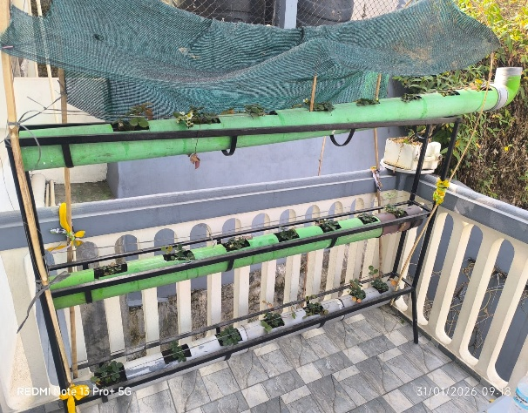
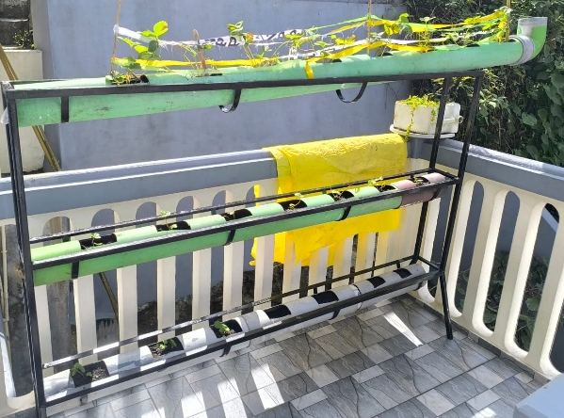
The number of leaves per plant was observed to be low during the initial growth phase (Fig,1) but increased significantly following the installation of the shade-net. This trend suggests that strawberry plants benefit from partial shading during the vegetative stage. The provision of shade likely reduces excessive transpiration and moisture loss, which is particularly critical under conditions where the substrate has limited water-holding capacity. Rapid dehydration of the substrate may otherwise lead to water stress and potential physiological damage to the plants. Thus, moderated light conditions appear to support improved vegetative growth and leaf development in strawberry. Similar observation was also report with various plants grown under different shade levels results in improved photosynthetic activity and reduced transpiration rate [4]. Shade nets did not only protect plants from high light intensities but also improved the vegetative growth [4, 12, 15].

Figure 1: Transplantation stages Figure 2: 50% Shade net tunnel

3.2 Days to flowering
Generally strawberry growing in winter when day length is less than 14 hours and temperatures range between 10–20°C, under such conditions, flower buds may become visible within 30–45 days after transplanting [13] or 4-6 weeks [6]. However, in this particular experiment flowering occur very late within 50-55 days after transplanting. This could be due to the negative impact of low tunnels skin with 50% shade net UVS polythene (200 μm) covered to protect seedling during prolong sun exposure. The impact of shade net to increased vegetative growth at the expense of reproductive growth. Similar report was also observed where flowering delayed under 50% shade net compared to open conditions [14]. After two months the Agro shade net was totally removed and hence this improved flower initiation (Fig) Takeda et al 2010 in his study suggested that the use of photoselective shade nets over strawberry plug plants blocks the light signal that initiates flowering until the netting is removed, hence, delaying the initiation of flower buds until plants are transplanted in the field. Colored shade nets modify the spectrum and amount of light transmitted to the transplants [11]. The ability to vegetatively grow and produce stolons was not affected by shading transplants.

3.3Number of flowers per plant
The number of flowers produced per plant during the initial phase was relatively low under tunnel shade net conditions. However, a significant increase in flowering was observed following the removal of the shade net. This response may be attributed to improved light availability, as higher light intensity is known to enhance reproductive development. Similarly, Ennahli and Kadir reported that increased light intensity promotes greater flower and fruit production compared to shaded conditions. [3].

3.4 Fruit characteristic and Yield
The fruits obtained from the experiment were generally medium to small in size, which may be attributed to the constraints imposed by the use of PVC plumbing pipes as growing containers (Fig,3). The limited volume of growing media available in such structures likely restricted root development and nutrient availability, thereby influencing fruit size. However, despite these limitations, the plants exhibited relatively good productivity, yielding up to 14 fruits per plant. Previous studies have reported that strawberry plants grown under open field conditions tend to produce higher values for parameters such as number of leaves per plant, fruit length, and fruit weight, whereas those cultivated under naturally ventilated polyhouse conditions demonstrate greater crown height, plant spread, and higher overall yield with an increased number of fruits per plant [9].

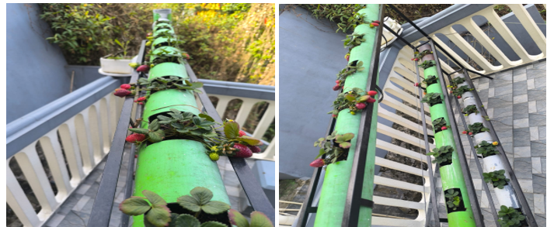
Figure 3: fruit characteristic
4. Conclusion

In the present study, the experimental conditions characterized by partial shading and a semi-controlled microclimate appeared to integrate the beneficial effects of both open-field and protected cultivation systems. The findings indicate that strawberry plants require partial shading during the vegetative stage, which promotes leaf development by reducing transpiration stress and improving moisture retention. Subsequent removal of the shade at the onset of flowering was found to enhance floral initiation and increase the number of flowers per plant, likely due to improved light availability. This strategic modulation of light conditions resulted in a balanced improvement in both vegetative and reproductive growth parameters. Overall, the plants exhibited a higher number of leaves, flowers, and fruits per plant, leading to an appreciable yield under the given system. These results suggest that adoption of low cost structured vertical farming can serve as an effective strategy for optimizing strawberry production under resource limited and semi protected cultivation conditions.

Competing interests

Authors have declared that no competing interests exist.

References

References
Beacham, A. M., Vickers, L. H., & Monaghan, J. M. (2019). Vertical farming: A summary of approaches to growing skywards. Journal of Horticultural Science and Biotechnology., 94, 277–283.
Edmondson, J. L., Cunningham, H., Densley Tingley, D. O., Dobson, M. C., Grafius, D. R., Leake, J. R., McHugh, N., Nickles, J., Phoenix, G. K., Ryan, A. J., Stovin, V., Taylor Buck, N., Warren, P. H., & Cameron, D. D. (2020). The hidden potential of urban horticulture. Nature Food, 3(1), 155–159.
Ennahli, S., & Kadir, S. (2006). Physiological Responses of Three Grapevine Cultivars to Partial Root Drying. HortScience, 41(4), 1011C-1011.
Gaurav, A. K., Raju, D.V.S., Janakiram, T., Singh, B., Jain, R and Rishnan, S. G. (2014). Effect of shade levels on production and quality of cordyline (Cordyline terminalisIndian Journal of Agricultural Sciences 85 (7): 931–5.
Giampieri, F., Tulipani, S., Alvarez-Suarez, J. M., Quiles, J. L., Mezzetti, B., & Battino, M. (2012). The strawberry: Composition, nutritional quality, and impact on human health. Nutrition, 28, 9–19.
Hancock, J. F. (1999). Strawberries. CAB International. Wallingford, UK.
Hernández-Martínez, N. R., Blanchard, C., Wells, D., & Salazar-Gutiérrez, M. R. (2023). Current state and future perspectives of commercial strawberry production: A review. Scientia Horticulturae, 312, 111893.
Nile, S. H. & Park, S. W. (2014). Edible berries: Bioactive components and their effect on human health. Nutrition, 30(2), 134-144.
Pandey, S., Singh, J., Singh, S. K. and Mourya, I. B. (2015). Influence of growing environment on growth, yield and chemical composition of strawberry (Fragaria × ananassa) fruits under open vs naturally ventilated polyhouse conditions. Indian Journal of Agricultural Sciences 85 (12): 1540–5.
Paranjpeand, A., Cantliffei, D., Lamb, E. M., Stoffella, P. J., & Powell, C. (2003). Winter strawberry production in greenhouses using soilless substrates: An alternative to methyl bromide soil fumigation. Reprinted from Proc. Ra. StateHort. Soc, 116, 98–105.
Shahak, Y., Gussahovsky, E. E., Gal, E. and Ganelevin, R. (2004). ColorNets: Crop protection and light-quality manipulation in one technology. Acta. Hort, 659, 143 –151.
Shahak, Y., Gal, E., Offir, Y. and Ben-Yakir, D. (2008). Photoselective shade netting integrated with greenhouse technologies for improved performance of vegetable and ornamental crops. In International Workshop on Greenhouse Environmental Control and Crop Production in Semi-Arid Regions, 797, 75-80.
Sharma, R. R. and Singh, R. (2009). “Strawberry cultivation in India.” Indian Journal of Agricultural Sciences.
Singh, B. (2014). Protected cultivation of horticultural crops in India: Challenges and opportunities. Agrotechnol 2014 ISSN: 2168-9881, AGT an Open Access Journal, 2(4), 51.
Stamps, R. H. (2009). Use of colored shade netting in horticulture. HortScience, 44(2), 239-241.
Stormonth-Darling, J., Symonds, R., Cooper, J. C., Burton, S., and Ransom, J. (2020). Homeworking and vacant office space: Can urban agriculture fill the void? Liverpool.
Walters, R. S. (2021). A Pluralistic Contextual Engineering Approach for Hydrosocial Adaptation: Smallholder Farming in the Biobío River Basin, Chile (Doctoral dissertation, University of Idaho).

