GEOSPATIAL ESTIMATION OF SEQUESTERED CARBON IN SOILS AND VEGETATION OF SOME FOREST RESERVES IN SOUTH-WEST NIGERIA

ABSTRACT
Carbon sequestration is essential for improvement of soil health and climate change mitigation. Indiscriminate landuse and forest exploitation have resulted in unstable carbon sequestration in soils and vegetation. Omo Forest Reserve (OFR) and Gambari Forest Reserve (GFR) in Southwestern Nigeria, have experienced a steady decline in vegetation cover from anthropogenic activities. This study was conducted to estimate the amount of carbon sequestered in soils, landuse types and vegetation of OFR and GFR using geospatial techniques. Two soil types (Alfisol and Inceptisol) and three landuse types were selected for detailed examination in the two sites. Three soil profile pits were described on each landuse and soil type per forest reserve following standard procedures. The properties were used to characterise and classify the soils, following USDA Soil Taxonomy, World Reference Base (WRB) and Local Series systems. Sequestered Carbon (SC) by soils (g C/m2) were estimated using Batjes method. Normalised Difference Vegetation Index (NDVI) was used to estimate vegetation biomass (Mg/ha) while SC by vegetation (Mg/ha) was obtained using biomass-carbon conversion factor. Data were analysed using descriptive statistics and ANOVA0.05. The Alfisols and Inceptisols corresponded with Lixisols and Cambisols; Egbeda and Gambari Series in the WRB and Local Series systems, respectively. SC by soils were 1065.77 and 842.44 in OFR and GFR respectively. Total biomass was higher in OFR (215.37) than GFR (22.16) and SC by vegetation were 107.69 and 11.08 respectively in OFR and GFR. The SC in soil types, landuse and horizons were not significantly different. Bulk density and horizon thickness enhanced carbon sequestration in the sub-surface horizons with Omo Forest Reserve having better carbon sequestration due to high healthy vegetation cover.
Keywords: Soil type, Land-use changetype, Forest reserve, Carbon sequestration, Normalised difference vegetation index
Introduction
Carbon (C) is an important element in the earth’s ecosystem as it forms the major building block of cellular structures for most living organisms existing on earth (Komalirani and Sharma, 2012; Hannah and Max, 2020). As plants and animals grow and die, their remains are decomposed by micro-organisms which deposit some organic complexes of variable proportions and chemical compositions in the soil (Olson et al., 2014). Agricultural activities like: the conversion of native grasslands and forest lands into agricultural land, are one of the most extensive landuse that contributes to the production of greenhouse gases (GHGs) (Hartemink, 2010; HLPE, 2012). It also leads to carbon stock reduction, resulting from the removal of above-ground biomass during harvest, subsequent burning, decomposition and losses of soil carbon through processes such as erosion and leaching (Fahnestock et al., 1996; Lal, 1999).
Net carbon sequestration is known to vary between locations and is significantly affected by land management (Lal, 2004). The general assumption of these variations in carbon has been that the more diverse the vegetation and number of plant species present in tropical forests, the more efficiently carbon can be sequestered (Nield, 2020). Due to some difficulties encountered in collecting field data of vegetation and soil in carbon studies, most researchers focused on collecting samples of the above-ground biomass (vegetation) destructively, thereby causing more damage to the ecosystem (Lu, 2006; Garcia et al., 2010). Remote sensing methods combined with field survey therefore, is considered an ideal method for obtaining data of above ground biomass.
Remote sensing is the art and science of gathering data and obtaining information in a spatial, spectral, and temporal form about an object, areas, etc., such as urban areas, land cover classification, vegetation, water resources and agriculture land without being in close contact with the object (Karaburun and Bhandari, 2010). Several researchers have used remote sensing as a technology to measure above-ground biomass (Kankare et al., 2013; Wannasiri et al., 2013) since it can gather data on forests over vast area of land at a realistic cost coupled with satisfactory precision based on recurring collection of data with little effort (Lu, 2006). Field procedures can be applied to evaluate above-ground biomass with high precision, as with most forest measurements, but they are typically slow to achieve, laborious and challenging to carryout in isolated places (Lu, 2006). When gathering information across huge areas, predominantly in extremely variable, geographically dispersed, and places difficult to access, remote sensing can significantly cut down on time and cost (Wulder et al., 2008). Currently, it is thought that using data from remote sensing is the most accurate way to calculate spatial biomass across broad areas in tropical environments.
A clearer understanding of the earth's environment can be attained through the use of multispectral remote sensing images (Ahmadi and Nusrath, 2012). A popular method for detecting changes in land cover and landuse, particularly in the amount and pattern of vegetation, is the Normalised Difference Vegetation Index (NDVI). It is an indicator of vegetation health. Satellite images are required in the preparation of NDVI using GIS software.
The NDVI is primarily developed for assessing vegetation cover from the reflective bands of satellite data (Sahebjalal and Dashtekian, 2013). It was developed by utilising the link between vegetation indices or biomass and spectral signatures (Foody et al., 2003; Muukkonen and Heiskanen, 2007). The use of vegetation indices makes it feasible to lessen the impact on reflectivity resulting from conditions such as viewing (arising from disparity in angle of sensor view or solar altitude) and shadows, particularly in areas with structures of vegetation stand complex in nature (Lu et al., 2002). The sensitivity of indices of vegetation to biomass, however, differs between environmental settings and can restrict the index's capacity to represent properly (Foody et al., 2001).
As sunlight hits an object, some of this spectrum's wavelengths are absorbed while others are reflected. Chlorophyll, a pigment found in plant leaves, effectively absorbs visible light between the wavelengths of 0.4 and 0.7 µm for photosynthesis. On the other hand, the cell structure of the leaves substantially reflects near-infrared light between 0.7 and 1.1 µm. These light wavelengths are each affected to varying degrees by the number of leaves a plant possesses. The NDVI is a straightforward numerical measure of Photosynthetic Active Radiation (PAR) (Ricotta et al., 1999; Zhang et al., 2009; Demirel et al., 2010). It is a measure of how green or active the photosynthesis of a plant is and therefore is widely used to calculate satellite image-based proxy for vegetation productivity (Scanlon et al., 2002; Kunkel et al., 2011). It essentially assesses the capacity of leaves and provides a measurement of the vegetative cover of the land surface across large areas (Malo and Nicholson, 1990). This index shows positive correlation with biomass, vegetation cover, photosynthetic activity and Leaf Area Index (LAI) (Schmidt and Karnieli, 2000).
Carbon sequestration via means such as soil and vegetation are considered to be a natural, obtainable and harmless process of capturing and storing carbon (Sedjo et al., 1995; Adams et al., 1999). There is however little or no information on the estimation of carbon sequestered in the soils of the different landuse types as well as in the vegetation of both study locations considered in this study. This study was conducted to estimate the amount of carbon sequestered in selected soil types, landuse types and vegetation of Omo Forest Reserve and Gambari Forest Reserve. Further specifics include to characterise and classify the soils and secondly, quantify the amount of carbon sequestered in the soils of the different landuse types and in the vegetation of both forest reserves.
Methodology
This research was carried out in Omo Forest Reserve located in Ijebu-East LGA, Ogun State, and Gambari Forest Reserve located in Oluyole LGA, Oyo State both in South-West Nigeria, purposely selected from the spectrum of landuse and soil types available within close proximity in the forest reserves. The Omo and Gambari forest reserves were selected as the study locations because they both have in common the same features in terms of landuse types: natural forests, arable lands, teak plantations and soil types: Alfisols and Inceptisols. These aforementioned features form part of the major characteristics upon which this research is centered.
Geographical Location of the Study Areas:
Omo Forest Reserve, (Figure 1) is known to be the largest forest reserve in Ogun State and one of the few remaining large blocks of high forest in Nigeria. It covers an area of about 130,500 hectares (Oyinloye et al., 2010). Omo Forest Reserve is located within Latitudes 06° 35´ 09.90´´ N - 07° 06´ 04.94´´ N, and Longitudes 04° 04´ 27.28´´ E - 04° 35´ 22.16´´ E. The reserve is administratively divided into four Jungles denoted as: J1, J2, J3, J4, J5 and J6.
Gambari Forest Reserve (Figure 2) is located in Oluyole Local Government Area (LGA) of Oyo State, and lies between Latitudes 07° 10´ 7.0´´ N and 07° 06´ 57.6´´ N and Longitudes 3° 52´ 37.3´´ E and 03° 52´ 02.8´´ E. Gambari Forest Reserve is located within the low land semi-deciduous forest belt of Nigeria covering a total land area of 17,984 ha. It is situated at the southern part of Ibadan, bounded by River Ona on the west and on the east by the main road of Ibadan to Ijebu-ode. Gambari Forest Reserve is one of the early forest reserves in Oyo State and it is divided into five sites namely: Onigambari, Busogboro, Onipe, Olonde and Mamu (Larinde and Olasupo, 2011).
Field Survey
An initial (reconnaissance) tour was made to both study locations selected for this study in order to have an idea and do a general appraisal of the terrain to be surveyed. The co-ordinates of the sampling points were obtained using the Global Positioning System (GPS) device and a semi-detailed survey approach was adopted for the main field work, incorporating remote sensing technology.
Identification of Soil Types and Landuse Types
Series of auger observations were made randomly at several spots and at varying depths (of 15, 30, 45, 60 90 and 120 cm where possible) at different physiographic positions (upper slope, middle slope and lower slope) all within a landuse types investigated. Soil observation (morphological and physical properties) including: texture (by hand feel), consistency, colour (using the Munsell colour chart), mottles, structure etc. were made. Soils with similar properties were noted and profile pits were sunk to further examine the soils for distinct properties.
Several landuse types ranging from arable land, planted forests, natural forest, fallow etc. exists in both Omo and Gambari forest reserves. Amongst the arable land were soils cropped to cassava which was common to both forest reserves. Planted forests spanned from Teak, Gmelina, Oak, Tea etc. Amongst the various planted forests, the Teak plantation was also common to both study locations and occupied a relatively larger area. There were however, substantial evidence of anthropogenic activities taking place in both forests.
Soil Profile Pit Establishment and Soil Sampling
One profile pit each was dug on the two soil types identified within a landuse. Then two other profile pits sited about 40-70 m, away from the main profile pit were sunk alongside (serving as replicates to the main profile pit) to further ascertain that the soil types were similar. Three profile pits were sunk on each of the soil type (Alfisol and Inceptisol) identified, all within a landuse type in Omo Forest reserve, giving a total of six profile pits on each landuse type which amounted to 18 profile pits in one study location. The same procedure was repeated at the Gambari forest reserve. Generally, a total of 36 profile pits were sunk across both study locations.
The profile pits were described according to FAO guidelines (FAO, 2006). Composite soil samples were collected from each horizon for routine chemical and physical analyses. Undisturbed soil samples were also collected from each horizon using a cylindrical metal core sampler (of known volume) for bulk density determination. Soils were analysed for morphological properties (colour, consistency, mottles, stoniness, roots, boundary forms etc.) in-situ.
Laboratory Analysis
A set of soil samples collected were air-dried and processed by passing them through a 2 mm mesh for particle size distribution, and other chemical properties. A little quantity of the 2 mm sieved soil was again passed through a 0.5 mm mesh to analyze for total nitrogen and organic carbon. The soils were analysed using standard methods as described by Udo et al. (2009).
Soil Characterisation and Classification
Soil characterisation (which involves the examination of soil morphological properties obtained in the field and results of the routine chemical and physical properties of the soils obtained from the laboratory) was carried out by examining the data from the morphological, physical and chemical properties derived from the soil analysis. The data derived from the soil characterisation were then used to classify the soil using three different soil classification systems: Soil Taxonomy 12th Edition (USDA, 2014); World Reference Base (WRB) for Soil Resources (FAO, 2014); and the Local series classification using Smyth and Montgomery (1962).
Determination of Soil Organic Carbon (SOC) Sequestered by Soil
Soil organic carbon sequestration was calculated on soil horizon basis using the method by Batjes (1996) and Ahukaemere (2016).
$${Soil Organic Carbon Sequestration (g C/m^{2})=BD}_{i}\left(g/{cm}^{3}\right)×{OC}_{i}\left(g/kg\right)×D_{i}\left(cm\right)$$
Where: BDi = bulk density of individual horizon (g/cm³);
OCi = organic carbon of individual horizon (g/kg);
Di = thickness of individual horizon layer (cm).
Evaluation of Vegetation Cover using Normalised Difference Vegetation Index
The Normalised difference vegetation index (NDVI) (is a 3-band satellite image LandSat technique and a numerical indicator used in analysing remotely sensed data by proxy and evaluate if the object being observed contains healthy green vegetation or not) was used in the extraction of various features in both Omo and Gambari forest reserves. Vegetation cover was estimated by the use of vegetation indices resulting from satellite images. Vegetation indices assists in the delineation of the pattern of distribution of vegetation and soil following the characteristic reflectance patterns of green vegetation. The LandSat imagery of both study locations spanning from 2011-2021 were acquired using LandSat 8, collated and interpolated using Earth explorer and ArcGIS Pro version 2.2 there by producing a characteristic reflectance pattern of green vegetation. These tools discriminate between different objects on land, like vegetation and water bodies, bare lands etc.
Frame Work for Calculating NDVI
Normalised Difference Vegetation Index was calculated based on the near-infrared and visible light reflected by the vegetation. Most of the visible light that hits the surface of the healthy vegetation were absorbed by it, and in turn, a large portion of the near-infrared light was reflected. Contrarily, sparse or unhealthy vegetation reflected less near-infrared light and more visible light. Calculations of NDVI for a given pixel gives a range of number from minus one (-1) to plus one (+1). However, no green leaves give a value close to zero, and a value of zero means no vegetation, while about +1 (0.8 - 0.9) indicates the highest possible density of green leaves.
List 1 : The NDVI range and their corresponding objects are listed below (Sumanta, 2016).
Range of NDVI Value | Name of Objects
-1 | Water body
0.15 | Rock, Bare soil, Cloud, Sand and snow
- – 0.3 | Shrub and Grass Land
- – 0.5 | Unhealthy and Sparse Forest
>0.5 | Healthy and Dense Forest

Normalised Difference Vegetation Index is calculated thus:
$$NDVI=\frac{\left(NIR-Red\right)}{\left(NIR+Red\right)}$$
In LandSst 8, $NDVI=\frac{B5-B4}{B5+B4}$
Where: NIR = Near-Infrared light; Red = Visible red light
Estimation of Carbon Stock from Vegetation Cover
This was carried out by measuring carbon stock particularly based on total vegetation cover data including dense and open forest extracted from Landsat imagery derived from NDVI. The vegetation cover obtained was then converted to carbon by multiplying it with the biomass-carbon conversion factors. Based on these conversion factors, an estimated carbon stock of the study areas was calculated. The conversion factors and the expressions used for this calculation are given below.
Biomass-Carbon Conversion Factors (Mirbach, 2000)
$$Total wood volume=vegetation cover×1.454×0.396 \left(in m^{3}\right)$$
$$Total dry matter biomass=wood volume×0.43 \left(in tonnes or Mg/ha\right)$$
$$Total carbon=dry matter biomass×0.5 \left(in tonnes or Mg/ha\right)$$
Where:
1.454 = to modify inside stem wood volume to include non-merchantable volume such as bark, crowns, and branches.
0.396 = to estimate below ground volume
0.43 = to convert wood volume (m³) to Mg of dry matter biomass
0.5 = to convert dry matter to C.
Statistical Analysis
Data generated were subjected to Analysis of Variance to compare the variations in selected chemical and physical properties and also in the amount of soil organic carbon sequestered in the various soil horizons (categorised as surface and sub-surface horizons denoted as A and B horizons), between the soil types, landuse types and their interactions. An average of four (4) horizons for all the profile pits for the sake of uniformity was used.
Descriptive analysis (Means and Coefficient of Variation) was carried out to show the variations in carbon within horizons, among landuse types and soil types.
RESULTS AND DISCUSSION
The mean values of chemical properties of the Alfisols and Inceptisols of arable land, natural forest and teak plantation in Omo and Gambari forest reserves are presented in Table 1. The pH of both sites were noted to be strongly acidic.
The strongly acidic nature of these soils could be attributed to the high precipitation and leaching associated with the two sites. Another reason could be attributed to the inherent characteristic acidic nature of Alfisols and Inceptisols which are often-times a consequence of the nature and property of the parent materials from which the soils are derived coupled with the influence of the leached horizons through the process of illuviation and eluviation. Eshett et al. (1990) and Onweremadu et al. (2007) reported that leaching enhances soil acidity under high annual rainfall condition which is a major characteristic of the tropics.
Organic carbon content was very high in the Alfisols and Inceptisols of arable land, natural forest and teak plantation in Omo and Gambari forest reserves. Although, the organic carbon was observed to follow an irregular pattern and thus, vary significantly within the horizons of the different landuse types. Low to high coefficient of variation of organic carbon content recorded in the arable land, natural forest and teak plantation of both Alfisols and Inceptisols is in line with the findings of Ahukaemere (2016), who recorded moderate to high variation in the organic carbon contents of the soil horizons in all the soil profile pit of the soils of some forest reserves in Nigeria.
The textural class of the soils of Omo and Gambari forest reserves (Table 2) traversed from sand to loamy sand at the surface horizons and sandy loam to sandy clay loam at the sub-surface horizons. This finding is at par with those of Chude et al. (2012) who noted that Alfisols and Inceptisols of basement complex rocks under rain forest vegetation have a characteristic loamy sand surface layers over more clayey subsoil and that soil texture vary greatly according to the rapid changes in rock lithology.
Following the examination, description and analysis of the soil characterisation given above, the soils of Omo and Gambari forest reserves were therefore classified as Alfisols and Inceptisols in the USDA soil classification systems; Lixisols and Cambisols in the WRB classification system; and Egbeda and Gambari at the local series level (Table 3).
Table 4 refer to the carbon sequestered by the surface and sub-surface horizons in arable land, natural forest and teak plantation and that of the soil types (Alfisols and Inceptisols). The surface and sub-surface horizons of Alfisols in Omo forest reserve were 365.07±89.66, 1410.68±166.00; 804.13±150.04, 1387.18±385.94 and 348.81±87.59, 1492.67±69.55 while that of Inceptisols were 1020.31±411.22, 1177.67±396.72; 1067.71±418.07, 1210.86±675.10 and 568.37±333.66, 573.91±190.70 for arable land, natural forest and teak plantation respectively. However, carbon sequestered by surface and sub-surface horizons of arable land, natural forest and teak plantation of Alfisols in Gambari forest reserve were 950.55±103.30, 802.14±361.55; 1044.16±174.85, 930.35±432.19 and 830.81±234.83, 1099.65±608.25 while those of Inceptisols were 829.98±169.45, 606.85±188.32, 613.23±133.31, 470.79±179.82 and 348.01±60.55, 1034.47±446.16 for arable land, natural forest and teak plantation respectively.
The carbon sequestered by the vegetation including sparse vegetation (shrubs and grasslands or senescing crops as well dense vegetation canopy) of the Omo and Gambari forest reserves were 107.69 and 11.08 Mg/ha respectively (Tables 5 and 6).
Generally, the sub-surface horizons of the arable land, natural forest and teak plantation of both Alfisols and Inceptisols recorded the highest amount of organic carbon content when compared with the surface horizons. This shows the characteristic nature and innate ability of the sub-surface horizons to store more carbon in relation to the surface horizons. This discovery is in line with those of Eswaran et al., (1993), Batjes (1996), Mbah and Idike (2011), Abebayehu (2013), and Ahukaemere (2016), who reported high carbon concentration in the deeper soil horizons. Nevertheless, Ahukaemere (2016) also reported high organic matter content in few surface horizons.
The highest soil organic carbon stock was recorded in the natural forest of Alfisols in Omo forest reserve and this was closely followed by the teak plantation and lastly, arable land. The high soil organic carbon value observed in the natural forest were majorly contributions of carbon sequestered in the sub-surface horizons and few contributions from the surface horizons. The high value recorded in the natural forest could be as a result of the partially decomposed supplementary organic material from litters and faunas which accumulated on the surface of the soil and gradually undergoing decomposition and pedoturbation with time. Or may probably be due to the deep rooting systems associated with trees where the activities of micro-organisms are relatively high following their interaction with tree roots through the process of rhizo-deposition. This finding is in line with those of Weintraub et al. (2007) and Strand et al. (2008) who reported a significant contribution of plant roots to Soil Organic Carbon (SOC) through accumulation of microbes in the root zone and by their decomposition, thereafter, supply carbon to the soil through the process known as rhizo-deposition.
Figures 3 and 4 shows the Normalised Difference Vegetation Index (NDVI) image of the Omo and Gambari forest reserves respectively. From the NDVI image of Omo forest reserve, water surfaces, man-made structures, bare soil and rock had a very low NDVI range of 0.1-0.2 with a corresponding land area of 367.80 m² occupying about 29.70% of the total land area; sparse vegetation including shrubs and grasslands or senescing crops recorded a low NDVI value of 0.2-0.3 with a land area of 457.10 m² occupying about 36.90% of the total land area; while the healthy dense vegetation canopy had a high NDVI range of 0.3-0.8 with a land area of 412.80 m² occupying 33.40% of the total land area.
The result of the NDVI image of Gambari forest reserve showed that water surfaces, man-made structures, bare soil and rock recorded a low NDVI range of 0.1-0.2 with a corresponding land area of 25.70 m² occupying about 22.30% of the total land area; sparse vegetation including shrubs and grasslands or senescing crops had a moderate NDVI range of 0.2-0.3 with a land area of 45.20 m² occupying about 39.20% of the total land area; while the healthy dense vegetation canopy also recorded a moderate NDVI range of 0.3-4.0 with a land area of 44.30 m² occupying about 38.50% of the total land area.
The total vegetation cover (obtained by adding the sparse and healthy dense vegetation) for Omo and Gambari forest reserves were 869.90 and 89.50 m³ respectively (Table 7); Total wood volume of the Omo and Gambari forest reserves were 500.87 and 51.53 m³ respectively while the total dry matter biomass of the Omo and Gambari forest reserves was 215.37 and 22.16 tonnes respectively. Therefore, the total carbon sequestered by the vegetation of the Omo and Gambari forest reserves are 107.69 Mg/ha and 11.08 Mg/ha respectively.
The carbon sequestered by vegetation of both Omo and Gambari forest reserves, showed that Omo forest reserve sequestered more carbon compared to Gambari forest reserve. The high carbon sequestered by the Omo forest reserve over the Gambari forest reserve could be as a result of the different agro-ecological zones in which the forest reserves are located. The Omo forest reserve is located in the humid wet tropics and have the tendency to: receive high rainfall; be highly vegetated with more diverse vegetation in terms of density and species and thereby producing more litters which adds to the organic matter contents of the soils of this area while the Gambari forest reserve is situated within the derived savanna or humid dry tropic agro-ecological zone and may not have same characteristics with that of Omo forest reserve.
In like manner, the NDVI of water surfaces, man-made structures, bare soil, rocks were very low in Omo forest reserve compared to the low values recorded in the Gambari forest reserve. Again, the NDVI of Sparse vegetation: shrubs and grasslands or senescing crops were low in Omo forest reserve but moderate in Gambari forest reserve. More so, the NDVI of healthy dense vegetation was high in Omo forest reserve compared to the moderate values obtained in the Gambari forest reserve. These factors also contributed greatly to the higher total carbon values recorded in Omo forest reserve over the Gambari forest reserve. Largely, the reason for such disparity in the amount of sequestered carbon, could be as a result of the effect and consequence of forest exploitation (of logging, deforestation etc.,) observed in both forest reserves. However, the Gambari forest reserve proved or showed more evidence of such anthropogenic disturbance compared to Omo forest reserve.
Consequently, the decomposition rate of the organic matter in the Omo forest reserve is most likely to be a bit slower than those of the Gambari forest reserve due to the climatic conditions such as relative humidity and temperature given the agro-ecological zone in which these forest reserves are situated. This finding validates those of Nield (2020) and Burke et al. (1989), who observed that carbon is efficiently sequestered in tropical forests with diverse vegetation and high number of plant species. Lal (2004) also noted that carbon sequestration fluctuates between locations and is significantly affected by land management.
The high NDVI range observed in the Omo forest reserve over the moderate values recorded in Gambari forest reserve could be as a result of the presence of healthier dense vegetation and the relative condition of the natural forest. Omo forest reserve had less evidence of anthropogenic activities like deforestation compared to Gambari forest reserve.

CONCLUSIONS
The Alfisols and Inceptisols (USDA), corresponded with Lixisols and Cambisols; Egbeda and Gambari Series in the WRB and Local Series systems respectively. The sub-surface horizons have more innate ability to store more carbon than the surface horizons. Omo forest reserve with higher biomass (vegetation) sequestered more carbon.
Carbon sequestered by vegetation was higher in Omo forest reserve than Gambari forest reserve by 81.34%. Most of the soil nutrients as well as sequestered carbon in the soils of the study areas were highly variable indicating they are very much unstable. Therefore, proper management geared towards reducing soil disturbance and increasing soil organic carbon is encouraged.
Very importantly, application of remote sensing in carbon studies, has proven to be effective in acquiring data on carbon stock of vegetation of large area of land particularly those that are not easily accessible.
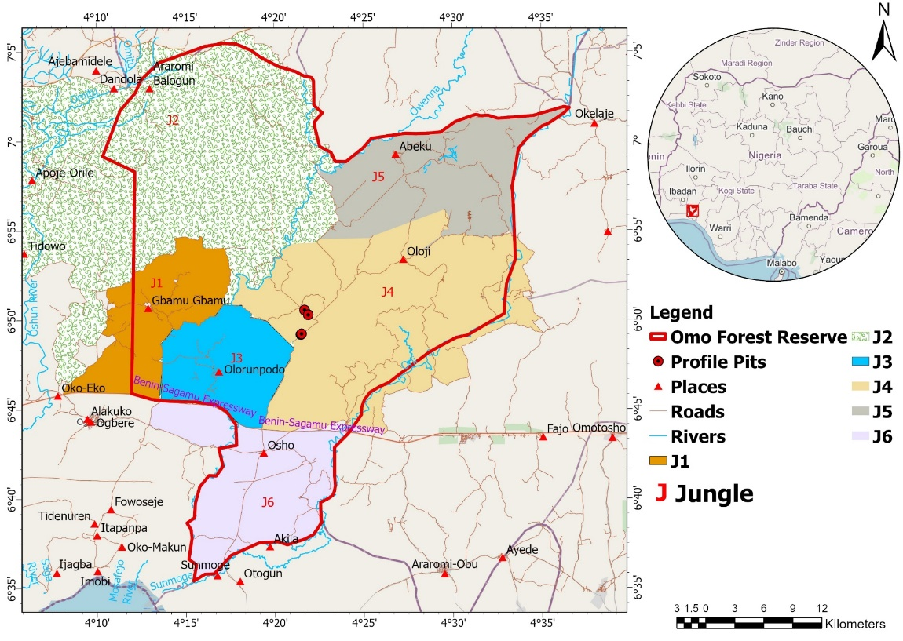
Figure 1: Map of Omo Forest Reserve

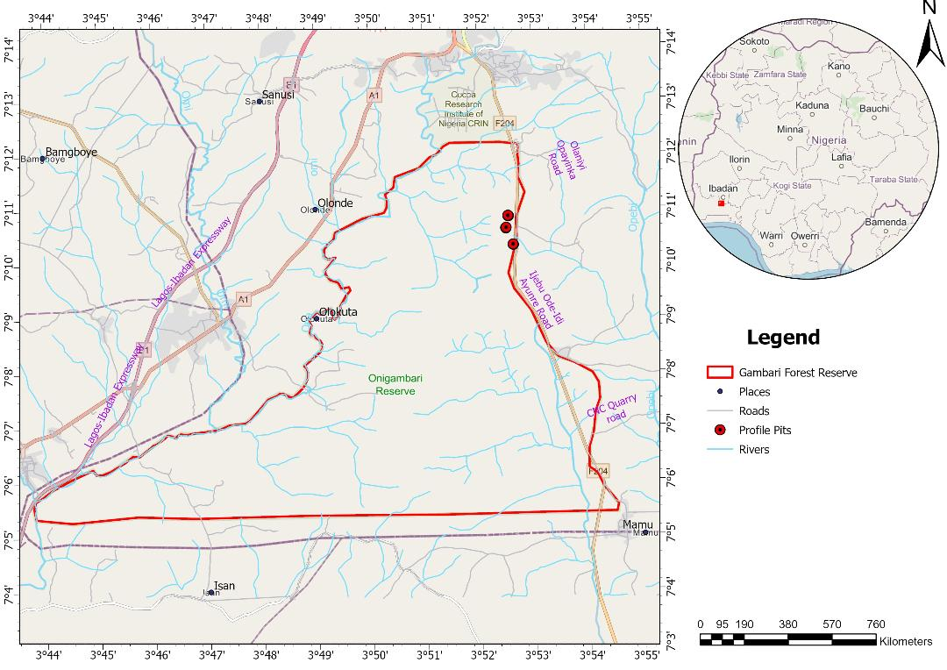
Figure 2: Map of Gambari Forest Reserve.

Table 1: Mean Values and Variations of Selected Chemical Properties of the different Soil and Landuse Types in Omo and Gambari Forest Reserve
 |  | Omo Forest Reserve |  |  |  |  | Gambari Forest Reserve
 |  | Alfisols |  | Inceptisols |  |  | Alfisols |  | Inceptisols
Landuse | Parameters | Mean | CV | Mean | CV |  | Mean | CV | Mean | CV
Arable Land | pH (H₂O) | 4.9 | 7.77 | 5.4 | 6.48 |  | 6.2 | 5.94 | 6.1 | 6.85
 | OC (g kg⁻¹) | 26.94 | 80.44 | 34.30 | 78.92 |  | 36.96 | 84.93 | 29.29 | 107.78
 | Total N (g kg⁻¹) | 1.68 | 80.36 | 2.14 | 78.97 |  | 2.31 | 84.85 | 1.83 | 107.65
 | Avail. P (mg kg⁻¹) | 21 | 78.62 | 2 | 62.9 |  | 2 | 76.54 | 2 | 121.60
 | K (cmol kg⁻¹) | 0.2 | 72.73 | 0.3 | 112.12 |  | 0.2 | 54.17 | 0.1 | 50.00
 | ECEC (cmol kg⁻¹) | 4.51 | 46.78 | 3.33 | 48.05 |  | 7.67 | 56.06 | 7.58 | 62.53
 | B/Sat (%) | 82.94 | 19.82 | 81.21 | 22.47 |  | 97.02 | 1.44 | 96.24 | 2.19
Natural Forest | pH (H₂O) | 5.0 | 12.57 | 5.0 | 9.92 |  | 5.8 | 6.76 | 5.9 | 8.55
 | OC (g kg⁻¹) | 35.91 | 98.72 | 27.48 | 107.82 |  | 30.05 | 100.93 | 25.72 | 105.56
 | Total N (g kg⁻¹) | 2.24 | 99.11 | 1.72 | 107.56 |  | 1.88 | 101.06 | 1.61 | 105.59
 | Avail P (mg kg⁻¹) | 28 | 144.86 | 2 | 115.3 |  | 1 | 152.99 | 2 | 102.90
 | K (cmol kg⁻¹) | 0.3 | 75.00 | 0.3 | 40.0 |  | 0.7 | 36.11 | 0.1 | 84.62
 | ECEC (cmol kg⁻¹) | 3.95 | 50.38 | 4.51 | 58.5 |  | 9.05 | 65.52 | 6.01 | 76.87
 | B/Sat (%) | 79.58 | 24.54 | 89.27 | 13.32 |  | 97.18 | 1.72 | 92.03 | 15.38
Teak Plantation | pH (H₂O) | 5.0 | 7.34 | 5.2 | 12.21 |  | 5.7 | 4.40 | 5.7 | 4.42
 | OC (g kg⁻¹) | 29.43 | 77.88 | 17.37 | 116.29 |  | 25.68 | 92.13 | 24.14 | 110.48
 | Total N (g kg⁻¹) | 1.84 | 77.72 | 1.55 | 125.16 |  | 1.60 | 92.50 | 1.51 | 110.6
 | Avail P (mg kg⁻¹) | 14 | 103.59 | 2 | 102.55 |  | 1 | 168.54 | 1 | 165.48
 | K (cmol kg⁻¹) | 0.2 | 68.18 | 0.3 | 92.59 |  | 0.4 | 26.83 | 0.3 | 153.33
 | ECEC (cmol kg⁻¹) | 4.52 | 76.11 | 4.04 | 56.44 |  | 9.57 | 34.90 | 6.45 | 47.29
 | B/Sat (%) | 90.49 | 6.4 | 79.01 | 21.85 |  | 97.76 | 1.26 | 96.93 | 1.8
CV: Coefficient of variation; n = 18

Table 2: Mean Values and Variations of Selected Physical Properties of the different Soil and Landuse Types in Omo and Gambari Forest Reserve
 |  | Omo Forest Reserve |  |  |  |  | Gambari Forest Reserve
 |  | Alfisols |  | Inceptisols |  |  | Alfisols |  | Inceptisols
Landuse | Parameters | Mean | CV | Mean | CV |  | Mean | CV | Mean | CV
Arable Land | Clay (g kg⁻¹) | 159 | 64.34 | 55 | 71.15 |  | 68 | 74.48 | 56 | 68.92
 | Silt (g kg⁻¹) | 128 | 64.55 | 221 | 38.72 |  | 227 | 25.26 | 182 | 32.26
 | Coarse Sand (g kg⁻¹) | 531 | 18.96 | 603 | 9.66 |  | 583 | 16.17 | 599 | 20.02
 | Fine Sand (g kg⁻¹) | 182 | 46.72 | 127 | 32.37 |  | 123 | 33.66 | 163 | 45.79
 | Gravel Content (%) | 24.44 | 45.84 | 20.69 | 41.40 |  | 27.29 | 85.62 | 30.57 | 97.56
 | Bulk Density (mg kg⁻¹) | 1.54 | 7.20 | 1.56 | 8.35 |  | 1.63 | 18.11 | 1.61 | 22.90
Natural Forest | Clay (g kg⁻¹) | 145 | 97.49 | 103 | 67.55 |  | 53 | 74.05 | 39 | 46.88
 | Silt (g kg⁻¹) | 214 | 51.84 | 165 | 44.87 |  | 315 | 37.94 | 169 | 31.67
 | Coarse Sand (g kg⁻¹) | 456 | 27.56 | 620 | 39.88 |  | 536 | 22.03 | 645 | 8.97
 | Fine Sand (g kg⁻¹) | 184 | 82.46 | 117 | 229.93 |  | 95 | 28.37 | 147 | 47.41
 | Gravel Content (%) | 50.80 | 32.44 | 23.67 | 64.45 |  | 24.54 | 109.95 | 7.35 | 119.81
 | Bulk Density (mg kg⁻¹) | 1.50 | 14.47 | 1.60 | 966.62 |  | 1.47 | 15.40 | 1.70 | 33.00
Teak Plantation | Clay (g kg⁻¹) | 91 | 92.97 | 146 | 84.32 |  | 53 | 79.22 | 49 | 60.17
 | Silt (g kg⁻¹) | 215 | 45.44 | 191 | 43.06 |  | 319 | 36.75 | 251 | 27.82
 | Coarse Sand (g kg⁻¹) | 528 | 30.56 | 538 | 17.70 |  | 487 | 25.34 | 552 | 14.81
 | Fine Sand (g kg⁻¹) | 166 | 87.49 | 135 | 27.05 |  | 141 | 41.95 | 148 | 29.47
 | Gravel Content (%) | 38.98 | 44.92 | 46.39 | 38.08 |  | 53.61 | 28.41 | 30.22 | 93.41
 | Bulk Density (mg kg⁻¹) | 1.58 | 8.27 | 1.59 | 7.88 |  | 1.61 | 10.10 | 1.71 | 14.09
CV: Coefficient of variation; n = 18

Table 3: Taxonomic Classification of the Soils of Omo and Gambari Forest Reserves
Forest Reserve/  Soil Type | Landuse | Profile No | USDA | WRB | SERIES
Omo/Alfisols | Arable Land | OMO A1 (1) | Typic Kandiustalf | Chromic Lixisol | Egbeda
 | Natural Forest | OMO F1 (1) | Typic Kandiustalf | Ferric Lixisol | Egbeda
 | Teak Plantation | OMO P1 (1) | Typic Haplustalf | Ferric Lixisol | Egbeda
Omo/Inceptisols | Arable Land | OMO A2 (1) | Fluvic Dystrustept | Gleyic Cambisol | Apomu
 | Natural Forest | OMO F2 (1) | Fluventic Dystrustept | Chromic Cambisol | Apomu
 | Teak Plantation | OMO P2 (1) | Typic Haplustept | Eutric Fluvisol | Apomu
Gambari/Alfisols | Arable Land | ONG 3 AL1 | Typic Plinthustalf | Petroplinthic Lixisol | Gambari
 | Natural Forest | ONG 2 NF1 | Typic Kandiustalf | Ferric Lixisol | Gambari
 | Teak Plantation | ONG1 TP1 | Oxic Haplustalf | Ferric Lixisol | Ibadan
Gambari/Inceptisols | Arable Land | ONG 3B AL1 | Plinthic Haplustept | Eutric Cambisol | Apomu
 | Natural Forest | ONG 2B NF1 | Udic Haplustept | Chromic Lixisol | Apomu
 | Teak Plantation | ONG 1B TP1 | Typic Haplustept | Eutric Cambisol | Matako

Table 4: Sequestered Carbon (g C m²) in Surface and Sub-Surface Horizons and Landuse, and Soil Types in Omo and Gambari Forest Reserves
 |  |  | Sequestered Carbon in Soil Horizon Depth |  |  |  |  |  |  |  | Sequestered Carbon in Soil Types
 |  |  | Alfisol |  |  | Inceptisol |  |  | Alfisols |  |  |  | Inceptisols
Location | Landuse |  | Surface | Sub-Surface |  | Surface | Sub-Surface |  | SOC (g C m²) | CV (%) |  |  | SOC (g C m²) | CV (%)
Omo | Arable Land |  | 365.07 | 1410.68 |  |  |  |  | 1013.58 | 92.55 |  |  | 1368.88 | 85.69
  1020.31
  1177.67
 | Natural Forest |  | 804.13 | 1387.18 |  | 1067.71 | 1210.86 |  | 1335.67 | 103.67 |  |  | 827.83 | 104.88
 | Teak Plantation |  | 348.81 | 1492.67 |  | 568.37 | 573.91 |  | 1269.11 | 74.65 |  |  | 579.54 | 83.24
Gambari | Arable Land |  | 950.55 | 802.14 |  | 892.98 | 606.85 |  | 911.00 | 95.77 |  |  | 616.07 | 101.64
 | Natural Forest |  | 1044.16 | 930.35 |  | 613.23 | 470.79 |  | 991.32 | 161.20 |  |  | 493.36 | 81.94
 | Teak Plantation |  | 830.81 | 1099.65 |  | 384.01 | 1038.47 |  | 922.11 | 129.01 |  |  | 1120.76 | 145.15

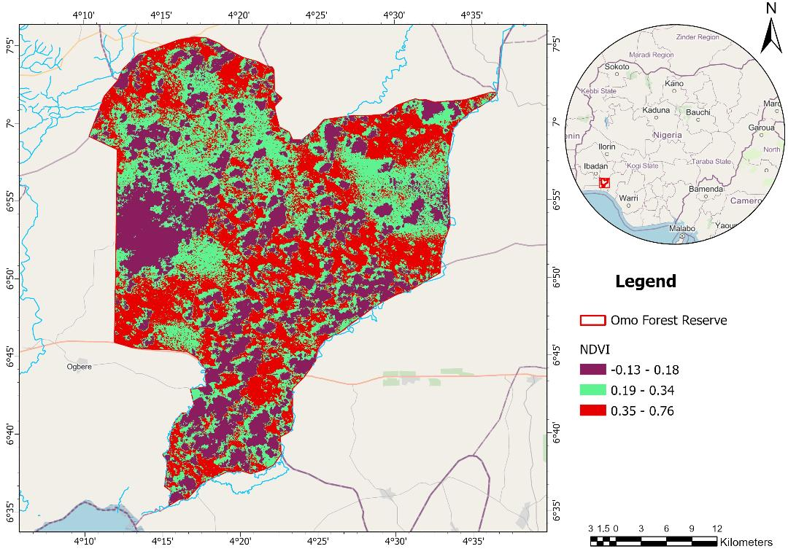
Figure 3: Normalised Difference Vegetation Index (NDVI) Image of Omo Forest Reserve
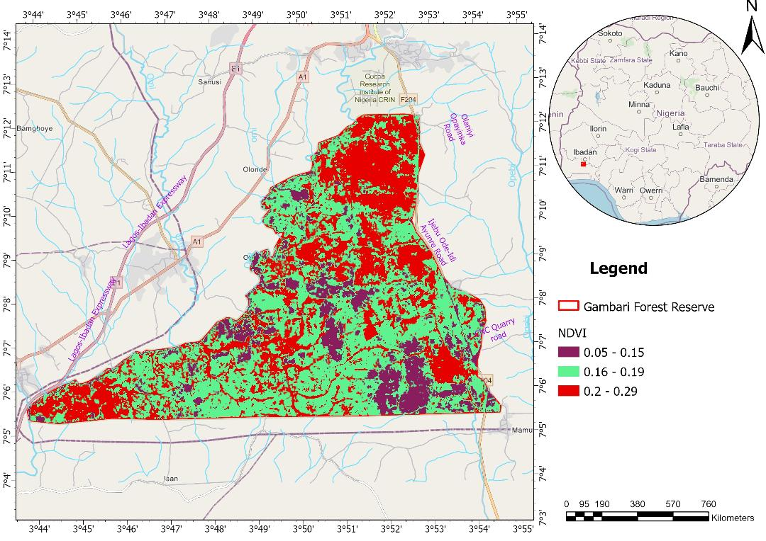
Figure 4: Normalised Difference Vegetation Index (NDVI) Image of Gambari Forest Reserve

Table 5: Normalised Difference Vegetation Index of Omo Forest Reserve
NDVI Range | NDVI Value | Land Forms |  |  |  | Area
 |  |  |  | ($m^{3}$) |  |  | (ha) |  | (%)
0.13-0.18 | Very Low | Water surfaces, man-made structures, bare soil, rock |  | 367.80 |  |  | 36775.2 |  | 29.70
0.19-0.34 | Low | Sparse vegetation: shrubs and grasslands or senescing crops |  | 457.10 |  |  | 45712.7 |  | 36.90
0.35-0.76 | High | Healthy dense vegetation canopy |  | 412.80 |  |  | 41279.9 |  | 33.40
 |  | Total |  | 1237.70 |  |  | 123767.8 |  | 100.00

Table 6: Normalised Difference Vegetation Index of Gambari Forest Reserve
NDVI Range | NDVI Value | Land Forms |  |  | Area
 |  |  |  | ($m^{3}$) | (ha) | (%)
0.05-0.15 | Low | Water surfaces, bare soil, rock |  | 25.70 | 2572.4 | 22.30
0.16-0.19 | Moderate | Sparse vegetation: shrubs and grasslands or senescing crops |  | 45.20 | 4520.2 | 39.20
0.20-0.29 | Moderate | Healthy dense vegetation canopy |  | 44.30 | 4433.4 | 38.50
 |  | Total |  | 115.20 | 11526 | 100.00

Table 7: Total Carbon Sequestered by Vegetation in Omo and Gambari Forest Reserves
Conversion factors | Omo | Gambari
Total vegetation cover ($m^{3}$) (Sparse + Healthy vegetation) | 869.90 | 89.50
Total wood volume ($m^{3}$) | 500.87 | 51.53
Total dry matter biomass (tonnes) | 215.37 | 22.16
Total carbon (Mg/ha) | 107.69 | 11.08

REFERENCES
Abebayehu, A. (2013). Evaluating organic carbon storage capacity of forest soil: case study in Kafa zone Bita District Southwest Ethiopia. American-Eurasian Journal of Agriculture and Environmental Science 13.1: 95-100.
Adams, D. M., Alig, R. J., McCarl, B. A., Callaway, J. M. and Winnett, S. M. (1999). Minimum cost strategies for sequestering carbon in forests. Land Economics 75: 360-374.
Ahmadi, H and Nusrath, A. (2012). Vegetation change detection of Neka River in Iran by using remote sensing and GIS, Journal of Geography and Geology, 2.1: 58-67.
Ahukaemere, C. M., Obi, C. I., Ndukwu, B. N. and Nwamadi, N. J. (2016). Characterisation and classification of soils of Egbema in Imo State, South Eastern Nigeria. Federal University of Technology, Owerri. Journal Series 2.1: 41-47.
Batjes, N. H. (1996). Total carbon and nitrogen in soils of the world. European Journal of Soil Science 47: 151– 163. https://doi.org/10.1111/j.1365-2389.1996.tb01386.x
Burke, I. C., Yonker, C. M., Parton, W. J., Cole, C. V., Flach, K. and David, S. (1989). Texture, Climate, and Cultivation Effects on Soil Organic Matter Content in U.S. Grassland Soils. Soil Science Society of America Journal 53.3: 800-805 DOI: 10.2136/sssaj1989.03615995005300030029x
Chude, V. O., Olayiwola, S. O., Daudu, C. and Ekeoma, A. (2012). Fertiliser use and management practices for crops in Nigeria. 4th edition. Federal Fertiliser Department, Federal Ministry of Agriculture and Rural Development, Abuja. p.224.
Demirel, H., Ozcinar, C. and Anbarjafari, G. (2010). Satellite image contrast enhancement using discrete wavelet transform and singular value decomposition, IEEE Geosciences and remote sensing letters 7.2: 333-337.
Eshett, E. T., Omueti, J. A. I. and Juo, A. S. R. (1990). Physico-chemical, morphological and clay mineralogical properties of soils overlying basement complex rocks in Ogoja, Northern Cross River State of Nigeria. Soil Science and Plant Nutrition 36.2: 203-214.
Eswaran, H., Van Den Berg, E. and Reich, P. (1993). Organic carbon in soils of the world. Soil Science Society of American Journal 57: 192–194. doi:10.2136/sssaj1993.03615995005700010034x Cross Ref Web of Science Google Scholar.
Fahnestock, P. B., Lal, R. and Hall, G. F. (1996). Landuse and erosion effects on two Ohio Alfisols. I. Soil Properties. Journal of Sustainable Agriculture 7: 63–84.
FAO (2006). World reference base for soil resources by IUSS-ISRC-FAO. Food and Agricultural Organisation, Rome, Italy. World Soil Resources Report No. 103
FAO (2014). Agriculture, Forestry and Other Landuse Emissions by Sources and Removals by Sinks. Exit Climate, Energy and Tenure Division, Food and Agriculture Organisation, Rome, Italy. 89: 3-5.
Foody, G. M., Boyd, D. S. and Cutler, M. E. J. (2003). Predictive relations of tropical forest biomass from Landsat TM data and their transferability between regions. Remote Sensing of Environment 85.4: 463-474.
Foody, G. M., Cutler, M. E., McMorrow, J., Pelz, D., Tangki, H. and Boyd, D. S. (2001). Mapping the biomass of Bornean tropical rain forest from remotely sensed data. Global Ecology and Biography 10.4: 379-387.
Garcia, M., Riano, D., Chuvicco, E. and Danson, F. M. (2010). Estimating biomass carbon stocks for a Mediterranean forest in central Spain using LiDAR height and intensity data. Remote Sensing of Environment 114.4: 816-830.
Hannah, R. and Max, R. (2020). CO₂ and Greenhouse Gas Emissions. Published online at OurWorldInData.org. Retrieved from: 'https://ourworldindata.org/co2-and-greenhouse-gas-emissions' World History Project 1-7.
Hartemink, A. E. (2010). Land use change in the tropics and its effect on soil fertility. In R. J. Gilkes, and N. Prakongkap (Eds.), Proceedings of the 19th World Congress of Soil Science, Brisbane, Australia, 01 - 06 August, 2010. 55-58 https://edepot.wur.nl/174757.
High Level Panel of Experts (HLPE) (2012). Food security and climate change. A report by the High Level Panel of Experts on Food Security and Nutrition of the Committee on World Food Security, Rome, Italy: Food and Agriculture Organisation of the United Nations, Archived from the original on 12 December 2014. 28-31.
Kankare, V., Vastaranta, M., Holopainen, M., Raty, M., Yu, X., Hyyppa, J., Hyyppa, H., Alho, P. and Viitala, R. (2013). Retrieval of forest above-ground biomass and stem volume with airborne scanning LiDAR. International Journal of Remote Sensing 5: 2257–2274.
Karaburun, A. and Bhandari, A. K. (2010). Estimation of C factor for soil erosion modelling using NDVI in Buyukcekmece watershed, Ozean Journal of Applied Sciences 3: 77-85.
Komalirani, Y. and Sharma, R. (2012). CO₂ Emission Reduction potential through improvements in technology from Civil Aviation Sector in India - A Case of Delhi-Mumbai Air Route. Research Journal of Recent Sciences 1: 134-144.
Kunkel, M. L., Flores, A. N., Smith. T. J., McNamara, J. P. and Benner, S. G. (2011). A simplified approach for estimating soil carbon and nitrogen stocks in semi-arid complex terrain, Geoderma 165: 1–11.
Lal R. (2004). Soil carbon sequestration impacts on global climate change and food security. Soil Science 304.5677: 1623–1627.
Larinde, S. L. and Olasupo, O. O. (2011). Socio-Economic Importance of Fuelwood Production in Gambari Forest Reserve Area, Oyo State, Nigeria. Journal of Agriculture and Social Research (JASR) 11.1: 201-202.
Lu, D. (2006). The potential and challenge of remote sensing-based biomass estimation. Environmental Journal of Remote Sensing, 27.7: 1297-1328.
Lu, D., Mausel, P., Brondizio, E. and Moran, E. (2002). Assessment of atmospheric correction methods for Landsat TM data applicable to Amazon basin LBA research. International Journal of Remote Sensing. 23: 2651–2671.
Malo, A. R. and Nicholson, S. E. (1990). A study of Rainfall dynamics in African Sahel using Normalised Difference Vegetation Index, Journal of Arid Environment 19: 1-24.
Mbah, C. N. and Idike, F. I. (2011). Carbon storage in tropical agricultural soils of south eastern Nigeria under different management practices. International Research Journal of Agricultural Science 1.2: 53-57.
Mirbach, M. (2000). Carbon budget accounting at the forest management unit level: an overview of issues and methods. Canadian Forest Service, Ottawa. Canada’s Model Forest Program 17: 13.
Muukkonen, P. and Heiskanen, J. (2007). Biomass estimation over a large area based on standwise forest inventory data and ASTER and MODIS satellite data: A possibility to verify carbon inventories. Remote Sensing of Environment 107.4: 617-624.
Nield, D. (2020). The diversity of tropical forest carbon sinks is more complicated than we thought. Scientific Reports 10:5066. 1-7.
Olson, K. R., Al-Kaisi, M., Lal, R. and Lowery, B. (2014). Experimental considerations, treatments and methods in determining soil organic carbon sequestration rates. Soil Science Society of America Journal 78: 348-360. https://doi.org/10.2136/sssaj2013. 09.0412. 28 March, 2014.
Onweremadu, E. U., Ndukwu, B. N., Opara, C. C. and Onyia, V. N. (2007). Characterisation of Wetland Soils of Zarama, Bayelsa, State, Nigeria in relation to Fe and Mn distribution. International Journal of Agriculture and Food Systems 1: 80-86.
Oyinloye, R. O., Adesina, F. A. and Salami, A. T. (2010). An assessment of the state of forest reserves in Southwestern Nigeria. Ife Research Publications in Geography 9: 155–179.
Ricotta, C., Avena, G. and Palma, A. D., (1999). Mapping and monitoring net primary productivity with AVHRRNDVI time-series: statistical equivalence of cumulative vegetation indices, ISPRS Journal of Photogrammetry and Remote Sensing, 54, 325-331.
Sahebjalal E. and Dashtekian, K. (2013). Analysis of landuse-land covers changes using normalised difference vegetation index (NDVI) differencing and classification methods. African Journal of Agricultural Research. 37: 4614.
Scanlon, T. M., Albertson, J., Caylor, K. and Williams, C. (2002). Determining land surface fractional cover from NDVI and rainfall time series for a savanna ecosystem. Remote Sensing Environment 82: 376–388.
Schmidt, H. and Karnieli, A. J. (2000). Remote sensing of the seasonal variability of vegetation in a semi-arid environment. Journal of Arid Environment, 45: 43-59.
Sedjo, R. A., Wisniewski, J., Sample, A. V. and Kinsman J. D. (1995). The economics of managing carbon via forestry: Assessment of existing studies. Environmental and Resource Economics 6: 139-165.
Smyth, A. J. and Montgomery, R. F. 1962. Soils and landuse in central western Nigeria. 1st ed. Government Western Nigeria Press, Ibadan, Nigeria. 264-265.
Strand, A. E., Pritchard, S. G., McCormack, M. L., Davis, M. A. and Oren, R. (2008). Irreconcilable differences: Fine-root life spans and soil carbon persistence. Science 319: 456-458.
Udo, E. J., Ibia, T. O., Ogunwale, J. A., Ano, A. O. and Esu, I. E. (2009). Manual of soil, plant and water analyses, published by Sibon Books Limited, Flat 15, Block 6, Fourth Avenue, Festac, Lagos. 183.
Wannasiri, W., Masahiko, N., Kiyoshi, H., Santitamnont, P. and Miphokasap, P. (2013). Extraction of mangrove biophysical parameters using Airborne LiDAR. Remote Sensing 5: 1787–1808.
Weintraub, M. N., Scott-Denton, L. E., Schmidt, S. K. and Monson, R. K. (2007). The effects of tree rhizo-deposition on soil exo-enzyme activity dissolved organic carbon and nutrient availability in a subalpine forest ecosystem. Oecologia 154: 327-338.
Wulder, M. A., White, J. C., Fournier, R. A., Luther, J. E. and Magnussen, S. (2008). Spatially Explicit Large Area Biomass Estimation Three Approaches Using Forest Inventory and Remotely Sensed Imagery in a GIS. Sensors 8: 529-560.
Zhang, X., Hu, Y., Zhuang, D., Oi, Y. and Ma, X. (2009). NDVI spatial pattern and its differentiation on the Mongolian Plateau, Journal of Geographical Sciences 19: 403-415.

