L-Methionine Improves Sperm DNA Integrity And Functional Semen Quality In Infertile Men: A Randomized Controlled Study

Abstract
Background:
Sperm DNA fragmentation index is considered an important marker of male reproductive potential. Increased DNA fragmentation is associated with impaired semen quality and poor reproductive outcomes. However, effective targeted therapies to improve sperm DNA integrity remain limited.

Aims:
To evaluate the effect of L-methionine supplementation on sperm DNA fragmentation and conventional semen parameters in infertile men with elevated sperm DNA fragmentation.

Materials and Methods:
This prospective randomized double-blind placebo-controlled trial was conducted between May 2024 and May 2025 at the infertility clinic of Diwaniyah teaching hospital in Iraq. A total of 40 infertile men with elevated sperm DNA fragmentation were randomly assigned in a 1:1 ratio to receive either oral L-methionine (500 milligrams twice daily) or matching placebo for 12 weeks (20 participants in each group). In addition, 20 fertile men were included as a reference control group. Conventional semen parameters and sperm DNA fragmentation were assessed before and after intervention using terminal deoxynucleotidyl transferase-mediated deoxyuridine triphosphate nick end labeling assay.

Results: L-methionine supplementation resulted in significant improvement in progressive motility, sperm morphology, and sperm viability, along with a significant reduction in sperm DNA fragmentation compared with placebo. No significant change was observed in sperm concentration. Between-group comparisons showed greater improvement in semen parameters and DNA integrity in the L-methionine group. Correlation analysis showed an inverse relationship between reduction in DNA fragmentation and improvement in progressive motility.

Conclusions: L-methionine supplementation was associated with improvement in sperm DNA integrity and semen quality in infertile men with elevated DNA fragmentation. These findings suggest a potential role for L-methionine in the management of male infertility associated with increased sperm DNA damage.

Keywords:
Male Infertility; DNA Fragmentation Index; Sperm Motility; Epigenetic Regulation; Methylation Pathways

Introduction

Infertility is defined as the inability to achieve pregnancy after 12 months of regular unprotected sexual intercourse and affects approximately 15% of couples worldwide. Male-related factors contribute to nearly 40–50% of cases, either as a primary or contributory cause [1,2]. Despite advances in reproductive medicine, male infertility remains a complex and often poorly understood condition. Conventional semen analysis, including sperm concentration, motility, and morphology, has traditionally been the cornerstone of male fertility evaluation. However, up to 30% of infertile men may present with normal semen parameters, highlighting the limitations of standard diagnostic tools and the need for more sensitive biomarkers of sperm function [3].

In recent years, sperm DNA fragmentation (DFI) has emerged as a critical determinant of male reproductive potential. It reflects the presence of single- or double-strand DNA breaks and is influenced by multiple environmental and biological factors, including thermal stress, radiation exposure, infections, and various clinical conditions. At the cellular level, DNA damage is frequently attributed to oxidative stress, defective chromatin remodeling, abortive apoptosis, and impaired DNA repair mechanisms during spermatogenesis [4].

Elevated DFI levels have been consistently associated with adverse reproductive outcomes, including reduced fertilization rates, poor embryo development, and increased risk of miscarriage [5]. Meta-analyses have shown that men with high DFI have significantly lower pregnancy rates compared with those with intact sperm DNA [6]. These findings highlight the clinical importance of targeting sperm DNA integrity in the management of male infertility.

Oxidative stress is considered a major contributor to sperm DNA damage. Although antioxidant therapy has been widely investigated, clinical trials have reported inconsistent results, with limited impact on reproductive outcomes [7,8]. These findings suggest that non-specific antioxidant approaches may not adequately address the underlying molecular mechanisms of sperm genomic instability.

In addition to oxidative stress, abnormalities in chromatin packaging and epigenetic regulation play a key role in sperm DNA vulnerability. Proper chromatin condensation depends on effective protamination and DNA methylation, both regulated through one-carbon metabolism. L-methionine, a precursor of S-adenosylmethionine (SAM), serves as a key methyl donor involved in DNA methylation and chromatin stabilization [4]. Disruption of these processes has been linked to increased susceptibility to DNA damage.

Despite its biological relevance, the clinical effects of L-methionine supplementation on sperm DNA integrity remain insufficiently investigated in well-designed randomized trials, particularly in patients with elevated DFI. Most previous studies have focused on non-specific antioxidant therapy rather than targeted metabolic modulation.

Therefore, this study aimed to evaluate the effect of L-methionine supplementation on sperm DNA fragmentation and conventional semen parameters in infertile men with elevated DFI. We hypothesized that L-methionine may improves sperm DNA integrity and functional semen quality through modulation of methylation-dependent pathways, with minimal effect on sperm concentration.

Materials and Methods

Study Design and Ethical Approval
This study was designed as a prospective, randomized, double-blind, placebo-controlled clinical trial conducted at a specialized infertility clinic from May 2024 to May 2025. Ethical approval was obtained from a local Institutional Review Board. Written informed consent was obtained from all participants in accordance with the Declaration of Helsinki.

Participants

Infertile Group
Eligible participants were infertile men aged 20–45 years with a history of primary or secondary infertility for at least 12 months and confirmed elevated sperm DNA fragmentation levels. Patients who had undergone varicocelectomy within the preceding six months were excluded.

Fertile Control Group
The control group included fertile men who had achieved natural conception within the previous two years and had normal semen parameters according to the World Health Organization (WHO) Laboratory Manual for the Examination and Processing of Human Semen (6th edition, 2021).

Exclusion Criteria
Participants were excluded if they had used antioxidant supplements within the preceding three months, had grade III varicocele, genitourinary infections, endocrine disorders, systemic diseases, severe smoking-related pathology, or a history of chemotherapy or radiotherapy.

Clinical Evaluation
All participants underwent comprehensive clinical assessment, including medical history, general physical examination, and genital examination. Hormonal evaluation included luteinizing hormone (LH), follicle-stimulating hormone (FSH), prolactin, and total testosterone. Testicular Doppler ultrasonography was also performed.

Semen Collection and Analysis
Semen samples were obtained by masturbation after at least 72 hours of sexual abstinence and collected in sterile polypropylene containers. Analysis was performed according to WHO guidelines (6th edition, 2021). Only samples with motile spermatozoa, sperm concentration>5 million/mL, and no evidence of significant leukocytospermia were included.

Assessment of Sperm Viability
Sperm viability was assessed using eosin–nigrosin staining. Equal volumes (50 μL) of semen and stain were mixed and incubated for 30 seconds. At least 200 spermatozoa were examined under a 100× oil-immersion objective.

Assessment of Sperm DNA Fragmentation
Sperm DNA fragmentation was assessed using the TUNEL assay. A commercially available kit (In-Situ Cell Death Detection Kit, BioAssay™, USA) was used according to the manufacturer’s instructions. At least 200 spermatozoa were analyzed per sample. TUNEL-positive spermatozoa showed green fluorescence, while intact DNA appeared blue (DAPI).

Randomization and Intervention
Participants were randomly allocated in a 1:1 ratio using computer-generated block randomization with allocation concealment.

- Group I: L-methionine 500 mg twice daily
- Group II: Matching placebo

The intervention lasted 12 weeks. Both participants and investigators were blinded. Placebo tablets were identical in appearance, size, and packaging.

Statistical Study
Data were analyzed using SPSS software (version 26.0; IBM Corp., Armonk, NY, USA). Continuous variables were expressed as mean ± standard deviation (SD). Between-group comparisons were performed using independent-sample t-tests, and within-group comparisons were conducted using paired-sample t-tests. A two-tailed P<.05 was considered statistically significant.

RESULTS:

A total of 60 participants were included in the study: 40 infertile men with elevated sperm DNA fragmentation index (DFI) and 20 fertile controls. Baseline comparisons showed that infertile participants had significantly impaired semen quality compared with fertile men. Specifically, infertile men exhibited lower sperm concentration and progressive motility, along with higher abnormal morphology, dead sperm percentage, and DFI (all P<.001). Baseline characteristics are presented in Table (1).

Table 1. Baseline Characteristics of Study Participants

Parameter Infertile (Mean ± SD) Fertile (Mean ± SD) P Value

Sperm concentration (×10⁶/mL) 13.70 ± 1.62 47.45 ± 19.75 P < .001
Progressive motility (%) 29.52 ± 9.04 66.05 ± 5.75 P<.001
Abnormal morphology (%) 62.42 ± 7.27 38.30 ± 7.42 P<.001
Dead sperm (%) 62.68 ± 5.67 37.85 ± 8.90 P<.001
DNA Fragmentation Index (%) 38.25 ± 8.26 17.20 ± 3.05 P<.001

Values are expressed as mean ± standard deviation (SD).

After 12 weeks of intervention, the methionine group showed significant improvements in key semen parameters. Progressive motility increased, while abnormal morphology and the percentage of dead sperm decreased significantly. In addition, a marked reduction in DFI was observed (all P<.001). In contrast, sperm concentration did not show a statistically significant change (P = .577). Detailed findings are presented in Table (2).

Table 2. Within-Group Comparison in the Methionine Group (n = 20)

Parameter Pre-treatment (Mean ± SD) Post-treatment (Mean ± SD) Mean Change (Δ ± SD) P Value
Sperm concentration (×10⁶/mL) 13.85 ± 1.81 13.75 ± 1.59 −0.10 ± 0.79 P = .577
Progressive motility (%) 30.00 ± 9.75 54.00 ± 3.68 +24.00 ± 8.71 P<.001
Abnormal morphology (%) 61.75 ± 5.78 44.80 ± 3.52 −16.95 ± 4.95 P<.001
Dead sperm (%) 62.90 ± 5.33 46.10 ± 4.15 −16.80 ± 4.95 P<.001
DNA Fragmentation Index (%) 36.80 ± 7.67 19.05 ± 7.46 −17.75 ± 10.18 P<.001

Values are expressed as mean ± standard deviation (SD).
Δ = Post-treatment minus Pre-treatment.

In the placebo group, no statistically significant differences were observed between pre- and post-treatment measurements. Sperm concentration, progressive motility, morphology, dead sperm percentage, and DFI remained largely unchanged after the intervention period (Table 3).

Table 3. Within-Group Comparison (Placebo Group, n = 20)

Parameter Pre-treatment Post-treatment Mean Change P Value
(Mean ± SD) (Mean ± SD) (Δ ± SD)
Sperm concentration (×10⁶/mL) 13.55 ± 1.43 13.30 ± 1.22 −0.25 ± 0.64 P = .096
Progressive motility (%) 29.05 ± 8.50 29.35 ± 8.30 +0.30 ± 0.92 P = .163
Abnormal morphology (%) 63.10 ± 8.61 63.35 ± 8.39 +0.25 ± 1.16 P = .349
Dead sperm (%) 62.45 ± 6.12 62.45 ± 5.80 0.00 ± 1.38 P = .999
DNA Fragmentation Index (%) 39.70 ± 8.77 39.45 ± 8.53 −0.25 ± 0.97 P = .262

Values are expressed as mean ± standard deviation (SD).
Δ = Post-treatment minus pre-treatment.

To evaluate the treatment effect, change scores (Δ = post-treatment minus pre-treatment) were compared between the methionine and placebo groups. Between-group analysis showed significantly greater improvements in progressive motility, abnormal morphology, dead sperm percentage, and DFI in the methionine group compared with placebo (all P<.001). These findings were associated with very large effect sizes (Cohen’s d>2), indicating a strong treatment effect. No significant between-group difference was observed in sperm concentration. Comparative results are presented in Table (4).

Table 4. Between-Group Comparison of Changes After 12 Weeks

Parameter Δ Methionine Δ Placebo Cohen’s d P Value
(Mean ± SD) (Mean ± SD)
Sperm concentration(×10⁶/mL) −0.10 ± 0.79 −0.25 ± 0.64 0.21 P = .513
Progressive motility (%) +24.00 ± 8.71 +0.30 ± 0.92 3.83 P<.001
Abnormal morphology (%) −16.95 ± 4.95 +0.25 ± 1.16 4.79 P<.001
Dead sperm (%) −16.80 ± 4.95 0.00 ± 1.38 4.63 P<.001
DNA Fragmentation Index (%) −17.75 ± 10.18 −0.25 ± 0.97 2.42 P<.001

Values are expressed as mean ± standard deviation (SD).
Δ = Post-treatment minus pre-treatment.

Graphical analysis further supported these findings. The reduction in DFI was significantly greater in the methionine group compared with placebo (Figure 1).

Figure 1. Between-group comparison of change in sperm DNA fragmentation index after 12 weeks of intervention.

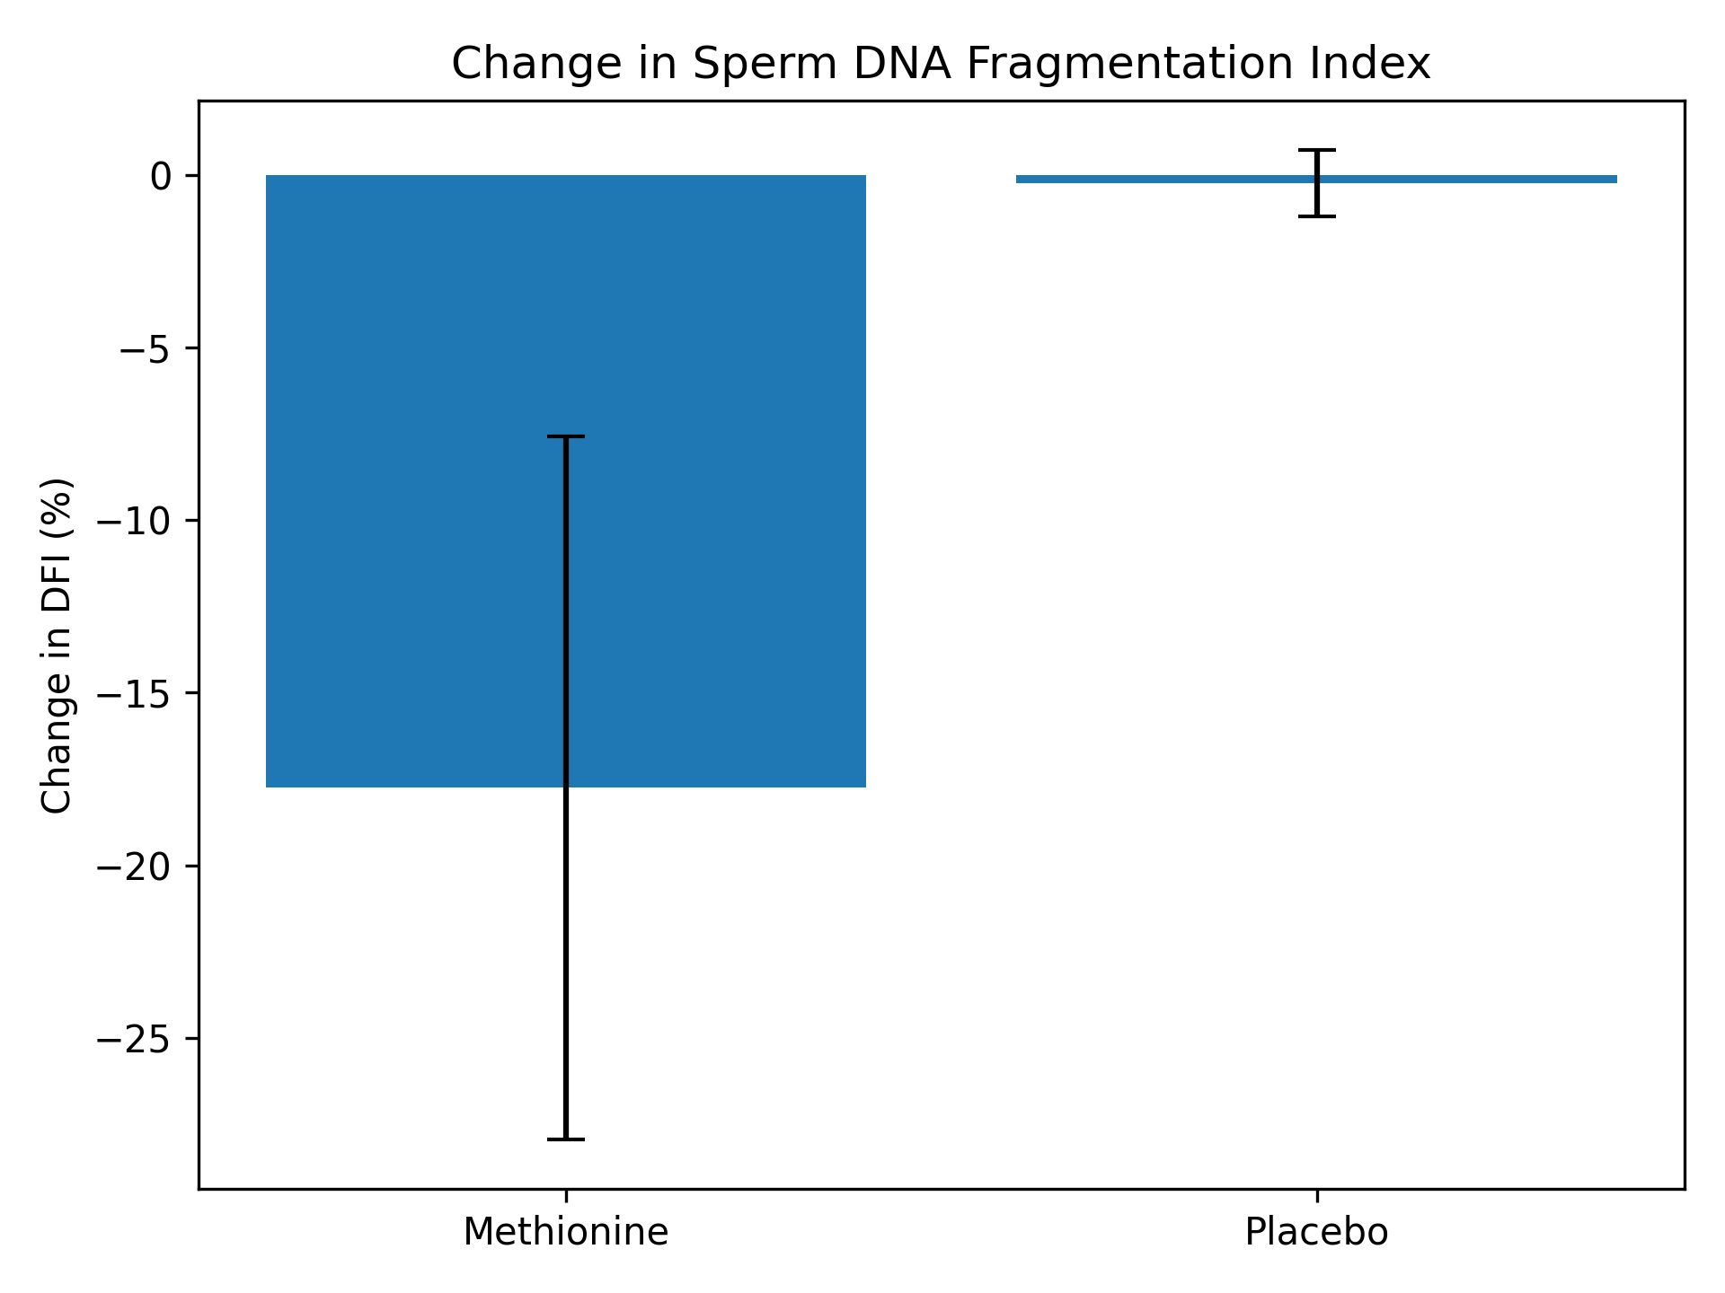

Error bars represent standard deviation. P<.001 between groups.

Similarly, progressive motility increased markedly in the methionine group (Figure 2).

Figure 2. Between-group comparison of change in progressive sperm motility after 12 weeks of intervention.

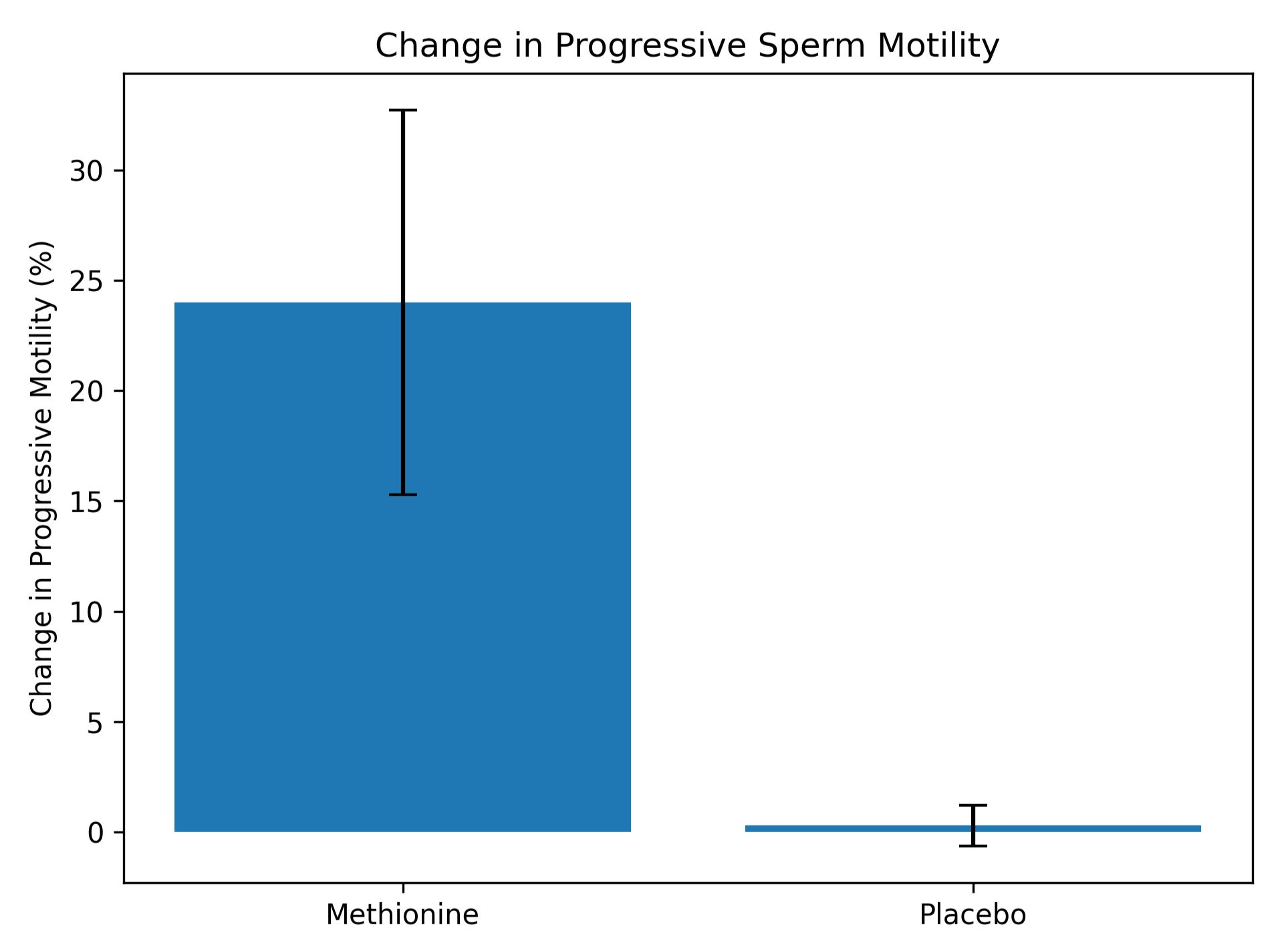

Error bars represent standard deviation. P < .001 between groups.

Correlation analysis within the methionine group showed a moderate inverse relationship between changes in DFI and progressive motility (r = −0.41, P = .076), as illustrated in Figure (3).

Figure 3. Correlation between changes in sperm DNA fragmentation index (ΔDFI) and progressive sperm motility in the methionine group.
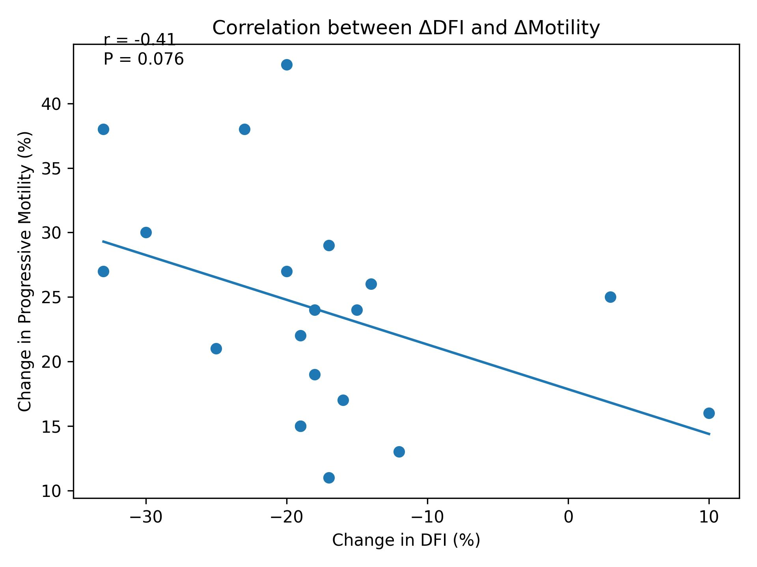
Pearson correlation coefficient: r = −0.41, P = .076.

DISCUSSION

Sperm DNA fragmentation (DFI) is increasingly recognized as a key determinant of male reproductive potential. In this study, elevated DFI was strongly associated with impaired semen quality, supporting its role as an important marker of male infertility. These findings are consistent with previous evidence linking high DFI levels to poor fertilization outcomes, compromised embryo development, and increased risk of miscarriage [9,10].

Previous studies evaluating antioxidant therapy in male infertility have reported inconsistent findings. While some studies demonstrated improvements in DFI without significant changes in semen parameters, others showed improvements in semen quality without a corresponding reduction in DNA fragmentation [11–13]. These discrepancies suggest that non-specific antioxidant approaches may not adequately target the molecular mechanisms underlying sperm chromatin instability.

In contrast, the present findings suggest that L-methionine may exert broader functional effects, improving sperm motility, morphology, and viability in addition to reducing DNA fragmentation. This difference may be explained by its distinct mechanism of action. Unlike conventional antioxidants that primarily reduce oxidative stress, L-methionine plays a central role in one-carbon metabolism and methylation processes.

As a precursor of S-adenosylmethionine (SAM), L-methionine contributes to DNA methylation, histone modification, and chromatin stabilization [15]. Disruption of these processes has been associated with increased susceptibility to DNA damage [16]. Therefore, restoration of methylation capacity may represent a targeted strategy for improving sperm genomic integrity.

The improvement in sperm morphology and motility may also be related to the role of methionine in protein synthesis and mitochondrial function. Previous studies have suggested that methionine metabolism is associated with enhanced sperm quality and motility [17,18]. These mechanisms collectively support the functional benefits observed in this study.

Notably, sperm concentration did not show significant improvement, which may reflect the longer duration required for spermatogenesis. This suggests that functional sperm parameters and DNA integrity may be more responsive to short-term metabolic interventions.

From a clinical perspective, improving sperm DNA integrity may have important implications for assisted reproductive techniques. Although clinical outcomes such as pregnancy and live birth rates were not assessed, the observed improvements in DFI provide a rationale for further investigation in this area.

The strengths of this study include its randomized, placebo-controlled design and the targeted inclusion of patients with elevated DFI. However, several limitations should be acknowledged, including the relatively small sample size and the lack of assessment of methylation or oxidative stress biomarkers.

A potential controversy raised by this study is whether targeted metabolic modulation may be more effective than conventional antioxidant therapy in improving sperm DNA integrity. Future studies with larger sample sizes and molecular endpoints are needed to further evaluate this hypothesis and to assess clinical reproductive outcomes.

conclusion
L-methionine supplementation improves sperm DNA integrity and functional semen parameters in infertile men with elevated DFI, with minimal effect on sperm concentration. These findings suggest that targeting methylation-dependent pathways may represent a promising therapeutic strategy for male infertility associated with genomic instability.

Conflicts of Interest
The authors declare that there are no conflicts of interest regarding the publication of this study. This research did not receive any specific grant from funding agencies in the public, commercial, or not-for-profit sectors.

COMPETING INTERESTS DISCLAIMER:
Authors have declared that they have no known competing financial interests OR non-financial interests OR personal relationships that could have appeared to influence the work reported in this paper.

References

[1] M. Vander Borght and C. Wyns, “Fertility and infertility: Definition and epidemiology,” Clin. Biochem., vol. 62, pp. 2–10, 2018.
[2] P. Thonneau et al., “Incidence and main causes of infertility in a resident population (1,850,000) of three French regions (1988–1989),” Hum. Reprod., vol. 6, no. 6, pp. 811–816, 1991.
[3] C. L. R. Barratt et al., “The diagnosis of male infertility: Evidence supporting global WHO guidance and future research priorities,” Hum. Reprod. Update, vol. 23, no. 6, pp. 660–680, 2017.
[4] M. Sigman, L. I. Lipshultz, and S. S. Howards, *Office Evaluation of the Subfertile Male*, 4th ed. New York, NY, USA: Cambridge Univ. Press, 2009, pp. 176.
[5] N. Zhao, X. L. Lu, J. T. Li, and J. M. Zhang, “Treatment of idiopathic oligozoospermia with combined human chorionic gonadotropin and human menopausal gonadotrophin: A randomized, double-blind, placebo-controlled clinical study,” Andrologia, vol. 51, no. 6, Art. no. e13271, 2019.
[6] Y. Zhang et al., “Methionine restriction: Association with redox homeostasis and implications for aging and disease,” Redox Biol., vol. 57, Art. no. 102464, 2022.
[7] L. Lauinger and P. Kaiser, “Sensing and signaling of methionine metabolism,” Metabolites, vol. 11, no. 2, Art. no. 83, 2021.
[8] M. Sepidarkish et al., “The effect of body mass index on sperm DNA fragmentation: A systematic review and meta-analysis,” Int. J. Obes., vol. 44, no. 3, pp. 549–558, 2020.
[9] L. Kooshesh et al., “Effect of letrozole on sperm parameters, chromatin status, and reactive oxygen species levels in idiopathic oligo/astheno/teratozoospermia,” Reprod. Biol. Endocrinol., vol. 18, no. 1, Art. no. 47, 2020.
[10] L. Simon, B. Emery, and D. T. Carrell, “Sperm DNA fragmentation: Consequences for reproduction,” Adv. Exp. Med. Biol., vol. 1166, pp. 87–105, 2019.
[11] P. Humaidan et al., “The combined effect of lifestyle intervention and antioxidant therapy on sperm DNA fragmentation and seminal oxidative stress in IVF patients: A pilot study,” Int. Braz. J. Urol., vol. 48, no. 1, pp. 131–156, 2022.
[12] A. Agarwal et al., “Impact of antioxidant therapy on natural pregnancy outcomes and semen parameters in infertile men: A systematic review and meta-analysis of randomized controlled trials,” World J. Mens Health, vol. 41, no. 1, pp. 14–48, 2023.
[13] A. Patki et al., “Impact of antioxidants on semen parameters and DNA fragmentation in subfertile males: A randomized, double-blind, placebo-controlled clinical trial,” Transl. Clin. Pharmacol., vol. 31, no. 1, pp. 28–39, 2023.
[14] S. Dutta, A. Majzoub, and A. Agarwal, “Oxidative stress and sperm function: A systematic review on evaluation and management,” Arab J. Urol., vol. 17, no. 2, pp. 87–97, 2019.
[15] D. B. McQueen, J. Zhang, and J. C. Robins, “Sperm DNA fragmentation and recurrent pregnancy loss: A systematic review and meta-analysis,” Fertil. Steril., vol. 112, no. 1, pp. 54–60.e3, 2019.
[16] C. Castellini et al., “Relationship between leukocytospermia and reproductive potential after assisted reproductive technology: A systematic review and meta-analysis,” Andrology, vol. 8, no. 1, pp. 125–135, 2020.
[17] D. C. Gonzalez et al., “Advanced paternal age and sperm DNA fragmentation: A systematic review,” World J. Mens Health, vol. 40, no. 1, pp. 104–115, 2022.
[18] K. Coyan, N. Baspinar, M. N. Bucak, and P. P. Akalin, “Influence of methionine and dithioerythritol on sperm motility, lipid peroxidation, and antioxidant capacities during liquid storage of ram semen,” Reprod. Domest. Anim., vol. 54, no. 3, pp. 426–433, 2019.

