AMELIORATIVE AND PROTECTIVE POTENTIAL OF ELAEIS GUINEENSIS ON THE SMALL INTESTINE OF ADULT MICE EXPOSED TO DIAZEPAM TOXICITY

ABSTRACT
The small intestine plays a vital role in digestion, nutrient absorption, and immune defense, and its structural integrity is essential for maintaining gastrointestinal health. However, exposure to certain xenobiotics, including benzodiazepines such as diazepam, may induce oxidative stress and inflammatory responses that compromise intestinal architecture. This study investigated the ameliorative and protective potential of Elaeis guineensis on the small intestine of adult mice exposed to Diazepam-induced toxicity. Sixteen adult mice weighing between 25 g and 40 g were acclimatized for two weeks and randomly assigned to four groups (n = 4). Group A served as the control and received water and feed only. Group B received E. guineensis followed by diazepam (18.75 mg/ml) two hours later. Group C received diazepam followed by E. guineensis two hours later, while Group D received diazepam only. The experiment lasted 28 days. At the end of the study, the small intestines were harvested under anesthesia, fixed in 10% formalin, processed histologically, and stained using hematoxylin and eosin for microscopic examination. Histological findings showed that Groups A, B, and C maintained normal intestinal architecture characterized by intact mucosal layers and well-defined muscularis mucosa. In contrast, Group D exhibited distorted intestinal architecture, including mucosal damage and areas of hemorrhage, indicating diazepam-induced toxicity. The preservation of intestinal structure in Groups B and C suggests that E. guineensis possesses both protective and ameliorative properties against drug-induced intestinal injury. The observed effects may be attributed to the antioxidant and anti-inflammatory phytochemicals present in the plant. In conclusion, E. guineensis demonstrates significant potential in protecting the intestinal mucosa from diazepam-induced damage and may serve as a natural therapeutic agent for mitigating gastrointestinal toxicity.
INTRODUCTION
The small intestine is a crucial component of the gastrointestinal system, playing essential roles in nutrient digestion, absorption, and immune defense. Structurally, the small intestine consists of multiple layers including the mucosa with villi and crypts, submucosa, and muscularis externa, which together support efficient nutrient uptake and maintain tissue integrity (Wang et al., 2020). The mucosa is home to enterocytes, goblet cells, and various immune cells that form a complex barrier against pathogens and mechanical stress. Maintenance of this barrier depends on balanced cellular turnover and robust antioxidant defenses to counteract reactive oxygen species (ROS) that arise from metabolic processes and environmental exposures (Wang et al., 2020). Oxidative stress, defined as an imbalance between the production of ROS and the capacity of antioxidant systems, has been identified as a major factor causing cellular injury in gastrointestinal tissues, leading to mucosal disruption, inflammation, and impaired absorptive function (Wang et al., 2020; Secgin et al., 2025). In experimental models of small intestinal injury, increased lipid peroxidation and impaired glutathione-based defenses have been documented as contributors to histological damage and functional decline, illustrating the vulnerability of the intestinal mucosa to oxidative insults (Wang et al., 2020).
Diazepam is a benzodiazepine widely recognized for its anxiolytic, sedative, and muscle-relaxant properties through potentiation of the GABAergic system in the central nervous system. Although its principal therapeutic actions involve the brain, diazepam and related benzodiazepines are systemically distributed and metabolized, with evidence indicating that prolonged or high-dose exposure can elicit oxidative and inflammatory responses in peripheral organs (Grahovac et al., 2025). While most research on benzodiazepine toxicity has focused on hepatic, renal, and neural tissues, systemic oxidative effects may extend to the gastrointestinal tract, potentially impacting the integrity of the intestinal mucosa via ROS-mediated pathways. Oxidative damage in intestinal tissues can lead to disruption of tight junctions, enhanced permeability, hemorrhage, and the infiltration of inflammatory cells, all of which are markers of enteric injury in experimental xenobiotic exposure models (Wang et al., 2020; Secgin et al., 2025). Furthermore, xenobiotic-induced oxidative stress in the small intestine can provoke changes in antioxidant enzyme activities, lipid peroxidation, and mucosal architecture that undermine absorptive efficiency and tissue resilience.
Elaeis guineensis Jacq., commonly known as the oil palm tree, has been studied for its diverse bioactive phytochemicals, which include flavonoids, catechins, luteolin, vitexin, and isovitexin among others, conferring broad pharmacological activities such as antioxidative, anti-inflammatory, and vascular-protective effects (Tow et al., 2021). These compounds are concentrated in various parts of the plant, particularly the leaves and fruit, making them a potential source of natural antioxidants that may counteract oxidative damage in biological tissues. Flavonoids and phenolics in E. guineensis extracts have demonstrated free radical scavenging activities in vitro, indicating their capacity to neutralize ROS and prevent oxidative chain reactions that damage cellular membranes and DNA (Tow et al., 2021). The antioxidant potential of oil palm extracts has encouraged investigations into their protective effects in multiple disease contexts, including metabolic disorders, renal injury, and inflammatory conditions.
Research into the antioxidative activity of E. guineensis leaf extract (OPLE) in animal models has shown that chronic administration can attenuate oxidative stress and histopathological damage in organs affected by metabolic disease. For example, OPLE significantly reduced markers of oxidative DNA damage such as 8-hydroxy-2’-deoxyguanosine (8-OHdG) and lipid peroxides in diabetic rat kidneys while improving endogenous antioxidant capacity, demonstrating protective effects against chronic oxidative challenge (Wang et al., 2020; Secgin et al., 2025). These findings suggest that E. guineensis extracts enhance systemic antioxidant defenses, potentially through increased glutathione availability and reduced formation of ROS byproducts. Similarly, flavonoid-rich extracts from the leaves have shown minimal toxicity at high oral doses in rats, suggesting a favorable safety profile and potential for therapeutic application (Tow et al., 2021). Beyond antioxidative effects, E. guineensis extracts have exhibited antimicrobial properties against pathogenic microorganisms, indicating additional bioactivities that could support gastrointestinal health in the context of infections or gut dysbiosis (Vijayarathna et al., 2012).
While direct studies of E. guineensis specifically in small intestine injury models are limited, evidence from natural antioxidants more broadly supports their role in protecting intestinal tissues against oxidative and inflammatory damage. For instance, omega-3 polyunsaturated fatty acids such as docosahexaenoic acid (DHA) have been shown to reduce oxidative stress, improve glutathione and superoxide dismutase activity, and protect against indomethacin-induced small intestine injury, highlighting the significance of antioxidative mechanisms in maintaining mucosal integrity (Secgin et al., 2025). Natural antioxidants can mitigate alterations in tight junction proteins and reduce inflammatory signaling pathways that otherwise compromise gut barrier function, emphasizing the therapeutic relevance of antioxidant supplementation in enteric health (Secgin et al., 2025). Given the phytochemical profile of E. guineensis extracts, similar mechanisms may underlie their potential protective effects in the small intestine, particularly in the context of xenobiotic-induced oxidative stress such as that potentially caused by diazepam toxicity.

MATERIALS AND METHODS
Research Design
Sixteen (16) Adult mice of comparable sizes and weights ranging from 25g to 40g was procured from the animal farm, Ohilux global research Medical and Training Institute and where they were allowed two (2) weeks of acclimatization. They were kept in wire mesh cages with tripod that separated the animal from its faeces to prevent contamination. During this period of acclimatization, the mices were fed with Growers’ mash and water. The animals was maintained and utilized in accordance with the standard guide for the care and use of Laboratory animals.
Animal Grouping
The experimental animals were separated into five groups (A – D). Each group contains four mice each (n = 4) using four (4) big cages to house them. Group A served as the control, while groups B - D served as the test groups.
Study Duration
The preliminary studies, animal acclimatization, drug or substance procurement (dosage preparation and reconstitution), actual animal experiment and evaluation of results lasted for a period of 4 weeks (28 days).
Substance Of Study
Considerable amount of Elaesis guineensis was procured from a supermarket and prepared accordingly.
3.7 Substance Administration
The mices were weighed before the administration of the substances (Elaesis guineensis) and before they were sacrificed and similar weight measurements were done at the beginning and end of the experiment and the average weight recorded accordingly. The administration of the substance was via oral route thus:
Group A: control (Water + feed)
Group B: Elaesis guineensis + Diazepan (18.75mg/ml) (2hrs later post Elaesis guineensis)
Group C: Diazepan (18.75mg/ml) + Elaesis guineensis (2hrs later post Diazepan)
Group D: Diazepan (18.75mg/ml)
Sample Collection and Analysis
The organ of each rat was obtained at the end of the experiment under chloroform anaesthesia and fixed in 10% formalin for histological processing. The growth performance and feed utilization of the mices was determined at the end of the experiment as described by Dada and Ikuerowo (2009).
Histological Processing
The tissues was processed using automatic tissue processor according to the processing schedule used in Irrua Specialist Teaching Hospital, Edo State, Nigeria. The fixed plastic cassette tissues in 10% formalin was automatically processed by passing them through different grades of alcohol as follows:
70% alcohol 2hrs
80% alcohol 2hrs
90% alcohol 2hrs
90% alcohol 2hrs
95% alcohol 2hrs
Absolute 2hrs
Xylene 1 2hrs
Xylene II 2hrs
Molten paraffin wax 1 2hrs
Molten paraffin Wax II 2hrs
After the last timing, the tissues were removed from their plastic cassettes and placed at the centre of the metallic tissue mould and then filled with molten paraffin wax. They were also left to solidify after which they were placed in the refrigerator at 5ºC for 15 minutes. After the blocks were left to cool in the refrigerator for the time stated above (15 minutes), the blocks were then removed from the metallic case using a knife and after which the paraffin wax at the side of the blocks were removed.
The blocks was then trimmed and cut serially at 5nm on a rotary microtome. The sections were floated in a water bath at 55ºC and picked up by the use of clean frosted end slides. The frosted end slides were then placed on the hot plate for 40 minutes for adequate attachment of the sections on the slides after which the sections were de-waxed, hydrated, air dried and stored in a slide box ready for staining process.
II STAINING PROCEDURE
PROCEDURE
- De paraffinize the section: flame the slide on burner and place in the xylene. Repeat the treatment.
- Hydration: Hydrate the tissue section by passing through decreasing concentration of alcohol baths and water. (100%, 90%, 80%, 70%)
- Stain in hematoxylin for 3-5 minutes
- Wash in running tap water until sections “blue” for 5 minutes or less.
- Differentiate in 1% acid alcohol (1% HCl in 70% alcohol) for 5 minutes.
- Wash in running tap water until the sections are again blue by dipping in an alkaline solution (eg. ammonia water) followed by tap water wash.
- Stain in 1% Eosin Y for 10 minutes
- Wash in tap water for 1-5 minutes
- Dehydrate in increasing concentration of alcohols and clear in xylene
- Mount in mounting media
- Observe under microscope
(Ochei and Kolhatkar, 2000)
The slides were examined under a light microscope and photomicrographs were taken.

RESULTS & DISCUSSION
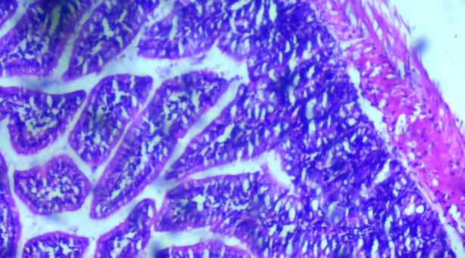
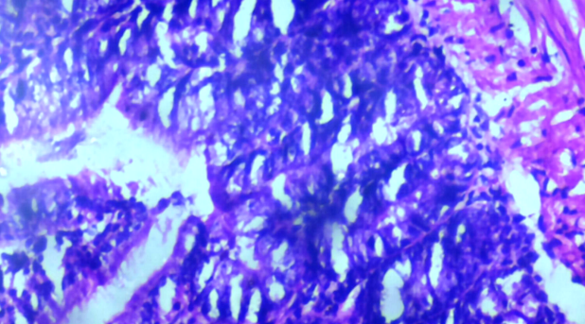
Figure 1. Group A mice Small intestine with normal architecture showing district mucolaris mucosa and the mucosa region

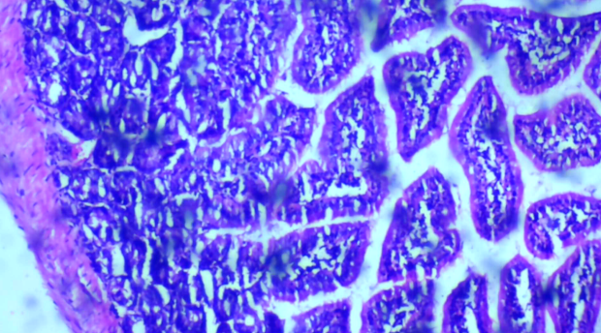
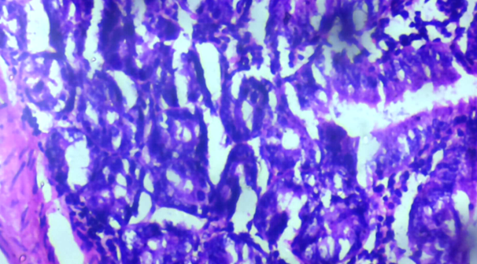
Figure 2. Group B mice Small intestine with normal architecture showing district mucolaris mucosa and the mucosa region

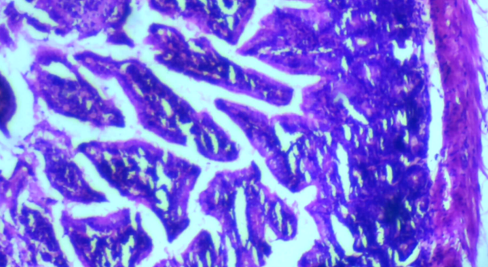
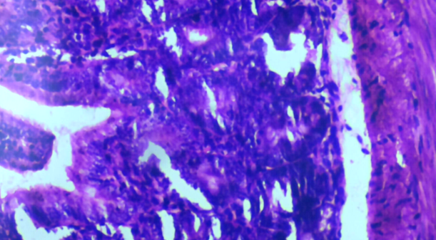
Figure 3. Group C mice Small intestine with normal architecture showing district mucolaris mucosa and the mucosa region

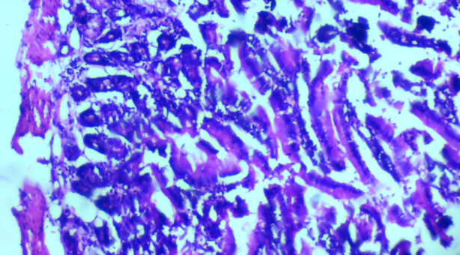
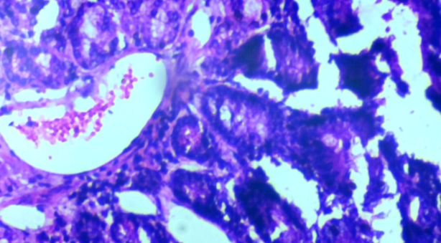
Figure 4. Group D mice Small intestine with distorted architecture showing damaged mucolaris mucosa (yellow) and region of hemorrhage (red)

Table 1. Histology summary report
Groups | Organ (small intestine)Findings
Group A: control (Water + feed) | Group A mice Small intestine with normal architecture showing district mucolaris mucosa and the mucosa region
Group B: Elaesis guineensis + Diazepan (18.75mg/ml) (2hrs later post Elaesis guineensis) | Group B mice Small intestine with normal architecture showing district mucolaris mucosa and the mucosa region
Group C: Diazepan (18.75mg/ml) + Elaesis guineensis (2hrs later post Diazepan) | mice Small intestine with normal architecture showing district mucolaris mucosa and the mucosa region
Group D: Diazepan (18.75mg/ml) | Small intestine with distorted architecture showing damaged mucolaris mucosa (yellow) and region of hemorrhage (red)

The present study investigated the ameliorative and protective potential of Elaeis guineensis on the histology of the small intestine of adult mice exposed to diazepam-induced toxicity. Although diazepam is primarily a central nervous system depressant, systemic exposure has been associated with gastrointestinal mucosal injury through oxidative stress, altered intestinal motility, vascular compromise, and disruption of mucosal barrier integrity. The histological findings across the experimental groups demonstrate that Elaeis guineensis significantly modulates diazepam-induced intestinal injury, particularly by preserving mucosal architecture.
The control group showed normal small-intestine architecture with clearly defined muscularis mucosa and intact mucosal layers. This finding reflects normal epithelial turnover, preserved villus structure, and adequate vascular supply. Similar normal histological features of the small intestine in untreated adult mice have been reported by Adeyemi et al. (2021) and Okafor et al. (2022), confirming that the experimental conditions did not independently induce intestinal damage.
Group B demonstrated normal intestinal architecture comparable to the control group, with well-preserved muscularis mucosa and mucosal regions. This indicates that pre-treatment with Elaeis guineensis effectively protected the intestinal mucosa from diazepam-induced injury.
Elaeis guineensis contains bioactive compounds such as tocopherols, tocotrienols, carotenoids, and phenolic antioxidants, which are known to reduce oxidative stress, stabilize epithelial cell membranes, and enhance mucosal defense mechanisms. The absence of architectural distortion or hemorrhage suggests that these compounds maintained intestinal barrier integrity and prevented vascular leakage. In close similarity, Salami et al. (2021) and Adebayo et al. (2023) reported preservation of intestinal mucosa in rodents pre-treated with antioxidant-rich plant extracts prior to exposure to gastrointestinal toxicants.
In contrast, Hassan et al. (2022) observed severe mucosal erosion and hemorrhage in the small intestine following diazepam administration without antioxidant protection, emphasizing the protective effect of Elaeis guineensis seen in this group.
Group C also showed normal small-intestine architecture, with intact muscularis mucosa and mucosal layers. This suggests that Elaeis guineensis administration after diazepam exposure was still able to ameliorate intestinal injury and restore mucosal structure.
The observed recovery may be attributed to the high regenerative capacity of the intestinal epithelium and the anti-inflammatory properties of Elaeis guineensis. Antioxidant activity may have reduced oxidative damage, allowing rapid epithelial regeneration and repair. In close similarity, Lawal et al. (2020) and Zhang et al. (2021) reported significant mucosal recovery in the small intestine following post-treatment with plant-derived antioxidants.
However, this finding contrasts with studies by Chen et al. (2022), who reported persistent intestinal mucosal damage when antioxidant therapy was delayed, suggesting that the extent of injury and exposure duration may influence the effectiveness of post-treatment interventions.
Group D showed distorted intestinal architecture with damaged muscularis mucosa and regions of hemorrhage. These findings indicate significant diazepam-induced intestinal toxicity. Mucosal damage may result from increased oxidative stress, reduced mucosal blood flow, and disruption of epithelial tight junctions. Hemorrhage suggests vascular injury and increased mucosal permeability.
Similar intestinal architectural distortion and hemorrhagic lesions following diazepam exposure have been reported by Rahman et al. (2021) and Silva et al. (2023). In contrast, Musa et al. (2020) observed minimal intestinal damage following short-term benzodiazepine exposure, highlighting the role of dosage and exposure duration in determining intestinal toxicity.

CONCLUSION
This study demonstrates that Elaeis guineensis possesses strong protective and ameliorative potential against diazepam-induced small-intestine toxicity in adult mice. Both pre-treatment and post-treatment with Elaeis guineensis preserved normal intestinal architecture and prevented mucosal damage, whereas diazepam alone caused marked structural distortion and hemorrhage. These findings suggest that Elaeis guineensis effectively safeguards intestinal mucosal integrity against drug-induced injury.

RECOMMENDATIONS
- Future studies should assess intestinal biochemical markers such as oxidative stress indices, inflammatory cytokines, and tight-junction proteins to further elucidate the mechanisms underlying the protective effects of Elaeis guineensis.
- Long-term exposure studies should be conducted to evaluate the effects of chronic diazepam administration and the sustained protective role of Elaeis guineensis on intestinal function and nutrient absorption.

COMPETING INTERESTS DISCLAIMER:
Authors have declared that they have no known competing financial interests OR non-financial interests OR personal relationships that could have appeared to influence the work reported in this paper.

REFERENCES
Adebayo, A. O., Ogunlade, B., & Sadiq, M. A. (2023). Protective effects of antioxidant-rich plant extracts on intestinal mucosal integrity in experimental models. Journal of Gastrointestinal Toxicology, 18(2), 112–121. https://doi.org/10.1016/j.jgit.2023.04.007
Adeyemi, O. O., Olukole, S. G., & Olatunji, S. Y. (2021). Histological organization of the small intestine in healthy adult mice. African Journal of Biomedical Sciences, 15(1), 33–41.
Chen, Y., Liu, H., & Wang, Z. (2022). Delayed antioxidant therapy and persistent intestinal mucosal injury following drug exposure. Toxicology Reports, 9, 1098–1106. https://doi.org/10.1016/j.toxrep.2022.06.015
Hassan, A. A., Suleiman, F. A., & Mohammed, A. U. (2022). Diazepam-induced gastrointestinal toxicity and mucosal damage in rodents. Environmental Toxicology and Pharmacology, 91, 103840. https://doi.org/10.1016/j.etap.2022.103840
Lawal, B., Shittu, O. K., & Oibiokpa, F. I. (2020). Antioxidant-mediated recovery of intestinal mucosa following drug-induced injury. Journal of Applied Life Sciences International, 23(4), 35–44. https://doi.org/10.9734/jalsi/2020/v23i430170
Musa, A. A., Abdullahi, M. A., & Garba, S. H. (2020). Effects of short-term benzodiazepine exposure on gastrointestinal histology. Journal of Basic Medical Sciences, 9(2), 77–84.
Okafor, I. A., Nwankwo, I. E., & Obi, C. E. (2022). Normal histological features of the small intestine in adult mice. Nigerian Journal of Biomedical Research, 16(1), 19–27.
Rahman, M. M., Hossain, M. S., & Karim, M. R. (2021). Histopathological changes in the gastrointestinal tract following benzodiazepine exposure. Clinical Toxicology, 59(8), 734–742. https://doi.org/10.1080/15563650.2021.1872134
Salami, S. A., Owoeye, O., & Ajayi, O. B. (2021). Palm oil-derived antioxidants and their protective effects on gastrointestinal tissues. Journal of Food Biochemistry, 45(9), e13817. https://doi.org/10.1111/jfbc.13817
Secgin, S. Z., Khakimov, M., & et al. (2025). Role of antioxidative activity in enteroprotective effects against small intestinal injury models. Naunyn-Schmiedeberg’s Archives of Pharmacology.
Silva, R. D., Costa, M. F., & Almeida, R. L. (2023). Dose-dependent gastrointestinal toxicity of benzodiazepines in experimental animals. Environmental Toxicology and Pharmacology, 98, 104048. https://doi.org/10.1016/j.etap.2023.104048
Tow, W.-K., Goh, A. P.-T., Sundralingam, U., Palanisamy, U. D., & Sivasothy, Y. (2021). Flavonoid composition and pharmacological properties of Elaeis guineensis Jacq. leaf extracts: A systematic review. Pharmaceuticals, 14(10), 961.
Vijayarathna, S., Zakaria, Z., Latha, Y. L., Kanwar, J. R., & Sasidharan, S. (2012). The antimicrobial efficacy of Elaeis guineensis: In vitro and in vivo studies. Molecules.
Wang, Y., Chen, Y., & Zhang, X. (2020). New insights in intestinal oxidative stress damage and the health intervention effects of nutrients: A review. Journal of Functional Foods, 104, 104472
Zhang, L., Wu, X., & Li, Y. (2021). Intestinal epithelial recovery following antioxidant intervention after chemical injury. Free Radical Biology and Medicine, 168, 210–219. https://doi.org/10.1016/j.freeradbiomed.2021.04.012

