Original Research Article

KNOWLEDGE, ATTITUDE AND PRACTICE (KAP) REGARDING INSULIN USE AMONG PATIENTS WITH DIABETES MELLITUS

ABSTRACT
Aims:To assess the knowledge, attitude, and practice regarding insulin use among patients with diabetes mellitus and to identify major gaps affecting safe insulin administration.
Study design:Cross-sectional observational study.
Place and Duration of Study:Department of General Medicine, ESIC Medical College and Hospital, Bangalore, over a period of 1 year.
Methodology:A structured questionnaire was administered to patients with diabetes mellitus receiving insulin therapy. The questionnaire included demographic and clinical data along with knowledge, attitude, and practice (KAP) items. Based on the analysable uploaded dataset, 4 knowledge items, 2 attitude items, and 3 practice items were scored. Each correct response was scored as 1 and each incorrect or unsure response as 0. The maximum analysable total KAP score was 9. Data were summarized using mean ± standard deviation, median with interquartile range, frequency, and percentage.
Results:A total of 100 patients were included in the final analysis. The mean duration of diabetes mellitus was 13.44 ± 6.88 years and the mean duration of insulin use was 55.37 ± 33.84 months. The mean knowledge score was 1.45 ± 0.91 out of 4, mean attitude score was 1.01 ± 0.64 out of 2, mean practice score was 1.35 ± 0.81 out of 3, and mean total KAP score was 3.81 ± 1.45 out of 9. Only 6% of participants knew the correct storage of insulin. Safe needle reuse practice was observed in only 37% of the participants, and proper disposal of needles in 45% of the participants
Conclusion:The study demonstrates substantial gaps in insulin-related knowledge and practice, with only moderate attitude scores. These findings support the need for repeated, structured, demonstration- based patient education regarding insulin administration, storage, site rotation, hypoglycaemia awareness, and disposal practices.
Keywords:Diabetes mellitus, insulin, knowledge, attitude, practice, hypoglycaemia, injection technique
INTRODUCTION
Diabetes mellitus is a chronic metabolic disorder characterized by persistent hyperglycaemia resulting from defects in insulin secretion, insulin action, or both.¹ It is a major public health challenge worldwide, and India contributes a substantial share of the global diabetes mellitus burden.² Insulin therapy remains the cornerstone of treatment in type 1 diabetes mellitus and is frequently required in type 2 diabetes mellitus when oral agents fail to achieve adequate glycaemic control or when patients present with marked hyperglycaemia, catabolic symptoms, acute illness, pregnancy, or progressive beta-cell dysfunction.^{1,3}
The effectiveness of insulin therapy depends not only on the prescription itself but also on the patient’s knowledge, attitude, and practice. Correct insulin use requires proper storage, correct injection technique, regular site rotation, awareness of hypoglycaemia, and safe disposal of used needles. ^{4,5} Deficiencies in any of these areas may result in poor glycaemic control, variable absorption, unnecessary dose escalation, lipohypertrophy, hypoglycaemia, and sharps-related hazards.^{4,6,7}

Attitude toward insulin is also highly relevant. Many patients perceive insulin as an indicator of disease worsening or personal failure, while others are hesitant to inject in public because of embarrassment, fear, pain, or stigma.^{8,9} Such attitudes may reduce adherence and delay optimal treatment.
Practice is the most clinically relevant domain because it reflects what the patient actually does. Even when patients know that needles should not be reused repeatedly or that injection sites must be rotated, actual behaviour may remain poor because of habit, cost constraints, fear, or lack of reinforcement.
Therefore, evaluation of all three domains—knowledge, attitude, and practice—is essential for identifying barriers to safe insulin use.
The present study was undertaken to assess the knowledge, attitude, and practice regarding insulin use among patients with diabetes mellitus receiving insulin therapy in a tertiary care teaching hospital.

MATERIAL AND METHODS

Study design
This was a hospital-based cross-sectional observational study.

Study setting
The study was conducted in the Department of General Medicine, ESIC Medical College and Hospital, Bangalore.

Study population
Patients with diabetes mellitus receiving insulin therapy were included in the study.

Inclusion and Exclusion criteria
Patients aged more than 18 years, diagnosed with diabetes mellitus, and currently on insulin therapy were included. Patients not receiving insulin therapy, those with severe acute illness, cognitive impairment, or inability to respond to the questionnaire, critically ill patients, those who refused consent, and those with incomplete data were excluded from the study.

Data collection tool
Data were collected using a structured, predesigned questionnaire assessing knowledge, attitude, and practice (KAP) regarding insulin use. The questionnaire included demographic and clinical details, followed by knowledge (4 items), attitude (2 items), and practice (4 items) related to insulin storage, injection technique, needle reuse, site rotation, hypoglycemia awareness, and disposal practices. The questionnaire was developed based on a review of relevant literature and standard guidelines on insulin administration and was pretested before use.

Each correct response was scored as 1 and each incorrect or unsure response as 0. Based on the analyzable dataset, the total KAP score ranged from 0 to 9, as three of the four practice items were included in the final analysis.

The questionnaire is provided as Appendix 1.

Demographic variables, including education level and socioeconomic status, were recorded. Education level was categorized into five groups (illiterate, primary, secondary, higher secondary, and graduate/postgraduate). Socioeconomic status was assessed using the modified Kuppuswamy scale based on monthly family income (Appendices 2 and 3).

7 Statistical analysis
Data were recorded in a structured proforma and entered into Microsoft Excel 2016 (Microsoft Corporation, Redmond WA). All entries were double checked for correctness. Continuous variables with normal distribution are expressed as mean ± standard deviation and variables that were not normally distributed are presented asmedian [interquartile range(IQR)]. Categorical variables were expressed as counts and percentage.

Statistical analyses was carried out using the statistical software IBM (International Business Machines Corporation) SPSS (Statistical Package for the Social Sciences) version 25.0 (IBM Corp Somers NY, USA)

RESULTS AND DISCUSSION

Baseline clinical characteristics
A total of 100 patients receiving insulin therapy were included in the final analysis. The mean duration of diabetes was 13.44 ± 6.88 years and the mean duration of insulin use was 55.37 ± 33.84 months.
Despite relatively long disease and treatment duration, knowledge and practice scores remained low, suggesting inadequate long-term reinforcement of insulin education.

Table 1. Clinical characteristics of study participants
Parameter | Value
Sample size | 100
Duration of diabetes (years)* | 13.44 ± 6.88
Duration of insulin use (months)* | 55.37 ± 33.84
Needle reuse frequency* | 2.42 ± 1.75
*Data are expressed as mean ± standard deviation

Overall KAP scores
The mean knowledge score was 1.45 ± 0.91 out of 4, the mean attitude score was 1.01 ± 0.64 out of 2, and the mean practice score was 1.35 ± 0.81 out of 3. The mean total KAP score was 3.81 ± 1.45 out of 9, indicating overall moderate-to-poor performance.

Table 2. Domain-wise KAP scores
Domain | Score | Median (IQR) | Maximum score
Knowledge | 1.45 ± 0.91 | 1 (1–2) | 4
Attitude | 1.01 ± 0.64 | 1 (1–1) | 2
Practice | 1.35 ± 0.81 | 1 (1–2) | 3
Total KAP | 3.81 ± 1.45 | 4 (3–5) | 9
*Data are express in median (interquatile range)

Figure 1. Correct responses for individual knowledge and practice-related items
The finding that only 6% of participants knew correct insulin storage is particularly important because improper storage can reduce insulin potency, especially in hot climates, and can contribute to poor glycaemic control despite apparent adherence.^{4,5} Poor knowledge regarding site rotation and needle reuse increases the risk of lipohypertrophy and erratic insulin absorption.^{6,7}

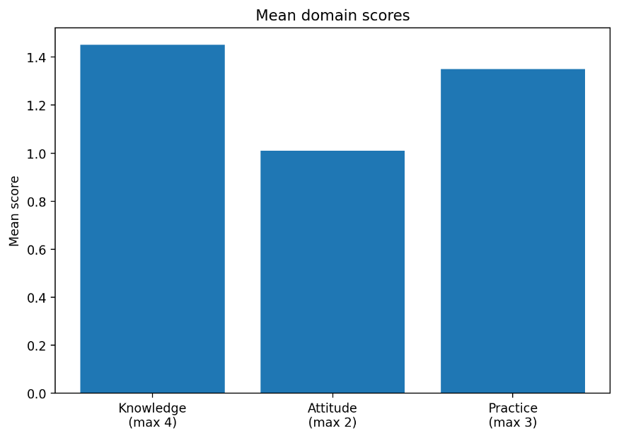

Knowledge domain
Knowledge was the weakest domain. Only 6% of participants knew correct insulin storage. Awareness regarding the need to avoid unsafe needle reuse, rotate injection sites, and recognize/manage hypoglycemia was also suboptimal.

Table 3. Knowledge item-wise responses

Knowledge item | Correct response (%)
Proper insulin storage | 6 (6)
Knowledge that needle reuse is unsafe | 46 (46)
Knowledge that injection site should be rotated | 46 (46)
Knowledge of hypoglycaemia recognition/management | 47 (47)

Figure 2. Correct responses for individual knowledge and practice-related items
The finding that only 6% of participants knew correct insulin storage is particularly important because improper storage can reduce insulin potency, especially in hot climates, and can contribute to poor glycaemic control despite apparent adherence.^{4,5} Poor knowledge regarding site rotation and needle reuse increases the risk of lipohypertrophy and erratic insulin absorption. Attitude domain
Attitude scores were relatively better than knowledge scores but still far from satisfactory. Only 48% gave the favourable response that insulin does not indicate worsening diabetes, while 53% were not worried or embarrassed about taking insulin in public.

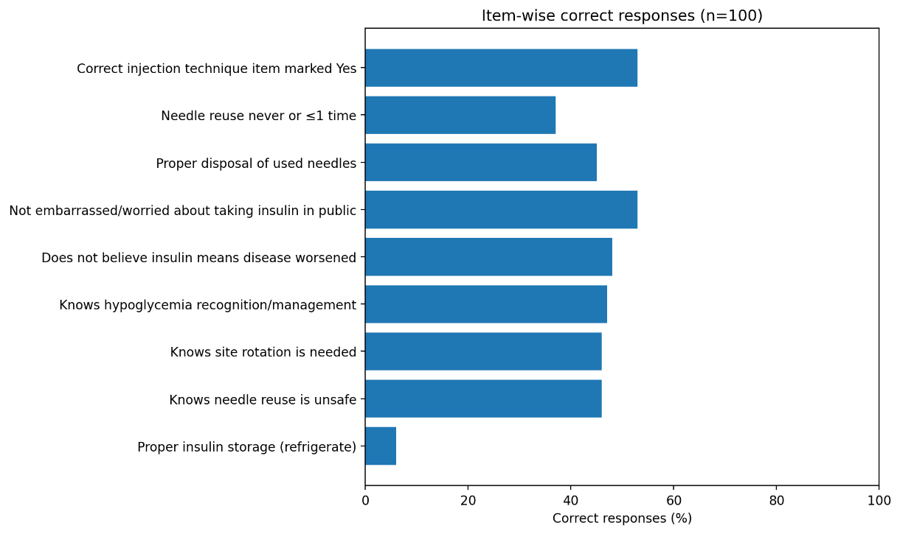

Table 4. Attitude item-wise responses
Attitude item | Favourable response n (%)
Does not believe insulin means diabetes has worsened | 48 (48)
Not worried/embarrassed about taking insulin in public | 53 (53)
These findings are consistent with psychological insulin resistance described in previous studies, where insulin is associated with disease severity, failure of self-care, or stigma.^{6,7}

^{8,9} Such attitudes may reduce adherence and delay intensification of therapy

Practice domain
The practice domain also showed significant deficiencies. Only 45% disposed of needles properly, and safe needle reuse practice was observed in only 37%. Correct injection-technique-related practice was reported by 53%.

Table 5. Practice item-wise responses
Practice item | Correct response n (%)
Proper disposal of used needles | 45 (45)
Safe needle reuse practice (never or ≤1 time) | 37 (37)
Correct injection-technique-related practice | 53 (53)

These findings show that actual day-to-day insulin-related behaviour remains poor even when some awareness is present. Practice is often shaped by cost constraints, habit, lack of demonstration, and absence of repeated counselling.

Disposal methods
Disposal practices were heterogeneous and often unsafe. Burning and vague “other” methods were common, while formal sharps-disposal practices were less frequent.

Table 6. Disposal methods used by study participants
Disposal method | No. (%)
Burned | 23 (23)
Others | 20 (20)
Plastic bottle | 17 (17)
Sharps container | 16 (16.)
Improper disposal | 12 (12)
Hospital collection | 12 (12)
Fig 3: Distribution of disposal methods among participants
Although storage in puncture-proof containers such as rigid plastic bottles may be safer than open disposal, it is still not equivalent to a structured sharps-disposal system unless managed properly. Burning and non-standard disposal methods create avoidable hazards for households and the community.^{4,6}

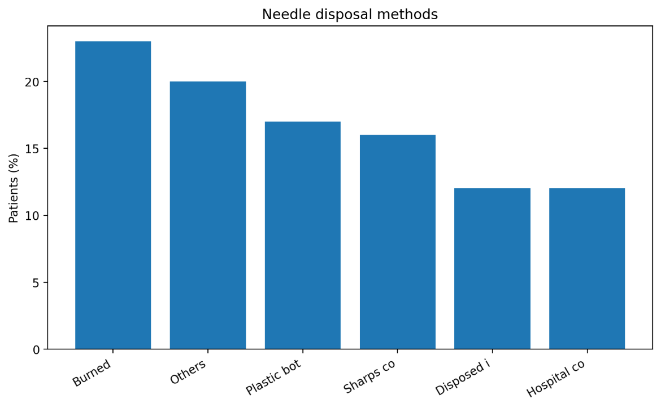

Domain comparison
Table 7. Comparative summary of KAP domains
Domain | Mean score | Interpretation
Knowledge | 1.45 / 4 | Poor
Attitude | 1.01 / 2 | Moderate
Practice | 1.35 / 3 | Poor
Total KAP | 3.81 / 9 | Moderate-to-poor
*KAP= knowledge, attitude and practice

Table 8. Mean domain scores as percentage of maximum possible score
Domain | Mean score | Maximum score | Percentage of maximum

Knowledge | 1.45 | 4 | 36
Attitude | 1.01 | 2 | 50
Practice | 1.35 | 3 | 45
Total KAP | 3.81 | 9 | 42
*KAP= knowledge, attitude and practice
This pattern demonstrates a clear KAP gap. Knowledge was the poorest domain, and practice also remained poor. Attitude was somewhat better, but still only around half of the maximum possible performance.

Total KAP score distribution
The median total KAP score was 4, with an interquartile range of 3–5, indicating clustering in the lower-middle range.

Figure 4. Distribution of total KAP scores among study participants
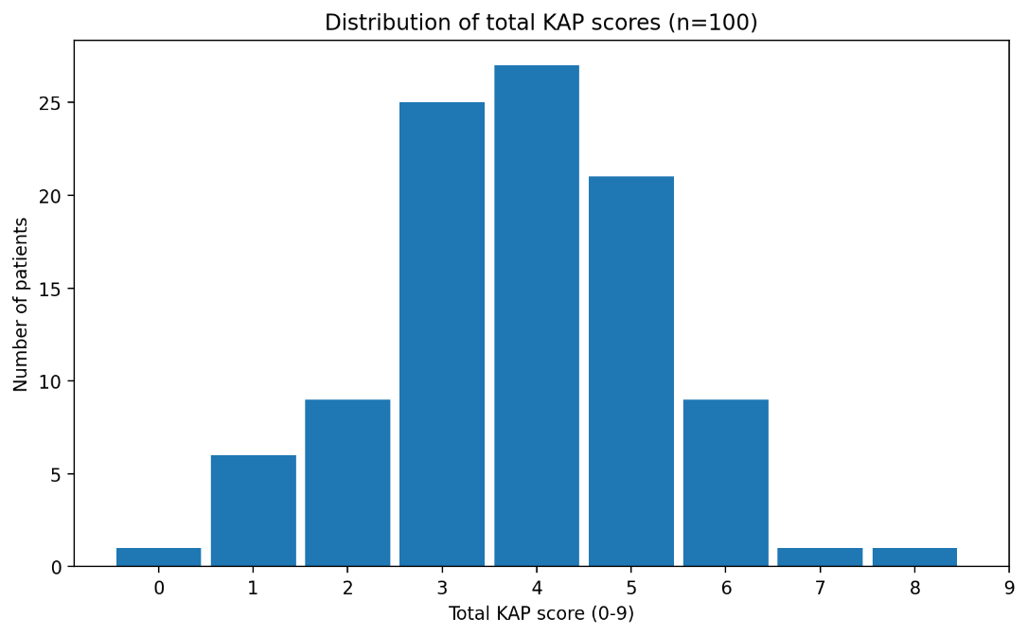
This score distribution supports the conclusion that most participants did not demonstrate high levels of insulin-related knowledge and practice.

This study demonstrates important deficiencies in insulin-related knowledge and practice among patients receiving insulin therapy, despite relatively long duration of diabetes mellitus and insulin use. The mean knowledge score was low, with correct understanding of insulin storage present in only 6% of participants. This is particularly relevant because storage errors can reduce insulin potency and may be misinterpreted clinically as treatment failure.^{4,5}
Awareness regarding needle reuse, site rotation, and hypoglycaemia was also inadequate. Repeated needle reuse and poor rotation practices are known contributors to lipohypertrophy, pain, tissue trauma, and erratic absorption.^{6,7,10} Similarly, poor awareness of hypoglycaemia is concerning because insulin- treated patients are inherently at risk of symptomatic and severe episodes.¹¹
Attitude-related findings showed that many participants still perceived insulin as a sign of worsening disease or felt discomfort about taking insulin in public. These findings align with prior literature on psychological insulin resistance and social barriers to insulin therapy.^{8,9,12}
Practice findings were particularly concerning. Only 37% demonstrated safe needle reuse practice and only 45% reported proper disposal behavior. Unsafe disposal practices such as burning or undefined methods suggest lack of standardized education and poor access to safe disposal systems.
Overall, the data suggest that an insulin prescription alone is not sufficient. Education must be repeated, practical, and demonstration-based. A one-time explanation at insulin initiation does not appear to produce durable behavioural improvement. Given that participants had diabetes mellitus for a mean duration of over 13 years and had been on insulin for over 4 years on average, the observed deficiencies point toward inadequate reinforcement rather than lack of opportunity to learn.

Strengths and limitations
A strength of the study is that it evaluates knowledge, attitude, and practice together rather than focusing on a single dimension of insulin use. It also reflects real-world patient behaviour in a tertiary care setting.
The main limitation is that the uploaded dataset supported analysis of a 9-point KAP structure rather than the full theoretical score suggested by all questionnaire items. In addition, the present analysis is primarily descriptive. If the original dataset in spreadsheet format is available, further subgroup

analysis by age, sex, education, socioeconomic status, and duration of diabetes could strengthen the manuscript.

CONCLUSION
This study shows that patients receiving insulin therapy have significant deficiencies in insulin-related knowledge and practice, with only moderate performance in the attitude domain. The weakest area was knowledge, especially awareness of correct insulin storage. Needle reuse and disposal practices were also inadequate in a substantial proportion of participants.
These findings highlight the need for structured and repeated education covering insulin storage, site rotation, needle reuse, hypoglycaemia recognition, and sharps disposal. Demonstration-based counselling by physicians, nurses, and diabetes educators should be integrated into routine follow-up. Improving patient knowledge and technique may improve glycaemic control, reduce complications, and decrease avoidable healthcare burden.

CONSENT
Informed consent was obtained from all participants included in the study.

ETHICAL APPROVAL
The study was conducted after obtaining approval from the appropriate Institutional Ethics Committee and in accordance with accepted ethical standards.

REFERENCES
- American Diabetes Association. Standards of care in diabetes—2024. Diabetes Care 2024;47:S1-S321.
- International Diabetes Federation. IDF Diabetes Atlas. 11th ed. Brussels, Belgium: International Diabetes Federation; 2025. Available from: https://diabetesatlas.org

- International Diabetes Federation. IDF Diabetes Atlas. 10th ed. Brussels: International Diabetes Federation; 2021.
- Inzucchi SE, Bergenstal RM, Buse JB, Diamant M, Ferrannini E, Nauck M, et al.Management of hyperglycaemia in type 2 diabetes: a patient-centered approach. Diabetes Care2015;38:140- 9.
- Frid AH, Kreugel G, Grassi G, Halimi S, Hicks D, Hirsch LJ, et al. New insulin delivery recommendations. Mayo Clin Proc 2016;91:1231-55.
- Hirsch LJ, Byron K, Gibney M. Intramuscular risk at insulin injection sites and rationale for shorter-length needles. Diabetes Technol Ther 2014;16:867-73.
- Kalra S, Mithal A, Sahay R, John M, Unnikrishnan AG, Saboo B, et al. Indian injection technique study: population characteristics and injection practices. Indian J Endocrinol Metab2017;21:600-7.
- Blanco M, Hernández MT, Strauss KW, Amaya M. Prevalence and risk factors of lipohypertrophy in insulin-injecting patients with diabetes. Diabetes Metab 2013;39:445-53.
- Peyrot M, Rubin RR, Lauritzen T, Skovlund SE, Snoek FJ, Matthews DR, et al. Resistance to insulin therapy among patients and providers. Diabetes Care 2005;28:2673-9.
- Polonsky WH, Fisher L, Guzman S, Villa-Caballero L, Edelman SV. Psychological insulin resistance in patients with type 2 diabetes. Diabetes Care 2005;28:2543-5.

- Grassi G, Scuntero P, Trepiccioni R, Marubbi F, Strauss K. Optimizing insulin injection technique and its effect on blood glucose control. J Clin Transl Endocrinol. 2014;1:145-50.
- Davis SN, Duckworth W, Emanuele N, Hayward R, Wiitala W, VADT Investigators. Effects of severe hypoglycemia on cardiovascular outcomes and death in type 2 diabetes. Endocrinol Metab Clin North Am 2013;42:657-76.
- Berard L, Cameron B, Woo V. Monitoring impact of diabetes education on self-care and glycemic outcomes. Can J Diabetes 2015;39:146-53.

APPENDIX
Appendix 1: Questionnaire used for assessment of knowledge, attitude, and practice regarding insulin use

A structured questionnaire was used to assess knowledge, attitude, and practice (KAP) regarding insulin use among patients with diabetes mellitus.

Section 1: Demographic and Clinical Data

- Age (in years):
- Sex: Male / Female
- Education level: Illiterate / Primary / Secondary / Higher Secondary / Graduate / Postgraduate
- Socioeconomic status: Upper / Upper-middle / Middle / Lower-middle / Lower
- Duration of diabetes (years):
- Duration of insulin use (months):
- Type of insulin used: Human / Analog / Premix / Others
- Who administers insulin? Self / Family / Nurse / Others Section 2: Knowledge
KQ1. Do you know how insulin should be stored properly? (Refrigerated, not frozen) KQ2. Is reusing insulin needles safe? (No)
KQ3. Should the injection site be rotated each time? (Yes)
KQ4. Do you know how to recognize and manage hypoglycemia? (Yes) Section 3: Attitude
AQ1. Do you think insulin means your diabetes has worsened? (No)
AQ2. Are you worried or embarrassed about taking insulin in public? (No) Section 4: Practice
PQ1. How do you dispose of used insulin needles? (Proper disposal in sharps container or puncture-proof container)
PQ2. How often do you reuse insulin needles? (Never or ≤1 time)

PQ3. Do you rotate the injection site regularly? (Yes)
PQ4. Do you clean the site and inject at the correct angle and depth? (Yes) Section 5: Additional Information
- Has the patient received prior training on insulin injection technique? (Yes/No)
- Source of training: Doctor / Nurse / Educator / Others
- Latest HbA1c (if available): %
- Remarks/Observations:

Scoring System:
Each correct response = 1 point Incorrect/unsure = 0 points
Attitude scored based on favorable response
Total KAP score calculated from analyzable items

Note: Of the four practice items, three were included in the final analysis based on data completeness.

Appendix 2: Education Classification
Education level was categorized as:

- Illiterate – cannot read or write
- Primary – up to 5th standard
- Secondary – 6th to 10th standard
- Higher secondary – 11th–12th / PUC
- Graduate/Postgraduate – college degree or higher

Appendix 3: Socioeconomic Status Classification (Modified Kuppuswamy Scale)
Socioeconomic status was classified based on monthly family income:

- Lower: < ₹15,000
- Lower-middle: ₹15,001–₹30,000
- Middle: ₹30,001–₹60,000
- Upper-middle: ₹60,001–₹1,00,000
- Upper: > ₹1,00,000

