SHORT RESEARCH ARTICLE

First Record of Shield-Tailed Snake (Uropeltis ellioti) in the Sloth Bear (Melursus ursinus) Diet from Nallamala Hills of Amrabad Tiger Reserve, India

ABSTRACT
The sloth bear (Melursus ursinus) is a unique myrmecophagous ursid whose diet exhibits considerable seasonal and geographical variation across its range in the Indian subcontinent. This study presents the first systematic documentation of the seasonal diet composition of sloth bears in Amrabad Tiger Reserve (ATR), Telangana, located in the Nallamala hills of the Eastern Ghats. The reserve, encompassing 2611 km² of southern tropical dry deciduous forest and savanna habitat, supports a diverse assemblage of flora and fauna.Over a one-year period, 143 sloth bear scats were collected opportunistically along forest trails and analyzed to determine dietary composition.A significant novel finding was the presence of reptilian remains, specifically the shield-tailed snake Uropeltis ellioti, identified in five scat samples through characteristic scales and vertebral fragments. This represents the first documented instance of Uropeltis species in the diet of sloth bears. The occurrence of this fossorial snake was largely restricted to the monsoon season, suggesting that increased soil moisture enhances accessibility of subterranean prey during digging for insects.These results demonstrate the high dietary flexibility and foraging plasticity of sloth bears in a dry deciduous forest ecosystem. By exploiting a broad spectrum of food resources—from insects and fruits to occasional vertebrates—sloth bears exhibit adaptive strategies that likely contribute to their persistence in fragmented and resource-variable habitats. This study provides baseline data on the feeding ecology of sloth bears in Amrabad Tiger Reserve and highlights the importance of conserving diverse microhabitats, including soil and litter layers, for the long-term survival of this Schedule I species.
Keywords: Diet composition, Uropeltis ellioti, Amrabad Tiger Reserve, Nallamala hills, Eastern Ghats, Myrmecophagy, Foraging ecology and Fossorial.
1.INTRODUCTION: The Sloth bear (Melursus ursinus) is widely distributed on the Indian sub continent– India, Nepal, Bhutan, and Sri Lanka and Bangladesh–ranges from the base of the Himalayas to the southern tip of the Western Ghats including the island of Sri Lanka (Prater, 1965). Most sloth bears in India reportedly occur in the tropical dry and moist deciduous forests of Chhattisgarh and Madhya Pradesh in Central India (Servheen 1990). Currently, much of the sloth bear range occurs outside protected areas in-fragmented forests (Jhala et al.2011). Presently its population is declining in many parts of its range due to deterioration and loss of its habitat (Johnsingh et al. 1986). In addition, poaching for gall bladder, capture of cubs from dens some time killing their mother have resulted in sloth bears vanishing from large parts of their former range. Population surveys have indicated that their numbers are low and possibly declining (Krishnan, 1972: Singh, 1973: Spillet, 1967). Sloth bear is included in Schedule I of Indian Wildlife Protection Act 1972 and Appendix I of CITES (Committee on International Trade in Endangered Species of Wild Fauna and Flora). Most bears are opportunistic omnivores. As such, their activities are governed by the availability of food items and dietary components within their habitat. This species is endemic to the Indian subcontinent and exhibits a range of unique morphological adaptations. These adaptations include a protrusible snout, long and flexible lips, powerful forelimbs, and a lack of upper incisors, all of which are specialised for myrmecophagy—feeding on social insects such as termites and ants (Ewer, 1973; Laurie & Seidensticker, 1977; Prater, 1971). Nutrition plays an important role in the reproductive rate of female bears (Jonkel and Cowan 1971). Most species of bears have been documented, at least on occasion, to feed on insects, especially ants (Joshi et al. 1997). However, the sloth bear is the only ursid having myrmecophagous. adaptations to feed on insects, especially termites and ants (Laurie and Seidensticker 1977, Joshi et al. 1997). Like other bears but unlike other myrmecophagous mammals, sloth bear diets vary seasonally and geograph ically across their range from Nepal south through India and Sri Lanka, depending on the availability of food and hardness of termite mounds (Laurie and Seidensticker 1977, Baskaran 1990, Gopal 1991, Gokula et al. 1995, Baskaran et al. 1997, Joshi et al. 1997). The Sloth Bear is a well known seed disperser, which influences the regeneration of some plant species (Sreekumar and Balakrishnan 2006). Consequently, its movement depends largely on the density and distribution of its key food availability in the area. Amrabad Tiger Reserve hosts a diverse array of wildlife, hosts a diverse array of wildlife hosts (Srinivasulu and Nagulu et al. 2002). However, no diet composition of sloth bear specific to the ATR is currently available. This Diet composition aims to document the Seasonal Diet preferences in Dry -Deciduous forest of Nallamala hills of Eastern Ghats.
2. MATERIALS AND METHODS
2.1.STUDY AREA
Amrabad Tiger Reserve (ATR) is spread across 2166 km the core area and 445 km is the buffer area, India was selected for assessing the prey population densities in this study for several important reasons. Spread across 2611 sq. km. in the new state of Telangana is one of the largest tiger reserves in India. It is part of the larger landscape which is spread across 6000 sq. km. separated by River Krishna, Nagarjunasagar Tiger Reserve, India’s largest tiger reserve. Classified as Southern Tropical Dry Deciduous Forests it is India’s largest Savannah Forest patch. The vegetation of the reserve mainly consists of the southern dry deciduous forest type (Champion and Seth., 1968) .comprising species like Terminalia tomentosa, Anogeisuss latifolia, Adina cordifolia, Hardwickia binate, Chloroxylon swietenia, Acacia sundra, Aegle marmelos, Dalbergia latifolia, Madhuca indica, among others, with patches of bamboo Bambusa arundinacea, Dendrocalamus strictus, with the forest thinning out to shrub savannas and grasslands. The natural vegetation is interspersed with forestry plantations of teak Tectona grandis (Reddy et al., 2004). Tigers Panthera tigris are the apex predator of the landscape. Other large carnivores that are found there are Dhole Cuon alpinus, Indian wolf Canis lupus pallipes, Leopard Panthera pardus and Sloth bear Melursus ursinus. Notable small and meso carnivores that are found there include jackal Canis aureus, jungle cat Felis chaus, and Rusty spotted cat Prionailurus rubiginosus, among others. The herbivore community includes Chital Axis axis, Sambar Rusa unicolor, Chowsingha, Wild boar Sus scrofa, Nilgai Boselaphus tragocamelous, and Chinkara (Reddy et al., 2004). The research specifically investigated how the sloth bears adapt their omnivorous diet to the fluctuating availability of resources across different seasons

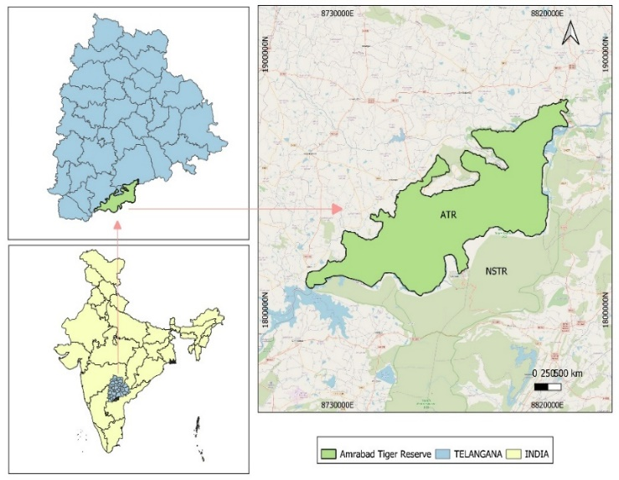
.

Fig.1.Map showing the Study area Amrabad Tiger Reserve
2.2.METHODOLOGY
Over one year, a total of 143 sloth bear droppings were collected randomly and opportunistic along forest trails during regular field surveys. (Still this Sloth bear Dropping collection on going research) Each dropping was identified based on characteristic features and preserved in Zip-lock bags with silica gel for laboratory examination. Each sample was weighed and soaked in tap water in a plastic container for approximately 24 hours. Following the soaking period, samples were thoroughly rinsed under running water using a two stage sieve system (0.7 mm and 0.4 mm mesh) to separate undigested residues from fine soil and digested material (Joshi et al., 1997; Mewada, 2015). After washing, the remaining material was weighed again. The contents were segregated and analysed to identify insect fragments, plant materials, and other animal remains representing different food categories some are identified on Macroscopic and microscopic level. Sloth bears (Melursus ursinus) in the Amrabad Tiger Reserve rely on a range of dietary resources that vary across seasons and habitat types. Understanding their feeding ecology is essential for assessing resource use and ecological adaptations. A systematic study of diet preferences, emphasizing seasonal variation and availability of key food items such as fruits, termites, and other invertebrates, can provide insights into foraging strategies and nutritional dependence. Such research may also reveal adaptive behaviors that enable sloth bears to persist in this semi-arid environment. The present study represents the first systematic attempt to document the feeding ecology of sloth bears in Amrabad Tiger Reserve.
3.RESULTS AND DISCUSSION
A total of 143 scat samples of the sloth bear (Melursus ursinus) were analyzed to understand dietary composition in the study area. The analysis revealed a broad spectrum of food items, dominated by invertebrates such as black ants, red ants, millipedes, beetles, and insect larvae including Tenebrio molitor. Plant remains, particularly Polyalthia cerasoides and Cassia fistula, were also identified, along with occasional crab fragments. This diverse composition reflects a flexible feeding strategy, consistent with earlier reports describing sloth bears as predominantly insectivorous but seasonally frugivorous (Laurie & Seidensticker, 1977; Joshi et al., 1997).
A notable observation was the presence of reptilian remains in five samples, identified as the shield-tailed snake Uropeltis ellioti. Identification was based on morphological examination of scales and vertebral fragments, with diagnostic features such as a blunt tail shield, keeled scales, and small body size confirming the species. This represents a novel dietary record, as no previous studies have documented Uropeltis species in the diet of sloth bears.
Shield-tailed snakes are fossorial and rarely encountered above ground, spending most of their life within soil substrates (Whitaker & Captain, 2004). Their occurrence in scat samples suggests that sloth bears are capable of excavating deeper soil layers while foraging. Although digging behavior is well established in the context of termite and ant predation (Laurie & Seidensticker, 1977), the consumption of a subterranean vertebrate indicates a greater degree of foraging plasticity than previously recognized.
The detection of Uropeltis ellioti was largely confined to the monsoon season, indicating a seasonal influence on prey availability. Increased soil moisture during this period likely facilitates the movement of fossorial fauna closer to the surface, enhancing their vulnerability to predation. Similar seasonal dietary shifts have been documented in sloth bears, where food selection closely follows resource availability (Bargali et al., 2004). The inclusion of crabs further supports the opportunistic nature of feeding, highlighting the ability to exploit both terrestrial and semi-aquatic resources when accessible.
The absence of prior records of shield-tailed snakes in sloth bear diet across available literature emphasizes the ecological significance of this finding. It expands the known trophic niche of the species and suggests that their ecological interactions may extend into below-ground faunal communities.
Overall, the dietary pattern observed in this study demonstrates that sloth bears are highly adaptable, opportunistic feeders. Their reliance on a wide range of food resources, including insects, plant material, and occasional vertebrates, is likely a key factor enabling survival in the resource-variable conditions of dry deciduous forests such as those in the Amrabad Tiger Reserve.

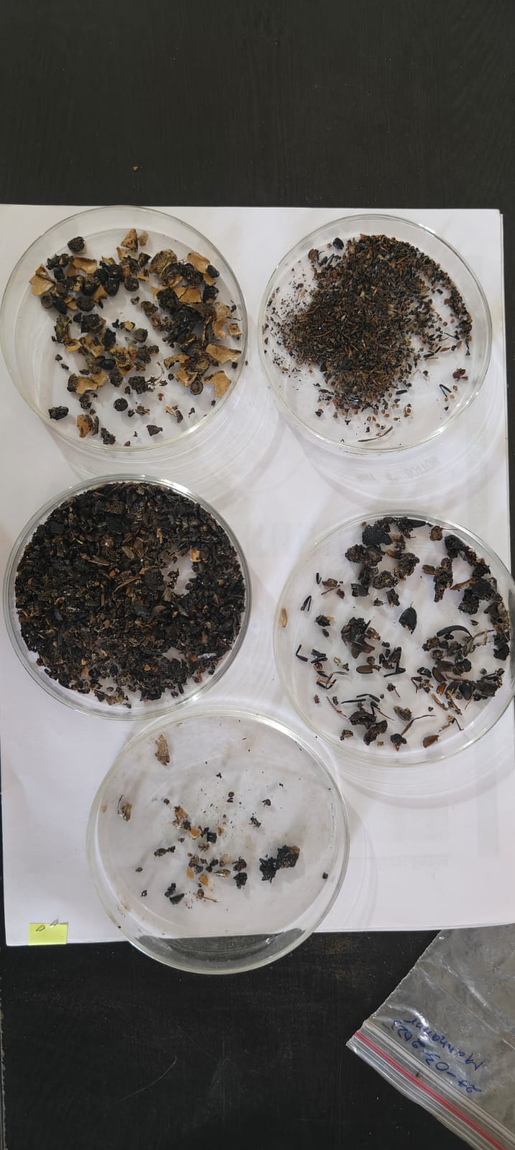
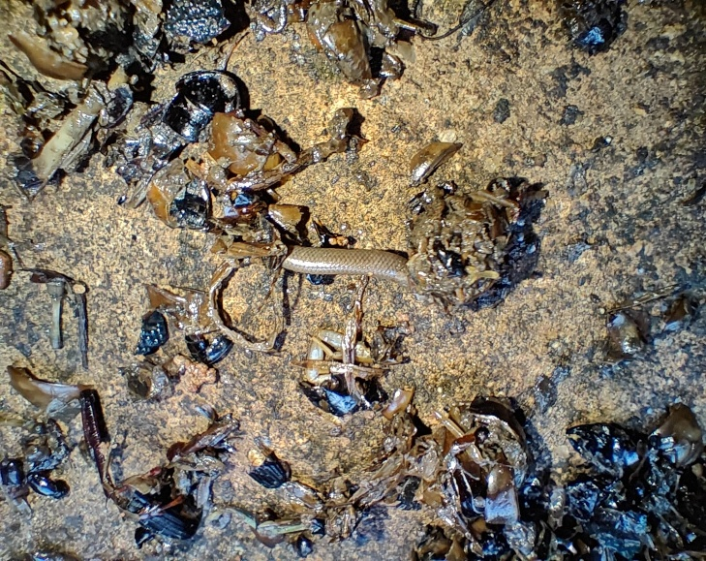
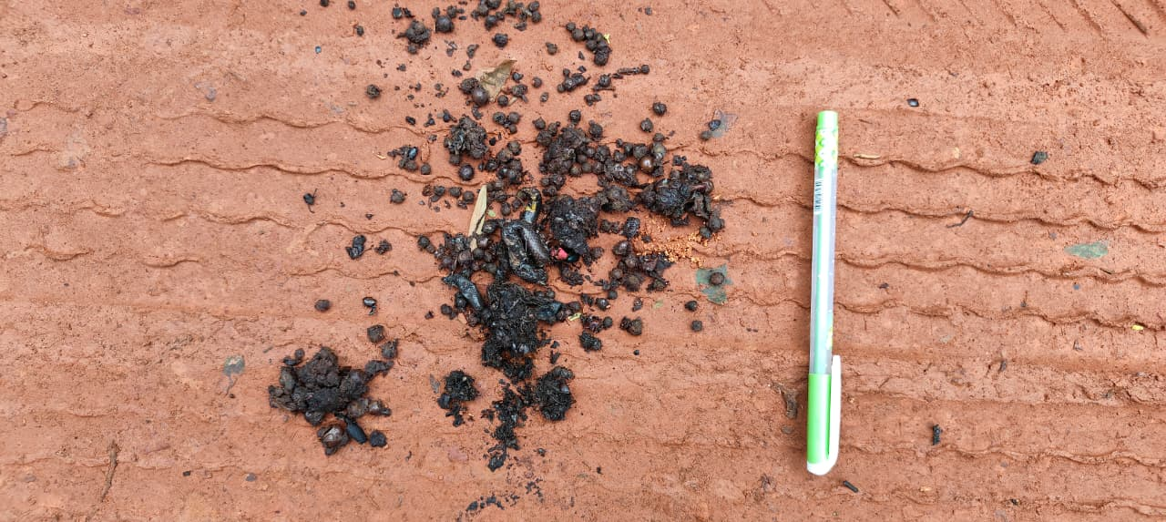
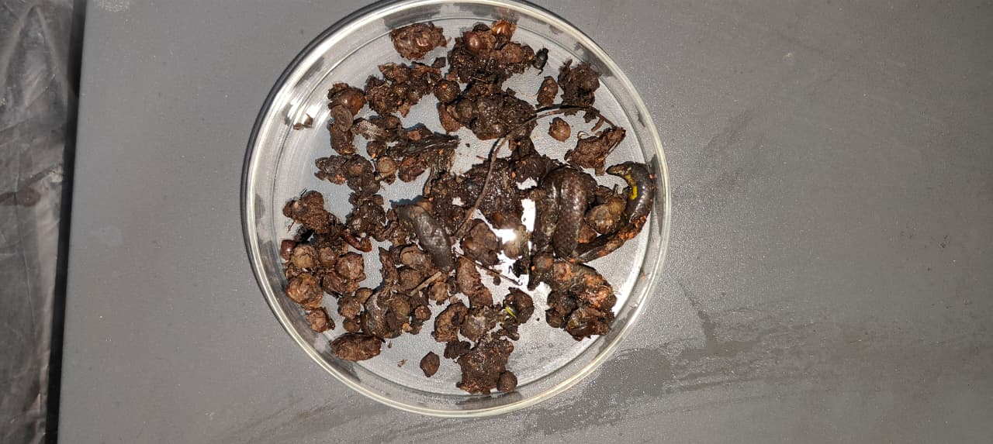
Fig.2 & 3. Showing Uropeltis ellioti in Sloth bear Droppings

Fig.4 & 5. Showing Separating food materials
4.CONSLUSION
The present study provides significant insights into the dietary ecology of sloth bears in the Amrabad Tiger Reserve. Reflecting the species’ ability to utilize a wide range of available food resources in a dry deciduous forest ecosystem. The most important finding of this study is the first documented occurrence of shield-tailed snakes (Uropeltis ellioti) in the diet of sloth bears. This novel record indicates that sloth bears are capable of exploiting fossorial prey through below-ground foraging, demonstrating a previously underreported aspect of their ecological behaviour. The seasonal occurrence of such prey further emphasizes the species’ adaptability in response to changing environmental conditions and food availability. These observations confirm that sloth bears are opportunistic feeders, with survival in resource-limited habitats largely dependent on their dietary flexibility. Their ability to switch between insectivore, frugivory, and occasional vertebrate predation highlights their ecological resilience. This study’s findings will be essential for improving our understanding of sloth bear foraging ecology and habitat use. The report concludes that the successful conservation of this species will depend on a multi-faceted approach that integrates robust, science-based research with effective habitat management. Equally important is fostering a deep-rooted commitment to biodiversity stewardship within local communities, ensuring the long-term conservation of sloth bears and the ecosystems they inhabit.

DISCLAIMER (ARTIFICIAL INTELLIGENCE)
The authors(s) hereby declare that generative AI technologies, including Large Language Models, were not used in the writing or editing of this manuscript.
COMPETING INTERESTS
Authors have declared that no competing interests exist
REFERENCES
Bargali, H.S., Akhtar, N. & Chauhan, N.P.S. (2004). Feeding ecology of sloth bear (Melursus ursinus) in a disturbed habitat in central India. Ursus, 15(2), 212–217.
Baskaran, N. (1990). An ecological investigation on the dietary composition and habitat utilization of sloth bear (Melursus ursinus) at Mudumalai Wildlife Sanctuary, Tamil Nadu (South India). M.Phil. Thesis, A.V.C. College, Mannambandal, Tamil Nadu, India.
Champion, H.G. & Seth, S.K. (1968). A revised survey of the forest types of India. Government of India Press, New Delhi.
Ewer, R.F. (1973). The Carnivores. Cornell University Press, Ithaca, NY.
Gokula, V., Sivaganesan, N. & Varghese, J. (1995). Food of the sloth bear (Melursus ursinus) in Mudumalai Wildlife Sanctuary, southern India. Journal of the Bombay Natural History Society, 92, 44–48.
Gopal, R. (1991). Ethological observations on the sloth bear (Melursus ursinus). Indian Forester, 117, 915–920.
Jonkel, C.J. & Cowan, I.M. (1971). The black bears in the spruce–fir forest. Wildlife Monographs, 27.
Joshi, A.R., Garshelis, D.L. & Smith, J.L.D. (1997). Seasonal and habitat-related diets of sloth bears (Melursus ursinus) in Nepal. Journal of Mammalogy, 78(2), 584–597. https://doi.org/10.2307/1382947
Krishnan, M. (1972). An ecological survey of the larger mammals of Peninsular India. Journal of the Bombay Natural History Society, 69(1), 27–54.
Laurie, A. & Seidensticker, J. (1977). Behavioural ecology of the sloth bear (Melursus ursinus). Journal of Zoology, 182(2), 187–204. https://doi.org/10.1111/j.1469-7998.1977.tb04155.x
Mewada, T.P. (2015). Index of relative importance of the dietary proportions of sloth bear (Melursus ursinus) in semi-arid region. Notulae Scientia Biologicae, 7(3), 281–288. https://doi.org/10.15835/nsb739577
Prater, S.H. (1965). The Book of Indian Mammals (3rd ed.). Bombay Natural History Society, Oxford University Press, Bombay.
Ratnayeke, S., van Manen, F.T. & Pelton, M.R. (2007). Home range and habitat use of sloth bears (Melursus ursinus inornatus) in Wasgomuwa National Park, Sri Lanka. Ursus, 18(2), 229–240. https://doi.org/10.2192/1537-6176(2007)18%5B229:HRAHUO%5D2.0.CO;2
Reddy, H.S., Srinivasulu, C. & Rao, K.T. (2004). Prey selection by the Indian tiger (Panthera tigris tigris) in Nagarjunasagar–Srisailam Tiger Reserve, India. Mammalian Biology, 69(6), 384–391. https://doi.org/10.1078/1616-5047-00152
Servheen, C. (1990). The status and conservation of the bears of the world. Eighth International Conference on Bear Research and Management Monograph Series, 2. International Association for Bear Research and Management, Victoria, Canada.
Singh, A. (1973). Tiger Haven. Macmillan, London.
Sreekumar, P.G. & Balakrishnan, M. (2006). Seed dispersal by the sloth bear (Melursus ursinus) in South India. Biotropica, 34(3), 474–477. https://doi.org/10.1111/j.1744-7429.2006.00166.x
Srinivasulu, V. & Nagulu, C. (2002). Mammalian and avian diversity of Nallamala Hills, Andhra Pradesh. Zoos’ Print Journal, 17(1), 671–684. https://doi.org/10.11609/JoTT.ZPJ.17.1.671-684
Whitaker, R. & Captain, A. (2004). Snakes of India: The Field Guide. Draco Books, Chennai.

