Hepato-Renal Consequences and Stress Response of Female Wistar Rats Exposed to Water Pipe Tobacco

ABSTRACT
Water pipe tobacco smoking, commonly known as shisha or hookah, has gained increasing popularity, particularly among females, despite growing evidence of its adverse health effects. This study investigated the hepato-renal consequences and oxidative stress response of female Wistar rats exposed to water pipe tobacco smoke. Twenty-five adult female Wistar rats (120–150 g) were randomly divided into five groups: a control group and four exposure groups subjected to shisha smoke for 10 or 20 minutes daily for either 2 or 4 weeks. Hepatic biomarkers (AST, ALT, ALP), renal function indices (urea, creatinine, electrolytes), and oxidative stress markers (GSH, SOD, catalase, and MDA) were analyzed using standard biochemical methods. Results showed significant increases (p < 0.05) in AST, ALT, and ALP levels in exposed groups compared to control, indicating hepatocellular injury and possible cholestatic damage. Renal function analysis revealed significant alterations in urea, creatinine, sodium, potassium, chloride, and bicarbonate levels, suggesting impaired renal and electrolyte homeostasis. Oxidative stress assessment demonstrated significant elevations in antioxidant enzymes (GSH, SOD, catalase) alongside increased malondialdehyde levels, indicating enhanced lipid peroxidation and oxidative damage. These findings demonstrate that exposure to water pipe tobacco smoke induces hepato-renal toxicity and oxidative stress in female Wistar rats, with effects dependent on exposure duration and intensity. The study highlights the potential health risks associated with shisha smoking and underscores the need for increased public health awareness and regulatory interventions.
Key Words: Water pipe tobacco, Oxidative stress, Liver enzymes, Renal function, Female Wistar rats

1. INTRODUCTION
Water pipe tobacco commonly known as shisha or hookah tobacco, is a flavoured tobacco product smoked using a water pipe. It is typically a mixture of tobacco, molasses or honey, glycerin and various flavoring agents, producing a sweet-smelling smoke when heated with charcoal (Maziak, 2015). The study of water pipe tobacco, encompasses its unique composition and various flavorings, creating a moist blend distinct from traditional cigarettes (Maziak, 2015). People smoke water pipe tobacco as a way to relax and unwind while some people try it out of curiosity or as part of experimenting with different forms of tobacco consumption. In some cultures, smoking hookah is a longstanding tradition and a part of social and family rituals. Some believe it is less harmful than cigarette smoking, though this is a misconception. Different classes of people smoke shisha including young adults, adolescents and adults. Smoking of shisha is mostly practiced by female (Jamil et al., 2011). The increasing prevalence of shisha smoking among females necessitates scientific investigation into its health implications. The harmful health effects of shisha smoking are mainly due to the presence of carbon monoxide, polycyclic aromatic hydrocarbons, volatile aldehydes (formaldehyde, acetaldehyde, acrolein, propionaldehyde, and methacrolein), nitric oxide (NO), nicotine, phenolic compounds, tar, ammonia, heavy metal and particulate matter in the smoke generated. (Elsayed et al., 2016). The carbon monoxide in the smoke competes with oxygen in the blood to form carboxyhemoglobin, leading to cell hypoxia and impaired cell respiration. The nicotine in smoke has been shown to have acute and chronic cardiovascular effects and increased heart rate. (Shihadeh et al., 2014). The PAHs, VA, heavy metals, and tar are known to cause carcinogenesis by mutation of the p53 tumour suppressor gene. Carbon monoxide, tar, NO, and other particulate material cause lung pathologies by decreasing forced vital capacity and impairing other lung functions. Shisha smokers have shown increased oxidative stress leading to cardiovascular changes and carcinogenesis. (Shihadeh et al., 2014, Elsayed et al.,2016).
Since water pipe tobacco is not only heated by charcoal but also contains additives, flavourings and sometimes contaminants from the tobacco itself, the burning of this tobacco during smoking might release heavy metals such as lead, cadmium, nickel and arsenic. These metals may come from the soil where the tobacco was cultivated, fertilizers and pesticides used in farming or from the combustion of the charcoal placed on top of the bowl and when inhaled, these metals enter the lungs and bloodstream, where they accumulate over time and might cause harmful effects including respiratory problems, kidney damage and increased risk of cancer (Nwauche et al., 2025).
The liver and kidneys play central roles in detoxification and excretion of xenobiotics, making them particularly vulnerable to tobacco-induced toxicity. Damage to these organs can be assessed using biochemical markers such as liver enzymes, renal function indices, and oxidative stress biomarkers. Despite increasing shisha use, experimental data on its hepato-renal and oxidative effects, especially in females, remain limited. Therefore, this study was designed to evaluate the hepato-renal consequences and oxidative stress response of female Wistar rats exposed to water pipe tobacco smoke, with the aim of providing experimental evidence on the potential health risks associated with shisha smoking.

2. MATERIALS AND METHODOLOGY
2.1 Materials and Equipment
- Agilent FS240AA Atomic Absorption Spectrophotometer
- Rotary evaporator
- Centrifuge
- Gas Chromatograph-Buck M910 scientific gas chromatography
- Inhalation chamber
- Shisha pot apparatus
- Pressure pump

2.2 Reagents and chemicals
Reagents and chemicals used were of analytical grade.
2.3 Purchase of shisha pot
A commercially available shisha pot apparatus & coal sample was purchased from a local retail shop in Port Harcourt, Rivers State.
2.4 Purchase of animals
Twenty five (25) adults female wistar rats weighing between 120-150kg were purchased from the animal house of Animal and Environmental Biology, Rivers State University. They were acclimatized for a period of seven (7) days prior to exposure with feed and water ad libitum.

2.5 Methods
2.5.1 Preparation of water pipe tobacco and Administration.
The base was filled with water and the stem was inserted into the base. The shisha tobacco flavor was sprinkled into the bowl and covered with an aluminum foil. A pin was used to create little holes on the foil, the coal was lit and placed on the foil.
A hose was used to connect the Shisha pot and a pressure pump to an inhalation chamber were the animals were kept. The pressure pump extracted the smoke from the Shisha pot and it was released to the animals for a period of time.
2.5.2 Experimental Design.
The animals were grouped into five groups. Group one animals which served as the control with no Shisha exposure. Group two animals were exposed to the Shisha smoke for ten (10) minutes per day for a period of two (2) weeks. Group three animals were exposed to the Shisha smoke for twenty (20) minutes per day for a period of two (2) weeks. Group four animals were exposed to the Shisha smoke for ten (10) minutes per day for a period of four (4) weeks. Group five animals were exposed to the Shisha smoke for twenty (20) minutes per day for a period of four (4) weeks.
Groups | Exposure period | Durations
1 | Control group (no shisha exposure)
2 | 10 minutes per day | 2 weeks
3 | 20 minutes per day | 2 weeks
4 | 10 minutes per day | 4 weeks
5 | 20 minutes per day | 4 weeks

2.6 Analysis of parameters
Liver biomarkers
2.6.1 Determination of Plasma Alanine Aminotransferase Activity
The plasma activity of alanine aminotranferase (ALT) was determined using Randox test kits (Randox Laboratories, Crumlin, England).
Principle
ALT was measured by monitoring the concentration of pyruvate hydrazone formed with 2,4 –dinitrophenyl hydrazine.
α – Oxoglutarate + L- Alanine L-Glutamate +Pyruvate
Procedure
Two test tubes were set up labelled T₁ (reagent blank) and T₂ (test sample). T₁ contained 0.10ml distilled water and 0.50ml Randox buffer solution, while T₂ contained 0.10ml plasma sample and 0.50ml Randox buffer solution. The contents were mixed and incubated for 30min at 37ºC. To each test tube was added 0.50ml of Randox 4 - dinitrophenylhydrazine solution and the contents were mixed and allowed to stand for 20mins at 25ºC. Sodium hydroxide (5ml) solution was added to each of the tubes. The contents were then mixed, and after 5min, their absorbance were read at 546nm against blank in a spectrophotometer Model 752S (Spectrumlab).
2.6.2 ​Determination of Plasma Aspartate Aminotransferase Activity
The plasma activity of aspartate aminotransferase (AST) was determined using Randox test kits (Randox laboratories, Crumlin, England).
Principle​
AST was measured by monitoring the concentration of oxaloacetate hydrazone formed with 2, 4- dinitrophenylhydrazine.
α – Oxoglutarate + L- Aspartate L-Glutamate + Oxaloacetate
Procedure
Two test tubes were set up labelled T₁ (reagent blank) and T₂ (test sample). T₁ contained 0.10ml distilled water and 0.50ml Randox buffer solution, while T₂ contained 0.10ml plasma sample and 0.50ml Randox buffer solution. The contents were mixed and incubated for 30min at 37ºC. To each test tube was added 0.50ml of Randox 4- dinitrophenylhydrazine solution and the contents were mixed and allowed to stand for 20mins at 25ºC. Then 5ml of sodium hydroxide solution was added to each of the tubes. The contents were mixed, and after 5min, their absorbances were read at 546nm against the reagent blank in a spectrophotometer.
2.6.3 Determination of Plasma Alkaline Phosphatase Activity
The plasma activity of alkaline phosphatase (ALP) was determined using Randox Test kits (Randox Laboratories, Crumlin, England).
Principle ​
p-Nitrophenyl phosphate is hydrolyzed in the presence of magnesium ions by phosphatase to phosphate and p-nitrophenol. The rate of p-nitrophenol liberation is proportional to the alkaline phosphatase activity and can be measured photometrically. The standard colorimetric method is according to the recommendations of the Deutsche Gesellschaft fur Klinische chemie.
ALP
p-Nitrophenyl phosphate + H₂0 Phosphate + p-nitrophenol
Procedure
To 0.02ml of the plasma sample in a cuvette was added 1.0ml of Randox ALP reagent (at 30ºC). The content was mixed and the initial absorbance was taken, after which the readings were taken after 1, 2 and 3 min, at 405nm in a spectrophotometer.
Kidney function biomarkers
2.6.4 Determination of Urea Concentration (Randox Kits)
Principle
In the presence of an enzyme called urease, serum that contains urea is hydrolyzed to ammonia. Photometrically, the ammonia is then assayed by Berthelot’s reaction.
Three test tubes labelled T1 (Sample), T2 (Blank) and T3 (Standard) were set up. 0.01ml of the Blood Urea Nitrogen (BUN) enzyme reagent was pipetted into all the test tubes. Exactly, 0.01ml of serum sample, 0.01ml of distilled water and 0.01ml of standard were pipetted into T1, T2 and T3 respectively. These were mixed very well and incubated at 37 ºC for ten minutes. To each tube was added 1.5ml of BUN colour developer and they were mixed and further incubated at 37 ºC for fifteen minutes. The spectrophotometer was zeroed at 456nm and the absorbance for the standard and sample were read against the reagent blank.
2.6.5 Determination of Creatinine Concentration (Randox Kits)
Principle
In alkaline solution, creatinine reacts with piciric acid to form a complex which is coloured. The creatinine concentration is directly proportional to the quantity of the complex formed.
Procedure
Three test tubes labeled T1 (Sample), T2 (Blank) and T3 (Standard) were set up. 3.0 ml of the working reagent was pipetted into all the tubes. Exactly zero point one of serum sample, zero point one milliliter of water and zero point one milliliter of standard were pipetted into T1, T2 and T3 respectively. They were incubated at 37 ºC after being properly mixed for fifteen minutes. The spectrophotometer was zeroed at 510 nm with the blank and the absorbance values were read.

2.6.6 Determination of Sodium Concentration (Maruna 1958)
Three test tubes labeled T1 (Blank), T2 (Standard) and T3 (Sample) were set up. Exactly 1.0ml of Precipitating Filtrate Reagent (PFR) was pipetted into the three tubes. A volume of 0.5ml of the sample was added to T2 and T3, while distilled water of the same volume into T1. The tubes were centrifuged for ten minutes at a very high speed. One milliliter of the reagent (acid) was pipetted into all the tubes and mixed. A volume of 0.05ml of supernatants was introduced to all the test tubes and mixed. A volume of 0.05ml of sodium color reagent (SCR) was also added to all tubes and mixed. The spectrophotometer was zeroed with distilled water at 550nm, the absorbance values were read and recorded.
2.6.7 Determination of Potassium (Colorimetric Method)
Three test tubes labeled T1 (Sample), T2 (Blank) and T3 (Standard) were set up. One (1ml) of Potassium reagent was pipette into all the test tubes. A volume of zero point zero one milliliter of the sample was carefully introduced to the respective tubes, mixed and permitted to stay for three minutes at 25˚C. The spectrophotometer was zeroed with the reagent at 500nm followed by reading and recording of the absorbance values.
2.6.8 Determination of Chloride (Colorimetric Method)
Three test tubes labeled T1 (Sample), T2 (Blank) and T3 (Standard) was properly aligned. Exactly, 1.5ml of chloride reagent was pippeted into all the test tubes. A volume of 0.01ml of the standard and sample was introduced to respective tubes and incubated for five minutes at 37ºC.
2.7 Determination of stress enzymes
2.7.1 Measurement of Reduced Glutathione (GSH) Activity
The level of the reduced Glutathione (GSH) was measured using a GSH assay kit (Cayman, Ann Arbor, MI, USA). This process involved an optimized enzymatic recycling method and glutathione reductase (GR). The sulphydryl group of the glutathione reacts with 5,5-dithiobis-2-nitrobenzoic acid (TNB). A mixture of disulfides, GSTNB was formed between GSH and TNB, which is reduced by GR to recycle GSH, thereby releasing more TNB. The rate of production of TNB is directly proportional to the recycling reaction which in turn is directly proportional to the GSH concentration in the sample. The absorbance of TNB was taken at a wavelength of 410nm which is used to determine the value of GSH and expressed as µmol/mg protein.
2.7.2 Estimation of Catalase (Cat) Activity
The catalase activity was estimated based on the peroxidatic function of catalase using the catalase assay kit (Cayman). This process is based on the reaction of the enzyme with methanol in the presence of hydrogen peroxide (H2O2). The product of this reaction, formaldehyde is measured at 540nm using the colorimetric calibration with a chromogen (4-amino-3-hydrazino-5-mercapto-1,2,4-triazole (Purpald). The catalase activity is expressed as protein.

2.7.3 Determination of SOD (Superoxide Dismutase)
Kit 19160 SOD (Sigma Aldrich, St. Louis, MO, USA) was used for the assay of SOD. First, 200 μl R1 reagent (WTS solution diluted 20-fold with buffer) was pipetted into a plastic cuvette and incubated at 37°C for 108 sec. Subsequently, 20 μl of sample was added and in 378 sec, the reaction was started by adding 20 μl R2 reagent (enzyme solution diluted 167-fold with buffer). The reaction was incubated for 72 sec and then absorbance was measured at λ=450 nm. The kinetic reaction was measured for 108 sec and the absorbance was recorded every 9 sec.
2.8 Statistical Analysis of data
All Data for biochemical analysis were analyzed for statistical differences and in rat treatment groups, by means of one-way ANOVA and post hoc LSD, on SPSS 27. In all, p<0.05 was considered significant. Data are presented as meanS.D (standard deviation).

3. RESULTS
Table 1: Liver enzymes of female wistar rats exposed for a period of 2 and 4 weeks.
GROUP | AST (U/L), | ALT (U/L) | ALP (U/L)
1. | $${23.00±2.00}^{b,e}$$ | $${16.66±4.50}^{b}$$ | ${30.66±2.08}^{b,c, d,e}$
2. | $${31.66±4.50}^{a,c,e}$$ | $${24.66±2.15}^{a,c}$$ | $${39.66±3.05}^{a,b,e}$$
3. | $${23.33±4.72}^{b}$$ | $${15.33±3.05}^{b}$$ | $${41.00±2.00}^{a,d}$$
4. | $${29.33±4.04}^{}$$ | $${20.00±3.00}^{}$$ | $${45.66±2.08}^{a,b,c}$$
5. | $${31.33±4.72}^{a,c}$$ | $${21.00±3.60}^{}$$ | $${44.33±2.51}^{a,b}$$
Each value is a mean of three replicates expressed as mean $±$ Standard Deviation. Values with superscript letter (a) indicates significant difference at p<0.05 when group 1(normal control rats) is compared with other groups. Values with superscript letter (b) indicates significant difference when group 2 is compared with other groups. Values with superscript letter ( c) indicates significant difference when group 3 is compared with other groups. Values with superscript letter (d) indicates significant difference when group 4 is compared with other groups. Values with superscript letter (e) indicates significant difference when group 5 is compared with other groups.
Key: AST= Aspartate transaminase, ALT= Alanine transaminase, ALP= Alkaline phosphate.

Table 2: Kidney Function Biomarkers of Female Wistar Rats Exposed for a period of 2 and 4 weeks.
GROUPS | UR(mmol/L) | CR(mmol/L) | K(mEq/L) | Na(mEq) | CL(mEq/L) | HCO3(mmol/L)
1 | 7${.63±0.11}^{}$ | $${148.33±4.16}^{c,d}$$ | $${4.86±0.15}^{b,c,d,e}$$ | $${149.33±4.04}^{b,c,d,e}$$ | $${85.33±2.51}^{c,d}$$ | $${21.33±1.52}^{b,d,e}$$
2 | $${5.66±0.35}^{}$$ | $${116.00±6.55}^{}$$ | $${4.16±0.61}^{a,c,e}$$ | $${134.33±2.89}^{a,c,e}$$ | $${84.66±2.51}^{c,d}$$ | $${27.33±1.52}^{a,c}$$
3 | $${4.46±0.59}^{}$$ | $${90.00±6.24}^{a}$$ | $${3.30±0.20}^{a,b,d}$$ | $${113.00±3.60}^{a,b,d}$$ | $${71.00±4.00}^{a,b,d,e}$$ | $${22.66±2.08}^{b,e}$$
4 | $${5.80±0.70}^{}$$ | $${120.00±7.96}^{a}$$ | $${4.13±0.35}^{a,c,e}$$ | $${134.00±8.18}^{a,c,e}$$ | $${77.33±2.51}^{a,b,c}$$ | $${25.33±2.51}^{a}$$
5 | $${5.26±0.25}^{}$$ | $${106.33±4.04}^{}$$ | $${3.40±0.20}^{a,b,d}$$ | $${118.33±3.51}^{a,b,d}$$ | $${81.33±4.04}^{c}$$ | ${26.33±1.52}^{a,c}$
Each value is a mean of three replicates expressed as mean $±$ Standard Deviation. Values with superscript letter (a) indicates significant difference at p<0.05 when group 1(normal control rats) is compared with other groups. Values with superscript letter (b) indicates significant difference when group 2 is compared with other groups. Values with superscript letter ( c) indicates significant difference when group 3 is compared with other groups. Values with superscript letter (d) indicates significant difference when group 4 is compared with other groups. Values with superscript letter (e) indicates significant difference when group 5 is compared with other groups.
Key: UR= Urea, CR=Creatinine, K=Potassium, Na= Sodium, Cl=Chlorine, HCO3= Bicarbonate

Table 3: Some Enzymatic and Non-enzymatic Stress Biomarkers of Female Wistar Rats exposed for a period of 2 and 4 weeks.
GROUPS | GSH(ug/dl) | CATALASE(u/ml) | SOD(u/ml) | MDA(umol/l)
1 | $${1.63±0.06}^{b,c,d,e}$$ | $${1.33±0.04}^{b,c,d,e}$$ | $${0.16±0.01}^{b,c,d,e}$$ | ${0.24±0.04}^{b,c,d,e}$
2 | $${1.77±0.12}^{a,c,d}$$ | $${3.95±0.13}^{a,e}$$ | $${0.24±0.02}^{a,c}$$ | $${0.54±0.02}^{a,e}$$
3 | $${2.15±0.05}^{a,b,e}$$ | $${3.89±0.23}^{a,e}$$ | $${0.32±0.02}^{a,b,d}$$ | $${0.47±0.02}^{a}$$
4 | $${2.24±0.06}^{a,b,e}$$ | $${3.41±0.83}^{a}$$ | $${0.23±0.05}^{a,c,e}$$ | $${0.54±0.06}^{a,e}$$
5 | $${1.91±0.04}^{a,c,d}$$ | $${3.12±0.13}^{a,b,c}$$ | $${0.31±0.05}^{a,d}$$ | $${0.46±0.05}^{a,b,d}$$
Each value is a mean of three replicates expressed as mean $±$ Standard Deviation. Values with superscript letter (a) indicates significant difference at p<0.05 when group 1(normal control rats) is compared with other groups. Values with superscript letter (b) indicates significant difference when group 2 is compared with other groups. Values with superscript letter (c) indicates significant difference when group 3 is compared with other groups. Values with superscript letter (d) indicates significant difference when group 4 is compared with other groups. Values with superscript letter (e) indicates significant difference when group 5 is compared with other groups.
Key: GSH= Glutathione, SOD=Superoxide dismutase, MDA= Malondialdehyde

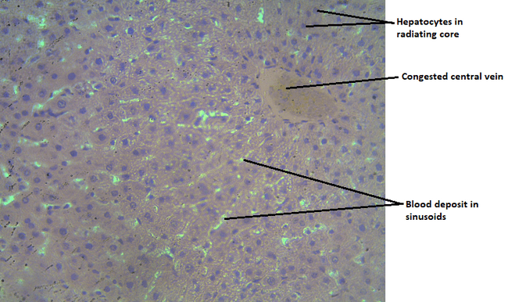
Plate 1: Photomicrograph of the liver tissue (group 1) showing distinct hepatocytes in radiating core from central vein (congestion), sinusoids with mild deposit. Tissue shows normal microstructure. H & E, X400

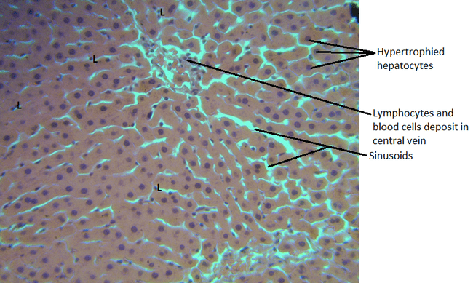
Plate 2: Photomicrograph of the liver tissue (group 2) showing congested central vein, hypertrophied hepatocytes in radiating cords and sinusoids containing red blood cells and lymphocytes (L) spread across the tissue. Tissue show mild distortion of the cytoarchitecture. H & E, X400

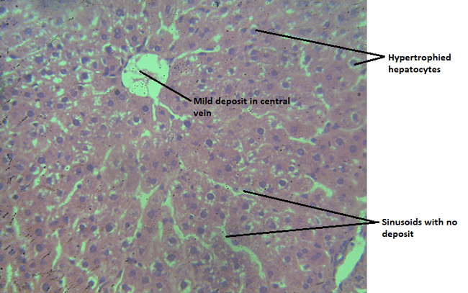
Plate 3: Photomicrograph of the liver tissue (group 3) showing central vein with mild deposit, sinusoids, pockets of hypertrophied hepatocytes. Tissue shows distortion of cytoarchitecture. H & E, X400

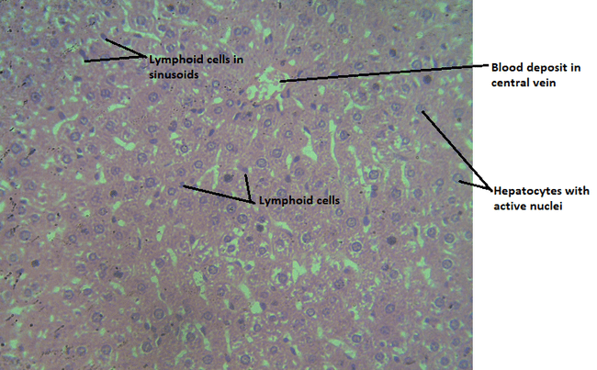

Plate 4: Photomicrograph of liver tissue (group 4) showing hepatocytes with active nuclei (pockets of degenerating hepatocytes observed), blood deposit and lymphoid cells in dilated sinusoids. Tissue shows distortion of microstructure. H & E, X400
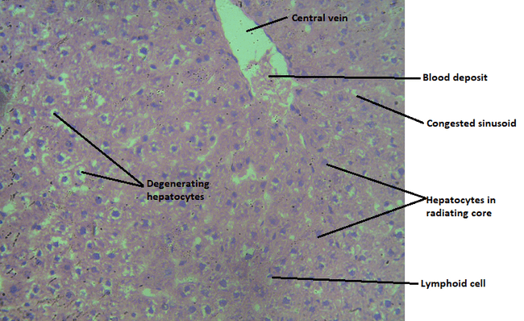
Plate 5: Photomicrograph of the liver tissue (group 5) showing congested central vein and sinusoids, pockets of degenerating hepatocytes. Tissue shows presence of lymphoid cells surrounding degenerating hepatocytes. Tissue shows distortion of cytoarchitecture. H & E, X400

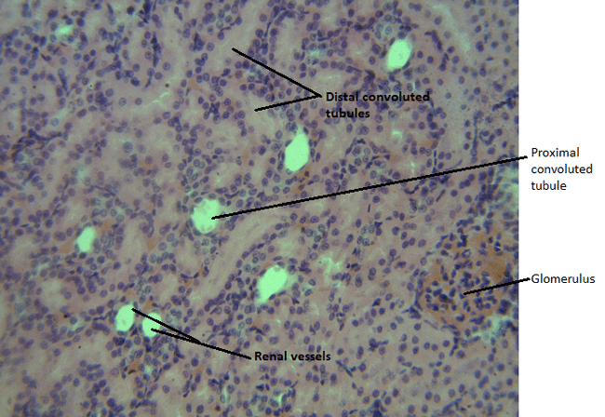
Plate 1: Photomicrograph of kidney tissue (group 1) showing well delineated glomerulus, proximal convoluted tubule, distal convoluted tubule and renal vessels. Normal Kidney tissue cytoarchitecture is indicated. H & E, X400

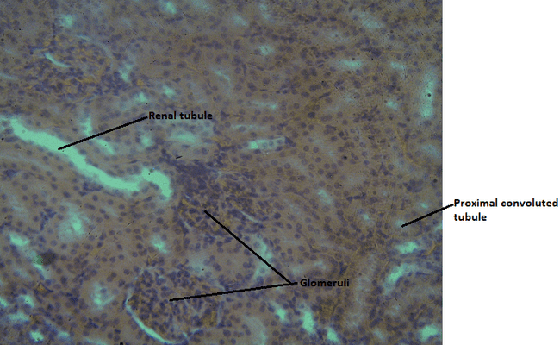
Plate 2: Photomicrograph of kidney tissue (group 2) showing glomeruli and well delineated proximal and distal convoluted tubules. Tissue shows normal cytoarchitectural appearance. H & E, X400

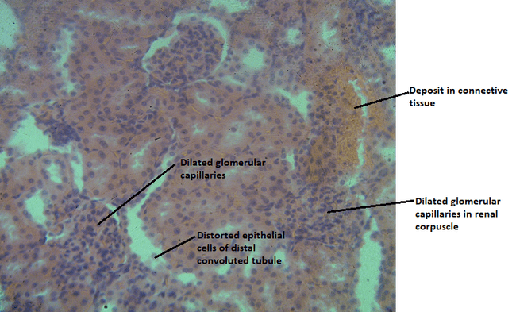

Plate 3: Photomicrograph of kidney tissue (group 3) showing dilated glomerular capillaries, distorted epithelial lining of distal convoluted tubules and deposit in connective tissue. Tissue shows distortion of cytoarchitectural appearance. H & E, X400

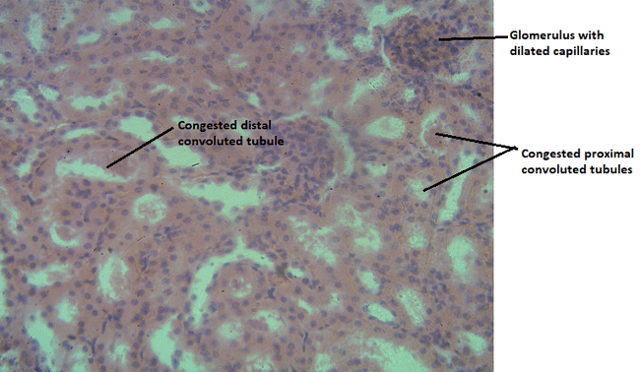
Plate 4: Photomicrograph of kidney tissue (group 4) showing dilated glomerular capillaries, congested proximal and distal convoluted tubules. Tissue shows distortion of cytoarchitectural appearance. H & E, X400

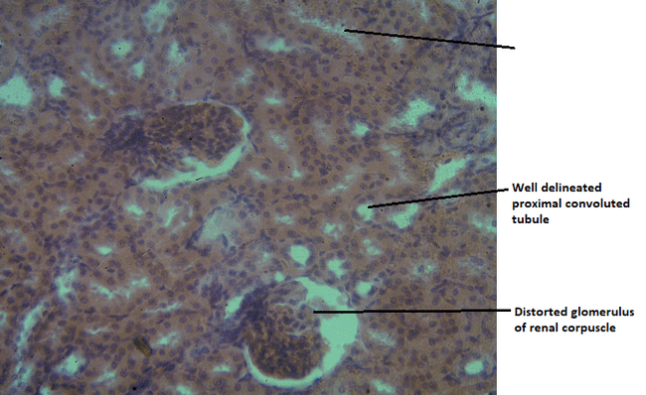
Plate 5: Photomicrograph of kidney tissue (group 5) showing distorted glomerular capillaries, well delineated proximal and distal convoluted tubules. Tissue shows distortion of cytoarchitectural appearance. H & E, X400

4. DISCUSSION OF FINDINGS
The liver is the largest solid organ, the largest gland and one of the most vital organs that functions as a center for metabolism of nutrients and excretion of waste metabolites (Ozougwu and Eyo, 2014). The liver is the primary organ for metabolizing xenobiotics, including the toxic components found in water pipe tobacco smoke (e.g., nicotine, carbon monoxide, heavy metals, and polyaromatic hydrocarbons). Damage to the liver cells (hepatocytes) or bile ducts results in the leakage of these intracellular enzymes into the bloodstream, increasing their serum levels. Hepatic biomarkers (AST, ALP and ALT) are indices used to assess the normal functioning as well as abnormalities of the liver. Table 1 shows the effect of water pipe tobacco exposure on liver enzymes of female wistar rats exposed for a period of 2 and 4 weeks.
Aspartate transaminase catalyzes the reversible transfer of an α-amino group between aspartate and glutamate and, as such, is an important enzyme in amino acid metabolism. AST is found in the liver, heart, skeletal muscle, kidneys, brain, and red blood cells. They are often used in assessing the functional integrity of liver, plasma membrane and endoplasmic reticulum (Ujjawal et al., 2014). The result showed that the level of AST increased in all the exposed groups compared to the control group. The level of AST increased in all the exposed groups (Groups 2, 3, 4, and 5) compared to the control group (Group 1). AST, while present in the liver, is also found in other organs like the heart, skeletal muscle, and kidneys. An increase in serum AST generally indicates damage or necrosis (cell death) in tissues rich in this enzyme. The consistent increase across all exposed groups suggests that shisha smoke constituents are causing cellular damage, likely in the liver (hepatocellular injury), but potentially also in other organs. The recorded result indicates that both short-term exposure (2 weeks) and longer-term exposure (4 weeks), as well as both lower (10 minutes) and higher (20 minutes) daily exposure times, are sufficient to induce this cellular injury. The elevated AST level is a significant marker for hepatotoxicity (chemical-driven liver damage) induced by the toxic components of water pipe tobacco smoke (Hassan et al., 2020). This finding is contrary to the findings of findings of Rashidi et al., (2020) who reported that tobacco smoke increased the concentration hepatic markers in experimental animals. Elevated level of hepatic markers indicates possible liver damage and this is commonly associated with conditions such as hepatitis, fatty liver disease or toxic exposures.
Alanine transaminase catalyzes the transfer of an amino group from L-alanine to α-ketoglutarate and the products of this reversible transamination reaction being pyruvate and L-glutamate. The result showed that the level of ALT increased in all the exposed groups when compared to control group except in the animals exposed to shisha for 20 minutes for two weeks where a decrease was observed. Alkaline phosphatase is an enzyme found in the blood stream. It is an ubiquitous membrane-bound glycoprotein that catalyzes the hydrolysis of phosphate monoesters at basic pH values (Ujjawal et al., 2014). It helps breaks down proteins in the body and exists in different form depending on where it originates. The result showed that the level of ALP increased in all the exposed groups compared to the control groups. The level of ALT increased in all exposed groups compared to the control group, except in the animals exposed to shisha for 20 minutes for two weeks (Group 3), where a decrease was observed. Its increase in most groups points directly to hepatocellular injury (damage to the liver cells) caused by the water pipe smoke and the mechanism might be similar to AST leakage, which is cell damage leading to the release of the enzyme into the serum.
The level of ALP increased in all the exposed groups (Groups 2, 3, 4, and 5) compared to the control group (Group 1). ALP is an enzyme found in several tissues, including the liver, bone, intestine, and placenta. An increase in serum ALP, especially when accompanied by transaminase (AST and ALT) increases, often suggests a cholestatic injury (impaired bile flow) or damage to the biliary system (bile ducts) in the liver. The simultaneous increase of ALP along with AST and ALT indicates possible hepatotoxicity resulting from the exposure to water pipe tobacco smoke (Yousef et al., 2021). Elevated ALP suggests that in addition to directly damaging liver cells, shisha smoke may also be disrupting the normal flow of bile out of the liver, which is a key part of the organ's detoxification process. The increase in the concentration of ALP in the groups exposed to shisha could be attributed to the fact that shisha contains harmful chemicals such a nicotine that can induce oxidative stress, thus leading to liver damage (Abdalla et al., 2021). Nicotine has been shown to alter the activity of enzymes such as alanine transaminase and aspartate transaminase (Hassan et al., 2020). The increased concentration of these markers is an indication that shisha smoke impairs liver function, leading to its damage. This finding is also contrary to the findings of findings of Rashidi et al., (2020) who reported that tobacco smoke increased the concentration hepatic markers in experimental animals. Elevated level of hepatic markers indicates possible liver damage and this is commonly associated with conditions such as hepatitis, fatty liver disease or toxic exposures.

The kidney functions to excrete metabolic waste products as well as to maintain water, pH, electrolyte balance, production of calcitriol and haemoglobin (Sreekumari and Vaidyanathan,2011). In mammals, the kidney functions as a major excretory organ for elimination of metabolic wastes from the body. Renalparameters such as urea and creatinine are used to detect abnormalities of the kidney (Zamzami et al., 2021). Renal parameters such as urea, creatinine and electrolytes are useful in assessing renal functions. Creatinine and urea are major catabolic products of protein metabolism and are indicators of renal function. Literatures show that elevation in the serum levels of these renal biomarkers may indicate renal dysfunction.
Creatinine is a nitrogenous end product of metabolism. It is the product of creatinine catabolism. Plasma creatinine concentration is the most widely used measure for estimation of glomerular filtration rate (Adrian, 2019).
Creatinine is a breakdown product of creatinine phosphate from muscle, and its plasma concentration is commonly used as a marker of Glomerular Filtration Rate (GFR), as it is usually freely filtered by the glomerulus and minimally reabsorbed. The level of creatinine also decreased in all the groups exposed to shisha when compared to the control group. This can possibly be attributed to chronic toxicity or illness from shisha exposure which might lead to muscle wasting, thus producing less initial creatinine for filtration. Although low creatinine might suggest improved GFR, in the context of other observed biochemical disturbances, it is more likely an indicator of non-renal factors like muscle catabolism or haemodilution. A true improvement in GFR is unlikely with a known toxic agent like shisha smoke. The result obtained in this study is contrary to the findings of Rashidi et al., (2020) who reported that tobacco smoke increased the concentration of urea and creatinine in experimental animals.
Urea, commonly referred to as blood urea nitrogen (BUN) is a nitrogenous waste product. It is the primary metabolite derived from dietary protein and tissue protein turn over (Hussain and Malik, 2019). Table 2 shows the effect of water pipe tobacco exposure on kidney markers of female wistar rats exposed for a period of 2 and 4 weeks. The result showed that the level of urea decreased in all the groups exposed to shisha when compared to the control group. The possible reason could be attributed to the fact that, the Shisha smoke constituents (e.g., carbon monoxide, heavy metals) could potentially cause hepatic damage). Since the liver is responsible for the urea cycle (converting ammonia into urea), damage could lead to reduced urea synthesis, resulting in a lower serum concentration. It could also be attributed to increased fluid Intake/Diuresis as nicotine or other compounds present in the shisha might induce a diuretic effect or the rats may have increased water intake due to the exposure, leading to a dilution of blood constituents, including urea.
Electrolytes play crucial role in maintaining various bodily functions including those related to the kidneys. They are essential for proper kidney function and are often used as biomarkers to assess renal health and function. Specific electrolytes such as sodium, potassium, chloride and bicarbonate are regularly measured to evaluate kidney function and alterations in their levels might indicate kidney-related issues (Onyeabo et al., 2021).
The level of potassium decreased (hypokalaemia) in all shisha-exposed groups compared to the control. Potassium is the main intracellular cation, and its balance is tightly regulated by the kidneys (distal tubules). The possible reason could be that the compounds found in the shisha such as nicotine and carbon monoxide can affect the renal tubules, possibly leading to increased secretion or impaired reabsorption of potassium ion. There could be a shift of potassium ion from the extracellular fluid (where it's measured) into the cells, perhaps due to β-adrenergic stimulation from nicotine. Hypokalaemia (low potassium) is a serious electrolyte disturbance that can lead to cardiac arrhythmias and muscle weakness, suggesting a significant disruption of cellular and renal homeostatic mechanisms.
The level of sodium decreased (hyponatraemia) in all shisha-exposed groups compared to the control. Sodium is the main extracellular cation, critical for maintaining plasma osmolality and fluid balance. The most likely cause could be haemodilution as the most common cause of hyponatraemia is excess free water in the plasma, leading to a dilutional effect. This aligns with the potential increased fluid intake/diuresis hypothesis proposed for urea and creatinine. Hyponatraemia (low sodium) indicates an imbalance in total body water relative to sodium. This can lead to cerebral oedema and neurological symptoms if severe, highlighting a major disruption of the kidney's role in volume and electrolyte control (Saeed et al., 2020).
The level of chloride decreased (hypochloraemia) in all shisha-exposed groups compared to the control. Chloride is the most abundant extracellular anion, often balancing with sodium and important for acid-base balance. Since chloride is tightly linked with sodium balance, its decrease is likely a consequence of the same factors causing hyponatraemia, primarily haemodilution or renal salt wasting. Hypochloraemia usually accompanies hyponatraemia and metabolic alkalosis, supporting the hypothesis of a systemic fluid and acid-base disturbance caused by shisha exposure (Saeed et al., 2020).
The level of bicarbonate increased in all shisha-exposed groups compared to the control. Bicarbonate is the primary buffer in the body and a key indicator of acid-base status. An increase in bicarbonate is indicative of metabolic alkalosis. If shisha exposure caused hypoventilation (retaining carbon monoxide), the kidneys would compensate by reabsorbing more bicarbonate to counteract the respiratory acidosis. It could also be that the toxic stress could lead to increased aldosterone secretion, which promotes potassium and hydrogen ion excretion in the kidney, thus retaining bicarbonate. The observed increase in bicarbonate indicates metabolic alkalosis, which can affect enzyme function, electrolyte balance, and central nervous system activity. This is a vital finding that suggests a major shift in the body's acid-base homeostasis due to the exposure. This result in this study is in consonance with the findings of Rashidi et al., (2020) who reported that tobacco smoke increased the concentration electrolytes in experimental animals.

Oxidative stress can be defined as a disturbance in the balance between the production of reactive oxygen species (free radicals) and antioxidant defenses (Betteridge, 2000). It can also be described as an imbalance of pro-oxidants and antioxidants which can be quantified in humans as the redox state of plasma (Dean, 2006). An antioxidant is a substance that when present at low concentrations compared with those of an oxidizing substrate, significantly delays or prevents oxidation of a substrate (Norma, et al., 2019). An antioxidant is a molecule stable enough to donate an electron to a rampaging free radical and neutralize it, thus reducing its capacity to damage. These antioxidants delay or inhibit cellular damage mainly through their free radical scavenging property (Halliwell, 2018). Table 3 shows the effect of water pipe tobacco exposure on some enzymatic and non-enzymatic stress biomarkers of female wistar rats exposed for a period of 2 and 4 weeks. The result showed that the concentration of GSH increased in all the groups exposed to shisha when compared to the control animals. The result also showed that the concentration of catalase increased in all the groups exposed to shisha when compared to the control animals. The result showed that the concentration of SOD increased in all the groups exposed to shisha when compared to the control animals. The result showed that the level of MDA increased in all the groups exposed to shisha when compared to the control animals. MDA elevation is a direct indicator of increased lipid peroxidation and oxidative damage to cell membranes. The general trend observed in the oxidative markers strongly suggests that water-pipe tobacco exposure causes significant sub-acute oxidative stress, forcing the body's antioxidant system to become highly activated in a defensive response.
The level of MDA increased in all shisha-exposed groups compared to the control. Malondialdehyde (MDA) is the most widely used biomarker for lipid peroxidation, which is the oxidative degradation of polyunsaturated fatty acids in the cell membrane. Shisha (Waterpipe Tobacco Smoke, WTS) contains thousands of toxic compounds, including high concentrations of carbon monoxide (CO), heavy metals, and various organic compounds. These constituents generate large amounts of Reactive Oxygen Species (ROS) and free radicals (like superoxide, hydroxyl radical, and hydrogen peroxide) directly upon inhalation. The elevated MDA level is a direct sign of major cellular damage induced by the toxicants in the shisha smoke. This indicates that the oxidant load from the smoke is overwhelming the body’s baseline defenses, leading to structural harm in tissues and organs (Hassan et al., 2020).
The concentration of GSH increased in all shisha-exposed groups compared to the control animals. Glutathione (GSH) is the body’s primary non-enzymatic antioxidant, directly neutralizing free radicals and serving as a substrate for the enzyme Glutathione Peroxidase (GPx) to detoxify hydrogen peroxide. In response to oxidative stress, the body attempts to compensate by aggressively synthesizing more GSH. The significant increase in GSH is a clear, compensatory response at the cellular level. The female Wistar rats’ defense system recognizes the massive influx of free radicals from the shisha smoke and upregulates the production of this essential molecule in a failed attempt to neutralize the damage. This increase demonstrates the severity of the pro-oxidant stimulus (Hassan et al., 2020).
The concentration of Catalase increased in all shisha-exposed groups compared to the control animals. Catalase is a crucial antioxidant enzyme responsible for detoxifying hydrogen peroxide, a potent but less reactive ROS, by converting it into water. Similar to GSH, the sustained exposure to the shisha smoke, and the resulting accumulation of hydrogen peroxide (possibly produced from the action of SOD), signals the body to induce the synthesis of more Catalase enzyme to meet the increased detoxification demand.
The increased Catalase activity confirms the presence of an elevated level of hydrogen peroxide in the cells and shows that the body is activating its major enzymatic defense lines against the oxidative threat.
The concentration of SOD increased in all shisha-exposed groups compared to the control animals. Superoxide Dismutase (SOD) is the first line of enzymatic defense. It converts the highly reactive superoxide radical into the less reactive hydrogen peroxide, which is then managed by Catalase and GPx. The increase in SOD activity signifies an overproduction of superoxide radicals by the shisha smoke, indicating that the initial stage of free radical attack is highly active (Hassan et al., 2020).
The histopathological findings strongly support the biochemical results. Liver sections from exposed groups (group 2-5) showed central vein congestion, dilated sinusoids, hepatocyte hypertrophy, degenerative changes, lymphocytic infiltration, and distortion of normal hepatic cytoarchitecture. These findings are consistent with toxic hepatopathy. Hepatocyte degeneration explains the leakage of AST and ALT into circulation, while inflammatory cell infiltration suggests an immune response secondary to oxidative damage. The progressive distortion observed in group 3, 20 minutes per day for 2 weeks and group 5, 20 minutes per day for 4 weeks indicates cumulative and dose-dependent hepatic injury. Adekomi et al. (2011) reported hepatocyte degeneration and sinusoidal distortion in rats exposed to tobacco smoke extract. Their findings confirm that tobacco-derived toxicants induce structural alterations in liver architecture, consistent with the congestion and cellular degeneration observed in this study. Nemmar et al. (2023) observed vacuolar degeneration of hepatocytes, inflammatory cell infiltration, and structural disruption in mice exposed to water pipe tobacco smoke. These morphological changes were accompanied by elevated liver enzymes and increased oxidative stress markers, suggesting that hepatocellular injury was mediated by oxidative mechanisms. The inflammatory infiltration observed in their study closely parallels the lymphocytic infiltration noted in the present work, reinforcing the role of smoke-induced inflammation in hepatic damage.
Renal histopathology revealed dilated glomerular capillaries, distorted epithelial lining of distal tubules, congestion of proximal and distal convoluted tubules, and connective tissue deposits in higher exposure groups. These structural abnormalities confirm renal injury despite the paradoxical reduction in traditional renal biomarkers. Tubular distortion aligns with observed electrolyte imbalance, reinforcing the presence of functional renal impairment. Rababa’h et al. (2021), in a comprehensive review of rodent models of water pipe smoke exposure, concluded that chronic water pipe smoke exposure consistently induces renal oxidative stress, inflammation, and histological alterations involving both glomerular and tubular compartments. These findings corroborate the glomerular capillary dilation and tubular disruption seen in this study. Although the present study observed reduced serum creatinine and urea levels, the histological abnormalities strongly support the presence of renal injury. Previous authors have noted that biochemical markers may not always reflect early structural damage, particularly when hepatic dysfunction or haemodilution influences serum metabolite levels (Nemmar et al., 2020).
Cardiac tissue sections demonstrated muscle fiber distortion, cellular degeneration, vascular congestion, and fiber shrinkage in exposed groups. These findings indicate myocardial structural compromise. Similarly, Al-Sawalha et al. (2015) reported structural alterations in rat ventricular tissue following water pipe smoke exposure, including cardio myocyte separation and inflammatory infiltration. The authors attributed these changes to oxidative stress and systemic hypoxia induced by smoke constituents. The cardiac degeneration observed in the present study may likewise be linked to oxidative stress and reduced oxygen-carrying capacity secondary to anaemia.

5. CONCLUSION
This study demonstrated that exposure to water pipe tobacco smoke induces significant hepato-renal toxicity and oxidative stress in female wistar rats. The observed elevation in hepatic enzymes (AST, ALT, and ALP) indicates hepatocellular injury and possible disruption of bile flow, reflecting impaired liver function. Alterations in renal biomarkers, including reduced urea and creatinine levels as well as marked electrolyte imbalances, suggest compromised renal handling of metabolic wastes and disturbance of fluid and electrolyte homeostasis. Furthermore, the significant increase in oxidative stress markers, particularly malondialdehyde, alongside elevated antioxidant defenses (GSH, SOD, and catalase), confirms the induction of oxidative stress and lipid peroxidation following shisha smoke exposure. These findings reveal that water pipe tobacco smoke exerts systemic toxic effects even with relatively short-term exposure. The study provides experimental evidence that shisha smoking is not a safe alternative to cigarette smoking and poses substantial risks to vital organs. Continuous exposure may predispose users to liver and kidney dysfunction through oxidative stress-mediated mechanisms. Public health education and stricter regulation of water pipe tobacco use are therefore strongly recommended.

REFERENCES
Al-Sawalha, N. A., Alzoubi, K. H., Khabour, O. F. (2015). Structural characterization of rat ventricular tissue exposed to waterpipe tobacco smoke. PLoS ONE, 10:12
Abdalla, A. N., Abd El-Rahman, S. S., & El-Shenawy, N. S. (2021). Nicotine-induced oxidative stress and hepatotoxicity in rats. Journal of Biochemical and Molecular Toxicology, 35:3
Adekomi, D. D., Tijani, A. A., & Musa, A. A. (2011). Histological study of smoke extract of Nicotiana tabacum on rat organs. Nigerian Medical Journal, 52(4), 217–222.
Adrian, J. L. (2019). Creatinine as a biomarker of renal function: Clinical applications and limitations. Clinical Biochemistry, 67, 1–7.
Betteridge, D. J. (2000). What is oxidative stress? Metabolism, 49(2 Suppl 1), 3–8.
Dean, R. T., Fu, S., Stocker, R., & Davies, M. J. (2006). Biochemistry and pathology of radical-mediated protein oxidation. Biochemical Journal, 324(1), 1–18.
Elsayed Y, Dalibalta S, Abu-Farha N. (2016). Chemical analysis and potential health risks of hookah charcoal. Sci Total Environ. 1; 569–570:262–268.
Halliwell, B. (2018). How to characterize an antioxidant- Anupdate. Biochemistry Soc Symposium, 61:73–101.
Hassan, S. K., El-Kholy, W. M., & El-Sayed, E. M. (2020). Hepatotoxic and oxidative stress effects of water-pipe tobacco smoking in experimental animals. Toxicology Reports, 7, 799–808.
Hussain, S., & Malik, A. (2019). Blood urea nitrogen and creatinine as indicators of renal impairment. Journal of Clinical and Diagnostic Research, 13(7), BC01–BC04.
Jamil, P., Vipin, S.K., Sanjeev, S.T., Pravesh, K. & Anil, S. (2011). Impact of waterpipe tobacco smoking on the oxidative stress and blood parameters in rats. Journal of Environmental Pathology, Toxicology and Oncology, 34(3),227-235
Maziak W, Taleb ZB, Bahelah R. (2015). The global epidemiology of waterpipe smoking. Tobac Control, 24(Suppl 1), 3–12.
Nemmar, A., Beegam, S., Yuvaraju, P., Yasin, J., Ali, B. H., & Adeghate, E. (2020). Nose-only water-pipe smoke exposure induces renal histopathological alterations, inflammation, oxidative stress, DNA damage, and apoptosis in mice. Frontiers in Physiology, 11, 46.

Nemmar, A., Beegam, S., Yuvaraju, P., Zaaba, N. E., Elzaki, O., & Adeghate, E. (2023). Pathophysiologic effects of waterpipe (shisha) smoke inhalation on liver morphology and function in mice. Life Sciences, 336, 122058.
Norma, F., Raul, S. & Claudia, V.C. (2019). Antioxidant compounds and their antioxidant mechanism. Antioxidants, 43(1), 1-28.
Nwauche, K.T., Okpokpo, H. G. and Nwaokezi, C. O. (2025). Health Risk Assessment of Selected Heavy Metals of Coal Used For Water Pipe Tobacco. Asian Journal of Biotechnology and Bioresource Technology, 11(4):156-164.
Onyeabo, C., Adebayo, A. H., & Olorunnisola, O. S. (2021). Electrolyte imbalance as indicators of renal toxicity in experimental animals. Journal of Basic and Clinical Physiology and Pharmacology, 32(5),891–898.
Ozougwu, J.C. and Eyo, J.E. (2014) Hepatoprotective effects ofAllium cepa extracts on paracetamol-induced liver damagein rat. African Journal of Biotechnology, 13(26): 2679
Rababa’h, A. M., Mardini, A. N., Ababneh, M. A., & Alzoubi, K. H. (2021). Waterpipe tobacco smoke and health: What have we learned from rodent models? Life Sciences, 284, 119898.
Rashidi, M., Mousavi, Z., & Jafari, M. (2020). Effects of tobacco smoke on biochemical, renal, and oxidative stress parameters in rats. Comparative Clinical Pathology, 29(2), 391–399.
Saeed, A. A., Al-Shahrani, S., & Al-Ghamdi, M. A. (2020). Hyponatraemia and hypochloraemia in toxic exposure: Renal and systemic implications. BMC Nephrology, 21(1), 312.
Shihadeh A, Eissenberg T, Rammah M, Salman R, Jaroudi E, El-Sabban M. (2014). Comparison of tobacco-containing and tobacco-free waterpipe products: effects on human alveolar cells. Nicotine Tob Res. (4):496–499.
Sreekumari, S. & Vaidyanathan, K. (2011). Functions and deficiency of biochemical markers. Journal of Medicine, 23(5), 123-143.
Ujjawal, S., Deejsga, P. and Rajendra,P. (2014). Alkaline phosphatase: an overview. Indian Journal of Clinical Biochemistry, 29(3), 269-278.
Yousef, M. I., Salem, M. H., & Ibrahim, H. Z. (2021). Biochemical and histopathological alterations in liver induced by tobacco smoke exposure. Environmental Toxicology and Pharmacology, 81, 103529.
Zamzami, M. A., Al-Harbi, N. O., & Al-Daghri, N. M. (2021). Renal dysfunction biomarkers and oxidative stress following tobacco smoke exposure. Environmental Science and Pollution Research, 28(14), 17322–17332

