Journal Name: | Asian Journal of Medicine and Health
Manuscript Number: | Ms_AJMAH_156896
Title of the Manuscript: | A systematic review of factors affecting uptake of contraception amongst adolescents in Nigeria
Type of the Article | REVIEW ARTICLE
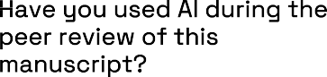


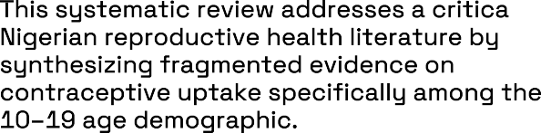
A minimum of 3-4 sentences may be required for this part.

  Rating Scale:  5 = Excellent 4 = Good 3 = Satisfactory 2 = Needs Improvement = Poor N/A = Not Applicable |  | 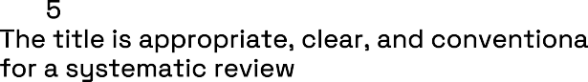
Rating Scale:
5 = Excellent 4 = Good 3 = Satisfactory 2 = Needs Improvement = Poor N/A = Not Applicable
Rating Scale:
5 = Excellent 4 = Good 3 = Satisfactory 2 = Needs Improvement = Poor N/A = Not Applicable
Rating Scale:
5 = Excellent 4 = Good 3 = Satisfactory 2 = Needs Improvement = Poor N/A = Not Applicable
Rating Scale:
5 = Excellent 4 = Good 3 = Satisfactory 2 = Needs Improvement = Poor N/A = Not Applicable
Rating Scale:
5 = Excellent 4 = Good 3 = Satisfactory 2 = Needs Improvement = Poor N/A = Not Applicable
Rating Scale:

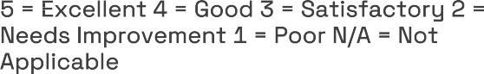
Page of

Rating Scale:
5 = Excellent 4 = Good 3 = Satisfactory 2 = Needs Improvement = Poor N/A = Not Applicable
Rating Scale:
5 = Excellent 4 = Good 3 = Satisfactory 2 = Needs Improvement = Poor N/A = Not Applicable
 | Identification of research gaps/future |  | 3
directions done Rating Scale:  5 = Excellent 4 = Good 3 = Satisfactory 2 = Needs Improvement = Poor N/A = Not Applicable |  |  | 3
 |  |  | 3
Rating Scale:  5 = Excellent 4 = Good 3 = Satisfactory 2 = Needs Improvement = Poor N/A = Not Applicable |  |  | 3
Rating Scale:  5 = Excellent 4 = Good 3 = Satisfactory 2 = Needs Improvement = Poor N/A = Not Applicable |  |  | 2
Quality of references (i.e. from peer reviewed authentic sources)  Rating Scale:  5 = Excellent 4 = Good 3 = Satisfactory 2 = Needs Improvement = Poor  N/A = Not Applicable |  |  | 4
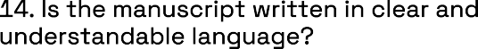  Rating Scale:  5 = Excellent 4 = Good 3 = Satisfactory 2 = Needs Improvement = Poor  N/A = Not Applicable |  |  | 4

 |  |  | (It is mandatory that authors should write his/her feedback here)


If your answer is NO, please provide a brief, clear suggestion for improvement.

If your answer is NO, please provide a brief, clear suggestion for improvement.
 |  | Yes
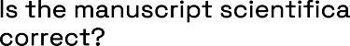  If your answer is NO, please provide a brief, clear suggestion for improvement. |  | Yes
  If your answer is NO, please provide clear suggestion for improvement. |  | Yes
  (YES or NO)  (If yes, kindly please write down the ethical issues here in details) |  | No

Reviewer details:

Ajit Kumar Dey, Silchar Medical College, India

