Original Research Article

Assessment of Changing Dynamics of Land Use, Land Cover, and Urban Expansion in Bankura Municipality and Its Vicinity

Abstract:
This work focuses on land use land cover (LULC) change and the growth of the urban area surrounding Bankura municipality. Satellite images from 1991, 2001, 2013, and 2021 have been used for land use change detection and to analyse urban expansion. For land use classification mapping, the Maximum Likelihood Classifier tools of ArcGIS 10.8 have been used and prepared supervised maps of different land classes (water body, bare land, built-up, vegetation, agricultural land and sand). Accuracy assessment is checked by overall accuracy and the Kappa coefficient. The study results indicate significant positive change of built-up area, vegetation and agricultural land and drastic negative change of bare land. Urbanisation, population growth, migration, economic growth, location and accessibility are the main causes of land use changes. The urban expansion of the study area, about 518 hectares in 2021, was found in the North-Northwest direction of the study area. The lowest built-up area has been observed in the South-South-West direction, and the area is about 20 hectares. The highest expansion of about 313 hectares was observed in the NNE direction from 2013 to 2021.

Keywords: LULC, Maximum Likelihood Classification, Supervised maps, Urbanisation, Urban Expansion

- Introduction
Rapid urbanisation is a common scenario for developing countries like India. Due to rapid urbanisation and unscientific human activities, land use and land cover changes have become one of the most triggering factors for global environmental change. (Kilic et al. 2006; Xiao et al. 2006; Aguilar et al. 2003; Lambin et al. 2001; Lambin and Geist 2006). According to Lambin and Geist (2006), various human-induced activities like migration, population growth, globalisation, technological development, and human responses to the changing economic conditions are the primary driving forces for land use and land cover change.
LULC changes over the last 300 years have turned into a tragedy for common, characterised by the loss of forests and expansion of agricultural lands (Houghton 2003). According to the United Nations (2018), 55 per cent of the total population lives in the world in urban areas, which is expected to be 68% by 2050. Vitousek et al. (1997) show that human activity has badly affected 50 per cent of the ice-free land Surface, and 10 to 55 per cent of the net primary productivity is captured by land use activities by human beings. (Rojstaczer et al., 2001).
Over the decades, recent changes in land use have seen land cover in developing countries decrease in rural areas and increase in urban areas through the process of fast urbanisation. (Dewan and Yamaguchi 2009a, b; Jat et al. 2008; Mundia and Aniya 2006). Urban areas currently cover only 3% of the Earth’s land surface, but over half of the world’s population now resides in cities (Herold et al. 2003; Liu and Lathrop 2002; United Nations 2001). Deng et al. (2009) and Weng (2007) analysed in their studies that increasing human activity has intensively changed the land use landscape pattern at both local and global scales. These changes immensely changed the ecosystem structure, function, and dynamics.
Accurate and timely monitoring information regarding urban LULC change is useful for understanding the various impacts of human activity on the overall ecological condition of the urban environment (Yeh and Li 1999; Dewan and Yamaguchi 2009a, b).
The population of the country is increasing very fast rate, and now the Indian population is about 1.5 billion, which is 17.78% of the World population. According to the World Bank collection, 2.25% urban growth was reported in 2023. Around 908.8 million people in India lived in rural areas in 2022, a decrease from 2021, which was 909.38 million, and in urban areas, 508.37 million people lived in 2022, an increase from 2018, which was 465.87 million. Urban growth is a dynamic and complex process, and through these processes, the urban area transforms into the urban landscape (Sahana et al. 2018). According to Dadras et al. al (2015), urban expansion can be imagined as a centre development process of urban areas.
Due to the urban growth and decreasing rate of vegetation in the cities of Bangladesh, urban heat rise (Dewan et al.,2021; Hassan et al., 2021) has been observed as the changing nature of land use and land cover enhances the albedo, which has extreme effects on the local environment of Alberta, Canada. According to Yohannes et al. (2021), the hydrological ecosystem has been immensely degraded by agricultural land and plantations in the Beressa watershed of the Blue Nile basin. Gradually increasing urbanisation and scarcity of annual rainfall changed the water availability of the upper catchment of the Bagmati River basin (Tuladhar et al. 2019). Rahman et al. (2021) show in their study that growing populations and urban expansion negatively affect the waterbodies and farmland, and also increase the food susceptibility in Sunamganj, Bangladesh.
The study area has reported urban expansion and consequent land use and land cover changes. The anthropogenic factors play a vital role in LULC change. The built-up and agricultural land expanded excessively over the land three decades. In contrast, natural bare land and sandy land decrease over the year. The urban built-up area has expanded rapidly and haphazardly in the last three decades. In this study area, the land is also affected by the growth of population and the haphazard expansion of built-up areas.
However, less attention has been paid to the changing pattern of the processes and patterns of urban growth and LULC changes in the area of Bankura Municipality and its surrounding areas during the transitional economy. In this paper, we employed the Maximum Likelihood Classification approach to identify the specific characteristics of LULC change, characterising the underlying driving forces in the Bankura Municipality area and its surroundings.
Objectives of the study are 1. To map and monitor land use/land cover change in Bankura Municipality and its vicinity from 1991 to 2021. (2) To analyse the spatial and temporal patterns and characteristics of urban expansion in that time period.
- Study area
Bankura is a city and municipality in the state of West Bengal, India. It is the headquarters of the Bankura district. The municipality is located at the confluence of the Gandheswari River and Dwarkeswar River. Bankura district is located in the north-western part of the state of West Bengal. It is a part of the Bardhaman Division of the State and is included in the area known as "Rarh" in Bengal. Bankura district is situated at 23.25°N 87.07°E. The Damodar River flows along the Northern boundary of the district. Bankura district is bounded by Purba Bardhaman and Paschim Bardhaman districts in the north and east, Paschim Medinipur district in the south, and Purulia to the west (Fig.1). The Bankura Forest comprises about 21% of the entire district. It has degraded in some areas due to overuse by humans. Bankura has a very hot climate in summer and moderate temperatures in winter. Rainfall occurs mostly between June to September, and the annual amount is about 1500mm. Till 2020, the highest ever recorded temperature was 47.4 °C, on 8 May 1977. The lowest was recorded on 9 January 2013, 4.8 °C. Bankura holds two state records. The record high temperatures of February (39.3 °C) and April (46.7 °C) are the highest in West Bengal.
The Bankura city is divided into 23 wards for which elections are held every 5 years. The Bankura Municipality has a population of 137,386, of which 69,843 are males, while 67,543 are females, as per a report released by Census India 2011. For the study of the LULC change and urban expansion, Bankura municipality and the surrounding buffer area of 4 kilometres have been selected.
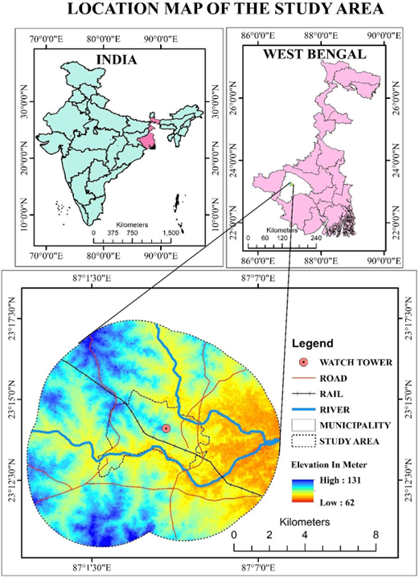
Fig. 1 Study area map
Bankura Municipality has a total administration of over 29,807 houses to which it supplies basic amenities like water and sewerage. It is also authorised to build roads within the Municipality's limits and impose taxes on properties coming under its jurisdiction.

- Materials and methodology
This work consists of changes in Land Use and land cover, and urban expansion of the study area using geospatial techniques. Different data are used here for analysing the work, and these are collected from different sources. Dada sources and processing are described in detail below (Fig.2 and Table 1, 2).
Mainly, secondary and ancillary data sets are used to establish the work. Landsat satellite images have been collected from the USGS Earth Explorer. 1991, 2001, 2013, and 2021 multi-temporal Landsat images have been acquired for this analytical work. Table 1 shows the data source and its description. All acquired imageries were registered in the UTM/WGS 1984 projected coordinate system. Landsat TM, ETM+ and OLI sensors imageries have been chosen to carry out the LULC classifications, and Blue, Green, Red and Near Infrared (NIR) bands were used to prepare composite images. For land use land cover change, supervised image classification (Maximum Likelihood Classification method) has been used using ArcGIS 10.8 software. Maximum Likelihood Classification (MLC) is the most popular and common tool for image analysis in remote sensing (Bolstad and Lillesand 1991; Richards and Jia 2006), and it is widely used in the moderate-resolution satellite images (Strahler 1980; Bayarsaikan et al. 2009; Vivekananda et al. 2021).
For image classification, training sample selection has been made for each selected year (1991, 2001, 2013, and 2021) in the selected area of Bankura Municipality and its vicinity. More than 30 training samples were assigned for the class, with one sample in each area (Agricultural land, vegetation, Built-up, water, bare land and sand). Then, training samples were merged to produce six classes. Then, a total of four signature files (.sig) were created for the LULC change study of three decades (1991–2021). Lastly, four LULC maps have been prepared using those signature flies before accuracy assessment. Table 2 shows the LULC types and their description. After producing all LULC maps, the accuracy assessment of classified images for selected years (2013, 2021) has been attained using the ArcGIS 10.8 software. Here Error matrix and the Kappa coefficient (k) are applied for accuracy assessment (Table 5).
For built-up area extraction 4km buffer of Bankura Municipality and its surrounding has been taken. Here, the selected centre point was the watch tower, located in Bankura Machan Tola. The centre point of the study area was selected because of its social, cultural and economic importance. The urban expansion occurred from the centre point in the early period. Here, the expansion of the built-up area is represented with the help of concentric buffers and directional zones.
The concentric buffer-wise built-up areas were shown by multiple ring buffers, from 0.5km to 0.85km. The intersect tool in ArcGIS is used to get the built-up areas as per the multi-ring buffers for showing the buffer-wise built-up expansion from 1991 to 2021.
The directional zone-wise built-up areas were shown with the help of 8th directional zones, which are North North-West, West North-West, West South-West, South South-West, South South-East, East South-East, East North-East, and North North-East.
For change detection analysis, a post-classification comparison matrix was generated of classified images from 1991 to 2001, 2001 to 2013, 2013 to 2021, and finally 1991 to 2021 by using the Arc GIS 10.8 and MS-Excel 2019 software for evaluating aggregate changes in the study area. After that, in 1990 and 2021, both years were selected to show land transformation over three decades in the selected areas.
Table 1: Details of the adopted satellite images.
Satellite | Sensor | Spatial resolution | Path/  row | Acquisition date | Source
Landsat 5 | TM | 30 m | 139/44 | 1991-11-08 | USGS Earth Explorer  (https://earthexplorer.usgs.gov/)
Landsat 7 | ETM+ | 30 m | 139/44 | 2001-12-29 | USGS Earth Explorer  (https://earthexplorer.usgs.gov/)
Landsat 8 | OLI | 30 m | 139/44 | 2013-12-22, 2021-11-10 | USGS Earth Explorer  (https://earthexplorer.usgs.gov/)

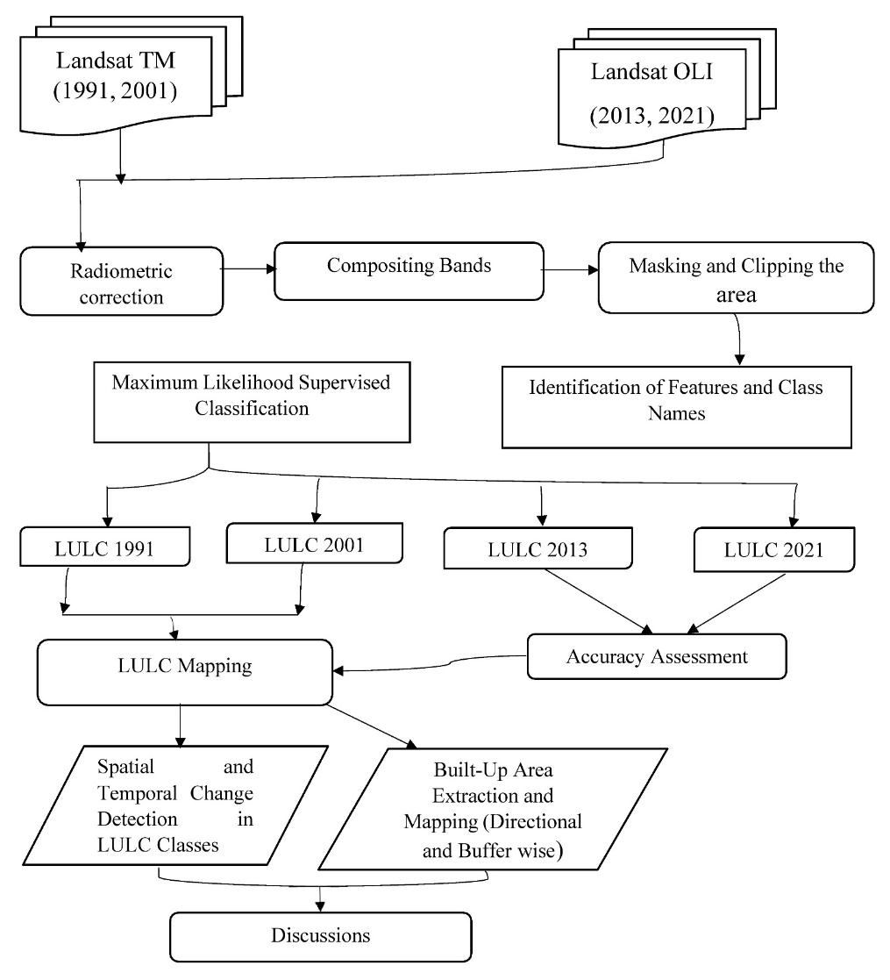
Fig. 2 Flow chart of methodology

Table 2 Types of LULC and their characteristics
LULC Type | Description
Agricultural land | Cropland and pasture, Orchards, groves, vineyards, nurseries, and ornamental horticultural areas.
Vegetation | Natural vegetation, homesteads with trees, plantations, etc.
Built-up area | Residential, commercial, industrial, transportation and built-up land.
Bare land | Brick fields, grazing fields, yard, waste-dumping sites, agricultural fallow land etc.
Waterbody | Streams, channels, lakes, reservoirs, etc.
Sand | Riverine sandy areas and other sandy land.

Results and discussions

4.1 Temporal changes of land use and land cover
Over three decades, the LULC status of different selected years (1991, 2001, 2013, and 2021) has been assessed in the study area. Multiband satellite images of Landsat have been used. The images were classified and evaluated in six classes, i.e. Water body, bare land, built-up, vegetation, agricultural land and sand. The supervised land use land cover maps are shown in Fig no 3, 4, 7, 8, and Tables 3 and 4 show the change matrix for varying areas from one class to another class from 1991 to 2021. The area has been calculated in hectare units and also shown the percentage of the area (Fig 5, 6, 9, and 10). The result come out from landform transformation during the year 1991, 2001, 2010 and 2021 that decreasing in waterbody, bare land and vegetation and increasing in built up area and agricultural land (Fig.11). Table 3 shows the changes of bare land in the study area 7128.50 ha (49.41%), 6810.48 ha (47.21%), 7015.80 ha (48.63%) and 3034.15 ha (21.03%) during the year 1991, 2001, 2013 and 2021, respectively. Bare land suddenly low down in 2021, and this land use was converted to agricultural land and built-up area. Built-up area gradually increased during the study period, i.e. 347.33ha (2.41%) in 1991; 744.05 ha (5.16%) in 2001; 1881.51ha (13.04%) in 2013 and 2398.82 ha (16.63%) in 2021. Agricultural land also changed, i.e. 2778.20 ha (19.26%), 2318.11ha (16.07%), 1180.37 ha (8.18%), 4425.99 ha (30.68%) in the years 1991, 2001, 2013 and 2021, respectively. The most significant changes in land use of agricultural land and built-up area were observed in 2021 due to extensive farming practices, growth of population and urbanisation. The vegetation cover increased in 2021 than 2013 because of plantation, agro-forestry, joint forest management, etc. Lastly, the study found that the water body of the study area decreased in 2021 due to water scarcity (insufficient rainfall and drought conditions).
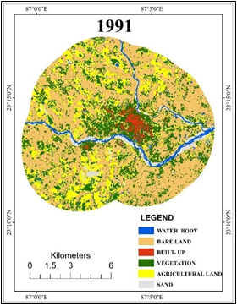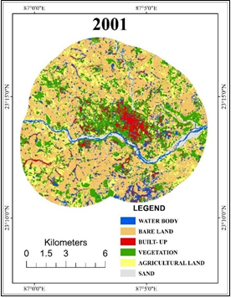
Fig 3. Land Use Land Cover Maps of 1991 Fig. 4. Land Use Land Cover Maps of 2001

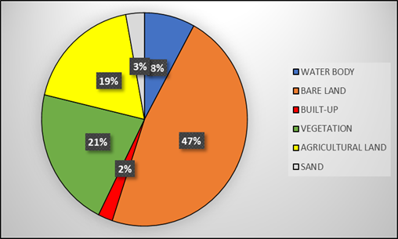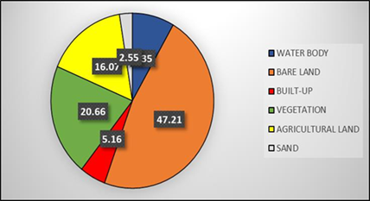
Fig 5. Percentage of Land Use and Land Cover in 1991 Fig. 6. Percentage of Land Use and Land Cover in 2001

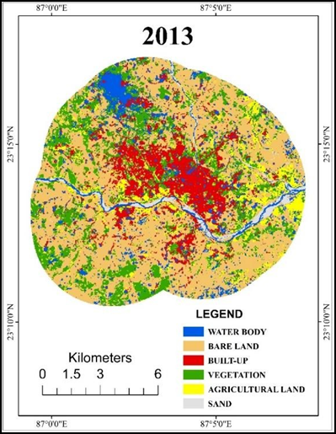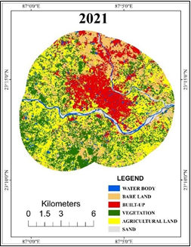
Fig 7. LULC map of 2013 Fig 8. LULC map 2021

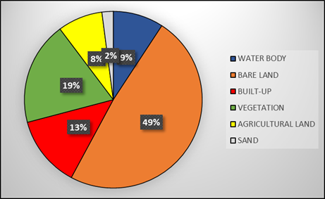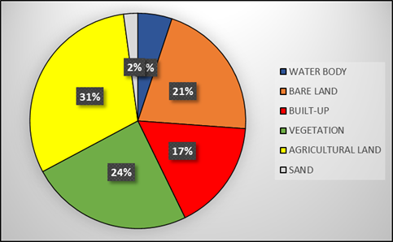
Fig 9. LULC in 2013 (%) Fig 10. LULC in 2021(%)

Table 3 Distribution of land use/land cover (area in hectare and percentage)
LULC | 1991(ha) | 1991(%) | 2001(ha) | 2001(%) | 2013(ha) | 2013(%) | 2021(ha) | 2021(%)
Water Body | 502.29 | 3.48 | 1204.23 | 8.35 | 1326.70 | 9.20 | 739.60 | 5.13
Bare Land | 7128.50 | 49.41 | 6810.48 | 47.21 | 7015.80 | 48.63 | 3034.15 | 21.03
Built-up | 347.33 | 2.41 | 744.05 | 5.16 | 1881.51 | 13.04 | 2398.82 | 16.63
Vegetation | 3227.97 | 22.38 | 2980.83 | 20.66 | 2725.13 | 18.89 | 3520.70 | 24.40
Agricultural land | 2778.20 | 19.26 | 2318.11 | 16.07 | 1180.37 | 8.18 | 4425.99 | 30.68
Sand | 442.07 | 3.06 | 367.69 | 2.55 | 296.54 | 2.06 | 307.29 | 2.13
Table 4 Land use / land cover change assessment
LULC CLASS | 1991 to 2001(%) | 2001 to 2013 (%) | 2013 to 2021 (%)
Water body | 4.87 | 0.85 | -4.07
Bare land | -2.20 | 1.42 | -27.6
Built-up | 2.75 | 7.88 | 3.59
Vegetation | -1.71 | -1.77 | 5.51
Agricultural land | -3.19 | -7.89 | 22.5
Sand | -0.52 | -0.49 | 0.07
Changes in area from 1991 to 2021
30
20
10
0
-10
Water body Bare land
Built-up
Vegetation
Agricultural land
Sand
-20
-30
-40
1991 to 2001 (%)
LULC Class

2001 to 2013 (%)
2013 to 2021 (%)

Fig 11. Change in area (%) of LULC
Accuracy assessment
Accuracy assessment of classified LULC maps was carried out for the years 2013 and 2020. The accuracy assessment of 1990 and 2000 could not be performed due to the low-resolution Google Earth images. During the time of accuracy assessment, several misclassifications were noticed between ground truth data and classified images, such as bare land considered agricultural land and built-up area. Moreover, built-up area is considered vegetation and water bodies. Bare land is sometimes classified as a waterbody because of the misclassification in the transitional fallow land zone surrounding the waterbody.
In this study, the overall accuracy was very good, ranging from 86 to 93%. The Kappa Coefficient is also admissible, for which a range from 0.6 to 0.8 is considered moderate (Table 5).
Year | Overall Accuracy | Kappa Coefficient
2013 | 86% | 0.75
2021 | 93% | 0.80
Table 5: Overall Accuracy and Kappa Coefficient of 2013 and 2021

4.2 Urban expansion of the study area
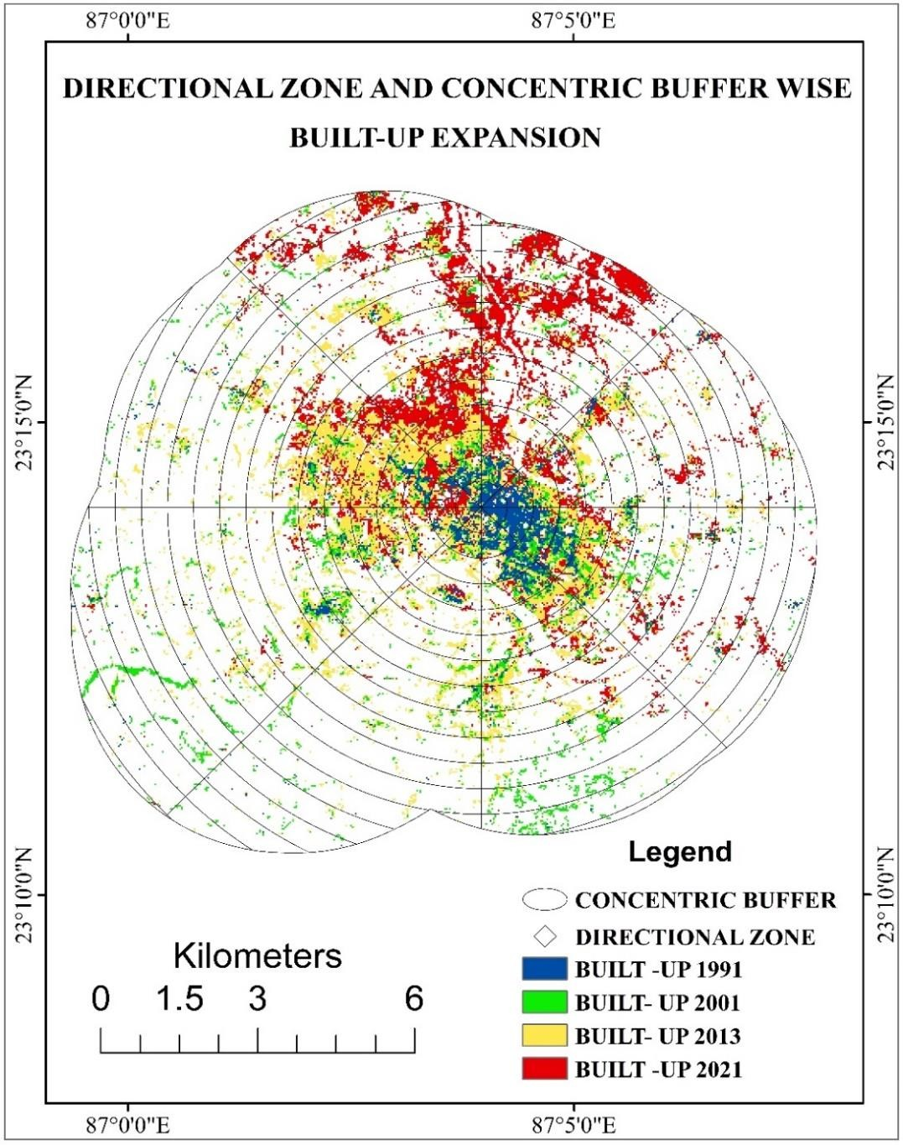
The Bankura Municipality and its surrounding areas are rapidly growing and urbanising. Moreover, Bankura town is the sub-divisional headquarters of the Bankura district. Thus, the built-up areas of the municipality continue to increase every year in each direction along with the distances in different periods of time (Fig.12). This municipality contains the largest housing project of the government. So, the area has the largest floating population in the district. It is also playing a significant role in expanding the built-up area in the district.
Fig 12. Expansion of Built–Up Area (1991 – 2021)

4.3 Direction of urban expansion
The municipality and its surrounding areas are situated in the Southern part of the district. Thus, urbanisation started from the central point of the city (Fig.13 and 14). The area then expanded towards the East South-East, South South-East, West South-West, West North-West and North North-West directions in the given period of time between1991 to 2013. On the other side, from 2013 to 2021, the built–up area expanded towards the North North-East, East North-East, East South-East, West North-West and North North-West direction (Table 6 and Fig.15). As the regional railway provides access to the North-East part of the district. Another railway runs in the South-Eastern direction. The municipality has good connectivity with Durgapur and another important industrial city. In 2021, the highest built-up area was found in North north-northwest direction, and the area was about 518 hectares. The lowest built-up area has been observed in South South-South-West direction, and the area is about 20 hectares. On the other side, the highest expansion of about 313 hectares was observed in the NNE direction from 2013 to 2021.
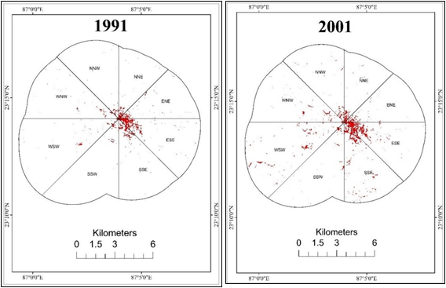

Fig. 13 Directional zone-wise built-up expansion in the study area from 1991 to 2021

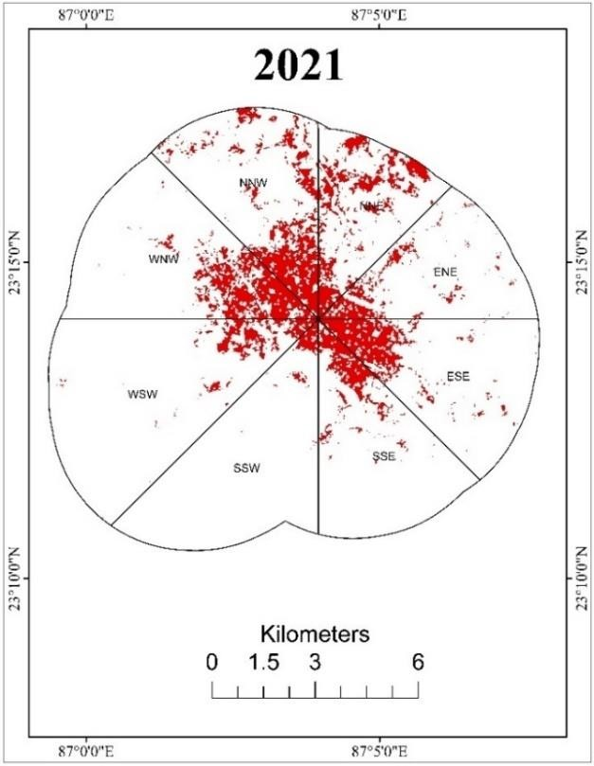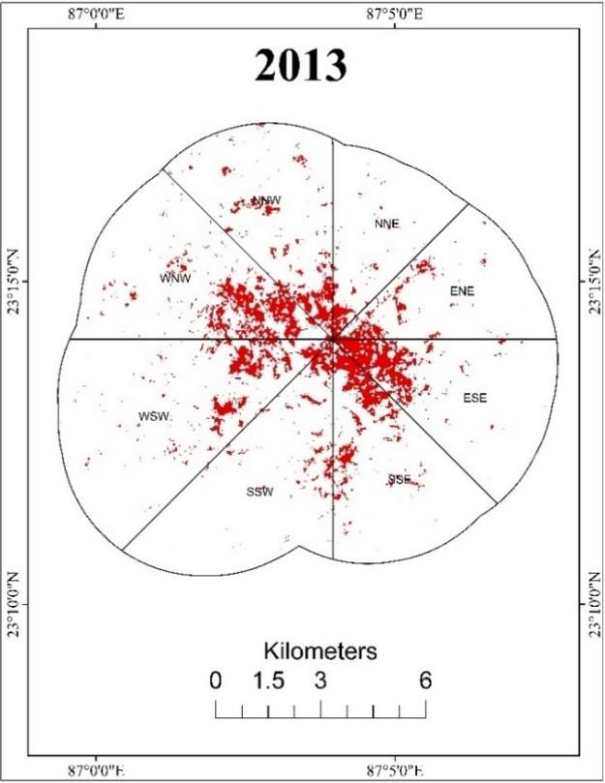
Fig. 14 Directional Zone-Wise Built-Up Expansion in the Study Area from 1991 to 2021
Table 6 Direction-wise built–up expansion
Direction | 1991  (Hectors) | 2001  (Hectors) | 2013  (Hectors) | 2021  (Hectors)
NNW | 24.10279 | 60.63567 | 239.161363 | 518.065571
WNW | 37.483274 | 76.07906 | 384.34228 | 432.688766
WSW | 38.866297 | 139.1105 | 312.793196 | 203.756886
SSW | 20.722655 | 55.96671 | 170.361692 | 65.462315
SSE | 58.83942 | 157.5281 | 272.659156 | 233.503891
ESE | 96.530734 | 154.3708 | 258.663541 | 321.070277
ENE | 44.874133 | 58.35855 | 150.192298 | 224.374264
NNE | 25.861277 | 41.6729 | 93.185315 | 408.117513
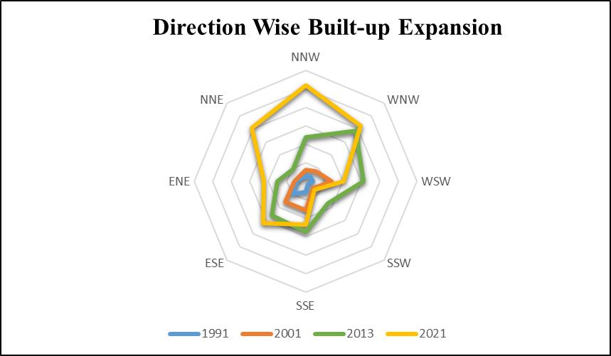
Fig 15. Direction-Wise Built-Up Land Distribution in the Study Area (1991-2021)

4.4 Concentric buffer-wise assessment of the urban expansion
In terms of concentric zones, the area is bound by the 0.5-kilometre radius circles drawn in Fig.16. As shown in the built-up map of 2021, the 0.5 to 3.5 km circle has the largest built-up area, which was about 1644 hectares. This zone covers the Howrah railway station, on the Adra-Chakradharpore section of the South Eastern Railway. On the other side, the central point of the area (i.e., 0.5 kilometres to 4.5-kilometre circle of the area), the urban expansion was not good in the given period of time from 1991 to 2013, because this zone was not well-connected with other cities or towns. This observation indicates that the built-up map of 2021 plays a vital role in developing good connectivity in increasing the built-up area expansion. The highest expansion of the urban area was observed in a 2.5-kilometre buffer area, which was about 196 hectares(Fig.17).
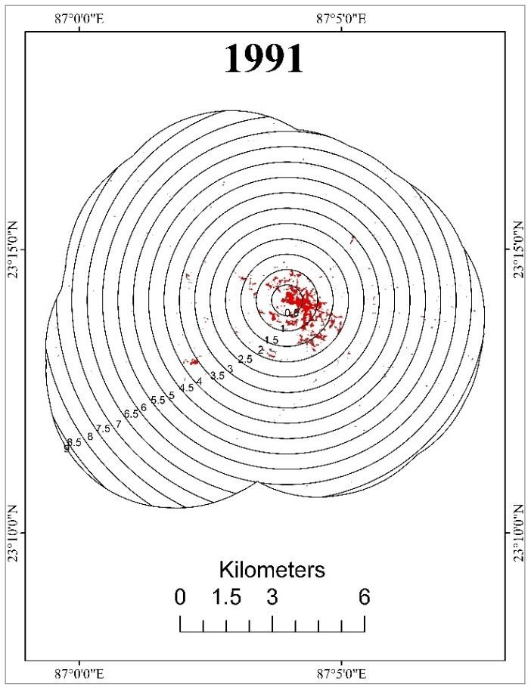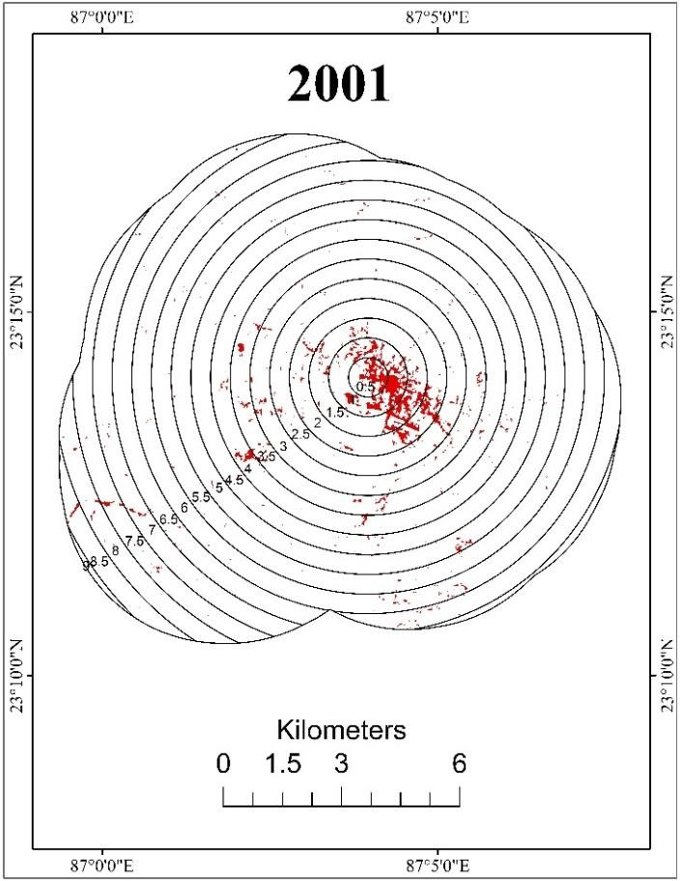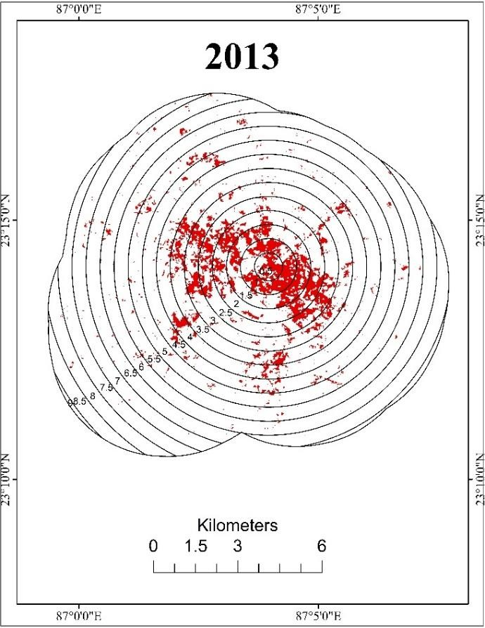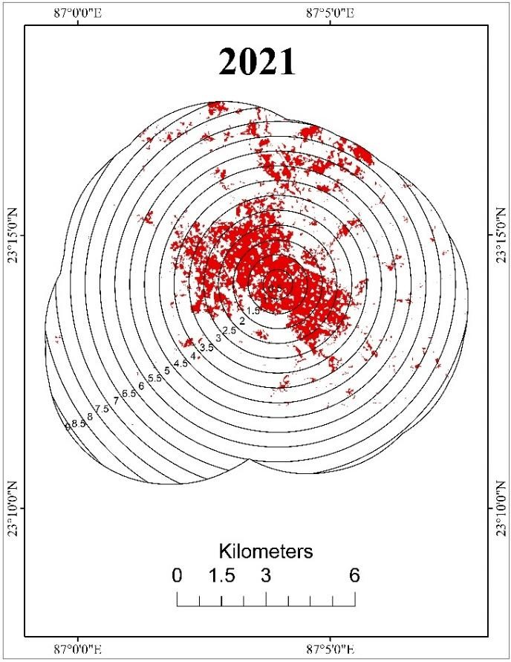
Fig 16. Concentric Buffer Wise Representation of Built-Up Area 1991 to 2021

Table 7 Distribution of built-up areas by concentric buffer distances
Distance  (Km) | 1991  (ha) | 2001  (ha) | 2013  (ha) | 2021  (ha)
0.5 | 38.233356 | 38.83198 | 55.37748 | 71.93178
1.0 | 96.765888 | 101.6914 | 171.2129 | 206.8844
1.5 | 58.079045 | 86.6036 | 207.0879 | 256.7172
2.0 | 50.171321 | 73.95986 | 223.3099 | 323.1977
2.5 | 15.10657 | 42.458 | 238.2388 | 317.7745
3.0 | 18.430856 | 53.17946 | 214.3597 | 279.9252
3.5 | 14.24572 | 61.37554 | 197.5526 | 192.6931
4.0 | 16.356285 | 51.18052 | 152.5181 | 179.673
4.5 | 5.971525 | 27.27581 | 125.1168 | 156.9647
5.0 | 6.537319 | 34.78602 | 104.929 | 114.6203
5.5 | 9.573863 | 33.36245 | 63.35595 | 156.0347
6.0 | 4.142539 | 39.82172 | 47.95415 | 55.90776
6.5 | 6.460878 | 37.34805 | 36.92532 | 64.67577
7.0 | 3.314026 | 20.71866 | 25.14469 | 16.64253
7.5 | 1.429889 | 20.75267 | 8.645778 | 0.119255
8.0 | 1.529164 | 13.01143 | 6.599406 | 4.328838
8.5 | 0.999163 | 6.939727 | 2.681813 | 0.057635
9.0 |  | 0.72067 | 0.450397 | 0.408947
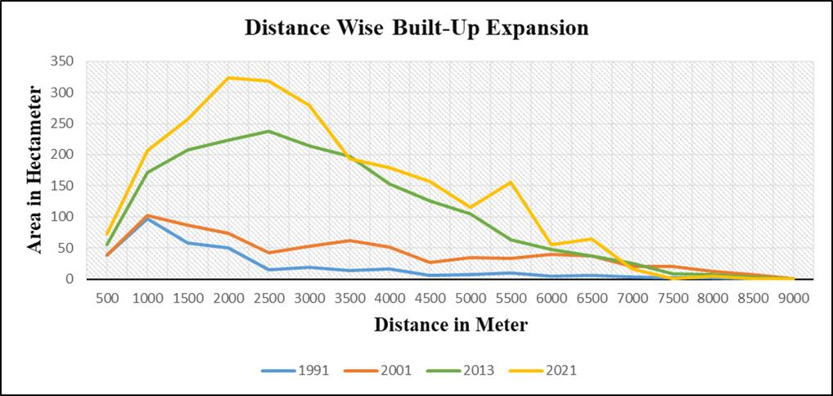
Fig 17. Graphical Representation of Built-Up Area by Distance

4.5 Discussion about urban expansion
By using the Landsat images for the years 1991, 2001, 2013, and 2021 this study identified water bodies, bare land, built-up area, and vegetation, agricultural land and also sand as six major LULC classes that have undergone significant changes in the surroundings area of Bankura Municipality, there by indicating rapid urban expansion due to population growth and economic developments in Bankura Municipality town. Most notable among LULC changes was the conversion of bare land into Agricultural land, manmade vegetation or the creation of green spaces and also an increase in the built-up area expansion over three decades. Bankura has almost 3,596,674 people during the time period 2011. In the previous census of 2001, Bankura district recorded an increase of 13.82% in its population compared to 1991. To accommodate the new settlers and provide them with various services, residential compounds and apartments, commercial centres, new residential hotels, restaurants, healthcare centres, and other social service facilities were also built during 1991–2021 in the districts of Bankura Municipality's surrounding areas.
Furthermore, the government’s land grant policy and the interest-free loan assisted the middle class and low-income families. At the same time, the construction of urban infrastructures, including roads, highways, schools, residential hotels, banks, shopping centres, and healthcare facilities, also contributed to the major urban expansion in the study area. The major findings of the study are Firstly, in the study area, from 1991 to 2021, the land classes, which were decreased, are the bare land ( -28.38%), sand ( -0.93%) and a very slight increase is found in water body (1.64%), vegetation (2.03%). On the other side, built-up and agricultural land were increased, which were about 14.22% and 11.42% from 1991 to 2021. Secondly, the study has explored the direction and distance patterns of urban sprawl in the selected study area. These findings show that in the years 1991 and 2001, the built-up expansion was very low, but in the years 2013 and 2021, this expansion rapidly grew because during this time period, the Municipality's surroundings area gained many useful facilities. Thirdly, from an urban planning perspective, the study results show that significant LULC and rapid urban sprawl occurred in the study area, thereby demanding careful planning for all subsequent construction. Such modification of the natural landscape may have affected the town's water drainage and flood control systems, as evidenced in the recent occurrence of flash flooding in the town after summer rain. Rapid urban sprawl has deteriorated the transportation, water, sewage, and utility service facilities in the study area, as evidenced by rush-hour traffic congestion in the central town, interrupted water supplies, and a lack of hospital services in the study area.
- Suggestions
As the satellite imageries help to maintain a truthful record of terrain during that period, it can be used to check the deviations in the land uses, to identify the changes in land use and land cover and to take appropriate action immediately, to maintain the green cover of vegetation and agricultural land. So, proper use of land should be implemented by which was not found in the last three decades. Haphazard and Unplanned built-up expansion was a significant problem in the study area. Hence, planners and Govt officials should adopt exact, sustainable, eco-friendly urban development planning for future developments. Land use and land cover patterns of the study area will help in the formulation of policies and programs for developmental planning.
- Conclusions
This study aimed to quantify land-use/land-cover changes and urban spread by using remote sensing and GIS technologies along with multi-temporal Landsat imagery of the Bankura Municipality from 1991 to 2021. This study also uncovered the impact of population growth on changes in the conventional land-use/land-cover arrangement of the area. The overall outcomes of the study indicate that agricultural land experienced maximum modifications over this time period, with a total reduction in agricultural land of 4425.999759 hectares. The vegetation and built-up area showed increasing trends, but the vegetation land increased due to the homestead planting of trees. This result also suggests that the increasing trend of population is one of the key factors underlying land-use changes. The built-up area grew during the time period, indicating significant urbanisation. Economic growth, location and accessibility were observed to be the most important elements that enhanced the urban area, while agricultural land contributed the most to urban growth. The urban area was the largest from 2013 to 2021. In 2021, the bare land became low 21. 03%, but this was a transitional effect of urbanisation. Urban expansion demonstrated spreading through both the active built-up area and the main transport routes, including the Howrah railway station, on the Adra-Chakradharpore section of the South Eastern Railway. The results of this study show that the urban expansion in the area, thereby facilitating appropriate considerations of environmental issues with respect to Sustainable Development goals.

Statements & Declarations:
Competing Interests: The corresponding author, representing all authors, confirms that there are no conflicts of interest to disclose.
Availability of Data and Materials: Please contact the author for data requests.
Ethics declaration: Not applicable.

References
- Anderson JR, Hardy EE, Roach JT, Witmer RE (1976) A land use and land cover classification system for use with remote sensor data. US Govt. https://doi.org/10.3133/pp964
- Arghadeep Bose, Indrajit Roy Chowdhury : ( 2020 ) Monitoring and modelling of spatio-temporal urban expansion and land-use/land-cover change using Markov chain model: a case study in Siliguri Metropolitan area, West Bengal, India, Modelling Earth Systems and Environment 6: 2235-2249. https://doi.org/10.1007/s40808-020-00842-6
- Chandra Kant Pawe, Anup Saikia : ( 2017 ) Unplanned urban growth: land use/land cover change in the Guwahati Metropolitan Area, India, Geografisk Tidsskrift-Danish Journal of Geography 118(1): 88-100. https://doi.org/10.1080/00167223.2017.1405357
- Dewan A, Kiselev G, Botje D (2021) Diurnal and seasonal trends and associated determinants of surface urban heat islands in large Bangladesh cities. Appl Geogr 135:102533. https://doi.org/10. 1016/j.apgeog.2021.102533.
- Gökhan Şen, Ersin Güngör, Hakan Şevik : ( 2018 ) Defining the effects of urban expansion on land use/cover change: a case study in Kastamonu, Turkey, Environmental Monitoring Assessment 190 ( 8 ) : 190-454 . https://doi.org/10.1007/s10661-018-6831- z
- Houghton RA (1999) The annual net fux of carbon to the atmosphere from changes in land use 1850–1990.Tellus B51 (2):298–313. https://doi.org/10.1034/j.1600-0889.1999.00013.x
- Hassan Q, Ejiagha I, Ahmed M, Gupta A, Rangelova E, Dewan A (2021) Remote sensing of local warming trend in Alberta, Canada during 2001–2020, and its relationship with large-scale atmospheric circulations. Remote Sens 13(17):3441.
- Hua AK, Ping OW (2018) The influence of land-use/land-cover changes on land surface temperature: a case study of Kuala Lumpur metropolitan city. Eur J Remote Sens 51(1):1049–1069. https://doi.org/10.1080/22797254.2018.1542976
- Jie Yin , Zhane Yin , Haidong Zhong , Shiyuan Xu , Xiaomeng Hu , Jun Wang , Jianping Wu:(2011) Monitoring urban expansion and land use/land cover changes of Shanghai metropolitan area during the transitional economy (1979–2009) in China , Environ Monit Assess 177:609–621 . https://doi.org/10.1007/s10661-010-1660-8
- Jayatra Mandal , Nupur Ghosh , Anirban Mukhopadhyay : ( 2019 ) Urban Growth Dynamics and Changing Land-Use Land-Cover of Megacity Kolkata and Its Environments , Journal of the Indian Society of Remote Sensing 47 :1707–1725 . https://doi.org/10.1007/s12524-019-01020-7
- Kalnay E, Cai M (2003) Impact of urbanization and land-use change on climate. Nature 423(6939):528–531. https://doi.org/10.1038/ nature01675.
- Kok Chooi Tan , Hwee San Lim , Mohd Zubir MatJafri , Khiruddin Abdullah : ( 2010 ) Landsat data to evaluate urban expansion and determine land use/land cover changes in Penang Island, Malaysia , Environmental Earth Science 60 ( 7) : 1509-1521 https://doi.org/10.1007/s12665-009-0286-z
- Kim C (2016) Land use classifcation and land use change analysis using satellite images in Lombok Island. Indones For Sci Technol 12(4):183–191. https://doi.org/10.1080/21580103.2016.1147498
- Lambin E, Turner B, Geist H, Agbola S, Angelsen A, Bruce J, Coomes O, Dirzo R, Fischer G, Folke C, George P, Homewood K, Imbernon J, Leemans R, Li X, Moran E, Mortimore M, Ramakrishnan P, Richards J, Skånes H, Stefen W, Stone G, Svedin U, Veldkamp T, Vogel C, Xu J (2001) The causes of land-use and land cover change: moving beyond the myths. Glob Environ Chang 11(4):261–269. https://doi.org/10.1016/S0959- 3780(01)00007-3
- Malik M, Rai SC (2019) Drivers of land use/cover change and its impact on Pong dam wetland. Environ Monit Assess 191(4) https://doi.org/10.1007/s10661-019-7347-x
- Misra S, Roy T (2019) The impact of land use land cover on the food plain of Bhagirathi River, Purba Bardhaman District, West Bengal, India. J Geogr Environ Earth Sci Int 1- 10.https://doi.org/10. 9734/jgeesi/2019/v19i230079
- Mohammad Mehedy Hassan , Mohhamad Nurul Islam Nazem : ( 2015 ) Examination of land use/land cover changes, urban growth dynamics, and environmental sustainability in Chittagong city, Bangladesh , Environment Development and sustainability 18 (3) : 697-716 . https://doi.org/10.1007/s10668-015-9672-8
- Rajagopal Bhagyanagar Babita , M. Kawal Gowdagere , S. Dwarakish Shrihari Surathkal. (2012) Land use/land cover change and urban expansion during 1983–2008 in the coastal area of Dakshina Kannada district, South India , Journal of Applied Remote Sensing 6 ( 1 ) : 063576-1 . https://doi.org/10.1117/1.JRS.6.063576
- Sandipta Das , Dasharatha P Angadi : ( 2021 ) Land use land cover change detection and monitoring of urban growth using remote sensing and GIS techniques: a micro-level study , GeoJournal 87( 6) : 2101–2123 . https://doi.org/10.1007/s10708-020-10359- 1
- Tuladhar D, Dewan A, Kuhn M, Corner JR (2019) The infuence of rainfall and land use/land cover changes on river discharge variability in the mountainous catchment of the Bagmati River. Water 11(12):2444. https://doi.org/10.3390/w11122444
- Yanyan Wu , Shuyuan Li , Shixiao Yu : ( 2016 ) Monitoring urban expansion and its effects on land use and land cover changes in Guangzhou city, China , Environ Monit Assess 188:54 . https://doi.org/10.1007/s10661-015-5069-2

