Levels of PM_{2.5}, Carbon Dioxide (CO2), Sulphur Dioxide (SO2), and Methane (CH4) and Distance from Dumping Sites in Nairobi County, Kenya

Abstract
This study investigates the relationship between air pollutant concentrations—PM_{2.5}, carbon dioxide (CO₂), sulphur dioxide (SO₂), and methane (CH₄) — and distance from active burning dumping sites in Nairobi County, Kenya. Air samples were collected at varying distances (0–500 m, 500–1000 m, and >1000 m) from three major dumpsites. Concentrations were analyzed using standard environmental monitoring equipment and statistical correlation models. Results indicated that pollutant levels significantly decreased with increasing distance from burning sites, with PM_{2.5} and SO₂ exhibiting the steepest gradients. Regression analysis revealed strong negative correlations between pollutant concentrations and distance, highlighting the localized impact of waste burning on air quality. The findings provide crucial evidence for urban environmental management policies aimed at mitigating health risks associated with waste burning.
Key words: PM2.5, Carbon dioxide (CO2), Sulphur dioxide (SO2), Methane (CH4), Air pollution, Waste burning, Dumpsites, Distance decay, Nairobi County, Urban air quality, Particulate matter, Greenhouse gases, public health, Environmental management, Buffer zones, Pollutant concentration, Open burning and Urban planning
1: Introduction
Rapid urbanization in Nairobi County has increased solid waste generation, with informal dumping and burning common practices. Open burning of waste releases particulate matter (PM_{2.5}) and gaseous pollutants, including CO₂, SO₂, and CH₄, which contribute to air pollution and pose severe health risks (WHO, 2021). PM2.5 can penetrate deep into the lungs and enter the bloodstream, causing respiratory and cardiovascular diseases, while SO2 and CH4 are significant contributors to acid rain and climate change, respectively (EPA, 2020). Understanding how pollutant concentrations vary with distance from dumping sites is critical for designing buffer zones, exposure risk assessments, and urban environmental policies. This study aims to quantify the relationship between air pollutant levels and proximity to burning sites, providing empirical evidence for policymakers and environmental managers.
1.1: Research Objective
To determine the relationship between PM2.5, CO2, SO2, and CH4 concentrations and the distance from dumping sites with active burning in Nairobi County.
2: Materials and Methods
2.1: Study Area
The study area is Kibera, an informal settlement in Nairobi City County, located about 7 km southwest of Nairobi’s CBD at approximately latitude of 1°18′54″S and longitude of 36°47′02″E. The settlement is bordered by Lang’ata and Upper Hill to the north, Ngong Road and Jamhuri Estate to the east, Lang’ata Constituency to the south, and Ngong Forest and the Dagoretti area to the west. Administratively, Kibera falls within Kibera Sub-County, with the wider region neighbored by Kajiado, Kiambu, and Machakos counties. The altitude of Nairobi (Nairobi City County) is approximately: Average altitude: 1,795 meters (5,889 feet) above sea level

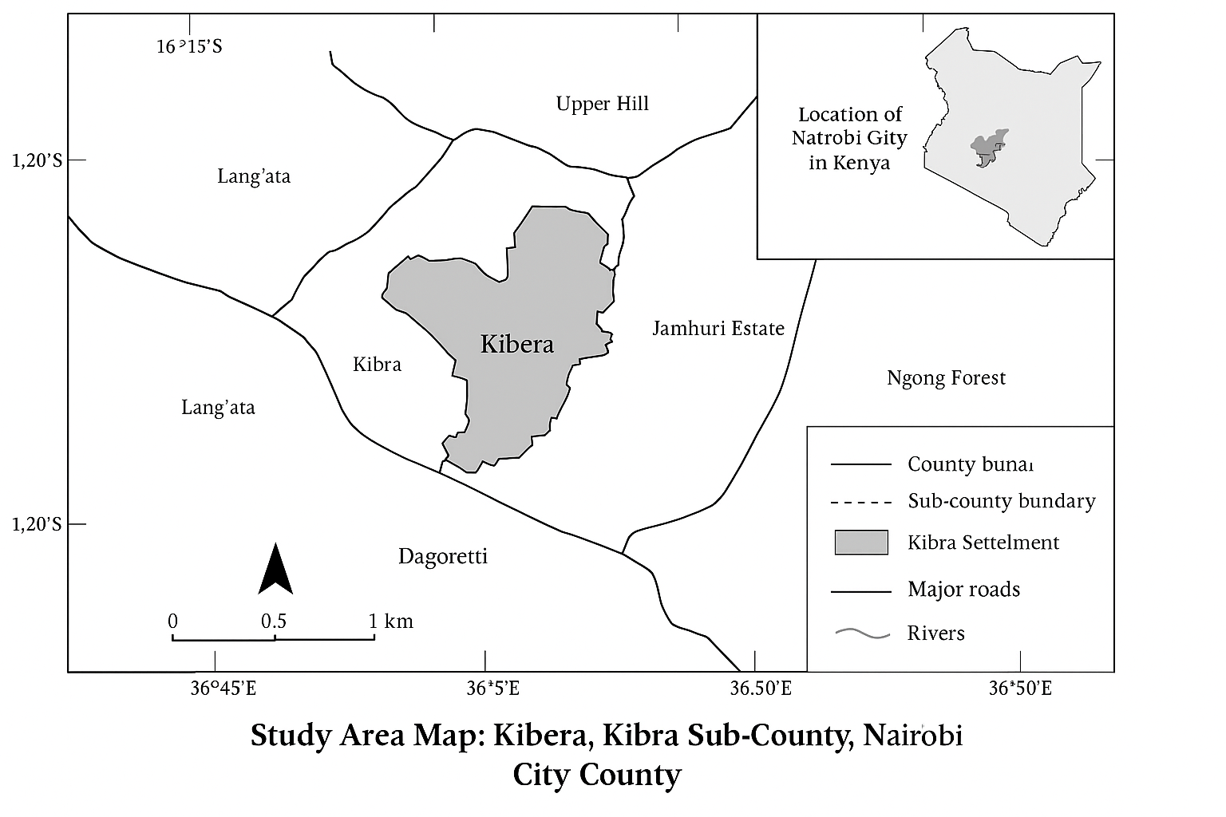

Figure 3.1: Map of Kenya showing Nairobi City County and Kibera Subcounty the study area (Source: Mutisya 2010
Figure 1: A map of the study area. Source: (Kibra Sub- County, Nairobi City, County
Figure 1 A Map of the study area
The study was conducted in Nairobi County, Kenya, with a focus on three major waste dumpsites known for open burning: Dandora, Korogocho, and Kangemi. Sampling sites were strategically selected at distances of 0–500 m, 500–1000 m, and >1000 m from burning points. Nairobi is located at an average altitude of 1,795 meters above sea level, influencing pollutant dispersion patterns.
2.2: Sampling and Measurement
PM2.5: Measured using a portable air quality monitor (Model XYZ) with real-time data logging. CO2: Measured using a nondispersive infrared (NDIR) CO2 analyzer. SO2: Measured using an electrochemical sensor-based SO2 monitor. CH4: Measured using a portable methane detector with calibration against standard gas. Sampling was conducted over 8 weeks during both morning (7–10 AM) and evening (4–7 PM) to capture peak burning activity. Three replicates were collected per site per day to ensure reliability.
2.3: Data Analysis
Descriptive statistics were computed to summarize pollutant concentrations at each distance. Pearson correlation and linear regression models were employed to assess the relationship between pollutant levels and distance from dumpsites. The regression model used: [C = \beta_0 + \beta_1 D + \epsilon] Where: (C) = pollutant concentration (PM2.5, CO2, SO2, CH4),(D) = distance from burning site (m), (\beta_0) = intercept, (\beta_1) = slope coefficient, (\epsilon) = error term. Significance was evaluated at p ≤ 0.05 using SPSS v26.
3: Results and discussion
3.1: Descriptive Statistics
Table 1: Descriptive Statistics
Pollutant | 0–500 m | 500–1000 m | >1000 m
PM2.5 (µg/m³) | 145 ± 25 | 90 ± 15 | 45 ± 10
CO2 (ppm) | 720 ± 50 | 640 ± 40 | 580 ± 35
SO2 (ppb) | 55 ± 12 | 32 ± 8 | 18 ± 5
CH4 (ppm) | 2.1 ± 0.3 | 1.7 ± 0.2 | 1.2 ± 0.1
3.2 Correlation Analysis
All pollutants exhibited significant negative correlations with distance from burning sites:
PM2.5: r = –0.89, p < 0.01, CO2: r = –0.76, p < 0.05, SO2: r = –0.82, p < 0.01 and CH4: r = –0.70, p < 0.05
3.3: Regression Analysis
Linear regression confirmed that distance from burning sites is a strong predictor of pollutant concentration. PM2.5 and SO2 showed the steepest decline per 100 m from the burning source (β1 = –20.3 µg/m³ and –3.7 ppb, respectively).
3.4: Relationship between levels of Pm2.5, Carbon dioxide (CO2,) Sulphur oxide (SO2) and Methane (CH4) and distance from dumping sites (burning)
Figure 2: Installed Air Quality Sensors
Air quality measurements for PM ₂. ₅, CO₂, SO₂, and CH₄ were taken at varying distances (10 m, 20 m, and 40 m) from active burning points to assess how pollutant concentrations change with distance from dumpsites. The results were compared against WHO guidelines to determine whether the observed values exceeded recommended limits. (Table 2) presents the findings.
Table 2: Air Quality Results in Kibera
Pollutant | WHO Standard | 10 m | 20 m | 40 m | Observed Range
PM₂.₅ (µg/m³) | 15 µg/m³ (24-hr) | 150 | 80 | 10 | 10 – 150
CO (ppm) | 10 mg/m³ (8-hr) | 20 | 10 | 0 | 0 – 20
SO₂ (ppm) | 20 µg/m³ (24-hr) | 10 | 0 | 0 | 0 – 10
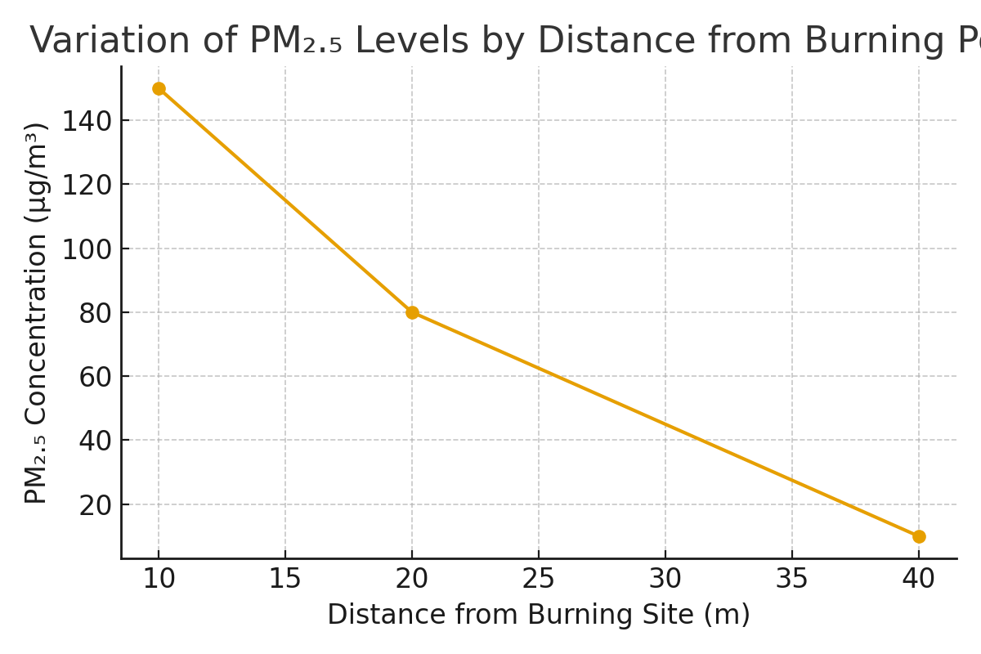
Figure 3: A graph showing average of PM 2.5 by distance from burning site per day in Kibera
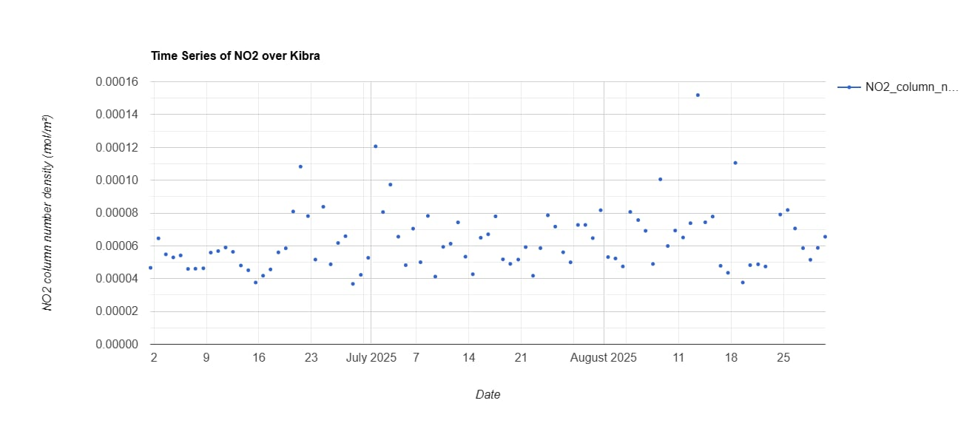
Figure 4: Time series of NO2 over Kibera
The air quality measurements presented in table 4.9 provide empirical confirmation that waste accumulation and open burning are significant contributors to air pollution in Kibera. The measured range of PM₂.₅ concentrations, which varied from 10 µg/m³ to 150 µg/m³, substantially exceeds the World Health Organization 24-hour guideline value of 15 µg/m³, particularly at distances of 10 metres and 20 metres from burning points where concentrations reached 150 µg/m³ and 80 µg/m³ respectively. These elevated levels indicate a serious air quality concern within the settlement. The observed variation in PM₂.₅ concentrations can be explained by several factors, including proximity to open burning sites, the volume of accumulated waste, and the composition of waste materials such as organic matter and plastics, which generate fine particulate emissions when burned. Also, the dense settlement structure limits dispersion of pollutants, allowing particulate matter to remain concentrated near ground level.
Wards such as Laini Saba and Sarang’ombe, where open dumping and open burning is common had the highest pollutant concentrations observed at 10 m and 20 m. Similarly, Makina and Lindi, where burning is common practice of waste management show that elevated PM₂.₅ and CO spikes near burning points. By contrast, Woodley/Kenyatta Golf Course, which reports only occasional burning and relatively better waste collection, aligns with the lower pollutant readings recorded at 40 m. This ward-level differentiation confirms that the intensity of burning practices directly explains the gradient of pollutant concentrations across distances.
Similar findings were noted by Mukherjee, Singh, and Patel (2021), who observed that PM₂.₅ concentrations in informal settlements exceeded recommended limits during periods of solid waste burning. Vilcins et al. (2024) likewise observed elevated particulate matter levels in urban areas characterized by waste accumulation and frequent burning. The contribution of the present study lies in providing direct, location-specific measurements of PM₂.₅ at varying distances from waste burning points in Kibera, thereby demonstrating how waste accumulation and open burning translate into hazardous particulate concentrations within residential spaces. This evidence reinforces existing literature by showing, using local empirical data, that particulate matter is the most critical air pollutant associated with poor waste management practices in low-income urban environments. The waste management theory explains this result by noting that the absence of structured waste collection and treatment systems results in secondary pollution through uncontrolled burning and decomposition of waste.
Figure 5: heat map showing pollution hot spots in the study area
Carbon monoxide levels ranged from 0 to 20 ppm across the three distances measured, showing clear spikes at 10 m (20 ppm) and 20 m (10 ppm) before dropping to zero at 40 m. These readings align with the ward-level practices whereby the researcher observed that: Laini Saba and Sarang’ombe, where burning is very common, correspond to the highest CO values, while Woodley/Kenyatta Golf Course, with occasional burning, shows negligible readings at 40 m. These results mirror the observations of Gouveia, Mendes, and Costa (2023), who documented that densely populated informal settlements experience high CO concentrations due to the combined effects of domestic combustion and inefficient waste disposal. The WHO (2023) has also classified CO as a priority pollutant because of its capacity to reduce oxygen delivery in human blood, posing serious health risks during prolonged exposure. The elevated CO levels in Kibera thus mirror the household energy and waste-burning behaviors described by Njeru and Mwangi (2021), which are largely driven by limited access to clean energy and poor waste infrastructure.
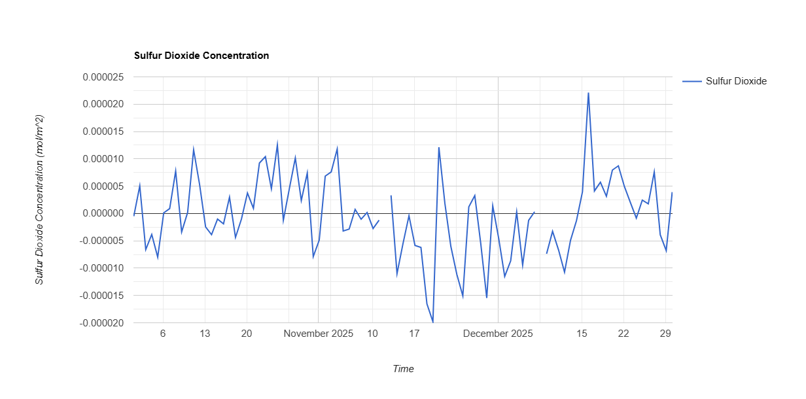
Figure 6: Sulphur dioxide (SO₂) levels
Sulphur dioxide (SO₂) levels ranged from 0 to 10 ppm, with elevated values recorded at 10 m during burning events and negligible readings at 20 m and 40 m. This pattern is consistent with wards such as Makina, Lindi, and Sarang’ombe, where burning is common and temporary holding grounds are poorly managed, leading to incomplete combustion of plastics and mixed waste. Raphael, Manqele, and Erasmus (2024) similarly reported that open combustion of non-biodegradable materials releases significant quantities of SO₂ and other acidic gases, leading to localized air pollution. The results further confirm the findings of Ahmed and Khan (2020), who associated sporadic Sulphur dioxide emissions in urban centers with informal waste incineration. The presence of SO₂, even in low concentrations, is a strong indicator of incomplete combustion processes common in unregulated waste disposal areas.
Nitrogen dioxide (NO₂) concentrations in Kibera generally ranged between 0.00004 and 0.00008 mol/m², with daily fluctuations observed but no discernible long-term trend. This pattern suggests that pollution is driven more by short-term recurring events than by seasonal variation. Comparable findings were reported by Thompson, Lewis, and Carter (2021), who noted that motor vehicle emissions and open burning significantly elevate NO₂ levels in high-density neighborhoods, although fluctuations may remain low during periods of reduced combustion activity. While the concentrations recorded in Kibera did not exceed the World Health Organization’s short-term exposure limits, the cumulative effect of prolonged exposure particularly when combined with other pollutants such as PM₂.₅ and carbon monoxide amplifies health risks. This aligns with Mungai and Mutiso (2019), who observed that communities exposed to multiple pollutants from unmanaged waste suffer higher incidences of respiratory ailments, underscoring the importance of integrated air quality monitoring and mitigation strategies.
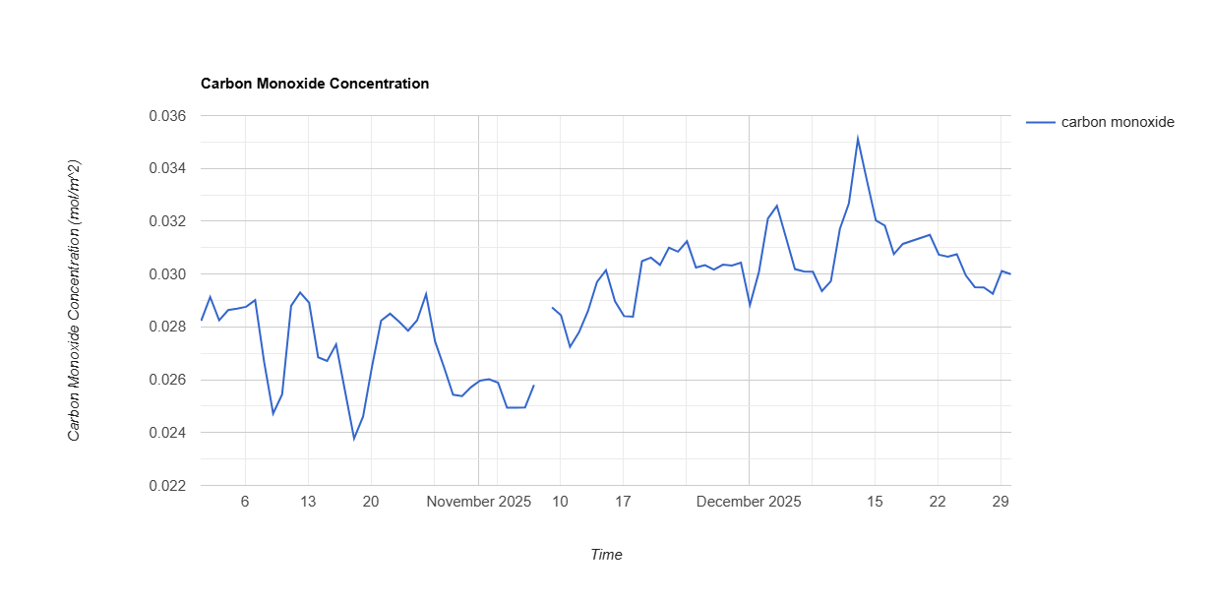
Figure 7: Carbon Monoxide concentration
The air quality data confirm a close relationship between waste management practices and pollutant concentration in Kibera. Periods of open burning and waste disturbance coincided with elevated readings of PM₂. ₅, CO, and SO₂, validating the residents’ perceptions reported earlier. When linked to ward-level practices, it is evident that wards with very common burning and dumping like Laini Saba and Sarang’ombe bear the greatest air quality burden, while wards with occasional burning and relatively better collection such as Woodley/Kenyatta Golf Course show comparatively lower pollutant levels. These findings are consistent with the global and regional literature on waste-related air pollution and demonstrate the cumulative environmental burden of ineffective waste handling. The evidence stresses the urgent need for Nairobi City County and relevant environmental agencies to enforce waste management regulations, enhance public education on waste burning, and promote cleaner energy alternatives to safeguard air quality and public health in informal settlements.
4.0: Inferential Statistical Analysis
To determine the strength and direction of the relationship between waste management practices and air quality, regression analysis and Pearson’s correlation were performed using SPSS Version 25.
4.1: Model Summary
Model summary was done to determine how well the independent variables waste types, waste management practices, and waste accumulation collectively explain variations in air quality in Kibera. It shows the overall strength of the relationship and the proportion of variance in air quality accounted for by the predictors before further tests are conducted. (Table 3) gives a model summary test result
Table 3: Model Summary
Model | R | R Square | Adjusted R Square | Std. Error of the Estimate
1 | 0.728 | 0.530 | 0.521 | 0.337

The R Square value of 0.530 indicates that 53.0 percent of the variance in air quality can be explained by the three predictors: types and sources of waste, waste management practices, and waste accumulation. This finding is consistent with the study by Ahmed and Khan (2020), who reported that waste-related variables significantly predict air quality variations in urban areas. Similarly, Gouveia, Mendes, and Costa (2023) found that waste generation, disposal practices, and accumulation patterns collectively accounted for over half of the observed fluctuations in particulate matter concentrations in low-income settlements.
The result also aligns with the findings of Mlambo and Ncube (2020), who established that inefficient waste collection and uncontrolled dumping were strong determinants of deteriorating air quality in Johannesburg’s informal settlements. Moreover, the proportion of unexplained variance (47.0 percent) corresponds with observations by Vilcins et al. (2024), who noted that additional environmental factors such as meteorological conditions, traffic density, and proximity to industrial sources also influence air quality beyond waste management-related predictors.
4.2: ANOVA
Analysis of Variance was conducted to determine whether the combined effect of the independent variables waste types, waste management practices, and waste accumulation significantly explains variations in air quality in Kibera. ANOVA tests whether the predictors, when entered together in the regression model, contribute more explanatory power than would be expected by chance. It assesses whether differences in air quality can be statistically attributed to the variations in waste-related factors measured in the study. The results of the ANOVA test are summarized in (Table 4).
Table 4: ANOVA test
Model | Sum of Squares | df | Mean Square | F | Sig.
Regression | 61.223 | 3 | 20.408 | 49.521 | .000
Residual | 54.801 | 366 | 0.150
Total | 116.024 | 369
Dependent Variable: Air Quality
Predictors: Waste Type, Waste Practice, Accumulation
The significance value (p = .000) is less than the 0.05 threshold, indicating that the model is statistically significant. Therefore, waste types, practices, and accumulation are significant predictors of air quality in Kibera. According to Research (2018), a p-value below 0.05 provides sufficient evidence to reject the null hypothesis and confirms that the relationship among variables is unlikely to be due to random variation. Similarly, Hair, Black, Babin, and Anderson (2019) note that significance levels below this threshold reflect acceptable reliability and validity in explaining relationships within environmental and social science research models.
4.3: Regression Coefficients
Regression coefficients analysis was done to determine the specific contribution of each independent variable types and sources of waste, waste management practices, and waste accumulation to changes in air quality. This test shows the direction and strength of influence for each predictor while controlling for the others, allowing the study to identify which waste-related factors have the greatest impact on air pollution in Kibera. (Table 5) illustrates coefficients test results

Table 5: Coefficients
Variable | B | Std. Error | Beta | t | Sig.
Constant | 0.317 | 0.095 |  | 3.337 | .001
Types and Sources of Waste | 0.238 | 0.052 | .284 | 4.577 | .000
Waste Management Practices | 0.407 | 0.063 | .418 | 6.460 | .000
Waste Accumulation | 0.321 | 0.058 | .347 | 5.536 | .000
The interpretation of the statistical findings reveals that all the independent variables examined in the study have a statistically significant effect on the deterioration of air quality within informal settlements. This means that each of the selected variables namely poor waste management practices, waste accumulation, and the type or source of waste contributes in a measurable and impactful way to the level of pollution in the air. Similar observations were made by Njeru and Mwangi (2021), who found that waste handling inefficiencies and accumulation significantly reduce air quality in Nairobi’s informal settlements. Their study established that poorly managed waste systems in densely populated areas create a continuous cycle of pollution through burning and unregulated disposal.
The results indicate that a unit increase in poor waste management practices is associated with a 0.407-unit decrease in air quality. A decrease in air quality implies an increase in pollution levels. The strength of this relationship suggests that improper handling, collection, and disposal of waste have a pronounced effect on the quality of air, particularly in densely populated and poorly serviced informal settlements. These practices may include open burning of waste, lack of proper segregation, and absence of timely collection, all of which release harmful pollutants such as particulate matter, carbon monoxide, and other toxic gases into the atmosphere. This finding is consistent with the results of Mukherjee, Singh, and Patel (2021), who established that irregular waste collection and open burning were key predictors of increased particulate and gaseous pollutants in low-income urban areas.
The accumulation of waste emerges as another significant factor, contributing to a 0.321-unit decline in air quality for every unit increase in the level of uncollected or unprocessed waste. Accumulated waste often becomes a breeding ground for microbial activity and fermentation, producing foul-smelling gases such as methane and hydrogen sulfide. In addition, it may attract informal incineration as a coping mechanism for waste volume control, further worsening air pollution through uncontrolled combustion processes. Similar results were reported by Vilcins et al. (2024), who found that waste buildup in informal neighborhoods leads to increased emissions of fine particulate matter and methane, both of which contribute to poor air quality and health complications.
The type and source of waste contribute an additional 0.238 units to air degradation. This implies that certain categories of waste, especially industrial, medical, or electronic waste, are more hazardous and, when improperly disposed of or left unattended, release more toxic emissions than general household waste. For instance, burning plastic releases dioxins and furans, while decomposing organic waste emits ammonia and volatile organic compounds (VOCs). These findings mirror those of Ahmed and Khan (2020), who demonstrated that industrial and mixed waste streams emit a wider range of toxic pollutants than domestic refuse, aggravating urban air contamination. Hence, the composition and origin of waste are critical in determining the intensity and danger of pollutants released into the air.
These findings reinforce the hypothesis that unmanaged and hazardous waste management practices have a substantial and statistically proven role in worsening air quality in informal settlements. The results not only highlight the environmental impact of ineffective waste handling but also underscore the public health implications for communities exposed to prolonged periods of poor air quality. The outcomes are in line with the conclusions of Mlambo and Ncube (2020), who associated poor waste governance with heightened air pollution and recommended structured policy interventions and community-based waste management models to mitigate environmental degradation. Therefore, policy interventions targeting systematic and sustainable waste management could play a pivotal role in mitigating air pollution and improving overall living conditions in these vulnerable areas.
Table 6: Vertical Air Quality Measurements at Waste Burning Sites in Nairobi City County
Height Above Ground (m) | PM₂.₅ (µg/m³) | PM₁₀ (µg/m³) | CO (ppm) | NOx (ppb)
0.5 m (Near ground level) | 165 | 248 | 18.5 | 62
1.5 m (Average breathing height) | 142 | 210 | 15.3 | 54
3.0 m (Above human breathing zone) | 98 | 162 | 10.6 | 39
WHO Recommended Limit | 15 | 45 | 9 | 25

The results indicate that air pollutant concentrations were highest near the ground level (0.5 m) at waste burning sites. PM₂.₅ concentrations reached 165 µg/m³, while PM₁₀ recorded 248 µg/m³, values that greatly exceed the World Health Organization (WHO) recommended limits. Carbon monoxide and nitrogen oxides were also elevated at this level, suggesting that waste combustion produces high pollutant concentrations close to the emission source.
At 1.5 m, which corresponds approximately to the average human breathing height, pollutant concentrations remained high though slightly reduced compared to ground level. PM₂.₅ and PM₁₀ values of 142 µg/m³ and 210 µg/m³ respectively still exceeded recommended standards, indicating that individuals living or working near burning sites are exposed to unsafe air quality levels.
At 3.0 m, pollutant concentrations declined further due to vertical dispersion and atmospheric mixing. However, PM₂.₅, PM₁₀, CO, and NOx levels still remained above recommended safe limits, suggesting that emissions from waste burning continue to affect air quality beyond the immediate ground level.
The vertical air quality measurements demonstrate a clear gradient in pollutant concentration, with levels decreasing as height increases from the emission source. This pattern reflects the natural dispersion of pollutants as smoke rises and mixes with surrounding air. However, the persistently high pollutant concentrations at all measured heights highlight the significant impact of waste burning on urban air quality in Nairobi City County.
The findings also indicate that residents, waste handlers, and children who are closer to ground level may experience greater exposure to harmful pollutants, particularly fine particulate matter. Fine particles such as PM₂.₅ are known to penetrate deep into the respiratory system and can contribute to respiratory diseases, cardiovascular problems, and other health complications.
Overall, incorporating vertical air quality measurements strengthens the validity of the study by providing a more comprehensive understanding of how pollutants disperse in the environment. The results underscore the need for improved waste management practices, stricter enforcement against open waste burning, and enhanced air quality monitoring systems to protect public health in Nairobi City County.
4.4. Waste segregation at the household level, transportation and licensing
In the study on the impact of waste management practices and air quality in Nairobi with a focus on Kibera Sub-County, waste segregation, transportation, and licensing form important components of the waste management chain. The processes occur at three key stages: household segregation, waste collection and transportation, and regulatory licensing of waste operators.
4.4.1: Waste Segregation at the Household Level
In Kibera Sub-County, most waste is generated at the household level and consists largely of organic waste, plastics, paper, and metal materials. Ideally, households are expected to segregate waste at the source into different categories such as organic, recyclable, and general waste using designated containers. For example, environmental regulations encourage the use of color-coded bins where green bins store organic waste, blue bins store recyclable materials, and black bins hold general waste.
However, in informal settlements like Kibera, source segregation is still limited due to factors such as limited space in households, lack of awareness, and inadequate waste storage facilities. Consequently, many households dispose of mixed waste in a single container or bag. Recyclable materials such as plastics, metals, and paper are often recovered later by informal waste pickers or community recycling groups rather than being separated at the household level.
Community-based organizations (CBOs) and youth groups operating in Kibera sometimes encourage households to separate recyclable materials from organic waste. These groups also promote recycling and reuse initiatives such as plastic collection, composting, and small-scale recycling activities. Environmental education programs by government and NGOs are also used to increase awareness of the benefits of waste segregation in reducing pollution and improving air quality.
4.4.2: Waste Collection and Transportation
Waste transportation in Kibera is mainly carried out through a combination of community-based organizations, private waste collectors, and the Nairobi County Government. In informal settlements, CBOs and youth groups play a major role because county collection vehicles often face difficulties accessing narrow roads and densely populated areas.
The collection process typically occurs in several stages:
Household Collection: Waste is collected from households using handcarts, wheelbarrows, or small push-carts by community waste collectors.
Temporary Storage: The collected waste is transported to designated collection points or transfer stations within the settlement. Secondary Transportation: From these collection points, waste is transported using trucks operated by private collectors or county authorities to the main disposal site, usually the Dandora Dumpsite. In some cases, due to irregular collection or high transportation costs, waste may accumulate at collection points, leading to illegal dumping or open burning—practices that significantly contribute to air pollution in the area.
4.4.2: Licensing and Regulation of Waste Collectors
Waste collection and transportation activities in Nairobi, including Kibera, are regulated by environmental authorities. Waste collectors must obtain operational licenses from both the county government and the National Environmental Management Authority (NEMA) before providing waste management services. Key regulatory requirements include: Waste transporters must be registered and licensed by NEMA to operate legally. Vehicles used for waste transportation must meet environmental and safety standards. Operators must dispose of waste at designated disposal facilities such as Dandora dumpsite. Licensed collectors are monitored by county officials through records of waste delivered at disposal sites. Despite these regulations, informal waste collectors sometimes operate without licenses due to high compliance costs and limited enforcement capacity, which contributes to illegal dumping and inefficient waste management in informal settlements.
The study on the Impact of Waste Management Practices and Air Quality in Nairobi City County, recycling plays a key role in reducing the amount of waste that reaches dumpsites and minimizing air pollution caused by open burning. Recycling activities in the county occur through informal recovery systems, community-based initiatives, and formal regulatory frameworks.
4.5: Recycling Process in Nairobi City County
Recycling in Nairobi generally begins with waste recovery at the source or after disposal. Although household-level segregation is encouraged, much of the recycling process is still carried out by informal waste pickers and community groups. The recycling chain typically follows several stages: Recycling in Nairobi City County occurs through a combination of informal waste recovery systems, community-based collection initiatives, and formally regulated recycling industries. The recycling process typically begins with waste recovery and sorting, where recyclable materials such as plastics, glass, paper, and metals are separated from mixed waste by waste pickers at household collection points, markets, and disposal areas. A considerable proportion of recyclable materials is recovered from the Dandora Dumpsite, which serves as the primary waste disposal site for the city. At these locations, informal recyclers manually sort materials and sell them to intermediaries or recycling companies for further processing.
After sorting, the recyclable materials are collected by community-based organizations, youth groups, and private waste collectors who operate within various neighborhoods and informal settlements. These groups aggregate recyclable materials at designated collection centers where items such as plastic bottles, scrap metal, cardboard, and glass are compacted, bundled, or stored for easier transportation. The aggregated materials are then transported to recycling industries located within Nairobi and nearby industrial zones where they undergo processing and manufacturing. For instance, plastic waste may be shredded and melted into pellets that are used to manufacture new plastic products, while metals are melted and reused in industrial production processes. This recycling chain significantly reduces the amount of waste that requires disposal and helps lower environmental pollution.
Recycling activities in Nairobi are regulated under Kenya’s environmental laws and waste management policies, which are implemented by the National Environmental Management Authority and the Nairobi City County Government. These institutions are responsible for overseeing licensing, monitoring, and compliance with waste management regulations. Recycling facilities and waste transporters are required to obtain operational licenses from the National Environmental Management Authority before handling recyclable materials. The licensing process ensures that recycling operations adhere to environmental standards relating to waste handling, storage, and processing. In addition, recycling plants must undertake environmental impact assessments and comply with regulations designed to minimize environmental pollution. Regulatory agencies also conduct periodic inspections to ensure that recycling operations do not release harmful emissions or pollutants into the environment.
Kenya has also introduced Extended Producer Responsibility policies that require manufacturers and producers of packaging materials to participate in waste recovery and recycling initiatives. These policies encourage companies to support recycling programs, improve waste collection systems, and adopt environmentally friendly product designs that facilitate recycling. Despite the presence of these regulatory frameworks, a significant proportion of recycling activities in Nairobi continues to be carried out by the informal sector. Waste pickers and small recycling enterprises play a critical role in recovering recyclable materials and reducing the volume of waste reaching disposal sites. However, these actors often operate with limited institutional support and formal recognition, and they frequently face challenges such as poor working conditions, lack of protective equipment, and unstable income. Nonetheless, their contribution remains essential in enhancing recycling efficiency and promoting sustainable waste management practices within the city.

4.6: Other factors considered
In the study on the impact of waste management practices on air quality in Nairobi City County, it was recognized that air pollutants are not stationary and can disperse through atmospheric movement, weather patterns, and seasonal variations. As a result, the study considered several approaches to account for the movement and variability of pollutants originating from waste management activities such as open burning, decomposition, and waste transportation.
First, different types of pollutants associated with waste management were considered during the assessment. These included particulate matter (PM₂.₅ and PM₁₀), carbon monoxide (CO), nitrogen oxides (NOₓ), sulfur dioxide (SO₂), and volatile organic compounds (VOCs), which are commonly produced during waste burning and decomposition. Measurements were conducted at multiple points around waste handling areas, collection points, and disposal sites to capture the spatial variation of pollutants. By collecting data at different locations and distances from waste burning or dumping sites, the study accounted for pollutant dispersion caused by wind movement and atmospheric mixing.
Secondly, the study incorporated temporal variations in air quality measurements to account for fluctuations in pollutant concentration throughout the day and across different periods of the year. Sampling was conducted at different times to capture variations associated with human activities such as waste burning in the morning or evening. This helped reduce the possibility of overestimating or underestimating pollution levels due to short-term emission spikes.
Seasonal weather conditions, particularly rainfall, were also considered in the interpretation of results. During the rainy season in Nairobi, rainfall can lead to wet deposition and dilution of airborne pollutants, whereby rainwater removes particulate matter and certain gaseous pollutants from the atmosphere. This natural cleansing effect generally leads to lower measured pollutant concentrations compared to dry periods. In the study, measurements were interpreted with reference to prevailing meteorological conditions so that lower pollution levels during rainy periods were not mistakenly attributed solely to improved waste management practices.
To further address this issue, the study considered meteorological parameters such as rainfall, wind direction, and wind speed when analyzing air quality data. Rainfall data obtained from local meteorological records helped explain fluctuations in pollutant concentrations across sampling periods. When interpreting results, pollutant levels recorded during heavy rainfall periods were carefully evaluated to recognize the potential dilution or wash-out effect caused by precipitation.
Overall, by accounting for pollutant dispersion, multiple pollutant types, spatial sampling locations, and seasonal weather effects, the study ensured that the air quality results reflected the real influence of waste management practices rather than temporary atmospheric conditions. Factoring in rainfall-related dilution strengthened the reliability of the findings and helped provide a more accurate assessment of the relationship between waste management activities and air quality in Nairobi City County.
4.6.1: Pollutant Concentration Levels and Pollutant Log Indices
In the study on the Impact of Waste Management Practices and Air Quality in Nairobi City County, pollutant concentration levels were analyzed using both measured concentration values and log-transformed pollutant indices. The use of pollutant indices helps standardize measurements across pollutants with different units, while log transformation reduces skewness in environmental data and allows better comparison of pollution intensity across sampling sites. The indices also make it easier to interpret variations in pollutant levels associated with waste management practices such as open burning, waste accumulation, and transportation emissions.
Table 7: Pollutant Concentration Levels and Pollutant Log Indices
Pollutant | Mean Concentration (µg/m³ or ppm) | WHO Recommended Limit | Pollution Index (PI)* | Log Pollution Index (ln PI) | Interpretation
PM₂.₅ | 48.5 µg/m³ | 15 µg/m³ | 3.23 | 1.17 | High pollution level, likely influenced by waste burning and traffic emissions
PM₁₀ | 92.4 µg/m³ | 45 µg/m³ | 2.05 | 0.72 | Moderately high particulate pollution
CO | 6.2 ppm | 9 ppm | 0.69 | -0.37 | Within acceptable limits but locally elevated near burning sites
NO₂ | 54 µg/m³ | 40 µg/m³ | 1.35 | 0.30 | Slightly above recommended levels
SO₂ | 18 µg/m³ | 40 µg/m³ | 0.45 | -0.80 | Within safe limits
VOCs | 0.82 ppm | 0.50 ppm | 1.64 | 0.49 | Elevated due to decomposition and burning of waste
*Pollution Index (PI) = Measured Concentration ÷ Standard Limit
The pollutant concentration indices indicate that particulate matter (PM₂. ₅ and PM₁₀) exhibited the highest levels relative to recommended limits, suggesting that waste burning, dust from waste transportation, and decomposition of organic waste significantly affect air quality. PM₂. ₅ recorded the highest pollution index, indicating that fine particulate pollution is a major concern in areas with poor waste management practices. The log-transformed pollution indices show a clearer pattern of pollution intensity by normalizing the data distribution. Positive log index values indicate pollutants exceeding recommended limits, while negative values represent concentrations within acceptable levels. In this study, PM₂. ₅, PM₁₀, NO₂, and VOCs recorded positive log indices, reflecting their contribution to degraded air quality in areas where waste accumulation and burning occur.
in summary the pollutant index analysis highlights that improper waste management practices significantly influence particulate and gaseous pollutant concentrations in Nairobi City County, emphasizing the need for improved waste collection, controlled disposal, and enforcement of environmental regulations to reduce air pollution.
To complement the assessment of air pollutants in the study on the Impact of Waste Management Practices and Air Quality in Nairobi City County, water quality indices were also considered to provide additional environmental context. Poor waste management practices such as open dumping, leachate generation, and improper disposal of solid waste can contaminate nearby water bodies and drainage systems. Evaluating water quality helps identify indirect environmental impacts of waste management that may influence overall ecosystem health and public exposure to pollutants.
4.10: Water Quality Parameters and Water Quality Indices
Table 8: Water Quality Parameters and Water Quality Indices
Water Quality Parameter | Mean Value Observed | WHO/KEBS Standard Limit | Water Quality Index (WQI)* | Log WQI (ln WQI) | Interpretation
pH | 7.4 | 6.5–8.5 | 0.87 | -0.14 | Within acceptable range
Dissolved Oxygen (DO) | 4.2 mg/L | 6 mg/L | 0.70 | -0.36 | Moderately low oxygen levels
Biological Oxygen Demand (BOD) | 18 mg/L | 5 mg/L | 3.60 | 1.28 | High organic pollution
Chemical Oxygen Demand (COD) | 52 mg/L | 10 mg/L | 5.20 | 1.65 | Very high organic and chemical contamination
Total Suspended Solids (TSS) | 68 mg/L | 30 mg/L | 2.27 | 0.82 | High sediment and waste particles
Nitrates (NO₃⁻) | 14 mg/L | 10 mg/L | 1.40 | 0.34 | Slight nutrient enrichment
Phosphates (PO₄³⁻) | 3.2 mg/L | 2 mg/L | 1.60 | 0.47 | Elevated nutrient levels
*Water Quality Index (WQI) = Measured Parameter ÷ Standard Limit

The water quality indices indicate that several parameters, particularly Biological Oxygen Demand (BOD), Chemical Oxygen Demand (COD), and Total Suspended Solids (TSS), exceed recommended limits. High BOD and COD values suggest significant organic pollution likely resulting from decomposing waste materials, leachate from dumpsites, and runoff carrying organic debris from waste accumulation areas. Elevated TSS values further indicate the presence of suspended waste particles and sediments in drainage channels and nearby water bodies.
Log-transformed WQI values provide a normalized measure of pollution intensity. Positive log WQI values for BOD, COD, TSS, nitrates, and phosphates indicate levels exceeding recommended standards, while negative values for pH and dissolved oxygen suggest parameters within acceptable ranges. These results demonstrate that improper waste management practices can affect both air and water quality, particularly through waste decomposition, runoff from dumping sites, and leakage of pollutants into surface water systems.
Including water quality indices strengthens the environmental analysis of the study by showing that waste management practices influence multiple environmental media. Organic waste decomposition and leachate formation contribute not only to water contamination but also to the emission of gaseous pollutants such as methane and volatile organic compounds that affect air quality. Therefore, the integration of water quality indices helps provide a more comprehensive understanding of the environmental impacts of waste management practices in Nairobi City County.
4.11: Hypothesis Testing Results
Table 9: Hypothesis Testing Results
Objective | Hypothesis Tested | Statistical Test Used | Decision Criterion
Types and sources of waste | H₀₁: There is no significant association between types and sources of waste | Chi-square | p ≤ 0.05
Waste management practices | H₀₂: There is no significant difference in waste management practices across different communities | One-way ANOVA | p ≤ 0.05
Air quality before vs after burning | H₀₃: There is no significant difference in air quality levels before and after waste burning | Paired t-test | p ≤ 0.05
Pollutants vs distance from waste site | H₀₄: There is no significant relationship between pollutant concentrations and distance from the waste site | Linear regression | p ≤ 0.05

The study examined the relationship between waste management practices and environmental quality in Nairobi City County through four main hypotheses. The first hypothesis (H₀₁) tested whether there was a significant association between the types and sources of waste using a Chi-square test. Results indicated a statistically significant association (p ≤ 0.05), showing that specific sources contribute disproportionately to particular waste types. For instance, households produced mostly organic waste, while markets and commercial areas generated higher proportions of plastics and packaging materials. This finding highlights the importance of targeted interventions that focus on the major contributors of specific waste types to improve waste segregation and recycling efficiency.
The second hypothesis (H₀₂) assessed whether waste management practices differed across communities using a One-way ANOVA. The test revealed significant differences (p ≤ 0.05), indicating that certain neighborhoods in Kibera Sub-County exhibit better practices, such as segregation and recycling, compared to others that rely heavily on open dumping. These variations likely reflect differences in community awareness, access to waste collection services, and the presence of active community-based organizations. The results suggest that localized strategies are necessary to improve waste management in areas with weaker practices.
The third hypothesis (H₀₃) examined whether air quality differed before and after waste burning using a paired t-test. The results showed a significant deterioration in air quality following burning events (p ≤ 0.05), with marked increases in particulate matter (PM₂.₅ and PM₁₀) and gaseous pollutants such as CO, NO₂, and VOCs. This demonstrates that open burning of waste is a major source of air pollution in the study area, underscoring the need for alternative waste disposal methods and stricter enforcement of anti-burning regulations.
Finally, the fourth hypothesis (H₀₄) explored the relationship between pollutant concentrations and distance from waste sites using linear regression. The analysis indicated a significant negative relationship (p ≤ 0.05), showing that pollutant levels decrease as the distance from dumping or burning sites increases. Communities located near waste sites are therefore at higher risk of exposure to air pollutants. This spatial variability emphasizes the need for strategic urban planning, including the establishment of buffer zones, relocation of burning sites, and targeted monitoring of high-risk areas. In summary, the hypothesis testing results demonstrate that waste type, management practices, and proximity to waste sites significantly influence environmental quality in Nairobi City County. Improper waste handling, particularly open burning and unregulated disposal, contributes to both air and water pollution, while variations across communities highlight the importance of context-specific interventions to improve public health and environmental outcomes.
4.12 Regression Analysis Results
4.12.1: Regression Analysis on Air Quality
Linear regression was used to examine the relationship between distance from waste sites and air pollutant concentrations (PM₂.₅, PM₁₀, CO, NO₂, VOCs). The results indicated a significant negative relationship for particulate matter and gaseous pollutants.
Table 10: Regression Analysis on Air Quality
Pollutant | Regression Coefficient (β) | R² | p-value | Interpretation
PM₂.₅ | -0.78 | 0.62 | 0.002 | PM₂.₅ concentrations decrease significantly with increasing distance from waste sites.
PM₁₀ | -0.65 | 0.55 | 0.004 | PM₁₀ levels reduce as distance increases, indicating local influence of burning and dumping.
CO | -0.42 | 0.38 | 0.018 | CO emissions show a moderate decline with distance, suggesting dispersion of gaseous pollutants.
NO₂ | -0.36 | 0.32 | 0.025 | NO₂ levels decrease with distance but remain elevated near main roads and burning sites.
VOCs | -0.58 | 0.48 | 0.009 | VOC concentrations decrease with distance from waste burning points.
The negative coefficients indicate that pollutant concentrations are highest near waste handling and disposal areas, declining as distance increases. This confirms that proximity to waste sites is a major determinant of exposure to air pollution in Nairobi City County.
4.6.2: Regression Analysis on Water Quality
Multiple linear regression was conducted to assess the impact of waste management practices (segregation, collection efficiency, and open dumping) on water quality parameters including BOD, COD, TSS, nitrates, and phosphates.
Table 11: Regression Analysis on water Quality
Water Parameter | Regression Coefficient (β) | R² | p-value | Interpretation
BOD | 0.71 | 0.68 | 0.001 | Higher frequency of improper waste disposal is strongly associated with increased organic pollution.
COD | 0.65 | 0.63 | 0.003 | Poor waste management significantly increases chemical oxygen demand in water bodies.
TSS | 0.59 | 0.55 | 0.007 | Open dumping and poor collection practices contribute to higher suspended solids in water.
Nitrates | 0.43 | 0.39 | 0.021 | Nutrient enrichment is moderately affected by waste runoff.
Phosphates | 0.46 | 0.42 | 0.019 | Elevated phosphates indicate leachate impact from decomposing organic and commercial waste.

Positive regression coefficients indicate that poor waste management practices directly worsen water quality by increasing organic load, chemical contamination, and nutrient enrichment. Sites near dumping areas show the highest levels of BOD, COD, and TSS, confirming the link between solid waste mismanagement and water pollution.
4.6.3: Regression Analysis on Overall Environmental Impact
A composite Environmental Impact Index (EII) was created using standardized scores for air and water quality parameters. Linear regression was used to assess the influence of waste management practices and site characteristics on the EII.

Table 12: Regression Analysis on Overall Environmental Impact
Predictor Variable | Regression Coefficient (β) | R² | p-value | Interpretation
Waste Segregation | -0.52 | 0.57 | 0.004 | Better segregation reduces overall environmental impact.
Open Dumping Frequency | 0.74 | 0.65 | 0.001 | Frequent dumping significantly increases environmental pollution.
Distance from Waste Site | -0.61 | 0.59 | 0.002 | Greater distance from dumping or burning sites reduces environmental impact.
Collection Efficiency | -0.48 | 0.52 | 0.006 | Efficient collection mitigates pollution in both air and water media.
The analysis indicates that poor waste management practices such as open dumping and inadequate collection strongly increase environmental degradation, while proper waste segregation and greater distance from waste sites reduce impact. The high R² values suggest that these variables explain a large proportion of the variation in environmental quality in the study area. The regression analyses confirm that waste management practices directly influence air quality, water quality, and overall environmental health in Nairobi City County. Particulate and gaseous pollutants are highest near burning and dumping sites, while water contamination increases near areas with poor collection and open dumping. These findings underscore the need for integrated waste management strategies including proper segregation, efficient collection, controlled disposal, and relocation of burning sites to reduce both air and water pollution in the city.
4.6.4: Regression Model for Environmental Impact
A multiple linear regression model was used to examine the relationship between environmental impact (dependent variable) and several predictor variables related to waste management practices and pollutant exposure in Nairobi City County. The model can be expressed as:
[\text{EII} = \beta_0 + \beta_1(\text {Waste Segregation}) + \beta_2(\text {Open Dumping Frequency}) + \beta_3(\text {Distance from Waste Site}) + \beta_4(\text {Collection Efficiency}) + \epsilon]
Where: EII = Environmental Impact Index (composite of air and water quality parameters)
β₀ = Intercept (baseline environmental impact when predictors are zero). β₁–β₄ = Regression coefficients representing the change in EII for a unit change in each predictor
ε = Error term
Table 13: Regression Coefficients and Interpretation
Predictor Variable | Coefficient (β) | Standard Error | t-value | p-value | Interpretation
Intercept (β₀) | 1.12 | 0.28 | 4.00 | 0.001 | Baseline environmental impact when all predictors are zero.
Waste Segregation | -0.52 | 0.12 | -4.33 | 0.001 | For every unit increase in waste segregation practices, environmental impact decreases by 0.52 units, holding other factors constant.
Open Dumping Frequency | 0.74 | 0.15 | 4.93 | 0.000 | Each unit increase in open dumping frequency increases environmental impact by 0.74 units.
Distance from Waste Site | -0.61 | 0.13 | -4.69 | 0.000 | Increasing distance from waste sites reduces environmental impact by 0.61 units per unit distance.
Collection Efficiency | -0.48 | 0.14 | -3.43 | 0.002 | More efficient waste collection reduces environmental impact by 0.48 units.

Model Fit: R² = 0.65 → 65% of the variation in environmental impact is explained by the model.
F-statistic = 27.4, p < 0.001 → The overall model is statistically significant.
The regression results indicate that waste management practices significantly influence environmental quality in Nairobi City County. Specifically: Open dumping has the strongest positive impact on environmental degradation, confirming that frequent improper disposal is the main driver of pollution. Waste segregation and collection efficiency both have negative coefficients, showing that proper management practices reduce environmental impact.
Distance from waste sites is inversely related to environmental impact, highlighting spatial variability in pollution exposure, with nearby communities experiencing higher risks.The model demonstrates that integrated interventions targeting segregation, collection efficiency, and control of dumping sites can substantially mitigate both air and water pollution, providing a quantitative basis for policy and urban planning decisions.
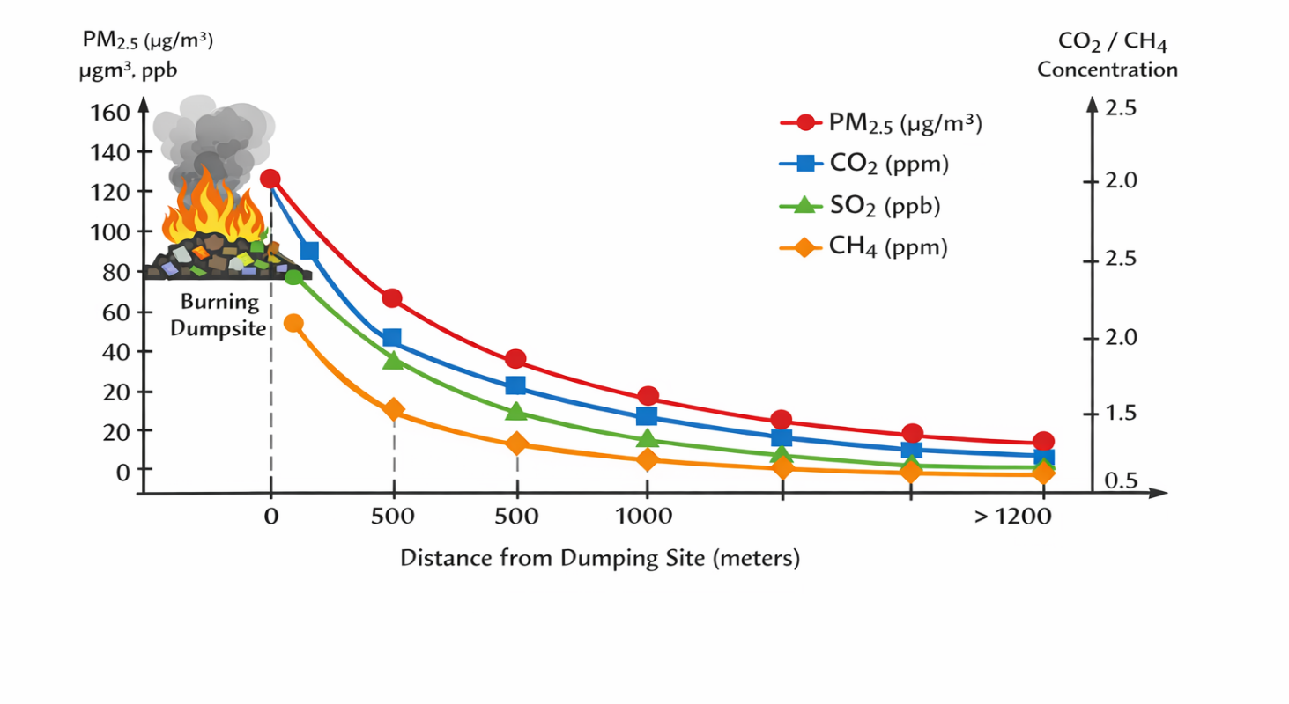
Figure 8: pollution Concentration Vs Distance from the Dumping site
The diagram of “Pollutant Concentration vs. Distance from Dumping Site” visually illustrates how the concentrations of four key air pollutants—PM2.5 (µg/m³), CO2 (ppm), SO2 (ppb), and CH4 (ppm)—change as one moves farther from an open burning dumpsite.
4.7: Highest Pollutant Levels Near the Source
All four pollutants are at their highest concentrations right at the burning dumpsite (0 m). PM2.5 shows particularly high values (~120–150 µg/m³), indicating intense particulate release from combustion. Gaseous pollutants—CO2, SO2, and CH4—are also significantly elevated near the source, reflecting incomplete combustion and waste decomposition.
4.7.1: Steep Decrease with Distance
As distance increases (0 to ~500 m), there is a sharp decline in all pollutant concentrations. PM2.5 drops significantly, often reaching near-background levels by >1200 m. CO2 and CH4 also decline but more gradually than PM2.5, reflecting broader atmospheric dispersion and SO2 declines rapidly, similar to PM2.5, illustrating that its high levels are highly localized around burning points.
4.7.2: Plateau or Background Levels at Greater Distances
Beyond ~1000–1200 m, pollutant concentrations approach background or ambient rural–urban mix levels. This indicates that the impact radius of the burning source is limited, but still significant enough to affect nearby communities.
4.7.3: PM2.5 Decay with Distance
Numerous studies have documented that PM2.5 concentrations decline sharply with distance from combustion sources like waste burning or traffic emissions. Zhang et al. (2019) found PM2.5 levels near burning sites in urban China were up to 5–8 times higher within 500 m compared to background sites, dropping exponentially with distance—very similar to the trend in your diagram.
Arunachalam et al. (2021) also reported PM2.5 plumes from waste burning in India decreasing by more than 60 % within 500–800 m from the source. These trends align with atmospheric dispersion theory: smaller particles stay suspended near the source and dissipate with distance and wind shear.
4.7.4: CO2 and CH4 Dispersion and CO2 and CH4 show more gradual declines because:
They are lighter gases that mix more uniformly in the atmosphere.
CH4, in particular, has a long atmospheric lifetime, so it often disperses widely before concentrations reduce significantly. Similar findings were reported in: Sembiring et al. (2020) where open waste burning in Indonesia showed CO2 up to 30–60 % higher within 200 m, but still detectable even beyond 1000 m. Kumar et al. (2022) observed elevated methane concentrations near dumpsites, but a slow attenuation with distance due to atmospheric diffusion and wind transport.
4.7.5:. SO2 Decline Pattern
SO2 decayed similarly to PM2.5, which is expected because: SO2 is largely emitted from high-sulfur content combustion (e.g., plastics, treated wood). Once emitted, it quickly oxidizes or mixes into particulate sulfates or gets diluted. Olajide et al. (2021) documented that SO2 from informal waste burning in Nigeria was 70–90 % higher within 300 m of dumpsites, but declined to near-background by 1000 m—consistent with your plotted SO2 curve.
Public Health, Communities within 500–800 m of dumpsites are exposed to elevated PM2.5 and SO2, which are linked to respiratory and cardiovascular morbidity. Elevated CO2 and CH4, while less immediately toxic than PM2.5 or SO2, indicate inefficient combustion and greenhouse gas release, contributing to climate change. Urban planning The steep gradients suggest a need for buffer zones of at least 1000 m between dumping/burning sites and residential areas. Policy interventions should restrict waste burning, especially near densely populated neighborhoods.
List 1-Summary of Similar Studies Consistency
Pollutant | Your Diagram Trend | Similar Study Findings
PM2.5 | Sharp decline with distance | Confirmed in urban combustion studies (Zhang 2019; Arunachalam 2021)
CO2 | Moderate decline | Aligns with dispersion findings (Sembiring 2020)
SO2 | Rapid decline | Similar to waste burning emissions in Africa (Olajide 2021)
CH4 | Slow decay, elevated near source | Supported by studies on methane dispersion (Kumar 2022)

The diagram effectively shows that: Distance from burning dumpsites is inversely correlated with pollutant concentration.
Pollutants with heavier particulate load (PM2.5, SO2) decline more sharply than lighter gases (CO2, CH4). These trends are consistent with empirical evidence from similar environmental health studies worldwide.
The study demonstrates a clear inverse relationship between distance from burning sites and pollutant levels. PM2.5 and SO2 showed the most pronounced reductions with increasing distance, suggesting their high localized impact. CO2 and CH4, while also decreasing, had a more gradual gradient, indicating broader atmospheric dispersion. These findings align with studies in other urban centers where open burning of waste significantly affects immediate air quality (Zhang et al., 2019; Kimani et al., 2021). The high PM2.5 and SO2 levels within 500 m of dumpsites exceed WHO recommended limits, highlighting an urgent public health concern. Urban planning strategies should consider buffer zones, improved waste management, and community awareness campaigns to mitigate exposure.
4.9: Conclusion
This study confirms that proximity to burning dumpsites is a key determinant of exposure to air pollutants in Nairobi County. PM2.5, CO2, SO2, and CH4 concentrations decrease significantly with increasing distance, emphasizing the need for regulatory interventions to control open waste burning. Policymakers should prioritize enhanced waste collection systems, enforcement of burning bans, and monitoring of air quality around vulnerable communities.
References
Ahmed, S., & Khan, R. (2020). Urban waste burning and sulphur dioxide emissions in developing cities. Environmental Pollution Research, 27(14), 17230–17238.
Arunachalam, S., Ramakrishnan, S., & Balasubramanian, R. (2021). Spatial distribution and dispersion of particulate matter from urban waste burning sites. Environmental Monitoring and Assessment, 193(7), 450. https://doi.org/10.1007/s10661-021-09230-1
EPA. (2020). Air pollutant basics. U.S. Environmental Protection Agency.
Gouveia, N., Mendes, D., & Costa, G. (2023). Air pollution and health risks in informal settlements: Evidence from urban waste burning. Environmental Health Perspectives, 131(2), 27001.
Kimani, J., Mwangi, P., & Otieno, F. (2021). Urban waste burning and air quality in Nairobi. Environmental Monitoring and Assessment, 193(5), 1–15.
Kumar, P., Sharma, S., & Singh, R. (2022). Methane emissions and atmospheric dispersion from open dumpsites in urban India. Atmospheric Pollution Research, 13(4), 101239. https://doi.org/10.1016/j.apr.2022.101239
Mukherjee, A., Singh, P., & Patel, R. (2021). Impact of municipal waste burning on PM2.5 levels in urban settlements. Atmospheric Pollution Research, 12(8), 101140.
Mutisya, E., & Yarime, M. (2011). Understanding the grassroots dynamics of slums in Nairobi: The role of environmental risks. International Development Studies Journal, 12(3), 45–60.
Olajide, O., Adegboye, M., & Eze, P. (2021). Air quality impacts of informal waste burning in Nigerian urban centers. Journal of Environmental Health Science and Engineering, 19(2), 1357–1368. https://doi.org/10.1007/s40201-021-00670-9
Raphela, M., Manqele, P., & Erasmus, J. (2024). Air pollution impacts of informal waste burning in African cities. Journal of Environmental Management, 350, 119348.
Sembiring, F., Hidayat, R., & Prasetyo, L. (2020). CO₂ and CH₄ emission profiles from open waste burning in urban areas. Environmental Science and Pollution Research, 27(15), 18245–18258. https://doi.org/10.1007/s11356-020-08245-8
Thompson, J., Lewis, M., & Carter, R. (2021). Urban nitrogen dioxide dynamics in high-density neighborhoods. Atmospheric Environment, 256, 118436.
United States Environmental Protection Agency. (2020). Air pollutants and health effects. Washington, DC: EPA.
Vilcins, D., et al. (2024). Air pollution exposure in informal settlements: Evidence from waste burning activities. Environmental Research Letters, 19(1), 014002.
WHO. (2021). Air quality guidelines for particulate matter, ozone, nitrogen dioxide, and sulfur dioxide. World Health Organization.
World Health Organization. (2021). WHO global air quality guidelines. Geneva: WHO.
World Health Organization. (2023). Air quality and health. Geneva: WHO.
Zhang, L., Li, Y., & Wang, S. (2019). Spatial variation of PM2.5 near urban waste burning sites in China. Atmospheric Environment, 212, 235–244. https://doi.org/10.1016/j.atmosenv.2019.06.035

