Original Research Article

Evaluation of Fungal Contamination in Some Selected Fast Foods Sold in Nnamdi Azikiwe University, Awka

ABSTRACT
Food borne diseases are diseases resulting from ingestion of bacteria, fungi toxins and cells produced by microorganisms present in food. Outbreaks of food borne diseases are caused by foods that are contaminated intrinsically or that become contaminated during harvesting, processing or preparation. This study was carried out to evaluate the fungal contaminants of some locally prepared fast foods sold by different canteens at Faculties of Biosciences, Management, Social science and Art in Nnamdi Azikiwe University Awka. A total of (20) twenty snack samples: meat-pie, moimoi, egg roll, puff puff and doughnut were aseptically purchased in a sterilized polythene bags and taken to the laboratory for studies. Results obtained showed that three molds species were associated with the selected snacks sample. The mold species isolated were Aspergillus flavus, Aspergillus niger and Penicillium cyclopium. Puff puff was the most heavily contaminated of the five fast food sampled with total mould count of 2.0x10^4. Mean total fungal count from the five snacks was significantly higher in Egg roll (9.5x10^5) and Moimoi (3.0x10^4) than in Meat pie (2.2x10^5), Doughnut (1.75x10^6) and Puff puff (1.44x10^6). Result of the frequency for occurrence of the individual molds showed that the most frequent mold in the samples was Aspergillus flavus. This study recommends proper and regular hand washing, sanitization of all equipment and utensils, care for the environment and the packaging materials to prevent the spread of contaminants in food.

Keywords: Fast foods, Contamination, Aspergillus flavus, Aspergillus niger and Penicillium cyclopium

INTRODUCTION
Fast foods can be described as foods that are ready for immediate consumption at the point of sale. Fast foods could be raw or cooked, hot or chilled and can be consumed without further heat treatment (Tsang, 2002). Different terms have been used to describe such ready to eat foods. These include convenient, ready, instant and fast foods. Examples of such ready to eat foods include pastries, meat pie, bread, sausage, egg roll, doughnut, burger, moi-moi, salad, fried meat, chicken, milk and milk products among others (Yohanna et al., 2019). A general observation of our society shows a social pattern characterized by increased mobility, large numbers of itinerary workers and less family or home centered activities. This situation however has resulted in more ready to eat foods taken outside home (Yohanna et al., 2019). According to Doyle and Evans (1999), food borne diseases are diseases resulting from ingestion of bacteria, fungi toxins and cells produced by microorganisms present in food. Data on issues of food borne diseases are well documented worldwide. Food borne illness is a major international health problem with consequent economic implications (Yohanna et al., 2019). Data released by American National Foodborne Disease Outbreak Surveillance indicated a considerable number of cases associated with foodborne outbreak reported from fast food or restaurants that is from 1998 to 2004 an average of 1,290 foodborne disease outbreak were recorded each year and that 25,600 people were hospitalized each year (CDC, 2006). These indicated that fast food or restaurants contribute immensely to the burden of foodborne diseases in majority of developed and developing countries (Usman et al., 2019).
Outbreaks of food borne diseases are caused by foods that are contaminated intrinsically or that become contaminated during harvesting, processing or preparation. The appraisal of knowledge level of food handlers about foodborne infection and their safety practices is an imperative issue in administration and regulation of outbreak of foodborne infection in Nigeria (Usman et al., 2019). Essentially, Smith et al., (2010) uncovered that in Nigeria, 27.7% of food handlers don’t wash their hands prior to food preparation and 28.1% utilize just water to wash their hands and 90% of food handlers have heard of typhoid fever but only 15.6% know how it was cause. Another problem associated with consumption of fast food is the adverse effect it has on one’s health. It is a fact that fast food is unhealthy than home-cooked meals, as they contain higher amount of unwanted nutrients like salt, fat and various type of additives (artificial chemicals). Frying destroys most of the essential nutrients from the food and very small amounts of vegetables and fruits are normally present in fast food. Usually when individuals eat too much of fast food, they might become obese and develop disease such diabetes, high blood pressure, stroke, and hearth related symptoms due to high cholesterol from excessive fat (Yohanna et al., 2019).

Fungi including mold and yeasts which are more adaptable to various conditions than other microorganisms have high tolerance for acidic condition and more often responsible for food spoilage than for food-borne illness (Sewgil et al., 2017). Fungi are the major contaminants of foods in the world. They are ubiquitous plant pathogens and major spoilage agents of foods and feedstuffs (Makun et al., 2010). Many species of fungi contaminate a large fraction of the world’s food, including maize, rice, sorghum, barley, rye, wheat, peanut, groundnut, soya, cottonseed, and other derivative products made from these primary feedstuffs in low-income countries (Rizzi et al., 2003; Saleemullah et al., 2006; Strosnider et al., 2006; Masoero et al., 2007; Caloni and Cortinovis, 2010). Invasion of food by various fungi may result in remarkable rapid quality deterioration (Sibanda et al., 1997; Boysen et al., 2000; Jonathan and Olowolaf., 2001) and consequently leading to food spoilage and sometimes production of secondary metabolites by the contaminants.

The major problem associated with snacks is the frequent incidence of contamination. Due to the nature of these snacks and their methods of preparation involving extensive handling, they are usually prone to contamination from water, air, storage/distribution facilities, environment and human activities (food handlers and vendors) (James et al., 2005; Oranusi et al., 2011). Earlier studies on the assessment of microbial contamination have reported poor knowledge practiced in food handling (Amadi et al., 2014). Furthermore, like many other processed foods, snacks are subjected to physical, chemical and microbiological spoilage by such organisms as Escherichia coli, Salmonella, Clostridium, Staphylococci, Listeria, Bacillus spp. and moulds of several genera like Rhizopus, Aspergillus and Penicillium (Smith et al., 2004; Annan-Prah et al., 2011; Odu and Akano, 2012). The major problem of long-term shelf life of snacks is contamination with fungi mostly of the genera Eurotium, Aspergillus, Monilia, Mucor, Cladosporium, Fusarium and Rhizopus. The implication of consuming contaminated snacks is the risk associated with ingestion of mycotoxins and other allergens produced by these contaminants (Coda et al., 2011),
The aim of this study is to evaluate fungal contamination in some selected fast food sold at Nnamdi Azikiwe University, Awka.

MATERIALS AND METHODS
Collection of samples
Twenty (20) samples of egg roll, doughnut, puffpuff, moimoi, meat-pie (fast food) were randomly procured from four (4) canteens at Biosciences, Management, Social science, Art Faculties, Nnamdi Azikiwe University Awka, Nigeria. The samples were collected in a sterile polyethylene bag and taken to the Department of Botany Laboratory for further analysis.

Media preparation
Sabouraud Dextrose Agar was used in the isolation and maintenance of fungi. The media was prepared according to the manufacturer’s instruction and autoclaved at 121ºC for 15 minutes. The media was then allowed to cool and dispensed into Petri dishes for further use.

Mould Isolation and Identification
The samples (Meat-pie, Moimoi, Egg roll, Puff puff and Doughnut) were dry blended aseptically with sterile mortar and pestle.
One gram (1g) of the Snacks samples were weighed out aseptically and introduced into 9ml of sterile distilled water, it was properly shaken to homogenize the sample. A 10-fold serial dilution of each of the sample was carried out using distilled water as the diluents. 0.1ml of appropriate dilutions (10⁻²) of the sample w Public health, and Medical and Environmental sciences ere pour plated in sterile plates of Sabouraud Dextrose agar plates for the culture of fungi. The culture plates were incubated at 37°C aerobically for 72 hours for fungi growth. Developing colonies on SDA were counted to obtain total fungal count. Discrete colonies for the fungi were obtained by sub culturing into SDA plates and were subsequently identified using standard methods.
Total Fungal Count and Total Coliform count was calculated thus:
TFC (CFU/ml) = (N) x 10
VD
Where TFC: Total Fungal Count
V: Volume plated
D: Dilution Factor
N: Number of colonies
10: Constant

Fungal Identification
This was done based on the description of the gross morphological appearance of fungal colonies on the SDA culture medium and the modified slide culture technique using lactophenol cotton blue stain for the microscopic evaluation under X10 and X40 magnification of the microscope (Agu and Chidozie, 2021); with reference to the Manual of Fungal Atlases (Barnett and Hunter, 2000; Watanabe, 2002; Ellis et al., 2007).

RESULTS & DISCUSSION
A total of two genera comprising three different species of molds were isolated from all the selected fast-food samples. The molds are Aspergillus flavus, Aspergillus niger and Penicillium cyclopium species (Table 1). Result for the frequency of occurrence of the individual molds showed that the most frequent mold in the samples was Aspergillus flavus.
In Table 2, degree of fast-food contamination with molds differed among the different fast foods. Puff puff was the most heavily contaminated of the five fast foods sampled with total mold count of 2.0x10^4 while no growth for total mold count was recorded for meat pie (Table 2). The total fungal colony counts for the fast foods are as follows: Eggroll (9.5x10^5), Puff puff (1.44x10^6), Moimoi (3.0x10^4), Doughnut (1.75x10^6) and Meat pie (2.2x10^5).
From Table 3, identification of the various fungi isolated from selected soil samples were based on colony and microscopic morphology

Table 1: Fungi Isolated from Five Selected Fast Food
Fast Food Sample | Molds isolated
PuffPuff | Aspergillus flavus, Aspergillus niger
Eggroll | Aspergillus flavus
Doughnut | Aspergillus flavus
MoiMoi | Penicillium cyclopium
Meatpie | Aspergillus flavus

Table 2: Total Fungal Count (CFU/ml)
Sample | Total  fungal  Count on plate | Total  Fungal  Count (CFU/ml) | Total  molds  counts | Total  Mold  Count (CFU/ml)
Eggroll | 95 | 9.5x10^5 | 1 | 1.0x10^4
Puff puff | 144 | 1.44x10^6 | 2 | 2.0x10^4
Moimoi | 3 | 3.0x10^4 | 1 | 1.0x10^4
Doughnut | 175 | 1.75x10^6 | 15 | 1.5x10^5
Meatpie | 22 | 2.2x10^5 | Nil | Nil

Table 3: Colonial and Microscopic Identifications of the Various Fungi Isolates.
Colony morphology | Microscopy | Identity
Colonies were compact with white or yellow basal felt covered by a dense layer of dark-brown to black conidial heads. | Conidial heads are large (up to 3 mm by 15 to 20 µm in diameter), globose, dark brown, becoming radiate and tending to split into several loose columns with age. Conidiophore stipes are smooth-walled, hyaline or turning dark towards the vesicle. Conidial heads are biseriate with the phialides borne on brown, often septate metulae. Conidia are globose to subglobose (3.5-5 µm in diameter), dark brown to black and rough-walled | Aspergillus niger
Colonies are granular, flat, often with radial grooves, yellow at first but quickly becoming bright to dark yellow-green with age. | Conidial heads are typically radiate, later splitting to form loose columns (mostly 300-400 µm in diameter), biseriate but having some heads with phialides borne directly on the vesicle (uniseriate). Conidiophore stipes are hyaline and coarsely roughened, often more noticeable near the vesicle. Conidia are globose to subglobose (3-6 µm in diameter), pale green and conspicuously echinulate. Some strains produce brownish sclerotia. | Aspergillus flavus
Colonies are typically suede-like and cinnamon-buff to sand brown in colour with a yellow to deep dirty brown reverse. | Conidiophore asymmetric with normal three stages of branching; conidiophores are rough, 3-5µm in diameter; phialides10 11 X 2.5 µm; conidia globose to subglobose, smooth, 3.1-3.8 µm in diameter. | Penicillium cyclopium

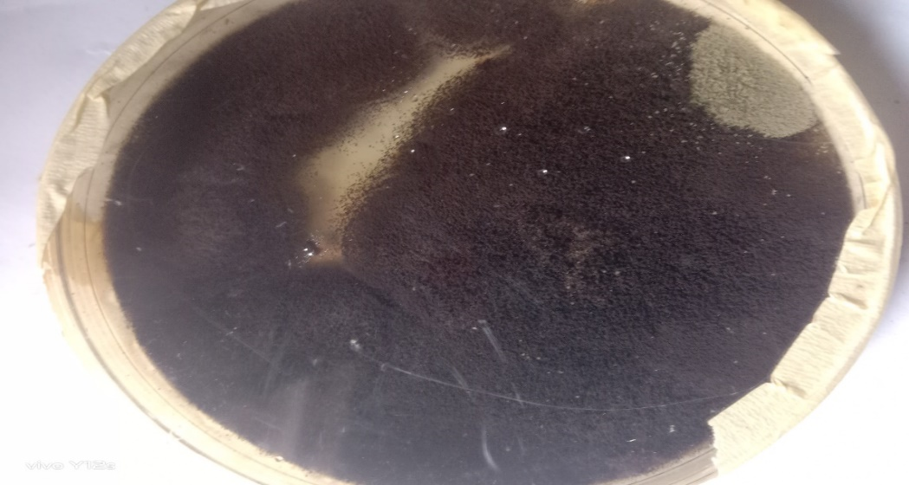

Plate 1: Culture of Aspergillus niger
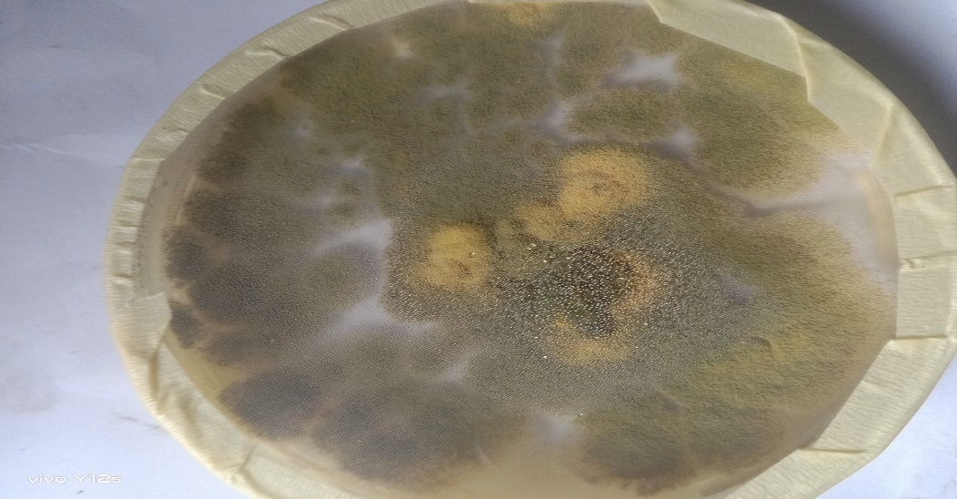
Plate 2: Culture of Aspergillus flavus
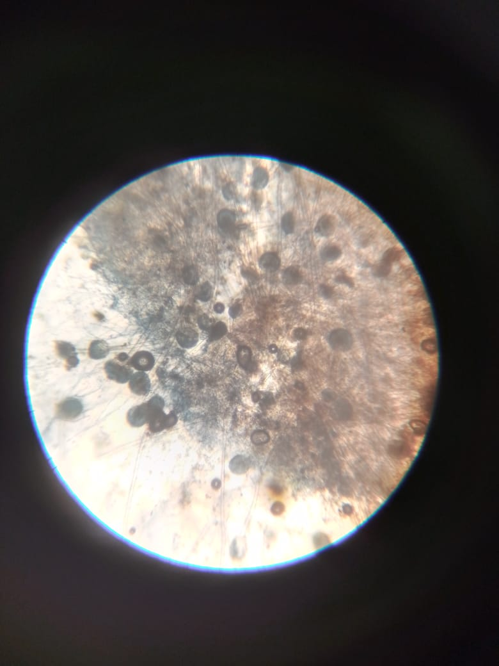
Plate 3: Microscopic view of Aspergillum sp.
In this study, the isolated molds were identified as food-borne which include: Aspergillus flavus, A. niger and Penicillium cyclopium. Several researchers (Ogundare and Adetuyi 2003; Annan-Prah et al., 2011 and Oranusi et al., 2011) have reported similar molds from different snacks. For instance, molds from freshly baked bread included Aspergillus flavus, Aspergillus niger, Absidia corymbifera, Penicillium frequentans westing, and Penicillium citrinum and their population increased with period of storage (Amadi et al., 2014). The high incidence of molds observed in this study could be associated with the very nutritious ingredients contained in the snacks (Amadi et al., 2014).
The presence of Penicillium spp., Aspergillus niger and Aspergillus flavus in the food sample is not surprising as they are dispersed in the form of spores which are abundant in the environment and can be introduced through dust and soil. Mixed culture has a higher potential (37.08%) to inhibit the growth of Aspergillus flavus (producer of Aflatoxin) (Sheikh-Ali et al., 2014). Mycotoxins are naturally occurring toxins produced by certain molds (fungi) and can be found in food. The molds grow on a variety of different crops and foodstuffs including cereals, nuts, spices, dried fruits, apples and coffee beans, often under warm and humid conditions. They can cause a variety of adverse health effects and pose a serious health threat to both humans and livestock. The adverse health effects of mycotoxins range from acute poisoning to long-term effects such as immune deficiency and cancer (Okeke et al., 2021).

CONCLUSION
It is concluded that the fast food sold in Nnamdi Azikiwe University Awka, Anambra State are contaminated, hence the presence of fungal organisms. This may be as a result of poor food handling, poor personal hygiene, dirty packaging materials or vendors and consumers’ poor attitudes towards food safety. Therefore, a comprehensive assessment of the methods of human exposures to these pathogenic microorganisms that thrive on fast food should be taken from time to time. Public awareness about the potential risk in the ingestion of these fast food should be aggressively embarked on in the study areas. The regulatory governmental agencies like National Agency for Food and Drugs Administration and Control (NAFDAC), school administrative bodies responsible for sanitation should be actively involved in making sure that food consumed by the people would not constitute health hazard and risks to the inhabitants/consumers.

RECOMMENDATION
Snacks (fast foods) are eaten by all age groups with high popularity amongst school children and youths, it is therefore mandatory that these foods must be free from contamination as much as possible. Food borne illness can be prevented by good hygiene practice during the preparation of food. To prevent occurrence of food borne illness, it is therefore important to ensure that foods sold are safe and hygienic, public awareness programs should be employed to educate personnel involved in food preparation, food processors, and food vendors. The public should be educated on the need for food safety and the requirement for water meant for human consumption and for food processing. Proper and regular hand washing, sanitization of all equipment and utensils, care for the environment and the packaging materials to prevent the spread of contaminants will help in safety of food.

COMPETING INTERESTS DISCLAIMER:
Authors have declared that they have no known competing financial interests OR non-financial interests OR personal relationships that could have appeared to influence the work reported in this paper.

REFERENCES
Agu, K.C. and Chidozie, C.P. (2021). An Improved Slide Culture Technique for the Microscopic Identification of Fungal Species. International Journal of Trend in Scientific Research and Development, 6 (1): 243-254.
Amadi J. E., P. C. Onyejekwe, C. O. Ozokonkwo and M. O. Adebola. (2014). Isolation and Identification of Molds Associated with Four Selected Snacks Sold in Nnamdi Azikiwe University, Awka and its Environs. Asian Journal of Agriculture and Food Science 2: 2321-1571.

Annan-Prah, A., Amewowor, D. H. A. K., Osei-Kofi, J., Amoono, S. E., Akorli, E. Saka, S. Y. and Ndadi, H. A. (2011). “Street Foods: Handling, hygiene and client expectations in a World Heritage Site Town, Cape Coast, Ghana”. African Journal of Microbiology Research 5(13): 1629-1634.

Barnett, H.L. and Hunter, B.B. (2000). Illustrated genera of imperfect fungi. 4th edition. Laskin, A. I. and Lechevalier, H. A. (editors). CRC Press, West Palm Beach, Florida, Pp 1- 197.

Boysen ME, Jacobsson K, Schnurer J (2000). Molecular identification of species from the Penicillium roqueforti group associated with spoiled animal feeds. Applied and Environmental Microbiology, 66: 1523–1526.

Caloni F, Cortinovis C. (2010) Toxicological effects of aflatoxins in horses. The Veterinary Journal, 188 (3): 270-273.

Centers for Disease Control and Prevention (CDC) (2006) Surveillance for Foodborne-Disease Outbreaks - United States, 1998-2002. Centers for Disease Control and Prevention, Pg no: 1-48.

Coda, R., Cassone, A., Rizzello, C. G., Nionelli, L., Cardinali, G., Gobbetti, M. (2011) “Antifungal activity of Wickerhamomyces anomalus and Lactobacillus plantarum during sour dough fermentation: Identification of novel compounds and long-term effect during storage of wheat bread”. In Applied Environmental Microbiology. 77(10): 3484-3492.

Doyle, M.P. and Evans, P.D. (1999). Food borne pathogens of recent concern. Revised Nutrition, 6: 25-41.

Ellis, D., Davis, S., Alexiou, H., Handke, R., and Bartley, R. (2007). Descriptions of Medical Fungi. www.mycology.adelaide.edu.au
James, A. S., (2005). “The role of breakfast in the treatment of obesity: A randomized clinical trial”, American Journal of Clinical Nutrition 55:645-651.

Jonathan S. G. And Olowolaf, T. B., (2001). Studies on nutrients contents and microorganisms associated with dodoIkire-a plantain snack from Western Nigeria. NISEB Journal, 1: 27-30.

Makun H. A., Anjorin S. T., Moronfoye, B., Adejo F. O., Afolabi O. A., Fagbayibo G., Balogun, B. O. And Surajudeen A. A (2010). Fungal and aflatoxin contamination of some human food commodities in Nigeria. African Journal of Food Science, 4(4): 127-135.

Masoero, F., Gallo, A., Moschini, M., Piva, G. And Díaz, D. (2007) Carryover of aflatoxin from feed to milk in dairy cows with low or high somatic cell counts. Animal, 1: 1344–1350.

Odu, N. N. and Akano, U. M. (2012). The Microbiological Assessment of Ready-To-Eat-Food (Shawarma) In Port Harcourt City, Nigeria. Nature and Science 10(8): 1-8.

Ogundare, A. O. and Adetuyi, F. C. (2003). “Studies on the microbial population of bread baked with wheat flour from South-Western Nigeria”, Food, Agriculture & Environment 1(3&4): pp. 85-87.

Okeke, O. P., Yusuf, K. O., Ononye, B. U., Udeh, N. P. and Ndudim G. C. (2021). Evaluation of the Microbial Contamination of Some Snacks: A Case Study of Lagos Mainland, Lagos State, Nigeria Asian Journal of Research in Zoology 4(2): 37-45.

Oranusi, S., Omagbemi, F. and Eni, A.O. (2011). Microbiological safety evaluation of snacks sold in fast food shops in Ota, Ogun state, Nigeria. International Journal of Agricultural and Food Science 1(4): 75-79.

Rizzi, L., Simioli, M., Roncada, P. And Zaghini, A., (2003). Aflatoxin B1 and clinoptilolite in feed for laying hens. Effect on egg quality, mycotoxin residues in livers and hepatic mixed function oxidase activities. Journal of Food Protection 66: 860–865.

Saleemullah, A. I., Khalil, I. A. And Shah, H. (2006). Aflatoxin contents of stored and artificially inoculated cereals and nuts. Food Chemistry, 98: 699-703.

Sewgil, S. A., Gazang, A. A., Chra, Z. H., Hanan, Y. J. (2017). Isolation and Identification of Fungi from fast food restaurants in Langa Bazar. International Journal of Environment, Agriculture and Biotechnology (IJEAB) 2: 2456-2478.

Sheikh-Ali, S.I., Akil, A., Mohd-Setapar, S.H. and Hoque, E.M. (2014). The Potential Hazards of Aspergillus sp in Foods and Feeds, and the Role of Biological Treatment: A Review. The Journal of Microbiology 52(10):807-818.

Sibanda, L., Marovatsanga, L. T. And Pestka, J. J. (1997). Review of mycotoxin work in sub-Saharan Africa. Food Control, 8: 21–29

Smith, I. S., Agomo, C. O., Bamidele, M., Opere, O. B. And Aboaba, O. O (2010) Survey of food handlers in bukas (a type of local restaurant) in Lagos, Nigeria about typhoid fever. Health 2: 951-956.

Smith, J. P., Daifas, D.P., El-khoury, W., Koukoutsis, J. and El-khoury, A., (2004) Shelf life and safety concerns of bakery products – A review. Critical Review on Nutrition. 44(1): 19-55.

Strosnider, H., Azziz-Baumgartner, E., Banziger, M., Bhat, R. V. And Breiman, R. (2006). Public Health Strategies for Reducing Aflatoxin Exposure in Developing Countries: A Workgroup Report. Environmental Health Perspectives, 12: 1898- 1903.

Tsang, D. (2002). Microbiological guidelines for ready-to-eat food. Road and Environmental Hygiene Department, Hong Kong. Pp 115-116.

Usman, S., Afolabi, O. O. And Modupe, L. H. (2019). Evaluation of Microbial Load in Fast Food Establishments in Kaduna Metropolis. Journal of Community Medical Public Health Care 6: 4

Watanabe, T. (2002). Morphologies of cultured fungi and key to species. In: Haddad, S., Dery, E., Norwitz, B.E. and Lewis, R. (editions). Pictorial atlas of soil and seed Fungi. 2nd edition. CRC Press LLC, 2000 N. W. Corporate Blvd., Boca Raton, Florida 33431. Pp 1-486.

Yohanna, A., Mohammed, S. S. D., Samaila, J., Yakubu, M. C., Nwankocha, L. And Suleiman, J. A. (2019). Bacteriological Assessment of Fast Foods Sold at Giden-Kwanu and Bosso campuses of Federal University of Technology, Minna, Nigeria. Bacterial Empire, 2:30-32.

