Effects of incorporating zeolite into the diet of Nile tilapia (Oreochromis niloticus Linnaeus, 1758) on growth performance and histopathological parameters

Abstract:

The aquaculture industry is one of the fastest-growing food sectors in the world. The use of natural clays such as zeolites and bentonites as adsorbent agents in aquaculture feeds may help reduce the bioavailability and toxicity of aflatoxin B1, while lowering risks to fish health and human food safety. This study will evaluate the effects of zeolite incorporation in the diet of tilapia juveniles on growth performance, body composition, survival rate, and histopathology of the small intestine.Five experimental diets containing 0%, 0.5%, 1%, 1.5%, and 2% zeolite were formulated using locally available ingredients and prepared into pellet feeds. Fish were fed daily at 15% of their body weight, with rations adjusted biweekly based on biomass. Data were analyzed using analysis of variance (ANOVA), and treatmentmeans were compared using Duncan’s multiple range test at a significance level of P < 0.05. Survival rates ranged from 70% to 88.33%, with the highest values recorded in fish feddiets containing 0.5% and 1.5% zeolite. Feed conversion ratio (FCR) showed no significant differences among fish fed 0%, 1%, and 1.5% zeolite diets, where a ssignificant variations were observed in the 0.5% and 2% zeolite groups. Proximate composition analysis revealed no significant differences in ash content among treatments. The present findings demonstrate that dietary inclusion of zeolite, particularly at a level of around 2%, can mitigate these adverse effects by improving intestinal morphology and function. To minimize the risks associated with mycotoxin contamination in aquaculture, it is essential to implement preventive strategies, including strict quality control of raw materials, the incorporation of mycotoxin-binding agents such as bentonite in feed formulations, and proper storage of feed under low-humidity conditions. Overall, the use of zeolite as a dietary additive represents a promising and practical approach to improving fishres ilience against mycotoxin-induced damage while supporting optimal growth and physiological performance.

Keywords : Aquaculture, Zeolite, Nile tilapia, Growth performance

Introduction

The development of aquaculture is essential to meet the growing demand for fish products andto ensure food security. The aquaculture industry is one of the fastest-growing food sectors in the world (Naylor et al., 2000; Subasinghe, 2005). According to Burel and Médale (2014), over the past 30 years, global aquaculture has continued to expand to meet the increasing demand for fish for human consumption, which can no longer be satisfied by capture fisheries alone.

Fish meal has long been used as the main ingredient in aquaculture feeds. Due to its high cost and environmental concerns, the aquaculture industry is continuously searching for plant-based alternatives to replace or supplement it in fish diets (Gatlin et al., 2007). However, feeds containing high levels of plant ingredients such as peanut meal, soybean meal, corn meal, and rice bran are more prone to contamination by mycotoxins.

The increasing use of plant ingredients in fish feed raises the risk of contamination by mycotoxins (aflatoxins, fumonisins, ochratoxin A, zearalenone, etc.) (Oliveira et al., 2020). One of the major challenges facing the aquaculture industry is to prevent exposure to feed-borne toxins such as aflatoxin B1 (AFB1). Among the different types of aflatoxins, AFB1 is the most common and the most toxic (Speijers and Speijers, 2004).

Ayyat et al. (2018) showed that treating fish with clay, ozone, and coumarin reduced aflatoxin residues. The use of natural clays such as zeolites and bentonites as adsorbent agents in aquaculture feeds may help reduce the bioavailability and toxicity of aflatoxin B1, while lowering risks to fish health and human food safety.

Studies have also shown that nano-zeolite can reduce the toxicity of AFB1 in Nile tilapia (Oreochromis niloticus). In addition, nano-zeolite has beneficial effects in reducing the negative impacts of AFB1 on the health status of tilapia (Hassaan et al., 2020).

The aim of this study is to confirm that the use of zeolite in Nile tilapia feed can reduce the levels of mycotoxins (aflatoxin) present in the diet. This study will evaluate the effects of zeolite incorporation in the diet of tilapia juveniles on growth performance, body composition, survival rate, and histopathology of the small intestine.

Materialand methods

Methods
Feed formulation
In this experiment, five types of diets were produced: Diet 1 without zeolite (0% zeolite), Diet 2 (0.5% zeolite), Diet 3 (1% zeolite), Diet 4 (1.5% zeolite), and Diet 5 (2% zeolite).The experimental diets were formulated using the Diet Formulator software. The feeds were made from peanut meal, rice flour, millet bran, corn flour, fish meal, fish oil, and vegetable oil.The main difference between the diets was the level of zeolite inclusion.
Table I : Centennial composition of the experimentaldiets (% dry matter).
Ingredients | Régimes
Ingredients | 0%  Zeolite | 0.5%  Zeolite | 1%  Zeolite | 1.5%  Zeolite | 2%  Zeolite
Fish meal(g) | 25 | 25 | 25 | 25 | 25
Yeast (g) | 4 | 4 | 4 | 4 | 4
Peanutmeal (g) | 20 | 20 | 20 | 20 | 20
Rice flour(g) | 15 | 15 | 15 | 15 | 15
Corn flour(g) | 20 | 20 | 20 | 20 | 20
Vitamins (g)ª | 1 | 1 | 1 | 1 | 1
Minerals (g)^{b} | 1 | 1 | 1 | 1 | 1
Fish oil and vegetable oil (1:1) (ml) | 2 | 2 | 2 | 2 | 2
Zeolite (%) | 0 | 0,5 | 1 | 1,5 | 2
Millet bran (g) | 10 | 10 | 10 | 10 | 10
CMC (binder) (g) | 2 | 2 | 2 | 2 | 2
TOTAL | 100 | 100 | 100 | 100 | 100
Protein (%) | 33.82 | 33.82 | 33.82 | 33.82 | 33.82
Lipid(%) | 8.73 | 8.73 | 8.73 | 8.73 | 8.73
ªVit A 250000 UI ; Vit D₃ 250000 UI ; Vit E 5000 mg ; Vit B₁ 100 mg ; Vit B₂ 400 mg ; Niacine 1000 mg ; Pantothenate Ca 2000 mg ; Vit B₆ 300 mg ; Vit K₃ 1000 g ; Vit C 5000 mg ; Biotine 15 mg ; Choline 100 g ; BHT 1000 mg ;
^{b}Phosphore 7% ; Calcium 17% ; Sodium 1.5% ; Potassium 4.6% ; Magnesium 7.5% ; Manganèse 738 mg ; Zinc 3000 mg ; Fer 4000 mg ; Copper 750 mg ; Iode 5 mg ; Cobalt 208 mg ; Calcium and ground attapulgite qs 1000 g ; Fluoride 1.5%.

Preparation of experimental diets
The different ingredients used to formulate the experimental diets are shown in Table I. This table presents the percentage composition of the five formulated diets. All feed ingredients were first ground using a mortar and pestle to obtain fine particles. They were then passed through a 1 mm mesh sieve. After all dry ingredients were thoroughly mixed, the required amounts of zeolite, fish oil, and vegetable oil were added according to the formula presented in Table 1.Water was then added at about 30% of the dry matter to obtain a soft and workable dough. The dough was passed through a 3.0 mm diameter die using a Moulinex meat grinder to produce spaghetti-like strands. The formulated feeds were dried for two days in a well-ventilated place, away from direct sunlight. After drying, the feeds were ground again with a mortar and pestle to obtain particles suitable for the mouth size of the fish.
The final pellet feeds were stored in airtight containers at room temperature until use. The required quantities were taken regularly to feed the fish throughout the experimental period.

Rearing conditions
The experiment was conducted for two months the Pr Omar Thiom THIAW Aquaculture Station of the Institute of Fisheries and Aquaculture, Cheikh Anta Diop University of Dakar.
Tilapia fry were obtained from the same station. Before the start of the trial, the fish were acclimated and fed the control diet for two weeks.
At the beginning of the experiment, fish with an average initial weight of 0.3 g were randomly distributed into 15 plastic tanks (50 L capacity), with 20 fish per tank. Each of the five experimental diets was assigned to three replicate groups for eight weeks.
Water quality was monitored twice daily (morning and evening) before feeding. Temperature and pH were measured, and siphoning and partial water renewal were carried out to maintain good water quality.
Fish were fed at 15% of their body weight per day. The daily ration was divided into three equal meals (9:00 a.m., 1:00 p.m., and 5:00 p.m.). Every two weeks, the feeding rate was gradually reduced according to the increase in biomass until the end of the experiment.
Each tank was continuously aerated using an air diffuser connected to an air compressor. Feeding was stopped 12 hours before fish weighing. All fish from each tank were sampled to determine the biochemical composition of each group. The fish were sacrificed, and in each tank, three fish were dissected to collect a portion of the posterior intestine for histopathological analysis. The remaining carcasses were frozen for later analysis of flesh composition.
Physico-chemical parameters
Water temperature and dissolved oxygen levels were measured twice daily using a multiparameter device.

Biochemical analysis of fish flesh
At the end of the experiment, all remaining fish from each dietary treatment were individuallyweighed and sacrificed. The carcasses of fish subjected to each diet were packaged for subsequent proximate composition analysis.The analysis of fish flesh was carried out at the ENSA﻿
bromatology laboratory in Thiès, following the procedures of the Association of Official Analytical Chemists (AOAC) (1995).
Samples were dried at105°C to constant weight to determine moisture content. Ash content was determined by combusting samples at540°C in a muffle furnace. Crude protein was determined by measuring nitrogen (N × 6.25) using the micro-Kjeldahl method(Kjeltec System1002 Distilling Unit, Tecator, Höganäs, Sweden). Crude lipids were extracted using the Soxhlet method(Soxtec System, Foss, Model HT, Sweden).

Growth, survival, and feed efficiency parameters
Growth performance, survival rate, and feed efficiency were monitored every two weeks using the formulas provided below. This involved weighing the fish in each tank and recording the number of dead individuals prior to calculations. Immediately after weighing, the fish were returned to previously cleaned tanks with renewed water. Total biomass per tank was calculated to adjust the daily feeding ration accordingly.

Mean absolute weight gain (MAWG)
MAWG (g) = Final Average Weight – Initial Average Weight

Relative mean weight gain (RMWG)
$$RMWG (\%) = \frac{FAW-IAW }{IAW}×100$$
Specific Growth Rate (SGR)
$$SGR\left(\%/j \right)=\frac{(\ln\left(FAW\right)-\ln\left(IAW\right)}{rearing duration} x 100$$
Survival Rate (SR)
$Survival Rate \left(\%\right)=\frac{Final number of fish}{Initial number of fish}x 100$
Determination of feed efficiency parameters
Feed Conversion Ratio (FCR)
$$FCR=\frac{Amount of feed distributed per fish}{MAWG }$$

Histopathological analysis
The histological study focused on the posterior intestines of the fish. At the end of the experiment, three fish per dietary treatment were dissected to collect samples of the posterior intestine. The collected samples were preserved in test tubes containing10% formalin diluted with distilled water.
Fixation is a fundamental step in histology, ensuring the preservation of tissue architecture and cellular structures. In this study, samples were fixed by immersion in Dubesque-Brazil fixative. Generally, small tissue fragments are preferred to ensure optimal penetration of the fixative. The volume of fixative must be at least 20 times greater than that of the specimen. Fixation duration depends on fragment size: a few hours for small samples,1 to3 days for mediumsized samples, and up to one week or more for large specimens.
After fixation, samples were washed with water depending on their size. The next step involved placing the samples in 2 to 3 baths of 96% alcohol, followed by 3 baths of ethanol for dehydration.
The impregnation step was followed by paraffin embedding. This involved placing the samples in a butanol–paraffin mixture (1/2 butanol + 1/2 paraffin), maintained in an oven at 56–60°C overnight to allow gradual tissue infiltration. The samples were then successively immersed in three paraffin baths, the third consisting of pure paraffin. The blocks were trimmed using a scalpel and sectioned with a microtome at a thickness of 4–6 µm.
For slide preparation, a heating plate was turned on, and slides were thoroughly cleaned with 70% alcohol. A small amount of albumin was applied to the slides, followed by a drop of distilled water. Sections were collected using a scalpel and placed on the slide. After spreading, excess water was removed, and the slides were dried on the heating plate. For proper identification, slides were labeled using a diamond marker with the sample name, researcher’s name, and slide number.
Staining involved deparaffinization and rehydration. Slides were immersed in a first toluene bath for 5 minutes, followed by a second toluene bath (5 min), then in a first butanol bath (5 min) and a second butanol bath (5 min). They were subsequently immersed in 95% alcohol (5 min), then 70% alcohol (5 min), and finally rinsed in running water (5 min).Slides were then progressively stained through successive baths: 70% alcohol (5 min), 95% alcohol (5 min), followed by first and second butanol baths (5 min each), and finally first and second toluene baths (5 min each).
The sections were mounted between slide and coverslip using a drop of Canada balsam as a mounting medium to ensure adhesion and preservation. The prepared slides were dried in an oven at37°C for at least 24 hours.
Histological observations were then performed using a light microscope. A Beda-brand optical microscope was used for image visualization.
Statistical Analysis
The collected data were entered and processed using Microsoft Excel. Statistical analysis was performed using the Statistical Analysis System (SAS) (Joyner, 1985) and subjected to analysis of variance (ANOVA). Duncan’s multiple range test was used to compare differences among treatments. The effect of dietary treatments was considered significant at P < 0.05.

RESULTS AND DISCUSSION
Results
Physicochemical parameters
Table II shows that water temperature remained generally stable despite the different zeolite inclusion levels, with values ranging from27.04±0.05 to 27.46±0.07 (mean:27.25°C), although a statistically significant difference was observed. In contrast, pH varied slightly among treatments, ranging from 8.43±0.02 to 8.43±0.02 (mean: 8.55), with a decreasing trend as the zeolite level increased.
Table II: Summary of temperature values
Diets | Mean Temperature(°C) | Mean pH
0% Zeolite | 27.04±0.05^{b} | 8.61±0.04ª^{b}
0.5% Zeolite | 27.46±0.07ª | 8.53±0.04ᵇ^{c}
1% Zeolite | 27.19±0.18^{ab} | 8.3±0.02^{d}
1.5% Zeolite | 27.41±0.06ª | 8.49±0.04^{cd}
2% Zeolite | 27.43±0.15ª | 8.43±0.02^{d}
^{ab}Les valeurs portant la même lettre ne sont pas significativement différentes (P<0.05)
Growth, feed efficiency, and survival parameters
Data related to absolute weight gain (MAWG), relative mean weight gain (RMWG), specific growth rate (SGR), feed conversion ratio (FCR), and survival rate (SR) were analyzed and are presented in Table III.

Table III:Growth, feed efficiency, and survival parameters
 | Diets
Parameters | 0%Zeolite | 0,5%Zeolite | 1%Zeolite | 1,5%Zeolite | 2%Zeolite
IMW (g) | 0.30 | 0.30 | 0.30 | 0.30 | 0.30
FMW (g) | 2.63 ± 0.37 ª | 2.34 ± 0.23ª | 2.49 ± 0.11 ª | 2.40 ± 0.28 ª | 2.49 ± 0.08 ª
AMWG (g) | 2,33± 0,38 ª | 2,03 ± 0,23 ª | 2,18 ± 0,10 ª | 2,10 ± 0,28 ª | 2,19 ± 0,08 ª
RMWG (%) | 765.4 ± 127.70ª | 671.14 ± 76.10ª | 717.22 ± 36 ª | 691.91 ± 91.32ª | 720.98 ± 28.34ª
SGR (%/d) | 3.84 ± 0.27 ª | 3.64 ± 0.18ª | 3.75 ± 0.08 ª | 3.69± 0.20 ª | 3.75 ± 0.06ª
FCR | 2.56 ±0.24 ^{ab} | 2.79 ± 0.31 ª | 2 .56 ± 0.19 ^{ab} | 2.70 ± 0.15^{ab} | 2.35± 0.10^{b}
SR (%) | 75.00 ± 5^{bc} | 83.33 ± 5.77^{ab} | 75.00 ± 8.66^{bc} | 88.33± 2.88ª | 70 ± 5 ^{c}
^{abc}Values with the same letters are not significantly different (P<0.05).
For all growth indicators(final mean weight, MAWG, RMWG, and SGR), the results show no significant differences among fish fed the different dietary treatments.

Regarding survival rate, it ranged from 70% to 88.33%. Notably, fish fed diets containing 0.5% and 1.5% zeolite recorded the highest survival rates, 83.33% and 88.33% respectively. For fish fed diets containing 0%, 1%, and 2% zeolite, no significant differences were observed.

Fish fed diets containing 0%, 1%, and 1.5% zeolite had FCR values that did not differ significantly. In contrast, fish fed diets with 2% and 0.5% zeolite showed significantly different FCR values.
Fish flesh composition
After8 weeks of experimentation, the results of the proximate composition analyses are presented in

Table IV: Proximate composition analyses of fish flesh (2nd experiment).
% de zeolite incorporated | Ash (%) | Protein brut (%) | Lipid brut (%)
0% Zeolite | 3.51 ± 0.10ª | 16.14 ± 0.10^{d} | 8.58 ± 0.18^{c}
0.5% Zeolite | 3.59 ± 0.08ª | 15.92 ± 0.09e | 9.15 ± 0.10^{b}
1% Zeolite | 3.55 ± 0.06ª | 16.63 ± 0.09^{c} | 9.20 ± 0.10^{b}
1.5 % Zeolite | 3.43 ± 0.09ª | 16.81 ± 0.1^{b} | 9.05 ± 0.12^{b}
2% Zeolite | 3.44 ± 0.08ª | 17.36 ± 0.06ª | 9.93± 0.09ª
^{abcde}Values with the same letters are not significantly different(P<0.05).
The ash content in the flesh of fish fed the different diets showed no significant differences. The highest protein level was observed in fish fed the diet containing2% zeolite, while fish fed the 0% zeolite diet exhibited the lowest protein content.
Furthermore, in fish fed diets containing0.5%, 1%, and1.5% zeolite, lipid content did not differ significantly. Fish fed the2% zeolite diet showed a higher lipid content.
Histopathological analysis
The fish intestine is a complex multifunctional organ. In addition to digestion and nutrient absorption, the intestine plays a crucial role in immunity, water and electrolyte balance, endocrine regulation of digestion, and metabolism (Buddington et al., 1997).
According to Camargo and Martinez(2007), histopathological examination is widely used to study pathological alterations causedby chemical or infectious biological agents.
A histopathological analysis of intestinal sections from juvenile tilapia fed for 56 days was conducted for each treatment.
In fish fed the0% zeolite diet, the intestinal villi exhibited marked necrosis and desquamation. Necrosis affected the entire intestinal mucosa, accompanied by an accumulation of enterocytes and tissue debris within the intestinal lumen. A significant reduction in villus length was also observed (Figures 1 and 2).
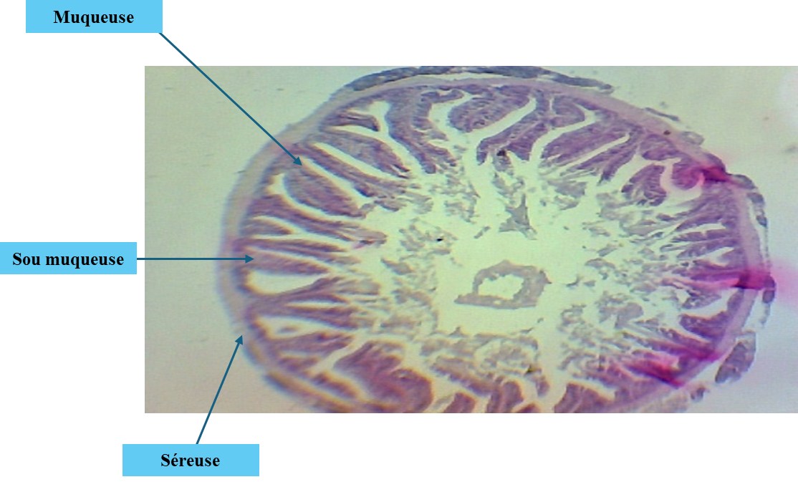
Figure1:Optical microscope observation of the small intestine of a fishfed a dietcontaining 0% zeolite..

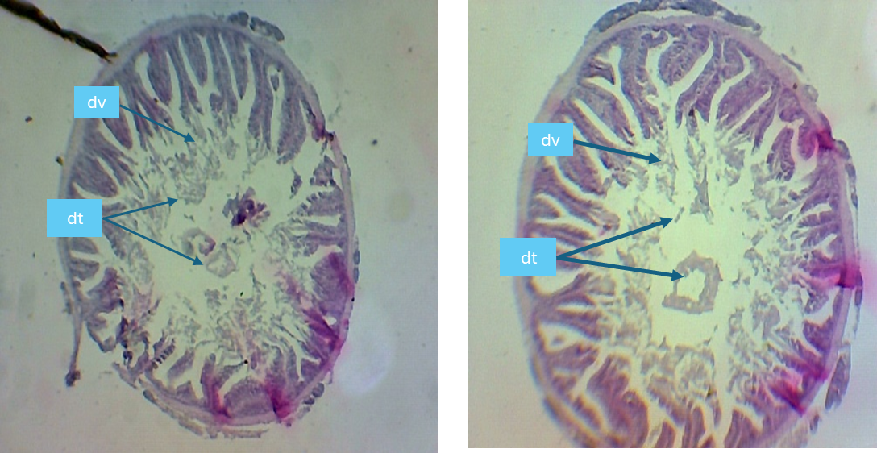DV:villousdegenerationdt: tissue debris
Figure2:Histological sections of the epithelium showing degeneration of intestinal villi in fish fed 0% zeolite (microscope observation ×40)
The same symptoms were observed in fish fed diets containing 0.5%, 1%, and 1.5% zeolite; however, it should be noted that the severity of the damage decreased progressively as the percentage of zeolite incorporated into the feed increased (Figures 3, 4, 5, and 6).
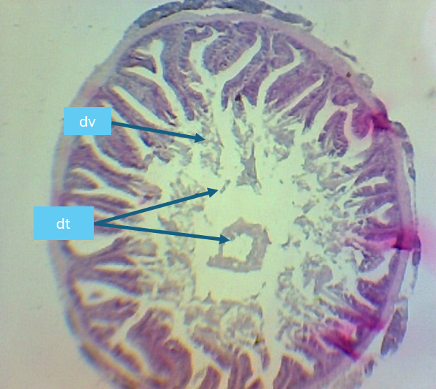
Figure3:Histological sections of the epithelium showing degeneration of intestinal villi in fish fed 0% zeolite (observed under a microscope at ×40 magnification)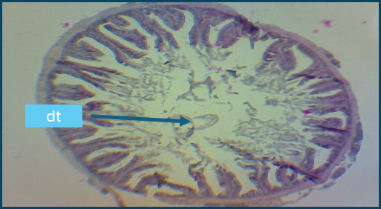
Figure4:Histological sections of the epithelium showing degeneration of intestinal villi in fish fed 1% zeolite (observed under a microscope at ×40 magnification)
Figure5:Histological sections of the epithelium showing degeneration of intestinal villi in fish fed 1.5% zeolite (observed under a microscope at ×40 magnification)
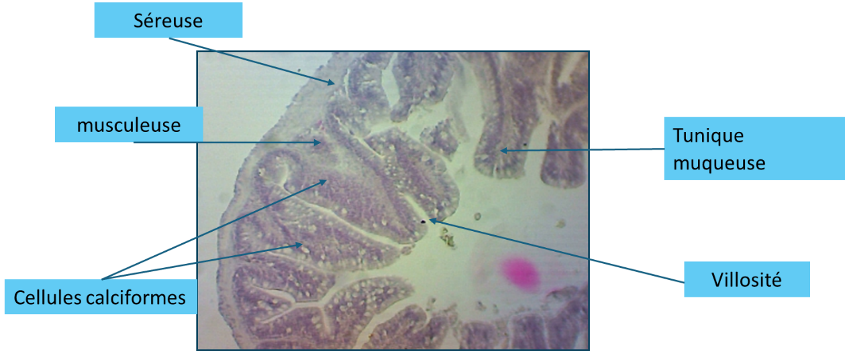
Figure6:Histological sections of the epithelium showing degeneration of intestinal villi in fish fed 2% zeolite (observed under a microscope at ×40 magnification)
Posterior intestine of fish fed the diet containing2% zeolite
The posterior intestine of fish fed the2% zeolite diet exhibited a normal structure; the mucosa,submucosa, muscularis, serosa, and villi were intact. A significant increase in the density of goblet cells was observed compared to the control group (0% zeolite)(Figure 6).

Discussion
In aquaculture, water physicochemical parameters, such as temperature and pH, are essential for assessing water quality and its suitability for supporting aquatic life. The mean values of these parameters in the present study fall within the recommended ranges for Nile tilapia (Oreochromis niloticus) culture (Malcolm et al., 2000; Hamouda, 2005; Azaza et al., 2008; Lazard, 2009) — 26–32°C and pH 8.41–8.69. These pH values are consistent with previous reports suggesting a recommended range of 6.5–9 for fish farming (Lawson, 1995; Tarazona and Munoz, 1995; Konan et al., 2017).
Regarding feed conversion, fish fed the 2% zeolite diet showed the most efficient FCR of 2.35, which is better than the 3.36 reported by Yildirim et al. (2009) for a 2% zeolite diet. Zeolite is commonly used as a feed additive in aquaculture at inclusion levels of 1–5% of total feed weight (Abbas et al., 2021; Jawahar et al., 2016). Abbas et al. (2021) reported that adding 1%, 3%, or5% zeolite to Nile tilapia diets improves growth and enhances resistance to lead toxicity. Jawahar et al. (2016) found that 4–6% zeolite in Channa striatus diets improves growth, hematobiochemical parameters, and immune response.
Growth parameters (final mean weight, MAWG, RMWG, SGR) in the present study indicated that diets containing 1%, 1.5%, and 2% zeolite supported good growth. This aligns with Sheikhzadeh et al. (2017), who reported increased growth in rainbow trout fed clinoptilolite (5 g/kg feed).
Regarding survival, fish fed 2% zeolite had the lowest survival rate, whereas those fed 0.5% and 1.5% diets had the highest survival. Observed mortalities were mainly attributed to handling during weighing. Although 2% zeolite increased fish weight, it negatively impacted survival, differing from Nssar (2019), who reported no negative effects and reduced stress indicators with zeolite supplementatio.
Proximate composition analysis (protein, fat, ash) is commonly used to evaluate the effect of diet on fish flesh composition, nutrient transfer efficiency, and nutritional status. Protein content was highest in fish fed 2% zeolite. Aflatoxin residue analysis in tilapia flesh was not performed, as previous studies indicate minimal to no bioaccumulation of aflatoxin B1 (AFB1) in tilapia muscle (Deng et al., 2010). Degeneration of intestinal villi in fish fed 0%, 0.5%, and 1% zeolite may be attributed to dietary mycotoxins, particularly aflatoxins. Observed lesions include villus atrophy, fusion or shortening of villi, reduced absorptive surface, and necrotic cells in the intestinal lumen. Barany et al. (2021) reported similar histopathological effects of AFB1, including epithelial desquamation, villus edema, epithelial cell necrosis, and mononuclear cell infiltration.
Knudsen et al. (2007) and Krogdalh et al.(2010) noted that gastrointestinal integrity can be affected by dietary fiber in plant protein sources or other antinutritional factors. Castro et al. (2019) suggested that zeolite may "polish" worn intestinal villi, stimulating regeneration and improving nutrient absorption. Nano-zeolites at low doses (2 mg/kg) do not alter intestinal histology in tilapia (Elshafy et al., 2023). In this study, 2% powdered zeolite in the diet preserved intestinal structure, likely by reducing aflatoxin effects.
Ellis et al. (2000) demonstrated that 2% dietary bentonite blocks aflatoxin absorption, reducing liver and kidney aflatoxin loads by at least 80% and increasing fecal AFB1 excretion by ~470% compared to controls. Similarly, 2% bentonite in trout diets contaminated with 20 µg/kg AFB1 significantly reduced AFB1 absorption. Essential oils are considered safe, biodegradable feed additives that inhibit Aspergillus flavus and A. parasiticus growth and aflatoxin production (Gupta et al., 2011; Rasoli et al., 2008). Kaolin, a clay similar to zeolite, has also been shown to detoxify aflatoxins in fish (Knezevich et al., 1994).
Conclusion
Aflatoxins, particularly AFB1, are mycotoxins produced by Aspergillus species (A. flavus, A. parasiticus). They are highly toxic, mutagenic, and carcinogenic to many species, including fish. Histopathological lesions observed include epithelial destruction, goblet cell loss, and inflammatory infiltration, leading to increased intestinal permeability and nutrient malabsorption. These effects are dose-dependent: higher AFB1 concentrations cause more severe histological and physiological alterations.
Incorporation of ~2% zeolite in Nile tilapia diets improved growth performance, protein utilization, and feed efficiency, likely through enhanced intestinal morphology. To prevent mycotoxin contamination in fish feed, it is recommended to:
- Strictly control raw materials (corn, oilcakes, etc.)
- Use mycotoxin adsorbents in feed (e.g., bentonite)
- Store feed under low-humidity conditions

References:
Burel C., Médale F. (2014). What about the use of plant proteins in aquaculture. OCL, 21 (4) D406 : 2 - 15.
Naylor, R. L., Goldburg, R. J., Primavera, J. H., Kautsky, N., Beveridge, M. C., Clay, J., Folke, C., Lubchenco, J., Mooney, H., & Troell, M. (2000). Effect of aquaculture on world fish supplies. Nature, 405(6790), 1017–1024. https://doi.org/10.1038/35016500
Subasinghe R. P. (2005). Epidemiological approach to aquatic animal health management: opportunities and challenges for developing countries to increase aquatic production through aquaculture. Preventive veterinary medicine, 67(2-3), 117–124. https://doi.org/10.1016/j.prevetmed.2004.11.004
Gatlin, D. M., Barrows, F. T., Brown, P., Dabrowski, K., Gaylord, T. G., Hardy, R. W., Herman, E., Hu, G., Krogdahl, Å., Nelson, R., Overturf, K., Rust, M., Sealey, W., Skonberg, D., J Souza, E., Stone, D., Wilson, R., & Wurtele, E. (2007). Expanding the utilization of sustainable plant products in aquafeeds: a review. Aquaculture Research, 38(6), 551–579. https://doi.org/10.1111/j.1365-2109.2007.01704.x
‌
Hassaan, M. S., Mohammady, E. Y., Adnan, A. M., Abd Elnabi, H. E., Ayman, M. F., Soltan, M. A., & El-Haroun, E. R. (2020). Effect of dietary protease at different levels of malic acid on growth, digestive enzymes and haemato-immunological responses of Nile tilapia, fed fish meal free diets. Aquaculture, 522, 735124. https://doi.org/10.1016/j.aquaculture.2020.735124
Malcolm, C., Beveridje, H. & McAndrew, B. J. (2000). Tilapias: biology and exploitation. Institute of aquaculture. University of stirling, Scotland. Kluwer Academic Publishers: 185
‌

