Original Research Article

Community Structure and Spatial Pattern of Coral Reef Fishes in Nipah Bay, North Lombok Regency

.
ABSTRACT
Reef fishes are key indicators of reef condition and mediators of benthic–pelagic processes. This study quantified the community structure and spatial pattern of reef fishes in Nipah Bay (North Lombok). Surveys were conducted in July 2025 at three stations and two depths (3 m and 7 m) using Underwater Visual Census along 70 × 5 m belt transects; species were identified in situ and total length was measured to estimate biomass with family-specific length–weight relationships. Water parameters (temperature, salinity, pH, current velocity, and TSS) were measured concurrently. Community structure was assessed using H′, E, D and Bray–Curtis similarity (with nMDS), while ANOVA tested among-station differences in water parameters. We recorded 1,884 individuals representing 55 species, 32 genera, and 15 families. Abundance was dominated by Pomacentridae, followed by Labridae and Acanthuridae, whereas Chaetodontidae were relatively scarce. Diversity was moderate–high (H′ = 2.13–3.02), evenness high (E = 0.67–0.86), and dominance low (D = 0.06–0.19). Bray–Curtis indicated the highest similarity between T1–T2 (0.604) and the lowest between T2–T3 (0.252), consistent with separation of T3 in the nMDS ordination. Target-family biomass totalled 58.07 g/m², dominated by Acanthuridae (25.14 g/m²). Given favourable and largely homogeneous water conditions, spatial variation in assemblages is most plausibly driven by benthic habitat attributes (structural complexity, substratum type, and live-coral cover). These findings provide an ecological baseline for habitat-focused management and long-term monitoring of reef-fish spatial dynamics in Nipah Bay.

Keywords: reef fish; community structure; spatial pattern; Bray-Curtis similarity; Lombok

1. INTRODUCTION

Coral reefs are among the most productive marine ecosystems and harbour exceptionally high biodiversity, underpinning both ecological processes and coastal economies. Ecologically, reefs provide primary habitat for a wide range of marine biota—serving as feeding grounds, spawning grounds, and nursery grounds (Rondonuwu et al., 2019). They also function as natural coastal defences by attenuating wave energy and thereby reducing shoreline abrasion (Nasir et al., 2017). Economically, coral reefs support marine tourism (e.g., snorkeling and scuba diving) and sustain valuable capture fisheries and the ornamental fish trade (Maulana et al., 2016).
Reef fishes are keystone components of reef food webs with substantial economic and aesthetic value. Functionally, they contribute to ecosystem stability through herbivory, planktivory, and carnivory, and are widely applied as bioindicators of reef condition; declines in their abundance or diversity often reflect habitat degradation or intensified anthropogenic pressures (Setiawan et al., 2017). Consequently, quantifying reef fish community structure and spatial patterns provides a robust lens for assessing ecosystem health and informing sustainable management strategies.
Nipah Bay, located in Malaka Village, Pemenang Subdistrict, North Lombok Regency, is a well-known marine tourism destination characterized by white-sand beaches and attractive underwater scenery (Werdiana et al., 2024). Beyond tourism, several reef fish species in this area are utilized by coastal communities as sources of livelihood. Recent studies across Lombok’s coastal sites demonstrate spatial variability in reef fish assemblages: Ridwan et al. (2023) reported 15 species from 6 families (549 individuals) in the coral transplantation area at Kecinan Beach; Putra et al. (2024) documented 76 species from 16 families (1,556 individuals) in the Gili Sulat–Gili Lawang Marine Tourism Park; and Irawan et al. (2024) recorded 34 species from 12 families at Pandanan Beach. However, to date there is no peer-reviewed account that specifically characterizes reef fish community structure in Nipah Bay.
Addressing this knowledge gap, the present study investigates the community structure and spatial patterns of reef fishes in Nipah Bay, North Lombok. The analysis encompasses diversity (H’), evenness (E), dominance (D), abundance, and biomass across two depth strata, and evaluates among-station similarity using the Bray–Curtis index. The findings are expected to provide an ecological baseline to support sustainable management of coral reef ecosystems and marine tourism in Nipah Bay, and to serve as a reference for long-term monitoring (Latuconsina, 2019).

2. material and methods

2.1. Study site
Fieldwork was conducted in July 2025 in the waters of Nipah Bay, Malaka Village, Pemenang Subdistrict, North Lombok Regency (Figure 1). Three observation stations were established to represent local reef conditions; at each station, surveys were carried out at two depths, 3 m (shallow zone) and 7 m (mid-depth zone), to capture variation in light intensity, live coral cover, and reef-fish assemblages.
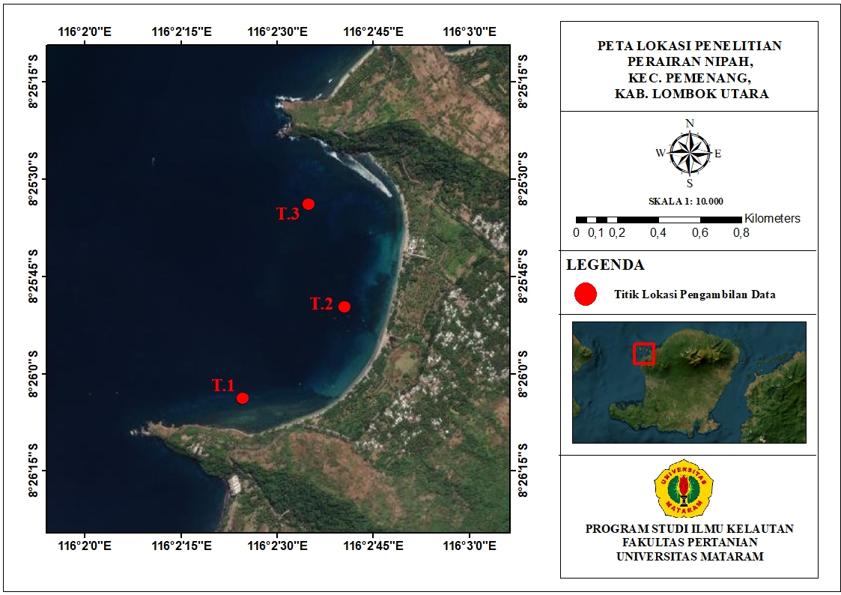
Figure 1. Study site map of Nipah Bay.

2.2. Reef fish surveys
Reef fish community structure was assessed using Underwater Visual Census (UVC) with belt transects measuring 70 × 5 m (effective width 2.5 m to each side of the transect line), following Giyanto et al. (2014) with minor field adjustments. For each station–depth combination, a single transect was carefully laid to minimise substrate disturbance. Observations commenced 5–15 min after transect deployment to allow fishes to resume natural behaviour.
During each dive, all reef fish within the belt were recorded, including species identity, abundance, and estimated total length (cm). The effective survey area per transect was 350 m².
Species identification was performed in situ based on external morphology (body shape, colour pattern, mouth/tail type, and diagnostic characters) following Giyanto et al. (2014) and Labrosse et al. (2002).
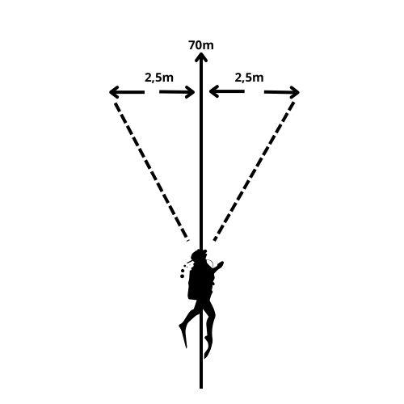
Figure 2. Schematic of UVC belt-transect survey.

2.3. Water quality measurements
Measured parameters comprised current velocity, temperature, pH, salinity, and Total Suspended Solids (TSS). Current velocity was measured using a current kite (5 m line) and a stopwatch; temperature was obtained from a dive computer; pH was measured with a calibrated pH meter; salinity with a refractometer. TSS samples were collected at each station–depth, stored in a cool box, and analysed gravimetrically in the laboratory. All measurements were recorded on a standardised datasheet.
2.4. Reef fish biomass estimation
Biomass estimation focused on seven target families (Serranidae, Lutjanidae, Lethrinidae, Haemulidae, Scaridae, Siganidae, and Acanthuridae). Individual body mass was estimated using the length–weight relationship:
W = a × Lb
where W is body mass (g), L is total length (cm), and a,b are family-specific constants (Giyanto et al., 2014). Total biomass per transect (g/m2) was computed as:
B = ∑W A
with A = 350 m2 (transect area). Target-family biomass was used as an indicator of ecological value and potential economic importance of the reef.
2.5. Community ecology indices
(a) Diversity (H’). Shannon–Wiener diversity index.
The Shannon-Wiener diversity index is used to describe the structure of coral reef fish communities based on the number of species and individuals :
H′=−∑ pi ln pi
where pi = ni / N is the abundance of species –i and N is total abundance (Armanto et al., 2022). Classification (Fachrul, 2007):
H′ ≤ 1 : low diversity
1 < H′ ≤ 3 : moderate diversity
H′ > 3 : high diversity
(b) Evenness (E).
Describing the distribution of the number of individuals among species :
E = H′ ln / S
where S is species richness (Odum, 1993).
Classification:
0 < E ≤ 0,5 : low evennes
0.5 < E ≤ 0.75 : moderate evennes
0.75 < E ≤ 1 : high evennes
(c) Dominance (D).
Measuring the dominance level of a species within a community (Odum, 1993) :
D = ∑pi2
Classification (Labrosse et al., 2002):
0 < D < 0.5 : low dominance
0.5 ≤ D < 0.75 : moderate dominance
0.75 ≤ D ≤1 : high dominance
2.6. Statistical analyses
Between-station similarity in community composition was evaluated using the Bray–Curtis index (abundance-based) and visualised with cluster dendrograms and/or non-metric multidimensional scaling (nMDS) to assess spatial patterns. Differences in water quality among locations were tested using one-way ANOVA. Assumptions of normality and homoscedasticity were verified; if violated, appropriate non-parametric tests were applied.
All computations were performed using commonly adopted software PAST with significance set at α=0.05.

3. results and discussion

3.1. Reef-fish community structure and diversity
Across two depth strata in Nipah Bay, the survey recorded 1,884 individuals representing 55 species, 32 genera, and 15 families (Tabel 1). Overall abundance was dominated by Pomacentridae, followed by Labridae and Acanthuridae, whereas Chaetodontidae occurred at low abundance (Figure 3). Relative to nearby Pandanan Beach (Irawan et al., 2024: 554 individuals; 34 species; 12 families), Nipah Bay supports a richer assemblage, consistent with locally favourable habitat conditions.
Table 1. Community structure (species-level composition) across stations and depths in Nipah Bay.

No | Family | Genus | Species | T1 | T2 | T3
1 | Acanthuridae | Acanthurus | A. auranticavus | + | + | -
2 | Acanthuridae | Acanthurus | A. olivaceus | - | - | +
3 | Acanthuridae | Acanthurus | A. tristis | + | + | -
4 | Acanthuridae | Ctenochaetus | C. striatus | + | + | +
5 | Acanthuridae | Naso | N. caeruleacauda | - | - | +
6 | Acanthuridae | Zebrasoma | Z. scopas | + | - | +
7 | Balistidae | Rhinecantus | R. verrucosus | + | - | -
8 | Chaetodontidae | Chaetodon | C. kleinii | + | + | +
9 | Chaetodontidae | Chaetodon | C. lunulatus | + | + | +
10 | Chaetodontidae | Chaetodon | C. melannotus | + | - | -
11 | Chaetodontidae | Chaetodon | C. triangulum | - | - | +
12 | Chaetodontidae | Chaetodon | C. trifascialis | + | - | -
13 | Chaetodontidae | Forcipiger | F. flavissimus | - | - | +
14 | Labridae | Cirrhilabrus | C. solorensis | - | + | -
15 | Labridae | Gomphosus | G. varius | - | - | +
16 | Labridae | Halichoeres | H. hortulanus | + | + | -
17 | Labridae | Halichoeres | H. podostigma | + | - | -
18 | Labridae | Halichoeres | H. scapularis | - | + | -
19 | Labridae | Labrichthys | L. unilineatus | - | + | -
20 | Labridae | Labroides | L. dimidiatus | + | + | +
21 | Labridae | Thalassoma | T. hardwicke | + | + | +
22 | Labridae | Thalassoma | T. jansenii | + | - | -
23 | Labridae | Thalassoma | T. lunare | + | + | +
24 | Mullidae | Parupeneus | P. macronema | + | - | +
25 | Nemipteridae | Scolopsis | S. bilineata | + | + | +
26 | Pinguipedidae | Parapercis | P. millepunctata | + | + | +
27 | Pomacanthidae | Centropyge | C. bicolor | + | + | +
28 | Pomacanthidae | Centropyge | C. tibicen | + | - | -
29 | Pomacanthidae | Centropyge | C. vlorikii | + | + | -
30 | Pomacentridae | Amblyglyphidodon | A. curacao | + | + | -
31 | Pomacentridae | Amphiprion | A. clarkii | + | + | -
32 | Pomacentridae | Chromis | C. caudalis | + | + | +
33 | Pomacentridae | Chromis | C. margaritifer | + | + | -
34 | Pomacentridae | Chromis | C. ternatensis | + | + | +
35 | Pomacentridae | Chromis | C. viridis | + | + | -
36 | Pomacentridae | Chrysiptera | C. rollandi | + | - | +
37 | Pomacentridae | Dascyllus | D. reticulatus | + | + | -
38 | Pomacentridae | Dascyllus | D. trimaculatus | + | + | +
39 | Pomacentridae | Dischistodus | D. melanotus | + | - | -
40 | Pomacentridae | Neoglyphidodon | N. melas | + | + | -
41 | Pomacentridae | Pomacentrus | P. auriventris | - | - | +
42 | Pomacentridae | Pomacentrus | P. bankanensis | + | - | +
43 | Pomacentridae | Pomacentrus | P. coelistis | + | + | +
44 | Pomacentridae | Pomacentrus | P. lepydogenis | + | + | +
45 | Pomacentridae | Pomacentrus | P. moluccensis | + | + | +
46 | Pomacentridae | Pomacentrus | P. reidi | + | + | -
47 | Scaridae | Chlorurus | C. bleekeri | - | - | +
48 | Scaridae | Chlorurus | C. capistratoides | + | + | +
49 | Scaridae | Chlorurus | C. sordidus | + | + | -
50 | Scaridae | Scarus | S. rivulatus | + | - | +
51 | Scorpaenidae | Pterois | P. antennata | - | + | -
52 | Serranidae | Cephalopolis | C. argus | + | - | -
53 | Siganidae | Siganus | S. fuscescens | - | + | -
54 | Tetraodontidae | Arothron | A. manilensis | - | + | -
55 | Zanclidae | Zanclus | Z. cornutus | + | + | -

Pomacentridae dominated at all stations and depths (57–393 individuals per station). This pattern is typical of branching-coral frameworks (notably Acropora spp.) that provide refuge and feeding niches for small–medium planktivorous/omnivorous major reef fishes (Rosdianto, 2021). Labridae (primarily invertivores) and Acanthuridae (herbivores) formed the next most abundant groups and are functionally important for biofouler control and algal suppression, respectively—processes that maintain benthic space for corals. Chaetodontidae, widely used as bioindicators of live-coral condition, were scarce, suggesting that live coral cover may be suboptimal at some sites (Aldyza et al., 2022).

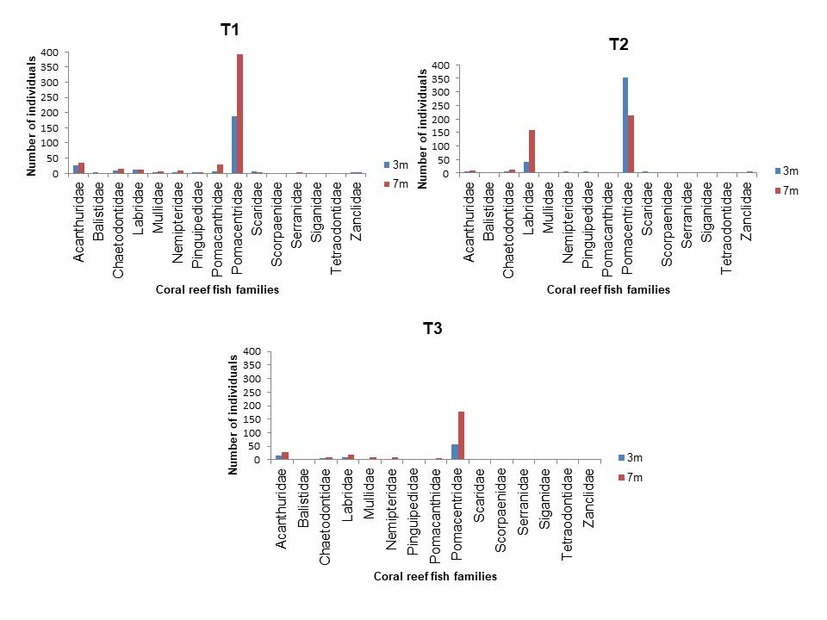
Figure 3. Community structure (family-level composition) across stations and depths in Nipah Bay.

3.2. Spatial–depth patterns and taxonomic richness

Taxonomic counts varied with depth among stations (Figure 4). At T1 and T3, 7 m harboured more families, genera, and species than 3 m, consistent with greater structural complexity and live coral cover at mid-depths, which increases niche availability via more refuge, feeding stations, and fine-scale rugosity (Ardian et al., 2020). At T2, the opposite pattern emerged: 3 m supported higher richness than 7 m, likely reflecting sand-dominated substrata at 7 m that reduce shelter and attachment surfaces. Such benthic simplification is known to depress fish richness and modify trophic composition (Riyantini et al., 2023; Armanto et al., 2022).

Ecological implications. The depth-linked shifts in richness indicate that benthic structure, rather than the water column, is the proximate driver of assemblage organization in Nipah Bay. Mid-depth sectors that retain branching/massive corals function as habitat-quality hotspots, promoting beta-diversity and potentially acting as thermal/hydrodynamic refugia that support cross-depth connectivity (Bellwood et al., 2004; Bongaerts et al., 2010; Graham & Nash, 2013; Wilson et al., 2007). Conversely, sandier mid-depths constrain invertivores and small site-attached planktivores by limiting shelter and benthic prey fields (Friedlander & Parrish, 1998). Maintaining habitat heterogeneity is therefore essential to preserve functional completeness across depths (Nyström et al., 2000).

Figure 4. Taxonomic richness (families, genera, species) by station and depth.

3.3. Community indices (H’, E, D)

Shannon–Wiener diversity (H’) ranged 2.13–3.02, peaking at T1.7 m (H’ = 3.02; 37 species), indicating moderate–high diversity and balanced relative abundances. Evenness (E) ranged 0.67–0.86, consistent with stable communities, while dominance (D) was 0.06–0.19, implying low dominance. In combination, moderate–high H’, high E, and low D portray a functionally intact assemblage (Odum, 1971; Armanto et al., 2022). Although Pomacentridae are numerically dominant as a family, no single species overwhelmingly dominated the assemblage.

Ecological implications. High evenness and low dominance suggest diffuse resource capture across species and functional redundancy, properties linked to resistance and resilience against disturbance (Elmqvist et al., 2003; Mouillot et al., 2013; Nash et al., 2015). Such redundancy buffers key processes (herbivory, planktivory, invertivory), reducing the likelihood of phase shifts under perturbation (Hughes et al., 2007; Mumby et al., 2006). However, the low Chaetodontidae—despite favourable water-column conditions—signals benthic constraints (e.g., patchy/declining live coral) that may erode specialist functions (corallivory) and reduce response diversity.

Figure 5. Ecology index

3.4. Target-family biomass
For four target families (Acanthuridae, Scaridae, Serranidae, and Siganidae), total biomass reached 58.07 g m⁻² (Figure 6). Acanthuridae contributed the largest share (48.03 g m⁻²), followed by Scaridae, Serranidae, and Siganidae. The highest site-specific biomass occurred at T3.7 m (27.17 g m⁻²), followed by T1.3 m (9.22 g m⁻²) and T1.7 m (7.35 g m⁻²). Elevated Acanthuridae biomass likely reflects abundant algal resources and schooling/foraging behaviour (Guerra et al., 2023). Spatial biomass variation aligns with benthic heterogeneity; sites combining live coral and algal turf typically support larger herbivores and hence higher biomass (Souza et al., 2025).

Figure 6. Biomass (g/m²) of target families across stations and depths.

3.5. Community similarity (Bray–Curtis) and nMDS
Bray–Curtis similarity (Table 2) indicated the highest similarity between T1 and T2 (0.604) and the lowest between T2 and T3 (0.252). The nMDS ordination (Figure 5) clustered T1 and T2 closely and separated T3, evidencing clear spatial turnover. The T1–T2 similarity likely reflects shared habitat attributes (e.g., higher live coral cover and hard substrata), whereas T3’s dissimilarity is consistent with lower live coral and/or higher dead coral/sand, which reconfigures species composition (Karkarey et al., 2020; Plass-Johnson et al., 2018).

Table 2. Bray–Curtis similarity among stations
 | T1 | T2 | T3
T1 | 1 | 0,604 | 0,393
T2 | 0,604 | 1 | 0,252
T3 | 0,393 | 0,252 | 1

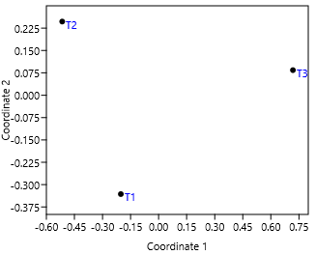
Figure 7. nMDS plot based on Bray–Curtis similarities among stations.

3.6. Water quality and ecological implications
Mean temperature (29.6–29.7 °C), pH (7.6–7.9), current velocity (0.11–0.15 m s⁻¹), and TSS (0.0004–0.00068 mg L⁻¹) (Table 2) were within favourable ranges for coral reefs and reef fishes. ANOVA detected no significant differences among stations for salinity (p > 0.05) and temperature (p > 0.05); pH differed significantly (p = 0.012), with the highest value at T3 and lowest at T2; current velocity did not differ (Welch ANOVA p = 0.051); TSS differed significantly (p = 9.647 × 10⁻⁶) and was highest at T3. Because hydrochemical conditions were largely homogeneous and optimal, the primary drivers of among-station differences are best attributed to benthic habitat attributes (live coral cover, rugosity, substratum composition) rather than to the water column (Effendi, 2003; Patty, 2013; Hutabarat & Evans, 2000; Mandey et al., 2022; Permatasari, 2020; Siswanto, 2015). Notably, all values are well below/within national marine-biota standards (Government of Indonesia, PP No. 22/2021).

Water Parameters | Mean Value ± SE*
Water Parameters | T1 | T2 | T3 | Marine water quality standard ¹
Temperature | 29,6 ± 1,5E-15ª | 29,7 ± 0ª | 29,6 ± 1,5E-15ª | 28 - 30
pH | 7,8 ± 0,03ª | 7,6 ± 0,08^{b} | 7,9 ± 0,02^{c} | 7 - 8,5
Current (m/s) | 0,15 ± 0,004ª | 0,11 ± 0,01ª | 0,15 ± 0,11ª | -
TSS (mg/L) | 0,0004 ± 2,46E-05ª | 0,00044 ± 1,99E-05^{b} | 0,00068 ± 2,09E-05^{c} | 20
*Superscript letters that are the same indicate no significant differences among stations; ¹Government Regulation/PP No. 22/2021.

3.7. Ecological synthesis and management implications

The assemblage exhibits a balanced structure—herbivory (Acanthuridae), invertivory (Labridae), and planktivory (Pomacentridae) are well represented—corroborated by moderate–high H’, high E, low D, and strong herbivore biomass. Nevertheless, low Chaetodontidae and the distinct composition at T3 identify priority areas for habitat-focused interventions. Recommended actions are: (i) protect and rehabilitate branching-coral microhabitats (e.g., Acropora spp.); (ii) mitigate local TSS sources and manage wave-exposed uses at T3; (iii) monitor sensitive indicators (Chaetodontidae) and implement quantitative benthic surveys (live coral cover, rugosity) to mechanistically link habitat to fish community patterns; and (iv) engage local stakeholders to balance tourism use and reef conservation.

3.8. Limitations and future directions

This study represents a single temporal snapshot (July 2025); monsoonal and interannual variability may influence assemblages. Future work should incorporate temporal replication and quantitative benthic measurements (e.g., point-intercept transects, structural complexity indices) to strengthen causal inference between benthic condition and fish community structure.

4. Conclusion

The reef-fish assemblage at Nipah Bay comprised 1,884 individuals from 55 species, 32 genera, and 15 families, numerically dominated by Pomacentridae, with Labridae and Acanthuridae also prominent, while Chaetodontidae were scarce. Community indices (H’ = 2.13–3.02; E = 0.67–0.86; D = 0.06–0.19) indicate a stable, functionally balanced structure without excessive single-species dominance. Spatially, richness and composition varied by site × depth, with higher richness at 7 m in T1 and T3 but higher richness at 3 m in T2, and Bray–Curtis similarity confirmed greater affinity between T1–T2 (0.604) than with T3 (0.252). These spatial patterns are best explained by benthic habitat attributes—structural complexity, substratum composition, and live-coral cover—rather than water-column conditions, which were favourable and relatively homogeneous. Target-family biomass totaled 58.07 g m⁻² and was dominated by Acanthuridae (48.03 g m⁻²), underscoring the role of herbivory in maintaining benthic space. Overall, Nipah Bay exhibits a well-structured community with distinct spatial gradients, providing a robust baseline for habitat-focused management and long-term monitoring of reef-fish spatial dynamics.

Competing interests

Declaration of competing interest should be placed here. All authors must disclose any financial and personal relationships with other people or organizations that could inappropriately influence (bias) their work. Examples of potential conflicts of interest include employment, consultancies, honoraria, paid expert testimony, patent applications/registrations, and grants or other funding. If no such declaration has been made by the authors, SDI reserves to assume and write this sentence: “Authors have declared that no competing interests exist.”.

References

Adibrata, I. M., Rahman, M., & Susilo, D. (2024). Reef fish community structure in the waters of small islands, Central Bangka Regency. Nekton, 4(1), 45–53. https://doi.org/10.47767/nekton.v4i1.724
Aldyza, N., Barus, T. A., Mulya, M. B., Sarong, M. A., Afkar, A., Andi, F., & Yuarza, G. (2022). Coral covers and the abundance of Chaetodontidae in Suaka Alam Perairan of Weh Island Aceh. Jurnal Biodjati, 7(1), 56–65. https://doi.org/10.15575/biodjati.v7i1.17604
Alimuddin, A., Idris, K., & Zainuddin, Z. (2019). Condition of Coral Reefs and Reef Fish in Waigoiyofa Village, Sula Islands Regency. Jurnal Enggano, 4(1), 110–122. https://doi.org/10.31186/jenggano.4.1.110-122
Ardian, D., Kurniawan, D., & Putra, R. D. (2020). The Relationship Between Percentage of Live Coral Cover and the Abundance of Chaetodontidae Indicator Fish in the Waters of Pengudang, Bintan Regency. Jurnal Akuatiklestari, 3(2), 21-29. https://doi.org/10.31629/akuatiklestari.v3i2.2590
Armanto, A., Nurrahman, Y. A., & Helena, S. (2022). Abundance and Diversity of Reef Fish in the Southern Waters of Kabung Island, Bengkayang Regency, West Kalimantan. Jurnal Laut Khatulistiwa, 5(2), 62–70. https://doi.org/10.26418/lkuntan.v5i2.54096
Bellwood, D. R., Hughes, T. P., Folke, C., & Nyström, M. (2004). Confronting the coral reef crisis. Nature, 429(6994), 827–833. https://doi.org/10.1038/nature02691
Bongaerts, P., Ridgway, T., Sampayo, E. M., & Hoegh-Guldberg, O. (2010). Assessing the ‘deep reef refugia’ hypothesis: focus on Caribbean reefs. Coral Reefs, 29, 309-327. https://doi.org/10.1007/s00338-009-0581-x
Effendi, H. (2003). *Telaah Kualitas Air Bagi Pengelolaan Sumber Daya Dan Lingkungan Perairan* [Water Quality Assessment for the Management of Aquatic Resources and Environments]. Yogyakarta: Kanisius.
Fachrul, M. F. (2007). *Metode Sampling Bioekologi* [Bioecological Sampling Methods]. PT Bumi Aksara.
Friedlander, A. M., & Parrish, J. D. (1998). Habitat characteristics affecting fish assemblages on a Hawaiian coral reef. Marine Biology, 133(2), 165–176. https://doi.org/10.1016/S0022-0981(97)00164-0
Giyanto, Manuputty, A. E. W., Abrar, M., Siringoringo, R. M., Suharti, S. R., Wibowo, K., Edrus, I. N., Arbi, U. Y., Cappenberg, H. A. W., Sihaloho, H. F., Tuti, Y., & Zulfianita, D. (2014). Coral Reef Health Monitoring Guide. Research Center for Oceanography (LIPI).
Guerra, A. S., Van Wert, J. C., Haupt, A. J., McCauley, D. J., Eliason, E. J., Young, H. S., Lecchini, D., & White, T. D. (2023). Differences in the behavior and diet between shoaling and solitary surgeonfish (Acanthurus triostegus). Ecology and Evolution, 13, e9686. https://doi.org/10.1002/ece3.9686

Graham, N. A. J., & Nash, K. L. (2013). The importance of structural complexity in coral reef ecosystems. Coral Reefs, 32(2), 315–326. 10.1007/s00338-012-0984-y
Gusmawati, N. F., Gunadharma, B. G., & Oktaviani, D. (2021). Coral Reef Fish Community Structure in the Waters of Gosong Pasir, Tanjung Jumlai, North Penajam Paser Regency, East Kalimantan. Jurnal Penelitian Perikanan Indonesia, 27(3), 167-178. https://doi.org/10.15578/jppi.27.3.2021.167-178
Hindaryani, I. P., Zainuri, M., Rochaddi, B., Wulandari, S. Y., Maslukah, L., Purwanto, P., & Rifai, A. (2020). Current Patterns and Their Influence on the Distribution of Nitrate and Phosphate Concentrations in the Coastal Waters of Mangunharjo, Semarang. Indonesian Journal of Oceanography, 2(4), 313-323. https://doi.org/10.14710/ijoce.v2i4.8528
Hughes, T. P., Rodrigues, M. J., Bellwood, D. R., Ceccarelli, D., Hoegh Guldberg, O., McCook, L., Moltschaniwskyj, N., Pratchett, M., Steneck, R., & Willis, B. (2007). Phase shifts, herbivory, and the resilience of coral reefs to climate change. Current Biology, 17(4), 360–365. https://doi.org/10.1016/j.cub.2006.12.049
Hutabarat, S., & Evans, S. M. (2000). Introduction to Oceanography. Jakarta: Universitas Indonesia Press.
Irawan, M. R. P., Candri, D. A., & Zamroni, Y. (2024). Community Structure of Fishes at Coral Reef ecosystem in Pandanan Beach, Northern Lombok, West Nusa Tenggara. Jurnal Biologi Tropis, 24(2), 965–973. https://doi.org/10.29303/jbt.v24i2.6962
Islamiyati, I., Sumiardi, A., & Masyruroh, A. (2022). Optimization of Activated Zeolite in the Desalination Process of Brackish Well Water (A Study in the Mekarsari Neighborhood, Pulomerak District, Cilegon). Jurnal Lingkungan dan Sumberdaya Alam (JURNALIS), 5(2), 84–96. https://ejournal.lppm-unbaja.ac.id/index.php/jls/article/download/1808/1071/5080
Karkarey, R., Rathod, P., Arthur, R., Yadav, S., & Alcoverro, T. (2020). Wave Exposure Reduces Herbivory In Post-Disturbed Reefs By Filtering Species Composition, Abundance And Behaviour Of Key Fish Herbivores. Scientific Reports, 10, 9854. https://doi.org/10.1038/s41598-020-66475-y
Komala, R., Noer, M. I., Miarsyah, M., Widyartini, D. S., & Handayani. (2024). Assess The Level Of Damage To The Coral Reef Ecosystem. Biodiversitas: Jurnal Ilmiah Biodiversitas. https://smujo.id/biodiv/article/download/17011/7570/1112417
Labrosse, P., Kulbicki, M., & Ferraris, J. (2002). Underwater Visual Census Survey: Proper Use And Implementation. Secretariat of the Pacific Community.
Latuconsina, H. (2019). Tropical Aquatic Ecology: Basic Principles of Aquatic Biological Resource Management. UGM Press.
Mandey, V. K., Barapadang, B., Wanimbo, E., & Ayer, P. I. L. (2022). Water Quality and Coral Reef Ecosystem Status in the Coastal Waters of Holtekam Village, Muara Tami District, Jayapura City. Jurnal Pesisir dan Laut Tropis, 10(2), 84–94. https://doi.org/10.31957/acr.v5i2.2716
Mandolang, M., Kusen, J. D., Warouw, V., Kaligis, E. Y., Paulus, J. H., & Rembet, U. N. J. W. (2021). Community Structure of Target Fish in Coral Reef Ecosystems within the Traditional Zone, Bunaken Island, Bunaken National Park. Jurnal Pesisir dan Laut Tropis, 9(3), 104–110. https://doi.org/10.35800/jplt.9.3.2021.36713
Maulana, H., Anggoro, S., & Yulianto, B. (2016). A Study on the Condition and Economic Value of Coral Reef Ecosystem Benefits at Wediombo Beach, Gunung Kidul Regency, Special Region of Yogyakarta. Jurnal Ilmu Lingkungan, 14(2), 82–87. doi:10.14710/jil.14.2.82-87
Mumby, P. J., Hastings, A., & Edwards, H. J. (2006). Fishing, trophic cascades, and the process of grazing on coral reefs. Science, 311(5757), 98–101. https://doi.org/10.1126/science.1121129
Mouillot, D., Graham, N. A. J., Villéger, S., & Mason, N. W. H. (2013). A functional approach reveals community responses to disturbance. Trends in Ecology & Evolution, 28(3), 167–177. https://doi.org/10.1016/j.tree.2012.10.004
Nash, K. L., Graham, N. A. J., Jennings, S., & Wilson, S. K. (2015). Herbivore cross scale redundancy supports response diversity and promotes coral reef resilience. Journal of Applied Ecology, 53(3), 646–655. https://doi.org/10.1111/1365-2664.12430
Nasir, M., Zuhal, M., & Ulfah, M. (2017). Coral Reef Fish Community Structure in the Waters of Batee Island, Peukan Bada District, Aceh Besar Regency. Bioleuser, 1(2), 76–85. https://jurnal.usk.ac.id/bioleuser/article/view/9079
Nugroho, B. S., & Koribudin, I. (2022). Coral Reef Fish Diversity in the Waters of Karang Jeruk, Tegal Regency. Syntax Literate: Jurnal Ilmiah Indonesia, 7(4), 3809-3815. https://doi.org/10.36418/syntax-literate.v7i4.6688
Nyström, M., Folke, C., & Moberg, F. (2000). Coral reef disturbance and resilience. Trends in Ecology & Evolution, 15(10), 413–417. https://doi.org/10.1016/S0169-5347(00)01948-0
Odum, E. P. (1971). Fundamentals of Ecology (3rd ed.). Philadelphia, PA: W. B. Saunders Company.
Odum, E. P. (1993). Fundamentals of Ecology (S. T. & B. Srigandono, Trans.). Yogyakarta: Gadjah Mada University Press.
Patty, S. I. (2013). Distribution of Temperature, Salinity, and Dissolved Oxygen in the Waters of Kema, North Sulawesi. Jurnal Ilmiah Platax, 1(3). https://media.neliti.com/media/publications/159571-ID-none.pdf
Plass-Johnson, J. G., et al. (2018). Spatio-Temporal Patterns in the Coral Reef Communities of the Spermonde Archipelago, Indonesia. Frontiers in Marine Science. https://www.frontiersin.org/articles/10.3389/fmars.2018.00036/full
Putra, N. W. A., Paryono, & Jefri, E. (2024). Reef Fish Abundance and Diversity at the Marine Protected Area of ​​Gili Sulat and Gili Lawang, East Lombok, West Nusa Tenggara. Jurnal Biologi Tropis, 24(3), 238–246. https://doi.org/10.29303/jbt.v24i3.7138
Putri, D. E., Nedi, S., & Kurniawan, D. (2022). Coral Reef Fish Community Structure in the Waters of Karang Bayang and Karang Lebar, Bengkulu Province. Jurnal Enggano, 7(1), 63–74. https://doi.org/10.31186/jenggano.7.1.63-74
Permatasari, I. N. (2020). Seasonal Variability of Temperature and Salinity in the Waters South of Java. Jurnal Riset Kelautan Tropis (J-Tropimar), 2(2), 66-74. https://doi.org/10.21776/ub.jfmr.2022.006.01.6
Government of the Republic of Indonesia. (2021). Government Regulation of the Republic of Indonesia Number 22 of 2021 concerning the Implementation of Environmental Protection and Management. State Gazette of the Republic of Indonesia of 2021 Number 32.
Ratnawati, H. I., Aldrian, E., & Soepardjo, A. H. (2018). Variability Of Evaporation-Precipitation (E-P) And Sea Surface Salinity (SSS) Over Indonesian Maritime Continent Seas. AIP Conference Proceedings, 020252. https://doi.org/10.1063/1.5064249
Ridwan, N., & Jefri, E. (2023). Variation Of Coral Fish Communities In Coral Transplantation Sites, Kecinan Beach, Malaka Village, North Lombok. Jurnal Biologi Tropis, 23(3), 201–206. https://doi.org/10.29303/jbt.v23i3.5106
Riyantini, I., Harahap, S. A., Kostaman, A. N., Aufaadhiyaa, P. A., Yuniarti, M. S., Zallesa, S., & Faizal, I. (2023). Abundance, diversity, and distribution of coral fish and megabenthos, and their relationship with coral reef conditions and water quality at Gosong Pramuka, Thousand Islands National Park. Marina Oceanography Bulletin, 12(2), 179-191. https://ejournal.undip.ac.id/index.php/buloma/article/download/48793/23671
Rondonuwu, A. B., Ruddy, D. J. M., John, L. T. (2019). Reef Fish in the Coral Reef Area, Likupang Kampung Ambon Village, East Likupang District, North Minahasa Regency. Platax Scientific Journal, 7(1), 90-97. 10.35800/jip.7.1.2019.21885

Rosdianto, R. (2021). Relationship of coral reef cover with reef fish abundance in the waters of Miang Island, Sangkulirang, East Kutai, East Kalimantan. Journal of Environmental Engineering and Sustainable Technology, 8(1), 1-9. https://repositori.stiperkutim.ac.id/id/eprint/128
Setiawan, F., Azhar, M., Estradivari, E., Muttaqin, E., Tarigan, S. A., Wijanarko, T., & Sadewa, S. (2017). Coral Reef Fish Biodiversity in the Lesser Sunda Banda Seascape Region (East Flores, Alor, and Southwest Maluku Regencies), Indonesia. Jurnal Kelautan: Indonesian Journal of Marine Science and Technology, 10(1), 1-20. http://dx.doi.org/10.21107/jk.v10i1.1349
Siswanto, A. D. (2015). Distribution of Total Suspended Solids (TSS) in the Vertical Profile of the Madura Strait Waters, Bangkalan Regency. Jurnal Kelautan: Indonesian Journal of Marine Science and Technology, 8(1), 26-32. https://doi.org/10.21107/jk.v8i1.809
Souza, T., Brijs, J., Tran, L., Crowder, L., & Johansen, J. L. (2025). Herbivore Functions In The Hot-Seat: Resilience Of Acanthurus Triostegus To Marine Heatwaves. PloS one, 20(1), e0318410.
Werdiana, I. G. B. K., Purwata, I. K., & Athar, L. M. I. (2024). Community Participation in Coral Reef Development as a Tourism Attraction at Nipah Beach. Journal of Responsible Tourism, 4(1), 151-160. https://doi.org/10.47492/jrt.v4i1.3473
Wilson, S. K., Graham, N. A. J., & Polunin, N. V. (2007). Appraisal of visual assessments of habitat complexity and benthic composition on coral reefs. Marine Biology, 151(3), 1069-1076. https://doi.org/10.1007/s00227-006-0538-3.

