Original Research Article

Jagatpur wetland- A Potential Birding Station
Commented [PM1]: Title could be rephrased as “avifaunal diversity” or “avifaunal assessment”
in District Bhagalpur,

Bihar, India


Abstract
Wetlands function as dynamic habitats that sustain rich avian diversity, offering good resources for both resident and migratory bird species. A detailed survey was conducted at Jagatpur Wetland in district Bhagalpur, Bihar. The present study was carried out from January 2023 to May 2025 to assess the avian and fish diversity at Jagatpur Wetland. During the study a total of 144 bird species were recorded, including 100 resident, 8 local migratory, and 36 migratory species. Based on conservation status, 1 species was recorded as endangered, 4 species as Vulnerable, 5 species as Near Threatened, and 134 species under the Least Concern category. These birds belong to 19 orders and 48 families, showing high taxonomic avian diversity. Along with avifaunal diversity, 24 fish species belonging to 6 orders and 13 families were also documented from this wetland. Fish diversity is ecologically important for many bird species depend on fish as their primary food source. The availability of diverse fish fauna increases food resources and attracts several piscivorous and semi-piscivorous birds, thereby supporting high avian diversity in the wetland. Besides, this wetland is also facing several anthropogenic threats like road construction, habitat disturbance, noise pollution, and increased human activity associated with road development adversely affecting bird populations and their natural behavior. The excessive growth of Eichhornia species has also accelerated eutrophication processes, further reducing the overall depth of the wetland. Therefore, urgent conservation and effective management measures are necessary to reduce threats and ensure the long-term sustainability of this important wetland ecosystem. These findings underscore the ecological significance of Jagatpur Wetland as a vital habitat supporting diverse bird communities.
Commented [PM4]: Many binomials require italicization, throughout the text
Commented [PM3]: Not specifically explained in the article, requires citation inside the main body of the article
Commented [PM2]: Must include the methodology followed in 3-4 lines

Keywords: Jagatpur Wetland, Avifauna, Fish Diversity, Threats, Eichhornia.
Commented [PM5]: Must be italicized

Introduction
Wetlands are the transitional zone between that terrestrial and aquatic ecosystems where the water
table usually at or near the surface or the land is covered with shallow water ( Cowardin et al.,1979;Commented [PM6]: Spacing errors throughout the text requires
Choudhary and Ghosh, 2004; Choudhary and Mishra, 2006; Choudhary et al., 2007). Wetlands are thecorrection treasure house of various life forms and are among the most productive and very sensitive freshwater ecosystems on the earth (Clarkson et al., 2013) and sustain different life forms through their direct and indirect ecological services ( Joshi et al., 2024; Banerjee et al., 2023; Sao et al., 2025). Apart from supportin
gCommented [PM7]: Could not find in the Reference section with
tthis author name
the livelihood of millions of people they also help in flood control and in maintaining the water table in adjacen
areas and also provide recreational benefit too (Rohitaswa et al., 2021). The wetlands of India incompassesCommented [PM8]: Spelling mistakes need attention
0.55 Mha of which Bihar itself covers about 43.63% of the total wetland area in the country (Sarkar et al.,throughout the text
2020). The wetlands have been reported to shelter about 85 species of fishes in India (Suresh and Chitranshi, 2011) and about 80 species of fishes in Bihar (Sinha and Jamal 2015; Zafar et al.,2025) and other animals including many wetland dependent birds (Sao et al., 2025).
Indian subcontinent has about 1300 species of birds or little over 13% of the world's bird ( Ali and
Repley, 1987; Ali, 1996; Grimmett et al., 2014). Out of 1300 species of birds found in Indian subcontinent,Commented [PM9]: Could use a recent reference

about 22% are totally dependent on wetlands (Birdlife international, 2007; Choudhary et al., 2014) and they are categorised as resident local migratory and migratory (Ali, 2002; Besten, 2008). A wide variety of birds both resident and migratory use wetland habitat (ponds, lakes, bills chaurs, rivers etc) for all parts of their life (Weller1981; Choudhary et al., 2008 , 2009). These wetlands provide the roosting, foraging and breeding grounds for a large number of resident as well as migratory birds ( Ali, 2002; Choudhary et al., 2010 a & 2010 b, 2011, 2013 a & 2013 b; Choudhary and Rohitashwa, 2011).

Birds occupy and important position in the animal kingdom. They are the best known and most easily recogniseable of all animals and play a major role to maintain the ecological balance being important members of the food chain and ecosystem (Ali, 2002; Grimmett et al., 2014; Besten, 2008). Birds are the bio indicators of the environment and are being used for conservation and environment impact assessment (Gregory et al., 2003; Choudhary and Rohitashwa, 2022; Choudhary et al., 2022 a; Choudhary and Jay 2025). Some birds play a key role as top carnivores in different ecosystem and also keep the nature clean from dead and decade matter (Ali, 2002; Choudhary et al., 2014, 2022 b; Choudhary and Abdullah, 2023).

feeding grounds and climate change
Commented [PM10]: Could be specific from the study area
Presently the birds are facing many threats like habitat destruction illegal poaching, lack of suitable
( Spark et al., 2002; Rohitashwa and Choudhary, 2024; Choudhary and
Jay, 2025). Birds are among the most vulnerable species to weather and climate change due to their high sensitivity to weather in climate change and has diverse effect on the migratory pattern and behaviour of many bird species (Choudhary and Rohitashwa, 2022; Choudhary et al., 2023; Choudhary and Jay, 2025).
There are few reports available about different species of avifauna from Bihar and Jharkhand in recent past (Singh et al., 1990; Ghosh et al.,1993; Choudhary and Ghosh, 2004;
;Commented [PM11]: It is not a study from Bihar or Jharkhand,
dwrongly cited
Mishra and Mandal, 2009
Sharma et al., 2009; Manjula et al., 2022; Choudhary and Abdullah, 2023; Gyani et al., 2024; Divyanshu an Kumari, 2025; Choudhary and Jay 2025).
Commented [PM12]: Could not find the reference
Commented [PM13]: Again, not a study from the study area, it
Present investigation is an attempt to prepare and comprehensive inventory or checklist of the is from HP
avifauna both resident and migratory in Jagatpur wetland and it's rounding areas in district Bhagalpur, Bihar. Threats mainly affecting the avifauna of this wetlands we are also investigated. Few important microphytes and fish fauna which directly or indirectly attract these birds were also studied.

Materials and Methods

  - Study Area

Northern and eastern Bihar are blessed with many wetlands of utmost importance in terms of conservation of wildlife in general and birds in particular. The Jagatpur wetland falling in the district Bhagalpur, Bihar is one among them. Jagatpur wetland (25°20'219’’N & 87°02'623’’E) is a perennial freshwater flood plain water body situated in the Gangetic plain. It is about 12 kms north east to Bhagalpur city and approximately 2km away from main stream of river Ganga with an area about 0.4 km² and located adjacent to Bhagalpur-Naugachia highway near Jagatpur village (Choudhary and Jay 2025). This wetland is mainly rain-fed but underground seepage and yearly flood also contributes to its volume and retains water till the end of February (Rohitaswa, 2021). The area under the wetland includes both government and private holdings. The area of this wetland varies depending on the season. However, during the rainy season the wetlands seems larger than its natural size which further enhances the beauty of the area (Kumar and Choudhary, 2010).
The wetland support many types of macrophytes that may be grouped into marginal, submerged, floating and emergent categories which mainly enclude Water Hyacinth (Eichhornia crassipes), Water thyme (Hydrilla) and Bermuda grass (Cynodon dactylon). The surroundings of the wetland are covered by various tree species like Mango (Mangifera indica), Peepal (Ficus religiosa),

Banyan (Ficus bengalensis), Sheesham (Dalbergia sissoo), Acacia, Jamun (Eugenia jambolana), etc. which provide both shelter and nesting sites for the birds . The open surface of the wetland is dominated by Eichornia Species causing threats for this wetland.

It is a home of a large number of resident as well as migratory birds. The suitable climatic conditions, topography and sufficient food present in this wetland provide a good roosting, feeding, breeding and wintering ground for large number of birds every year (Chintapalli et al., 2022; Choudhary and Jay, 2025)

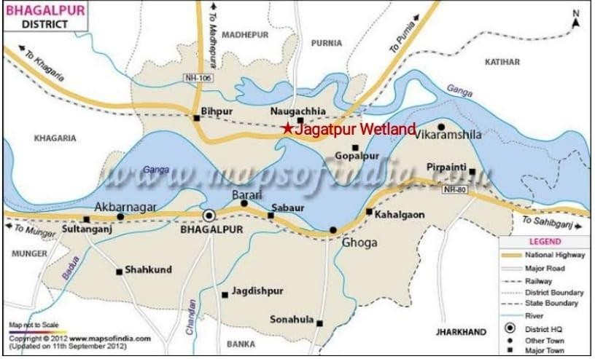
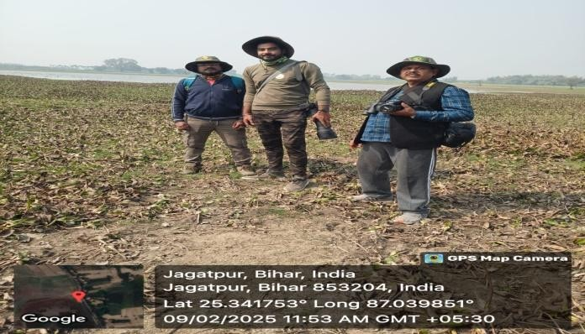
Fig 1 : River map of district Bhagalpur showing Geographical location of Jagatpur wetland.
Commented [PM14]: Must not be included under materials and methods section
.

Fig 2 : A view of Jagatpur wetland in district Bhagalpur, Bihar. Authors standing near the wetland.

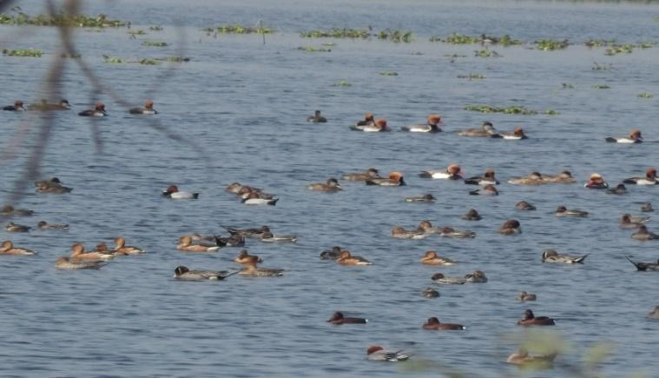
Fig 3 : A view of mix flock of migratory birds in Jagatpur wetland.

Methodology

All species of migratory and resident birds included in this study were recorded based on their occurrence and frequency of sightings from January 2023 to May 2025.This freshwater lake provides an important habitat for a wide range of resident and migratory bird species. To collect accurate data, field observations were made by using binoculars for viewing birds from a safe distance without causing disturbance, and a field guide was used to support proper identification of each species. A notebook and pen were employed to systematically record details such as species name, number of individuals, behavior, feeding patterns, and habitat preferences (Choudhary and Mishra, 2006). Bird surveys were conducted using two standard methods: the Point Count Method by which birds recorded from fixed observation points within a specific time period, and the Transect Method, which involved walking along a predetermined path and documenting birds observed within a set distance on either side (Nandhini and Jagatheeswari, 2024). Accurate identification was considered crucial for understanding bird behavior, population dynamics, ecological roles, and conservation status. Binoculars were used in identification of birds. Photographs and videos were captured by using digital camera (Nikon B600), camera (Nikon p950) and DSLR (Nikon D5600) for photographic evidence (Choudhary and Jay 2025).
Commented [PM15]: Methodology does not indicate sampling design, not properly discussed bird survey methods like radius of count, length of transect missing, no statistical analysis like indices or abundance, method of fish sampling missing, identification method for fishes not mentioned.

Result
During the course of this study, a total of 144 bird species were recorded at Jagatpur Wetland and its surrounding areas in district Bhagalpur, Bihar. These species were observed across different seasons from January 2023 to May 2025. Out of 144 bird species 100 were resident, 8 were local migratory and 36 species were migratory. Among the recorded species, 1 species was recorded endangered, 4 species were classified as Vulnerable, 134 species were listed under the Least Concern category and 5 species were identified as Near Threatened. The bird species was belonging to 19 orders and 48 families. Among these families, Anatidae was the most abundant, represented by 14 species and order Passeriformes exhibited the highest diversity, with 48 species recorded.
During this investigation fishes of the Jagatpur wetland were also collected and identified by A text book of fishery science and Indian Fisheries (Srivastava, 2013) and by interogating local fisherman (Choudhary and Sagar, 2025). These fishes are the main food item of many birds attracting them into this wetland. Altogether 24 freshwater water fishes species belonging to 6 orders and 13 families were documented with their status and occurrence.

The highest number of species was identified within the order Cypriniformes (9 species) followed by Perciformes (7 species), Mastacembeleformes and Ophiocephaliformes each have 3 species where Symbranchiformes and Clupeiformes each have 1 species (Table 1, Histogram 1).
Cyprinidae is the most abundant family with 4 species followed by, Masteacembelidae , Ophiocephalidae and Anabantidae have 3 species in each, Bagridae and Centropomidae have 2 species. During the investigation only 1 species was found in family Siluridae, Clupeidae, Claridae, Heteropneustidae, Gobiidae, Nandidae and Symbranchidae.


Threats:
Table 1. A cheklist of birds of Jagatpur wetland and its adjoining areas in district
Bhagalpur, Bihar, India
Commented [PM17]: Could mention the village name
Commented [PM16]: Not analyzed in this study, looks only descriptive, not analytical
Few threats were also recorded during this investigation. This beautiful wetland, which serves as an important habitat for migratory birds, is slowly being damaged. As a result, the variety of species and the number of many bird populations are decreasing. Unregulated fishing, encroachment and reclamation of the wetland, and the dumping of solid waste and domestic sewage from nearby villages are harming the area severely. In addition, increasing road traffic, construction of roads, schools, and fuel stations, the withdrawal of water for irrigation, and the gradual stilt formation contributing to the slow destruction of the wetland’s natural and peaceful environment. Approximately half of the wetland area has become infested with Eichhornia, resulting in a reduction in the open- water zone. The excessive growth of Eichhornia has also accelerated eutrophication processes, further reducing the overall depth of the wetland. These changes collectively pose significant
ecological challenges and may negatively impact the habitat suitability for migratory bird species.

 |  |  |  |  |  |  |  |  |  |  |  | Commented [PM18]: More than 50 spelling mistakes in the binomials, many outdated names, wrongly identified family and orders, requires major corrections in the table
S.n  o. | Family with Local name | Common English name | Scientific name |  |  |  | Order | Habitat | Statu s and Occu  renc e | IUCN  statu s
 | Family - Podicipitidae
1 | Pandubbi or panduk | Little Grebe or Dabchick |  | Podiceps fulicols |  |  | Podicipediforme | W, | RC | LC |  | Commented [PM19]: Spell check
1 | Pandubbi or panduk | Little Grebe or Dabchick |  |  |  |  | s
 | Family - Phalacrocoracidae
2. | Chota pankawa | Little cormorant | Phalacrocorax niger |  |  |  | Suliformes | W,WE | RC | LC
3. | Bara pankawa | Large cormorant | Phalacrocorax carbo |  |  |  | Suliformes | W,WE | RC | LC
 | Family - Anhingidae
4 | Banbi,  Sarp pakshi | Darter , snake bird |  | Anhinga ruja |  |  | Suliformes | W,WE | RC | NT |  | Commented [PM20]: Check the name
 | Family - Ardeidae
5 | Karchia bagula | Little Egret |  | Ergetta garzetta |  |  | Pelecaniformes | W | RC | LC |  | Commented [PM21]: Spell check


- Patankha bagula
Median Egret
Ergetta intermedia
Pelecaniformes WE
RC LC

- Bara bagula

- Gai bagula

- Andha bagula
- Anjan , Kubud
- Lal anjan , Khajra
- Kwak

Family - Ciconidae

- Ghongil
Large Egret Cattle Egret
Pond heron Grey heron Purple heron Night heron

Openbill stork
Ardea alba Bulbulcus ibis
Ardeola grayii Ardea cinerea Ardea perpurea Nicticorax nicticorax

Anastomus oscitans
Pelecaniformes Pelecaniformes
Pelecaniformes Pelecaniformes Pelecaniformes Pelecaniformes

Ciconiiformes
WE RC

G RC

WE RC
,WE RC
WE RC
WE RC

WE,PF LM
LC

LC Commented [PM22]: Spell check
LC LC
LC Commented [PM23]: Spell check
LC Commented [PM24]: Spell check

LC

- Hazi Laglag

- Loha sarong
White neck stork Black neck stork
Ciconia episcopus

Ephippioryynchus asciaticus
Ciconiiformes Ciconiiformes
WE,PF RC
,
WE, RC
VU

NT
Commented [PM25]: Spell check

- Jhangil
Painted stork
Mycteria leucocephala
Ciconiiformes
WE,
RC NT

- Chota Garur ,
Chandiyari
- Bara Garur , Hargila

Lesser Adjuvant stork
Greater adjuvant stork

Leptoptilus javanicus Leptoptilus dusius

Ciconiiformes Ciconiiformes

WE ,

WE,

RC VU

RC E

Commented [PM26]: Spell check

Family - Threskiornithidae
- Karankul or kala baza

Black ibis

Pseudibis papilosa

Pelecaniformes

WE,

RC LC

- Safed baza
White ibis
Threskiornis aethiopica
Pelecaniformes
WE,
LM LC

Family - Anatidae

- Chota silhi

Lesser whistling teal

Dendroeygna javanica

Anseriformes W

RC LC
Commented [PM27]: Spell check

- Bara silhi
Large whistling duck
Dendrocygna bicolor
Anseriformes W
RC LC

- Giria

- Seekhper, Dighounch
Cotton teal

Nothern pintail
Nettapus coromandelianus
Anas acula
Anseriformes W

Anseriformes W
RC LC

MC LC

Commented [PM28]: Spell check

- Tidari
Northern Shoveller
Spatula clypeata
Anseriformes W
MC LC

- Karra
Common teal
Anas creca
Anseriformes W
MC LC
Commented [PM29]: Spell check

- Chaita
Gargeny
Anas querquedula
Anseriformes W
MC LC

- Maila, Gugrail
Gudwal
Mareca strepera
Anseriformes W
MC LC

29 | Lalsir | Red crested pochard | Netta rufina | Anseriformes | W | MC | LC
30 | Karchia battakh | White eye pochard | Aythya nyroca | Anseriformes | W | MC | NT
31 | Kalsira, Ablak battakh | Tufted pochard | Aythya ferina | Anseriformes | W | MC | VU
32 | Chota lalsir | Common pochard | Aytha ferina | Anseriformes | W | MC | LC
33 | Patari | Wigeon | Mareca Penelope | Anseriformes | W | MC | LC
34 | Nakta | Comb duck | Sarkidiornis sylvicola | Anseriformes | W | MC | LC
 | Family - Accipitridae
35 | Baaz , Chipka | Shikra | Accipetor badius | Accipitriformes | ST, LT | RC |  | VU |  | Commented [PM30]: Wrong status
36 | Cheel | Paria kite | Milvns migrans | Accipitriformes | Sk | RC | LC |  |  | Commented [PM30]: Wrong status
37 | Dhobia cheel | Brahminy kite | Haliastur indus | Accipitriformes | LT, | LM | LC |  |  | Commented [PM30]: Wrong status
38 | Kala cheel | Black kite | Milvus migrans | Accipitriformes | Sk | RC | LC |  |  | Commented [PM30]: Wrong status
39 | Kapasi cheel | Black winged kite | Elanus coeruleus | Accipitriformes | LT, Wr | RC | LC |  |  | Commented [PM30]: Wrong status
40 | Madhu baaz , Sunhutela | Oriental honey buzzard | Pernis ptilorhynchus | Accipitriformes | LT | RC | LC |  |  | Commented [PM30]: Wrong status
41 | Teesa cheel | White eye buzzard | Butastor teesa | Accipitriformes | LT,Wr | RC | LC |  |  | Commented [PM30]: Wrong status
42 | Lamtanga chuhamar | Long legged buzzard | Buteo rafinus | Accipitriformes | LT, Sk | MC | LC |  |  | Commented [PM30]: Wrong status
43 | Gilahrimar baaz | Booted eagle | Hieraaetus pennatus | Accipitriformes | Sk | MC | LC |  |  | Commented [PM30]: Wrong status
44 | Dogra cheel | Crested serpent eagle | Spilornis cheela | Accipitriformes | LT | RC | LC |  |  | Commented [PM30]: Wrong status
45 | Desi chitra ukab | Indian spotted eagle | Clanga hastata | Accipitriformes | LT, Sk | RC | LC |  |  | Commented [PM30]: Wrong status
 | Family - Pandionidae |  |  |  |  |  |  |  |  | Commented [PM30]: Wrong status
46 | Machranga | Osprey | Pandion haliaetus | Accipitriformes | FW | MC | LC |  |  | Commented [PM30]: Wrong status
 | Family - Falconidae |  |  |  |  |  |  |  |  | Commented [PM30]: Wrong status
47 | Khermutia baaz | Common kestrel | Falco tinnun culus | Falconiformes | ST, LT,Wr | MC | LC |  |  | Commented [PM30]: Wrong status
48 | Saheebaaz | Peregrine falcon | F. peregrinus | Falconiformes | LT, Sk | MC | LC |  |  | Commented [PM30]: Wrong status
 | Family - Rallidae |  |  |  |  |  |  |  |  | Commented [PM30]: Wrong status
49 | Sarier , kareem | Purple moorhen | Porphyrio porphyrio | Gruiformes | AV,WE | RC | LC |  |  | Commented [PM30]: Wrong status

50 | Van murgi, | White breasted water hen | Amourornis phoenicurus | Gruiformes | AV,WE | RC | LC
51 | Jal murgi | Indian moorhen | Gallinula chloropus | Gruiformes | AV,W | RC | LC
52 | Tilakdhari, Kesrar | Common Coot | Fulica atra | Gruiformes | W , AV | MC | LC
 | Family - Jacanidae
53 | Jal pipi , Katvi | Bronze winged jacana | Metopidius indicus | Charadriiformes | WE,AV | RC | LC
54 | Pihua | Pheasant tail jacana | Hydrophasiansus chirurgus | Charadriiformes | AV,W | RC | LC
Family -
Charadriidae
55 | Merwa | Little ring plover | Charandrius dubius | Charadriiformes | WE,WL | MC | LC
56 | Merwa | Kentish plover | Anarhynchus alexandrinus | Charadriiformes | WE | MC | LC
57 | Tithari | Red wattled lapwing | Vallenus indicus | Charadriiformes | WE, WL | RC | LC
Family -
Recurvirostridae
58 | Gajpawn | Black winged stilt | Himantopus himantopus | Charadriiformes | WE | RC | LC
 | Family - Tringinae
59 | Chupka | Spotted sandpiper | Tringa glareola | Charadriiformes | WE | MC | LC
60 | Merwa | Common sand piper | Tringa hypoleucos | Charadriiformes | WE | MC | LC
61 | Runni | Little stint | Calidris minutus | Charadriiformes | WE | MC | LC
 | Family - Laridae
62 | Kurri, Mach lauka | Caspian tern | Sterna caspia | Charadriiformes | FW | M | NT
 | Family - Alcedinidae
63 | Chota kilkila | Common kingfisher | Alcedo athis | Coraciiformes | WE,FW  ,AV | RC | LC
64 | Kilkila | White breasted kingfisher | Halcyon smyrnensis | Coraciiformes | AV, FW | RC | LC
 | Family - Cerylidae

65 | Safed kilkila | Pied kingfisher | Ceryle rudis | Coraciiformes | AV,FW | RC | LC
 | Family - Picidae
66 | Lal kathphorya | Rufous woodpeeker | Celeus brachyurus | Piciformes | ST,LT, | RC | LC
67 | Gehuwan kathphorya | Fulvus breasted woodpecker | Dendrocopus macei | Piciformes | LT | RC | LC
68 | Bhura sir kathphorya | Grey capped pygmy woodpecker | Picoides canicapilus | Piciformes | LT | RC | LC
69 | Kathphorba | Lesser flame back | Dinopium  benghalense | Piciformes | ST,LT | RC | LC
Family -
Megalaimidae
70 | Bara Basanta | Brown headed barbet | Megaluma zeylanica | Piciformes | ST,LT | RC | LC
71 | Thathera,chota basanta | Coppersmith barbet | Megaluma haemacephala | Piciformes | ST,LT | RC | LC
72 | Nilkanth basanta | Blue throated barbet | Psilopogon asiaticus | Piciformes | ST, LT | RC | LC
 | Family - Strigidae
73 | Chittidar ullu , pencha | Spotted owlet | Athema brama | Strigiformes | ST,LT | RC | LC
74 | Chugad | Collard scops owl | Ottus bakamoena | Strigiformes | ST,LT, | RC | LC
75 | Sunhara ullu | Barn owl | Tyto alba | Strigiformes | ST,LT, | RC | LC
 | Family - Columbidae
76 | Kabutar | Blue rock pigeon | Collumba livia | Columbiformes | G | RC | LC
77 | Chitta fakhta | Spotted dove | Streptopelia chinensis | Columbiformes | ST,LT,  Wr | RC | LC
78 | Panduk or parauk | Eurasian Collared Ring dove | Streptopelia decaocto | Columbiformes | ST,LT,  Wr | RC | LC
79 | Dhor fakhta | Red collard dove | Streptopelia tranquebarica | Columbiformes | ST,LT,  Wr | RC | LC
80 | Harial | Yellow footed green pigeon | Treron phoenicoptera | Columbiformes | LT | RC | LC

 | Family - Bucerotidae
81 | Dhusar Dhanesh |  |  | Indian grey hornbill | Ocyceros birostris | Bucerotiformes | LT | RC | LC
82 | Hudhud |  |  | Common hoopoe | Upupa epops | Bucerotiformes | G,ST,L T | RC | LC
 | Family - Coracidae
83 | Neel kanth |  |  | Indian roller | Coracias bengalensis | Coraciiformes | ST,LT, WI | RC | LC
 | Family - | Meropiae |  |  |  |  |  |  |  |  | Commented [PM31]: Spell check
84 | Patringa |  |  | Small green bee eater | Merops orientalis | Coraciiformes | Wr, ST | RC | LC |  | Commented [PM31]: Spell check
85 | Bara patringa |  |  | Blue tailed bee eater | Merops philipinnus | Coraciiformes | Wr, ST | RC | LC |  | Commented [PM31]: Spell check
 | Family - Cuculidae |  |  |  |  |  |  |  |  |  | Commented [PM31]: Spell check
86 | Koel |  |  | Asian koel | Eudynamus scolopacea | Cuculiformes | ST,LT | RC | LC |  | Commented [PM31]: Spell check
87 | Papiha |  |  | Common hawk cuckoo | Hierococcyx varius | Cuculiformes | ST,LT | RC | LC |  | Commented [PM31]: Spell check
88 | Mahokha |  |  | Greater coucal or pheasant crow | Centropus siensis | Cuculiformes | ST,LT, B | RC | LC |  | Commented [PM31]: Spell check
 | Family - Psittacidae |  |  |  |  |  |  |  |  |  | Commented [PM31]: Spell check
89 | Sugga , tota |  |  | Rose ringed parakeet | Pisttacula krameri | Psittaciformes | ST,LT, | RC | LC |  | Commented [PM31]: Spell check
 | Family - Apodidae |  |  |  |  |  |  |  |  |  | Commented [PM31]: Spell check
90 | Tari batasi |  |  | Asian plam swift | Appus affinis | Apodiformes | Sk | RC | LC |  | Commented [PM31]: Spell check
91 | Batasi |  |  | House shift | Cypsiurus balasinensis | Apodiformes | Sk | RC | LC |  | Commented [PM31]: Spell check
 | Family - Laniidae |  |  |  |  |  |  |  |  |  | Commented [PM31]: Spell check
92 | Lambpucha Lahtora |  |  | Long tail shrike | Lanius schach | Passeriformes | B, ST | MC | LC |  | Commented [PM31]: Spell check
93 | Bhura Lahtora |  |  | Brown shrike | Lanius crisatus | Passeriformes | B,ST | MC | LC |  | Commented [PM31]: Spell check
 | Family - Corvidae |  |  |  |  |  |  |  |  |  | Commented [PM31]: Spell check
94 | Kaua |  |  | House crow | Corvus splendens | Passeriformes | G,B,ST | RC | LC |  | Commented [PM31]: Spell check

95 | Kaga |  |  | Jungle crow or long billed crow | Corvus macrorhynchos |  |  | Passeriformes | G, B, LT | RC | LC
96 | Khakha , Mahalat |  |  | Roufous treepie | Dendrocita vagabanda |  |  | Passeriformes | ST,LT | RC | LC
 | Family - Oriolidae
97 | Peelak |  |  | Gloden oriole | Oriolus oriolus |  |  | Passeriformes | ST,LT | RC | LC
98 | Kala sir peelak |  |  | Black headed oriole | Oriolus xanthornus |  |  | Passeriformes | ST,LT | RC | LC
99 | Chakdil |  |  | White browed fantail flycatcher | Rhipidura aureola |  |  | Passeriformes | ST,LT | RC | LC
Family -
Campephagidae
100 |  |  |  | Scarlet minivit | Pericrocotus flammeus |  |  | Passeriformes | LT | RC | LC
 | Family - Dicruridae
101 | Kotwal |  |  | Black drongo | Dicrurus macrocercus |  |  | Passeriformes | WL,B,S T,LT | RC | LC
Family -
Hirundinidae
102 | Ababil |  |  | Barn swallow | Hirundo rustica |  |  | Passeriformes | Sk | RC | LC
103 | Ababil |  |  | Red rumped swallow | Hirundo daurica |  |  | Passeriformes | Sk | RC | LC
104 | Ababeel |  |  | Common swallow |  | Hirundo rustica |  | Passeriformes | WE , | MC | LC |  | Commented [PM32]: Duplicate with s. no. 102
104 |  |  |  | Common swallow |  |  |  |  | FW |  |  |  | Commented [PM32]: Duplicate with s. no. 102
105 | Leesra |  |  | Wire tailed swallow | Hirundo smithi |  |  | Passeriformes | WE , FW | LM | LC |  | Commented [PM32]: Duplicate with s. no. 102
 | Family - Paridae |  |  |  |  |  |  |  |  |  |  |  | Commented [PM32]: Duplicate with s. no. 102
106 | Ramgangra |  |  | Grey tit | Parus major |  |  | Passeriformes | ST,LT, B | RC | LC |  | Commented [PM32]: Duplicate with s. no. 102
 | Family -  Pycnonotidae |  |  |  |  |  |  |  |  |  |  |  | Commented [PM32]: Duplicate with s. no. 102
107 | Bulbul |  |  | Red vented bulbul | Pycnonotus cafer |  |  | Passeriformes | B,ST,W L | RC | LC |  | Commented [PM32]: Duplicate with s. no. 102
108 | Sah bulbul |  |  | Red whishkered bulbul | Pycnonotus jocosus |  |  | Passeriformes | B,ST,W L | RC | LC |  | Commented [PM32]: Duplicate with s. no. 102
 | Family - Cisticolidae |  |  |  |  |  |  |  |  |  |  |  | Commented [PM32]: Duplicate with s. no. 102
109 | Sada dum fudki |  |  | Plain prinia | Prinia inornata |  |  | Passeriformes | B,ST | RC | LC |  | Commented [PM32]: Duplicate with s. no. 102
110 | Sileti dum fudki |  |  | Ashy prinia | Prinia socialis |  |  | Passeriformes | B,ST | RC | LC |  | Commented [PM32]: Duplicate with s. no. 102
 | Family - | Zosteropida |  |  |  |  |  |  |  |  |  |  | Commented [PM33]: Spell check

111 | Swetnayan | Oriental white eye | Zostero palpebrosus | Passeriformes | B,ST | RC | LC
 | Family - Silvidae
112 | Kachbachia | Jungle barbbler | Turdoides striatus | Passeriformes | B,ST | RC | LC
 | Family - Alaudidae
113 | Chota bharat | Oriental skylark | Alauda gulgula | Passeriformes | B,ST | RC | LC
Family -
Muscicapidae
114 | Narangisir kastura | Orange headed thrush | Zoothera citrina | Passeriformes | G,ST | MC | LC
115 | Lal kanthi Makhimar | Red throated fly catcher | Ficedula parva | Passeriformes | G,ST | MC | LC
116 |  | Taiga flycatcher |  | Passeriformes | Bush | MC | LC
117 | Dahiyar , Dhovan | Oriental magpie robin | Copsychus saularis | Passeriformes | G,ST | MC | LC
118 | Dahiyar | Indian robin | Saxicoloides fulicata | Passeriformes | G,ST | RC | LC
119 | Thirthira | Black red start | Phoenicurus ochruros | Passeriformes | B,WE,S T | MC | LC
120 | Thartharkampni | Brown rock chat or indian chat | Cercomela fusca | Passeriformes | BD | RC | LC
121 | Nilkanthi | Blue throat | Luscina svecica | Passeriformes | PF | RC | LC
122 | Abkal jhari pidda | Pied bushchat | Saxicola caprata | Passeriformes | PF | RC | LC
 | Family - Sturnidae
123 | Deshi myna | Common myna | Acaridotheres tristis | Passeriformes | G,ST,L T,WL | RC | LC
124 | Ablak myna,guhia myna | Pied myna | Sturnus contra | Passeriformes | G,ST,L T,WL | RC | LC
125 | Brahminy myna | Black headed myna | Sturnus pagodrum | Passeriformes | G,ST,L T,WL | LM | LC
126 | Dariya myna, Gang myna | Bank myna | Acridotheres ginginianus | Passeriformes | WE,PF | LM | LC
127 | Slaty sir myna | Chestnut tailed starling | Sturnus malabaricus | Passeriformes | ST,LT | RC | LC
128 | Jangli myna | Jungle myna | Aeridotheres fuscus | Passeriformes | ST,LT | RC | LC

Family -
Nectoriniidae
129 | Sakarkhosa , Kala pidda | Purple sunbird | Nectarinia asiatica | Passeriformes | ST,B | RC | LC
 | Family - Passeridae
130 | Goraiya | House sparrow | Passer domesticus | Passeriformes | G,B,WL | RC | LC
131 | Baya | Weaver bird | Ploceus philippinus | Passeriformes | ST,LT | LM | LC
 | Family - Motacillidae
132 | Khanjan | Large pied wagtail | Motacilla maderaspatersis | Passeriformes | G,WE, | RC | LC
133 | Dhoban | White wagtail | Motacilla alba | Passeriformes | G,WE,, | RC | LC
134 | Panika | Yellow head wagtail | Motailla citreola | Passeriformes | WF,AV | MC | LC
135 | Panika or Slaty khanjan | Grey wagtail | Motacilla caspica | Passeriformes | WE, | MC | LC
136 | Charchari | Paddy field pipit | Anthus rufulus | Passeriformes | WE | RC | LC
137 | Gulabi charchari | Rosy pipit | Anthus roseatus | Passeriformes |  | MC | LC
 | Family - Estrildidae
138 | Lalmunia | Red avadevet | Amandava amandava | Passeriformes | PF | RC | LC
139 | Salki munia , Telia munia | Scaly breasted munia | Lonchura punctulata | Passeriformes | PF | RC | LC
 | Family - Phasianidae
140 | Bhura teetar | Grey frankolin | Francolinus pondicerianus | Galliformes | PF , BU | RC | LC
141 | Saubeegi | Common lora | Aegithina asciatica | Galliformes | ST | LM | LC
142 | Tilakdhari / Kesrar | Eurasian Coot | Fulica atra | Galliformes | W , AV | MC | LC
143 | Bater | Jungle bush quail | Perdicula asiatica | Galliformes | PF , BU | RC | LC
 | Family - Turdidae
144 | Narangi kastura | Orange headed thrush | Zoothera citrina | Passeriformes | PF, G | MC | LC

Abbreviation : W-Water, WE-Water edge, PF- Paddy field, BU-Bush, AV- Aquatic vegetation, FW- Flying over water, G- Ground, Sk-Sky, , RC-Resident common, MC- Migratory common, LM- Local migratory, ST- Small tree, LT- Large tree, Wr-Telephone wire

Fig 4: Pie chart showing percent distribution of migratory and resident birds as per IUCN status.
Fig 5: Histogram showing number of bird species belong to different families recorded in three
consecutive years 2023-
202
Commented [PM35]: Year missing
Commented [PM34]: Not a histogram, must be bar chart
Number of Individuals in different families
15
10
5
Number of Individuals in
0 different families
IUCN status
3% 31%%

Vulnerable Near Treatened Endangered Least concern
93%
Podicipitid…
Ardeidae Anatidae Falconidae
Charadriid… Laridae Picidae
Columbidae Meropiae Apodidae Oriolidae Hirundinid… Cisticolidae Alaudidae
Nectorinii…
Estrildidae

Table 2 : |  |  | Fish fauna recorded in |  | Jagatpur wetland. |  |  |  | Commented [PM36]: All the fish listed requires proper
S.No. | Local Name | Scientific Name |  | Family |  | Order | IUCN  Status | Occ | uidre | ntification keys
 |  |  |  |  |  |  |  | rence
1. | Chital | Notopterus chitala |  | Clupeidae |  | Clupeiformes | LC | C
2. | Catla | Catla catla |  | Cyprinidae |  | Cypriniformes | LC | VC
3. | Rohu/Rehu | Labeo rohita |  | Cyprinidae |  | Cypriniformes | LC | VC
4. | Pothia | Puntius ticto |  | Cyprinidae |  | Cypriniformes | LC | VC
5. | Morla | Amblyphayngodo n mola |  | Cyprinidae |  | Cypriniformes | LC | VC
6. | Tengra | Mystus tengra |  | Bagridae |  | Cypriniformes | LC | VC
7. | Tengra | Mystus seenghala |  | Bagridae |  | Cypriniformes | LC | C
8. | Buari | Wallago attu |  | Siluridae |  | Cypriniformes | VU | C
9. | Mangur | Clarius batrachus |  | Claridae |  | Cypriniformes | LC | C

10. | Singhi | Heteropneustes fossilis | Heteropneustidae | Cypriniformes |  |  |  | LC | C
11. | Bami | Mastacembelus  armetus | Mastacembelidae | Mastecembeleformes |  |  |  | LC | VC
12. | Gainchi | Mastacembelus aculeatus | Mastacembelidae | Mastecembeleformes |  |  |  | LC | VC
13. | Gainchi | Mastacembelus  puncalus | Mastacembelidae |  | Mastecembeleformes |  |  | LC | VC | Co | mmented [PM37]: Spell check
14. | Garai | Channa punctatus | Ophiocephalidae | Ophiocephaliformes |  |  |  | LC | VC
15. | Sauri | Channa marulius | Ophiocephalidae | Ophiocephaliformes |  |  |  | LC | VC
16. | Chenga | Channa gacheia | Ophiocephalidae | Ophiocephaliformes |  |  |  | LC | C
17. | Kawai | Anabas testudineus | Anabantidae | Perciformes |  |  |  | LC | C
18. | Kholsa | Colisa fasciatus | Anabantidae | Perciformes |  |  |  | LC | VC
19. | Kholsa | Colisa lalius | Anabantidae | Perciformes |  |  |  | LC | VC
20. | Bulla | Glossogobius giuris | Gobiidae | Perciformes |  |  |  | LC | RO
21. | Dhalo | Nandus nundus | Nandidae | Perciformes |  |  |  | LC | RO
22. | Chanda | Chanda nama | Centropomidae | Perciformes |  |  |  | LC | VC
23. | Chanda | Chanda ranga | Centropomidae |  | Perciformes |  |  | LC | C | Co | mmented [PM38]: Outdated grouping, fishes order re- gned
24. | Mud Eel/Sap Machli/ Kuchia | Monopterus cuchia | Symbranchidae | Symbranchiformes |  |  |  | LC | RO | assi | mmented [PM38]: Outdated grouping, fishes order re- gned


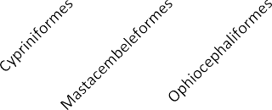

Fig 6: Histogram showing the relationship among number of orders, families and fish species.
Abbreviations : LC -Least Concern , EN -Endangered , NT - Near Threatened , VU -
Vulnerable , VC - Very Common, C – Common, RO - Rare or Occasionally
Showing relationship among family, order and
species
10
9
8
7
6
5
4
3
2 No. of Family
1
0 No. of Species
Commented [PM40]: Technically wrong diagram, cannot show relationship
Commented [PM39]: The histogram is conceptually wrong, there is no x axis title, nor y axis title

Plate 1: Photographs of some migratory species
Commented [PM41]: Many species require proper identification at the species level, there is a high-risk of misidentification, like
white ibis, rufous woodpecker, sandpipers, etc.

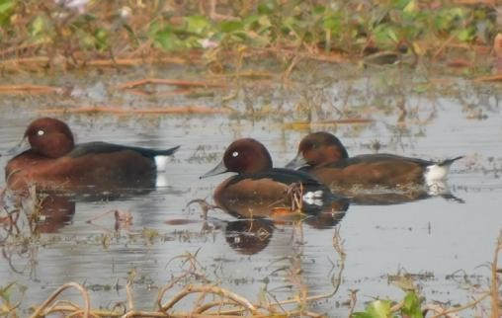 | 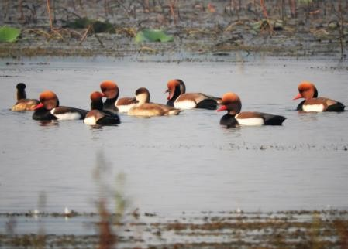
Ferruginous duck (Aythya nyroca) | Red creasted pochard (Netta rufina)
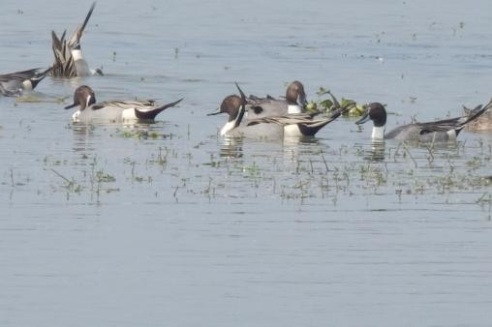 | 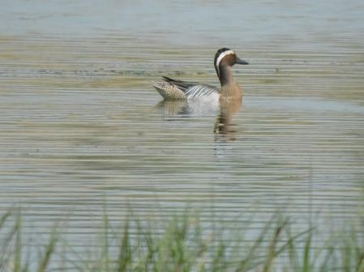
Northern pintail (Anus acuta) | Garganey (Spatula querquedula)
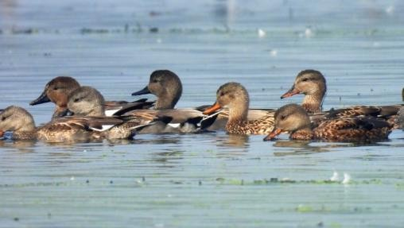 | 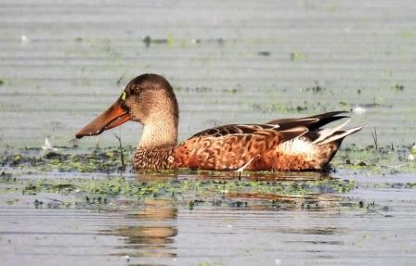
Gadwall (Mareca strepera) | Northern shoveller (Spatula clypeata)

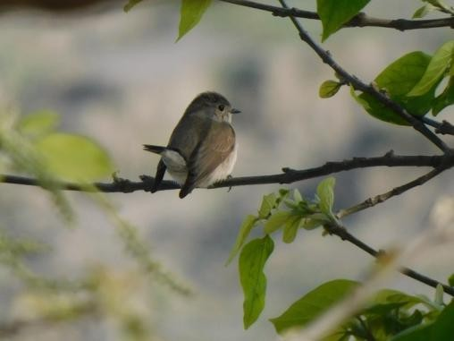 | 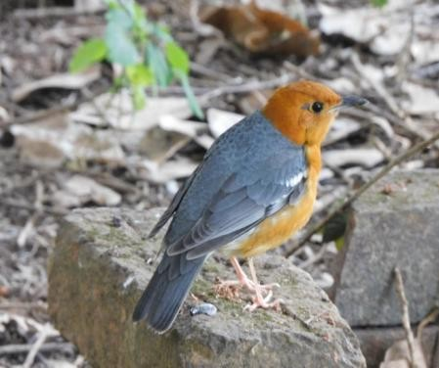
Taiga flycatcher (Ficedula albicilla) | Orange headed thrush (Zoothera citrina)
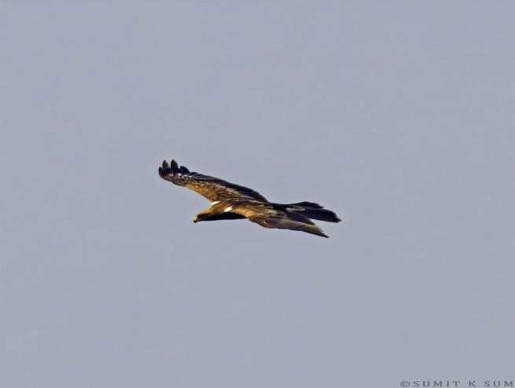 | 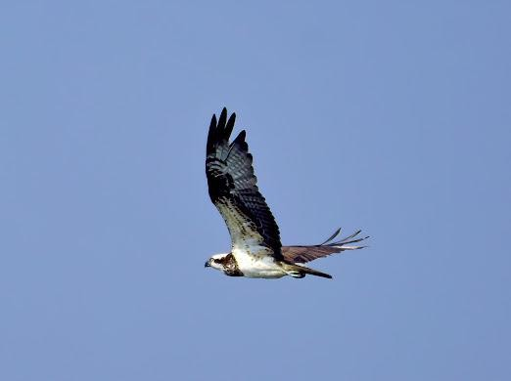
Booted eagle (Hieraaetus pennatus) | Osprey (Pandion haliaetus)
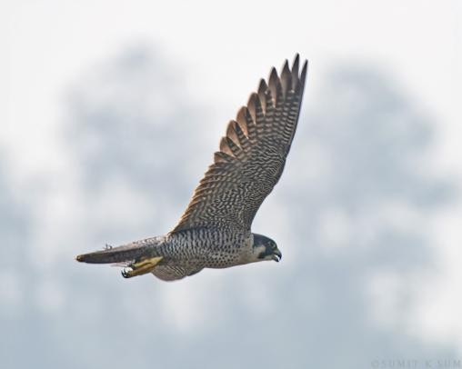 | 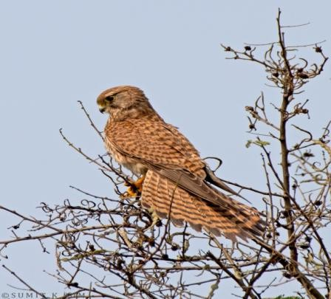
Peregrine falcon (Falco peregrinus) | Common kestrel (Falco tinnunculus)

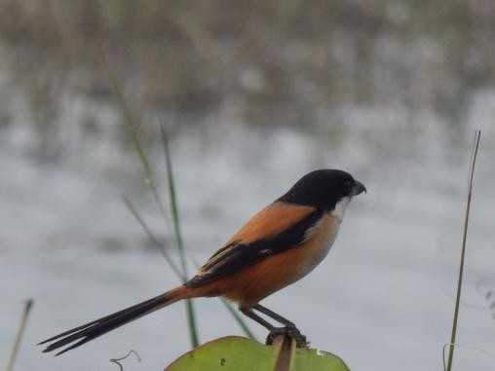 | 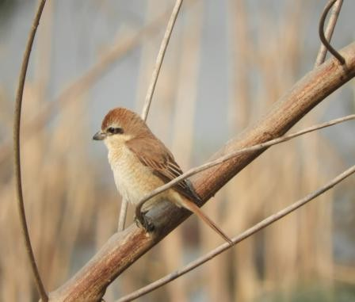
Long tailed shrike (Lanius schach) | Brown shrike (Lanius cristatus)
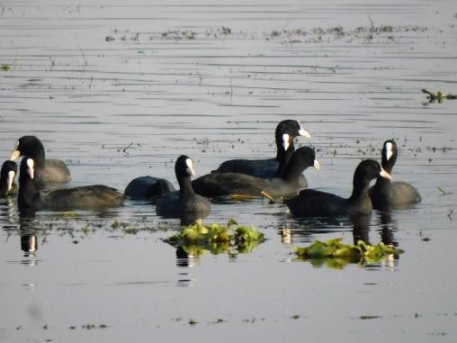 | 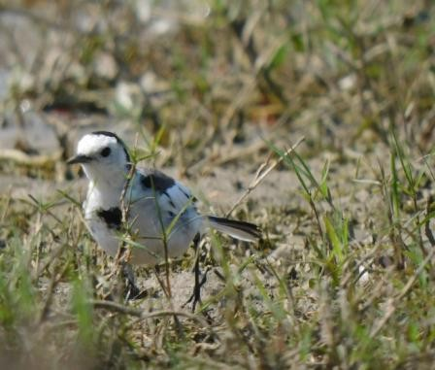
Eurasian coot (Fulica atra) | White wagtail (Motacilla alba)
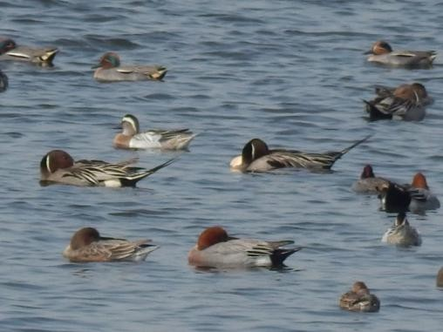 | 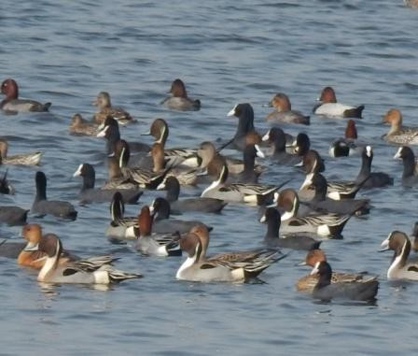
Flock of migratory birds including Green winged teal, Garganey, Northern pintail, Eurasian wigeon and
Eurasian coot
podi

Plate 2: Photographs of some local resident species

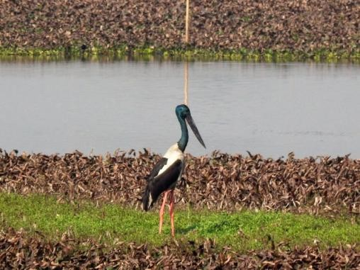 | 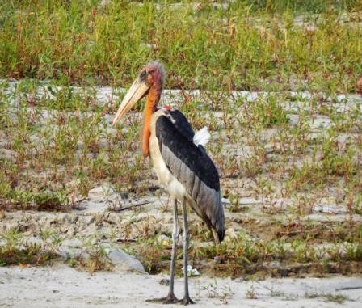
Black necked stork (Ephippioryynchus asciaticus) | Greater adjutant stork (Leptoptilos dubius)
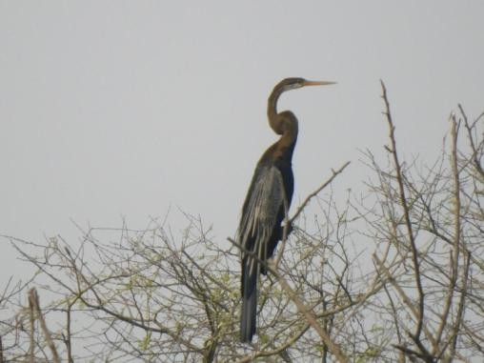 | 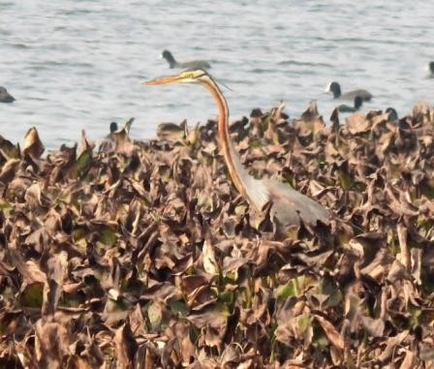
Oriental darter (Anhinga melanogaster) | Purple heron (Ardea purpurea)

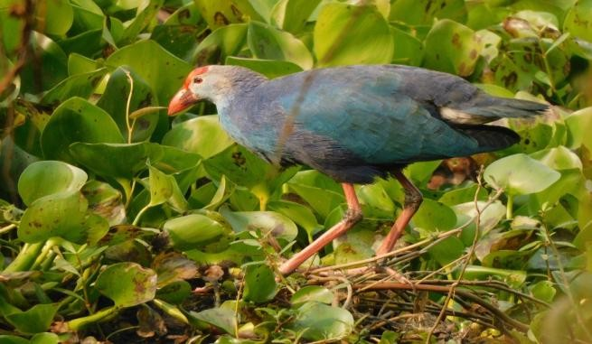 | 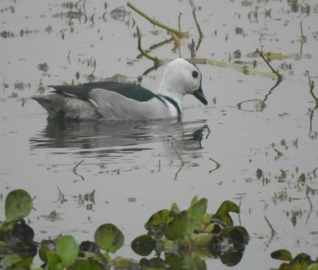
Purple swamphen (Porphyrio porphyria) | Cotton pygmy goose (Nettapus coromandelianus)
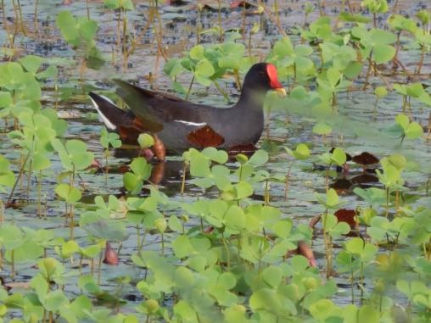 | 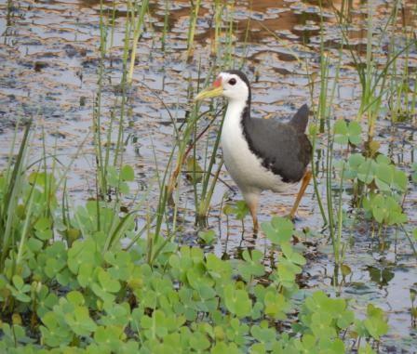
Indian moorhen (Gallinula chloropus) | White breasted waterhen (Amaurornis  phoenicurus)
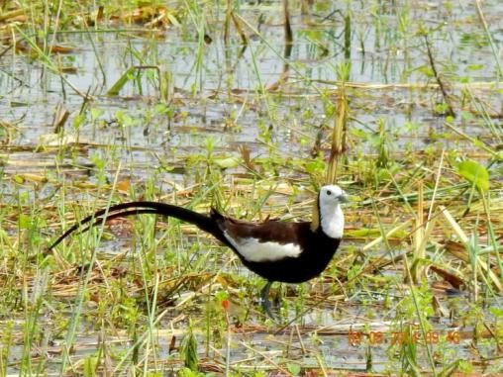 | 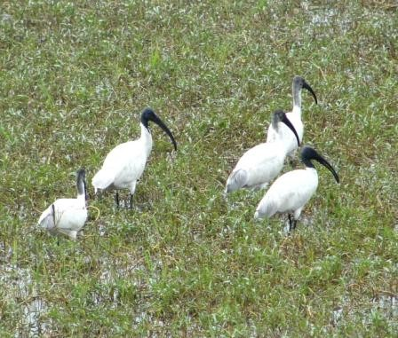
Pheasant tailed jacana (Hydrophasianus chirurgus) | White ibis ( Eudocimus albus)

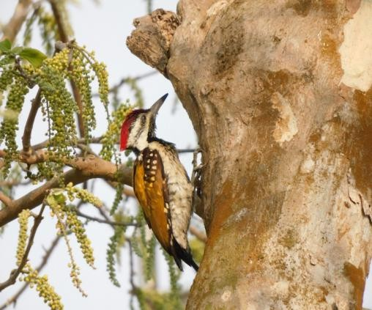 | 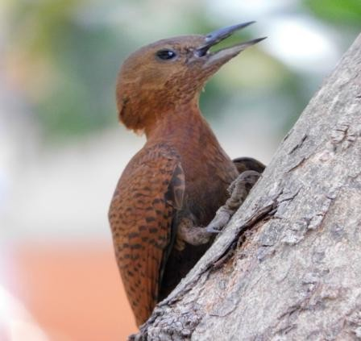
Black-rumped flameback woodpecker (Dinopium benghalense) | Rufous woodpecker (Celeus brachyurus)
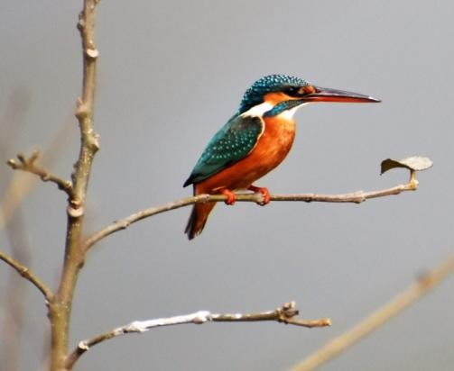 | 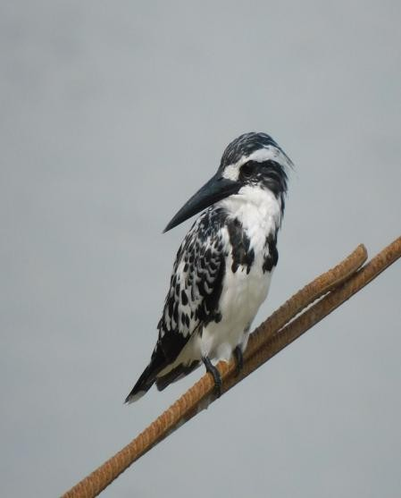
Common Kingfisher (Alcedo atthis) | Pied kingfisher (Ceryle rudis)

Discussion:
Commented [PM42]: Discussion requires deeper analysis with previous research works
The diversity of bird species within an ecosystem serves as an indicator of overall habitat health (Ali, 2002). Wetland birds, in particular, play a crucial role in wetland ecosystems by functioning as integral components of food webs (Grimmett et al., 2014). The International Wetlands (Ramsar) Convention defines wetlands as areas in which water is the dominant environmental factor influencing plant and animal life. This definition encompasses rivers, lakes, coastal zones, forests, ponds, fish farms, canals, and similar environments, with water depths of up to 6 meters during high tide (Ramsar Bureau Convention, 2000).
The present study documented a rich diversity of avifauna in Jagatpur wetland of Bhagalpur district, Bihar. A total of 144 bird species were recorded over the study period from January 2023 to May 2025, in this wetland and its surrounding habitats, support a healthy and productive ecosystem (Reddy et al., 2013). The dominance of resident species (100 species) suggests that the wetland provides stable resources and suitable breeding conditions throughout the year (Choudhary et al.,

2022 a). The presence of local migrants (8 species) and long-distance migratory species (36 species) highlights the importance of this wetland as a seasonal refuge and feeding ground for birds moving along migratory routes. From a conservation point, the occurrence of one Endangered species, four Vulnerable species, and five Near Threatened species underscores the ecological value of the site. Most species fell under the Least Concern category (134 species), which indicates that the habitat remains relatively undisturbed and capable of supporting a wide variety of birds (Choudhary and Abdullah, 2023). In terms of taxonomy, birds from 19 orders and 48 families were identified. The family Anatidae was the most abundant (14 species), reflecting the suitability of the wetland for waterfowl (Maykar and Pawar 2025). Likewise, Passeriformes showed the highest diversity with 48 species, which is typical for wetlands with varied vegetation and foraging niches (Reddy et al., 2023).

Fish diversity was also assessed since fish constitute a major food source for many wetland bird species. A total of 24 freshwater fish species from 6 orders and 13 families were recorded from Jagatpur wetland. The dominance of the order Cypriniformes (9 species) may be due to favorable conditions for cyprinid fishes, which commonly thrive in freshwater bodies (Kumar et al., 2019). Families such as Masteacembelidae, Ophiocephalidae, and Anabantidae each contributed three species, indicating a balanced distribution of predatory and non-predatory fishes (Sarkar et al., 2012). Several families, including Siluridae, Clupeidae, Claridae, Heteropneustidae, Gobiidae, Nandidae, and Symbranchidae, were represented by only one species each, suggesting that these groups may have more specific habitat requirements or lower population densities (Singh, 2024).

Conclusion:
The Jagatpur wetland is quite rich in biodiversity. The astonishing and natural habitat in and around the wetland is mesmerizing in beauty, attracting various species of birds. Overall, the combined bird and fish diversity reveals that the Jagatpur wetland serve as an important ecological hotspots.
To overcome the present threats a proper management plan is urgently required to restore its ecological condition and conservation of fishes to preserve the natural beauty. The presence of threatened bird species and diverse fish communities highlights the need for continued protection and sustainable management of these wetlands to ensure long term conservation of their biodiversity. These findings also emphasize the critical role of Jagatpur Wetland in supporting avian diversity and underline the need for continued monitoring and conservation efforts to protect this important wetland ecosystem.

COMPETING INTERESTS DISCLAIMER:

Authors have declared that they have no known competing financial interests OR non-financial interests OR personal relationships that could have appeared to influence the work reported in this paper.

Refrences:
Ali, S. and Ripley, S. D. (1987). Compact Edition of the Handbook of the Birds of India and Pakistan. Oxford University Press, New Delhi.

India.
Ali, S. (2002). The Book of Indian Birds. Edn 13th, BNHS, Oxford University Press, Mumbai,

Banerjee, D., Bharti, D., Kumar, S., Mitra, A., Joshi, R., & Gupta, D. (2023). Faunal

Composition of Ramsar Wetlands from India: An Analysis. Records of the Zoological Survey of India, 123(1S).
BirdLife International. (2007). The Chestnut-banded Plover is an overlooked globally Near Threatened species. Bird Conservation International, 17(3), 283–293. https://doi.org/10.1017/S0959270907000779.
Chintapalli B, Patra R, Kumar A, Kumar S. (2022). Jagatpur Wetland:A Hidden Gem of Wilderness from Bhagalpur. ResearchGate;. Retrieved from https://www.researchgate.net/publication/361259684Jag atpur_Wetland_A_Hidden_Gem_of_Wilderness_from_B hagalpur
Choudhary, D. N., & Ghosh, T. K. (2004). Sighting of Greater Adjutant Storks in the wetlands of North Bihar. Newsletter for Birdwatchers, 44(4), 62–63.
Choudhary, D. N. & Mishra, A. (2006). Sighting of some threatened bird species in Vikramshila Gangetic Dolphin Sanctuary (VGDS), Bhagalpur, Bihar. Newsletter for Birdwatchers, 46(5), 68–70.
Choudhary, D. N., Mishra, A. and Singh, A. K. (2007). Breeding of little tern and other wetland birds in VGDS, Bhagalpur, Bihar. MISTNET, 8(2), 13-14.
Choudhary, D. N., Mishra, A. and Choudhary, N.(2008) A mixed breeding colony of Little Tern, Black‑winged Stilt and Red‑wattled Lapwing in VGDS, Bhagalpur, Bihar. NLBird Watchers. 49(1), 17– 18.
Choudhary, D. N., Mishra, A., Ghosh, T. K., Agrawal, S. and Rohitashwa, R. (2009). Avifauna of Eco park of Barauni Refinery, Begusarai, Bihar. Mistnet, 9(2), 6-8.
Choudhary, D. N., Mandal, J. N., Mishra, A., & Ghosh, T. K. (2010). First ever breeding record of Black‑necked from Bihar. Indian Birds, 6(3), 80–82.
Choudhary, D. N ., Rohitashwa, R., Pankaj, P. P. and Verma, V. C. (2010). Study of foraging behaviour of some wetland birds in Bhagalpur, Bihar. Columban J. Life Sci., 11(1-2), 59-62.
Choudhary, D. N., Mandal, J. N., & Rohitashwa, R. (2011). Distribution and potential breeding records of Lesser and Greater Adjutant storks in Bhagalpur, Bihar, India. Indian Birds, 7(2), 38–40.
Choudhary, D. N., Ghosh, T. K., Mandal, J. N. and Rohitashwa, R. (2013). “Observations on the breeding of the Woolly‑necked Stork in Bihar, India.” Indian Birds 8(4): 93–94.
Choudhary, D. N., Ghosh, T. K., Mandal, J. N., & Pan, T. K. (2014). Study of breeding behaviour of Greater Adjutant in Kosi river flood plains of Naugachia in Bhagalpur, Bihar, India. Rivers for Life: Proceedings of the International Symposium on Biodiversity : Ganges-Brahmaputra-Meghna River Systems, 99–104.
Choudhary, D. N. and Rohitashwa, R. (2022). Some observations on the behavioural changes in few resident birds during COVID-19 induced lockdown in Bhagalpur, Bihar, India. International Journal of Advanced Research in Biological Sciences, 9(1), 58–64.
Choudhary, D. N., Chintapalli, B. and Rohitashwa, R. (2022). Behavioural response of some migratory birds and Gangetic Dolphins to COVID-19 induced lockdown: A case study in the Vikramshila Gangetic Dolphin Sanctuary (VGDS), Bhagalpur, Bihar, India. Asian Journal of Env. and Ecology, 17(3): 1-8.

Choudhary DN, Abdullah. (2023). Some Observations on the nest site selection, nesting and other breeding behaviors of Greater adjutant Stork (Leptoptilos dubios) in the flood plains of Kosi river in district Bhagalpur, Bihar, India. Asian Journal of Environment & Ecology.20(2),19-31. https://doi.org/10.9734/ajee/2023/v20i2434.
Choudhary, D. N. & Sagar, P. (2025). First Record of Ichthyofaunal Diversity in 1Champanala, Bhagalpur, Bihar, India. Asian Journal of Fisheries and Aquatic Research, 27(8): 100–113.
Choudhary, D.N. & Jay, J.K. (2025). Some observations on the impact of climate change on the migratory behaviour of some birds in district Bhagalpur, Bihar, India. International Journal of Fauna and Biological Studies, 12(5): 120–128.
Cowardin, L. M., Carter, V., Golet, F. C., & LaRoe, E. T. (1979). Classification of wetlands and deepwater habitats of the United States (FWS/OBS-79/31). U.S. Department of the Interior, Fish and Wildlife Service.
Clarkson, B. R., Ausseil, A.-G. E., & Gerbeaux, P. (2013). Wetland ecosystem services. In Ecosystem Services in New
Besten, D. and Willem, J. (2008). Birds of India and the Indian Subcontinent: Mosaic Books.
ISBN 819027760X. Zealand: Conditions and Trends (pp. 192–202). Manaaki Whenua Press.

Divyanshu, & Kumari, C. (2025). Avian diversity at Vikramshila Gangetic Dolphin Sanctuary, Bhagalpur, Bihar, India. International Journal of Fauna and Biological Studies, 12(1), 45–53. https://www.ijfmr.com/papers/2025/1/34641.pdf
Ghosh, T. K., Choudhary, S. K. & Mishra, A. (1993). A checklist of the birds of Udhuwa Lake Bird Sanctuary, Rajmahal (Bihar). Journal of Freshwater Biology, 5: 83–91.
Gregory, R.D., Noble, D., Field, R., Marchant, J., Raven, M., & Gibbons, D.W. (2003). Using birds as indicators of biodiversity. Ornis Hungarica, 12-13: 11–24.
Grimmett R, Inskipp C, Inskipp I. Birds of the Indian subcontinent. Edn 2nd, Oxford Univ press, New Delhi.
Gyani, G. C., Masroor, M. D. & Jhunnu, D. K. (2024). First record of Laughing Gull,
Leucophaeus atricilla (Linnaeus, 1758) from Bihar. Species, 25, e24s1669.

Joshi, O., Singh, N., & Sathiyaselvam, P. (2024). Waterbird diversity of Saman Wetland Complex in Uttar Pradesh: a crucial site for the India’s National Action Plan on migratory birds. Journal of Threatened Taxa, 16(6), 25283–25494.
Manjula, M., Rahul Kumar & Rakesh Kumar. 2022. Birds in and around the Gidhhi and Pushpakarni Lake: An ideal bird watching site in Nalanda. Journal of Entomology and Zoology Studies, 10(5): 118-126. DOI:10.22271/j.ento.2022.v10.i5b.9048
Maykar, M. B. & Pawar, R. T. (2025). Avifauna Diversity and Conservation Status of Majalgaon Reservoir, Maharashtra State, India. Uttar Pradesh Journal of Zoology, 46(5): 176–190. https://doi.org/10.56557/upjoz/2025/v46i54834
Milton W. Weller, 1981. Freshwater Marshes: Ecology and Wildlife Management. Univ.
Minnesota Press. 146 pp.

Minj, D. K., Sao, A., & Kumar, H. (2025). Study of the avian faunal biodiversity in the wetlands of Durg district, India. International Journal of Engineering Sciences & Research Technology, 14(6), 27–35. https://doi.org/10.29121/ijesrtp.v14.i6.2025.4

Nandhini, M., & Jagatheeswari, J. (2024). Diversity and Conservation of Wetland Avifauna in Nanjarayan Lake, Tiruppur, Tamil Nadu, India. Uttar Pradesh Journal of Zoology, 45(18): 254–267. DOI: 10.56557/upjoz/2024/v45i184445
Ramsar Burea Convention (2000). What is convention wetlands. Ramsar Information Paper No. 1. World wetlands day, Gland Switzerland.
Raja Reddy, G., Baskaran, M., Kumara Swamy, G. & Adimallaiah, D. (2013). Avian Diversity in and around the Baitarani Reserve Forest of Joda, Keonjhar District, Odisha, India. Newsletter for Birdwatchers, 53(5), 69–76.
Rohitashwa, R., Bose, R., & Singh, V. (2021). Jagatpur Wetland: A paradise for migratory birds.
Science Reporter, 58(03), 24–25.

Rohitashwa R, and Choudhary, D. N. (2024). Threatened birds on postage stamps of India:A step towards conservation. BUCEROS.;29(3):22-27.
Sarkar, U. K., Mishal, P., Borah, S., Karnatak, G., Chandra, G., Kumari, S., … & Roy, K. (2020). Status, potential, prospects, and issues of floodplain wetland fisheries in India: synthesis and review for sustainable management. Reviews in Fisheries Science & Aquaculture, 29, 1–32. https://doi.org/10.1080/23308249.2020.1779650
Sharma, D.K., Paliwal, R., & Saikia, U. (2009). Faunal diversity of Simbalbara Wildlife Sanctuary: Himachal Pradesh — Aves. In: Faunal Diversity of Simbalbara Wildlife Sanctuary. Conservation Area Series Vol. 41. Zoological Survey of India. Pages 81–101.
Singh, S., Kothari, A. & Pande, P. (eds.) (1990). Directory of National Parks and Sanctuaries in Himachal Pradesh: Management Status and Profiles. Indian Institute of Public Administration, New Delhi. 164 pp.
Sinha, A., & Jamal, A. (2015). Freshwater Ornamental Fish of Bihar. CIFRI, Kolkata, India.

Sparks ,T. S., Crick, H. Q. P., Elkins, N., Moss, R., Myllne, K. (2002). Birds, weather and climate. Weather, ;57(11):399410. https://doi.org/10.1256/004316502321951264.
Srivastava, C. B. L. (2013). A Text Book of Fishery Science and Indian Fisheries. Kitab
Mahal.

Suresh, V. R., & Chitranshi, V. R. (2011). Floodplain wetland fisheries. In T. P. Trivedi (Ed.), Handbook of Fisheries and Aquaculture (pp. 275–301). ICAR, New Delhi.
Zafar, M. M., Sulaiman, M. A., Divya, Gaurav, K., Anjum, S., Sharma, G., & Kumari, A. (2025). Documenting the current ichthyofaunal status of River Ganga in the Middle Gangetic Plains (Patna, India). International Journal of Fisheries and Aquatic Studies, 13(2), 178–188.

