Diversity and distribution of grass species along the altitudinal gradients of Kumaun Himalaya

Abstract
The grasses are the most prevalent and extensively dispersed group of monocotyledon flowering plants. The current study aims to explore the taxonomic status, diversity, distribution,
and ethnobotanical relevance of grasses across different altitudinal ranges of the Kumaun Himalaya. The field survey was carried out in three study sites: Kosi (1000-1400 m), Katarmal (1400-1800 m), and Shitlakhet (1800-2200 m). The study recorded 82 grass species, out of which the maximum 61 grasses species were recorded at middle altitude, Katarmal, followed by higher altitude at Shitlakhet with 47 species. However, the minimum 27 species were recorded at lower altitude, Kosi. It was also observed that out of 82, the ethnobotanical uses, and socio-economic value mentioned in the literature was found only on 66 species of grasses. But remaining 16 species lack such information. These grasses are important source of fodder, medicine, and food, as well as for their ecological, socio-religious, and economic purposes in the region. The use value of 66 species ranged from 0.03 to 1.66 and the RFC ranged from 0.03 to 0.86, with C. dactylon possesses the highest UV and RFC values. Pearson correlation coefficient analysis demonstrates a strong positive relationship of UV and RFC (0.9791; p <0.001), displaying that species cited frequency had higher use value. Regression analysis further validate that RFC is a notable predictor of UV (R2 = 0.9586). The results reveal the significance of the grass diversity of the Kumaun Himalaya both ecologically and culturally, emphasizing the need for conservation and sustainable management practices to protect these vital plant resources.
Keywords: Poaceae, use value, Pearson correlation coefficient, Relative Frequency Citation.
- Introduction: Poaceae are the most common and widely distributed family of monocotyledon flowering plants, which includes cereals, millets, and grasses. They grow in a wide range of soil types, climates, and elevations across the globe. They occupy over 20% of the total Earth's land surface, making them ecologically dominant (Hussain et al., 2019). It is the fifth most species-rich flowering plant family, with roughly 11,500 species organized into 12 subfamilies, 52 tribes, 90 subtribes, and 768 genera (Soreng et al., 2022). In contrast, Poaceae, with about 1,500 species, is the largest plant family in India, and the country ranks third globally in grass species diversity, after Brazil and the former USSR (Kellogg et al., 2020).
The Indian Himalayan Region (IHR), covers over 5.3 lakh km² and represents a major portion of the hotspot. Its supporting about 40% of India’s plant endemic species including 8000 angiosperms along with 1748 medicinal plant species (Maikhuri et al., 2000; Sinha et al., 2019). Besides, nearly 60% of the country’s grass taxa, which occupying 18% of the national land area and over half of its forest cover (Samant et al., 1998). Uttarakhand, located primarily in the Western Himalaya and divided into the Garhwal and Kumaun regions, is an essential component of the IHR. The Kumaun Himalaya where the present study was conducted, forms a distinct part of the Himalayan mountain system. Grasses constitute the major component of livestock feed, many of which are rich in protein and thereby enhance nutritional quality and milk yield. Additionally, several grass species possess aromatic and medicinal properties, while their well-developed root systems play a crucial role in soil stabilization and in minimizing landslide hazards.
However, the grass flora of the Kumaun has received limited floristic attention and is primarily documented through scattered and fragmentary reports, lacking a comprehensive and systematic evaluation of grass species diversity and distribution. This is particularly true across the region’s different forest types, where grasses play a crucial ecological and socio-economic role. Therefore, this study seeks to fill the knowledge gap by comprehensively documenting the diversity, distribution, and ecological significance of grasses across multiple forest types in the Kumaun Himalaya, providing vital data for their conservation and sustainable management.
- Materials and Methods
Study area: The present study was conducted at three selected localities in the Almora region, a part of the central Kumaun Himalaya of Uttarakhand, India, namely Kosi, Katarmal, and Shitlakhet, covering different altitudinal zones and forest types. All study sites fall within the Hawalbag block of Almora district. Across the elevational gradient and associated forest types of the study area, site first Kosi, located at an elevation of 1000–1400 m, represents the lower altitudinal zone and is dominated by pure pine forests. The second site, Katarmal, situated between 1400 and 1800 m, corresponds to the middle altitudinal zone and is characterized by mixed pine–oak forests. While third site i.e. Shitlakhet, located at elevations ranging from 1800 m to 2200 m, represents the higher altitudinal zone and is dominated by pure oak forests. These altitudinal differences, forest structure, and associated microclimatic conditions play a significant role in shaping the grass species composition and their distribution in the region.
Specimen collection and herbarium preparation: The collection of grass specimens was carried out over a period of two years from the three selected study sites. The collection was made during the rainy season, which corresponds to the peak growth period for grasses. All the specimens were randomly collected from a variety of habitats throughout the study area, including slopes, cultivated land, forest borders, roadsides, and other typical locations. Field samples of each grass species, along with their localities, field notes and photographs, were collected and subsequently brought to the laboratory for further examination. During field visits, specimens were collected in both flowering and fruiting stages, with detailed records maintained for each sample, including name of collector, date of collection, collection number, location, habit, habitat, local uses, and other relevant field notes. All the specimens were preserved as types specimens using standard procedures, including pressing, drying, poisoning, mounting, and other necessary techniques (Rao & Sharma, 1990). All voucher specimens were deposited in the Departmental Herbarium, Biodiversity Conservation Laboratory, Department of Botany, Soban Singh Jeena University Campus Almora, Uttarakhand (India).
Identification: Identification of grass species was carried out using standard taxonomic literature (Blatter & McCann, 1935; Bor, 1960; Kabeer & Nair, 2009; Ray & Sainkhediya, 2012; Siddabathula & Prasanna, 2023). For this purpose, online resources such as POWO (Plants of the World Online) and e-Flora’s were also consulted.
Data analysis: The acquired data was evaluated methodically utilizing Microsoft Excel 21, R software and supporting papers. The importance of each species was calculated using quantitative indices such as the use value (UV) metric and relative frequency of citation (RFC) method. To evaluate UV and RFC values, secondary information was considered which is based on narrative literature evaluation of published ethnobotanical records, allowing an assessment of each species' cultural, medicinal, or utilitarian relevance. The Pearson correlation coefficient was computed utilizing R version 4.5.2 to determine the relationship between Use Value (UV) and Relative Frequency of Citations (RFC).
Use value (UV) analysis: This value is a quantifiable indicator of a species' relative value or importance in a community (Phillips & Gentry, 1993). The UV was determined using the following formula: UV=∑Ui/n where Ui= The number of use-reports collected from each source for a specific species; N= total number of sources evaluated.
Relative frequency of citation (RFC): This index measures the local significance of each species based on the frequency of citation (Tardío & Pardo-De-Santayana, 2008) which is calculated by the formula given below: RFC= FC/N where FC= number of secondary literature sources citing a specific species; N= is the total number of sources evaluated. RFC values range from 0 (not mentioned by anyone) to 1 (cited by all informants), with higher values indicating greater importance or popularity of a species.
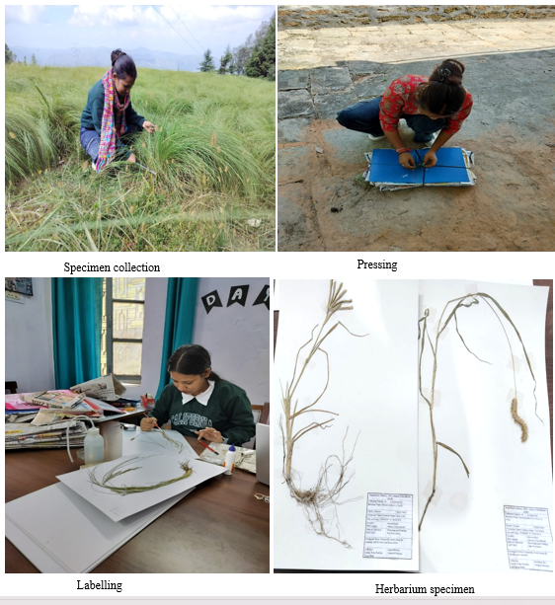

Figure 1. Illustration of herbarium specimens

- Results
Enumeration of grass species of the study area: During the study, a total of 82 grass species belonging to 48 genera, 15 tribes, and 5 subfamilies of the family Poaceae were recorded from the study area (Table 1). These five subfamilies include Panicoideae, Chloridoideae, Pooideae, Bambusoideae, and Arundinoideae. Among these, Pooideae was recorded as the most dominant subfamily comprising five tribes (Aveneae, Brachypodieae, Bromeae, Poeae, and Triticeae) with their eight representative genera. The Pooideae followed by Panicoideae and Chloridoideae with four tribes each. Sub family Panicoideae, represented by maximum twenty-nine genera, whereas Chloridoideae, with four tribes (Eragrostideae, Cynodonteae, Triraphideae, and Zoysieae), comprised nine genera. However, Bambusoideae and Arundinoideae were each represented by a single tribe and single genus. Out the 15 tribes recorded in the study area, Andropogoneae emerged as the most dominant tribe, comprising 18 genera and 24 species. The documented grass taxa exhibited a wide range of growth forms and biological adaptations, reflecting the diverse environmental conditions of the region. Among them, 58 species exhibited a perennial growth form, while 25 species displayed their annual growth form. Furthermore, the grasses found in the study area were ecologically resilient and occurred in two types of habitats: terrestrial and rocky (chasmophytic). Terrestrial grasses thrive in soil-rich habitats, such as forest floors and open slopes, whereas rocky grasses are found in rock crevices and fissures where soil is scarce or limited. Only 82 grass species recorded, 64 were terrestrial, three exhibited characteristics of rocky habitats, and 15 were present in both types of habitats.
Distribution pattern of grass species across the study sites: During the study it was analysed that species richness varied along the altitudinal gradient, with the highest number of grass species recorded at the middle altitude region at Katarmal represented by 61 species. It was followed by higher elevation zone (47 species). While the lowest richness was recorded at the lower altitude site at Kosi (27 species). In addition, 18 grass species including A. setosa, U. villosa, C. fulvus, C. citratus, C. dactylon, S. spontaneum, D. longiflora, D. setigera, D. radicosa, S. diandrus, E. indica, H. contortus, H. vulgare, I. albens, S. pumila, T. anathera, T. aestivum, and Z. mays displayed their common occurrence across all three altitudinal zones. It indicates a genetically flexible constitution that allows persistence under diverse climatic conditions. Besides, E. colona, S. notata, and C. zizanioides were confined only at lower altitude at Kosi. These three species exhibited restricted distribution across the study area. In contrast, 26 species were recorded only at middle altitude region at Katarmal (Table 1). Furthermore, 19 species out of 82 were confined only to the higher altitude at Shitlakhet and these were not observed at other two sites (Table 1).
Use value (UV): The use value (UV) of the recorded grass species ranged from 0.03 to 1.56. Based on these values, the species were categorized into three groups: low use value (< 0.30), medium use value (0.31-0.60), and high use value (> 0.60). Among the 66 grass species, 12 species include C. dactylon (1.66), S. spontaneum (1.36), I. cylindrica (1.26), E. indica (1.03), C. zizanioides (0.93), Apluda mutica (0.86), A. donax (0.86) S. verticillata (0.83), Z. mays (0.8), E. colona (0.73), H. contortus (0.7) and P. minor (0.7) exhibited their high use values. These species possess greater cultural importance and wider ethnobotanical relevance. This value was followed by 10 species with medium use values, while the remaining 44 species fell into the low use value category reflect limited or specialised usage only (Fig. 2).
Relative frequency of citation (RFC): The relative frequency of citation (RFC) of all the 66 grass species was ranged from 0.03 to 0.83. Based on these values, the species were classified into three categories: low RFC (< 0.20), medium RFC (0.21-0.40), and high RFC (> 0.41). Thus, 13 species namely C. dactylon (0.86), E. indica (0.73), S. spontaneum (0.7), I. cylindrica (0.7), C. zizanioides (0.63), H. contortus (0.56), A. mutica (0.56), S. verticillata (0.53), A donax (0.5), E. colona (0.46), P. minor (0.46), Z. mays (0.43) and C. martini (0.43) were recorded for their high RFC values. It showed these species are the most frequently mentioned particularly in ethnobotanical literature. This was followed by 11 species having medium RFC, while the remaining 42 species exhibited with lower RFC values. It corresponds to species having fewer or less frequent mentioned in the previous literature (Fig. 3).
Correlation between UV and RFC: Pearson's correlation analysis was also done to evaluate the association between Use Value (UV) and Relative Frequency of Citation (RFC). The study found a very substantial positive link between UV and RFC, with a correlation coefficient value (r =0.979). This suggests a strong linear relationship between the two indices, implying that grass species which are frequently mentioned in the literature along with their higher UV and citation frequency. The correlation was extremely statistically significant (p< 0.001), indicating that it not caused by random variation.
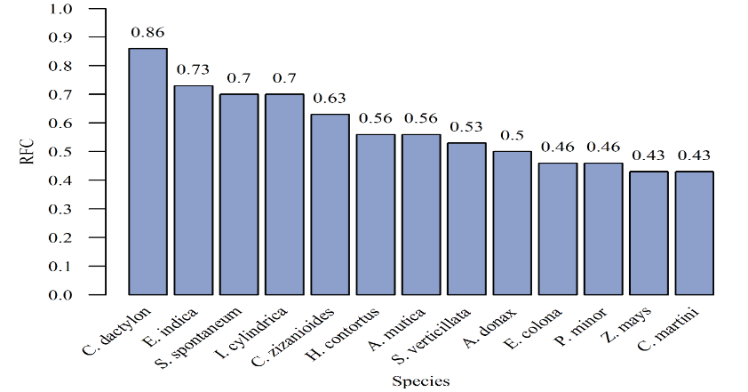

Figure 2. Illustrating High use value grass species

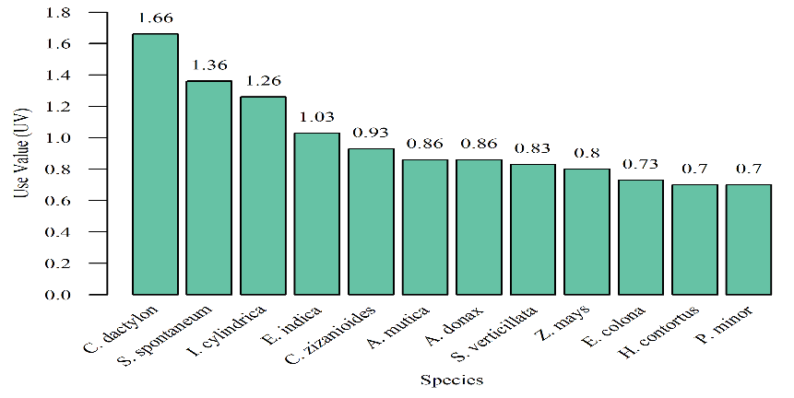

Figure 3. Showing high RFC grass taxa
Regression analysis between UV and RFC: After determining a substantial association, linear regression analysis was performed on the same secondary dataset, with UV as the dependent variable and RFC as the independent variable. The regression model had a high coefficient of determination (R² = 0.9586), indicating that RFC is a significant predictor of use value (Fig. 4).
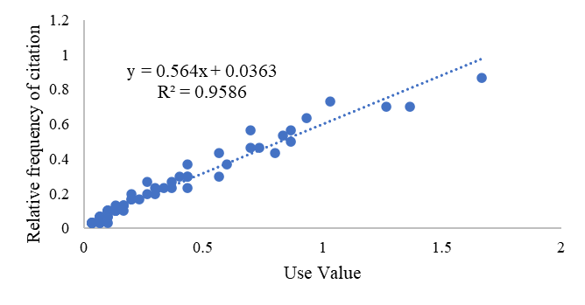
Figure 4. Demonstrating the linear relationship between Use Value (UV) and Relative Frequency of Citation (RFC) of 66 grass species were recorded in the study area. The regression line (y = 0.564x + 0.0363) has a strong positive association (R² = 0.9586), indicating that species with higher use values are cited more frequently.
Conservation status: Based on conservation assessments, the IUCN conservation status of the grass species also studied in the present investigation. Following verification from the IUCN Red List of Threatened Species, the reported grass species were classified into three global conservation categories: Least Concern, Not Evaluated, and Data Deficient.
The results indicated that maximum 62 species were found under Not evaluated category followed by 19 grass species of the Least Concern category. Besides, a single species Triticum aestivum as recorded in the Data Deficient category.
- Discussion: The current study reveals a notable diversity of grass species in the Almora region (Kumaun Himalaya) and exhibits distinct variation throughout the altitudinal gradients. Previous studies also show a diverse floristic composition in the Himalayan region (Rawat, 2005; Kandwal & Gupta, 2009; Singh & Singhal, 2025). In the present study, the grass subfamily Pooideae and the tribe Andropogoneae found abundance in the region. Their luxuriant presence was also reported (Saha et al., 2024). The species richness pattern is consistent with highest diversity at mid-altitudes and decreased diversity at both lower and higher elevations (Xu et al., 2016; Rawat et al., 2021). While the decrease at higher elevations is probably caused by harsh climatic conditions and shorter growth seasons. The lower diversity at lower altitudes affects due to greater anthropogenic disturbances (Grytnes & McCain, 2007).
The study found that grasses are essential as ecological and social purposes. Plant resources and traditional knowledge systems are closely linked, as indicated by the richness of medicinally and culturally relevant species (Sagar & Sarwar, 2018; Sumalatha et al., 2025). Among the recorded species, Cynodon dactylon showed the highest UV and RFC, demonstrating its extensive use and significant cultural significance. Similar results were observed in previous studies, where C. dactylon is acknowledged as a highly valued species because of its numerous uses in religious rituals, traditional medicine, and fodder (Sahoo & Barik, 2005; Harun et al., 2017). Additionally, the strong positive correlation between UV and RFC is in line with well-established ethnobotanical exploration, which suggests that these species are frequently cited, have greater utility and cultural significance (Phillips & Gentry, 1993).
Overall, grass diversity in the Kumaun region is determined not only by altitude and ecological factors but is also profoundly influenced by human dependence and traditional knowledge systems. This illustrates how urgently these ecologically and culturally important resources must be conserved and used sustainably.
- Conclusion: The present study exhibits the critical ecological, economic, and cultural importance of various grass species. Grasses are primarily used as livestock feed, supporting rural livelihoods, while soil-conserving species play a vital role in stabilizing fragile Himalayan slopes. Many grass species also possess therapeutic value, reflecting traditional knowledge and local health practices. Analysis of Use Value (UV) and Relative Frequency of Citation (RFC) of some species displayed their high cultural and ecological importance, as well as lesser-known species with potential uses. Grass diversity varied across the three sites, with the highest diversity at Katarmal and the lowest at Kosi region. The study exhibits the need for strengthened conservation efforts in areas like Kosi, where human pressures continue to threaten grassland diversity. Conservation efforts are essential to mitigate disturbances and preserve local biodiversity, ensuring that vital resources remain available for both ecological health and human use. In contrast, grasses in Katarmal region should be managed sustainably to maintain their ecological and socio-cultural benefits.
Disclaimer (Artificial Intelligence)
Author hereby declares that NO generative AI technologies such as Large Language Models (ChatGPT, COPILOT, etc) and text-to-image generators have been used during writing or editing of this manuscript.
Competing Interests
Authors have declared that no competing interests exist.

Table 1. An account of grass taxa recorded from different localities within the study area along with their various uses
S. N. | Grass species | Common name | Habitat | Life form | Lower altitude | Middle altitude | Higher altitude | Conservation status | Uses | UV | RFC
1. | Agrostis idahoensis Nash | Bent ghaas | Terrestrial | Perennial | - | - | + | NE | Fo, Sc | 0.06 | 0.06
2. | Apluda mutica L. | Mauritius ghaas | Chasmophyte /terrestrial | Perennial | + | + | - | NE | Fo, M, Mu, Sc | 0.86 | 0.56
3. | Arthraxon lancifolius (Trin.) Hochst. | Lance-leaved Hedgehog grass | Chasmophyte | Annual | - | - | + | NE | Fo, M | 0.16 | 0.13
4. | A. hispidus var. hispidus | Reddish Carpet grass | Terrestrial | Annual | - | + | + | NE | Fo, M | 0.1 | 0.1
5. | Arundinella bengalensis (Spreng.) Druce | Bengal Bamboo | Terrestrial | Perennial | + | + | - | NE | Fo, Sc, M | 0.16 | 0.1
6. | A. nepalensis Trin. | Nalika ghaas | Terrestrial | Perennial | - | + | + | LC (2020) | Fo, M, Mu, Sc | 0.1 | 0.06
7. | A. pumila (Hochst. ex A. Rich.) Steud. | Dwarf Reed grass | Chasmophyte/ terrestrial | Annual | - | - | + | NE | Fo | 0.03 | 0.03
8. | A. setosa Trin. | Tough Grass | Chasmophyte/ terrestrial | Perennial | + | + | + | NE | Fo, Sc, M | 0.1 | 0.03
9. | Arundo donax L. | Giant red | Terrestrial | Perennial | - | + | - | LC (2013) | Fo, M, Mu | 0.86 | 0.5
10. | Avena sativa L. | Oat | Terrestrial | Annual | - | + | - | NE | Fo, M, Fd | 0.56 | 0.3
11. | Bambusa bambos (L.) Voss | Bamboo or Baans | Terrestrial | Perennial | - | + | - | NE | M, Mu | 0.1 | 0.1
12. | Bothriochloa bladhii (Retz.) S. T. Blake | Purple plume grass | Terrestrial | Perennial | - | + | + | NE | Fo, M, Sc | 0.36 | 0.23
13. | B. pertusa (L.) A. Camus | Indian Blue Grass | Terrestrial | Perennial | - | + | - | NE | Fo, M | 0.36 | 0.26
14. | Brachypodium pinnatum (L.) P. Beauv. | Feather False Brome | Terrestrial | Perennial | - | + | + | NE | - | - | -
15. | B. sylvaticum (Huds.) | Slender false brome | Terrestrial | Perennial | - | + | - | NE | - | - | -
16. | Bromus catharticus Vahl | Catharticus Brome | Terrestrial | perennial | - | - | + | NE | Fo | 0.06 | 0.06
17. | B. marginatus Nees exSteud | Margin Brome | Terrestrial | Perennial | - | + | - | NE | - | - | -
18. | Capillipedium assimile (Steud.) A. Camus | Similar Capillipedium | Chasmophyte/ terrestrial | Perennial | - | + | - | NE | Fo, M | 0.13 | 0.1
19. | C. parviflorum (R.Br.) Stapf | Small-flowered Hair grass | Chasmophyte/ terrestrial | Perennial | - | + | + | NE | Fo, Mu | 0.13 | 0.1
20. | Cenchrus orientalis (Rich.) Morrone | Oriental Fountain Grass | Chasmophyte/ terrestrial | Perennial | - | + | - | LC (2014) | Fo | 0.06 | 0.06
21. | C. pedicellatus (Trin.) Morrone | Field Sandbur | Terrestrial | Perennial | - | - | + | LC (2017) | Fo, M | 0.2 | 0.16
22. | C. purpureus (Schumach.) Morrone | Napier ghaas | Terrestrial | Perennial | - | + | - | LC (2014) | Fo, Sc | 0.1 | 0.06
23. | Chrysopogon fulvus (Spreng.) Chiov. | Godiya ghaas | Terrestrial | Perennial | + | + | + | NE | Fo, Sc | 0.16 | 0.13
24. | C. gryllus (L.) Trin. | Cricket Wiregrass | Chasmophyte/ terrestrial | Perennial | - | - | + | NE | Fo, Sc | 0.1 | 0.06
25. | C. zizanioides (L.) Roberty | Khus grass | Terrestrial | perennial | + | - | - | NE | Fo, M, Rc, Sc, Mu | 0.93 | 0.63
26. | Cymbopogon citratus (DC.) Stapf | Lemon Grass | Terrestrial | Perennial | + | + | + | NE | M | 0.33 | 0.23
27. | C. martini (Roxb.) Will.Watson | Rosha grass | Terrestrial | Perennial | + | + | - | NE | Fo, M | 0.56 | 0.43
28. | Cynodon dactylon (L.) Pers | Doob | Terrestrial | Perennial | + | + | + | NE | Fo, M, Sc, Rc | 1.66 | 0.86
29. | Digitaria eriantha Steud | Common Finger Grass | Terrestrial | Perennial | - | + | - | NE | Fo | 0.06 | 0.06
30. | D. longiflora (Retz.) Pers. | Mosi ghaas | Terrestrial | Annual | + | + | + | NE | Fo | 0.26 | 0.26
31. | D. setigera Roth | hairy crabgrass | Terrestrial | Annual | + | + | + | NE | Fo | 0.2 | 0.2
32. | D. stewartiana Bor | Stewart's Finger Grass | Terrestrial | Annual | - | - | + | NE | - | - | -
33. | D. radicosa (J. Presl) Miq. | Timor grass | Terrestrial | Perennial | + | + | + | NE | Fo | 0.06 | 0.06
34. | Echinochloa colona (L.) Link | Jungle rice | Terrestrial | Annual | + | - | - | LC (2020) | Fo, M, Mu | 0.73 | 0.46
35. | E. frumentacea Link | Jhangora | Terrestrial | Annual | - | + | - | LC (2018) | Fo, Fd, Rc, M | 0.13 | 0.1
36. | Eleusine coracana (L.) Gaertn. | Mandua | Terrestrial | Annual | - | + | - | LC (2014) | Fd, M, Rc | 0.4 | 0.3
37. | E. indica (L.) Gaertn. | Indian  goosegrass | Chasmophyte/ terrestrial | Annual | + | + | + | LC (2011) | Fo, M, Sc, Mu | 1.03 | 0.73
38. | Eragrostiella bifaria (Vahl) Bor | Bushman grass | Terrestrial | Perennial | - | + | - | NE | Fo | 0.03 | 0.03
39. | E. brachyphylla (Stapf) Bor | Short-leaved Eragrostiella | Terrestrial | Perennial | - | + | - | NE | - | - | -
40. | E. nardoides (Trin.) Bor | Nardoid Eragrostiella | Terrestrial | Perennial | + | + | - | NE | - | - | -
41. | Eragrostis atrovirens (Desf.) Trin. ex Steud. | Black Lovegrass | Terrestrial | Perennial | - | + | - | LC (2020) | Fo | 0.1 | 0.1
42. | E. cilianensis (All.) Vignolo ex Janch. | Stink grass | Terrestrial | Perennial | - | - | + | NE | Fo, M | 0.43 | 0.36
43. | E. curvula (Schrad.) Nees | Babila ghaas | Terrestrial | Perennial | - | - | + | NE | Fo | 0.03 | 0.03
44. | E. papposa (Roem. & Schult.) Steud. | Papp's Lovegrass | Terrestrial | Perennial | - | + | + | NE | Fo | 0.03 | 0.03
45. | E. viscosa (Retz.) Trin. | Sticky Lovegrass | Terrestrial | Perennial | - | + | - | NE | Fo | 0.03 | 0.03
46. | Eulalia mollis (Griseb.) Kuntze | Soft Eulalia | Terrestrial | Perennial | - | + | + | NE | M | 0.03 | 0.03
47. | Heteropogon contortus (L.) P. Beauv. ex Roem. & Schult. | Kumeria ghaas | Chasmophyte/ terrestrial | Perennial | + | + | + | NE | Fo, M, Mu, Sc | 0.7 | 0.56
48. | Hordeum vulgare L. | Jau | Terrestrial | Annual | + | + | + | LC (2010) | Fo, Fd, M, Rc | 0.43 | 0.23
49. | Imperata cylindrica (L.) Raeusch. | Siru ghaas | Terrestrial | Perennial | - | + | - | LC (2010) | Fo, M, Mu, Rc, Sc | 1.26 | 0.7
50. | Isachne albens Trin. | White murain grass | Terrestrial | Perennial | + | + | + | NE | - | - | -
51. | Microstegium falconeri (Hook.f.) Clayton | Himalayan Browntop Grass | Chasmophyte | Annual | - | - | + | NE | - | - | -
52. | M. nudum (Trin.) A. Camus | Nude Bristlegrass | Terrestrial | Perennial | - | - | + | NE | - | - | -
53. | Mnesithea laevis (Retz.) Kunth | Smooth Mnesithea | Terrestrial | Perennial | + | + | - | NE | Fo, M | 0.1 | 0.1
54. | Miscanthus sinensis Andersson | Eulalia grass | Terrestrial | Perennial | - | - | + | NE | Sc | 0.03 | 0.03
55. | Muhlenbergia himalayensis Hack. ex Hook.f. | Himalayan Muhly | Terrestrial | Perennial | - | - | + | NE | - | - | -
56. | Megathyrsus maximus (Jacq.) B.K. Simon & S.W.L. Jacobs | Guinea grass | Terrestrial | Perennial | - | + | - | NE | Fo, M | 0.23 | 0.16
57. | Neyraudia arundinacea (L.) Henrard | Burma reed | Terrestrial | Perennial | - | + | - | NE | Mu, Sc | 0.06 | 0.03
58. | Oplismenus compositus (L.) P. Beauv. | Running Mountain Grass | Terrestrial | Perennial | - | + | + | LC (2021) | Fo, M, Sc | 0.3 | 0.23
59. | Paspalum distichum L. | Knotgrass | Terrestrial | Perennial | + | + | - | LC (2015) | Fo | 0.03 | 0.03
60. | P. dilatatum Poir. | Dallis grass | Terrestrial | Perennial | - | + | - | NE | Fo | 0.13 | 0.13
61. | Perotis indica (L.) Kuntze | Indian Comet Grass | Terrestrial | Annual | - | + | - | NE | Fo, M | 0.16 | 0.13
62. | Phacelurus speciosus (Steud.) C.E. Hubb. | Showy Muraina Grass | Terrestrial | Perennial | - | - | + | NE | - | - | -
63. | Phalaris minor Retz. | Minor Canary Grass | Terrestrial | Annual | - | + | - | NE | Fo, M | 0.7 | 0.46
64. | Poa annua L. | Annual bluegrass | Chasmophyte/ terrestrial | Annual | - | - | + | LC (2013) | Fo, M | 0.43 | 0.3
65. | P. infirma Kunth. | Weak Bluegrass | Chasmophyte/ terrestrial | Annual | - | - | + | NE | Fo | 0.06 | 0.06
66. | Sacciolepis indica (L.) Chase | Indian maiden grass | Terrestrial | Annual | - | + | - | LC (2020) | Fo, M | 0.2 | 0.16
67. | Saccharum spontaneum L. | Kusa ghaas | Terrestrial | Perennial | + | + | + | LC (2020) | Fo, M, Mu, Sc | 1.36 | 0.7
68. | Sehima notata (Hack.) A. Camus | Notched Grass | Terrestrial | Perennial | + | - | - | NE | - | - | -
69. | Setaria homonyma (Steud.) Chiov. | Homonyma Foxtail | Terrestrial | Annual | - | + | - | NE | - | - | -
70. | S. pumila (Poir.) Roem. & Schult | Yellow Foxtail | Chasmophyte/ terrestrial | Annual | + | + | + | NE | Fo, M | 0.3 | 0.2
71. | S. verticillata (L.) P. Beauv | Hooked bristle grass | Chasmophyte/ terrestrial | Annual | - | + | - | NE | Fo, M, Mu | 0.83 | 0.53
72. | Sporobolus coromandelianus (Retz.) Kunth | Giant drop seed | Terrestrial | perennial | - | - | + | NE | Fo | 0.1 | 0.1
73. | S. diandrus (Retz.) P. Beauv. | Indian Dropseed | Terrestrial | Perennial | + | + | + | NE | Fo, M, Mu | 0.26 | 0.2
74. | S. piliferus (Trin.) Kunth | Hance's Dropseed | Terrestrial | Perennial | - | + | + | NE | Fo | 0.03 | 0.03
75. | S. indicus (L.) R.Br. | Smut grass | Terrestrial | Perennial | - | + | + | LC (2021) | Fo, M | 0.43 | 0.3
76. | Themeda anathera (Nees ex Steud.) Hack. | Loonder Grass | Terrestrial | Perennial | + | + | + | NE | Fo | 0.03 | 0.03
77. | Tripidium rufipilum (Steud.) Welker, Voronts. & E.A. Kellogg | Red-haired Tripidium | Chasmophyte/ terrestrial | Perennial | - | - | + | NE | - | - | -
78. | Tripogon filiformis Nees ex Steud. | Thread Grass | Chasmophyte/ terrestrial | Perennial | - | + | + | NE | Fo, Sc | 0.06 | 0.03
79. | T. trifidus Munroe Stapf. | Three-lobed Bristlegrass | Chasmophyte | Perennial | - | + | - | NE | - | - | -
80. | Triticum aestivum L. | Gehoon | Terrestrial | Annual | + | + | + | DD (2017) | Fo, Fd, Rc, M | 0.6 | 0.36
81. | Urochloa villosa (Lam.) T.Q. Nguyen | Para ghaas | Terrestrial | Annual | + | + | + | NE | - | - | -
82. | Zea mays L. | Makka | Terrestrial | Annual | + | + | + | LC (2017) | Fo, Fd, M, Rc | 0.8 | 0.43
Abbreviations: Fo=fodder; M=medicine; Rc=religious ceremony; Sc= soil conservation; Fd=food, LC= least concerned; NE = not evaluated; DD= data deficient; UV= use value; RFC= relative frequency of citation; + (present); -(absent).
References
Blatter, E., and McCann, C. (1935). The Bombay grasses.
Bor, N. L. (1960). The Grasses of Burma, Ceylon, India and Pakistan. Pergamon Press.
Grytnes, J. A., and McCain, C. M. (2007). Elevational trends in biodiversity. Encyclopedia of biodiversity, 2, 1-8.
Harun, N., Chaudhry, A. S., Shaheen, S., Ullah, K., and Khan, F. (2017). Ethnobotanical studies of fodder grass resources for ruminant animals, based on the traditional knowledge of indigenous communities in Central Punjab Pakistan. Journal of Ethnobiology and Ethnomedicine, 13(1), 56.
Hussain, M., Khan, S. M., Abd_Allah, E. F., Ul Haq, Z., Alshahrani, T. S., Alqarawi, A. A., and Ahmad, H. (2019). Assessment of plant communities and identification of indicator species of an Ecotonal Forest zone at Durand Line, District Kurram, Pakistan. Applied Ecology & Environmental Research, 17(3).
Kabeer, K. A. A. and Nair, V. J. (2009). Flora of Tamil Nadu – Grasses. Botanical Survey of India, Kolkata.
Kandwal, M. K., Gupta, B. K. (2009). An update on grass flora of Uttarakhand. Indian Journal of Forestry, 32(4), 657-668.
Kellogg, E. A., Abbott, J. R., Bawa, K. S., Gandhi, K. N., Kailash, B. R., Ganeshaiah, K. N., and Raven, P. (2020). Checklist of the grasses of India. PhytoKeys, 163, 1-560.
Maikhuri, R. K., Nautiyal, S., Rao, K. S., and Semwal, R. L. (2000). Indigenous knowledge of medicinal plants and wild edibles among three tribal sub communities of the central Himalayas, India. Indigenous Knowledge and Development Monitor, 8(2), 7-13.
Phillips, O., and Gentry, A. H. (1993). The useful plants of Tambopata, Peru: I. Statistical hypotheses tests with a new quantitative technique. Economic Botany, 47(1), 15-32.
Rao, R. R., and Sharma, B. D. (1990). A manual for herbarium collections. Botanical Survey of India.
Rawat, D. S., Bagri, A. S., Parveen, M., Nautiyal, M., Tiwari, P., and Tiwari, J. K. (2021). Pattern of species richness and floristic spectrum along the elevation gradient: A case study from western Himalaya, India. Acta Ecologica Sinica, 41(6), 545-551.
Rawat, G.S. (2005). Alpine Grass cover of Uttarakhand. Alpine Meadows of Uttaranchal. Ecology, Land use and Status of Medicinal and Aromatic Plants. Bishen Singh Mahendra Pal Singh.
Ray, S., and Sainkhediya, J. (2012). Diversity of grasses in Nimar region, Madhya Pradesh. Indian Journal of Plant Science, 1, 144-152.
Sagar, A., and Sarwar, A. G. (2018). Weed diversity of the family Poaceae in Bangladesh Agricultural University campus and their ethnobotanical uses: Poaceae grasses in BAU and their uses. Journal of the Bangladesh Agricultural University, 16(3), 372-379.
Saha, K., Chandran, M., Bisht, A. S., Parvin, N., and Negi, R. (2024). Evaluating Grass Diversity and Conservation Approaches in Binsar WLS, Kumaun Himalaya, India. Indian Journal of Pure and Applied Biosciences, 12(5), 20-27.
Sahoo, A. K., and Barik, K. L. (2025). Sustainable use of local fodder grasses: a case study from Mayurbhanj district of Odisha. Ethnobotany Research and Applications, 31, 1-36.
Samant, S. S., and Dhar, U. (1998). Palni LMS Medicinal Plants of Indian Himalaya: Diversity Distribution Potential Values. Almora: GB Pant Institute of Himalayan Environment and Development.
Siddabathula, N., and Prasanna, P., 2023. Grasses of Telangana. Botanical Survey of India.
Singh, J and Singhal, V.K. (2025). Grasses and Sedges of India: Diversity, Ethnobotany and Ethnopharmacological Aspects. Pp. 01-66.
Sinha, B. K., Dash, S. S., and Singh, P. (2019). Plants of Indian Himalayan Region: an annotated checklist and pictorial guide. Botanical Survey of India.
Soreng, R.J., Peterson, P.M., Zuloaga, F.O., Romaschenko, K., Clark, L.G., Teisher, J.K., Gillespie, L.J., Barberá, P., Welker, C.A., Kellogg, E.A. and Li, D.Z. (2022)a. A worldwide phylogenetic classification of the Poaceae (Gramineae) III: An update. Journal of Systematics and Evolution, 60(3), 476-521.
Sumalatha, B. S., Mishra, S., and Jethy, S. (2025). Grass diversity of Siddheswar temple: ethnobotanical significance of a sacred grove. In Grasses and Sedges of India: Diversity, Ethnobotany and Ethnopharmacological Aspects. ISBN: 978-81-989192-0-5, 205-218.
Tardío, J., and Pardo-de-Santayana, M. (2008). Cultural importance indices: a comparative analysis based on the useful wild plants of Southern Cantabria (Northern Spain). Economic Botany, 62(1), 24-39.
Xu, X., Zhang, H., Tian, W., Zeng, X., and Huang, H. (2016). Altitudinal patterns of plant diversity on the Jade Dragon Snow Mountain, southwestern China. Springer Plus, 5(1), 1566.

