Original Research Article

Bibliometric Analysis of Forensic Accounting using Scopus Database

Abstract
Forensic accounting is as old as corporate irregularities. Initially, this work was handled by accountants and auditors, but as the complexities increased, a new specialized field was required to detect and control fraudulent activity. Forensic accounting is a combination of skills required to investigate financial and non-financial fraud in organizations. The present study applies bibliometric analysis (RStudio) using the Scopus database from 1969 to 2026 to examine the trends and patterns of research in the area of forensic accounting. This bibliometric analysis aims to delineate the evolutionary trajectory of academic discourse within forensic accounting, identifying key thematic shifts, prominent authors, influential publications, and collaborative networks that have shaped the field over the specified period. The results indicate a paradigm shift from traditional accounting to digital forensics. The research on forensic accounting is expanding from United States to Southeast Asia. The findings also reveal that internal control plays a dominant role to combat financial crimes.

Key Words: Corporate irregularities, Fraudulent activities, Financial and non-financial fraud, RStudio, digital forensics.

1. Introduction
Forensic accounting is a specialized field that combines accounting, auditing, and investigative skills to uncover financial fraud and irregularities. It has gained increasing prominence in recent years due to heightened regulatory scrutiny and the growing complexity of financial transactions(Lakshmi & Menon, 2016; Mazumder, 2011). Every organization audits its financial reports, but sometimes, even after due care, audit reports reveal some red flags. Here, the role of forensic accountant comes to investigate the activities using analytical methodologies to identify whether these constitute mistakes or fraudulent acts. Forensic accountants are appointed when authorities identify suspicious activity(Friedrich, 2021). Forensic accounting's goal is to detect fraud, gather evidence, and provide advice on fraud prevention(Afriyie et al., 2022; Enofe et al., 2013). The demand for forensic accounting has surged due to corporate scandals and economic crimes that erode public trust and inflict substantial financial losses on companies(Jain & Lamba, 2020; Dearden, 2015). The integration of forensic accounting techniques into conventional auditing practices offers preventive measures against corporate failures and helps mitigate financial leakages(Rehman & Hashim, 2018). This proactive strategy ensures the stability and long-term sustainability of businesses by identifying and addressing vulnerabilities before they escalate into major issues(Imoniana & Silva, 2013). Forensic accountants play a crucial role in litigation support services, offering expert testimony and analysis to assist in legal proceedings(Akyel, 2012; Oyedokun, 2013). Moreover, their expertise is vital in investigative accounting, where they employ advanced analytical techniques to trace illicit financial flows, identify hidden assets, and provide comprehensive reports that support legal and regulatory actions(Bhasin, 2013; Mert, 2022). The rise in financial crimes across both the private and public sectors has propelled forensic accounting into the spotlight, highlighting its critical role in maintaining financial integrity and accountability(Dada & Jimoh, 2020; Abiola & Adisa, 2020). The increasing complexity of global financial transactions and the rise in fraud cases across sectors have heightened the importance of forensic accounting in ensuring the transparency and accountability of financial statements(Munandar & Honggowati, 2025). Forensic accounting involves applying accounting knowledge and legal skills to resolve issues in a court of law(Kiflee et al., 2022). It includes not only unearthing fraud but also documenting it with all supporting documents(Simeunović et al., 2016). The forensic accountant must collect the necessary documents to support or refute a claim, review related documents to conduct a preliminary examination of the case and identify weaknesses, assist with the interrogation of witnesses, and formulate questions regarding financial matters(Enofe et al., 2013). A study found that 39% of organizations had identified the need for a forensic accountant(Polycarp, 2019). Forensic accounting plays a pivotal role in today's financial environment by aiding in the detection, prevention, and investigation of financial crimes(Ellili et al., 2024). It is essential to strengthen forensic accounting institutions and increase the use of their services in the public sectors of developing nations to combat financial crime effectively(Kasum, 2009).
Forensic accountants are increasingly vital in today's business environment, tasked with preventing and uncovering fraud, identifying occupational and financial statement fraud, and providing support in legal matters. Forensic accountants can serve in a variety of roles, including the prevention and detection of civil and criminal fraud, measuring economic damages in litigation, valuing business or intangible assets, and testifying as an expert in courts of law(Crain et al., 2017). The application of big data techniques and psychological intuition has further enhanced the accuracy of fraud detection, enabling forensic accountants to identify and prevent technology-based fraud, such as money laundering, financial statement manipulation, and cybercrime(Munandar & Honggowati, 2025). As sophisticated technology becomes more readily available and financial transactions become more complex, the need for forensic accountants is expected to continue rising, underscoring their vital role in protecting financial systems(Daraojimba et al., 2023). The role of forensic accounting is also associated with local government, experiential learning, and the balanced scorecard. Furthermore, the forensic accountant is an expert witness and is legally bound by the current litigation system(Kiflee et al., 2022). The skills required of forensic accountants extend beyond traditional accounting expertise, encompassing critical thinking, deductive analysis, problem-solving, analytical proficiency, investigative flexibility, and effective communication.
These specialized skills enable them to navigate complex financial landscapes, uncover unauthorized financial practices, and provide admissible evidence in legal proceedings. These professionals are instrumental in deciphering intricate financial data, often leveraging advanced analytical tools and a deep understanding of financial regulations to expose illicit activities(Hossain et al., 2024). The increasing sophistication of financial crimes, often facilitated by technological advancements, necessitates that forensic accountants continually update their skills, particularly in areas such as data analytics and artificial intelligence. The integration of artificial intelligence into forensic accounting marks a significant advancement, enabling the analysis of large datasets to identify anomalies and fraudulent patterns that may elude conventional auditing methods(AL-RAGGAD & Al-Raggad, 2024). This technological integration enables more efficient and accurate detection of financial misconduct, thereby enhancing the overall efficacy of fraud-detection mechanisms(Đukić et al., 2023). This continuous evolution necessitates a dynamic approach to the field, where practitioners must remain abreast of both technological advancements and the shifting landscape of financial malfeasance. The demand for ongoing adaptation stems from the insufficiency of professional accountancy training alone to address control deficiencies and the escalating risk of fraudulent activities, particularly when acting as an expert witness in legal contexts(Oyedokun, 2013). This insufficiency underscores the imperative for continuous professional development and specialized education, enabling forensic accountants to effectively counteract the evolving tactics of financial perpetrators(Ozili, 2015). Moreover, the need for accounting experts in litigation has become crucial, particularly in regions such as the United States and Canada, where new litigation requirements emphasize the importance of objective, sound expert opinions from forensic accountants(Kiflee et al., 2022). This necessitates robust educational frameworks and professional bodies to regulate the standards of practice and ethical codes, ensuring forensic accountants are well-prepared to detect and prevent fraud. The burgeoning field of forensic accounting research reflects a growing academic interest in addressing complex financial crimes, thus necessitating comprehensive bibliometric analyses to map its evolving landscape and identify research gaps(Ellili et al., 2024). These analyses provide a quantitative assessment of scholarly literature, revealing publication trends, key authors, influential institutions, and prominent research themes, which is essential for understanding the developmental trajectory of forensic accounting as a discipline(Munandar & Honggowati, 2025). This approach enables a comprehensive mapping of disciplinary growth, identifying interdisciplinary connections and emerging areas, such as the application of administrative law in digital forensic contexts(AL-RAGGAD & Al-Raggad, 2024). Specifically, bibliometric studies on forensic accounting often use software RStudio (Biblioshiny) to visualize keyword co-occurrences, authorship networks, and journal citations, thereby revealing dominant research themes and the evolution of sub-fields(Kurniawan et al., 2025). Such analyses are critical for academics and practitioners alike, offering insights into established research fronts and highlighting under-served areas requiring further investigation, such as the ontological distinction between fraud risk and actual fraud events.
The relevance of forensic accounting and fraud detection is increasing. To this end, it is necessary to raise awareness among organizations. Much research has been conducted in this field, and it continues to be expanded. The trend in forensic accounting publications is one parameter by which a researcher can identify research areas and gaps. Similarly, the relevance and key topics of the publications can assist stakeholders and policymakers in framing strategies to prevent and detect fraudulent activities. The research objectives of the study are:
1) To analyze the rise in interest in the field of forensic accounting from 1969 to 2026.
2) To identify the leading authors, affiliations, and countries contributing to forensic accounting research.
3) To determine the dominant areas of forensic accounting.
4) To map the conceptual structure and intellectual landscape of forensic accounting through co-occurrence and co-citation analyses.
5) To identify the trends in the forensic accounting discipline.

2. Review of Literature
A review of the literature helps identify existing gaps and provides a basis for further inquiry. The traditional accounting system is unable to protect the public’s interest due to loopholes in the legal system and insufficient internal controls; therefore, there is an urgent need for regulatory reforms(Affès & Sardouk, 2016; Campa et al., 2023; Free, 2015; Kumar, 2025; Macc & Al-Adeem, 2022; Sari & Muslim, 2023; Vorster & Nwosu, 2024). Organizations need to identify whistle-blowers and the motive behind the fraud to protect themselves from retaliation. Some studies identify the essential skills of forensic accountants, such as problem-solving, distinctive thought processes, investigative methods, and experience(Prabowo, 2013). Studies have explained forensic accountants' working skills and personal attributes. Forensic accounting and corporate investigation navigate situations of misconduct while maintaining a balance between professional objectivity and commercial interests(Bhasin, 2013; Mert, 2022; Popoola et al., 2014; Rashid, 2023; Suleiman & Ahmi, 2018; Tapanjeh & AlTarawneh, 2020; Williams, 2006; Winfield & Roberts, 2023). The primary drivers of fraudulent activity are inadequate corporate governance and poor organizational culture, which can severely affect an organization, resulting in financial strain and social pressure. Therefore, the use of forensic accounting services can help detect and curb fraudulent activities such as account falsification and cash theft(Enofe et al., 2013). These services also encompass legal support, providing expertise in judicial proceedings and contributing to a more transparent and accountable financial system(Agboare, 2021; Airout et al., 2024; Alshira’h & Lutfi, 2023; Alshurafat et al., 2021; Anghel & Poenaru, 2023; Denhere, 2023; Ellili et al., 2024; Mittal et al., 2021; Munandar & Honggowati, 2025; Oyedokun, 2022; Tapanjeh & AlTarawneh, 2020). There are many forensic accounting theory for practitioners and academicians that elucidates techniques for detecting fraud in financial statements and assists in accounting and non-accounting decision-making. The major factors that influence the number of fraud cases are governance, global competitiveness, and institutional determinants(Gaffaroglu & Alp, 2024; Hanifah, 2024; Máté et al., 2019; Nawawi & Salin, 2018; Roshanpoor et al., 2024; Sadaf et al., 2018; Shanikat & Aldabbas, 2025). Fraud is a threat to a country's economic development. The major corporate frauds, such as Enron's, leading to shareholders experiencing $74 billion in losses and to bankruptcy; these frauds, often referred to as 'Crimes in numbers' and 'Crimes in amount,' causing significant financial damage and economic losses(Kulmie et al., 2023). Therefore, there is a critical need to integrate technology and digital data analysis into forensic accounting education to address the growing complexity of financial crimes in information technology environments(Pearson & Singleton, 2008). Analytical techniques, such as Benford’s Law and digital-based tests, can be used to identify anomalies and fraudulent patterns in large datasets. Continuous monitoring programs can detect financial errors, behavioral changes, and potential tax evasion. Emerging technologies, such as data mining, electronic confirmations, neurocriminology, and advanced handwriting analysis techniques, can help combat sophisticated financial crimes. The fraud triangle framework is also a superior and effective measure for assessing asset misappropriation risks for both accounting and non-accounting majors.

3. Research Methodology
The present study employs a comprehensive bibliometric analysis using articles from the Scopus database, covering the period from 1969 to 2026, to systematically map the intellectual structure and evolution of forensic accounting research. Bibliometric analysis is a quantitative technique for examining publication trends,, influential authors, prominent institutions, key topics, and leading journals(Kumar, 2025). The method offers a robust framework for identifying knowledge gaps and future research directions(Afriyie et al., 2022). The Scopus database was used as the primary platform, as it provides comprehensive coverage of peer-reviewed literature, ensuring a broad and representative sample of global research in forensic accounting(Shahana et al., 2023). The search for research papers used the string: TITLE-ABS-KEY ( "Forensic Accounting" OR "Forensic Audit" OR "investigation accounting" OR "financial statement fraud" ) AND ( LIMIT-TO ( SUBJAREA , "COMP" ) OR LIMIT-TO ( SUBJAREA , "SOCI" ) OR LIMIT-TO ( SUBJAREA , "ECON" ) OR LIMIT-TO ( SUBJAREA , "BUSI" ) ) AND ( LIMIT-TO ( DOCTYPE , "ar" ) OR LIMIT-TO ( DOCTYPE , "cp" ) OR LIMIT-TO ( DOCTYPE , "ch" ) OR LIMIT-TO ( DOCTYPE , "re" ) ) AND ( LIMIT-TO ( PUBSTAGE , "final" ) ) AND ( LIMIT-TO ( SRCTYPE , "j" ) OR LIMIT-TO ( SRCTYPE , "p" ) OR LIMIT-TO ( SRCTYPE , "k" ) ) AND ( LIMIT-TO ( LANGUAGE , "English" ) ) AND ( LIMIT-TO ( OA , "all" ) ). The data were exported using inclusion and exclusion criteria, including only published articles in English and open-access sources. Finally, 770 articles were exported and stored in CSV format to use in RStudio (Biblioshiny) across all streams to identify trends and patterns in forensic accounting, considering single authors, international co-authors, keywords, and average citations per document. The data were collected on 7 March 2026.

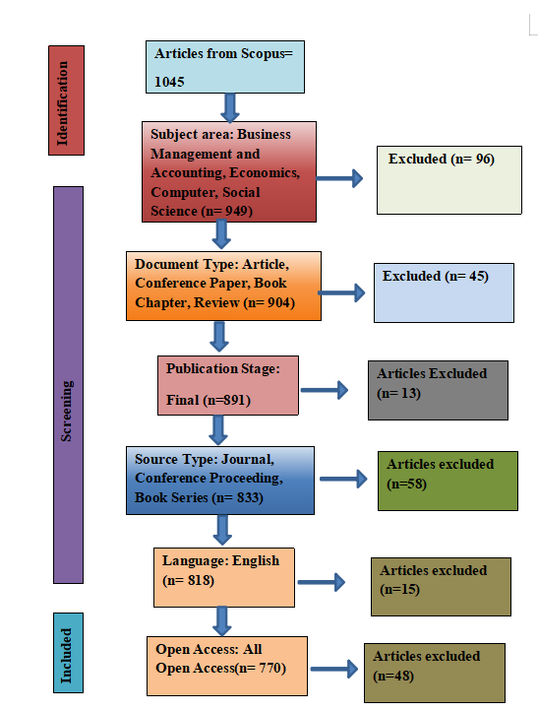

Figure 1: PRISMA Model for screening of Scopus dataset
Source: Researchers own based on Scopus database

The process began with a comprehensive search in the Scopus database, yielding 1,045 documents. Scopus was selected for its extensive coverage of high-impact accounting and auditing journals. The figure outlines five filtering stages designed to remove irrelevant or low-quality data:
- Subject Area (n=949): Excluding 96 documents narrowed the scope to relevant fields such as Business, Management, Accounting, Economics, Computer Science and Social Science. This approach maintains focus on the "interdisciplinary intersection" of financial investigation and technology.
- Document Type (n=904): Excluding 45 documents allowed focus on Articles, Conference Papers, Book Chapters, and Reviews. This step prioritizes peer-reviewed research over editorials or notes, ensuring the "intellectual rigor" of the findings.
- Publication Stage & Source (n=833): Excluding 13 "Articles in Press" and 58 non-standard sources ensures the data reflects finalized, published research from reputable journals and proceedings.
- Language (n=818): Restricting the analysis to English is a common bibliometric pra-Language. Limiting the analysis to English is a standard bibliometric practice to maintain a "unified linguistic baseline" for keyword co-occurrence and thematic mapping.
- Interpretation: This choice is significant. While it reduced the dataset from 818 to 770, it narrows the study to research highly accessible to the global academic community.
- Data Integrity: A sample size of 770 is considered "highly representative and statistically robust" for a bibliometric study, providing sufficient data points to generate complex networks in Biblioshiny.
The figure 1 demonstrates methodological transparency. It shows that the results are not a random collection of papers but a "curated dataset" refined for quality with 770 documents, placing the study in a strong position compared to other bibliometric works in this field, which often range from 400 to 1,000 documents.

4.1 Results and Discussions
Figure 2 describes the dataset collected from Scopus for the period 1969–2026. The dataset comprises 770 documents, 436 sources, and 1,749 authors.
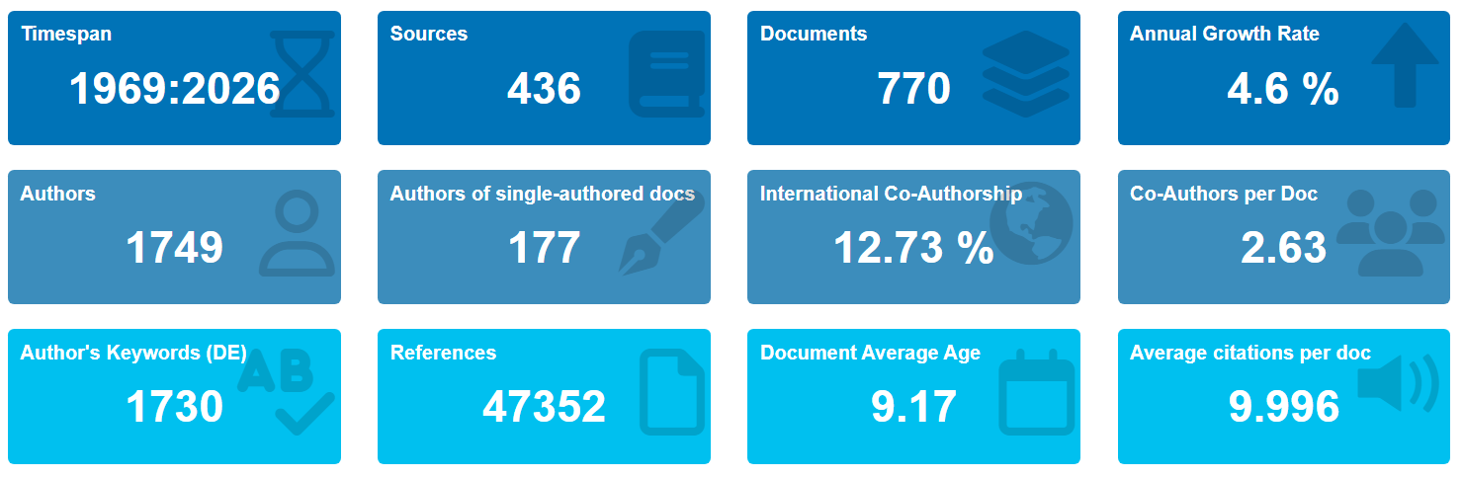
Figure 2: Description of data
Source: Processed Scopus data from RStudio

4.1.1 Publication Trend
The analysis of publication trends reveals a dynamic evolution in forensic accounting, reflecting the increased academic interest and diversification of research over time. The line chart shows the number of documents by year. The annual number of documents (y‑axis) over publication year (x‑axis, 1969–2026) is minimal until the mid‑1990s, then gradually increases, rising sharply after 2015, peaking near 2025. This growth underscores the field's increasing relevance for addressing financial complexities and fraud detection across various economic sectors(Munandar & Honggowati, 2025).
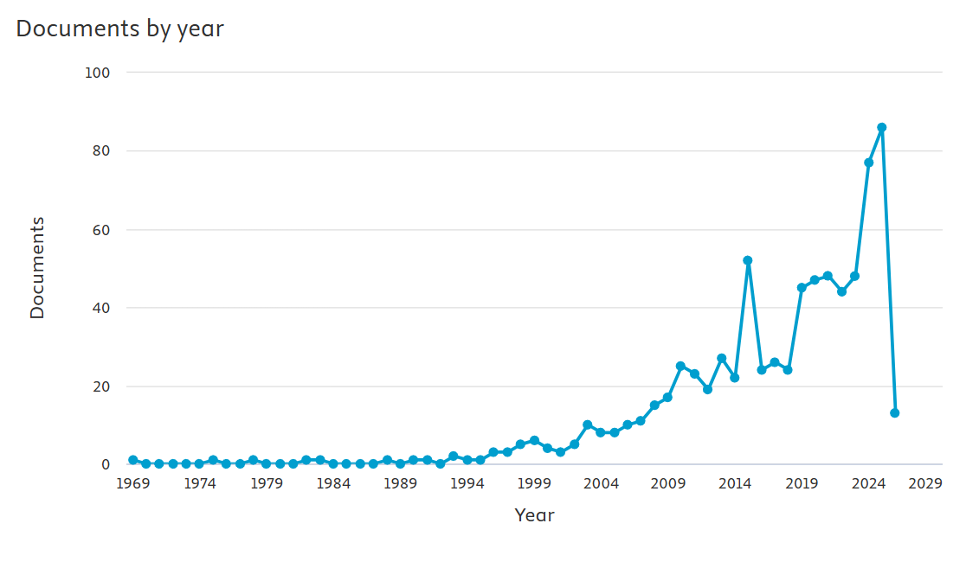
Figure 3: Documents published over the years
Source: Processed Scopus data from RStudio.

4.1.2 Documents by Subject Area and Type
Further examination of document distribution by subject area reveals the multidisciplinary nature of forensic accounting, highlighting its intersections with various academic disciplines and practical applications.
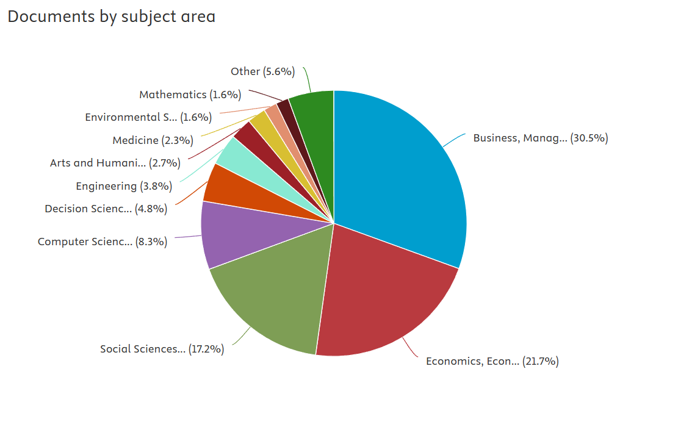
Figure 4: Documents by Subject Area
Source: Processed Scopus data

Figure 4 reflects the share of retrieved documents from the Scopus database. Business, Management, and Accounting accounts for the highest percentage of publications (30.5%), followed by Economics and Econometrics at 21.7%. Social Sciences contribute 15.3% to research, and Computer Science contributes 8.3%.
This interdisciplinary engagement highlights the expanding scope of forensic accounting beyond traditional financial audits, integrating computational methods and behavioral sciences to address complex financial crimes(Ramadhan et al., 2025). The increasing contributions of computer science and the social sciences further indicate a shift towards technologically driven forensic methodologies and an understanding of human behavioral aspects contributing to financial malfeasance(Al-Raggad et al., 2025; Grosu et al., 2022). This multidisciplinary integration is critical for developing robust frameworks for fraud prevention and investigation, especially given the emergence of advanced technologies such as data analytics and cyber forensic accounting(Haddad et al., 2024). Such advancements necessitate a collaborative research paradigm between auditing professionals and computer scientists to effectively leverage digital forensic technologies within investigative frameworks(Ramadhan et al., 2025).

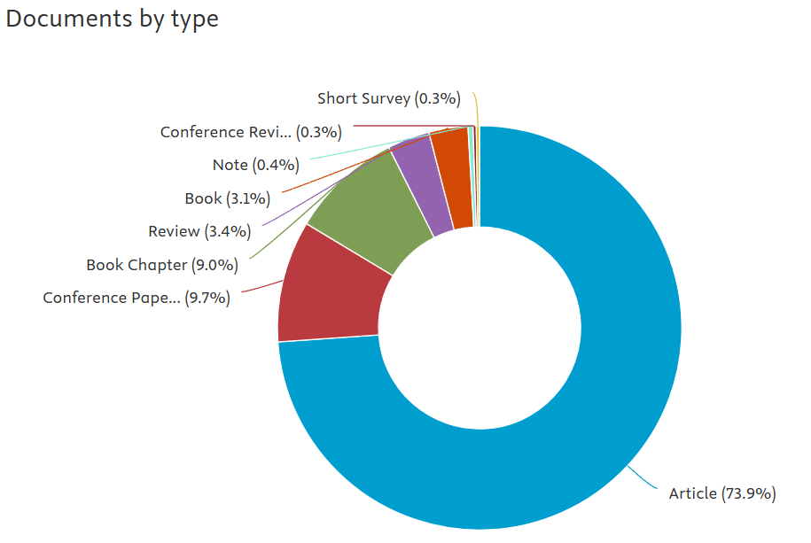
Figure 5: Documents by Type
Source: Processed Scopus data

Figure 5 shows that articles are the primary format for disseminating research in forensic accounting, comprising 73.9% of the total documents. Conference papers and book chapters are 9.7% and 9.0%, respectively. The high percentage of articles indicates that forensic accounting is gaining global academic attention(Airout et al., 2024; Kumar et al., 2025). Moreover, other publication types, such as conference papers, book chapters, and reviews, reflect the multidisciplinary growth of forensic accounting(Kiflee et al., 2022; Munandar & Honggowati, 2025).
As Figure 4 indicates, forensic accounting intersects with other disciplines such as economics and econometrics, the social sciences, and computer science, which is significant for such investigations, as investigators require a diverse set of skills, including analytical and critical thinking, as well as digital forensic skills, to detect fraudulent activity(Akkeren et al., 2013).

4.1.3 Documents Per Year by Source
The line graph in Figure 6 indicates the number of documents per year (y‑axis) for the top five journals, i.e., Journal of Financial Crime, Issues in Accounting Education, Auditing, Journal of the International Academy for Case Studies, and Managerial Auditing Journal, from 1994 to 2026. The Journal of Financial Crime (Blue line) appears to have a spike in publication in 2022, reaching a peak of 6 documents. Similarly, journals such as Issues in Accounting Education (maroon line) and Journal of the International Academy (purple line) showed significant increases in 2011 and 2015, respectively, reaching 6 documents each. This suggests that these journals provide a foundational base for next-generation academics.
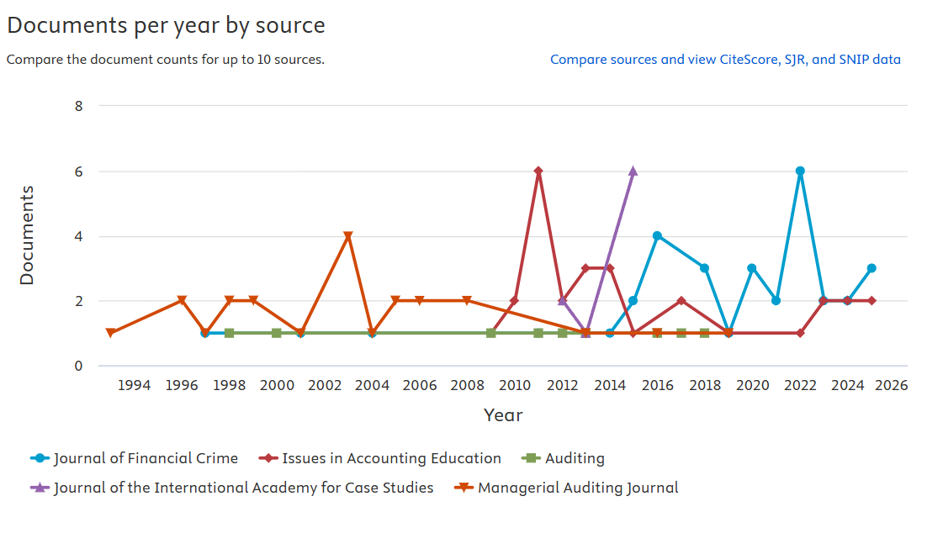
Figure 6: Documents per year by source
Source: Processed Scopus data
The patterns in Figure 6 reflect the paradigm shift in the discipline of forensic accounting. The rising number of publications in the Journal of Financial Crime in recent years indicates that global professionals and academics are focusing on more complex economic crimes, such as embezzlement and financial statement fraud(Afriyie et al., 2022; Zenzerović & Šajrih, 2023). The variety of journals in forensic accounting, including those from social science, computer science, and economics, signals that forensic accounting is not only a core pillar of auditing but has become an interdisciplinary field in the modern business environment(Rehman & Hashim, 2018).

4.1.4 Documents by Country
The bar chart in Figure 7 shows the top countries contributing to global productivity in forensic accounting research. As the bar chart indicates, the United States and Indonesia show a strong presence with 221 and 110 published documents, respectively.
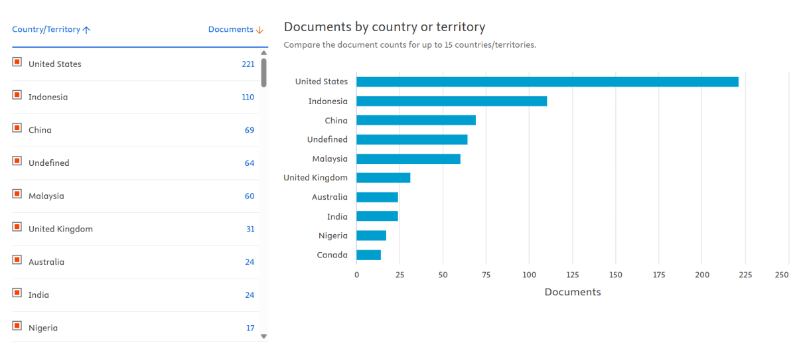
Figure 7: Documents by Country
Source: Processed Scopus data

The United States' dominance as an intellectual leader in document contributions can be traced back to the US Treasury's innovative investigative techniques(Grosu et al., 2022; Saha et al., 2024). Moreover, the US also provides a base for research by academicians and professionals through developed financial markets and legislative frameworks such as the Sarbanes-Oxley Act(Ajayi-Nifise et al., 2024) The high rankings of Indonesia and Malaysia reflect a strong push by their governments to integrate forensic accounting into university curricula to prepare the next generation of accountants and to strengthen corporate governance and internal control to prevent fraud. However, the contributions of emerging economies like China, India, and Nigeria are expanding the field's boundaries by promoting financial transparency, protecting stakeholders' interests, and reducing digital crime(John-Oti, 2025).

4.1.5 Three-Field Plot
Figure 7 illustrates a Three Field Plot, also known as a Sankey Diagram. The plot shows the intellectual connections among three key elements: Cited References (CR) on the left, authors (AU) in the middle, and Authors' Keywords (DE) on the right. The thickest line indicates the strongest relationship. The cited references and Authors on the left side give an intellectual foundation to modern research, as research by Jensen M.C. and Kranacher M.J. is cited by most active authors, Nawawi A., and Salin A.S.A.P. Jensen and Kranacher’s research is centered on corporate governance and the fraud triangle theories, so it can be inferred that academics and professionals are focusing on corporate governance and the fraud triangle to reduce financial irregularities in organizations(Solikhah & Cahyaningtyas, 2024).
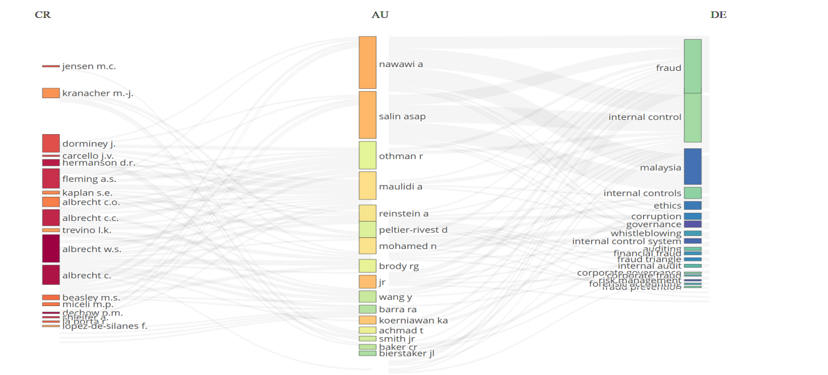
Figure 8: Three Field Plot
Source: Processed Scopus data with R Studio

The middle column of most prominent authors, such as Nawawi A., Salin A.S.A.P., and Othman R., acts as a knowledge bridge between the traditional forensic accounting approach and the modern approach. The right corner shows the core research themes of the top authors. The keywords “Fraud” and “Internal Control” have the largest nodes, suggesting they are prominent themes. The other emerging areas include “Whistleblowing”, “Corruption”, “Governance”, and “Fraud Triangle”. The country of Malaysia is also prominent among the keywords, which shows the authors’ geographical concentration of research.

4.1.6 Most Relevant Sources
The chart below represents the most relevant sources of publications. The Journal of Financial Crime (33) has the highest contribution because its core purpose is to investigate fraudulent transactions to detect and prevent legal violations.
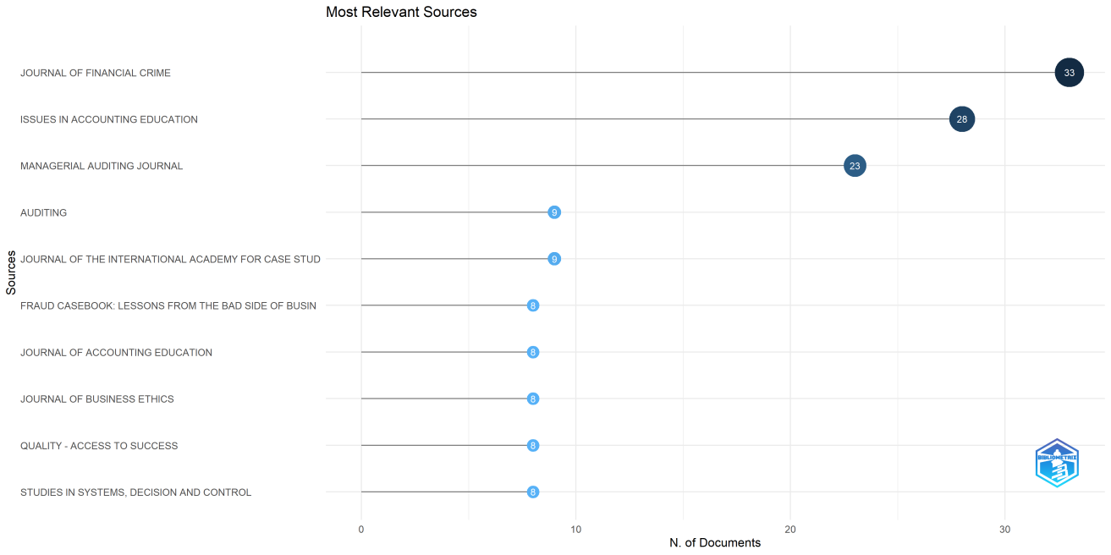
Figure 9: Most Relevant Source
Source: Processed Scopus data with R Studio

The contribution of journals like Issues in Accounting Education ranks second, with 28 documents, focusing on paradigms in the literature. The Managerial Auditing Journal represents the proactive contribution (23), which focuses on internal controls and auditing standards(Kumar et al., 2021). The inclusion of reputable journals, i.e., Auditing, the Journal of Accounting Education, and the Journal of Business Ethics, indicates the broader scope of the research(Panigrahi et al., 2024).

4.1.7 Bradford’s Law
Figure 10 represents the core sources according to Bradford’s Law. Bradford’s Law is used to identify the core sources of documents for high-impact literature. As the chart shows, the field of forensic accounting is growing globally. The Journal of Financial Crime is the primary source for approximately 33 articles, followed by Issues in Accounting Education, with approximately 28 articles.
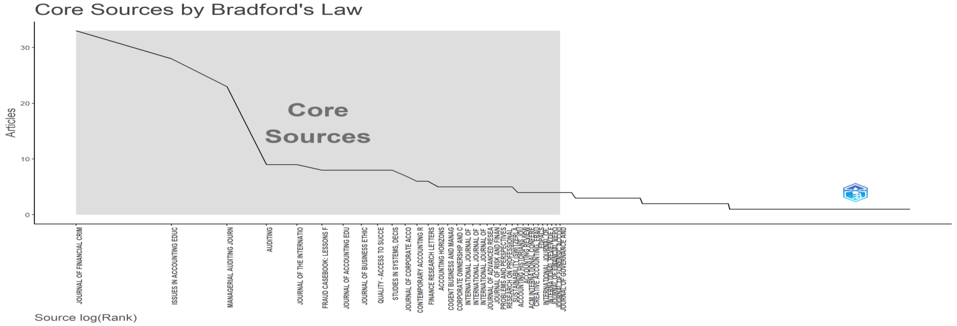
Figure 10: Bradford’s Law
Source: Processed Scopus data with R Studio
In the chart, it is clear that a few core journals account for the majority of the discourse on forensic accounting. Additionally, the chart’s long tail on the right indicates that many journals contribute only one to two articles, but the scope of forensic accounting extends beyond its specialized fields, i.e., Accounting and Finance.

4.1.8 Source Local Impact
Table 1 indicates the top 10 journals' local impact based on productivity and influence. The Journal of Financial Crime has the highest publication count. H-Index and G-Index are critical metrics that measure the quantity and citation impact of publications(Nash-Stewart et al., 2012; Patra et al., 2006). The higher the H-Index and G-Index, the greater the research's impact(Nash-Stewart et al., 2012). The M-Index assesses a journal's influence from its first publication(Nash-Stewart et al., 2012). The highest M-Index value indicates an increasing influence(Guida, 2018). The Journal of Financial Crime began publication in 1997; the M-Index reflects its consistent and prolific contributions to this field.

Table 1: Source Local Impact
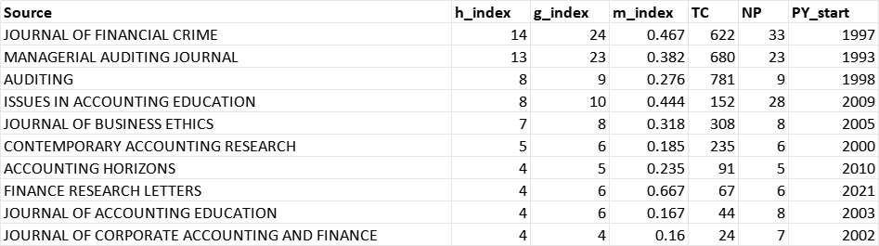
Source: Processed Scopus data with RStudio.

Despite having fewer publications (9), the journal Auditing, established in 1998, has the highest total citations (781). This indicates that the research published by this journal is highly influential and serves as a foundational reference for other researchers. The oldest journal, since 1993, Managerial Auditing Journal maintains its long-term presence with H-Index (13) and G-Index (23), M-Index (0.382), with 680 total citations. The journal Finance Research Letters with the highest M-Index (0.667) those that started in 2021, indicates a rapid impact compared to more established journals. The placement of journals Issues in Accounting Education (NP-28) and Journal of Business Ethics (TC-308) among the top 10 highlights the importance of forensic accounting education and ethical standards in the accounting field.
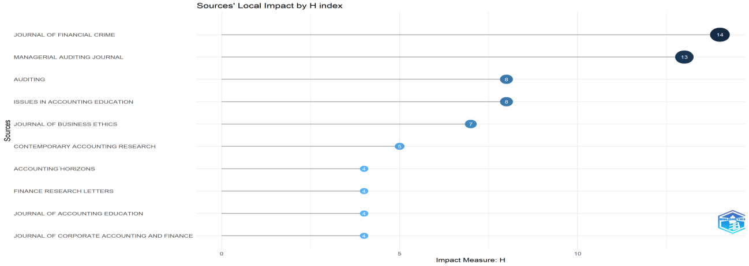
Figure 11: Source Local Impact by H Index
Source: Processed Scopus data with RStudio
Figure 11 is a graphical representation of Table 1, showing the dominance of the Journal of Financial Crime and the Managerial Auditing Journal. These findings align with broader bibliometric analyses highlighting the prominence of specialized journals in forensic accounting research(Aivaz et al., 2024; Soltani et al., 2023). The H-Index gap between the top two journals and the others indicates that many sources contribute to forensic accounting, but the bulk of the work is concentrated in specialized auditing and crime-focused areas(Ellili et al., 2024). This framework helps researchers identify gaps and future research directions.

4.1.9 Most Relevant Authors
Figure 12 below shows that the most productive authors are Nawawi A and Salin ASAP. Their work is mostly centered on the whistleblowing system, corporate governance, and internal control. This aligns with earlier scholars' findings that, while forensic accounting is a "promising and exciting area," the body of research remains "fragmented and emergent." There is a noticeable drop in the number of documents following these two authors. The remaining authors have at least 5 documents, suggesting that the forensic accounting discipline is still in a phase of dynamic maturation.
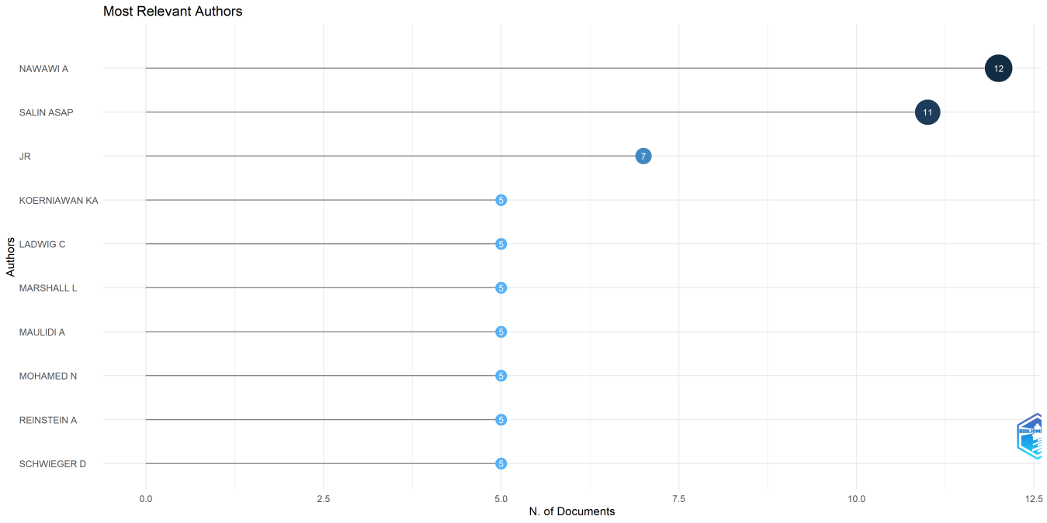
Figure 12: Most relevant authors
Source: Processed Scopus data with R Studio
Authors such as Reinstein are often cited in foundational works on auditing standards and modern fraud detection(Suleiman & Ahmi, 2018). Authors from Indonesia and the Middle East, such as Maulidi and Koerniawan, support the earlier finding that modern forensic accounting is shifting toward emerging economies to combat corruption and digital crime.

4.1.10 Most Relevant Affiliation
Table 2 indicates the most relevant affiliations, ranked by publication. The Universiti Teknologi Mara is a growing hub for publishing articles on forensic accounting. The affiliations are predominantly from institutions in Malaysia and Indonesia.

Table 2: Most Relevant Affiliations
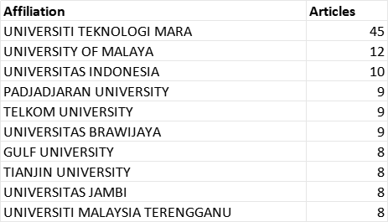
Source: Processed Scopus data with RStudio

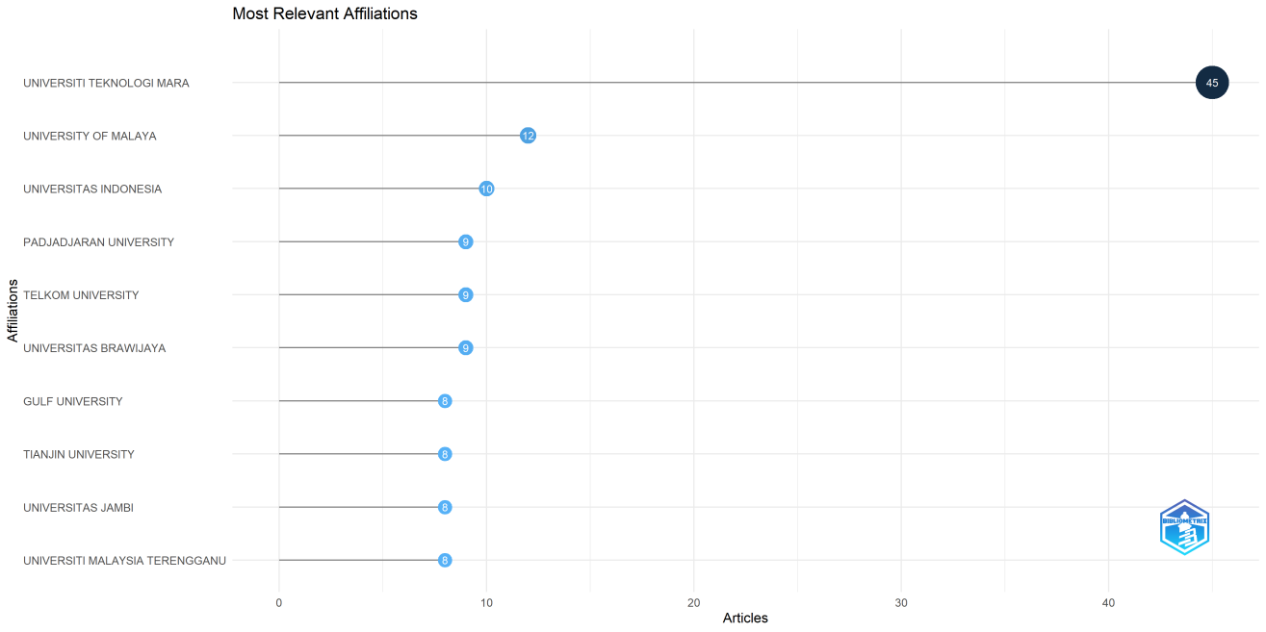
Figure 13: Most Relevant Affiliations
Source: Processed Scopus data with RStudio

Figure 13 is a graphic presentation of Table 2. The figure shows that emerging economies are currently leading in technology-focused forensic accounting rather than traditional auditing. This paradigm shift suggests that the focus of new academic interest is modern financial crimes and digital transformation.

4.1.11 Corresponding Authors Country
Table 3 indicates the geographical distribution of research based on the number of articles published by Single Country Publications (SCP) and Multiple Country Publications (MCP). The USA is a leader in single-country publications (64 articles), while Malaysia leads in multiple-country publications with 13 articles. The United Kingdom exhibits the highest level of collaboration at 54.5%, reflecting that its researchers actively engage in international collaborations, potentially blending global knowledge and fostering the maturation of forensic accounting as a global field(Winfield & Roberts, 2023). Bahrain also shows a high collaboration rate of 50%. India, Nigeria, and Australia have MCP rates of 0. The lack of international co-authorship supports the observation that while forensic accounting is a promising field, research remains somewhat "fragmented and emergent."
Table 3: Corresponding Authors’ Country
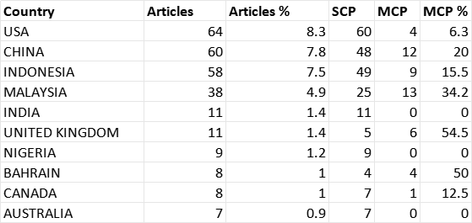
Source: Processed Scopus data with RStudio

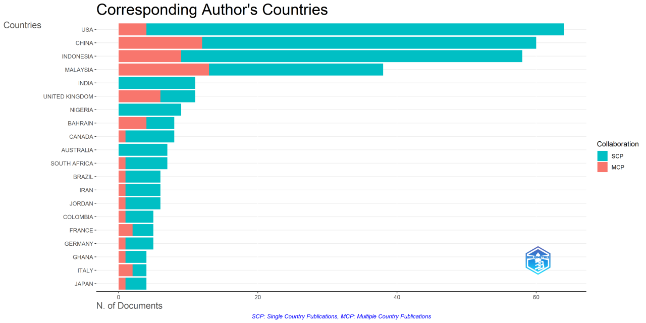
Figure 14: Corresponding Authors' Countries
Source: Processed Scopus data with RStudio

As section 4.1.4 indicates, the USA has the largest total number of documents, e.g., 221, and thus contributes significant intellectual capital, whereas Southeast Asia develops new avenues of knowledge as it integrates these practices into curricula and government structures(Forscher & Schmidt, 2024; Ong, 2021).

4.1.12 Most Cited Country
Table 4 and Figure 15 illustrate the most-cited countries by total citations and average article citations, respectively, to measure overall influence and individual paper impact. The USA is the pioneer and primary driver, with a total of 894. While the USA leads in total citations, Ghana leads in average citations (31.80). This indicates that even with fewer publications, Ghana has highly influential and widely cited documents. Ghana focuses on local issues such as corruption, digital fraud, and governance(Addo & Senyo, 2020; Bradbury, 2007). Countries such as Sweden (30.70 average) and Italy (27.00 average) demonstrate 'quality over quantity'.
Table 4: Most Cited Countries
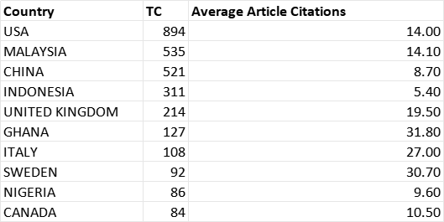
Source: Processed Scopus data from RStudio

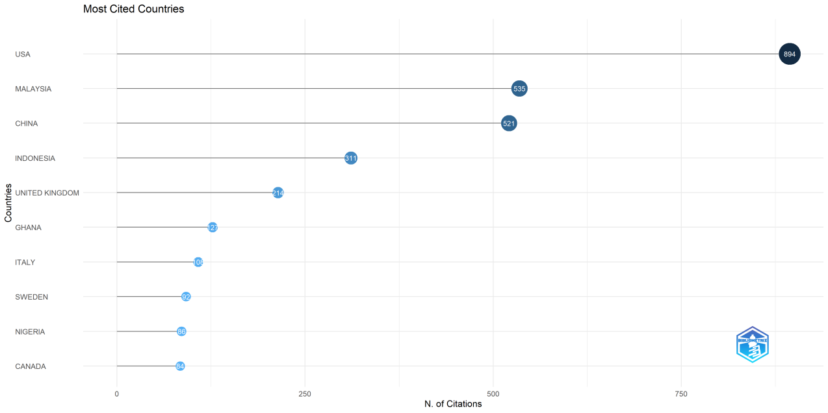
Figure 15: Most Cited Country
Source: Processed Scopus data from RStudio

Thus, Table 4 and Figure 15 reveal the quantity of publications and quality gap: for example, Indonesia has 311 total citations, with an average citation of 5.40, whereas China has 51 total citations, with an average citation of 8.70. The high average citation rate in developing economies like Ghana and Nigeria (9.60) indicates that the African region is receiving more global attention. The USA and Malaysia contribute to the quantity, while Ghana, Sweden, and Italy publish high-impact research.

4.1.13 Most Globally Cited Documents
Table 5 and Figure 16 present the research papers that shaped the theoretical and practical foundation of the discipline. The table shows the three metrics: Total Citations, Total Citations per Year, and Normalized Citations. Total Citations show the cumulative impact of research since publication, while Total Citations per Year reflect the latest popularity and rate of citation(Ho et al., 2018; Kalantari et al., 2017). The Normalized Citations are used to compare older and more recent high-impact studies(Waltman, 2016; Wang et al., 2021).

Table 5: Most Globally Cited Document
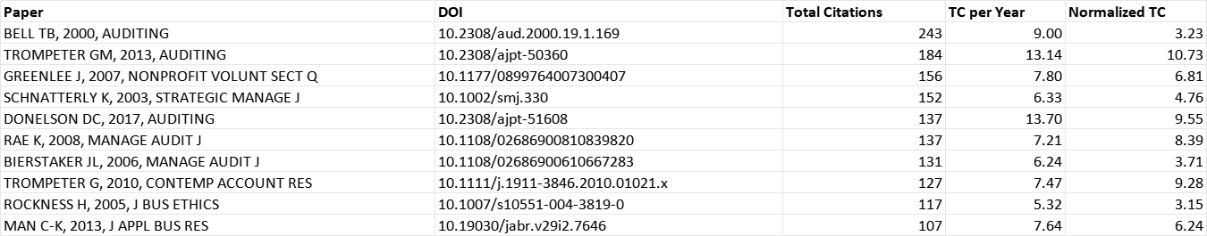
Source: Processed Scopus data from RStudio

The paper by Bell TB in Auditing is the most cited document, with 243 citations, and was published in 2000. The study focused on audit risk and the detection of fraudulent financial reporting(Bell & Carcello, 2000). The research published by Trompeter GM in Auditing (2013) has the highest Normalized Total Citation (10.73). It suggests that, even after 13 years of publication, the paper remains highly relevant. The study by Donelson DC (2017) in Auditing has the highest Total Citation Per Year (13.70). This indicates that the research demonstrates ongoing impact as the discipline of forensic accounting undergoes a paradigm shift towards corporate governance(Xanthopoulou et al., 2024).
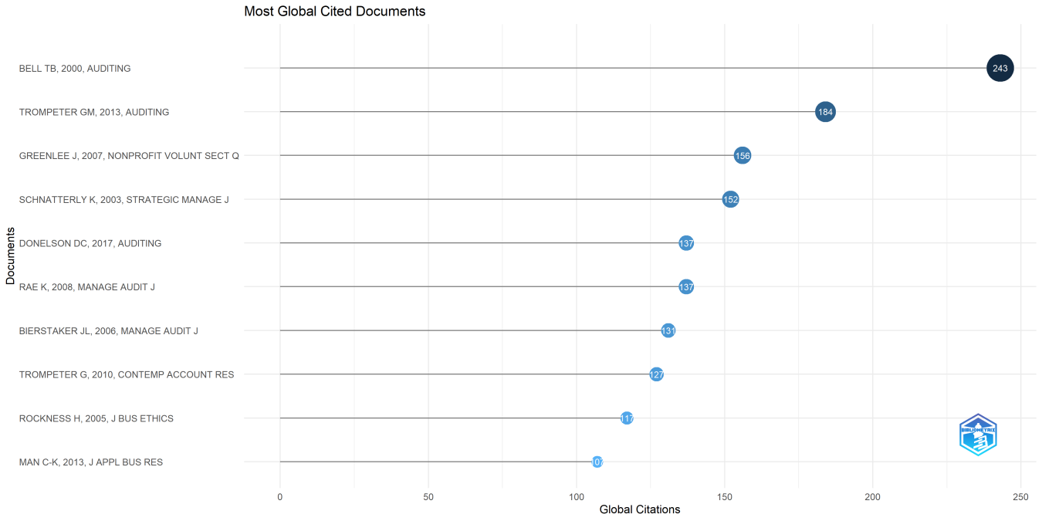
Figure 16: Most Global Cited Documents
Source: Processed Scopus data from R Studio

As the above figure and table show, the top papers, e.g., Bell (2000), Trompeter (2013), and Donelson (2017), are from Auditing and Contemporary Accounting Research. The findings reveal that the roots of forensic accounting lie in auditing standards, and a higher audit quality is required to prevent and detect financial crime. The research by Rae and Biestaker in the Managerial Auditing Journal underscores the significance of the internal control system and the fraud triangle in the corporate environment for combating financial crime. The study by Rockness in the Journal of Business Ethics and by Schnatterly in the Strategic Management Journal demonstrates that forensic accounting is not just a technical field, but also that professional ethics are pivotal for long-term financial integrity.

4.1.14 Most Frequent Words
Table 6 and Figure 17 show the most frequent words used in titles, abstracts, or keywords. The most frequent term is “Internal Control” (Occurrences: 66), which emphasizes the true and fair disclosure of organizational activities. The second most frequent word is “Finance” (48 times), highlighting the discipline's deep connections to financial systems and fraud detection(Kumar et al., 2025). Geographically, the United States appears 24 times, showing the highest number of publications and citations. The presence of the words “Information System and Information Management” indicates the paradigm shift from traditional forensic accounting to digital forensics. Forensic accountants now require technical and analytical skills to handle complex digital crimes(Daraojimba et al., 2023).

Table 6: Most Frequent Words
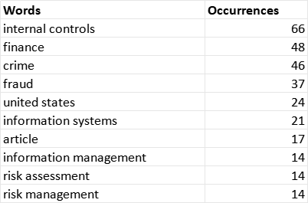
Source: Processed Scopus data from RStudio
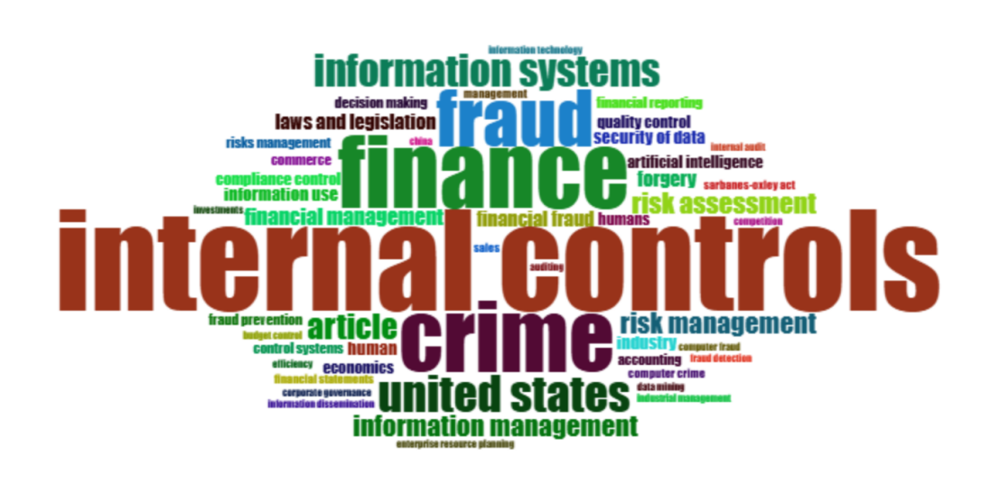
Figure 17: Word Cloud
Source: Processed Scopus data from RStudio

The word cloud shows the diversity of terms, including laws and legislation, decision-making, information management, technology, and others. This reflects that forensic accounting goes beyond traditional accounting and has become a professional career that integrates accounting, auditing, and investigative skills. The frequency of words like “Internal Control” and “Risk Management” underscores that researchers focus on proactive strategies to identify and analyze potential vulnerabilities before they escalate into major crises(Imoniana & Silva, 2013). The inclusion of technical terms such as AI, Data Mining, and Digital Forensic Technologies is central to combating increasingly sophisticated financial fraud schemes(Kapo et al., 2024; Wang et al., 2024).

4.1.15 Trending Topics
Table 7 and Figure 18 show the trending topics in the discipline of forensic accounting based on word frequency and temporal distribution (Q1, Median, and Q3. The term “United States” first appears in Q1 of 1994 (median year 2004). The word “Fraud” appeared in Q1 of 2005 and has remained a core term, focusing on the investigation and prevention of financial misconduct.

Table 7: Trending Topics
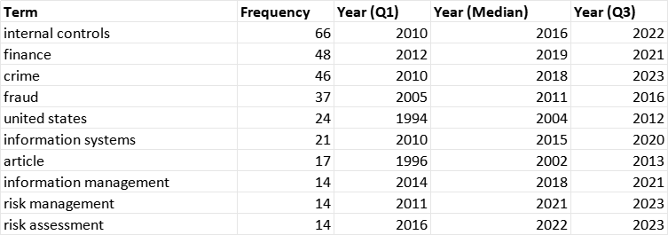
Source: Processed Scopus data from RStudio

The word “Internal Controls” appears 66 times with a median year of 2016, indicating that scholars considered it a first-line defense against financial irregularities. The term “Information System,” with a median year of 2015, indicates a shift towards digital forensics. Furthermore, the word “finance,” with a frequency of 48 and a median year 2019, and the word “crime,” with a median year 2018 and a frequency of 46, signify a multidisciplinary approach intersecting accounting, finance, and law to address complex economic crimes. The terms “Risk Management and Risk Assessment,” with median years 2021 and 2022, respectively, reflect recent trends. The researchers are now focusing on proactive prevention, using theories such as the “Fraud Triangle” to assess risk before fraud occurs.
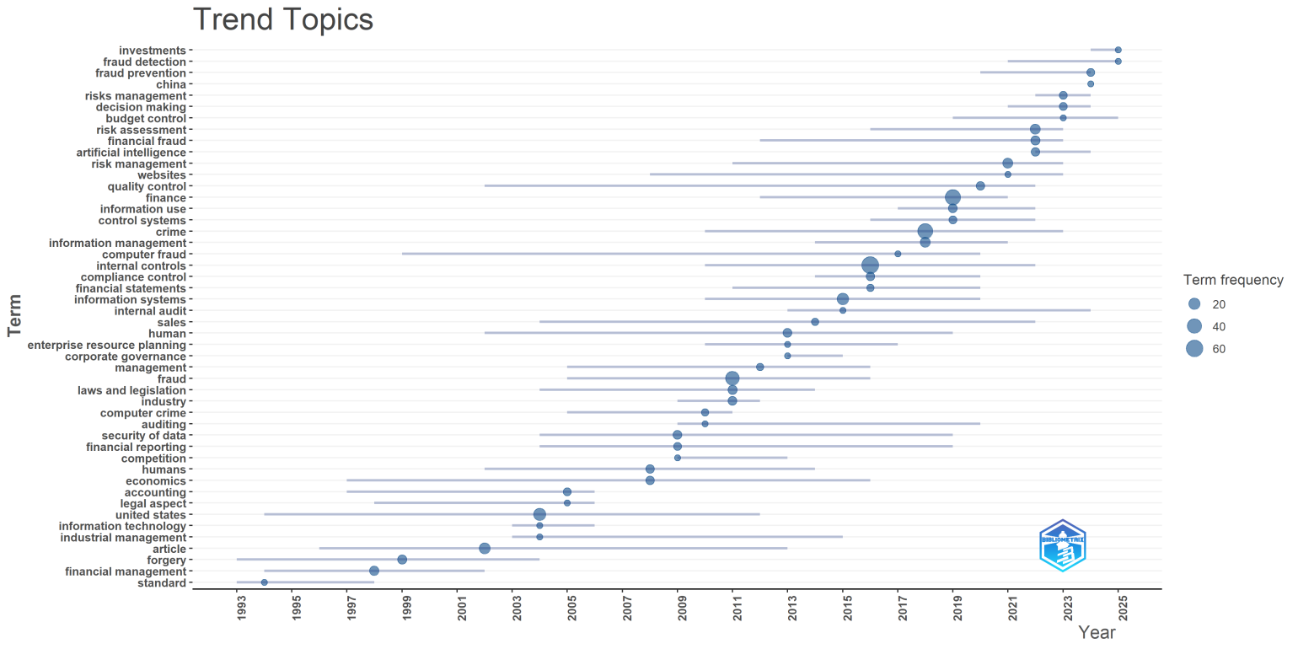
Figure 18: Trending Topics
Source: Processed Scopus data from R Studio

Thus, the discipline is becoming more strategic, focusing not just on “finding the crime” but on “managing the risk” through advanced investigative frameworks. In summary, the table and figure show the transition of forensic accounting from a US-centric auditing niche (pre-2010) into a global, technology-driven, risk-management discipline (2018–present)(Daraojimba et al., 2023; Kumar et al., 2025; Munandar & Honggowati, 2025).

4.1.16 Co-occurrence Network
Figure 19 shows the Keyword Co-Occurrence network map. This network shows how different concepts are interrelated through their co-occurrence in research papers. For normalization, Metric Association Strength is used for the co-occurrence network with full counting, where each co-occurrence has a weight of 1. A thesaurus file merges synonyms (e.g., fraud-frauds), and a specific stop-word list also removes irrelevant terms (e.g., article, research, KPI overload, teaching cases, drug diversion). The nodes represent key research terms; the larger a node, the more frequent its occurrence, while the links between nodes illustrate co-occurrence relationships and their strength. It highlights internal control and finance as central nodes, underscoring their foundational role in the forensic accounting discourse(Kiflee et al., 2022; Nugrahanti, 2023).

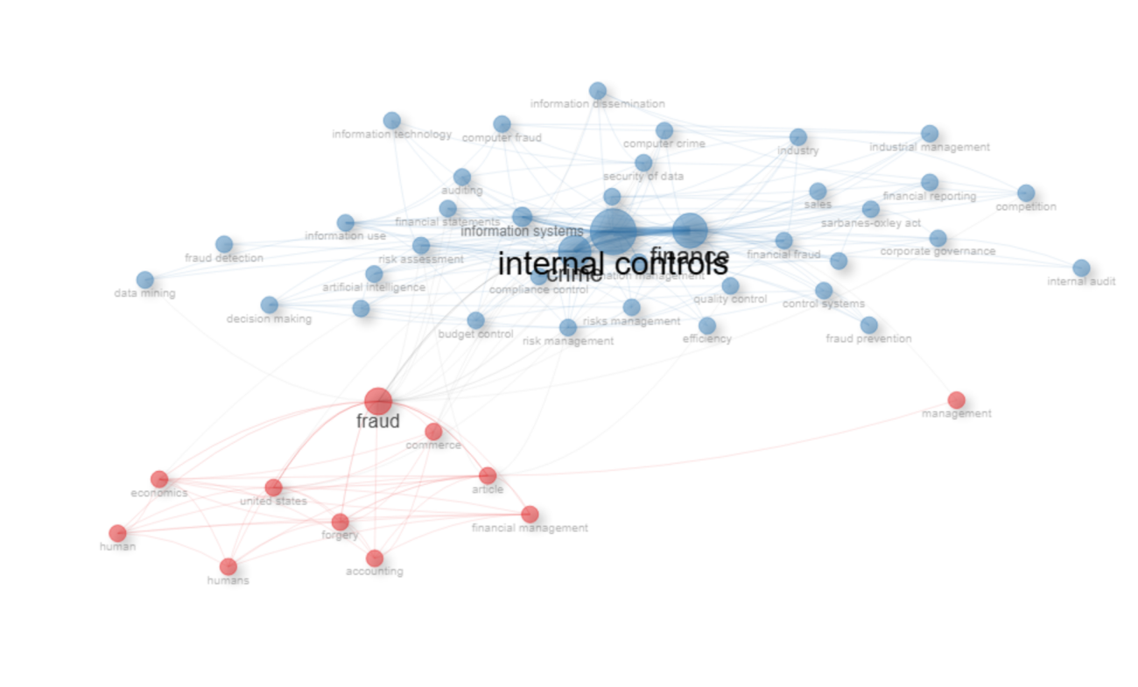
Figure 19: Co-occurrence Network
Source: Processed Scopus data from RStudio

The color of nodes shows the thematic clusters. In the Co-occurrence Network, blue indicates structural or technological clusters, and red indicates conceptual or fundamental clusters. The network map illustrates that forensic accounting has evolved from a US-centric auditing niche into a global, technology-driven discipline(Daraojimba et al., 2023; Kumar et al., 2025). The bridge between the clusters where "Crime" and "Finance" meet "Fraud" shows that the field now sits at the critical intersection of accounting, law, and information technology(Airout et al., 2024). The figure provides evidence that while internal control remains the most discussed mechanism for integrity, the current "center of gravity" for research is shifting toward digital compliance and automated detection systems (Munandar & Honggowati, 2025; Ramadhan et al., 2025).

4.1.17 Co-citation Network
Figure 20 visualizes the authors' co-citation network, showing authors whose work is frequently co-cited. The network is divided into clusters shown in red, blue, and green, with the size of the nodes indicating the total number of citations, and the thickness of the lines connecting them represents the strength of their co-citation relationships. Albrecht W.S. and Albrecht C.C. are central nodes that highlight foundational research on fraud detection and prevention, drawing on theories of the fraud triangle(Homer, 2019). In the blue cluster, the nodes represent work by Carcello, J.V. on the structural and monitoring aspects of forensic accounting. The present work is associated with the establishment of ethical measures and the critical role of audit committees in safeguarding financial integrity(Montesdeoca et al., 2019). Overall, the blue cluster explores accounting themes.
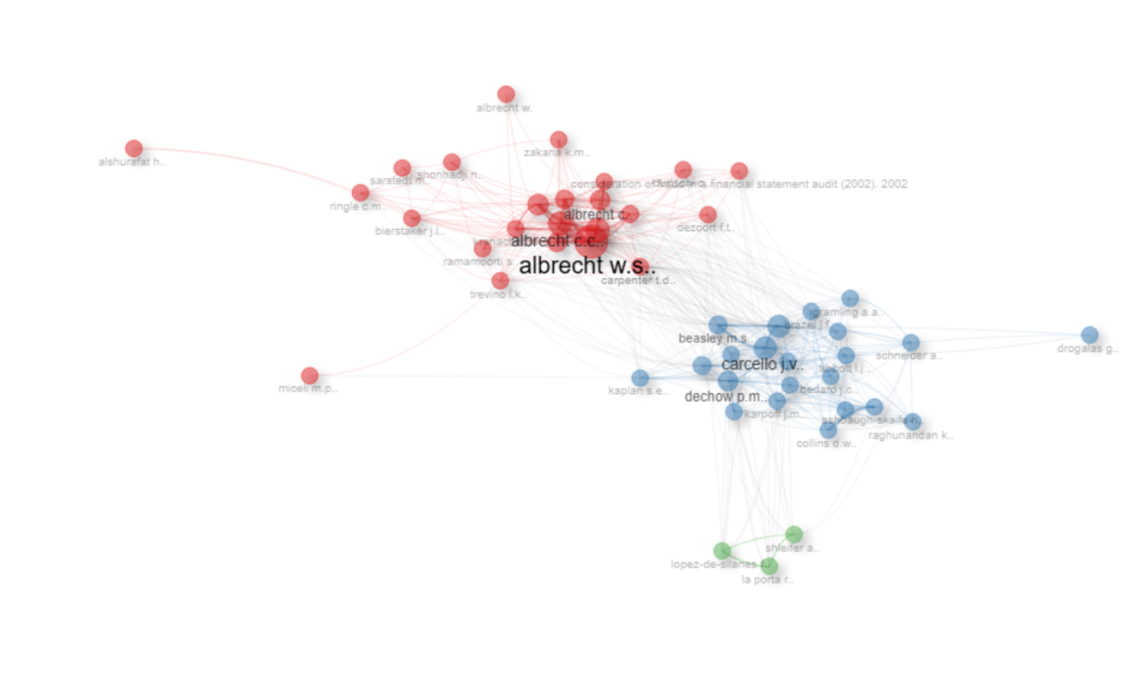
Figure 20: Co-citation network
Source: Processed Scopus data from RStudio

The green cluster comprises work related to the legal and regulatory framework. Thematic Focus: These works analyze how a country's legal origin, regulatory enforcement, and governance capital influence the prevalence and reporting of fraud cases(AL-RAGGAD & Al-Raggad, 2024; Máté et al., 2019). The co-citation network confirms that forensic accounting is not a narrow discipline but a technical and interdisciplinary field that builds on three pillars: behavioral psychology, corporate governance, and micro-regulatory context.(Judijanto & Defitri, 2024)

4.1.18 Author Collaboration Network
The author collaboration network in Figure 21, also known as the co-authorship map, identifies specific research teams and collaborative units. The main feature of this map is a red cluster indicating that Salin and Nawawi are the most frequently co-authored. The collaboration is notably strong in Southeast Asian countries, particularly Malaysia, where the research focuses on whistleblowing systems, internal controls, and corporate governance to detect fraud. The figure also shows many other collaborative clusters (e.g., green, blue, grey, and Wang clusters), which represent specialized research islands.

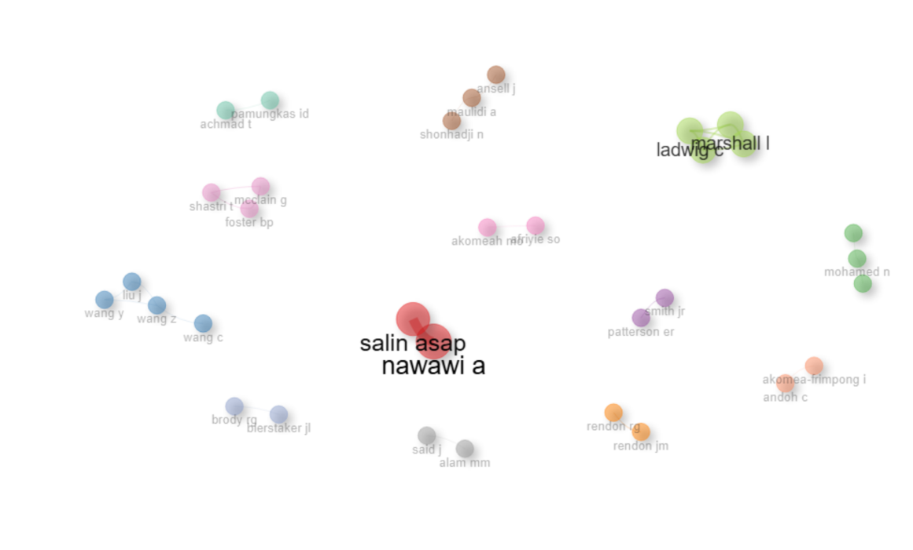
Figure 21: Collaboration Network
Source: Processed Scopus data from R Studio

The critical observation of this figure is its fragmentation, indicating that the discipline of forensic accounting is “emergent and fragmented”(Ellili et al., 2024). The gaps in clusters suggest opportunities for growth.

4.1.19 Citation Score
Figure 22 shows the citation scores of publications by year, indicating a shift in the focus of forensic accounting from traditional accounting to computer science. A high citation score indicates the profound influence and widespread recognition of research within the academic community, reflecting the scholarly significance and utility of published works(Asare & Samusevych, 2023).
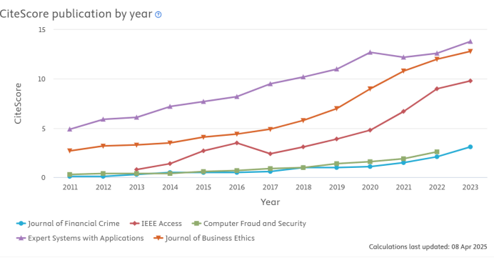
Figure 22: Citation Score
Source: Processed Scopus data from RStudio
The figure illustrates the five most prominent journals and their citation scores in the domain of forensic accounting and financial crime. The journal Expert Systems with Applications has the highest citation score, increasing from 5.0 in 2011 to 14.0 in 2023. The increase in citations underscores the importance of high-impact research, especially in AI and ML. Consequently, there is a growing need to integrate digital forensic technologies. Computer scientists and auditors can collaborate to address this challenge(Ramadhan et al., 2025). The Journal of Business Ethics has the second-highest citation score, ranging from approximately 3.0 to 13.0. This reflects the strong emphasis on ethical considerations and corporate governance within the forensic accounting discourse, aligning with the journal's observed prevalence of articles on these topics(Albalawee et al., 2024). Thus, the figure indicates that journals focusing on the intersection of technology, ethics, and crime are currently leading the intellectual impact within forensic accounting research.

Conclusion
The bibliometric study provides a systematic and longitudinal overview of the forensic accounting discipline. The data were collected from 1969 to 2026 from the Scopus database. By analyzing 770 documents, the study mapped the field's geographic, thematic, and evolutionary intellectual structure. The study has transitioned from a niche auditing specialty to a globally integrated technology-driven discipline.
The key findings of the study indicate that the United States is a foundational “pioneer and primary driver” of this field, ranking first in publications (221 documents) and total citations (894). However, the “center of gravity” is shifting towards Southeast Asia, with China, Indonesia, and Malaysia, as research publications are emerging. Furthermore, the USA leads in publications, while Ghana and Sweden exhibit the highest average citation per paper. This indicates that highly impactful specialized research is increasingly originating from diverse global contexts. Thematically, “Internal Control” is the dominant research pillar, with 66 occurrences, and it serves as a deterrent to corporate fraud in the literature. However, the trend analysis confirms a paradigm shift after 2018, with research moving from traditional fraud detection to proactive risk management and digital forensics. Authors such as Albrecht established the intellectual and collaborative structure of the Fraud Triangle. Salin and Nawawi are focusing on regional research, which indicates the network remains somewhat fragmented. The lack of international connections suggests that, while “isolated excellence” exists, the field has yet to achieve an integrated global research community.
The present study contributes to the literature by providing a state-of-the-art roadmap for researchers, practitioners, and educators. For academics, it identifies Risk Assessment and Digital Evidence as the most promising frontiers for future inquiry. For practitioners, the rising CiteScores of journals like Expert Systems with Applications and Journal of Business Ethics highlight the increasing necessity of integrating automated technical tools with robust ethical frameworks to combat modern financial crime.
Despite its comprehensive scope, this study is limited by its reliance on a single database. Future research should consider integrating data from Web of Science or Dimensions to capture a broader range of emerging journals. Additionally, while this study identifies a shift toward digital forensics, future qualitative reviews should investigate the specific challenges of implementing Blockchain and AI in forensic investigations within developing economies. In conclusion, forensic accounting is currently in a phase of dynamic maturation. As financial crimes become increasingly digital and transnational, the continued evolution of this field will depend on bridging the existing gaps between technological innovation, ethical management, and international research collaboration.

References
Abiola, J. O., & Adisa, R. A. (2020). Introducing Forensic Accounting Curiculum In Nigerian Universities: An Empirical Submission. Archives of Business Research, 8(5), 33. https://doi.org/10.14738/abr.85.8146
Addo, A., & Senyo, P. (2020). Digitalization and Government Corruption in Developing Countries: Towards a Framework and Research Agenda. Academy of Management Proceedings, 2020(1), 16765. https://doi.org/10.5465/ambpp.2020.16765abstract
Affès, H., & Sardouk, H. (2016). Accounting Conservatism and the Company’s Performance: the Moderating Effect of the Ownership Structure. Journal of Business & Financial Affairs, 5(2). https://doi.org/10.4172/2167-0234.1000188
Afriyie, S. O., Akomeah, M. O., Amoakohene, G., Ampimah, B. C., Ocloo, E. C., & Kyei, M. O.-. (2022). Forensic Accounting: A Novel Paradigm and Relevant Knowledge in Fraud Detection and Prevention. International Journal of Public Administration, 46(9), 615. https://doi.org/10.1080/01900692.2021.2009855
Agboare, E. I. (2021). Impact of Forensic Accounting on Financial Fraud Detection in Deposit Money Banks in Nigeria. African Journal of Accounting and Financial Research, 4(3), 74. https://doi.org/10.52589/ajafr-ruc0s0iq
Airout, R., Azam, S. A., & Airout, M. (2024). Bibliometric insights into the intellectual dynamics of forensic accounting research. Cogent Business & Management, 11(1). https://doi.org/10.1080/23311975.2024.2344748
Aivaz, K.-A., Florea, I. O., & Munteanu, I. (2024). Economic Fraud and Associated Risks: An Integrated Bibliometric Analysis Approach. Risks, 12(5), 74. https://doi.org/10.3390/risks12050074
Ajayi-Nifise, A. O., Olubusola, O., Falaiye, T., Mhlongo, N. Z., & Daraojimba, A. I. (2024). A Review of U.S. Financial Reporting Scandals and Their Economic Repercussions: Investigating Their Broader Impact and Preventative Measures. Finance & Accounting Research Journal, 6(2), 183. Fair East Publishers. https://doi.org/10.51594/farj.v6i2.787
Akkeren, J. V., Buckby, S., & MacKenzie, K. (2013). A metamorphosis of the traditional accountant. Pacific Accounting Review, 25(2), 188. https://doi.org/10.1108/par-06-2012-0023
Akyel, N. (2012). Forensic Accounting Training: A proposal for Turkey. Procedia - Social and Behavioral Sciences, 55, 77. https://doi.org/10.1016/j.sbspro.2012.09.480
Albalawee, N., Huson, Y. A., Budair, Q., Alqmool, T., & Arasheedi, N. M. K. (2024). Connecting legal compliance and financial integrity: A bibliometric survey of accounting practices in the corporate supply chain. Uncertain Supply Chain Management, 12(2), 893. https://doi.org/10.5267/j.uscm.2023.12.016
AL-RAGGAD, A. K., & Al-Raggad, M. (2024). Analyzing Trends: A Bibliometric Study of Administrative Law and Forensic Accounting in the Digital Age. Heliyon. Elsevier BV. https://doi.org/10.1016/j.heliyon.2024.e37462
Al-Raggad, M., Albalawee, N., Almahasneh, A. A. A. A., Huson, Y. A., & Albajaly, A. (2025). Unveiling financial crimes: advancing forensic accounting practices and ethical integrity through bibliometric insights. Safer Communities, 24(3), 244. https://doi.org/10.1108/sc-11-2024-0069
Alshira’h, A. F., & Lutfi, A. (2023). FORENSIC ACCOUNTING METHODS AND VALUE-ADDED TAX FRAUD. Journal of Southwest Jiaotong University, 58(3). https://doi.org/10.35741/issn.0258-2724.58.3.78
Alshurafat, H., Shbail, M. O. A., & Mansour, E. (2021). Strengths and weaknesses of forensic accounting: an implication on the socio-economic development. Journal of Business and Socio-Economic Development, 1(2), 135. https://doi.org/10.1108/jbsed-03-2021-0026
Anghel, G., & Poenaru, C.-E. (2023). Forensic Accounting, a Tool for Detecting and Preventing the Economic Fraud. Valahian Journal of Economic Studies, 14(2), 87. https://doi.org/10.2478/vjes-2023-0018
Asare, K. N., & Samusevych, Y. (2023). Exploring Financial Fraud, Tax Tools, and Economic Security Research: Comprehensive Bibliometric Analysis. Financial Markets Institutions and Risks, 136. https://doi.org/10.61093/fmir.7(3).136-146.2023
Bell, T. B., & Carcello, J. V. (2000). A Decision Aid for Assessing the Likelihood of Fraudulent Financial Reporting. Auditing A Journal of Practice & Theory, 19(1), 169. https://doi.org/10.2308/aud.2000.19.1.169
Bhasin, M. L. (2013). Corporate Governance and Forensic Accountants’ Role : Global Regulatory Action Scenario. International Journal of Accounting Research, 1(1), 1. https://doi.org/10.12816/0001124
Bradbury, M. (2007). Toward a Cost-Effectiveness Assessment of State Ethics Commissions: An Analysis of Enforcement Outputs. Public Integrity, 9(4), 333. https://doi.org/10.2753/pin1099-9922090402
Campa, D., Quagli, A., & Ramassa, P. (2023). The roles and interplay of enforcers and auditors in the context of accounting fraud: a review of the accounting literature Journal of Accounting Literature, 47(5), 151. Elsevier BV. https://doi.org/10.1108/jal-07-2023-0134
Crain, M. A., Hopwood, W. S., Pacini, C., & Young, G. R. (2017). Essentials of Forensic Accounting. https://doi.org/10.1002/9781119449423
Dada, S. O., & Jimoh, F. B. (2020). Forensic accounting and financial crimes in Nigerian public sector. Journal of Accounting and Taxation, 12(4), 118. https://doi.org/10.5897/jat2020.0417
Daraojimba, R. E., Farayola, O. A., Olatoye, F. O., Mhlongo, N., & Oke, T. T. (2023). Forensic Accounting in the Digital Age: A U.S. Perspective: Scrutinizing Methods and Challenges in Digital Financial Fraud Prevention. Finance & Accounting Research Journal, 5(11), 342. https://doi.org/10.51594/farj.v5i11.614
Dearden, T. E. (2015). Trust: the unwritten cost of white-collar crime. Journal of Financial Crime, 23(1), 87. https://doi.org/10.1108/jfc-02-2015-0007
Denhere, V. (2023). The state of forensic accounting: South Africa versus the United States of America. International Journal of Research in Business and Social Science (2147-4478), 12(7), 332. https://doi.org/10.20525/ijrbs.v12i7.2904
Đukić, T., Pavlović, M., & Grdinić, V. (2023). Uncovering Financial Fraud: The Vital Role of Forensic Accounting and Auditing in Modern Business Practice. Economic Themes, 61(3), 407. https://doi.org/10.2478/ethemes-2023-0021
Ellili, N. O. D., Nobanee, H., Haddad, A. E., Alodat, A. Y., & AlShalloudi, M. (2024). Emerging Trends in Forensic Accounting Research: Bridging Research Gaps and Prioritizing New Frontiers. Journal of Economic Criminology, 4, 100065. https://doi.org/10.1016/j.jeconc.2024.100065
Enofe, A. O., Okpako, P. O., & Atube, E. N. (2013). The Impact of Forensic Accounting on Fraud Detection. Journals & Books Hosting (International Knowledge Sharing Platform), 5(26), 61. http://iiste.org/Journals/index.php/EJBM/article/view/8063
Forscher, P. S., & Schmidt, M. (2024). A better how: notes on developmental meta-research. https://doi.org/10.62372/isci6112
Free, C. (2015). Looking through the fraud triangle: a review and call for new directions. Meditari Accountancy Research, 23(2), 175. https://doi.org/10.1108/medar-02-2015-0009
Friedrich, C. (2021). Private Investigations and Self-Disclosure of Suspected Fraud: Experimental Evidence on Forensic Accounting Services. Behavioral Research in Accounting, 33(1), 65. https://doi.org/10.2308/bria-2020-045
Gaffaroglu, S., & Alp, S. (2024). Detecting frauds in financial statements: a comprehensive literature review between 2019 and 2023 (June). Pressacademia. https://doi.org/10.17261/pressacademia.2023.1849
Grosu, V., Botez, D., Melega, A., Kicsi, R., Mihailă, S., & Macovei, A.-G. (2022). Bibliometric analysis of the transformative synergies between blockchain and accounting in the uprooting of economic criminality. Journal of Entrepreneurship and Sustainability Issues, 9(4), 77. https://doi.org/10.9770/jesi.2022.9.4(4)
Guida, G. (2018). An Analysis of Scientific Research Performance in Italy: Evaluation Criteria and Public Funding. International Journal of Economics and Finance, 10(7), 45. https://doi.org/10.5539/ijef.v10n7p45
Haddad, H., Alharasis, E. E., Fraij, J., & Al-Ramahi, N. M. (2024). How Do Innovative Improvements in Forensic Accounting and Its Related Technologies Sweeten Fraud Investigation and Prevention? WSEAS TRANSACTIONS ON BUSINESS AND ECONOMICS, 21, 1115. https://doi.org/10.37394/23207.2024.21.93
Hanifah, H. S. (2024). Global Insights into Financial Statement Fraud Detection and Prevention. Summa Journal of Accounting and Tax, 2(1), 1. https://doi.org/10.61978/summa.v2i1.972
Ho, Y., Lim, L. B. L., & Mónge-Nájera, J. (2018). Brunei Publications in the Science Citation Index Expanded (1973-2016): Bibliometrics and comparison with other tropical countries. Revista de Biología Tropical, 66(3), 1090. https://doi.org/10.15517/rbt.v66i3.31714
Homer, E. M. (2019). Testing the fraud triangle: a systematic review. Journal of Financial Crime, 27(1), 172. Emerald Publishing Limited. https://doi.org/10.1108/jfc-12-2018-0136
Hossain, M. Z., Kibria, H., & Johora, F. T. (2024). Ethical Challenges in Forensic Accounting: Balancing Professional Responsibility and Legal Obligations. Open Journal of Accounting, 13(3), 57. https://doi.org/10.4236/ojacct.2024.133005
Imoniana, J. O., & Silva, R. M. (2013). Revisiting the concepts of forensic accounting and corporate fraud. International Journal of Auditing Technology, 1(2), 175. https://doi.org/10.1504/ijaudit.2013.057343
Jain, D. E., & Lamba, J. (2020). Forensic Accounting: A Way to Fight, Deter and Detect Fraud. IARS International Research Journal, 10(1). https://doi.org/10.51611/iars.irj.v10i1.2020.106
John-Oti, E. J.-O., Stephen Gowon. (2025). Financial Crimes: A Comparative Study of Nigeria and Chinese Approaches to Combating the Scourge. International Research Journal of Economics and Management Studies, 4(5). https://doi.org/10.56472/25835238/irjems-v4i5p108
Judijanto, L., & Defitri, S. Y. (2024). Bibliometric Analysis of Forensic Accounting Research Trends in Countering Fraud in the Public Sector. West Science Accounting and Finance, 2(3), 552. https://doi.org/10.58812/wsaf.v2i03.1413
Kalantari, A., Kamsin, A., Kamaruddin, H. S., Ebrahim, N. A., Gani, A., Ali, E., & Band, S. S. (2017). A bibliometric approach to tracking big data research trends. Journal Of Big Data, 4(1). https://doi.org/10.1186/s40537-017-0088-1
Kapo, A., Turulja, L., & Vidačak, Z. (2024). Innovative approaches in forensic accounting: The role of data analytics. Journal of Forensic Accounting Profession, 4(1), 1. https://doi.org/10.2478/jfap-2024-0001
Kasum, A. S. (2009). The Relevance of Forensic Accounting to Financial Crimes in Private and Public Sectors of Third World Economies: A Study from Nigeria. SSRN Electronic Journal. https://doi.org/10.2139/ssrn.1384242
Kiflee, A. K. R., Hasbullah, N. N., & Shaharuddin, S. (2022). Forensic Accounting Growth: Bibliometric Analysis Perspective. International Journal of Academic Research in Business and Social Sciences, 12(7). https://doi.org/10.6007/ijarbss/v12-i7/13921
Kulmie, D. A., Hilif, M. D., & Hussein, M. S. (2023). Socioeconomic Consequences of Corruption and Financial Crimes. International Journal of Economics and Financial Issues, 13(5), 88. https://doi.org/10.32479/ijefi.14714
Kumar, R. (2025). Bibliometric Analysis: Comprehensive Insights into Tools, Techniques, Applications, and Solutions for Research Excellence. Spectrum of Engineering and Management Sciences, 3(1), 45. https://doi.org/10.31181/sems31202535k
Kumar, S. (2025). Exposing financial shenanigans: The role of Indian accounting standards (Ind AS) in enhancing corporate accountability and governance. BenchCouncil Transactions on Benchmarks Standards and Evaluations, 5(3), 100228. https://doi.org/10.1016/j.tbench.2025.100228
Kumar, S., Khan, S., & Yadav, R. (2025). A bibliometric analysis of research on forensic accounting from 2006 to 2024. Social Sciences & Humanities Open, 12, 101693. https://doi.org/10.1016/j.ssaho.2025.101693
Kumar, S., Pandey, N., Burton, B., & Sureka, R. (2021). Research patterns and intellectual structure of Managerial Auditing Journal: a retrospective using bibliometric analysis during 1986-2019. Managerial Auditing Journal, 36(2), 280. https://doi.org/10.1108/maj-12-2019-2517
Kurniawan, S., Mayuri, N. K. L., Fitriana, F., & Santoso, R. A. (2025). Bibliometric Analysis of The Development of Forensic Audit Research Based on VOS-Viewer. Golden Ratio of Finance Management, 5(1), 145. https://doi.org/10.52970/grfm.v5i1.1013
Lakshmi, P. A., & Menon, G. (2016). Forensic Accounting: A Checkmate for Corporate Fraud. Journal of Modern Accounting and Auditing, 12(9). https://doi.org/10.17265/1548-6583/2016.09.002
Macc, A. M. A., & Al-Adeem, K. R. (2022). A Defense on Accounting Discretion: An Empirical Inquiry based on Users’ Awareness. Financial Markets Institutions and Risks, 6(3), 26. https://doi.org/10.21272/fmir.6(3).26-39.2022
Máté, D., Sadaf, R., Oláh, J., Popp, J., & Szűcs, E. (2019). The Effects of Accountability, Governance Capital, and Legal Origin on Reported Frauds. Technological and Economic Development of Economy, 25(6), 1213. https://doi.org/10.3846/tede.2019.10717
Mazumder, M. M. M. (2011). Forensic Accounting – An Investigative Approach of Accounting. SSRN Electronic Journal. https://doi.org/10.2139/ssrn.1864346
Mert, I. (2022). Investigation Techniques, Methods, Types, and Increasing Impact of Forensic Accounting in Digital Period. Maliye Finans Yazıları, 118, 13. https://doi.org/10.33203/mfy.1084274
Mittal, P., Kaur, A., & Gupta, P. (2021). The Mediating Role of Big Data to Influence Practitioners to Use Forensic Accounting for Fraud Detection. European Journal of Business Science and Technology, 7(1), 47. https://doi.org/10.11118/ejobsat.2021.009
Montesdeoca, M. R., Medina, S., & Santana, F. B. (2019). Research Topics in Accounting Fraud in the 21st Century: A State of the Art. https://doi.org/10.3390/su11061570
Munandar, M. R. A., & Honggowati, S. (2025). Bibliometrics Analysis of Forensic Accounting Research. Journal of Economics and Business, 8(1). https://doi.org/10.31014/aior.1992.08.01.650
Nash-Stewart, C. E., Kruesi, L., & Mar, C. D. (2012). Does Bradford’s Law of Scattering predict the size of the literature in Cochrane Reviews? Journal of the Medical Library Association JMLA, 100(2), 135. https://doi.org/10.3163/1536-5050.100.2.013
Nawawi, A., & Salin, A. S. A. P. (2018). Whistle blowing intentions – evidence from Malaysian PLC. International Journal of Law and Management, 60(5), 1111. https://doi.org/10.1108/ijlma-04-2017-0096
Nugrahanti, T. P. (2023). Analyzing the Evolution of Auditing and Financial Insurance: Tracking Developments, Identifying Research Frontiers, and Charting the Future of Accountability and Risk Management. West Science Accounting and Finance, 1(2), 59. https://doi.org/10.58812/wsaf.v1i02.119
Ong, S. (2021). Southeast Asian countries join forces for scientific strength. Nature, 591(7850). https://doi.org/10.1038/d41586-021-00670-3
Oyedokun, G. E. (2022). Determinants of Forensic Accounting Techniques and Theories: An Empirical Investigation. Annals of Spiru Haret University Economic Series, 22(3). https://doi.org/10.26458/22319
Oyedokun, Prof. G. E. (2013). An Assessment of the Role of Forensic Accountants in Litigation Support Services (An Explanatory Approach). SSRN Electronic Journal. https://doi.org/10.2139/ssrn.2410664
Ozili, P. K. (2015). Forensic accounting and fraud: A review of literature and policy implications. International Journal of Accounting and Economics Studies, 3(1), 63. https://doi.org/10.14419/ijaes.v3i1.4541
Panigrahi, G. R., Barpanda, N. K., & Sethy, P. K. (2024). Navigating the cyber forensics landscape a review of recent innovations. International Journal of Informatics and Communication Technology (IJ-ICT), 13(1), 27. Institute of Advanced Engineering and Science (IAES). https://doi.org/10.11591/ijict.v13i1.pp27-33
Patra, S. K., Bhattacharya, P. P., & Verma, N. (2006). Bibliometric Study of Literature on Bibliometrics. DESIDOC Bulletin of Information Technology, 26(1), 27. https://doi.org/10.14429/dbit.26.1.3672
Pearson, T., & Singleton, T. (2008). Fraud and Forensic Accounting in the Digital Environment. Issues in Accounting Education, 23(4), 545. https://doi.org/10.2308/iace.2008.23.4.545
Polycarp, S. (2019). The Role of Forensic Accounting in Detecting Economic Crimes. Research Journal of Finance and Accounting. https://doi.org/10.7176/rjfa/10-16-11
Popoola, O. M. J., Ahmad, A. C., & Samsudin, R. S. (2014). Forensic Accounting Knowledge and Mindset on Task Performance Fraud Risk Assessment. International Journal of Business and Management, 9(9). https://doi.org/10.5539/ijbm.v9n9p118
Prabowo, H. Y. (2013). Better, faster, smarter: developing a blueprint for creating forensic accountants. Journal of Money Laundering Control, 16(4), 353. https://doi.org/10.1108/jmlc-05-2013-0017
Ramadhan, M. D., Sukmadilaga, C., & Mubarrok, A. Z. (2025). A Bibliometric Analysis of Competence, Professional Skepticism, And Digital Forensics In Investigative Audit Quality. JRAK, 17(2), 401. https://doi.org/10.23969/jrak.v17i2.30663
Rashid, C. A. (2023). A requirement for fraud investigation professionals. Journal of Global Economics and Business, 4(12), 75. https://doi.org/10.31039/jgeb.v4i12.121
Rehman, A., & Hashim, F. (2018). Forensic Accounting on Corporate Governance Maturity mediated by Internal Audit: A Conceptual Overview. Proceedings of the 1st Economics and Business International Conference 2017 (EBIC 2017). https://doi.org/10.2991/ebic-17.2018.26
Roshanpoor, A., Kythreotis, A., & Soltani, M. (2024). The moderate role of national culture and prosperity index on the effectiveness of the fraud triangle to prevent financial statement fraud: a cross-country meta-analysis approach. International Journal of Accounting Auditing and Performance Evaluation, 1(1). https://doi.org/10.1504/ijaape.2024.10061969
Sadaf, R., Oláh, J., Popp, J., & Máté, D. (2018). An Investigation of the Influence of the Worldwide Governance and Competitiveness on Accounting Fraud Cases: A Cross-Country Perspective. Sustainability, 10(3), 588. https://doi.org/10.3390/su10030588
Saha, S., Hasan, A. R., Mahmud, A., Ahmed, N., Parvin, N., & Karmakar, H. (2024). Cryptocurrency and financial crimes: A bibliometric analysis and future research agenda. Multidisciplinary Reviews, 7(8), 2024168. https://doi.org/10.31893/multirev.2024168
Sari, R., & Muslim, M. (2023). Accountability and Transparency in Public Sector Accounting: A Systematic Review. Amkop Management Accounting Review., 3(2), 90. https://doi.org/10.37531/amar.v3i2.1440
Shahana, T., Lavanya, V., & Bhat, A. R. (2023). State of the art in financial statement fraud detection: A systematic review. Technological Forecasting and Social Change, 192, 122527. Elsevier BV. https://doi.org/10.1016/j.techfore.2023.122527
Shanikat, M., & Aldabbas, M. M. (2025). Perception of Corporate Governance Factors in Mitigating Financial Statement Fraud in Emerging Markets: Jordan Experience. Journal of Risk and Financial Management, 18(8), 430. https://doi.org/10.3390/jrfm18080430
Simeunović, N., Gojko, G., & Ristić, N. (2016). Forensic accounting in the fraud auditing case. The European Journal of Applied Economics, 13(2), 45. https://doi.org/10.5937/ejae13-10509
Solikhah, N., & Cahyaningtyas, F. (2024). Analysis of Financial Statement Fraud in the Perspective of Fraud Triangle Theory in Energy Companies. Kompak Jurnal Ilmiah Komputerisasi Akuntansi, 17(2), 133. https://doi.org/10.51903/kompak.v17i2.2139
Soltani, M., Kythreotis, A., & Roshanpoor, A. (2023). Two decades of financial statement fraud detection literature review; combination of bibliometric analysis and topic modeling approach. Journal of Financial Crime, 30(5), 1367. https://doi.org/10.1108/jfc-09-2022-0227
Suleiman, N., & Ahmi, A. (2018). Mitigating Corruption Using Forensic Accounting Investigation Techniques. Indian-Pacific Journal of Accounting and Finance, 2(1), 4. https://doi.org/10.52962/ipjaf.2018.2.1.38
Tapanjeh, A. M. A. –, & AlTarawneh, A. R. (2020). Applicability of Forensic Accounting to Reduce Fraud and its Effects on Financial Statement of Jordanian Shareholding Companies From the Perspective of Judiciary and Certified Public Accountant. International Journal of Financial Research, 11(2), 436. https://doi.org/10.5430/ijfr.v11n2p436
Vorster, H. H., & Nwosu, L. I. (2024). Evaluating policies and regulations used to control corruption among accounting officers in the public sector of South Africa: a systematic literature review. Frontiers in Sociology, 9, 1371287. https://doi.org/10.3389/fsoc.2024.1371287
Waltman, L. (2016). A review of the literature on citation impact indicators [Review of A review of the literature on citation impact indicators]. Journal of Informetrics, 10(2), 365. Elsevier BV. https://doi.org/10.1016/j.joi.2016.02.007
Wang, J., Xu, S., Mariani, M. S., & Lü, L. (2021). The local structure of citation networks uncovers expert-selected milestone papers. Journal of Informetrics, 15(4), 101220. https://doi.org/10.1016/j.joi.2021.101220
Wang, Z., Shen, Q., Bi, S., & Fu, C. (2024). AI Empowers Data Mining Models for Financial Fraud Detection and Prevention Systems. Procedia Computer Science, 243, 891. https://doi.org/10.1016/j.procs.2024.09.107
Williams, J. W. (2006). Private Legal Orders: Professional Markets and the Commodification of Financial Governance. Social & Legal Studies, 15(2), 209. https://doi.org/10.1177/0964663906063575
Winfield, J., & Roberts, M. (2023). Forensic Accounting: Time for a Unified Global Approach. Journal of Forensic Accounting Profession, 3(1), 38. https://doi.org/10.2478/jfap-2023-0002
Xanthopoulou, A., Skordoulis, M., Kalantonis, P., & Arsenos, P. (2024). Integrating corporate governance and forensic accounting: A sustainable corporate strategy against fraud. Journal of Governance and Regulation, 13, 327. https://doi.org/10.22495/jgrv13i2siart9
Zenzerović, R., & Šajrih, J. (2023). Financial statements fraud identifiers. Economic Research-Ekonomska Istraživanja, 36(3). https://doi.org/10.1080/1331677x.2023.2218916

