SOCIOECONOMIC DETERMINANTS OF HOUSEHOLD ADOPTION OF SOLAR ENERGY IN TRANS-NZOIA COUNTY, KENYA

ABSTRACT
The solar energy systems adoption constitutes an important integration to Kenya’s transition towards sustainable economic development and the realization of Vision 2030. Despite national efforts, the rate of solar energy adoption remains relatively low in rural areas, largely due to existence of a knowledge gap in understanding the specific socioeconomic factors that drive or hinder the adoption of solar energy in these regions. This study investigated the effects of household income, access to credit facilities, awareness of the benefits of solar energy, and education level on the adoption of solar energy in Trans-Nzoia County. The study was anchored on four theoretical frameworks: the Diffusion of Innovations Theory, Theory of Planned Behavior, Economic Theory of Consumer Choice, and Social Cognitive Theory. A cross-sectional research design was adopted, targeting a stratified random sample of 385 households in the county. Primary data were collected through structured questionnaires and analyzed using descriptive statistics and binary logistic regression to estimate the probability of solar energy adoption based on the identified socioeconomic factors. The regression analysis results revealed that education level (β = 0.035, p < 0.05), access to credit facilities (β = 0.272, p < 0.05), and awareness of solar energy benefits (β = 0.213, p < 0.05) were statistically significant predictors of the likelihood of adoption of solar energy. In contrast, household income (β = 0.024, p > 0.05) was not a statistically significant predictor of adoption. These findings suggest that the decision to use solar energy is influenced by factors other than income, such as educational attainment, financial inclusion, and access to information. Households with higher levels of education, better access to credit, and increased awareness were more likely to adopt solar technology, indicating that non-income factors, particularly financial accessibility and information dissemination, play an important role in shaping energy decisions in rural areas. The robustness of the model was affirmed through diagnostic tests, including the Hosmer-Lemeshow goodness-of-fit test. County governments and energy stakeholders implement public awareness campaigns on solar energy in selected wards on an annual basis, with measurable indicators such as the number of households reached and changes in solar adoption rates. Financial institutions should introduce tailored solar financing such as pay-as-you-go credit for low- and middle-income households within before 2030, with success measured by loan uptake and repayment rates. Also, Ministry of Education, should integrate basic renewable energy modules into primary and secondary school curricula before 2030, with monitoring based on curriculum rollout and student participation. Future research, should conduct multi-county comparative studies involving at least three counties within the next 3-5 years to examine regional variations in solar adoption. They also should systematically assess cultural attitudes, grid and off-grid infrastructure readiness, and county-level policy and regulatory frameworks, using standardized indicators to enable comparability across diverse Kenyan contexts.
This study aimed to explore the socioeconomic determinants of solar energy adoption in the rural areas of Trans-Nzoia County, a region where the adoption of solar energy is still low despite the high ambitions for the nation's development. A cross-sectional study design was employed for this study. A total of 385 households were targeted for the study. Using a binary logistic regression model, the study established that the determinants of solar energy adoption were the education level of the respondents (β = 0.035, p < 0.05), availability of credit (β = 0.272, p < 0.05), and the benefits of solar energy (β = 0.213, p < 0.05), while the income levels were not statistically significant for the adoption of solar energy. The robustness of the model was checked by the Hosmer-Lemeshow test.
Keywords: Solar energy adoption, rural households, socioeconomic factors, financial inclusion, Kenya
INTRODUCTION
The current global macro-environment is defined by a dynamic energy landscape, with governments worldwide shifting to renewable energy sources to decarbonize their economies and strengthen energy security. Solar energy has emerged as a critical component of this shift, providing a plentiful, clean, and decentralized source of power generation to both households at small scale, and companies at large scale (IRENA, 2021). The continued use of existing energy sources for electricity generation is the primary contributor to global climate change (Ahmad et al., 2020). Solar energy, emitted by the Sun's nuclear fusion, provides an enormous amount of energy to Earth every day, greatly beyond aggregate human consumption (Msafiri, 2009). As a green technology, solar PV effectively lowers the cost of imported oil while also lowering CO2 emissions (Rezaee et al., 2019). Several countries have taken steps to increase the use of solar energy in their energy mix (Merino., 2019). The 2020 Sustainable Global Progress Report, solar PV climbed by 12% in 2019, delivering 115 GW of power, with a global solar PV output of 627 GW (Renné, 2022).
The importance of solar PV is highlighted by its role in reducing CO2 emissions, as residential appliances account for a significant portion of world emissions (Ali et al., 2020). IRENA (2020), solar PV has increased its proportion of worldwide electricity generation by 28.3%. Initiatives such as the African Union's Green Recovery Action Plan (GRAP) (African Union, 2023) and the Africa Renewable Energy Initiative (AREI) seek to ensure African benefits from the global green transition. The African Development Bank (AfDB) has taken a proactive approach to growing finance for African renewable energy, with the goal of achieving universal electricity access by 2025 (African Development Bank., 2019). In 2017, the Bank achieved a significant milestone by approving power generation projects totaling 1,400 MW from renewable energy (AfDB, A. U. C., & UNECA, A. S. Y., 2012).
Africa, with its abundance of solar energy, has seen solar PV develop as a viable choice for electricity generation in both local and large-scale applications (AU, 2021). Solar energy technology is being acknowledged as a market commodity in Africa, rather than a byproduct of donor initiatives (Mutua & Kimuyu,2015). Solar PV projects are thought to improve the quality of life for low-income households by creating job opportunities (Irfan et al., 2019), reducing CO2 emissions (Sweerts et al., 2019), and being the most cost-effective renewable energy source, thus stabilizing electricity prices (Kabir et al., 2018). However, Africa's installed solar technology capacity is currently just 5 GW, with a potential of 315 GW by 2040, as projected by the African Union 2063 Agenda, and supported by the IEA African Case scenario (IEA, 2019). Solar PV integration with on-grid storage is expected to result in a 6% reduction in operating and investment costs by 2050 (Takase et al., 2021)
Kenya, a Sub-Saharan African country, is still experiencing an energy crisis as a result of several socioeconomic issues such as reliability, costs, low and stagnating consumption, low and falling revenue per customer, and distribution (Takase et al., 2021). Historically, modern renewable energy has been primarily urban-focused, making it a luxury in many nations, including Kenya (Vernet,., 2019). In 2023, Kenya's energy availability rate was reported to be 69.7% (Felix., & Sayas., 2023). To close the electricity access gap, the Kenyan government has established many policies and programs to promote the adoption of alternative renewable energy sources, such as solar photovoltaic devices (Energy Africa, 2018). Nonetheless, a variety of factors influence households' and organizations' decisions to invest in solar panel technology (Klepacka,2018).
LITERATURE REVIEW AND HYPOTHESES DEVELOPMENT

Credit Facilities and the Adoption of Solar Energy
Greater financial accessibility encourages household adoption of new technologies (Khushbu et al, 2015). The availability of financial facilities is critical to solar energy uptake, especially in rural and low-income communities. Based on the research findings of numerous experts, it is clear that financial restrictions are a key barrier to widespread adoption of solar photovoltaic (PV) systems. For example, Ahmed et al. (2022) found that capital availability is a crucial factor influencing solar energy adoption. Similarly, Asaduzzaman et al. (2010) observed that the cost of solar energy systems influences their uptake.
Credit facilities can help households overcome these financial constraints by providing the required funds to engage in solar energy. This is especially significant in rural locations where access to traditional banking services may be restricted. Hillerbrand and Goldammer (2018) discovered that low-income rural households use solar energy to improve their quality of life and safeguard the environment, implying that with more access to financing, these households would be more likely to adopt solar technology. Credit facilities can help households living in less permanent structures, which may have lower adoption rates, finance the initial cost of solar PV systems.
Furthermore, the Pay As You Go (PAYG) model has had a considerable impact on the adoption of solar energy technology, especially in areas with limited access to traditional energy sources. This strategy enables households to purchase solar energy systems without making big upfront payments, instead opting to pay for the service in modest, affordable increments over time. The PAYG model's flexibility has made solar energy more accessible to low-income households that would otherwise be unable to afford the upfront costs connected with solar equipment (Ondraczek, 2013). PAYG has played an important role in increasing the adoption of solar energy technology in many developing countries by eliminating the financial barriers to entry.
In Kenya, where many rural and peri-urban regions are not linked to the national electrical grid, the PAYG model has played an important role in encouraging the switch to solar energy. According to studies, households with access to PAYG solar systems are more likely to embrace solar technology because the payment structure is affordable and convenient (GOGLA, 2019). The strategy enables customers to prepay for electricity using mobile money platforms that are widely utilized in Kenya, so integrating with existing financial habits and smoothing the transition to solar energy (Taneja, 2018). As a result, the PAYG model has helped to increase the use of solar energy in off-grid areas, offering an alternative to traditional energy sources like kerosene, which are both expensive and environmentally hazardous. The PAYG model's effectiveness in boosting solar energy adoption is also dependent on its ability to instill consumer trust and lessen perceived risks associated with new technology. PAYG systems often feature warranties and customer support services, so households feel more confident in their investment knowing they can get help if problems emerge (GOGLA, 2019). Furthermore, because the approach is pay-as-you-go, if a household is displeased with the product, they can stop making payments without incurring a long-term financial obligation. This risk minimization is especially relevant in areas where consumer protection laws may be weak and trust in new technologies is poor (Ondraczek, 2013).
Another key benefit of the PAYG model is that it promotes energy equity by making solar electricity available to a larger portion of the population. Traditional energy solutions frequently increase socioeconomic inequities, as wealthier homes can afford to connect to the grid or purchase costly generators. However, the PAYG model democratizes access to solar energy, allowing even low-income households to reap the benefits of renewable energy sources (Rolffs et al., 2015). This inclusivity not only improves environmental sustainability, but it also promotes social fairness by ensuring that more people have access to reliable, clean energy. Furthermore, the PAYG model has fueled innovation in the solar energy sector by driving businesses to create solutions that are both affordable and high-quality. The competitive market for PAYG solar systems has encouraged technological advancements, resulting in more efficient and long-lasting products that provide better value to consumers (GOGLA, 2019. Companies that use the PAYG model are driven to build systems that will perform well over time, as their revenue is contingent on ongoing customer pleasure and payment. This emphasis on quality ensures that the benefits of solar energy are achieved in the long run, rather than being negated by subpar products.
Despite these advantages, the PAYG approach is not without drawbacks. One of the most pressing concerns is the potential of payment default, especially in low-income households who may face financial difficulties. Companies that offer PAYG solar systems must balance the requirement for flexible payment terms with the danger of nonpayment, which might jeopardize the business model's profitability (Taneja, 2018). Furthermore, there are worries regarding the long-term viability of the PAYG model, particularly in regions where the cost of financing and sustaining the systems may be expensive. To ensure the model's long-term viability, constant innovation and potentially supporting legislation to decrease these risks are required.
Onsomu (2013) explored the social and economic implications of solar PV installation in rural locations, and discovered that financial considerations, such as installation costs, have a substantial impact on solar energy installation. Access to credit would lessen these financial difficulties, allowing for increased household solar energy adoption.
RESEARCH METHODODLOGY

Sample size and data
The study will employ a stratified random sampling technique to select a representative sample of households from Trans-Nzoia County. The population will be stratified based on key demographic and socioeconomic characteristics, such as location (rural vs. urban), income levels, and education levels. This stratification will ensure that the sample captures the diversity of the county's population and that the findings are representative of the different socioeconomic groups. A sample size of approximately 384 households will be targeted, based on Cochran's formula for determining sample size in large populations. The final sample size will be adjusted based on the available resources and the response rate during data collection (Kombo and Tromp, 2006).
Cochran's formula:
n₀ = Z²×p×(1−p)
E²
Where:
n₀ = sample size
Z = Z-score (standard normal deviate corresponding to the desired confidence level; e.g., 1.96 for 95% confidence)
p = estimated proportion of an attribute that is present in the population (if unknown, 0.5 is used as it provides the maximum sample size)
E = desired margin of error (precision level)
After calculating the sample size, the correction for finite population size is applied if the population is small, using:
_______n_{0______}
n = 1 + n₀ – 1
N
Where:
N = total population size
n = adjusted sample size
Calculation Steps
Assumptions:
- Confidence level: 95% (Z = 1.96)
- Proportion (p): 0.5 (for maximum variability)
- Margin of error (E): commonly 0.05 (5%)
The initial sample size (n₀​) will be:
n₀ = 1.96² × 0.5 × (1−0.5) = 3.8416 × 0.25 = 384.16
0.05² 0.0025
Adjusting for finite population size (N = 220075) it comes to:
384.16 384.16 384.16
n = 1 + 384.16 = 1 + 0.00175 = 1.00175
220075
= 383.49
​ ≈ 384
Final Sample Size
The adjusted sample size will be the final sample size which will be is approximately 384 households.
Table 1 : Sample Distribution
Sub County Name | No. of  Households | Distribution of  Questionnaire
Kiminini | 56,613 | 99
Saboti | 47,576 | 83
Cherangany | 49,955 | 87
Endebess | 23,705 | 41
Kwanza | 42,226 | 74
Total | 220075 | 384
Note…..???

Measurement of Variables

3.7.1 Dependent Variable
The dependent variable for this study is Household Adoption of Solar Energy. It was measured using a binary response option (Yes/No) based on the household’s adoption status. The item was:
- Have you adopted solar energy in your household?
  - Yes [ ]
  - No [ ]
For purposes of analysis, responses was coded as 1 = Yes (adopted) and 0 = No (not adopted). This binary approach is consistent with prior adoption studies and has been widely applied in household energy adoption research (modified from studies such as Mwakaje & Ouma, 2019; Davies et al., 2019; Kamau & Wanjohi, 2021; Ali & Rashid, 2023; Okello & Kimani, 2022; Ahmed et al., 2022; Mutuku, 2015).

3.7.2 Independent Variables
This study conceptualizes economic determinants of household solar energy adoption using the following independent variable:
(iii) Access to Credit
Access to credit is conceptualized as the third independent variable. It was measured using a binary response option (Yes/No) capturing whether the household can obtain credit from banks, SACCOs, or informal financial institutions:
- Do you have access to credit from financial institutions such as banks, SACCOs, informal financial institutions, etc.?
  - Yes [ ]
  - No [ ]
Responses was coded as 1 = Yes (has access) and 0 = No (no access).

Data Analysis Model
Logit (P) = In$\left(\frac{p}{1}-p\right)=β0​+β2HI+β2Hc+β3Hl+β4Ha$ + e
Where:
P is the probability of the household adopting solar energy (dependent variable).
In $\left(\frac{p}{1}-p\right)$ is the log-odds of solar energy adoption.
β0​ is the intercept of the model.
β1​, β2​, β3, & β4​ are the coefficients for the independent variables
Hi= Household income
Hc= Household accesss to credit facilities
H$l$ = Household head literacy
Ha = Household awareness and information dissemination
e = represents the error term
Empirical findings and discussion

Descriptive Statistics with respect to variables
The study utilized means and standard deviations when conducting descriptive statistics.

Descriptive statistics on solar energy adaption
Based on the findings shown in the descriptive statistics in Table 2 and Figure 1 below, solar energy adoption in Trans Nzoia County is notably high, with 73% of households reporting current usage. The minimum and maximum values—0 and 1, respectively—represent binary responses, where 0 = No and 1 = Yes, indicating that not all households have adopted the technology. The mean value of 0.73 reinforces that a substantial majority are using solar power, while a standard deviation of 0.443 suggests moderate variation in adoption among respondents.
The high adoption rate is promising in light of Kenya’s broader national renewable energy goals. According to Biwott (2018), Trans Nzoia County possesses significant solar energy potential, yet adoption has historically been constrained by limited awareness and affordability. The findings here show that such barriers may be weakening, likely due to expanding access to off-grid technologies and growing public awareness.
This trend aligns with Jepkoech & Munene (2024), who found that household adoption of solar energy correlates positively with education and income—factors that, in this study, showed moderate to high levels in the sampled population. Additionally, Nyangaresi (2024) highlights that awareness, product reliability, and supportive policy frameworks have a direct impact on increased adoption, which may help explain the above-average uptake recorded here.
Despite these encouraging results, the 26.7% non-adoption rate still indicates gaps. As Ongiyo (2019) notes, gender dynamics and economic vulnerability can restrict access to renewable technologies, especially in low-income or female-headed households. These constraints remain critical to address if the county aims to achieve universal access to clean energy.
Figure 1: Solar energy adaption
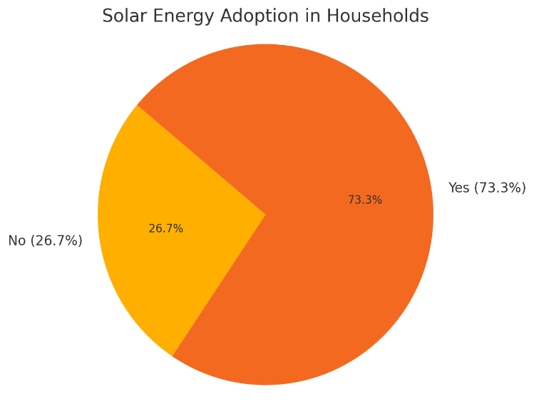
Table 2: Descriptive statistics for solar energy adaption
Descriptive Statistics | N | Mean | Std. Deviation
Use of Solar Energy in Households | 348 | 0.73 | 0.443
Note. Research Data (2025)

Descriptive statistics on access to credit
Based on the findings shown in the descriptive statistics in Table 3 and Figure 2 below, access to credit among respondents in Trans Nzoia County is relatively high. The mean value is 0.76 on a binary scale (where 1 = has access and 0 = no access), with a standard deviation of 0.427. This indicates that approximately 76% of the respondents reported having access to credit facilities, while the remaining 24% do not.
Figure 3 reinforces this pattern, where the majority of responses cluster around access (1), showing that credit availability is moderately well distributed across the population. This finding is crucial when evaluating the enabling environment for solar energy adoption. Credit access plays a pivotal role in the uptake of solar technology, as it directly affects the ability of households to afford the relatively high upfront costs of installation and equipment.
According to Jepkoech and Munene (2024), financial accessibility—including microloans and installment plans—was found to significantly increase the likelihood of solar energy adoption among low- and middle-income households in Kenya. Similarly, Nyangaresi (2024) underscores that access to credit facilities not only facilitates affordability but also boosts consumer confidence in investing in renewable energy infrastructure.
Given the relatively high education levels and moderate income distribution previously discussed, access to credit acts as a critical bridge, making renewable energy a more practical choice. In regions like Trans Nzoia, with high solar potential but economic disparities, access to credit could be the differentiator in scaling household-level adoption.
Figure 2: Access to credit
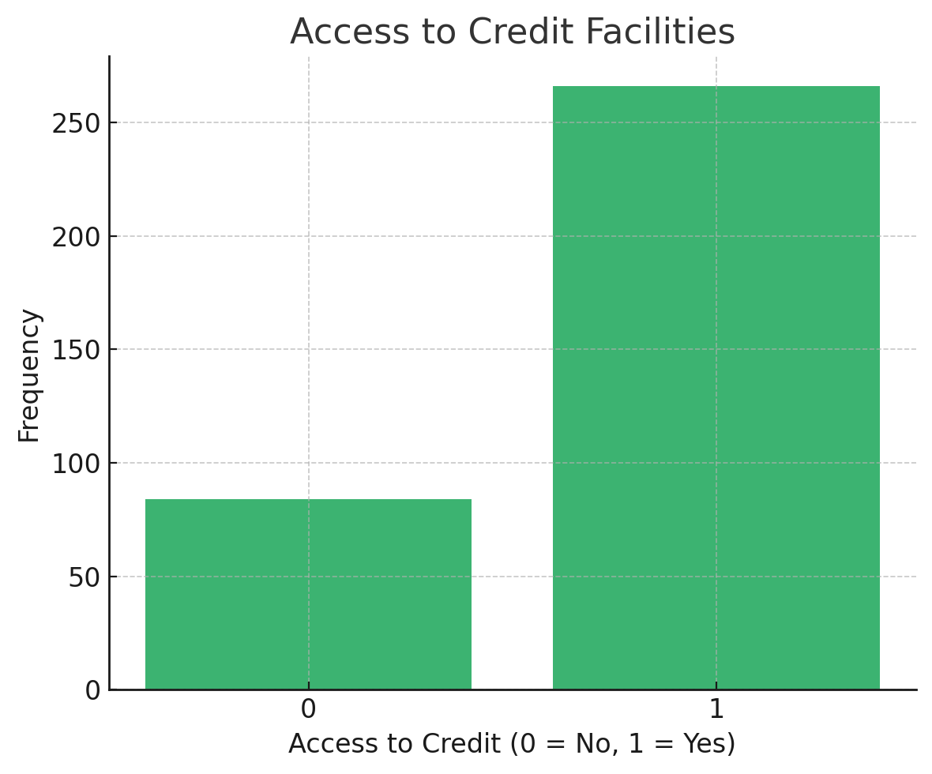
Table 3: Descriptive statistics for access to credit
Descriptive Statistics | N | Mean | Std. Deviation
Access to Credit (Binary: 0 = No, 1 = Yes) | 350 | 0.76 | 0.428
Note. Research Data (2025)

Logistic regression model assumptions
The diagnostic test results presented in Table 4 provide critical insight into the validity, fit, and predictive performance of the binary logistic regression model used to assess factors influencing solar energy adoption.
To begin with, the Block 0 Classification Accuracy (Null Model) is reported at 73.3%, which reflects the model's ability to correctly predict outcomes when only the constant (intercept) is included, and no predictor variables are added. This means that if the model simply predicted every case as "Yes" for solar usage (the majority class), it would be correct 73.3% of the time. While this shows an inherent class imbalance favoring solar adopters, it does not offer explanatory value.
The model’s performance improves substantially in Step 1, when the independent variables are included. The overall classification accuracy increases to 91.4%, with 79.1% of non-adopters and 95.9% of adopters correctly classified. This marked improvement in predictive accuracy demonstrates the usefulness of the selected predictors and confirms that the full model is capable of meaningfully distinguishing between adopters and non-adopters of solar energy.
The Omnibus Test of Model Coefficients yields a Chi-square value of 322.839 (df = 7, p < 0.001), indicating that the inclusion of predictor variables significantly improves the model fit compared to the null model. This result confirms that the predictors as a group explain a statistically significant portion of variance in the dependent variable (solar adoption).
The model fit is further supported by the Nagelkerke R², which is 0.691. This pseudo-R² statistic suggests that the model explains approximately 69.1% of the variance in the likelihood of adopting solar energy. Although not a direct equivalent to R² in linear regression, values above 0.5 in logistic regression are considered strong, especially in behavioral and social science models.
Lastly, the Hosmer-Lemeshow Test, a goodness-of-fit test for logistic regression, produced a Chi-square value of 13.320 with a p-value of 0.101. Since this p-value is greater than the standard threshold of 0.05, it indicates that there is no significant difference between observed and predicted values, implying that the model fits the data well. A non-significant Hosmer-Lemeshow test is desired as it suggests that the model’s estimates align closely with actual outcomes.
Table 4: Logistic regression model assumptions
Model Component | Result / Interpretation
Block 0 Classification Accuracy (Null Model) | 73.3% (predicts all cases as "Yes" for solar usage)
Step 1 Classification Accuracy (Full Model) | 91.4% overall accuracy; 79.1% correctly classified "No", 95.9% correctly classified "Yes"
Omnibus Tests of Model Coefficients | χ² = 322.839, df = 7, p < 0.001 (model significantly better than null model)
Model Fit (Nagelkerke R²) | 0.691 (explains ~69.1% of variance in solar energy adoption)
Hosmer-Lemeshow Test | χ² = 13.320, df = 8, p = 0.101 (non-significant → good model fit)
Note. Research Data (2025)

Correlation Analysis
Based on the results in Table 5 below, the study examined the bivariate relationships between solar energy adoption and four key independent variables: education level, income, access to credit facilities, and awareness of the benefits of solar energy, using Pearson’s correlation coefficient.
The analysis shows that education level is positively correlated with solar energy adoption, with a correlation coefficient of 0.143 (p = .005). This weak but statistically significant relationship suggests that individuals with higher education levels are slightly more likely to adopt solar energy. Similarly, income shows a positive correlation of 0.216 (p < .005) with solar usage, indicating that individuals with higher income are more capable of affording and thus adopting solar energy technologies, though the relationship remains moderate in strength.
A stronger correlation is observed between access to credit facilities and solar energy adoption, with a coefficient of 0.360 (p < .005). This moderate, statistically significant positive relationship underscores the importance of financial access in influencing adoption decisions—households with access to credit are considerably more likely to adopt solar energy.
In contrast, the relationship between awareness of solar energy benefits and adoption is negative and moderate in strength, with a correlation coefficient of -0.478 (p < .005). This inverse relationship may seem counterintuitive, as greater awareness would typically be expected to drive adoption. However, this result could be due to reverse coding of the awareness scale or a behavioral gap where individuals are aware of solar energy benefits but face other barriers such as cost or infrastructure that prevent actual adoption.
Table 5: Correlations results

Use of solar energy |  | Education level |  |  | Income |  | Access to credit facilities |  | Awareness of benefits of solar energy
Use of solar energy | 1
Education level | .143** |  | 1
Education level | (.001)
Income | .216 |  | .623 | 1
Income | (.000) |  | (.000)
Access to credit facilities | .360 |  | .513 | .500 |  | 1
Access to credit facilities | (.000) |  | (.000) | (.000)
Awareness of benefits of solar energy | -.478 |  | -.275 | -.444 |  | -.382 |  | 1
Awareness of benefits of solar energy | (.000) |  | (.000) | (.000) |  | (.000)
**. Correlation is significant at the 0.01 level (2-tailed).
Note. Research Data (2025)

CONCLUSIONS AND RECOMMENDATIONS
This study sought to examine whether selected socio-economic factors influence the adoption of solar energy technologies among households in Trans Nzoia County, Kenya. The primary predictor variables examined were education level, household income, access to credit facilities, and awareness of the benefits of solar energy. The research targeted household energy choices in the county, utilizing cross-sectional survey data analyzed through logistic regression modeling. The findings revealed that education level and awareness significantly influenced solar energy adoption, suggesting that individuals with higher education and greater awareness are more likely to embrace renewable technologies. Access to credit facilities also had a strong positive effect, indicating that financial support mechanisms are critical in overcoming the upfront cost barriers associated with solar technology. In contrast, household income did not show a statistically significant effect, implying that income alone may not directly determine adoption decisions in the absence of enabling conditions such as financing and information. These findings highlight the importance of integrating educational outreach, awareness campaigns, and accessible financing options in strategies aimed at increasing the uptake of solar energy solutions among households in Trans Nzoia County.
First, to enhance the role of education in shaping energy decisions, education policies could incorporate renewable energy topics into school curricula, adult literacy programs, and vocational training. These efforts may help increase energy literacy and enable households to make more informed choices about solar technology adoption. Awareness campaigns might also be expanded through community-based platforms such as local radio stations, agricultural extension services, and barazas to ensure the message reaches rural and marginalized populations.
In light of the strong association between access to credit and solar energy adoption, policies may be developed to facilitate affordable financing mechanisms. This could include encouraging microfinance institutions and commercial banks to offer low-interest, flexible loan products tailored to solar investments. Innovative financial models like pay-as-you-go (PAYG) or lease-to-own arrangements may be promoted to reduce upfront costs. Additionally, the introduction of credit guarantee schemes backed by public agencies might incentivize financial institutions to lend to low-income and rural households.
Regarding awareness, policymakers may prioritize structured information dissemination through regular outreach programs and solar demonstration projects in public institutions like schools and health centers. Such projects could provide visible evidence of solar technology effectiveness, which in turn may help build community trust and accelerate adoption.
Since the study found that income alone does not significantly influence adoption, future policy designs might shift focus from income-based subsidies to holistic frameworks that also address educational access, credit availability, and public awareness. A more integrated strategy could empower even low-income households to adopt solar technologies based on informed decision-making rather than just financial capacity.
County governments may also explore the establishment of Renewable Energy Coordination Units (RECU) to support the implementation and monitoring of these initiatives. These units could coordinate stakeholders, align resources, and ensure that interventions are responsive to the specific context of Trans-Nzoia and similar rural settings.

REFERENCES
AfDB, A. U. C., & UNECA, A. S. Y. (2012). African Development Bank Group. African Union Commission, United Nations Economic Commission for Africa.
African Development Bank. (2019). Off-Grid Solar Market Assessment: Kenya. Abidjan: African Development Bank.
African Union Commission. (2023). Investing in renewable energies for Southern Africa’s sustainable development.
Ahmed, S., Al Mamun, M. R., & Shamsuddin, S. (2022). Factors influencing the adoption of solar energy in Bangladesh: An empirical analysis. Energy Reports, 8, 1019-1029.
Asaduzzaman, M., Rahman, M. M., & Begum, R. A. (2010). Factors affecting the adoption of solar energy technologies in households: A case of Rajshahi city, Bangladesh. International Journal of Renewable Energy Research, 2(4), 667-676.
Biwott, P. K. (2018). Assessing the solar energy resource potential in Trans-Nzoia County for decentralized domestic power generation. University of Nairobi. https://erepository.uonbi.ac.ke/handle/11295/105411
County Government of Trans Nzoia. (2023). Trans Nzoia County Integrated Development Plan 2023-2027.
County Government of Trans-Nzoia. (2018). Trans-Nzoia County integrated development plan 2018-2022.

Felix, R., & Sayas, L. (2023). A Method to Synthesize Hourly Time-series of Solar Power Plants in Peru for Long-Term Planning. Renewable Energy Research and Applications, 4(2), 171-181.
GOGLA. (2019). Global Off-Grid Solar Market Report: Semi-Annual Sales and Impact Data. Retrieved from https://www.gogla.org
Hillerbrand, R., & Goldammer, J. (2018). The socio-economic benefits of decentralized solar energy solutions for rural electrification: A case study in Uttar Pradesh, India. Energy for Sustainable Development, 43, 163-174.
Hosmer, D. W., Lemeshow, S., & Sturdivant, R. X. (2013). Applied Logistic Regression (3rd ed.). Wiley.
IRENA. (2021). Renewable energy market analysis: Kenya. International Renewable Energy Agency.
Jepkoech, S., & Munene, R. W. (2024). Factors affecting adoption of solar power energy projects among households in Baringo County, Kenya. International Academic Journal of Human Resource and Business Administration, 4(4), 218–249. https://mail.iajournals.org/articles/iajhrba_v4_i4_218_249.pdf
Kamau, P. (2023). Exploring the Socio-Economic Implications of Photovoltaic Solar Installation: A Case Study of Githunguri Sub-county, Kenya. Renewable Energy Perspectives, 12(3), 89-104.
Klepacka, A. M., Florkowski, W. J., & Meng, T. (2018). Clean, accessible, and cost-saving: Reasons for rural household investment in solar panels in Poland. Resources, Conservation and Recycling, 139, 338-350.
Msafiri, A. (2009). Factors influencing solar energy adoption in low-income households: A case study in Trans-Nzoia, Kenya. Renewable Energy, 34(1), 18–23.
Mutua, J., & Kimuyu, P. (2015). Factors influencing solar energy adoption in low-income households: A case study in Trans-Nzoia, Kenya. Renewable Energy, 34(1), 18–23

Nyangaresi, A. N. (2024). Assessing the factors influencing the adoption of off-grid renewable energy technologies in Kenya: A case for Kisii County. Strathmore University.
Okello, P. A., & Kimani, M. N. (2022). Examining Factors Influencing Home Solar PV Adoption: Findings from a Cross-Country Study in Tanzania, Kenya, and Uganda. Journal of Sustainable Development, 38(1), 102-115.
Ondraczek, J. (2013). Are we there yet? Improving solar energy use in Kenya through innovation in policies, business models, and technologies. Renewable and Sustainable Energy Reviews, 16(4), 3171-3186.
Ondraczek, J. (2013). The sun rises in the East (of Africa): A comparison of the development and status of solar energy markets in Kenya and Tanzania. Energy Policy, 56, 407–417. https://doi.org/10.1016/j.enpol.2013.01.007
Ongiyo, C. O. (2019). Analysis of socio-economic factors influencing adoption of biogas technology among farm households in North Rift Region, Kenya. PhilArchive. https://philpapers.org/rec/ONGAOS
Onsomu, E. N. (2013). An analysis of the social and economic implications of solar photovoltaic installation in rural areas: The case of Kenya. Journal of Sustainable Development, 6(6), 107-115.
Takase, M., Kipkoech, R., & Essandoh, P. K. (2021). A comprehensive review of energy scenario and sustainable energy in Kenya.
Taneja, J. (2018). Pay-as-you-go solar systems in Kenya: The next leap forward. Center for Global Development. Retrieved from https://www.cgdev.org
Vernet, A., Khayesi, J. N., George, V., George, G., & Bahaj, A. S. (2019). How does energy matter? Rural electrification, entrepreneurship, and community development in Kenya. Energy Policy, 126, 88-98.

