Case report
Superior Iliac Hip Dislocation: A Rare Entity—Case Report and Literature Review

Abstract
Background:
Superior iliac hip dislocation is an extremely rare subtype of traumatic hip dislocation. Because of its unusual presentation and mechanism, it may be difficult to diagnose, and current management principles are mainly derived from isolated case reports in the literature.
Case presentation:
We report the case of a 22-year-old man admitted to the emergency department following a high-energy road traffic accident involving a motorcycle collision with direct trauma to the right hip. Symptoms began approximately three hours before admission. Clinical examination revealed a painful fixed deformity of the right hip maintained in abduction and external rotation, with complete functional impairment. Distal neurovascular examination was normal.
Plain radiographs demonstrated a superior iliac dislocation of the right femoral head. Pelvic computed tomography demonstrated bony lesions involving the posterior and superior walls of the acetabulum, without intra-articular fragments or associated injury of the proximal femur.
Urgent closed reduction was performed under general anesthesia using longitudinal traction with the hip in slight flexion. Post-reduction radiographs confirmed a concentric reduction, and stability testing showed a stable hip up to 90° of flexion.
Conclusion:
Superior iliac hip dislocation is a rare injury that requires early diagnosis and prompt reduction. Computed tomography is essential to detect associated acetabular lesions. Long-term follow-up is recommended because of the potential risk of femoral head osteonecrosis and secondary osteoarthritis.
Keywords:
Hip; Superior iliac dislocation; Road traffic accident; Closed reduction; Case report.

Introduction
Hip dislocation is an orthopedic emergency that requires urgent reduction to prevent serious complications such as femoral head osteonecrosis and post-traumatic arthritis. It usually occurs after high-energy trauma, most commonly road traffic accidents. Posterior dislocations are the most frequent, whereas anterior dislocations are uncommon and include inferior (obturator) and superior (pubic or iliac) types.
Superior iliac hip dislocation is an exceptionally rare injury pattern and has been reported only in a limited number of cases in the literature. Because of its unusual clinical presentation and atypical radiological appearance, it may be misdiagnosed or overlooked during the initial assessment.
In this report, we present a case of superior iliac hip dislocation following high-energy trauma, highlighting its clinical and radiological characteristics, discussing potential diagnostic pitfalls, and reviewing the principles of management of this rare injury.

Case presentation
We report the case of a 22-year-old male patient admitted to the emergency department following a high-energy road traffic accident involving a motorcycle collision with a car, resulting in direct trauma to the right hip. Symptoms began approximately three hours before admission. The patient sustained a closed right hip injury resulting in a superior iliac hip dislocation, with no other clinically evident associated injuries. The patient had no relevant past medical history.
On initial assessment, the patient was alert and cooperative with a Glasgow Coma Scale score(GCS) of 15/15. Hemodynamic and respiratory parameters were stable. Physical examination of the pelvis and right lower limb revealed a painful fixed deformity of the right hip maintained in abduction and external rotation, associated with complete functional impairment. No skin lesions or open wounds were noted. Distal neurovascular examination was normal, with preserved peripheral pulses and no sensory or motor deficits (Fig. 1).
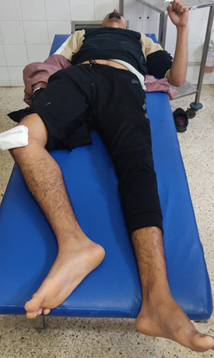
Fig.1: Pre-reduction clinical photograph showing right lower limb shortening with external rotation of the limb

Plain anteroposterior pelvic radiographs demonstrated a superior dislocation of the right femoral head, displaced superiorly and adjacent to the iliac bone, without clearly identifiable associated fractures (Fig. 2).
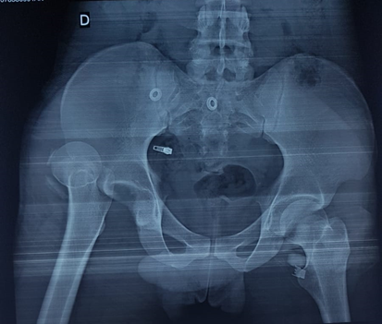
Fig.2: The radiograph demonstrates a superior dislocation of the right femoral head. No associated bony injury is identified

After appropriate preoperative preparation, urgent closed reduction was performed under general anesthesia. The patient was placed in the supine position on a firm table. Counter-traction was applied to the pelvis while longitudinal traction was applied along the femoral axis with the hip maintained in slight flexion (approximately 30°) and the knee flexed. Reduction was achieved without difficulty, with restoration of limb length and alignment.
Following reduction, stability testing demonstrated a stable hip up to 90° of flexion without redislocation. Immediate post-reduction anteroposterior pelvic radiographs subsequently confirmed a concentric reduction of the hip joint (Fig. 3).
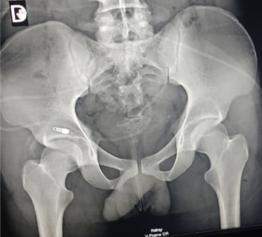
Fig.3: Post-reduction radiographic control
Pelvic computed tomography performed after reduction revealed bony lesions of the posterior and superior acetabular walls with small detached bony fragments, without intra-articular fragments or proximal femoral involvement (Fig. 4)
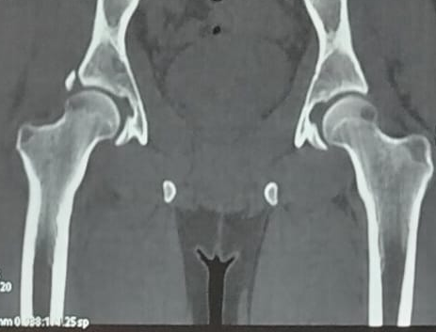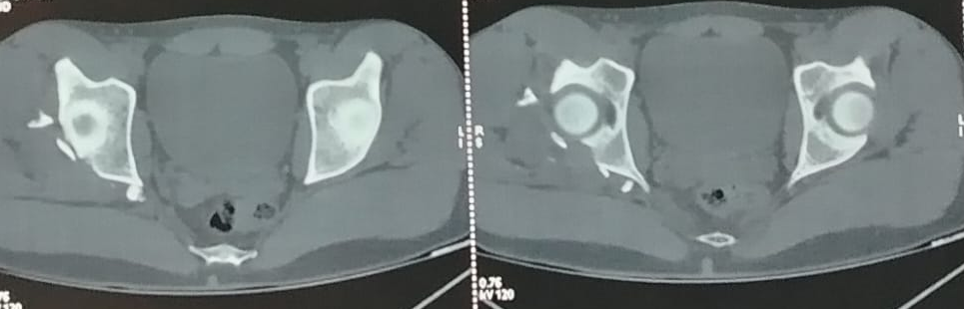
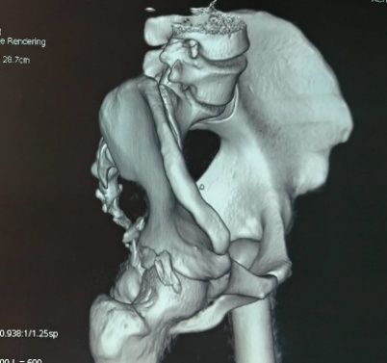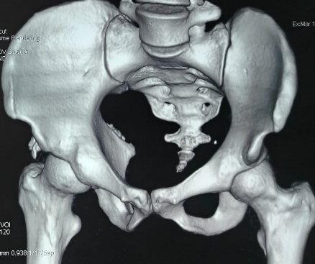
Fig.4: Pelvic CT scan demonstrating bony lesions of the posterior and superior walls of the acetabulum with small detached bony fragments, without intra-articular fragments or involvement of the proximal femur

Post-reduction management consisted of initial bed rest followed by non-weight-bearing ambulation for six weeks. Medical treatment included step II analgesics and prophylactic low-molecular-weight heparin. Clinical and radiological follow-up was planned to monitor functional recovery and to screen for potential late complications, particularly femoral head osteonecrosis and secondary osteoarthritis.
Methods
We report the case of a patient admitted to our emergency department following high-energy trauma, who was subsequently diagnosed with a superior iliac hip dislocation. The patient was managed in a specialized orthopedic trauma unit.
Initial assessment included a thorough clinical examination and standard pelvic radiographs, which established the diagnosis of hip dislocation. Urgent closed reduction was performed under general anesthesia according to institutional trauma protocols.
Post-reduction radiographs were obtained to confirm concentric reduction of the femoral head. Pelvic computed tomography was subsequently performed after reduction to evaluate the acetabulum, detect possible associated bony lesions, and exclude intra-articular fragments.
The patient underwent clinical and radiological follow-up to assess functional recovery and to monitor for potential late complications, particularly avascular necrosis of the femoral head and secondary osteoarthritis.

DISCUSSION
Superior iliac hip dislocation represents an exceptionally rare subtype of traumatic hip dislocation. Unlike the classic posterior pattern, which accounts for the vast majority of traumatic hip dislocations, superior displacement of the femoral head toward the iliac wing is rarely encountered in clinical practice and may therefore be under-recognized. The rarity of this injury explains why most of the available evidence relies on isolated case reports and small case series, with limited consensus regarding optimal management and long-term prognosis. (1,2)
Because of its unusual presentation, superior iliac hip dislocation may initially be misdiagnosed, most commonly as posterior dislocation, particularly in emergency settings. Careful clinical examination remains essential. In our patient, the affected limb was maintained in abduction and external rotation with complete functional impairment, a posture consistent with an anterior or superior displacement mechanism. This differs from the classical presentation of posterior dislocation, which typically involves flexion, adduction, and internal rotation of the limb. (1,3)
Plain radiographs usually allow rapid confirmation of the diagnosis. In the present case, anteroposterior pelvic radiographs demonstrated superior displacement of the femoral head adjacent to the iliac bone, consistent with a superior iliac hip dislocation. However, standard radiographs may fail to detect subtle acetabular lesions or osteochondral injuries.
For this reason, computed tomography is recommended following reduction to evaluate the acetabulum and identify associated injuries that may not be visible on plain radiographs. (4) In our case, pelvic CT performed after reduction revealed bony lesions of the posterior and superior acetabular walls with small detached bony fragments, without intra-articular fragments or proximal femoral involvement. These findings highlight the importance of systematic cross-sectional imaging after hip dislocation to accurately assess associated injuries and guide management. (1,4)
Traumatic hip dislocation typically results from high-energy trauma, most commonly road traffic accidents. In our patient, a motorcycle collision with direct impact to the right hip constituted a typical mechanism capable of producing this severe injury. The superior iliac type is thought to result from combined forces leading to superior and lateral displacement of the femoral head toward the iliac wing. Although rare, similar mechanisms have been described in previously reported cases. (2,5)
Urgent reduction remains the cornerstone of management for all traumatic hip dislocations. Several studies have demonstrated that delayed reduction significantly increases the risk of femoral head osteonecrosis. (1,6) Therefore, reduction should be performed as early as possible after injury. In the present case, reduction was performed within the early hours following trauma, which is considered favorable for preservation of femoral head vascularity.
Closed reduction under general anesthesia remains the first-line treatment in most cases, provided that the dislocation is reducible and that no large associated fractures require surgical fixation. (1) In our patient, reduction was successfully achieved using longitudinal traction along the femoral axis with counter-traction applied to the pelvis while maintaining the hip in slight flexion (approximately 30°). This maneuver allowed atraumatic reduction while minimizing the risk of iatrogenic damage to the femoral head and surrounding soft tissues. Open reduction is reserved for irreducible dislocations, interposed fragments, or major associated fractures. (5)
Following reduction, clinical stability testing demonstrated a stable hip up to 90° of flexion without redislocation, and post-reduction radiographs confirmed concentric reduction of the hip joint. These findings supported the decision to pursue conservative post-reduction management.
Despite successful reduction, traumatic hip dislocation may involve significant soft tissue injury, including capsular disruption, ligamentum teres rupture, or labral tears. These lesions may contribute to late instability or degenerative changes. Advanced imaging such as MRI may be considered in selected cases, particularly if persistent pain or mechanical symptoms develop during follow-up. (4,7)
Post-reduction management protocols remain debated. Historically, traction was frequently used; however, current evidence suggests that routine traction after simple hip dislocation may not provide additional benefit compared with early mobilization. (8) In our case, treatment consisted of initial bed rest followed by non-weight-bearing ambulation for six weeks, allowing protection of the joint and soft tissue healing after high-energy trauma.
Thromboprophylaxis with low-molecular-weight heparin was administered because of temporary immobilization and the increased risk of venous thromboembolism in patients with lower-limb trauma.
The most feared complications of hip dislocation remain avascular necrosis of the femoral head and secondary post-traumatic osteoarthritis, which may develop even after apparently successful reduction. (1,6) These potential complications justify long-term clinical and radiological follow-up. In our patient, early reduction represents a favorable prognostic factor, although careful monitoring remains necessary.
Given the extreme rarity of superior iliac hip dislocation, each additional case contributes valuable information regarding clinical presentation, imaging findings, reduction techniques, and functional outcomes. Further accumulation of cases and multicenter analyses may help improve understanding of this uncommon injury and establish more standardized management recommendations. (2,5)
Conclusion
Superior iliac hip dislocation is an exceptionally rare injury pattern and remains a diagnostic and therapeutic challenge in emergency trauma care. Our case highlights the importance of early recognition based on careful clinical assessment and prompt radiological evaluation to avoid misdiagnosis and delayed management.
Urgent closed reduction under general anesthesia remains the cornerstone of treatment and can achieve satisfactory joint reduction and stability in most cases. Post-reduction computed tomography is essential to identify associated acetabular lesions that may not be visible on plain radiographs.
Despite successful reduction and an initially stable hip joint, long-term clinical and radiological follow-up is mandatory because of the potential risk of late complications, particularly femoral head osteonecrosis and secondary osteoarthritis. Reporting such rare cases contributes to improving the understanding of this uncommon injury and may help guide future management strategies.

Research registration
Not applicable.
Data availability statement
The data generated or analyzed during this study are available from the corresponding author upon request.
Ethical approval
Not applicable. Case reports are exempt from ethical approval at our institution.
Informed consent
Written informed consent was obtained from the patient for publication of this case report and accompanying images.
Conflicts of interest
The authors declare no conflict of interest.

References
- Dawson-Amoah K, Raszewski J, Duplantier N, Waddell BS. Dislocation of the hip: a review of types, causes, and treatment. Ochsner J. 2018;18(3):242-252.
- Dharmshaktu GS, Adhikari N, Mourya P. Superior iliac hip dislocation: a rare injury and literature review. J Orthop Assoc South India. 2020.
- Epstein HC. Traumatic dislocation of the hip. Clin Orthop Relat Res. 1973;92:116-142.
- Mandell JC, Marshall RA, Weaver MJ, Harris MB, Sodickson AD, Khurana B. Traumatic hip dislocation: what the orthopedic surgeon wants to know. Radiographics. 2017;37(7):2181-2201.
- Admani AA, Gakuya EM. Anterior superior dislocation of the hip joint: a report of 3 cases and review of the literature. East Afr Orthop J. 2014;8:71-75.
- Clegg TE, Roberts CS, Greene JW, Prather BA. Hip dislocations: epidemiology, treatment, and outcomes. Injury. 2010;41(4):329-334.
- Reggiori A, Brugo G. Traumatic anterior hip dislocation associated with anterior and inferior iliac spines avulsions and a capsular-labral lesion. Strategies Trauma Limb Reconstr. 2008;3(1):39-43.
- Schlickewei W, Elsässer B, Mullaji AB, Kuner EH. Hip dislocation without fracture: traction or mobilization after reduction? Injury. 1993;24(1):27-31.

