Case report
Primary Central Nervous System Lymphoma Presenting As A Space-Occupying Lesion: A Case Report

.

ABSTRACT

Primary central nervous system lymphoma (PCNSL) is an aggressive and rare subtype of diffuse large B-cell lymphoma, which is specifically confined to the central nervous system (CNS). As a mature B-cell neoplasm, PCNSL's unique features often result in nonspecific clinical presentations, making diagnosis challenging. Here, we present a case of a 62-year-old woman who presented with a 1-week history of right-sided body weakness, altered behaviour, incoherent speech, and facial asymmetry. A Computed Tomography (CT) scan of the brain revealed a space-occupying lesion in the frontoparietal region with associated mass effect and midline shift. The patient underwent an emergency craniotomy with tumour resection, after which she made a good recovery and was discharged home a few days later. Histopathological examination confirmed the diagnosis of primary CNS diffuse large B-cell lymphoma. This case highlights the diagnostic and management challenges associated with PCNSL, which will be discussed in detail.

Keywords: Primary central nervous system lymphoma; Diffuse large B-cell lymphoma; Central nervous system; Brain tumour; Chemotherapy

INTRODUCTION

Lymphoma of the central nervous system (CNS), both primary and secondary, represents a rare but highly aggressive subset of extra-nodal non-Hodgkin lymphoma (NHL) comprising 2.2 % of all central nervous system (CNS) tumours.^{[1]} PCNSL can impact sites anywhere along the entire neuraxis, including the orbits, dura, leptomeninges, brain parenchyma, cranial nerves and spinal cord. On the other hand, secondary CNS lymphoma refers to systemic NHL that has disseminated to the CNS.^{[2]} Diffuse large B-cell lymphoma (DLBCL) is the most common form of PCNSL histology at about 95%, usually localized to the parenchyma, but other locations are also possible, as previously described. While the remaining 5% may consist of T-cell, Burkitt lymphoblastic and marginal zone lymphomas.^{[3]}

PCNSL occurs in both immunocompetent and immunodeficient patients and are more associated with leptomeningeal involvement. Hence primary/congenital and acquired immunodeficiency (particularly HIV and post-transplant conditions) are an important risk factor for PCNSL.^{[2][3]} Patients typically present with an intracranial mass lesion, with a combination of generalized symptoms including increased intracranial pressure associated with non-specific such as headache, cognitive decline, confusion, behavioural disruption, lethargy and lateralizing deficits such as hemiparesis, hemisensory loss or ataxia. However, systemic symptoms such as fever of unknown origin, night sweats and weight loss which are a common presentation in systemic lymphoma may not be present in PCNSL.^{[3][4]} Furthermore, leptomeningeal disease may cause cranial neuropathies or symptoms localizing to the cauda equina presenting as urinary retention or saddle anaesthesia. Direct nerve invasion can cause a painful radiculopathy. Ocular involvement may happen in as many as 25% of patients and they may present with report of frank visual deficit.^{[2]}

Following these symptoms, further evaluation would follow by neuroimaging, either with MRI or CT scan. Once diagnosis is made, treatment of PCNSL may include surgery, chemotherapy and radiotherapy. In some cases, a combination of corticosteroids, chemotherapy and radiotherapy may be curative or provide long-lasting palliation for patients in good clinical condition.^{[5]} The prognosis of PCNSL remains poor despite evolvement of treatment options. Median survival described between 17-45 months after symptomatic treatment.^{[6]} This case report reviews the presentation, diagnosis, treatment, and prognosis of PCNSL, contributing to the growing body of literature on this challenging disease.

CASE PRESENTATION

We report a case of a 62-year-old lady with no known medical illness previously. She presented with right sided body weakness for a week and associated with altered behaviour, incoherent speech and facial asymmetry. She denied headache, nausea, vomiting, trauma, unsteady gait or seizures. Clinical examination noted she is alert with Glasgow coma scale (GCS) was 15 and pupils 3mm bilaterally reactive. There was presence of weakness of her right side of body with muscle power of 4 out of 5. CT brain was done for her which showed a left frontoparietal space occupying lesion with perilesional oedema and midline shift and mass effect. She was admitted and underwent emergency surgery craniotomy and tumour excision. Intraoperatively the tumour was pale looking with high vascularity, removed in total, otherwise brain is pulsatile.

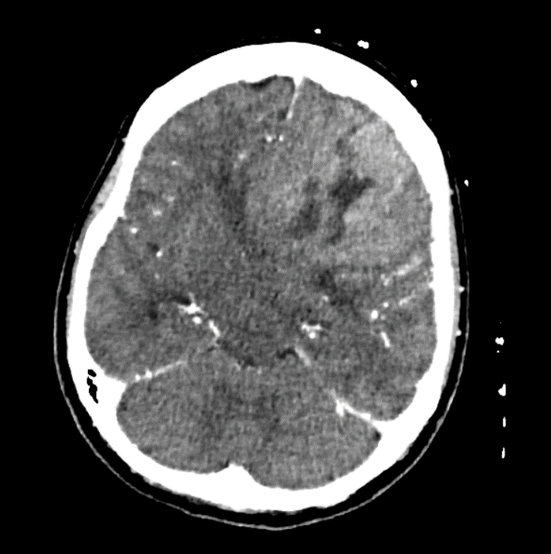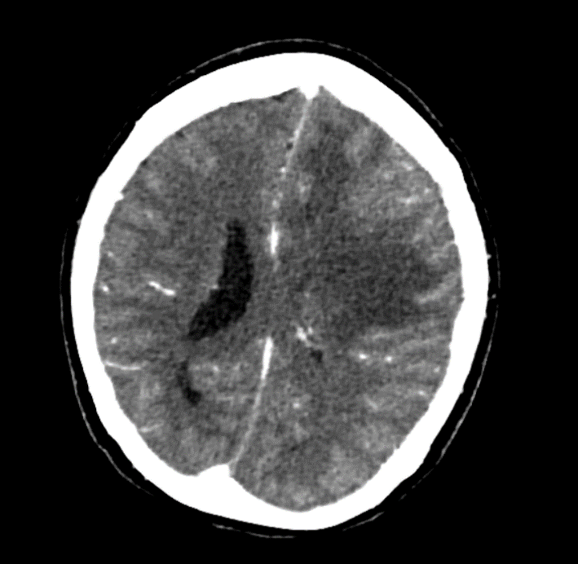
Figure 1: CT contrast showed isodense mass at left frontal lobe which appears intra-axial and demonstrate enhancement. Within the lesions, there are areas of hypodensities likely necrosis. No calcification noted. There is associated cerebral oedema, mass effect, midline shift and obstructive hydrocephalus, suspicious of primary brain tumour with differential of glioma.

Post operatively, she has good recovery. GCS remains full with slight improvement of power over her right side of body. CT brain post operatively showed improving midline shift. She was allowed discharge with dexamethasone on a tapering dosage. In clinic review she has much improved recovery, ambulating without aid or assistance and no residual neurological deficit. Histopathological report came back as primary CNS DLBCL. Immunohistochemical stains showed the tumour cells are positive for CD20, BCL-6, MUM-1and BCL2; negative for CKAE1/AE3, GFAP, CD3, CD10 (<30%) and C-MYC; Ki-67 proliferation index high ~90%. She was then referred to haematology team for further management. Evaluation by haematology team, proceeded with pre-chemo workup and PET CT and bone marrow aspiration and trephine biopsy (BMAT). Results of BMAT showed no lymphomatous infiltration. PET scan showed hypermetabolic area involving residual left frontal lobe and left parietal lobe causing midline shift, no FDG avid disease elsewhere. She was then started on her first cycle of chemotherapy with rituximab, methotrexate, procarbazine, and vincristine (R-MPV). She has improvement after the first chemo and follow on for subsequent chemo with intrathecal therapy.

During follow up, she underwent MRI brain after the first chemo, showed left enhancing solid component within the surgical cavity measuring 3.4x3.2x4.0cm which demonstrate T2W/FLAIR hyperintense signal with patchy enhancement at the posterior aspect of the lesion, this suggests residual tumour. She was then continued on for further chemotherapy cycle.
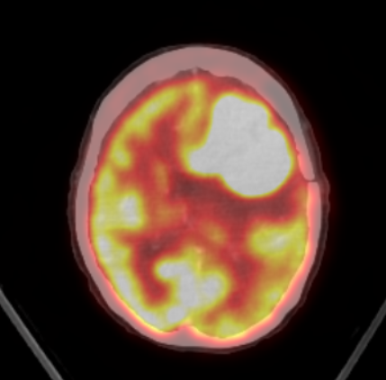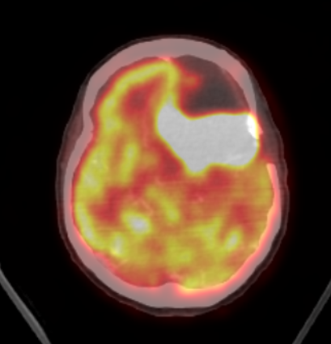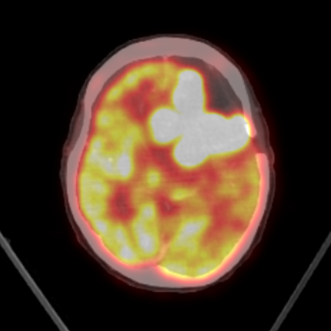
Figure 2: post-operative PET scan showed hypermetabolic area involving residual left frontal lobe and left parietal lobe causing midline shift

DISCUSSION

Primary CNS DLBCL is an extremely rare tumour with aggressive behaviour. It can present in ways that mimic other brain tumour such as gliomas or metastases hence making initial diagnosis challenging. As mentioned earlier, PCNSL have been associated with immunodeficient patients but incidence in immunocompetent patients have shown an increment. As for our patient she did not show evidence of immunodeficiency. Studies have shown that in immunocompetent populations, the median age of PCNSL occurrence is 53–57 years old, with a male: female ratio of 1.2:1. Meanwhile, the occurrence of PCNSL in immunocompromised populations, the median age of occurrence is 31–35 years old, with a male: female ratio of 7.38:1.^{[6]}

In the process of making diagnosis for PCNSL involves relevant clinical features, radiological investigations, and tissue biopsy.^{[7]} As clinical features may not be diagnostic, visible tumour on imaging is essential to ensure an early brain biopsy and histologic diagnosis. CT and MRI can be the initial radiological investigations done for PCNSL. Unenhanced CT typically reveals hyper- or isoattenuated lesions, while enhanced CT may demonstrate briskly enhancing lesions that are often peri-ventricular and lack central necrosis so the enhancement is diffuse; surrounding oedema is variable. The tumour is single in 60–70% of patients and multiple in the remainder. Almost all immunodeficient patients have multiple lesions at diagnosis. On the contrary, MRI may prove to be more ideal and is the imaging of choice. Conventional MRI may not be reliable to differentiate CNS lymphoma from other neoplastic lesion in the brain such as metastases, malignant gliomas, meningiomas; or nonneoplastic diseases like multiple sclerosis, stroke, pyogenic abscess; as most lesions only showed marked contrast enhancement both at CT and MRI.^{[8]}

Hence MRI with Perfusion-weighted Gadolinium contrast is the imaging of choice. Often MRI reported involved a single brain lesion either located in the hemispheres, basal ganglia, corpus callosum, and periventricular regions (66%), supratentorial location (87%), or frontoparietal lobes (39%). Less frequently, the eyes (15–25%), cerebrospinal fluid (7–42%) and only in rare cases, the spinal cord is involved. Additional imaging such as fluorodeoxyglucose–positron-emission tomography (FDG-PET) reportedly may aid in distinguishing PCNSL from other lesions.^{[8]}

In our case, PET scan was done post operatively which showed hypermetabolic area involving residual left frontal lobe and left parietal lobe causing midline shift. But no other significant hypermetabolic activity elsewhere that may suggest distance metastasis. In the typical PCNSL, the metabolic pattern shown in the PET scan is an area of high homogeneous increase of 18F-FDG, mostly in the subcortical regions. Often, this area is more visible at visual analysis due to the presence of hypometabolism in the adjacent cortex because of compression or oedema. These patterns are also seen in disease recurrence too. PET scan also plays vital role in staging of PCNSL at diagnosis or follow up as it can helps to diagnose systemic disease with higher sensitivity than conventional imaging. it can exclude systemic lymphoma at presentation.^{[1]} A study by Mohile et al showed a 7% of patients with suspected PCNSL were found to have systemic NHL by total body FDG-PET, while CT scans and bone marrow biopsies were negative. Moreover, total body FDG PET was positive in 27% of patients during restaging for recurrent disease. However, high uptake of basal ganglia, cortex and thalamus makes diagnosis difficult. Hence, tissue diagnosis or pathological analysis is still the gold standard.^{[1][3]}

Tissue diagnosis can be obtained either through biopsy or through surgical resection. Studies compares the outcomes of surgical resection vs biopsy. From a systematic review by Rafal et al noted there are few studies that indicate surgical resection may improve overall survival and progression free survival, while other studies found that no significant difference between resection and biopsy.^{[9]} Especially if the patients are over 70, with multiple or deep-seated lesions, or with low Karnofsky Performance Status (KPS). On the contrary, study by Schellekes et al. found that patients under 70 with superficially located single lesions and a postoperative KPS >70 benefited significantly from resection. Often, patients selected for biopsy are those that have multiple or deep-seated lesions; they are older and not fit for surgery.^{[9]} In a separate study, surgical resection is important for management of PCNSL especially when in combination with chemotherapy and radiotherapy.^{[6]} Complications from both either surgical resection and biopsy includes surgical site infection, meningitis, cerebrospinal fluid leak, intracranial bleeding, seizure, focal deficit and brain infarction. In a study by Alexis et al, showed that biopsy have low rate of complications. On the other hand, study by Rafal et al showed there are no significant difference of complications between surgery and biopsy.^{[9]}
Primary central nervous system lymphoma (PCNSL) is highly sensitive to both chemotherapy and radiation, which can improve patient survival. High-dose methotrexate (HD-MTX)-based chemotherapy is the recommended first-line treatment.^{[9][10]} However, while effective, relapse is common. Up to half of patients may have relapse and 10% to 15% have primary refractory disease.^{[11]} In our case, haematology team started her on a chemotherapy regimen of rituximab, methotrexate, procarbazine, and vincristine (R-MPV). In a trial involving treatment with R-MPV, there is a complete response rate of 47-79% in patient receiving 5-7 cycles of chemotherapy respectively.^{[1]} Standard treatments for other lymphomas, like diffuse large B-cell lymphoma (DLBCL), are ineffective for PCNSL due to poor penetration across the blood-brain barrier (BBB).^{[11]} Some studies report a 90% response rate and a median survival of 60 months with combinations like HD-MTX and procarbazine. Meanwhile, temozolomide, which crosses the BBB, has also shown effectiveness and may be used in refractory cases.^{[6]} Stem cell transplant (ASCT) can help address chemoresistance and in cases of relapse or refractory.^{[10][11]} As for radiation therapy, whole brain irradiation of 40–50 Gy followed by localized irradiation of 60 Gy on regions of oedema is recommended as the best regimen.^{[6]} Previously whole-brain radiotherapy (WBRT) has been used to treat newly diagnosed PCNSL. Overall response rates (ORRs) reached 90%, but overall survival (OS) was limited to 12 to 18 months. When it is added to the HD-MTX treatment, it enhanced and prolonged survival in PCNSL.^{[11]}

Conclusion

In conclusion, primary central nervous system lymphoma (PCNSL) is a rare but aggressive form of diffuse large B-cell lymphoma, with a challenging diagnosis due to its nonspecific clinical presentation. While advancements in neuroimaging, biopsy techniques, and treatments, including chemotherapy and radiotherapy, have improved management, PCNSL remains a difficult disease to treat, especially due to frequent relapses and its resistance to conventional systemic therapies. This case underscores the importance of early diagnosis and a multidisciplinary approach to optimize outcomes, though the prognosis for PCNSL continues to be poor despite evolving therapeutic options.

References

- Phillips, E. H., Fox, C. P., & Cwynarski, K. (2014). Primary CNS Lymphoma. Current Hematologic Malignancy Reports, 9(3), 243–253. doi:10.1007/s11899-014-0217-2
- Green K, Munakomi S, Hogg JP. Central Nervous System Lymphoma. [Updated 2024 May 28]. In: StatPearls [Internet]. Treasure Island (FL): StatPearls Publishing; 2024 Jan-. Available from: https://www.ncbi.nlm.nih.gov/books/NBK545145/
- Chiavazza C, Pellerino A, Ferrio F, Cistaro A, Soffietti R, Rudà R. Primary CNS Lymphomas: Challenges in Diagnosis and Monitoring. Biomed Res Int. 2018 Jun 21;2018:3606970. doi: 10.1155/2018/3606970. PMID: 30035121; PMCID: PMC6033255.
- Deckert M, Engert A, Brück W, Ferreri AJ, Finke J, Illerhaus G, Klapper W, Korfel A, Küppers R, Maarouf M, Montesinos-Rongen M, Paulus W, Schlegel U, Lassmann H, Wiestler OD, Siebert R, DeAngelis LM. Modern concepts in the biology, diagnosis, differential diagnosis and treatment of primary central nervous system lymphoma. Leukemia. 2011 Dec;25(12):1797-807. doi: 10.1038/leu.2011.169. Epub 2011 Aug 5. PMID: 21818113.
- van Westrhenen A, Smidt LCA, Seute T, Nierkens S, Stork ACJ, Minnema MC, Snijders TJ. Diagnostic markers for CNS lymphoma in blood and cerebrospinal fluid: a systematic review. Br J Haematol. 2018 Aug;182(3):384-403. doi: 10.1111/bjh.15410. Epub 2018 May 29. PMID: 29808930; PMCID: PMC6099264.
- Chen D, Gu W, Li W, Liu X, Yang X. Primary diffuse large B-cell lymphoma of the central nervous system: A case report and literature review. Oncol Lett. 2016 May;11(5):3085-3090. doi: 10.3892/ol.2016.4365. Epub 2016 Mar 22. PMID: 27123068; PMCID: PMC4840863.
- Mandal S, Shah S, Gami S, Ray B, Poulose J. A Case Report on Primary Central Nervous System Lymphoma in Immunocompetent Individual. Cureus. 2021 Jun 28;13(6):e15990. doi: 10.7759/cureus.15990. PMID: 34336481; PMCID: PMC8318614.
- Haldorsen, I. S., Kråkenes, J., Krossnes, B. K., Mella, O., & Espeland, A. (2009). CT and MR Imaging Features of Primary Central Nervous System Lymphoma in Norway, 1989–2003. American Journal of Neuroradiology, 30(4), 744–751. doi:10.3174/ajnr.a1447
- Chojak R, Koźba-Gosztyła M, Polańska K, Rojek M, Chojko A, Bogacz R, Skorupa N, Więcław J, Czapiga B. Surgical resection versus biopsy in the treatment of primary central nervous system lymphoma: a systematic review and meta-analysis. J Neurooncol. 2022 Dec;160(3):753-761. doi:
- Steffanoni S, Calimeri T, Marktel S, Nitti R, Foppoli M, Ferreri AJM. Diagnosis and Treatment Using Autologous Stem-Cell Transplantation in Primary Central Nervous System Lymphoma: A Systematic Review. Cancers (Basel). 2023 Jan 15;15(2):526. doi: 10.3390/cancers15020526. PMID: 36672475; PMCID: PMC9856418.
- Grommes C, DeAngelis LM. Primary CNS Lymphoma. J Clin Oncol. 2017 Jul 20;35(21):2410-2418. doi: 10.1200/JCO.2017.72.7602. Epub 2017 Jun 22. PMID: 28640701; PMCID: PMC5516483.

