Case report
LIMB RECONSTRUCTION SYSTEM IN THE PRIMARY MANAGEMENT OF COMPOUND SEGMENTAL TIBIAL SHAFT FRACTURE : A CASE REPORT

ABSTRACT
An open segmental shaft fracture is one of the most complex types of fracture in orthopedic injury, which is basically caused due to high-energy trauma and is associated with either soft tissue damage, compromised vascularity, and high risk of infection and non-union. Achieving stable fixation remains a significant challenge. The Limb Reconstruction System (LRS) is based upon the principle of biological fixation and distractive osteogenesis and provides a minimally invasive option that allows stable fixation and effective wound healing management with early mobilization.
A 23-year-old male patient presented with the open segmental fracture of the right tibial shaft due to a road accident. Clinical findings showed an anteromedial open wound with exposed bone and soft tissue contamination. Radiographs confirmed a segmental tibial fracture with an associated fibular fracture (Gustiulo-Anderson Type II/IIIA) either type IIIA or type II. Emerging management included resuscitation, intravenous antibiotics, and tetanus prophylaxis followed by urgent surgical intervention. Thorough wound debridement was performed, and stabilization was achieved using LRS fixation. Early mobilization and weight-bearing were initiated; several follow-ups showed progressive healing with complete radiological union at one year. The patient achieved an excellent recovery with full range of motion of the knee and ankle and no complications such as infection, pin tract issues, nonunion, or limb length discrepancy.
The limb reconstruction system is a safe and effective modality for managing complex open segmental tibial fractures. It provides stable fixation, preserves the biological milieu, enables early rehabilitation, and also results in excellent functional and radiological outcomes with minimal complications. The limb reconstruction system is used as a preferred alternative in the management of high-risk fractures.

Keywords: Limb Reconstruction System,Tibial Shaft, Trauma Surgery, Fracture

INTRODUCTION
Tibial shaft fracture is the most common long bone fracture, (Sharr PJ,et al.year) making them one of the most frequent long bone injuries encountered in orthopedic treatment, because the tibia is located subcutaneously(Shen M et al year), especially in the anteromedial surfaces, these fractures are linked to open injuries(Cannada LK et al). Due to inadequate soft tissue covering, impaired vascularity, and a significantly higher risk of infection and nonunion, open or complex tibial fractures provide substantial therapeutic problems.(Templeman DC et al)

A more severe category of these injuries are segmental tibial fractures, which are characterized by multiple fractures located within the same bone and are frequently brought on by severe trauma like auto accidents.(Corey RM et al) These fractures are linked to significant soft tissue injury, instability, and challenges in attaining the best possible fracture healing. In these situations, it may not always be appropriate to use traditional fixation techniques such plating or intramedullary nailing, particularly if there is soft tissue loss and an infection risk.(Shen M et al)

Based on the concepts of compression distraction histogenesis and distraction osteogenesis, the limb reconstruction system is a flexible external fixation tool that will result in stable fixation while maintaining the biological milieu of the fracture site(UIKEY et al). Effective wound care, early mobilization, and weight bearing are all made possible by the Limb Reconstruction System, which enhances functional results and lowers problems.(Mylsamy et al)

In this case study a young male had a complex segmental tibial shift fracture that was treated with LRS fixation. The purpose of the paper is to demonstrate the clinical efficacy of this method in attaining fracture union, preserving limb length, and minimally complicating the restoration of functional mobility.

CASE PRESENTATION

A 23-year-old male patient came to the hospital with the complaints of severe pain, swelling, and bleeding from his right leg due to a road traffic accident. The injury was sustained due to high velocity trauma, and the patient was brought to the emergency department shortly after the incident. (Figure 1)
On initial examination, the patient was conscious and oriented and was hemodynamically stable. Local examination of the right leg revealed an open wound over the anteromedial aspect of the tibia/leg with active bleeding and a visible bone fragment. (Figure 1). There was a soft tissue injury with contamination of the wound. The affected limb was tender with abnormal mobility and crepitus on the fracture site. Distal neurovascular status was intact, with palpable dorsal is pedis and posterior tibial pulses and no sensory and motor deficit.
The injury was provisionally diagnosed as an open segmental fracture of the tibial shaft with an associated fibular fracture; based upon the clinical findings, it was categorized under the GustiloAnderson classification (Type II / Type IIIA). Type 3A.
Radiographic evaluation of the anteroposterior and lateral views of the leg confirmed a segmental fracture of the tibia shaft with a fracture of the fibula (Figure 2) with no additional injuries of the skeleton identified. Emergency management was initiated as per advanced Trauma Life Support protocol. The patient received intravenous fluid, IV Ceftriaxone, and tetanus prophylaxis. Urgent surgical intervention was planned.
Under anesthesia, wound debridement was performed using a copious amount of normal saline to remove devitalized tissue and other contamination. after adequate debridement. An LRS fixator was applied, and care was taken to place the pins away from the zone of injury to allow for proper wound care and to prevent risk of infection. The fixator was applied to achieve optimal alignment and stability, and after the compression was applied at the fracture site to reduce the fracture gap. What’s about soft tissue management??
Postoperative radiography shows proper alignment and fixation with the LSR external fixator (Figure 3 and Figure 4). The limb was immobilized with the LRS fixator in situ. Postoperatively, the patient was started on IV Ceftriaxone and Tramadol. Early mobilization was encouraged with partial weightbearing initiated as tolerated, along with active and passive range of motion exercise of the knee and ankle joint to prevent stiffness (Figure 5, Figure 6, Figure 7).
The patient was discharged in stable condition with advice for regular follow-up after 1 month, 3 months, 6 months, and 1 year postoperatively. By 1 year, a good functional outcome was seen (figure
8).
Functionally the patient showed excellent recovery. At the final follow-up, the range of motion was
Knee: 0 to 135
Ankle plantar flexion: 0 to 45 Ankle dorsiflexion: 0 to 20.
There were no postoperative complications such as pain, tract infection, loosening or breakage of pins, joint stiffness, neurovascular compromise, chronic osteomyelitis, or limb length discrepancy.

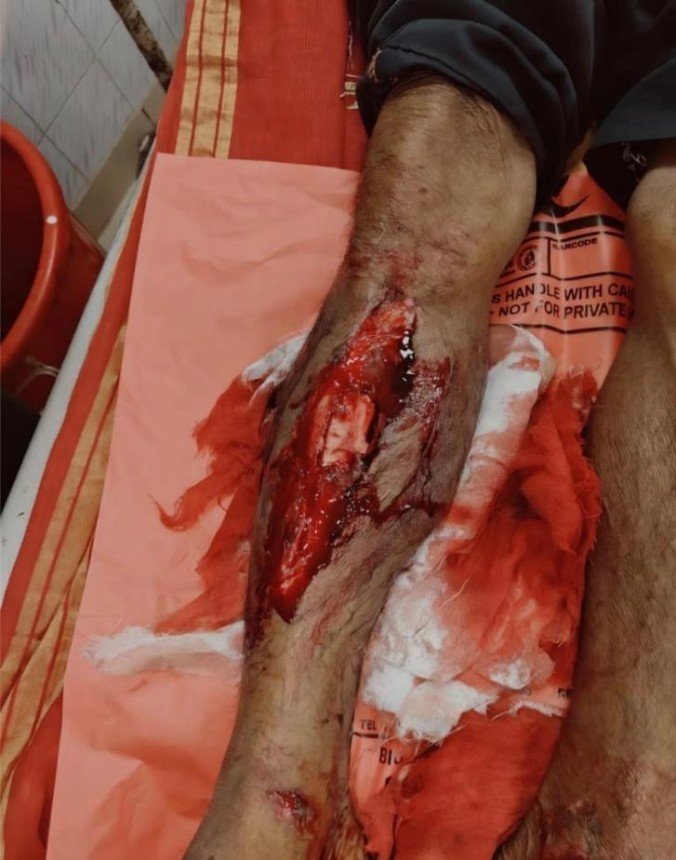

Fig 1: Open segmental fracture of right tibial shaft with exposed bone.

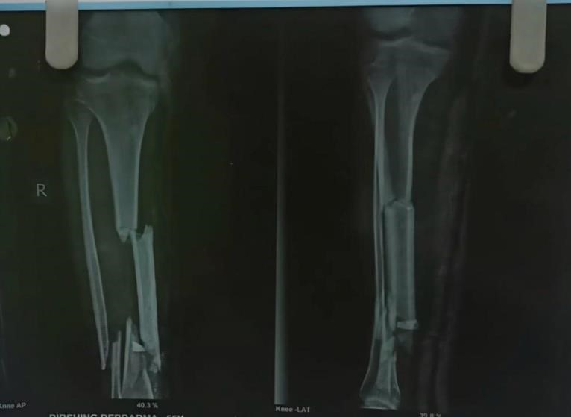

Fig 2 : Anteroposterior and lateral radiographs showing segmental fracture of tibial shaft with associated fibular fracture.

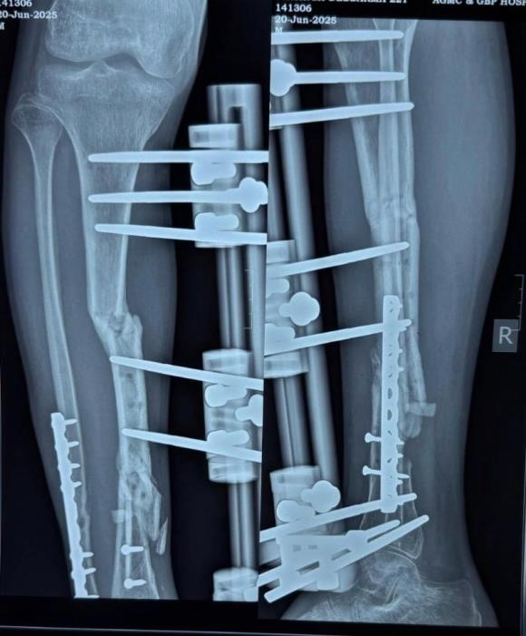

Fig 3: Postoperative radiograph showing alignment of tibial shaft fracture with LRS fixator in situ.
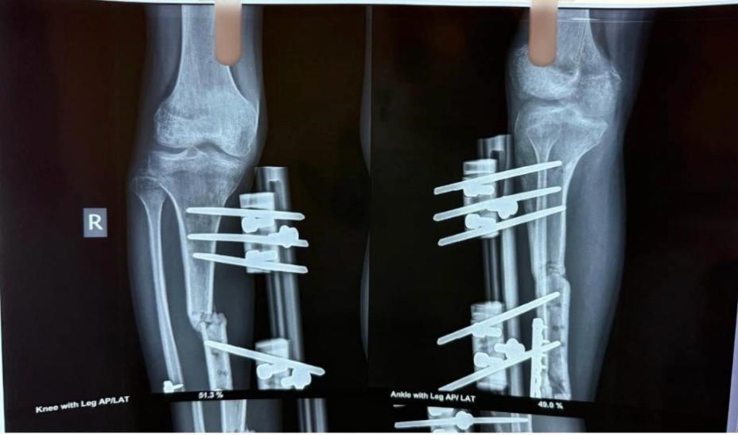
Fig 4:Postoperative radiograph showing stabilization of tibial fracture with LRS fixator.

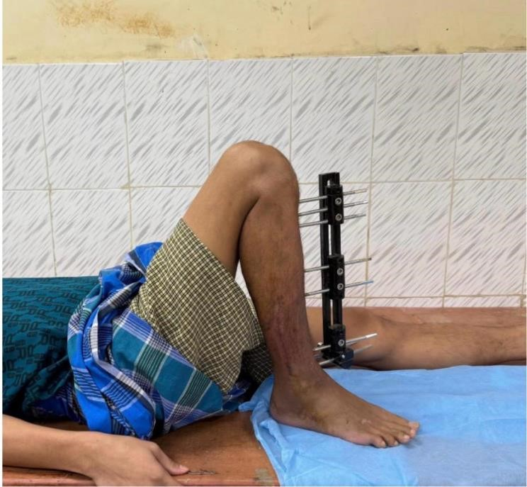

Fig

5:

Early

postoperative

clinical

image

showing

LRS

fixator

in

situ.

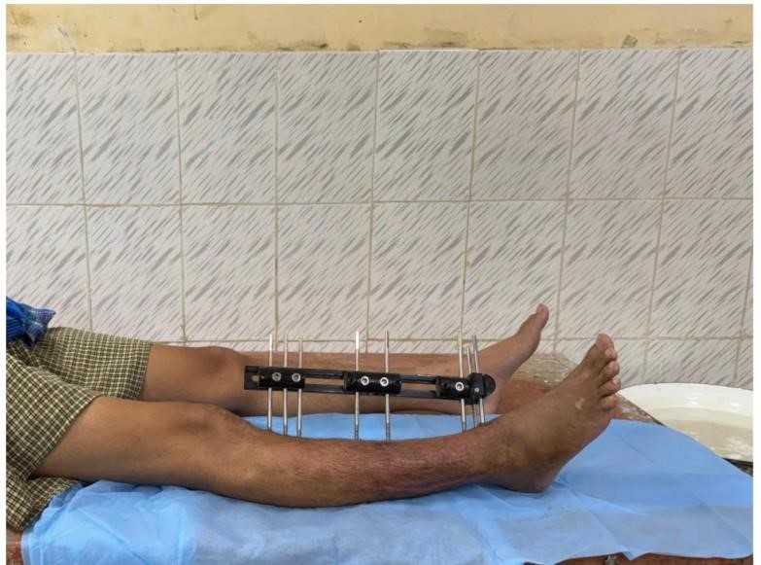

Fig 6: Follow-up image showing maintained alignment with LRS fixator.

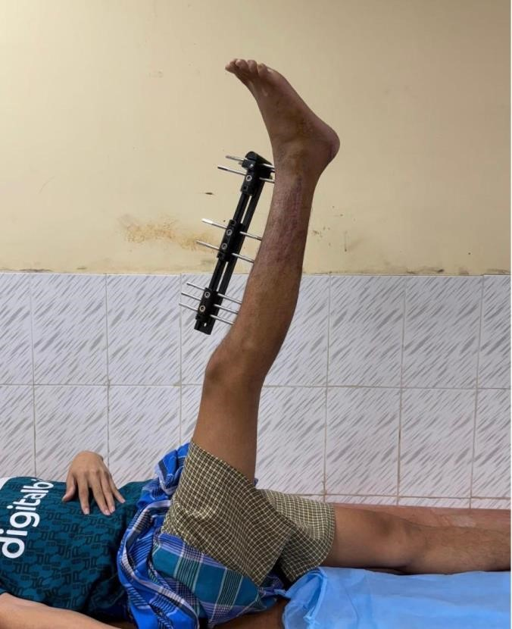
Fig 7: Follow-up image showing progression towards fracture healing.

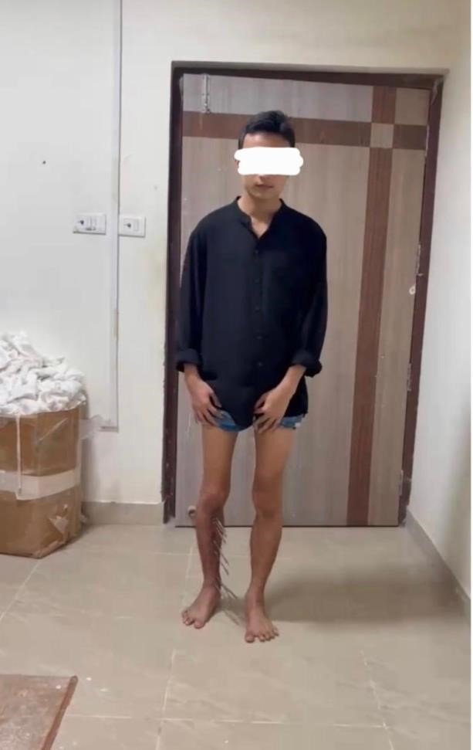

Fig 8: Final follow-up showing complete union of tibial shaft fracture.

DISCUSSION
The management of open segmental tibial fractures remains complex to achieve stable fixation while minimizing complications due to extensive tissue loss and bone comminution.(Stone JP et al) In the present case, the use of LRS resulted in satisfactory fracture union and excellent functional recovery. In this report, a male patient around 23 years old with an open segmental fracture of the tibial shift was managed with debridement and stabilization using a limb reconstruction system. which showed a complete radiological union at one year and excellent functional recovery without any complication. This finding is similar to previous published literature, which supports the effectiveness of LRS in managing open tibial fractures.
Patil MY et al. reported the outcome of 54 patients with open tibial fractures, which were treated with LRS, which demonstrated a high union rate and showed excellent results based on the ASAMI criteria. Their study concluded that LRS provides stable fixation while preserving the biological environment necessary for fracture healing, which is similar to the outcome of our study.
Bishnoi S et al. evaluated the LRS in compound tibial fractures and reported an excellent outcome of around 70% of patients with low complication rates. There was no complication of pin tract infection and joint stiffness.
Mangukiya HJ et al. compared LRS with AO monolateral external fixator and reported better functional and radiological outcomes with LRS, particularly in terms of fracture alignment and patient comfort. In this present case, satisfactory and full range of motion at the knee and ankle joint were achieved, which correlates with the advantage of LRS devices. describe in the study
Adherence to the open fracture care paradigm, which involves early and thorough debridement, proper antibiotic medication, stable fixation, and early rehabilitation, is responsible for the success seen in this specific case.(Minehara H et al) By regularly supplying blood to the bone, the LRS external fixator stabilizes the fracture and encourages appropriate healing through the creation of calluses.(Paulino et al) The danger of infection can be decreased by positioning the pins away from the damaged region.(Shakir et al)However, because this is a case report, there are certain limitations; the findings cannot be generalized to other individuals. Furthermore, no comparison with alternative treatment approaches was done. To gain a better understanding of the significance of LRS in treating complicated open tibial fractures, large-scale patient studies are required.
In summary, this case demonstrates that early debridement in conjunction with LRS external fixation is a safe and efficient treatment option for open segmental tibial fractures, providing good functional and radiological results with few complications when used in accordance with sound surgical principles.
CONCLUSION
In conclusion, this case shows an excellent functional and radiological outcome in an open segmental tibial fracture due to early debridement and stabilization using a limb reconstructive system. This technique provides stable fixation, promotes bone healing, and also results in early mobilization with minimal complications. However, this is a single case report; further studies with a large sample size are required to confirm the effectiveness and wider use of LRS in managing complex tibial fractures.

Pls correct the citations. Follow standard citation system either Vancouver or Harvard system.

REFERENCES

- Sharr PJ, Buckley RE. Current concepts review: open tibial fractures. Acta Chir Orthop Traumatol Cech. 2014;81(2):95-107. PMID: 25105791.
- Shen M, Tejwani N. Open tibial shaft fracture fixation strategies: intramedullary nailing, external fixation, and plating. OTA Int. 2024 Jun 5;7(4 Suppl):e316. doi: 10.1097/OI9.0000000000000316. PMID: 38840705; PMCID: PMC11149753.
- Cannada LK, Anglen JO, Archdeacon MT, Herscovici D Jr, Ostrum RF. Avoiding complications in the care of fractures of the tibia. J Bone Joint Surg Am. 2008 Aug;90(8):1760-8. PMID:
18676909.
- Templeman DC, Anglen JO, Schmidt AH. The management of complications associated with tibial fractures. Instr Course Lect. 2009;58:47-60. PMID: 19385519.
- Corey RM, Park NK, Cannada LK. Segmental Tibia Fractures: An Analysis of Complication and
Healing Rates. J Orthop Trauma. 2018 Jun;32(6):296-300. doi:
10.1097/BOT.0000000000001132. PMID: 29432320.
- UIKEY, KISHOR & BHALAVI, MONA & SAIYAM, SHELENDRA & HR,
JHUNJHUNWALA. (2022). MANAGEMENT OF COMPLICATED TRAUMA BY LIMB RECONSTRUCTION SYSTEM (MONO-LATERAL EXTERNAL FIXATOR) IN LOWER
EXTREMITY. Asian Journal of Pharmaceutical and Clinical Research. 157-161. 10.22159/ajpcr.2022.v15i12.46302.
- Mylsamy, Arun & Sengodan, Vetrivel. (2025). Functional outcome of limb reconstruction system in lower limb compound fractures: A prospective study. Indian Journal of Orthopaedics Surgery. 11. 48-55. 10.18231/j.ijos.2025.010.
- Stone JP, Mears DC, Jarrett J. The management of open and complex fractures of the tibia. Bull N Y Acad Med. 1980 Apr;56(3):323-40. PMID: 6929201; PMCID: PMC1805150.
- Patil MY, Gupta SM, Kurupati SK, Agarwal S, Chandarana V. Definitive Management of Open Tibia Fractures Using Limb Reconstruction System. J Clin Diagn Res. 2016 Jul;10(7):RC01-4. doi: 10.7860/JCDR/2016/17978.8124. Epub 2016 Jul 1. PMID: 27630916; PMCID:
PMC5020215.
- Bishnoi S, Gupta S, Saraf A, Singh SK, Parakh NK, Kumar SK. Functional and Radiological
Outcome of Ilizarov Ring Fixator versus Limb Reconstruction System in Compound Tibial Diaphyseal Fractures Grade II, IIIA, and IIIB. J Orthop Case Rep. 2025 Nov;15(11):339-349. doi: 10.13107/jocr.2025.v15.i11.6398. PMID: 41281870; PMCID: PMC12636848.
- Mangukiya HJ, Mahajan NP, Pawar ED, Mane A, Manna J. Functional and radiological outcome in management of compound tibia diaphyseal fracture with AO monolateral fixator versus Limb reconstruction system. J Orthop. 2018 Jan 31;15(1):275-281. doi: 10.1016/j.jor.2018.01.041.
PMID: 29657482; PMCID: PMC5895934.
- Minehara H, Maruo A, Amadei R, Contini A, Braile A, Kelly M, Jenner L, Schemitsch GW,
Schemitsch EH, Miclau T 3rd. Open fractures: Current treatment perspective. OTA Int. 2023 Jun
16;6(3 Suppl):e240. doi: 10.1097/OI9.0000000000000240. PMID: 37533445; PMCID:
PMC10392445.
- Paulino, M. F., Roseiro, L. M., Balacó, I., Neto, M. A., & Amaro, A. M. (2022). Evaluation of
Bone Consolidation in External Fixation with an Electromechanical System. Applied Sciences,
12(5), 2328. https://doi.org/10.3390/app12052328
- Shakir, Irshad MD; Ganash, Rajan BS; Watson, J. Tracy MD. Lower extremity nontensioned traction pins: is it a benign procedure?. Current Orthopaedic Practice 29(1):p 63-67, January/February 2018. | DOI: 10.1097/BCO.0000000000000572

