Case report

Gallstone Ileus in an Elderly Female Patient : Case Report

Abstract: Gallstone ileus is a rare but important cause of mechanical small bowel obstruction, particularly in elderly patients. It accounts for approximately 1–4% of all bowel obstructions but may represent up to 25% of non-strangulated obstructions in patients over 65 years of age. We present the case of a 68-year-old female who presented with signs of intestinal obstruction secondary to gallstone impaction. Computed tomography revealed pneumobilia, a cholecystoduodenal fistula, and small bowel obstruction consistent with gallstone ileus. The patient underwent timely surgical intervention with enterolithotomy, resulting in an uneventful recovery. This case highlights the importance of early diagnosis, appropriate surgical decision-making, and individualized management strategies in elderly patients.
Keywords: gallstone ileus, cholecystoduodenal fistula, biliary-enteric fistula, enterolithotomy, small bowel obstruction

Introduction: Gallstone ileus is an uncommon but clinically significant complication of cholelithiasis, resulting from the passage of one or more gallstones into the gastrointestinal tract through a biliary-enteric fistula, most commonly a cholecystoduodenal fistula [1]. This condition leads to mechanical obstruction, typically at the level of the terminal ileum due to its relatively narrow lumen and reduced peristaltic activity.
Although gallstone ileus accounts for a small proportion of all intestinal obstructions, its incidence increases significantly with age. In elderly populations, particularly those over 65 years, it may account for up to one-quarter of non-strangulated small bowel obstructions [2]. The condition is more frequently observed in females, likely reflecting the higher prevalence of gallstone disease in this population.
The clinical presentation of gallstone ileus is often non-specific and may include intermittent abdominal pain, nausea, vomiting, and signs of bowel obstruction. This variability frequently results in delayed diagnosis, contributing to relatively high morbidity and mortality rates, reported between 7% and 18% [3]. Advances in imaging, particularly computed tomography (CT), have significantly improved diagnostic accuracy.
This report presents a case of gallstone ileus in an elderly female patient, emphasizing diagnostic challenges, surgical management, and relevant considerations in current clinical practice.

Case Presentation: A 68-year-old female presented to the emergency department with a three-day history of progressively worsening abdominal pain, predominantly localized to the right upper quadrant. The pain was associated with nausea, multiple episodes of vomiting, and absence of bowel movements for the preceding 24 hours. She also reported low-grade fever.
Her medical history was significant for hypertension and chronic gastritis. There was no previously documented history of gallstone disease or prior abdominal surgery.
On physical examination, the patient appeared mildly dehydrated. Abdominal examination revealed distension, tenderness in the right upper quadrant, and reduced bowel sounds. There were no signs of peritonitis.
Laboratory investigations demonstrated leukocytosis (white blood cell count: 17,000/µL), elevated liver enzymes (AST: 125 U/L, ALT: 142 U/L), mildly elevated gamma-glutamyl transferase (GGT: 70 U/L), and elevated C-reactive protein (CRP: 18 mg/L), suggesting an inflammatory process.
Contrast-enhanced abdominal CT imaging revealed classical findings consistent with gallstone ileus, including pneumobilia, evidence of a cholecystoduodenal fistula, and dilated small bowel loops with a transition point indicating obstruction (Figure 1). A hyperdense intraluminal mass consistent with a gallstone was identified within the small intestine.
Initial management included intravenous fluid resuscitation, electrolyte correction, and nasogastric decompression. Given the radiological findings and clinical deterioration, the patient was taken to the operating room within 24 hours.

Surgical Intervention: Exploratory laparotomy revealed dilated small bowel loops with a clear transition point approximately 100 cm proximal to the ileocecal valve. A large gallstone measuring approximately 4 cm in diameter was identified as the cause of obstruction.
A longitudinal enterotomy was performed proximal to the site of impaction, and the gallstone was successfully extracted (Figure 2). The enterotomy was subsequently closed transversely to reduce the risk of luminal narrowing.
No attempt was made to perform cholecystectomy or fistula repair during the same operation, given the patient’s age and comorbidities, and the priority of minimizing operative time and surgical risk.
The postoperative course was uneventful. The patient resumed oral intake gradually and was discharged on postoperative day three. Plans were made for interval evaluation regarding elective cholecystectomy and fistula closure.

Discussion: Gallstone ileus represents a rare but important cause of mechanical bowel obstruction, particularly in elderly populations. It arises as a late complication of chronic cholelithiasis, where repeated inflammation leads to the formation of a biliary-enteric fistula, allowing gallstones to migrate into the intestinal lumen.
The pathophysiology involves chronic inflammation of the gallbladder wall, adhesions to adjacent bowel, and eventual erosion leading to fistula formation. The most common fistula type is cholecystoduodenal, accounting for approximately 70% of cases [4-5].
Clinical presentation is often variable and may be intermittent due to the “tumbling phenomenon,” where the gallstone temporarily obstructs and then moves distally. This contributes to diagnostic delay, which is associated with increased morbidity.
CT imaging is considered the gold standard for diagnosis, with high sensitivity and specificity. The presence of Rigler’s triad—pneumobilia, bowel obstruction, and an ectopic gallstone—is highly suggestive of gallstone ileus [6-7]. In addition, CT allows precise localization of the obstruction and assessment of complications such as bowel ischemia.
From a surgical perspective, the primary goal is relief of obstruction. Enterolithotomy alone remains the most widely accepted approach, especially in elderly or high-risk patients. This approach is associated with shorter operative time and lower morbidity compared to one-stage procedures that include cholecystectomy and fistula repair [8-9].
The debate regarding optimal surgical management remains ongoing. While a one-stage procedure may reduce the risk of recurrent gallstone ileus and biliary complications, it carries a higher risk of perioperative complications. Therefore, patient selection is critical, and a staged approach is often preferred in elderly or comorbid individuals[10].
In the present case, enterolithotomy alone was performed, which aligns with current evidence favoring a conservative surgical approach in high-risk patients. The favorable postoperative outcome further supports this strategy.
Stone size is another important factor in gallstone ileus. Stones larger than 2–2.5 cm are more likely to cause obstruction, with most cases involving stones between 2 and 5 cm in diameter [11]. The 4 cm gallstone in our patient is consistent with this observation.
The most common site of impaction is the terminal ileum, due to its anatomical and functional characteristics. The location of obstruction in our case, approximately 100 cm proximal to the ileocecal valve, is consistent with typical findings.
Early diagnosis and timely intervention are crucial in reducing morbidity and mortality. This case underscores the importance of considering gallstone ileus in elderly patients presenting with signs of bowel obstruction, even in the absence of a known history of gallstones[12-13].

Conclusion: Gallstone ileus is a rare but potentially life-threatening condition that should be considered in elderly patients presenting with intestinal obstruction. Prompt diagnosis using CT imaging and appropriate surgical management are essential to improve outcomes. Enterolithotomy alone remains a safe and effective treatment option in selected patients, particularly those with significant comorbidities.

References:
- Dai XZ, Li GQ, Zhang F, Wang XH, Zhang CY. Gallstone ileus: Case report and literature review. World J Gastroenterol. 2013; 19(33): 5586–5589. doi: 10.3748/wjg.v19.i33.5586.
- Morosin T, De Robles MSB, Putnis S. Gallstone Ileus: An Unusual Cause of Intestinal Obstruction. Cureus. 2020; 12(3): e7284. doi:10.7759/cureus.7284.
- Kirchmayr W, Mühlmann G, Zitt M, et al. Gallstone ileus: Rare and still controversial. ANZ J Surg. 2005; 75(4): 266-269. doi: 10.1111/j.1445-2197.2005.03368.x.
- Ploneda-Valencia CF, Gallo-Morales M, Rinchon C, Navarro-Muñiz E, Bautista-López CA, de la Cerda-Trujillo LF, Rea-Azpeitia LA, López-Lizarraga CR. Gallstone ileus: An overview of the literature. Rev Gastroenterol Mex. 2017 Jul-Sep;82(3):248-254. English, Spanish. doi: 10.1016/j.rgmx.2016.07.006. Epub 2017 Apr 19. PMID: 28433486.
- Artioli G, Muri M, Praticò FE, Marcantoni EA, Gazzani SE, Lana S, Bacchini E, Capretti G, Muri M, Torri T. Gallstone ileus: literature review. Acta Biomed. 2016 Jul 28;87 Suppl 3:40-4. PMID: 27467866.
- Masannat Y, Masannat Y, Shatnawei A. Gallstone ileus: a review. Mt Sinai J Med. 2006 Dec;73(8):1132-4. PMID: 17285212.
- Tsang CF. A rare case of gallstone ileus—the unanswered question. J Surg Case Rep. 2021; 2021(4): rjab164. doi: 10.1093/jscr/rjab164.
- Salazar-Jiménez, M. I., Alvarado-Durán, J., Fermín-Contreras, M. R., Rivero-Yáñez, F., Lupian-Angulo, A. I., & Herrera-González, A. (2018). Íleo biliar, revisión del manejo quirúrgico [Gallstone ileus, surgical management review]. Cirugia y cirujanos, 86(2), 182–186. https://doi.org/10.24875/CIRU.M18000032
- Alemi, F., Seiser, N., & Ayloo, S. (2019). Gallstone Disease: Cholecystitis, Mirizzi Syndrome, Bouveret Syndrome, Gallstone Ileus. The Surgical clinics of North America, 99(2), 231–244. https://doi.org/10.1016/j.suc.2018.12.006
- Chang, L., Chang, M., Chang, H. M., Chang, A. I., & Chang, F. (2018). Clinical and radiological diagnosis of gallstone ileus: a mini review. Emergency radiology, 25(2), 189–196. https://doi.org/10.1007/s10140-017-1568-5
- Brezean, I., Aldoescu, S., Catrina, E., Fetche, N., Marin, I., & Păcescu, E. (2010). Gallstone ileus: analysis of eight cases and review of the literature. Chirurgia (Bucharest, Romania : 1990), 105(3), 355–359.
- Zappia, F., Petracca, G., & Talarico, C. A. (2017). Gallstone ileus. A case treated with minilaparotomy and a review of the literature. Annali italiani di chirurgia, 6, S2239253X1702535X.
- Jakubauskas, M., Luksaite, R., Sileikis, A., Strupas, K., & Poskus, T. (2019). Gallstone Ileus: Management and Clinical Outcomes. Medicina (Kaunas, Lithuania), 55(9), 598. https://doi.org/10.3390/medicina55090598
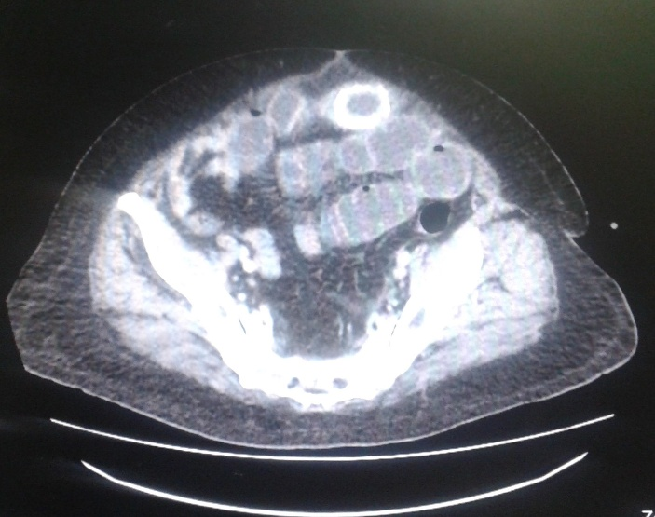
Figure 1: Abdominal CT scan demonstrating pneumobilia, dilated small bowel loops, and an ectopic gallstone consistent with Rigler’s triad.
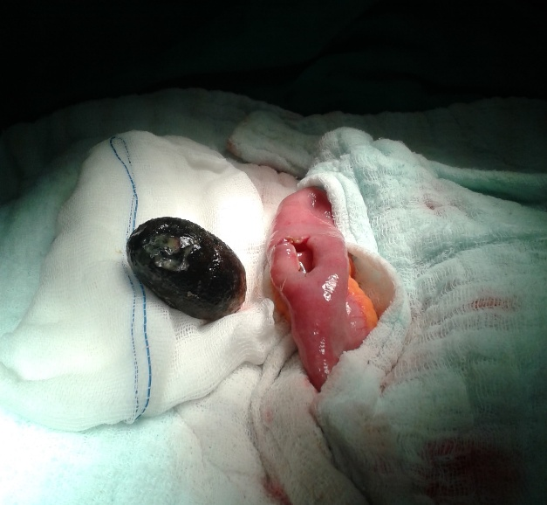
Figure 2: Intraoperative view showing the extracted gallstone measuring approximately 4 cm following enterotomy.

