Review Article
Exploring the Role of Quantum Dot–Based Nanotechnologies for Nematode Detection and Management: A Review

Abstract
Nematodes are among the most extensive metazoan species groups because their populations exist in various habitats which include soil, freshwater, marine, agricultural and forest locations. The study of nematodes presents challenges because researchers need to study their biological functions and behaviour patterns and their capacity to move and grow their populations but face difficulties because the organisms remain hidden at microscopic dimensions and there are no working devices that enable researchers to observe their activities in real time. The management of plant-parasitic nematodes requires the use of chemical nematicides which create major dangers that affect both environmental ecosystems and human health. The new quantum dot-based nanotechnology of carbon quantum dots (CQDs) provides a solution for current technological challenges present in this field. The review presents an extensive analysis which evaluates current research that demonstrates how quantum dots function in nematode detection and visualisation and physiological assessment and management. The research demonstrated that CQDs present two different functions which depend on their concentration level according to the results of recent case studies that examined three types of nematodes which included plant-parasitic nematodes (Bursaphelenchus xylophilus), entomopathogenic nematodes (Steinernema spp.) and model nematodes (Caenorhabditis elegans). At low concentrations, CQDs function as biocompatible fluorescent labels which permit in vivo tracking and ecological research because they do not produce lethal or sublethal or transgenerational effects. The extended exposure of organisms to high CQD concentrations results in physiological stress which leads to locomotion and reproduction problems. Accordingly, this review stresses on the multifunctional capacity CQDs as bridging tools between nematode detection and sustainable management. It also gives the future research directions and challenges regarding their safe and effective applications.

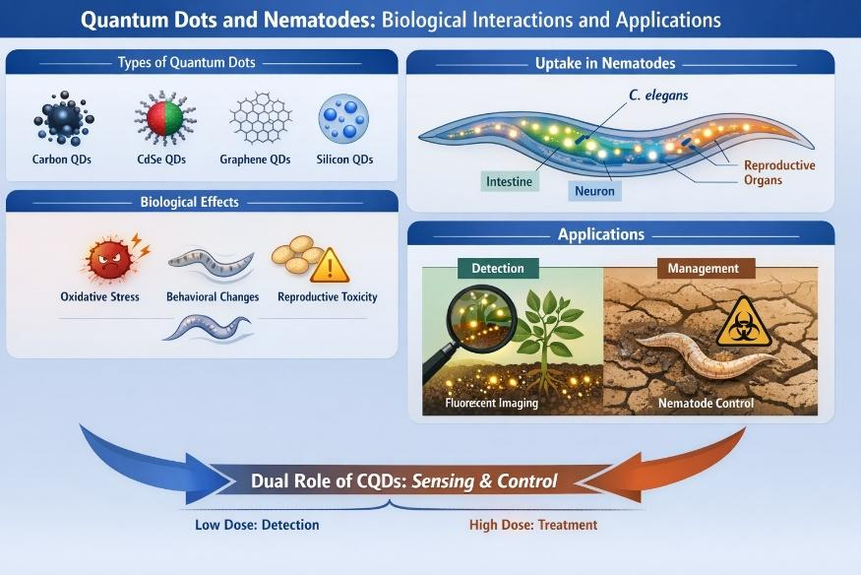

Graphical Abstract

Keywords- Quantum dots, nematode detection, nanotoxicology, xenobiotic metabolism sustainable nematode management
1. Introduction
Nematodes are among the most numerous animals globally, with millions of individuals estimated per square meter of soil and present in almost all trophic levels (Hoogen et al., 2019). Nematodes in agro-ecosystems play various roles where free-living species support nutrient cycling and soil health, entomopathogenic nematodes (EPNs) such as Steinernema and Heterorhabditis spp. are significant biological control agents, as well as plant parasitic nematodes like Meloidogyne spp and Bursaphelenchus xylophilus that cause debilitating yield losses in crops and forests (Hazir et al., 2024; Jones et al., 2013; Kikuchi et al., 2011). However, nematode research faces persistent technical challenges. Traditional methods of identification and tracking rely on morphological taxonomy or molecular diagnostics, which consume much time, require special expertise and are hardly applicable to vast population numbers or field conditions (Kikuchi et al., 2011; Espada et al., 2016). Caenorhabditis elegans is a very helpful model organism to study the biosafety, uptake, biodistribution, transgenerational effects and molecular mechanisms of the biological responses to nanomaterials like quantum dots and carbon, based nanoparticles (Wu et al., 2019; Li et al., 2021). The study of nematode movement, survival and interactions in soil is similarly constrained by the lack of effective in vivo labelling methods. Alongside these challenges, nematode control has traditionally revolved around chemical nematicides, including organophosphates, carbamates and macrocyclic lactones, with many posing significant concerns about environmental persistence, toxicity to non-target organisms and human health implications (Kang et al., 2012; Rajasekharan & Ramesh, 2017).
Nanotechnology has emerged as a revolutionary approach in agriculture and biological sciences to provide novel materials having unique physicochemical properties. Lim et al., 2015; Wang and Hu, 2014). Although the first semiconductor QDs based on cadmium and selenium provided excellent imaging results, the associated toxicity limited their use in the environment (Feliu et al., 2016; Liang et al., 2022). Carbon quantum dots (CQDs), which are mostly composed of carbon, hydrogen and oxygen, are safer alternatives with a high degree of biocompatibility, inexpensive and have more options in terms of synthesis (Sun et al., 2006; Cao et al., 2012). For the purpose of nematode detection and management, this review focusses specifically on carbon quantum dots and critically assesses recent developments in quantum dot-based nanotechnologies. Based on imaging, behavioural and transcriptomic evidence, the present review aims to critically evaluate the recent advances in quantum dot–based nanotechnologies with respect to nematode detection and management and to show how carbon quantum dots (CQDs) can serve the dual role of innocuous bio-labels and potent stressors relevant to nematode control depending on the mode of exposure to the QD nanoparticles.
3. Quantum Dots Used in Nematology: Types, Properties and Biological Relevance
3.1 Types of Quantum Dots Applied in Nematode Research
To this end, a variety of quantum dots have been employed in nematode-based nanotechnological studies, using the Caenorhabditis elegans model organism to assess uptake, biodistribution, toxicity and transgenerational effects. These quantum dots have been classified as carbon-based, metal-based semiconductor, graphene-related, silicon-based and polymer-functionalized. Carbon quantum dots (CQDs) are the most widely studied classes in nematology due to their low intrinsic toxicity, high water solubility and strong fluorescence. CQDs with glucose, citric acid and other biomass precursors have been successfully employed for in-vivo labelling, long-term tracking and physiology pertinence determinations in C. elegans, Bursaphelenchus xylophilus and entomopathogenic nematodes (Steinernema spp.) with predominantly intestinal uptake and dose-dependent biotic effects (Kang et al., 2015; Han et al., 2021; San-Blas et al., 2025).

Metal-based semiconductor quantum dots such as CdS, CdSe, CdTe and CdS/ZnS core-shell have also been studied in the nematode systems mainly for nanotoxicological purposes. C. elegans studies have also established that these quantum dots cause oxidative stress, delay in development, reduced fertility and shortened lifespan, factors that are linked to cadmium ion leakage and reactive oxygen species (Qu et al., 2011; Zhao et al., 2015). Their high toxicity outweighs their optical benefits against environmental or agricultural nematological application. Graphene quantum dots (GQDs), which are composed of a few-layer graphene fragments, have been investigated as a type of intermediate regime that retains the advantage of a carbon-based material but with higher crystallinity. The biocompatibility of graphene quantum dots (GQDs) with Caenorhabditis elegans was better than with cadmium-based quantum dots but worse than carbon quantum dots (CQDs), as exposure to oxidized and doped GQDs caused moderate toxicity, increased reactive oxygen species and behavioural impairment at high concentrations (Deng et al., 2018; Qu et al., 2019).
Studies with silicon quantum dots (Si-QDs) have been assessed in very few nematode studies, primarily the comparative biosafety evaluation. These non-metallic semiconductor quantum dots show less toxicity than cadmium ones but, on the whole, have much weaker fluorescence intensity, limiting their scope of use to strictly laboratory-controlled investigations (Li et al., 2013). In addition, polymer-coated and surface-functionalized QDs-including PEGylated and ligand-modified systems have been employed in C. elegans. The evidence suggests that surface functionalization can completely alleviate acute toxicity but cannot circumvent bioaccumulation and long-term physiological implications (Feliu et al., 2016).
Quantum Dots Used in Nematology

Carbon-Based QDs
• Carbon Quantum Dots (CQDs)
• Graphene Quantum Dots (GQDs)
Semiconductor QDs
• CdSe
• CdTe
• ZnS
Surface-Functionalized QDs
• PEGylated
• Amino-functionalized

Doped Quantum Dots
• N-doped
• S-doped

Figure 1 – Classification of Quantum Dots Used in Nematology

Type of QD | Composition | Main Model Nematode | Primary Application | Toxicity Level | Key Reference
CQDs | Carbon-based | C. elegans, B. xylophilus, Steinernema spp. | Imaging, dual role | Low–Moderate | Han et al., 2021
CdSe/CdTe QDs | Cadmium-based | C. elegans | Nanotoxicology | High | Qu et al., 2011
GQDs | Graphene-based | C. elegans | Oxidative stress study | Moderate | Deng et al., 2018
Si-QDs | Silicon-based | C. elegans | Comparative biosafety | Low | Li et al., 2013
Table 1. Types of quantum dots investigated in nematode research and their biological relevance
3.2 Quantum Dots and Carbon Quantum Dots: Properties Relevant to Nematode Studies
Quantum dots are nanoscale (less than 20 nm) particles that experience quantum confinement and, therefore, have size-dependent absorption and emission spectra (Brus, 1983; Ekimov et al., 1985). Their high brightness, resistance to photobleaching and broad excitation coupled to narrow emission bands have led to numerous applications in bioimaging and sensing (Sadhu and Patra, 2013; Song et al., 2019).
Carbon quantum dots are compositionally and, in terms of toxicity differ from metal-based QDs. Examples of common precursors for the hydrothermal, microwave-assisted, or pyrolytic QD synthesis include glucose, citric acid, urea, or biomass and many surface functional groups exist on CQDs to facilitate water solubility and biological interactions (Atchudan et al., 2018; Lim et al., 2015). CQDs demonstrate low cytotoxicity compared to cadmium QDs in various biological models, including zebrafish, mice and nematodes (Kang et al., 2015; Singh et al., 2018). For nematode research, CQDs present an advantageous aptitude of (i) strong intrinsic fluorescence for the transparent organism, (ii) long-term photostability for extended periods of observation and (iii) tunable size and surface chemistry which can be altered to influence biological uptake and effects (Xu et al., 2018; Cong et al., 2019).
4. Carbon Quantum Dots for In Vivo Labelling and Visualisation: Case Studies
4.1 Labelling of Entomopathogenic Nematodes
The research conducted by San-Blas et al. in 2025 established a groundbreaking achievement which enabled scientists to use two carbon quantum dot types for successful in vivo labelling of Steinernema feltiae infective juvenile (IJ) specimens. The CQDs showed a gradual increase in fluorescent capacity during in vitro tests because they mostly concentrated in lysosome-like organelles found inside intestinal cells. The fluorescence intensity reached its highest point after about fourteen days which stayed visible for multiple months and maintained visibility even when the nematodes were moved to uncontaminated water. The study found no lethal effects or sublethal effects or transgenerational effects because all three tested abilities showed no changes across different generations. The research shows that traditional dyes and heavy-metal QDs lead to negative effects on nematode fitness while displaying fast photobleaching properties according to Chazotte (2011) and Shaner et al. (2005). The authors showed that non-experts could identify and separate labelled EPNs from unlabelled or morphologically similar nematodes through their method which displayed successful soil matrix application.
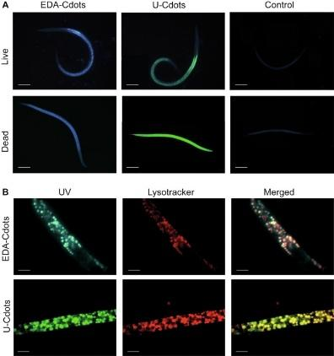

Figure 2. Fluorescence microscopy image of Steinernema feltiae infective juveniles after being treated with carbon quantum dots (CQDs) in vivo. The intestinal region is brightly fluorescent, which suggests that the carbon quantum dots have accumulated inside lysosome, like organelles. This picture shows that the nematodes not only successfully ingested the dots but also that the fluorescence remained stable inside them. Thus, carbon quantum dots can be used as bioimaging probes for long, term in vivo studies. Adopted from San-Blas et al. (2025)

4.2 Semiconductor Quantum Dot–Labelled Nanocarriers for In Vivo Imaging in Nematodes –
One highly communicable case of semiconductor quantum dot, assisted imaging in nematodes is the work of Stavitskaya et al. (2021), who explored the in vivo distribution of label CdS and Cd₀.₇Zn₀.₃S quantum dot, tagged halloysite nanotubes (HNTs) in Caenorhabditis elegans. Here, HNTs were decorated with fluorescent semiconductor quantum dots and given to the worms through feeding. Fluorescence microscopy made it possible to observe the nanoparticles' entry and distribution inside the nematodes in real time. The strongest pharyngeal region and tail fluorescence signals showed the nanocomposites' uptake and later internal transport. The comparative imaging, optical, fluorescence, and then merged overlay images, confirmed the presence of CdS/HNT, Azine, Cd₀.₇Zn₀.₃S/HNT, Azine and CdS/HNT, NH inside the nematodes while pristine halloysite nanotubes revealed only a dim fluorescence. The use of semiconductor quantum dot, functionalized nanotubes allow in vivo tracking, biodistribution studies and nanotoxicological evaluation of nematodes with high sensitivity and accuracy. In this respect, the strategy may be considered as an invaluable tool for furthering the investigation of nanoparticle delivery and the bioimaging of nematodes.

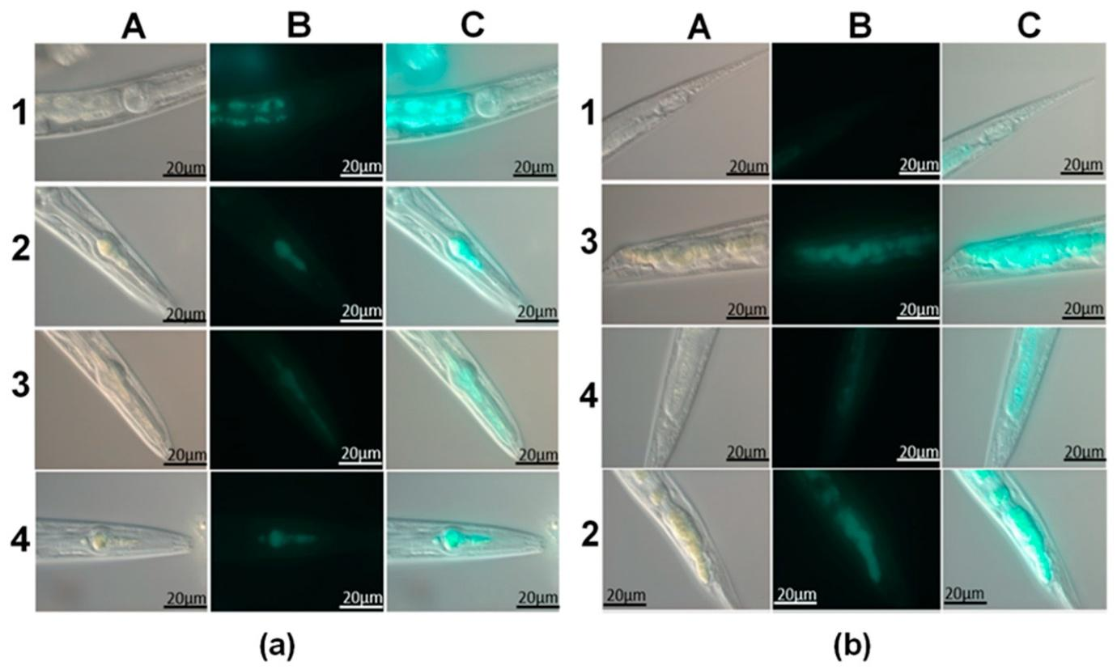

Figure 3. Representative micrographs of Caenorhabditis elegans following ingestion of fluorescently labelled halloysite nanotubes. (a) Pharyngeal region and (b) tail region of the nematodes. For each treatment: A- bright-field (optical) images; B- fluorescence images; C- merged images showing alignment of optical and fluorescence signals. Treatments include (1) pristine halloysite, (2) CdS/HNT-Azine, (3) Cd₀.₇Zn₀.₃S/HNT-Azine, (4) CdS/HNT-NH₂ nanocomposites. Adapted from Stavitskaya et al. (2021)
4.3 Implications for Ecological and Applied Research
Being able to label and track nematodes in large numbers and at a very low cost is a great breakthrough in technology that will benefit both ecological research and applied nematode control. Initially, nematology researchers depended on traditional observation as well as indirect diagnostic methods which limited the level of detail at which they could understand nematode movement and behaviour (Smits, 1996). Currently, the usage of nanotechnology and fluorescent nanoparticle tools is revolutionizing this area. It has been demonstrated that the labeling of entomopathogenic nematodes with carbon quantum dots (CQD) is not only highly efficient, but also that CQDs do not cause toxicity and can be used for the visualization of the movement and longevity of nematodes in soil and water (San-Blas et al., 2025). Besides that, nanomaterial, based methods with the use of CQDs or other types of engineered nanoparticles have been tested for the development of nematode control methods, example-nematicidal activity against larval and egg stages, thereby opening the possibility of combining imaging and management applications (Fakheri et al., 2025). Therefore, the combination of quantum dot, based imaging with eco, friendly nematode control techniques signify a move from traditional methods to new, high, resolution tools for both scientific research and biological control.
5. Carbon Quantum Dots as Stress-Inducing and Nematicidal Agents: Case Studies
5.1 Physiological and Behavioural Effects in Bursaphelenchus xylophilus
The research conducted by Han and his collaborators in 2021 presents the most complete study about CQD toxicity to plant-parasitic nematodes. The researchers used CQDs derived from glucose to assess how B. xylophilus lifespan and mobility and reproductive capacity and body distribution and gene expression patterns were affected. Bioimaging displayed that CQDs spread throughout the entire body of the nematode while the intestine emerged as the main area where CQDs collected. The behavioural tests demonstrated that both the concentration of the substance and the duration of exposure determined the test results. The study discovered that when organisms faced CQDs present at concentrations >4 mg mL⁻¹ their survival rate dropped after they went through extended exposure that lasted more than 72 hours and their thrashing activity decreased while their egg-laying ability dropped to a significant extent. They found that the analysis showed that all three ways of testing showed that the nanoparticles and heavy-metal quantum dots and their effects on nematodes created similar results to those found in previous studies (Qu et al., 2011; Zhao et al., 2015).
5.2 Transcriptomic Insights into CQD-Induced Stress
The analysis of transcriptome data discovered more than 1600 genes which showed differential expression after CQD treatment and showed strong activation of detoxification pathways. The research found that genes which code for cytochrome P450s and glutathione S-transferases and UDP-glucuronosyl transferases showed significant up-regulation because their expression activated foreign substance metabolic processes (Han et al. 2021). The study showed that nanoparticle-induced stress increased fatty-acid β-oxidation and energy metabolism through the over-expression of related genes.
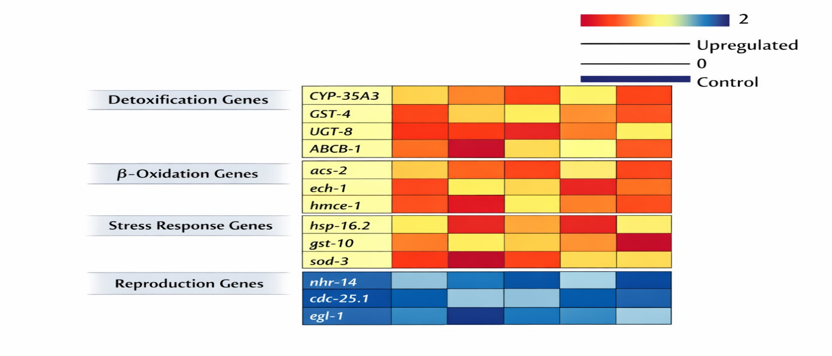

Figure 4- Differential gene expression pattern in nematode exposed to high concentration of CQDs
The study found that genes linked to locomotion and reproduction showed different expression patterns which established a genetic foundation for the detected changes in behaviour. The research found that Caenorhabditis elegans and zebrafish exhibited similar detoxification mechanisms after they were exposed to graphene and carbon-based quantum dots, which demonstrated the widespread nature of these biological processes (Deng et al., 2018; Qu et al., 2019).
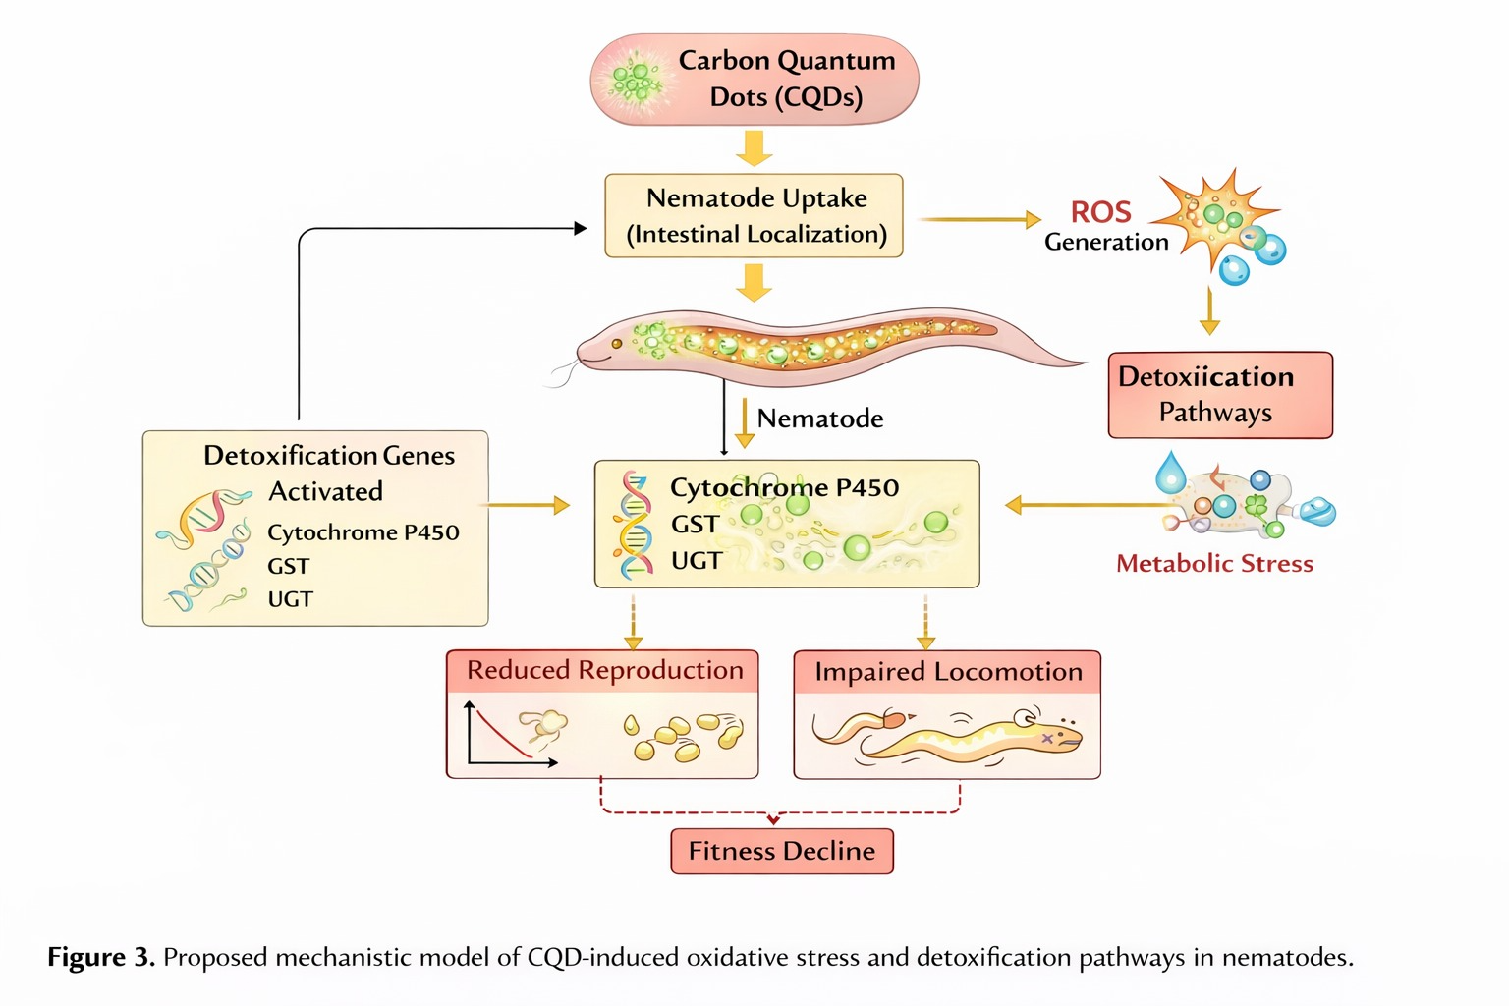
Figure 5- Proposed mechanistic model of CQD-induced oxidative stress and detoxification pathways in nematodes
Nematode Species | CQD Concentration | Exposure Duration | Observed Effect | Mechanism Involved | Reference
B. xylophilus | >4 mg/mL | 72 h | Reduced survival | ROS, detox gene activation | Han et al., 2021
C. elegans | Variable | Multigenerational | Reproduction decline | P450 upregulation | Zhao et al., 2015
Steinernema feltiae | Low dose | Long-term | No toxicity, stable fluorescence | Biocompatible labeling | San-Blas et al., 2025
Table 2. Concentration-dependent biological effects of carbon quantum dots in nematodes

6. Detection versus Management: A Concentration-Dependent Dual Role of CQDs
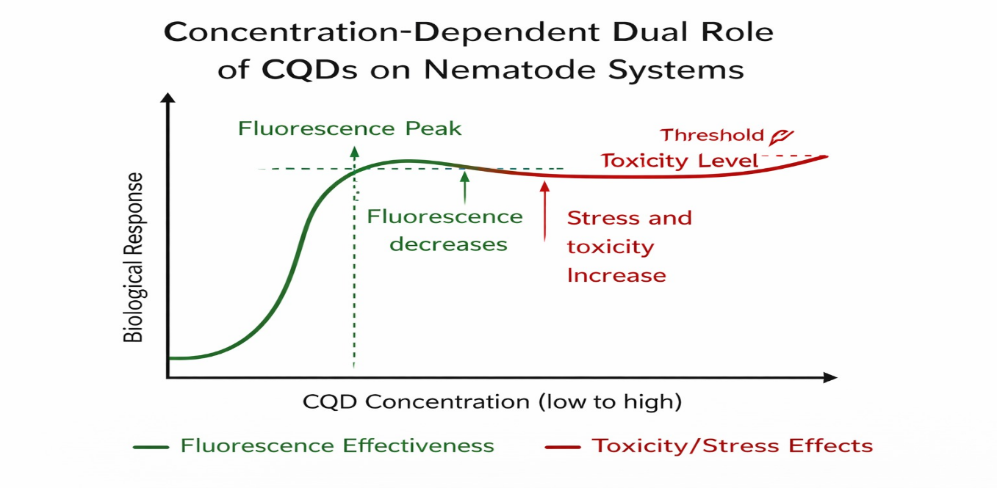

Figure 6 – Concentration-Dependent Dual Role Model
Basically, current findings have been shown that carbon quantum dots have a potential ambivalent action with nematodes which depends on the concentration level. At low, optimized doses carbon quantum dots might be applied as highly biocompatible fluorescent tracers for long, term in vivo labelling and ecological studies of nematodes. Carbon quantum dots at high doses or for a longer time would trigger chronic physiological stress and hence the behaviour and reproduction are changed, detoxification pathways are turned on and finally, the fitness of nematodes is lowered.
This is a very significant issue for sustainable agriculture. CQDs allow an easy way to follow entomopathogenic nematodes in soil thus a better evaluation and optimization of biological control strategies become possible. However, since they induce stress in plant, parasitic nematodes, it suggests their potential usage as green nematicidal agents or as one of the components of integrated pest management systems only if the impact on non, target organisms is thoroughly assessed.

Application | Advantage | Limitation | Research Gap
In vivo labeling | Stable fluorescence | Environmental fate unknown | Soil persistence studies needed
Stress induction | Potential green nematicide | Non-target risk | Field validation
Transcriptomics | Mechanistic clarity | Cost | Omics-field integration

Table 3. Opportunities and challenges of CQDs in nematode detection and management
8. Conclusions
Carbon quantum dots offer an adaptable nanotechnology platform for advancing the study of nematodes. Several case studies have shown that CQDs can be employed as non, toxic, stable fluorescence tags for live detection and ecological tracking as well as being able to induce stress and, at the proper dose, have a nematicidal effect. By combining detection and management, the application of CQD in the technologies is highly desirable in the deepening of ecological knowledge, increasing the effectiveness of biological control measures and transitioning to more sustainable methods of dealing with nematode problems in crop and forest production.

7. Future Perspectives and Challenges
So far, at the frontline of nematode research and management, CQDs hold a major promise yet several challenges need to be addressed before their wide application. To ensure reproducibility among different studies, standardisation of synthesis, characterisation and dosing protocols is a must. Systematic investigation of long, term environmental fate, interactions with soil microbiota and effects on non, target organisms is warranted by this work (Contreras et al., 2013; Yao et al., 2018). In the coming years, research should combine the labelling with CQDs with high, resolution imaging, molecular biology tools and field experiments. Another way to use the toolbox is through functionalised and doped CQDs that can facilitate targeted interactions or provide better fluorescence properties.

COMPETING INTERESTS DISCLAIMER:
Authors have declared that they have no known competing financial interests OR non-financial interests OR personal relationships that could have appeared to influence the work reported in this paper.

References
Atchudan, R., Edison, T. N. J. I., Lee, Y. R., & Shanmugam, M. (2018). Green synthesis of fluorescent carbon quantum dots from Ginkgo biloba leaves for bioimaging and sensing applications. Journal of Photochemistry and Photobiology B: Biology, 183, 39–45. https://doi.org/10.1016/j.jphotobiol.2018.04.015
Brus, L. E. (1983). A simple model for the ionization potential, electron affinity and aqueous redox potentials of small semiconductor crystallites. The Journal of Chemical Physics, 79(11), 5566–5571. https://doi.org/10.1063/1.445676
Cao, L., Meziani, M. J., Sahu, S., & Sun, Y.-P. (2012). Photoluminescence properties of graphene versus other carbon nanomaterials. Accounts of Chemical Research, 46(1), 171–180. https://doi.org/10.1021/ar300128j
Chazotte, B. (2011). Labeling cellular organelles with fluorescent dyes. Cold Spring Harbor Protocols, 2011(9), pdb.top115. https://doi.org/10.1101/pdb.top115
Cong, S., Tian, Y., Li, Q., Zhao, Z., & Geng, F. (2019). Single-crystalline graphitic carbon nitride quantum dots with efficient photoluminescence. Advanced Materials, 26(25), 4260–4267. https://doi.org/10.1002/adma.201400363
Contreras, E. Q., Puppala, H. L., Escalera, G., Zhong, W., & Colvin, V. L. (2013). Size-dependent impacts of silver nanoparticles on the lifespan, fertility, growth and locomotion of Caenorhabditis elegans. Environmental Toxicology and Chemistry, 32(12), 2716–2723. https://doi.org/10.1002/etc.2361
Deng, Y., Petersen, E. J., Challis, K. E., Rabb, S. A., Holbrook, R. D., Ranville, J. F., & Nelson, B. C. (2018). Multiple-method analysis of TiO₂ nanoparticle uptake in Caenorhabditis elegans. Environmental Science & Technology, 51(18), 10675–10683. https://doi.org/10.1021/acs.est.7b02452
Ekimov, A. I., Efros, A. L., & Onushchenko, A. A. (1985). Quantum size effect in semiconductor microcrystals. Solid State Communications, 56(11), 921–924. https://doi.org/10.1016/0038-1098(85)90695-9
Espada, M., Silva, A. C., Eves-van den Akker, S., Cock, P. J. A., Mota, M., & Jones, J. T. (2016). Identification and characterization of parasitism genes from the pinewood nematode Bursaphelenchus xylophilus. Molecular Plant Pathology, 17(6), 844–856. https://doi.org/10.1111/mpp.12329
Fakheri, R., Ahmadi, M., Hosseini, S. A., & Karimi, A. (2025). Nematicidal activity of carbon quantum dot–based nanocomposites against strongyle nematodes: In vitro evaluation of larval and egg stages. BMC Veterinary Research, 21, Article 94. https://doi.org/10.1186/s12917-025-04494-5
Feliu, N., Docter, D., Heine, M., del Pino, P., Ashraf, S., Kolosnjaj-Tabi, J., Macchiarini, P., Nielsen, P., Alloyeau, D., Gazeau, F., Stauber, R. H., & Parak, W. J. (2016). In vivo degeneration and the fate of inorganic nanoparticles. Chemical Society Reviews, 45(9), 2440–2457. https://doi.org/10.1039/C5CS00699F
Han, Y., Wang, J., Li, S., Zhang, X., & Wu, Q. (2021). Toxicity of carbon quantum dots to Bursaphelenchus xylophilus: Physiological and transcriptomic responses. RSC Advances, 11(11), 6410–6421. https://doi.org/10.1039/D0RA10688A
Hazir, S., Kaya, H.K., Stock, S.P., & Keskin, N. (2024). Entomopathogenic nematodes for biological control: Recent advances and future prospects. Biological Control, 189, 105364. https://doi.org/10.1016/j.biocontrol.2023.105364
Jones, J.T., Haegeman, A., Danchin, E.G.J., Gaur, H.S., Helder, J., Jones, M. G. K., … Perry, R. N. (2013). Top 10 plant-parasitic nematodes in molecular plant pathology. Molecular Plant Pathology, 14(9), 946–961. https://doi.org/10.1111/mpp.12057
Kang, Y.F., Fang, Y.W., Li, Y.H., Li, Y., & Wang, J. (2015). Toxicity evaluation of carbon quantum dots using multiple in vivo and in vitro systems. Scientific Reports, 5, 16767. https://doi.org/10.1038/srep16767
Kang, S., Herzberg, M., Rodrigues, D. F., & Elimelech, M. (2012). Antibacterial effects of carbon nanotubes: Size does matter! Langmuir, 24(13), 6409–6413. https://doi.org/10.1021/la800951v
Kikuchi, T., Cotton, J. A., Dalzell, J. J., Hasegawa, K., Kanzaki, N., McVeigh, P., … Jones, J. T. (2011). Genomic insights into the origin of parasitism in the emerging plant pathogen Bursaphelenchus xylophilus. PLoS Pathogens, 7(9), e1002219. https://doi.org/10.1371/journal.ppat.1002219
Lim, S. Y., Shen, W., & Gao, Z. (2015). Carbon quantum dots and their applications. Chemical Society Reviews, 44(1), 362–381. https://doi.org/10.1039/C4CS00269E
Li, Y., Zhong, L., Zhang, L., Shen, X., Kong, L., & Wu, T. (2021). Research advances on the adverse effects of nanomaterials in a model organism, Caenorhabditis elegans. Environmental Toxicology and Chemistry, 40, 2406–2424. https://doi.org/10.1002/etc.5130
Li, C., Tang, M., & Wang, D. (2013). Translocation and neurotoxicity of CdTe quantum dots in RMEs motor neurons in nematode Caenorhabditis elegans. Journal of Hazardous Materials, 283, 480–489. https://doi.org/10.1016/j.jhazmat.2014.09.063
Liang, Y., Liu, H., Xia, W., & Chen, Z. (2022). Environmental behavior and toxicity of quantum dots. Environmental Pollution, 292, 118357. https://doi.org/10.1016/j.envpol.2021.118357
Qu, M., Li, W., & Li, Y. (2011). Toxicity of quantum dots to Caenorhabditis elegans. Journal of Nanoscience and Nanotechnology, 11(3), 2393–2399. https://doi.org/10.1166/jnn.2011.3612
Qu, G., Liu, S., Zhang, S., Wang, L., Wang, X., Sun, B., … Jiang, G. (2019). Graphene oxide induces oxidative stress and apoptosis in Caenorhabditis elegans. Environmental Science & Technology, 46(11), 6068–6076. https://doi.org/10.1021/es300772p
Rajasekharan, S. K., & Ramesh, S. (2017). Nematode management and environmental sustainability. Journal of Environmental Management, 190, 188–197. https://doi.org/10.1016/j.jenvman.2016.12.033
San-Blas, E., Morales-Maza, A., & Campos-Herrera, R. (2025). In vivo labeling of entomopathogenic nematodes using carbon quantum dots for long-term ecological studies. Journal of Invertebrate Pathology, 196, 108031. https://doi.org/10.1016/j.jip.2024.108031
Sadhu, S., & Patra, A. (2013). Quenching of quantum dot emission by fluorescent gold clusters: What it does and does not share with the Förster formalism. The Journal of Physical Chemistry C, 117(29), 15429–15437. https://doi.org/10.1021/jp404952p
Shaner, N. C., Steinbach, P. A., & Tsien, R. Y. (2005). A guide to choosing fluorescent proteins. Nature Methods, 2(12), 905–909. https://doi.org/10.1038/nmeth819
Singh, R., Dutta, S., & Narayan, R. (2018). Biocompatibility and biosafety of carbon quantum dots. Journal of Nanobiotechnology, 16, 55. https://doi.org/10.1186/s12951-018-0389-9
Smits, P. H. (1996). Post-application persistence of entomopathogenic nematodes. Biocontrol Science and Technology, 6(3), 379–387. https://doi.org/10.1080/09583159631326
Song, X., Shen, W., Xu, L., Wang, Y., & Yang, B. (2019). Quantum dots for bioimaging and photodynamic therapy. Journal of Materials Chemistry C, 7(5), 1234–1245
Stavitskaya, A., Fakhrullina, G., Nigamatzyanova, L., Sitmukhanova, E., Khusnetdenova, E., Fakhrullin, R., & Vinokurov, V. (2021). Biodistribution of Quantum Dots-Labelled Halloysite Nanotubes: A Caenorhabditis elegans In Vivo Study. Materials, 14(19), 5469. https://doi.org/10.3390/ma14195469
Sun, Y.-P., Zhou, B., Lin, Y., Wang, W., Fernando, K. A. S., Pathak, P., … Wang, H. (2006). Quantum-sized carbon dots for bright and colorful photoluminescence. Journal of the American Chemical Society, 128(24), 7756–7757. https://doi.org/10.1021/ja062677d
van den Hoogen, J., Geisen, S., Routh, D., Ferris, H., Traunspurger, W., Wardle, D. A., … Crowther, T. W. (2019). Soil nematode abundance and functional group composition at a global scale. Nature, 572, 194–198. https://doi.org/10.1038/s41586-019-1418-6
Wang, Y., & Hu, A. (2014). Carbon quantum dots: Synthesis, properties and applications. Journal of Materials Chemistry C, 2(34), 6921–6939. https://doi.org/10.1039/C4TC00988F
Wu, T., Xu, H., Liang, X., & Tang, M. (2019). Caenorhabditis elegans as a complete model organism for biosafety assessments of nanoparticles. Chemosphere, 221, 708–726. https://doi.org/10.1016/j.chemosphere.2019.01.096
Xu, J., Wang, L., Mu, Y., Zhang, Y., Wang, M., Wang, Q., Wang, K., Guan, S., & Li, J. (2018). Carbon quantum dots as fluorescent probes for imaging and detecting free radicals in Caenorhabditis elegans. Journal of Nanoscience and Nanotechnology, 18(2), 763–771. https://doi.org/10.1166/jnn.2018.15190
Yao, Y., Costa, M., & Konrad, J. (2018). Environmental fate and ecotoxicity of nanomaterials. Environmental Toxicology and Chemistry, 37(1), 35–47. https://doi.org/10.1002/etc.3960
Zhao, Y., Wu, Q., Li, Y., & Wang, D. (2015). Transgenerational effects of nanoparticle exposure in nematodes. Nanotoxicology, 9(4), 512–520. https://doi.org/10.3109/17435390.2014.950916

