Opinion Article
Climate-Smart Livestock Production in Africa: Opportunities, Investments, and the Road beyond Barriers

ABSTRACT
The livestock sector is a foundation of daily bread in Africa, imparting remarkably to food security, income generation, and national Gross Domestic Product (GDP). Nevertheless, climate change poses critical threats through increased temperature, drought, and disease prevalence, reducing productivity and sustainability. This opinion article examines opportunities, investment priorities, and barriers to implementing Climate-Smart Livestock (CSL) systems across the region. The CSL approach aims to achieve a “triple win” of improving productivity, enhancing adaptation to climatic change and variability, and mitigating the greenhouse gas (GHG) emissions. The article points out key investment areas, including genetic improvement of climate-adaptive livestock breeds, disease resilience, sustainable feed and forage systems, and inclusive value chain development. Indigenous breeds such as Boran and Mpwapwa cattle exemplify the genetic potential for adaptation, while innovations in feed conservation, forage diversification, and community breeding programs can further enhance productivity and resilience. In spite of these opportunities, weak institutional frameworks, limited finance, market barriers, and socio-cultural inequalities are constraining CSL. Critics argue that CSL interventions are capital-intensive, technologically biased, and may marginalize smallholders. However, evidence shows that community-based breeding, cooperative feed production, and gender-responsive initiatives can deliver equitable and sustainable outcomes. The paper concludes that a transformative pathway for African livestock requires context-specific investments, supportive policies, and active participation of both public and private actors. Aligning indigenous knowledge with modern technologies is essential for ensuring that CSL delivers inclusive growth, environmental sustainability, and resilience for Africa’s livestock-dependent communities.
Keywords: Livestock resilience; genetic resources; feeds and forage systems; greenhouse gases; livestock production Africa
- INTRODUCTION
Production of livestock in Africa is central to their livelihood, contributing significantly to employment, food security, and GDP. The livestock sector in Africa is supporting more than 800 million residents and contributing to 15-80% of agricultural GDP in a large number of sub-Saharan African countries (FAO, 2024). The livestock sector not only provides food and income but also plays a part in the provision of manure for soil fertility and draft power as well as social and cultural capital, making them a vital advantage in the social framework of African communities.
Even so, this vital industry faces an empirical threat from amplified implications of climate change. Raised temperature, reduced productivity, recurrent dry spells, and proliferation of livestock diseases are weakening the productivity, food security, and economic sustainability of pastoral and agro-pastoral farmers (Thornton et al., 2024). In this circumstance, climate-smart livestock (CSL) farming constitutes an approach that aims to achieve the triple-win objectives, which are enhancing adaptation to climate shocks and variability, sustainably increasing of livestock production, and reducing the effect of greenhouse gas (GHG) emissions. This approach is in line with the main concept of Climate-Smart Agriculture that has been promoted by FAO, but CSL still has a unique role in contributing and being affected and can also be one of the strategies for reducing the effect of GHG emissions like methane, carbon dioxide, and nitrous oxide (World Bank, 2023).
The purpose of investing in Climate smart agriculture CSA has become increasingly critical. The report from the World Bank (2023), shows that the annual funding gap in climate-smart agriculture in Africa outstrips USD 15 billion, with livestock investment remaining specifically financially challenged. This deprivation keeps going in spite of growing authentication that low-emission and adaptive systems can remarkably minimize poverty, enhance food security, and reinforce national economies. Successful interventions require both public and private sector engagement (PPS), assisted by friendly policies, innovative funding mechanisms, and research-driven technologies that respond to sustainable livestock production.
However, there are some barriers that prohibit the progress of CSL production on the African continent. Some of them include weak institutions, fragmented policy implementation, low access to credit, and limited market infrastructure. Nonetheless, social-cultural and gender inequalities constrain youth and women who play an essential role livestock value chains such as milking and processing milk products and meat products (Walter Svinurai, 2023).
Therefore, this article provides critical insight into investing needs and barriers in the pursuit of climate-smart livestock production in Africa. It claims that sustainable transformation of the sector relies on inclusive, context-specific, and strategic investments that traverse socio-economic, institutional, and technological gaps.
- MAIN ARGUMENTS
  - Genetic Improvement and Climate-Adaptive Livestock Breeds Investments
Genetic resources of livestock constitute an essential, so far underutilized integrant of Africa’s climate adaptation capability. Native livestock breeds have spread throughout many centuries to tolerate harsh climatic situations, prevalence of diseases, and shifting feed resources. Although, these genetic resources are more and more threatened by unsystematic breeding, environmental degradation, and constrained investigation funding (FAO, 2024). Improving climate-adaptable livestock breeds needs a measured approach that homogenizes crossbreeding, synthetic animals, reserved local animals, selective breeding, and genomic approaches such as interbreeding livestock that can withstand hot conditions.
Investments in genetic resource improvement can strengthen productivity and adaptive capacity. For example, a study done in some African countries like Kenya and Ethiopia shows that breeding exotic and indigenous cattle can increase milk yield by up to 40% and also tolerate higher temperatures and diseases (Rege et al., 2020). Moreover, genetic engineering tools can be leveraged to recognize genetic markers related to feed efficiency, reduction of methane production, and drought tolerance, speeding up the breeding of livestock breeds that can withstand harsh conditions.
Nonetheless, genetic improvement programs need to be circumstantial. Investment should target communities based on breeding programs, researchers, and international organizations (Mapiye et al., 2019). Where possible, there should be gene banks for the reserving of genetic resources of Africa, such as Boran, Mpwapwa, and Tswana cattle that can withstand increased temperature and have higher productivity (Figure 1).
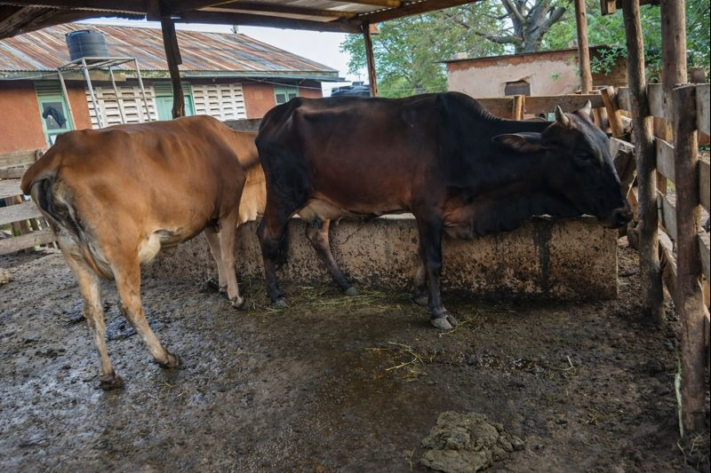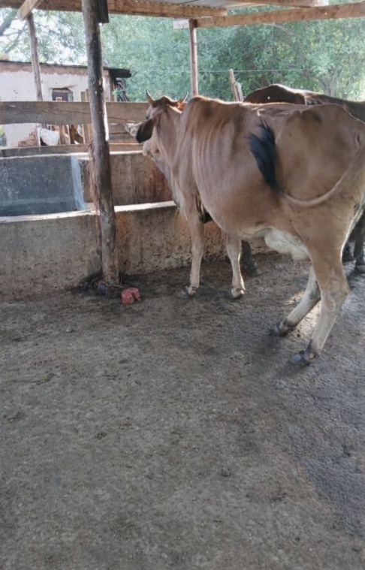
Figure 1: Mpwapwa breed cattle that can withstand harsh conditions in Tanzania
2.2 Enhancing the Health and Disease Resistance of Animal
Climate change is speeding up the proliferation of vector-transmitted and transboundary diseases such as African horse sickness, Rift Valley fever, blue tongue, and other tick-borne diseases (FAO, 2018).These diseases not only lead to direct production loss but also hamper livelihood stability, food security, and trade. Financing in disease-resilient livestock is therefore indispensable for sustaining production and resilient livestock. Key areas for the investment are improving veterinary services delivery, especially in pastoral communities; reinforcing the disease surveillance system; diversifying the production and distribution of thermostable vaccines to be used in tropical locations; and strengthening regional coordination through entities such as the African Union–Interafrican Bureau for Animal Resources (AU-IBAR, 2019). Investing in these systems can create synergies between climate adaptation and disease management, supporting both livestock and human health under the One Health framework.
2.3 Sustainable Forage and Feed systems for Producing Low Emission Livestock
Feed availability and quality remain the major problem for the production of livestock in sub-Saharan Africa. Seasonal feed fluctuation that has been caused by recurring dry spells and deterioration of rangelands has significantly reduced livestock productivity and elevated emission intensity per unit of output (Thornton et al., 2024). There is a need for conducting investment in eco-friendly feeds and forage systems for enhancing livestock productivity but also reducing the effect of greenhouse gases (GHGs). Key investment slots include integration of crop and livestock systems, development of climate-resilient forages and advanced feed conservation technologies such as hay and silage making. Studies conducted in semi-arid regions of East Africa have shown that these forages like, Cenchrus ciliaris and Chloris gayana, can produce high biomass yields and can persist under drought conditions (Togo et al.,2025). Promoting these grasses and improved grazing management, like rotational grazing, can enhance feed availability and increase carbon sequestration in the soil.
Moreover, processing of feed and supplementation using locally available by-products such as molasses and legume leaf meals may improve feed efficiency and reduce methane emission per unit of product (Kuwi et al., 2024). Regional research institutions and private sector partnerships can play a key role in scaling up these innovations through contract farming, forage seed systems, and capacity building for pastoral communities.
2.4 Market, Value Chain Integration and Infrastructure Investments
For the advancement of climate-smart livestock industry, there should be a desirable market and an effective value chain. Although numerous African pastoralists are isolated from valuable markets due to restricted market information, poor institutional collaborations, and weak infrastructure. These restrictions demoralize investments and lower financial support for adopting sustainable practices (Fushai et al., 2025). Investment in value chain integration is thus so important. Developing climate-resilient infrastructure such as cold chains, processing facilities, and rural roads can minimize post-harvest losses and improve product quality. Furthermore, digital platforms that connect farmers to markets and provide climate information can enhance decision-making and transparency. Another key area involves promoting inclusive business models, such as contract farming, cooperative marketing, and public–private partnerships (PPPs), which can attract private investment and share risks among stakeholders. Integrating environmental certification and carbon-credit schemes into livestock value chains may also unlock new revenue streams for smallholders adopting low-emission practices.
3. COUNTER-AGUMENT AND REBUTTAL
3.1 Criticism 1: Investing in Climate-Smart Livestock is too Costly with Limited Funds
The majority of livestock keepers believe that climate-smart livestock interventions like advanced forage and feed systems, low-emission technologies and genetic improvement require higher capital that developing countries of Africa cannot afford. Most studies that have been done show that the initial cost of CSL can be high; after establishment, the economic return for the investment will be of the long-term, and also the vulnerability cost may be reduced. CSL has also increased productivity through lessened mortality, disease prevention, and improved feed efficiency. These have been done in Tanzania, Uganda, Ethiopia, and Kenya (Rugerri, 2024). Therefore, CSL doesn’t cost that investment due to different approaches that can be done by smallholder farmers, such as diversification of livestock, integration of livestock and crops, and keeping of native species. All these approaches are friendly for the farmers who are having low income (Amole & Ayantunde, 2016).
3.2 Criticism2: Livestock Production is Intrinsically Unstable due to Greenhouse Gas Emissions
Critics argue that some of the livestock groups, particularly ruminants, are the major cause of methane and nitrous oxide and other environmental degradation, recommending that minimizing livestock numbers is the most constructive strategy (IPCC, 2021). Some climate activists suggest shifting from animal protein to crop protein may reduce the effect of GHGs from livestock (Houzer et al., 2021). While the Africa share of global livestock emission is estimated to be not more than 7%, this means that Africa livestock production for contributing to global GHG emission is not significant (Zhu et al., 2016). Moreover, livestock in Africa are multifunctional assets that provide income by selling milk, skin, eggs, and meat; nutrition; manure; and other ecosystem services. Instead of eliminating the sector, there is a need to optimize it for a balanced solution, such as providing feeds with low emissions, such as legumes, and maintaining the health of the animal. Therefore, CSL is one of the pathways of attaining three wins: reducing GHGs, increase production and adapting to climate shock (Figure 1). (Hyland et al., 2016).
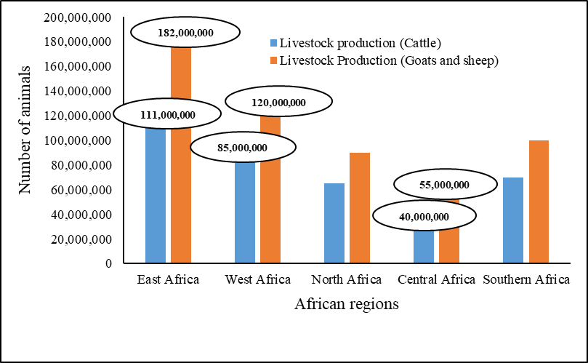
Figure 2: Livestock Production in Africa

3.3 Criticism3: Climate-Smart Livestock Ignores Socio-Cultural Aspects and Concentrates Much on Advanced Technology
A key critique of Climate-Smart Livestock (CSL) frameworks is that they often prioritize technological innovations such as like improved livestock breeds, feed efficiency, and emission tracking while neglecting indigenous knowledge, cultural traditions, and long-standing pastoral systems that have sustained communities for generations (Leslie & McCabe, 2013). Critics warn that externally imposed models risk disrupting social cohesion, customary grazing rights, and the mobility crucial for maintaining rangeland health. However, this critique highlights the need to contextualize innovation rather than reject it. Successful CSL initiatives across Africa demonstrate that blending local knowledge with scientific advances yields the best outcomes. For example, community-based rangeland management in Ethiopia and Kenya integrates traditional grazing calendars with modern climate forecasts to enhance pasture management and prevent degradation (Crane et al., 2022). By incorporating tools such as early warning systems, participatory breeding, and weather-index insurance, CSL can complement and strengthen traditional resilience practices. Embedding indigenous approaches within policy frameworks is therefore vital to ensure CSL strategies remain culturally relevant and socially inclusive.
3.4 Criticism4: Climate-Smart Livestock Favors Commercial Farms and Underrepresents Smallholders
Arguments raise that climate-smart livestock (CSL) initiatives often conveniently benefit wealthy commercial farms capable of investing in advanced technologies and carbon-credit programs, while leaving behind smallholders and pastoralists who face financial and informational constraints (Thornton et al., 2024). This imbalance could widen social inequities and threaten traditional livestock systems. However, this concern is only partly valid. Evidence from participatory breeding initiatives in Ethiopia, Tanzania, and Kenya shows that community-driven approaches can enhance breed resilience and local ownership (Kathambi et al., 2025). Likewise, small scale feed cooperatives and forage seed enterprises in Kenya demonstrate how inclusive collective action can equitably scale CSL innovations (Wambu & Gichuki, 2024). Ultimately, the success of CSL interventions hinges on inclusive institutions, gender-responsive policies, and community engagement, ensuring that benefits reach marginalized producers rather than concentrating among elites.
- CONCLUSION
Climate-smart livestock production stands as a pivotal solution for achieving resilient, productive, and environmentally sustainable agricultural systems across Africa. As climate variability intensifies, the livestock sector faces unprecedented challenges—from recurrent droughts and degraded rangelands to disease outbreaks and feed shortages—that threaten livelihoods and food security. This article demonstrates that investing in Climate-Smart Livestock (CSL) systems provides a transformative opportunity to address these vulnerabilities while advancing adaptation, mitigation, and productivity goals simultaneously.
Key to this transformation is the strategic investment in climate-adapted livestock breeds, sustainable feed and forage systems, and disease surveillance mechanisms that safeguard animal and human health. Equally, enabling policies and inclusive institutions are essential to ensure equitable participation of pastoralists, women, and youth—groups that are often marginalized in livestock value chains but are central to their sustainability. Incorporating indigenous knowledge and participatory approaches into CSL design ensures that innovations remain context-specific, culturally appropriate, and locally owned.
Also, strengthening market access, digital technologies, and value chain integration can enhance profitability and resilience among producers. Public–private partnerships, coupled with regional research collaborations, will play a critical role in scaling up these innovations and unlocking climate finance to bridge the existing investment gap. Ultimately, the success of climate-smart livestock production in Africa depends on coordinated multi-stakeholder engagement that links science, policy, and community action. When effectively implemented, CSL has the potential to transform African livestock systems into engines of inclusive growth, food security, and climate resilience paving the way for a sustainable agricultural future that benefits both people and the planet.
COMPETING INTEREST
There is no any competing interest that has raised during formulating this article between the Authors.
DISCLAIMER (ARTIFICIAL INTELIGENCE)
There is no generative AI technologies like large language models (ChatGTP, COPILOT, CHATBOT etc.) and text-to-image generators that have been used during writing and editing the manuscript.
REFERENCES
Amole, T. A., & Ayantunde, A. (2016). Amole TA, Ayantunde AA. 2016. Climate-smart livestock interventions in West Africa: A review. CCAFS Working Paper no. 178. 178, 53. www.ccafs.cgiar.org%0ATitles
AU-IBAR. (2019). The African Union – Interafrican Bureau for Animal Resources (AU-IBAR). International Scientific Council for Trypanosomiasis Research and Control (ISCTRC) Abuja Declaration, July.
Crane, T., Habermann, B., Marty, E., Arndt, C., Leitner, S., Worku, T., & Gichuki, L. (2022). Climate change adaptation and mitigation in extensive livestock systems in East Africa. Findings from the Programme for Climate-Smart Livestock Systems. GIZ, Eschborn. Findings from the Programme for Climate-Smart Livestock Systems.
FAO. (2018). Starting the change. Climate Change and Transboundary Pest and Diseses, 86–98. https://doi.org/10.1057/978-1-352-00132-7_5
FAO. (2024). FAO in Africa: Highlights in 2023. Food and Agriculture Organization of the United Nations Accra.
Fushai, F., Chitura, T., & Oke, O. E. (2025). Climate-smart livestock nutrition in semi-arid Southern African agricultural systems. Frontiers in Veterinary Science, 12(February). https://doi.org/10.3389/fvets.2025.1507152
Houzer, E., Scoones, I., Production, F. A. O. A., & Jacquemot, P. P. (2021). Are livestock always bad for the planet ? https://doi.org/10.19088/STEPS.2021.003
Hyland, J. J., Styles, D., Jones, D. L., & Williams, A. P. (2016). Improving livestock production efficiencies presents a major opportunity to reduce sectoral greenhouse gas emissions. Agricultural Systems, 147, 123–131. https://doi.org/10.1016/j.agsy.2016.06.006
IPCC. (2021). Introducing the Topical Collection: ‘Climate change communication and the IPCC.’ In Climatic Change (Vol. 169, Issues 3–4). https://doi.org/10.1007/s10584-021-03253-3
Kathambi, E. K., Sonstegard, T. S., & Larsen, P. A. (2025). Review: Cross-breeding, advanced reproductive technologies, and genetic selection in twelve dairy production systems in Africa. Animal, 19(3), 101424. https://doi.org/10.1016/j.animal.2025.101424
Kuwi, S. O., Kamwangire, D. F., Kasiba, B., Katabazi, L. V, Lyahama, O. J., Fupi, G. F., Kajuna, J. A., Mgalula, J. R., Munisi, W. G., & Moto, E. A. (2024). Effects of supplementing Leucaena pallida based multi-nutrient block on feed intake and body weight performance of goats fed poor-quality forage in semi-arid Tanzania during dry season. 94(July), 652–655.
Leslie, P., & McCabe, J. T. (2013). Response diversity and resilience in social-ecological systems. Current Anthropology, 54(2), 114–143. https://doi.org/10.1086/669563
Mapiye, C., Chikwanha, O. C., Chimonyo, M., & Dzama, K. (2019). Strategies for sustainable use of indigenous cattle genetic resources in Southern Africa. Diversity, 11(11), 1–14. https://doi.org/10.3390/d11110214
Rege, J. E. O., Ochieng, J., & Hanotte, O. (2020). Livestock genetics and breeding. The Impact of the International Livestock Research Institute, 59–102. https://doi.org/10.1079/9781789241853.0059
Rugerri, M. (2024). Livestock Sector Climate Finance Flows in Ethiopia, Kenya, Tanzania and Uganda. May.
Thornton, P. K., Wollenberg, E. K., & Cramer, L. K. (2024). Livestock and Climate Change: Outlook for a more sustainable and equitable future. December. https://hdl.handle.net/10568/172688
Togo, B. G., Kuwi, S. O., Mussa, N. J., Kajuna, J. A., Fupi, G. F., Kasiba, B. R., Mgalula, J. R., Felix, D. K., Katabazi, L. V, & Mtei, E. P. (2025). Climate Change and Livestock Production in Semi-Arid Regions : The Untapped Potential of Climate-Resilient Forages. 25(10), 45–52.
Walter Svinurai. (2023). Livestock production and greenhouse gas emissions in the Southern African Development Community: 2000-2020. https://www.researchgate.net/publication/374288633_Livestock_production_and_greenhouse_gas_emissions_in_the_Southern_African_Development_Community_2000-2020?_tp=eyJjb250ZXh0Ijp7ImZpcnN0UGFnZSI6Il9kaXJlY3QiLCJwYWdlIjoiX2RpcmVjdCJ9fQ
Wambu, C., & Gichuki, C. (2024). Leveraging on Agricultural Cooperatives in Feed and Fodder Production Among Smallholder Dairy Farmers in Meru County, Kenya. Journal of the Kenya National Commission for UNESCO, 5(1), 1–18. https://doi.org/10.62049/jkncu.v5i1.180
World Bank. (2023). Kenya Country Climate and Development Report. Kenya Country Climate and Development Report. https://doi.org/10.1596/40572
Zhu, B., Kros, J., Lesschen, J. P., Staritsky, I. G., & de Vries, W. (2016). Assessment of uncertainties in greenhouse gas emission profiles of livestock sectors in Africa, Latin America and Europe. Regional Environmental Change, 16(6), 1571–1582. https://doi.org/10.1007/s10113-015-0896-9

