Original Research Article

Ground water potential zone identification of Giridih district, Jharkhand, India using Geospatial Technologies

Abstract
The depilation of groundwater is a primary global concern, derived by the escalating incidence of water scarcity in many regions. Identifying ground water potential zone (GWPZ) is one of the most important challenges. This study purpose is to delineate the GWPZ using the Geospatial technology (Remote sensing, GIS, GPS) and Analytical Hierarchy Process (AHP) method of Giridih district, Jharkhand India. Different thematic layers like Rainfall (RF), Drainage Density (DD), Land use land cover (LULC), Geomorphology (GE), Lithology (LI), Slope (SL), Soil (SO) were taken into consideration to identify groundwater potential zones. All the above-mentioned thematic layers were generated using remotely sensed data in GIS environment. After that based on their relative importance suitable weights were assign to all thematic layer derived from Saaty’s scale. These thematic layers were integrated using weighted linear combination method in ArcGIS. The GWPZ of the study area were then categorized as good, moderate, and poor.
Key words: Ground water potential zone; AHP; Remote sensing; GIS; Giridih (India)
- Introduction
Groundwater in most part of the world is under escalating stress because of rapid urbanization, unplanned infrastructure, overexploitation of groundwater, change in land use land cover and climate change (Biswas et al., 2020; Okello et al., 2015; Sridhar and Parimalarenganayaki 2025). Throughout the world total groundwater use for irrigation purposes, domestic uses, industrial use is about 42%, 36% and 27% respectively (Shao et al., 2020). Currently, 2.5 billion people of the world use the groundwater for drinking purposes (Achu et al., 2020). In India groundwater fulfils around 85% of total drinking water supply, signifying high level of dependence (Kolanuvada et al., 2019). As reported by NITI Aayog (2017–2018), water demand in India is expected to double by 2030.
However, groundwater depletion rate in India is increasing due to excessive use is a serious concern (Kumar et al., 2025). Many of India developing cities experience excessive groundwater extraction because of rapid and unplanned urbanization (CGWB 2019; Sridhar, D and Parimalarenganayaki, S. 2024). Urbanization not only disturb aquifer rechange due to construction of roads and buildings but also wastewater is not adequately treated to recharge the ground water. Mismanagement of water is one of the major causes of the declining the groundwater in term of quality and quantity (Das and Pal, 2019). For many regions in India, where precipitation is very uncertain and nearly 89% of the cultivated area is under rainfed farming there is urgent need for water resources planning and development in the micro-watershed area. (Dongardive et al., 2018).

The application of Geospatial techniques offers synoptic, rapid, recent and complex spatial data to generate various thematic layers that play important role in the delineate groundwater potential zones (GWPZ) (Sener et al., 2005 ; Jha et al., 2010 ; Aouragh et al., 2017; Kumar et al., 2022; Yosef et al., 2024; Alemu et al., 2025; ).The weights of various thematic layers has been determined using analytical hierarchy process (AHP) methods which is one of the most widely used multi-criteria decision-making (MCDM) model. Many researchers have used this method in the recent past to find the suitable weight to various thematic layers and their classes (Manap et al., 2014; Kumar and Pandey 2016; Singh et al., 2018a.; Murmu et al., 2019; Kumar et al.,2022; Ally et al., 2024; Patel et al., 2024; Kumar et al., 2025).
The present study, different thematic layers such as Rainfall (RF), Drainage Density (DD), Land use land cover (LULC), Geomorphology (GE), Lithology (LI), Slope (SL) and Soil (SO) were generated using remote sensing, GIS and AHP techniques for delineate the GWPZ of Giridih district, Jharkhand, India.

- Material and Method
2.1 Study area
The location extent of the study area is between latitudes 23°58' N to 24°48' N and longitudes 85°48' E to 86°30' E, as shown in Fig.1. Giridih District is geographically divided into two natural divisions, which are the central plateau and lower plateau. The study area is divided into two water heads that is Barakar and Usri rivers. The area is having many coal fields. The temperature in the study area is ranges from 8° C to 40° C, while the monsoon-season rainfall varies between 1200 and 1400 mm.
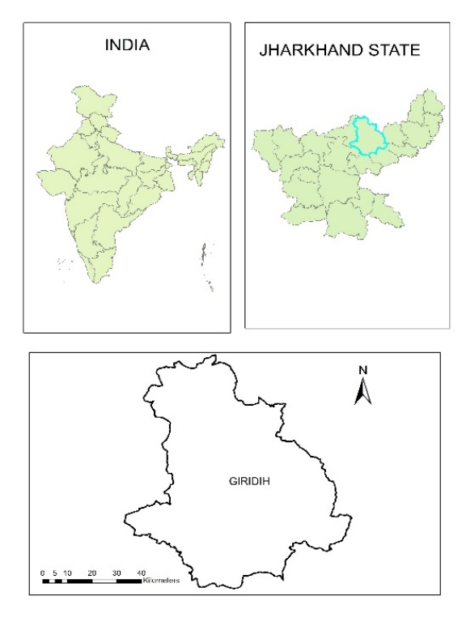
Fig 1: Location map of study area
2.2 Data used
Data used for assessment of ground water potential zone, seven different thematic layers such as RF, DD, LULC, GE, LI, SL, SO were generated using satellite data. Slope and drainage density of the study area was prepared using Cartosat 1 Digital elevation model (DEM). Cartosat 1 DEM was acquired from Bhuban portal (www.bhuvan.nrsc.gov.in). The lithology of the study area was obtained from the Geological Survey of India (GSI) and maps was generated in ArcGIS software. The geomorphological of the study area was downloaded from Bhuban portal and prepared a thematic map in GIS environment. Various LULC classification techniques have been applied in earlier studies for the classification of satellite imagery for land use land cover (Kumar et al., 2018; Mahmoud et al., 2022; Hameed et al., 2026). In this work, Landsat 8 OLI data was used to prepared different LULC classes with maximum likelihood classification algorithm. Landsat 8 OLI data was acquired from USGS website (www.usgs.gov.in) with spatial resolution of 30m.
2.3 Assignment of weights and normalize using AHP
The weights of each of these thematic layers such as RF, DD, LULC, GE, LI, SL, SO was assigned to the Ground water risk related with each layer. All thematic layers were resampled in 30m resolution and projected in UTM Zone 46N with datum WGS84. In this study, AHP method by Saaty (2000) i.e. the pairwise comparison matrix has been used to determine the GWPZ. It is used as a decision-solving method to finalize the weights assigned to different thematic layers and their respective features. This method is the most frequently used by many researchers in recent years (Murmu et al., 2019; Kumar et al., 2022; Alrawi et al., 2022; Kumar M et al., 2025; Dey et al., 2025). The following steps were used to compute the final weights of all the thematic layers:

Sum the values in each column of the pair-wise comparison matrix using the formula,
$L_{ij}=\sum_{n=1}^{n}{C_{ij}}$ …………………………………. [1]
Where$L_{ij}$ is the total column value of the pair-wise comparison matrix and
$C_{ij}$ are the criteria used for the analysis, i.e., population density, elevation, slope etc.
Divide each element in the matrix by its total row to generate a normalized pair-wise comparison matrix.
$X_{ij}$= $\frac{C_{ij}}{\sum_{n=1}^{n}{C_{ij}}}$ ………………………………….. [2]
Where $X_{ij}$ = normalized pair-wise comparison matrix
Divide the sum of the normalized row of the matrix by the number of criteria/parameter (N) to generate the standard weight by using the following formula,
$W_{ij}$ = $\frac{\sum_{j=1}^{n}{X_{ij}}}{N}$……………………………………… [3]
Where$W_{ij}$ = Standard weight
For calculating the consistency vector values the following formula was used:
$λ$ = $\sum_{i=1}^{n}{{CV}_{ij}}$ …………………………….…… [4]
Where λ= Consistency vector
Consistency Index (CI) was used as a deviation or degree of consistency which was then calculated using the formula below:
CI =$\frac{λ-n}{n-1}$ ……………………………….……... [5]
Where CI = Consistency Index, n = Number of criteria
Consistency ratio (Cr) is calculated by using the formula:
Cr = $\frac{CI}{RI}$…………………………………………... [6]
Where, RI = random inconsistency

If the value of Consistency ratio is less than or equal to 0.10 then the inconsistency is acceptable. Random inconsistency values for ‘n’ number of criteria i.e. number of parameters.
Table 1. Random inconsistency values (Saaty, 1980)
n | 2 | 3 | 4 | 5 | 6 | 7 | 8 | 9
RI | 0 | 0.52 | 0.9 | 1.12 | 1.24 | 1.32 | 1.41 | 1.45
Where n = number of criteria used and RI = Random Inconsistency

Assessment of groundwater potential zones

Total score for each thematic layers has been calculated using formula (Saaty 1980)
TS = $\sum{W×R }$……………………………………………………... [7]
Where, TS = Total Score, W = weight of the parameters and R = weight of the features.
The Ground water potential zone is then calculated using rather calculator in GIS environment adding weight of all thematic parameters.
GWPZ = RF, DD, LULC, GE, LI, SL, SO.............................................. [8]
Where, GWPZ = Ground water potential zone, RF= Rainfall, DD= Drainage Density, LULC = Land use and Land cover, GE= Geomorphology, LI= Lithology, SL = Slope, SO= Soil
- Result and Discussion
Identification of groundwater of area zone is depended depends on numerous factors such as precipitation, geological structure, LULC, drainage of the area (Acharya, 2017). In this research work RF, DD, LULC, GE, LI, SL, SO have been used to find out the GWPZ.
3.1 Factor affecting ground water potential zone
3.1.1 Rainfall (RF)
Rainfall of any area play important role to recharge the groundwater. In this work, 10 years of TRMM monthly rainfall data (2014–2024) were collected. These data were then used to generate rainfall map using the Inverse Distance Weighted (IDW) interpolation method in ArcGIS. The rainfall of this area is divided into four categories that is 1593-1655mm, 1655-1716mm, 1716-1780mm and 1780-1839mm respectively (Fig2a).
3.1. 2 Drainage Density (DD)
Drainage density of any area plays important role in delineation of groundwater potential zone. Higher drainage density encourages more runoff of the area causes less infiltration. The drainage density of the area is categorized into 0-1.2 km/km², 1.2-2.5 km/km², 2.5-3.5 km/km², 3.5-4.6 km/km², 4.6-5.8 km/km², and 5.8 -7 km/km² (Fig. 2b).
3.1.3 Land use Land cover (LULC)
Existing LULC of any area suggest the proper location for the groundwater recharge (Kumar et al.2022;). LULC of the study area was classified into waterbody, wasteland, forest, built up land and agriculture. Water bodies were assigned highest weight followed by agriculture land (Fig. 2c).
3.1.4 Geomorphology (GE)
The geomorphology of any region reflects its land form and structure features, which play vital role in identifying GWPZ. The study area consists of Alluvial plain, River / water body (with water), Dyke ridge, Fracture line valley, pediment, Plateau weathered, Denudational hill and Quartz reef (Fig. 2d).
3.1.5 Lithology (LI)
Groundwater potential zones are also depended on lithology. GWPZ strongly influenced by the porosity and permeability of subsurface materials, as these properties control the storage and movement of water. (Rahmati et al., 2015, Singh et al., 2013a). The study area is mainly covered by river/water body (sand), Alluvium, Sandstone, Schist, Granite, Granitoid gneiss and Quartzite. Most part of the area is covered by Granitoid gneiss (Fig. 2e).

3.1.6 Slope (SL)
Slope have important role in water percolation, mainly in hilly terrains. In hill terrain where area is steep, most part of rainfall tends to flow rapidly downslope as surface runoff. In area with steep slope affects infiltration capacity, soil moisture retention, and subsurface flow dynamics causes limiting groundwater recharge (Ghosh et al., 2016). Therefore, slope play important role in groundwater potential assessment specially in area like Jharkhand, India which is hilly terrain. The slope map was classified into five classes that comprised 0-2 %, 2-5%,5-15%,15-25% and >25% slope respectively (Fig. 2f).
3.1.7 Soil (SO)
Percolation of water to the ground is depend on the types of soil present in the area. The study area is of two types of soil, silty loam and sandy clay. Silty loam allows better water movement than the sandy clay, which tends to hold water and slows percolation due to its higher clay content.
3.2 Weight assessment of thematic layers using Analytical Hierarchy Process (AHP)
The Analytical Hierarchy Process (AHP) was applied to all the thematic layer including RF, DD, LULC, GE, LI, SL, SO for identification of GWPZ. Pairwise comparison matrix was created and normalized weight were derived using Equation 1-7. After achieving the satisfactory Cr resulting normalized weights were assigned to the respective thematic layers. The Normalized weight obtained for RF, DD, LULC, GE, LI, SL, SO are 0.37,0.20,0.15,0.11,0.8,0.05 and 0.04 respectively. The Pairwise comparison matrix and Normalized weight are shown in the Table 2,3 and 4.
Table 2 Pair-wise comparison matrix of seven thematic layers

 | RF | DD | LULC | GE | LI | SL | SO
RF | 1.00 | 2.00 | 3.00 | 4.00 | 5.00 | 6.00 | 7.00
DD | 0.50 | 1.00 | 1.00 | 2.00 | 3.00 | 4.00 | 5.00
LULC | 0.33 | 1.00 | 1.00 | 1.00 | 2.00 | 3.00 | 4.00
GE | 0.25 | 0.50 | 1.00 | 1.00 | 1.00 | 2.00 | 3.00
LI | 0.20 | 0.33 | 0.50 | 1.00 | 1.00 | 1.00 | 2.00
SL | 0.17 | 0.25 | 0.33 | 0.50 | 1.00 | 1.00 | 1.00
SO | 0.14 | 0.20 | 0.25 | 0.33 | 0.50 | 1.00 | 1.00
TOTAL | 2.59 | 5.28 | 7.08 | 9.83 | 13.50 | 18.00 | 23.00

Table 3: Normalized pair-wise matrix
 | RF | DD | LULC | GE | LI | SL | SO | Normalized Weight
RF | 0.39 | 0.38 | 0.42 | 0.41 | 0.37 | 0.33 | 0.30 | 0.37
DD | 0.19 | 0.19 | 0.14 | 0.20 | 0.22 | 0.22 | 0.22 | 0.20
LULC | 0.13 | 0.19 | 0.14 | 0.10 | 0.15 | 0.17 | 0.17 | 0.15
GE | 0.10 | 0.09 | 0.14 | 0.10 | 0.07 | 0.11 | 0.13 | 0.11
LI | 0.08 | 0.06 | 0.07 | 0.10 | 0.07 | 0.06 | 0.09 | 0.08
SL | 0.06 | 0.05 | 0.05 | 0.05 | 0.07 | 0.06 | 0.04 | 0.05
SO | 0.06 | 0.04 | 0.04 | 0.03 | 0.04 | 0.06 | 0.04 | 0.04

Pair-wise comparison matrix and corresponding normalized weights were computed for all classes within each thematic layer (Table 5). After that Final weights of all the class were obtained by multiplying normalized weights of respective thematic layers by the normalized weight of individual class. The final weight of the class is shown in the table 5. The final weight has been assigned to all layer and their individual features and then convert it into rater layer.

Table 5: Normalized and final weights of different features of five thematic layers for groundwater potentiality
S. No. | Theme | Normalized Weight | Class | Final Weight
1 | Rainfall (RF)  (mm/year) | 0.37 | 1780-1839 | 0.21
1 | Rainfall (RF)  (mm/year) | 0.37 | 1716-1780 | 0.10
1 | Rainfall (RF)  (mm/year) | 0.37 | 1655-1716 | 0.04
1 | Rainfall (RF)  (mm/year) | 0.37 | 1593-1655 | 0.02
2 | Drainage Density (DD)  (km/km²) | 0.20 | 0-1.2 | 0.135
2 | Drainage Density (DD)  (km/km²) | 0.20 | 1.2-2.5 | 0.080
2 | Drainage Density (DD)  (km/km²) | 0.20 | 2.5-3.5 | 0.048
2 | Drainage Density (DD)  (km/km²) | 0.20 | 3.5-4.6 | 0.029
2 | Drainage Density (DD)  (km/km²) | 0.20 | 4.6-5.8 | 0.017
2 | Drainage Density (DD)  (km/km²) | 0.20 | 5.8-7.0 | 0.006
3 | Land Use/ Land Cover  (LULC) | 0.15 | Water bodies | 0.067
3 | Land Use/ Land Cover  (LULC) | 0.15 | Agriculture | 0.039
3 | Land Use/ Land Cover  (LULC) | 0.15 | Forest | 0.023
3 | Land Use/ Land Cover  (LULC) | 0.15 | Waste lands | 0.013
3 | Land Use/ Land Cover  (LULC) | 0.15 | Built up | 0.008
4 | Geomorphology (GE) | 0.11 | Alluvial plain | 0.036
4 | Geomorphology (GE) | 0.11 | River / water body (with water) | 0.025
4 | Geomorphology (GE) | 0.11 | Dyke ridge | 0.017
4 | Geomorphology (GE) | 0.11 | Fracture line valley | 0.012
4 | Geomorphology (GE) | 0.11 | Pediplain | 0.008
4 | Geomorphology (GE) | 0.11 | Plateau weathered | 0.005
4 | Geomorphology (GE) | 0.11 | Denudational hill | 0.004
4 | Geomorphology (GE) | 0.11 | Quartz reef | 0.003
5 | Lithology (LI) | 0.08 | River/water body, river/water body (sand) | 0.029
5 | Lithology (LI) | 0.08 | Alluvium (sand/clay dominant), alluvium (sand/silt dominant) | 0.019
5 | Lithology (LI) | 0.08 | Sandstone, shale, coal | 0.013
5 | Lithology (LI) | 0.08 | Schist, phyllite with mica schist | 0.008
5 | Lithology (LI) | 0.08 | Granite | 0.005
5 | Lithology (LI) | 0.08 | Granitoid gneiss | 0.003
5 | Lithology (LI) | 0.08 | Quartzite | 0.002
6 | Slope (SL) (%) | 0.05 | 0 – 2% | 0.025
6 | Slope (SL) (%) | 0.05 | 2-5% | 0.013
6 | Slope (SL) (%) | 0.05 | 5-15% | 0.007
6 | Slope (SL) (%) | 0.05 | 15-25% | 0.003
6 | Slope (SL) (%) | 0.05 | >25% | 0.002
7 | Soil (SO) | 0.04 | Silt Loam | 0.032
7 | Soil (SO) | 0.04 | Sandy Clay | 0.008

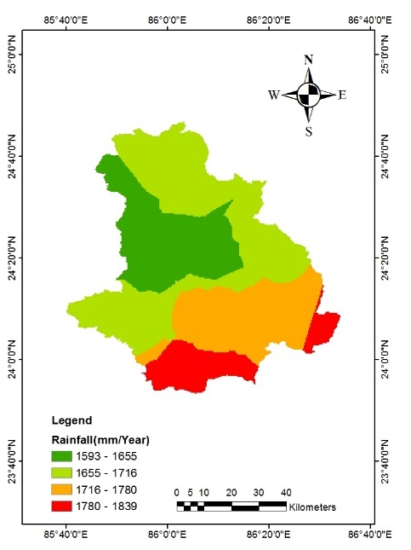  - Rainfall map of study area | 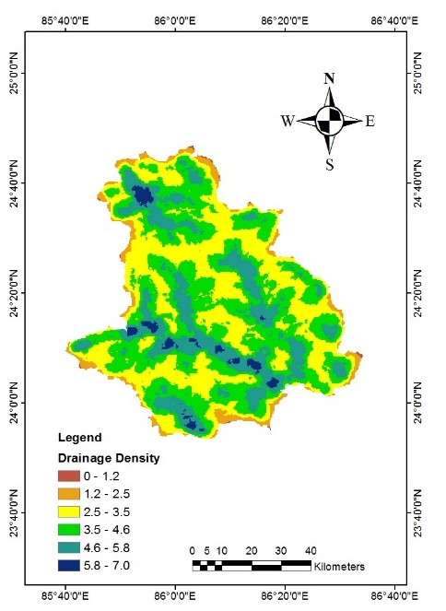  (b) Drainage Density map of study area | 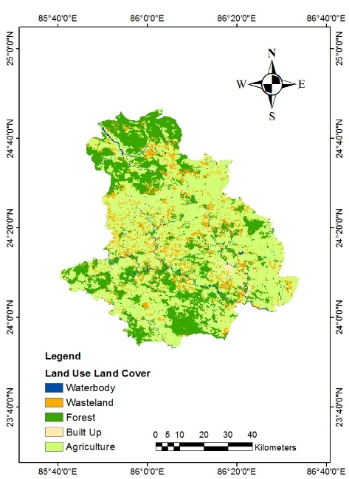  (c) LULC map of study area
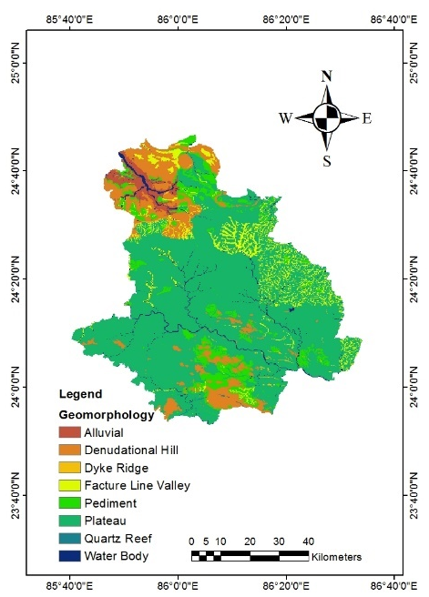  (d) Geomorphology map of study area | 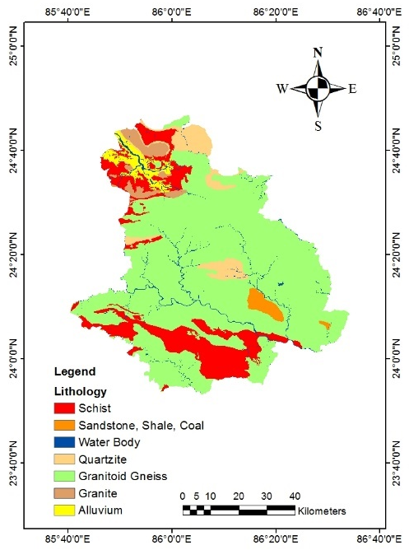  (e) Lithology map of the study area | 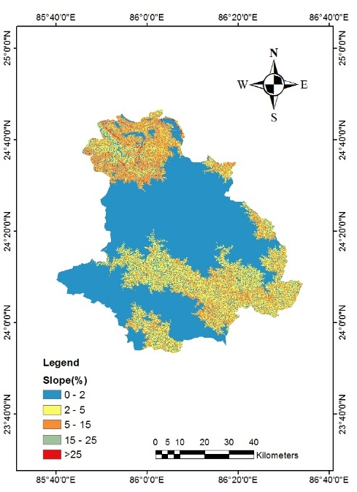  (f) Slope map of the study area
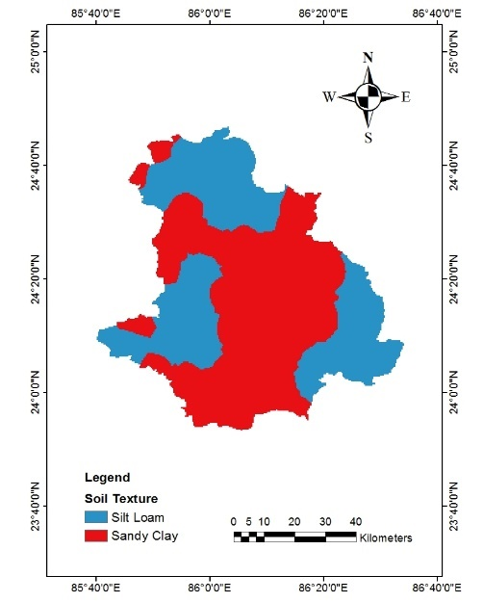
(g) Soil map of the study area
Figure 2: Maps of different thematic layers
The total score obtained after overlay all the thematic layer study area is classified into very good, moderate, and poor zone. The final map of GWPZ is shown in the figure 3. The result shows that area closer to river of waterbody is come under good zone which is mainly in southern part of the area. Whereas the southern part of the study area is come under poor zone.

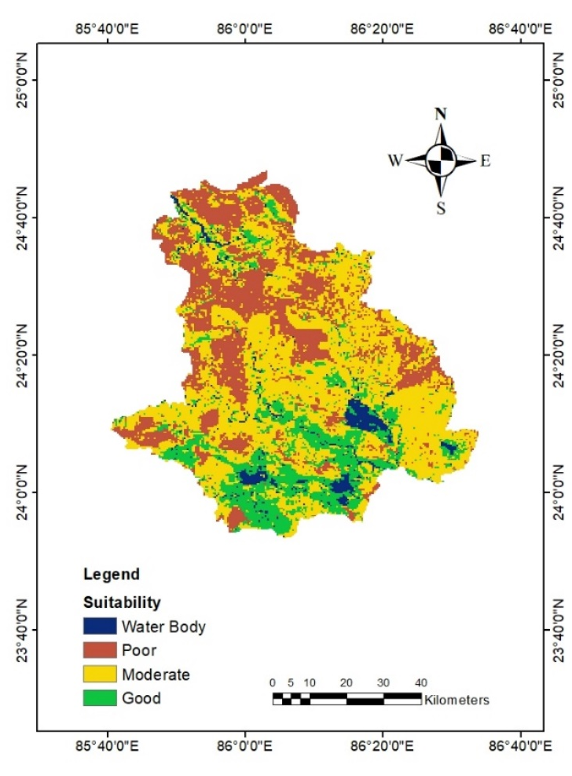
Figure 3. Ground water potential zone of the study area.
Conclusion
The increasing population, infrastructure development of the city needs fresh water, hence time to time delineation of groundwater potential zones of any area is very important to meet the demands. Delineation of GWPZ in Giridih district, Jharkhand, India using geospatial techniques and AHP is found efficient to the time, labour and money and thereby enables quick decision-making for sustainable water resources management. The study concluded that groundwater condition in the northern part of the study area is come under poor GWPZ hence area needs to be prioritized for proper management plan. This study assists water resource planners in identifying suitable locations within study area for groundwater recharge to avoid the water scarcity to urban population particularly in summer season.

References
Achu, A. L., Thomas, J., & Reghunath, R. (2020). Multi-criteria decision analysis for delineation of groundwater potential zones in a tropical river basin using remote sensing, GIS and analytical hierarchy process (AHP). Groundwater for Sustainable Development, 10, 100365. https://doi.org/10.1016/j.gsd.2020.100365
Alemu, W.T., Suryabhagavan, K.V., Azagegn, T., Terefe, T., Legese, B.B., Tsegaye, A.M., Bojer, A.K. and Alam, B.M. (2025). Groundwater potential zone mapping using GIS and remote sensing: A case of Teji River catchment, Southwest Shewa Zone, Ethiopia. Earth Systems and Environment. Available at: https://doi.org/10.1007/s41748-025-00811-y
Ally, A. M., Yan, J., Bennett, G., Lyimo, N. N., & Mayunga, S. D. (2024). Assessment of groundwater potential zones using remote sensing and GIS-based fuzzy analytical hierarchy process (F-AHP) in Mpwapwa District, Dodoma, Tanzania. Geosystems and Geoenvironment, 3(1), 100232. https://doi.org/10.1016/j.geogeo.2023.100232
Alrawi, I., Chen, J., Othman, A.A. (2022). Groundwater potential zone mapping: integration of multi-criteria decision analysis (MCDA) and GIS techniques for the Al- Qalamoun region in Syria. ISPRS Int. J. GeoInf. 11 (12). https://doi.org/10.3390/ ijgi11120603. Article 12.
Aouragh MH, Essahlaoui A, El Ouali A, El Hmaidi A, Kamel, S. (2017). Groundwater potential of Middle Atlas plateaus Morocco using fuzzy logic approach GIS and remote sensing. Geomatics, Nat. Hazards Risk 8(2):194–206. https:// doi. org/ 10. 1080/ 19475 705. 2016. 11816 76
Biswas P, Vellanki BP. (2020).Occurrence of emerging contaminants in highly anthropogenically influenced river Yamuna in India. Sci Total Environ 782: 146741.
Central Ground Water Board (CGWB) (2019). Groundwater quality in India. Ministry of jal shakti. Government of India. http://cgwb.gov.in/〉.
Das, B., Pal, S.C. (2019). Combination of GIS and fuzzy-AHP for delineating groundwater recharge potential zones in the critical Goghat-II block of West Bengal, India. HydroResearch 2, 21–30.
Dey, R. K., Halder, P., Nandy, S., & Ansary, R. (2025). Identifying groundwater potential zones using multi-criteria approach in agriculture-dominated landscapes of Malda district, India. Groundwater for Sustainable Development, 30, 101497. https://doi.org/10.1016/j.gsd.2025.101497
Dongardive, M. B., Patode, R. S., Nagdeve, M. B., Gabhane, V. V., & Pande, C. B. (2018). Water resources planning for the micro watersheds using geospatial techniques, International Journal of Chemical Studies, 6(5), 2950-2955.
Ghosh, P.K., Bandyopadhyay, S., Jana, N.C. (2016). Mapping of groundwater potential zones in hard rock terrain using geoinformatics: a case of Kumari watershed in western part of West Bengal. Model. Earth Syst. Environ. 2 (1), 1. https://doi.org/10. 1007/s40808-015-0044-z.
Hameed, M. R., Fatah, B. A., Hasan, S. F., & Shareef, M. A. (2026). Assessing the classification of land use and land cover using dual polarization (VV, VH) radar data: An analysis of the Kirkuk Governorate in Iraq. International Journal for Scientific Research (IJSR), 5(3).
Jha, M.K., Chowdary, V.M., Chowdhury, A. (2010). Groundwater assessment in Salboni Block, West Bengal (India) using remote sensing, geographical information system and multi-criteria decision analysis techniques. Hydrogeol. J. 18 (7), 1713–1728. https://doi.org/10.1007/s10040-010-0631-z.
Kumar, A., Pandey, AC (2016). Geoinformatics based groundwater potential assessment in hard rock terrain of Ranchi urban environment, Jharkhand state (India) using MCDM–AHP techniques. Groundw Sustain Dev 2:27–41
Kumar, A., Krishna, A.P. (2018). Assessment of groundwater potential zones in coal mining impacted hard-rock terrain of India by integrating geospatial and analytic hierarchy process (AHP) approach. Geocarto Int. 33 (2), 105–129. https://doi.org/10.1080/ 10106049.2016.1232314.
Kumar, M., Dash, A., Majid, S. I., Tiwari, A., Bhadwal, S., & Sahu, N. (2025). Delineation of groundwater potential zones of India using GIS-based fuzzy-AHP techniques. Environmental and Sustainability Indicators, 28, 100932. https://doi.org/10.1016/j.indic.2025.100932
Kumar, M., Dash, A., Majid, S.I., Tiwari, A., Bhadwal, S. and Sahu, N. (2025). Delineation of groundwater potential zones of India using GIS based fuzzy-AHP techniques. Environmental and Sustainability Indicators, 28, p.100932.
Kumar, M., Denis, D. M., Singh, S. K., Szabó, S., & Suryavanshi, S. (2018). Landscape metrics for assessment of land cover change and fragmentation of a heterogeneous watershed. Remote Sensing Applications: Society and Environment, 10, xxx–xxx.
Kumar, M., Singh, S.K., Kundu, A. et al. (2022). GIS-based multi-criteria approach to delineate groundwater prospect zone and its sensitivity analysis. Appl Water Sci 12, 71 https://doi.org/10.1007/s13201-022-01585-8
Mahmoud, A. S., Mezali, M. R., Hameed, M. R., & Naje, A. S. (2022). A framework for improving urban land cover using object and pixel-based techniques via remotely sensed data. Nature Environment and Pollution Technology, 21(5), 2189–2200. https://doi.org/10.46488/NEPT.2022.v21i05.013
Manap, M.A., Nampak, H., Pradhan, B., Lee, S., Sulaiman, W.N.A., Ramli, M.F. (2014). Application of probabilistic-based frequency ratio model in groundwater potential mapping using remote sensing data and GIS. Arab. J. Geosci. 7 (2), 711–724. https:// doi.org/10.1007/s12517-012-0795-z.
Murmu P, Kumar M, Lal D, Sonker I, Singh, SK (2019). Delineation of groundwater potential zones using geospatial techniques and analytical hierarchy process in Dumka district, Jharkhand. India. Groundw Sustain Dev 9:100239
NITI Aayog–Annual Report (2017-2018), Government of India.
Patel, D. K., Thakur, T. K., Thakur, A., Karuppannan, S., Swamy, S. L., & Pant, R. R. (2024). Groundwater potential zone mapping using AHP and geospatial techniques in the upper Narmada basin, central India. Discover Sustainability, 5(1), 355.
Rahmati, O., Nazari Samani, A., Mahdavi, M., Pourghasemi, H.R., Zeinivand, H. (2015). Groundwater potential mapping at Kurdistan region of Iran using analytic hierarchy process and GIS. Arab. J. Geosci. 8 (9), 7059–7071. https://doi.org/10.1007/s12517-014-1668-4.
Saaty, T.L., 1980. The Analytic Hierarchy Process: Planning, Priority Setting, Resource Allocation.
Sener, E., Davraz, A., Ozcelik, M. (2005). An integration of GIS and remote sensing in groundwater investigations: a case study in Burdur, Turkey. Hydrogeol. J. 13 (5–6), 826–834. https://doi.org/10.1007/s10040-004-0378-5.
Shao, Z., Huq, M. E., Cai, B., Altan, O., & Li, Y. (2020). Integrated remote sensing and GIS approach using Fuzzy-AHP to delineate and identify groundwater potential zones in semi-arid Shanxi Province, China. Environmental Modelling & Software, 134, 104868. https://doi.org/10.1016/j.envsoft.2020.104868
Singh, L.K., Jha, M.K., Chowdary, V.M. (2018a). Assessing the accuracy of GIS-based Multi-Criteria Decision Analysis approaches for mapping groundwater potential. Ecol. Indicat. 91, 24–37.
Singh, P., Thakur, J.K., Singh, U. (2013a). Morphometric analysis of Morar River Basin, Madhya Pradesh, India, using remote sensing and GIS techniques. Environ. Earth Sci. 68, 1967–1977. https://doi.org/10.1007/s12665-012-1884-8.
Sridhar D, Parimalarenganayaki S. A (2024). Comprehensive review on groundwater contamination due to sewer leakage: sources, detection techniques, health impacts, mitigation methods. Water Air Soil Pollut;235(1):56.
Yosef Ze -M, Birhanu B, Suryabhagavan KV, Tsegayet T (2024). GIS based suitability mapping of managed aquifer recharge in Diredawa catchment, Eastern Ethiopia. Int J River Basin Manage. http://doi.org/10.1080/15715124.2361038

