Factors explaining population growth in the central district of Abomey-Calavi (Benin)

Abstract
The population growth observed in the central district of Calavi results from the interaction of two main dynamics. On the one hand, natural increase, driven by relatively high fertility and birth rates, contributes significantly to population growth. On the other hand, migration flows, characterized by the attraction of populations from other localities seeking socio-economic opportunities, reinforce this demographic dynamic. All of these factors contribute to rapid population expansion and increased pressure on infrastructure and urban space.

Keywords : Population growth, Abomey-Calavi, Migration dynamics, Urban management.

Introduction
Urbanization is a major global concern today, due to the accelerated pace of urbanization observed in recent decades. According to the United Nations, more than half of the world's population now lives in urban areas, and this proportion is expected to continue to increase significantly in the coming years [12]. This dynamic is particularly pronounced in developing countries, where rapid population growth is accompanied by significant challenges in urban planning, access to basic services, and sustainable land management [9; 3]. In sub-Saharan Africa, urbanization is characterized by rapid and often uncontrolled urban expansion. This growth is fueled by both high natural population growth and significant migration flows from rural areas [11; 4]. However, this urbanization occurs within a context of weak institutional capacity and inadequate infrastructure, particularly in sanitation, housing, and access to drinking water, which exacerbates the vulnerability of urban populations [8]. In West Africa, this dynamic is particularly pronounced. In Benin, the population increased from 6,769,914 inhabitants in 2002 to 9,983,884 inhabitants in 2013, representing an intercensal growth rate of 3.5% [6]. This sustained population growth is observed in both urban and rural areas, but it is more marked in urban areas, where economic and social opportunities attract a growing population [7]. At the local level, the municipality of Abomey-Calavi appears as one of the main centers of urban growth in Benin. Due to its proximity to Cotonou and its role as an urban expansion zone, it is experiencing rapid population growth, fueled by natural increase and significant migration flows [6; 1]. The central district of Calavi, in particular, is strongly affected by this dynamic, leading to increased pressure on infrastructure, urban services, and spatial organization. In this context, it appears essential to analyze the determinants of this demographic growth as well as its implications on the organization of urban space and the living conditions of populations, in order to better guide planning and sustainable urban development policies.
2. Materials and Methods
2.1. Study Area
The municipality of Abomey-Calavi is located in the Atlantique department. It is bordered to the north by the municipality of Zè, to the east by the municipalities of Sô-Ava and Cotonou, and to the west by the municipalities of Ouidah and Tori-Bossito. It covers an area of ​​539 km², representing 0.48% of the area of ​​Benin. Figure 1 shows the geographical location of the municipality of Abomey-Calavi.
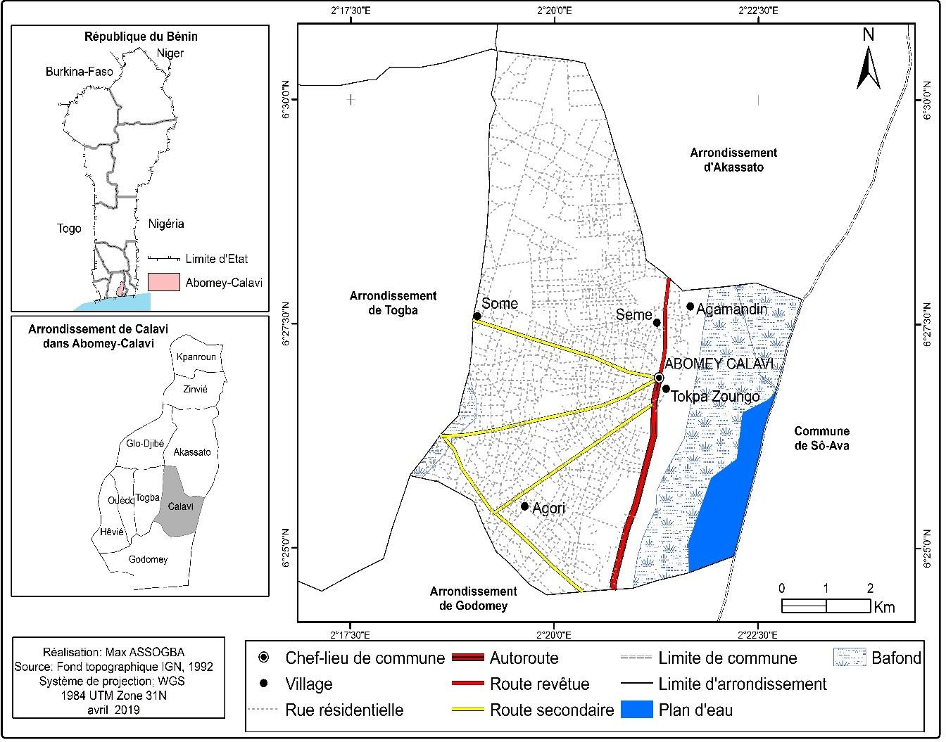
Figure 1: Geographical location of the municipality of Abomey-Calavi
2.2. Data and Materials Used
This study employs a mixed-methods approach combining quantitative and qualitative data. Secondary data were obtained from institutional sources, as well as from scientific documents from specialized documentation centers. Primary data were collected through field surveys using semi-structured interviews, direct observations, and household questionnaires. The sample was drawn from a random sampling of 1% of households (n = 52), supplemented by 20 key informants, for a total of 72 respondents.
2.3. Data Processing and Analysis Methods
The collected data underwent processing that combined statistical and qualitative analysis. Quantitative data were processed using Excel for calculating indicators and generating tables and graphs, while QGIS was used for spatial analysis. The population projection was based on an exponential model using the growth rate. The qualitative data were analyzed using a thematic approach to interpret stakeholders' perceptions. The overall analysis is based on the PEIR (Pressure-State-Impact-Response) model, which helped structure the interpretation of the relationships between population growth, environmental pressures, and health implications.
3. Results
3.1. Dynamics of Population Growth in the Central District of Calavi
The results show that population growth in the central district of Calavi is primarily due to positive natural increase, characterized by a surplus of births over deaths. Indeed, analysis of data from the RGPH3 [6] highlights a still high level of fertility in the municipality of Abomey-Calavi. The total fertility rate (TFR), although gradually declining, remains relatively high, falling from 7.2 children per woman in 1979 to 5.7 in 2002, and then to 3.5 in 2010 [5]. This trend reflects a demographic transition that has begun but is not yet complete. Furthermore, the crude birth rate remains high, contributing significantly to population growth. Conversely, the crude death rate, while still significant, is gradually decreasing. This relative decline in mortality, combined with the maintenance of a high birth rate, reinforces the imbalance between births and deaths, and thus explains the sustained population growth in the study area.

3.2. Mortality Trends

The results show a gradual decline in the crude death rate in the central district of Calavi. This decrease is partly explained by improved access to healthcare services, particularly vaccination campaigns, which have contributed to reducing mortality, especially among children. Furthermore, the age structure of the population reveals a high proportion of young people, resulting from both high fertility rates and a relative decrease in mortality among children under five, although this remains a concern. This dynamic is reflected in a characteristic age pyramid, marked by a relatively broad base and a progressive narrowing starting in the older age groups, particularly from age 10 onwards [5].

3.1.3. Age Structure of the Population

The age and sex structure of the population of the municipality of Abomey-Calavi is understood through the age pyramid, a classic demographic analysis tool that represents the distribution of the population according to these two variables. It constitutes a synthetic indicator of demographic dynamics, providing information on the relative size of the different age groups as well as on trends in birth rates, death rates, and, to a lesser extent, migration.

The analysis of the age pyramid based on data from the RGPH3 (2002) reveals a predominantly young population, characterized by a broad base reflecting high fertility rates. This configuration indicates a high rate of generational renewal and sustained population growth. Furthermore, the gradual narrowing observed in the older age groups reflects both still significant mortality at advanced ages and a relatively limited life expectancy. This demographic structure confirms that the municipality of Abomey-Calavi is in a phase of demographic transition, marked by a gradual decline in mortality but a continued relatively high fertility rate.

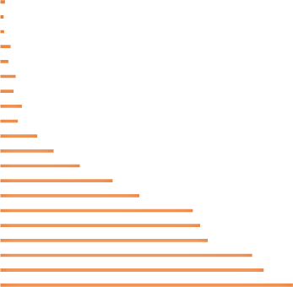
Figure 2 presents the age pyramid of the municipality of Abomey-Calavi based on data from the 2002 census.
Women Male
100 et +
(95-99
(90-94)
(85-89)
(80-84)
(75-79)
(70-74)
(65-69)
(60-64)
(55-59)
(50-54)
(45-49)
(40-44)
(35-39)
(30-34)
(25-29)
(20-24)
(15-19)
(10-14)
(5-9)
(0-4)
-30000
-20000
-10000
0
10000
20000
30000

Figure 2 : Age pyramid of the municipality of Abomey-Calavi in ​​2002
Source : INSAE/RGPH3 (2003)
Analysis of the age pyramid reveals a particularly broad base and a sharply narrowed apex, reflecting a predominantly young population and a relatively low life expectancy. This demographic configuration is characteristic of rapidly growing populations, where birth rates remain high while mortality, although declining, remains significant at advanced ages. Such a structure poses major development challenges. On the one hand, it implies the need to meet the growing needs of a young population, particularly in terms of education, access to employment, healthcare services, and social infrastructure. On the other hand, it underscores the importance of improving living conditions and access to healthcare in order to increase life expectancy.
3.1.4. Migration Dynamics
The results show that population growth in the central district of Calavi is strongly influenced by migration flows, particularly from the city of Cotonou. This attractiveness is explained by geographical proximity, the relative availability of land, and the settlement opportunities offered by the municipality.
Table I: Migration Flows and Net Migration in the Municipality of Abomey-Calavi
Municipality | Emigrants | Immigrants | Net migration | Outflow rate (%)
Abomey-Calavi | 44 187 | 125 948 | 81 761 | 3,76
Source : INSAE, RGPH3, 2013

3.1.5. Demographic Trends in the Central District of Calavi
The demographic trends in the central district of Calavi are part of a broader dynamic characterized by the interaction between natural population changes (births and deaths) and migration flows. This reflects the profound transformations of the municipality's socio-economic and territorial structures. The results highlight sustained population growth, characterized by an average intercensal growth rate estimated at 6.7%. This trend demonstrates significant population expansion, resulting from both the maintenance of a relatively high fertility rate and the area's attractiveness to migrants. Furthermore, the analysis of population trends over the period 2002–2025 shows a continuous upward trend, confirming the role of the central district of Calavi as an area of ​​high population density and rapid urban growth. The graph below illustrates the evolution of the population of the central district of Calavi between 2002 and 2025.
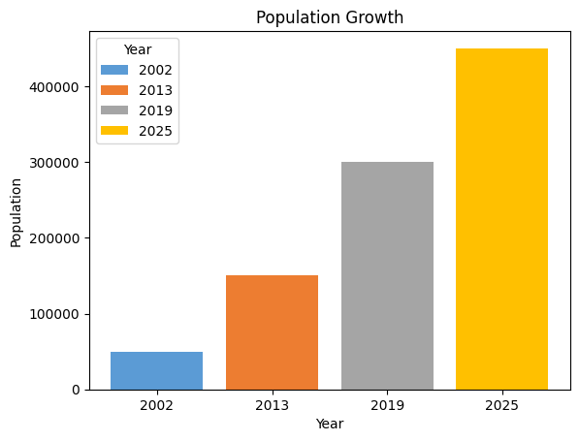
Figure 3 : Population projection for the central district of Calavi to 2025
Source : Field surveys, 2019

Analysis of demographic projections indicates that, assuming current trends continue, the population of the central district of Calavi could double in approximately 23 years. This growth reflects a particularly strong dynamic, driven by both high natural increase and significant migration flows. Such population growth raises major challenges in urban planning and infrastructure development. In particular, strengthening healthcare infrastructure appears to be a priority in order to support this growth and ensure the sustainable improvement of living conditions for the population.
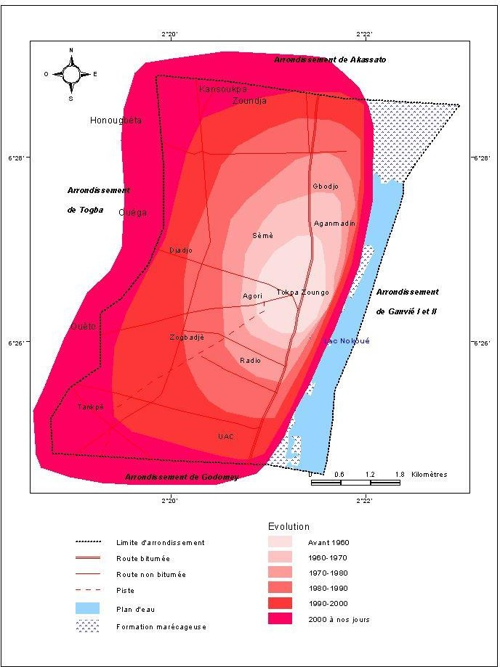
Figure 4 : Evolution of the urban space of the Abomey-Calavi district
The figure highlights the dynamics of spatial expansion in the central district of Calavi through different periods of urbanization. Analysis of the color gradients shows a progressive expansion of urban occupation, moving from an older central core (pre-1980) to increasingly widespread urbanization towards the peripheries, particularly pronounced from the 1990s to the present day. This spatial evolution reflects a process of continuous urban sprawl, characterized by densification of the center (light areas) and rapid expansion of peripheral areas (red to pink areas). This dynamic is strongly influenced by the proximity of Cotonou, which acts as a magnet, encouraging the settlement of new populations seeking space and opportunities. Furthermore, urbanization largely follows road axes, confirming the structuring role of transport infrastructure in the organization of urban space. Areas near main roads appear to be the most densely populated, while more distant areas experience gradual urbanization. This trend suggests that in the medium and long term, the central district of Calavi could evolve towards almost continuous urbanization, forming a conurbation with Cotonou. However, this rapid growth poses significant challenges in terms of urban planning, resource management, and infrastructure development, particularly in newly urbanized areas.
4- Discussion
The results of this study highlight sustained demographic growth in the central district of Calavi, resulting from a combination of high natural increase and significant migration flows. This pattern aligns with trends observed in sub-Saharan African cities, where urban growth is fueled by both fertility rates and the attractiveness of urban centers [11; 4]. At the national level, several studies conducted in Benin confirm this dynamic. According to analyses by [6] and researchers such as [1], the municipality of Abomey-Calavi is currently a prime location for accommodating populations due to its proximity to Cotonou and the relative availability of land. This attractiveness explains the largely positive net migration observed in the study area, reflecting a spatial redistribution of the population across Greater Nokoué. Furthermore, the persistence of a relatively high total fertility rate, despite a downward trend, reflects an incomplete demographic transition, characteristic of developing countries [5]. Studies conducted in Benin, notably by [2], show that this situation results from a lag between the decline in mortality and the decline in birth rates. Thus, the excess of births over deaths remains a determining factor in population growth. Analysis of the age structure confirms this dynamic, with a predominantly young population. This characteristic, widely documented in demographic studies in Benin [7], represents both an opportunity in terms of the demographic dividend and a major challenge for public policy. Indeed, as [9] points out, the lack of sufficient investment in education, employment, and health can transform this potential into a source of social instability. Furthermore, the spatial expansion observed in the central district of Calavi demonstrates a process of rapid urban sprawl, consistent with analyses by Beninese and West African researchers on unplanned urban growth [1; 8]. This extensive urbanization, often driven by transportation routes, leads to the progressive occupation of the peripheries, generally characterized by inadequate basic infrastructure and high exposure to environmental and health risks. Demographic projections, suggesting a doubling of the population in about twenty years, further accentuate these challenges. This aligns with the conclusions of several studies conducted in Benin that warn of the consequences of rapid, uncontrolled population growth, particularly regarding access to basic social services and urban space management [6; 1]. Thus, the results obtained confirm that the central district of Calavi is at the heart of a process of rapid urban transformation, characteristic of cities in transition in West Africa. This situation highlights the need for integrated urban planning, taking into account demographic dynamics, in order to guarantee sustainable and inclusive urban development.
Conclusion
This study has highlighted the determinants and implications of population growth in the central district of Calavi. The results show that this growth is primarily based on a combination of still high natural increase and significant migration flows, particularly from Cotonou. This dual dynamic contributes to a rapid population increase and a progressive transformation of the urban space. The analysis of the age structure reveals a predominantly young population, reflecting both significant demographic potential and substantial challenges in meeting basic social needs. Furthermore, the observed spatial expansion highlights a process of rapid, often poorly controlled, urban sprawl, increasing pressure on urban infrastructure and services, particularly in the areas of health and sanitation. The demographic projection, which suggests a doubling of the population in the medium term, underscores the urgent need for appropriate urban planning. In the absence of effective public policies, this growth could lead to a deterioration of living conditions and a worsening of socio-spatial inequalities. Thus, the situation in the central district of Calavi illustrates the major challenges linked to rapid urbanization in African cities. It highlights the need to integrate demographic dynamics into urban development strategies in order to promote sustainable, inclusive, and resilient land-use planning.

References
[1] Adjakpa A. Urban Dynamics and Land Use in the Municipality of Abomey-Calavi. Master's Thesis. Abomey-Calavi: University of Abomey-Calavi; 2018.
[2] Baloubi R. Analysis of Demographic Dynamics and Their Socio-Economic Impacts in Benin. Master's Thesis. Abomey-Calavi: University of Abomey-Calavi; 2010.
[3] World Bank. World Development Report: The Changing Nature of Work. Washington (DC): World Bank; 2019.
[4] Cohen B. Urbanization in Developing Countries: Current Trends, Future Projections, and Key Challenges for Sustainability. Technol Soc. 2006;28(1-2):63–80.
[5] National Institute of Statistics and Economic Analysis (INSAE). Demographic and Health Survey (DHS) Benin. Cotonou: INSAE; 2006.
[6] National Institute of Statistics and Economic Analysis (INSAE). Fourth General Population and Housing Census (RGPH4): Final Results. Cotonou: INSAE; 2013.
[7] National Institute of Statistics and Economic Analysis (INSAE). Demographic Outlook for Benin. Cotonou: INSAE; 2015.
[8] Jagun A. Urban expansion and infrastructure challenges in West African cities. Afr Urban Stud J. 2023;12(2):45–62.
[9] United Nations Development Programme (UNDP). Human Development Report. New York: UNDP; 2011.
[10] Souiah SA, Toutain J. Demographic Analysis and Population Dynamics. Paris: Armand Colin; 2005.
[11] UN-Habitat. The State of African Cities 2014: Re-imagining sustainable urban transitions. Nairobi: United Nations Human Settlements Programme; 2014.
[12] UN-Habitat. World Cities Report 2020: The value of sustainable urbanization. Nairobi: United Nations Human Settlements Programme; 2020.

