Original Research Article

Continuous Low-Level Chlorine Dioxide Gas Exposure and Curing Treatment on Sweet Potato Spoilage during Storage: A Pilot Study under Practical Warehouse Conditions

.
ABSTRACT

Aims: This pilot study compared spoilage incidence of sweet potatoes (Ipomoea batatas cv. 'Beniharuka') stored under continuous low-level chlorine dioxide (ClO₂) gas exposure with and without curing treatment.
Study Design: A two-by-two arrangement of treatments in a non-replicated pilot trial. Each treatment combination was housed in a single warehouse compartment.
Place and Duration of Study: Two agricultural warehouses in Ibaraki Prefecture, Japan, from 12 December 2024 to 24 January 2025.
Methodology: A total of 507 tubers (80 kg) were allocated to four groups according to the presence or absence of ClO₂ exposure (mean concentration 0.039 ppm for the first 14 days; reduced thereafter due to equipment malfunction) and curing (40 °C, 100% RH, 90 h). Temperature, relative humidity, and ClO₂ concentration were monitored continuously. Spoilage was assessed weekly by visual inspection and palpation, and risk ratios (RR) with 95% confidence intervals were calculated using χ² and Fisher's exact tests.
Results: During weeks 3–6, spoilage incidence was lower in the ClO₂ exposure group than in the non-exposure group (12/236 vs 58/235; RR = 0.206, 95% CI 0.114–0.373, p < 0.001), whereas curing was associated with higher spoilage incidence (48/253 vs 22/218; RR = 1.88, 95% CI 1.17–3.01, p = 0.009). However, the ClO₂ compartment was operated at lower temperature (−1.9 °C) and relative humidity (−18.5 percentage points) than the control; therefore, the observed reduction cannot be attributed to ClO₂ exposure alone.
Conclusion: Under practical warehouse conditions, continuous low-level ClO₂ exposure at concentrations below the OSHA occupational exposure limit (TWA 0.10 ppm) was associated with reduced sweet potato spoilage. Because environmental conditions differed between compartments, further trials under controlled conditions are needed to isolate the effect of ClO₂ from that of temperature and humidity.

Keywords: chlorine dioxide gas exposure, curing treatment, postharvest spoilage, sweet potato, storage stability

1. INTRODUCTION

Postharvest disposal rates of sweet potatoes are estimated at 20–25% during storage, 5–15% during distribution, and 10–15% at the consumer stage (Edmunds et al., 2025). Taken together, cumulative losses can become substantial across the postharvest supply chain before sweet potatoes reach consumers. As one method to address this food loss issue, curing treatment aimed at promoting wound healing and suppressing storage diseases in sweet potatoes is widely used. The outcome of curing treatment varies depending on treatment conditions and the type of pathogen involved. Major microbial agents responsible for postharvest spoilage of sweet potatoes include Botryodiplodia theobromae, Ceratocystis fimbriata, Fusarium spp., and Rhizopus spp. Curing promotes wound healing of storage roots and is widely used to suppress microbial spoilage, typically under conditions of approximately 32–35 °C and 80–95% relative humidity (Ray and Ravi, 2005). Among these pathogens, Rhizopus spp. are major causal agents of soft rot in stored sweet potatoes (Ray and Ravi, 2005). As many storage pathogens are sensitive to elevated temperature, heat treatment around 35 °C has been reported to improve resistance of sweet potatoes to soft rot during storage (Wu et al., 2023). Kaneta et al. (2021) investigated the effects of curing and high-temperature treatment during long-distance maritime transport of sweet potatoes. Curing at 35 °C for 72 hours after washing and pre-shipment preparation did not show a statistically significant reduction in spoilage and disposal rates compared with the untreated group; however, high-temperature treatment at 42 °C for 36 hours reduced spoilage and disposal rates, and the disposal rate was suppressed to 0.7% after 52 days of storage. Based on such findings, some producers have adopted elevated curing temperatures (e.g., 40 °C) in commercial operations, although optimal conditions may vary with cultivar and postharvest handling history. On the other hand, deterioration in quality has been reported depending on curing duration and combined treatment conditions.
Accordingly, curing does not always yield the intended outcomes depending on conditions, other preservation technologies need to be considered. For example, chlorine dioxide (ClO₂) gas is a strong oxidizing disinfectant that acts on a wide range of microorganisms while not generating carcinogenic by-products such as trihalomethanes through reactions with organic matter (Benarde et al., 1965; Jiang et al., 2024). Therefore, chlorine dioxide gas exposure is attracting attention as a postharvest treatment distinct from curing. Mitani et al. (2024) circulated low-concentration chlorine dioxide gas (500–1000 ppb) in a sealed container and examined the storage stability of sweet potatoes. In a short-term storage test using samples inoculated with Rhizopus stolonifer, fungal growth was completely suppressed in the treated group, and a reduction in mold incidence was also observed during one-month storage. Luu (2019) reported that exposure to chlorine dioxide gas at 200–1000 ppm for 30–90 minutes reduced Salmonella enterica inoculated onto sweet potato surfaces by 2–5 log CFU/g, demonstrating concentration- and time-dependent bactericidal effects.
However, previous studies have mainly examined bactericidal effects and cross-contamination prevention using aqueous solutions or gas treatments alone, and realistic and systematic evaluation combining chlorine dioxide gas exposure with curing treatment has not been conducted. Furthermore, previous reports were conducted under controlled laboratory conditions with small sample sizes, and verification under practical warehouse environments where temperature and humidity fluctuate has not been attempted. Therefore, the objective of this pilot study was to compare spoilage incidence under chlorine dioxide gas exposure and curing treatment in a practical warehouse setting.

2. material and methods

2.1 Materials
Sweet potatoes produced in Miyazaki Prefecture (Ipomoea batatas cv. Beniharuka, unwashed with soil attached) weighing 80 kg (507 tubers) were used in this study. All samples were harvested from the same field on the same date in mid-December 2024 and shipped in two lots: one cured by the supplier (40 °C, 100% RH, 90 h) and one uncured. The postharvest transport route, transport duration, temperature and humidity control conditions during transport, and handling after arrival were standardised across both lots. After transport, the samples were stored under identical conditions until the start of the experiment.

2.2 Experimental design
Samples were divided into four groups of approximately 20 kg each according to the presence or absence of chlorine dioxide gas exposure and curing treatment: chlorine dioxide with curing (141 tubers), chlorine dioxide without curing (116 tubers), no chlorine dioxide with curing (131 tubers), and no chlorine dioxide without curing (119 tubers).
Curing was performed by the supplier prior to shipment at 40 °C and 100% relative humidity for 90 hours, in accordance with their standard commercial protocol. Both curing and non-curing groups were placed at predetermined positions within the warehouse (described below) immediately after transport. The ClO₂ exposure and control groups were each housed in a separate agricultural warehouse (one compartment per treatment); therefore, treatment effects were not independently replicated at the compartment level.

2.3 Chlorine dioxide exposure method
In the exposure area, an ultrasonic humidifier A (Mist Saver, Miyagawa Shoten Co., Ltd., Nagahama, Shiga, Japan) was installed as the chlorine dioxide gas spraying device, and a 30 mmol/L chlorine dioxide aqueous solution (prepared by dissolving sodium chlorite and citric acid in 30 L of purified water to achieve concentrations of 37.5 mmol/L and 10.0 mmol/L, respectively) was sprayed. The spray rate was set at 1 L/h (nominal value), and a cycle of 20 minutes of spraying followed by 100 minutes of standby was repeated under timer control. In addition, ultrasonic humidifier B (YX-L03810L, 520 Co., Ltd., Minato-ku, Tokyo, Japan) was filled with water and operated continuously for humidification. In the control area, chlorine dioxide gas was not sprayed, and only ultrasonic humidifier C (KWX-304, Doshisha Co., Ltd., Osaka, Japan) was operated continuously for humidification. Industrial fans were installed in both areas to continuously agitate the air. On day 14, ultrasonic humidifier A malfunctioned; the contingency measures and resulting concentration changes are described in Section 3.2.

2.4 Storage environmental conditions
The experimental layout is shown in Figure 1. The exposure area had internal dimensions of approximately 4 m × 10 m with a ceiling height of 3 m (gas-phase volume = 120 m³), and the control area had internal dimensions of approximately 2 m × 4 m with a ceiling height of 2 m (16 m³). The two areas were independent agricultural warehouses and were not interconnected. Mechanical ventilation was not performed in either area, and operation was conducted under practical warehouse conditions including opening and closing of entrances, loading, and human movement associated with routine work. Other agricultural products (e.g., yacon roots) were stored concurrently under these routine conditions.
As the experimental period (described below) occurred during winter, the exposure area was heated using an air conditioner and the control area was heated using an electric heater. Within each area, samples were further divided into two groups according to the presence or absence of curing treatment and were placed in perforated containers (49 cm × 33 cm × height 30 cm).
In both exposure and control areas, two temperature and relative humidity sensors (TR43A, T&D Corporation, Matsumoto, Nagano, Japan) were installed to measure and record temperature and humidity at 30-minute intervals. In the centre of the exposure area, a chlorine dioxide gas sensor (BW Solo ClO2, Honeywell, Charlotte, NC, USA) was installed to measure and record concentration at 1-minute intervals. These sensors were arranged according to the layout shown in Figure 1 and were used for continuous measurement. The positions of the sprayers, fans, and measurement devices were fixed and were not relocated during the observation period.

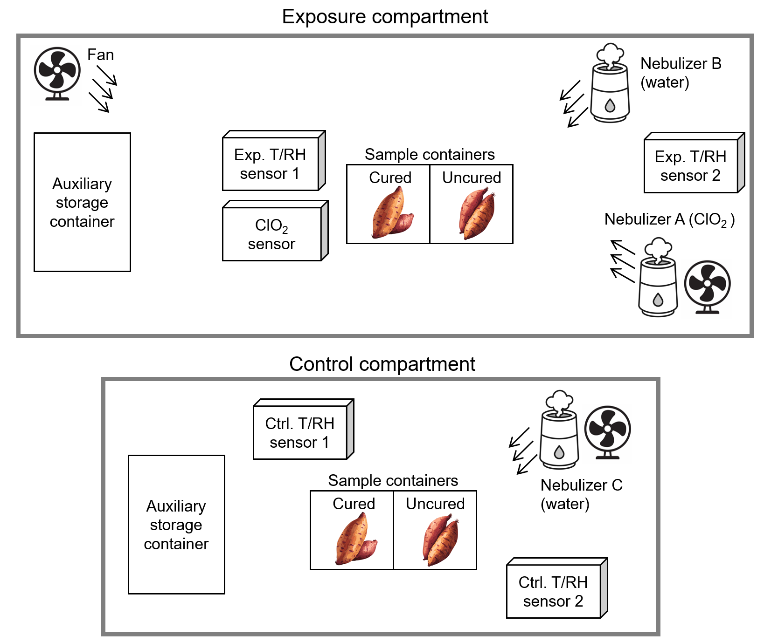
Fig. 1 Experimental environment

The ClO₂ exposure compartment (4 m × 10 m × 3 m; 120 m³) was equipped with a ClO₂ nebulizer (NaClO₂ 37.5 mmol L⁻¹ and citric acid 10.0 mmol L⁻¹ in 30 L of pure water; spraying rate 1 L h⁻¹, operated in 20-min spray/100-min standby cycles) and fans for gas mixing. Cured and uncured ‘Beniharuka’ sweet potato samples (unwashed) were placed on racks with minimal tuber contact. Ambient conditions were logged with two temperature-and-relative-humidity sensors, hereafter referred to as Exp. T/RH sensor, in addition to ClO₂ sensor monitoring gas concentration. The control compartment (2 m × 4 m × 2 m; 16 m³) had no ClO₂ supply but was equipped with a water nebulizer to maintain comparable humidity levels and housed parallel cured and uncured samples. Environmental conditions were recorded by sensors, hereafter referred to as Ctrl. T/RH sensor. The experiment was conducted under routine warehouse conditions where other agricultural products (e.g., yacon roots used for storage purposes) were stored concurrently.

2.5 Spoilage assessment
During the experimental period, the condition of all samples was checked once per week, and spoilage was assessed by visual inspection and palpation. Assessment was performed by an experienced producer (25 years of agricultural experience), and the criterion was defined as a condition in which the tissue became soft and could be indented by finger pressure. The assessor was not blinded to treatment allocation. Samples judged to be spoiled were promptly removed from the area and excluded from subsequent observation.
The number of spoiled samples each week in each area and the number of remaining samples at the beginning of each week were recorded. The early distribution period (approximately within the first two weeks) was considered to be strongly influenced by mechanical injury during transport and initial individual variability, resulting in reduced detection power of treatment effects, therefore the primary analysis period was defined as Weeks 3–6. The risk set at the start of Week 3 was defined as the number of remaining samples after excluding those judged as spoiled during Weeks 1–2, and the number of newly spoiled samples during Weeks 3–6 was treated as events for calculating incidence.

2.6 Statistical analysis
The observation period was six weeks from 12 December 2024 to 24 January 2025, and measurements from each sensor were recorded. The values from two temperature and humidity sensors installed in each area were averaged within each area and mean and median values were calculated for temperature and relative humidity. Between-group comparisons were performed using unpaired t-tests to examine differences. In addition, equivalence between groups was examined using the TOST (two one-sided test), with ±1 °C for temperature and ±5% for relative humidity defined as equivalence margins.
The primary analysis was conducted for Weeks 3–6, as defined above, and, as a sensitivity analysis, the same comparisons were repeated using cumulative incidence over the full observation period (Weeks 1–6). In this analysis, the denominator was defined as the initial number of tubers allocated to each group at baseline, and all incident spoilage events identified during Weeks 1–6 were included. This analysis was performed to examine whether the direction and magnitude of the treatment effect were robust to inclusion of the early distribution period.
All statistical analyses were two-sided with a significance level of 0.05. Effect size was expressed as risk ratio (RR) with 95% confidence intervals. Between-group differences were tested using the χ² test (without continuity correction) and Fisher’s exact test. Stratified analysis was conducted to assess confounding and interaction using the primary analysis dataset (Weeks 3–6). Data were stratified according to the presence or absence of curing treatment when evaluating the effect of chlorine dioxide exposure, and according to the presence or absence of chlorine dioxide exposure when evaluating the effect of curing. Adjusted RR and 95% confidence intervals were estimated using the Mantel–Haenszel method, and homogeneity between strata was evaluated using Woolf’s test (degrees of freedom = 1, two-sided). Each treatment was conducted in a single, non-replicated compartment; therefore, tubers within the same compartment cannot be considered fully independent observations. The p-values and confidence intervals reported are likely to be anti-conservative. Statistical analyses were performed using Python 3.11.8, pandas 1.5.3, matplotlib 3.6.3, SciPy 1.14.1, and statsmodels 0.13.5.

3. results and discussion

3.1 Differences in storage environmental conditions (temperature and humidity)
Figure 2 shows the temperature trends in the exposure and control compartments during the observation period. The mean temperature in the exposure compartment (Exp. T/RH sensor) was 12.31 °C (median 12.50 °C), which was lower than that in the control compartment (Ctrl. T/RH sensor), with a mean of 14.25 °C (median 13.80 °C). An unpaired t-test indicated a difference between groups (p < 0.001). The TOST equivalence test showed that the values did not fall within the ±1 °C equivalence margin; therefore, the exposure compartment was operated under lower temperature conditions than the control.
Figure 3 shows the relative humidity trends in the exposure and control compartments. The mean relative humidity in the exposure compartment was 66.65% (median 66.00%), which was lower than that in the control compartment (mean 85.19%, median 86.00%). An unpaired t-test indicated a difference between groups (p < 0.001). The TOST equivalence test showed that the values did not fall within the ±5% equivalence margin; therefore, the exposure compartment was operated under lower humidity conditions than the control.
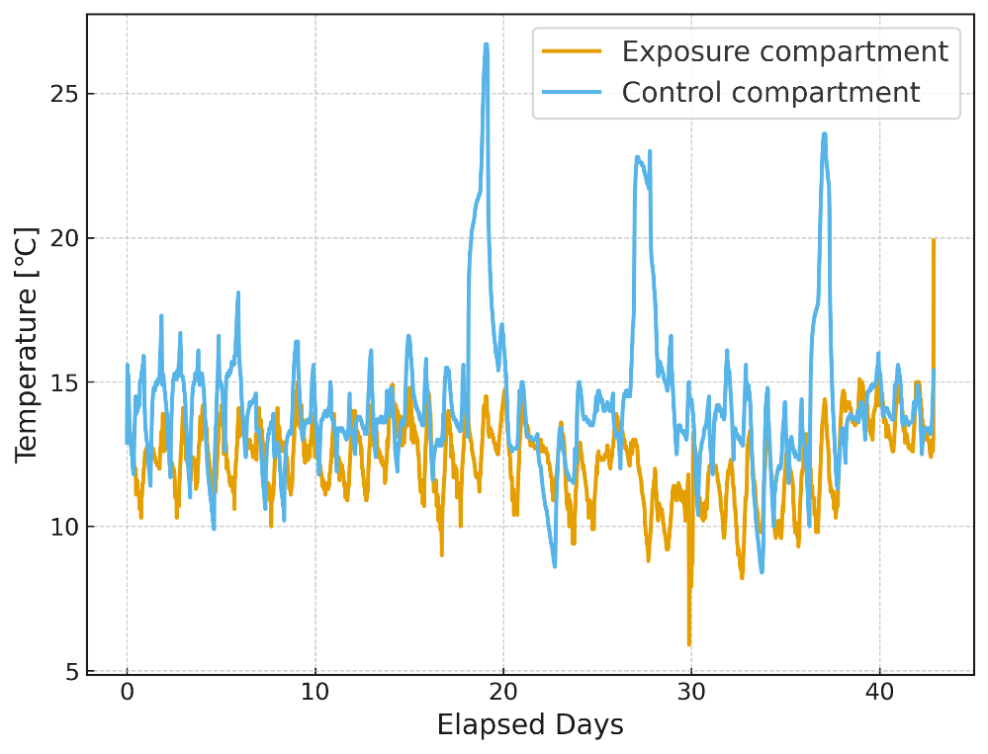
Fig. 2 Temperature time series in exposure and control compartments during the observation period
The ClO₂ exposure compartment (Exp. T/RH sensors 1–2) had a significantly lower temperature than the control compartment (Ctrl. T/RH sensors 1–2), with a mean of 12.3 °C (median, 12.5 °C) versus 14.3 °C (median, 13.8 °C). The difference was significant in an unpaired t-test (p < 0.001), and a TOST equivalence test confirmed that the two groups did not fall within the predefined ±1 °C equivalence margin. Thus, the exposure compartment was consistently operated under lower temperature conditions compared with the control.

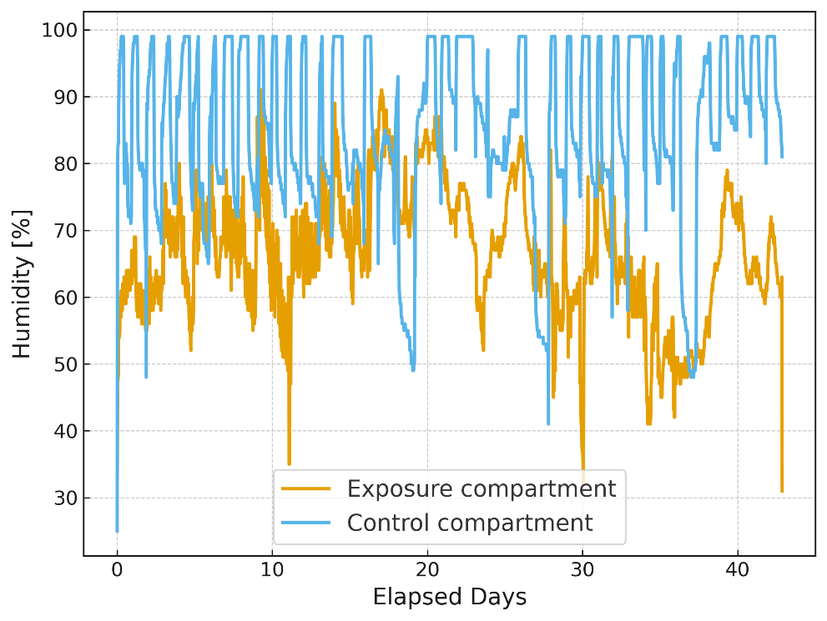
Fig. 3 Relative humidity time series in exposure and control compartments during the observation period
The mean relative humidity in the ClO₂ exposure compartment was 66.7% (median 66.0%), which was significantly lower than that in the control compartment (85.2%, median 86.0%). An unpaired t-test revealed a significant difference between compartments (p < 0.001), and a TOST equivalence test with a ±5% margin also indicated non-equivalence. Accordingly, the exposure compartment was maintained under drier conditions than the control, which may have contributed to differences in spoilage incidence.

3.2 ClO₂ concentration dynamics and C×t evaluation
The measurements obtained from the chlorine dioxide sensor installed in the exposure compartment are shown in Figure 4. On day 14 of the observation period, ultrasonic humidifier A malfunctioned and chlorine dioxide nebulisation stopped. Therefore, the installation locations of ultrasonic humidifiers B and C were exchanged, and chlorine dioxide aqueous solution was provisionally set in ultrasonic humidifier C to resume nebulisation. The spray rate of ultrasonic humidifier C was set at 100 mL/h (nominal value), which was approximately one-tenth of that of ultrasonic humidifier A (1 L/h, nominal). Accordingly, ultrasonic humidifier C was operated continuously without timer control.
In the overall observation period shown in Figure 4(a) (12 December 2024–24 January 2025), the mean concentration was 0.0214 ppm. However, the overall average appeared lower because the concentration markedly decreased after day 14 due to malfunction. The mean concentration during the first 14 days, when chlorine dioxide was sufficiently supplied, was 0.0389 ppm. The enlarged view of days 2–3 in Figure 4(b) shows a sawtooth concentration pattern corresponding to intermittent operation, confirming that the measurement functioned properly.

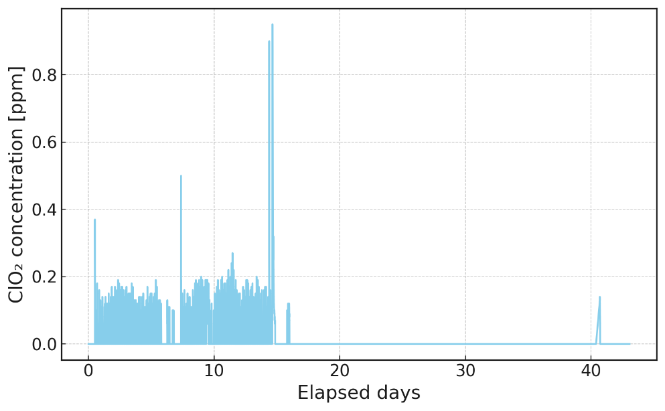
(a)
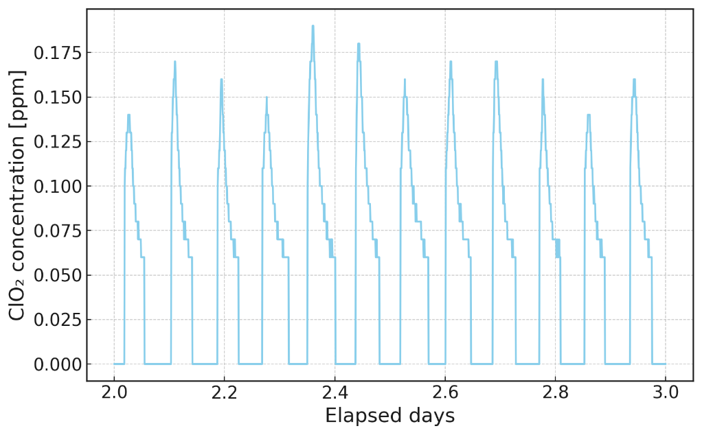
(b)
Fig. 4 ClO₂ concentration time series in the exposure compartment.
(a) Concentration dynamics throughout the entire observation period (December 12, 2024–January 24, 2025). Note that ClO₂ nebulization was unintentionally stopped after approximately day 14 due to a malfunction of the medium-sized ultrasonic humidifier, resulting in a decline of measured concentrations in the later period. (b) Enlarged view of days 2–3 to highlight short-term fluctuations.

3.3 Comparison of spoilage risk by treatment condition
Under the exposure concentration conditions described above, the association between treatment conditions and spoilage incidence was examined across four groups defined by the presence or absence of ClO₂ exposure and curing treatment. Weekly spoilage counts by group are shown in Table 1, and statistical results calculated from these counts are presented in Table 2.

Table 1 Weekly spoilage counts by ClO₂ exposure and curing status
“Initial N” denotes the number of tubers allocated to each group at baseline (post-transport). “Week 1” – “Week 6” are incident spoilage counts newly identified in each week; once classified as spoiled (soft on finger pressure by a trained assessor), samples were removed and did not contribute to subsequent weeks. Group codes: ClO₂ (+) = stored under chlorine dioxide exposure; ClO₂ (-) = no exposure; Curing (+) = cured prior to storage; Curing (-) = no curing. Operational parameters are specified in Methods. All samples were ‘Beniharuka’ sweet potatoes (unwashed), harvested from a single lot and stored from mid-December 2024 to late-January 2025 under real-world warehouse conditions.
Group | Initial N | Week 1 | Week 2 | Week 3 | Week 4 | Week 5 | Week 6
ClO₂ (+), Curing (+) | 141 | 0 | 11 | 2 | 1 | 1 | 4
ClO₂ (+), Curing (-) | 116 | 0 | 10 | 0 | 2 | 0 | 2
ClO₂ (-), Curing (+) | 131 | 0 | 8 | 15 | 7 | 8 | 10
ClO₂ (-), Curing (-) | 119 | 0 | 7 | 5 | 10 | 1 | 2

Table 2 Summary of statistical tests for spoilage risk and cumulative incidence
“Primary analysis” (Weeks 3–6) and “Sensitivity analysis” (Weeks 1–6 cumulative) summarize risk ratios (RR) and 95% confidence intervals for pairwise comparisons of spoilage incidence under chlorine dioxide (ClO₂) exposure and curing treatments. χ² and Fisher’s exact tests were used to assess group differences, while stratified analyses employed the Mantel–Haenszel method with Woolf’s test for homogeneity (df = 1, two-sided). “Data” indicate the number of spoiled tubers relative to the risk set at the beginning of each analysis period. RR < 1 represents a protective (spoilage-suppressive) effect, whereas RR > 1 indicates an increased spoilage risk. Bold values denote statistically significant results (p < 0.05). All analyses were two-sided with α = 0.05. Experimental and operational parameters are described in Methods.

Analysis Type | Comparison | Data | RR  (95% CI) | p-value | Interpretation
Primary  (Weeks 3–6) | ClO₂ (+) vs ClO₂ (-) | 12/236 vs 58/235 | 0.206 (0.114–0.373) | χ² test p < 0.001; Fisher’s exact test  p < 0.001 | ClO₂ group showed significantly lower spoilage
Primary  (Weeks 3–6) | Curing (+) vs Curing (-) | 48/253 vs 22/218 | 1.88 (1.17–3.01) | χ² test p = 0.0069; Fisher’s exact test  p =0.0090 | Curing group showed significantly higher spoilage
Sensitivity (Weeks 1–6 cumulative) | ClO₂ (+) vs ClO₂ (-) | 33/257 vs 73/250 | 0.440 (0.303–0.638) | χ² test p < 0.001; Fisher’s exact test  p < 0.001 | ClO₂ group showed significantly lower spoilage
Stratified (MH) | ClO₂ effect stratified by curing | — | 0.203 (0.112–0.367) | Woolf’s test p = 0.56 | No heterogeneity across curing strata

During the primary analysis period (Weeks 3–6), the spoilage incidence was lower in the ClO₂ exposure group than in the non-exposure group (12/236 vs 58/235; RR = 0.206, 95% CI 0.114–0.373; χ² test, p < 0.001; Fisher’s exact test p < 0.001). In contrast, spoilage incidence was higher in the curing group than in the non-curing group (48/253 vs 22/218; RR = 1.88, 95% CI 1.17–3.01; χ² test, p = 0.007; Fisher’s exact test p = 0.009).
Sensitivity analysis (Weeks 1–6 cumulative) showed the same tendency. ClO₂ exposure was associated with lower cumulative spoilage incidence (33/257 vs 73/250; RR = 0.440, 95% CI 0.303–0.638; χ² test, p < 0.001; Fisher’s exact test p < 0.001), whereas curing treatment was associated with higher cumulative spoilage incidence (67/272 vs 39/235; RR = 1.48, 95% CI 1.04–2.11; χ² test, p = 0.027; Fisher’s exact test p = 0.029). The primary and sensitivity analyses were consistent.
Stratified analysis was conducted to assess confounding and interaction. The stratified RR for ClO₂ exposure did not differ substantially according to curing status (Mantel–Haenszel method adjusted RR = 0.203, 95% CI 0.112–0.367, Woolf’s test p = 0.56). Similarly, the stratified RR for curing did not differ substantially according to ClO₂ exposure status (Mantel–Haenszel method adjusted RR = 1.96, 95% CI 1.24–3.09, Woolf’s test p = 0.56). These findings suggest no marked interaction between the two treatments.
The reduction in risk ratio to 0.206 observed in the ClO₂ exposure group is consistent with the microbiostatic effects reported previously (Mitani et al., 2024; Luu, 2019). In the present study, chlorine dioxide was supplied continuously for more than 14 days at a low mean concentration of 0.039 ppm. The antimicrobial mechanism of chlorine dioxide is considered to involve oxidative modification of intracellular proteins and enzymes, and its effect depends on the integrated value of concentration and exposure time (C×t) (Ogata, 2007; Ge et al., 2021; Hornstra et al., 2011). In the previous report by Mitani et al. (2024), the integrated value during short-term exposure of sweet potato slices in which growth of Rhizopus stolonifer was completely suppressed (0.2–0.3 ppm × 4,200 min = 840–1,260 ppm·min) was of the same order as that in the present study (0.039 ppm × approximately 20,000 min ≈ 780 ppm·min; calculated from the first 14 days before equipment malfunction). Therefore, the observed spoilage suppression is compatible with the accumulation of C×t under continuous exposure even at low concentration.
However, in the present study, the exposure compartment was operated at a temperature 1.9 °C lower and relative humidity 18.5% lower than the control (p < 0.001; see Section 3.1). Previous studies have shown that germination of Fusarium spp.is influenced by temperature and relative humidity, although the relationship with humidity is not strictly monotonic and may depend on environmental conditions (Elvira-Recuenco et al., 2021; Manstretta et al., 2016; Beyer et al., 2004). Therefore, the differences in temperature and humidity may also have contributed to suppression of pathogen growth together with ClO₂ exposure.
The increase in risk ratio to 1.88 observed in the curing group was inconsistent with previous reports. Kaneta et al. (2021) reported that curing at 35 °C for 72 hours did not significantly reduce spoilage during storage, whereas high-temperature treatment at 42 °C for 36 hours decreased spoilage and disposal rates during long-distance transport. The curing condition applied in the present study (40 °C for 90 h) followed the operational specifications of the supplier from which the sweet potatoes were procured. Compared with previously reported curing conditions, this treatment may have imposed greater thermal stress. Prolonged exposure to elevated temperature may damage periderm tissue and compromise the wound-healing barrier, thereby facilitating pathogen invasion during subsequent storage.

3.4 Confounding and study limitations
Interpretation of the ClO₂ effect should be considered in the context of environmental differences between the two storage compartments. A limitation of the present study is the difference in volume between the ClO₂ compartment (120 m³) and the control compartment (16 m³), which led to differences in temperature and humidity conditions. Although the Mantel–Haenszel method adjusted RR was 0.203, separation of the ClO₂ exposure effect from environmental effects is difficult. For rigorous causal inference, an experimental design under identical volume and air-conditioning control is required.
Furthermore, causative spoilage microorganisms were not identified, and therefore the specific microbial species targeted by ClO₂ remain unknown. The presence of other stored root crops may have contributed to the background microbial load, and cross-contamination via airborne or contact-mediated transmission of storage fungi cannot be excluded. Comparison with minimum inhibitory concentrations (MIC) for major sweet potato pathogens such as Rhizopus stolonifer and Ceratocystis fimbriata is required. Since each treatment was assigned to a single warehouse compartment without replication (see Section 2.2), the statistical tests treat individual tubers as independent units despite shared environmental exposure within each compartment. This pseudoreplication means that the reported p-values and confidence intervals are likely anti-conservative, and the observed differences may partly reflect compartment-level variation rather than treatment effects alone. In addition, spoilage assessment was conducted by a single unblinded assessor (see Section 2.5), introducing the possibility of observer bias. Finally, the ClO₂ nebuliser malfunctioned on day 14, resulting in substantially reduced gas supply during the latter half of the observation period (see Section 3.2). Consequently, the exposure conditions were not uniform across the full six-week period. Despite these constraints, the findings provide implications from a practical perspective.

3.5 Practical implications and future optimisation
From a practical standpoint, continuous exposure to low-concentration chlorine dioxide may suppress cross-contamination. In particular, lower spoilage incidence was observed over the six-week observation period, although ClO₂ was supplied at the intended concentration only during the first 14 days. The mean concentration during this period (0.039 ppm) was below the occupational exposure limits defined by the Occupational Safety and Health Administration (OSHA) (TWA 0.10 ppm; STEL 0.30 ppm) (OSHA, 2025). However, these effects may interact with temperature and humidity conditions; therefore, optimisation incorporating temperature, humidity, and exposure time is required. In the next phase, exploration of optimal conditions using response surface methodology (RSM) and generalised linear mixed models (GLMM) is required to balance spoilage suppression and quality maintenance.

4. Conclusion

To explore the potential of chlorine dioxide gas exposure and curing treatment for suppressing sweet potato spoilage during storage, spoilage incidence was compared under practical warehouse conditions using 80 kg (507 tubers) of ‘Beniharuka’ sweet potatoes harvested in Miyazaki Prefecture, with four groups established according to the presence or absence of chlorine dioxide exposure and curing treatment. In the chlorine dioxide exposure group, gas was supplied for 14 days at a mean concentration of 0.039 ppm using a 30 mmol/L aqueous solution. In the curing group, treatment was conducted at 40 °C and 100% relative humidity for 90 hours. The observation period was from 12 December 2024 to 24 January 2025, and spoilage incidence in each group was periodically assessed.
In the chlorine dioxide exposure group, the spoilage incidence was lower than that in the non-exposure group. During Weeks 3–6, spoilage incidence was 12/236 and 58/235, respectively, with a risk ratio of 0.206 (95% confidence interval 0.114–0.373, p < 0.001). Sensitivity analysis showed the same tendency, and the cumulative spoilage incidence in the exposure group was reduced to 0.44 times that of the non-exposure group. In contrast, spoilage incidence increased in the curing treatment group, with a risk ratio of 1.88 (95% confidence interval 1.17–3.01, p < 0.01).
The integrated exposure value of chlorine dioxide (C×t) was approximately 780 ppm·min (calculated from the first 14 days before equipment malfunction), corresponding to the lower bound of the inhibitory range reported previously. The observed lower spoilage incidence is compatible with microbiostatic effects of prolonged low-level exposure. However, because the exposure compartment had a mean temperature 1.9 °C lower and relative humidity 18.5% lower than the control compartment, the contribution of reduced temperature and humidity to suppression of pathogen proliferation cannot be excluded. In addition, the non-replicated single-compartment design and unblinded assessment limit causal inference (see Section 3.4).
Based on these findings, continuous exposure to low-concentration chlorine dioxide gas at a mean concentration of 0.039 ppm was associated with reduced spoilage incidence under conditions below the occupational exposure limit (TWA 0.10 ppm). Future studies should optimise chlorine dioxide concentration, temperature, humidity, and curing duration under controlled and replicated conditions to isolate treatment effects and define operational parameters that balance spoilage suppression and quality maintenance.

Competing interests

This study was supported by research funding from NSW Inc. Some authors are employees of NSW Inc.; however, the company had no role in the study design, data analysis, or interpretation of the results.

Consent (whereever applicable)

Not applicable.

Ethical approval (whereever applicable)

This study did not involve human participants or animals; therefore, ethical approval was not required.

References

Edmunds, B. A., Boyette, M. D., Clark, C. A., Ferrin, D. M., Smith, T. P., & Holmes, G. J. (2025). Postharvest handling of sweetpotatoes: NC State Extension Publications. https://content.ces.ncsu.edu/postharvest-handling-of-sweetpotatoes
Ray, R. C., & Ravi, V. (2005). Post harvest spoilage of sweetpotato in tropics and control measures: Critical Reviews in Food Science and Nutrition, 45(7–8), 623–644. https://doi.org/10.1080/10408390500455516
Wu, J., Zhang, J., Ni, W., Xu, X., George, M., & Lu, G. (2023). Effect of heat treatment on the quality and soft rot resistance of sweet potato during long-term storage: Foods, 12(23), 4352. https://doi.org/10.3390/foods12234352
Kaneta, T., Nakamura, N., Shiina, T., & Baba, T. (2021). High-temperature curing treatment improves storage stability of sweet potato ‘Kokei No.14’ (Naruto-Kintoki): Food Preservation Science, 47(2), 67–75. https://doi.org/10.5891/jafps.47.67
Benarde, M. A., Israel, B. M., Olivieri, V. P., & Granstrom, M. L. (1965). Efficiency of chlorine dioxide as a bactericide: Applied Microbiology, 13(5), 776–780. https://doi.org/10.1128/am.13.5.776-780.1965
Jiang, Y., Qiao, Y., Jin, R., Jia, M., Liu, J., He, Z. and Liu, Z., (2024). Application of chlorine dioxide and its disinfection mechanism: Archives of microbiology, 206(10), 400. https://doi.org/10.1007/s00203-024-04137-7
Mitani, R., Yamanaka, H., Ishigaki, Y., Nakayama, D., Sakamoto, M., Watanabe, C., Mori, T., & Okuda, T. (2024). Microbiostatic effect of indoor air quality management with low-concentration gaseous chlorine dioxide on fungal growth: Asian Journal of Atmospheric Environment, 18(1), 24. https://doi.org/10.1007/s44273-024-00047-8
Luu, P. (2019). Efficacy of aqueous and gaseous chlorine dioxide in reducing Salmonella, E. coli O157:H7, and Listeria monocytogenes on sweet potatoes, strawberries, and blueberries: Louisiana State University and Agricultural & Mechanical College. https://doi.org/10.31390/gradschool_theses.4893
Ogata, N. (2007). Denaturation of protein by chlorine dioxide: Oxidative modification of tryptophan and tyrosine residues: Biochemistry, 46(16), 4898–4911. https://doi.org/10.1021/bi061827u
Ge, Y., Zhang, X., Shu, L., & Yang, X. (2021). Kinetics and mechanisms of virus inactivation by chlorine dioxide in water treatment: A review: Bulletin of Environmental Contamination and Toxicology, 106, 560–567. https://doi.org/10.1007/s00128-021-03137-3
Hornstra, L. M., Smeets, P. W. M. H., & Medema, G. J. (2011). Inactivation of bacteriophage MS2 upon exposure to very low concentrations of chlorine dioxide: Water Research, 45(4), 1847–1855. https://doi.org/10.1016/j.watres.2010.11.041
Elvira-Recuenco, M., Pando, V., Berbegal, M., Muñoz, A. M., Iturritxa, E., & Raposo, R. (2021). Influence of temperature and moisture duration on pathogenic life-history traits of predominant haplotypes of Fusarium circinatum on Pinus spp. in Spain. Phytopathology, 111(11), 2002-2009. https://doi.org/10.1094/PHYTO-10-20-0445-R
Manstretta, V., Morcia, C., Terzi, V., & Rossi, V. (2016). Germination of Fusarium graminearum ascospores and wheat infection are affected by dry periods and by temperature and humidity during dry periods: Phytopathology, 106(3), 262–269. https://doi.org/10.1094/PHYTO-05-15-0118-R
Beyer, M., Röding, S., Ludewig, A., & Verreet, J. A. (2004). Germination and survival of Fusarium graminearum macroconidia as affected by environmental factors: Journal of Phytopathology, 152(2), 92–97. https://doi.org/10.1111/j.1439-0434.2003.00807.x
Occupational Safety and Health Administration (OSHA). (2025). Chlorine dioxide. https://www.osha.gov/chemicaldata/16

