Assessment of Physico-biochemical variability in different collections of Plum (Prunus salicina L.) cv. Santa Rosa in mid hills of Uttarakhand

ABSTRACT
A survey was conducted in Kumaon hills of Uttarakhand for evaluation of physico-chemical characteristics in twenty-nine collections of Santa Rosa plum at ICAR- Central Institute of Temperate Horticulture, Regional Station, Mukteshwar, Nainital, Uttarakhand. The data recorded on the basis of physico-chemical characteristic of plum among different genotype of Santa Rosa. The physical characteristics of fruits such as fruit weight (58.14 g), fruit length (4.58 cm), pulp weight (56.23 g) and specific gravity (1.34 g/cc) were found highest in Collection-20, while lowest fruit weight (19.93 g), fruit diameter (2.87 cm) and pulp weight (19.01 g) were found in Collection-26. The highest pulp stone ratio, T.S.S. and acidity was recorded in Collection-29 (36.42), Collection-25 (16.60 °B) and Collection-18 (2.45%) while lowest in Collection-7 (17.35), Collection-17 (10.40 °B) and Collection-2 (0.27%) respectively. The highest ascorbic acid (15.30 mg/100 g) was recorded in Collection-16, Collection-21, Collection-22 and Collection-24, while lowest in Collection-3 (3.28 mg/100 g). The highest total sugars, reducing sugar, carotene content and total anti-oxident were recorded in Collection-4 (9.52%), Collection-23 (7.94 %), Collection-3 (1224.47 µg/100 g) and Collection-25 (40.06 mMTE/L) while lowest in Collection-28 (4.85%), Collection-18 (2.38%), Collection-12 (17.49 µg/100 g) and Collection-23 (4.78 mMTE/L). Theses collections could further be utilized in the breeding programme for the improvement of crop.

KEYWORDS: Plum, evaluation, collection, cultivar, physico-chemical parameter

Introduction
Plum (Prunus salicina L.) is one of the most important deciduous fruit crops of India. It is widely cultivated in temperate regions of the world. Of the stone fruits, it ranks next to the peaches in economic importance. It has large number of species, but the commercially grown species are divided into two groups i.e. Prunus domestica L. [European plum- hexaploid (2n = 6x = 48)] and Prunus salicina L. [Japanese plum-diploid (2n = 2x = 16)] were introduced during 1870 in Himachal Pradesh. Plum is the most diverse in all the Prunus species and could be the most diverse in all deciduous stone fruit crop species which belongs to genus Prunus of sub family Prunoideae and family Rosaceae (Weinberger et.al., 1975; Watkins et.al., 1976; Potter et.al., 2000). Watkins et.al., 1976 identified five centres of origin for plums viz. The European group (P. domestica) of plum is native Europe, western Asia for P. insititia (Damson plum), western & central Asia for P. cerasifera (cherry plum), North America for P. Americana (American plum) whereas the Japanese group of plum is native to China. The commercially important plum trees are medium-sized, usually pruned to 5–6 meters (16–20 ft) height. The tree is of medium hardiness. The crop is grown in temperate zones in which China, Romania and U.S.A are leading countries for the production of plums (Blazek et.al., 2007).
The total production of plum in the world is 99, 21,953 MT in which China ranks first with production of 53, 72,899 MT (Anonymous et.al., 2016). Its area and production in India is 24,000 ha and 89,000 MT and in Jammu and Kashmir 4,083 ha and 11,860 MT respectively (Anonymous et.al., 2018-19). In Uttarakhand state occupies an area of 9075.68 ha with an annual production of 34836.78 MT respectively (Apak et.al., 2004). Plums are important source of compounds influencing human health and preventing the occurrence of many diseases (Stacewicz et.al., 2000). In addition to the nutritional value of fruits, plums have a significant role in the prevention and treatment of certain disorders such as cardio-vascular, renal, stomach and other illnesses (Usenik et.al., 2008) The fruits of plums are used as fresh, dried or processed into jam, marmalade, juice and brandy etc (Voca et.al., 2009). The processed products include candy, frozen fruit, jams, jelly products and traditional Serbian plum for alcoholic beverages (Milosevic et.al., 2010). Santa Rosa is a leading major commercial cultivar of Japanese plum. It is the cross between Prunus salicina as a female parent with Prunus simoni and Prunus americana as a pollen parent (Salaria, 2009). The present investigation was carried out to study the qualitative and quantitative attributes of fruit in cv. Santa Rosa plum. Therefore, the proposed study was described to characterise various genotypes of plum (cultivated and wild plum) existing in the Kumaun hill region on the basis of their physico-biochemical traits and assess the variability among the diverse population.
Material and Methods
A survey was conducted in Kumaun hills of Uttarakhand for evaluation of physico chemical characteristics in twenty-nine collections of Santa Rosa are described in Table No.1 collected from different villages. The observations on physico-chemical parameters of fruits were recorded. The physical attributes like fruit weight (g), fruit volume (cc), fruit length (cm), fruit diameter (cm), specific gravity (g/cc), fruit firmness (lb/in2), pulp weight (g), seed weight (g) and pulp/stone ratio. The chemical characters include total soluble solid (ºB), acidity (%), ascorbic acid (mg/100 g), reducing sugars (%), total sugars (%), non-reducing sugars (%), carotene (µg/100) g) and total anti-oxidant activity (mMTE/L) were recorded during storage. The fruit firmness was measured with the help of a penetrometer were expressed as Ib/inch². The germplasm collected from villages of Nainital district. The village adopted as a strategy to collect the information about the plum genotypes available in the area. In each village four to five local farmers were consulted before identification of a genotype for collection. Variants were collected randomly at fruit maturity stage from different sites of the district and marked with durable label (aluminium sheet).
Table-1 List of different Santa Rosa germplasms collected during exploration
Serial No. | Collection No. | Collected from
1 | C1 | Darmoli
2 | C2 | Gehana
3 | C3 | Sunera
4 | C4 | Sheetla
5 | C5 | Reetha
6 | C6 | Sargakhet
7 | C7 | Harinagar Nathuakhan
8 | C8 | Orakhan
9 | C9 | Hartola
10 | C10 | Budibana
11 | C11 | Galla
12 | C12 | Ganguachor
13 | C13 | Sathkhol
14 | C14 | Kokilbana
15 | C15 | Satbunga
16 | C16 | Darima
17 | C17 | Pata
18 | C18 | Bhlad
19 | C19 | Sunkiya
20 | C20 | Lodh
21 | C21 | Nathuakhan
22 | C22 | Kalapatal
23 | C23 | Gunialekh
24 | C24 | Kuedal
25 | C25 | Pharpadi
26 | C26 | Chaurlekh
27 | C27 | Dubhkher
28 | C28 | Gajar
29 | C29 | Mukteshwar

The survey was carried out under ICAR-Central institute of Temperate Horticulture, Regional Station, Mukteshwar, Nainital, Uttarakhand. The experimental site is lies between 29.47° north latitude and 79.64° longitude east. It has an average elevation of 2,286 meters above from mean sea level (7,500 feet). The experiment orchard lies under temperate agroclimatic zone of Uttarakhand, where summer is moderately hot during May-June while, winter is severe during December-January. Soil macro and micro nutrient play an important role in productivity and quality of plum (Sidhu & Kaundal . 2005; Milosevic et.al., 2009).
The fruit firmness was measured with the help of a penetrometer were expressed as Ib/inch² and the total soluble solid was measured with the help of a refractometer were expressed as ͦBrix. Total anti-oxidant activity was recorded by using the method described by (Apak et al., 2004). The colour values of different plum collections were obtained in terms of L*, a*, b*, C* and h° values using a Lovibond RT series reflectance tintometer. The ‘L*’ measures luminosity or lightness and varies from zero (black) to one hundred (perfect white). The chromaticity dimension ‘a*’ measures redness when positive, grey when zero, and greenness when negative. The ‘b* ’value measures yellowness when positive, grey when zero, and blueness when negative. The ‘C* ’describes the Chroma (saturation) of the colour, a measure of how far from the grey tone the colour is. Hue angle (h°), describes the hue of the colour, i.e., colour tonalities (red, green, yellow etc.) as per the method described by (Mapson, et.al., 1970). The data determined the significance differences using Randomized Block Design (RBD) one way analysis of variance (ANOVA) as suggested by (Gomez et.al., 1984). The chemical characteristics of the fruits viz., titratable acidity and TSS/Acidity ratio were recorded by using the methods described by (Ranganna et.al., 2010).
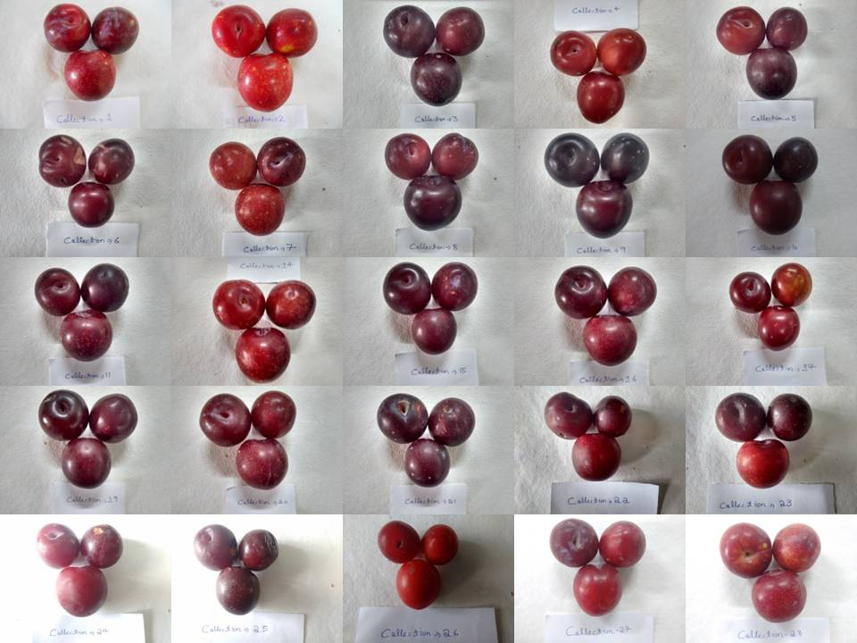

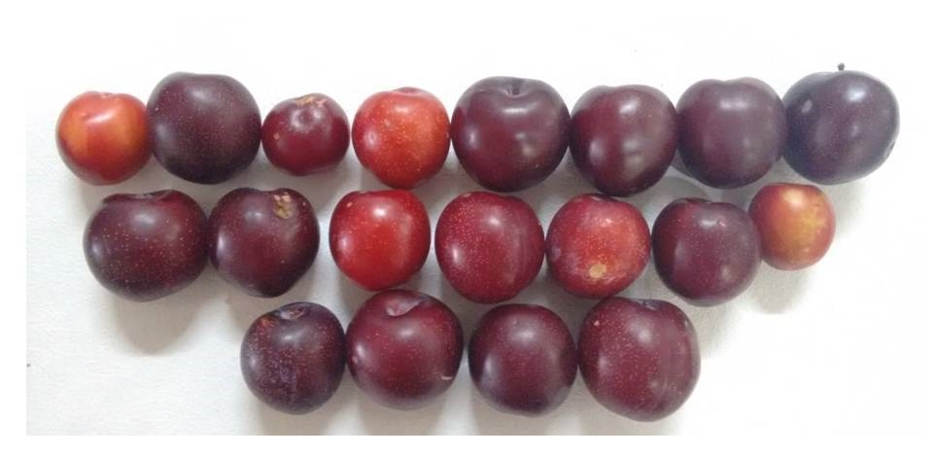
Figure1: variability in Santa Rosa Plum collected from Kumaon region of Uttarakhand
Results and discussion
Physical fruit characteristics
Considerable variation in physical fruit characteristics was observed among the evaluated Santa Rosa plum collections (Table 2). Fruit weight varied significantly among the collections, with the highest fruit weight recorded in Collection-20 (58.14 g) followed by Collection-1 (56.23 g), Collection-3 (52.81 g), Collection-19 (50.76 g) and Collection-9 (48.21 g), whereas the lowest fruit weight was observed in Collection-26 (19.93 g). Similar variation in fruit weight among plum cultivars has also been reported by earlier researchers (Karamursel et. al., 2007; Kishor et.al., 2017). Fruit volume also varied among the collections, with the maximum fruit volume observed in Collection-1 (76.67 cc), followed by Collection-9 and Collection-12 (60.00 cc), Collection-3 (55.00 cc) and Collection-24 (53.33 cc), while the minimum fruit volume was recorded in Collection-6 (23.33 cc). Significant differences were also observed in fruit size parameters such as fruit length and fruit diameter. The maximum fruit length was recorded in Collection-20 (4.58 cm), followed by Collection-1 (4.52 cm), Collection-28 (4.37 cm) and Collection-27 (4.29 cm), whereas the minimum fruit length was observed in Collection-23 (3.27 cm). Similarly, fruit diameter was highest in Collection-1 (4.54 cm), followed by Collection-28 (4.41 cm), Collection-3 (4.33 cm) and Collection-19 (4.27 cm), while the lowest fruit diameter was recorded in Collection-26 (2.87 cm). Similar variations in fruit dimensions among plum cultivars were reported by (Kishor et.al., 2017; Son et.al., 2010).
Specific gravity also showed variation among the collections, with the highest value recorded in Collection-20 (1.34 g/cc) followed by Collection-19 (1.27 g/cc), Collection-11 (1.25 g/cc) and Collection-13 (1.15 g/cc), whereas the lowest values were observed in Collection-22 and Collection-23 (0.65 g/cc). Fruit firmness ranged from 1.60 lb/in² in Collection-21 to 8.57 lb/in² in Collection-13, indicating substantial variability in fruit texture among the collections. Pulp weight also differed significantly among the germplasms. The highest pulp weight was recorded in Collection-20 (56.23 g), followed by Collection-1 (54.64 g), Collection-3 (51.15 g) and Collection-19 (48.51 g), whereas the lowest pulp weight was recorded in Collection-26 (19.01 g). Seed (stone) weight ranged from 0.86 g in Collection-4 to 2.37 g in Collection-12, which is consistent with earlier findings reported by (Dhatt et.al., 1992; Kishor et.al., 2017; Vukojevic et.al., 2012). The pulp to stone ratio varied considerably among the collections, with the highest ratio observed in Collection-29 (36.42%), followed by Collection-11 (34.57%), Collection-1 (34.53%) and Collection-4 (32.58%), while the lowest ratio was recorded in Collection-7 (17.35%). Such variability in pulp to stone ratio among plum cultivars has also been reported by (Josan et.al., 1999; Narayan et.al., 2017; Sharma et.al., 2018; Singh et.al., 2011; Thakur et.al., 2014). The higher pulp to stone ratio observed in some collections may be attributed to greater fruit weight and comparatively lower stone weight.
The graphical representation of fruit weight further highlights the variability among the evaluated germplasms (Fig. 2). The highest fruit weight was recorded in Collection-20 (58.14 g), followed by Collection-1 (56.23 g), Collection-3 (52.81 g) and Collection-19 (50.76 g), while the lowest fruit weight was observed in Collection-26 (19.93 g). The observed variation may be attributed to genetic differences among the germplasms as well as the prevailing environmental conditions of the mid-hill region of Uttarakhand. Fruit weight is an important commercial attribute as it directly influences yield and market acceptability.
Chemical fruit characteristic
Considerable variation was observed among the Santa Rosa plum collections with respect to chemical fruit characteristics (Table 3). The highest total soluble solids (TSS) were recorded in Collection-25 (16.60 °B), followed by Collection-26 (16.10 °B), Collection-3 (15.80 °B), Collection-8 (15.60 °B) and Collection-24 (15.00 °B), whereas the lowest TSS was observed in Collection-17 (10.40 °B). Similar findings regarding variation in TSS among plum cultivars have also been reported by earlier researchers (Kumar et.al., 2017; Lysiak et.al., 1999; Walkowiak-Tomezak et.al., 2008). Titratable acidity also varied among the collections, with the lowest acidity recorded in Collection-2 (0.27%), while the highest acidity was observed in Collection-18 (2.45%) followed by Collection-19 (2.31%). Ascorbic acid content showed considerable variation, with the highest value (15.30 mg/100 g) recorded in Collection-16, Collection-21, Collection-22 and Collection-24, whereas the lowest value was recorded in Collection-3 (3.28 mg/100 g). Similar ranges of ascorbic acid content in plum fruits have been reported by previous studies (Gill et.al 2002; Murtaza et.al., 2012). The synthesis of ascorbic acid in fruits is influenced by the availability of hexose sugars, and its reduction during ripening may be associated with oxidation processes and changes in acidity levels [14]. Total sugars were highest in Collection-4 (9.52%), followed by Collection-23 (9.26%), Collection-26 (8.70%) and Collection-22 (8.33%), whereas the lowest total sugars were recorded in Collection-28 (4.85%). Reducing sugars showed a similar trend, with the highest value recorded in Collection-23 (7.94%), followed by Collection-26 (6.85%), Collection-7 (6.26%) and Collection-8 (5.75%), while the lowest value was observed in Collection-18 (2.38%). The variation observed in reducing and non-reducing sugars, total soluble solids and acidity among the collections may be attributed to genetic differences among cultivars as well as environmental factors such as agro-climatic conditions, management practices, location and storage conditions (Erturk et.al., 2009; Mehrotra et.al., 1999; Sharma et.al., 1993).
Carotene content also varied significantly among the collections, with the highest value recorded in Collection-3 (1224.47 µg/100 g) followed by Collection-4 (724.09 µg/100 g), Collection-22 (533.55 µg/100 g), Collection-26 (484.70 µg/100 g) and Collection-2 (389.04 µg/100 g), whereas the lowest carotene content was recorded in Collection-12 (17.49 µg/100 g). Similarly, total antioxidant activity ranged from 4.78 mMTE/L in Collection-23 to 40.06 mMTE/L in Collection-25, followed by Collection-27 (39.17 mMTE/L), Collection-29 (39.02 mMTE/L) and Collection-24 (38.74 mMTE/L). The results obtained in the present investigation are in close agreement with earlier findings reported by (Brijlal et.al., 2017; Lysiak et.al., 1999; Laila et.al., 2012). Significant variation in fruit size parameters such as fruit length and fruit diameter was also observed among the Santa Rosa plum collections (Fig. 3). The maximum fruit length was recorded in Collection-20 (4.58 cm), followed by Collection-1 (4.52 cm), Collection-28 (4.37 cm) and Collection-27 (4.29 cm), whereas the minimum fruit length was observed in Collection-23 (3.27 cm). Similarly, fruit diameter was highest in Collection-1 (4.54 cm), followed by Collection-28 (4.41 cm), Collection-3 (4.33 cm) and Collection-19 (4.27 cm), while the lowest diameter was recorded in Collection-26 (2.87 cm). These variations in fruit dimensions indicate considerable morphological diversity among the collections, which may be attributed to genetic variability and adaptation to local agro-climatic conditions. Similar variations in fruit length and diameter among plum cultivars have been reported by (Attri et.al., 2017; Son et.al., 2010).
Fruit colour characteristic
Among the evaluated Santa Rosa plum collections, noticeable variation was observed in fruit colour characteristics (Table 4). Collection-2 exhibited the highest luminosity value (L* = 58.08), indicating comparatively lighter fruit colour, followed by Collection-7 (L* = 48.02) and Collection-5 (L* = 37.17), whereas the lowest luminosity was recorded in Collection-16 (L* = 20.03). The highest redness (a* = 35.84), yellowness (b* = 28.79), chroma (C* = 45.96) and hue angle (h° = 38.80) were observed in Collection-26, indicating more intense colour development. In contrast, the lowest values of redness (a* = 4.21), yellowness (b* = 0.72), chroma (C* = 4.33) and hue angle (h° = 9.44) were recorded in Collection-19. These results are in close agreement with earlier findings reported by (Debnath et.al., 2017; Kastelec et.al., 2008). The edible portion of the fruit, represented by pulp weight, also showed considerable variation among the collections (Fig. 3). The highest pulp weight was recorded in Collection-20 (56.23 g), followed by Collection-1 (54.64 g), Collection-3 (51.15 g) and Collection-19 (48.51 g), whereas the lowest pulp weight was observed in Collection-26 (19.01 g). Stone weight varied from 0.86 g in Collection-4 to 2.37 g in Collection-12. Such variation in pulp and stone weight directly influences the pulp to stone ratio, which is an important quality parameter determining the edible portion of the fruit and its consumer preference. Collections possessing higher pulp weight with relatively lower stone weight are considered desirable for fruit quality improvement. Similar variability in pulp and stone weight among plum cultivars has been reported by earlier researchers (Minnas et.al., 1992; Kumar et.al., 2017; Simic et.al., 2012).
Conclusion
The present study can be concluded that the collections of Santa Rosa performed better in respect to physico-chemical properties. The most of the physio-chemical characteristics were found superior in Collection-20, Collection-1, Collection-25 and Collection-2. However, this variability may be due to edaphic factors of environment which needs further investigation.

Table-2 Comparative data of fruit physical characteristics among different Santa Rosa germplasms
Collection No. | Fruit weight (g) | Fruit volume (cc) | Fruit length (cm) | Fruit diameter (cm) | Specific gravity (g/cc) | Fruit firmness (lb/in²) | Pulp weight (g) | Seed/stone weight (g) | Pulp/stone ratio
C1 | 56.23 | 76.67 | 4.52 | 4.54 | 0.73 | 4.67 | 54.64 | 1.59 | 34.53
C2 | 28.02 | 31.67 | 3.42 | 3.65 | 0.90 | 1.87 | 26.81 | 1.21 | 22.45
C3 | 52.81 | 55.00 | 4.08 | 4.33 | 0.96 | 3.37 | 51.15 | 1.66 | 31.07
C4 | 28.31 | 28.33 | 3.77 | 3.54 | 1.00 | 4.27 | 27.45 | 0.86 | 32.58
C5 | 43.09 | 43.33 | 4.09 | 3.95 | 0.99 | 4.27 | 41.43 | 1.66 | 25.97
C6 | 23.27 | 23.33 | 3.28 | 3.47 | 1.01 | 2.53 | 22.33 | 0.94 | 23.85
C7 | 36.99 | 36.67 | 3.63 | 3.53 | 1.01 | 7.50 | 34.95 | 2.04 | 17.35
C8 | 47.95 | 46.67 | 3.93 | 4.22 | 1.04 | 5.90 | 46.11 | 1.84 | 25.97
C9 | 48.21 | 60.00 | 4.22 | 4.02 | 0.81 | 2.67 | 46.71 | 1.50 | 30.96
C10 | 43.06 | 41.67 | 4.19 | 3.92 | 1.03 | 2.67 | 41.56 | 1.50 | 27.59
C11 | 47.74 | 38.33 | 4.05 | 4.16 | 1.25 | 2.27 | 46.40 | 1.35 | 34.57
C12 | 46.42 | 41.67 | 4.18 | 4.21 | 1.12 | 5.40 | 44.04 | 2.37 | 20.63
C13 | 39.72 | 35.00 | 3.89 | 3.93 | 1.15 | 8.57 | 38.21 | 1.50 | 26.25
C14 | 48.19 | 41.67 | 4.23 | 4.18 | 1.16 | 4.07 | 46.11 | 2.09 | 22.85
C15 | 39.21 | 40.00 | 4.13 | 3.88 | 0.98 | 3.10 | 37.55 | 1.65 | 23.66
C16 | 45.52 | 40.00 | 4.07 | 4.19 | 1.14 | 1.87 | 43.24 | 2.28 | 19.14
C17 | 23.34 | 31.67 | 3.38 | 3.29 | 0.74 | 2.60 | 22.23 | 1.11 | 20.53
C18 | 40.36 | 36.67 | 3.94 | 3.91 | 1.10 | 3.40 | 38.76 | 1.59 | 25.92
C19 | 50.76 | 40.00 | 4.15 | 4.27 | 1.27 | 3.70 | 48.51 | 2.25 | 22.57
C20 | 58.14 | 43.33 | 4.58 | 4.27 | 1.34 | 2.80 | 56.23 | 1.90 | 30.50
C21 | 44.68 | 38.33 | 4.03 | 4.06 | 1.14 | 1.60 | 42.74 | 1.94 | 21.77
C22 | 39.19 | 60.00 | 3.71 | 3.91 | 0.65 | 3.47 | 37.95 | 1.24 | 30.62
C23 | 29.45 | 45.00 | 3.27 | 3.53 | 0.65 | 4.30 | 28.47 | 0.99 | 30.40
C24 | 40.03 | 53.33 | 3.79 | 3.88 | 0.75 | 3.20 | 38.72 | 1.31 | 29.98
C25 | 29.08 | 41.67 | 3.32 | 3.35 | 0.70 | 1.97 | 27.87 | 1.21 | 23.19
C26 | 19.93 | 25.00 | 3.28 | 2.87 | 0.80 | 3.87 | 19.01 | 0.92 | 20.70
C27 | 40.81 | 36.67 | 4.29 | 3.99 | 1.11 | 5.73 | 39.24 | 1.57 | 25.49
C28 | 48.20 | 45.00 | 4.37 | 4.41 | 1.07 | 4.72 | 46.74 | 1.46 | 32.34
C29 | 45.18 | 41.67 | 4.23 | 4.23 | 1.09 | 6.60 | 43.94 | 1.24 | 36.42
Mean | 40.82 | 42.01 | 3.93 | 3.92 | 0.99 | 3.90 | 39.28 | 1.54 | 26.55
CD at 5% | 8.24 | 8.61 | 0.37 | 0.36 | 0.16 | 2.50 | 8.21 | 0.52 | 9.03

Table-3 Comparative data of fruit chemical characteristics among different Santa Rosa germplasms
Collection No. | TSS (°B) | Acidity (%) | Ascorbic acid  (mg/100 g) | Reducing sugars (%) | Total sugars (%) | Non-Reducing sugars (%) | Carotene (µg/100 g) | Total anti-oxidant  activity(mMTE/L)
C1 | 11.80 | 1.11 | 5.47 | 3.02 | 6.99 | 3.78 | 248.39 | 10.50
C2 | 10.80 | 0.27 | 5.47 | 2.92 | 5.80 | 2.73 | 389.04 | 16.78
C3 | 15.80 | 1.68 | 3.28 | 4.35 | 7.94 | 3.41 | 1224.47 | 9.91
C4 | 11.20 | 2.11 | 8.74 | 4.32 | 9.52 | 4.95 | 724.09 | 8.72
C5 | 11.80 | 1.88 | 5.47 | 4.07 | 7.02 | 2.80 | 286.70 | 5.39
C6 | 13.00 | 1.74 | 6.55 | 4.59 | 6.83 | 2.13 | 102.08 | 25.35
C7 | 13.40 | 2.01 | 12.02 | 6.26 | 7.58 | 1.25 | 74.05 | 9.76
C8 | 15.60 | 1.37 | 9.84 | 5.75 | 8.03 | 2.17 | 104.40 | 6.06
C9 | 14.60 | 1.51 | 8.74 | 3.85 | 6.47 | 2.49 | 117.77 | 27.23
C10 | 14.00 | 0.57 | 8.75 | 4.63 | 8.16 | 3.36 | 117.25 | 13.74
C11 | 12.80 | 1.44 | 12.02 | 3.70 | 8.00 | 4.08 | 135.77 | 11.83
C12 | 13.80 | 0.70 | 7.65 | 3.82 | 6.56 | 2.60 | 17.49 | 10.51
C13 | 11.60 | 1.78 | 13.12 | 4.39 | 7.55 | 3.00 | 107.22 | 10.91
C14 | 11.40 | 1.54 | 13.12 | 4.67 | 7.25 | 2.44 | 177.94 | 8.80
C15 | 11.20 | 0.54 | 9.84 | 5.62 | 6.64 | 0.97 | 300.59 | 32.83
C16 | 12.80 | 1.04 | 15.30 | 4.04 | 5.65 | 1.53 | 293.65 | 11.17
C17 | 10.40 | 2.11 | 10.93 | 5.50 | 7.19 | 1.61 | 80.23 | 12.83
C18 | 13.20 | 2.45 | 10.93 | 2.38 | 7.07 | 4.45 | 242.22 | 13.57
C19 | 14.40 | 2.31 | 12.02 | 4.59 | 5.97 | 1.31 | 240.68 | 19.11
C20 | 13.00 | 2.14 | 6.56 | 3.71 | 6.29 | 2.45 | 233.99 | 17.92
C21 | 13.00 | 1.61 | 15.30 | 3.88 | 7.30 | 3.25 | 224.22 | 20.92
C22 | 13.20 | 1.24 | 15.30 | 4.20 | 8.33 | 3.92 | 533.55 | 6.82
C23 | 14.20 | 1.01 | 13.12 | 7.94 | 9.26 | 1.26 | 157.88 | 4.78
C24 | 15.00 | 1.21 | 15.30 | 4.10 | 7.94 | 3.65 | 188.99 | 38.74
C25 | 16.60 | 1.51 | 13.12 | 4.63 | 7.33 | 2.56 | 247.62 | 40.06
C26 | 16.10 | 1.11 | 8.74 | 6.85 | 8.70 | 1.75 | 484.70 | 5.82
C27 | 10.80 | 0.44 | 10.93 | 3.91 | 6.47 | 2.44 | 90.00 | 39.17
C28 | 11.60 | 2.24 | 6.55 | 3.50 | 4.85 | 1.29 | 126.00 | 37.41
C29 | 10.80 | 0.80 | 7.65 | 2.57 | 5.59 | 2.87 | 218.56 | 39.02
Min. | 10.40 | 0.27 | 3.28 | 2.38 | 4.85 | 0.97 | 17.49 | 4.78
CD at 5% | 0.54 | 0.06 | 0.46 | 0.20 | 0.31 | 0.32 | 6.71 | 2.64

Table-4 Comparative data of fruit colour characteristics among different Santa Rosa
Collection No. | Skin ground colour
Collection No. | L* | a* | b* | Chroma (C*) | Hue angle (h°)
C1 | 35.01 | 19.85 | 8.94 | 21.80 | 23.93
C2 | 58.08 | 18.65 | 9.67 | 21.05 | 25.89
C3 | 27.91 | 10.36 | 4.36 | 11.00 | 21.95
C4 | 35.63 | 23.92 | 12.21 | 27.02 | 27.10
C5 | 37.17 | 19.54 | 9.42 | 21.70 | 24.76
C6 | 27.74 | 23.58 | 9.47 | 25.41 | 21.88
C7 | 48.03 | 32.27 | 22.83 | 39.51 | 33.67
C8 | 29.93 | 14.87 | 5.54 | 15.99 | 19.99
C9 | 31.72 | 5.86 | 1.14 | 5.94 | 11.53
C10 | 34.60 | 5.89 | 1.37 | 6.03 | 13.09
C11 | 24.76 | 11.03 | 3.76 | 11.64 | 18.87
C12 | 35.25 | 27.48 | 13.41 | 30.51 | 25.91
C13 | 29.10 | 27.44 | 17.59 | 27.42 | 31.20
C14 | 31.99 | 20.32 | 10.22 | 22.27 | 26.74
C15 | 29.41 | 10.54 | 4.42 | 11.28 | 20.30
C16 | 20.03 | 10.46 | 2.86 | 10.62 | 14.50
C17 | 27.37 | 17.29 | 6.40 | 18.50 | 20.07
C18 | 30.77 | 26.27 | 12.00 | 29.33 | 23.74
C19 | 29.17 | 4.21 | 0.72 | 4.33 | 9.44
C20 | 29.07 | 7.23 | 2.24 | 7.43 | 18.54
C21 | 31.29 | 10.75 | 3.92 | 11.44 | 20.65
C22 | 25.68 | 10.28 | 4.45 | 11.20 | 23.40
C23 | 32.77 | 13.74 | 7.37 | 15.60 | 28.20
C24 | 32.70 | 10.88 | 3.82 | 11.53 | 19.35
C25 | 29.84 | 5.01 | 1.86 | 5.34 | 20.38
C26 | 36.39 | 35.84 | 28.79 | 45.96 | 38.80
C27 | 33.42 | 22.80 | 7.42 | 23.99 | 18.19
C28 | 36.89 | 25.83 | 11.12 | 28.13 | 23.05
C29 | 31.88 | 23.96 | 12.24 | 26.84 | 25.95
CD at 5% | 7.60 | 6.93 | 3.82 | 6.95 | 4.21

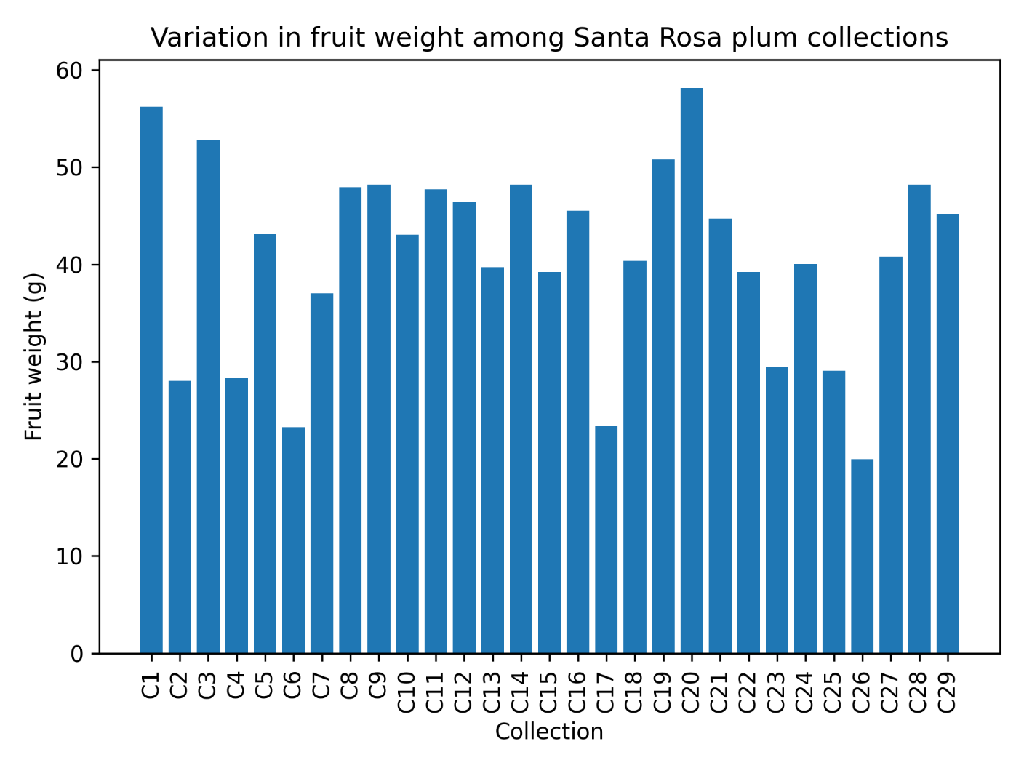

Figure 2: Variation in fruit weight among different Santa Rosa plum collections evaluated under mid-hill conditions of Uttarakhand.

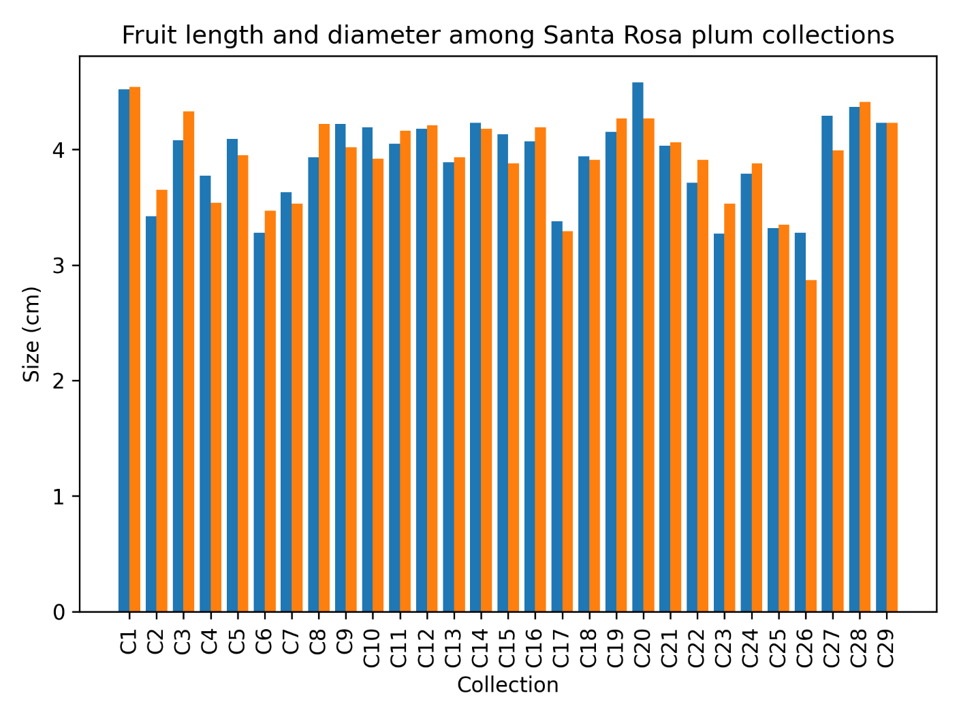

Figure 3: Comparative fruit dimensions (length and diameter) among Santa Rosa plum collections.

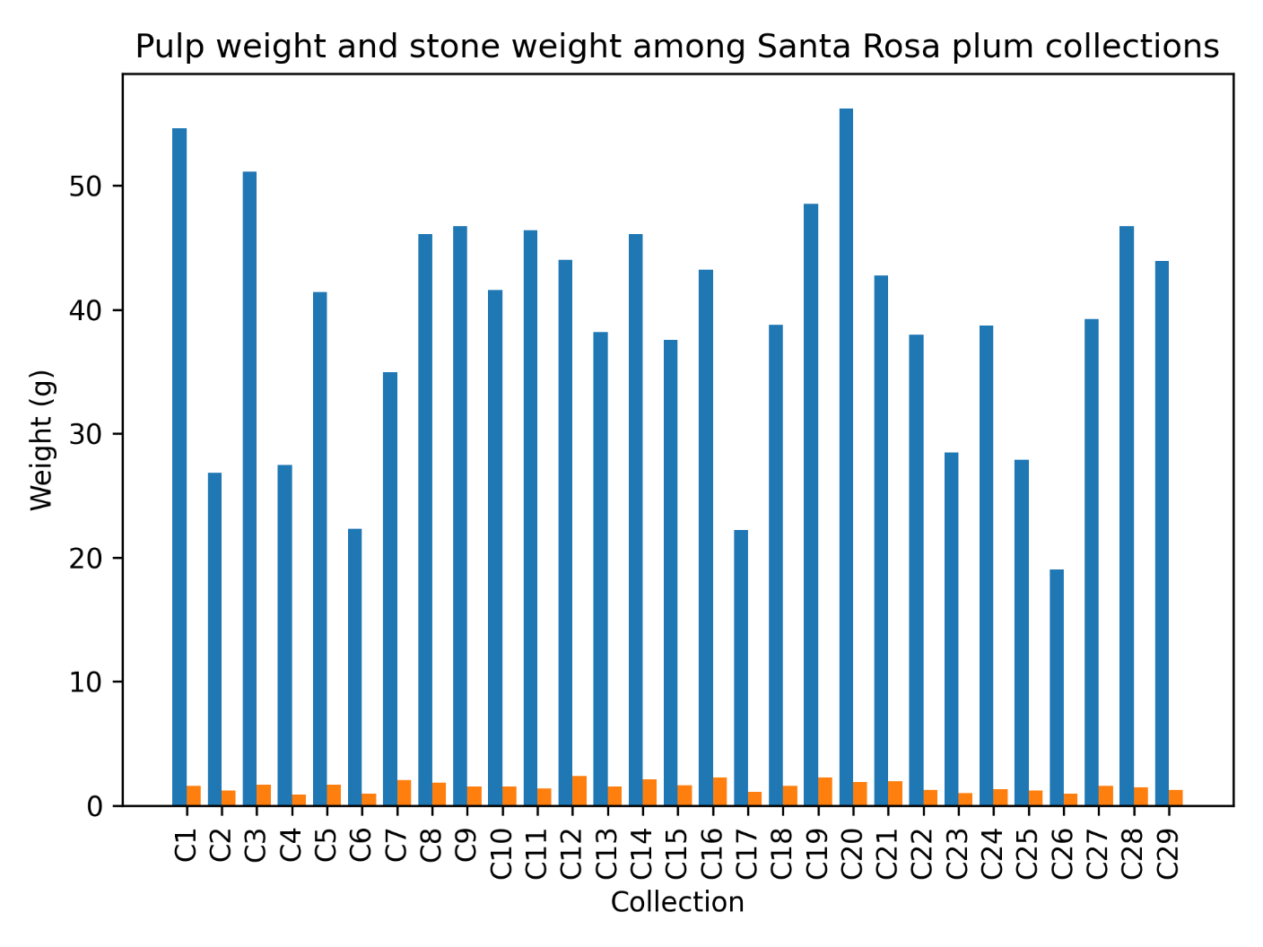

Figure 4: Variation in pulp weight and stone weight among Santa Rosa plum collections.
References
Anonymous. Food Agriculture Organization Statistical Database. 2016.
Anonymous. Indian Horticulture Database, National Horticulture Board, Ministry of Agriculture, Govt. of India. 2018-19.
Anonymous. State Horticulture Mission, Government of Uttarakhand, 2020-2021.
Apak, R., Guclu, K., Ozyurek, M. and Karademir, S.E. Novel total anti-oxidant capacity index for dietary polyphenol and vitamin C and E, using their cuppric ion reducing capability in presence of neocuproine; CUPRAC method. J. Agric. Food Chem. 2004; 52:7970-81.
Blazek, J. A survey of the genetic resources used in plum breeding. In VIII International Symposium on Plum and Prune Genetics, Breeding and Pomology. 2007; 734: 31-45.
Dhatt, A.S., Chanana, Y.R., Minnas, P.P.S. and Bindra, A.S. Table plum Fla. 1-2. Indian Horticulture. 1992; 37: 41.
Erturk, Y., Ercisli, S. and Tosun, M. Physico chemical characteristics of wild plum fruits (Prunus spinosa L.). International Journal of Plant Production. 2009; 3: 89-92.
Gill, M.I. and Tomas, F.A. Barberan, Hess-Pierce, B., Kader, A.A. J. Agricult. Food Chem., 2002; 50, 4976-4982.
Gomez, K.A. and Gomez, A.A. Statistical Proceedings for Agriculture Research (2nd edn.), John Wiley and Sons Inc., New York. 1984.
Josan, J.S., Sharma, J.N., Mehrotra, N.K. and Monga, P.K. Performance of some plum cultivars under arid irrigated region of Punjab. Indian Journal of Horticulture, 1999; 56: 299-303.
Karamursel, OF., Sevik I, Sarisi HC, Kocal, H. & Ozturk, FP. Adaptation of European plums (Prunus domestica L.) under egirdir ecological conditions. 5th Turkish Nat Hort Congress. 2007; 1: 481-485.
Kishor, A., Narayan, R., Brijlal, M., Kumar, A., Attri, B.L., Debnath, S. and Joshi, K.K. Variability in physico-chemical characteristic of plum genotypes collected from Kumaon hills of Uttarakhand. Chem. Sci. Rev. Lett. 2017; 6(21): 520-524.
Lysiak, G. Evaluation of productivity of ten plum cultivars growing on two rootstocks. Pr. Kom. Nauk Roln. Kom. Nauk Lesn. 1999; PTPN 87: 95-101.
Mapson, L.W. Vitamins in fruits. In: The biochemistry of fruit and their products. Academic Press, London and New York, 1970; pp-369-384.
Milosevic T, Glisic I & Milosevic N. Dense planting effect on the productive capacity of some plum cultivars. Acta Horticulturae. 2009; 825: 485–490.
Milosevic T, Milosevic N & Mratinic E. Morphogenic variability of some autochthonous plum cultivars in western Serbia. Brazilian Archives of Biology and Technology. 2010; 53: 1293–1297.
Moghaddam EG, Ava SH, Akhavan S, & Hosseini S. Phenological and pomological characteristics of some plum (Prunus spp.) cultivars grown in Mashhad, Iran. Crop Breed J. 2011; 1(2): 105-108.
Murtaza, I., Ahsan, H., Laila, O., Sharma, G. and Ali, S.A. Curr. Trends Biotechnol. Pharm., 2012, 6(4), 425- 432.
Potter D, Eriksson T, Evans RC, Oh S, Smedmark JEE, Morgan DR. Phylogeny and classification of Rosaceae. Plant Systematics and Evolution. 200; 266: 5- 43.
Ranganna, S. Handbook of Analysis and Quality Control for Fruit and Vegetable Products, Tata McGraw Hill Publishing Company Ltd., New Delhi. 2010.
Sharma, D.D.; Kumar, M.; Singh, N. and Shylla. Plant growth and fruiting behavior of newly introduced plum (Prunus salicina Lindl.) cultivars under mid-hills conditions of Himachal Pradesh. The pharma Innovation Journal. 2018; 7(4): 408-413.
Sharma, J.N. and Josan, J. S. Varietal performance of plum under arid irrigated region of Punjab. Indian Journal of Horticulture. 1993; 50(4):301-305.
Sidhu LS & Kaundal GS. Effect of planting density on fruit yield, foliar nutrient content and root distribution of plum (Prunus salicina Lindl.) cv. Satluj Purple. Acta Horticulturae. 2005; 696: 299–302.
Singh, D., Sharma, V.K. and Kumar, K. Evaluation and characterization of some exotic plum germplasm accessions for fruit quality traits. Journal of Hill Agriculture, 2011; 2(1): 59- 62
Son, L. Determination on quality characteristics of some important Japanese plum (Prunus Salicina Lindl.) cultivars grown in Mersin-Turkey. 2010, 5(10); 1144-1146.
Stacewicz SM, Bowen PE, Hussain EA, Damayanti WBI and Farnsworth NR. Chemical composition and potential health effects of prunes: a functional food. Critical reviews in food science and Nutrition. 2000; 41: 251-286.
Sundouri, A.S., Verma, S.K., Sharma, M.K., Simnani, S.A., Khalil, Aroosa., Nazir, N. and Mustaq, R. Varietal characteristic of exotic plum cultivars under changing climate scenario of North Western Himalayas. Int. J. Curr. Microbiol. App. Sci. 2018; 7(7): 3389-3399.
Thakur, G.; Sharma, Lata and Yadav, A. Floral and physico-chemical characters of Japanese plum (Prunus salicina Lindl.) cultivars. Journal Research, Punjab Agriculture University. 2014; 51(1): 36-41.
Usenik, V., Kastelec, D., Veberic, R. and Stampar F. Quality changes during ripening of plums (Prunus domestica L.). Food Chemistry. 2008; 11(1): 830-836.
Voca, S., Galic, A., Sindrak, Z., Dobricevic, N., Pliestic, S., Druzic, J. Chemical composition and antioxidant capacity of three plum cultivars. Agric. Consp. Sci., 2009; 74(3), 273–276.
Vukojevic, D., Simic, J., Dragisic, N., Sevo, D., Misimovic, M., Zavisic, N., Bolic, E. and Radanovic, B. Evaluation of the quality of autochthonous plum cultivars in the area of Bosanski Petrovac. Third International Scientific Symposium “Agrosym Jahorina”. 2012; pp. 161-65.
Walkowiak-Tomezak, D., Regula, J & Lysiak, G. Physico-chemical properties and antioxidant Activity of selected plum cultivars fruit. Acta Sci Pol Technol Aliment. 2008; 7(4): 15-22.
Watkins, R. In evolution of crop plants (ed.N.W. Simmonds) Longmans, London, 1976; pp. 243-246.
Weinberger, J.H. In Advances in fruit breeding (eds.J. Jamick and J.N. Moore) Purdue Univ. Press. U.S.A. 1975; pp. 336-347.

